AN ASSESSMENT OF DESIGN AND IMPLEMENTATION OF LANGUAGE TRANSLATOR
(A CASE STUDY OF BENIN LANGUAGE)

ABSTRACT
English is the official language of only seven countries comprising little more than five percent of the world's population. Yet the majority of online content is in English. While many business people speak English as a second language, most prefer to communicate in their native tongue Using machine translation one could easily translate the content in one language to the other largely in real time. This paper describes the role of an Intermediate language in machine translation of natural languages, how modular the work can be accomplished in translating a one language to other.

TABLE OF CONTENT
Certification
Dedication
Acknowledgement
Abstract
List of Figures
List of Tables
Table of Contents

CHAPTER ONE
1.1 Introduction
1.2 Statement of the problem
1.3 Aims and objectives
1.4 Significant of the study
1.5 Justification of study
1.6 Scope of the study
1.7 Definition of terms
CHAPTER TWO
Literature review
2.1 Background theory of study
2.2 previous methods in use
2.3 current methods in use
CHAPTER THREE
System Analysis And Design
3.1 Introduction
3.2 Method adopted
3.3 Operations of existing system
3.4 Design methodology
3.5 Analysis of findings
3.6 Input to the system
3.7 Output from the system
3.8 Processing tasks

CHAPTER FOUR
System Development and Implementation
4.1 Introduction
4.2 Input design
4.3 Output design
4.4 System architecture
4.5 System flowchart
4.6 System implementation
4.7 Program coding

CHAPTER FIVE
Summary, conclusion and recommendation
5.1 Summary
5.2 Conclusion
5.3 Recommendation
References
Appendix(Source Codes)

CHAPTER ONE
1.1 INTRODUCTION
Electronic Benin Phrasebook is a computer-based system (processed by Assembler) that was developed to specifications in an effort to build a variable, reliable, beneficial, and good relationship between two parties who share one source of motivation, which is the potential to solve visitors' problems (Blench, 2022). Driller's issues by creating a Benin electronic phrasebook to aid in assisting in the provision of answers to issues related with a language barrier. This system includes some helpful terms and phrases in the Benin language together with their translations, and it is intended for use by tourists to locations where the Benin language is spoken (Blench, 2022). In the event that more references to this area of research are required in the future, the project work may also be used as a focus point. This application was designed to replace the manual Benin phrasebook, which can be compared to a bilingual dictionary. It contains a clearly and orderly defined set of words and phrases with their respective translations, and its purpose is to simplify communication between visitors (natives of other countries) and natives of the land of Benin so that visitors can more fully enjoy their time there on vacation or business. It eliminates the threat posed by vacation tourism in a particular manner. This phrasebook is software that explains the meanings of frequent terms in Benin country using perfect English diction, and it will always be of use to any visitor who is attempting to get acquainted with some of the words to exchange pleasantries, greetings, and commonly uttered words (Crozier, 2022). Once an outsider has the ability to converse in Yoruba, the level of intimacy between the people of Benin and visitors will increase, and better relationships and good will will be developed. As you were well aware, tourism will play a significant role in the global economy's recovery once there is no longer a barrier to the free flow of information between the vectors and the drivellers, which will be to everyone's advantage.
1.2 STATEMENT OF THE PROBLEM
The following are the problems that can be deduced from the old system.
- lack of effectiveness in communication among Benin villagers and visitors
- communication interference and visitors
- misinterpretation of some phrases since it takes lot of efforts to decode the correct phrases that suitable for content of a typical situation
- lack of concentration since there no manual to fall back on
- untimely response to the sender of the communication to visitor
- language barrier
1.3 AIM AND OBJECTIVES
The aim of the project is to develop a system that will process and translate Benin Language (greeting) to English Language.
The objectives of this project are:
- Design electronic Benin phrasebook that will carry out the basic operations of Benin greeting language.
- Carry out a comparative analysis of electronic phrasebook with the written one
- The purpose of digital Benin phrasebook for tourist can better be accessed via internet although internet is language resource, reviewing words and has wide usage by all countries
- It also provides solution to problems associated with the language barrier among the visitors and the indigenous native of Benin land.

1.4 SIGNIFICANCE OF THE STUDY
- This is to teach foreigners that are willing to learn Benin language
- To break some barrier that people face in learning the language
- To make it very possible for people to interact with people speak the language
- To learn some phrases and to put in practise.
1.5 JUSTIFICATION OF STUDY
This project is designed to bring the usefulness of information technology to the doorstep of non-Benin people that are non-literate or transact business with Benin indigenes
1.6 SCOPE OF STUDY
The project work is developed to encourage and motivate the foreigners (visitors) for the purpose of visiting our nation (or Benin City) and to enhance tourism. It designed as typically user’s friendly system whereby each and every visitor will be able to interact, converse and transact business smoothly without any prejudice. It provides for an individual the ability to browse the Electronic Benin Phrasebook in order to check for the meaning of particular words or phrases (mostly greetings) that best suitable for the situation on the ground with little or no human intervention for it most efficiency and effectiveness.
1.7 DEFINITION OF TERMS
- Tourist : A person who is travelling or visiting a place for pleasure
- Benin : This is one of the tribe of Nigerian nation and it is also the western part of Nigeria
- Assembler: A program that converts symbolically-coded programs into object level, machine code.
- Phrasebook : A book containing lists of common expressions translated into another language, especially for people visiting a foreign country
- Tourist : A person who is travelling or visiting a place for pleasure
- Benin: This is one of the tribe of Nigerian nation and it is also the western part of Nigeria
- Pronunciation guide: This is the list containing different types of words and the best way on how to pronounce it
- Phrase list : This is a list that contains many phrases and words with their corresponding meaning
- VB: Visual Basic
- Argument: A value supplied to a procedure, macro, subroutine, or command that is required in order to evaluate that procedure, macro, subroutine, or command. Synonymous with parameter.
- Assembler: A program that converts symbolically-coded programs into object level, machine code. In an assembler program, unlike a compiler, there is a one-to-one correspondence between human-readable instructions and the machine-language code.
- Authentication: Process of establishing who you are.
- Authorization: Permission to access non-public information or use equipment that is either fully or partially restricted. Process of establishing what you can do.
- BASIC: Beginners All-purpose Symbolic Instruction Code. A commonly used personal-computer language first developed at Dartmouth during the 1960s.
- Batch processing: Originally, a method of organizing work for a computer system, designed to reduce overhead by grouping similar jobs. In one scheme, jobs were collected into batches, each requiring a particular compiler. The compiler was loaded, and the jobs submitted in sequence to the compiler. The term has come to be applied to background processing of jobs not requiring user intervention on multiuser systems. See compiler.
- Batch query: A query that has been saved so that it can be used more than once and run in the background.
- Buffer: A temporary memory for data normally used to accommodate the difference in the rate at which two devices can handle data during a transfer

CHAPTER TWO
LITERATURE REVIEW
2.1 BACKGROUND THEORY OF STUDY
Communication is a critical element of patient safety and quality care. Addressing communication barriers is also an important component of an organizations safety strategy and risk management activities, and is often a legal requirement. Language access services, including interpreters, translators, using written materials or communication boards, and using writing sign language in the most frequently encountered languages, are essential to meeting many of the communication needs encountered by health care organizations. The benefits of including language access services in foreigners.
Buzzwords like globalization and global supply chain frequently come up in discussions on training networking and economic growth. At least once a week, a heading triumphantly declares a company lost in translation due to language or cultural missteps. English language remains the most popular when conducting business every. It is the most widely published language, it has the most words and it’s spoken by the most non-native speakers.
Companies and some foreigners final that establishing localized sales offices or hiring commissioned representatives helps to eliminate potential language and cultural barriers. It’s a simple solution, one that avoids getting caught in a situation where translation or alternative business practices cause confusion. In the case of kid software in Switzerland, communication is imperative in servicing its software to a global customer base. As an individual or small organization, the company originally tired a single employee to address language issues in-house.It is important for us to have all the documentation and the software looked after and to have someone organize it all. The problem with translation is that you start from scratch again and again. As soon as you change a small percentage of the source text, someone has to translate it all. It does not matter if only two words or a complete sentence is changed; the translation effort it still the same.Many Asian cultures believe a person’s family and religions background help determine their business practices. Where dealing specifically with countries like china, Japan and India, employees take the extra steps necessary to make their customers comfortable. It helps to know the background of our relationship, friends, and customer. If we can provide a close and friendly relationship, the customer feels mutually respected.
TRANSLATION
Translation is the communication of the meaning of a source-language text by means of an equivalent target-language text. While interpreting—the facilitating of oral or sign-language communication between users of different languages—antedates writing, translation began only after the appearance of written literature. There exist partial translations of the Sumerian Epic of Gilgamesh (ca. 2000 BCE) into Southwest Asian languages of the second millennium BCE.
Translators always risk inappropriate spill-over of source-language idiom and usage into the target-language translation. On the other hand, spill-overs have imported useful source-language calques and loanwords that have enriched the target languages. Indeed, translators have helped substantially to shape the languages into which they have translated.
Owing to the demands of business documentation consequent to the Industrial Revolution that began in the mid-18th century, some translation specialties have become formalized, with dedicated schools and professional associations.
Because of the laboriousness of translation, since the 1940s engineers have sought to automate translation or to mechanically aid the human translator. The rise of the Internet has fostered a world-wide market for translation services and has facilitated language localization.
Translation studies systematically study the theory and practice of translation.

2.2 PREVIOUS METHOD IN USE
What native speakers often do not realize is that frequently it is not the other person’s accent but their own way of speaking that creates the greatest barriers to effective communication. The strategies below ensure you are not putting up your own roadblocks to effective communication.
2.2.1 Frequently check for understanding is not taken
Not able to check that both that you have understood what is been said and that others have not able to have the fully understood you. Practice reflective listening to check your own understanding and use open-ended questions to check other people’s understanding
2.2.2 Not mindful of jargon:
Watch the use of TLAs (Three Letter Abbreviation) and other organizational language that may not be understood by others. If you use them, provide in parentheses a description of what these are so others can learn to use the same language you do.

2.3 CURRRENT METHOD IN USE
Computer has been an indispensable tool in lexicography for decodes and this has prompted its advent in developing a phrasebook for Benin language electronically. The need to store, sort and retrieve large amount of linguistic information drew publishers to electronic approach.The system spells out your expectations and deadlines clearly. Instead of, “please get back to me shortly”. Spend time early in your communication defining what these means to you and others invest in building a shared vocabulary.

CHAPTER THREE
SYSTEM ANALYSIS AND DESIGN
3.1 INTRODUCTION
In this chapter, a detailed investigation and analysis of the present system is carried out so as to help give the researcher an in-depth knowledge of the present system and also be able to know the problems inherent in the system.
For proper understanding and documentation of this very system, the researcher carried out an extensive research and study of the operations of language translation system. To achieve this aim, some data gathering techniques were employed such as: interviewing, review of documents and forms, sample sheets, etc.
Hence, the project was carried out by, also taking into consideration the following:
- The system analysis which contain the out and input to the existing system.
- The organizational flow chart,
- The problems and weaknesses of the existing system, a tool after which the new system to be designed later would be able to or provide solutions to the various problems identified in the present system.
3.2 Methodology Adopted
Prototyping Model has been used for software development according to which a throwaway prototype of the proposed system, based on the currently known requirements, is given to the user so that he has a fair idea about how the proposed system is going to be like. This will help him in deciding the interface, input and output requirements.
It can be easily adjudged that inputs and outputs are big in number, can increase exponentially and may create a big chaos if not restricted properly. As the user spends some time on the prototype, he will become more precise about his own input and output Requirements. This prototype will provide him with an environment analogous to the proposed system’s environment.
Due to object oriented support in Visual Basic, various concepts (like reusability, polymorphism, isolation etc.) are already there but for the efficient management of system components, Component based Software Engineering will also be exercised which will help in a resultant library of components, the benefit of which will be reusability and fast development.
Due to lack of hierarchical structure in object oriented approach, there is no meaning of Bottom-up or Top-down testing. Testing will begin from the rudimentary levels of the system and will move towards higher level components, which will be based on design phase rather than coding phase Words.
3.3 OPERATIONS OF EXISTING SYSTEM
Mostly, the phrasebook contained important expressions for situational communication between a foreigner and native Beninspeakers in the areas of bargaining, greeting, description, members, colours etc. without doubt, any foreigners that might interact with a native of Benin need the phrase book of Benin that is translated to English for smooth communication. Hence manual Benin phrasebook was capturing for this operation visitors needs to browse through this digital phrasebook that can be likened to bilingual dictionary, study it, knowing the appropriate word that are best suitable for a particular occasion to reach the effectiveness of their communication and to eradicate. The communication barrier between Benin people and foreigner some terminologies are employed and used which thus includes are followings
Pronunciation Guide
Phrase Meaning
1) Aremiegbe: may you be nourished by what you have eaten.
2) I hoenkoyoUrhuese : heard you, hello thank you.
3) I hoenOvbimwenAkponmwenOsa: I heard my child,To God be the glory.
4) Kada: is predominantly a male greeting after meal.
5) Eregbue: wives greetings after meal.
6) Bukpe: female greetings after meal.

3.4 DESIGN METHODOLOGY
The basic description of the software design methods used in the creation of digital phrasebook and reason for choosing these methods were clearly stated.Considering the description of program or software used, VB programming language was chosen to develop an electronic Benin phrasebook and this will allows the phrasebook to work on a wide range of platforms including internet and other local websites.

3.5 ANALYSIS OF FINDINGS
This is the process of using research method sampling and other techniques to collect information about the interaction and language barrier among the visitors to enhance their communication level. It is also called data collection which is a classical requirement.
3.6 INPUT TO THE SYSTEM
Input to the system are;
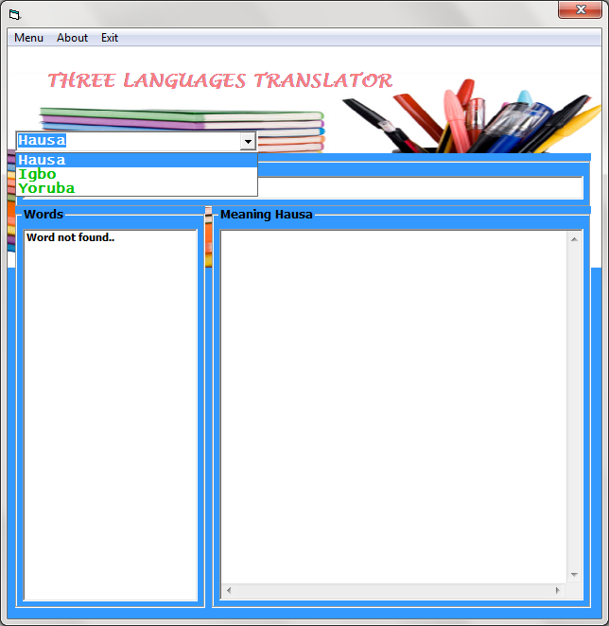
3.7 OUTPUT FROM THE SYSTEM
The outputs from the system are;
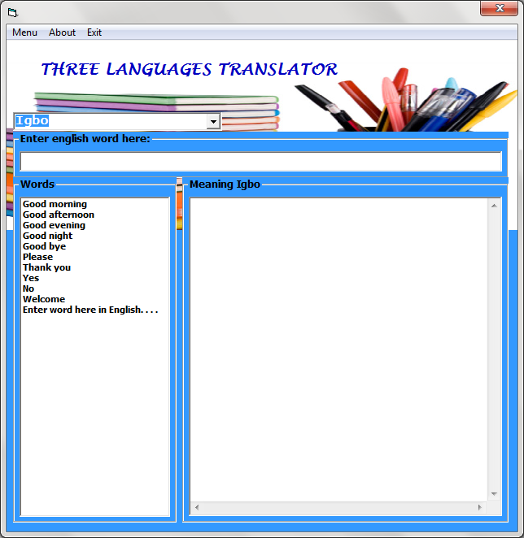
- Vowels
- Consonants
- Basics
- Days
- Months
3.8 PROCESSING TASKS
The nature of work undergoing with the existing manual Benin phrasebook can probably lead to the following under listed factors.
- Ineffective output of communication i.e communication breakdown
- Code mixing in communication which result to loss of concentration
- Unitionely feedback or response to the sender
- Wordy phrasal sentences
- Misinterpretations of some phrase it takes lot of efforts to decode the correct phrase, that most suitable for situation.
Solution
- Since it is electronic (i.e automated), it has the ability to show on the screen for spontaneous usage.
- It enhance the communication among the visitors and beautify tourist centre
- It gives orderly and clear definition (s) of Benin words and simple expressions in English and obliterates the menace of travel and tourism

CHAPTER FOUR
SYSTEM DEVELOPMENNT AND IMPLEMENTATION
4.1 INTRODUCTION
System design refers to the system building process. It also focuses on the technical or implementation of the system. It involves studying how a system actually works or should work.The system is designed to fulfil some design objective modulus represented in flow chart and VTOC packages.

4.2 INPUT DESIGN
The proposed system specifies the input data variables that will be fed into the system with the format in which the output is presented will determine to a large extent the type of data that will be regarded by the system hence, a good place to start analysing the system input specificity is the type of output expected.
Figure 1
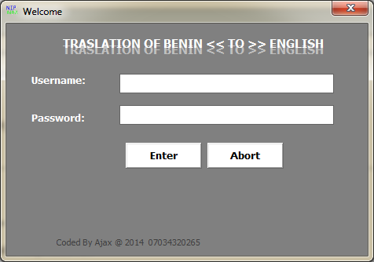
Name: login form
Input source: keyboard

USER NAME

Password

Log in

Exist

Attribute | Data type | Length
User’s name | Text | 10
Password | Text | 10

Display

Sound

Close
(+) pronunciation Guide
Vowels

Consonants

(+) phrase list
Basic

Months
Output

Field name: Main
Access mode: Random Access
Input source: Keyboard and Mouse
Strong location: Database
Attribute | Data type | Length
Vowels | Text | 50
Consonants | Text | 50
Basics | Text | 50
Days | Text | 50
Months | Text | 50

4.3 OUTPUT DESIGN
Without input data, there cannot be any output. Therefore, the output is the processing activities that take on the input data.
The output design specifies how the output of the process data will look the form that it will take.This is an important stage in implementing the system. It determines how useful the system is the screen form and layout for this project is shown below.
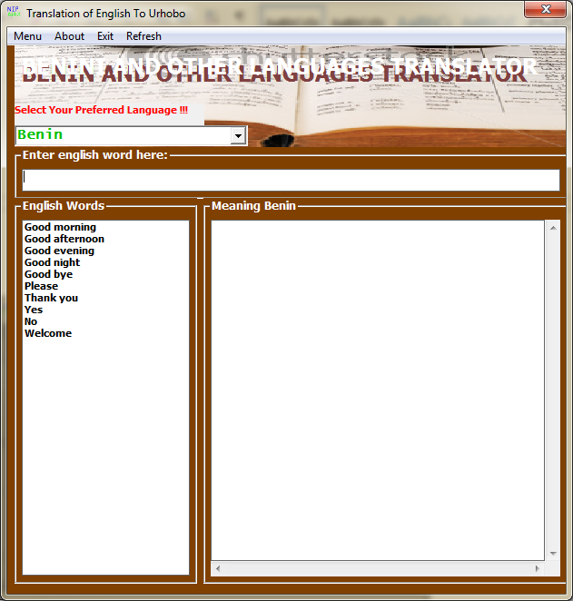

Electronic Benin Phrasebook
(+) pronunciation guide
Vowels
Consonants
(+) phrase list
Basic
Days
Months

DISPLAY

SOUND

CLOSE

4.4 SYSTEM ARCHITECTURE
Main menu
Close
Translate phrase
No
Add keyword
Update
Pick a choice
Refresh
Type key word
Yes
Select English phrase
Abort program
About
Reset
Do not add keyword
Type Benin keyword
Type English keyword
Update keyword
Not found
Translate keyword
End
Clear field
Add keyword

4.5 System flowchart
Start
Translate Keyword Supplied by the user
Load Keyword in a list box
Go to Add Keyword dialog window
Select operation
Translate
Add keyword
Select word to translate
Update Keyword
Is Operation equal to Translate
Is operation equal to Add keyword
A

Yes

No

Yes
No
Update any Keyword and Refer all record
Translate any selected Keyword by the user
Is operation equal to select word translate
Is operation equal to update
Error Handler
A
Display appropriate error message to the user
Stop

Yes

No

Yes

No

Yes

HIPO CHART
INPUT PROCESS OUTPUT
About
Abort
Process Refresh
Process About
Process Abort program
Enter word in English
Display Refresh program
Refresh Refresh
Display Exit
Display About
Display Translated word in Yoruba
update
Display update
Add keyword
Process Translate
Process update
Process Add Keyword
Display Supply Keyword
Add to Database
Process Reset
Process Close
Reset
Close
Display Reset all fields
Display Exit

4.6 SYSTEM REQUIREMENT
Hardware requirements
- 14 SVGA Monitor
- Computer system
- 500 Gigabyte of Hard Drive
- RAM of 4 Gigabyte
- Standard key board
- Mouse
- Intel dual core processor
- Power cable
Software requirements
a) Microsoft Visual Basic 6.0 was used to write the program.
b) Operating system used was Window 7 Ultimate.
c) Microsoft Access data base was used.
4.6 SYSTEM IMPLEMENTATION
The test activities were carried out in stages. Each module was tested after and during Design using visual basic debugger.

System Testing
The modules tested include the module discussed earlier in the previous chapters. Each of these modules was tested with some test data. After each debugging stage, the module would be integrated into the main system.
Main System Driver Testing
The main driver, being the convert page was tested for proper connectivity to the database. Improper linkage to database was immediately corrected and assurance was made to see that data were adequately retrieved and presented without errors.
Performance Evaluation/Cost Analysis
The performance of the system was very near the expected result. That is about 95% of the expected result. The work is valued at One Hundred Thousand naira (#100,000.00).
1. CREATING NEW ENTITY
This is used to add a new Hard word to the field In this function, whenever a new entity is required to be added, the corresponding forms are opened and the database is manipulated to check whether the data already exists or not. If it already exists, then it prompts that “Entry already existing” and if not than the data is entered with the various validation checks.

2. DISPLAY_RECORD
This function is used to display all the operations including the user operation, file conversion.

3. Validation & Error Handling
In this function, the validity of data entered by the user during the various businessprocesses is checked through various validation checks. If there is any error occurs than itshould handle that particular error and give the required messages.

4. Searching
In this function, room, customer well as members can search details from the database according to their authentications.
4.7 PROGRAM CODING
The environment used in the development of the website in Dream weaver mix environment with SQL server environment.The environment entails graphic picture to make of the main menu more attractive.
SOURCE CODE
This entails the codes used in the development of the application and the codes used in storing the table created. The source code shown in Appendix B.
PROGRAM TESTING
The aspect of program testing in this project work is
- Error free of the inputs for production of output
- Ability free to advertise product or school program in animated format
- Ability to easy access of web page
- Easy online product order

CODING PROBLEMS ENCOUNTERED
Some problems were encountered during the coding of this program.The problems are identified below:
- Syntax error: It occurs in a situation that declared something to the integer and later in the running aspect inputted text like names
- Persal error: It occurs when brace was open and not closed of some other mistake related
- Mysal error: This error occurs when a database cannot be selected or the name is typed wrongly.

USE OF SAMPLE DATA
The samples are created for easy inputting of customer details to the order and easy viewing of the web pages.
Easy online booking of advertisement
Easy getting access to new product available on the application
SYSTEM IMPLEMENTATION
Implementation of the new website requires one to conduct a run data of program, so as to ensure the system achieves its defined objectives and purpose. The system design that is the application must be subjected to trial running with test data consisting of valid data so as to prove its error free.

CHAPTER FIVE
SUMMARY, CONCLUSION AND RECOMMENDATION
5.1 SUMMARY
Despite the visibility provided by the internet and the importance of the internet as a facilitator of quick knowledge, exchange barriers to communication disrupt the information cycle. One of the main barriers continues to be a principal obstacle language. If someone intends to reach speakers of other languages, the contents of their posting/electronic publication need to be translated.
- No current operational translational system can produce good quality output without either placing restrictions on input texts or involving human assistance before, during or after translation processes. Those involved in MT development and utilization admit the necessity of pre-editing documents for translation in order to guarantee reasonable results. Users are beginning to realize that they must control the kind of language that they use when they intend to communicate across language by eliminating right at the start of the publication’s development cycle any factor that are likely to hinder localization. This process may sometimes involve extensive culturalization of content including certain non-verbal elements such as icons and layouts, to make the presentation more suitable for the target audience. Fascinating paper on culturally inapt machine translation is worth mentioning in this context.
- Present machine translation systems make ‘simple’ grammatical errors that no human translator would make. All have difficulties in the selection of pronouns, prepositions, definite and indefinite articles-particularly when translating from languages such as Russians which do not have articles. The revision of machine translating output typically involves a great deal of low-level correction, and it is not surprising that translators have a generally poor opinion of machine translation systems. Revisers of machine translation output are prepared to accept difficulties with technical vocabulary and with homographs and polyesters, but the repetitive correction of the same mistranslation is irritating, both for operators of interactive machine translation systems. Much can be done to simplify the editing facilities, but it would be preferable if the mistakes where not there in the first place.
- Machine translation cannot as yet deal with culturally based ontological issues, although this has been attempted.

5.2 CONCLUSION
Due to lack of space, only a few of the machine translation software packages are discussed in the following chapter. The software is reviewed in alphabetical order, and according to my linguistic ability to trial it. The list is limited to software translating to or from English. Hundreds more of other language couple packages exist.
5.3 RECOMMENDATION
Choose your medium of communication effectively; carefully choose your form of communication (phone or video conference, email, instant message e.t.c). Be mindful not to ‘overuse’ email. While useful, there are times when the medium is likely to be ineffective. When a message is complex and complicated or there is tension or conflict that needs to be resolved, switch to another medium.

REFERENCES
Blench, Roger (2022) Research on Minority Languages in Nigeria in 2001. Ogmios.
Blench, Roger (2022) 'The Status of the Languages of Central Nigeria', in Brenzinger, M. (ed.) Endangered languages in Africa. Köln: KöppeVerlag, 187-206. online version
Crozier, David & Blench, Roger (2022) An Index of Nigerian Languages (2nd edition). Dallas: SIL
Mikael Parkvall, "Världens 100 störstaspråk 2007" (The World's 100 Largest Languages in 2007), in Nationalencyklopedin
Blench, Roger (2002) Research on Minority Languages in Nigeria in 2001. Ogmios.
Blench, Roger (1998) 'The Status of the Languages of Central Nigeria', in Brenzinger, M. (ed.) Endangered languages in Africa. Köln: KöppeVerlag, 187-206. online version
Crozier, David & Blench, Roger (1992) An Index of Nigerian Languages (2nd edition). Dallas: SIL
Mikael Parkvall, "Världens 100 störstaspråk 2007" (The World's 100 Largest Languages in 2007), in Nationalencyklopedin

Igbo language at Ethnologue (17th ed., 2013)

Hammarström, Harald; Forkel, Robert; Haspelmath, Martin; Bank, Sebastian, eds. (2016).
"Hausa". Glottolog 2.7. Jena: Max Planck Institute for the Science of Human History.

Laurie Bauer, 2007, The Linguistics Student’s Handbook, Edinburgh

Schuh, Russell G.; Lawan D. Yalwa. "Hausa". Handbook of the International Phonetic Association. Cambridge University Press. pp. 90–95. ISBN 0-521-63751-1.

Hausa ejectives and laryngealized consonants. Sound files hosted by the University of California at Los Angeles, from: Ladefoged, Peter: A Course in Phonetics. 5th ed. Thomson/Wadsworth.

Newman, Paul (1937/2000) The Hausa Language: an encyclopedic reference grammar. Yale University Press. p. 397.

Verde, Tom (October 2011). "From Africa, in Benin". Saudi Aramco World. Retrieved 2014-05-25.

SOURCE CODE

Private Sub Command1_Click()
If (Text1.Text = "") Or (Text2.Text = "") Then
MsgBox "Enter your correct username and password", vbOKOnly + vbInformation, "Input Error"
Text1.Text = ""
Text2.Text = ""
Text1.SetFocus
'Exit Sub
End If

If (Text1.Text = "benin") Or (Text2.Text = "benin") Or (Text1.Text = "ajax") Or (Text2.Text = "ajax") Then
frmEDictionary.Show
Unload Me
Else
Text1.Text = ""
Text2.Text = ""
Text1.SetFocus

End If

End Sub

Private Sub Command2_Click()
End
End Sub
Option Explicit
Dim Word As String
Public Sub GetWords()
List1.Clear
Connection
sql = "SELECT Words FROM tblEDictionary"
Set rs = New ADODB.Recordset
rs.Opensql, Conn, adOpenDynamic, adLockOptimistic
Do While Not rs.EOF
List1.AddItem rs!Words
rs.MoveNext
Loop
rs.Close: Set rs = Nothing

End Sub

Private Sub Combo1_Change()
If Combo1.Text = "Benin" Then Frame3.Caption = "Meaning Benin"
If Combo1.Text = "Yoruba" Then Frame3.Caption = "Meaning Yoruba"
If Combo1.Text = "Urhobo" Then Frame3.Caption = "Meaning Urhobo"

End Sub

Private Sub Combo1_Click()
If Combo1.Text = "Benin" Then Frame3.Caption = "Meaning Benin"
If Combo1.Text = "Yoruba" Then Frame3.Caption = "Meaning Yoruba"
If Combo1.Text = "Urhobo" Then Frame3.Caption = "Meaning Urhobo"

End Sub

Private Sub Command1_Click()
'Set objtexttospeak = CreateObject("SAPI.spvoice")
'objtexttospeak.speaktxtmeaning.Text

End Sub

Private Sub Form_Load()

Connection

If Combo1.Text = "Benin" Then Frame3.Caption = "Meaning Benin"
If Combo1.Text = "Yoruba" Then Frame3.Caption = "Meaning Yoruba"
If Combo1.Text = "Urhobo" Then Frame3.Caption = "Meaning Urhobo"

Call GetWords

End Sub

Private Sub List1_Click()
Word = List1.Text

Connection
sql = "SELECT * FROM tblEDictionary WHERE (Words='" & Word & "')"
Set rs = New ADODB.Recordset
rs.Opensql, Conn, adOpenDynamic, adLockOptimistic
If Not rs.EOFThen
With Me

If Combo1.Text = "Benin" Then
.txtmeaning.Text = rs!Benin
ElseIf Combo1.Text = "Yoruba" Then
.txtmeaning.Text = rs!Yoruba
ElseIf Combo1.Text = "Urhobo" Then
.txtmeaning.Text = rs!Igbo
End If
End With
End If
End Sub

Private Sub mnuAbout_Click()
frmAbout.Show 1
End Sub

Private Sub mnuExit_Click()
End
End Sub

Private Sub mnuRefresh_Click()
Unload Me
frmEDictionary.Show

End Sub

Private Sub subaddnewword_Click()
frmAddNewWord.Show 1
End Sub

Private Sub subdeveloperprofile_Click()
'frmdevelopersprofile.Show 1
End Sub

Private Sub Timer1_Timer()
Label2.Visible = Not Label2.Visible

End Sub

Private Sub txtenglishword_Change()

List1.Clear

Connection
sql = "SELECT * FROM tblEDictionary WHERE Words LIKE '" & Trim(txtenglishword.Text) & "%'"
Set rs = New ADODB.Recordset
rs.Opensql, Conn, adOpenDynamic, adLockOptimistic
If Not rs.EOFThen

Do While Not rs.EOF
List1.AddItem rs!Words
rs.MoveNext
Loop
'rs.Close: Set rs = Nothing
Else
List1.AddItem "Word not found.."
End If
End Sub

