AN APPLICATION FOR ONLINE COMMODITY AND DELIVERY SYSTEM

Thesis Submitted in Partial Fulfilment of the Requirement For the Degree of

B.Sc.

In

Computer Science [Software Engineering] By

**UMEOKEKE** Amaka Chelsea BU/18B/IT/3232

To

The Department of Computer Science Baze University, Abuja

DECEMBER, 2020

## DECLARATION

This is to certify that this Thesis entitled AN APPLICATION FOR ONLINE COMMODITY AND DELIVERY SYSTEM, which is submitted by AMAKA CHELSES UMEOKEKE in partial fulfilment of the requirement for the award of degree for B.Sc. in Software Engineering to the Department of Computer Science, Baze University Abuja, Nigeria, comprises of only my original work and due acknowledgement has been made in the text to all other materials used.

Date: 9th February, 2021 Name of Student: AMAKA CHELSEA UMEOKEKE

**APPROVED BY** ………………………..

### Head

Dept. of Computer Science

## CERTIFICATION

This is to certify that this Thesis entitled AN APPLICATION FOR ONLINE COMMODITY AND DELIVERY SYSTEM, which is submitted by AMAKA CHELSEA UMEOKEKE in partial fulfilment of the requirement for the award of degree for B.Sc. in Software Engineering to the Department of Computer Science, Baze University Abuja, Nigeria, comprises of only my original work and due acknowledgement has been made in the text to all other materials used.

.

Date: 9th February, 2021 Supervisor: Dr Chandrashekhar Uppin

## APPROVAL

This is to certify that the research work, AN APPLICATION FOR ONLINE COMMODITY AND DELIVERY SYSTEM, which is submitted by AMAKA CHELSES UMEOKEKE with Student ID BU/18B/IT/3232 has been approved by the Department of Computer Science, Faculty of Computing and Applied Science, Baze University, Abuja, Nigeria.

By

Dr. Chandrashekhar Uppin Date

1st Supervisor

Mr. Abubakar Usman Date

2nd Supervisor

Dr. Chandrashekhar Uppin Date

Head of Department

Prof M. B. Hammawa Date

Dean, Faculty of Computing and Applied Science

Prof. Ahmed Baita Garko Date

External Examiner

## ACKNOWLEDMENT

I would like to thank God almighty for giving me the strength, privilege, wisdom and understanding to carry out this project successfully and most importantly guiding me throughout my stay at Baze university. I am forever grateful to my wonderful supervisors for their patience and understanding throughout my project implementation. I will be forever grateful for their support and guidance during my project. To all the lecturers that have made an Impact in my educational up-bringing at Baze University one way or the other I am forever grateful and I appreciate all the effort put into teaching me what I know now. Once again thank you for the positive impact you have all had in my academic career.

I would like to thank my parent and siblings for all their relentless prayers, emotional, moral and financial support all through my university days. Because you were all source for my motivation and inspiration.

To all my friends who was always there to lift me up and motivate me to keep going, I am grateful to have you all in my life. Thank you for the motivations, lifting each other up during the stressful and hard days in school and pushing each other to do better. I will forever hold you all dear to my heart.

Lastly; I will like to thank Baze University for grooming me to be the better version of myself. Preparing and setting me up for a brighter future.

## DEDICATION

Firstly, I would like to dedicate this project to the Almighty God for giving me the strength and hope to finish this phase of my life. Secondly, I would also like to dedicate the project to my parents Mr and Mrs Jude Umeokeke for their unwavering support both financially and physically. The relentless prayers that they showered on me saw me through this chapter of my life. Thirdly, I would also thank my amazing siblings for their additional prayers and support.

Furthermore, I would also love to appreciate my amazing and awesome professors for their patience, guidance and support during this project. I would like to offer a special thanks to Dr. Chandler Uppin, Dr. Usman, Dr. Sylvanus, Dr. Amit, prof. Peter Ogedebe, Mrs. Fatima Baba, Mrs. Esther and Mr Charles for everything they have taught me and impacted in my life.

Finally, to my friends both the ones that had a huge impact and minimal impact I would like to say a big thank you and I appreciate you all.

## ABSTRACT

Individuals shop regularly including weekday and weekends but most people find their free time on weekends to shop for important products like groceries. Studies show that about 60 million people shop on weekends and online in Nigeria. The difficult part of shopping online is the act of waiting on long queues and with the recent pandemic, people are now more reluctant to join those queues. The purpose of this project was to create an E-Commerce mobile application that is dedicated to enabling customers purchase goods and shop effectively online during the Covid-19 pandemic. The issue of the pandemic and the goal of reducing physical contact has motivated several vendors to participate in online shopping. Even before the current pandemic, the SARS pandemic of 2003 brought about a rise in E-Commerce. This brought about the birth of the likes of Ali-Baba. Nigerian E-Commerce companies followed suit years later with the likes of Jumia and Konga. E-Commerce represented a massive economic push of buying goods and offering services through online platforms. It provided customers the ability to also make online payments securely without any issues. Following the requirements and specifications, the application was created in a way that focuses on the customer ordering commodities from the comfort of their homes. The end user would be able to place their order online, get billed, and make payment to have their goods delivered. The commodities that have been listed on the application included grocery, vegetable and fruit, medicine, health and body care. The application provides customer with options of selecting vendors according to their location. The application also permits vendors that do not have physical stores to sell their products. In this project, the application would help people avoid standing on long queues and catching the virus: 1) The application will allow them choose their products of choice into their shopping cart, 2) Confirm that the products selected are what they wish to purchase 3) Confirm the purchase and pay for the products using pay stack or cancel the purchase

4) A receipt is generated for the purchased items including date and time of delivery. Once payment is made, the customer receives an order confirmation in their e-mail. The application also stores the customer previous shopping list to make it easier for them to select the same products and fulfil their shopping needs. The application product search feature will also enable the user know when quickly whether a product is out of stock. The software has been developed using Erwin, Visual Paradigm, Android Studio, Heroku, Cloudinary, Github, Laravel and Flutter. Also, third party API’s and Licences like Pay stack was implemented for secure payment. This E- Commerce application has been designed to be in a mobile platform and to run on android devices. Chapter 1 introduces the project topic including the scope of the study together with the aims and objectives. Chapter 2 introduces the literature review including historical overview and similar E-Commerce application products. Chapter 3 involves the analysis and design of the application, methodology and the requirement specifications. Chapter 4 is the testing of the application with its main features and a user guide for the end user. Chapter 5 includes the limitations of the application and the recommendations to help solve these limitations.

**TABLE OF CONTENTS**

ABSTRACT VII

LIST OF TABLES XI

LIST OF FIGURES XII

LIST OF ABBREVIATION XIII

CHAPTER 1: INTRODUCTION 1

* 1. OVERVIEW 1
  2. BACKGROUND AND MOTIVATION 2
  3. STATEMENT OF THE PROBLEM 4
  4. AIM AND OBJECTIVES 5
  5. SIGNIFICANCE OF THE PROJECT 6
  6. PROJECT RISKS ASSESSMENT 6
  7. SCOPE/PROJECT ORGANIZATION 6

CHAPTER 2: LITERATURE REVIEW 8

* 1. HISTORICAL OVERVIEW 8
  2. SIMILAR WORK 10
  3. SUMMARY 11

CHAPTER 3: REQUIREMENTS, ANALYSIS, AND DESIGN 12

* 1. OVERVIEW 12
  2. PROPOSED MODEL 13
  3. METHODOLOGY 13
     1. DATA COLLECTION METHOD (QUESTIONNAIRES) 14
     2. DATA COLLECTION METHOD (SECONDARY RESEARCH) 14
  4. TOOLS AND TECHNIQUES 14
  5. ETHICAL CONSIDERATION 15
  6. REQUIREMENT ANALYSIS 15
  7. REQUIREMENTS SPECIFICATIONS 15
     1. Functional Requirement Specifications 16
     2. Non-Functional Requirement Specifications 17
  8. SYSTEM DESIGN 18
     1. Application Architecture 18
     2. Use Case 21
        1. Login 22
        2. Browse Category 23
        3. Search Products 24
        4. View Product Description 25
        5. Add Products to Cart 25

3.8.2.8 Check Item Quantity 26

* + - 1. Remove Product from Cart 27
      2. Change Quantity 28
      3. Checkout 29
      4. Payment Method 30
    1. Data Design 31
    2. Activity Diagrams 32
    3. Dataflow Diagram 33
    4. Entity-Relationship Diagram (ERD) 34
    5. User Interface Design 34
  1. Summary 39

CHAPTER 4: IMPLEMENTATION AND TESTING 40

* 1. OVERVIEW 40
  2. MAIN FEATURES 41
  3. IMPLEMENTATION APPLICATIONS 41
  4. IMPLEMENTATION PROBLEMS 42
  5. OVERCOMING IMPLEMENTATION PROBLEMS 42
  6. TESTING 43
     1. Tests Plans (for Unit Testing, Integration Testing, and System Testing) 44
        1. Test Identifier 44
        2. Reference 44
        3. Approach 45
        4. DELIVERABLES 45
        5. APPROVALS 45
        6. TEST PLAN 46
     2. Test Suite (for Unit Testing, Integration Testing, and System Testing) 48
     3. Test Traceability Matrix(for Unit Testing, Integration Testing, and System Testing) 55
     4. Test Report Summary (for Unit Testing, Integration Testing, and System Testing) 56
     5. Error Reports and Modifications 57
  7. USER GUIDE 57
  8. SUMMARY 57

CHAPTER 5: DISCUSSION, CONCLUSION, AND RECOMMENDATIONS 58

* 1. OVERVIEW 58
  2. OBJECTIVE ASSESSMENT 58
  3. LIMITATIONS AND CHALLENGES 59
  4. FUTURE ENHANCEMENTS 59
  5. RECOMMENDATIONS 60
  6. SUMMARY 60

REFERENCES 62

APPENDICES 65

DETAILED PROJECT DOCUMENTATION 65

## LIST OF TABLES

TABLE 3.1: FUNCTIONAL REQUIREMENT SPECIFICATIONS 16

TABLE 3.2: NON-FUNCTIONAL REQUIREMENT SPECIFICATIONS 18

TABLE 3.3: LOGIN USE CASE NARRATIVE 22

TABLE 3.4: BROWSE CATEGORY USE CASE NARRATIVE 23

TABLE 3.5: SEARCH PRODUCTS USE CASE NARRATIVE 24

TABLE 3.6: VIEW PRODUCT USE CASE NARRATIVE 25

TABLE 3.7: ADD PRODUCTS TO CART USE CASE NARRATIVE 25

TABLE 3.8: CHECK ITEM QUANTITY USE CASE NARRATIVE 26

TABLE 3.9: REMOVE PRODUCT FROM CART USE CASE NARRATIVE 27

TABLE 3.10: CHANGE QUANTITY USE CASE NARRATIVE 28

TABLE 3.11: CHECKOUT USE CASE NARRATIVE 29

TABLE 3.12: PAYMENT METHOD USE CASE NARRATIV 30

TABLE 4.1: TEST SUITE PERFORMED FOR USER LOGIN 48

TABLE 4.2: TEST SUITE PERFORMED FOR PRODUCT INPUT 49

TABLE 4.3: TEST SUITE PERFORMED FOR HOME PAGE 50

TABLE 4.4: TEST SUITE PERFORMED FOR SORT PRODUCT 51

TABLE 4.5: TEST SUITE PERFORMED FOR SHOPPING CART PAGE 52

TABEL 4.6: TEST SUITE PERFORMED FOR CATEGORY PAGE 53

TABLE 4.7: TEST SUITE PERFORMED FOR CHECKOUT PAGE 54

TABLE 4.8: TEST TRACEABILITY MATRIX 55

TABLE 4.9: TEST RESULTS 56

## LIST OF FIGURES

FIGURE 3.1: APPLICATION ARCHITECTURE (CUSTOMER’S VIEW) 19

FIGURE 3.2: APPLICATION ARCHITECTURE (ADMINS VIEW) 20

FIGURE 3.3: APPLICATION ARCHITECTURE (VENDORS VIEW) 21

FIGURE 3.4: USE CASE DIAGRAM 22

FIGURE 3.5: USER INTERFACE DESIGN DIAGRAM 32

FIGURE 3.6: ACTIVITY DIAGRAM 32

FIGURE 3.7: DATA FLOW DIAGRAM 33

FIGURE 3.8: ENTITY RELATIONSHIP DIAGRAM 34

FIGURE 3.9: SPLASH SCREEN PAGE 35

FIGURE 3.10: HOME PAGE 36

FIGURE 3.11: MENU PAGE 36

FIGURE 3.12: LOGIN PAGE 37

FIGURE 3.13: REGISTER PAGE 38

FIGURE 3.14: PRODUCT DETAIL PAGE 38

FIGURE 3.15: CHECKOUT PAGE 39

### LIST OF ABBREVIATIONS

CPU Central Processing Unit

ERD Entity Relationship Diagram

IT Information Technology

REQ Requirements

## CHAPTER 1: INTRODUCTION

### Overview

The society we live in has changed immensely since the introduction of the online commodity and delivery systems. This is generally known as E-Commerce. From business to communication, from shopping to travelling. This method of communication has brought about easier ways of doing business and it has allowed companies promote and sell their products to a wider range of new markets by overcoming geographical borders. This has provided consumers of these products a wider market of choices when they have access to internet technologies. Mobile devices with access to internet have given companies an opportunity to reach their consumers in more diverse ways.

According to (Alquatani & Goodwin, 2012) E-Commerce represents an economic movement of buying and selling goods and services through online platforms. They usually include a wide range of activities like retail stores, online payments etc. All these usually occur through three main transaction categories which includes business to business, business to customer and customer to customer (Alquatani & Goodwin, 2012). A subdivision of E- Commerce called Mobile Commerce or M-Commerce represents the activities mentioned above like online payments which are easily performed using portable devices like phones, tables and smart watches (Chmielarz & Parys, 2017).The increase in the usage of mobile devices in performing economic activities in online environments led to the development of E-Commerce.

E-Commerce was designed to ease the process of completing specific orders which includes online order, online billing and payment on delivery. E-Commerce has shortened the steps required to place an order, from adding products to the cart to completing payment and choosing the delivery method (Pantelimon & Georgescu , 2020). The rise of E-Commerce has also subsequently influenced the creation of adjacent fields such as electronic marketing, software development, user interface and user experience development (Bhati Anam, et al.,

2020). The global E-Commerce market grew in 2014 from $117b to $469b in 2019, this has been as a result of the exponential growth in the usage of mobile phone users (Markets and Markets, 2020) . The E-Commerce market is expected to grow in huge numbers and there are expectations for further financial investments due to the increase in use of smart phones and devices that are internet enabled. These days’ mobile applications play a huge role in the E-Commerce scene as they are optimized and require lesser steps to complete an order. Several articles have discussed the importance of user experience in the E-Commerce market of today and user interface developers have become more specialized to designing user friendly interfaces (Research and Markets, 2020). There are several of E-Commerce mobile applications in the shopping world in the market which ranges from mobile retailing to mobile shopping. Majority of online vendors have caught up to the trends and are now implementing mobile applications to internet enabled devices for their businesses and this has brought about a rise in their customer portfolio.

This paper will review how Covid-19 has impacted the use of E-Commerce in the business world. This will involve the development of an E-Commerce application for online shopping and delivery. Moreover, the focus will be on developing a sophisticated application that would enable customers order goods from their comfort of their homes and get it delivered with several payment options like pay on delivery or online payment amid the pandemic.

### Background and Motivation

Coronavirus has drastically changed the trend in the world. This change has affected every business and how trading is done. Coronavirus has significantly impacted the whole E- Commerce world (Pantelimon & Georgescu , 2020). According to, (Bhati Anam, et al., 2020) research has shown that 52% of consumers avoid going to crowded areas for shopping and 36% said unless they get the vaccine they would not participate in physical shopping. Ever since the start of the Covid-19 Pandemic, many E-Commerce firms have started to experience short term changes that has affected their business. For example, most Americans have adopted E-Commerce as a mode of shopping during the pandemic due to

the closure of physical stores (Ovorekia, 2020) . The outbreak has led to a major change in business conditions for several companies.

Overall, sales through E-Commerce has increased because of corona virus and that can be seen in the 74% increase in Walmart’s E-Commerce grocery shopping (Bhati Anam, et al., 2020). E-Commerce has also increased in most developing countries like Nigeria and Pakistan. In the case of Pakistan, e-commerce has increased rapidly at a 10% rate daily (Bhati Anam, et al., 2020). Retail sales through E-Commerce shows that Covid-19 has a significant impact on it and sales are expected to reach $6.5 trillion by 2023 (Jones, 2020). Companies that have taken the step to invest courageously into the E-Commerce segment of their business can capture the market and emerge market leaders after the pandemic. For most organizations, now is the time to launch that digital market place, click and collect universe. According to (United Nations, 2020), a senior retail contributor pointed out in Forbes that nobody knows what to expect next from the corona virus but when it comes to how people shop, there is a lot of uncertainty. The outcome of the pandemic would make retailers who have never really developed E-Commerce capabilities to change their narrative and instigate a massive push towards getting their operations online into reasonable shape.

(Skeldon, 2020) Stated that retail sales on mobile applications were up 30% compared to the first quarter of 2020 and 25% stronger than the last quarter of 2019 Pre-Covid. Globally, E-Commerce is driving customer shifts to online shopping where shoppers have spent 1.6 trillion hours on their mobiles in 2020 thereby producing growth in E-Commerce that could have taken two to four years (Skeldon, 2020). According to (United Nations, 2020), Covid-19 propelled mobile usage forward and as the holiday season approaches together with 2021, businesses who prioritize E-Commerce would outlast competitors as it represents an important driver for revenue growth. Statistics from (Oven & Hicintuka, 2020) , identified that E-Commerce has increased overall by 25% but however , companies that use this should be willing to adapt to the changes that has been brought by the Covid-19 pandemic by modifying their marketing format and business model to gain customer satisfaction. Several E-Commerce sellers have started developing sale strategies

due to the pandemic (Oven & Hicintuka, 2020). Although the pandemic has produced a significant business opportunity, delivery delays are one of the issues that has been faced during this period and it has created demand uncertainty (Denger, 2020). It is therefore important that companies that optimize E-Commerce as a way to give their customers a penultimate experience. It is important that customers are given value by offering modes of quick and affordable shipping (Fleming, 2020). Other ways this can be done is tracking their package with notifications and alerts to keep them informed of their delivery. The companies could also improve customer value by offering broader shipping choices like free and discounted shipping. At this instance, it is hard to predict the final outcome of Covid-19 Pandemic, it can be seen that e-commerce can be leveraged to offer people a more relaxing experience amid all the chaos.

### Statement of the Problem

Covid-19 is still current and there is lack of adequate research about it and its relation to E-Commerce. What is known so far is that it affects most companies. A report by (Frost & Sullivan, 2020) stated that the outbreak is not only a health crisis but also an economic one. A lot of business are suffering immensely due to the impact of the pandemic on china as most companies do their business through China. Covid-19 is also bound to have consequences for consumers but many retailers have different opinions regarding its impact. (Oven & Hicintuka, 2020) Stated that in a survey of 304 E-Commerce retailers 32% believed that Covid-19 would bring down their businesses while 30% believed it would bring it up. This study further reiterated that online retailers have to adapt to the current change in the business environment brought about by the pandemic. A lot of retailers have closed their physical stores, most especially in Nigeria. Most of them have displayed Covid-19 messages on their websites. Offline retailers and consumers are now becoming more dependent on digital commerce strategies and digital tools in other to keep business and shopping going (Abdin, 2020).

Businesses are having a great opportunity at this tie through E-Commerce as consumers do not want to go outside and expose themselves to the virus. So therefore, digital tools are a great option to receive orders, distribute orders and produce after sale service.

Therefore, an appropriate E-Commerce mobile application that would assist in receiving online orders, online payments and quick delivery of the products ordered would be implemented. This application developed in this thesis would accomplish this need.

### Aim and Objectives

The Aim

The aim of this project is to develop a mobile application that would enable customers order commodities from the comfort of their homes amid the Covid-19 pandemic. This system would have three phases which includes online order, online billing and payment on delivery and finally the home delivery. The payment can be made online , after the customer have made their order, it should take the vendor two hours to deliver the items to the customer after the order and the order must not pass a day before it is delivered to the customer. Each commodity billing is based on the vendors the commodity it is gotten from and the system would not restricted to a geographical location, the customer just needs to select which of the location they are in. The commodities would be in four categories which includes grocery, vegetable and fruit, Medicine, Health and body care. This system can also be used after the pandemic is over.

The following objectives have been outlined to achieve the above stated aim of the thesis

* + - Evaluate existing Literature relating to E-commerce during Covid-19
    - Analyze the impact of Covid-19 on E-Commerce.
    - Development of an E-Commerce mobile application
    - Validation of the results

### Significance of the Project

As mentioned earlier, there is currently little or no literature detailing the impact of the Covid-19 Pandemic on E-Commerce or the solutions to it. Therefore, the implementation of this project and the mobile application that follows suit would potentially benefit the business world during this pandemic considering nobody knows when it ends. The research would add substantial knowledge not only to the business world but also to academia by providing information and technical specifications that are somewhat scarce to organizations in Nigeria. There would be a detailed report on the implementation of this project which would also leave room for further improvement. Considering this is new literature, this project stands as the first of its kind and therefore opens a new a momentous avenue for this research area. The E-Commerce application has been basically designed to contribute more to the Nigerian society by helping decrease the spread of the Covid-19 Pandemic. With this mobile application, the rate of spread of the pandemic in Nigeria would be easily controlled and this helps to create a safer environment while also helping businesses to thrive in this difficult times. This application not only makes shopping from home easier and faster but also ensures the continuous growth of the economy.

### Project Risks Assessment RISKS

* + - Loss of work due to equipment failure.
    - Unavailability of necessary software’s and API’s.
    - Change in version of tools to be used in application design.

### Scope/Project Organization

The scope of this research involves how much Covid-19 has affected businesses and their customers. The research is focused on the e- commerce space in Nigeria. There is an intricate study of how much the e-commerce space in Nigeria can strategize during the

pandemic to avoid loss of lives and loss of business. The scope would also creating a mobile application that would:

* + - Cover the ability to make orders comfortably from home
    - Receive orders in suitable time
    - Make payment for orders through safe channels
    - Computational cost, because the application should be able to run on a mobile device.

Chapter one is an outline of the introduction to the project, the background of study, the problem statement, scope of work and the aims and objectives. Chapter two is a review of the pertinent literature. Chapter three discusses the research methodology which entails the design, analysis and the approach that would be taken to analyze the research. Chapter four deals with the implementing the requirements of the application, evaluating it and testing it. Chapter 5 is the conclusion limitation, and suggested improvements for the system.

### CHAPTER 2: LITERATURE REVIEW

### Historical Overview

The Covid-19 Pandemic has highlighted a digital gap both within and across countries. The (World Trade Organization, 2020) and (Bhati Anam, et al., 2020) said that the implementation of social distancing and lockdowns in response to the pandemic has led to consumers increasing their rate of shopping online. (World Trade Organization, 2020) and (United Nations, 2020) also argued that this has created the need for efficient and affordable IT services and emerging technologies to aid in achieving helping consumers go about their business easily . (Nakhate & Jain, 2020) (Fleming, 2020) And (Ovorekia, 2020) established that the pandemic has made it obvious that E-Commerce is an important tool in providing a solution. (Kpmg, 2020) Explained that Global E-Commerce showed significance overall growth during the start of the pandemic.

Several research by (Bhati Anam, et al., 2020); (Denger, 2020) and (Jones, 2020) reiterated that asides helping consumers shop safely, E-Commerce mobile applications can also aid small businesses by making them more competitive and drive their growth. (Columbus, 2020)Mentioned that the reality of life now is that Covid-19 will forever change how retailing is done and its impact on E-Commerce is one that nobody imagined would happen as at January. According to (Cooper, 2020) and (Zhnag, et al., 2020) Mobile devices have presently become more popular during the pandemic as a means of online shopping. They all established that online shopping has become a form of entertainment for people to spend their leisure time, so that are looking for the paramount experience. Even before Covid-19, 57% of shoppers in the United States used mobile apps even when physically shopping (Udavant, 2020) . So therefore in during the current pandemic, just like (Cooper, 2020) and (Zhnag, et al., 2020) mentioned, consumers will not want a paramount user-friendly experience. In the United States, 72% of consumers are using mobile devices to shop in stores (Columbus, 2020). Online retailers are getting overwhelmed with orders and improved revenue growth but they are also making sure they work towards improving customer experience. Consumers are motivated now more than ever to stay at home and shop online

which creates an ideal market condition to create, test and launch new experience driven mobile applications. Companies in countries like Cyprus followed the global trend and developed online presence, sales and delivery through mobile applications (Kpmg, 2020). (Angler, 2020) Supported this statement made by (Kpmg, 2020), he pointed out the rapid rise in the usage of mobile applications amongst people ever since the start of Covid-19 Pandemic.

The report by the (World Trade Organization, 2020) pointed out that in developed countries, online shopping has become the norm of the day and their businesses have become more pro- active than others in doing this. In some African countries, to facilitate online shopping, the government in collaboration with certain businesses have compiled E-Commerce mobile applications with different food products in various markets to enable consumers order groceries (World Trade Organization, 2020). The Consumers are given options of paying online through their phones and have their purchases delivered by bicycles, motorcycles etc. This has subsequently created more employment. A lot of countries like Russia and the UAE have encouraged making mobile payments. (Pandy & Parmar, 2020) Investigated the factors affecting consumer’s online shopping behavior and the results showed that several factors like online shopping experience, product characteristics, payment options and delivery of goods plays an important role in online shopping. Although normal life is gradually returning, the effects of the pandemic has made it devastating for companies that sell products and services the traditional way. Starting an E-Commerce application for your business is always a good option at any time during this pandemic and people would always remain likely to buy products online from their homes to avoid contact. Therefore it is a wonderful idea and would definitely bring about a high return on investment in the future. Despite the challenges in light of the pandemic, online shopping together with E-Commerce has become the fall back solution.

### Similar Work

When we revert back to the 2003 SARS pandemic, we see that just like in Covid-19, the retail sector had to adapt to the market conditions that followed both pandemics. In china, several retail outlets shut down when the SARS pandemic started but like they say, with crises comes great opportunities. (China Chamber of Commerce and Industry, 2020). In relation to this, Alibaba is one of the great opportunities that manifested from this pandemic. They underwent several challenges during the pandemic in 2003. This was when E- Commerce was just at a developmental stage where workers in Alibaba usually write down orders of customers and send text messages to their phones to confirm when the orders would be shipped. The employees at that point even physically delivered customers’ orders to their residential address although this was reserved for people close to Alibaba’s head office. The pandemic motivated the then and present CEO of Alibaba Jack Ma to push his employees to work from home. This singular act of his ensured the spread of the pandemic remained minimal. Jack Ma encouraged his workers to take their workstations home to ensure their platform was still operational. Alibaba used this opportunity to develop a website that focused on customers called Taobao and it was launched after quarantine (Devanesan, 2020). The organization greatly benefitted from the internet at that point because it became a necessary tool for doing business and both businesses and consumers were compelled to buy and sell goods online. (Sigmar, 2020). This signified the full birth of E-Commerce and created a wide acceptance for it. The SARS Pandemic made people buy the idea of shopping online instead of physical shopping. Asides Alibaba, another organization called JD.Com benefitted from the pandemic as they were able to launch their E-Commerce website a year later and are now worth $60B (Huddlestone, 2020).

There is an unrelenting fact that Covid-19 has had huge effects on the online commodity and delivery system. The pandemic has had huge impacts on different nature of products, some impacts have been high and some have been low (Andrienko, 2020). Overall, online commodity and delivery systems have significantly increased because of the pandemic. For example, Walmart grocery has seen a 74% increase in their online shopping since the pandemic (Bhati Anam, et al., 2020). Currently, asides Walmart the following organizations have seen an increase in their online shopping category: Amazon, Ebay, Aliexpress, Rakuten

have all seen at least 80% increase too in their online shopping platforms (Bhati Anam, et al., 2020). Also, as mentioned previously online commodity and delivery systems have seen an increase in developing countries like Pakistan and Nigeria. In Nigeria for example, online shopping application Trade Depot really bridged the gap between vendors and customers during the pandemic. Trade Depot is an end to end distribution platform that supplies thousands of small scale retailers in Countries like Nigeria, Ghana and South Africa and these products range from detergents to spices (Azubuike, 2020).

In Pakistan, Food delivery service Panda also launched an online commodity and delivery system to provide quick food service to their customers and they have good hope that E- commerce would move up in their economy (Nazi, 2020). In medicine, GoodRx is a healthcare E-Commerce Mobile application that was started that allow people track their prescriptions and prices on their medications and it was registered as the third highest site that was visited (Raj, 2020). Also, Amazon introduced an AI-Powered tool called style snap that deploys machine learning to help users search for similar clothes to what they have previously purchased that is available in the application (Raj, 2020). According to (Raj, 2020), the online commodity grocery market has picked up and has seen a 20.63% growth in demand for online groceries by customers. Some products are already high in demand during this pandemic and some vendors cannot fulfill this so this has caused a surge in various E- Commerce applications

### Summary

The Covid-19 Pandemic is the new norm that has pushed every aspect of life from analog to digital. It has change how we think and has twisted the dynamics of our social and commercial behaviors. E-Commerce is helping to accelerate this new reality of ours and is otherwise a lifeline to businesses and consumers alike. Managing the spread of Covid-19 can be possible if consumers are familiar with E-Commerce mobile applications, their willing ness to learn to use them and their attitude towards protecting themselves from catching and spreading the virus. These E-Commerce mobile applications have made it possible for us to

be able to take control of shopping where we can order our necessities from the comfort of our homes, pay for them and have it securely delivered.

### CHAPTER 3: REQUIREMENTS, ANALYSIS, AND DESIGN

### Overview

This section will include strategies that would be adopted for data collection and analysis. It explains the prerequisite design analysis, how the system would function and the tools that would be used in the design. The researcher made sure that the data used was meticulously analyzed together with the technique tools used for bringing the application to life. Even after the creation of the application, space was left for necessary improvements. A working application would be implemented and the development of a prototype established.

When the application is properly analyzed, facts are collected and interpreted. The problems are also identified together with the breakdown of the application into its components. This section is conducted for the purpose of studying the application in order to understand the necessary objectives whereby it can be easily improved and ensure that it works efficiently to achieve its purpose of design. In implementing the application, the design is a blueprint that describes how the system would operate where it figures out how the system would provide a solution to the existing problem. It details the applications outputs, inputs and user interface. This chapter specifically incorporates the procedures, hardware, software that relate to the components of the application.

### Proposed Model

The application is a tool used by two categories of people, Business owners and customers. This application attempts to enable Nigerians in selected cities to join this global movement of efficient shopping and delivery of essential items from the comforts of their homes, for delivery to their doorsteps.

The customer gets to order commodities from the comfort of their homes. The application would be in three phases which includes online order, online billing and payment on delivery and finally the home delivery. The payment can be made either online or pay-on-delivery, after the customer have made their order, it takes the business owner 2hours after the order has being made to be deliver the item to the customer, the order must not pass a day before it is delivered to the customer.

Finally, each commodity billing is based on the vendors the commodity it is gotten from.

### Methodology

(Kothari, 2004) Stated that data collection methods usually include questionnaires, Interviews, participant’s observation, focus groups and document analysis. For the purpose of this research, questionnaires and secondary research would be used as data collection methods. They would be used as a means of determining the experience and feelings of the business owners and customers towards the application. Also, the waterfall model would be used here as part of the methodology. According to, (Petersen, et al., 2009) the model is a design process which is often used in software development and researchers believe it would be around for a long time. (Van Casteren, 2017)Stated that this model runs through phases which includes conception, initiation, analysis, design, construction, testing and maintenance. The waterfall model also leaves room for design changes if it is required, makes it easier to arrange tasks and document the processes and result.

### Data Collection Method (Questionnaires)

Questionnaires are research instruments that consist of questions that focuses on gathering information from participants (Syed, 2016). They have advantage over other surveys because they are cheaper and do not require plenty effort from the researcher to compile data. It allows for data to be collected from various groups of people that have experience in the field of research and also from users of the application. Using this format to ask questions provides better results than other techniques of data collections as its mode of delivery guarantees that the participants can remain anonymous which means legitimate responses can be gotten. This method would be used I the course of building this application to get information and data from the experienced people in the field and also from the users of the application to aid in its structure.

### Data Collection Method (Secondary Research)

This mode of data collection comes from primary sources which can be used for the ongoing research (Syed, 2016). It is considered less time consuming and there is a better chance of gathering more information through this method than with primary data. Desk research would be used in this case, where it involves collecting already existing data through the internet whereby necessary information is extracted from multiple sources of information. If the search is refined properly, then chances of gathering relevant information remains high.

### Tools and Techniques

Collection of data duly involves assembly and assessing of information on variables of concern in a systematic fashion that enables one to answer the important research questions, test them and evaluate it is a measured technique whereby information is efficiently gathered and analyzed to produce the needed outcomes for a research. It focuses on ascertaining everything about a research.

### Ethical Consideration

In the design of this application, there has to be has to be procedures that te developer has to follow to create an acceptable software.

* **Alignment of goals:** During the design of the application, the developer and app owners must make sure their goals align with that of the users. The design process has to let you proceed with the goals and objectives of the project. It is necessary to note that the application should be used to solve the identified problem.
* **Privacy:** The participants in this research would be informed of confidentiality and also that their involvement is voluntary. They would be told initially about the purpose of the project and that it is solely for academic needs.
* **Following Guidelines:** Existing Policies about development of mobile applications by the federal government would be followed and ethical guidelines for E-Commerce application development including relevant bodies that apply would be considered.

### Requirement Analysis

The purpose of this is to enable the researcher detect problems within the framework fundamentals, most predominantly the insufficiency and loopholes. The analysis is broken down into three stages namely: scrutiny of necessity, consistency and culmination checking, feasibility checking.

### Requirements Specifications

This presents a detailed description of the application that is being developed. It focuses on its functional and non-functional requirements. It consists of all necessary requirements expected for the development of the application. For the application to work properly, there has to be a clear understanding of how it would be created and how it would work.

### Functional Requirement Specifications

This focuses on the important functionalities that the application is expected to perform. It describes what the application would need, the user and also the inputs and outputs. The functional specification is basically the technical aspect of the application that matches the requirements of the application that has been stated initially.

### Table 3. 1: Functional Requirement Specifications

|  |  |  |
| --- | --- | --- |
| **Requirement** | **Narrative** | **Type** |
| Req-101 | The mobile application would run on an  android. | Configuration |
| Req-102 | A user interface would be incorporated in the  design. | Functional |
| Req-103 | The operating system shall be android 6.0 and  above | Configuration |
| Req-104 | There would be a minimum of 1Gigabyte  space on the mobile smart phone for the application to install. | Configuration |
| Req-105 | A minimum of 530 MB RAM memory | Configuration |
| Req-106 | All android smartphones would be able to  accommodate the application. | Functional |
| Req-107 | User input would be taken by the application. | Functional |
| Req-108 | User would be able to login and register into  the application. | Functional |
| Req-109 | User can log out at their own convenience from  the application. | Functional |
| Req-110 | Background activity would be present in the  application. | Functional |

|  |  |  |
| --- | --- | --- |
| Req-111 | User can select products of their choice from  the application. | Functional |
| Req-112 | User can get recommendations of selected  products from their previous search in the application. | Functional |
| Req-113 | User would be able to sort their products based  on price and location in the application. | Functional |
| Req-114 | User information would be taken for delivery  purposes from the application. | Functional |
| Req-115 | User shall now be able to see the products in  the cart displayed in the application. | Functional |
| Req-116 | Users can view product category in the  application. | Functional |
| Req-117 | User would be able to delete and add products  willingly in the cart from the application. | Functional |
| Req-118 | Secure payment shall be provided in the  application. | Functional |
| R-119 | There would be reliability and independence in  the application functions. | Functional |
| Req-120 | The database used would be SQLite | Configuration |
| Req-121 | The application shall allow user to access  vendors close to them based on their location | Functional |

### Non-Functional Requirement Specifications

This focuses on showing the requirement that specifies what is needed in measuring the operation of the application and instead of its expected behavior. The plan for applying this is detailed in the architecture of the application because it is highly significant. This basically states how the application is expected to function.

**Table 3.2: Non-Functional Requirement Specifications**

|  |  |  |
| --- | --- | --- |
| **Req.**  **No.** | **Description** | **Type** |
| Req-101 | During the start of the application on the smartphone, it would continue to run even in  the background unless it is shut down by the user | Performance |
| Req- 102 | The application shall relatively and actively secure the financial details of users shopping for various products. It shall secure access of private data. | Security |
| Req-  103 | Users would find the application simple and  Straight forward to operate. |  |
| Req-  104 | The application will remain running till shutdown by  user |  |
| Req-  105 | User would always have access to the application at  all times. |  |

## System Design

This section of this chapter defines and shows the design and architecture which gives an overview of how the application would function after implementing all the requirements in the abstract level. The system design consists of application architecture, Use Case, Data Design, Activity Diagram, Data flow diagram, Entity relationship diagram, User Interface Diagram.

### Application Architecture

These are sets of fundamental elements and interfaces in which an application is composed based on user specifications. This can be said to be the carcass of a mobile application and the efficiency of the mobile application is determined by its quality. If there is a mistake in

any section of this architecture during the creation of the application it could affect its potential success. Presenting a proper architecture saves time, energy and costs.

### Figure 3.1: Application Architecture (Customer’s view).

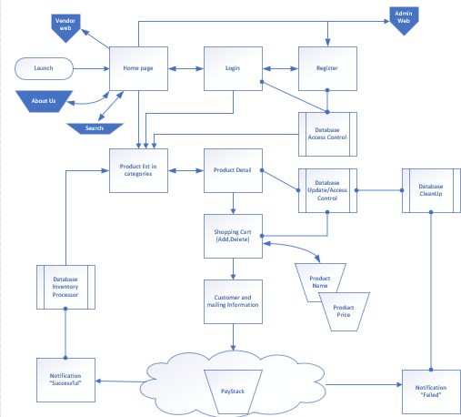

**Figure 3.2: Application Architecture (Admin’s view)**

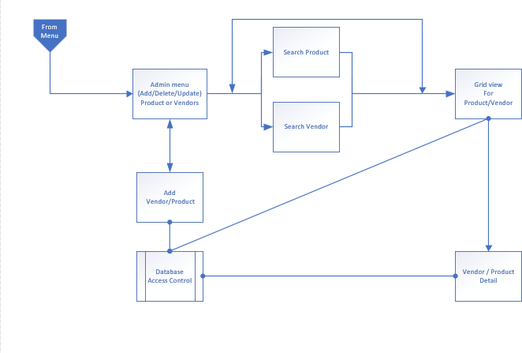

### Figure 3.3: Application Architecture (Vendor’s view)

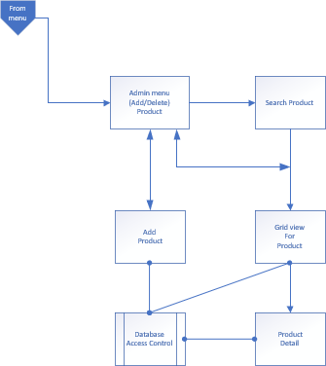

### Use Case

This captures the functionality of the mobile application. It is basically used to organize the requirements of the system. As can be seen below, it is made up of several possible interactions between end users and the application. It portrays all the steps the end user takes to achieve a particular activity.

### Figure 3.4: Use Case

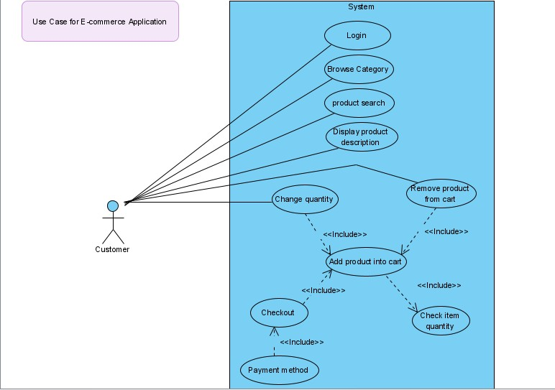

### Login

### Table 3.3: Login Use Case Narrative

|  |  |
| --- | --- |
| **Use Case Name** | **Login** |
| **Brief Narrative** | The procedure of logging in involves the customer inputting the username and password. These are now checked and  authorized within the system. |

|  |  |
| --- | --- |
| **Sequence of Events** | * The signing in button should be clicked by the customer. * The Login box would now be displayed * Username and Password should be inputted by the customer. * Customer should now click on the login button. |
| **Actor** | Customer |
| **Pre-Existing Conditions** | Customer should have an account  standing in the system. |
| **Post-Conditions** | Other functionalities of the system will be  readily available to the customer. |
| **Exceptions** | If username and/or password is incorrect,  the process of logging in would be halted and the customer would be duly notified. |

### Browse Category

### Table 3.4: Browse Category Use Case Narrative

|  |  |
| --- | --- |
| **Use Case Name** | **Browse Category** |
| **Brief Narrative** | Viewing the contents of the system should  be readily available to the customer |
| **Sequence of Events** | * Customer should be able to click on the name of the category that interests them * When the customer makes this   selection, the system would |

|  |  |
| --- | --- |
|  | display the contents of the particular category. |
| **Actor** | Customer |
| **Pre-Existing Conditions** | None |
| **Post-Conditions** | The Customer would be able to easily browse through several other categories and also view other products in several  other categories. |

### Search Products

### Table 3.5: Search Products use case narrative

|  |  |
| --- | --- |
| **Search Product** | **Login** |
| **Brief Narrative** | A search bar is provided where customers  can search for a specific product through a keyword. |
| **Sequence of Events** | * Customer enters key word. * Customer clicks search button * The system would display the results that correlates to the keyword inputted in the search bar. |
| **Actor** | Customer |
| **Pre-Existing Conditions** | None |
| **Post-Conditions** | The results of the keyword inputted would be made available and easily viewed by  the customer. |

### View Product Description

### Table 3.6: View Product Use Case Narrative

|  |  |
| --- | --- |
| **Use Case Name** | **View Product Description** |
| **Brief Narrative** | The product details like name, image, price etc would be displayed on the system so the customer would be able to  view them. |
| **Sequence of Events** | * Customer clicks on product name * Product description displayed by system. |
| **Actor** | Customer |
| **Pre-Existing Conditions** | Contents of a category should have been  initially viewed before clicking on product name. |
| **Post-Conditions** | The customer would be able to add the  selected product to the shopping cart |

### Add Products to Cart

### Table 3.7: Add products to cart use case narrative

|  |  |
| --- | --- |
| **Use Case Name** | **Add Products to Cart** |
| **Brief Narrative** | Customer should be able to add the selected products to the shopping cart |
| **Sequence of Events** | * Customer clicks add to cart button * System would now add the selected product to the customers |

|  |  |
| --- | --- |
|  | shopping cart together with other items in the cart   * System displays notification showing item in the cart; |
| **Actor** | Customer |
| **Pre-Existing Conditions** | Customer should be logged into the  system and the quantity of the product should be selected. |
| **Post-Conditions** | Other functionalities of the system like removal and changing of quantity of the selected product would be available. Also, the customer would be able to view the  checkout receipt. |
| **Exceptions** | If selected product does not exist or is out of stock, the customer would be notified and the process of adding the product  would be non-functional. |

### Check Item Quantity

### Table 3 8: Check Item Quantity Use Case Narrative

|  |  |
| --- | --- |
| **Use Case Name** | **Check Item Quantity** |
| **Brief Narrative** | System checks the quantity of the product to ensure the customers preferred quantity exists. |
| **Sequence of Events** | System can check existing quantity of the  product |
| **Actor** | None |
| **Pre-Existing Conditions** | None |

|  |  |
| --- | --- |
| **Post-Conditions** | None |

### Remove Product from Cart

### Table 3.9: Remove Product from Cart Use Case Narrative

|  |  |
| --- | --- |
| **Use Case Name** | **Remove Product from Cart** |
| **Brief Narrative** | Customer should be able to easily remove the product added to the cart |
| **Sequence of Events** | * Customer clicks on the button of shopping cart * Systems displays contents of shopping cart * Customer clicks on button to remove the selected product. * Customer clicks OK to confirm removal of product form the cart * System removes product from the cart. * System hereby displays updated shopping cart list. |
| **Actor** | Customer |
| **Pre-Existing Conditions** | Customer has to be logged into the system and the product should already be in the  cart. |
| **Post-Conditions** | None |

### Change Quantity

### Table 3.10: Change Quantity Use Case Narrative

|  |  |
| --- | --- |
| **Use Case Name** | **Change Quantity** |
| **Brief Narrative** | Customer should have the option of changing the quantity of a product already selected in the shopping cart. |
| **Sequence of Events** | * Customer should be able to click on shopping cart button. * The system has to display the contents of the shopping cart. * Customer can click change quantity button of a product. * The system should display a dialog box the get a new quantity. * Customer can easily enter the new quantity and click OK to update the quantity of the product on the cart. * System changes quantity of product in the cart * Systems displays an updated shopping cart. |
| **Actor** | Customer |
| **Pre-Existing Conditions** | Customer has to be logged into the system and the product should already be in the  cart including the preferred quantity. |
| **Post-Conditions** | Customer should be able to remove or  change the quantity of the selected |

|  |  |
| --- | --- |
|  | product in the cart and also view the  checkout receipt. |
| **Exceptions** | If the preferred product does not have the available quantity selected by the customer, the procedure is nullified and  the customer would be informed. |

### Checkout

### Table 3.11: Checkout Use Case Narrative

|  |  |
| --- | --- |
| **Use Case Name** | **Checkout** |
| **Brief Narrative** | Customer should have the option of buying the products in the cart. |
| **Sequence of Events** | * Customer clicks on cart button * The system displays the contents of the shopping cart. * Customer clicks on check out button. * The system should display checkout receipt. * Customer confirms order |
| **Actor** | Customer |
| **Pre-Existing Conditions** | Customer has to be logged into the system and shopping cart should be filled with  preferred products. |
| **Post-Conditions** | Customer should be able pay for the items  after checkout. |

|  |  |
| --- | --- |
| **Exceptions** | If the cart is empty, then the customer would not be able to check out and pay for the items and they would be duly  informed by the system. |
|  |  |

### Payment Method

**Table 3.12: Payment Method Use Case Narrative**

|  |  |
| --- | --- |
| **Use Case Name** | **Payment Method** |
| **Brief Narrative** | Customer should have the option of paying for the items after checkout. |
| **Sequence of Events** | * The systems displays the authentication mode of payment * Customer can now enter their financial information needed for payment * The system then gives the customer an option to confirm or cancel the payment. * Customer now has the option of confirming or cancelling the payment. * System now displays confirmation that the order has been completed or cancelled. |
| **Actor** | Customer |

|  |  |
| --- | --- |
| **Pre-Existing Conditions** | Customer has to be logged into the system  and should confirm the details of the preferred order. |
| **Post-Conditions** | None |
| **Exceptions** | * If payment information provided by the customer is invalid, the process of payment would be nullified and the customer would be informed. * If payment is unsuccessful, the process of payment would be nullified and the customer would be informed. |

## Data Design

This is the first design activity that is implemented when developing an application. It helps in achieving a less complex program structure. The information derived from this is transformed into data structures that are needed to implement the application.

**Figure 3.5: User Interface Design Diagram**

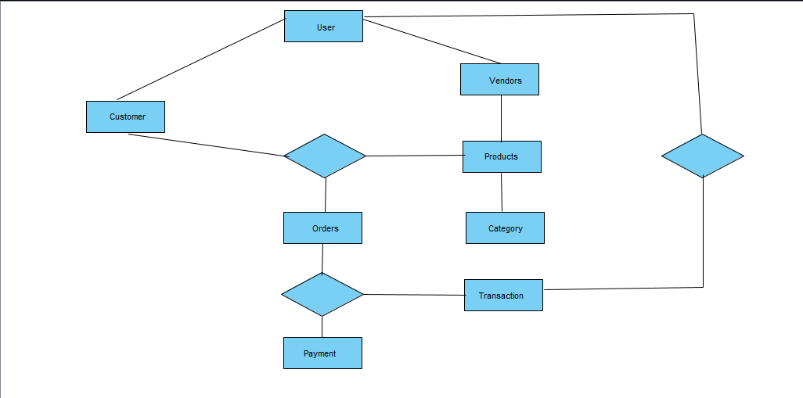

## Activity Diagrams

An activity diagram is a model that shows the process of a task or action from a use case. This is another important diagram that significantly describes the aspects of the application. It is essentially an advanced version of a flow chart that simulates the flow from one action in the application to another. In an activity diagram, it shows how activities are coordinated in the application to provide different services.

**Figure 3.6: Activity Diagram**

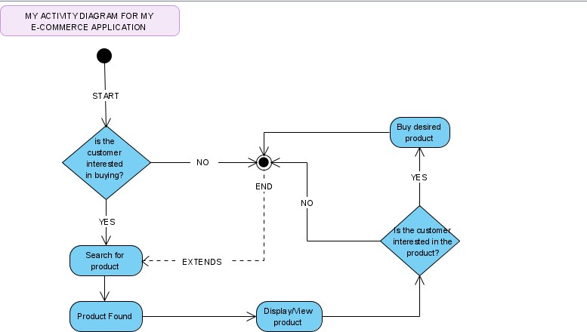

## Dataflow Diagram

A data flow diagram is known as a more traditional way of envisioning how information would flow within the application. It would show how information would enter and exit the application, what alters this information and where it would be kept.

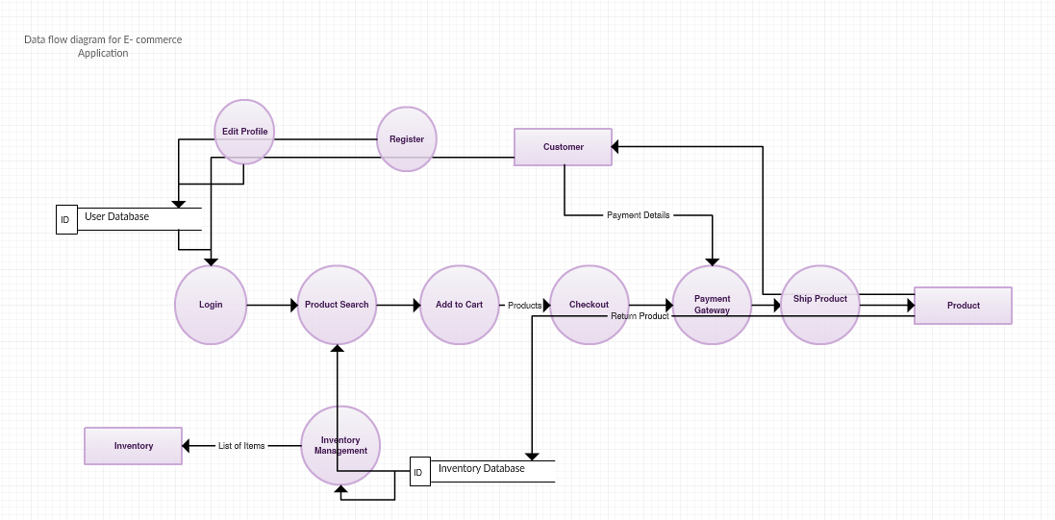**Figure 3.7: Data Flow Diagram**

## Entity-Relationship Diagram (ERD)

This is a structural diagram that is usually used in database design. It has different signs and connectors that show two crucial information in the design of the application which is the main units within the system scope and the relationships between those units

**Figure 3.8: Entity Relationship Diagram**

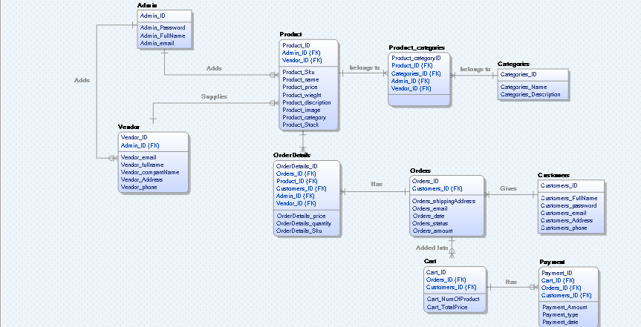

## User Interface Design

This is a crucial part of the application. It basically presents how the application looks, feels and its interactivity. It is a point of interaction between the end user and the application. It is about ensuring that the user interface in the application is as in-built as

possible and this means considering every visual and interactive element that the end user might encounter. These includes icons, color schemes, imagery etc. The goal of this is to present an application that can visually guide the user and prevents them from thinking a lot when using it. It brings out the applications visual assets to the interface while making sure it is aesthetically pleasing.

### Figure 3.9: Splash Screen

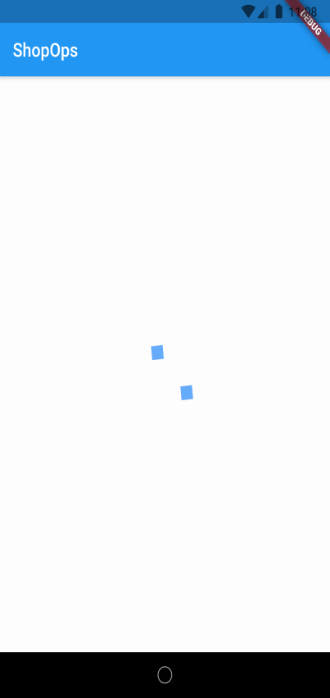

When you open the application, the splash screen is the first thing the user sees. The splash screen loads for like 4-7 seconds before moving the home page

### Figure 3.10: Home Page

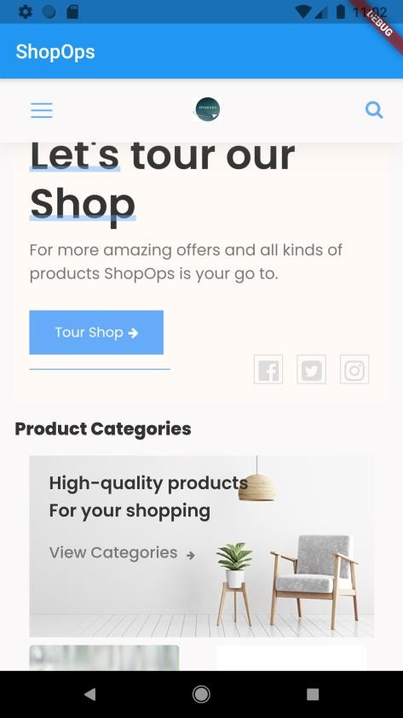

The home page is where the user can see latest products or featured product, and even sort products based on prices and location. The user can also find the menu in the home page.

### Figure 3.11: Menu Page

The menu page consists of the categories, shopping cart, register and login option. Here the user can select which ever options they desire to execute.

### Figure 3.12: Login Page

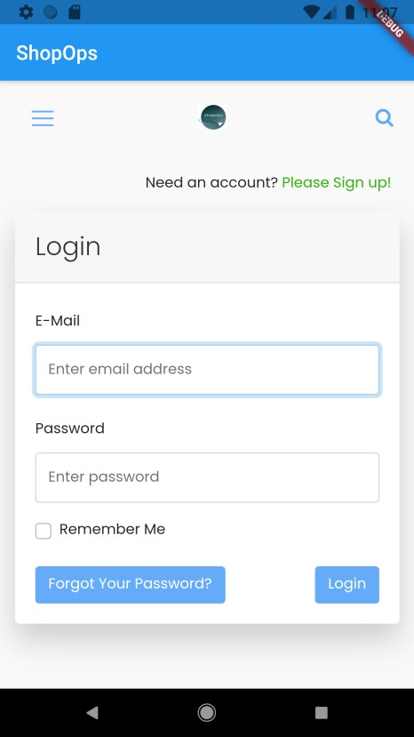

The login page can only be assessed by a returning user or an existing user. The login page has forgot password button for users that cannot remember their password and remember me check option for users that want their login in details to be saved. The login page has an avenue for user to sign up if they do not have an account.

### Figure 3.13: Register Page

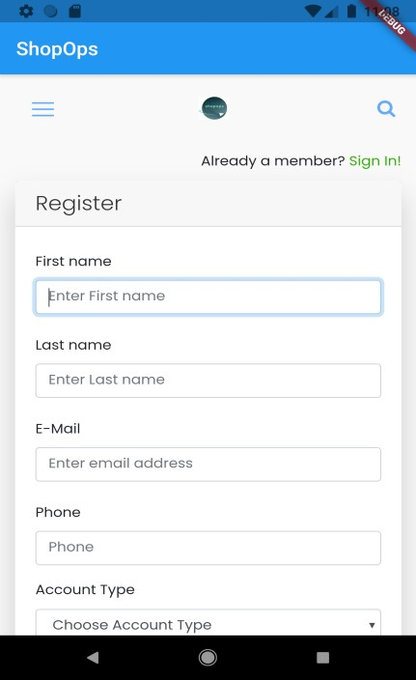

The register page is for users that are new to the application and would want to have an account with the application. Here the page collect all the necessary information from the user so they can be stored and create an account for them

### Figure 3.14: Product Detail Page

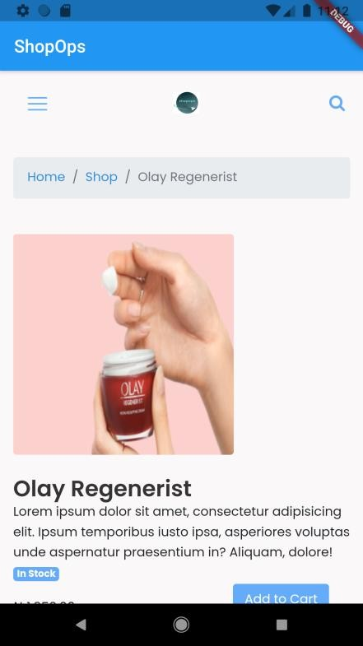

Here when a user select a product the user can see the details of the product, how much the product cost, if the product is in stock, and add the product to cart.

### Figure 3.15: Checkout Page

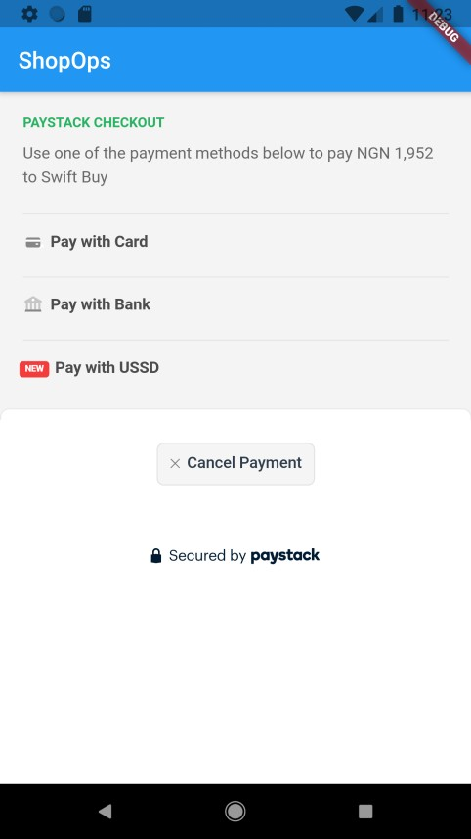

Here the user selects their means of payment after they are done shopping for products. The checkout page has pay with card, pay with bank and pay with USSD options to pick from when paying. If after checkout, the user decides not to pay for the products anymore, he/she can cancel the payment. Other User interface design pages can be found in the user guide manual in Appendix E below.

## Summary

This chapter was used to give a breakdown of the research methodology, analysis and design of the application through a system will allow the customers to select the desired items from a list of available commodities provided by all the vendors in the customer’s specific location. It also detailed the flow chart process and actions that are carried out in the application. The research methodology that was used here involved questionnaires to those experienced in

this kind of application and also to business owners and customers. Secondary research was also used and analyzed to identify opportunities for improvements to the application. The report obtained from these methods were used to design an efficient system that meets the condition of the project. This chapter also includes the specifications of the functional and non-functional requirements of the application. The methods and procedures involved in the design of the application including its architecture is also explained here.

# CHAPTER 4: IMPLEMENTATION AND TESTING

## Overview

This chapter details how the design of the application would be implemented and also how testing would be undertaken to determine its functionality. Therefore, the importance of implementing this application can be seen as stated below.

* + - **Deployment of the Application:** This makes available an application that is readily available to various users during the COVID-19 Pandemic. Implementing this application solely consists of including important processes that explains how the application would function to a new user. This implementation would also bring about putting out the complete application into Google play store while also ensuring that all necessary information needed is effective. This would also provide accuracy and validation towards the functions of the application to certify that it is in top condition.
    - **Transition to Usage:** The aim of this is to ensure that after the application has been designed, several important tasks would be concluded before it is ready to be released and put into use. This varies from software and hardware purchase, training the users of the application, installation of the application, testing the workability of the application, running the application and ensuring it has been accepted by the user. This is generally about assisting the application developer to

move from development to operational thereby releasing the application from the hands of the developer to the end user.

## Main Features

This application was specifically designed to enable its users shop for products of their choice and have it delivered in the comfort of their homes from their mobile devices. The application would be able to allow visiting user to register to the application, and if they are already a registered user, it will allow them to login. It would enable users to easily select products or items that interest them in their location. These products range from self-care products to food. Each product would have a price and the available quantity to enable the user make a choice more effectively. The application complies the selected products by the user and sends it to the checkout cart where the prices are compiled according to the quantity selected by the user. Product(s) from the cart can either be delete or added. The application will be able to allow user sort for product(s) based on prices (low or high) and latest and would allow user(s) to search for vendors based on their location. The application will also provide the user with the option of performing a final checkout of the selected products by paying for them through imputing their financial information. The application would be easy for new or returning visitors to access the application smoothly or easily.

## Implementation Applications

Below are the list of application and platform I will be using to execute my project.

* + - **Heroku:** This is used to host applications within a database. It is also an online platform as a service (PaaS).
    - **Cloudinary:** This offers manipulation features for swift media. It can also be used to host media contents which can be cached into any platform.
    - **Github**: This provides a platform that stores repository while also keeping track of changes that occur during the storage. It also features the ability to return to

previously used codes and share it with other developers or let them contribute to the coding process from their own location.

* + - **Laravel:** This would be used in the backend and is a PHP framework
    - **Flutter**: This is a platform that is managed by Google and is used to develop applications for Ios and Android.
    - **Pay stack**: This is an online payment platform.

Other applications installed are also:

1. Flutter SDK
2. Git tool
3. Vscode
4. Composer
5. Xampp
6. Heroku CLI

## Implementation Problems

During this project implementation I encountered several technical challenges. These challenges includes:

* + - Integrating maps
    - Integrating database for the android environment
    - Coding issues
    - Problem with the splash screen taking longer than it should.
    - Operating Environment i.e. lack of electricity, lack of sufficient internet and laptop malfunction.
    - Installation of the application

## Overcoming Implementation Problems

Although I encountered various problems during the implementation of this application, I was able to overcome them and deliver a highly functional application. That meets user

requirements as state in the analysis and design. Several errors that I bumped into during the coding stage were carefully debugged, reviewed and effectively corrected. I also faced difficulties in the interface of the application (splash screen) but this was tackled by researching similar applications to get an idea of the possible solution. I also had to solicit the aid of a senior colleague in my industrial training office to be able to indoctrinate my idea to the application. It was absolutely difficult integrating the Google maps into the application after much effort trying to input my card details that I do not use for the trial process and Google rejecting it. I was left with two options paying for it or searching for other means that could help meet up with one of the user requirement which later opted for Bauman package that use IP address to get the location of the user. I had to on forums which in turn helped me come up with a solution. For the problems concerning the application installation, I watched YouTube to guide me in installing the application and at the end I was able to deliver the software that met all the user requirement.

## Testing

Due to the importance of avoiding technical challenges, testing the application is an important component of this project. In project fundamentals, quality assurance is a key part of any project to ensure premium delivery. Testing a software is basically method that involves checking whether the software developed matches requirements expected and to make sure the software product is free from defect. The main purpose of testing a software is to identify possible gaps, errors or any requirement missing in contract to the actual requirements. The reason why software testing is important is because if there is an error or bug in the software, those error or bugs could be early identified and resolved before the product is delivered and also reaffirming the quality of the software . If I software product is properly, it ensures product security, reliability and high performance which in turn reduce cost, saves times and finally meets customer satisfaction. This testing is usually planned in advance and conducted in a systematic method. The strategy in testing software is that it tries to integrate software test design method into well planned sequences of steps that leads to a successful software development.

## Tests Plans (for Unit Testing, Integration Testing, and System Testing)

Below is the test plan for “An Application for Online Commodity and Delivery System”.

### Test Identifier:

**TEST LEVEL: Master Test Plan**

### AUTHOR’S NAME: Chelsea Amaka Umeokeke

**AUTHOR’S CONTACT:** [Amaka3232@bazeuniversity.com.ng](mailto:Amaka3232@bazeuniversity.com.ng)

### Reference

* + - * + An Application for Online Commodity and Delivery System
        + Work Plan
        + Detailed project documentation
        + Test summary

### Introduction

This is the final test plan for this An Application for Online Commodity and Delivery System. This would help in addressing the system requirements in the earlier chapters and try to tally it to ensure its accuracy. The methods that would be used here during testing are both the black and white testing methods. It is used to determine the essential parts that need to be tested in the application.

### Features to Be Tested

The following areas listed were focused on during testing of the software

* + - * + Login page.
        + Home page(featured product)
        + Search page
        + Category page
        + Shopping cart page
        + Menu
        + Checkout page

### Approach

Theses testing can be done at different levels but using measuring criteria. Built in debugger in android studio will be used, android emulator would also be used to test the application before it is then deployed.

### Deliverables

The deliverable of the test plan includes:

* + - * + Test cases
        + Test report
        + Traceability matrix
        + Test results
        + Error report

### Approvals

Chelsea Amaka Umeokeke Chief Technology Officer

### Test Plan

The following steps that have been run through to when testing the E-Commerce application.

### Main Pages

* Login Page
* Sign up Page
* Home Page
* Featured Products
* Latest Offers
* Information Pages: About the page, Shipping Information, Returns Policy, Terms Page, Privacy Policy

### Product Category Pages

* Filters such as product filters and types of product.
* Sorting products by name and price
* Add to Basket

### Product Detail Pages

* Product title
* Product description
* Product images
* Enlarge image
* Related products
* View of products
* Any further product information

### Product Search

* Keyword Search

### Shopping Basket

* Add products to basket
* Remove product from basket
* Change quantities
* Select delivery option
* Check delivery cost

### Pay Now

* Move into Checkout process

### Checkout and Payment Systems

* Check final amount to pay
* Make payment through pay stack
* Check confirmation e-mail when payment is made

### Mobile Device Compatibility

* Android Smartphone – such as Samsung Galaxy S10
* Android Tablet – such as Google Nexus
* Windows Phone – such as Nokia

## Test Suite (for Unit Testing, Integration Testing, and System Testing)

### Table 4.1: Test Suite Performed for User login

Test case TC-001(User Login)

|  |  |
| --- | --- |
| Test Suit ID | Req-108 |
| Test Case ID | TC-001 |
| Test case summary | This test case is designed to ensure that users are able to login |
| Related Requirement | Req-108 |
| Prerequisite | * ShopOps application must be installed * Run application and login |
| Test Procedure | 1. Launch ShopOps 2. login |
| Test Data | Login |
| Expected Result | User should be able to login into the application |
| Actual Result | The user logged into the application |
| Status | Passed |
| Remarks | The test was successful |
| Created by | Chelsea Amaka Umeokeke |
| Date Created | 15th November 2020 |
| Executed by | Chelsea Amaka Umeokeke |
| Date of Execution | 15th November 2020 |
| Test Environment | Hardware : Hp pavilion  Software: Android Studio Emulator |

### Table 4.2: Test Suite Performed for product input

Test case TC-002(Input product)

|  |  |
| --- | --- |
| Test Suit ID | Req-107 |
| Test Case ID | TC-002 |
| Test case summary | This test case is designed to allow user input product into the application |
| Related Requirement | Req-107 |
| Prerequisite | * Launch application * User logs in and search for product |
| Test Procedure | 1. Launch ShopOps 2. User clicks on search and input name of desired product |
| Test Data | Input product |
| Expected Result | User should be able to input name of product |
| Actual Result | Users were able to input the name of product |
| Status | Passed |
| Remarks | The test was successful |
| Created by | Chelsea Amaka Umeokeke |
| Date Created | 17th of November 2020 |
| Executed by | Chelsea Amaka Umeokeke |
| Date of Execution | 17th November 2020 |
| Test Environment | Hardware Hp  Software: Android Studio Emulator |

### Table 4.3: Test Suite Performed for Home page (featured product)

Test case TC-003(View featured product)

|  |  |
| --- | --- |
| Test Suit ID | Req-112 |
| Test Case ID | TC-003 |
| Test case summary | This test case is designed to allow view featured product on the homepage |
| Related Requirement | Req-112 |
| Prerequisite | * Launch application * User Sign in |
| Test Procedure | 1. Launch ShopOps 2. User sign in and view featured product on homepage |
| Test Data | View featured product |
| Expected Result | User should be able to view featured product on the homepage |
| Actual Result | The result was as expected |
| Status | Passed |
| Remarks | The test was successful |
| Created by | Chelsea Amaka Umeokeke |
| Date Created | 17th of November 2020 |
| Executed by | Chelsea Amaka Umeokeke |
| Date of Execution | 17th of November 2020 |
| Test Environment | Hardware: Hp pavilion  Software: Android Studio Emulator |

### Table 4.4: Test Suite Performed for Sort product

Test case TC-004(Sort product)

|  |  |
| --- | --- |
| Test Suit ID | Req-113 |
| Test Case ID | TC-004 |
| Test case summary | This test case is designed to allow user sort for product based on their location or price |
| Related Requirement | Req-113 |
| Prerequisite | * Launch application * User signs in |
| Test Procedure | 1. Launch ShopOps 2. Click on Sort 3. Click on location or price |
| Test Data | View location and price range |
| Expected Result | The user should be able to sort product based on price or location |
| Actual Result | The result was as expected |
| Status | Passed |
| Remarks | It was successful |
| Created by | Chelsea Amaka Umeoekeke |
| Date Created | 18th of November 2020 |
| Executed by | Chelsea Amaka Umeoekeke |
| Date of Execution | 18th of November 2020 |
| Test Environment | Hardware Hp pavilion  Software: Android Studio Emulator |

### Table 4.5: Test Suite Performed for Shopping cart page

Test case TC-005(View Shopping cart)

|  |  |
| --- | --- |
| Test Suit ID | Req-115 |
| Test Case ID | TC-005 |
| Test case summary | This test case is designed to allow users display shopping cart |
| Related Requirement | Req-115 |
| Prerequisite | * Launch application * User Sign in |
| Test Procedure | 1. Launch ShopOps 2. User sign in and click on shopping cart |
| Test Data | Display shopping cart |
| Expected Result | User should be able to display items in the shopping cart |
| Actual Result | The result was as expected |
| Status | Passed |
| Remarks | The test was successful |
| Created by | Chelsea Amaka Umeokeke |
| Date Created | 20th of November 2020 |
| Executed by | Chelsea Amaka Umeokeke |
| Date of Execution | 20th of November 2020 |
| Test Environment | Hardware: Hp pavilion  Software: Android Studio Emulator |

### Table 4.6: Test Suite Performed for Category page

Test case TC-006(Category page)

|  |  |
| --- | --- |
| Test Suit ID | Req-116 |
| Test Case ID | TC-006 |
| Test case summary | This test case is designed to allow users view product category |
| Related Requirement | Req-116 |
| Prerequisite | * Launch application * User Sign in |
| Test Procedure | 1. Launch ShopOps 2. User sign in and click on category |
| Test Data | View product category |
| Expected Result | User should be able to view product category |
| Actual Result | The result was as expected |
| Status | Passed |
| Remarks | The test was successful |
| Created by | Chelsea Amaka Umeokeke |
| Date Created | 20th of November 2020 |
| Executed by | Chelsea Amaka Umeokeke |
| Date of Execution | 20th of November 2020 |
| Test Environment | Hardware: Hp pavilion  Software: Android Studio Emulator |

### Table 4.7: Test Suite Performed for Checkout page

Test case TC-007(View Checkout page)

|  |  |
| --- | --- |
| Test Suit ID | Req-114 |
| Test Case ID | TC-005 |
| Test case summary | This test case is designed to allow users to view checkout page |
| Related Requirement | Req-114 |
| Prerequisite | * Launch application * User Sign in |
| Test Procedure | 1. Launch ShopOps 2. User sign in and move to the checkout page 3. Input their details |
| Test Data | View checkout page and input details |
| Expected Result | User should be able to move to the checkout page and input their details |
| Actual Result | The result was as expected |
| Status | Passed |
| Remarks | The test was successful |
| Created by | Chelsea Amaka Umeokeke |
| Date Created | 21th of November 2020 |
| Executed by | Chelsea Amaka Umeokeke |
| Date of Execution | 21th of November 2020 |
| Test Environment | Hardware: Hp pavilion  Software: Android Studio Emulator |

## Test Traceability Matrix (for Unit Testing, Integration Testing, and System Testing)

**Table 4.8: Test traceability matrix**

|  |  |  |  |  |  |
| --- | --- | --- | --- | --- | --- |
| **Requirement**  # | **Narrative** | **Importance** | **Test**  **Case** | **Test Data** | **Test Result** |
| Req-108 | User would be able to login into the application | 1 | 1 | 15/11/2020 | Passed |
| Req-107 | User would be able to input product into the application. | 5 | 4 | 17/11/2020 | Passed |
| Req-112 | User would be able to view the home page in the application | 3 | 3 | 17/11/2020 | Passed |
| Req-113 | User would be able to categorize product according to location and price in the  application. | 5 | 5 | 18/11/2020 | Passed |
| Req-116 | User would be able to view product category in the application. | 4 | 5 | 20/11/2020 | Passed |
| Req-115 | User would be able to view the shopping cart in the application. | 5 | 5 | 20/11/2020 | Passed |

|  |  |  |  |  |  |
| --- | --- | --- | --- | --- | --- |
| Req-114 | User would be able to use proceed to the checkout page in the application. | 5 | 5 | 21/11/2020 | Passed |

## Test Report Summary (for Unit Testing, Integration Testing, and System Testing)

**4.9 Test Results**

|  |  |
| --- | --- |
| SUMMARY OF TEST CARRIED  OUT | RESULTS |
| Number of functions tested: | 7 |
| Number of functions not tested: | 0 |
| Number of tests passed: | 7 |
| Number of tests failed: | 0 |
| Percentage of tests passed: | 100% |
| Percentage of tests failed: | 0% |

## Error Reports and Modifications

Error Reports

* There were some internal errors that occurred due to inaccuracies during the coding process.

Modifications

* To modify this errors encountered during the coding process, I was able to isolate the faulty module, then comments on each line of code. Until I was able to identify the error.

## User Guide

This is an explanation of how end users of the application will make full use of it. It describes how the users would proceed into the application when it is in operation. It serves as a tool to guide the users when using the application. The user guide manual can be seen in Appendix E below.

## Summary

This chapter can be summarized as the explanation of the tools used in developing the application, the procedure used in implementing the application and the how testing was conducted on the application before it was put out for the end user. This chapter detailed how these processes were implemented. According to the history of software development and its life cycle, implementation and testing is very critical because if done adequately, it would help present a very reliable and efficient application that meets the specification and requirements. If implementation and testing is not done properly, it would definitely affect the general output and efficiency of the application.

# CHAPTER 5: DISCUSSION, CONCLUSION, AND RECOMMENDATIONS

## Overview

This project was effectively delivered based solely on the requirement specification for the end user. There was adequate focus on the design of the application to ensure that the reliability of the data is maintained to avoid any issues related to it. The application has been designed in such a way that the end user is provided with a responsive and straight forward interface. The application would not have a need for a user guide as it has been created in such a way that the user knows that it was made for them. This application can only be used on android and can be used from version 6.0 upwards. Any individual with relative understanding on how to use an android device would be able to make use of this application. This application has been built in such a way that there is room for further modifications which can be easily implemented. The preceding document has been provided as a report to show how the application works and how it was developed.

## Objective Assessment

According to the aims of the project, the following objectives were achieved:

* + - Development of an application that enables users to shop for products on their mobile phone and from the comfort of their homes.
    - There was successful compilation of several products ranging from grocery, vegetables and fruit, Medicine, Health and body care in the application.
    - Development of an application that enables the user successfully make an order, safety make payment and have their order delivered.
    - Inclusion of location services so that the end user would be able to shop for products according to their location.

## Limitations and Challenges

After the design of this application, several limitations were detected. They are named as below:

* + - Only registered end users can have access to the functionalities of the application.
    - Users can only shop for one item at a time.
    - Users cannot confirm eligibility of the product being delivered.
    - IOS users cannot make use of the application.
    - Users cannot be able to track their delivery online.

## Future Enhancements

To bring this project from a place of the current model to an advanced level and the points listed below are the considered enhancements.

* + - More Categories and products could be added to the application to give users more varieties of products.
    - More geographical locations like foreign countries could be included to enable more users have access to the application.
    - A delivery time slot could also be included so that users can communicate to the vendor on when they want their goods delivered.
    - A tracker could be a supplementary inclusion, so that the user would be able to track their delivery.
    - Users could also get in-app notifications to stay in touch when new products are added.
    - The application would be moved to IOS.

## Recommendations

After the development of the application, including design and testing, the following recommendations are being made on ways in which the application could still be improved. Considering the situation of things with the pandemic, several applications like this would continuously emerge which is why further improvements remain necessary.

* + - Further analysis and development into the design of the application is recommended to ensure it stays in line with the recent trends.
    - Adding more vendors into the application is recommended so that users can see more goods asides the ones included.
    - It is recommended that vendors can have their personal bio data taken which would only be visible to the system administrator so as to ascertain their eligibility.
    - Inclusion of the application to IOS is also recommended as this will expand the coverage.

## Summary

People and technology remain key contributors to the economy of today. E-Commerce mobile applications are of high importance as they help companies market their products while also helping customers choose products from the comfort of their homes. Since the invention of mobile phones, there has been greater access to the internet and now E- Commerce mobile applications have increased the usage of phones for business. Applications for E-Commerce have however been developed to cover all phases of market. This project was created specifically to aid in tackling the spread of Covid-19 pandemic through E-Commerce. As mentioned earlier, the rapid growth of the use of mobile devices has brought about more economic activities in the online environment and the growth of E-Commerce in the current world. This application was designed to ease the process of completing orders online which includes delivery. This application ensures that the end user would have no need to be physically active in the shops which thereby reduces the

spread of the virus. The application would shorten the steps involved in placing order which includes adding products to the cart, making payment and picking delivery options. Making use of several research methods played an important part in creating important results. This application was created in a way that makes it different from other ones as the end user would be able to get their order two hours after making payment and also it is strictly based on location. This makes it convenient for both parties. E-Commerce has come to stay and it would help people plan their lives better going forward during this pandemic. The project eventually turned out be a valuable experience in software development and although challenges were encountered the development process was a great success.

# REFERENCES

1. Abdin, M., (2020) Doing Businesses during COVID-19 Crisis and Afterwards.
2. Alquatani, A. & Goodwin, R., (2012) E-Commerce Smart Phone Application. International Journal of Advanced Computer Science and Application, 3(8), pp. 54-59.
3. Andrienko, O. (2020) E-Commerce and Consumer Trends during Corona Virus
4. Angler, (2020). Make the most of Mobile Apps during the Lockdown caused by the pandemic COVID-19. [Online]
5. Available at: https:/[/www](http://www.angleritech.com/custom-mobile-app-development-).[angleritech.com/custom-mobile-app-development-](http://www.angleritech.com/custom-mobile-app-development-) covid19/
6. [Accessed 2 December 2020].
7. Azubuike, A., (2020) Sustaining Small Retail, s.l.: International Finance Corporation.
8. Bhati Anam, et al., (2020) E-commerce trends during COVID-19 Pandemic. International Journal of Future Generation Communication and Networking, 13(2), pp. 1449-1452.
9. China Chamber of Commerce and Industry, (2020). How SARS led to the birth of China E-Commerce. [Online]
10. Available at: <http://ccilc.pt/en/imprensa/how-sars-led-to-the-birth-of-china-e-> commerce/ [Accessed 5 December 2020].
11. Chmielarz, W. & Parys, T., (2017). The Use of Mobile Technologies in E- Commerce, Warsaw: University of Warsaw.
12. Columbus, L., (2020). How COVID-19 Is Transforming E-Commerce. [Online]
13. Available at: https:/[/www](http://www.forbes.com/sites/louiscolumbus/2020/04/28/how-).[forbes.com/sites/louiscolumbus/2020/04/28/how-](http://www.forbes.com/sites/louiscolumbus/2020/04/28/how-) covid-19-is-transforming-e-commerce/?sh=104e200c3544 [Accessed 30 November 2020].
14. Cooper, B., (2020). How Mobile Apps Help Retailers Solve Pandemic Challenges. [Online]
15. Available at: https:/[/www](http://www.inc.com/entrepreneurs-organization/how-mobile-apps-).[inc.com/entrepreneurs-organization/how-mobile-apps-](http://www.inc.com/entrepreneurs-organization/how-mobile-apps-) help-retailers-solve-pandemic-challenges. [Accessed 1 December 2020].
16. Denger, E., (2020). How to modify your e-commerce strategy during the coronavirus crisis
17. Devanesan, J., (2020). SARS Helped Alibaba become a $470b titan. [Online]
18. Available at: https://techwireasia.com/2020/06/sars-helped-alibaba-become-a- 470b-titan-now-its-giving-back/ [Accessed 6 December 2020].
19. Elhirim, M. & Elsayed, A., (2020). The Effect of COVID-19 Spread on the e- commerce market: The case of the 5 largest e-commerce companies in the world, Egypt: Ain Shams University.
20. Fleming, K., (2020). Optimizing the ecommerce fulfilment experience in luxury retail
21. Frost, S. & Sullivan, E., (2020). Coronavirus Outbreak Aerospace Industry Fights Back with Business Mitigation Strategies,
22. Huddlestone, T., (2020). The SARS epidemic threatened Alibaba’s survival in 2003—here’s how it made it through to become a $470 billion company. [Online]
23. Available at: https:/[/www](http://www.cnbc.com/2020/03/26/chinas-2002-2003-sars-).[cnbc.com/2020/03/26/chinas-2002-2003-sars-](http://www.cnbc.com/2020/03/26/chinas-2002-2003-sars-) outbreak-helped-alibaba-become-e-commerce-giant.html [Accessed 6 December 2020].
24. Jones, K., (2020) Covid-19: The Pandemic Economy.
25. Kothari, C. R.,(2004) Research Methodology: Methods and Techniques, New Delhi: New Age International.
26. KPMG, (2020) Retail, Wholesale and E-Commerce: Sector Trends and Current Challenges: KPMG.
27. Markets and Markets, (2020) M-Commerce Market. [Online]
28. Available at: https:/[/www](http://www.marketsandmarkets.com/Market-Reports/mobile-).[marketsandmarkets.com/Market-Reports/mobile-](http://www.marketsandmarkets.com/Market-Reports/mobile-) commerce-market-184.html [Accessed 21 November 2020].
29. Nakhate, S. & Jain, N., (2020) ,The Effect of Corona Virus on E-Commerce. Indian Place Names, 40(68), pp. 516-518.
30. Nazi, A., (2020) The Pandemic is E-Commerce time to shine but will it last?
31. Oven, H. & Hicintuka, M., (2020) Covid-19: How does it affect international e- commerce firms?, Sweden: Linnaeus University.
32. Ovorekia, O., (2020) How I Built a Mobile App for Online Shopping Amid the COVID-19 Lockdown. [Online]
33. Available at: https:/[/www](http://www.freecodecamp.org/news/how-i-built-a-mobile-app-for-).[freecodecamp.org/news/how-i-built-a-mobile-app-for-](http://www.freecodecamp.org/news/how-i-built-a-mobile-app-for-) online-shopping-amid-covid-19-lock-down/ [Accessed 25 November 2020].
34. Pandy, A. & Parmar, J., (2020) Factors affceting Consumer Online Shopping Behavior, s.l.: s.n.
35. Pantelimon, F. & Georgescu , T., (2020) The Impact of Mobile e-Commerce on GDP: A Comparative Analysis between Romania and Germany and how Covid-

19 Influences the e-Commerce Activity Worldwide , Bucharest: Bucharest University of Economic Studies, Romania.

1. Petersen, K., Wohlin, C. & Baca, D., (2009) The Waterfall Model in Large Scale Development, Sweden: Blekinge Institute of Technology.
2. Raj, V., (2020) How is Coronavirus Evolving E-commerce Businesses?. [Online]
3. Available at: https://customerthink.com/how-is-coronavirus-evolving-e- commerce-businesses/ [Accessed 17 December 2020].
4. Research and Markets, (2020) Cision. [Online]
5. Available at: https:/[/www](http://www.prnewswire.com/news-releases/m-commerce-).[prnewswire.com/news-releases/m-commerce-](http://www.prnewswire.com/news-releases/m-commerce-) industry-projected-to-grow-by-5-1-trillion-during-2020-2027-covid-19-

adjusted-301066132.html[Accessed 21 November 2020].

1. Sigmar, C., (2020) Post-Pandemic Retail: Lessons from SARS and the Success of Alibaba. [Online]
2. Available at: https:/[/www](http://www.rethink.industries/article/post-pandemic-retail-lessons-).[rethink.industries/article/post-pandemic-retail-lessons-](http://www.rethink.industries/article/post-pandemic-retail-lessons-) from-sars-and-the-success-of-alibaba/
3. [Accessed 6 December 2020].
4. Skeldon, P., (2020) Internet Retailing: M-commerce grows by 30% in lockdown, moving ‘three to four years’ in a few months. [Online]
5. Available at: https://internetretailing.net/mobile-theme/mobile-theme/m- commerce-grows-by-30-in-lockdown-moving-three-to-four-years-in-a-few- months-21872
6. [Accessed 26 November 2020].
7. Syed, K., (2016) Basic Guidelines for Research: An Introductory Approach for All Discipline,
8. Udavant, S., (2020) How to Build a Mobile-Friendly Site or App for Your Business. [Online]
9. Available at: https:/[/www](http://www.thebalancesmb.com/creating-a-successful-mobile-).[thebalancesmb.com/creating-a-successful-mobile-](http://www.thebalancesmb.com/creating-a-successful-mobile-) retail-app-4119866[Accessed 2 December 2020].
10. United Nations, (2020) Covid-19 and E- Commerce: Impact on Businesses and Policy Responses, .: United Nations Conference on Trade and Development.
11. Van Casteren, W., (2017) The Waterfall Model and Agile Methodologies: A comparison by project characteristics, Netherlands: Open Universiteit Nederland.
12. World Trade Organization, (2020) E-Commerce, Trade and Covid-19 Pandemic,
13. Zhnag, W., Leng, X. & Liu, S., 2020. Research on mobile impulse purchase intention in the perspective of system users during COVID-19, Ubiquitious Computing.

## APPENDICES

**Appendix A - Project Document**

The project documentation for an application for online commodity and delivery system

### DETAILED PROJECT DOCUMENTATION

**Candidate Name:** Amaka Chelsea Umeokeke

**Student Id No:** BU/18B/IT/3232

An application for online commodity and delivery system

**Course of Study:** B.Sc. Software Engineering

## Appendix B - Questionnaire

**QUESTIONNAIRE**

Dear Sir/Ma,

Department of Computer Science Faculty of Computer Science Baze University, Abuja

Nigeria.

September 17, 2020

You are kindly invited to participate in this E-Commerce mobile application about buying products online from the comfort of your homes during the Covid-19 Pandemic. Your participation in this exercise is completely voluntary and there would be no foreseeable risks associated with this. If you however feel uncomfortable to answering the questions, you can withdraw at any point in time. Your opinion is very important to this survey.

It is very important for us to learn your opinions.

Your responses would remain strictly confidential and data from this would be reported collectively. If you have any questions at any point during your survey you can contact Amaka Chelsea Umeokeke at [amaka3232@bazeuniversity.edu.ng](mailto:amaka3232@bazeuniversity.edu.ng)

Yours faithfully

Amaka Chelsea Umeokeke

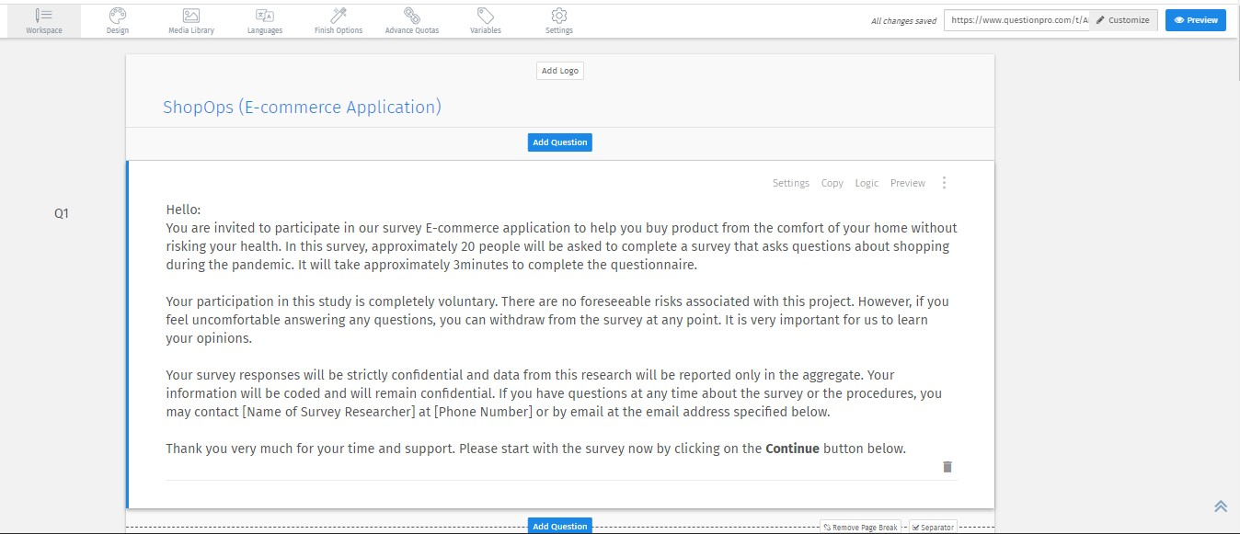

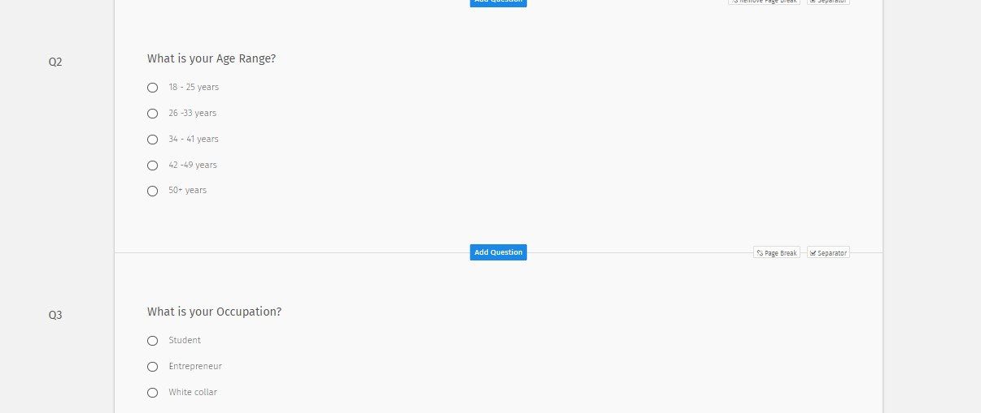

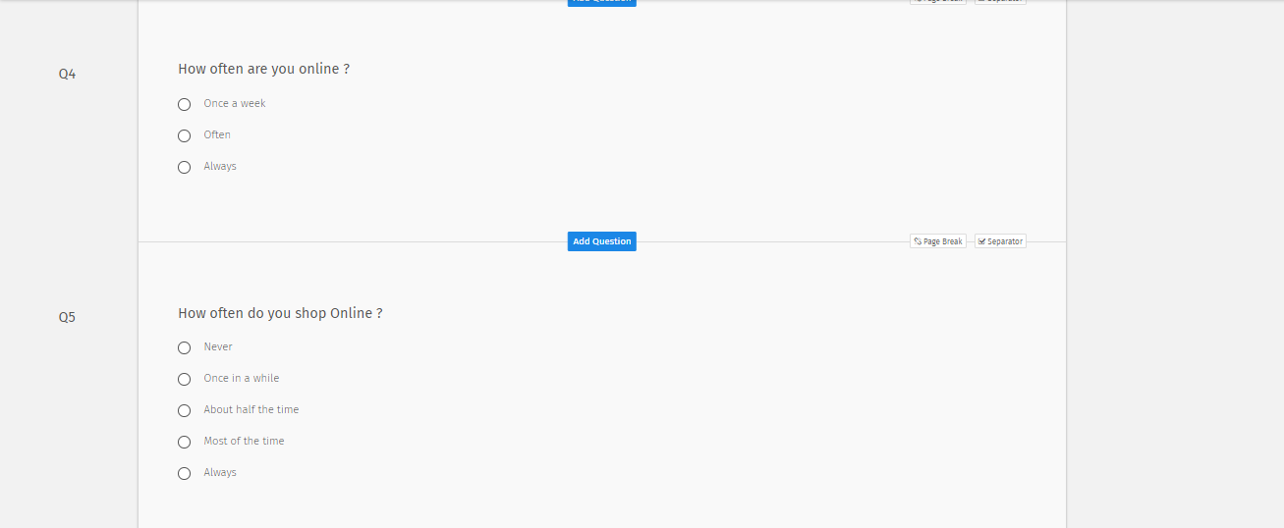

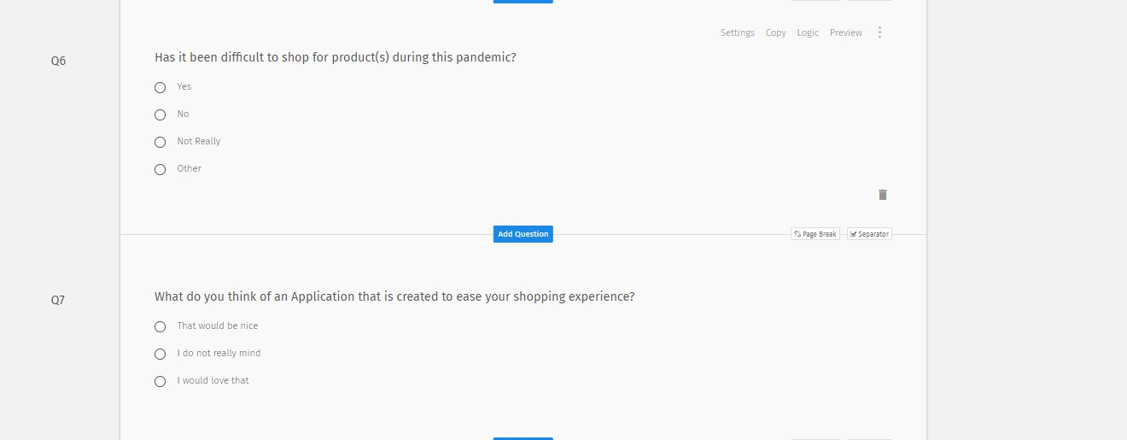

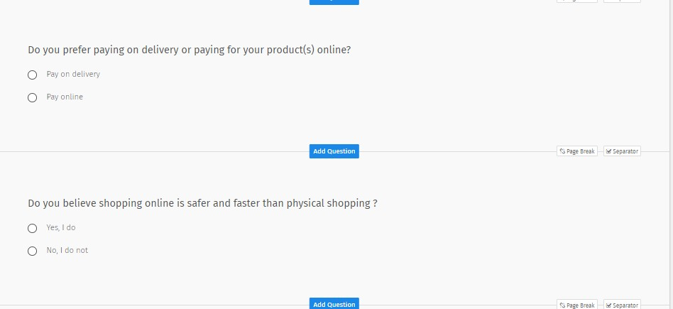

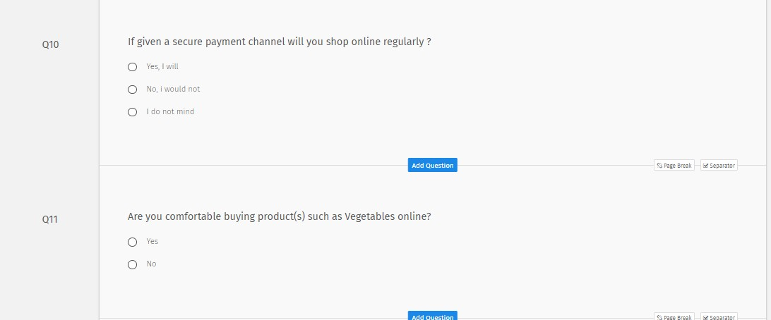

## Appendix C – Source Codes

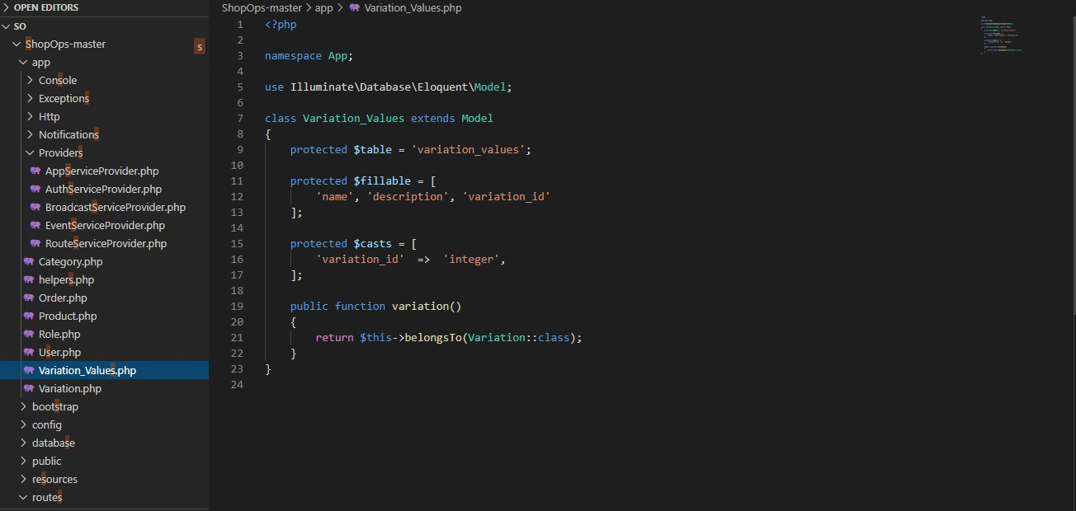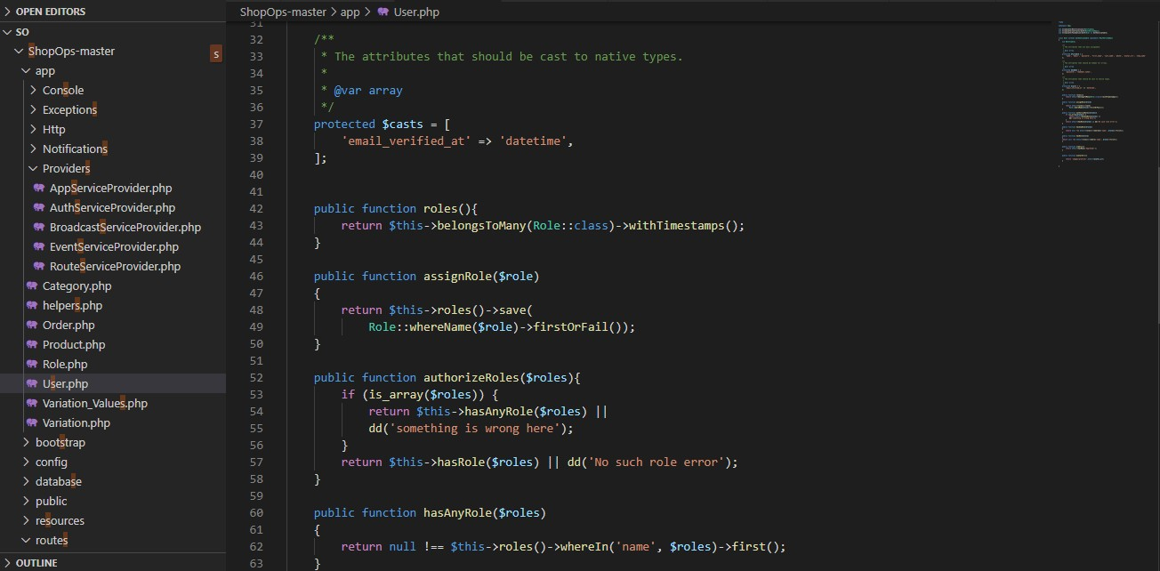

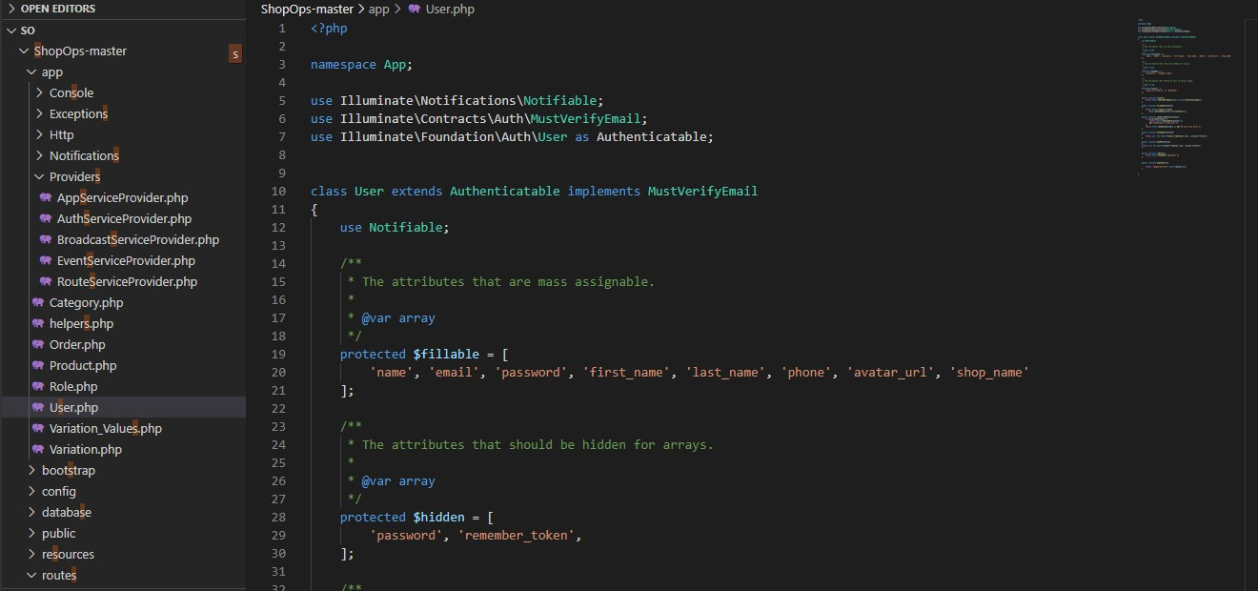

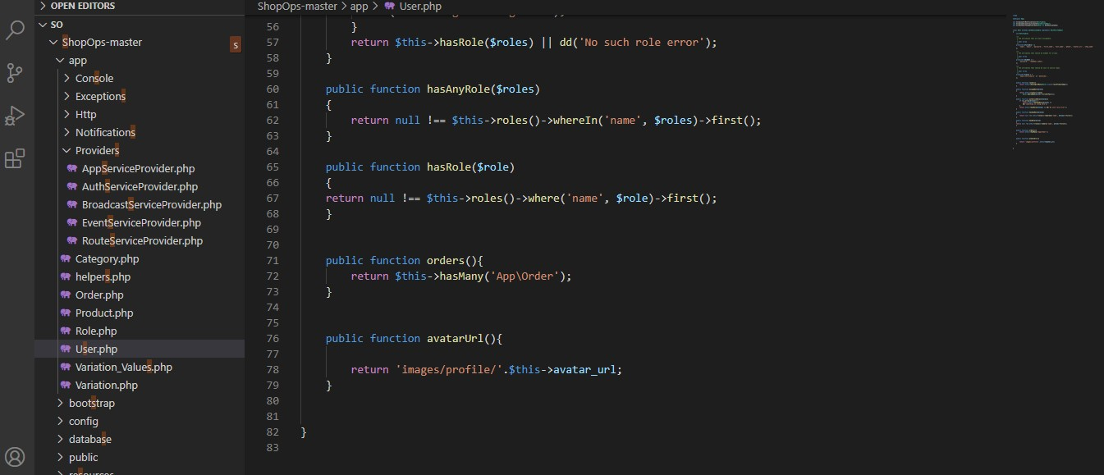

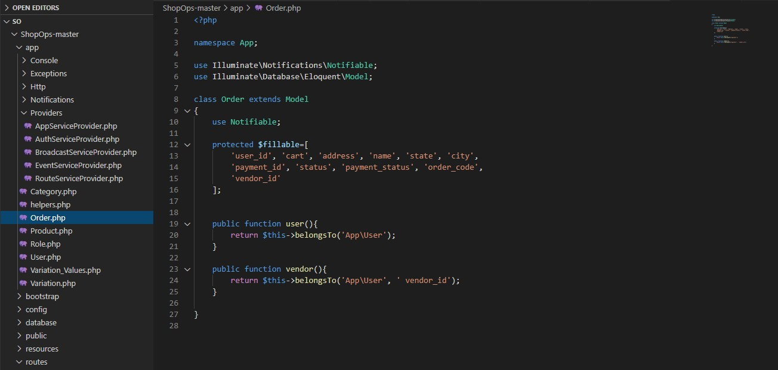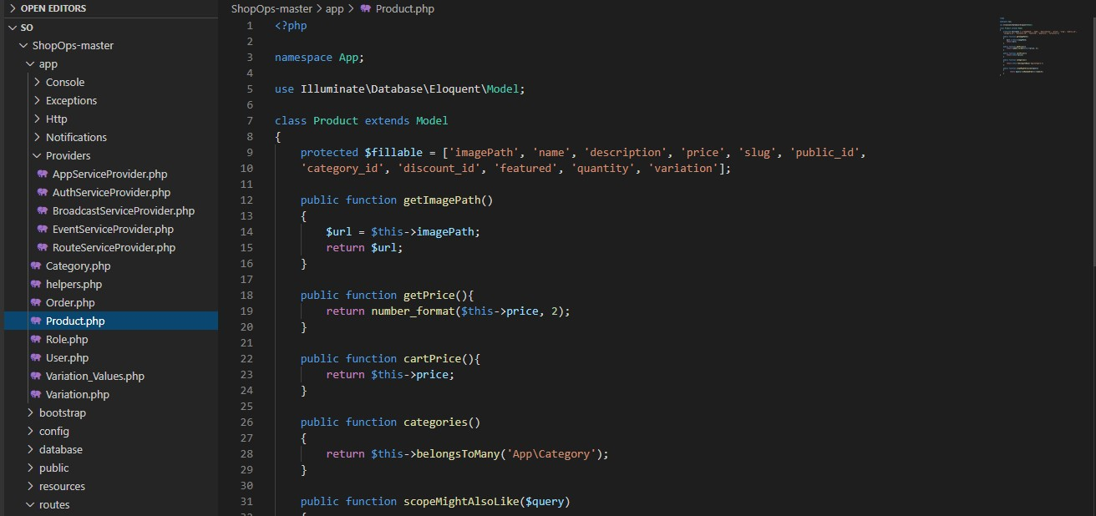

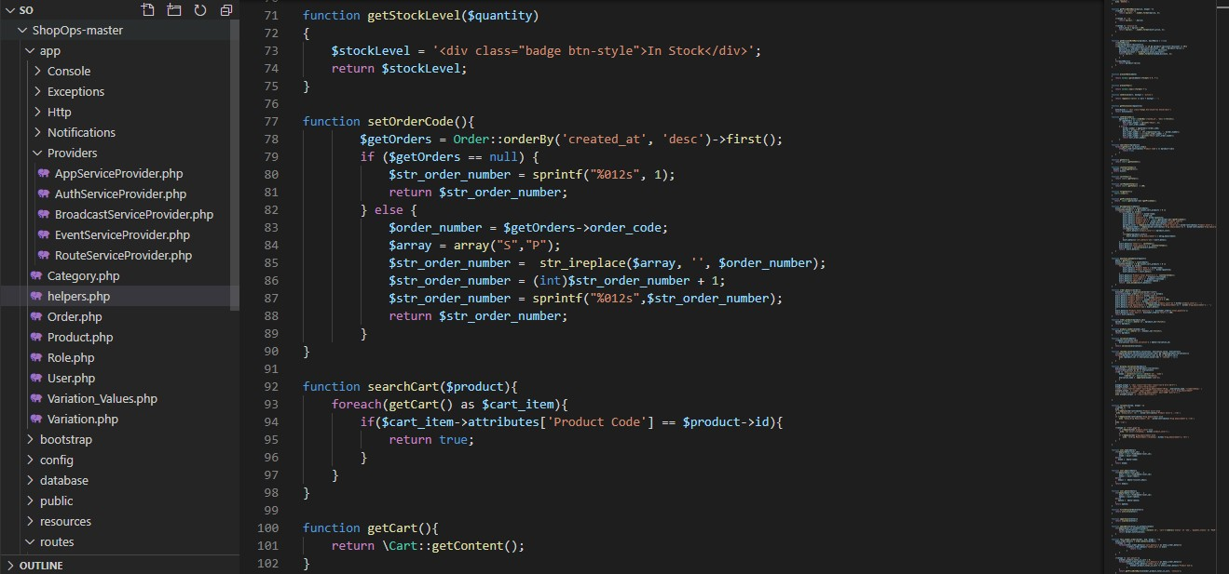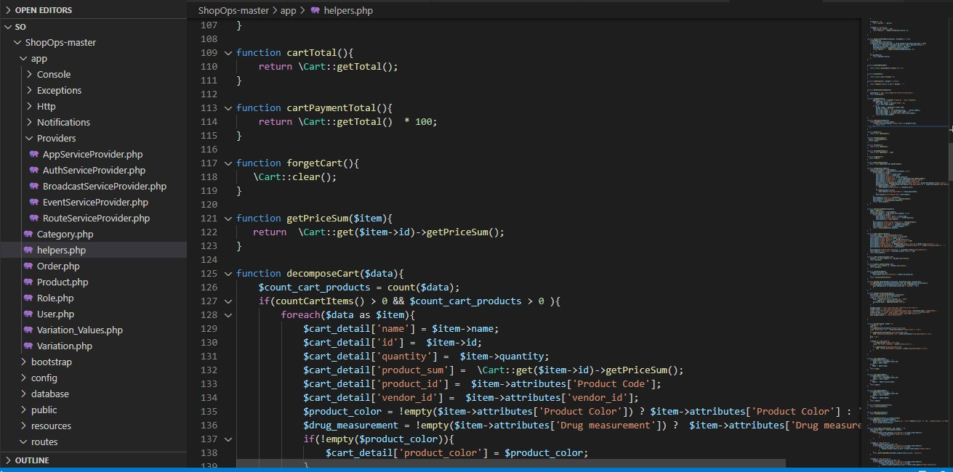

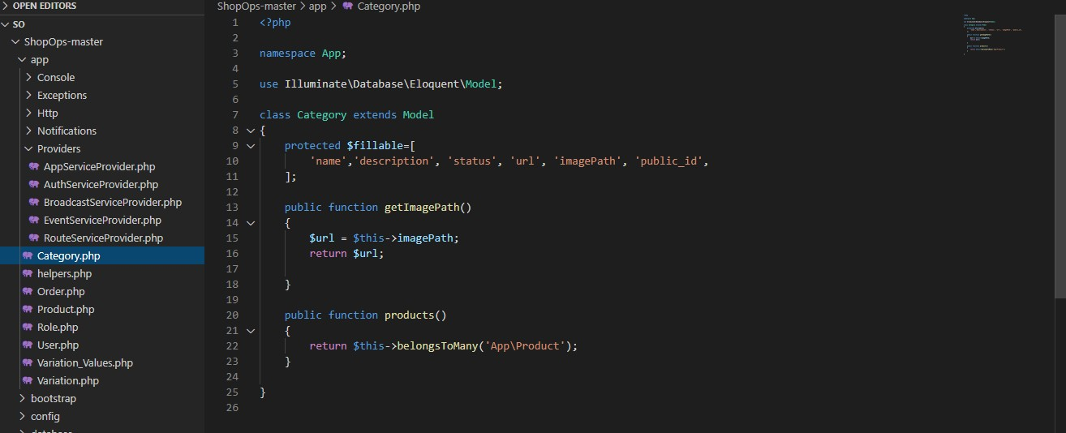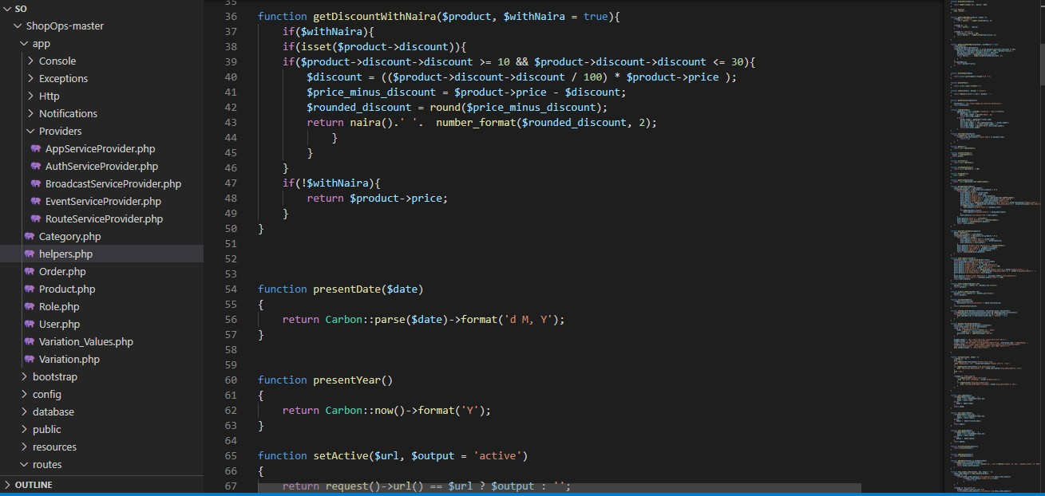

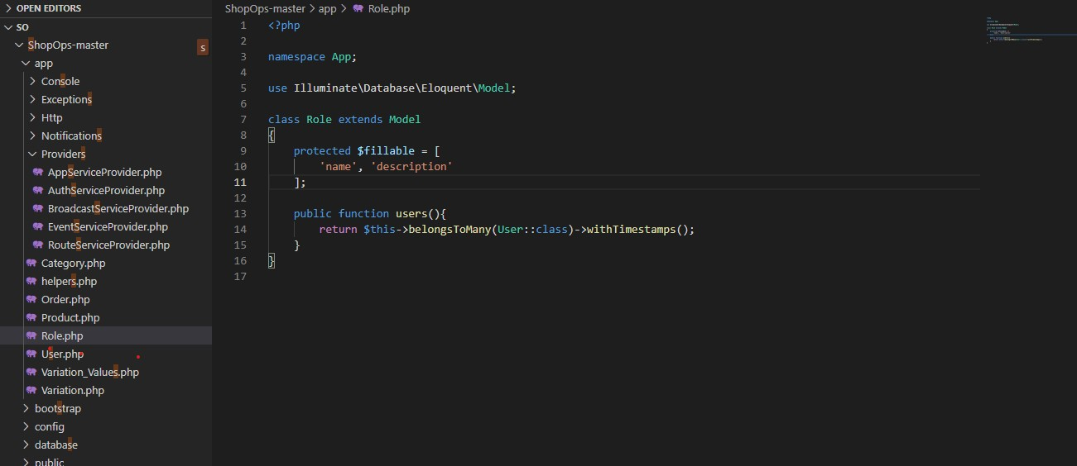

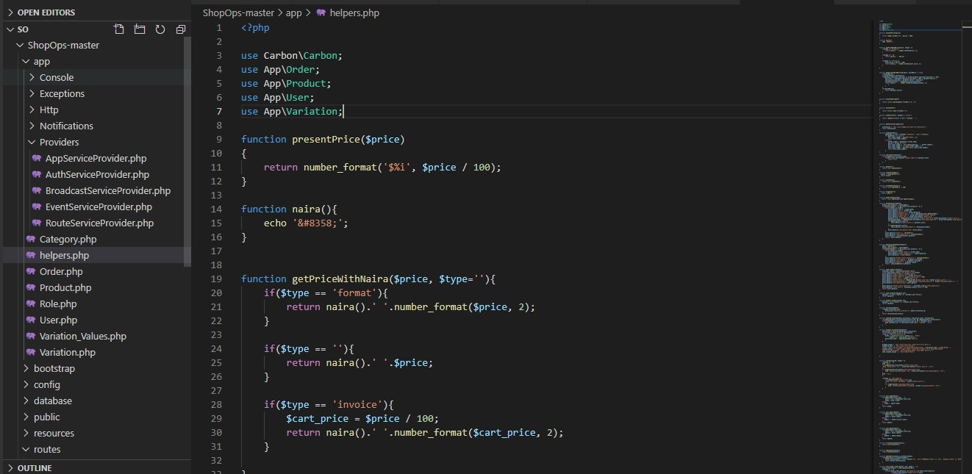

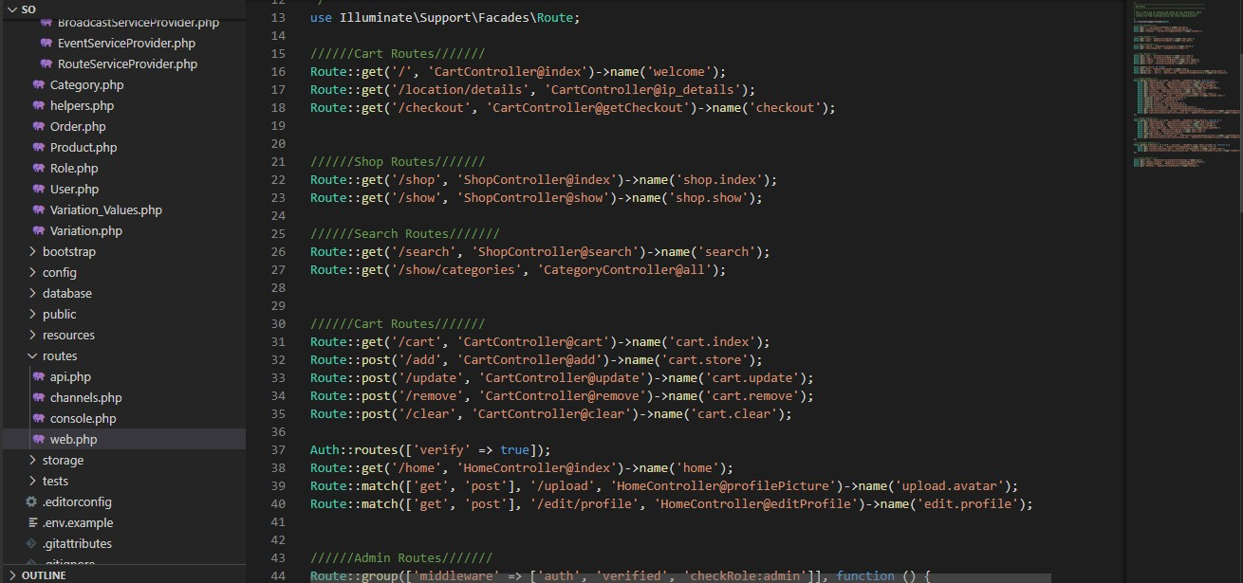

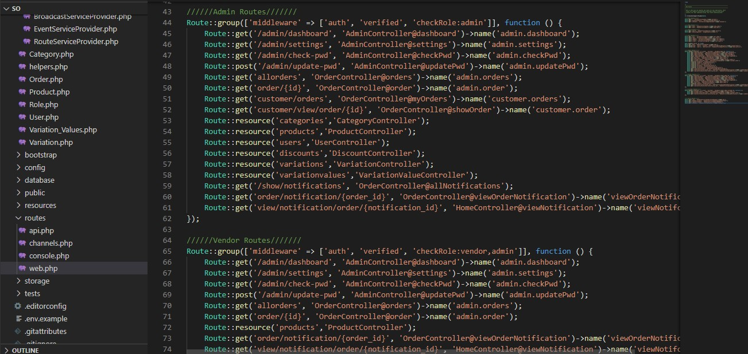

**Appendix D – Test Cases**

### Test Suite Performed for User login

Test case TC-001(User Login)

|  |  |
| --- | --- |
| Test Suit ID | Req-108 |
| Test Case ID | TC-001 |
| Test case summary | This test case is designed to ensure that users are able to login |
| Related Requirement | Req-108 |
| Prerequisite | * ShopOps application must be installed * Run application and login |
| Test Procedure | 1. Launch ShopOps 2. login |
| Test Data | Login |
| Expected Result | User should be able to login into the application |
| Actual Result | The user logged into the application |
| Status | Passed |
| Remarks | The test was successful |
| Created by | Chelsea Amaka Umeokeke |
| Date Created | 15th November 2020 |
| Executed by | Chelsea Amaka Umeokeke |
| Date of Execution | 15th November 2020 |
| Test Environment | Hardware : Hp pavilion  Software: Android Studio Emulator |

### Test Suite Performed for product input

Test case TC-002(Input product)

|  |  |
| --- | --- |
| Test Suit ID | Req-107 |
| Test Case ID | TC-002 |
| Test case summary | This test case is designed to allow user input product into the application |
| Related Requirement | Req-107 |
| Prerequisite | * Launch application * User logs in and search for product |
| Test Procedure | 1. Launch ShopOps 2. User clicks on search and input name of desired product |
| Test Data | Input product |
| Expected Result | User should be able to input name of product |
| Actual Result | Users were able to input the name of product |
| Status | Passed |
| Remarks | The test was successful |
| Created by | Chelsea Amaka Umeokeke |
| Date Created | 17th of November 2020 |
| Executed by | Chelsea Amaka Umeokeke |
| Date of Execution | 17th November 2020 |
| Test Environment | Hardware Hp  Software: Android Studio Emulator |

### Test Suite Performed for Home page (featured product)

Test case TC-003(View featured product)

|  |  |
| --- | --- |
| Test Suit ID | Req-112 |
| Test Case ID | TC-003 |
| Test case summary | This test case is designed to allow view featured product on the homepage |
| Related Requirement | Req-112 |
| Prerequisite | * Launch application * User Sign in |
| Test Procedure | 1. Launch ShopOps 2. User sign in and view featured product on homepage |
| Test Data | View featured product |
| Expected Result | User should be able to view featured product on the homepage |
| Actual Result | The result was as expected |
| Status | Passed |
| Remarks | The test was successful |
| Created by | Chelsea Amaka Umeokeke |
| Date Created | 17th of November 2020 |
| Executed by | Chelsea Amaka Umeokeke |
| Date of Execution | 17th of November 2020 |
| Test Environment | Hardware: Hp pavilion  Software: Android Studio Emulator |

### Test Suite Performed for Sort product

Test case TC-004(Sort product)

|  |  |
| --- | --- |
| Test Suit ID | Req-113 |
| Test Case ID | TC-004 |
| Test case summary | This test case is designed to allow user sort for product based on their location or price |
| Related Requirement | Req-113 |
| Prerequisite | * Launch application * User signs in |
| Test Procedure | 1. Launch ShopOps 2. Click on Sort 3. Click on location or price |
| Test Data | View location and price range |
| Expected Result | The user should be able to sort product based on price or location |
| Actual Result | The result was as expected |
| Status | Passed |
| Remarks | It was successful |
| Created by | Chelsea Amaka Umeoekeke |
| Date Created | 18th of November 2020 |
| Executed by | Chelsea Amaka Umeoekeke |
| Date of Execution | 18th of November 2020 |
| Test Environment | Hardware Hp pavilion  Software: Android Studio Emulator |

## Appendix E – User Guide/Manual

As mentioned earlier, the application would be implemented in an android phone. The user guide manual are as follows:

* The application starts with a splash screen, then moves to the home page.
* In the home page, there is the menu, featured products or latest products.
* When a user select the menu, the user will be able to locate the category, shopping cart, search, and login or register option.
* When a user clicks on the login option, the user is then moved to the login page, in this page the user is asked to input their username and password to sign in if they have an account.
* In the login page, new users are also given an option to register if they do not have an account.
* As a new user to register, you will have to input your email, password, first name, phone number and gender before clicking on the sign in button.
* When selecting a product, the user has two options, either by searching for the product or going to the product category.
* After the user has selected their desired means of selecting product. The product is then moved to the cart
* The user can either proceed to check out or continue shopping.
* When the user has selected all the product(s) of their choice, he/she then click on checkout.
* It will take the user to the checkout page, where they can now click on the checkout button to proceed to payment.
* It will take the user to the payment page, where they are asked to input their personal information and bank details to pay for the product.
* After the user pays, an e-receipt appears to confirm payment of order and it is sent to their mail.

