**AN ANNOUNCEMENT APPLICATION FOR IMPROVING INFORMATION DISSEMINATION**

|  |  |  |
| --- | --- | --- |
| **TABLE OF CONTENTS** | |  |
| TITLE PAGE | | i |
| DECLARATION | | ii |
| CERTIFICATION | | iii |
| DEDICATION | | iv |
| ACKNOWLEDGEMENT | | v |
| TABLE OF CONTENTS | | vi |
| LIST OF TABLES | | viii |
| List of Figures | | ix |
| ABSTRACT | | x |
| **CHAPTER ONE: INTRODUCTION** | | 1 |
| 1.1 | Background to the Study | 1 |
| 1.2 | Statement of Problem | 2 |
| 1.3 | Aim and Objective of The Study | 3 |
| 1.4 | Methodology | 3 |
| 1.5 | Justification of The Study | 4 |
| 1.6 | Scope and Limitations | 4 |
| 1.7 | Definition of Terms | 5 |
| **CHAPTER TWO: LITERATURE REVIEW** | | 6 |
| 2.1 | Information Dissemination | 6 |
|  | 2.1.1 Importance of information dissemination | 6 |
| 2.2 | Methods of information dissemination | 7 |
| 2.3 | Evolution of information dissemination | 10 |
| 2.4 | Announcement application | 10 |
| 2.5 | Existing works on announcement notification | 11 |
| **CHAPTER THREE: METHODOLOGY** | | **Error! Bookmark not defined.** |
|  | VI |  |

|  |  |  |  |  |
| --- | --- | --- | --- | --- |
| 3.1 | Method of Identification for User and System Requirement **Error! Bookmark not defined.** | | | |
|  | 3.1.1 Identification of system requirements | | **Error! Bookmark not defined.** | |
|  | 3.1.2 | Identifying user requirement |  | 16 | |
| 3.2 | System Design and Method | |  | 16 | |
|  | 3.2.1 | Use case diagram |  | 17 | |
|  | 3.2.2 | Sequence diagram |  | 24 | |
|  | 3.2.3 | Activity diagram |  | 24 | |
|  | 3.2.4 | Class diagram |  | 31 | |
|  | 3.2.5 | Architecture diagram |  | 31 | |
| 3.3 | System Implementation | |  | 31 | |
|  | 3.3.1 | Database implementation |  | 31 | |
|  | 3.3.2 | Frontend implementation |  | 31 | |
|  | 3.3.3 | Backend implementation |  | 34 | |
| **CHAPTER FOUR: RESULTS AND DISCUSSION** | | |  | 36 | |
| 4.1 | Results of Database Implementation | |  | 36 | |
| 4.2 | Mobile Front-End Implementation | |  | 36 | |
| 4.3 | Discussion of Result | |  | 50 | |
| **CHAPTER FIVE CONCLUSION AND RECOMMENDATIONS** | | | | 51 | |
| 5.1. Summary | | |  | 51 | |
| 5.2. Conclusion | | |  | 51 | |
| 5.3. Recommendation | | |  | 51 | |
| **References** | | |  | 53 | |

VII

|  |  |  |
| --- | --- | --- |
| **LIST OF TABLES** | |  |
| Table 3. | 1: Delete notice | 19 |
| Table 3. | 2: Send notice | 20 |
| Table 3. | 3: Receive and read notice | 22 |
| Table 3. | 4: Make complaint | 24 |

VIII

|  |  |
| --- | --- |
| **List of Figures** |  |
| Figure 3 . 1: use case diagram of notice system | ix |
| Figure 3 . 2: Sequence diagram to send complaint notice | 27 |
| Figure 3 . 3: Sequence diagram for deleting notice | 28 |
| Figure 3 . 4: Sequence diagram to login | 29 |
| Figure 3 . 5: Activity diagram | ................. 30 |
| Figure 3 . 6: Class diagram of the system | 32 |
| Figure 3 . 7: System Architecture | 33 |
| Figure 4. 1: Course collection | 37 |
| Figure 4. 2: User Collection | 38 |
| Figure 4. 3: Department Collection | 39 |
| Figure 4. 4: Post Collection | 40 |
| Figure 4. 5: Login View | 41 |
| Figure 4. 6: Admin Home View | 43 |
| Figure 4. 7: Course Management View | 44 |
| Figure 4. 8: Department Management View | 45 |
| Figure 4. 9: Manage Staff View | 46 |
| Figure 4. 10: Staff Home view | 47 |
| Figure 4. 11: Student Home View | 48 |
| Figure 4. 12: Notice Detail View | 49 |

IX

**ABSTRACT**

The aim of the study is to develop an application that allows users to receive and send announcement using their mobile devices in order to overcome communication barriers faced during the dissemination of announcement within Mountain Top University. The study identified the various user and system requirements, specified the system design and implemented the system.

A review of the literature was being done to identify and understand existing information dissemination systems. The user and system requirements of the system were identified from system users using informal interviews. The system design was specified using UML diagrams, such are use case, sequence and class diagram. The database was implemented using SQLite. The implementation of the frontend was done using HTML, CSS, and Bootstrap. The backend was implemented using Python and Django framework.

The results of the system showed the implementation of the system’s database for storing the information alongside the front-end of the web and mobile application. The results revealed that the system was able send information out to student connected to the app through a given URL.

The study concludes that using the system within the school environment would improve the mode of information dissemination and overall communication especially when the information needs to be passed urgently.

**Keywords:** *Announcement app, Information Dissemination*

X

**CHAPTER ONE**

**INTRODUCTION**

**1.1** **Background to the Study**

Information are resources that, when used, would leads to knowledge. Like any resource, it must be discovered, assessed and produced to become knowledge. The need and usage of information is increasing rapidly due to the high demand for social and dynamic developments in technology and science in the advent of the 20th

* 21st century (Aboyade & Ogunsola, 2005). It is well known that the key to successful task performance is efficient and effective information gathering and processing (Dudek, 1991). Nowadays, information is everywhere and anywhere, as

the digital age is rapidly taking over the world, information is now at everyone’s fingertip. People can access to any information once they are linked up to the WWW (word wide web). Therefore, methods of information dissemination have drastically evolved throughout the years, and the medium for information has evolved from traditional (old-fashion) to modern via digital resources. (Rosmani, Mutalib, & Sarif, 2020).

Generally, phones were innovated for calling purpose but now a days we use it more for social activity such as WhatsApp, Facebook, hike etc. So, technology comes forward to us and it is our duty to use it for our important purpose. Following these thought we developed this system. The management of accurate and up-to-date information regarding a student’s academic career is difficult and time-consuming task for the schools. Now-a-days the information to parents regarding their ward is provided through post cards, SMS or Email, but these techniques too are very much hectic time inefficient and lengthy. (Jadhav S. L., Mhade, Gosavi, & Jagushte, 2016).

1

In the past, we primarily relied on local and national broadcasts to pick up public service announcements. A more holistic distribution approach that includes not only earned, but also paid, owned, and shared tactics across many platforms is a better method to reach and motivate the intended audience these days. (Apata & Ogunrewo, 2010). Effective distribution is characterized as involving the audience in a process, whether it is one of enhanced awareness, comprehension, commitment, or action. We all have a tendency to immediately select up and run with the most apparent channels of distribution, such as newsletters, websites, and direct mail. This is because they are tangible outputs that can be easily demonstrated as reliable distribution methods. However, it will be necessary to investigate and assess which ways are the most successful and appropriate for addressing the needs of your users. (Harmsworth & Turpin, 2000).

With the advent of ICT, many successful attempts to replace the old means of notice board dissemination with more modern methods have been developed. As a result, an Android application was created for college notification on college-related announcements. E-Announcement Boards, Mobile Announcement Apps, and Online Notice Boards are all technologies that may be utilized on any computer system that is linked to the internet, whether it is through a wired or wireless network (Karanam, Matasugur, Sandhya, & Swathi, 2019). It has made information distribution more simple, convenient, and effective simply by being online, reducing the time and effort required by the prior system to convey a message to students and instructors.

**1.2** **Statement of Problem**

The traditional method of generating and sharing notification in the institution is always time and resource consuming. The use of word of mouth is always falls to the risk of having the information altered by those sent to pass it out and it may not

2

reach the receiver on time before the information is due. The use of notice board is restricted in distance and may not be read before the information becomes overdue. The solution to these problems is to design and implement an application through which students get notifications on their tabs, anytime regarding urgent and important information, activities on various events related their institution.

**1.3** **Aim and Objective of The Study**

The aim of the study is to develop an application that allows users to receive

and send announcement using their mobile devices in order to overcome

communication barriers faced during the dissemination of announcement within

Mountain Top University.

The specific objectives are to

1. identify existing works on application development information management and dissemination;
2. identify the system and user requirements;
3. design the system based on (ii);
4. implement the system; and
5. test the system.

In order to achieve the aforementioned objectives, the methods that was used are stated as followed.

1. A review of related literature covering the field of Information Dissemination, Mobile Application Development, and Information Management was conducted from scientific article

3

1. Informal interview and observation were be made for users of the system and the environment in which the system would operate in to ensure that the system performs at its optimum.
2. System design specified using the Unified Modeling Language (UML) diagram such as: data flow diagram (DFD), use-case diagram, class diagram, sequence diagram.
3. System was built through the use of Dart programming language and Flutter framework and a database which was created to store the data for the system.
4. System was be tested by users.

**1.5** **Justification of The Study**

The study was brought about by the need for a better and faster mode of communication within tertiary education environment. Due to the rapid rising in the popularity of mobile application, it has been easier to perform tasks that usually take a stationary workspace to perform. There was a need to make life style better and easier for people to enable them to achieve these tasks faster and more efficient from any location.

**1.6** **Scope and Limitations**

The scope of the study was to develop an Announcement Application for effective dissemination of information.

The limitation of this project includes:

1. The system enables the sender-users to send announcement to a large group of people but announcement cannot be not sent to specific individuals. The lowest level the system reaches is the college; i.e., the sender can only filter as little as send an announcement to a specific college.

4

1. The proposed system does not enable sending of communication between two receiver-users. The system is announcement app for passing urgent and/or important information across to a group of users and not a chatting app.

**1.7** **Definition of Terms**

1. **Android**: a popular mobile operating system built on the Linux kernel.
2. **Announcement app**: An application used for broadcasting announcement.
3. **Django**: Django is a model-template-views-based web framework that is free and open-source and uses Python.
4. **Information Dissemination**: the dissemination of information. To spread information.
5. **Java**: The object-oriented, class-based, general-purpose programming language Java was created to have fewer implementation requirements.
6. **Mobile App**: software application built for mobile devices.
7. **Native app**: an application solely built for one type of OS, usually either iOS or Android operating system.
8. **Software Development Life Cycle (SDLC):** the process used by the software industry to design, develop and test high quality software.
9. **World Wide Web (WWW)**: Also known as Web, is an information system in which documents and other web resources are identified by Uniform Resource Locators (URLs).

5

**CHAPTER TWO**

**LITERATURE REVIEW**

**2.1** **Information Dissemination**

Information can be described as processed data. Data, which is knowledge that can be processed to convey a meaning, comes before the definition of information. As a result, information can be defined as unprocessed data that has been purified to the point where it can be analyzed. Information, unlike data, is ordered, explicit, and has its own form and meaning. Depending on how it is evaluated, it can be linked to any situation. (Zoikoczy, 1981).

The act or practice of disseminating or spreading something is called dissemination, and it comes from the Latin word for seed (Merriam Webster). The idea with Information Disseminating is that information spreads like seeds sown by a farmer. Information Dissemination means to spread information, knowledge, and or opinions as far and wide as possible. (Ariztia, 2020). It refers to as an active spreading and the distribution of information of all kinds to the users or the targeted audiences that requires it. (igi-global)

**2.1.1** **Importance of information dissemination**

The ideal strategy for disseminating information is one that effectively reaches the biggest target populations. To adequately serve its intended audience, the Cooperative Extension Service, or simply office setting, must first define who that audience is and how to most effectively target and deliver information to that group (Orr, 2003). As a result, because today's audience is considerably larger, it is a must look for the most effective ways to contact people depending on their information preferences. Some of these reasons are the following:

6

1. **Judgement**: Information is frequently communicated in the hopes of improving an organization's knowledge base and, as a result, making better decisions in future scenarios.
2. **Awareness**: A notion, practice, or principle is frequently distributed in order to teach, explain, or promote it.
3. **Response**: Information is often shared simply in the hopes of eliciting feedback that was necessitate the generation of additional data or the use of data to validate something.
4. **Collaboration**: Information is frequently shared in order for a group of people to share their knowledge and communication channels. (DWTDI Project)

**2.2** **Methods of information dissemination**

Thriving organizations need effective information dissemination strategies to boost morale, productivity and the company’s bottom line. These are one of the most common ways it is being done:

1. **Email**: Drawing up a mailing list of essential persons to get materials and information about your project after you've defined your target audiences is a good place to start. This might be a nominated contact in an academic department or someone who has already expressed an interest in the activities of your initiative. Email is still a popular method of corporate communication, but critical information can get lost in the shuffle.
2. **Media**: Obtaining national or local press coverage can considerably raise the profile of your project and reach a large number of people within the higher education sector or the industry in which you work. It can be successful to

7

target the journalists in charge of the learning and teaching part, or the most relevant portion, of the major educational newspapers.

1. **One-to-One:** Although creating one-on-one contact with people can be a drain on resources for any project, previous projects have discovered that targeting important people who you believe will improve your project's chances of success can be quite beneficial (Dwayne, Orr, & Kelemen, 2006).
2. **Roadshows**: If you are willing to travel significantly, roadshows can be an excellent way to demonstrate the work of your project to a certain institution, department, or group of departments. They can be an effective approach to connect with those who might not otherwise attend workshops or conferences. It's crucial to consider the topic and/or theme of your roadshow, keeping in mind the needs of your target market.
3. **Workshops**: Workshops are often different from conferences in that they cater to smaller groups of people and require a much greater and more active degree of participation.
4. **Conferences**: The majority of projects have enough money to put on a national conference or a medium- to large-scale event. Such an event can have significant benefits, but it can also be expensive and time-consuming to prepare, so it is critical to budget appropriately and plan for the number of staff time required to ensure a well-organized and successful conference. Conferences can be a great way to meet face-to-face with your intended audience and discuss problems that are important to your project's work.
5. **Reports**: Reports are a good way to advertise and communicate findings from your project, and they can be included as part of the deliverables. These can be

8

printed or made accessible on your website. The latter, on the other hand, makes updating and disseminating information much easier.

1. **Websites**: A website provides easy access to project information and can be easily updated. Your newsletter, briefings, brochures, and mailing lists can all be used to promote your website. Maintain your site's value by keeping it updated and highlighting fascinating stuff on the front page so that visitors can know right away that there's something new to look at. Keep in mind that tracking website hits is only effective if you can be certain that users are actively seeking and utilizing the site. Your target audiences, on the other hand, must be aware of it and interested enough to visit the site in the first place. After you've drawn them in, you'll need to figure out how to keep them coming back to the site on a regular basis. It is critical that your website appears when consumers conduct a search. To ensure that search engines like Yahoo pick up your site, you'll need to employ metatags. (Harmsworth & Turpin, 2000).
2. **Briefings**: A briefing can be anything in the middle of a newsletter and a catalog. It's only an A4 page long, but it can help you summarize the project's work and keep others up to date on your progress.
3. **Newsletters**: Every quarter, term, or phase of your project, send out a short newsletter (maximum four sides of A4) to keep your audience up to date on progress and maintain interest. Although a large sum of money is not required to produce such a newsletter, it is critical that it is well-presented and appears as professional as possible.

9

**2.3** **Evolution of information dissemination**

Known as the three Ps, posters, presentations, and papers, have historically been the three primary ways of dissemination. (Ariztia, 2020). However, technology advances to us, and it is our responsibility to put it to good use. Workplace groups must be able to openly communicate and coordinate creative endeavors. When team members are unable to be physically present, project management software steps in to fill the gap. Managers can use project management systems to communicate with their teams about new tasks, priorities, and deadlines. Having immediate access to data and analytical reports shared by employees can aid in the growth of the company. Managers can provide critical feedback to the team if changes are required. (Jadhav S. L., Mhade, Gosavi, & Jagushte, 2016).

Files, information, tasks, documents, projects, and teams are all organized through channels. Users may easily access information using cellphones, tablets, or PCs whenever they need it. Instant communication eliminates the frustrations and bottlenecks that occur when people play phone tag. Companies can also create private intranet software networks to share confidential or sensitive information (Dowd, 2021).

Internal and external news, budget information, shipping updates, and staff changes can all be disseminated using customized apps. Instead of sending an email and waiting for a response that may or may not arrive, employees may connect with one another and reach out to vendors or clients in real time.

**2.4** **Announcement application**

10

An announcement application is an application which can be used to set up all of the critical messages that you want to make available in real time to your client Portal users. You can set the length for which the message will be active [Start Date - End Date], and it will automatically expire and be withdrawn from the client portal once the end date is reached. (Xapdigital, 2020) On Client Portal, the Announcement app allows you to configure and show all of your essential alerts and announcements for your consumers.

**2.5** **Existing works on announcement notification**

Karanam, Matasugur and Sandhya (2019), developed a College Notification System which was used to replace the traditional method of dissemination on notice board with an E-notice board through their android devices. They reviewed existing traditional systems and identified the advantages and disadvantages alongside the cost of the existing system and compared it with their proposed system. They created models for each user type. The result was the development of an android application for college notification on college related notices directly to users’ android devices. E-Notice Board also runs on any computer system either by local area network or wired or wireless network. The proposed system was a simple, convenient and efficient online notification system which reduces the effort put into putting out a notice for the students and instructor.

Riadh (2016), developed a Notification System to Students using an Android Application, which enabled students to connect to the educational web site of the university through their mobile devices. The system developed had more access restriction on the instructor (message sender). It prevented instructors who have been blocked from sending messages. The proposed system required that both students and

11

instructors are to be registered through GCM, a free service provided by Google without any quotas. The system made communication easier and quicker between the instructors and students, by enabling them to access the notifications through their mobile devices. The system proposed was separated into two versions. Mobile for the receiver and only a web application for the sender.

Tandra and Kumar (2016), developed a Student Notification System (SNS) to help students get information pertaining to their academic as efficiently as possible. They made an analysis of their existing system for all the activities related to making an announcement. They find issues within the existing system and were able to propose a SNS to cover majorities of their activities. They developed a system that enabled students to view important information pertaining to their periodic notifications. The functionalities of the system were limited by those who have permission to send information. Only admin and H.O.D (s) are accepted senders.

Bharamagoudar, Geeta and Totad (2013) developed a Web Based Student Information Management System for recording and updating of students’ information to improve the efficiency of record management in their college. They designed a series of data flow diagrams showing how the flow of their data was. Requirements were gathered on how the users would use the system. Functional and non-functional requirements were also gathered to show what actions can be taken by the users and the features the system would have, which defined the characteristics of the system. The system was built using web development tools such as HTML, CSS, PHP, JavaScript, and SQL. The result was a web-based system which enabled users to login, register, view basic information etc. The system built helps improve the work standard but the drawback is that it only exists as a web application.

12

13

**CHAPTER THREE**

**METHODOLOGY**

**3.1** **Method of Identification for User and System Requirement**

Using informal interviews and an evaluation of the existing methods for identifying and accounting for students within the department, the user and system requirements of the software system were identified during this project. The techniques used in highlighting the system requirements of the software include; Nonfunctional requirements that specify criteria that can be used to judge the operation of the system, functional requirements which describe the services the software must offer, Hardware requirements, and the Software requirements.

During the course of the development of the system, the user requirements were identified and they include; system admin requirements, sender and receiver user requirements. In this chapter, the following models; Use case, Sequence, Activity, class, and System architecture, that were used in the system design was adequately discussed. This chapter would also talk about the method of system implementation, database implementation, and front-end implementation. Finally approaches to testing the system was highlighted.

**3.1.1 Identification of system requirements**

This section discusses the functional and non-functional requirements of the system being developed. It highlights the requirements for system implementation. Also described in this section are the hardware and software requirements for the development of an announcement application for Mountain Top University.

1. **Non-functional requirements**

The non-functional requirements of the system include:

14

1. Ease of use: the system was implemented in such a way that the user was able to operate it with little to no help need. The texts and buttons were properly styled for easy viewing and they perform the function for which they are stated. Users should be to use the system based on their roles.
2. Response time/speed: a request made to the system should be responded to immediately while displaying the correct output.
3. user role identification: system should be able to identify which user is logged and the correct role of the user.
4. Reliability: users should be able to communicate through the system as long as there is a stable connection to the server network.
5. Security: users and admin are expected to use the interface assigned to their roles.
   1. **Functional requirements**

The functional requirements include;

1. System should allow only registered/authorized users to log into the system and display an interface for their roles.
2. System should be able to send and receive messages/notification among two or more devices.
3. Users should be able to view messages/notice pertaining to user.
4. A user should be able to complain and or interact with another user through ethernet.
5. Registration admin should be able to create users and assign them roles
6. User should be able to send message/notice to specific channels of users.

15

1. **Hardware requirements**

This mobile application, it should have a functioning storage space of about

5GB, 4GB memory, and good battery life.

1. **Software requirements**

The software required to implement this system includes: browser, good Wi-Fi

card.

**3.1.2 Identifying user requirement**

This section highlights the system and user requirements of the system.

1. **System admin requirements**

In this project the registration officer is assigned the role of administrator. The

admin can register and assign roles to the user (Sender and Receiver). The admin is responsible for checking complaints along notifications sent. The admin has the privilege and the authority to ban users and deleting notices which have been found inappropriate.

1. **System sender user requirements**

The Sender users are the ICT personnel, Head of department, lecturers, student

representative council, assigned receiver users.

1. **System receiver requirements**

A Receiver user is any user who does not fall into the category of either of the

previous two user category but are authorized to use the system.

**3.2** **System Design and Method**

The system design was specified using relevant UML diagrams such as use case diagram, sequence diagram, class diagram, and activity diagram. The system architecture was also designed and described in this section with appropriate diagram.

16

The UML diagrams used in designing the system represent various functions and actions that are available on the system and how they are used by the users of the system as identified in the previous section.

**3.2.1** **Use case diagram**

The use case diagram figure 3.1 described below, presents users of this system and the various actions that they can perform on the system. It also talks about their different roles, and conditions for each actor to perform various activities and for those activities to be termed as successful.

Table 3.1 describes the delete notice process. This use case applies to both admin and staff users. The user navigates to the selected notice page then clicks on delete. The user confirms deletion of the notice. The users must have logged in to their account and must have access to the notice. The user successfully deletes the notice. If the process is unsuccessful, a message is prompted from the system on what the problem is and a request to try again.

Table 3.2 describes the send notice process. This use case applies to both admin and staff users. User navigates to the notice group/channel to send message to then user selects create notice. User attaches relevant document if needed and clicks send. User must be logged in as either admin of staff to gain access to the send notice feature. The user sends notice successfully else if the process was not successful, the user receives a prompt from the system describing the error and requesting user to try again.

Table 3.3 describes the receiving and reading notice process. This use case applies to all users. User navigate to the notice page. The user receives new notice as it comes in. The user can then navigate to the respective notice page. The user then

17

reads the notice once the user receives notice and is able to read the notice process has

been

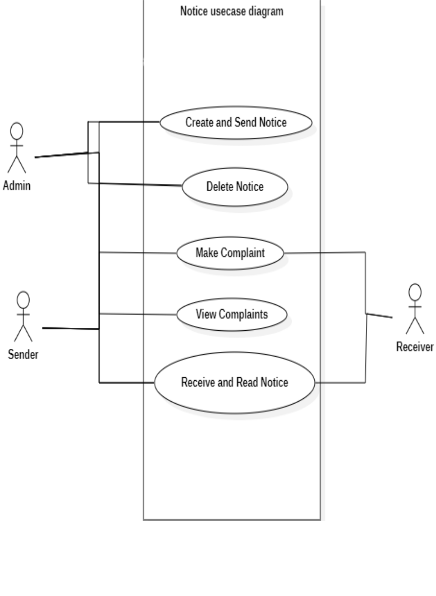

**Figure 3.1: Use case diagram of notice system**

18

|  |  |  |
| --- | --- | --- |
| Use case Name | Delete Notice | |
|  |  | |
| Actors | Admin, Sender User | |
|  |  |  | |
| Flow of Events | • | The user navigates to the selected notice page | |
|  | • | The user clicks on delete | |
|  | • | The user confirms deletion of the notice | |
|  |  | |
| Entry Condition | The users must have logged in to their account and must have | |
|  | access to the notice | |
|  |  | |
| Exit Condition | The user successfully deletes the notice. | |
|  | If the process is unsuccessful, a message is prompted from the | |
|  | system on what the problem is and a request to try again. | |
|  |  | |
| Quality Requirements | The user must successfully delete the notice without errors | |
|  |  | |
|  | **Table 3.1: Delete Notice** | |
|  |  | 19 | |

Use case Name

Send Notice



**Table 3.2: Send Notice**

20

|  |  |
| --- | --- |
| Actors | Admin, Sender |
|  |  |
| Flow of Events | • User navigates to the notice group/channel to send |
|  | message to |
|  | • User select create notice |
|  | • User attaches relevant document if needed |
|  | • User select send |
|  |  |
| Entry Condition | User must be logged in as the appropriate user |
|  |  |
| Exit Condition | The user sends notice successfully. |
|  | If the process was not successful, the user receives a prompt |
|  | from the system describing the error and requesting user to |
|  | try again. |
|  |  |
| Quality Requirements | The user must successfully send a notice to the appropriate |
|  | notice group/channel without errors |
|  |  |

21

Use case Name

Receive and Read Notice



**Table 3.3: Receive and read Notice**

22

|  |  |
| --- | --- |
| Actors | Admin, Sender, Receiver |
|  |  |
| Flow of Events | User navigate to the notice group/channel |
|  |  |
| Entry Condition | The user receives notice for a new message |
|  | The user navigates to the respective notice group/channel |
|  | The user then reads the notice |
|  |  |
| Exit Condition | The user receives notice and is able to read the notice |
|  | If the process was unsuccessful, the user receives a prompt from |
|  | the system describing the error. |



Quality Requirements

The user receives and reads the notice without error

23

successful else if the process was unsuccessful, the user receives a prompt from the system describing the error.

Table 3.4 describe the making of comments and complaints process. This use case is for both sender and receiver users. The user navigates to the respective notice page and sends complaint successfully. The use clicks on complaints and sends complaints and if the process was unsuccessful, the user receivers a prompt from the system describing the error.

**3.2.2** **Sequence diagram**

Sequence diagrams were used to illustrate the order of action for each process on the system. It shows the internal component and the user involved in the process. Some of the processes designed with these diagrams are Login, register staff/student, view message.

**3.2.3** **Activity diagram**

Figure 3.5 below, describes the flow of activity of the system. Once a user requests to log in, if the request was successful, the user logs in to their account in the specific roles. If the login was unsuccessful, the user is prompted to try again. If a user registers as the admin, then user can perform the following processes such as ban user, create and send message, receive message, delete notice, view complaints. If user registers as a staff, then the user is able to create messages, delete messages, view complaints, receive and read notices. If user is not registered as the previous two then the user was a student which was able to read and receive notice, send message and make complaints.

24

**Table 3.4: Make Complaint**



Use case Name

Make Complaint

25

|  |  |
| --- | --- |
| Actors | Sender, Receiver |



|  |  |
| --- | --- |
| Flow of Events | The user navigates to the respective notice channel |

|  |  |
| --- | --- |
| Entry Condition | Users sends complaint successfully |

|  |  |
| --- | --- |
| Exit Condition | The use clicks on complaints and sends complaints |
|  | If the process was unsuccessful, the user receivers a prompt from |
|  | the system describing the error. |

Quality Requirements

The user sends the complaints without error

26

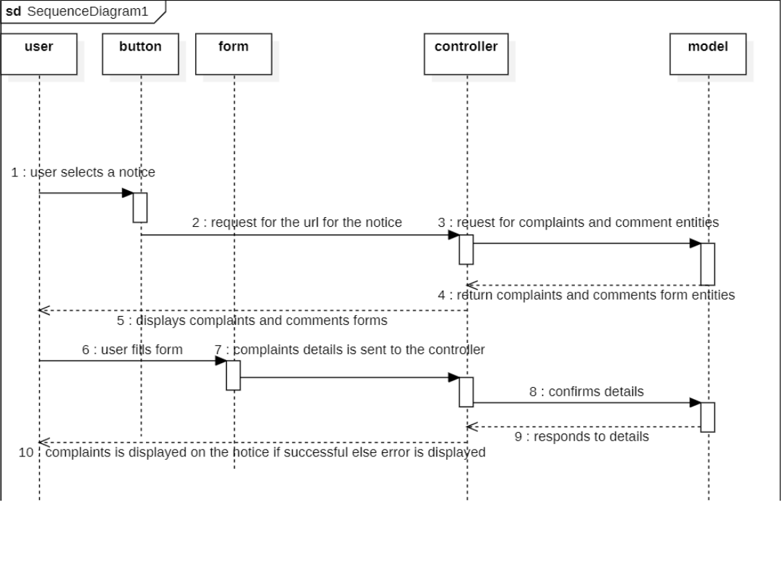

**Figure 3.2: Sequence diagram to send complaint notice**

27

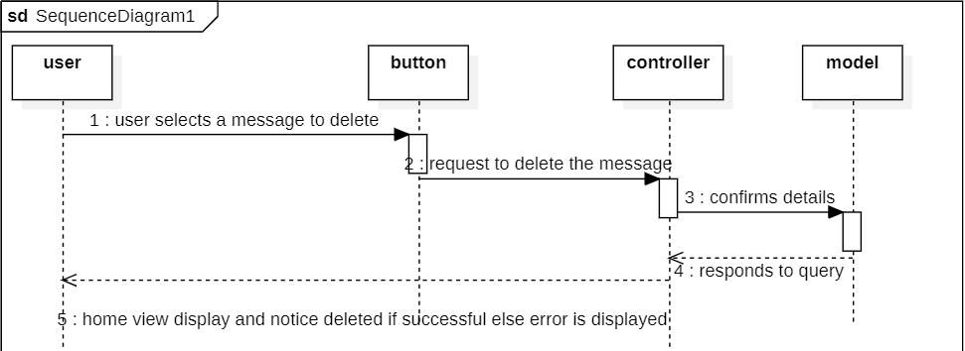

**Figure 3.3: Sequence diagram for deleting notice**

28

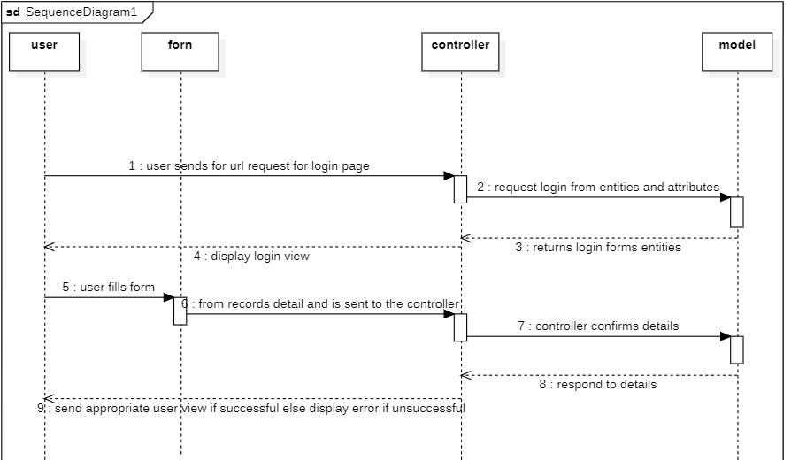

**Figure 3.4: Sequence diagram to login**

29

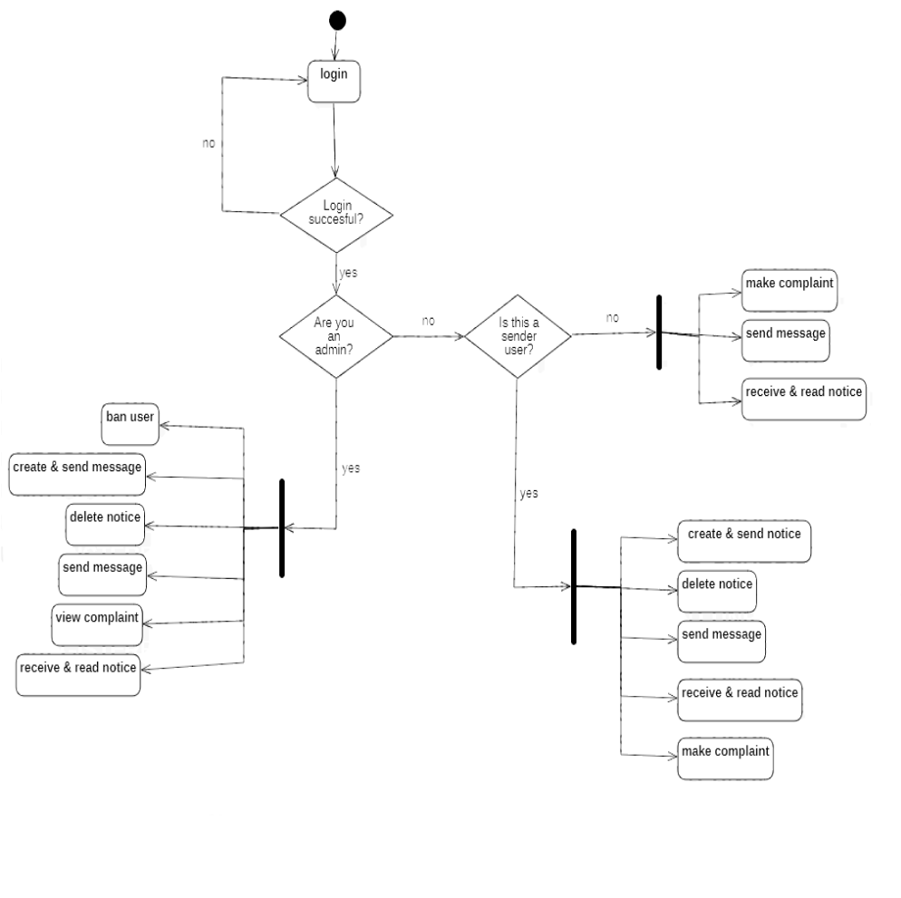

**Figure 3.5: Activity diagram**

30

**3.2.4 Class diagram**

Figure 3.6 is the class diagram. The class diagram shows the relationship between the system entities. Attributes of each of these entities represent columns of the tables that they model in the database.

**3.2.5 Architecture diagram**

The system architecture in figure 3.7 below, depicts that the system presented via hosting on Django server. Once the browser requests for the URL of the system, it is navigated to the Django server. The server interfaces with the definition of routes to serve the appropriate page and execute the necessary requests. The system database is managed by SQLite database which holds all collections used by the system.

**3.3** **System Implementation**

This system was implemented using several technologies, languages, and dependencies.

**3.3.1** **Database implementation**

This project employed an SQLite database management service to control data storage, retrieval, and manipulation throughout the system. With each collection holding documents for each record entity in the system, collections for staff, students, admin, post, departments, and courses were created using the beginner-friendly SQLite database. The SQLite database was viewable in the system using the SQLite DB Browser app, which was available.

**3.3.2 Frontend implementation**

1. Bootstraps: Used for front-end web development, the CSS framework called Bootstrap that is free and open-source stresses mobile responsiveness. It

31

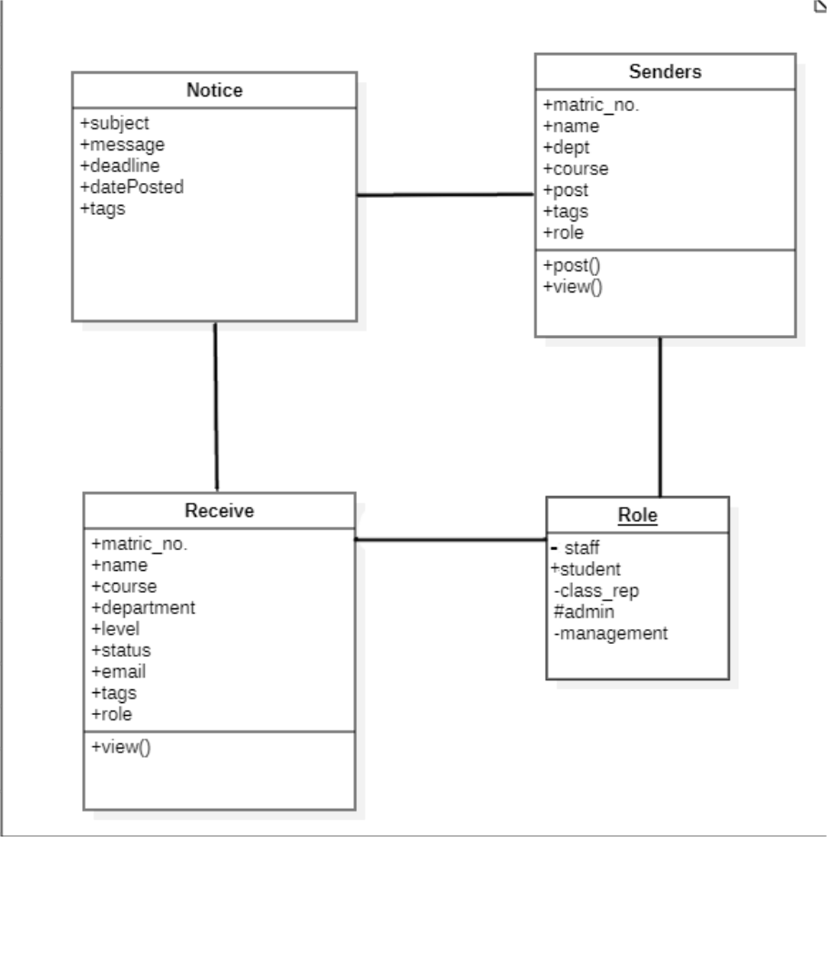

**Figure 3.6: Class diagram of the system**

32

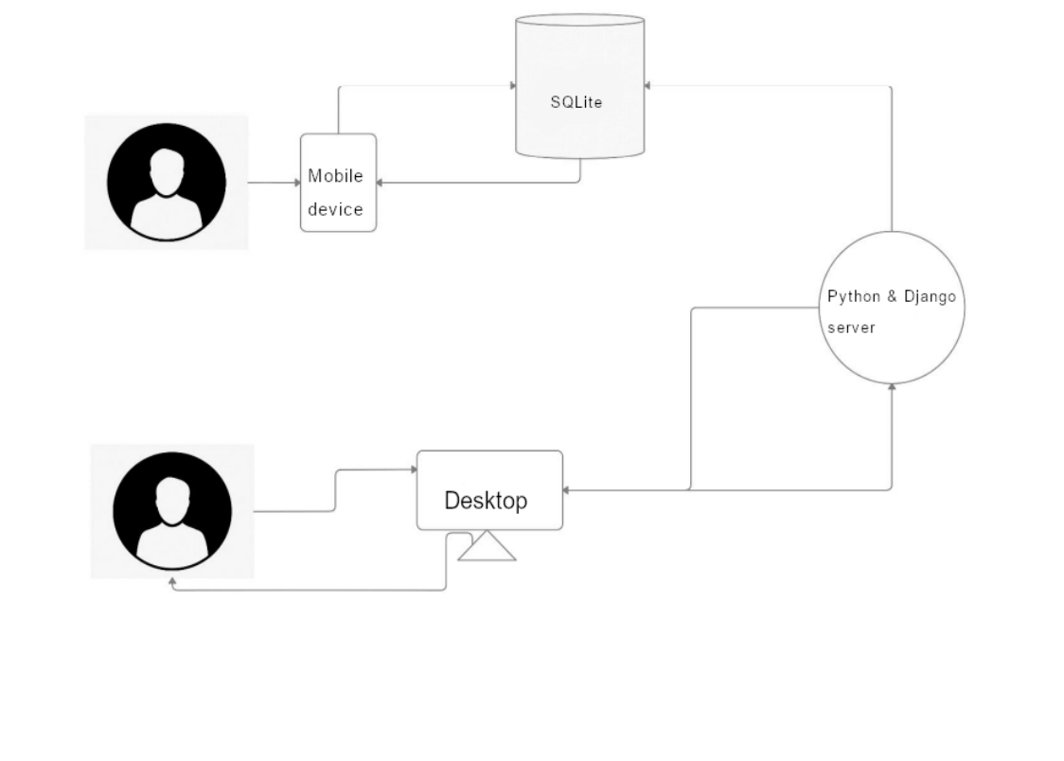

**Figure 3.7: System Architecture**

33

features HTML, CSS, and JavaScript-based design templates for typography, forms, buttons, navigation, and other interface components.

1. CSS: It was used to style the view pages by accessing the style classes declared in the CSS files. The classes were made available by a declaration of the path of the style sheet in the head tag, using a link tag
2. HTML: HTML is the markup project that was used to develop the structure of the web pages and their content in this project. The version of HTML used in the project work is HTML5
3. JavaScript: JavaScript is a text-based programming language used for both client-side and server-side, that allows for the development of an interactive web page. It is used for both frontend and backend implementation across the web development stack. It was used in this project as a scripting language
4. Visual studio code: Visual studio code is a code editor that supports development operations like debugging, task running, and version control. This editor was used in the development of the web application portion of this project.

**3.3.3** **Backend implementation**

1. Django: High-level Python web framework that promotes quick development and streamlined, practical design. It was created by seasoned programmers and handles a lot of the hassle associated with web development, freeing you up to concentrate on building your app without having to invent the wheel. It is open source and free.

34

1. Python: Python is a general-purpose, high-level, interpreted programming language. Code readability is prioritized in its design philosophy, which makes heavy use of indentation. Python uses garbage collection and dynamic typing.
2. WebSocket: The computer communications technique enables full-duplex communication channels via a single TCP connection. As of 2011, the IETF standardized the WebSocket protocol as RFC 6455. The present API standard under the name of Web Sockets makes it possible for web apps to use this protocol.

35

**CHAPTER FOUR**

**RESULTS AND DISCUSSION**

**4.0** **Overview**

This chapter presents the result of the mobile announcement application and a description of the results obtained. This section covers the result of the database, implemented with SQLite, and the front-end implementation of the mobile announcement application, developed html, CSS and JavaScript was duly highlighted.

**4.1** **Results of Database Implementation**

Figure 4.1 shows the result of the collection for a different course. Course collection consist of id, course name, created at, updated at, and department name id which gets its id form available departments. Figure 4.2 shows the collection of different users. The users collection consist of last log in date and date user was created, superuser and staff, username, first and last name, and user type which determine whether a user is an admin a sender or a receiver. Figure 4.3 shows the collection of various departments. Department collection consist of id, department name, date created and date updated. Figure 4.4 is a collection of post. Post consist of the attribute id, title, contents, created date and author_id, which is a foreign key to the user collection id.

**4.2** **Mobile Front-End Implementation**

Figure 4.5 shows the login view, this is where users can login with their email and password. The system redirects them to their respective roles (students: receivers, staff: senders, admin: admin sender). Figure 4.6 shows the admin dashboard/home view. Here the admin can create and add notice that can be broadcasted out towards

36

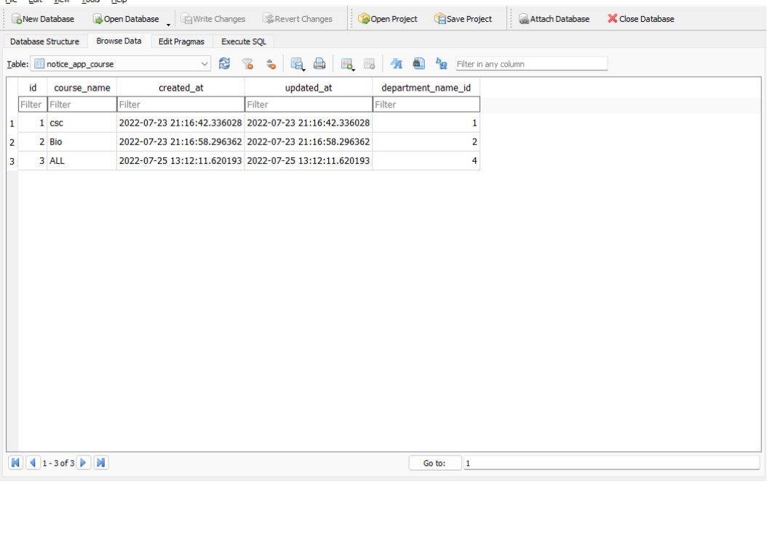

**Figure 4.1: Course collection**

37

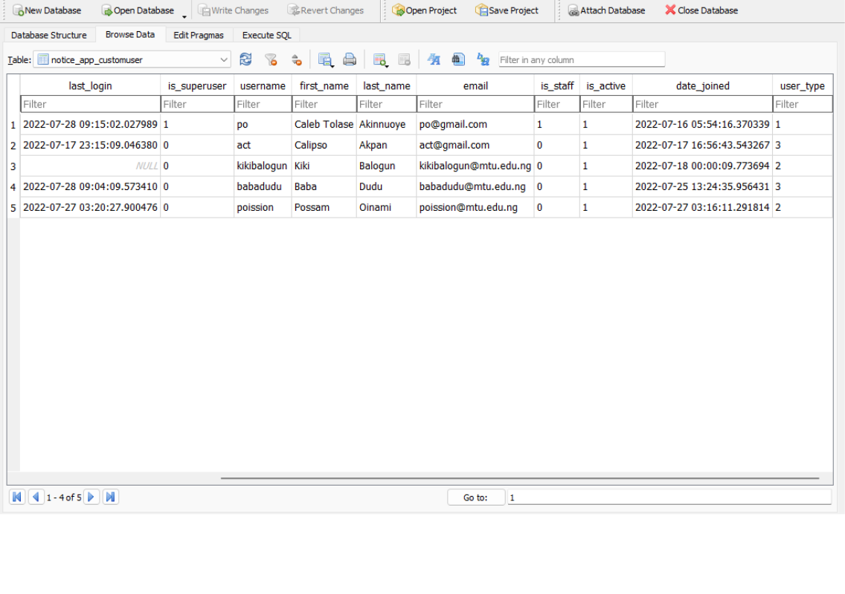

**Figure 4.2: User Collection**

38

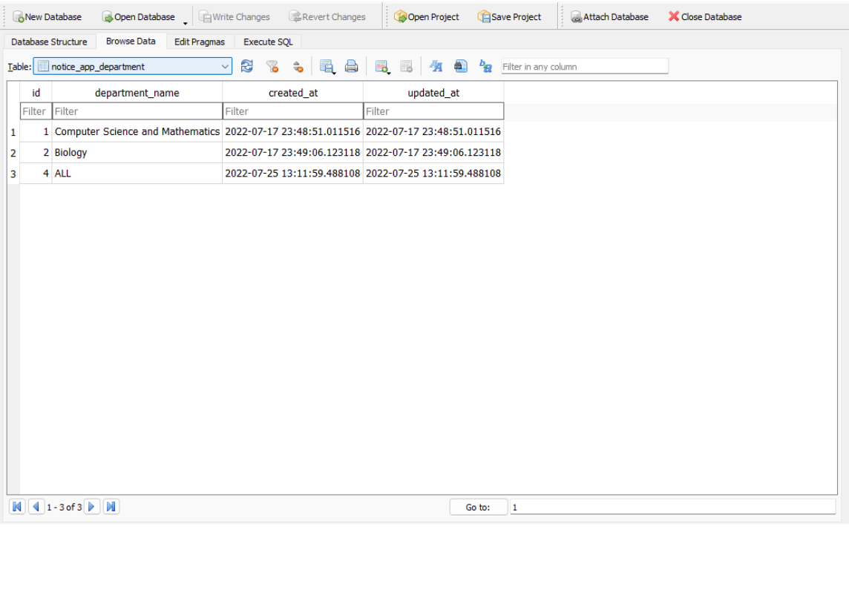

**Figure 4.5: Department Collection**

39

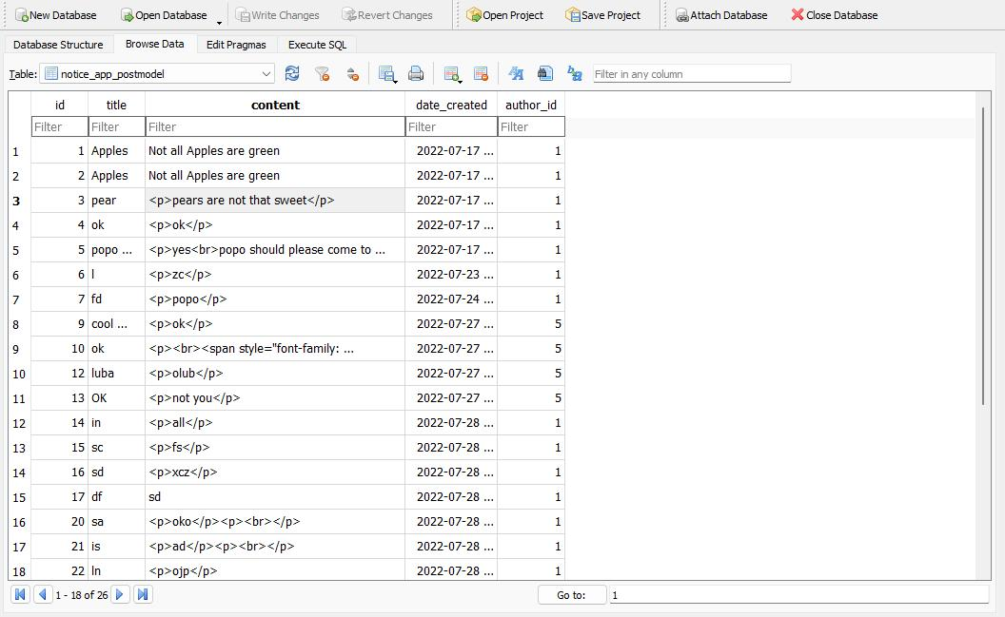

**Figure 4.6: Post Collection**

40

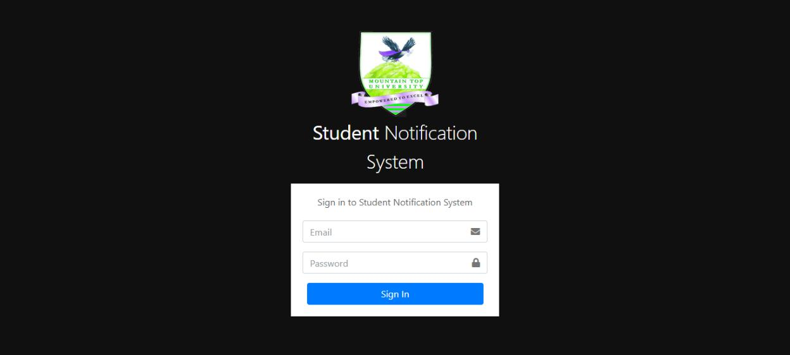

**Figure 4.7: Login View**

41

receivers (students and staff). Admin have access to view details of a notice made and along with that the admin have quick access to other pages via the navigation bar. Figure 4.7 shows the manage course view. Here the Admin can create courses which are assigned under departments to the system.

Admin can also use this to add special categories for student’s takin a particular group on the campus. E.g., usher under chaplaincy. Figure 4.8 is the manage department view. This page enables the admin to create departments that are under the school. E.g., biological sciences or chaplaincy. Figure 4.9 is the manage staff view which is used to create pre-defined sender(staff) users of the system. Admin can add, edit or delete a user. This page helps with dealing with users having issues with their login/account details and like to edit them. Or users who have lost access to their login details. The admin can easily edit and reset their password for them.

Figure 4.10 is the staff dashboard/home view. Here the staff can create and add notice that can be broadcasted out towards receivers (students and other staff). staff have access to view details of a notice made and along with that the staff have quick access to other pages via the navigation bar. Figure 4.11 is the student dashboard/home view. Here the student can read notice that have been broadcasted out by sender (admin and staff). Students have access to view details of a notice made and along with that the students have quick access to other pages via the navigation bar. Figure 4.12 is the notice detail view which is accessible by all users. In this section the user can view details of a particular notice and decide to make a complaint or a comment which was later viewed by the owner of the notice.

42

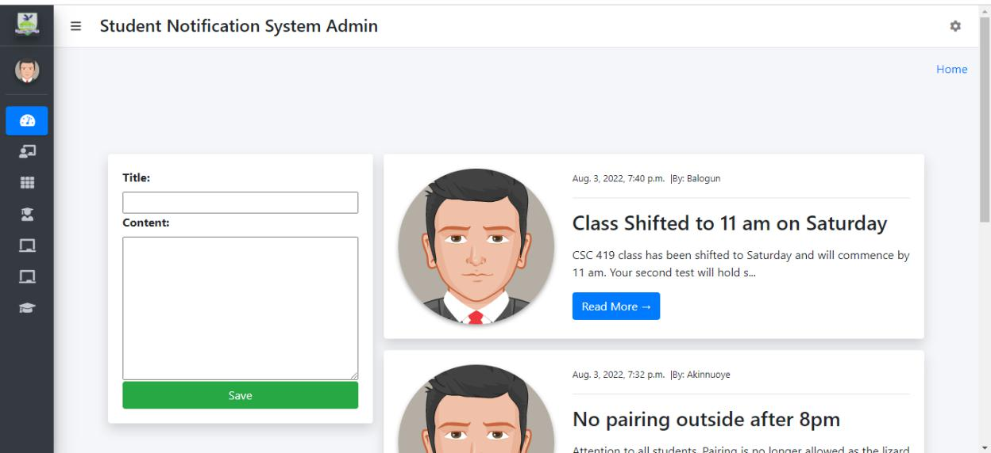

**Figure 4.8: Admin Home View**

43

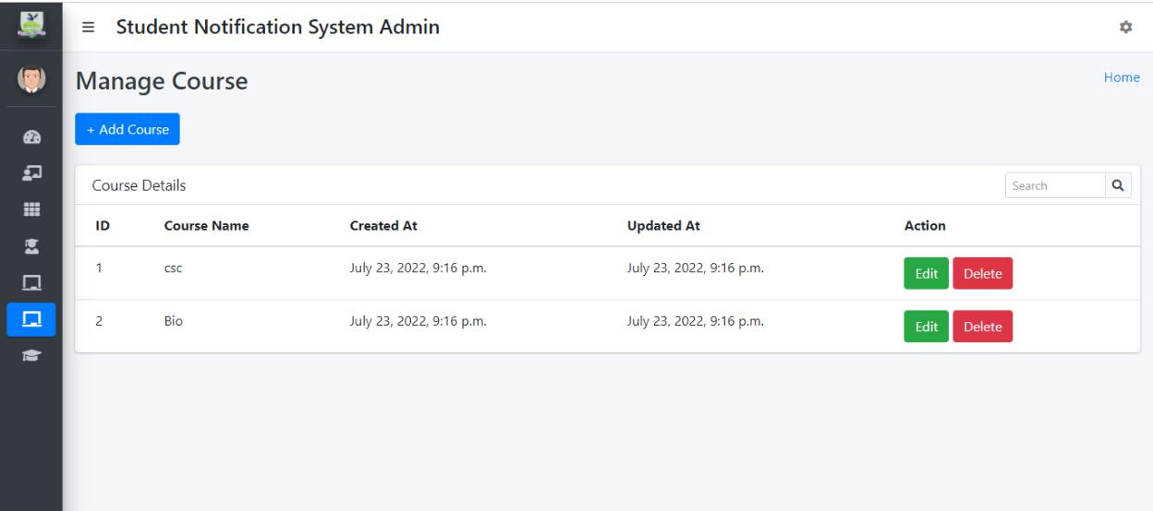

**Figure 4.9: Course Management View**

44

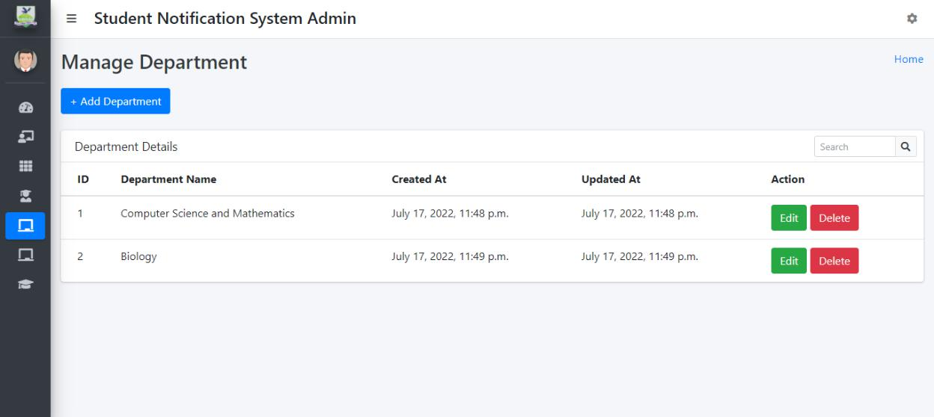

**Figure 4.10: Department Management View**

45

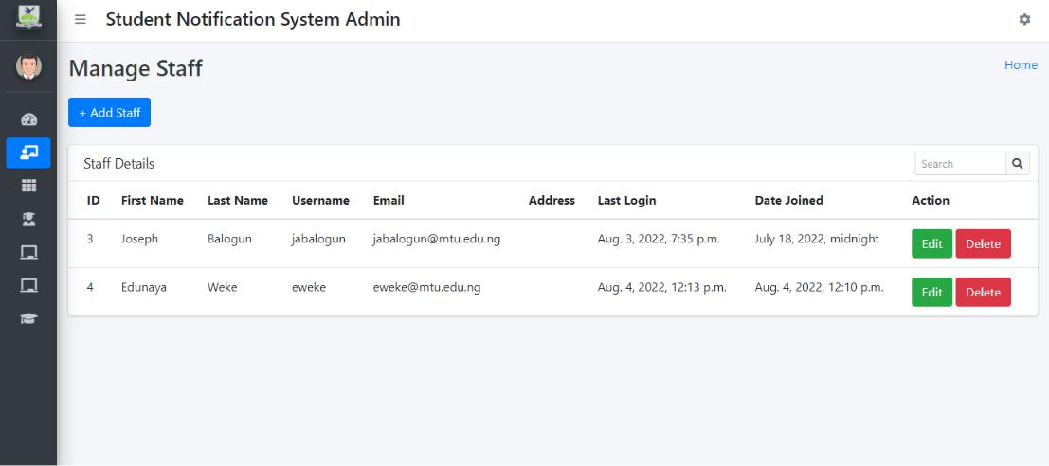

**Figure 4.11: Manage Staff View**

46

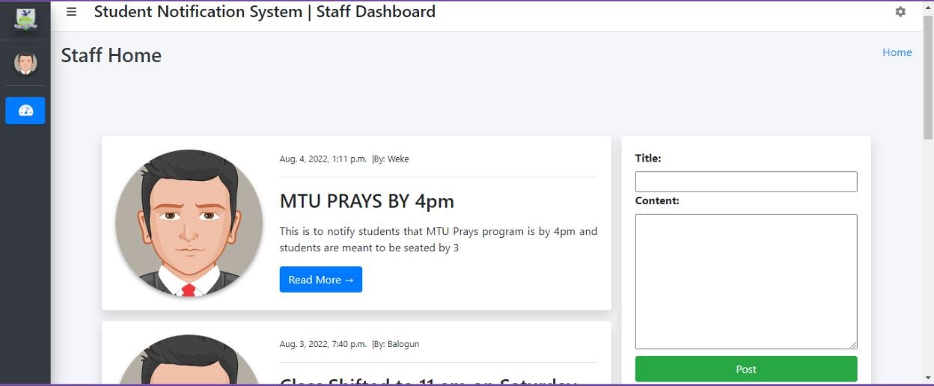

**Figure 4.12: Staff Home view**

47

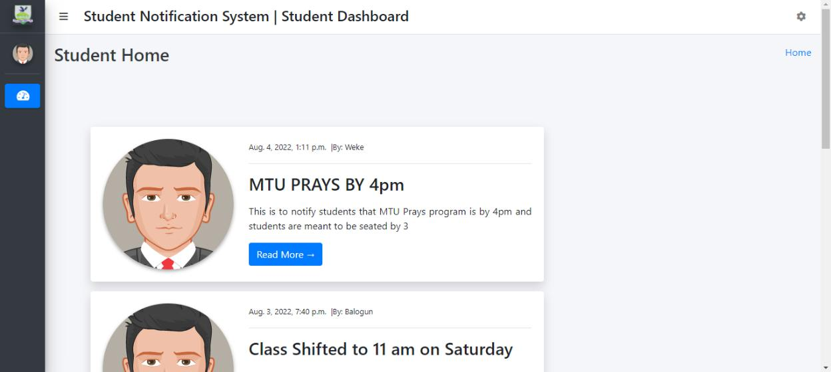

**Figure 4.13: Student Home View**

48

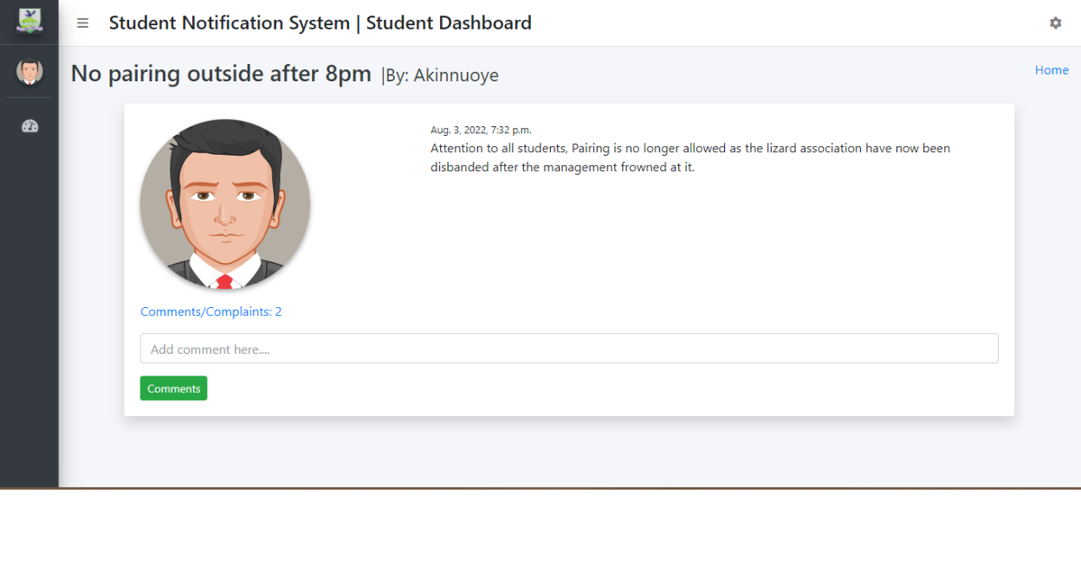

**Figure 4.14: Notice Detail View**

49

**4.3** **Discussion of Result**

The result of the study on the topic of Identity and Access Management systems presented expected results based on the objectives that were initially stated on the topic. The results of the identification of user and system requirement aided the definition of the system users been the admin user, staff(sender) user and student(receiver) user. The results reveal that the admin user is responsible for creating login accounts for users of the system both sender and receiver in which staff(sender) have the ability to send notifications and also read notifications and comment or issue complain on a notice. The admin is responsible for creating various department that exist in Mountain Top University. It shows that admin is also responsible for creating courses (or unit groups) and assigning them to a department.

The result reveals that the staff (sender) users are responsible for sending notifications and reading notifications. They are also responsible for reading and making replies to complaints/comments. This user is also responsible for deleting and edition of notification that they post. The result reveals that student (receiver) users are responsible for receiving and reading notices.

The result also revealed that the methods incorporated in this study cater to the user and system requirement initially specified for the system with a unique interface for each user role and a database that handles records for all the involved entities in the system and their various operations. Hence it is safe to say that the result of this system presents a solution to the manual method of sending notification and passing information around the university environment.

50

**CHAPTER FIVE**

**CONCLUSION AND RECOMMENDATIONS**

**5.1.** **Summary**

This project created an announcement app system that enables the admin, management and academic staff to efficiently disseminate information to students as well as get student feedback via comments from their posts within a short amount of time without physically be there. During this study, the system's software and hardware requirements were identified together with the user and system requirements that had to be satisfied. In order to represent user requirements and systems, UML diagrams such as use case diagrams, activity diagrams, sequence diagrams, and class diagrams were used to specify the requirements. The frontend of the system was created using HTML, CSS, and JavaScript, and Firebase was used to handle the system's database.

**5.2.** **Conclusion**

In conclusion, this study has designed and implemented an announcement app as an information dissemination system that allows users to receive and send announcement using their mobile devices solves the challenges of communication barriers faced during the dissemination of announcement. The study was able to determine the system and user requirements by identifying the numerous limitations that characterized this system. The designs for this system were sufficiently described with pertinent UML diagrams in order to be compatible with the intended functions of the suggested system.

**5.3.** **Recommendation**

The study recommends that future works in this area be done to integrate various announcement and communication functions such as live chat room,

51

anonymous complain and reporting, and image or video conferences and advertisements, etc. into the system developed in this study to create a robust unified platform that can handle all operations about information dissemination.

52

**References**

Aboyade, W. A., & Ogunsola, L. A. (2005). “Information and Communication Technology in Nigeria: Evolution or Revolution,. *J. Soc. Sci, 11*(1), 7–14.

Apata, G., & Ogunrewo, J. O. (2010). Analysis of Traditional Information Dissemination and Communication Method among Rural Farmers. Evidence from Traditional Communities in Nigeria. *Department of Library Services, JABU*, 1-8.

Ariztia, J. (2020, June 6). *What are dissemination strategies?* Retrieved from ASKINGLOT: https://askinglot.com/what-are-dissemination-strategies

BAIF Development Research Foundation. (1992). INFORMATION

DISSEMINATION FOR COMMUNITY DEVELOPMENT.

*INTERNATIONAL DEVELOPMENT RESEARCH CENTRE*, 1-21.

Bharamagoudar, S., Geeta, R., & .Totad, S. (2013). Web Based Student Information Management. *International Journal of Advanced Research in Computer and Communication Engineering*.

Dowd, M. (2021, January 11). *Tools for Disseminating Workplace Information*. Retrieved from chron.com: https://work.chron.com/tools-disseminating-workplace-information-11070.html

Dudek, C. (1991). *Guidelines on the Use of Changeable Message Signs.* Washington, DC: U.S. Department of Transportation.

Dwayne, D. C., Orr, C. L., & Kelemen, D. B. (2006). METHODS OF

INFORMATION DISSEMINATION TO LIMITED-SCALE LANDOWNERS. 5.

DWTDI Project. (n.d.). *Why disseminate information?* Retrieved from Different ways to disseminate information: http://dwtdi.wikidot.com/blog:whydisseminate

53

Harmsworth, S., & Turpin, S. (2000). Creating an Effective Dissemination Strategy (An Expanded Interactive Workbook for Educational Development Projects). *TQEF National Co-ordination Team*, 17-23.

igi-global. (n.d.). *What is Information Dissemination.* Retrieved from igi-global: https://www.igi-global.com/dictionary/intelligence-security-informatics/14382 Jadhav, S. L., Mhade, T. R., Gosavi, M. K., & Jagushte, S. S. (2016). Web based Notification Management System. *IJSTE - International Journal of Science*

*Technology & Engineering, Volume 2*(Issue 10), 3.

Jadhav, S. L., Mhade, T. R., Gosavi, M. K., & Jagushte, S. S. (2016). Web based Notification Management System. *IJSTE - International Journal of Science Technology & Engineering, Volume 2*(Issue 10), 3.

Jin, M.-s., Qiu, C.-l., & Li, J. (2012). “The Designment of student information

management system based on B/S architecture. *978-1- 4577-1415-3/12*.

Karanam, S., Matasugur, N., Sandhya, & Swathi, D. (2019). College Notification System, . 1.

Merriam Webster. (n.d.). *What is dissemination?* Retrieved from Merriam Webster:

https://www.merriam-webster.com/dictionary/dissemination

Norasiah M.A., N. A. (2003). Intelligent student information system. *International conference on telecommunication technology proceedings, Shah Alam, Malaysia*.

Orr, C. (2003). . Informational Needs of Limited-Scale Landowners within the Urban/Rural Interface of Lincoln County, Oklahoma.

Rosmani, A. F., Mutalib, A. A., & Sarif, S. M. (2020). The evolution of information dissemination, communication media and technology in Malaysia. *Journal of Physics: Conference Series*, 1-11.

54

TANG, Y.-f., & ZHANG, Y.-s. (2009). Design and implementation of college student information management system based on the web service. *Natural Science Foundation of Shandong Province*.

Xapdigital. (2020, March 14). *Announcement App*. Retrieved from salesforce.com: https://appexchange.salesforce.com/appxListingDetail?listingId=a0N3A00000 G0yDmUAJ

Zhibing Liu, H. W. (2010). Design and implementation of student information management system. *International symposium on intelligence information processing and trusted computing*, 1.

Zhi-gang YUE, Y.-w. J. (2010). he development and design of the student management system based on the network environment. *International Conference on Multimedia Communications*, 6-5.

Zoikoczy, P. (1981). Information Technology: An Introduction. 157.

55