AFFINITY AND REACTIVITY STUDIES OF THE REACTION OF
HUMAN (Homo sapiens) AND CAT (Felis catus) HAEMOGLOBINS WITH 5,5´-DITHIOBIS(2-NITROBENZOATE)


BY

ABIMBOLA MODUPE OLATUNDE

B.Tech. (Hons) Pure & Applied Chemistry (LAUTECH, Ogbomosho), M.Sc Biophysical Chemistry (Ibadan)
Matric No.: 109422

A Thesis in the Department of Chemistry,
Submitted to the Faculty of Science in partial Fulfillment of the requirements for the Degree of

DOCTOR OF PHILOSOPHY
of the UNIVERSITY OF IBADAN

APRIL 2014

ABSTRACT

Some haemoglobins have high oxygen affinity (high-affinity) while others have low oxygen affinity (low-affinity) as exemplified in human and cat haemoglobins respectively. High-affinity haemoglobins bind organic phosphates strongly and this lowers their oxygen affinities and their CysF9[93]β sulphydryl reactivities. Low-affinity haemoglobins on the other hand, bind organic phosphates weakly, and their oxygen affinities are hardly affected. Consequently, an assumption which is yet to be verified is that the reactivity of their CysF9[93]β is not affected by organic phosphates. Furthermore, the reaction of 5,5´- dithiobis(2-nitrobenzoate) - DTNB - with CysF9[93]β of haemoglobins in the relaxed quaternary conformation has been found to be reversible but this is yet to be determined in the tense quaternary conformation. This research was therefore aimed at studying the effect of organic phosphate-binding on low-affinity cat haemoglobins and the reversibility of the reaction of DTNB with human deoxyhaemoglobin.
The major and minor haemoglobins in cat haemolysate were separated on a column of carboxymethylcellulose. Human oxyhaemoglobin was isolated from blood using standard laboratory techniques. Solutions of deoxyhaemoglobin were prepared by passing humidified nitrogen gas over an aliquot of oxyhaemoglobin. Pseudo-first order kinetics of the reaction of DTNB with the CysF9[93]β sulphydryl of human and cat haemoglobins were studied at 25°C. The DTNB concentration was varied while that of the sulphydryl was kept constant. The second order rate constants, k_{F}, were obtained from linear plots of the pseudo-first order rate constant, k_{obs}, versus the DTNB concentration. Equilibrium experiments were performed by adding 3 cm³ of a 50 μmol (haem) dm⁻³ haemoglobin solution into varying volumes of a stock 29 mmol dm⁻³ DTNB solution inside test tubes. The mixtures were equilibrated at 25°C for 6 to 8 hours. The absorbances of these mixtures were measured at 412 nm, using a UV-visible spectrophotometer, and substituted into an equation derived to determine the equilibrium constant, K_{equ}, of the reaction. All experiments were carried out between pH 5.6 and 9.0 for both the stripped and inositol hexakisphosphate (inositol-P₆)-bound haemoglobin. Data were analysed using descriptive statistics.
The percentages of major and minor haemoglobins in cat haemolysate were 60.0
± 4.0 and 40.0 ± 4.0 respectively. Plots of k_{obs} at constant pH against the DTNB concentration were linear. The plots had positive intercepts for deoxyhaemoglobin,

indicating that its reaction with DTNB is reversible. Stripped human oxyhaemoglobin gave a bell-shaped pH-dependence profile for k_{F}, with a maximum value of 31.9 ± 0.6 mol⁻¹dm³s⁻¹ at pH 7.1. In the presence of inositol-P₆, k_{F} decreased. In contrast, cat haemoglobins gave simple pH-dependence profiles. Inositol-P₆ increased k_{F} by about two-fold throughout the experimental pH range. The K_{equ} increased in the presence of inositol-P₆ for both cat haemoglobins and human deoxyhaemoglobin. This is an indication of increased affinity for DTNB in both haemoglobins. The affinity of deoxyhaemoglobin for DTNB was also higher compared to that of oxyhaemoglobin.
The CysF9[93]β of low-affinity cat haemoglobins had their reactivities increased by inositol hexakisphosphate. The reaction of 5,5´-dithiobis(2-nitrobenzoate) with haemoglobin was reversible in the tense quaternary structure.
Keywords: Oxygen affinities, Relaxed and tense quaternary structures, Sulphydryl group reactivities, Inositol hexakisphosphate, Human and cat haemoglobins.

Word count: 493

DEDICATION

TO THE GLORY OF GOD THE FATHER, SON AND HOLY SPIRIT AND
IN MEMORY OF MY LATE FATHER, ENGINEER ISAAC OLUFUNMINIYI BABAFUNSO
AND

IN HONOUR AND APPRECIATION OF MY SWEETHEART, MR OLUFEMI OLATUNDE

ACKNOWLEDGEMENTS

The Lord God Almighty has been so good to me; this work is a living proof. I could never have done anything in it without Him; He started it and completed it. I give all glory to His Holy Name.
I am ever indebted to Professor K. O. Okonjo, who not only supervised this work but gave me hope when I had none of ever pursuing a PhD degree; he agreed to supervise me even when it looked impossible. You have given my life a new meaning and I cannot thank you enough for your fatherly supervision and constant corrections that have bettered my life thus far. It is a privilege to be called your student.
The equally exceptional co-supervision given by Professor J. O. Babalola is deeply appreciated. Thank you for being there in all the hard and rough times, and especially for opening up a link for me to work in a laboratory of international repute in Italy.
I also appreciate the Head of the Department of Chemistry, Professor A. A. Adesomoju, and Professors R. O. Oderinde & O. O. Osibanjo, who had been heads of the department at one time or the other during the course of this work. All members of staff of the department are also highly appreciated.
I thank the Alexander von Humboldt Foundation, Bonn, Federal Republic of Germany, for supporting Professor K.O. Okonjo with equipment grants for over three decades. The research grants, which were provided to Prof. K. O. Okonjo and Prof. J. O. Babalola by the University of Ibadan, are also appreciated. The equipment support grant, which was made available by the Post-graduate school of the University of Ibadan, is also highly appreciated. The Macarthur Foundation, University of Ibadan, is immensely appreciated for the overseas training grant awarded me to carry out some part of this research in Italy.
I am greatly indebted to Professor Stefano Bettati, my host, and all the members of the Department of Biochemistry and Molecular Biology, University of Parma, Italy, under the leadership of Professor Andrea Mozarrelli, for creating a conducive atmosphere for research and accommodating me throughout my stay in Italy. Professor Bettati and his wife went out of their way to make things easy for me in a non-English speaking country. I am very grateful to Drs. Luca Ronda (my amiable tutor) and Stefano Bruno.
The family of Pastor and Mrs Solomon Modupe gave me a home away from home in Italy. For this, I express my deepest appreciation and to the entire members of Zoe

Pentecostal Ministry, Reggio Emilia, Italy for taking me as one of their own during my stay in Italy.
Mrs. Victoria Aderinokun’s contribution to this PhD research work, in terms of man-power, cannot be quantized. To you I owe, in part, the work done with cat haemoglobins in this thesis. I also thank Mr. Joel Ajayi and Mrs. Ronke Lawal for their technical support of this research. In the same vein, I thank Messrs Dimeji Abiola, Nurudeen Odedare. Messrs Gabriel Orodepo and Gbenga Peleyeju are appreciated for lifting up my weary hands at different times of need.
I appreciate my research colleagues, including Drs. Gbenga Bello, Abideen Adeogun, Matthew Adebayo, Benevolent Atolaiye, John Ajaelu, Mrs. Toyin Enang- Fasuyi and Mrs. Bisola Adediji, for the knowledge they exchanged with me and for all their cooperation. Drs. Kamil Yusuff, Vincent Oninla, Messrs Victor Adedeji, Martins Omorogie and Mrs. L. C. Overah are also appreciated.
My academic colleagues are all appreciated for their contribution in no small measure to the success of this research work. In particular, I am grateful to Drs. Tola Omoregie, Nnenna Odozi, Olaolu Olaoluwa and Mrs. Tunmise Eugene-Osoikhia.
My mother, Mrs Oluremi Aduke Babafunso, my parents-in-law, Papa Samuel and Mama Esther Olatunde are highly appreciated for being supportive throughout. God blessed me with wonderful in-laws: I cannot forget especially Miss Bose Oyelowo and Mrs Toyin Adedokun nee Olatunde, both of whom were very helpful in taking care of my children at different times when I was just not available. My siblings, Tolu, Tope, Titi and Dare are acknowledged.
I also specially appreciate the following people: Dr. (Mrs.) Olapeju Aiyelaagbe, Dr. and Mrs. Kolawole Ajanaku, Dr. Adedayo Fodeke, Dr. G. O. Adewuyi, Dr. B. O. Olu-Owolabi, Dr (Mrs) Ajayi, Dr. Aderoju Osowole, Dr. Nelson Obi-Egbedi, Pastor and Pastor (Mrs.) Toyese Oyebisi, Mr. and Mrs. Segun Oyebola and Mr. and Mrs. Bayo Adedeji. I am immensely grateful to Dr. F. O. Ogundare (Acting Head, Physics department).
Next to my Lord Jesus Christ, my husband, Mr. Olufemi Olatunde, deserves my deepest gratitude for everything I cannot begin to mention here. It is an honour and joy to be your wife, a privilege I have never stopped thanking God for. You stood by me and supported me all through; I still wonder if there is something good I did to be given you. Thanks.

I apologize to my lovely children, Oluwadunsin, Oluwadara and Oluwatobiloba, for not being totally there for you these important formative years. I only hope we can make up for the time lost. Thank you for bearing with me.
I once again praise the Lord God Almighty, the Alpha and Omega, Who gave me a good beginning in completing this thesis. I know He will be with me till the end. THANK YOU, FATHER.
Abimbola Modupe OLATUNDE

CERTIFICATION

We certify that the work reported in this thesis was carried out under our supervision by Abimbola Modupe OLATUNDE in the Department of Chemistry, University of Ibadan, Ibadan.

…………………….………….………..…….
Supervisor Kehinde Onwochei Okonjo
B.Sc., Ph.D (Ibadan) Professor, Department of Chemistry
University of Ibadan Ibadan, Nigeria

….………………..………..……..………….
Co-Supervisor Jonathan Oyebamiji Babalola
B.Sc. (Ed) (O.A.U.), MSc., Ph.D (Ibadan)
Professor, Department of Chemistry University of Ibadan
Ibadan, Nigeria

 | TABLE OF CONTENTS
Subject  Title |  | Page  i
Abstract |  | ii
Dedication |  | iv
Acknowledgements |  | v
Certification |  | viii
Table of contents |  | ix
List of Figures |  | xiv
List of Tables |  | xxi

CHAPTER ONE INTRODUCTION

  - Proteins and oxygen transport 1
  - Haemoglobin 2
    - The globin 2
    - The haem… 9
  - The levels of protein structure in haemoglobin 14
    - Protein primary structure 16
    - Protein secondary structure 18
    - Protein tertiary structure 21
    - Quaternary structure of proteins 25
    - The nomenclature of amino acids in haemoglobin… 25
  - Human (Homo sapiens) haemoglobin 27
  - Domestic cat (Felis catus) haemoglobins 29
  - Aim of this work 31
CHAPTER TWO LITERATURE REVIEW
  - Structure-function relationship in haemoglobin 32
  - Molecular bases for the quaternary structure change 34
    - Allostery 38
    - Cooperativity and the Bohr Effect 40
  - The biochemistry of sulphydryl groups 52
    - Sulphydryl groups in haemoglobins 53
    - The CysF9(93)β sulphydryl group 54
    - Sulphydryl 57
      - Mercaptide formation 59
      - Alkylation 60
      - Addition across C=C bond 60
      - Oxidation of sulphydryl groups 61
CHAPTER THREE MATERIALS AND METHODS
  - Chemicals. Equipment and Software used 63
    - List of chemicals and reagents 63
    - List of equipment 64
    - List of software 65
  - Preparation of buffer solutions 66
    - Preparation of standard buffer solutions… 66
    - Preparation of phosphate buffer solutions: pH 5.6 – 8.0… 66
    - Preparation of borate buffer solutions: pH 8.0 – 9.0… 68
  - Preparation of reagents and samples 70
    - Preparation of anticoagulant 70
    - Preparation of saline solution 70
    - Preparation of dialysis solution 70
    - Preparation of inositol hexakisphosphate (inositol-P₆) solution 70
    - Preparation of carbon monoxide gas 71
    - Preparation of Drabkin’s solution 73
    - Preparation of 5, 5′-dithiobis(2-nitrobenzoate), DTNB, solution 73
    - Preparation of buffer solutions for haemoglobin separation 73
    - Preparation of resins and packing of Dintzis column 74
      - Preparation of resins 74
      - Packing of Dintzis column 75
  - Preparation of haemoglobin 77
    - Preparation of cat haemolysate 77
    - Separation of cat haemoglobins 77
    - Preparation of human deoxyhaemoglobin 79
  - Determination of haemoglobin concentration 83
    - Determination of carbonmonoxyhaemoglobin concentration 83
    - Determination of oxyhaemoglobin concentration 83
    - Determination of aquomethaemoglobin concentration 84
  - Kinetics 84
    - Kinetics of reaction of 5,5'-dithiobis(2-nitrobenzoate) with the
sulphydryl groups of human oxyhaemoglobin A 84
    - Kinetics of reaction of 5,5'-dithiobis(2-nitrobenzoate) with the
sulphydryl groups of human deoxyhaemoglobin A 86
    - Kinetics of reaction of 5,5'-dithiobis(2-nitrobenzoate) with the
sulphydryl groups of cat haemoglobins 87
  - Equilibrium studies 87
    - Determination of equilibrium constants for the reaction of DTNB
with sulphydryl groups of human deoxyhaemoglobin A 87
    - Determination of equilibrium constants for the reaction of DTNB
with sulphydryl groups of cat haemogobin (T quaternary state) 88
CHAPTER FOUR RESULTS
  - Kinetics 90
    - The theory of haemoglobin kinetics 90
    - Kinetics of reaction of human oxyhaemoglobin A with DTNB 92
      - Stripped human oxyhaemoglobin A 92
      - Human oxyhaemoglobin A in the presence of inositol-P₆ 99
      - Determination of the apparent forward second order rate constant (k_{F})
for the reaction of DTNB with stripped human oxyhaemoglobin 105
      - pH dependence of the apparent forward second order rate constant, k_{F} 110
    - Kinetics of the reaction of human deoxyhaemoglobin A with DTNB 114
      - Determination of the apparent forward second order rate constant (k_{F})
for the reaction of DTNB with stripped human deoxyhaemoglobin 125
    - Theoretical analysis of pH dependence of the apparent forward second
order rate constant 128
    - Kinetics of the reaction of DTNB with cat haemoglobin in the presence of inositol-P₆ 132
      - Determination of the pseudo first order rate constant, k_{obs}, for the reaction of DTNB with minor cat oxyhaemoglobin in the presence of
inositol-P₆ 138
      - Determination of the apparent forward second order rate constant (k_{F}) for the reaction of DTNB with minor cat oxyhaemoglobin in the presence of
inositol-P₆ 144
      - pH dependence of k_{F} for minor cat oxyhaemoglobin 148
  - Equilibrium studies 156
    - Theory of the equilibrium reaction 156
    - Determination of the equilibrium constant, K_{equ}, for the reaction of human deoxyhaemoglobin A with DTNB 159
    - pH dependence of the equilibrium constant, K_{equ}, for the reaction of stripped human deoxyhaemoglobin A with DTNB 159
    - Quantitative analyses of the pH dependence profiles of –log₁₀K_{equ} 165
    - Determination of the equilibrium constant, K_{equ}, for the reaction of DTNB
with cat haemoglobins in the presence of inositol-P₆ 172
    - pH dependence of the equilibrium constant, K_{equ}, for the reaction of cat haemoglobins with DTNB in the presence of inositol-P₆ 172
    - Effect of inositol-P₆ on the pH dependence profiles of –log₁₀K_{equ} for
the reaction of DTNB with cat haemoglobins 185
    - Quantitative analyses of the pH dependence profiles of –log₁₀K_{equ} 192
CHAPTER FIVE DISCUSSION
  - Human Haemoglobin 205
    - Kinetics 205
      - Reversibility of the reaction of DTNB with haemoglobins 205
      - Comparison of the rates of reaction of oxy- and deoxyhaemoglobin 206
      - Effect of pH on k_{F} 206
    - Equilibrium studies 208
      - Comparisn of the affinities of deoxy- and oxyhaemoglobin for ligands… 208
  - Cat haemoglobin… 210
    - Kinetics… 210
      - Effect of inositol-P₆ on k_{F} 210
    - Equilibrium studies 210
      - Effect of inositol-P₆ on the pH dependence of K_{equ} 210
CHAPTER SIX CONCLUSION AND RECOMMENDATION
  - Conclusion 212
  - Recommendation 212
REFERENCES 213
APPENDICES 226

LIST OF FIGURES

Figure Subject Page
1.1a General structure of an amino acid 3
1.1b Formation of a peptide bond between two amino acids 3
  - c The L and D isomers of amino acids 3
  - Selenocysteine, the 21st L-α amino acid 8
  - a A pyrrole molecule 10
  - b The porphyrin skeleton 10
  - a Protoporphyrin IX 11
  - b Ferro–protoporphyrin IX 11
  - Coordination of the iron atom in haem 13
  - Levels of structure in proteins 15
  - The primary structure of a pentapeptide 17
  - The structure of a helix 19
  - a Antiparallel β sheet 20
  - b Parallel β sheet 20
  - a Structure of myoglobin by 3-D Fourier synthesis 22
  - b Structure of myoglobin: schematic ribbon model 23
  - Formation of a disulphide bond 24
  - A molecular 3-D ribbon model of haemoglobin 26
2.1a 3-D molecular model and 2-D drawing showing the position of the iron
ion in the haem of deoxyhaemoglobin 33
  - b Schematic diagram showing Fe²⁺ out of plane of the porphyrin in the
haem group of deoxyhaemoglobin 33
  - 15 degrees rotation of an αβ dimer on transition from T to R state 36
  - A schematic representation of the salt bridges that are broken during
the transition from the T to the R state 37
  - Sequential model of allostery for a tetrameric protein (e.g. haemoglobin) showing the sequential changes in the conformation of a subunit from
the pure unligated T state to the fully liganded R state… 39
  - A plot of fractional saturation against partial pressure of oxygen pO₂ for myoglobin and haemoglobin 42

  - a Effect of pH and CO₂ concentration on the oxygen affinity of haemoglobin 43
  - b Direct determination of the Bohr effect from plots of proton uptake
against pH 44
  - a The binding site of 2,3-BPG in deoxyhaemoglobin 47
  - b The binding site of inositol-P6 in deoxyhaemoglobin 48
  - Oxygen saturation curves comparing the oxygen affinities of foetal and
maternal red blood cells 49
  - Organic phosphates that act as allosteric effector molecules 51
  - Structure of some sulphydryl reagents 58
  - Set up for the preparation of carbon monoxide 72
  - Dintzis column 76
  - a Set-up for the deoxygenation of haemoglobin 81
3.3b Deoxygenation of haemoglobin solution in progress 82
  - A typical kinetic trace for the reaction of DTNB with the sulphydryl groups
of stripped human oxyhaemoglobin A in phosphate buffer pH 6.59 93
  - A typical kinetic trace for the reaction of DTNB with the sulphydryl groups
of stripped human oxyhaemoglobin A in phosphate buffer pH 7.39 94
  - A typical kinetic trace for the reaction of DTNB with the sulphydryl groups
of stripped human oxyhaemoglobin A in borate buffer pH 8.87 95
  - Semi-logarithmic plot of the time course for the reaction of 5,5'-dithiobis (2-nitrobenzoate) with stripped human oxyhaemoglobin A sulphydryl
Groups in phosphate buffer pH 6.59 96
  - Semi-logarithmic plot of the time course for the reaction of 5,5'-dithiobis (2-nitrobenzoate) with stripped human oxyhaemoglobin A sulphydryl
groups in phosphate buffer pH 7.39 97
  - Semi-logarithmic plot of the time course for the reaction of 5,5'-dithiobis (2-nitrobenzoate) with stripped human oxyhaemoglobin A sulphydryl
groups in borate buffer pH 8.87 98
  - A typical kinetic trace for the reaction of 5,5'-dithiobis(2-nitrobenzoate) with sulphydryl groups of human oxyhaemoglobin A in the presence of
inositol-P₆ in phosphate buffer pH 6.60 100

  - a A typical kinetic trace for the reaction of 5,5'-dithiobis(2-nitrobenzoate) with sulphydryl groups of human oxyhaemoglobin A in the presence of
inositol-P₆ in phosphate buffer pH 7.39 101
  - b A typical kinetic trace for the reaction of 5,5'-dithiobis(2-nitrobenzoate) with sulphydryl groups of human oxyhaemoglobin A in the presence of
inositol-P₆ in boratate buffer pH 8.40 102
  - Semi-logarithmic plot of the time course for the reaction of 5,5'-dithiobis (2-nitrobenzoate) with sulphydryl groups of human oxyhaemoglobin A
in the presence of inositol-P₆ in phosphate buffer pH 6.60 103
  - Semi-logarithmic plot of the time course for the reaction of 5,5'-dithiobis (2-nitrobenzoate) with sulphydryl groups of human oxyhaemoglobin A
in the presence of inositol-P₆ in phosphate buffer pH 7.39 104
  - Dependence of the pseudo-first order rate constant, k_{obs,} on [DTNB] for the reaction of DTNB with CysF9[93]β of stripped human
oxyhaemoglobin A in phosphate buffer pH 6.59 106
  - Dependence of the pseudo-first order rate constant, k_{obs,} on [DTNB] for the reaction of DTNB with CysF9[93]β of stripped human
oxyhaemoglobin A in phosphate buffer pH 7.39 107
  - Dependence of the pseudo-first order rate constant, k_{obs,} on [DTNB] for the reaction of DTNB with CysF9[93]β of human oxyhaemoglobin A in
the presence of inositol-P₆ in phosphate buffer pH 6.60 108
  - Dependence of the pseudo-first order rate constant, k_{obs,} on [DTNB] for the reaction of DTNB with CysF9[93]β of human oxyhaemoglobin A in
the presence of inositol-P₆ in phosphate buffer pH 7.39 109
  - Dependence of k_{F,} the apparent forward second order rate constant, on pH for the reaction of CysF9[93]β of stripped human oxyhaemoglobin A with
5,5′-dithiobis(2- nitrobenzoate) 111
  - Dependence of k_{F,} the apparent forward second order rate constant, on pH For the reaction of CysF9[93]β of human oxyhaemoglobin with
5,5′-dithiobis(2- nitrobenzoate) in the presence of inositol-P₆ 112
  - Comparison of the pH-dependence profiles of k_{F,} for the reaction of CysF9[93]β of human oxyhaemoglobin A with
5,5′-dithiobis(2- nitrobenzoate) 113

  - A typical absorption spectrum of stripped human oxyhaemoglobin A
in phosphate buffer pH 6.80 115
  - A typical absorption spectrum of stripped human deoxyhaemoglobin A
in phosphate buffer pH 6.80 116
  - A typical absorption spectrum of stripped human deoxyhaemoglobin A
in phosphate buffer pH 6.80 at the end of a kinetic run 117
  - A typical kinetic trace for the reaction of 5,5'-dithiobis(2-nitrobenzoate) with sulphydryl groups of stripped human deoxyhaemoglobin A at 25°C:
absorbance versus time, [DTNB] = 100 μmol dm⁻³ 118
  - A typical kinetic trace for the reaction of 5,5'-dithiobis(2-nitrobenzoate) with sulphydryl groups of stripped human deoxyhaemoglobin A at 25ºC:
absorbance versus time, [DTNB] = 250 μmol dm⁻³ 119
  - A typical kinetic trace for the reaction of 5,5'-dithiobis(2-nitrobenzoate) with sulphydryl groups of stripped human deoxyhaemoglobin A at 25ºC:
absorbance versus time, [DTNB] = 400 μmol dm⁻³ 120
  - Semi-logarithmic plot of the time course for the reaction of 5,5'-dithiobis (2-nitrobenzoate) with stripped human deoxyhaemoglobin A sulphydryl
groups in phosphate buffer pH 8; [DTNB] = 100 μmol dm⁻³ 122
  - Semi-logarithmic plot of the time course for the reaction of 5,5'-dithiobis (2-nitrobenzoate) with stripped human deoxyhaemoglobin A sulphydryl
groups in borate buffer pH 8; [DTNB] = 250 μmol dm⁻³ 123
  - Semi-logarithmic plot of the time course for the reaction of 5,5'-dithiobis (2-nitrobenzoate) with stripped human deoxyhaemoglobin A sulphydryl
groups in phosphate buffer pH 8; [DTNB] = 400 μmol dm⁻³ 124
  - The dependence of the pseudo-first order rate constant, k_{obs}, on the DTNB concentration for the reaction of DTNB with stripped human
deoxyhaemoglobin A at 25°C 126
  - A comparison of the dependence of the pseudo-first order rate constant, k_{obs}, on the DTNB concentration for the reaction of DTNB with
stripped human oxy and deoxyhaemoglobin A at 25°C 127
  - A typical kinetic trace for the reaction of 5,5'-dithiobis(2-nitrobenzoate) with sulphydryl groups of minor cat oxyhaemoglobin in the presence of inositol-P₆
at 25°C: absorbance versus time, pH 6.04 133

  - A typical kinetic trace for the reaction of 5,5'-dithiobis(2-nitrobenzoate) with sulphydryl groups of minor cat oxyhaemoglobin in the presence of inositol-P₆
at 25°C: absorbance versus time, pH 7.12 134
  - A typical kinetic trace for the reaction of 5,5'-dithiobis(2-nitrobenzoate) with sulphydryl groups of minor cat oxyhaemoglobin in the presence of inositol-P₆
at 25°C: absorbance versus time, pH 8.45 135
  - A typical kinetic trace for the reaction of 5,5'-dithiobis(2-nitrobenzoate) with sulphydryl groups of minor cat oxyhaemoglobin in the presence of inositol-P₆
at 25°C: absorbance versus time, pH 8.60 136
  - A typical kinetic trace for the reaction of 5,5'-dithiobis(2-nitrobenzoate) with sulphydryl groups of minor cat oxyhaemoglobin in the presence of inositol-P₆
at 25°C: absorbance versus time, pH 8.80 137
  - Semi-logarithmic plot of the time course for the reaction of 5,5'-dithiobis(2- nitrobenzoate) with the minor cat oxyhaemoglobin sulphydryl groups in
the presence of inositol-P₆, phosphate buffer pH 6.04 139
  - Semi-logarithmic plot of the time course for the reaction of 5,5'-dithiobis(2- nitrobenzoate) with the minor cat oxyhaemoglobin sulphydryl groups in
the presence of inositol-P₆, phosphate buffer pH 7.12. 140
  - Semi-logarithmic plot of the time course for the reaction of 5,5'-dithiobis(2- nitrobenzoate) with the minor cat oxyhaemoglobin sulphydryl groups in
the presence of inositol-P₆, borate buffer pH 8.45 141
  - Semi-logarithmic plot of the time course for the reaction of 5,5'-dithiobis(2- nitrobenzoate) with the minor cat oxyhaemoglobin sulphydryl groups in
the presence of inositol-P₆, borate buffer pH 8.60 142
  - Semi-logarithmic plot of the time course for the reaction of 5,5'-dithiobis(2- nitrobenzoate) with the minor cat oxyhaemoglobin sulphydryl groups in
the presence of inositol-P₆, borate buffer pH 8.80 143
  - The dependence of the pseudo-first order rate constant, k_{obs}, on the DTNB concentration for the reaction of DTNB with the minor cat oxyhaemoglobin
in the presence of inositol-P₆ at 25°C, phosphate buffer pH 5.76 145
  - The dependence of the pseudo-first order rate constant, k_{obs}, on the DTNB concentration for the reaction of DTNB with the minor cat oxyhaemoglobin
in the presence of inositol-P₆ at 25°C, phosphate buffer pH 6.97 146

  - The dependence of the pseudo-first order rate constant, k_{obs}, on the DTNB concentration for the reaction of DTNB with the minor cat oxyhaemoglobin
in the presence of inositol-P₆ at 25°C, phosphate buffer pH 8.45 147
  - Dependence of k_{F,} the apparent forward second order rate constant, on pH for the reaction of CysF9[93]β of minor cat oxyhaemoglobin with
5,5′-dithiobis(2- nitrobenzoate) in the presence of inositol-P₆ 149
  - Comparison of the pH-dependence profiles of kF for the reaction of
CysF9[93]β of minor cat oxyhaemoglobin A with DTNB 150
  - Dependence of –log₁₀K_{equ} on pH for the reaction of DTNB with
CysF9[93]β of stripped human deoxyhaemoglobin A 162
  - Dependence of –log₁₀K_{equ} on pH for the reaction of DTNB with
CysF9[93]β of human deoxyhaemoglobin A in the presence of inositol-P₆ 163
  - A comparison between the dependence of –log₁₀K_{equ} on pH for the reaction of DTNB with the CysF9[93]β of stripped human oxy- and deoxyhaemo-
globin A 164
  - Dependence of –log₁₀K_{equ} on pH for the reaction of DTNB with
CysF9[93]β of the major cat oxyhaemoglobin in the presence of inositol-P₆ 176
  - Dependence of –log₁₀K_{equ} on pH for the reaction of DTNB with CysF9[93]β
of the major cat carbonmonoxyhaemoglobin in the presence of inositol-P₆ 177
  - Dependence of –log₁₀K_{equ} on pH for the reaction of DTNB with CysF9[93]β
of the major cat aquomethaemoglobin in the presence of inositol-P₆ 178
  - Dependence of –log₁₀K_{equ} on pH for the reaction of DTNB with CysF9[93]β
of the minor cat oxyhaemoglobin in the presence of inositol-P₆ 182
  - Dependence of –log₁₀K_{equ} on pH for the reaction of DTNB with CysF9[93]β
of the minor cat carbonmonoxyhaemoglobin in the presence of inositol-P₆ 183
  - Dependence of –log₁₀K_{equ} on pH for the reaction of DTNB with CysF9[93]β
of the minor cat aquomethaemoglobin in the presence of inositol-P₆ 184
  - Effect of inositol-P₆ on the equilibrium constant for the reaction of DTNB
with CysF9[93]β of the major cat oxyhaemoglobin 186
  - Effect of inositol-P₆ on the equilibrium constant for the reaction of DTNB
with CysF9[93]β of the major cat carbonmonoxyhaemoglobin 187
  - Effect of inositol-P₆ on the equilibrium constant for the reaction of DTNB
with CysF9[93]β of the major cat aquomethaemoglobin 188

  - Effect of inositol-P₆ on the equilibrium constant for the reaction of DTNB
with CysF9[93]β of the minor cat oxyhaemoglobin 189
  - Effect of inositol-P₆ on the equilibrium constant for the reaction of DTNB
with CysF9[93]β of the minor cat carbonmonoxyhaemoglobin 190
  - Effect of inositol-P₆ on the equilibrium constant for the reaction of DTNB
with CysF9[93]β of the minor cat aquomethaemoglobin 191
  - Typical kinetic traces of the reaction of DTNB with the sulphydryl groups of stripped human oxy and deoxyhaemoglobin… 207

LIST OF TABLES

Table Subject Page
  - L-α amino acids present in proteins classified based on the functional side Groups 5
  - a Amino acid sequence of the α chain of human haemoglobin A 28
  - b Amino acid sequence of the β chain of human haemoglobin A 28
  - a Amino acid sequence of the α chain of cat haemoglobins A & B 30
1.3b Amino acid sequence of the β chain of cat haemoglobin A 30
1.3c Amino acid sequence of the β chain of cat haemoglobin B 30
2.1 Titratable sulphydryl groups of various haemoglobins and their locations
in the haemoglobin molecule 56
  - The amounts of 0.4 mol dm⁻³ NaOH, 0.4 mol dm⁻³ NaH₂PO₄ and NaCl
required for phosphate buffers pH 5.6 - 8.0 67
  - The amounts of 0.3 mol dm⁻³ NaOH, 0.3 mol dm⁻³ H₃BO₃ and NaCl
required for borate buffers pH 8. 0 – 9.0 69
  - The reaction of CysF9[93]β of human oxyhaemoglobin A with
5,5′-dithiobis(2-nitrobenzoate) 131
  - The reaction of CysF9[93]β of minor cat oxyhaemoglobin with
5,5′-dithiobis(2-nitrobenzoate)in the presence of inositol-P₆ 151
  - The reaction of CysF9[93]β of stripped major cat oxyhaemoglobin with
5,5′-dithiobis(2-nitrobenzoate) 153
  - The reaction of CysF9[93]β of stripped minor cat oxyhaemoglobin with
5,5′-dithiobis(2-nitrobenzoate) 154
  - The reaction of CysF9[93]β of major cat oxyhaemoglobin with
5,5′-dithiobis(2-nitrobenzoate)in the presence of inositol-P₆ 155
  - Reaction of DTNB with CysF9[93]β of stripped human deoxyhaemoglobin A: raw data for the determination of K_{equ} 161
  - Reaction of DTNB with CysF9[93]β of stripped human deoxy- and oxyhaemoglobin: best-fit parameters used to fit equilibrium data… 168
  - Tertiary conformation transition constants, K_{rti}, for the haemoglobin species 170
  - Equilibrium constants, K_{Ei}, for the reaction of DTNB with the haemoglobin species… 171

  - Reaction of DTNB with CysF9[93]β of the major cat oxyhaemoglobin
+ inositol-P₆: raw data for the determination of K_{equ} 173
  - Reaction of DTNB with CysF9[93]β of the major cat carbonmonoxy haemoglobin + inositol-P₆: raw data for the determination of K_{equ} 174
  - Reaction of DTNB with CysF9[93]β of the major cat aquomethaemoglobin
+ inositol-P₆: raw data for the determination of K_{equ} 175
  - Reaction of DTNB with CysF9[93]β of the minor cat oxyhaemoglobin
+ inositol-P₆: raw data for the determination of K_{equ} 179
  - Reaction of DTNB with CysF9[93]β of the minor cat carbonmonoxy haemoglobin + inositol-P₆: raw data for the determination of K_{equ} 180
  - Reaction of DTNB with CysF9[93]β of the minor cat aquomethaemoglobin
+ inositol-P₆: raw data for the determination of K_{equ} 181
  - Reaction of 5,5′-dithiobis(2-nitrobenzoate) with the CysF9[93]β sulphydryl groups of the major derivatives of cat haemoglobin + inositol-P₆: best-fit parameters used to fit the equilibrium data reported in Figure 4.46 – 4.48 193
  - Reaction of 5,5′-dithiobis(2-nitrobenzoate) with the CysF9[93]β sulphydryl groups of the stripped derivatives of major cat haemoglobin 194
  - Reaction of 5,5′-dithiobis(2-nitrobenzoate) with the CysF9[93]β sulphydryl groups of the minor derivatives of cat haemoglobin + inositol-P₆: best-fit parameters used to fit the equilibrium data reported in Figure 4.50 – 4.52 195
  - Reaction of 5,5′-dithiobis(2-nitrobenzoate) with the CysF9[93]β sulphydryl groups of the derivatives of stripped minor cat haemoglobin 196
  - Reaction of DTNB with the CysF9[93]β sulphydryl groups of the stripped major cat haemoglobin: Tertiary conformation transition constants, K_{rti}, for
the haemoglobin species. 197
  - Reaction of DTNB with the CysF9[93]β sulphydryl groups of major cat haemoglobin in the presence of inositol-P₆: Tertiary conformation transition constants, K_{rti}, for the haemoglobin species. 198
  - Reaction of DTNB with the CysF9[93]β sulphydryl groups of the stripped minor cat haemoglobin: Tertiary conformation transition constants, K_{rti}, for
the haemoglobin species. 199
  - Reaction of DTNB with the CysF9[93]β sulphydryl groups of minor cat haemoglobin in the presence of inositol-P₆: Tertiary conformation transition constants, K_{rti}, for the haemoglobin species. 200

  - Reaction of DTNB with the CysF9[93]β sulphydryl groups of the stripped major cat haemoglobin: Equilibrium constants, K_{Ei}, for the reaction of DTNB
with the haemoglobin species… 201
  - Reaction of DTNB with the CysF9[93]β sulphydryl groups of major cat haemoglobin in the presence of inositol-P₆: Equilibrium constants, K_{Ei}, for the reaction of DTNB with the haemoglobin species 202
  - Reaction of DTNB with the CysF9[93]β sulphydryl groups of the stripped minor cat haemoglobin: Equilibrium constants, K_{Ei}, for the reaction of DTNB
with the haemoglobin species… 203
  - Reaction of DTNB with the CysF9[93]β sulphydryl groups of minor cat haemoglobin in the presence of inositol-P₆: Equilibrium constants, K_{Ei}, for the reaction of DTNB with the haemoglobin species 204

CHAPTER ONE INTRODUCTION


PROTEINS AND OXYGEN TRANSPORT

Oxygen plays a vital role in the breathing process and in the metabolism of living organisms. Probably the only living cells that do not need oxygen are some anaerobic bacteria that obtain energy from other metabolic processes. The oxidation of nutrient compounds (i.e. burning of nutrients by oxygen) is the source of energy for most animals, mainly mammals.
In the human body (and for most mammals), oxygen is absorbed in the lungs and transported by the blood stream to the cells where it is needed. Apart from the plasma, which takes up a great share (about 55%) of the total blood volume, 40% of the blood is made up of red blood cells (or erythrocytes); the remaining portion consists of white blood cells and platelets (Weed et al., 1963). The red blood cells consist mainly of about 95% of a protein known as haemoglobin, an iron-containing protein found in the red blood cells of vertebrates and in the tissues of some invertebrates. Haemoglobin transports oxygen from the lungs or gills to the rest of the body (i.e. the tissues) where it releases the oxygen for cell use. Myoglobin is another oxygen binding protein that is found in the muscles of some vertebrates. It serves as a storage protein for the oxygen transported by haemoglobin.
Some invertebrates have alternative proteins for oxygen transport. Examples of such proteins include haemocyanin and haemerythrin, which are found in the blood of arthropods and annelids respectively. Also, some Antarctic fishes do not require haemoglobin (Ruud, 1954). This is not a surprising adaptation since oxygen is more soluble in water at low temperatures. Consequently, the extremely cold Antarctic seas are rich in oxygen.

HAEMOGLOBIN

The name haemoglobin is a combination of two words: haem and globin. It is composed of four globular protein chains, each with a ring-like non-protein haem group. Each haem group contains one iron atom which can bind one oxygen molecule. Oxygen binds reversibly to these iron atoms and is transported through blood. When oxygen is bound to the iron atom, the haemoglobin changes colour from purple (the colour of deoxygenated haemoglobin) to bright red (the colour of oxyhaemoglobin). Haemoglobin has a molecular weight of 64,000 daltons. We now take a detailed look into these two components of haemoglobin.

The Globin
Haemoglobins are polymers of amino acids: the globin part of haemoglobin consists of polypeptide chains made up of amino acids. With the exception of proline, which has a secondary amino group, each amino acid has a carboxylic acid group, a primary amino group, a hydrogen atom and a distinctive side chain, an R – group, bonded to the central carbon atom, the α-carbon atom (Figure 1.1a).
Each amino acid residue is joined to its neighbour by a specific type of covalent bond called a peptide bond (Figure 1.1b). Of the over three hundred naturally occurring amino acids, only twenty (20) constitute the monomer units of most proteins, including haemoglobin (Champe et al., 1987, Murray et al., 2006). With four different groups attached to the α-carbon atom, amino acids are chiral and exist as laevorotatory and dextrorotatory isomers, which are mirror images of each other. Only the L- isomer amino acids are constituents of proteins (Figure 1.1c).

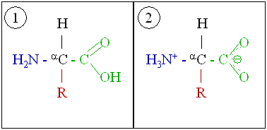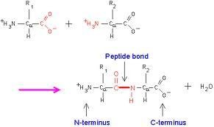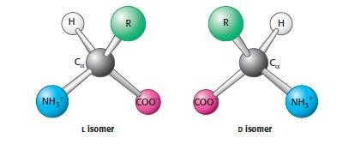Figure 1.1a: General structure of an amino acid in its unionized (1) and zwitterionic (2) form

Figure 1.1b: Formation of a peptide bond between two amino acids

Figure 1.1c: The L and D isomers of amino acids (Stryer, 2004)

Amino acids are often designated by either a three-letter abbreviation or a one- letter symbol. In proteins, almost all the carboxyl and amino groups are involved in peptide linkages (the joining together of amino acids by peptide bonds to form polypeptides) and are therefore not available for further reaction except for hydrogen bonding. The nature of the side chains or R – groups is therefore the determining factor of the role of an amino acid in a protein. Table 1.1 below summarises the list of the twenty essential L-α amino acids in proteins, classified based on the properties of their side chains. As shown in the Table, proline differs from other amino acids in that its side chain forms a five-membered ring structure with the α-amino nitrogen. As such, proline has a secondary amino goup and it is often referred to as an imino acid. In addition, Table 1.1 includes the nomenclature (full names, 3- and 1- letter symbols), the structural formulas of the amino acids as zwitter ions and the ionization constants, pK_{a}s, of all dissociable protons present of the twenty essential L-α amino acids in proteins.
A 21st L-α amino acid, selenocysteine (Figure 1.2), also found in a handful of proteins, is not included in the table. As its name implies, a selenium atom replaces the sulphur of its structural analogue, cysteine (Murray et al, 2003). However, unlike the other 20 genetically encoded amino acids (listed below), selenocysteine arises by a co- translational insertion from a previously modified amino acid. Moreover, it is not specified by a simple three-letter codon.

Table 1.1: L-α amino acids present in proteins, classified based on the functional group of the side chain. (Source: Murray et al. 2003)

NAME/ SYMBOL | STRUCTURAL FORMULA | pK₁  α-COOH | pK₂ α-NH ⁺  3 | pK₃  R Group
With Aliphatic Side Chains
Glycine Gly [G] |  | 2.4 | 9.8
Alanine Ala [A] |  | 2.4 | 9.9
Valine Val [V] |  | 2.2 | 9.7
Leucine Leu [L] | 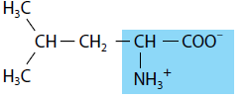 | 2.3 | 9.7
Isoleucine Ile[I] | 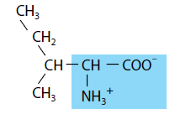 | 2.3 | 9.7
With Side Chains Containing Hydroxylic (OH) Groups
Serine Ser [S] | 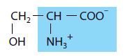 | 2.2 | 9.2 | about 13
Threonine Thr [T] | 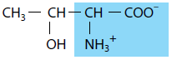 | 2.1 | 9.1 | about 13
Tyrosine Tyr [Y] | 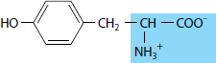 | 2.2 | 9.1 | 10.1
(continued…)

Table 1.1: (…continued)

NAME/ SYMBOL | STRUCTURAL FORMULA | pK₁  α-COOH | pK₂ α-NH ⁺  3 | pK₃  R Group
With Side Chains Containing Sulphur Atoms
Cysteine Cys [C] |  | 1.9 | 10.8 | 8.3
Methionine Met [M] |  | 2.1 | 9.3
With Side Chains Containing Acidic Groups or Their Amides
Aspartic acid Asp [D] |  | 2.0 | 9.9 | 3.9
Asparagine Asn [N] | 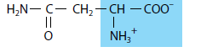 | 2.1 | 8.8
Glutamic Acid Glu [E] | 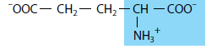 | 2.1 | 9.5 | 4.1
Glutamine Gln [Q] | 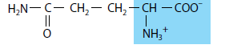 | 2.2 | 9.1
With Side Chains Containing Basic Groups
Arginine Arg [R] |  | 1.8 | 9.0 | 12.5
Lysine Lys [K] |  | 2.2 | 9.2 | 10.8
Histidine His [H] | 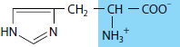 | 1.8 | 9.3 | 6.0
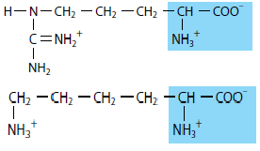
(continued…)

Table 1.1: (…continued)

NAME/ SYMBOL | STRUCTURAL FORMULA | pK₁  α-COOH | pK₂ α-NH ⁺  3 | pK₃  R Group
Containing Aromatic Rings
Histidine  His [H] | See above | 1.8 | 9.3 | 6.0
Phenylalanine Phe [F] |  | 2.2 | 9.2
Tyrosine Tyr [Y] | See above | 2.2 | 9.1 | 10.1
Tryptophan Trp [W] |  | 2.4 | 9.4
Imino Acid
Proline Pro [P] |  | 2.0 | 9.6

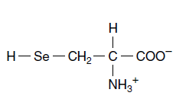Figure 1.2: Selenocysteine, the 21st L-α amino acid

The Haem
The haem is a small non-protein molecule (prosthetic group), consisting of an iron (Fe) ion, (i.e. a charged atom) chelated in between a heterocyclic ring known as porphyrin. One of the most important classes of chelating agents in nature are the porphyrins (Stryer, 2004). A porphyrin ring consists of four pyrrole molecules cyclically linked together with methylene bridges (Figures 1.3a and 1.3b).
Porphyrins are classified based on the constituents of their side chains. The most naturally abundant porphyrins are the protoporphyrins in which four methyl groups, two vinyl groups and two propionate groups are attached as side chains (Mathewson and Corwin, 1961). Protoporphyrins can exist in fifteen isomeric forms, depending on the arrangement of the side chains on the eight available positions. In haemoglobin, the common type of porphyrin found is protoporhyrin IX (Figure 1.4a) with the iron atom bound in the centre (Figure 1.4b). The iron atom in the centre of the ring coordinates with the four nitrogens of the pyrroles, which all lie in one plane. For oxygenation to occur, the iron atom is usually in the +2 state (Fe²⁺).

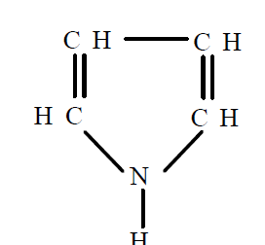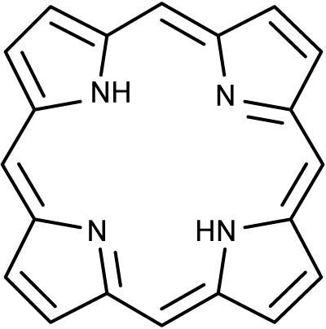Figure 1.3a: A pyrrole molecule

Figure 1.3b: The porphyrin skeleton

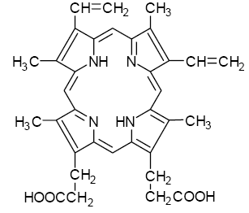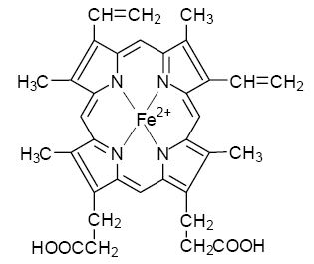Figure 1.4a: Protoporphyrin IX

Figure 1.4b: Ferro – protoporphyrin IX (Haem)

The haem resides in a small hydrophobic cleft within each globular protein (or polypeptide). It is held in the cleft by both hydrophobic interactions and a covalent bond between the iron and a nitrogen atom of a nearby histidine side chain, the proximal histidine, on the polypeptide. At the fifth co-ordination position, the iron is bound strongly to the globular protein via the imidazole ring of the histidine residue. This histidine residue is located below the porphyrin ring at the 87th and 92nd positions on the F8 helices of the α and β chains respectively. These correspond to HisF8[87]α and HisF8[92]β. The sixth co-ordination position on the iron atom can reversibly bind oxygen by a coordinate covalent bond, completing the octahedral group of six ligands (Weiss, 1964; Pauling, 1964; Figure 1.5).
Oxygen binds to the iron of the haem at a site opposite the proximal histidine. Another histidine residue lies nearby in each subunit. It is called the distal histidine and is located at postions HisE7[58]α and HisE7[63]β (Perutz, 1970). Apart from preventing the oxidation of the iron by oxidizing agents, these histidine residues also block carbon monoxide (CO) from binding to the iron. These roles are very crucial because at a higher oxidation state (Fe³⁺), a non-physiological derivative, ferrihaemoglobin (methaemoglobin), in which haemoglobin is unable to bind oxygen is formed. Secondly, if the distal histidine were absent, even low levels of CO would out-compete oxygen for the iron binding site. This could result in suffocation.

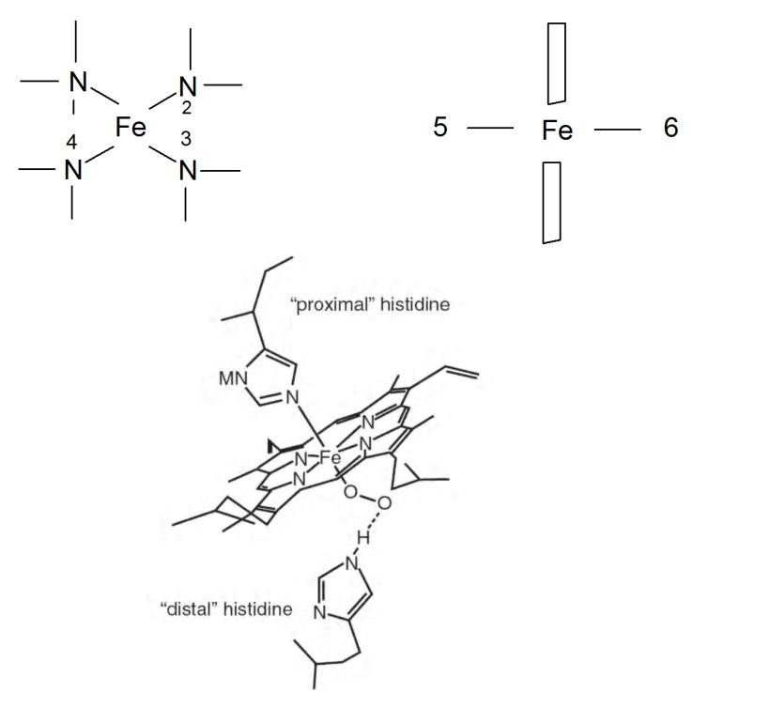Figure 1.5: Coordination of the iron atom in haem

THE LEVELS OF PROTEIN STRUCTURE IN HAEMOGLOBIN
The twenty common amino acids found in haemoglobin (and in all proteins) are joined together by peptide bonds. The linear sequence of the linked amino acids contains the information necessary to generate a protein molecule with a unique three- dimensional shape. The overall three-dimensional structure of a protein must be such as to enable the protein to function in the cells of the body. For instance, a binding site that is specific for just one molecule or a group of molecules with similar structural properties must first be created. This is because the specific binding site of a protein defines its role. Secondly, the three-dimensional structure must exhibit the degrees of flexibility and rigidity appropriate to the function of the protein.
For large macromolecules such as haemoglobin, four levels of structural organization are commonly defined (Figure 1.6). A description of all covalent bonds (mainly peptide bonds and disulphide bonds) linking amino acid residues in a polypeptide chain is referred to as the protein primary structure. The most important feature of the primary structure is the sequence of amino acid residues. The secondary structure refers to stable arrangements of amino acid residues that are located near to each other in the linear sequence. The secondary structure gives rise to regularly recurring structural patterns. The tertiary structure describes all aspects of the three- dimensional folding of a polypeptide chain, including the final arrangement of domains in the polypeptide. Domains are the fundamental functional and three-dimensional structural units of polypeptides. When a protein has more than one polypeptide chain, as obtains in haemoglobin, their arrangement in space is referred to as the quaternary structure.

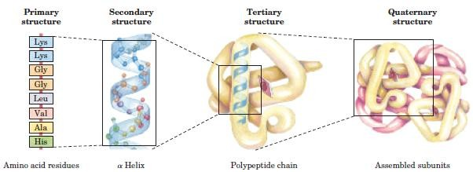Figure 1.6: Levels of protein structure in haemoglobin

Protein primary structure
The number and sequence of all the amino acid residues in a polypeptide chain constitute its primary structure. In proteins, the α-carboxyl group of one amino acid is covalently linked to the α-amino group of another amino acid by a peptide (amide) bond. The formation of a peptide bond is usually accompanied by the loss of a molecule of water (Figure 1.1b). Peptide bonds are quite stable kinetically as they are not broken by conditions that denature proteins, such as heating or high concentrations of urea; however, the bonds are labile to strong acids or bases (Anfinsen, 1973). A linear series of amino acids that are joined together by peptide bonds form a polypeptide chain. A polypeptide chain is therefore made up of a regularly repeating portion and a varying part, consisting of distinct side chains (Figure 1.7). Consequently, a polypeptide chain has one free terminal amino and one free terminal carboxylic acid end. By convention, the amino end is taken to be the beginning of a polypeptide chain.

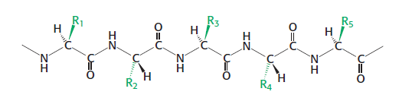Figure 1.7: The primary structure of a pentapeptide showing the components of the polypeptide chain (the various distinct side chains are represented by R)

Protein secondary structure
The term secondary structure refers to regular folding patterns of the polypeptide backbone. Helices, sheets, turns and loops are examples of such periodic foldings that are found in the protein secondary structure. Pauling and Corey (1951) were the first to propose the existence of the alpha (α) helix and beta (β) pleated sheet, which are the two common foldings encountered in nature. Other secondary structures include the β turn (bend) and the omega (Ω) loop.
The α-helix is a rod-like, spiral structure made up of a tightly packed and coiled polypeptide backbone (Figure 1.8a). The α-helix is stabilized by hydrogen bonds between the amino (NH) and carbonyl (CO) groups of the main chain. The hydrogen bonds are parallel to the spiral structure and extend from the C=O group of one peptide bond to the –NH– group of a peptide linkage four residues away (Figure 1.8b). The side chains of the amino acid residues extend outward from the central axis (Figure 1.8c). A turn of an α-helix is therefore made up of 3.6 amino acid residues covering a distance of about 5.4 Å. The helical structure makes it possible for amino acids that are spaced three or four residues apart in the primary sequence to be spatially close together. Only right-handed helices, which are energetically more favourable than left-handed helices, are found in proteins. The α-helices are a major component of tissues such as hair and skin (Champe et al, 1987).
The second repetitive structural arrangement, discovered by Pauling and Corey, is the β-sheet. It is another form of secondary structure in which all the peptide bonds are involved in hygrogen bonding. In contrast to the α-helical conformation, the backbone of the polypeptide in β sheets is extended into a zigzag structural conformation. In this arrangement, hydrogen bonds are formed between adjacent segments. A β-sheet is thus formed from two or more separate polypeptide chains that are arranged either parallel or anti parallel to each other (Figures 1.9a & b). The parallel arrangement has the same amino-to-carboxyl orientation (i.e. all the N-termini of individual β strands are together), while in the antiparallel arrangement, the N- and C- terminal ends of the β strands are alternated (i.e. opposing amino-to-carboxyl orientations). The surfaces of the β sheets appear pleated; the structures are therefore often called β-pleated sheets.The β sheets are found in fatty acid-binding proteins and in silk fibroin such as the fibroin of spider webs.

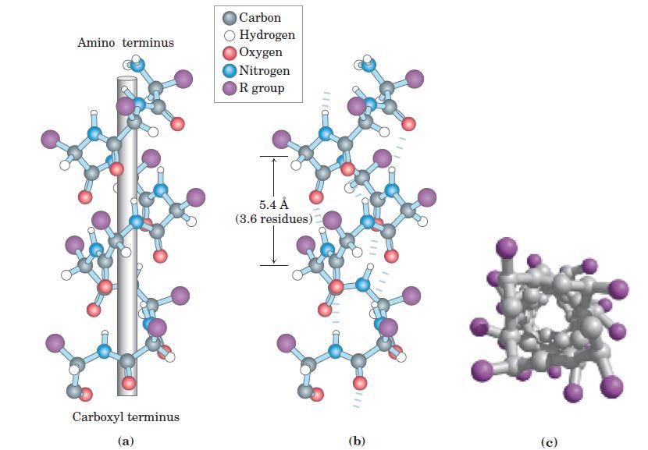Figure 1.8: The structure of the α helix: (a) ball-and-stick model of a right-handed α helix showing the parallel planes of the peptide bonds and the rod-like axis of the helix.
- model of the side view showing the hydrogen bonds (dashed lines) between NH and CO groups. (c) An end-view of the helix showing the coiled back bone and side chains (in purple) projecting outward. (Source: Nelson and Cox, 2004)

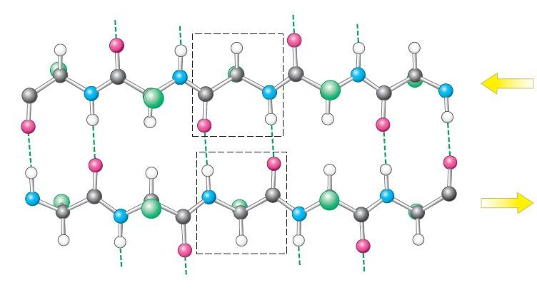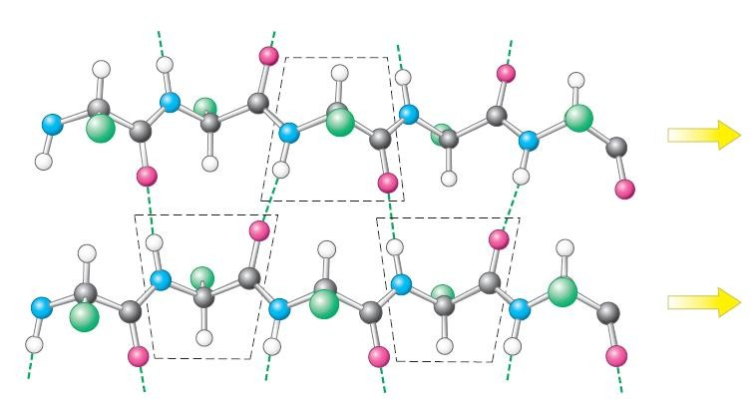Figure 1.9a: Antiparallel β sheet with adjacent β strands running opposite each other. Hydrogen bonds (dashed lines) between the NH and CO groups stabilize the structure.

Figure 1.9b: Parallel β sheet with adjacent β strands running same direction. Hydrogen bonds (dashed lines) between the NH and CO groups stabilize the structure. (Source: Stryer, 2004)

Protein tertiary structure
The tertiary structure of a protein refers to the entire three-dimensional conformation of a polypeptide. The term “tertiary” refers both to the folding of domains and to the final arrangements of domains in the polypeptide chain. It indicates how the secondary structures assemble to form domains and how these domains relate to one another spatially. Domains are the fundamental functional and three-dimensional structural units of polypeptides. A polypeptide chain that contains more than two hundred amino acids in length usually consists of more than one domain. A domain is capable of performing a particular chemical or physical function on its own. Therefore, each domain has the characteristics of a small, compact protein that is structurally independent of the other domains in the polypeptide chain. Myoglobin, the oxygen carrier in the muscle, is a good example of tertiary structure. It consists of a single polypeptide chain of 153 amino acid residues (Figures 1.10a & b).
The tertiary structure of a protein is stabilized by four interactions. They are disulphide bonds, hydrophobic interactions, hydrogen bonds and ionic interactions. Of all these interactions, the first two are most prominent. Disulphide bonds contribute to the stability of the three-dimensional shape of a protein molecule and prevent it from being denatured. A disulphide bond is a covalent linkage formed from the sulphydryl group (-SH) of each of two cysteine residues to form a cystine residue (Figure 1.11). The folding of the polypeptide chains brings the cysteine residues that are located far from each other on a polypeptide chain, or that are located on two different polypeptide chains, into close proximity for covalent bonding.
The contrasting distribution of polar and nonpolar residues also maintains the protein structure. This is referred to as hydrophobic interactions in which amino acids with nonpolar side chains are located in the interior of the molecule, while amino acids with polar or charged side chains tend to be located on the surface of the polypeptide molecule.

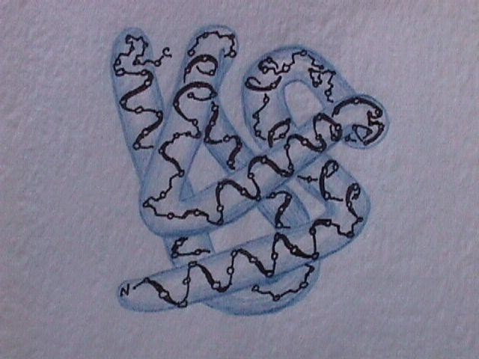Figure 1.10a: Structure of myoglobin by three-dimensional Fourier synthesis at 2 Å resolution (Kendrew, 1961).

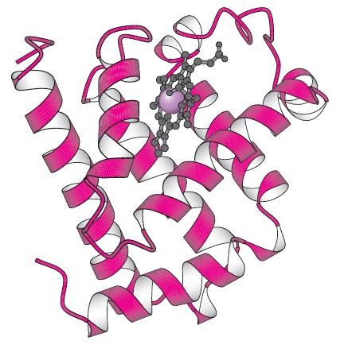Figure 1.10b: Structure of myoglobin: schematic ribbon model showing the α-helices. The haem group is shown in black and the iron is shown as a purple sphere. (Stryer, 2004)

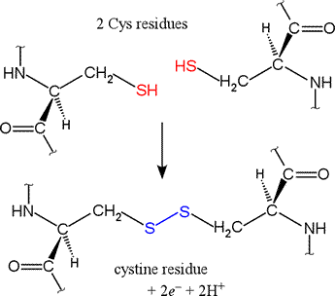2 cysteine residues

Cystine residue

+ 2e⁻ + 2H⁺

Figure 1.11: Formation of a disulphide (-S-S-) bond from two cysteine residues

Quaternary structure of proteins
Proteins that contain more than one polypeptide chain exhibit the fourth level of structural organization termed the quaternary structure. Each polypeptide chain in the protein is called a subunit. The spatial arrangement of these subunits and the nature of their interactions is referred to as the quaternary structure of the protein. The subunits are held together by noncovalent interactions such as hydrogen bonds and hydrophobic interactions. Subunits in a protein molecule are capable of functioning independently of each other, or they may work together cooperatively as in haemoglobin. The haemoglobin tetramer is made up of a pair each of two different polypeptide subunits represented by the Greek alphabets α and β (Figure 1.12).
Although the α and β chains have different amino acid sequences, they both fold up into similar three-dimensional structures. Each polypeptide chain is made up of eight α-helical segments having an equal number of non-helical regions in between them and at the ends of the chain. Starting from the amino terminus, the helices are named A, B, C,… H, while the non-helical segments that lie in between the helices are named AB, BC, CD, etc. The non-helical segment at the amino terminus is called NA, and the non- helical segment at the carboxyl terminus is called HC. This makes it possible to trace or identify by name a particular residue within the long polypeptide chain.

The nomenclature of amino acids in haemoglobin
The name of an amino acid is indicated by the position it occupies on the segment (whether helical or non-helical) of the polypeptide chain it belongs to. For example, the ninth residue on the F helix of the β chain of human haemoglobin is a cysteine residue. If this residue is numbered, starting from the amino terminal end of the β chain, it is the ninety-third amino acid. The combination of these two methods gives this amino acid the nomenclature CysF9[93]β, signifying the name and position of the residue both on the helix (or non-helical segment) and on the polypeptide chain to which it belongs. We can therefore also have SerNA1[1]β, which refers to a serine, which is the first amino acid residue on the non-helical region between the amino terminal end and the A helix, and also the first residue on the β polypeptide chain, starting from the amino terminus (Watson and Kendrew, 1961; Perutz, 1964).

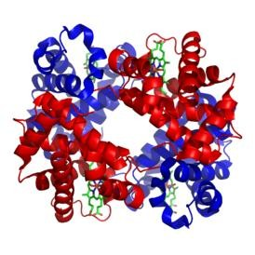Figure 1.12: A molecular 3-dimensional “ribbon” model of haemoglobin showing the four subunits each with its haem displayed in the ball-and-stick presentation.

  - Human (Homo sapiens) haemoglobin

In humans, the subunit compositions of the principal haemoglobins are as follows:
Normal adult haemoglobin, HbA: α₂β₂ (96-98% of the total haemoglobin content) Foetal haemoglobin, HbF: α₂γ₂ (0.5-0.8% of the total haemoglobin of an adult)
A minor adult haemoglobin, HbA₂: α₂δ₂ (1.5-3.2% of the total adult haemoglobin)


In the adult haemoglobin, the α chains are made up of 141 amino acid residues each while each of the β chains contains 146 residues. The amino acid sequences of the α and β chains of the major haemoglobin in adult humans, haemoglobin A, are presented with a one-letter symbol system of nomenclature. The cysteine residues in the chains, ( C ), have been highlighted for emphasis as they will be further discussed in the course of this work.

Table 1.2a: Amino acid sequence of the α chain of human haemoglobin A

1 10 20 30
V L S P A D K T N V K A A W G K V G A H A G E Y G A E A L E

40 50 60
R M F L S F P T T K T Y F P H F D L S H G S A Q V K G H G K

70 80 90
K V A D A L T N A V A H V D D M P N A L S A L S D L H A H K


100 110 120
L R V D P V N F K L L S H C L L V T L A A H L P A E F T P A

130 140
V H A S L D K F L A S V S T V L T S K Y R

Table 1.2b: Amino acid sequence of the β chain of human haemoglobin A

1 10 20 30
V H L T P E E K S A V T A L W G K V N V D E V G G E A L G R

40 50 60
L L V V Y P W T Q R F F E S F G D L S T P D A V M G N P K V

70 80 90
K A H G K K V L G A F S D G L A H L D N L K G T F A T L S E

100 110 120
L H C D K L H V D P E N F R L L G N V L V C V L A H H F G K

130 140 146
E F T P P V Q A A Y Q K V V A G V A N A A L A H K Y H

  - Domestic cat (Felis catus) haemoglobins

The haemolysate of cat erythrocytes contains two types of haemoglobin (Taketa et al., 1968; 1971). The major component, designated as haemoglobin A, accounts for 60-70% while the minor component, designated as haemoglobin B, makes up the remaining 30-40% of the total haemoglobin content (Lessard & Taketa, 1969, Abbasi & Braunitzer, 1985). The amino acid sequences reveal that although the two haemoglobins have identical α chains, their β chains differ at four positions. Whereas haemoglobin B has the amino terminal serine of its β chain acetylated, the N-terminal residue at position NA1[1]β of haemoglobin A is a free glycine; the minor haemoglobin B contains a serine in place of threonine at position A1[4]β, another serine in place of asparagine at position H17[139]β, and arginine in place of lysine at position HC1[144]β (Abbasi and Braunitzer, 1985). The amino acid sequences of the identical α chains and the two different β chains of the major and minor cat haemoglobins are presented in Table 1.3a-c below using the one-letter system of nomenclature. We have highlighted and underlined the cysteine residues in the chains for emphasis and for later discussion in the course of this work.

Table 1.3a: Amino acid sequence of the α chain of cat haemoglobins A & B
1 10 20 30
V L S A A D K S N V K A C W G K I G S H A G E Y G A E A L E

40 50 60
R T F C S F P T T K T Y F P H F D L S H G S A Q V K A H G Q

70 80 90
K V A D A L T Q A V A H M D D L P T A M S A L S D L H A Y K

100 110 120

L R V D P V N F K F L S H C L L V T L A C H H P A E F T P A

130 140
V H A S L D K F F S A V S T V L T S K Y R

Table 1.3b: Amino acid sequence of the β chain of the major cat haemoglobin A
1 10 20 30
G F L T A E E K G L V N G L W G K V N V D E V G G E A L G R

40 50 60
L L V V Y P W T Q R F F E S F G D L S S A D A I M S N A K V

70 80 90
K A H G K K V L N S F S D G L K N I D L K G A F A K L S E

100 110 120
L H C D K L H V D P E N F R L L G N V L V C V L A H H F G H

130 140 146
D F N P Q V Q A A F Q K V V A G V A N A L A H K Y H

Table 1.3c: Amino acid sequence of the β chain of the minor cat haemoglobin B

10 20 30
*S F L S A E E K G L V N G L W G K V N V D E V G G E A L G R

40 50 60
L L V V Y P W T Q R F F E S F G D L S S A D A I M S N A K V

70 80 90
K A H G K K V L N S F S D G L K N I D D L K G A F A K L S E

100 110 120
L H C D K L H V D P E N F R L L G N V L V C V L A H H F G H

130 140 146
D F N P Q V Q A A F Q K V V A G V A S A L A H R Y H
*acetylated N-terminal amino acid (Source: Abbasi and Braunitzer, 1985)

AIM OF THIS WORK

Previous research carried out in our laboratory has demonstrated that, in the relaxed (R) quaternary conformation, the reaction of CysF9[93]β of haemoglobins with 5,5'-dithiobis-(2-nitrobenzoate (DTNB for short) is reversible (Okonjo and Fodeke, 2006; Okonjo et al., 2006; 2007; 2008; 2009; 2010). The reversibility of this reaction has not been tested on haemoglobin in the tense (T) conformation. We have therefore set out to determine whether the DTNB reaction is reversible in the T conformation. For this purpose, we have reacted DTNB with human deoxyhaemoglobin.
The remarkable difference in the haemoglobins of the domestic cat compared to human haemoglobin is that the former have mutations involving some of the amino acid residues at the organic phosphate binding site (Abbasi and Braunitzer, 1985). This led to previous work on the reaction of derivatives of stripped cat major and minor haemoglobins with DTNB to determine the reversibility and the equilibrium constant of the reaction (Okonjo and Fodeke, 2006). In the current research, we have further extended the work to include haemoglobin in the presence of inositol-P₆.
The cat haemoglobins are classed among the low (oxygen) affinity haemoglobins, whereas human haemoglobin A is classed among the high (oxygen) affinity haemoglobins (Bunn, 1971). The question that arises is whether this classification will be reflected as differences in sulphydryl reactivity. The specific aims of the present research are as follows:
- To determine the reversibility of the reaction of DTNB with
  - human oxyhaemoglobin A, which has the R quaternary structure, and
  - human deoxyhaemoglobin A, which has the T quaternary structure.
- To determine the apparent forward second order rate constant, k_{F}, of the reaction as a function of pH.
- If the reaction is reversible, to determine the equilibrium constant, K_{equ}, as a function of pH.
- To determine the effect of inositol-P₆ on k_{F} and K_{equ} for the reaction of DTNB with cat haemoglobin.
- To determine the tertiary structure transition constant, K_{rt}, from the pH dependence of k_{F} and K_{equ}.

CHAPTER TWO LITERATURE REVIEW

STRUCTURE - FUNCTION RELATIONSHIP IN HAEMOGLOBIN

The changes in structure that accompany binding of oxygen to haemoglobin have been the subject of extensive analyses. All of the structural analyses rely on the assumption of two stable quaternary structural states for haemoglobin – the fully oxygenated and the completely deoxygenated states. These are referred to as the R and T quaternary states respectively. The globin units of deoxyhaemoglobin are tightly held by electrostatic bonds in the tense (T) conformation, which has a relatively low affinity for oxygen. The binding of oxygen imposes chemical and mechanical stresses that break these electrostatic bonds, leading to the relaxed (R) conformation. The remaining binding sites become more exposed and have higher affinities for oxygen (Monod et al., 1965). In order to fully understand the mechanism of this structural change, it is important to take a closer look at the two quaternary structural conformations of haemoglobin at the molecular level.
In deoxyhaemoglobin, the iron of the haem lies approximately 0.4 Å outside the plane of the porphyrin ring (Figure 2.1a). In this form the well-defined hole in the ring is slightly too small for the Fe²⁺ to fit in. The iron atom is pulled out of the plane of the porphyrin towards the proximal histidine residue to which it is attached, thus giving the haem group a non-planar “domed” shape (Baldwin & Chothia, 1979; Fermi et al., 1984). Upon oxygen binding at the sixth coordination site, rearrangement of electrons occurs within the iron atom such that it becomes effectively “smaller” and can fit appropriately into the plane. In this form, the haem group of oxyhaemoglobin is planar (Figure 2.1b, Perutz, 1970).

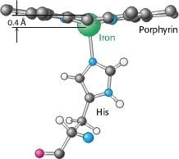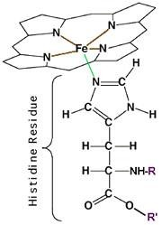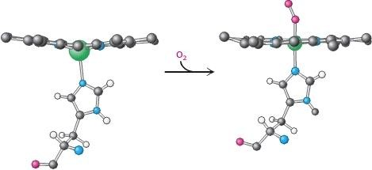Figure 2.1a: 3-D molecular model (left) and 2-D drawing (right) showing the position of iron (Fe²⁺) in the haem of deoxyhaemoglobin

Figure 2.1b: Schematic diagram showing Fe²⁺ (green ball attached to the proximal histidine), out of the plane of the porphyrin in the haem group of deoxyhaemoglobin (left), being pulled into plane upon oxygen binding (i.e. oxyhaemoglobin- right hand side of the equation). (Source: Stryer, 2004)

MOLECULAR BASES FOR THE QUATERNARY STRUCTURE CHANGE

The three-dimensional structure of the haemoglobin tetramer is formed from the association of two pairs of identical αβ dimers i.e. α₁β₁ and α₂β₂. In the T state, these dimers are linked together by an extensive interface which includes amino acid residues on helices C and G, and the non-helical FG segment. The carboxyl terminus of each of the four chains is also part of the interface. When iron moves into the plane of the porphyrin upon oxygenation, the proximal histidine on the F-helix moves with it. This movement in turn shifts the position of other amino acids that are close to this histidine residue such that one pair of the αβ dimer rotates 15 degrees with respect to the other (Figure 2.2).
Eight salt bridges that stabilize the T-state (including the one at the carboxyl terminal end of the F helix which lies at the interface between the two dimers), are broken in the transition to the R state (Figure 2.3). This leads to an alteration of the structure of the interface between the four subunits and a change in shape of the whole protein. In the new shape it becomes easier for the other three haems to be oxygenated, thereby enhancing their ability to bind more oxygen molecules, a property known as cooperative binding.
The difference between the R and T states could be so pronounced in some organisms that their haemoglobins dissociate into dimers during the quaternary structure transition (Antonini, 1967). The T → R transition provides the major basis for explaining haemoglobin function as shown by the structural changes that accompany such transitions. These include crucial functional properties like cooperativity of oxygen binding and allosteric control by acidity, carbon dioxide and anions (Monod et al., 1965; Perutz et al., 1968).
Monod, Wyman and Changeaux were the postulators of the concept of equilibrium (between the two quaternary states) as the core of the concerted model for allosteric interactions. Hence it is also called the MWC model. The uniqueness of the MWC model is in the universality of the equilibrium concept and the simplicity of formulating the operating mechanism. This is in contrast to the sequential model postulated by Koshland, Nemethy and Filmer, also known as the KNF model, which does not assume equilibrium of quaternary structures [Koshland et al., 1966]. However, this simplified view has been challenged by various groups because it does not fully

describe the effect of physiological heterotropic effectors on the oxygen dissociation curve of haemoglobin (Benesch et al., 1968; Tyuma et al., 1973; Goodford et al., 1977). According to the MWC model, an allosteric regulator like 2,3- bisphosphoglycerate (2,3-BPG) preferentially binds to and stabilizes the T state. This binding causes a right shift in the oxygen dissociation curve of haemoglobin. It has however been shown that in practice 2,3-BPG not only binds preferentially to the T state, but also reduces its oxygen affinity (Minton and Imai, 1974; Goodford et al., 1977). Another observation that the MWC model fails to justify is that allosteric effectors such as 2,3-BP, adenosine triphosphate and bezafibrate not only affect the equilibrium of the quaternary structures but also that of the tertiary structures which are linked to the quaternary structure transition. This observation has been qualitatively and quantitatively established (Okonjo et al., 1989; Coletta et al., 1995; Imai et al., 2002; Tsuneshige et al., 2002; Yonetani et al., 2002; Samuni et al., 2006; Yokoyama et al.,
2006; Okonjo et al., 2008).
It is therefore established that the two-state model of Monod et al. (1965), is deficient. Other models were subsequently proposed to overcome some of these deficiencies. Such models are introduced in the following sections.

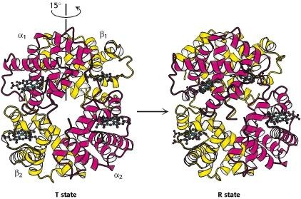Figure 2.2: 15 degrees rotation of an αβ dimer pair on transition from the T to the R state

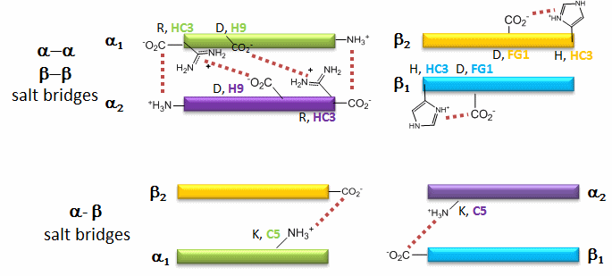Figure 2.3: A schematic representation of the salt bridges that are broken during transition from the T to the R state. The amino acids are denoted by a single letter symbol (written in black) followed by a coma and their position on the corresponding helix (written in colour)

ALLOSTERY
The word „allostery‟ was first used by Jacques Monod and François Jacob in 1961 to explain the phenomenom observed in the experiments carried out by Jean-Pierre Changeux on end-product inhibition of the enzyme L-threonine deaminase (Monod and Jacob, 1961). Changeux, who at the time was a student in Monod‟s laboratory, observed sterical (structural) differences between the reactant (L-threonine) and the end product L-isoleucine. This led to the proposal that by binding at a regulatory and different (non- overlapping) site, the end product could inhibit the enzyme without competing with the reactant. Simply put, allostery is defined as a change in shape or activity of a protein which results from combination with another substance at a point other than the chemically active site.
Twenty-five years before the word was coined, Pauling (1935) had proposed a model for intramolecular control in haemoglobin to account for the observed positive cooperativity during oxygen binding reactions. In 1966, Daniel Koshland and his colleagues (Némethy and Filmer) took up the Pauling model and came out with what is generally referred to as the „Sequential‟ or KNF model. Koshland proposed that changes in structure take place in sequence (hence the name sequential) within an oligomeric protein as more active sites are occupied (Figure 2.4). This means that the binding of a substrate to one site does not necessarily induce a total structural transition of the whole protein, though the substrate affinity of neighbouring sites could be influenced in the process.
This model is in complete contrast to the „Concerted‟ model which was earlier proposed in 1965 by Monod, Wyman and Changeux and is generally referred to as the MWC model. The concerted model assumes that the entire molecule can undergo conformational transition from T → R regardless of the ligation state (i.e. whether the protein is partially or fully liganded). This implies that an allosteric protein can only exist in two states, T and R, which are in equilibrium and no intermediates are allowed. An important advantage of the sequential model over the concerted model is its ability to explain negative cooperativity. Nevertheless, the MWC model has had a major impact in the understanding of cooperativity because of the universality of the equilibrium concept which has found widespread applications in biology, ranging from haemoglobin to membrane receptors. The behaviour of many allosteric proteins has been described with good accuracy by the MWC model (Imai, 1982).

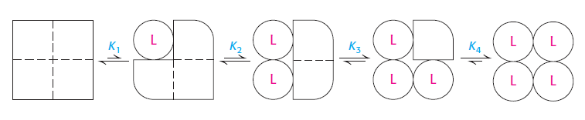T state R state

Figure 2.4: Sequential model of allostery for a tetrameric protein (e.g. haemoglobin) showing the sequential changes in the conformation of subunits from the pure unligated T state (represented by squares) to the fully liganded R state (represented by circles) upon the binding of a ligand (L)

.

Haemoglobin provides a classic example of an allosteric protein. It possesses, among other properties, multiple interacting binding sites; the ability to bind non- covalently to a primary ligand (oxygen); homotropic effects (quaternary conformation changes induced upon binding the primary ligand); and heterotropic effects (regulation of the primary ligand binding by a secondary effector molecule binding at a different site). The two-state allosteric (MWC) model provides an excellent description of homotropic effects in cooperative ligand binding by this protein. However, the MWC model fails to adequately account for the heterotropic effects which are also observed. This and other inadequacies have led to the proposition of various allosteric models in a bid to completely justify and correctly answer fundamental questions concerning the structure-function relation of haemoglobin. Some of the proponents of other allosteric models include Maurizio Brunori, the proponent of the cooperon model (Brunori et al., 1986), Szabo and Karplus, whose model is based on Perutz‟s stereochemical mechanism, (Perutz, 1970; Szabo and Karplus, 1972) and Henry et al., (2002), the proponents of the tertiary two-state (TTS) allosteric model.

COOPERATIVITY AND THE BOHR EFFECT

A molecule of haemoglobin is capable of binding a total of four oxygen molecules (the ferrous ion on the haem group of each of the four subunits has an oxygen binding site). The binding of oxygen to the haem is a cooperative process. Cooperativity is not unique to haemoglobin. It is a term used to describe the interaction that occurs in biological molecules which possess multiple sites that interact in a highly specific manner for a given substrate. The interaction is such that the affinity of a given site for the substrate is markedly influenced by the state of binding at other sites. In haemoglobin, the binding of the first oxygen molecule to the haem group of one subunit increases the affinity of a neighbouring subunit for oxygen. This, in turn, further increases the affinity of the next neighbouring subunit, and so on (that is to say, the subunits cooperate). Similarly, the dissociation of one oxygen molecule facilitates the ease and rate of the sequential dissociation of the other three. Cooperativity could either be termed positive (when the affinities of the other subunits for a ligand are increased in the process) or negative (when the affinities are decreased).

The sigmoidal shape of the oxygen dissociation curve of haemoglobin (Figure 2.5), which signifies the transition from low to high affinity states as more binding sites become occupied, is a direct consequence of its cooperative behaviour. The sigmoid curve can be viewed as being made up of two Michaelis-Menten curves, one corresponding to the T state, the other to the R state. In molecules like myoglobin, for which cooperativity is not observed, the curve is usually hyperbolic in shape (Figure 2.5). The oxygen binding (or dissociation) curve describes the relation between the oxygen content (saturation) and the oxygen tension (i.e., partial pressure) at equilibrium. In 1904, Christian Bohr, a Danish physiologist and father of Neils Bohr the physicist, observed that the affinity of haemoglobin for oxygen is inversely related to acidity and the concentration of carbon dioxide (Bohr et al., 1904). This phenomenon is referred to as the Bohr Effect, a situation in which an increase of protons, H⁺ (i.e. decrease in pH) and carbon dioxide, CO₂, shifts the oxygen binding curves of haemoglobin to the right, thereby lowering the affinity of haemoglobin for oxygen
(Figure 2.6a and b).

% saturation

myoglobin (hyperbolic)

haemoglobin (sigmoidal)

pO₂ (mm Hg)

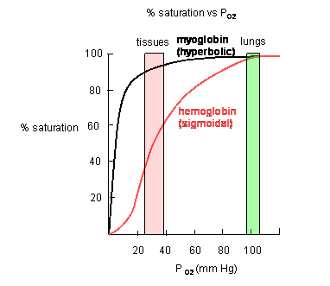Figure 2.5: A plot of oxygen saturation (in %) against partial pressure of oxygen, pO₂, for myoglobin and haemoglobin (Source: Jakubowski, 2010)

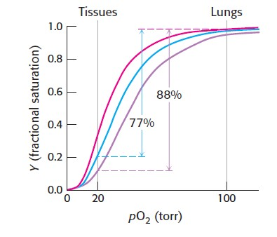Figure 2.6a: Effect of pH and CO₂ concentration on the oxygen affinity of haemoglobin. red curve ≡ pH 7.4, no CO₂; blue curve ≡ pH 7.2, no CO₂; purple curve ≡ pH 7.2, 40 torr CO₂.

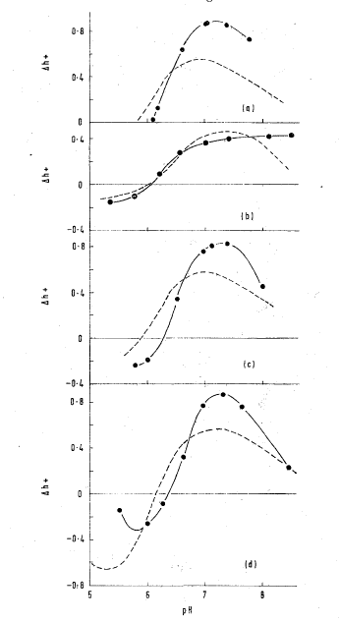Figure 2.6b: Direct determination of the Bohr effect from plots of proton uptake (∆h⁺) against pH for the reaction of oxygen with the haemoglobins of (a) mouse, (b) pigeon,
- human A and (d) guinea pig in the presence (represented by solid lines) and absence (dashed lines) of 2,3-BPG. (Source: Bailey et al., 1970)

The physiological implication of this is that when there is a decrease in blood pH, which is usually as a result of an increase in the concentration of blood CO₂, haemoglobin is able to release or unload its oxygen. This is the situation that obtains in tissues where metabolism results in the production of CO₂ which reacts with water to form carbonic acid. Carbonic anhydrase, an enzyme in the red blood cells, facilitates the dissociation of this acid into proton and bicarbonate ion.
CO₂ + H₂O H₂CO₃ H⁺ + HCO₃⁻
In the lungs where the oxygen concentration is high, binding of oxygen causes haemoglobin to release protons. Subsequently, the protons combine with the bicarbonate ions to form carbon dioxide which is exhaled during respiration. However, the loading and unloading of oxygen, which is closely associated with the uptake and release of protons, occur simultaeneously. Therefore, there is little or no net change in blood pH.
2,3-bisphosphoglycerate (2,3-BPG), an anionic compound that is present in the red blood cells at approximately the same concentration as haemoglobin, also helps in regulating the affinity of haemoglobin for oxygen (Benesch et al., 1969; Arnone, 1972). The crystal structure of haemoglobin shows that a molecule of 2,3-BPG binds in a positively charged central cavity („a pocket‟) between the β chains. This binding stabilizes the T conformation and reduces its affinity for oxygen (Bunn and Jandl, 1970; Imai, 1982). A close look at the binding site reveals that three positively charged groups on each β chain interact directly with this heterotropic effector molecule. They are HisNA2[2]β, LysEF6[82]β and HisH21[143]β (Arnone, 1972; Figure 2.7a). A fourth residue, ValNA1[1]β, is also „indirectly‟ implicated (but not shown in the figure) in the binding of BPG to haemoglobin.
Inositol hexakisphosphate (inositol-P₆) is a close analogue of inositol pentakisphosphate, the physiological effector in avian erythrocytes. It is by far the most effective among organic phosphates that regulate the affinity of haemoglobin for oxygen (Benesch et al., 1968; Bunn and Guidotti, 1974). The very high overall negative charge of inositol-P₆ gives it the ability to effectively neutralize positive charges on residues which are present at the organic phosphate binding site; it is therefore the most widely used organic phosphate in experimental studies. According to Arnone and Perutz (1974), the same amino acid residues bind to both 2,3-BPG and inositol-P₆ (Figure 2.7b). In addition to lowering the affinity of haemoglobin for oxygen, these heterotropic effector molecules simultaneously lower the reactivity of the CysF9[93]β sulphydryl

groups of haemoglobin (Vandecasserie et al., 1971, 1973; Okonjo, 1980; Yokoyama et al., 2006).
Although most of the amino acid residues on the β chains of adult human haemoglobin are conserved in the nearly identical γ chains of foetal haemoglobin, one of the critical differences is at the 2,3-BPG binding site where HisH21[143]β is substituted by a serine. This substitution decreases the affinity of foetal haemoglobin for 2,3-BPG because there is a reduction in the positive charge at the binding site, making it easier for oxygenation to occur. This accounts for foetal haemoglobin being of a higher oxygen affinity relative to adult haemoglobin (Figure 2.8), and hence oxygen is effectively transferred from the maternal to the foetal red blood cells. For the same reasons, foetal haemoglobin is not able to efficiently unload its oxygen.
Other organic phosphates and anions compete with 2,3-BPG for binding sites on haemoglobin. The regulatory effect of 2,3-BPG on oxygen binding tends to reduce considerably in the presence of other salts (Benesch et al, 1969; Imai, 1982).

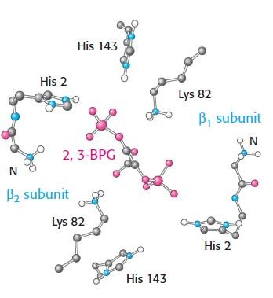

Figure 2.7a: The binding site of 2,3-BPG in deoxyhaemoglobin (Arnone, 1972)

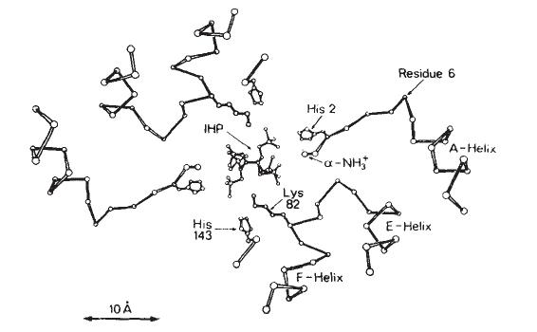Figure 2.7b: The binding site of inositol-P₆ (IHP) in deoxyhaemoglobin (Arnone and Perutz, 1974)

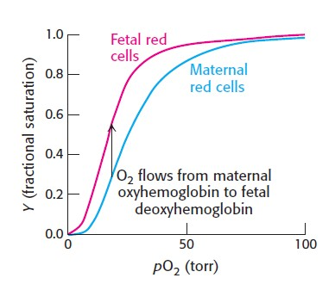Foetal red cells
Maternal red cells

O₂ flows from maternal oxyhaemoglobin to foetal deoxyhaemoglobin

Figure 2.8: Oxygen saturation curves comparing the oxygen affinities of foetal and maternal red blood cells

Apart from 2,3-BPG and protons, other organic phosphates (Figure 2.9) act as allosteric effector molecules. Adenosine mono-, di-, and triphosphates (ATP) are found in amphibian and reptilian haemoglobins, while inositol pentakisphosphate, (IPP), is found in avian haemoglobins. These allosteric effectors act as regulators of the affinity of haemoglobin for oxygen (Benesch et al., 1968; Weber and White, 1986; 1994).

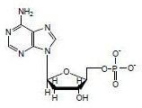
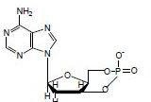
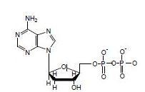Adenosine monophosphate cyclic adenosine monophosphate
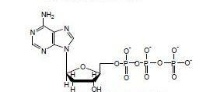

Adenosine diphosphate(ADP) Adenosine triphosphate(ATP)
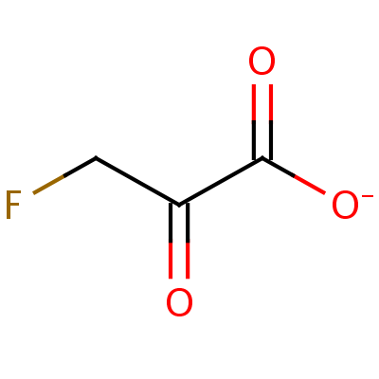
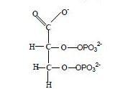

3-Fluoropyruvate 2,3-bisphosphoglycerate (2,3-BPG)
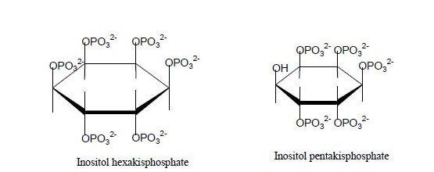

Figure 2.9: Organic phosphates that act as allosteric effectors molecules

THE BIOCHEMISTRY OF SULPHYDRYL GROUPS

Almost all proteins contain sulphur as part of the side chain of three different amino acids. Two of these, methionine and cysteine, are among the twenty essential amino acids; the third, cystine, is the oxidized form of cysteine and contains the disulphide (–S-S–) bond. Methionine contains sulphur as part of the less reactive and non-polar (hydrophobic) side (or R) group, -SCH₃, whereas in cysteine the side group is the sulphydryl (–SH) group, which is also generally referred to as a thiol group (Zuazaga et al., 1984). Both sulphydryl groups and disulphide bonds play very important roles in biology. In proteins they are important determinants of the conformational properties and hence the functions which the proteins perform. The disulphide bonds are the only covalent cross-links between separate polypeptide chains or between loops of a single chain (Zuazaga et al. 1984), contributing to the three-dimensional structure of the protein.
All haemoglobins of animal origin are known to contain sulphydryl groups. So far, the only exceptions are the haemoglobins of some amphibian species, namely, tadpole (Jocelyn, 1972). Sulphydryl groups are very reactive species. They readily react with most alkylating, arylating and acylating agents, though their reaction with the latter results in thiol esters which are quite unstable and usually hydrolyze in aqueous media (Means and Feeney, 1971). They are easily oxidized by even the mildest oxidizing agents:
2RSH + oxidizing agent  RSSR + 2H⁺ + reducing agent

Cysteines are capable of reacting with heavy metal ions like Zn²⁺, Cd²⁺, Pb²⁺, Hg²⁺ and Ag⁺ due to the high affinity between the sulphydryl groups and the metal ions. Such reactions may lead to the deformity and/or inactivation of the protein. The sulphydryl group of cysteine is the most reactive site in proteins (Creighton, 1993). The thiolate anion formed, RS⁻, is about five hundred times more nucleophilic than the corresponding alkoxy analogue RO⁻. This high reactivity puts the sulphydryl group among the important functional groups investigated in the reactivities, functions, mechanisms and structural conformations of macromolecules (Go and Jones, 2005). Apart from acting as precursors of disulphide bonds that stabilize proteins, sulphydryl groups also participate in many biological processes, including enzyme reactivity. Cysteine residues are commonly found as catalytic residues in the active sites of enzymes such as the thioredoxin family (Kortemme and Creighton, 1995), viral

cysteine proteases (Bazan and Fletterick, 1988), papain (Kampluis et al., 1985) and rhodanese (Ploegman et al., 1979).

SULPHYDRYL GROUPS IN HAEMOGLOBINS
Sulphydryl groups have been used to probe the mechanism by which oxygen binds to haemoglobin. Riggs (1952) observed that sulphydryl groups are closely linked with the mechanism of haem-haem interaction in the oxygenation process. From their experiments on the effect of four different organic mercurials on haem-haem interaction, Riggs and Wolbach also observed that „an intimate relation exists between the haems and the sulphydryl groups‟ (Riggs and Wolbach, 1956). Their results showed that while the addition of 2 moles of mersalyl or mercuric chloride (HgCl₂) reduces haem-haem interactions and increases the oxygen affinity of horse haemoglobin, p-chloromercuribenzoate (pCMB) or methyl mercury hydroxide (CH₃HgOH) at the same concentration have similar effect on haem-haem interactions, but little or no effect on oxygen affinity. In general, monitoring the reactivities of sulphydryl groups in haemoglobin aid better understanding of the mechanism of reaction, vis-à-vis oxygen binding.
It has been observed that the number of sulphydryl groups in native haemoglobin differs from that of denatured haemoglobin. The observed difference could be explained in terms of the accessibility of such groups to reagents. In haemoglobins and other proteins, the sulphydryl group can either be termed as reactive or unreactive, based on the chemical nature of their physical environment (or domain) which ultimately affects their behaviour towards sulphydryl reagents. Unreactive sulphydryl groups are those involved in hydrophobic and intrachain bonding; they bind together various subunits of the polypeptide chain and may become buried or masked in the tetrameric molecule. As such they become inaccessible (or less reactive) to reagents. The reactive sulphydryl groups, on the other hand, are accessible to most sulphydryl reagents, since they are only involved in labile inter- and intra-molecular linkages, behaving as simple thiols to sulphydryl reagents. Some protein sulphydryl groups may also be inaccessible or made unreactive by neighbouring residues in the polypeptide and are thus unable to react with sulphydryl reagents.
The number of available (reactive) sulphydryl groups present in haemoglobin is usually determined by spectroscopic titration. When organic mercurials such as p- chloromercuri(II)benzoate (pCMB) and p-hydroxymercuri(II)benzoate (pMB) are used

as the titrating agents, all the free sulphydryl groups that are not buried or masked by neighbouring residues are detectable. On the other hand, non-mercurial reagents such as Ellman‟s reagent (5,5'-dithiobis-(2-nitrobenzoate); DTNB for short) can only titrate or detect those sulphydryl groups that can form the thiolate anion (Okonjo et al., 1979; Hallaway et al., 1980). For example, there are three cysteine residues per αβ dimer in human haemoglobin A at positions G11[104]α, F9[93]β and G14[112]β, making a total of six sulphydryl groups per tetramer molecule. Only the pair at F9[93] of the two β chains are partially exposed and thus reactive towards sulphydryl reagents. The other two are internal and remain unreactive in the liganded as well as unliganded forms of haemoglobin.
In the amino acid sequence of the major cat haemoglobin, a total of twelve sulphydryl groups are present – four on the two β chains at positions F9[93] and G14[112], and eight on the two α chains at positions A11[13], B15[34], G11[104] and G18[111]. The same positions are occupied with the same number of sulphydryl groups in the minor haemoglobin (Kleinschmidt and Sgouros, 1987). The result of the titration of cat haemoglobins with DTNB reveals that only the two sulphydryl groups located at position [F9]93 of the two β chains are reactive towards DTNB in both the major and minor haemoglobin (Okonjo and Fodeke, 2006). It was demonstrated that the Cys[F9]93β sulphydryl group is the only one capable of ionizing to the thiolate anion form: hence it was the only one found to be DTNB-reactive out of the eight sulphydryl groups that were detected by organic mercurials in Boyer titrations. In Table 2.1 below, we show, for various animal haemoglobins, the total number of sulphydryl groups per molecule and the number that are reactive towards organic mercurials and non-mercurial reagents.

THE CYSF9[93]β SULPHYDRYL GROUP
The CysF9[93]β sulphydryl group is conserved in most mammalian and avian haemoglobins and it is also one of the important residues that have been extensively studied. It is located between the proximal histidine residue, HisF8[92]β, and an aspartic acid residue located in the non-helical FG segment of the β chain. This AspFG1[94]β forms an intrasubunit salt bridge with the imidazole group of another histidine residue, HisHC3[146]β, an interaction that stabilizes the deoxy conformation and is also responsible for 40% of the alkaline Bohr effect (Perutz et al., 1969). CysF9[93]β has been used as a probe in the detection of ligand-induced

conformational changes which occur in the protein moiety. In the T-state the side chain of CysF9[93]β in human haemoglobin A is external but is screened by the imidazole group of His146[HC3]β, which forms a salt bridge with the γ-carboxyl of Asp94[FG1]β; in the R-state, the side chain, though internal, is partially exposed (Perutz M.F., 1970). This is because the salt bridge between the histidine and the aspartic acid residue is broken.

Table 2.1: Titratable sulphydryl groups of various haemoglobin and their locations in the haemoglobin molecule.

Haemoglobin sulphydryl of | Number titratable with DTNB | Number titratable with pCMB | Total number of sulphydryl | Locations
Rabbit | 2 | 2 | 4 | ªCysF9[93]β, ^{c}CysG11[104]α
Monkey | 2 | 2 | 6 | ªCysF9[93]β, ^{c}CysG11[104]α, ^{c}CysG14[112]β
Human foetal | 2 | 2 | 4 | ªCysF9 [93]β, ^{c}CysG14[112]β
Human adult | 2 | 2 | 6 | ªCysF9[93]β,^{c}CysG14[112]β, ^{c}CysG11[104]α
Horse | 2 | 2 | 4 | ªCysF9[93]β, ^{c}CysG11[104]α
Guinea pig | 4 | 4 | 6 | ªCysF9[93]β, ^{c}CysH3[125]β, ^{c}CysG11[104]α
Echidna | 2 | 2 | 4 | ªCysF9[93]β, ^{c}CysG14[112]β
Dog | 2 | 4 | 8 | ªCysF9[93]β, ^{b}CysG18[111]α, ^{c}CysG11[104]α,  ^{c}CysG14[112]β
Chicken  Minor | 4 | 6 | 8 | ªCysF9[93]β, ªCysB5[23]β, ^{b}CysH4[126]β, ^{c}CysG11[104]α
Chicken major | 4 | 8 | 10 | ªCysF9[93]β, ªCysB5[23]β, ^{b}CysH4[126]β, ^{c}CysH13[130]α ^{c}CysG11[104] α
Duck major | 4 | 8 | 10 | ªCysF9[93]β, ªCysB5[23]β, ^{b}CysH4[126]β, ^{b}CysH13[130]α,  ^{c}CysG11[104]α
Pigeon | 4 | 8 | 10 | ªCysF9[93]β, ªCysB5[23]β, ^{b}CysH4[126]β, ^{b}CysH13[130]α,  ^{c}CysG11[104]α
ª sulphydryl groups titratable with all sulphydryl reagents. ^{b} sulphydryl groups titratable with only organic mercurials. ^{c} masked sulphydryl groups.
(Source: Kleinschmidt and Sgouros, 1987; Okonjo et al., 1979, 1993, 1997, 2008)

SULPHYDRYL REAGENTS
In the early years of haemoglobin research, oxidizing agents like ferricyanide and tetrathionate, or the heavy metal compound para-chloromercuribenzoate were used in estimating the number of sulphydryl groups. Since titratison is the common mode of assay, this sulphydryl determining agents are also sometimes referred to as titrating agents. Ferricyanide in particular was considered a convenient titrating agent because of its ready availability and stability. Para-chloromercuribenzoate (pCMB) has been used as a sulphydryl reagent as far back as 1937 (Hellerman et al., 1941). According to Anson (1941), the inclusion of pCMB as a titrating agent provides a good test for the sulphydryl specificity of the titration processs. Whereas other sulphydryl reagents (e.g porphyridin, ferricyanide and tetrathionate) oxidize the sulphydryl to disulphide, pCMB only combines with but does not oxidize the sulphydryl groups. Results have shown that a reagent may react with sulphydryl group of free cysteine and not with the cysteine bound in a protein. The feasibility of the reaction depends on (1) the type and concentrations of the sulphydryl reagents and proteins, (2) the experimental conditions of time, temperature, pH and (3) whether the protein is in its native or denatured form. In general, sulphydryl reagents react less readily with protein sulphydryl groups than with the sulphydryl groups of a free cysteine (Anson, 1941). Generally sulphydryl reagents can be grouped into the following categories:

      - Organic mercurials: mersalyl, methyl mercury hydroxide (CH₃HgOH), mercuric chloride (HgCl₂) and p-chloro- or p-hydroxymercuri (II) benzoate (pCMB or pMB).

      - Alkyl halides: iodoacetate, iodoacetamide, fluoropyruvate.

      - Maleimides: N-ethylmaleimides (NEM), N-polymethylene carboxylmaleimide (PM), N-(9-acridinyl)maleimide (NAM) and eosin-5- maleimide (EMA).

      - Aromatic disulphides: bis(p-nitrophenyl) disulphide, 2,2'-dithiobispyridine, 4,4'-dithiobispyridine, 5,5'-dithiobis-(2-nitrobenzoic acid) (DTNB).

We show in Figure 2.10 the structures of some of these reagents and discuss their mode of quantification in the section that follows.

- COO
- COO

Hg

CI
p - chloromercuri(II)benzoate

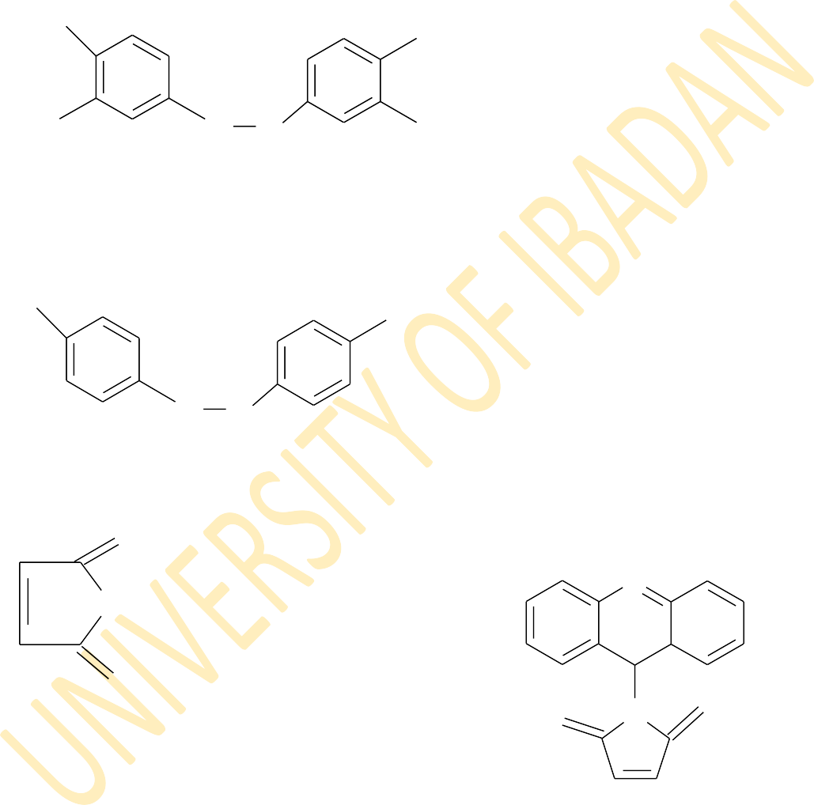
O2N
Hg

OH
p - hydroxymercuri(II)benzoate

NO2

-OOC
-
S S COO

5,5' -dithiobis(2 -nitrobenzoate) (DTNB)

O2N

NO2

S S
Bis(p-nitrophenyl disulphide)

O
N
N - C2H5

O

N - Ethylmaleimide
O N O

NEM
N - (9 -acridiyl) maleimide NAM

O
NH2 NH2 O
+ HS - CH2CHCOOH HOOCHCH2 - S - CH2C - + H I-
O
Cysteine Carboxymethylcysteine
ICH2 C - O
Iodoacetate

Figure 2.10: Structures of some sulphydryl reagents

Mercaptide formation
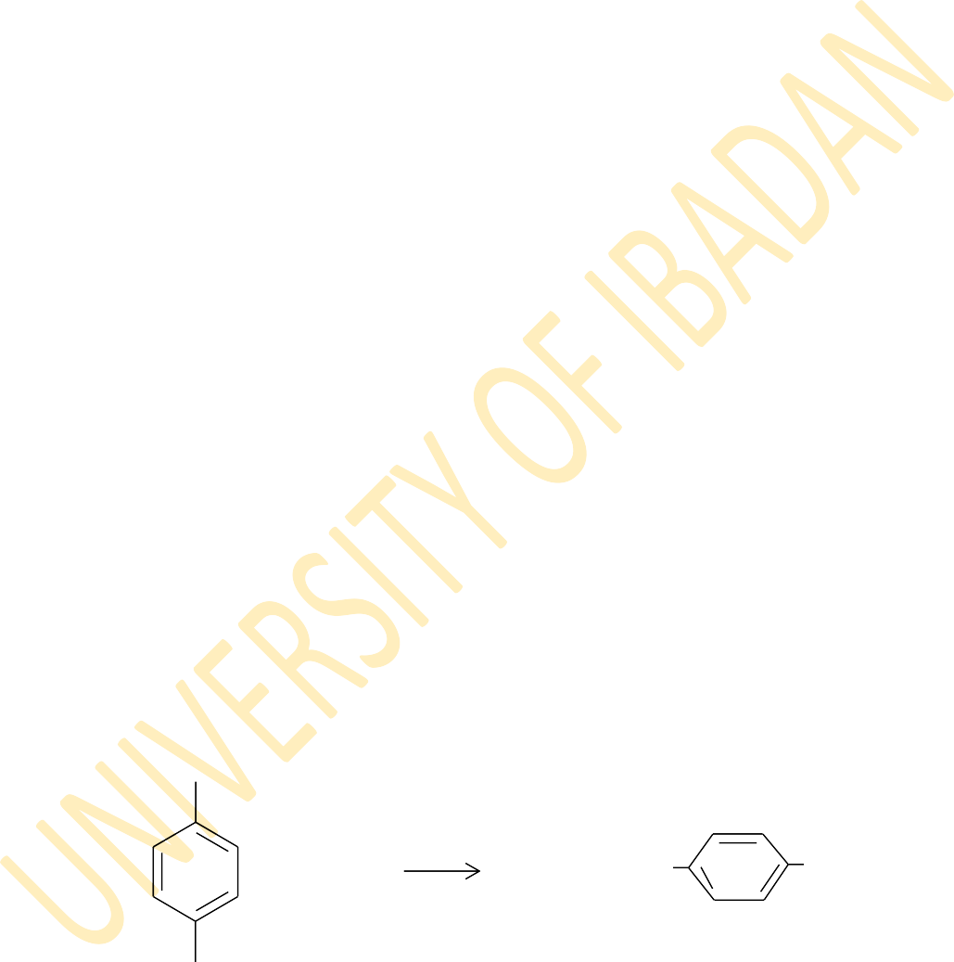
The term „mercapto‟ was originally used to describe the very strong complex formed between thiols and mercuric ions. The reactions of simple thiols with mercuric chloride, HgCl₂, gives mercaptides of types (RS)₂Hg, (RS)₂Hg₂ and (RS)₂Hg₃ (Stricks and Kolthoff, 1952). Inorganic mercurials like HgCl₂ are multifunctional because they can react with more than one ligand to form multi-dentate complexes. Organic mercurials on the other hand, are univalent and have a high specificity for sulphydryl groups. They are therefore more dependable stoichiometrically, reacting with protein and non-protein thiols accordintg to the following equation (Hughes, 1957; Simpson, 1961):
RHgX + R'SH ⇋ RHgSR' + HX
where R can be aromatic (-C₆H₅, -C₆H₄COOH or –C₆H₄SO₃H) or aliphatic, and R' represents other amino acid residues (apart from cysteines) in the protein moiety. The substituted phenyl mercurials are usually less soluble than the unsubstituted ones. Also the presence of the carboxyl (COO⁻) and trioxosulphate (SO₃²⁻) groups reduce the ability of organic mercurials to penetrate into cells.
The kinetics of the reactions of organomercurials with thiols has been studied (Hasinoff et al., 1971). They react quantitatively with all thiol groups in proteins except those that are masked within the protein moiety. A typical reaction between p- chloromercuri(II)benzoate, pCMB, and a protein sulphydryl (PSH) is represented as follows:

- COO

+ P - SH P - S - Hg

- COO

HCI
+

Hg CI
The disadvantages of organic mercurials include low solubility, their light absorption is affected by the anionic composition of the medium, and they are not very stable in aqueous solution (Jocelyn, 1972).

Alkylation
The alkylation of thiols results in the formation of sulphides, as shown in the following equation:
R-SH+ R'X R-S-R' + HX

This method involves the use of alkylating reagents such as alkyl halides or αβ unsaturated reagents. The alkyl halides include iodoacetate or its hydrolysed form, iodoacetic acid, iodoacetimide and fluoropyruvate. Iodoacetate and iodoacetamide are the most widely used alkyl substituting agents in protein sulphydryl groups. A typical reaction between iodoacetate and a cysteine molecule is represented below (Neer, 1970).

O NH2
NH2 O

ICH2 C - O
+ HS - CH2CHCOOH HOOCHCH2 - S - CH2C
+ H I-
- O

Iodoacetate Cysteine Carboxymethylcysteine

Addition across C=C bond

The αβ-unsaturated reagents are the alkylating reagents which allow thiols to be added across a carbon-carbon double bond. This group consists mainly of maleimides which include N-ethylmaleimide (NEM), a membrane permeating reagent, N-(9-acridinyl) maleimide (NAM), a fluorescent reagent and eosin-5-maleimide (EMA), a membrane impermeable and fluorescent reagent (Majima et al., 1993; Yamamoto, 1993). Sulphydryl groups form irreversible adducts to the polarized or easily polarizable double bonds in these reagents. An example is given below showing the reaction between a protein sulphydryl in its ionized and NEM.

HC C
PS⁻+ H⁺ +
O

N C2H5
H PSC C
O

N C H

HC C
O
2 5
HC C
H O

Although NEM is the best known and most widely used of the maleimides, it has a major disadvantage of being not very stable in aqueous solution. It is also non- specific, as it forms adducts with sulphides, sulphites and thiosulphates (Benesch and Benesch, 1957)

Oxidation of sulphydryl groups by aromatic disulphides
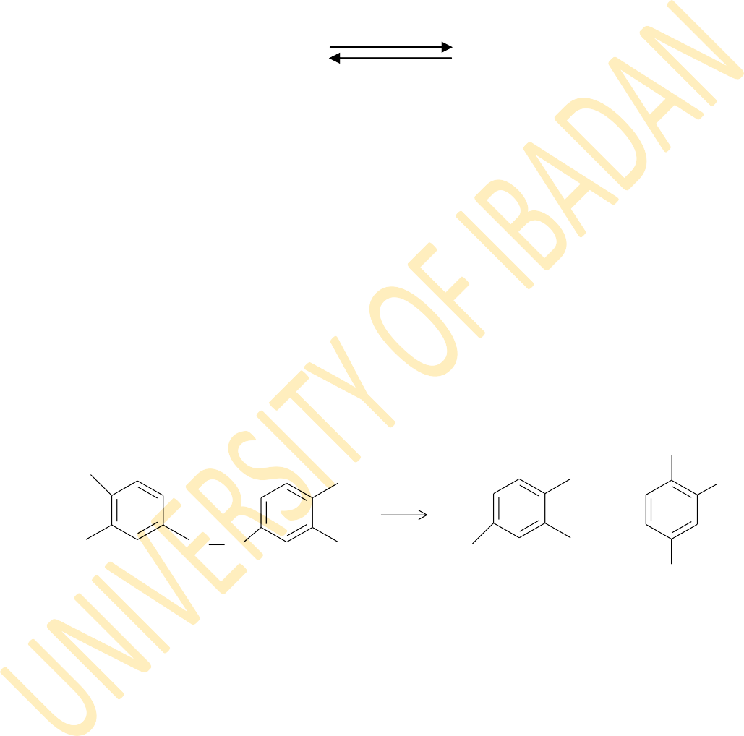
The sulphydryl groups in proteins are oxidized by several sulphydryl reagents (under mild conditions) to form disulphides.
reducing
agent
2RSH + oxidizing agent RSSR + 2H⁺ + 2e⁻
The oxidizing agents are usually groups having disulphide bonds which can be reduced upon reaction with the sulphydryl groups of proteins. Oxidation can occur through thiol-disulphide exchange reactions. This is the mechanism by which aromatic disulphides react with protein sulphydryl groups (Ellman, 1959). A typical example is 5,5'-dithiobis(2-nitrobenzoic acid) or DTNB for short. DTNB contains a disulphide bond which is reduced upon reaction with protein sulphydryl groups, the later being oxidized in the process. It reacts only with the ionized form of the protein sulphydryl, PS⁻, as shown in the equation.

O2N
-

NO2

NO2
NO2

- COO

P-S + +

-OOC
S S
DTNB
- COO

PS - S
COO-

S-
5 -thio-2-nitrobenzoate (TNB)

This reaction can be monitored spectrophotometrically and can be used to assay the reaction of sulphydryl groups. Such aromatic disulphides, especially those bearing electron-withdrawing groups, react quantitatively with aliphatic thiols to yield the corresponding aromatic thiol. This aromatic thiol is intensively coloured due to resonance of the thiol anion with the aromatic ring. Assay of this colour therefore measures the concentration of the original thiol. Bis(p-nitrophenyl) disulphide was the first disulphide to be used in this manner, but it has a very low solubility in water (Stevenson et al, 1960; Jocelyn, 1972).
Other aromatic disulphides that have been used in the assay of protein sulphydryl groups include 2,2´-dithiobispyridine (2-DTP), 4,4´-dithiobispyridine (4-

DTP), cystamine and dimercaptoethanol (Taylor et al., 1966). However, most of these disulphides are not charged and they are insensitive to the electrostatic environment of the sulphydryl groups in proteins. 2-DTP and 4-DTP are not soluble at room temperature and they must be stored at 5°C. This makes DTNB a more preferred reagent since it is commercially available and very stable as the sodium salt and in neutral solution if protected from light (Zuazaga et al., 1984).

CHAPTER THREE MATERIALS AND METHODS

CHEMICALS, EQUIPMENT AND SOFTWARE USED

List of Chemicals and Reagents
      - Amberlite IR-120 (Na) ion-exchange resin, analytical grade, BDH Ltd, Poole, England
      - Amberlite resin IRA-400 (Cl), analytical grade, BDH Ltd, Poole, England
      - Ammonium chloride, NH₄Cl, AnalaR, BDH Chemicals Ltd, Poole, England
      - Boric acid, H₃BO₃, ACS reagent, Sigma Chemical Co. USA
      - Citric acid (2-hydroxypropane-1,2,3-tricarboxylic acid mono hydrate, C₃H₄(OH)(COOH).H₂O, M & B Laboratory Chemicals, Dagenham, England
      - Di-sodium hydrogen orthophosphate anhydrous, Na₂HPO₄, AnalaR, BDH Chemical Ltd, Poole England
      - D(+)-glucose (dextrose) anhydrous, C₆H₁₂O₆, AnalaR, BDH Chemicals Ltd, Poole, England
      - Ethanol 96% vv AnalaR BDH Chemicals Ltd Poole, England
      - Hydrochloric acid (HCl, specific gravity 1.18) BDH Ltd, Poole, England
      - Inositol hexaphosphoric acid dodecasodium salt, Sigma Aldrich Chemie GmbH, Steinheim Germany
      - Phytic acid dodecasodium salt hydrate, C₆H₁₈Na₁₂O₂₄.xH2O, Sigma Aldrich Chemical Company, USA.
      - Potassium chloride, KCl, AnalaR, BDH Chemicals Ltd, Poole, England
      - Potassium cyanide, KCN, AnalaR, BDH Chemicals Ltd, Poole, England
      - Potassium ferricyanide, K₃Fe(CN)₆, AnalaR, BDH Chemicals Ltd, Poole, England
      - Pre-swollen microgranular cation exchanger CM52 carboxymethyl cellulose, Whatman Int. Ltd. Maidstone, England
      - Silver nitrate, AgNO₃, AnalaR, BDH Chemicals Ltd, Poole, England

      - Sodium acetate trihydrate, CH₃COONa.3H₂O, BDH Chemicals Ltd, Poole, England
      - Sodium chloride, NaCl, AnalaR, BDH Chemicals Ltd, Poole, England
      - Sodium dihydrogen orthophosphate, NaH₂PO₄.2H₂O, AnalaR, BDH Chemicals Ltd, Poole, England
      - Sodium hydrogen carbonate, AnalaR, BDH Chemicals Ltd, Poole, England
      - Sodiun hydroxide pellets, NaOH, AnalaR, BDH Chemicals Ltd, Poole, England
      - Sodium formate, HCOONa, AnalaR, BDH Chemicals Ltd, Poole, England
      - Sulphuric acid, (H₂SO₄, specific gravity 1.84), BDH Chemicals Ltd, Poole, England
      - Tri-sodium citrate, Na₃C₆H₅O₇.2H₂O, AnalaR, BDH Chemicals Ltd, Poole, England
      - 5,5'-Dithiobis(2-nitrobenzoic acid), C₁₄H₈N₂O₈S₂, Sigma-Aldrich Ind., St. Louis, MO 63103, USA
      - Sodium dithionite, Na₂S₂O₄, Sigma-Aldrich Chemical Company, USA
      - Nitrogen gas, AnalaR, BDH Chemicals Ltd, Poole, England
      - Liquefied Nitrogen, AnalaR, BDH Chemicals Ltd, Poole, England

List of Equipment
      - Carl Zeiss PMQ II 35083 UV/Visible spectrophotometer (for equilibrium studies involving cat haemoglobins)
      - Cecil Bioquest CE 2501 UV/Visible spectrophotometer (for kinetics involving cat haemoglobins)
      - Varian Cary® 400Scan UV/Visible spectrophotometer (for all studies on human haemoglobin)
      - Carré refrigerant plant room thermostat
      - Crioterm 10-80 water bath thermostat
      - MSE High speed 18 thermostated centrifuge
      - Radiometer Copenhagen PHM 85 precision pH meter
      - Techne fail-safe tempunit themostat/pump
      - Metler balance

List of Software
      - Discrete, a computer programme for the analysis of multiple exponential signals (Provencher, 1976a; 1976b)
      - Data stream version 3.3 (2549), Cecil Instrument Ltd, Milton Technical Centre, Cambridge England
      - Cary WinUV software, Varian Australia Pty Ltd, Victoria 3170, Australia
      - Scientist, MicroMath Scientific Software Incorporation
      - Sigma Plot, Systat Software

PREPARATION OF BUFFER SOLUTIONS

Preparation of standard buffer solutions
Standard buffers pH 4.010 ± 0.010 and pH 9.210 ± 0.010 were prepared by dissolving one tablet each of the respective standard buffer (made by British Drug Houses Limited, Poole, England), in distilled water and making up to the mark in a 100 cm³ volumetric flask. These standard solutions were used for standardizing the Radiometer Copenhagen PHM 85 precision pH meter at 25°C.

Preparation of phosphate buffer solutions: pH 5.6 - 8.0
Phosphate buffer solutions were prepared from reagent grade chemicals made by British Drug Houses [BDH]. A stock solution of 0.4 mol dm⁻³ sodium hydroxide, NaOH (mol. wt. = 40.00 g/mol), was prepared by weighing 16.00 g of sodium hydroxide pellets and dissolving in distilled water in a 1 dm³ volumetric flask. The solution was then made up to the mark with distilled water. In a similar way, a stock solution of 0.4 mol dm⁻³ sodium dihydrogen phosphate dihydrate, NaH₂PO₄.2H₂O (mol. wt. =156.01) was made by weighing 62.4 g of the salt and dissolving in a 1 dm³ volumetric flask. The solution was also made up to the mark with distilled water.
Phosphate buffer solutions of specific pH values were prepared by mixing the specified amounts of the prepared stock solutions of 0.4 mol dm⁻³ sodium hydroxide and 0.4 mol dm⁻³ sodium dihydrogen phosphate, as shown in Table 3.1. The ionic strength of each buffer solution was made up to 0.05 mol dm⁻³ by adding the required amount of sodium chloride. Each buffer solution was made up to the mark with distilled water in a 1 dm³ flask. The pH of each buffer solution was checked on a Radiometer PHM 85 Precision Research pH meter, which had earlier been standardized with standard buffer solutions pH 4.010 and 9.210. When necessary the pH of a buffer solution prepared was adjusted by titrating it with a buffer of a higher or lower pH to attain the desired pH. The amounts of 0.4 mol dm⁻³ NaOH, 0.4 mol dm⁻³ NaH₂PO₄ and NaCl required for each buffer are shown in Table 3.1.

Table 3.1: The amounts of 0.4 mol dm⁻³ NaOH, 0.4 mol dm⁻³ NaH₂PO₄ and NaCl required for phosphate buffers pH 5.6 - 8.0, I = 0.05 mol dm⁻³; total volume = 1 dm³.
pH | Volume of 0.4 mol dm⁻³ NaOH (cm³) | Volume of 0.4 mol dm⁻³ NaH₂PO₄ (cm³) | Mass of NaCl added (g)
5.6 | 1.00 | 25 | 2.29
5.8 | 1.83 | 25 | 2.26
6.0 | 2.82 | 25 | 2.21
6.2 | 4.82 | 25 | 2.14
6.4 | 6.30 | 25 | 2.04
6.6 | 8.87 | 25 | 1.93
6.8 | 11.8 | 25 | 1.79
7.0 | 14.8 | 25 | 1.65
7.2 | 17.5 | 25 | 1.52
7.4 | 19.7 | 25 | 1.42
7.6 | 21.4 | 25 | 1.35
7.8 | 22.6 | 25 | 1.29
8.0 | 23.3 | 25 | 1.24
Source: Colowick and Kaplan, 1954

Appendix H shows how the ionic strength of each buffer was determined

Preparation of borate buffer solutions: pH 8.0 - 9.0
A stock solution of 0.3 mol dm⁻³ sodium hydroxide, NaOH, was prepared by dissolving 12.00 g of sodium hydroxide pellets in distilled water and making up to the mark in a 1 dm³ volumetric flask. A stock solution of 0.3 mol dm⁻³ boric acid, H₃BO₃, was also prepared by dissolving 18.55 g of the acid (FW = 61.83) in distilled water and making up to the mark in a 1 dm³ volumetric flask.
Borate buffer solutions of specific pH values were prepared by mixing the specified amounts of the stock 0.3 mol dm⁻³ sodium hydroxide and 0.3 mol dm⁻³ boric acid solutions in a 1 dm³ volumetric flask. The ionic strength was made up to 0.05 mol dm⁻³ by adding the calculated amounts of sodium chloride. The solutions were made up to the mark with distilled water. The pH of each buffer was checked on a Radiometer PHM 85 Precision Research pH meter which had earlier been standardized with standard buffer solutions pH 4.0l0 and 9.210. When necessary, the pH was adjusted by titrating a prepared buffer solution with a buffer solution of a higher or lower pH to the desired pH. The required amounts of the 0.3 mol dm⁻³ NaOH, 0.3 mol dm⁻³ H₃BO₃ and NaCl are shown in Table 3.2 below.

Table 3.2: The amounts of 0.3 mol dm⁻³ NaOH, 0.3 mol dm⁻³ H₃BO₃ and NaCl required for borate buffers (pH 8. 0 – 9.0, I = 0.05 mol dm⁻³); total volume, 1 dm³.
pH | Volume of 0.3 mol dm⁻³ NaOH (cm³) | Volume of 0.3 mol dm⁻³ H₃BO₃ (cm³) | Mass of NaCl (g)
8.0 | 20.0 | 250 | 2.57
8.2 | 29.5 | 250 | 2.40
8.4 | 42.7 | 250 | 2.17
8.6 | 60.0 | 250 | 1.82
8.8 | 82.0 | 250 | 1.48
9.0 | 107.0 | 250 | 1.05

PREPARATION OF REAGENTS AND SAMPLES

Preparation of anticoagulant
A solution of acid-citrate-dextrose (ACD) anticoagulant was prepared by dissolving 5.10 g of trisodium citrate dihydrate, 1.6 g of citric acid monohydrate and
2.4 g of anhydrous dextrose in distilled water in a 200 cm³ volumetric flask. The solution was then made up to the mark with distilled water (Haemoglobin Laboratory Procedures, J.G. Beetlestone). Anticoagulant solutions were prepared fresh just before use.

Preparation of saline
The normal saline for most erythrocytes, including that of human, is 9.5 g of sodium chloride per dm³ of solution. But in the case of cat haemoglobin an isotonic saline of 11.5 g NaCl per dm³ was found to be suitable for washing the erythrocytes. Therefore 11.5 g of sodium chloride was weighed and dissolved in a 1 dm³ volumetric flask. This was then made up to the mark with distilled water. The solution was stored at 5°C in a refrigerator.

Preparation of dialysis solutions
Dialysis solutions were prepared by addition of 0.029 g of sodium chloride, 10 cm³ of 0.4 mol dm⁻³ sodium dihydrogen phosphate and 5 cm³ of 0.4 mol dm⁻³ disodium hydrogen phosphate to 5 dm³ of distilled water. It was ensured that the final pH of the solutions was between 6.5 and 7.5 (Haemoglobin Laboratory Procedures,
J.G. Beetlstone). The solutions were kept at 5°C in the cold room.

Preparation of inositol hexakisphosphate (inositol-P₆) solution
Two types of reagent grade inositol hexakisphophate, purchased from Sigma Chemical Company, were used without further treatment. From the first, supplied as the disodium salt of the acid, a 0.01 mol dm⁻³ solution of inositol-P₆ (molar mass 948) was prepared by weighing and dissolving 0.237 g of the salt in phosphate buffer pH
6.0 in a 25 cm³ volumetric flask. The buffer solution was added until close to the mark. The initial pH of the resulting solution was around 10.0. Thereafter, the solution was titrated to pH 6.7 with a few drops of concentrated hydrochloric acid.
From the second salt, which was supplied as phytic acid sodium salt from rice, with a formular weight of 660.03, a 0.01 mol dm⁻³ solution of inositol-P₆ was made by

weighing and dissolving approximately 0.165 g of the salt in phosphate buffer pH 6.0 in a 25 cm³ volumetric flask. More of the solution of the phosphate buffer was added until close to the mark. The initial pH of the resulting solution was around 4.0. This solution was then titrated to pH 6.7 using less than 1 cm³ of a 3 mol dm⁻³ sodium hydroxide solution.

Preparation of carbon monoxide gas

Carbon monoxide (CO) gas was prepared by reacting concentrated sulphuric acid with sodium methanoate:
HCOONa(s) + H2SO4(aq) NaHSO4(aq) + H2O(l) + CO(g)

The carbon monoxide gas evolved was allowed to pass through three wash bottles. The first two bottles contained sodium hydroxide solution while the third contained distilled water. Carbon monoxide is neither soluble in sodium hydroxide nor distilled water, so they merely removed any acid vapour that might have been released along with the gas during preparation. The carbon monoxide gas produced was stored in a gas trap bottle for later use. The setup used in the preparation of CO gas is shown in the Figure 3.1.

- 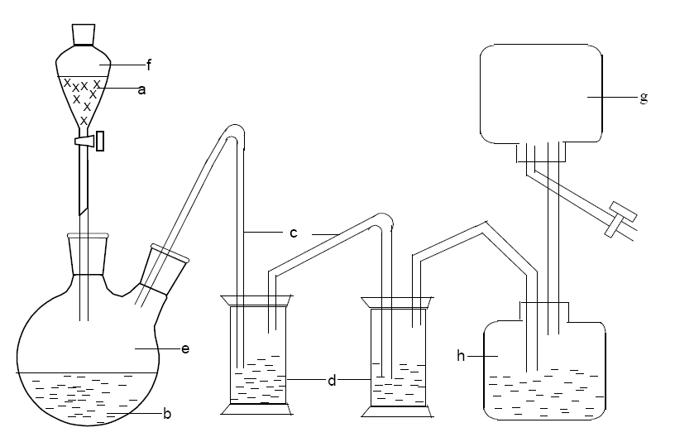concentrated tetraoxosulphate(VI) acid;
- sodium methanoate;
- delivery tube;
- aqueous NaOH to remove fumes of conc. H₂SO₄;
- two-necked round bottom flask;
- separating funnel;
- gas trap;
- gas collected over water.

Figure 3.1: Setup for the preparation of carbon monoxide.

Preparation of Drabkin’s solution
Drabkin‟s solution was prepared by weighing 0.05 grams of potassium ferricyanide, K₃FeCN₆, 0.125 grams of potassium cyanide, KCN, and 2.50 grams of sodium hydrogen carbonate, NaHCO₃. The mixture of the weighed salts was dissolved and made up to the mark with distilled water in a 250 cm³ volumetric flask. To prevent photodecomposition, the solution was stored in an amber bottle and used up within one month of preparation (Haemoglobin Laboratory Procedures, J.G. Beetlestone).

Preparation of 5, 5′-dithiobis(2-nitrobenzoate), DTNB, solution
A 50 mmol dm⁻³ solution of DTNB was prepared by accurately weighing and dissolving 0.4954 g of the reagent grade chemical purchased from Sigma Chemical Company, St Louis, USA, in 95% ethanol. The bright yellow solution was transferred into a 25 cm³ standard flask and made up to the mark with 95% ethanol.
A solution of 0.2 mol dm⁻³ sodium dihydrogen phosphate was prepared by dissolving 0.78005 grams of the hydrated salt (NaH₂PO₄.H₂O, molar mass 156.01) in distilled water in a 25 cm³ volumetric flask. This was then made up to the mark with distilled water. Similarly, a 0.2 mol dm⁻³ solution of disodium hydrogen phosphate, was also prepared by dissolving 1.4196 g of the anhydrous salt (molar mass 141.96) with distilled water in a 50 cm³ volumetric flask and then making up to the mark. A
0.2 mol dm⁻³ phosphate buffer was then prepared by titrating 50 cm³ of the 0.2 mol dm⁻³ Na₂HPO₄ solution with approximately 1.5 cm³ of sodium dihydrogen phosphate solution to pH 8.00 ± 0.01.
18 cm³ of the 0.2 mol dm⁻³ phosphate buffer pH 8.00 ± 0.01 was added with continuous stirring to 25 cm³ of the 50 mmol dm⁻³ DTNB solution to give a solution of pH 6.51. The concentration of this DTNB solution was 29.07 mmol dm⁻³. This was used as the stock solution for both the equilibrium and kinetics experiments. In addition, 10 cm³ of the prepared 29.07 mmol dm⁻³ was diluted further to obtain a 2.9 mmol dm⁻³ solution, which was also used in experiments involving deoxyhaemoglobin.

Preparation of buffer solutions for haemoglobin separation
10 mmol dm⁻³ sodium dihydrogen phosphate was prepared by dissolving 7.8005 g of sodium dihydrogen phosphate dihydrate, NaH₂PO₄.2H₂O (M.W=156.01), in a 5000 cm³ standard flask using distilled water. This was then made up to the mark

with distilled water. A solution of 10 mmol dm⁻³ disodium hydrogen phosphate was made by dissolving 7.098 g of disodium hydrogen phosphate crystals, Na₂HPO₄ (M.W=141.96), in a 5000 cm³ standard flask using distilled water. The solution was then made up to the mark with distilled water.
Some of the 10 mmol dm⁻³ sodium dihydrogen phosphate solution was added to 10 mmol dm⁻³ disodium hydrogen phosphate solution in a v/v ratio of 1:2 to obtain a buffer solution of pH 6.5. The pH was checked using the Radiometer PHM 85 Precision Research pH meter which had previously been standardized.
In a similar manner, volumes of the 10 mmol dm⁻³ sodium dihydrogen phosphate solution were added to the 10 mmol dm⁻³ disodium hydrogen phosphate solution in a ratio 1:4 to obtain a buffer solution of pH 8.0. The ionic strength of the phosphate buffer pH 8 was adjusted to 200 mmol dm⁻³ by adding 11.90 g of sodium chloride to 1 dm³ of the buffer solution. The pH of the solution was checked using the Radiometer PHM 85 Research pH meter.

Preparation of resins and Packing of Dintzis column
The Dintzis column is a mixed bed of ion exchange resins used for stripping haemoglobin of undesirable ions and organic phosphates (Dintzis, 1952). It is made up of five layers of resins, two of which serve as indicators- the mixed and the mixed indicator form. The other three are respectively prepared as described below to contain hydrogen ions (H⁺), acetate ions (CH₃COO⁻) and ammonium ions (NH₄⁺).

Preparation of resins
- Hydrogen form
Amberlite resin IR 120 was packed into a 50 cm³ burette and washed slowly with about 10 times its volume of 3 mol dm⁻³ HCl. The resin was then washed with distilled water until the effluent was acid-free, i.e., neutral to blue litmus paper.

Acetate form
Amberlite resin IRA 400 was packed into a 50 cm³ burette and about 10 times its volume of 3 mol dm⁻³ HCl was passed slowly through it. The resin was then washed with distilled water until the effluent was acid free (neutral to blue litmus). About 10 times its volume of 3 mol dm⁻³ sodium acetate, CH₃COONa, was then passed through the column. The resin was again washed with distilled water until the effluent gave no precipitate with silver nitrate (AgNO₃) solution.

Ammonium form
100 cm³ of 3 mol dm⁻³ sodium chloride solution, (NaCl_{(aq)}) was passed slowly through a packed column of Amberlite IR 120 resin. The resin was washed with distilled water until the effluent gave no precipitate with silver nitrate. Thereafter ten times its volume of 3 mol dm⁻³ ammonium chloride solution, NH₄Cl_{(aq)}, was slowly passed through the column. The resin was then washed with distilled water until the effluent from the column gave no precipitate with AgNO₃ solution.

Mixed form and mixed indicator form
Each of these two forms of the resins was washed with distilled water, without further treatment.

Packing of Dintzis Column
A 50 cm³ burette, with one end plugged with glass wool, served as the column. About 7 cm length of the generated hydrogen form of the resin was packed into the burette containing distilled water. (The tap was opened while the column was being packed, but care was also taken to ensure that there was always distilled water over the resin throughout the packing process). About 3 cm length of mixed indicator form was added, followed by 3 cm length of the mixed form, 7 cm length of the acetate form and, finally, 7 cm length of the ammonium form of the resin were added to the column (Figure 3.2). The column was then washed thoroughly with distilled water (Dintzis, 1952).

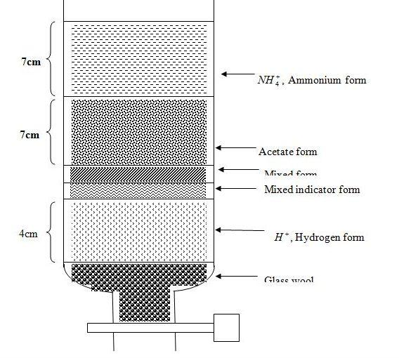Ammonium form, NH₄⁺
7cm

Acetate form, CH₃COO⁻
7cm
Mixed Form
Mixed indicator form

7cm
Hydrogen form, H⁺

Glass wool

Figure 3.2: Dintzis Column

PREPARATION OF HAEMOGLOBIN

Preparation of Cat haemolysate
Cat blood was obtained from domestic cats (Felis catus) purchased from a local market. The blood was collected into freshly prepared acid-citrate-dextrose anticoagulant. Haemoglobin was prepared using standard laboratory procedures: The blood sample was centrifuged for 20 minutes at 5°C at a speed of 15,000 rpm using an MSE High Speed 18 ultracentrifuge, with an 8 x 50 cm³ capacity rotor. The red blood cells were washed three times with isotonic saline solution (11.5 g NaCl/dm³) to remove other proteins present in the blood. After each washing the resulting mixture was centrifuged at 10,000 rpm for 15 minutes. After the third washing, the sediment (erythrocytes) was lysed by shaking it vigorously with an equal volume of ice-cold distilled water to yield a mixture of haemoglobin solution and red cell debris.
This mixture was centrifuged at 15,000 rpm for 20 minutes to remove all stromal impurities. The haemoglobin was decanted from the cake of cell debris, after which 5% w/v of sodium chloride was added to precipitate other non-haem proteins. This was left for 20 minutes at 5°C in a refrigerator. The haemoglobin was further centrifuged at a speed of 15,000 rpm for 20 minutes. Low molecular weight impurities contained in the haemoglobin were then removed by dialysing it for three hours in a 5 dm³ Buchner flask against 10 mmol dm³ phosphate buffer (pH ≈ 6.5) at 5°C using polyvinyl chloride dialysis tubing. This procedure was repeated two more times. Haemoglobin prepared this way is in the oxygenated form, referred to as oxyhaemoglobin.

Separation of Cat haemoglobins
Whatman carboxymethylcellulose (CMC-52), a microgranular pre-swollen cation exchanger, was washed several times in a beaker with 10 mmol dm⁻³ phosphate buffer pH 6.5 until the pH of the supernatant was about 6.5. About 100 cm³ of the pre- washed CMC-52 resin was then packed into a 3 cm (diameter) x 30 cm glass column.
10 mmol dm⁻³ phosphate buffer (pH 6.5) was then passed through the column gradually until the pH of the effluent was 6.5. The resin in the column was allowed to settle and the buffer was drained to minimize dilution of the haemoglobin. The washed resins and buffers were kept in the cold room at 5°C for later use.
Cat haemolysate comprises of two haemoglobin types: the major and the minor haemoglobin. The separation of the cat haemoglobins was carried out in the cold room

at 5°C using the washed and packed CMC-52 (a modified method of Taketa et al., 1971). Cat haemolysate, previously dialysed with 10 mmol dm³ phosphate buffer pH 6.5, was loaded on top of the column. The minor haemoglobin was eluted first with 10 mmol dm⁻³ phosphate buffer pH 6.5. Complete elution of the minor haemoglobin from the column was indicated by loss of colour from the effluent. The major haemoglobin, which still remained bound to the resin after the minor haemoglobin had been completely removed, was eluted inside a cold room at 5 - 10°C , by passing 10 mmol dm⁻³ phosphate buffer pH 8.0 (I = 0.2 mol dm⁻³) through the column. The major haemoglobin came out as a dark red solution. After separation, the major and minor fractions of the haemoglobin were further dialysed twice at 5°C (for three hours per dialysis) against 10 mmol dm⁻³ phosphate buffer (pH = 6.8). The dialysis was carried out to remove unwanted chloride and phosphate ions.
These oxyhaemoglobin fractions were then converted to the carbonmonoxy derivative by bubbling carbon monoxide gas into each of the fractions for about 20 minutes. The haemoglobin fractions were divided into small portions and stored in a freezer as the carbonmonoxy derivatives. A portion was thawed at a time for use. This was to ensure that fresh haemoglobin was used throughout the experiments. Since the organic phosphate 2,3-biphosphoglycerate (2,3-BPG) which exists with haemoglobin in the red blood cell is not easily removed from haemoglobin by dialysis, each haemoglobin solution was passed through a Dintzis column to remove endogenous 2,3-BPG and excess ions.
To determine the relative proportions of the major and minor haemoglobins, we first determine the number of moles of each fraction thus:

where
CjVj = nj
Cn Vn = nn
- (14)

(13)

C , V and n respectively represent the concentration (mol dm⁻³), volume (dm³) and
j j j
number of moles of the major fraction, and
C , V and n respectively represent the concentration (mol dm⁻³), volume (dm³) and number of moles of the minor fraction.
n n n
The concentrations, in mol dm⁻³, were determined as described in section 3.5, while the volumes were measured in dm³. The relative proportion of the major haemoglobin, P_{major}, is given by:

P = ⎧⎪ n j × ⎫⎪ (15)

major
⎨n + n
100⎬%

⎩⎪ j n ⎪⎭
While the relative proportion of the minor haemoglobin, P_{minor}, is given by:
P = ⎧⎪ nn × ⎫⎪ (16)

minor
⎨n + n
100⎬%

⎩⎪ j n ⎪⎭
The result of this estimation gave the percentages of major and minor haemoglobins in cat haemolysate as 60.0 ± 4.0 and 40.0 ± 4.0 respectively.

Preparation of human deoxyhaemoglobin
The haemoglobin used in the deoxy experiments was first prepared as oxyhaemoglobin from blood obtained from non-smoking, adult human donors. After passing it through a carboxymethyl CM-52 column, the solution of human oxyhaemoglobin A obtained was introduced dropwise into liquid nitrogen with a Pasteur pipette. This is referred to as flash freezing. Flash freezing in liquid nitrogen in this way turns the oxyhaemoglobin solution into small, firm and solid-like pellets. The flash frozen oxyhaemoglobin pellets were kept in a number of plastic Wheaton bottles and stored in the freezer at -80°C. Prior to use, a few pellets of the human oxyhaemoglobin A were brought out of the freezer and allowed to thaw gently in ice. Deoxygenation was carried out as described below in a thermostated room at 20°C.
Humidified nitrogen gas (i.e. nitrogen gas that had been passed through deionised water) was used to deoxygenate the thawed oxyhaemoglobin solution (Figure 3.3a). This was done to prevent dehydration of the haemoglobin solution which could lead to marked changes between the concentration of the starting oxyhaemoglobin and the end-product, the deoxyhaemoglobin solution. Anhydrous sodium dithionite salt, Na₂S₂O_{4(s)}, was added to the humidifier to completely eliminate the presence of oxygen.
A 10 µmol (haem) dm⁻³ (5 µmol dm⁻³ reactive sulphydryl groups) solution of human oxyhaemoglobin A was prepared in an appropriate buffer of known pH. 1 cm³ of this solution was transferred into a specially fabricated 0.2 cm × 1 cm cuvette. This cuvette has fitted to its mouth, a reservoir compartment, which can hold solutions when tilted and in which mixing or reaction can be carried out (Figure 3.3b). The cuvette was then covered with a resealable septum seal and Teflon tapes held tightly in place by an open-top, plastic screw-cap. Humidified nitrogen gas was introduced into the solution inside the cuvette from a flow meter which has a long narrow pipe fitted

with a long thin needle. The needle was inserted into the cuvette through the septum seal. A second shorter needle was also inserted to disallow pressure build-up inside the cuvette.
The flow meter was adjusted to about 0.1 dm³ per minute and nitrogen gas was allowed to flow through the oxyhaemoglobin solution until it was completely deoxygenated. This usually lasted between 2 and 3 hours (Figures 3.3a and 3.3b). Complete deoxygenation was confirmed by comparing the spectrum of the solution obtained on a Varian Cary 400Scan UV/Visible spectrophotometer (from 300 nm to 700 nm) with that of a standard spectrum of human deoxygenated haemoglobin within the same wavelength range (Antonini and Brunori, 1969; Brunori et al., 1968).
All experiments (kinetics and equilibrium studies) involving deoxsyhaemoglobin were carried out inside the sealed specialized cuvettes immediately after deoxygenation.

(a)

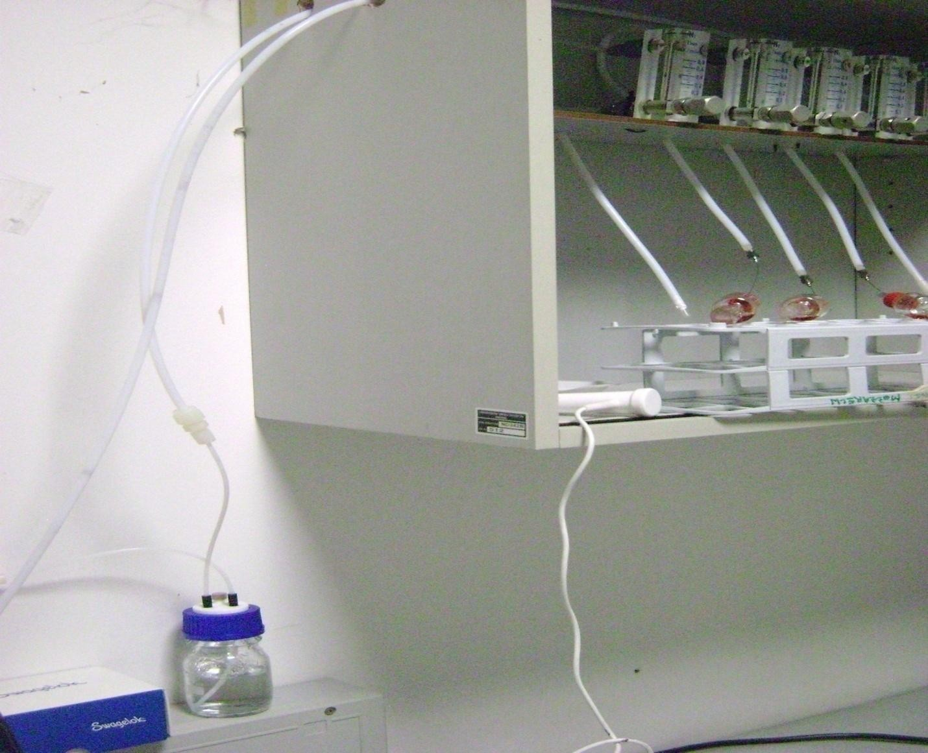(b)

(h)

(c)
(g)

- (f)

(e)

Figure 3.3a: Set up for the deoxygenation of haemoglobin

  - a flow meter;
  - pipe carrying humidified N₂ gas into flow meter;
  - pipe carrying dry N₂ gas from tank to flow meter;
  - pipe carrying dry N₂ gas from tank to humidifier;
  - humidifier (containing distilled water and Na₂S₂O_{4(s)} );
  - temperature sensor;
  - special cuvettes containing haemoglobin solution;
  - flow meter pipes fitted with needles.

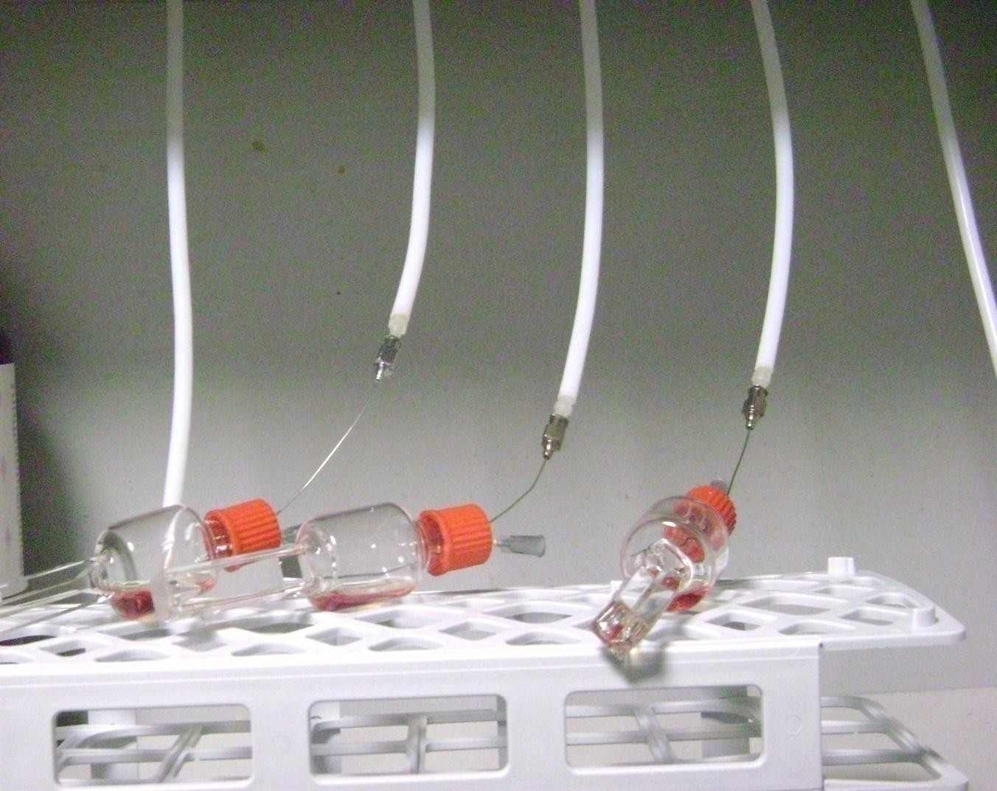Figure 3.3b: Deoxygenation of haemoglobin solution in progress

DETERMINATION OF HAEMOGLOBIN CONCENTRATION

Determination of carbonmonoxyhaemoglobin concentration

For experiments on carbonmonoxyhaemoglobin, the haemogloglobin solution was initially passed through a Dintzis column to remove small undesirable ions and to strip the haemoglobin completely of organic phosphates. 0.1 cm³ of the stripped carbonmonoxyhaemoglobin was added to 10 cm³ of distilled water. The solution was then mixed thoroughly and its absorbance read at 537.5 nm. The concentration, which was corrected for dilution, was determined in moles per haem using the equation below and 1.4 x 10⁴ mol⁻¹ dm³ cm⁻¹ as the molar extinction coefficient (Zwiderweg et al., 1981):
A × (10 + v) ×10⁻⁴
C = 537.5 (17)
1.4× l × v
A_{537.5} = Absorbance at 537.5 nm

C = Concentration of haemoglobin in moles of haem dm⁻³ v = Volume of haemoglobin
l = path length of cuvette

The concentration of the minor haemoglobin, [Hb]_{minor}, was approximately between
6.0 × 10⁻⁴ and 1.0 × 10⁻³ mol dm⁻³, while that of the major haemoglobin, [Hb]_{major}, was between 1.2 × 10⁻³ and 2.5 × 10⁻³ mol dm⁻³.

Determination of oxyhaemoglobin concentration
To convert the haemoglobin stored in the carbomonoxy form to oxyhaemoglobin, light from a 60 watt electric bulb was focused on a measured volume of the carbomonoxyhaemoglobin inside a beaker for between 30 – 50 minutes. The beaker was placed in a bucket containing ice cubes and the haemoglobin inside the beaker was stirred very gently with the aid of a magnetic stirrer throughout the photolysis process. After all the carbon monxide had been displaced, the resulting oxyhaemoglobin was passed through a Dintzis column. The concentration of oxyhaemoglobin was then determined by reading the absorbance of the cyanomethaemoglobin complex formed after 0.1 cm³ of oxyhaemoglobin was added to 10 cm³ of Drabkin‟s solution. The molar extinction coefficient (per haem) at 540 nm was assumed to be 1.09 x 10⁴ mol⁻¹ dm³ cm⁻¹ (Austin and Drabkin, 1935; Wiedermann and Olson, 1975). The absorbance was read off at 540 nm on a Cecil

UV/Visiblespectrophotometer and the concentration of the haemoglobin was calculated using the equation below:

A × (10 + v) ×10⁻⁴

(18)
C = 540
1.09× l × v

A₅₄₀ = Absorbance at 540 nm

C = Concentration of haemoglobin in moles of haem per dm³ v = Volume of haemoglobin
l = path length of cuvette

Determination of the aquomethaemoglobin concentration
Aquomethaemoglobin was prepared by adding a solution of freshly prepared potassium ferricyanide, K3Fe(CN)6, to oxyhaemoglobin solution. The volume of K3Fe(CN)6 added must be equivalent to 2-fold the number of moles of the oxyhaemoglobin solution to be converted. The aquomethaemoglobin solution was passed through a Dintzis column to remove excess K3Fe(CN)6 and the haemoglobin concentration was determined by reading off the absorbance of the solution obtained after 0.1 cm³ of the aquomethaemoglobin was added to 10 cm³ of distilled water, together with a few crystals of recrystalized potassium cyanide. The mean absorbance value from three repetitions was used to calculate the concentration of the aquomethaemoglobin.

KINETICS

    - Kinetics of the reaction of 5,5'-dithiobis(2-nitrobenzoate), DTNB, with the sulphydryl groups of human oxyhaemoglobin A

One of the advantages of DTNB over other sulphydryl reagents is that the kinetics of its reaction with haemoglobin sulphydryl groups can be monitored on a simple UV-Visible spectrophotometer (Neer et al., 1968). Furthermore, DTNB is sensitive to the electrostatic environments that characterize the reactivity of the CysF9[93]β sulphydryl group (Neer, 1970; Amiconi et al., 1971; Okonjo et al., 1995). We restricted our DTNB experiments to pH 9.0 and below because it is known that above pH 9.0 complications arise on account of the increased rate of hydrolysis of disulphide bonds (Robyt et al., 1971). The reactions of DTNB with both the stripped human oxyhaemoglobin and inositol-bound haemogloin solutions, were monitored at 412 nm on a Varian Cary UV-Visible spectrophotometer under pseudo-first order conditions. This was achieved by reacting each of the haemoglobin samples with at least a sixty – fold excess of DTNB per sulphydryl group.
A 10 µmol (haem) dm⁻³ (5 µmol dm⁻³ reactive sulphydryl groups) solution of a haemoglobin derivative in a chosen buffer was allowed to equilibrate at 25°C in a thermostated water bath. The spectrophotometer was set by inputing all the necessary parameters: wavelength, temperature and times (start and end). A 3 cm³ aliquot of this haemoglobin solution was then transferred into a 1 cm x 1 cm cuvette. (For experiments carried out in the presence of inositol-P₆, a calculated volume of the 0.01 mol dm⁻³ inositol-P₆ that would result in a fiinal concentration of 10 µmol dm⁻³ was added to the 10 µmol (haem) dm⁻³ solution of haemoglobin before equilibration). The cuvette was placed in the cell compartment of the spectrophotometer which was also thermostated at 25°C. The reaction was initiated by quickly mixing the haemoglobin with a calculated volume of the stock 29.07 mmol dm⁻³ DTNB solution in 95% ethanol that would give a final DTNB concentration of 300 – 600 µmol dm⁻³. The reaction timing was initiated simultaneously by pressing the auto start button of the spectrophotometer. The kinetic traces (change in absorbance or transmittance as a function of time) were displayed on a computer screen and stored on the computer. Each kinetic run was repeated at least two additional times under identical experimental conditions.

The data were analyzed with two softwares. The first was a 1990 update of DISCRETE, a computer programme for the analysis of multiple exponential signals (Provencher, 1976a; 1976b). The other was a SigmaPlot® Systat software. The two softwares gave similar results. The analyses gave a single kinetic phase for stripped haemoglobin and for haemoglobin in the presence of inositol-P₆. The pseudo-first order rate constants calculated from different kinetic traces, k_{obs}, were plotted against the DTNB concentration. The resulting linear graph gave a slope, k_{F}, the apparent second-order forward rate constant, and a positive intercept.

    - Kinetics of the reaction of 5,5'-dithiobis(2-nitrobenzoate), DTNB, with the sulphydryl groups of human deoxyhaemoglobin A. (The experiments described in this section were carried out at the Department of Biochemistry and Molecular Biology, University of Parma, Italy).
The kinetics of the reaction of 5,5'-dithiobis(2-nitrobenzoate), DTNB, with the sulphydryl groups of human deoxyhaemoglobin A was monitored at 412 nm. Immediately after deoxygenation was complete, the sealed, specialized cuvette containing ≈ 10 µmol (haem) dm⁻³ solution of human deoxyhaemoglobin A was transferred from the thermostated room into the cell compartment of the Cary 400 spectrophotometer thermostated at 25°C with a Crioterm® water bath. A spectrum of the haemoglobin solution was taken between 300 and 700 nm. The disappearance of the characteristic peaks for human oxyhaemoglobin A at 541, 577, 415 & 344 nm, and the appearance of the characteristic peaks for human deoxyhaemoglobin A at 555 & 430 nm, confirmed complete deoxygenation (Antonini and Brunori, 1969; Brunori et al., 1968; Figures 4.18 & 4.19). About 10 cm³ of 29.07 mmol dm⁻³ DTNB in 95% ethanol was similarly deoxygenated by allowing humidified nitrogen gas to pass over the solution for about 30 minutes in a small, septum-sealed, amber bottle.
Prior to the initiation of the reaction, the deoxyhaemoglobin solution in the cell compartment was re-connected to a continuous flow of humidified nitrogen gas. The spectrophotometer was set by inputing all the necessary parameters: wavelength, temperature and times (start and end). A calculated volume (mm³) of deoxygenated
29.07 mmol dm⁻³ DTNB solution that would give a final concentration between 100 and 400 µmol dm⁻³ of DTNB was introduced into the sealed cuvette via a gastight microsyringe. The kinetics of the reaction was immediatley initiated by gently but

quickly shaking the mixture in the cuvette and pressing the start button on the spectrophotometer.
The kinetic traces (change in absorbance or transmittance as a function of time) were displayed on a computer screen and stored on the computer. Each kinetic run could only be repeated once under identical experimental condition due to the length of time required for deoxygenation and because only three such specialised cuvettes were available for use. For the same reason we could not conduct a full pH- dependence study of the reaction. However, we were able to monitor the kinetics of the reaction at pH 8 at several concentrations of DTNB. The data were analyzed with the SigmaPlot® Systat software.

Kinetics of reaction of 5,5'-dithiobis(2-nitrobenzoate) with the sulphydryl groups of cat haemoglobin.

The reaction of DTNB with liganded haemoglobin derivatives of the domestic cat was monitored at 412 nm in a manner similar to that of human oxyhaemoglobin A. The only difference was that the reaction was monitored on a Cecil BioQuest® UV- Visible spectrophotometer and there was no need for deoxygenation to be carried out. Also, the normal 1 cm by 1 cm cuvettes were used, and as such, we were able to repeat each kinetic run more than once.

EQUILIBRIUM STUDIES

    - Determination of equilibrium constants for the reaction of DTNB with sulphydryl groups of human deoxyhaemogobin A. (The experiments described in this section were carried out at the Department of Biochemistry and Molecular Biology, University of Parma, Italy).
A 50 µmol (haem) dm⁻³ (25 µmol dm⁻³ in reactive sulphydryl groups) oxyhaemoglobin solution was prepared in a phosphate buffer of desired pH and ionic strength 50 mmol dm⁻³. A 1 cm³ aliquot of this solution was measured into each of the three available, specially fabricated, 0.2 cm × 1 cm cuvettes. The solution was deoxygenated as previously described. After complete deoxygenation was confirmed from the spectrum, a known volume of a deoxygenated 29 mmol dm⁻³ DTNB solution was added with a gastight microsyringe into the deoxyhaemoglobin solution in each cuvette. The mixtures were shaken gently and allowed to equilibrate for between 6 and 8 hours under a continuous nitrogen flow. All the deoxygenation and equilibration processes were carried out at 25°C in a CARRÉ refrigerant plant thermostated room.
After equilibration, the spectrum of each solution was taken from 300 – 700 nm on the Varian Cary 400Scan UV/Visible spectrophotometer which was connected to an external computer recording unit equiped with a Cary® WinUV software. Owing to the limited number of the specially fabricated cuvettes available for it was difficult to obtain sufficient data points to determine the equilibrium constant (K_{equ}) at a single wavelength. It therefore became necessary to employ other means to obtain more data points from the experiments performed at each pH. Eyer et al. (2003) have determined the molar absorption coefficients of 5-thio-2-nitrobenzoate (TNB) at four other wavelengths apart from 412 nm. Therefore, by assuming molar absorption coefficients of 13.8, 14.0, 11.0, 8.0 and 4.0 (× 10³ mol⁻¹dm³ cm⁻¹) at 405, 412, 436, 450 and 470
nm respectively, the equilibrium constant was calculated for the content in each cuvette from the change in absorbance at each of the listed wavelengths, using a programme written on a MicroMath Scientist software (Appendix G1). The differences in absorbance at specific wavelengths between the spectra before and after equilibration were noted and imputed into a programme written on the MicroMath Scientist Software for the analysis of equilibrium data (Appendix G1, page 278).
This procedure was repeated in phosphate buffers pH 5.6 – 7.8 and borate buffers pH 8.0 - 9.0 (ionic strength = 50 mmol dm⁻³), and with 2.9 mmol dm⁻³ DTNB.

Determination of equilibrium constants for the reaction of DTNB with sulphydryl groups of cat haemoglobin.

All equilibrium experiments carried out on the reaction of DTNB with cat haemoglobin sulphydryl groups were for the R quaternary conformation, i.e. liganded haemoglobins, and were done in the presence of inositol-P₆. The equilibrium constants for the corresponding stripped derivatives had previously been determined (Okonjo et al., 2006)
3 cm³ aliquots of a 50 μmol (haem) dm⁻³ haemoglobin solution in a buffer at a given pH, were added to varying volumes (between 2 and 100 mm³) of a stock 29 mmol dm⁻³ DTNB solution accurately measured into several clean, dry test tubes. Inositol-P₆ solution was added into each test tube in the ratio [inositol-P₆] : [reactive sulphydryl per haemoglobin tetramer] = 4:1. The mixtures were stirred and left to equilibrate for 4 - 6 hours at 25°C in a thermostated water bath. The absorbance of each solution was read at 412 nm on a Zeiss PMQ II UV-Visible spectrophotometer. The equilibrium constant, K_{equ}, was calculated for the content of each test tube using a programme written on a MicroMath Scientist software (Appendix G2, page 279). The programme was such that it took account of the dilution of the solution in each tube caused by the addition of DTNB. The programme also calculated the concentration of 5-thio-2-nitrobenzoate (TNB), the chromophoric product of the DTNB reaction, assuming a molar absorption coefficient of 14,000 mol⁻¹ dm³ cm⁻¹ for TNB. The mean value calculated for K_{equ} was subject to a standard error of about 10%. At the end of the 4-6 hour incubation period, the pH of each solution was measured using a Radiometer PHM 85 Research pH meter, which had previously been standardized with standard buffers pH 4.00 and 9.21. This experimental procedure was repeated at pH values between 5.6 and 7.8 (phosphate buffers) and between 8.0 and 9.0 (borate buffers), each of ionic strength of 50 mmol dm⁻³.

CHAPTER FOUR RESULTS

KINETICS


THE THEORY OF HAEMOGLOBIN KINETICS
The complete reaction of haemoglobin with 5,5´-dithiobis(2-nitrobenzoate) – DTNB – may be depicted as (Okonjo et al., 2007; 2008; 2009):

PSH+ DTNB QSH  H⁺ + PS⁻ + DTNB kF H⁺ + PS.ST+ TNB⁻  QTNB

PS.ST+ TNBH

□    k     
R
…………..(4.1)

In the above equation, PSH is haemoglobin with the CysF9[93]β sulphydryl group in its protonated, unreacting (with DTNB) form; PSˉ is its corresponding DTNB-reacting form; PS.ST is the mixed disulphide formed after the reaction with DTNB; TNBˉ is 5-thio-2-nitrobenzoate, the anionic chromophoric product of the reaction; TNBH is obtained from the protonation of TNB⁻ ; the ionization constants of CysF9[93]β and TNBH are given as Q_{SH} and Q_{TNB} respectively; k_{F} is the apparent (forward) second order rate constant for the DTNB reaction step in which PS.ST is formed; and k_{R} is the corresponding reverse rate constant.
Let a and b represent the initial concentrations of PS⁻ and DTNB, respectively. If x is the concentration of PS.ST or TNB⁻ formed after time t, then the rate of the reaction is given by:

− d(a− x) = k (a− x)(b− x) − k (x)²
….………….. (4.2)

dt F R

- da + dx = k ab− k x(a+ b) + k x² − k x²

………….... ..(4.3)

dt dt
F F F R

But ⎧− da = k ab⎫

….……...….. (4.4)

⎨ dt F ⎬

⎩ ⎭
Therefore,
dx = −k x (a+ b) + (k − k

) x²

…………….. (4.5)

dt F F R

Under the pseudo-first order conditions employed in these experiments, b >> a, Equ.
4.5 therefore becomes

dx = −k ⎧bx−⎛1− 1 ⎞ x² ⎫

……………….(4.6)

dt ^{F} ⎨
⎜ K ⎟ ⎬

⎩ ⎝ ⎠ ⎭

(where K is the equilibrium constant and is equal to
kF )
kR

dx = − k ⎧bx+⎛ 1 − ⎞ 2 ⎫
1 x

……………….(4.7)


dt ^{F} ⎨
⎜ K ⎟ ⎬

⎩ ⎝ ⎠ ⎭

Since x is small, then x² becomes smaller still. Therefore ⎛ 1 −
⎜
K
⎞
1⎟ x

² << bx and Equ.

4.7 becomes
dx = −k bx
⎝ ⎠

…...……..……(4.8)

dt ^{F}

Rearranging and integrating Equ. 4.8 gives
- 1 dx = k dt

……………… (4.9)

_{b} ∫ x F ∫

- 1 lnx = k t + c

…………… ..(4.10)

b F

where c is a constant. Re-writing Equ. 4.10,
−ln x = kFbt + C = kobst + C

…….…… ….(4.11)

where C = bc and k_{obs} = k_{F}b, (where k_{obs} is the pseudo-first order rate constant).
Equ. 4.11 is in the form of the equation of a straight line; hence a plot of –ln x against time t should give a slope k_{obs}.
If A₀ is the absorbance at time t = 0; A_{t} the absorbance at any time t after the reaction has started; A_{equ} the absorbance at equilibrium; and x the concentration of the species whose absorbance is being monitored in the course of the reaction, then, at time t, x 𝖺 A_{equ} – A_{t}. Equ. 4.11 can then be written as:

−ln(Aequ − At ) = kFbt+C
At t = 0, −ln(Aequ − A0 ) = C
Therefore, −ln(Aequ − At ) = kFbt−ln(Aequ − A0 )
…………… (4.12)

…………….(4.13)

…………….(4.14)

Hence a plot of −ln(Aequ − At )
versus t should give a straight line of slope
kFb = kobs

KINETICS OF THE REACTION OF HUMAN OXYHAEMOGLOBIN A WITH DTNB

Stripped human oxyhaemoglobin A


Figures 4.1 – 4.3 show typical kinetic traces at various pHs for the reaction of DTNB with stripped human oxyhaemoglobin at 412 nm. Similar traces were obtained at other pHs over the pH range 5.6 ≤ pH ≤ 9.0. The data were analysed with the SigmaPlot® Systat software. The corresponding semi – logarithmic (pseudo-first order) plots are shown in Figures 4.4 – 4.6 respectively. A straight line graph was obtained in each case throughout the experimental pH range. This shows that the

assumption ⎛ 1
⎜
K
⎞ ₂
1⎟ x
−
<< bx is valid for stripped human oxyhaemoglobin. Hence

⎝ ⎠
Equ. 4.14 is validated.
The analyses of the traces gave monophasic kinetics. This agrees with the fact that only two sulphydryl groups per human haemoglobin tetramer are reactive towards DTNB (c.f. Table 2.1, page 56).

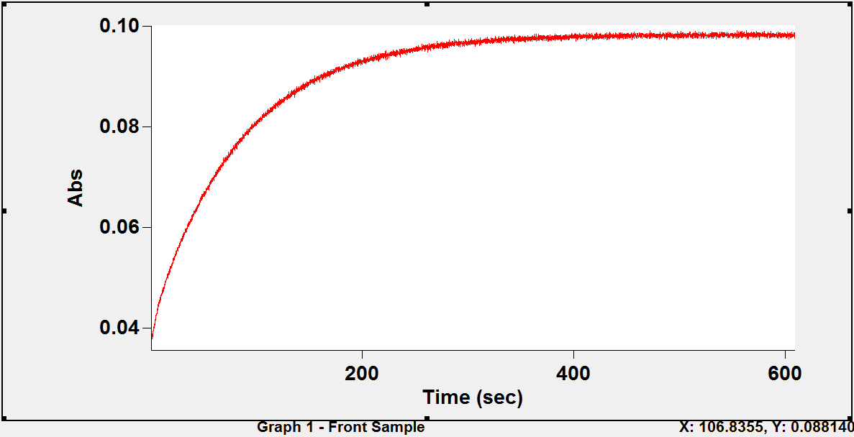Figure 4.1: A typical kinetic trace for the reaction of 5,5'-dithiobis(2- nitrobenzoate) with the sulphydryl groups of stripped human oxyhaemoglobin A at 25ºC and 412 nm: absorbance versus time.
Conditions: phosphate buffer pH 6.59 (ionic strength 50 mmol dm⁻³, added salt, NaCl); haemoglobin concentration, 10 µmol (haem) dm⁻³ (5 µmol dm⁻³ in reactive sulphydryl groups); [DTNB] = 300 µmol dm⁻³.

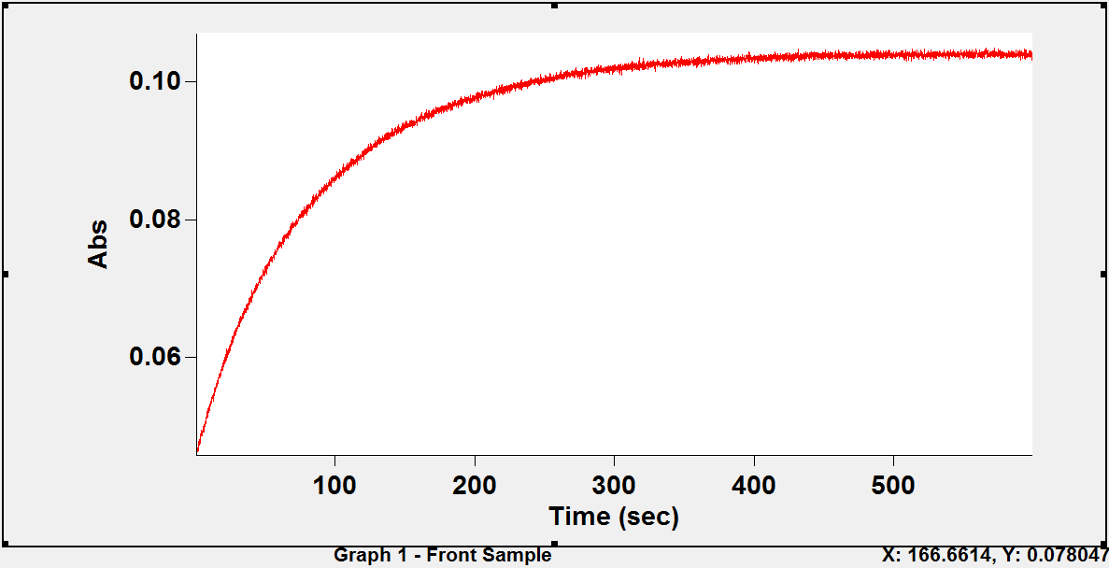Figure 4.2: A typical kinetic trace for the reaction of 5,5'-dithiobis(2- nitrobenzoate) with the sulphydryl groups of stripped human oxyhaemoglobin A at 25ºC and 412 nm: absorbance versus time.
Conditions: phosphate buffer pH 7.39 (ionic strength 50 mmol dm⁻³, added salt, NaCl); haemoglobin concentration, 10 µmol (haem) dm⁻³ (5 µmol dm⁻³ in reactive sulphydryl groups); [DTNB] = 300 µmol dm⁻³.

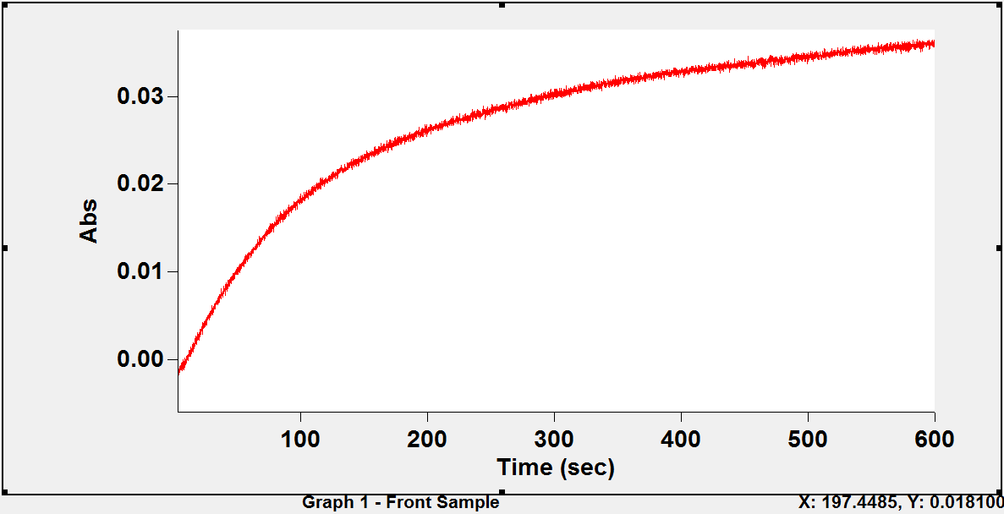Figure 4.3: A typical kinetic trace for the reaction of 5,5'-dithiobis(2- nitrobenzoate) with the sulphydryl groups of stripped human oxyhaemoglobin A at 25ºC and 412 nm: absorbance versus time.
Conditions: borate buffer pH 8.87 (ionic strength 50 mmol dm⁻³, added salt, NaCl); haemoglobin concentration, 10 µmol (haem) dm⁻³ (5 µmol dm⁻³ in reactive sulphydryl groups); [DTNB] = 300 µmol dm⁻³.

-ln(Aequ-At)

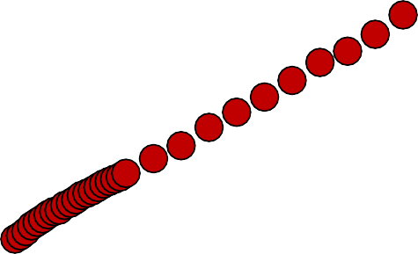Figure 4.4: Semi-logarithmic plot of the time course for the reaction 5,5'-dithiobis(2- nitrobenzoate) with stripped human oxyhaemoglobin A sulphydryl groups in phosphate buffer pH 6.59; k_{obs} = 12.0 (± 0.06) × 10⁻³ s⁻¹. The plot was linear for 5.2 half lives. Data from Figure 4.1.
7

6.5
y = 0.012x + 2.837
R² = 0.999
6

5.5

5

4.5

4

3.5

3

2.5
0
50
100
150
Time (s)
200
250
300

-ln(Aequ-At)

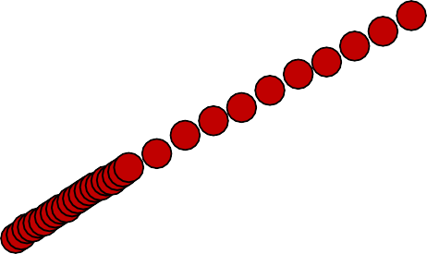Figure 4.5: Semi-logarithmic plot of the time course for the reaction 5,5'-dithiobis(2- nitrobenzoate) with stripped human oxyhaemoglobin A sulphydryl groups in phosphate buffer pH 7.39; k_{obs} = 11.0 (± 0.08) × 10⁻³ s⁻¹. The plot was linear for 4.8 half lives. Data from Figure 4.2.
6.5

6
y = 0.011x + 2.881
R² = 0.998
5.5

5

4.5

4

3.5

3

2.5
0
50
100
150
Time (s)
200
250
300

-ln(Aequ-At)

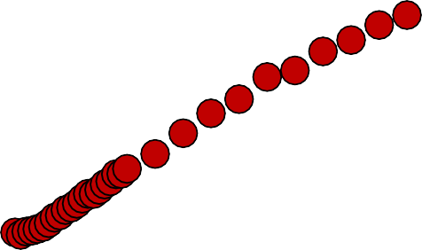Figure 4.6: Semi-logarithmic plot of the time course for the reaction 5,5'-dithiobis(2- nitrobenzoate) with stripped human oxyhaemoglobin A sulphydryl groups in borate buffer pH 8.87; k_{obs} = 6.4 (± 0.09) × 10⁻³s⁻¹. The plot was linear for 2.8 half lives. Data from Figure 4.3
5.5
y = 0.006x + 3.291
R² = 0.993
5
4.5
4
3.5
3
0
50
100
150
Time (s)
200
250
300

Human oxyhaemoglobin A in the presence of inositol-P₆

The effect of inositol-P₆ on the reaction of DTNB with human oxyhaemoglobin was studied at 412 nm. Typical kinetic traces of the reaction are shown in Figures 4.7 and 4.8a. Similar traces were obtained over the pH range 5.6 ≤ pH ≤ 8.0. Above pH 8.0, the DTNB reaction became too slow (see Figure 4.8b) and it became impossible to analyse the traces with any of the analysis software (DISCRETE or SigmaPlot). The semi – logarithmic plots of the data in Figures 4.7 and 4.8a are shown in Figures 4.9 and 4.10. A straight line graph was obtained in each case within the pH range 5.6 ≤ pH
≤ 8.0. This confirmed that Equ. 4.14 is valid to be used for the reaction of DTNB with human oxyhaemoglobin in the presence of inositol-P₆.
The apparent forward second order rate constant, k_{F}, was determined from the least square slopes of plots of the pseudo-first order rate constant, k_{obs}, against the DTNB concentration. These are shown in Figures 4.9 - 4.10.

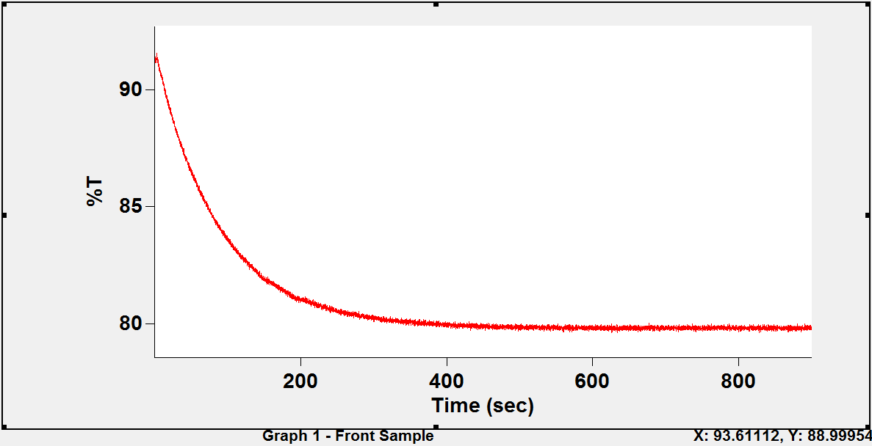Figure 4.7: A typical kinetic trace for the reaction of 5,5'-dithiobis(2- nitrobenzoate) with the sulphydryl groups of human oxyhaemoglobin A in the presence of inositol-P₆ at 25°C and 412 nm: transmittance* versus time.
Conditions: phosphate buffer pH 6.60 (ionic strength 50 mmol dm⁻³, added salt, NaCl); haemoglobin concentration, 10 µmol (haem) dm⁻³ (5 µmol dm⁻³ in reactive sulphydryl groups); [inositol-P₆] =10 µmol dm⁻³; [DTNB] = 300 µmol dm⁻³.

* transmittance was the default measurement setting on the spectrophotometer. This can easily be set to read absorbance values instead. In some instances like this case, the spectrophotometer was not adjusted to read absorbance. The conversion was effected on the data using the equation:
A = log ⎛ 100 ⎞ , where A is the absorbance and T the transmittance.
10 ⎜ T ⎟
⎝ ⎠

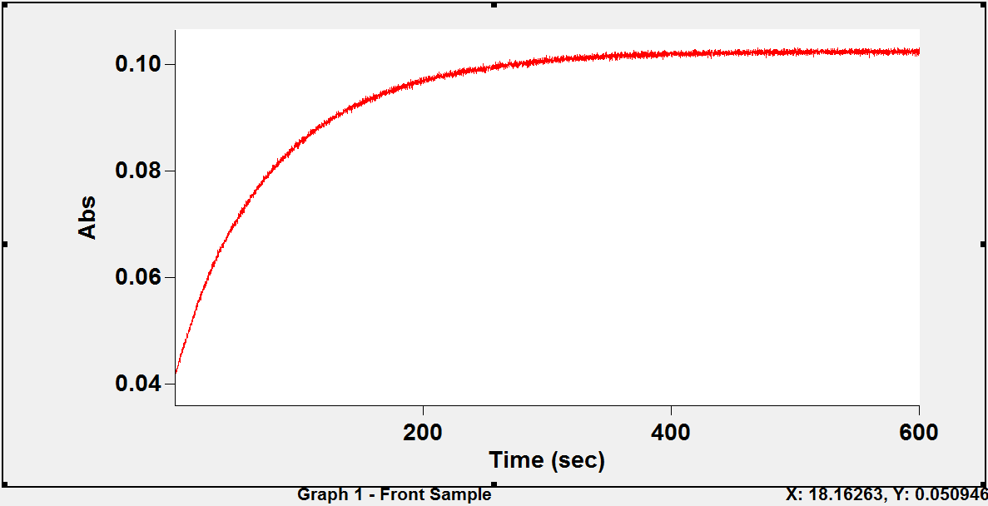Figure 4.8a: A typical kinetic trace for the reaction of 5,5'-dithiobis(2- nitrobenzoate) with the sulphydryl groups of human oxyhaemoglobin A in the presence of inositol-P₆ at 25°C and 412 nm: absorbance versus time.
Conditions: phosphate buffer pH 7.39 (ionic strength 50 mmol dm⁻³, added salt, NaCl); haemoglobin concentration, 10 µmol (haem) dm⁻³ (5 µmol dm⁻³ in reactive sulphydryl groups); [inositol-P₆] =10 µmol dm⁻³; [DTNB] = 300 µmol dm⁻³.

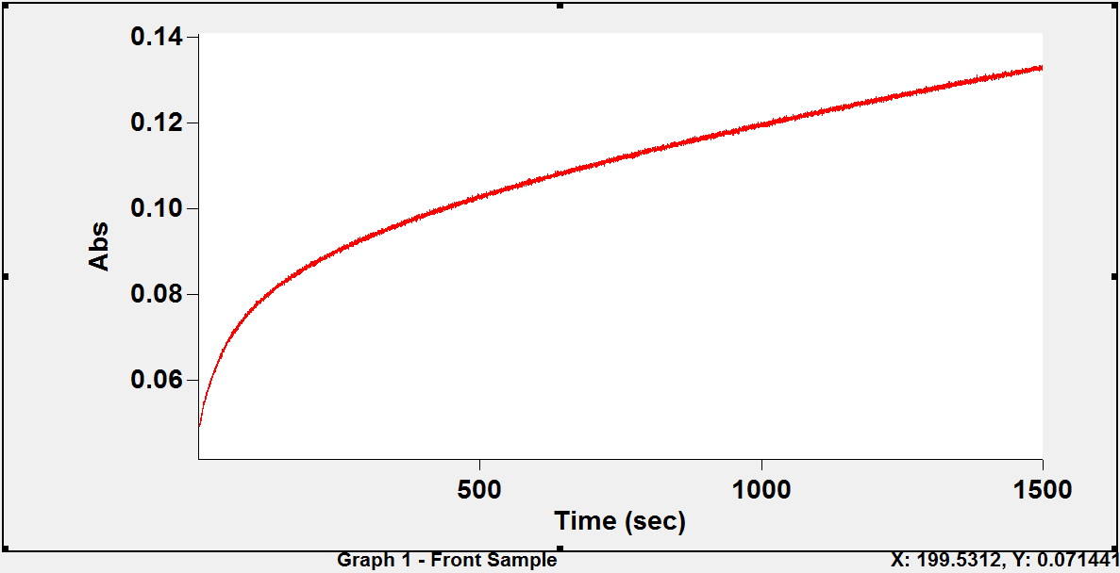Figure 4.8b: A typical kinetic trace for the reaction of 5,5'-dithiobis(2- nitrobenzoate) with the sulphydryl groups of human oxyhaemoglobin A in the presence of inositol-P₆ at 25°C and 412 nm: absorbance versus time.
Conditions: borate buffer pH 8.40 (ionic strength 50 mmol dm⁻³, added salt, NaCl); haemoglobin concentration, 10 µmol (haem) dm⁻³ (5 µmol dm⁻³ in reactive sulphydryl groups); [inositol-P₆] =10 µmol dm⁻³; [DTNB] = 400 µmol dm⁻³.

-ln(Aequ-At)

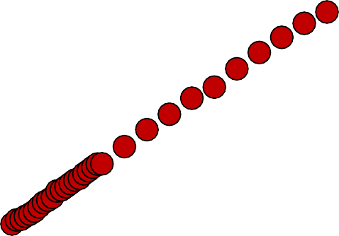Figure 4.9: Semi-logarithmic plot of the time course for the reaction 5,5'-dithiobis(2- nitrobenzoate) with the sulphydryl groups of human oxyhaemoglobin A in the presence of inositol-P₆ in phosphate buffer pH 6.60; k_{obs} = 9.4 (± 0.09) × 10⁻³ s⁻¹. The plot was linear for 4.1 half lives. Data from Figure 4.7.
5.5
y = 0.009x + 2.808
R² = 0.996
5
4.5
4
3.5
3
2.5
0
50
100
150
Time (s)
200
250
300

-ln(Aequ-At)

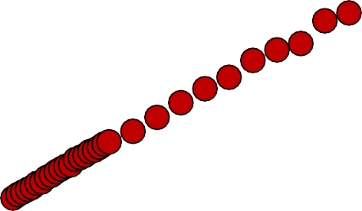Figure 4.10: Semi-logarithmic plot of the time course for the reaction 5,5'-dithiobis(2- nitrobenzoate) with the sulphydryl groups of human oxyhaemoglobin A in the presence of inositol-P₆ in phosphate buffer pH 7.39; k_{obs} = 13.0 (± 0.1) × 10⁻³ s⁻¹. The plot was linear for 5.6 half lives. Data from Figure 4.8a.
7

6.5
y = 0.012x + 2.822
R² = 0.996
6

5.5

5

4.5

4

3.5

3

2.5
0
50
100
150
Time (s)
200
250
300

DETERMINATION OF THE APPARENT FORWARD SECOND ORDER RATE CONSTANT, k_{F}, FOR THE REACTION OF DTNB WITH HUMAN OXYHAEMOGLOBIN.

We studied the kinetics of the reaction of DTNB with human oxyhaemoglobin A (stripped, and in the presence of inositol-P₆) in order to determine whether the reaction is reversible or irreversible. This was done under pseudo-first order (conditions) by fixing the haemoglobin concentration at 10 μmol (haem) dm⁻³ (that is, 5 μmol dm⁻³ in reactive sulphydryl groups) while the concentration of DTNB was varied between 300 and 600 μmol dm⁻³. The concentration of inositol-P₆, when it was required was fixed at 10 μmol dm⁻³.
Values of the pseudo-first order rate constant, k_{obs}, were obtained from the slopes of the pseudo-first order plots. Plots of k_{obs} against the DTNB concentration, [DTNB], were linear and had significant intercepts (Figures 4.11 and 4.12 for stripped oxyhaemoglobin, and Figures 4.13 and 4.14 for oxyhaemoglobin in the presence of inositol-P₆). This indicates that the reaction of DTNB with both stripped oxyhaemoglobin and oxyhaemoglobin A in the presence of inositol-P₆ is a reversible process. Similar results were obtained at all pH values investigated. Values of the apparent forward second order rate constant, k_{F}, were calculated from the least squares slopes of the linear plots.

103 × kobs (s-1)

Figure 4.11: Dependence of the pseudo-first order rate constant, k_{obs}, on [DTNB] for the reaction of DTNB with CysF9[93]β of stripped human oxyhaemoglobin at 25°C. Conditions: phosphate buffer pH 6.59; (ionic strength 50 mmol dm⁻³; added salt, NaCl); haemoglobin concentration, 10 μmol (haem) dm⁻³ (5 μmol dm⁻³ in reactive sulphydryl groups).
25.00
20.00
15.00
10.00
5.00
0.00
0.00
1.00
2.00
3.00
4.00
5.00
6.00
7.00
104 × [DTNB] (mol dm-3)
Each experimental point is the mean of at least three determinations. (Slope, the apparent second order rate constant, k_{F} = 27.70 (± 2.0) mol⁻¹dm³s⁻¹; intercept = (4.23 ± 0.9) × 10⁻³ s⁻¹; square of the correlation coefficient, R² = 0.989.

103 × kobs (s-1)

Figure 4.12: Dependence of the pseudo-first order rate constant, k_{obs}, on [DTNB] for the reaction of DTNB with CysF9[93]β of stripped human oxyhaemoglobin at 25°C. Conditions: phosphate buffer pH 7.39; (ionic strength 50 mmol dm⁻³; added salt, NaCl); haemoglobin concentration, 10 μmol (haem) dm⁻³ (5 μmol dm⁻³ in reactive sulphydryl groups).
25.00
20.00
15.00
10.00
5.00
0.00
0.00
1.00
2.00
3.00
4.00
5.00
6.00
7.00
104 × [DTNB] (mol dm-3)
Each experimental point is the mean of at least three determinations. (Slope, the apparent second order rate constant, k_{F} = 32.27 (± 1.1) mol⁻¹dm³s⁻¹; intercept = (2.41 ± 0.5) × 10⁻³ s⁻¹; square of the correlation coefficient, R² = 0.997.

103 × kobs (s-1)

Figure 4.13: Dependence of the pseudo-first order rate constant, k_{obs}, on [DTNB] for the reaction of DTNB with CysF9[93]β of human oxyhaemoglobin A in the presence of inositol-P₆ at 25°C.
25
20
15
10
5
0
0.00
1.00
2.00
3.00
4.00
5.00
6.00
7.00
104 × [DTNB] (mol dm-3)
Conditions: phosphate buffer pH 6.60; (ionic strength 50 mmol dm⁻³; added salt, NaCl); haemoglobin concentration, 10 μmol (haem) dm⁻³ (5 μmol dm⁻³ in reactive sulphydryl groups); [inositol-P₆] = 10 µmol dm⁻³.
Each experimental point is the mean of at least three determinations. (Slope, the apparent second order rate constant, k_{F} = 24.8 (± 4.6) mol⁻¹dm³s⁻¹; intercept = (4.71± 2.1) × 10⁻³ s⁻¹; square of the correlation coefficient, R² = 0.936.

103 × kobs (s-1)

Figure 4.14: Dependence of the pseudo-first order rate constant, k_{obs}, on [DTNB] for the reaction of DTNB with CysF9[93]β of human oxyhaemoglobin A in the presence of inositol-P₆ at 25°C.
25
20
15
10
5
0
0.00
1.00
2.00
3.00
4.00
5.00
6.00
7.00
104 × [DTNB] (mol dm-3)
Conditions: phosphate buffer pH 7.39; (ionic strength 50 mmol dm⁻³; added salt, NaCl); haemoglobin concentration, 10 μmol (haem) dm⁻³ (5 μmol dm⁻³ in reactive sulphydryl groups); [inositol-P₆] = 10 µmol dm⁻³.
Each experimental point is the mean of at least three determinations. (Slope, the apparent second order rate constant, k_{F} = 23.9 (± 2.1) mol⁻¹dm³s⁻¹; intercept = (4.76
± 1) × 10⁻³ s⁻¹; square of the correlation coefficient, R² = 0.984.

pH DEPENDENCE OF THE APPARENT FORWARD SECOND ORDER RATE CONSTANT, k_{F}
- Stripped human oxyhaemoglobin A
Figure 4.15 shows the pH dependence profile of k_{F} for stripped human oxyhaemoglobin A. The curve is bell shaped, with values of k_{F} increasing steadily from 18.32 mol⁻¹ dm³ s⁻¹ at pH 5.87 to a maximum of ≈ 32 mol⁻¹ dm³ s⁻¹ at pH 7.03, after which it began to decrease at higher pH values. This implies that the reaction of the CysF9[93]β sulphydryl group of human haemoglobin is dependent on pH: the utmost pH of reaction being around the physiological pH (pH 7).

Human oxyhaemoglobin A in the presence of inositol-P₆
Figure 4.16 shows the pH dependence profile of k_{F} for oxyhaemoglobin in the presence of inositol-P₆. The value of k_{F} increases with pH from 5.8 to around pH 7.0, after which it remains essentially constant.

In Figure 4.17, we compare the pH dependence profiles for stripped human oxyhaemoglobin A and oxyhaemoglobin A in the presence of inositol-P₆. It is seen that k_{F} is essentially the same between pH 5.8 and 6.8, implying that inositol-P₆ has no effect within this pH range. Between pH 6.9 and 7.5 however, the addition of inositol- P₆ significantly reduces k_{F} and hence, the reactivity. Since most experiments on sulphydryl reactivity were usually performed at the physiological pH (around pH 7.0), it was concluded that inositol-P₆ decreases the sulphydryl reactivity (Guidotti, 1965; Neer, 1970; Okonjo, 1980a; Okonjo et al., 1995; 1996). The results in Fiqure 4.17 indicate that this conclusion may not be valid at non-physiological pH values.

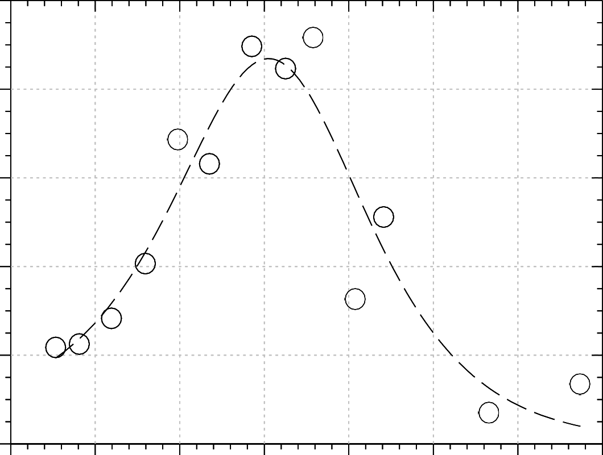
34

30

26
k_{F} (mol⁻¹ dm³ s⁻¹)

22

18

14
5.6 6.1 6.6 7.1 7.6 8.1 8.6 9.1

pH

Figure 4.15: Dependence of k_{F}, the apparent forward second order rate constant, on pH for the reaction of CysF9[93]β of stripped human oxyhaemoglobin with 5,5′- dithiobis(2- nitrobenzoate). Conditions as in Figures 4.11 – 4.14.

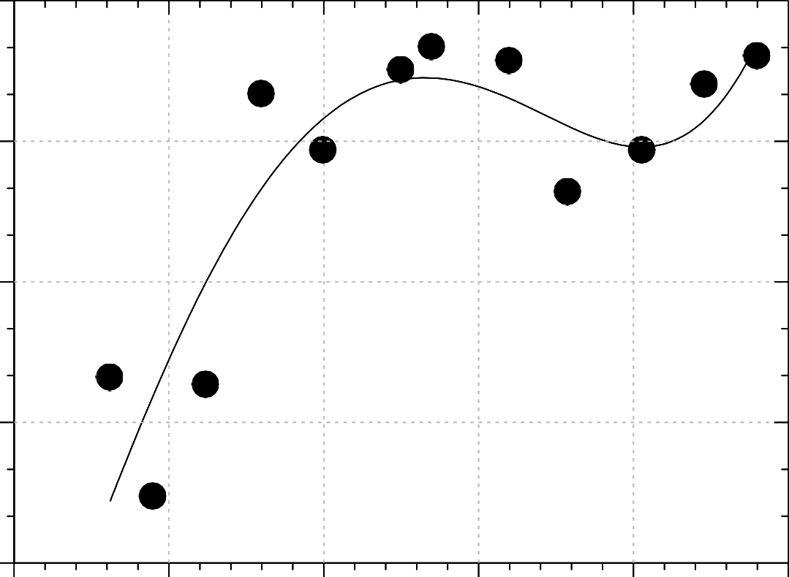
28

25
k_{F} (mol⁻¹ dm³ s⁻¹)

22

19

16
5.6 6.1 6.6 7.1 7.6 8.1

pH

Figure 4.16: Dependence of k_{F}, the apparent forward second order rate constant, on pH for the reaction of CysF9[93]β of human oxyhaemoglobin A with 5,5′-dithiobis(2- nitrobenzoate) in the presence of inositol-P₆. Conditions as in Figures 4.11 – 4.14, except for the addition of inositol-P₆; [inositol-P₆]:[haemoglobin tetramer] = 4:1

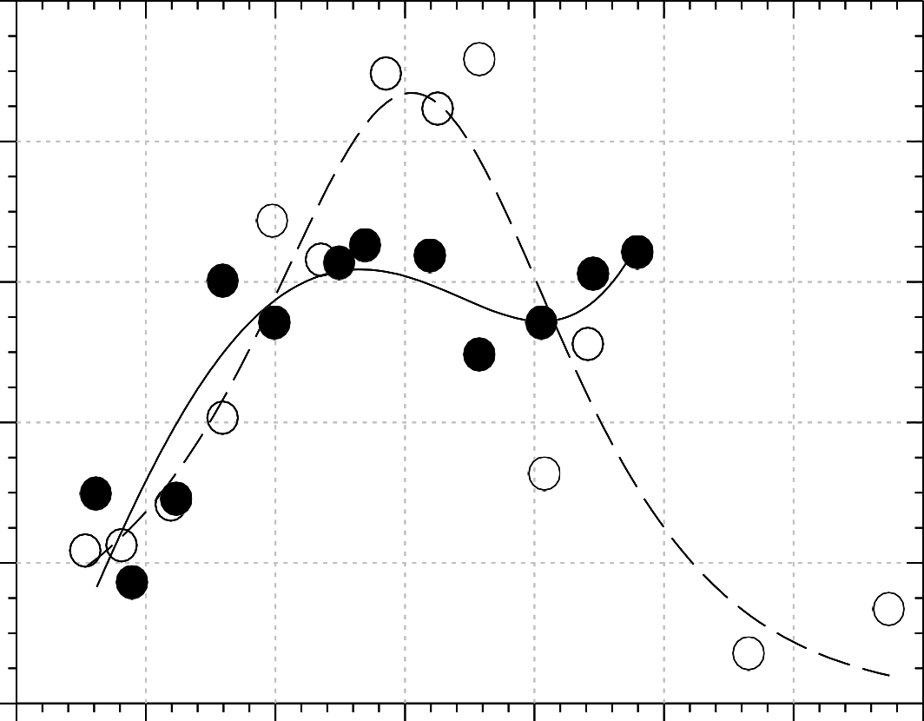
34

30
k_{F} (mol⁻¹ dm³ s⁻¹)

26

22

18

14
5.6

6.1 6.6 7.1 7.6 8.1 8.6 9.1

pH
Figure 4.17: Comparison of the pH-dependence profiles of k_{F,} for the reaction of
CysF9[93]β of human oxyhaemoglobin A with 5,5′-dithiobis(2- nitrobenzoate): stripped haemoglobin (open circles); haemoglobin with inositol-P₆ (filled circles). Conditions as in Figures 4.11 – 4.14.

KINETICS OF THE REACTION OF DTNB WITH HUMAN DEOXYHAEMOGLOBIN A
It has already been demonstrated that the reaction of DTNB with various haemoglobins in the R quaternary state is a reversible process (Okonjo and Fodeke, 2006; Okonjo et al., 2006). Although this makes it likely that DTNB will react reversibly with deoxyhaemoglobin, which is in the T quaternary state, it is still safer to check this assumption experimentally. The best way to do this is to study the kinetics of the reaction.
At the onset of each kinetic run, a spectrum of the haemogobin solution, prepared in a desired buffer at a specific pH, was taken before and after deoxygenation. The complete disappearance of the characteristic oxyhaemoglobin peaks at 347, 415, 541 and 576 nm, and the appearance of the characteristic deoxyhaemoglobin peaks at 430 and 555 nm, indicated that deoxygenation was complete. A spectrum of the haemoglobin solution was also taken at the end of each kinetic run to verify that re-oxygenation had not occurred.
Figure 4.18 shows the spectrum of a 10 µmol (haem) dm⁻³ solution of oxyhaemoglobin in pH 6.80 buffer. Figure 4.19 is the spectrum of the same haemoglobin solution after complete deoxygenation. Here we see the deoxyhaemoglobin peaks at 430 and 555 nm replacing the oxyhaemoglobin peaks at 347, 415, 541 and 576 nm. The slight differences between some of these values and those of a standard are negligible. The spectrum shown in Figure 4.20 was taken after the kinetic run. Except for the new peak appearing at 330 nm, the spectrum shows that the integrity of the deoxyhaemoglobin solution has not been compromised. The peak at 330 nm in Figure 4.20 is probably due to TNB. Since this peak is very intense, this may be a good wavelength to study the DTNB reaction. The spectrum of oxyhaemoglobin reacted with DTNB (not shown) also shows an intense peak at 330 nm.
The kinetic traces obtained for the reaction of human deoxyhaemoglobin A with DTNB at pH 8 are shown in Figures 4.21 – 4.23 for various concentrations of DTNB ranging from 100 - 400 μmol dm⁻³. The data were analysed with the SigmaPlot® Systat software.

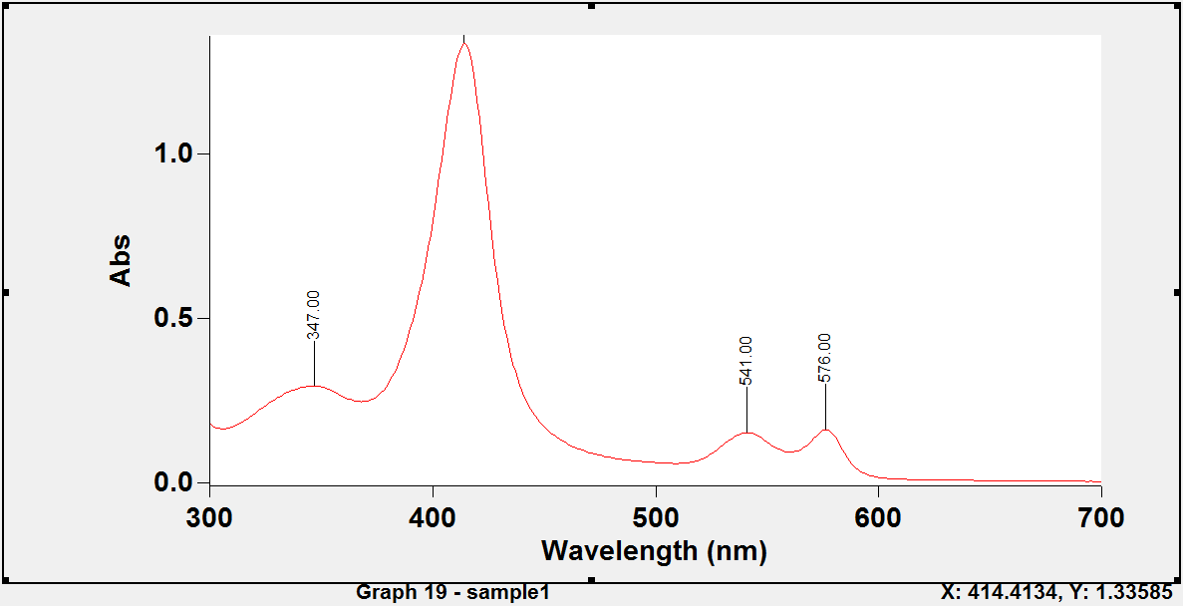Figure 4.18: A typical absorption spectrum of stripped human oxyhaemoglobin A in phosphate buffer pH 6.80 (ionic strength 50 mmol dm⁻³; added salt, NaCl) taken on a Cary® UV/Visible 400 Scan Spectrophotometer; [Hb] = 10 μmol (haem) dm⁻³.
The wavelength and the corresponding absorbance value of the Soret peak (the peak with the highest absorbance value) are shown at the bottom right corner of the spectrum

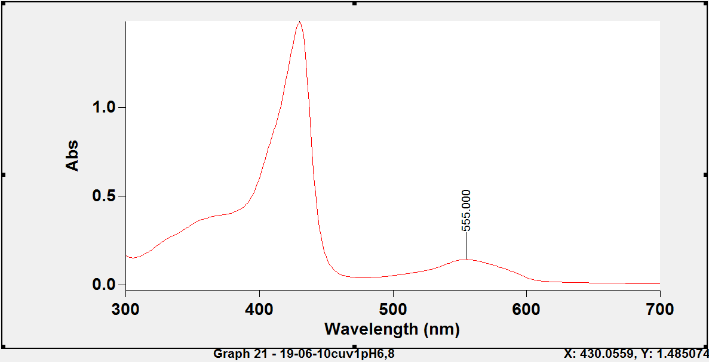Figure 4.19: A typical absorption spectrum of stripped human deoxyhaemoglobin in phosphate buffer pH 6.80 (ionic strength 50 mmol dm⁻³; added salt, NaCl) at the onset of the kinetics (i.e., before the addition of DTNB); [Hb] = 10 μmol (haem) dm⁻³.
The wavelength and the corresponding absorbance value of the Soret peak (the peak with the highest absorbance value) are shown at the bottom right corner of the spectrum.

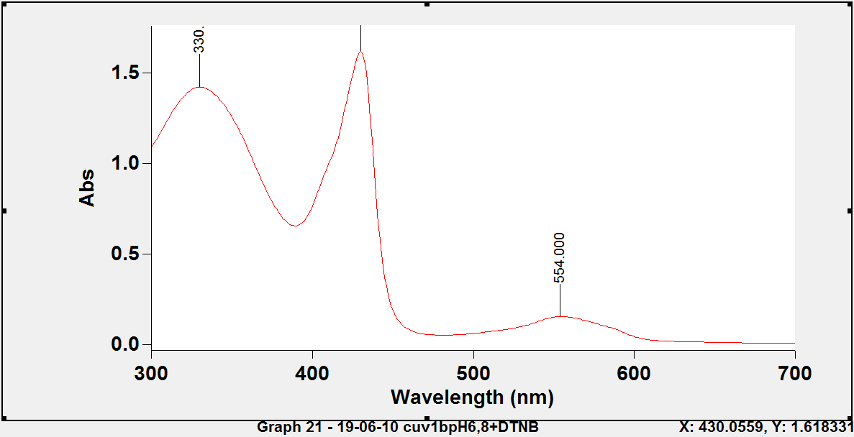Figure 4.20: A typical absorption spectrum of stripped human deoxyhaemoglobin in phosphate buffer pH 6.80 (ionic strength 50 mmol dm⁻³; added salt, NaCl) at the end of a kinetic run (i.e after DTNB had reacted); [Hb] = 10 μmol (haem) dm⁻³; [DTNB]
= 300 μmol dm⁻³.
The wavelength and the corresponding absorbance value of the Soret peak (the peak with the highest absorbance value) are shown at the bottom right corner of the spectrum.

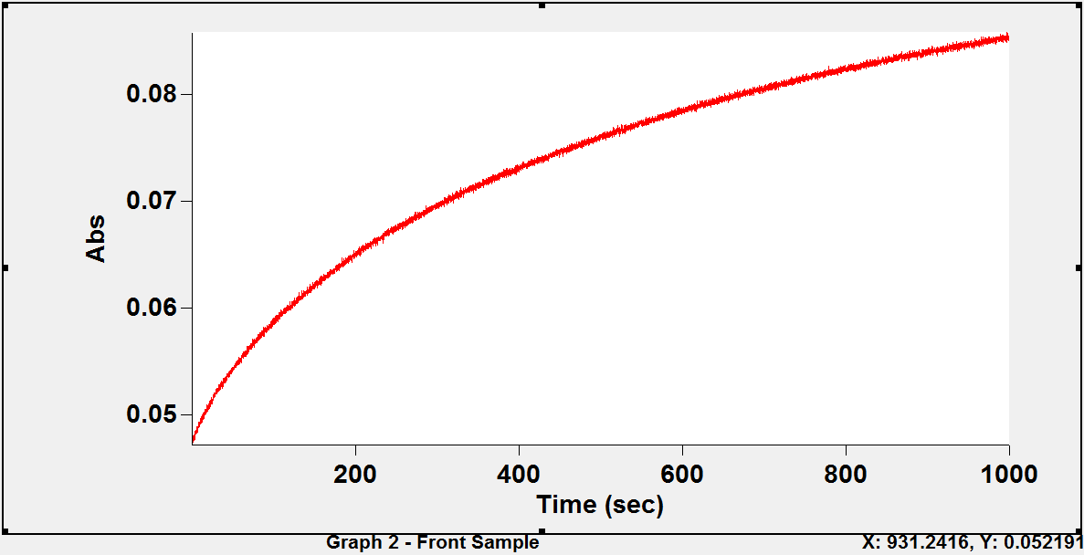Figure 4.21: A typical kinetic trace for the reaction of 5,5'-dithiobis(2- nitrobenzoate) with the sulphydryl groups of stripped human deoxyhaemoglobin A at 25°C: absorbance versus time.
Conditions: borate buffer pH 8.00 (ionic strength 50 mmol dm⁻³, added salt, NaCl); haemoglobin concentration, 10 µmol (haem) dm⁻³ (5 µmol dm⁻³ in reactive sulphydryl groups); [DTNB] = 100 µmol dm⁻³; observation wavelength, λ = 412 nm.

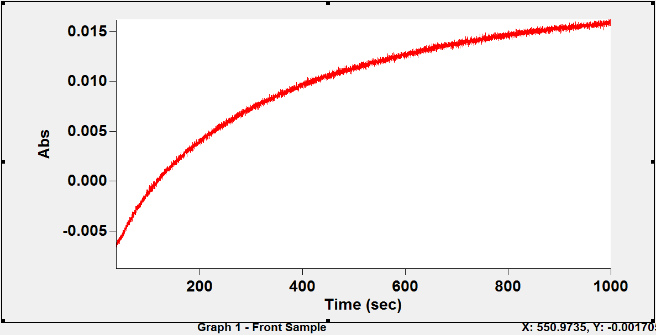Figure 4.22: A typical kinetic trace for the reaction of 5,5'-dithiobis(2- nitrobenzoate) with sulphydryl groups of stripped human deoxyhaemoglobin A at 25ºC: absorbance versus time.
Conditions: borate buffer pH 8.00 (ionic strength 50 mmol dm⁻³, added salt, NaCl); haemoglobin concentration, 10 µmol (haem) dm⁻³(5 µmol dm⁻³ in reactive sulphydryl groups); [DTNB] = 250 µmol dm⁻³; observation wavelength, λ = 412 nm.

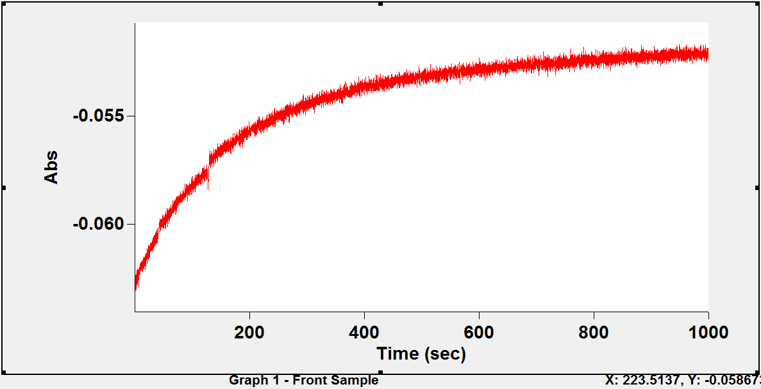Figure 4.23: A typical kinetic run for the reaction of 5,5'-dithiobis(2-nitrobenzoate) with sulphydryl groups of stripped human deoxyhaemoglobin A at 25ºC: absorbance versus time.
Conditions: borate buffer pH 8.00 (ionic strength 50 mmol dm⁻³, added salt, NaCl); haemoglobin concentration, 10 µmol (haem) dm⁻³(5 µmol dm⁻³ in reactive sulphydryl groups); [DTNB] = 400 µmol dm⁻³; observation wavelength, λ = 412 nm.

The corresponding pseudo-first order (semi – logarithmic) plots for the reaction of stripped human deoxyhaemoglobin A with DTNB are shown in Figures 4.24 – 4.26. A straight line graph was obtained in each case for all concentrations of DTNB at pH
8.0. This demonstrates that Equ. 4.14 is also valid for human deoxyhaemoglobin and

that ⎛ 1 −
⎜
K
⎞
1⎟ x

² << bx (compare Equ. 4.7 and 4.8).

⎝ ⎠

-ln(Aequ-At)

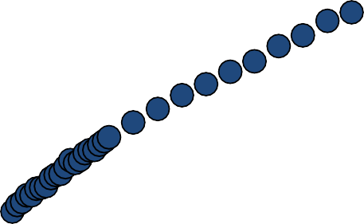Figure 4.24: Semi-logarithmic plot of the time course for the reaction 5,5'-dithiobis(2- nitrobenzoate) with stripped human deoxyhaemoglobin A sulphydryl groups in borate buffer pH 8.00; [DTNB] = 100 µmol dm⁻³; k_{obs} = (2.45 ± 0.04) × 10⁻³ s⁻¹. The plot was linear for 1.1 half lives. Data from Figure 4.21.
4
y = 0.002x + 3.193
R² = 0.992
3.8
3.6
3.4
3.2
3
0
50
100
150
Time (s)
200
250
300

-ln(Aequ-At)

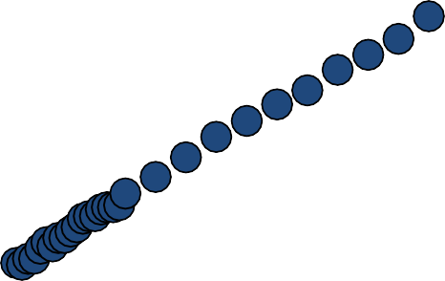Figure 4.25: Semi-logarithmic plot of the time course for the reaction 5,5'-dithiobis(2- nitrobenzoate) with stripped human deoxyhaemoglobin A sulphydryl groups in borate buffer pH 8.00; [DTNB] = 250 µmol dm⁻³; k_{obs} = (3.45 ± 0.04) × 10⁻³ s⁻¹. The plot was linear for 1.5 half lives. Data from Figure 4.22.
4.8
4.6
y = 0.003x + 3.708
R² = 0.996
4.4
4.2
4
3.8
3.6
0
50
100
150
Time (s)
200
250
300

-ln(Aequ-At)

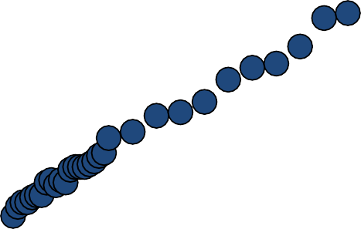Figure 4.26: Semi-logarithmic plot of the time course for the reaction 5,5'-dithiobis(2- nitrobenzoate) with stripped human deoxyhaemoglobin A sulphydryl groups in borate buffer pH 8.00. [DTNB] = 400 µmol dm⁻³; k_{obs} = (5.31 ± 0.07) × 10⁻³ s⁻¹. The plot was linear for 2.3 half lives. Data from Figure 4.23.
6.2
5.8
y = 0.005x + 4.561
R² = 0.993
5.4
5
4.6
4.2
0
50
100
150
Time (s)
200
250
300

DETERMINATION OF THE APPARENT FORWARD SECOND ORDER RATE CONSTANT, k_{F}, FOR THE REACTION OF DTNB WITH STRIPPED HUMAN DEOXYHAEMOGLOBIN.

Pseudo-first order kinetics of the reaction of DTNB with stripped human deoxyhaemoglobin A was carried out in order to determine the nature (whether reversible or irreversible) of the reaction. The values of the pseudo-first order rate constant, k_{obs}, were obtained from the slope of the pseudo-first order (semi- logarithmic) plot. At pH 8.00, the plot of the pseudo-first order rate constant, k_{obs}, against the DTNB concentration, [DTNB], was linear, and had significant intercept (Figure 4.27). This indicates that the reaction of DTNB stripped human deoxyhaemoglobin A is a reversible process at this pH. From the preceeding work on oxyhaemoglobin, we can assume that reversibility will hold throughout the experimental pH range for the reaction of stripped human deoxyhaemoglobin with DTNB. The value of the apparent forward second order rate constant, k_{F}, was calculated from the least squares slope of the linear plot.
In Figure 4.28, we present a comparison of the dependence of k_{obs} on DTNB concentration for the reaction of DTNB with stripped human oxyhaemoglobin A and stripped human deoxyhaemoglobin A at pH 8.00. The values of k_{F} (inset in the graph) obtained showed that the reaction is much faster in oxyhaemoglobin (k_{F} = 20.61) than in deoxyhaemoglobin (k_{F} = 4.23). This result is not surprising since it has been shown that in the T-state (deoxyhaemoglobin), Cys(F9)93β is screened by the imidazole group of His146(HC3)β, which forms a salt bridge with the γ-carboxyl of Asp94(FG1)β; It is therefore difficult, though not impossible, for sulphydryl reagents to access this sulphydryl group (Perutz, 1970; Neer, 1970). In the R-state (oxyhaemoglobin) on the other hand, Cys(F9)93β is exposed and easily accessible to sulphydryl reagents because the salt bridge between the histidine and the aspartic acid residue is broken during the T → R transition.

103 × kobs (s-1)

Figure 4.27: The dependence of the pseudo-first order rate constant, k_{obs}, on the DTNB concentration for the reaction of DTNB with stripped human deoxyhaemoglobin A at 25°C.
4.50
3.50
2.50
1.50
0.00
0.50
1.00
1.50
2.00
2.50
3.00
3.50
4.00
4.50
104 × [DTNB] (mol dm-3)
Conditions: borate buffer pH 8.00; (ionic strength 50 mmol dm⁻³; added salt, NaCl); haemoglobin concentration, 10 μmol (haem) dm⁻³ (5 μmol dm⁻³ in reactive sulphydryl groups).
Each experimental point is the mean of at least two determinations. (Slope, the apparent second order rate constant, k_{F} = 4.55 (± 0.2) mol⁻¹dm³s⁻¹; intercept = (1.89
± 0.05) × 10⁻³ s⁻¹; square of the correlation coefficient, R²=0.991.

103 × kobs (s-1)

Figure 4.28: A comparison of the dependence of the pseudo-first order rate constant, k_{obs}, on the DTNB concentration for the reaction of DTNB with stripped human oxyhaemoglobin A (blue symbols) and deoxyhaemoglobin A (red symbols) at 25°C. Conditions: borate buffer pH 8.00; (ionic strength 50 mmol dm⁻³; added salt, NaCl); haemoglobin concentration, 10 μmol (haem) dm⁻³ (5 μmol dm⁻³ in reactive sulphydryl groups).
y = 4.55x + 0.002 R² = 0.993
y = 20.61x + 0.002 R² = 0.971
12.00
10.00
8.00
6.00
4.00
2.00
0.00
0.00
1.00
2.00
3.00
4.00
5.00
104 × [DTNB] (mol dm-3)

THEORETICAL ANALYSIS OF pH DEPENDENCE OF THE APPARENT FORWARD SECOND ORDER RATE CONSTANT, k_{F}
The quantitative analysis of the pH dependence profiles of k_{F} for the reactivities of haemoglobin sulphydryl groups provides information on the nature and number of amino acid residues influencing such reactions (Okonjo & Aboluwoye, 1992; Okonjo & Okia, 1993; Okonjo et al., 1996). The dependence of the apparent second order forward rate constant, k_{F}, on pH was analysed with Scheme I(a) below for all haemoglobin types and derivatives.
In Scheme I(a), n represents the number of ionizable groups that are electrostatically linked to the CysF9[93]β site; H_{n}PSH, H_{n-1}PSH, …., H_{n-i+1}PSH, …., HPSH and PSH are haemoglobin species having n, (n-1), …., (n-i+1), …., 1 and 0 protons bound to the electrostatically thiol-linked ionizable groups. Each of these species has its thiol group protonated: DTNB does not react with these species. H_{n}PS⁻, H_{n-1}PS⁻, …., H_{n-i+1}PS⁻ , , HPS⁻ and PS⁻ are the corresponding thiolate anion forms of
the various species: These are the species that react with DTNB. The various Q terms signify ionization constants.

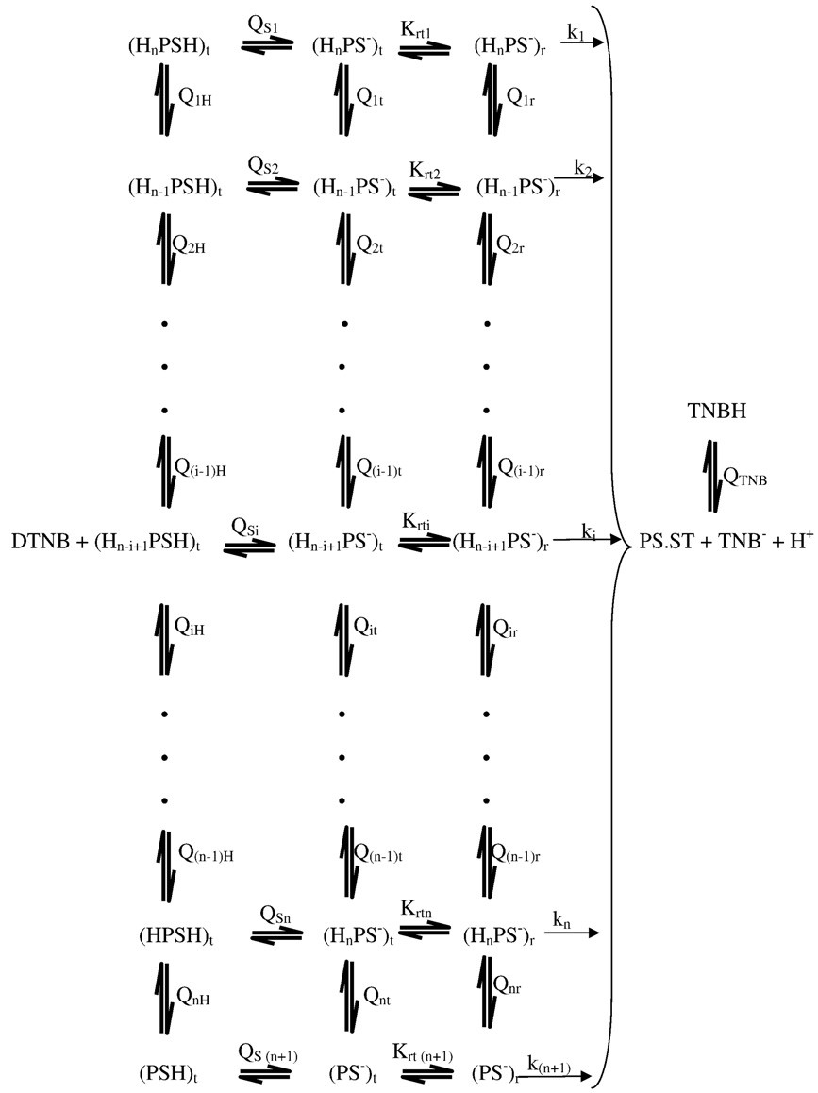 (HPS-) (HPS⁻)_{r}
t

SCHEME I(a)

Since only the thiolate anion forms are reactive towards DTNB (Wilson et al., 1977; Okonjo et al., 1979; Hallaway et al., 1980), the relationship between k_{F} and the parameters in Scheme Ia is given by Equ. 4.15 (Okonjo et al., 2010).

n ⎛ n

⎞-1

k + ∑k ⎡H⁺ ⎤n -i + 1 ⎜ ∏Q ⎟
n + 1 i ⎣ ⎦
jr

k =
F
-1 ⎡
i = 1
⎝ j = i
-1
⎠
+ n - i + 1

-1 ⎤

n ⎡ + ⎤n - i + 1 ⎛ n ⎞
⎢ ⎡ + ⎤n - i + 1 ⎛ n
⎞ ⎡⎣H
⎤⎦ ⎧⎪
n ⎛ n
⎡ ⁺ ⎤
⎞ ⎫⎪⎥

1 + ∑⎣H ⎦
⎜ ∏Qjr ⎟
+ Krt(n + 1)
1 + ⎣H ⎦
⎜ ∏Qjt ⎟ + Q
⎨1 + ∑⎣H ⎦
⎜ ∏QjH ⎟ ⎬

i = 1
⎝ j = i ⎠ ⎢
⎝ j = i ⎠
s(n + 1) ⎪⎩

i = 1
⎝ j = i
⎠ ⎪⎭⎥

⎣ ⎦

…………. (4.15)

The dependences of k_{F} on pH for all the kinetic data reported in this thesis were analyzed using Equ. 4.15. The curve fitting was achieved with the aid of a programme written on MicroMath SCIENTIST (Appendix G4). The lines through the experimental points obtained for human oxyhaemoglobin A (Figures 4.16 and 4.17) were drawn with Equ. 4.15, using the best fit parameters reported in Table 4.1 for n = 2.

Table 4.1: The reaction of CysF9[93]β of human oxyhaemoglobin A with 5,5′- dithiobis(2-nitrobenzoate); Best fit parameters used to fit the kinetic data reported in Fig 4.30 (Compare with Scheme Ia and Equ. 4.15 for n = 2).

Parameters | Stripped oxyhaemoglobin | Oxyhaemoglobin  + inositol-P₆
pQ_{1r} | 7.169 | 7.020
pQ_{1t} | 7.593 | 7.810
pQ_{2r} | 7.121 | 8.240
pQ_{2t} | 6.684 | 8.820
pQ_{1H} | 6.451 | 6.241
pQ_{2H} | 6.391 | 7.630
pQ_{S3} | 7.900 | 8.777
Krt3 | 0.002 | 0.381
k₁ (mol⁻¹ dm³ s⁻¹) | 15.616 | 462.819
k₂ (mol⁻¹ dm³ s⁻¹) | 66.774 | 56.237
k₃ (mol⁻¹ dm³ s⁻¹) | 14.081 | 108.244

KINETICS OF THE REACTION OF DTNB WITH MINOR CAT OXYHAEMOGLOBIN IN THE PRESENCE OF INOSITOL-P₆
The kinetics of the reaction of DTNB with CysF9[93]β of the stripped derivatives (oxy-, carbonmonoxy-, and aquomet-) of cat major and minor hemoglobins have already been studied (Okonjo and Fodeke, 2006). The data obtained showed that the reaction was a reversible process. The effect of inositol-P₆ on the kinetics of the reaction has also been studied for the two cat haemoglobins and their derivatives (Fodeke, 2005). The only exception was the minor cat oxyhaemoglobin, for which the effect of inositol-P₆ was not determined.
Fodeke found that the reactivity of the sulphydryl INCREASED in the presence of inositol-P₆. This is contrary to previous results on the effect of inositol-P₆ on various haemoglobins (Gray and Gibson, 1971; Okonjo, 1980a; Okonjo and Nwozo, 1997). To check these unsual results, we have carried out the same experiments on the minor cat oxyhaemoglobin. Moreover, Fodeke‟s results indicated that at pH ≥ 8.6 the semi-log plots of the kinetic data are non-linear for both stripped haemoglobin and in the presence of inositol-P₆. It is also necessary to check this result. Typical kinetic traces for the reaction of DTNB with the CysF9[93]β sulphydryl of minor cat oxyhaemoglobin in the presence of inositol-P₆ are shown in
Figures 4.29 - 4.33 at various pH values.

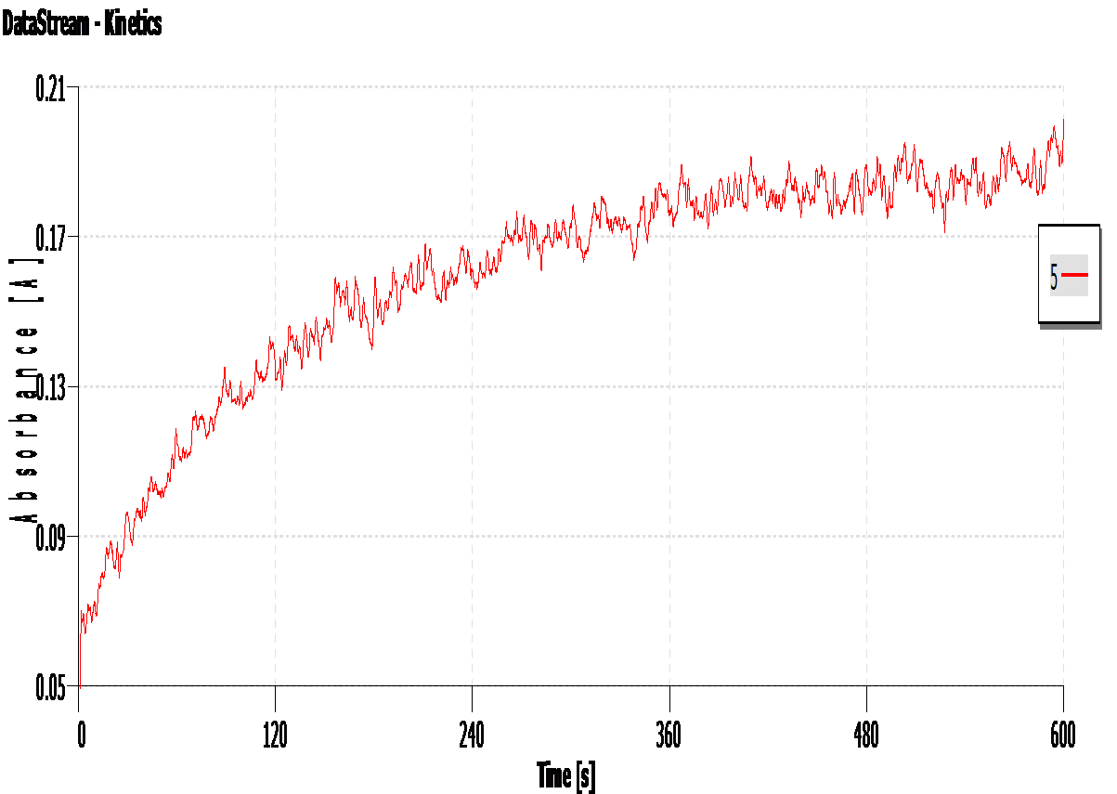Figure 4.29: A typical kinetic trace for the reaction of 5,5'-dithiobis(2- nitrobenzoate) with the sulphydryl groups of the minor cat oxyhaemoglobin in the presence of inositol-P₆ at 25°C: absorbance versus time.
Conditions: phosphate buffer pH 6.04 (ionic strength 50 mmol dm⁻³, added salt, NaCl); haemoglobin concentration, 10 µmol (haem) dm⁻³ (5 µmol dm⁻³ in reactive sulphydryl groups); [DTNB] = 400 µmol dm⁻³; [inositol-P₆] =10 µmol dm⁻³; observation wavelength, λ = 412 nm.

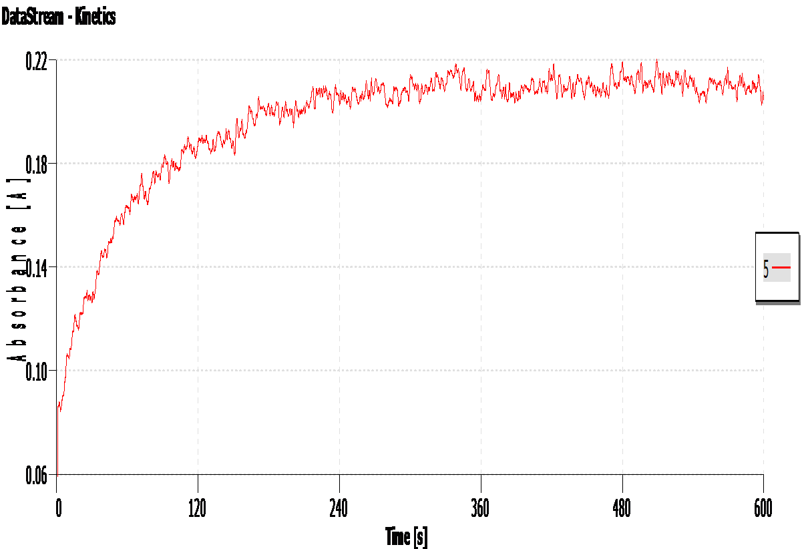Figure 4.30: A typical kinetic trace for the reaction of 5,5'-dithiobis(2- nitrobenzoate) with the sulphydryl groups of the minor cat oxyhaemoglobin in the presence of inositol-P₆ at 25°C: absorbance versus time.
Conditions: phosphate buffer pH 7.12 (ionic strength 50 mmol dm⁻³, added salt, NaCl); haemoglobin concentration, 10 µmol (haem) dm⁻³ (5 µmol dm⁻³ in reactive sulphydryl groups); [DTNB] = 400 µmol dm⁻³; [inositol-P₆] =10 µmol dm⁻³; observation wavelength, λ = 412 nm.

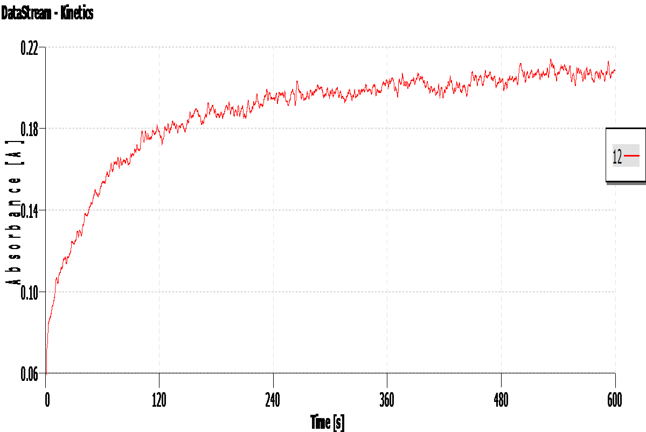Figure 4.31: A typical kinetic trace for the reaction of 5,5'-dithiobis(2- nitrobenzoate) with the sulphydryl groups of the minor cat oxyhaemoglobin in the presence of inositol-P₆ at 25°C: absorbance versus time.
Conditions: borate buffer pH 8.45 (ionic strength 50 mmol dm⁻³, added salt, NaCl); haemoglobin concentration, 10 µmol (haem) dm⁻³ (5 µmol dm⁻³ in reactive sulphydryl groups); [DTNB] = 300 µmol dm⁻³; [inositol-P₆] =10 µmol dm⁻³; observation wavelength, λ = 412 nm.

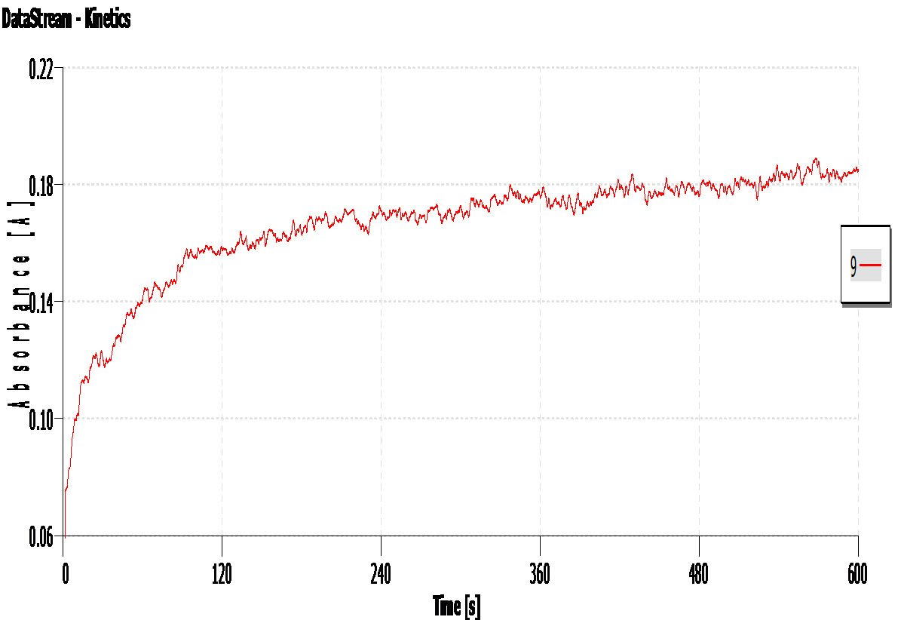Figure 4.32: A typical kinetic trace for the reaction of 5,5'-dithiobis(2- nitrobenzoate) with the sulphydryl groups of the minor cat oxyhaemoglobin in the presence of inositol-P₆ at 25°C: absorbance versus time.
Conditions: borate buffer pH 8.60 (ionic strength 50 mmol dm⁻³, added salt, NaCl); haemoglobin concentration, 10 µmol (haem) dm⁻³ (5 µmol dm⁻³ in reactive sulphydryl groups); [DTNB] = 300 µmol dm⁻³; [inositol-P₆] =10 µmol dm⁻³; observation wavelength, λ = 412 nm.

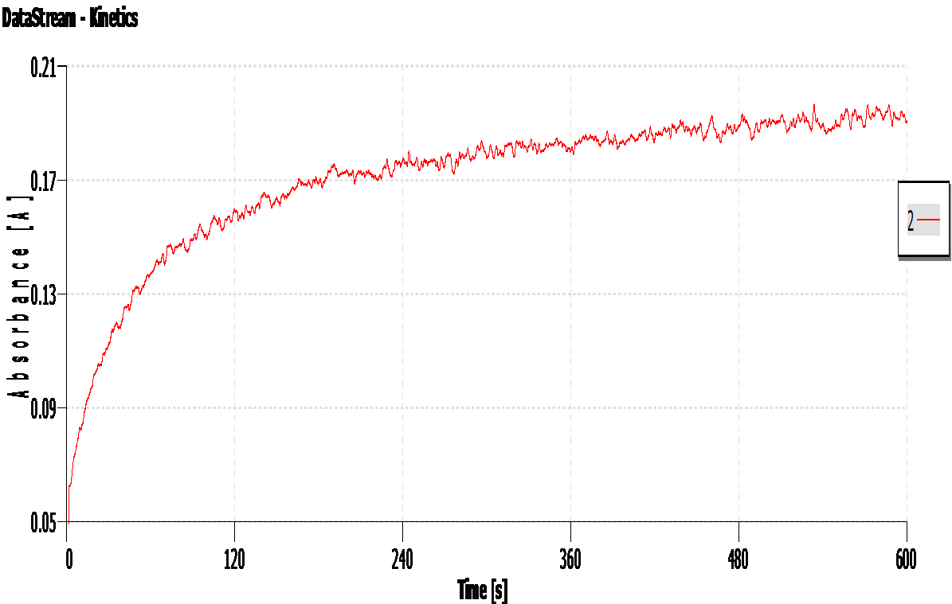Figure 4.33: A typical kinetic trace for the reaction of 5,5'-dithiobis(2- nitrobenzoate) with the sulphydryl groups of the minor cat oxyhaemoglobin in the presence of inositol-P₆ at 25°C: absorbance versus time.
Conditions: borate buffer pH 8.80 (ionic strength 50 mmol dm⁻³, added salt, NaCl); haemoglobin concentration, 10 µmol (haem) dm⁻³ (5 µmol dm⁻³ in reactive sulphydryl groups); [DTNB] = 300 µmol dm⁻³; [inositol-P₆] =10 µmol dm⁻³; observation wavelength, λ = 412 nm.

Determination of the pseudo-first order rate constant, k_{obs}, for the reaction of DTNB with minor cat oxyhaemoglobin in the presence of inositol-P₆
The pseudo-first order plots of the traces shown in Figures 4.29 – 4.33 are reported in Figures 4.34 – 4.38 respectively. It is seen that the plots in Figures 4.34 –
4.36 are linear. However, those in Figures 4.37 and 4.38 are non-linear. This confirms the findings of Fodeke (2005), namely that at pH ≥ 8.6 the kinetics appear to be no longer pseudo-first order. The linear plots in Figures 4.34 – 4.36 conform to Equ. 4.12 and 4.14. This indicates that at pH < 8.6 the DTNB reaction is truly pseudo-first order.

-ln (Aequ –At)

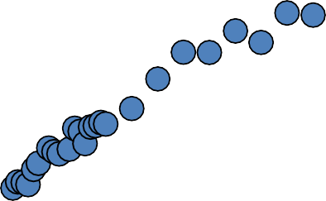Figure 4.34: Semi-logarithmic plot of the time course for the reaction 5,5'-dithiobis(2- nitrobenzoate) with the minor cat oxyhaemoglobin sulphydryl groups in the presence of inositol-P₆ ; phosphate buffer pH 6.04; [DTNB] = 400 µmol dm⁻³; [inositol-P₆] = 10 µmol dm⁻³; k_{obs} = 5.48 (± 0.09) × 10⁻³ s⁻¹. The plot was linear for 2.4 half lives. Data from Figure 4.29.
3.8
y = 0.005x + 2.054
R² = 0.990
3.3
2.8
2.3
1.8
0
50
100
150
Time (s)
200
250
300

-ln (Aequ –At)

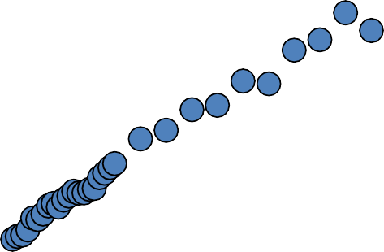Figure 4.35: Semi-logarithmic plot of the time course for the reaction 5,5'-dithiobis(2- nitrobenzoate) with the minor cat oxyhaemoglobin sulphydryl groups in the presence of inositol-P₆; phosphate buffer pH 7.12; [DTNB] = 400 µmol dm⁻³; [inositol-P₆] = 10 µmol dm⁻³; at 25°C; k_{obs} = 1.33 (± 0.04) × 10⁻² s⁻¹. The plot was linear for 5.8 half lives. Data from Figure 4.30
6.5
y = 0.013x + 2.167
R² = 0.989
5.5
4.5
3.5
2.5
1.5
0
50
100
150
Time (s)
200
250
300

-ln (Aequ –At)

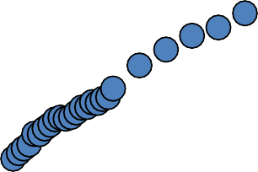Figure 4.36: Semi-logarithmic plot of the time course for the reaction 5,5'-dithiobis(2- nitrobenzoate) with the minor cat oxyhaemoglobin sulphydryl groups in the presence of inositol-P₆; borate buffer pH 8.45; [DTNB] = 300 µmol dm⁻³; [inositol-P₆] = 10 µmol dm⁻³; k_{obs} = 1.29 (± 0.02) × 10⁻² s⁻¹. The plot was linear for 5.6 half lives. Data from Figure 4.31.
6.5
y = 0.012x + 2.205
R² = 0.994
5.5
4.5
3.5
2.5
1.5
0
50
100
150
Time (s)
200
250
300

-ln (Aequ –At)

Figure 4.37: Semi-logarithmic plot of the time course for the reaction 5,5'-dithiobis(2- nitrobenzoate) with the minor cat oxyhaemoglobin sulphydryl groups in the presence of inositol-P₆; borate buffer pH 8.60; [DTNB] =300 µmol dm⁻³; [inositol-P₆] = 10 µmol dm⁻³. Data from Figure 4.32.
3.6
3.1
2.6
2.1
0
50
100
150
Time (s)
200
250
300

-ln (Aequ – At)

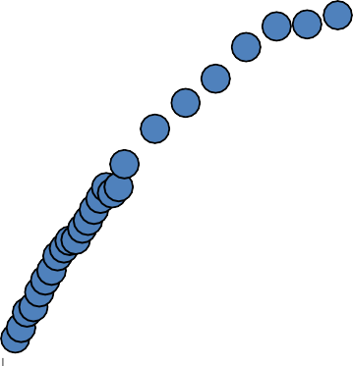Figure 4.38: Semi-logarithmic plot of the time course for the reaction 5,5'-dithiobis(2- nitrobenzoate) with the minor cat oxyhaemoglobin sulphydryl groups in the presence of inositol-P₆; borate buffer pH 8.80; [DTNB] = 300 µmol dm⁻³; [inositol-P₆] = 10 µmol dm⁻³. Data from Figure 4.33.
4
3.5
3
2.5
2
0
50
100
150
Time (s)
200
250
300

Determination of the apparent forward second order rate constant (k_{F}) for the reaction of DTNB with minor cat oxyhaemoglobin in the presence of inositol-P₆
Typical plots of the pseudo-first order rate constant, k_{obs}, against the DTNB concentration, [DTNB], for the reaction of DTNB with the minor cat oxyhaemoglobin in the presence of inositol-P₆ are shown in Figures 4.39 – 4.41. The plots obtained are linear, with significant intercepts. This is a strong indication that the reaction is reversible. Similar results were obtained at all pH values in the range 5.6 ≤ pH ≤ 8.5. The apparent forward second order rate constant, k_{F}, was calculated from the least square slopes of the plots obtained. k_{F} could not be determined from the plots obtained at 8.5 < pH ≤ 9.0, since the semi-logarithmic plots for the time-course of the reaction of DTNB with minor cat oxyhaemoglobin in the presence of inositol-P₆ did not give straight lines within this pH range.

103 × kobs (s-1)

Figure 4.39: The dependence of the pseudo-first order rate constant, k_{obs}, on the DTNB concentration for the reaction of DTNB with the minor cat oxyhaemoglobin in the presence of inositol-P₆ at 25°C.
12.00
10.00
8.00
6.00
4.00
2.00
0.00
0.00
1.00
2.00
3.00
4.00
5.00
6.00
104 × [DTNB] (mol dm-3)
Conditions: phosphate buffer pH 5.76; (ionic strength 50 mmol dm⁻³; added salt, NaCl); [haemoglobin] = 10 μmol (haem) dm⁻³ (5 μmol dm⁻³ in reactive sulphydryl groups); [inositol-P₆] = 10 µmol dm⁻³.
Each experimental point is the mean of at least three determinations. Slope (the apparent second order rate constant, k_{F}) = 13.7 (±1.22) mol⁻¹dm³s⁻¹; intercept = 2.4 (±0.6) × 10⁻³ s⁻¹; square of the correlation coefficient, R² = 0.984.

103 × kobs (s-1)

DTNB concentration for the reaction of DTNB with the minor cat oxyhaemoglobin in the presence of inositol-P₆ at 25°C.
16.00
12.00
8.00
4.00
0.00
0.00
1.00
2.00
3.00
4.00
5.00
6.00
104 × [DTNB] (mol dm-3)

Figure 4.40: The dependence of the pseudo-first order rate constant, k_{obs}, on the
Conditions: phosphate buffer pH 6.97; (ionic strength 50 mmol dm⁻³; added salt, NaCl); [haemoglobin] = 10 μmol (haem) dm⁻³ (5 μmol dm⁻³ in reactive sulphydryl groups); [inositol-P₆] = 10 µmol dm⁻³.
Each experimental point is the mean of at least three determinations. Slope (the apparent second order rate constant, k_{F}) = 22.06 (± 2.15) mol⁻¹dm³s⁻¹; intercept = (1.8 ± 0.01) × 10⁻³ s⁻¹; square of the correlation coefficient, R² = 0.981.

103 × kobs (s-1)

Figure 4.41: The dependence of the pseudo-first order rate constant, k_{obs}, on the DTNB concentration for the reaction of DTNB with the minor cat oxyhaemoglobin in the presence of inositol-P₆ at 25°C.
25.00
20.00
15.00
10.00
5.00
0.00
0.00
1.00
2.00
3.00
4.00
5.00
6.00
7.00
104 × [DTNB] (mol dm-3)
Conditions: borate buffer pH 8.45; (ionic strength 50 mmol dm⁻³; added salt, NaCl); [haemoglobin] = 10 μmol (haem) dm⁻³ (5 μmol dm⁻³ in reactive sulphydryl groups); [inositol-P₆] = 10 µmol dm⁻³.
Each experimental point is the mean of at least three determinations. Slope (the apparent second order rate constant, k_{F}) = 33.90 (± 2.73) mol⁻¹dm³s⁻¹; intercept = (2.0 ± 1.3) ×10⁻³ s⁻¹; square of the correlation coefficient, R² = 0.987.

pH DEPENDENCE OF k_{F} FOR MINOR CAT OXYHAEMOGLOBIN

The dependence of the apparent forward second order rate constant, k_{F}, on pH for the reaction of DTNB with the minor cat oxyhaemoglobin in the presence of inositol-P₆ is shown in Figure 4.42. The kinetics gave a simple profile comparable to that of the stripped minor cat oxyhaemoglobin (Figure 4.43), with k_{F} increasing throughout the experimental pH range. In comparison to the stripped haemoglobin, k_{F} for the reaction in the presence of inositol-P₆ increases by a factor ≈ 2 between pH
5.76 and 8.45. This demonstrates that the reaction of CysF9[93]β of the minor cat oxyhaemoglobin with DTNB in the presence of inositol-P₆ is faster than that of the stripped derivative. It also confirms the findings of Fodeke (2005). These results are indeed very interesting because, to the best of our knowledge, previous workers have reported the very opposite (Gray and Gibson, 1971; Okonjo et al., 1996; 2006; 2010; Okonjo and Nwozo, 1997).
The data presented in Figure 4.42 were fitted with scheme Ia and Equ. 4.15. In Table 4.2 we report the best-fit parameters for the lines through the experimental points obtained for minor cat oxyhaemoglobin. Previous data reported by Okonjo and Fodeke (2006), were fitted with an old scheme (scheme Ib) that did not include the tertiary structure transition constant. We have therefore refitted the previous data with Scheme Ia and Equ. 4.15. The best fit parameters for the refitted data are reported in Tables 4.3 – 4.5.

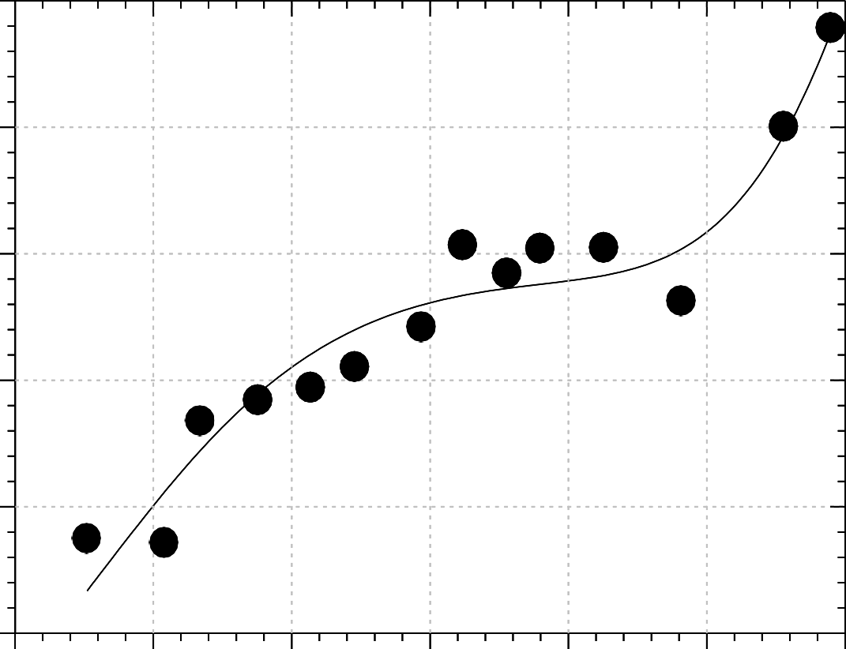
35

30

25
k_{F} (mol⁻¹ dm³ s⁻¹)

20

15

10
5.5 6.0 6.5 7.0 7.5 8.0 8.5
pH

Figure 4.42: Dependence of k_{F}, the apparent forward second order rate constant, on pH for the reaction of CysF9[93]β of the minor cat oxyhaemoglobin with 5,5′- dithiobis(2- nitrobenzoate) in the presence of inositol-P₆.
Conditions: 25°C; phosphate buffers, pH 5.6 - 7.8; borate buffers, pH 8.0 - 9.0 (ionic strength 50 mmol dm⁻³; added salt, NaCl); [haemoglobin] = 10 µmol (haem) dm⁻³ (5 µmol dm⁻³ in reacting sulphydryl groups); [inositol- P₆] =10 µmol dm⁻³; [DTNB] = 300 - 600 µmol dm⁻³.

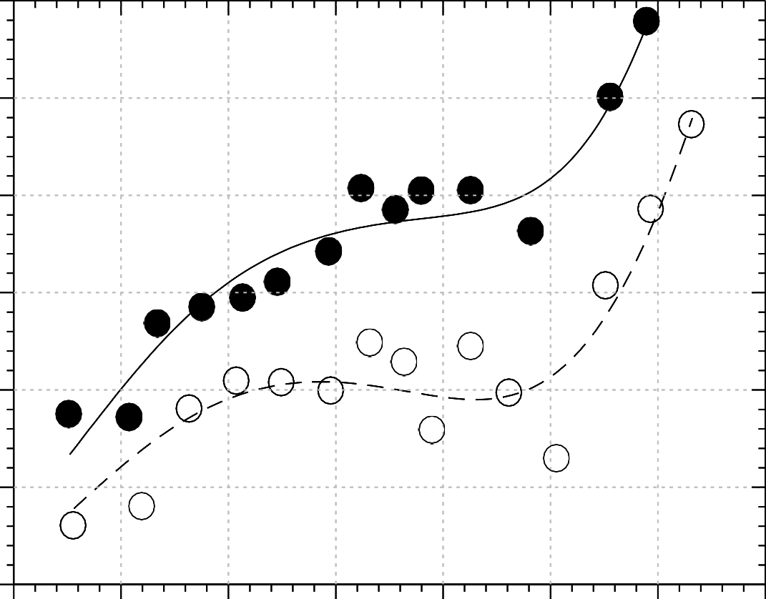
35

30

25
k_{F} (mol⁻¹ dm³ s⁻¹)

20

15

10

5
5.5 6.0 6.5 7.0 7.5 8.0 8.5 9.0

pH

Figure 4.43: Comparison of the pH-dependence profiles of k_{F} for the reaction of CysF9[93]β of the minor cat oxyhaemoglobin with 5,5′-dithiobis(2-nitrobenzoate): stripped haemoglobin (open circles); haemoglobin plus inositol-P₆ (filled circles).
Conditions: 25ºC; phosphate buffers, pH 5.6 - 7.8; borate buffers, pH 8.0 - 9.0 (ionic strength 50 mmol dm⁻³; added salt, NaCl); haemoglobin concentration, 10 µmol (haem) dm⁻³ (5 µmol dm⁻³ in reacting sulphydryl groups); DTNB concentrations, 300 - 600 µmol dm⁻³.
Data for stripped cat haemoglobin obtained from Okonjo and Fodeke (2006).

Table 4.2: The reaction of CysF9[93]β of the minor cat oxyhaemoglobin with 5,5′- dithiobis(2-nitrobenzoate); Best fit parameters used to fit the kinetic data reported in Figures 4.42 and 4.43 (Compare with Scheme Ia and Equ. 4.15 for n = 2).

Parameters Stripped minor minor oxyhaemoglobin oxyhaemoglobin + inositol-P₆

pQ_{1r} | 7.04 | 7.37
pQ_{1t} | 7.72 | 8.01
pQ_{2r} | 8.43 | 7.94
pQ_{2t} | 8.37 | 8.00
pQ_{1H} | 6.31 | 5.81
pQ_{2H} | 7.85 | 9.32
pQ_{S3} | 8.35 | 8.82
Krt3 | 1.04 | 0.197
k₁ (mol⁻¹ dm³ s⁻¹) | 214.26 | 3257.3
k₂ (mol⁻¹ dm³ s⁻¹) | 20.92 | 39.7
k₃ (mol⁻¹ dm³ s⁻¹) | 94.09 | 90.0

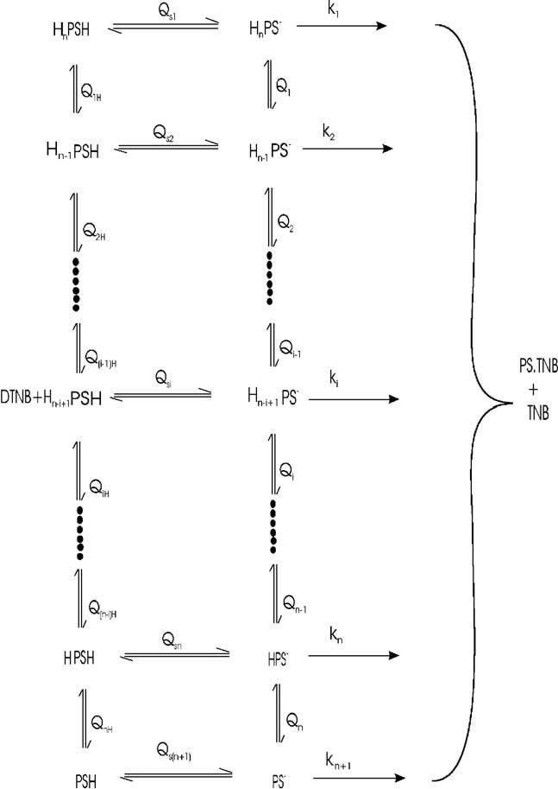Scheme Ib

Table 4.3: The reaction of CysF9[93]β of stripped major cat haemoglobins with 5,5′-dithiobis(2-nitrobenzoate); Best fit parameters used to refit the kinetic data reported by Okonjo and Fodeke, 2006 (Compare with Scheme Ia and Equ. 4.15 for n = 2).

Paramters | Major Cat Haemoglobin Derivatives |  |  | Mean
 | Oxy | Carbonmonoxy | Aquomet
pQ_{1r} | 6.87 | 6.90 | 7.54 | 7.10 ± 0.2
pQ_{1t} | 7.73 | 7.33 | 8.41 | 7.82 ± 0.4
pQ_{2r} | 8.32 | 7.48 | 8.29 | 8.03 ± 0.3
pQ_{2t} | 8.78 | 8.57 | 8.44 | 8.60 ± 0.1
pQ_{1H} | 6.24 | 5.98 | 6.37 | 6.20 ± 0.1
pQ_{2H} | 7.59 | 7.06 | 8.16 | 7.97 ± 0.4
pQ_{S3} | 8.70 | 8.29 | 8.79 | 8.59 ± 0.2
Krt3 | 0.84 | 0.84 | 0.79 | 0.82 ± 0.02
k₁ (mol⁻¹ dm³ s-1) | 660.60 | 743.09 | 755.80 | -
k₂ (mol⁻¹ dm³ s-1) | 0* | 293.83 | 60.46 | -
k₃ (mol⁻¹ dm³ s-1) | 289.93 | 104.17 | 135.62 | -

*k₂ was fixed at zero in this case because all attempts to fit the data without fixing the value of k₂ gave a negative value

Table 4.4: The reaction of CysF9[93]β of stripped minor cat haemoglobins with 5,5′-dithiobis(2-nitrobenzoate); Best fit parameters used to refit the kinetic data reported by Okonjo and Fodeke, 2006 (Compare with Scheme Ia and Equ. 4.15 for n = 2).

Paramters | Minor Cat Haemoglobin Derivatives |  |  | Mean
 | Oxy | Carbonmonoxy | Aquomet
pQ_{1r} | 7.42 | 6.33 | 6.59 | 6.78 ± 0.4
pQ_{1t} | 7.57 | 7.72 | 7.29 | 7.53 ± 0.1
pQ_{2r} | 7.89 | 8.83 | 7.93 | 8.22 ± 0.3
pQ_{2t} | 8.30 | 9.06 | 8.12 | 8.49 ± 0.3
pQ_{1H} | 6.29 | 4.75 | 5.08 | 5.37 ± 0.5
pQ_{2H} | 7.33 | 6.66 | 5.15 | 6.38 ± 0.7
pQ_{S3} | 8.75 | 8.95 | 8.60 | 8.77 ± 0.1
Krt3 | 1.85 | 1.28 | 1.83 | 1.65 ± 0.2
k₁ (mol⁻¹ dm³ s-1) | 205.6 | 623.4 | 161.27 | -
k₂ (mol⁻¹ dm³ s-1) | 181.6 | 192.9 | 442.76 | -
k₃ (mol⁻¹ dm³ s-1) | 145.1 | 137.2 | 86.19 | -

Table 4.5: The reaction of CysF9[93]β of major cat haemoglobins in the presence of inositol-P₆ with 5,5′-dithiobis(2-nitrobenzoate); Best fit parameters used to refit the kinetic data reported by Okonjo and Fodeke, 2006 (Compare with Scheme Ia and Equ.
4.15 for n = 2).

Paramters | Major Cat Haemoglobin Derivatives + inositol-P₆ |  |  | Mean
 | Oxy | Carbonmonoxy | Aquomet
pQ_{1r} | 6.83 | 7.73 | 6.79 | 7.12 ± 0.3
pQ_{1t} | 7.77 | 8.27 | 7.48 | 7.83 ± 0.3
pQ_{2r} | 8.34 | 7.88 | 8.34 | 8.19 ± 0.2
pQ_{2t} | 8.61 | 8.32 | 8.24 | 8.39 ± 0.1
pQ_{1H} | 6.29 | 6.48 | 6.39 | 6.39 ± 0.06
pQ_{2H} | 8.04 | 8.24 | 7.98 | 8.087 ± 0.09
pQ_{S3} | 8.14 | 8.17 | 8.20 | 8.17 ± 0.02
Krt3 | 0.08 | 0.954 | 0.28 | 0.438 ± 0.3
k₁ (mol⁻¹ dm³ s-1) | 60.65 | 495.3 | 167.74 | -
k₂ (mol⁻¹ dm³ s-1) | 27.29 | 67.0 | 7.90 | -
k₃ (mol⁻¹ dm³ s-1) | 86.48 | 244.2 | 109.20 | -

EQUILIBRIUM STUDIES

THEORY OF THE EQUILIBRIUM REACTION

Earlier work indicated that the CysF9[93]β sulphydryl group of haemoglobins must be in the thiolate anion form before it can react with DTNB (Boyer, 1954; Okonjo et al., 1979 and Hallaway et al., 1980). Therefore, the reaction between DTNB and haemoglobin sulphydryl groups can be represented as:


PSH+ DTNB QSH  H⁺ + PS⁻ + DTNB Kequ  H⁺ + PS.ST +TNB⁻  QTNB PS.ST +TNBH
□          
….....……. (4.16)

We define the terms that appear in Equ. 4.16 as follows (Okonjo and Fodeke, 2006): - The equilibrium constant for the ionization of the sulphydryl group, Q_{SH}, is given by:

[H⁺ ][PS⁻ ] [DTNB] [H⁺ ][PS⁻ ]

QSH =
f f =

[PSH][DTNB]f
f

[PSH]
……….... (4.17)

The equilibrium constant for the DTNB reaction step, K_{equ}, is given by:

[H⁺ ][PS.ST][TNB⁻ ] [PS.ST][TNB⁻ ]

Kequ =
[H⁺ ][PS⁻ ] [DTNB] = [PS⁻ ] [DTNB]
……..….. (4.18)

f f f f

The equilibrium constant for the ionization of TNBH is given by:

[H⁺ ][PS.ST][TNB⁻ ] [H⁺ ][TNB⁻ ]

QTNB =
[PS.ST][TNBH]
=
[TNBH]
………..… (4.19)

In Equ. 4.17 and 4.18, the subscript f denotes free, unreacted species. It can be deduced from Equ. 4.19 that

[TNBH] =
[H⁺ ][TNB⁻ ] QTNB

..…..……… (4.20)

From the stoichiometry of Equ. 4.16,

[PS.ST] = [TNB⁻ ] + [TNBH]
…………….. (4.21)

Substituting for [TNBH] from Equ. 4.20 into Equ. 4.21, we obtain

₋ ⎧ [H⁺ ] ⎫

[PS.ST] = [TNB ]⎨1+
⎩
⎬
TNB ⎭
Q
……………. (4.22)

Also from Equ. 4.16, the total concentration of haemoglobin sulphydryl groups, [P]_{total}, is given by


[P] = [PSH] + [PS⁻ ] + [PS.ST]
total f
…………….. (4.23)

From Equ. 4.17, we can substitute for [PSH]; and from Equ. 4.22, we can substitute for [PS.ST] in Equ. 4.23

₋ ⎧ [H⁺ ]⎫ − ⎧ [H⁺ ] ⎫

[P]total = [PS ]f ⎨1 + Q ⎬ + [TNB ]⎨1 + Q ⎬
…….…...… (4.24)

⎩ SH ⎭ ⎩ TNB ⎭

Therefore,

₋ ⎧ [H⁺ ] ⎫
⎩

[PS⁻ ] =
[P]total −[TNB ] ⎨1 + Q
⎬
TNB ⎭

….……….. (4.25)

^{f} ⎧ [H⁺ ]⎫

⎨1 +
⎩
⎬
SH ⎭
Q

The total concentration of DTNB, [DTNB]_{total}, is given by

[DTNB] = [DTNB] + 1 {[PS.ST] + [TNB⁻ ] + [TNBH]}

…….…….. (4.26)

total f 2
1 was used because DTNB splits into two: half of it reacts with haemoglobin (PS⁻) to
2
form a mixed disulphide, PS.ST, while the other half forms TNB⁻ . We can write an expression for the concentration of the unreacted DTNB, [DTNB]_{f}, as

[DTNB]f = [DTNB]total
2
− 1 {[PS.ST] +[TNB⁻ ] +[TNBH]}
…………… (4.27)

₋ ⎧ [H⁺ ] ⎫

[DTNB]f = [DTNB]total −[TNB ]⎨1+ Q
⎩
⎬
TNB ⎭
…………… (4.28)

Substituting respectively for [PS.ST], [PS⁻]_{f}, and [DTNB]_{f} from Equ. 4.22, 4.25 and
4.28 into Equ. 4.18, we obtain,

− 2 ⎧
[H⁺ ] ⎫

Kequ =

⎧
⎪[P]

⎧
[TNB ] ⎨1+
− −
[TNB ]


[H⁺ ] ⎫⎫
⎬⎪
⎨1+
⎩
⎬
TNB ⎭
Q

…… (4.29)

⎪ total
⎨
⎪
⎩⎪

⎧
⎨1+
⎩
⎩
[H⁺ ]⎫
⎬
Q
SH ⎭
QTNB ⎭⎪{[DTNB]
⎪
⎬ total
⎪⎭
⎧
[TNB ]}⎨1+
− −
⎩
[H⁺ ] ⎫
⎬
Q
TNB ⎭

− 2 ⎧
[H⁺ ] ⎫⎧

[H⁺ ]⎫

[TNB ] ⎨1+ Q
⎬ ⎨1+ Q ⎬

Kequ = ⎧⎪
⎩ TNB ⎭⎩ SH ⎭
⎧ [H⁺ ] ⎫⎫⎪ ⎧⎪
⎧ [H⁺ ] ⎫⎫⎪
…… (4.30)

⎨[P]
−[TNB⁻ ]⎨1+ ⎬⎬⎨[DTNB]

−[TNB⁻ ]⎨1+ ⎬⎬

⎩⎪ total
⎩ QTNB ⎭⎪⎭ ⎪⎩
total
⎩ QTNB ⎭⎪⎭

From the foregoing, it follows that if the values of the total haemoglobin concentration, [P]_{total}, the total DTNB concentration, [DTNB]_{total}, and the concentration of TNB⁻ formed at equilibrium are known, the equilibrium constant for the DTNB reaction, K_{equ}, may be determined, provided the ionization constants, Q_{TNB} and Q_{SH}, are also known. A value of 8.30 was assumed for pQ_{SH} of the CysF9[93]β sulphydryl group. The value ranges between 8.0 and 8.6 (Okonjo and Okia, 1993; Okonjo et al., 1995; 1996). Similarly, the value of pQ_{TNB} used at 25°C was 5.27 as earlier determined by Nwosu (2004).

DETERMINATION OF THE EQUILIBRIUM CONSTANT, K_{equ}, FOR THE REACTION OF HUMAN DEOXYHAEMOGLOBIN WITH DTNB.

In order to determine [TNB⁻] for the reaction of DTNB with human deoxyhaemoglobin A, we measured the absorbance values of TNB⁻, the chromophoric end product of the reaction of DTNB with human deoxyhaemoglobin A, at 405, 412, 450 and 470 nm. By assuming molar absorption coefficients of 14050, 14220, 7800 and 3940 mol⁻¹ dm³ cm⁻¹ respectively (Eyer et al., 2003), we were able to determine [TNB⁻] by appropriate substitution into the Beer-Lambert equation: 𝐴 = 𝜀𝑐𝑙 (A represents the absorbance value, ε is the molar absorption coefficient, and 𝑙 is the path length through which the light passes). The equilibrium constant, K_{equ}, for the reaction was then calculated using Equ. 4.30. A computer programme was written on MicroMath Scientist software for this purpose (Appendix G1, page 278).

pH dependence of the equilibrium constant, K_{equ}, for the reaction of stripped human deoxyhaemoglobin A with DTNB

A typical data set for the determination of the equilibrium constant for the reaction of DTNB with stripped human deoxyhaemoglobin A is shown in Table 4.6. The value of K_{equ} is 5.79 ± 1.8. The error involved in this determination (31%) is rather high. This indicates that the K_{equ} values at 412 nm are on the high side, probably because of the closeness of the Soret peak of deoxyhaemoglobin at 430 nm.
Figure 4.44 shows the dependence of –log₁₀K_{equ} on pH for the reaction of stripped human deoxygenated haemoglobin with DTNB. Only two experimental points could be obtained in the presence of inositol-P₆ at pH 5.84 and 6.20 (Figure 4.45). Although the data obtained is limited, there is a clear indication that inositol-P₆ inreases affinity of deoxyhaemoglobin for DTNB.
A comparison between the pH dependence of K_{equ} for the reaction of stripped human deoxy- and oxyhaemoglobin A is presented in Figure 4.46. The stripped oxyhaemoglobin data was obtained from Okonjo et al., (2007). All equilibrium data obtained on human deoxyhaemoglobin A were from experiments carried out using a Cary® UV/Visible 400Scan spectrophotometer (courtesy of Department of Biochemistry and Molecular Biology, University of Parma, Italy).

Table 4.6: Reaction of DTNB with CysF9[93]β of stripped human deoxyhaemoglobin A: raw data for the determination of K_{equ}. pH 6.89; ionic strength 50 mmol dm⁻³; [DTNB] = 29 mmol dm⁻³. (Compare with Equ. 4.31)
Volume (mm³) of 29 mM DTNB | *[Hb] μmol dm-3 | Absorbance | Kequ
 |  | A412
5 | 55 | 0.059 | 14.467
10 | 57 | 0.069 | 15.857
 |  | A450
5 | 55 | 0.019 | 2.126
10 | 57 | 0.025 | 1.941
15 | 57 | 0.024 | 1.261
 |  | A470
5 | 55 | 0.012 | 4.374
10 | 57 | 0.015 | 3.723
15 | 57 | 0.015 | 2.557
 |  |  | Mean = 5.79 ± 1.8

*The haemoglobin concentrations usually increased slightly from the initial 50 μmol dm⁻³ due to dehydration during deoxygenation.

0.0

-0.5

-1.0
-log10Kequ

-1.5

-2.0

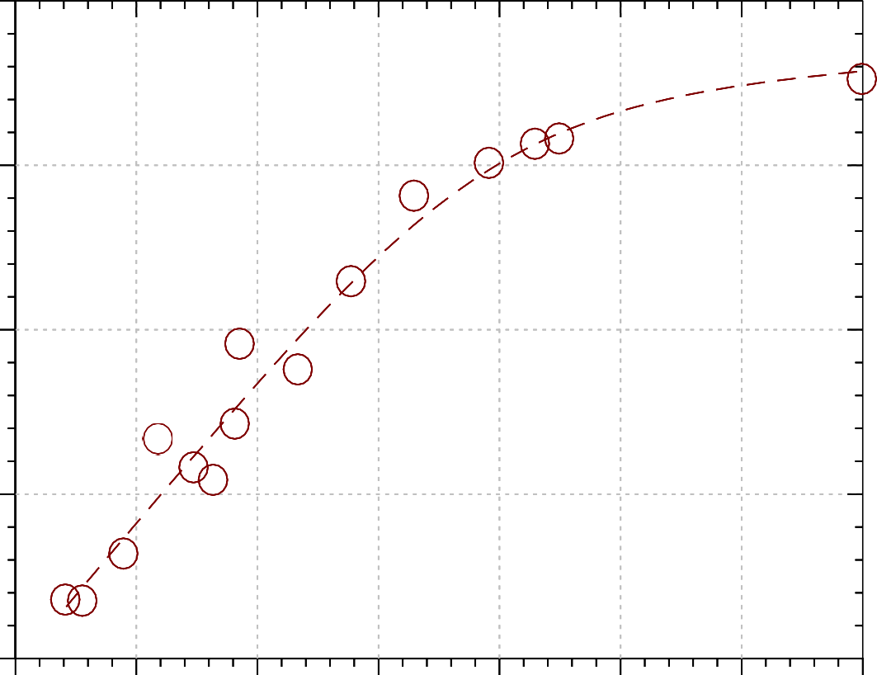
5.5 6.0 6.5 7.0 7.5 8.0 8.5 9.0

pH

Figure 4.44: Dependence of –log₁₀K_{equ} on pH for the reaction on DTNB with CysF9[93]β of stripped human deoxyhaemoglobin A .
Conditions: Phosphate buffers, pH 5.6 – 7.8; borate buffers, pH > 8.0 (ionic strength 50 mmol dm⁻³; added salt, NaCl); initial haemoglobin concentration, 50 µmol haem dm⁻³ (25 µmol dm⁻³ in reactive sulphydryl group). Each data point is subject to a standard error of about ± 0.1 in the log.

0.0

-0.5

-1.0
-log10Kequ

-1.5

-2.0

-2.5

-3.0

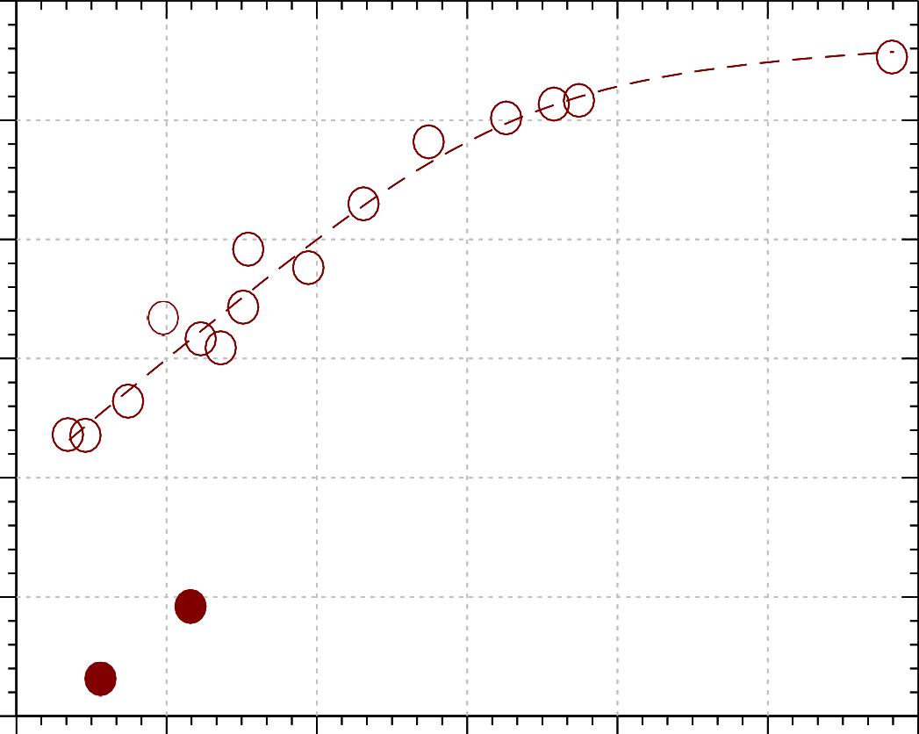
5.5 6.1 6.7 7.3 7.9 8.5 9.1

pH

Figure 4.45: Dependence of -log₁₀K_{equ} on pH for the reaction DTNB with CysF9[93]ß of human deoxyhaemoglobin A in the presence of inositol-P₆ (filled circles): The open circles on a dashed line show the corresponding profile for the stripped derivative.
Conditions: phosphate buffers, pH 5.6 – 7.8; borate buffers, pH > 8.0 (ionic strength 50 mmol dm⁻³; added salt, NaCl); initial haemoglobin concentration, 50 µmol haem dm⁻³ (25 µmol dm⁻³ in reactive sulphydryl group); stock DTNB concentration, 29.07 mmol dm⁻³; [inositol-P₆] = 50 µmol dm⁻³. Each data point is subject to a standard error of about ± 0.1 in the log.

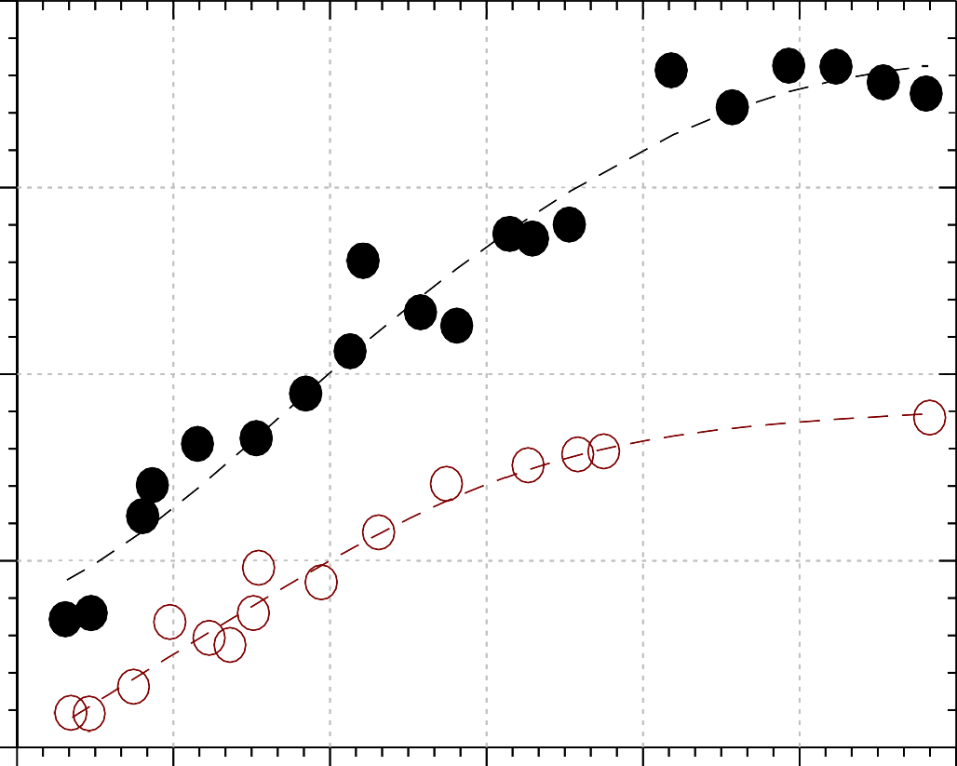
2.0

1.0

0.0
-log10Kequ

-1.0

-2.0

5.5

6.1

6.7

7.3 7.9 8.5 9.1

pH

Figure 4.46: A comparison between the dependence of –log₁₀K_{equ} on pH for the reaction of DTNB with CysF9[93]β of stripped human oxy- (filled circles) and deoxy- (open circles) haemoglobin A.
Conditions: Phosphate buffers, pH 5.6 -7.8; borate buffers, pH 8.0 – 9.0 (ionic strength 50 mmol dm⁻³; added salt, NaCl); haemoglobin concentration, 50 µmol haem dm⁻³ (25µmol dm⁻³ in reactive sulphydryl group); stock DTNB concentration, 29.07 mmol dm⁻³. Each data point is subject to a standard error of about ± 0.1 in the log.
Data for stripped haemoglobin obtained from Okonjo et al., 2007

It is seen from Figure 4.44 that the equilibrium constant for the the reaction of DTNB with stripped human deoxyhaemoglobin A exhibits significant pH dependence, varying by about two orders of magnitude between pH 5.6 and 9.0. This is an indication that the reaction of DTNB with CysF9[93]β sulphydryl of human deoxyhaemoglobin A is electrostatically linked to the ionization of groups on the haemoglobin molecule. From Figure 4.45, it can be assumed that K_{equ} for the reaction in the presence of inositol-P₆ will likewise increase throughout the experimental pH range, as obtained at pH 5.84 and 6.20. An increase in K_{equ} implies that the affinity of human deoxyhaemoglobin A for DTNB increases in the presence of inositol-P₆. Similar results were obtained with cat haemoglobins in the R-quaternary state. It is also seen in Figure 4.46 that stripped deoxyhaemoglobin has a higher affinity for DTNB than oxyhaemoglobin.

QUANTITATIVE ANALYSES OF THE pH DEPENDENCE PROFILES OF –log₁₀K_{equ}
The strong pH dependence of –log₁₀K_{equ} is an indication that the reaction of CysF9[93]β sulphydryl with DTNB is coupled to the ionizations of side chains of some other amino acid groups on the protein. Quantitative analyses of the pH dependences of K_{equ} will enable the determination of the nature and the number of these groups. Hence, Scheme II was proposed for the analysis of K_{equ} (Okonjo et al., 2008, 2009).
In Scheme II, the protons arising from the various ionization steps have been omitted for clarity. H_{n-i+1}PSH (i = 1, 2, …, n+1) are haemoglobin species in which the sulphydryl group is in its protonated form, which does not react with DTNB. These species are therefore omitted from the Scheme. H_{n-i+1}PS⁻ (i = 1, 2, …., n+1) are species in which the sulphydryl is in its thiolate anion form, the form that reacts with DTNB; H_{n-i+1}PS.ST (i = 1, 2, …., n) are the mixed disulfide species formed after the reaction of the sulphydryl with DTNB. Species marked with subscripts r or t are those in which the sulphydryl is in the r or t tertiary isomeric form of haemoglobin, respectively. The various proton ionization constants are represented as Q_{i}, Q_{ir} and Q_{it} (i = 1, 2, …, n) to differentiate them from the equilibrium constants K_{Ei} (i = 1, 2, …., n
+ 1) for the reaction of DTNB; and K_{rt(n} ₊ ₁₎ is the equilibrium constant at high pH for

the r 
t tertiary conformational transition.

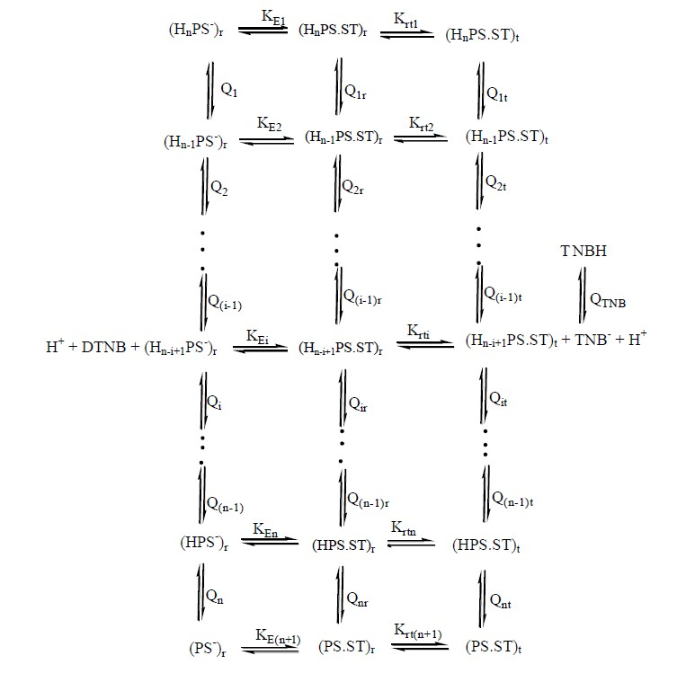SCHEME II

According to Okonjo et al. (2008), the relationship between K_{equ} and the parameters of Scheme II is given by the equation:

⎪⎧ _{n}
n-i+1 ⎛ n
⎞-1
⎪⎧ n
n-i+1 ⎛ n
⎞-1 ⎪⎫⎪⎫

K ⎨1 + ∑(H⁺ )
E(n+1) jr rt(n+1) jt
⎜∏Q ⎟ + K
⎨1 + ∑(H⁺ )
⎜∏Q
⎟ ⎬⎬

Kequ =
⎩⎪ i=1
⎧⎪
⎝ j=i
⎠ ⎪⎩
⎪⎧ n n-i+1 ⎛ n
i=1

⎞-1

⎪⎫⎪⎫
⎝ j=i
⎠ ⎪⎭⎪⎭

…..… (4.31)

⎨1 + K
⎨∑(H+ )
⎜∏Q
⎟ K-1 ⎬⎬

⎩⎪ ⎪⎩ i=1
E(n+1) jr Ei
⎝ j=i ⎠
⎪⎭⎪⎭

The data in Figures 4.45 – 4.46 were fitted with Eq. 4.31. The best-fit lines through the data points were obtained with a value of n = 2. The best-fit parameters are reported in Table 4.7. [The curve-fitting programme was written on a MicroMath Scientist software (Appendix G3)].

Table 4.7: Reaction of 5,5′-dithiobis(2-nitrobenzoate) with the CysF9[93]β sulphydryl groups of stripped human deoxy- and oxyhaemoglobin A. Best-fit parameters used to fit the equilibrium data reported in Figure 4.43 using Scheme IIb and Eq. 4.33, for n = 2.
Paramters | Deoxyhaemoglobin A | *Oxyhaemoglobin A
pQ_{1r} | 5.85 | 6.17
pQ_{1t} | 6.62 | 7.02
pQ_{2r} | 7.30 | 8.00
pQ_{2t} | 7.63 | 8.73
KE3 / KE2 | 0.15 | 0.02
KE3/KE1 | 0.026 | 0.001
-log₁₀K_{E3} | -0.15 | 1.73
Krt3 | 0.34 | 0.13

*Data for the stripped human oxyhaemoglobin A were obtained from Okonjo et al, 2007.

We now try to account for the difference in the affinities of deoxy- and oxyhaemoglobin for DTNB seen in Figure 4.46. We found that the best-fit value of n for the data reported in Figure 4.43 is 2. This means that the haemoglobin species

undergoing the r
□  t tertiary transition are the mixed disulphide species H₂PS.ST,


HPS.ST and PS.ST (see Scheme II for n = 2). The corresponding tertiary structure transition constants for these species are K_{rt1}, K_{rt2} and K_{rt3}. K_{rt3} was already calculated during the data fit with Equ. 4.31 and is reported in Table 4.13. In order to calculate K_{rt1} and K_{rt2}, we apply microscopic reversibility to Scheme II for n = 2. This results in the following equations:

Krt2 = Krt3
….….. (4.32)

Q2r Q2t

Krt1 = Krt2

…….. (4.33)

Q1r Q1t

Writing Equ. (4.32) and (4.33) in base 10 logarithmic form, we obtain: logK_{rt2} = logK_{rt3} + pQ_{2t} – pQ_{2r} (4.34)
logK_{rt1} = logK_{rt2} + pQ_{1t} – pQ_{1r} (4.35)

Table 4.8 reports the values of K_{rt1}, K_{rt2} and K_{rt3} together for deoxy- and oxyhaemoglobin; the percentage t isomer population of each of the species H₂PS.ST, HPS.ST and PS.ST is also reported in the same table.
Furthermore, we need to calculate the equilibrium constants K_{E1} and K_{E2} from the parameters reported in Table 4.7. These are the equilibrium constants for the reaction of DTNB with species H₂PS⁻ and HPS⁻, while K_{E3} is the corresponding value for PS⁻. These equilibrium constants are reported in Table 4.9.

Table 4.8: Tertiary conformation transition constants, K_{rti} (i = 1, 2, 3), for the haemoglobin species H₂PS.ST, HPS.ST and PS.ST, respectively. Compare with Scheme Ia for n = 2. The numbers in brackets are the percentage t isomer populations.

Haemoglobin Species | Transition constant | Stripped deoxyhaemoglobin | Stripped oxyhaemoglobin
H₂PS.ST | Krt1 | 4.320  (81.2%) | 4.779  (82.7%)
HPS.ST | Krt2 | 0.732  (42.3%) | 0.667  (40.0%)
PS.ST | Krt3 | 0.336  (25.1%) | 0.126  (11.2%)

Table 4.9: Equilibrium constants, K_{Ei} (i = 1, 2, 3), for the reaction of DTNB with the haemoglobin species H₂PS⁻, HPS⁻ and PS⁻, respectively. Compare with Scheme II for n
= 2.

Haemoglobin Species | Equilibrium constant | Stripped deoxyhaemoglobin | Stripped oxyhaemoglobin
H₂PS⁻ | KE1 | 52.61 | 15.5
HPS⁻ | KE2 | 9.33 | 1.0
PS⁻ | KE3 | 1.37 | 0.019

DETERMINATION OF THE EQUILIBRIUM CONSTANT, K_{equ}, FOR THE REACTION OF DTNB WITH CAT HAEMOGLOBINS IN THE PRESENCE OF INOSITOL-P₆
The concentration of 5-thio-2-nitrobenzoate, [TNB⁻], the chromophoric product of the DTNB reaction at a particular pH, was determined from experimentally measured absorbance values at the specified pH. A molar absorption coefficient of 14,000 mol⁻¹ dm³ cm⁻¹ was assumed for TNB⁻ at 412 nm (Ellman, 1958). This, along with other known variables, was substituted into Equ. 4.30 in order to obtain the equilibrium constant for the DTNB reaction. A computer programme written on a MicroMath Scientist software was used to aid the calculation of K_{equ} at the various pHs (Appendix G2).

pH DEPENDENCE OF THE EQUILIBRIUM CONSTANT, K_{equ}, FOR THE REACTION OF CAT HAEMOGLOBINS WITH DTNB IN THE PRESENCE OF INOSITOL-P₆
Tables 4.10 – 4.12 show typical raw data sets for the determination of the equilibrium constant for the reaction of DTNB with the major derivatives of cat haemoglobin in the presence of inositol-P₆. The corresponding data sets for the minor derivatives of cat haemoglobin are shown in Tables 4.13 – 4.15. The figures that follow are the pH dependence profiles of –log₁₀K_{equ} for the three derivatives of the major and minor cat haemoglobins in the presence of inositol-P₆.
It is seen that strong pH dependences are observed for –log₁₀K_{equ} for all the derivates of both the major and minor cat haemoglobins. This is an indication that the reaction of DTNB with CysF9[93]β of cat haemoglobin is coupled to the ionization of groups on the haemoglobin molecule. In each of the major derivatives (Figures 4.47 – 4.49), K_{equ} varies by not less than three orders of magnitude over the pH range 5.6 ≤ pH ≤ 9.0. A similar trend is observed for the minor derivatives, as shown in Figures 4.50 – 4.52.

Table 4.10: Reaction of DTNB with CysF9[93]β of the major cat oxyhaemoglobin + inositol-P₆ : raw data for the determination of K_{equ} at 25°C. Conditions: pH 7.51; [Hb] = 50 µmol dm⁻³; [inositol-P₆] = 100 µmol dm⁻³; [DTNB] = 29 mmol dm⁻³.
DTNB vol (mm³) | A412 | [TNB] (μmol dm⁻³) | Kequ
2.5 | 0.113 | 8.07 | 1.759
5.0 | 0.125 | 8.93 | 0.921
7.5 | 0.126 | 9.00 | 0.583
10.0 | 0.128 | 9.14 | 0.441
12.5 | 0.130 | 9.29 | 0.360
15.0 | 0.134 | 9.57 | 0.322
17.5 | 0.132 | 9.43 | 0.262
20.0 | 0.135 | 9.64 | 0.242
22.5 | 0.150 | 10.7 | 0.286
25.0 | 0.148 | 10.6 | 0.247
27.5 | 0.190 | 13.6 | 0.472
30.0 | 0.240 | 17.1 | 1.020
32.5 | 0.195 | 13.9 | 0.432
35.0 | 0.230 | 16.4 | 0.728
37.5 | 0.292 | 20.9 | 2.331
40.0 | 0.298 | 21.3 | 2.545
42.5 | 0.270 | 19.3 | 1.250
45.0 | 0.300 | 21.4 | 2.377
 |  |  | Mean = 0.920 ± 0.1

Table 4.11: Reaction of DTNB with CysF9[93]β of the major cat carbonmonoxyhaemoglobin + inositol-P₆ : raw data for the determination of K_{equ} at 25°C. Conditions: pH 8.51; [Hb] = 50 µmol dm⁻³; [inositol-P₆] = 100 µmol dm⁻³; [DTNB] = 29 mmol dm⁻³.
DTNB vol (mm³) | A412 | [TNB] (μmol dm⁻³) | Kequ
2.5 | 0.116 | 8.29 | 0.420
5.0 | 0.145 | 10.4 | 0.313
7.5 | 0.180 | 12.9 | 0.371
10.0 | 0.150 | 10.7 | 0.152
12.5 | 0.162 | 11.6 | 0.146
15.0 | 0.155 | 11.1 | 0.107
17.5 | 0.169 | 12.1 | 0.117
20.0 | 0.176 | 12.6 | 0.115
22.5 | 0.175 | 12.5 | 0.100
25.0 | 0.180 | 12.9 | 0.097
27.5 | 0.201 | 14.4 | 0.126
30.0 | 0.236 | 16.9 | 0.209
32.5 | 0.232 | 16.6 | 0.179
35.0 | 0.200 | 14.3 | 0.096
37.5 | 0.290 | 20.7 | 0.481
40.0 | 0.286 | 20.4 | 0.410
42.5 | 0.283 | 20.2 | 0.360
45.0 | 0.261 | 18.6 | 0.216
 |  |  | Mean = 0.223 ± 0.02

Table 4.12: Reaction of DTNB with CysF9[93]β of the major cat aquomethaemoglobin + inositol-P₆ : raw data for the determination of K_{equ} at 25°C. Conditions: pH 8.86; [Hb] = 50 µmol dm⁻³; [inositol-P₆] = 100 µmol dm⁻³; [DTNB]
= 29 mmol dm⁻³.

DTNB vol (mm³) | A412 | [TNB] (μmol dm⁻³) | Kequ
2.5 | 0.170 | 12.1 | 1.220
5.0 | 0.214 | 15.3 | 0.932
7.5 | 0.240 | 17.1 | 0.866
10.0 | 0.278 | 19.9 | 1.281
12.5 | 0.288 | 20.6 | 1.224
15.0 | 0.295 | 21.1 | 1.173
17.5 | 0.298 | 21.3 | 1.062
22.5 | 0.300 | 21.4 | 0.841
27.5 | 0.294 | 21.0 | 0.579
30.0 | 0.309 | 22.1 | 0.803
32.5 | 0.312 | 22.3 | 0.808
35.0 | 0.325 | 23.2 | 1.242
37.5 | 0.336 | 24.0 | 2.208
40.0 | 0.315 | 22.5 | 0.721
42.5 | 0.339 | 24.2 | 2.515
 |  |  | Mean = 1.165 ± 0.3

1.5

0.5

-0.5
-log10Kequ

-1.5

-2.5

-3.5

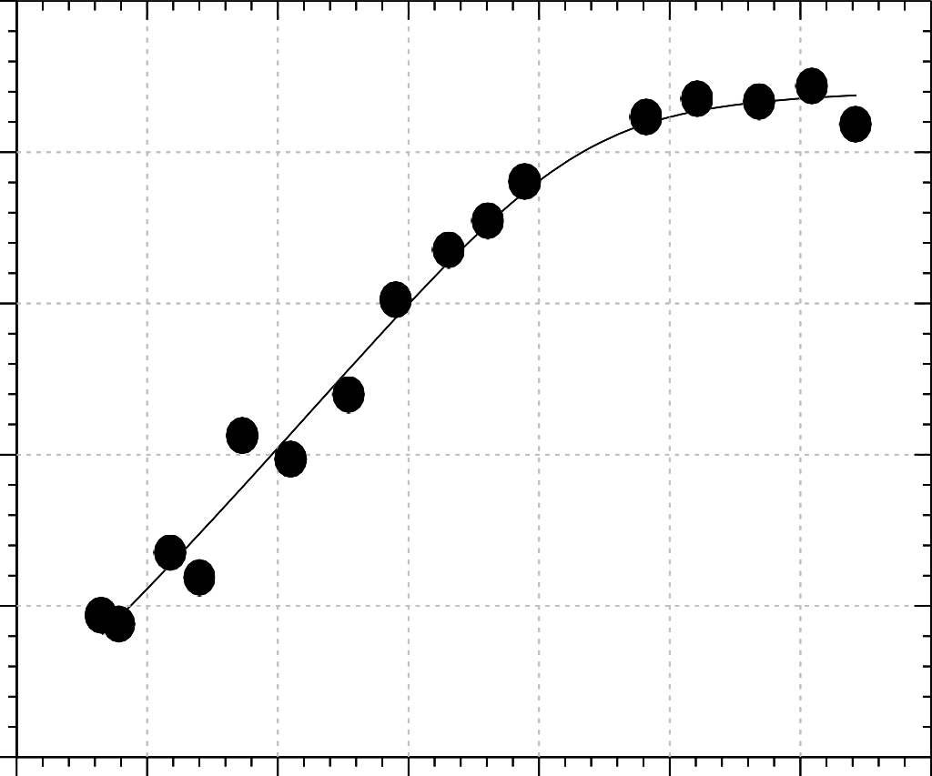
5.7 6.2 6.7 7.2 7.7 8.2 8.7 9.2

pH

Figure 4.47: Dependence of –log₁₀K_{equ} on pH for the reaction of DTNB with CysF9[93]β of the major cat oxyhaemoglobin in the presence of inositol-P₆ Conditions: phosphate buffers pH 5.6 – 7.8; borate buffers pH 8.0 – 9.0 (ionic strength 50 mmol dm⁻³; added salt, NaCl); [DTNB] = 29.07 mmol dm⁻³; [haemoglobin] = 50 µmol (haem) dm⁻³ (25 µmol dm⁻³ in reactive sulphydryl group); [inositol-P₆] = 100 µmol dm⁻³. Each data point is the mean of a minimum of 10 determinations and is subject to a standard error of about ± 0.1 in the log.

1.0

0.5

0.0

-0.5
-log10Kequ

-1.0

-1.5

-2.0

-2.5

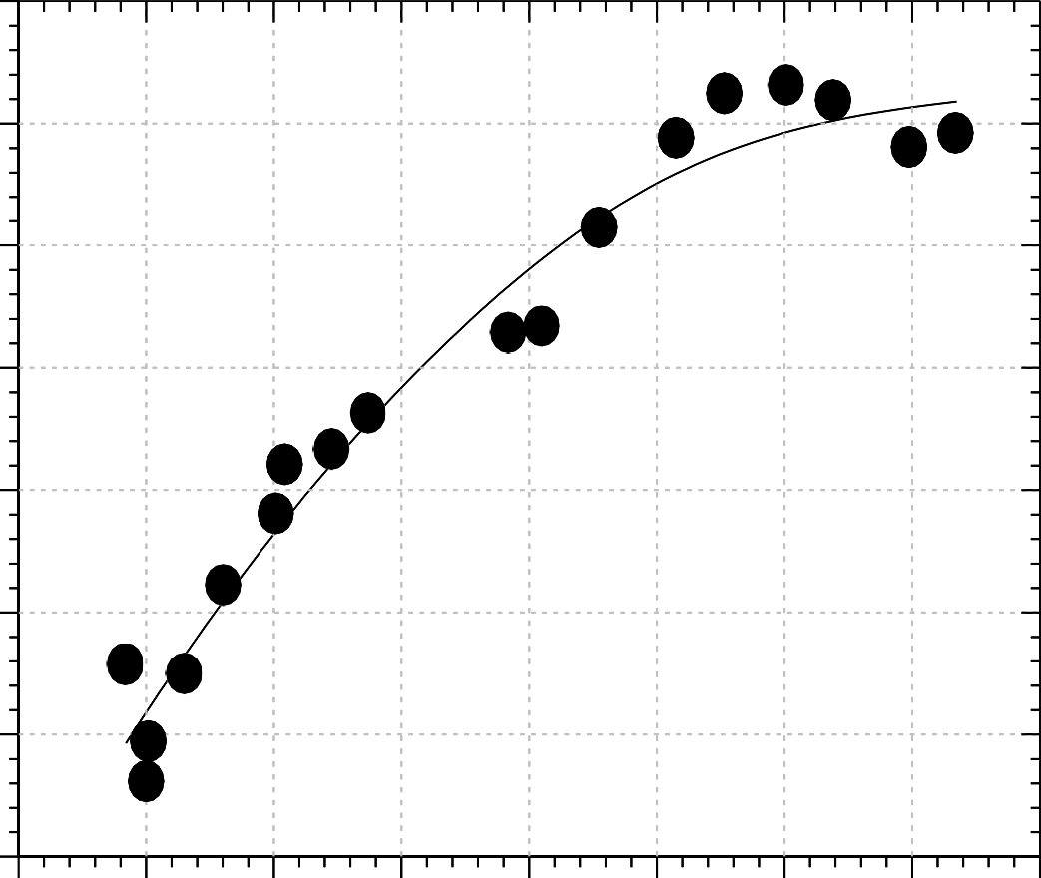
5.5 6.0 6.5 7.0 7.5 8.0 8.5 9.0 9.5

pH

Figure 4.48: Dependence of –log₁₀K_{equ} on pH for the reaction of DTNB with CysF9[93]β of the major cat carbonmonoxyhaemoglobin in the presence of inositol- P₆.
Conditions: phosphate buffers pH 5.6 – 7.8; borate buffers pH 8.0 – 9.0 (ionic strength 50 mmol dm⁻³; added salt, NaCl); [DTNB] = 29.07 mmol dm⁻³; [haemoglobin] = 50 µmol (haem) dm⁻³ (25 µmol dm⁻³ in reactive sulphydryl group); [inositol-P₆] = 100 µmol dm⁻³. Each data point is the mean of a minimum of 10 determinations and is subject to a standard error of about ± 0.1 in the log.

0.5

0.0

-0.5

-1.0
-log10Kequ

-1.5

-2.0

-2.5

-3.0

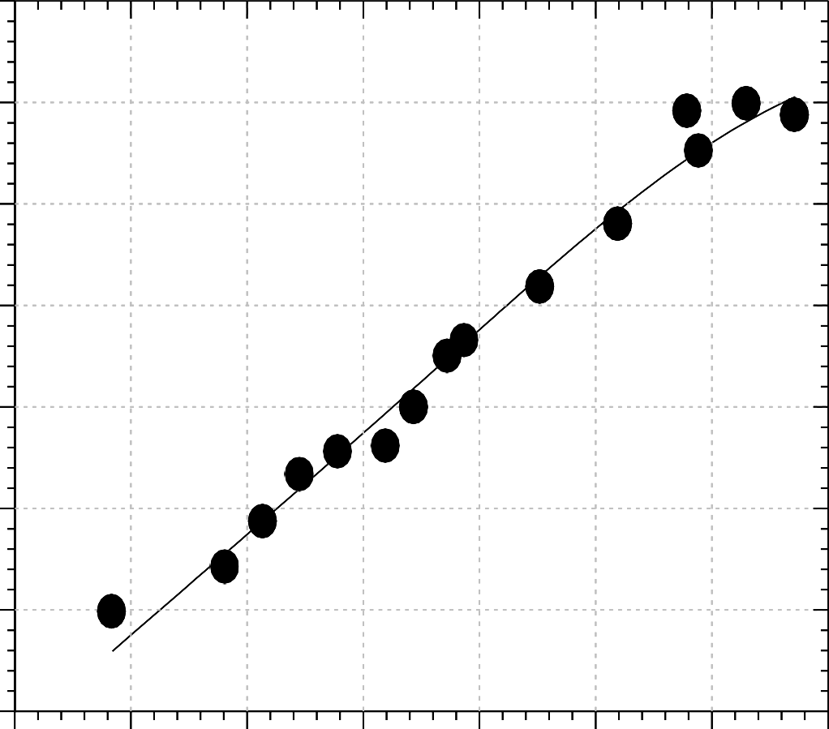
5.5 6.0 6.5 7.0 7.5 8.0 8.5 9.0

pH

Figure 4.49: Dependence of –log₁₀K_{eq} on pH for the reaction of DTNB with CysF9[93]β of the major cat aquomethaemoglobin in the presence of inositol-P₆.
Conditions: phosphate buffers pH 5.6 – 7.8; borate buffers pH 8.0 – 9.0 (ionic strength 50 mmol dm⁻³; added salt, NaCl); [DTNB] = 29.07 mmol dm⁻³; [haemoglobin] = 50 µmol (haem) dm⁻³ (25 µmol dm⁻³ in reactive sulphydryl group); [inositol-P₆] = 100 µmol dm⁻³. Each data point is the mean of a minimum of 10 determinations and is subject to a standard error of about ± 0.1 in the log.

Table 4.13: Reaction of DTNB with CysF9[93]β of the minor cat oxyhaemoglobin + inositol-P₆: raw data for the determination of K_{equ} at 25°C. Conditions: pH 8.12; [Hb]
= 50 µmol (haem) dm⁻³; [inositol-P₆] = 100 µmol dm⁻³; [DTNB] = 29 mmol dm⁻³.

DTNB vol (mm³) | A412 | [TNB] (μmol dm⁻³) | Kequ
2.5 | 0.170 | 5.71 | 0.233
5.0 | 0.101 | 7.21 | 0.181
7.5 | 0.124 | 8.86 | 0.194
10.0 | 0.148 | 10.57 | 0.229
12.5 | 0.164 | 11.71 | 0.241
15.0 | 0.185 | 13.21 | 0.287
17.5 | 0.198 | 14.14 | 0.304
20.0 | 0.204 | 14.57 | 0.291
22.5 | 0.235 | 16.79 | 0.438
25.0 | 0.24 | 17.14 | 0.427
27.5 | 0.228 | 16.29 | 0.313
30.0 | 0.257 | 18.36 | 0.480
32.5 | 0.180 | 12.86 | 0.116
35.0 | 0.199 | 14.21 | 0.149
37.5 | 0.161 | 11.50 | 0.072
40.0 | 0.172 | 12.29 | 0.082
42.5 | 0.182 | 13.00 | 0.091
45.0 | 0.170 | 12.14 | 0.070
 |  |  | Mean = 0.233 ± 0.02

Table 4.14: Reaction of DTNB with CysF9[93]β of the minor cat carbonmonoxyhaemoglobin + inositol-P₆ : raw data for the determination of K_{equ} at 25°C. Conditions: pH 7.14; [Hb] = 50 µmol (haem) dm⁻³; [inositol-P₆] = 100 µmol dm⁻³; [DTNB] = 29 mmol dm⁻³.
DTNB vol (mm³) | A412 | [TNB] (μmol dm⁻³) | Kequ
2.5 | 0.092 | 6.6 | 2.099
5.0 | 0.150 | 10.7 | 3.385
7.5 | 0.171 | 12.2 | 3.075
10.0 | 0.209 | 14.9 | 4.334
12.5 | 0.204 | 14.6 | 3.064
15.0 | 0.272 | 19.4 | 8.893
17.5 | 0.280 | 20.0 | 8.909
20.0 | 0.274 | 19.6 | 6.711
22.5 | 0.248 | 17.7 | 3.507
25.0 | 0.285 | 20.4 | 6.749
30.0 | 0.284 | 20.3 | 5.417
32.5 | 0.240 | 17.1 | 2.047
35.0 | 0.244 | 17.4 | 2.037
37.5 | 0.322 | 23.0 | 14.554
40.0 | 0.321 | 22.9 | 12.956
42.5 | 0.330 | 23.6 | 20.397
 |  |  | Mean = 6.758 ± 1.4

Table 4.15: Reaction of DTNB with CysF9[93]β of the minor cat aquomethaemoglobin + inositol-P₆ : raw data for the determination of K_{equ} at 25°C. Conditions: pH 8.51; [Hb] = 50 µmol (haem) dm⁻³; [inositol-P₆] = 100 µmol dm⁻³; [DTNB] = 29 mmol dm⁻³.
DTNB vol (mm³) | A412 | [TNB] (μmol dm⁻³) | Kequ
2.5 | 0.094 | 6.7 | 0.229
5.0 | 0.154 | 11.0 | 0.375
7.5 | 0.202 | 14.4 | 0.550
10.0 | 0.112 | 8.0 | 0.069
12.5 | 0.204 | 14.6 | 0.311
15.0 | 0.246 | 17.6 | 0.531
17.5 | 0.184 | 13.1 | 0.152
20.0 | 0.168 | 12.0 | 0.099
22.5 | 0.142 | 10.1 | 0.054
25.0 | 0.203 | 14.5 | 0.144
27.5 | 0.194 | 13.9 | 0.111
30.0 | 0.175 | 12.5 | 0.074
32.5 | 0.207 | 14.8 | 0.117
35.0 | 0.214 | 15.3 | 0.122
37.5 | 0.205 | 14.6 | 0.097
40.0 | 0.249 | 17.8 | 0.195
42.5 | 0.258 | 18.4 | 0.216
45.0 | 0.291 | 20.8 | 0.407
 |  |  | Mean = 0.214 ± 0.03

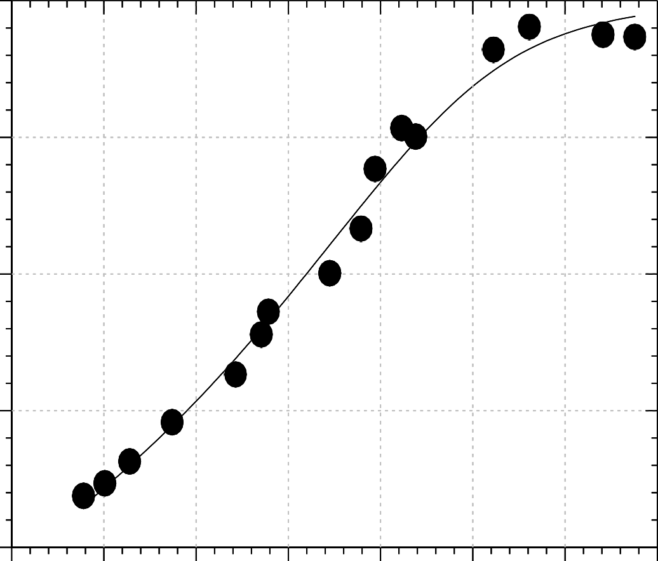
1

0

-1
-log10Kequ

-2

-3
5.5 6.0 6.5 7.0 7.5 8.0 8.5 9.0

pH

Figure 4.50: Dependence of –log₁₀K_{equ} on pH for the reaction of DTNB with CysF9[93]β of minor cat oxyhaemoglobin in the presence of inositol-P₆.
Conditions: phosphate buffers pH 5.6 – 7.8; borate buffers pH 8.0 – 9.0 (ionic strength 50 mmol dm⁻³; added salt, NaCl); [DTNB] = 29.07 mmol dm⁻³; [haemoglobin] = 50 µmol (haem) dm⁻³ (25 µmol dm⁻³ in reactive sulphydryl group); [inositol-P₆] = 100 µmol dm⁻³. Each data point is the mean of a minimum of 10 determinations and is subject to a standard error of about ± 0.1 in the log.

0.0

-0.5

-1.0
-log10Kequ

-1.5

-2.0

-2.5

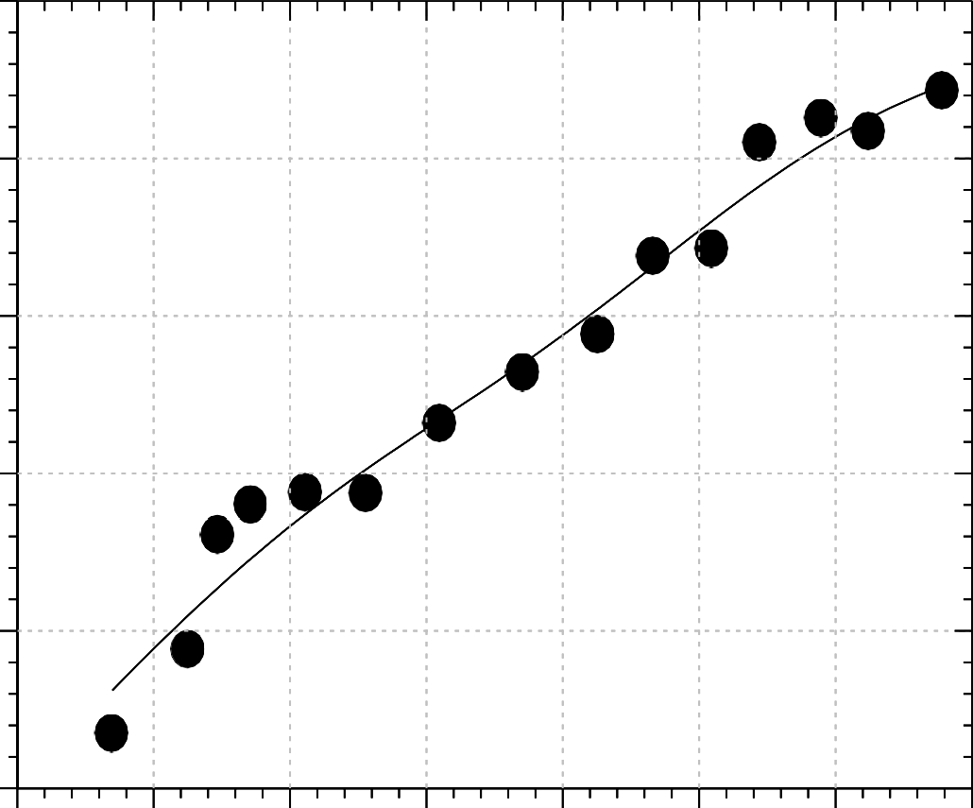
5.5 6.0 6.5 7.0 7.5 8.0 8.5 9.0

pH

Figure 4.51: Dependence of –log₁₀K_{equ} on pH for the reaction DTNB with CysF9[93]β of the minor cat carbonmonoxyhaemoglobin in the presence of inositol- P₆.
Conditions: phosphate buffers pH 5.6 – 7.8; borate buffers pH 8.0 – 9.0 (ionic strength 50 mmol dm⁻³; added salt, NaCl); [DTNB] = 29.07 mmol dm⁻³; [haemoglobin] = 50 µmol (haem) dm⁻³ (25 µmol dm⁻³ in reactive sulphydryl group); [inositol-P₆] = 100 µmol dm⁻³. Each data point is the mean of a minimum of 10 determinations and is subject to a standard error of about ± 0.1 in the log.

1.0


0.5

0.0

-0.5

-1.0


-1.5
-log10Kequ

-2.0

-2.5

5.6 6.1 6.6 7.1 7.6 8.1 8.6 9.1

pH

Figure 4.52: Dependence of –log₁₀K_{equ} on pH for the reaction of DTNB with CysF9[93]β of the minor cat aquomethaemoglobin in the presence of inositol-P₆. Conditions: phosphate buffers pH 5.6 – 7.8; borate buffers pH 8.0 – 9.0 (ionic strength 50 mmol dm⁻³; added salt, NaCl); [DTNB] = 29.07 mmol dm⁻³; [haemoglobin] = 50 µmol (haem) dm⁻³ (25 µmol dm⁻³ in reactive sulphydryl group); [inositol-P₆] = 100 µmol dm⁻³. Each data point is the mean of a minimum of 10 determinations and is subject to a standard error of about ± 0.1 in the log.

4.2.7 EFFECT OF INOSITOL-P₆ ON THE pH DEPENDENCE PROFILES OF
–log₁₀K_{equ} FOR THE REACTION OF DTNB WITH CAT HAEMOGLOBINS

One of the goals of this current research was to determine the effect of inositol–P₆ on K_{equ} for the reaction of DTNB with the cat haemoglobins. The equilibrium constant, K_{equ}, for the reaction of stripped cat haemoglobins with DTNB had earlier been determined (Okonjo et al., 2006). In order to show the effect of inostol-P₆ on the equilibrium constant for the reaction, we compare the pH-dependence profiles of the stripped cat haemoglobin with that of cat haemoglobin to which inositol-P₆ has been added in a ratio 1 : 4 (haemoglobin tetramer : inositol-P₆). The comparisons are shown in Figures 4.53 – 4.58 for major and minor cat oxy-, carbomonoxy- and aquomethaemoglobins respectively.
It is seen from the figures that the presence of inositol-P₆ does not abolish the strong pH dependence of –log₁₀K_{equ}. In addition, affinity for DTNB increased in the presence of inositol-P₆ in all cases.

4.0

3.0

2.0

1.0
-log10Kequ

0.0

-1.0

-2.0

-3.0

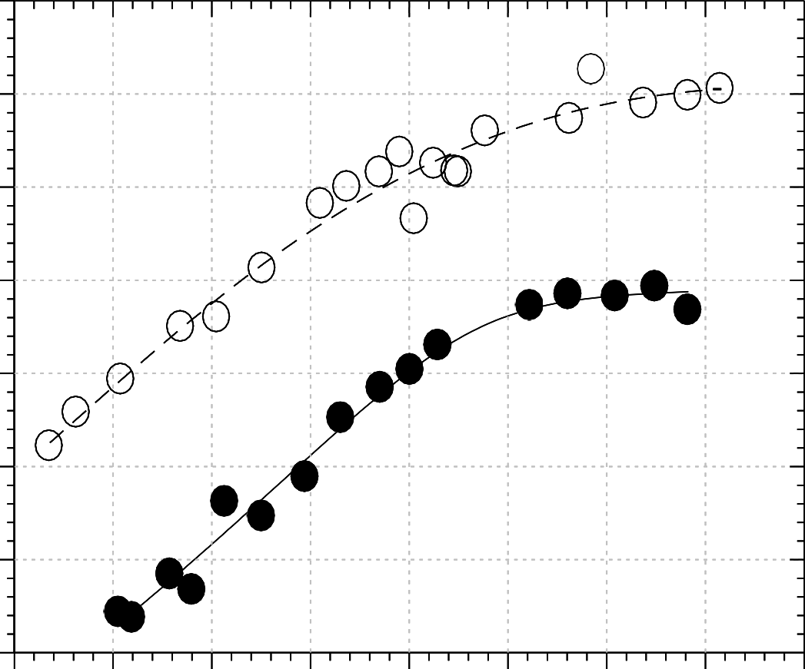
5.5 6.0 6.5 7.0 7.5 8.0 8.5 9.0 9.5

pH

Figure 4.53: Effect of inositol-P₆ on the equilibrium constant for the reaction of 5,5′- dithiobis(2-nitrobenzoate) with CysF9[93]ß of the major cat oxyhaemoglobin.
Open circles, stripped haemoglobin (Okonjo and Fodeke, 2006); filled circles, haemoglobin + inositol-P₆.

3.5

2.5

1.5
-log10Kequ

0.5

-0.5

-1.5

-2.5

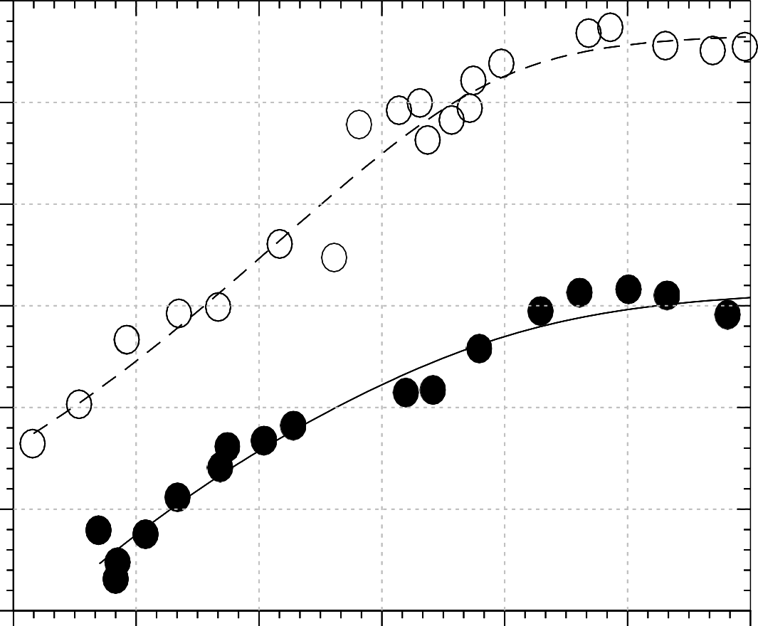
5.5 6.1 6.7 7.3 7.9 8.5 9.1

pH

Figure 4.54: Effect of inositol-P₆ on the equilibrium constant for the reaction of 5,5′- dithiobis(2-nitrobenzoate) with CysF9[93]ß of the major cat carbonmonoxyhaemoglobin.
Open circles, stripped haemoglobin (Okonjo and Fodeke, 2006); filled circles, haemoglobin + inositol-P₆.

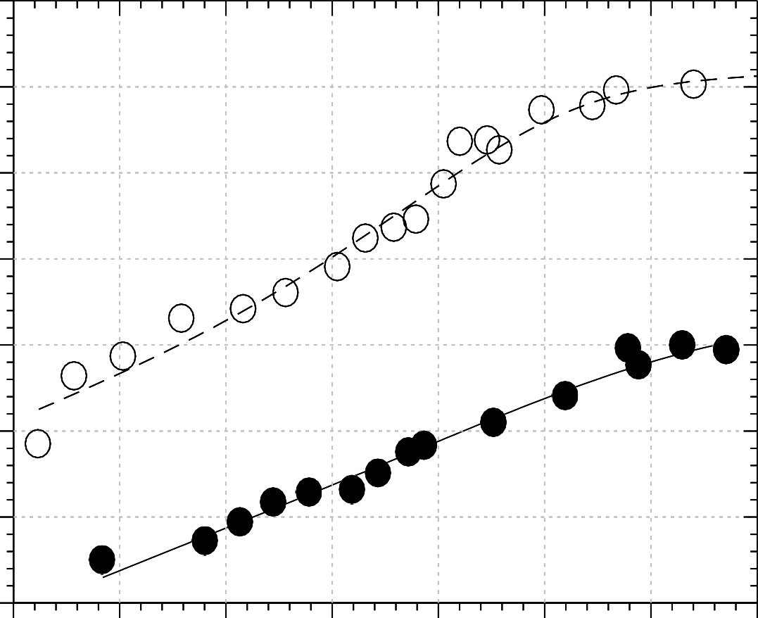
4

3

2

1
-log10Kequ

0

-1

-2

-3
5.5 6.0 6.5 7.0 7.5 8.0 8.5 9.0

pH

Figure 4.55: Effect of inositol-P₆ on the equilibrium constant for the reaction of 5,5′- dithiobis(2-nitrobenzoate) with CysF9[93]ß of the major cat aquomethaemoglobin.
Open circles, stripped haemoglobin (Okonjo and Fodeke, 2006); filled circles, haemoglobin + inositol-P₆.

3.0

2.0

1.0
-log10Kequ

0.0

-1.0

-2.0

-3.0

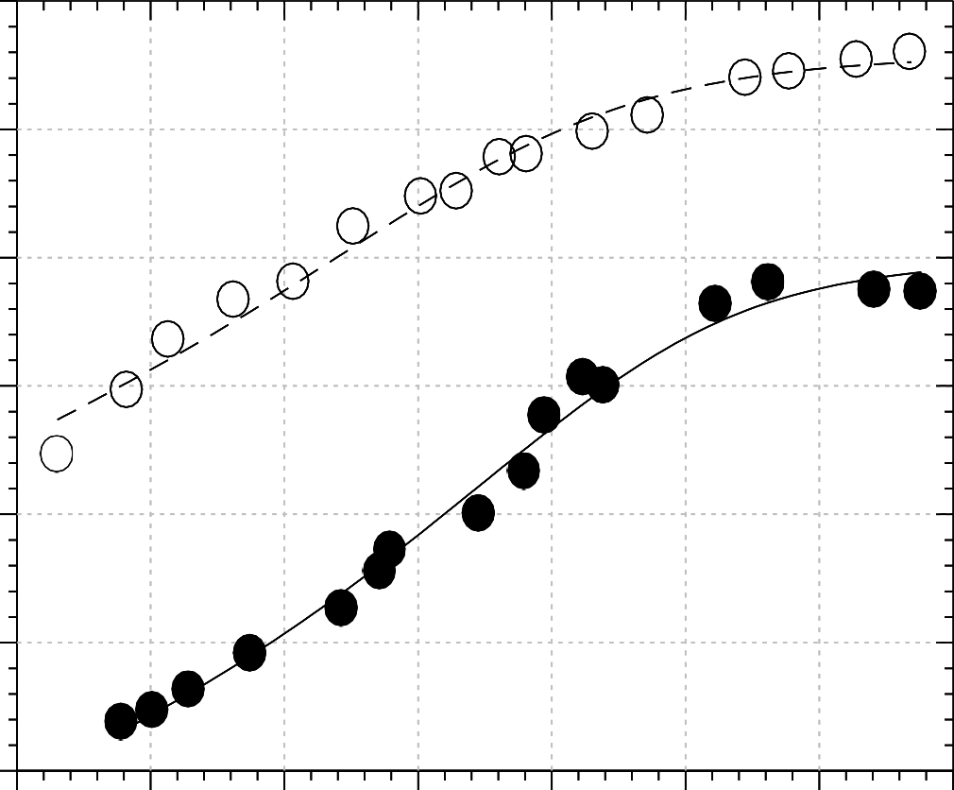
5.5 6.0 6.5 7.0 7.5 8.0 8.5 9.0

pH

Figure 4.56: Effect of inositol-P₆ on the equilibrium constant for the reaction of 5,5′- dithiobis(2-nitrobenzoate) with CysF9[93]ß of the minor cat oxyhaemoglobin.
Open circles, stripped haemoglobin (Okonjo and Fodeke, 2006); filled circles, haemoglobin + inositol-P₆.

3.0

2.0

1.0
-log10Kequ

0.0

-1.0

-2.0

-3.0

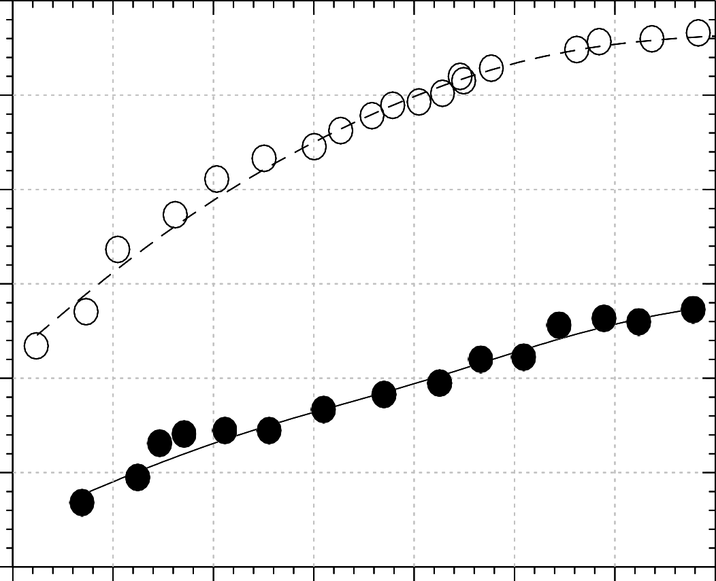
5.5 6.0 6.5 7.0 7.5 8.0 8.5 9.0

pH

Figure 4.57: Effect of inositol-P₆ on the equilibrium constant for the reaction of 5,5′- dithiobis(2-nitrobenzoate) with CysF9[93]ß of the minor cat carbonmonoxyhaemoglobin.
Open circles, stripped haemoglobin (Okonjo and Fodeke, 2006); filled circles, haemoglobin + inositol-P₆.

3.0

2.0


1.0

0.0
-log10Kequ

-1.0

-2.0

-3.0

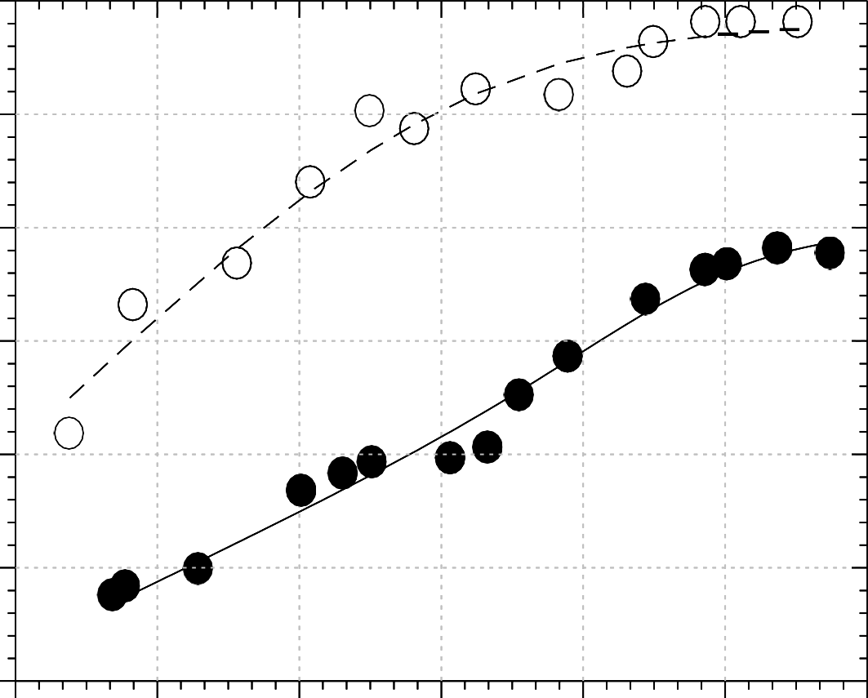
5.5 6.1 6.7 7.3 7.9 8.5 9.1

pH

Figure 4.58: Effect of inositol-P₆ on the equilibrium constant for the reaction of 5,5′- dithiobis(2- nitrobenzoate) with CysF9[93]ß of the minor cat aquomethaemoglobin. Open circles, stripped haemoglobin (Okonjo and Fodeke, 2006); filled circles, haemoglobin + inositol-P₆.

4.2.8 QUANTITATIVE ANALYSES OF THE pH DEPENDENCE PROFILES OF –log₁₀K_{equ}

Scheme II was used to analyse the strong pH dependences of the reaction of derivatives of cat haemoglobin in the presence of inositol-P₆ reported in Figures 4.47 –
4.52. The data were fitted with Eq. 4.31. The best-fit parameters were obtained with a value of n = 2 and are reported in Tables 4.16 and 4.18. [The curve-fitting programme was written on a MicroMath Scientist software (Appendix G3)].
As it was in the kinetic studies, previous data reported by Okonjo et al. (2006), on the reaction of DTNB with the CysF9[93]β sulphydryl of the stripped derivatives of cat haemoglobins, were fitted with a Scheme that did not consider the tertiary structure transition constant, K_{rt}. We have therefore refitted this previous data with Scheme II. The best-fit parameters are reported in Tables 4.17 and 4.19.
The parameters that account for the difference in the affinities of the stripped haemoglobins and haemoglobin in the presence of inositol-P₆ are reported in Tables 4.20 – 4.27.

Table 4.16: Reaction of 5,5′-dithiobis(2-nitrobenzoate) with the CysF9[93]β sulphydryl groups of derivatives of the major cat haemoglobin in the presence of inositol-P₆. Best-fit parameters used to fit the equilibrium data reported in Figures
4.46 – 4.48 using Scheme II and Eq. 4.31, for n = 2.

Paramters | Major Cat Haemoglobin Derivatives (+ inositol-P₆) |  |  | Mean
 | Oxy | Carbonmonoxy | Aquomet
pQ_{1r} | 5.54 | 5.73 | 7.35 | 6.20 ± 0.6
pQ_{1t} | 8.36 | 6.15 | 7.30 | 7.27 ± 0.7
pQ_{2r} | 6.95 | 6.79 | 8.03 | 7.26 ± 0.4
pQ_{2t} | 7.60 | 8.12 | 8.90 | 8.21 ± 0.4
KE3/ KE2 | 0.073 | 0.014 | 0.64 | -
KE3/ KE1 | 0.0022 | 0.0023 | 0.0022 | -
-log₁₀K_{E3} | 0.99 | 0.60 | 0.15 | -
Krt3 | 1.14 | 1.56 | 2.44 | 1.23 ± 0.2

Table 4.17: Best-fit parameters used to fit the equilibrium data (Okonjo et al., 2006) for the reaction of 5,5′-dithiobis(2-nitrobenzoate) with the CysF9[93]β sulphydryl groups of derivatives of stripped major cat haemoglobin.

Paramters | Stripped Major Cat Haemoglobin Derivatives |  |  | Mean
 | Oxy | Carbonmonoxy | Aquomet
pQ_{1r} | 7.20 | 5.65 | 6.59 | 6.48 ± 0.5
pQ_{1t} | 6.66 | 7.79 | 8.34 | 7.60 ± 0.6
pQ_{2r} | 7.76 | 6.01 | 6.90 | 6.89 ± 0.6
pQ_{2t} | 8.82 | 8.97 | 8.78 | 8.86 ± 0.06
KE3/ KE2 | 0.0009 | 0.093 | 0.97 | -
KE3/ KE1 | 0.0002 | 9.5 × 10⁻⁶ | 0.0001 | -
-log₁₀K_{E3} | 3.06 | 3.19 | 3.03 | -
Krt3 | 0.33 | 0.082 | 0.15 | 0.19 ± 0.08

Table 4.18: Reaction of 5,5′-dithiobis(2-nitrobenzoate) with the CysF9[93]β sulphydryl groups of derivatives of the minor cat haemoglobin in the presence of inositol-P₆. Best-fit parameters used to fit the equilibrium data reported in Figures
4.50 – 4.52 using Scheme II and Eq. 4.31, for n = 2.

Paramters | Minor Cat Haemoglobin Derivatives (+ inositol-P₆) |  |  | Mean
 | Oxy | Carbonmonoxy | Aquomet
pQ_{1r} | 6.82 | 6.07 | 8.53 | 7.14 ± 0.8
pQ_{1t} | 8.19 | 6.88 | 8.63 | 7.90 ± 0.6
pQ_{2r} | 8.19 | 8.31 | 8.23 | 8.24
pQ_{2t} | 8.03 | 8.58 | 8.45 | 8.35 ± 0.2
KE3/ KE2 | 0.07 | 0.42 | 0.91 | -
KE3/ KE1 | 0.007 | 0.063 | 0.0001 | -
-log₁₀K_{E3} | 1.03 | -0.34 | 0.92 | -
Krt3 | 2.91 | 1.40 | 1.34 | 1.88 ± 0.5

Table 4.19: Best-fit parameters used to fit the equilibrium data (Okonjo et al., 2006) for the reaction of 5,5′-dithiobis(2-nitrobenzoate) with the CysF9[93]β sulphydryl groups of derivatives of stripped minor cat haemoglobin.

Paramters | Minor Cat Haemoglobin Derivatives |  |  | Mean
 | Oxy | Carbonmonoxy | Aquomet
pQ_{1r} | 5.52 | 6.99 | 4.98 | 5.83 ± 0.3
pQ_{1t} | 7.39 | 5.95 | 7.00 | 6.78 ± 0.4
pQ_{2r} | 7.50 | 7.14 | 7.11 | 7.25 ± 0.1
pQ_{2t} | 8.22 | 8.44 | 8.75 | 8.47 ± 0.2
KE3/ KE2 | 0.13 | 0.0001 | 9.97 × 10⁻⁵ | -
KE3/ KE1 | 0.005 | 0.0002 | 1.00× 10⁻⁷ | -
-log₁₀K_{E3} | 2.54 | 2.52 | 2.82 | -
Krt3 | 0.32 | 0.40 | 0.10 | 0.27 ± 0.1

Table 4.20: Reaction of DTNB with CysF9[93]β of stripped major cat haemoglobin: Tertiary conformation transition constants, K_{rti} (i = 1, 2, 3) for the haemoglobin species H₂PS.ST, HPS.ST and PS.ST, respectively. Compare with Scheme Ia for n = 2. The numbers in brackets are the percentage t isomer populations.

Haemoglobin Species | Transition constant | Stripped major cat haemoglobin derivatives
 |  | Oxy | Carbonmonoxy | Aquomet
H₂PS.ST | Krt1 | 1.096  (52.3%) | 10,323  (100%) | 656.9  (99.8%)
HPS.ST | Krt2 | 3.800  (79.2%) | 74.8  (98.7%) | 11.7  (92.1%)
PS.ST | Krt3 | 0.331  (24.9%) | 0.082  (7.58%) | 0.154  (13.34%)

Table 4.21: Reaction of CysF9[93]β of DTNB with major cat haemoglobin in the presence of inositol-P₆: Tertiary conformation transition constants, K_{rti} (i = 1, 2, 3) for the haemoglobin species H₂PS.ST, HPS.ST and PS.ST, respectively. Compare with Scheme Ia for n = 2. The numbers in brackets are the percentage t isomer populations.

Haemoglobin Species | Transition constant | Major cat haemoglobin derivatives + inositol-P₆
 |  | Oxy | Carbonmonoxy | Aquomet
H₂PS.ST | Krt1 | 3,364  (100%) | 87.72  (98.9%) | 33.7  (97.1%)
HPS.ST | Krt2 | 5.092  (83.4%) | 33.35  (97.1%) | 18.1  (94.8%)
PS.ST | Krt3 | 1.14  (53.3%) | 1.56  (60.9%) | 2.44  (70.9%)

Table 4.22: Reaction of CysF9[93]β of DTNB with stripped minor cat haemoglobin: Tertiary conformation transition constants, K_{rti} (i = 1, 2, 3) for the haemoglobin species H₂PS.ST, HPS.ST and PS.ST, respectively. Compare with Scheme Ia for n = 2. The numbers in brackets are the percentage t isomer populations.

Haemoglobin Species | Transition constant | Stripped minor cat haemoglobin derivatives
 |  | Oxy | Carbonmonoxy | Aquomet
H₂PS.ST | Krt1 | 124  (99.2%) | 0.728  (42.1%) | 461.7  (99.8%)
HPS.ST | Krt2 | 1.68  (62.7%) | 7.981  (88.9%) | 4.41  (81.5%)
PS.ST | Krt3 | 0.32  (24.2%) | 0.40  (28.6%) | 0.10  (9.09%)

Table 4.23: Reaction of CysF9[93]β of DTNB with minor cat haemoglobin in the presence of inositol-P₆: Tertiary conformation transition constants, K_{rti} (i = 1, 2, 3) for the haemoglobin species H₂PS.ST, HPS.ST and PS.ST, respectively. Compare with Scheme Ia for n = 2. The numbers in brackets are the percentage t isomer populations.

Haemoglobin Species | Transition constant | Minor cat haemoglobin derivatives + inositol-P₆
 |  | Oxy | Carbonmonoxy | Aquomet
H₂PS.ST | Krt1 | 47.2  (97.9%) | 16.8  (94.4%) | 2.80  (73.7%)
HPS.ST | Krt2 | 2.01  (66.8%) | 2.61  (72.3%) | 2.22  (69%)
PS.ST | Krt3 | 2.91  (74.4%) | 1.40  (58.3%) | 1.34  (57.3%)

Table 4.24: Reaction of CysF9[93]β of DTNB with stripped major cat haemoglobin: Equilibrium constants, K_{Ei} (i = 1, 2, 3), for the reaction of DTNB with the haemoglobin species H₂PS⁻, HPS⁻ and PS⁻, respectively. Compare with Scheme II for n
= 2.

Haemoglobin Species | Equilibrium constant | Stripped major cat haemoglobin derivatives
 |  | Oxy | Carbonmonoxy | Aquomet
H₂PS.ST | KE1 | 4.35 | 68 | 9.33
HPS.ST | KE2 | 1.0 | 0.007 | 0.00096
PS.ST | KE3 | 0.0009 | 0.0006 | 0.00093

Table 4.25: Reaction of CysF9[93]β of DTNB with major cat haemoglobin + inositol-P₆: Equilibrium constants, K_{Ei} (i = 1, 2, 3), for the reaction of DTNB with the haemoglobin species H₂PS⁻, HPS⁻ and PS⁻, respectively. Compare with Scheme II for n
= 2.

Haemoglobin Species | Equilibrium constant | Major cat haemoglobin derivatives + inositol-P₆
 |  | Oxy | Carbonmonoxy | Aquomet
H₂PS.ST | KE1 | 46.5 | 109.2 | 321.8
HPS.ST | KE2 | 1.40 | 17.9 | 1.11
PS.ST | KE3 | 0.10 | 0.25 | 0.71

Table 4.26: Reaction of CysF9[93]β of DTNB with stripped minor cat haemoglobin: Equilibrium constants, K_{Ei} (i = 1, 2, 3), for the reaction of DTNB with the haemoglobin species H₂PS⁻, HPS⁻ and PS⁻, respectively. Compare with Scheme II for n
= 2.

Haemoglobin Species | Equilibrium constant | Stripped minor cat haemoglobin derivatives
 |  | Oxy | Carbonmonoxy | Aquomet
H₂PS.ST | KE1 | 0.58 | 15.1 | 15,136
HPS.ST | KE2 | 0.022 | 30.0 | 15
PS.ST | KE3 | 0.0029 | 0.003 | 0.0015

Table 4.27: Reaction of CysF9[93]β of DTNB with minor cat haemoglobin + inositol-P₆: Equilibrium constants, K_{Ei} (i = 1, 2, 3), for the reaction of DTNB with the haemoglobin species H₂PS⁻, HPS⁻ and PS⁻, respectively. Compare with Scheme II for n
= 2.

Haemoglobin Species | Equilibrium Constant | Stripped minor cat haemoglobin derivatives
 |  | Oxy | Carbonmonoxy | Aquomet
H₂PS.ST | KE1 | 13.33 | 34.7 | 1202
HPS.ST | KE2 | 1.33 | 5.21 | 0.13
PS.ST | KE3 | 0.093 | 2.19 | 0.12

CHAPTER FIVE DISCUSSION

HUMAN HAEMOGLOBIN

KINETICS
      - Reversibility of the reaction of DTNB with human haemoglobin

Studies of the kinetics of the reaction of the CysF9[93]β sulphydryl group of some animal haemoglobins with DTNB have revealed that this reaction is reversible for stripped haemoglobin and for haemoglobin in the presence of inositol-P₆: Plots of k_{obs}, the pseudo-first order rate constant, against the DTNB concentration are linear, with non-zero intercepts (Okonjo and Fodeke, 2006; Okonjo et al, 2010; Adebayo, 2010; Ajaelu, 2012; Atolaiye, 2012). From the linear plots of k_{obs} against varying concentrations of DTNB (Figures 4.11 - 4.12, pages 106-107), we have demonstrated in this thesis that the reaction of DTNB with stripped human oxyhaemoglobin A is reversible. The plots have significant positive intercepts within the pH range 5.6 - 9.0. Addition of inositol-P₆ does not abolish the reversibility of the reaction (Figure 4.13 - 4.14, pages 108-109).
So far, it has been demonstrated that the reaction of DTNB with the CysF9[93]β sulphydryl of haemoglobins in the R quaternary state is reversible. It is necessary to test the reversibility of this reaction in the T quaternary state. We have therefore used human deoxyhaemoglobin A for this purpose. Figure 4.27 (page 126), shows that the plot of k_{obs} against [DTNB] is linear and has a positive intercept. This demonstrates that the reaction of CysF9[93]β of deoxyhaemoglobin with DTNB is a reversible process. Consequently, it can now be concluded that the reaction of DTNB with the CysF9[93]β sulphydryl groups of haemoglobins, whether in the T or R state, is reversible.

Comparison of the rates of reaction of oxy- and deoxyhaemoglobin

Figure 4.59 (a) below shows the kinetic trace for the reaction of DTNB with human oxyhaemoglobin A at pH 9.00. Figure 4.59 (b) shows the corresponding trace for deoxyhaemoglobin under the same experimental conditions. It is clearly seen that the former reaction is faster than the latter. The time frame for the oxyhaemoglobin reaction is 1,000 seconds, while that of the deoxyhaemoglobin reaction is 8,000 seconds. Figure 4.28 (page 127) corroborates this result. The reason for this slower rate of the deoxy reaction is because, in the T state, the side chain of CysF9[93]β in human haemoglobin A is external; but it is screened by the imidazole group of HisHC3[146]β, which forms a salt bridge with the γ-carboxyl of AspFG1[94]β (Perutz, 1970). This makes it „slightly‟ inaccessible to sulphydryl reagents. Hence, in the T state, CysF9[93]β has a low reactivity. In the R state, this salt-bridge is broken and the reaction of CysF9[93]β becomes faster. The kinetic traces for deoxyhaemoglobin in Figures 4.21 – 4.23 (pages 118-120) compared to the corresponding traces for oxyhaemoglobin in Figures 4.1 – 4.3 (pages 93-95) further buttress this point.

Effect of pH on k_{F}

Attempts to do a full pH dependence kinetic study of the reaction of DTNB with deoxyhaemoglobin were not successful because the reaction was too slow (see Figure 4.59b), requiring more than 2 hours for a single kinetic run. Since the reaction required a continuous flow of N₂ gas, the experiment was discontinued to prevent wastage of the gas. It was only at pH 8 that the reaction was fast enough for k_{obs}, and subsequently k_{F}, to be determined.
In the reaction of DTNB with stripped oxyhaemoglobin, a bell-shaped pH- dependence profile was obtained for k_{F} (Figure 4.15, page 111). This changed to a simple profile upon the addition of inositol-P₆ (Figure 4.16, page 112). As shown in Figure 4.17 (page 113), the reaction of stripped human oxyhaemoglobin A is not always faster than the same reaction in the presence of inositol-P₆. It is seen that at high pH inositol-P₆ increases the reactivity, and at low pH the reactivity is the same as for stripped haemoglobin. We conclude that the assumption that inositol-P₆ reduces the reactivity of CysF9[93]β is not strictly correct for human haemoglobin; it is only correct in the physiological pH range.

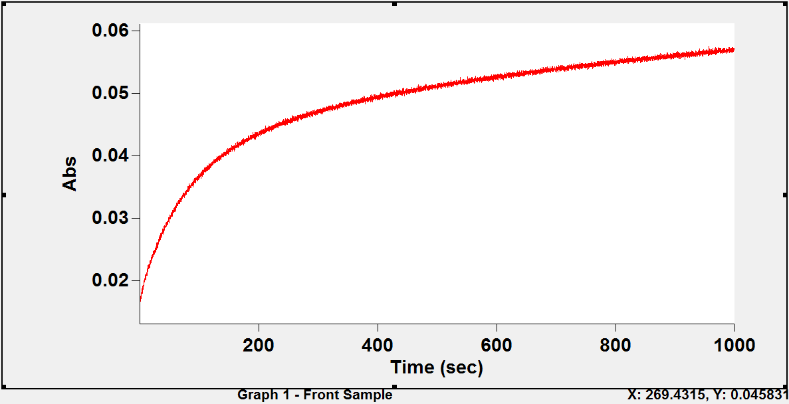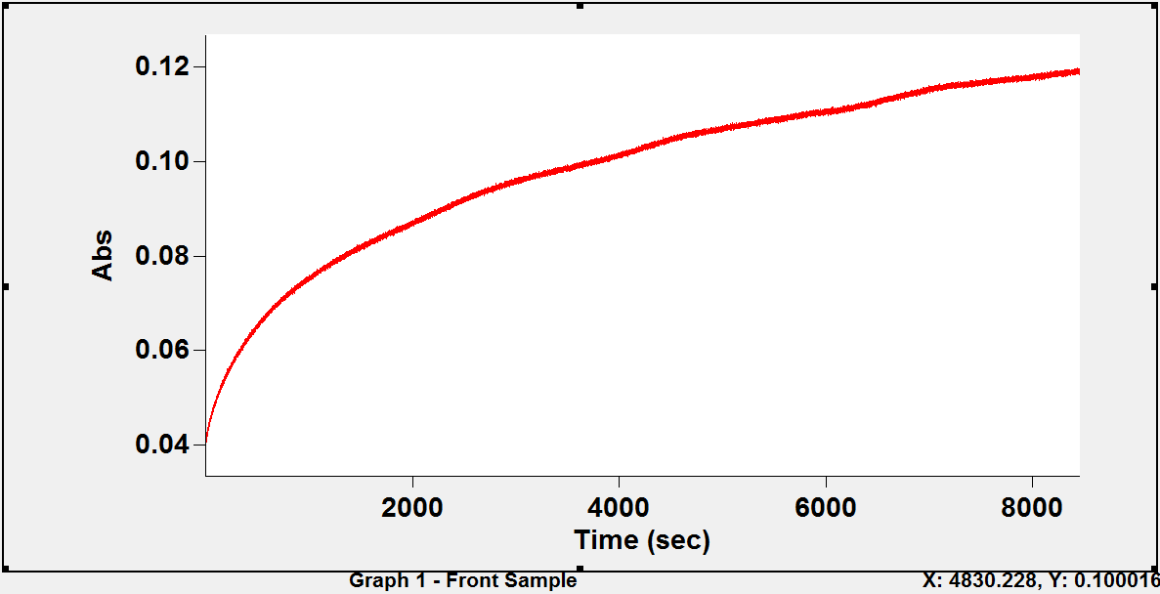(a)

(b)

Figure 4.59: Typical kinetic traces for the reaction of 5,5'-dithiobis(2-nitrobenzoate) with the sulphydryl groups of stripped human haemoglobin (a) oxy (b) deoxy .
Conditions: 25°C; borate buffer pH 9.00 (ionic strength 50 mmol dm⁻³, added salt, NaCl); haemoglobin concentration, 10 µmol (haem) dm⁻³ (5 µmol dm⁻³ in reactive sulphydryl groups); [DTNB] = 100 µmol dm⁻³.

EQUILIBRIUM STUDIES
      - Comparison of the affinities of deoxy- and oxyhaemoglobin for ligands

In haemoglobin studies the T quaternary state is associated with deoxyhaemoglobin and the R quaternary state with oxyhaemoglobin. Figure 4.46 (page 163) shows that the affinity of deoxyhaemoglobin for DTNB is different from that of oxyhaemoglobin. This result is in line with the Monod-Wyman-Changeux (MWC) model, which states that the affinities of the R and T quaternary states for a ligand are different. However, the model also states that the R-state has a higher affinity for a ligand than the T-state. It is seen that with DTNB as the ligand this is not the case. Rather, the T-state has a higher affinity than the R-state.
In Table 4.7 (page 168) the pQ values reported for the haemoglobin species in the R-state are higher than those for the same species in the T-state. So, with DTNB as ligand, the R-state has a higher affinity for protons than the T-state. This finding is reminiscent of the alkaline Bohr effect arising from oxygen binding to deoxyhaemoglobin. In this latter case, however, the T-state has a higher affinity for protons than the R-state.
The MWC model stipulates that the intrinsic affinities of the R and T states for a ligand cannot be changed by an allosteric effector. According to this model, any change in affinity caused by an allosteric effector can only arise from an effector- induced redistribution of the relative populations of the R and T quaternary states. In the case of oxygen binding to haemoglobin, this has been shown to be incorrect and several laboratories have reported that allosteric effectors lower the intrinsic affinities of the R- and of the T-state (Goodford et al., 1977; Lalezari et al., 1990; Shibayama et al., 2002; Yokoyama et al., 2006). Although it has been suggested that effector- induced tertiary structure transitions might be responsible for the lowering of the oxygen affinity of haemoglobin, there is no direct experimental proof of this. This is because both tertiary and quaternary structure transitions occur together in the oxygen binding system.
By using DTNB as ligand to the CysF9[93]β sulphydryl group of T-state and R-state haemoglobin, it is possible to eliminate any complication arising from the
R   T quaternary transition. Table 4.8 (page 170) shows that the tertiary transition
equilibrium constants K_{rt1} and K_{rt2} and the corresponding t isomer populations calculated from them are practically the same for species H₂PS.ST and HPS.ST of deoxy- and oxyhaemoglobin. However, the t population of PS.ST is higher for

deoxyhaemoglobin by 14%. This cannot suffice to explain the difference in affinities seen in Figure 4.46. Table 4.9 (page 171) shows that the equilibrium constants K_{E1}, K_{E2} and K_{E3} for the reaction of species H₂PS⁻, HPS⁻ and PS⁻ with DTNB are all higher for deoxyhaemoglobin. These may account for the difference in affinities seen in Figure 4.46, but not fully. A complete accounting will require, in addition, a calculation of the relative populations of the species H₂PS⁻, HPS⁻ and PS⁻ in deoxy- and oxyhaemoglobin.
Although the data are limited, nevertheless it is clear from Figure 4.45 (page 162) that the addition of inositol-P₆ to deoxyhaemoglobin increases the affinity of CysF9[93]β for DTNB in the T-state. An increase in the affinity of the CysF9[93]β sulphydryl group for DTNB usually leads to an increase in K_{rt}. This has been found to be true for human haemoglobin in the R quaternary state (Okonjo et al., unpublished). It is therefore expected that the value of K_{rt} for the reaction of DTNB with human deoxyhaemoglobin will increase in the presence of inositol-P₆.
The reaction of haemoglobin with DTNB and the effect of inositol-P₆ on it seem to be the antithesis of the reaction of haemoglobin with oxygen and the effect of inositol-P₆ on it:
- In the DTNB reaction, the T-state has a higher affinity for the ligand (DTNB) than the R-state, whereas in the oxygen binding reaction the T-state has a lower affinity for the ligand (oxygen).
- In the DTNB reaction the pK_{a}s of linked groups are higher in the R-state than in the T-state (Table 4.13) whereas in the oxygen reaction the pK_{a}s of the linked groups are lower in the R-state than in the T-state (the alkaline Bohr effect).

CAT HAEMOGLOBIN

KINETICS

Effect of inositol-P₆ on k_{F}

Fodeke (2005) found that inositol-P₆ increases the rate of the reaction of DTNB with the CysF9[93]β sulphydryl group of cat major and minor haemoglobins. Since this result is contrary to previous results on the effect of inositol-P₆ on other haemoglobins (Gray and Gibson, 1971; Okonjo, 1980; Okonjo and Nwozo, 1997), it seemed necessary to check out Fodeke‟s findings.
We were able to confirm Fodeke‟s results. In addition, since he did not check the effect of inositol-P₆ on the minor cat oxyhaemoglobin, we decided to check this out also. Figure 4.43 (page 150) shows that the reaction of the minor cat oxyhaemoglobin with DTNB is faster in the presence of inositol-P₆ throughout the experimemtal pH range. This result is the reverse of what was obtained for human oxyhaemoglobin where the addition of inositol-P₆ reduced the reactivity through most of the experimental pH range (see Figure 4.17, page 113). The increased reactivity of the cat haemoglobins in the presence of inositol-P₆ is most likely linked to mutations at their organic phosphate binding sites. In the minor (and also the major) cat haemoglobin, HisNA2[2]β of human haemoglobin is substituted with PheNA2[2]β. In addition to this, the minor cat haemoglobin has a serine at the NA1[1]β position, and the terminal amino group of SerNA1[1]β is acetylated.

EQUILIBRIUM STUDIES

Effect of inositol-P₆ on the pH dependence of K_{equ}

All the three derivatives of the major and minor cat haemglobins exhibit strong pH dependences in their reaction with DTNB for both stripped and in the presence of inositol-P₆ (Figures 4.47 – 4.52; pages 176-184). Tables 4.20 – 4.23 (pages 197-200) show that K_{rt3} (and the corresponding t population) is higher in the presence of inositol-P₆ than for the stripped derivatives. Tables 4.24 – 4.27 (pages 201-204) show that the equilibrium constants K_{E1}, K_{E2} and K_{E3} for the reaction of species H₂PS⁻, HPS⁻ and PS⁻ with DTNB are all higher in the presence of inositol-P₆, except for the minor aquomethaemoglobin,. These account mostly for the increase observed in the affinity of inositol-bound haemoglobin (cf stripped haemoglobin: Figures 4.47 – 4.52, pages 176-184). These results are very interesting, especially when compared to those

obtained for quail haemoglobin which has more organic phosphate binding sites (Okonjo et al., 2008; Appendix F, Figures F1.3 – F1.4, pages 270-271). It is seen in the figures that addition of inositol-P₆ does not significantly affect the values of K_{equ}. The quail results seem to be a feature found in avian haemoglobins that still needs to be understood.

CHAPTER SIX CONCLUSION AND RECOMMENDATION

CONCLUSION
The results described in this thesis clearly demonstrate that the reaction of human deoxyhaemoglobin A with DTNB is a reversible process. Since deoxyhaemoglobin exists in the T quaternary state, this is the first demonstration that the DTNB reaction with T-state haemoglobin is a reversible process. Consequently, it can be concluded that haemoglobin reacts with DTNB reversibly, irrespective of its quaternary structure.
Surprisingly, the results also demonstrate that deoxyhaemoglobin has a higher affinity for DTNB than oxyhaemoglobin, and that the allosteric effector inositol-P₆ increases the affinities of both for DTNB. Furthermore, the affinity of (R quaternary state) oxyhaemoglobin for protons is higher than the affinity of (T quaternary state) deoxyhaemoglobin. These results make the DTNB reaction the antithesis of the oxygen binding reaction.
The experiments on the cat haemoglobins were carried out to check the validity of the results previously reported by Fodeke, that inositol-P₆ increases the rate of the DTNB reaction. These surprising results have been confirmed in this thesis and an explanation has been provided for them at the molecular level in terms of changes of some of the amino acid residues at the inositol-P₆ binding site of the cat haemoglobins compared with human haemoglobin.

RECOMMENDATION
The reaction of DTNB with human haemoglobin (oxy or deoxy) gives rise to the appearance of an intense absorbance peak at 330 nm in both the oxy and deoxy spectra. This is a new phenomenon that has not been reported previously. It is recommended that the origin of this peak should be investigated.

REFERENCES

Abbasi, A., and Braunitzer, G. 1985. The primary structure of hemoglobins from domestic cat (Felis catus, Felidae). Biological Chemistry Hoppe Seyler 366(8): 699-704.
Aboluwoye, C. O. 1990. Effect of electrostatically linked ionizable groups on the sulphydryl reactivities of haemoglobins. Ph.D thesis, University of Ibadan.
Adair, G. S. 1925. A critical study of the direct method of measuring the osmotic pressure of haemoglobin. Proceedings of the Royal Society, London. A(108): 172-218.
Adebayo, M. A. 2010. Equilibrium and kinetic studies of the reaction of 5,5'- dithiobis(2-nitrobenzoate) with the haemoglobins of guinea fowl (Numida meleagris). PhD thesis. University of Ibadan.
Adediji, T. A. 2007. Effect of inositol hexakisphosphate on the equilibrium constant for the reaction of 5,5'-dithiobis(2-nitrobenzoate) with human oxyhaemoglobin A. Unpublished work. University of Ibadan.
Ajaelu, C. J. 2012. Kinetics and equilibrium studies of the reaction of 5,5'-dithiobis(2- nitrobenzoate) with goat (Capra hircus) haemoglobin. PhD thesis. University of Ibadan.
Amiconi, G., Antonini, E., Brunori, M., Nason, A. and Wyman, J. 1971. Functional properties of human hemoglobin treated with 5, 5'-Dithiobis, 3,3'-nitrobenzoic acid. European Journal of Biochemistry 22(3): 321-326.
Anfinsen, C. B. 1973. Principles that govern the folding of protein chains. Science, 181: 223-230.
Antonini, E. 1967. Hemoglobin and its reaction with ligands. Science 158: 1417-1425 Antonini, E. and Brunori, M. 1969. The rate of conformation change associated with
ligand binding in haemoglobin. Journal of Biological Chemistry 244: 3909- 3912.
Antonini, E. and Brunori, M. 1971. Haemoglobin and myoglobin in their reactions with ligands. North-Holland Publishing Company, Amsterdam, London Frontiers of Biology 21:55-95.
Arnone, A. 1972. X-ray diffraction study of binding of 2,3-diphosphoglycerate to human deoxyhaemoglobin. Nature 237: 146-149.

Arnone, A. and Perutz, M. F. 1974. Structure of inositol hexaphosphate–human deoxyhaemoglobin complex. Nature 249: 34-36.
Atolaiye, B. O. 2012. Kinetic and Equilibrium studies of the reaction of 5,5'- dithiobis(2- nitrobenzoate) with haemoglobins of dog and donkey. PhD thesis. University of Ibadan.
Austin, J. H. and Drabkin, D. L. 1935. Spectrophotometric studies III: Methaemoglobin. Journal of Biological Chemistry 112: 67-88.
Bailey, J. E., Beetlestone, J. G. and Irvine, D. H. 1970. Reactivity differences between haemoglobins, Part XVII: The variability of the Bohr effect between species and the effect of 2,3-diphosphoglyceric acid on the Bohr effect. Journal of the Chemical Society. 1273(9): 756-762.
Baldwin, J. M. 1975. Structure and function of haemoglobin. Progress in Biophysics and Molecular Biology 29(3): 225-320.
Baldwin, J. and Chothia, C. 1979. Haemoglobin: the structural changes related to ligand binding and its allosteric mechanism. Journal of Molecular Biology 129: 175-220.
Bazan, J. F. and Fletterick, R. J. 1988. Viral cysteine proteases are homologous to the trypsin-like family of serine proteases: Structural and functional implications. Proceedings of the National Academy of Sciences, USA 85: 7872–7876.
Beetlestone, J. G. Haemoglobin laboratory procedures, Biophysical Research Laboratory, Chemistry Department, University of Ibadan.
Bello, O. S. 2008. Equilibrium and kinetic parameters of the reaction of 5,5′- dithiobis(2-nitrobenzoate) with the sulphydryl groups of the haemoglobins of the quail (Cortunix cortunix japonica). Ph.D Thesis. University of Ibadan.
Benesch, R. and Benesch, R. E. 1957. Determination of sulphydryl and disulphide groups by specific proton displacement. Biochimica et Biophysica Acta 23: 643-644.
Benesch, R., Benesch, R.E. and Enoki, Y. 1968. The interaction of hemoglobin and its subunits with 2,3-diphosphoglycerate. Proceedings of the National Academy of Sciences 61(3): 1102–1106.
Benesch, R.E., Benesch, R. and Yu, C.I. 1968. Reciprocal binding of oxygen and diphosphoglycerate by human hemoglobin. Proceedings of the national academy of Science USA 59: 526-532.

Benesch, R.E., Benesch, R. and Yu, C.I. 1969. The oxygenation of hemoglobin in the presence of 2,3-diphosphoglycerate: Effect of temperature, pH, ionic strength and hemoglobin concentration. Biochemistry 8(6): 2567-2571.
Benesch, R. E., Benesch, R., Renthal, R. D. and Maeda, N. 1972. Affinity labeling of the polyphosphate binding site of hemoglobin. Biochemistry 11(19): 3575- 3585.
Bettati, S., Mozzarelli, A. and Perutz, M. F. 1983. Allosteric mechanism of haemoglobin; rupture of salt bridges raises the affinity of the T structure. Journal of Molecular Biology 281: 581 – 585.
Bohr, C., Hasselbalch, K.A. and Krogh, A. 1904. Concerning a Biologically Important Relationship - The influence of the carbon dioxide content of blood on its oxygen binding. Skandinavean Archives of Physiology 15: 401-412.
Boyer, P. D. 1954. Spectrophotometric study of the reaction of protein sulfhydryl groups with organic mercurials. Journal of the American Chemical Society 76: 4331-4337.
Boyer, S. H., Hathaway, P., Pascasio, F., Borbley, J. and Orton, C. 1966. Difference in amino acid sequences of tryptic peptides from three sheep hemoglobin β chains. The Journal of Biological Chemistry 242(9): 2211 – 2232.
Braunitzer, G., Helse, K., Rudloff, V. and Hilschmann, N. 1964. The haemoglobins.
Advances in Protein Chemistry 19: 1-71.
Brunori, M., Antonini, E., Wyman, J. and Anderson S. R. 1968. Spectral differences between haemoglobin and isolated haemoglobin chains in the deoxygenated state. Journal of Molecular Biology 34(2): 357-361.
Brunori, M., Coletta, M., Di Cera, M. 1986. A cooperative model for ligand-binding to biological macromolecules as applied to oxygen carriers. Biophysical Chemistry 23(3-4): 215-222.
Bunn, H. F. and Jandl, J. H. 1970. Control of haemoglobin function within the red cell.
New England Journal of Medicine 282: 1414-1421.
Bunn, H. F. and Guidotti, G. 1971.Stabilizing interactions in hemoglobin. Journal of Biological Chemistry 247: 2345-2350.
Champe, P. C., Harvey, R. A. and Ferrier, D. R. 1987. Lippincott‟s illustrated reviews: Biochemistry. 1st edition. Lippincott Williams & Wilkins pp 1-3.

Coletta, M., Ascenzi, P., Castagnola, M. and Giardina, B. 1995. Functional and spectroscopic evidence for a conformational transition in ferrous liganded human hemoglobin. Journal of Molecular Biology 249: 800-803.
Colowick, S. P. and Kaplan, N. O. 1954. Preparations of Buffers for use in enzyme studies. Methods in Enzymology. 1:
Creighton, T. E. 1990. Protein folding. Biochemical Journal. 270(1): 1-16. Creighton, T. E. 1993. Proteins, 2nd edition, W. H. Freeman & Co., New York.
Cui, Q. and Karplus, M. 2008. Allostery and cooperativity revisited. Protein Science
17: 1295-1307.
De Bruin, S. H., Rollema, Janssen, L. H. M. and Van Os, G. A. J. 1974. The interaction of chloride ions with human haemoglobin. Biochemical Biophysical Resource Communication 58: 210–215.
Dintzis, H. M. 1952. Dielectric properties of human mercaptalbumin. Ph.D Thesis, Harvard University.
Ellman, G. L. 1958. A colorimetric method for determining low concentrations of mercaptans. Archives of Biochemistry and Biophysics 74: 443-450.
Ellman, G. L. 1959. Tissue sulfhydryl groups. Archives of Biochemistry and Biophysics 82: 70-77.
Eyer, P., Worek, F., Kiderlen, D., Sinko, G., Stuglin, A., Simeon-Rudolf, V. and Reiner, E. 2003. Molar absorption coefficients for the reduced Ellman reagent:
reassessment. Analytical Biochemistry 312: 224-227.
Fermi, G. and Perutz, M. F. 1981. Haemoglobin and myoglobin. Oxford, United Kingdom.
Fermi, G., Perutz, M. F. and Shaanan, B. 1984. The crystal structure of human deoxyhaemoglobin at 1.74 Å resolution. Journal of Molecular Biology 175(2): 159-174.
Fodeke, A. A. 2005. Equilibrium and kinetics of the reaction of 5,5'-dithiobis-(2- nitrobenzoate) with the haemoglobins of domestic cat (Felis catus). PhD Thesis, University of Ibadan.
Garby, L., Gerber, G. and De Verdier, C. H. 1969. Binding of 2,3-diphosphoglycerate and adenosine triphosphate to human haemoglobin. European Journal of Biochemistry 10: 110-115.

Gray, R. D. and Gibson, Q. H. 1971. The effect of inositol hexaphosphate on the kinetics of CO and O₂ binding by human hemoglobin. Journal of Biological Chemistry 246: 7168-7174.
Green, D. W., Ingram, V. M. and Perutz, M. F. 1954. On the heavy atom isomorphous replacement method. Proceedings of the Royal Society of America 225: 287- 307
Go, Y-M. and Jones, D. P. 2005. Intracellular proatherogenic events and cell adhesion modulated by extracellular thiol/disulfide redox state. Circulation 111: 2973– 2980.
Goodford, P. J., Norrington, F. E., Paterson, R. A. and Wootton, R. 1977. The effect of 2,3-diphosphoglycerate on the oxygen dissociation curve of human haemoglobin. Journal of Physiology 273: 631–645.
Guidotti, G. 1965. The rates of the reaction of the sulfhydryl groups of human hemoglobin. Journal of Biological Chemistry 240: 3924-3927.
Hallaway, B. E., Hedlund, B. E. and Benson, E. S. 1980. Studies on the effect of reagent and protein charges on reactivity of the β93 sulfhydryl group of human hemoglobin using selected mutations. Archives of Biochemistry and Biophysics 203: 332–342.
Hasinoff, B. B., Madsen, N. B. and Avramovic-Ziki, C. O. 1971. Kinetics of the reaction of p-chloromercuri-mercaptoethanol and phosphorylase B. Canadian Journal of Biochemistry 49: 742-751.
Hellerman, L., Chinard, F.P. and Ramsdell, P.A. 1941. o-Iodosobenzoic acid, a reagent for the estimation of cysteine, glutathione and the substituent sulfhydryl groups of certain proteins. Journal of the American Chemical Society 63: 2551-2553.
Henry, E. R., Bettati, S., Hofrichter, J. and Eaton, W.A. 2002. A tertiary two-state allosteric model for haemoglobin. Biophysical Chemistry 98: 149-164.
Hughes, W. L. 1957. A physicochemical rationale for the biological activity of mercury and its compounds. Annals of The New York Academy of Sciences 65: 454-460.
Hughes, W. L. 1949. Protein mercaptides. Cold Spring Harbor Symposium of Quantitative Biology 14: 79-83.
Imai, K. 1982. Allosteric effects in haemoglobin. Cambridge University Press, England.

Imai, K., Tsuneshige, A. and Yonetani, T. 2002. Description of hemoglobin oxygenation under universal solution conditions by a global allostery model with a single adjustable parameter. Biophysical Chemistry 98: 79-91.
Ingar, S. H. and Kass, E. H. 1951. Sulfhydryl content of normal hemoglobin and hemoglobin in sickle cell anemia. Proceedings of the Society for Experimental Biology and Medicine 77: 74
Iwuagwu, S. L. 1973. The effect of anions on ligand binding to methaemoglobin. PhD thesis, University of Ibadan.
Iwuoha, E.I. and Okonjo, K.O. 1993. Role of the relaxation of the iron (II) ion spin states: equilibrium and kinetics of ligand binding to methaemoglobin. Journal of the Chemical Society 89 (21): 3921-3924.
Jakubowski, H. 2010. Model binding systems. UC Davis Biowiki.
Jocelyn, P.C. 1972. Assay of thiols and disulphides. Biochemistry of the SH group.
Academic Press, London. Chapter 6: 132-167.
Kampluis, I. G., Drenth, J., and Baker, E. N. 1985. Thiol proteases. Comparative studies based on the high-resolution structures of papain and actinidin, and on amino acid sequence information for cathepsins B and H, and stem bromelain. Journal of Molecular Biology 182: 317–329.
Kendrew, J. C. 1961. The three dimensional structure of a protein molecule. Scientific American 205: 96-110.
Kleinschmidt, T. and Sgouros, S. 1987. Haemoglobin sequences. Mini-review.
Biological Chemistry Hoppe-Seyler 368: 579-615.
Kortemme, T. and Creighton, T. E. 1995. Ionisation of cysteine residues at the termini of model α-helical peptides. Relevance to unusual thiol pK_{a} values in proteins of the thioredoxin family. Journal of Molecular Biology 253: 799–812.
Koshland, D.E. Jr., Nemethy, G. and Filmer, D. 1966. Comparison of experimental binding data and theoretical models in proteins containing subunits. Biochemistry 5: 365-385.
Laberge, M., Kovesi, I., Yonetani, T. and Fidy, J. 2005. R-state haemoglobin bound to heterotropic effectors: models of DPG, IHP and RSP13 binding sites. FEBS Letters 579: 627-632.
Lalezari, I., Lalezari, C., Poyart, M., Marden, J., Kister, B., Bohn, B., Fermi, G., and Perutz, M. F. 1990. New effectors of human hemoglobin: structure and function. Biochemistry 29: 1515-1523

Lehninger, A. L., Nelson, D. L. and Cox, M. M. 1993. Principles of Biochemistry 2nd edition. Worth, New York.
Lessard, J. L. and Taketa F. 1969. Multiple hemoglobins in fetal, newborn and adult cats. Biochimica et Biophysica Acta 175(2): 441-444
Majima, E., Koike, H., Hong, Y. M., Shinohara, Y. and Terada, H. 1993. Characterization of cysteine residue of mytochondrial ADP/ATP carrier with the SH-reagent eosine-5-maleimide and N-ethylmaleimide. The Journal of Biological Chemistry 268 (290): 22181-22187.
Mathewson, J.A. and Corwin, A.H. 1961. Biosynthesis of pyrrole pigments: A mechanism of porphibilinogen polymerization. A proposed mechanism for the most abundant natural isomer. Journal of the American Chemical Society 83: 135-137.
Means, G. E. and Feeney, R. E. 1971. Chemical modification of proteins Holden-Day Inc., San Francisco pp 217-220.
Minton, A. P and Imai, K. 1974. The three-state model: A minimal allosteric description of homotropic and heterotropic effects in the binding of ligands to hemoglobin. Proceedings of the National Academy of Science USA 71: 1418- 1421.
Mirsky, A. E. and Anson, M. L. 1936. Sulfhydryl and disulfide groups of proteins III: Sulfhydryl groups of native proteins- hemoglobin and the proteins of the crystalline lens. The Journal of General Physiology 19: 439-450.
Monod, J. and Jacob, F. 1961. Teleonomic mechanisms in cellular metabolism, growth and differentiation. Cold Spring Harbor Symposium on Quantitative Biology 26: 389-401.
Monod, J., Wyman, J. and Changeux, J.P. 1965. On the nature of allosteric transitions: a plausible model. Journal of Molecular Biology 12: 88-118.
Murray, R. K., Granner D. K. and Rodwell V. W. 2003; 2006. Harper‟s Illustrated Biochemistry, 26th and 27th Edition. McGraw Hill companies 14-17.
Neer, E. J., Konigsberg, W. and Guidotti, G. 1968. The interactions between α and β chains of human hemoglobin. The Journal of Biological Chemistry 243(8): 1971-1978.
Neer, E. J. 1970. The reactions of sulfhydryl groups of human hemoglobin β₄*. The Journal of Biological Chemistry 245(3): 564-569.

Nelson, D. L. and Cox, M. M. 2004. Lehninger principles of Biochemistry. 4th edition pp79, 116-156.
Nwozo, S. O. 1999. Influence of allosteric effectors on the reactivities of the F9[93]β and B5[23]β sulphydryl groups of chicken and pigeon hemoglobins. PhD thesis University of Ibadan.
Nwosu, C. 2004. BSc. Project. Department of Chemistry, University of Ibadan.
Okonjo, K. O. and Ilgenfritz, G. 1978. Temperature-jump studies on formate binding to methaemoglobin and metmyoglobin. Archives of Biochemistry and Biophysics 189 (2): 499-507.
---------------, Taiwo, A., Balogun, M. and Ekisola, O. B. 1979. Reactivities of the sulphydryl groups of dog haemoglobin. Biochimica et Biophysica Acta 576: 30-38.
---------------, 1980a. Effect of organic phosphates on the sulphydryl reactivities of oxyhemoglobins A and S. Journal of Biological Chemistry 255(8): 3274-3277.
---------------, 1980b. Kinetic and thermodynamic parameters of the iron spin-state transition in human aquomethaemoglobin. European Journal of Biochemistry. 105: 329-334.
---------------, Vega-Catalan, F. J. and Ubochi, C. I. 1989. Temperature-jump studies on haemoglobin: Kinetic evidence for a non-quaternary isomerization process in deoxy- and carbonmonoxyhaemoglobin. Journal of Molecular Biology 208: 347-354.
--------------- and Aboluwoye, C. O. 1992. Ionizable groups linked to the reaction of 2,2'-dithiobispyridine with haemoglobin. Biochimica et Biophysica Acta 1159: 303-310.
--------------- and Okia, T.O. 1993. Haemoglobins with multiple sulphydryl groups. The reaction of pigeon haemoglobin with 5, 5'- dithiobis(2-nitrobenzoate). Journal of Protein Chemistry 12 (5): 1-8.
---------------, Aboluwoye, C. O., Babalola J. O. and Usanga I. A. 1995. Organic phosphate binding groups electrostatically linked to the reactivity of CysF9[93]β sulphydryl group of haemoglobin. Journal of the Chemical Society (Faraday Transactions) 91: 2095-2100.
---------------, Aken‟ova, Y. A., Aboluwoye, C. O., Nwozo, S., Akhigbe, F. U., Babalola, J. O. and Babarinde, N. A. 1996. Effect of A3[6]β^{Glu→Val} mutation on

reactivity of CysF9[93]β sulphydryl group of human haemoglobin S.
Journal of the Chemical Society (Faraday Transactions) 92: 1739-1746.
--------------- and Nwozo, S. 1997. Ligand dependent reactivity of the CysB5[23]β sulphydryl group of the major haemoglobin of chicken. Journal of the Chemical Society (Faraday Transactions) 93: 1361-1366.
--------------- and Fodeke, A. A. 2006. Reversible reaction of 5,5´-dithiobis(2- nitrobenzoate) with the haemoglobins of the domestic cat: acetylation of NH₃⁺ terminal group of the β-chain transforms the complex pH-dependence of the forward apparent second order rate constant to a simple form. Biophysical Chemistry 119: 196-204.
---------------, Fodeke, A. A. and Kehinde, A. T. 2006. Reversible reaction of 5,5'- dithiobis(2-nitrobenzoate) with the CysF9[93]β sulphydryl groups of the haemoglobins of the domestic cat: Variation of the equilibrium and reverse rate constants with pH. Biophysical Chemistry 121: 65-73.
---------------, Adediji, T. A., Fodeke, A. A., Adeboye, A. and Ezeh, C. V. 2007. Transition of haemoglobin between two tertiary conformations: Determination of equilibrium and thermodynamic parameters from the reversible reaction of 5,5'-dithiobis(2-nitrobenzoate) with CysF9[93]β sulphydryl group. Biophysical Chemistry 128: 56-62.
---------------, Bello, O. S and Babalola, J. O. 2008. Transition of haemoglobin between two tertiary conformations: The transition constant differs significantly for the major and minor haemoglobins of the Japanese quail (Cortunix cortunix japonica). Biochimica et Biophysica Acta 1784: 464-471.
---------------, Adeogun, I. and Babalola, J. O. 2009. Transition of haemoglobin between two tertiary conformations: Inositol hexakisphosphate increases the transition constant and the affinity of sheep haemoglobin for 5,5´-dithiobis(2- nitrobenzoate). Biochimica et Biophysica Acta 1794: 398-409.
---------------, Adeogun, I. and Babalola, J. O. 2010. Tertiary conformational transition in sheep haemoglobins induced by reaction with 5,5´-dithiobis(2- nitrobenzoate) and by binding of inositol hexakisphosphate. Biophysical Chemistry 146: 65-75.
Pauling, L. 1935. The oxygen equilibrium of hemoglobin and its structural interpretation. Proceedings of the National Academy of Science 21: 181-191.

Pauling, L., Corey, R. B. and Branson, H. R. 1951. The structure of proteins; two hydrogen-bonded helical configuration of the polypeptide chain. Proceedings of the National Academy of Science USA 37(4): 205-211.
Pauling, L. and Corey, R. B. 1951. The pleated sheet, a new layer configuration of polypeptide chains. Proceedings of the National Academy of Science USA 37(5): 251-256.
Pauling, L. 1964. The architecture of molecules Proceedings of the National Academy of Science USA 51(5): 977-984.
Perrella, M. and Russo, R. 2003. Allosteric Proteins: Lessons to be learned from the hemoglobin intermediates. News of Physiology and Science 18: 232-236
Perutz, M. F. and Mitchison, J. M. 1950. State of haemoglobin in sickle cell anaemia.
Nature (London) 116: 677-679.
Perutz, M. F. 1964. The hemoglobin molecule. Scientific American 196: 64-76. Perutz, M. F. 1968. Preparation of haemoglobin crystals. Journal of Crystal Growth
2: 54-56.
--------------, Muirhead, H., Mazzarella, L., Crowther, R.A., Grier, J. and Kilmartin,
J.V. 1969. Identification of residues responsible for the alkaline Bohr effect in haemoglobin. Nature 222: 1240-1243.
--------------, 1970. Stereochemistry of cooperative effects in haemoglobin. Nature
228: 726-739.
--------------, Fersht, A. R., Simon, S. R., Roberts, G. C. K. 1974. Influence of globin structure on the state of the heme. II. Allosteric transitions in methemoglobin. Biohemistry 12(10): 2174-2186.
--------------, 1979. Regulation of the oxygen affinity of haemoglobin: Influence of the structure of globin on the haem. Annual Review of Biochemistry 48: 327-386.
-------------- and Imai, K. 1980. Regulation of oxygen affinity of mammalian hemoglobins. Journal of Molecular Biology 136: 183-191.
--------------, Bauer, C., Gros, G., Leclereq, F., Vandecasserie, C., Schnek, A. G., Braunitzer, G., Friday, A. E. and Joysey, K. A. 1983. Allosteric regulation of crocodilian haemoglobin. Nature 291: 682-684.
--------------,1983. Species adaptation in a protein molecule. Molecular Biology and Evolution 1: 1-28.

--------------, Fermi, G., Abraham, D. J., Poyart, C. and Bursaux, E. 1986. Hemoglobin as a receptor of drugs and peptides: X-rays studies of the stereochemistry of binding. Journal of American Chemical Society 108: 1064-1078.
--------------, Fermi, G, Luisi, B, Shaanan, B, Liddington, R. C. 1987. Stereochemistry of cooperative mechanisms in haemoglobin. Accounts of Chemical Research 20: 309–321.
Ploegman, J. H., Drent, G., Kalk, K. H. and Hol, W. G. J. 1979. The structure of bovine liver rhodanese. Journal of Molecular Biology 127: 149–162.
Provencher, S. W. 1976a. An eigenfunction expansion method for the analysis of exponential decay curves. Journal of Chemical Physics 64: 2772-2777.
Provencher, S. W. 1976b. A Fourier method for the analysis of exponential decay curves. Biophysical Journal 16: 27-41.
Riggs, A. F. 1952. Sulfhydryl groups and the interaction between the hemes in hemoglobin. The Journal of General Physiology 36(1): 1-16.
Riggs, A. F. and Wolbach, R. A. 1956. Sulfhydryl groups and the structure of haemoglobin. The Journal of General Physiology 39(4): 585-605.
Robyt, J. F., Ackerman, R. J. and Chittenden, C. G. 1971. Reaction of protein disulfide groups with Ellman‟s reagent: A Case study of the number of sulfhydryl and disulfide groups in aspergillus oryzea α-amylase, papain, and lysozyme. Archives of Biochemistry and Biophysics, 147: 262 – 269.
Ruud, J. T. 1954. Vertebrates without erythrocytes and blood pigments. Nature 173: 848-850.
Samuni, U., Roche, C. J., Dantsker, D, Juszczak, L. And Friedman, J. M. 2006. Modulation of reactivity and conformation within the T-quaternary state of human haemoglobin: The combined use of mutagenesis and sol-gel encapsulation. Biochemistry 45: 2820-2835.
Shibayama, N., Miura, S., Tame, J.R.H., Yonetani, T. and Park, S.Y. 2002. Crystal structure of horse carbonmonoxyhemoglobin-bezafibrate complex at 155 Å resolution, a novel allosteric binding site in R-state haemoglobin. Journal of Biological Chemistry 277: 1064-1078.
Simpson, R. B. 1961. Association constants of methylmercury with sulfhydryl and other bases. Journal of the American Chemical Society 83: 4711-4717.
Stricks ,W. and Kolthoff, M.1952. Reaction between mercuric mercury and cysteine and glutathione. Journal of the American Chernical Society. 75:5673 - 5681.

Stevenson, T. D., Mc Donald, B. L. and Roston, S. 1960. Colorimetric method for determination of erythrocyte glutathione. Journal of Laboratory and Clinical Medicine 56: 157-160.
Stryer, L. 2004. Biochemistry 6th Edition. W. H. Freeman & Company, New York.
48-54.
Szabo, A. and Karplus, M. 1972. A mathematical model for structure-function relations in haemoglobin. Journal of Molecular Biology 72: 163-197.
Taketa, F., Smits, M.R. and Lessard, J.L. 1968. Hemoglobin heterogeneity in cat.
Biochemical and Biophysical Research Communication 30(3): 219-225.
Taketa, F., Mauk, A.G. and Lessard, J.L. 1971. β chain amino termini of the cat hemoglobins and the response to 2,3-diphosphoglycerate and adenosine triphosphate. Journal of Biological Chemistry 246(14): 4471-4476.
Taylor, J. F., Antonini, E., Brunori, M. and Wyman, J. 1966. Studies on human haemoglobin treated with various sulfhydryl reagents. The Journal of Biological Chemistry 241: 241-248.
Tsuneshige, A., Park, S. and Yonetani T. 2002. Heterotropic effectors control the hemoglobin function by interacting with its T and R states: a new view on the principle of allostery. Biophysical Chemistry 98:49-63.
Tyuma, I., Imai, K. and Shimizu, K. 1973. Analysis of oxygen equilibrium of hemoglobin and control mechanism of organic phosphates. Biochemistry 12: 1491-1498.
Vandecassarie, C. A., Schnek, G. and Leonis, J. 1971. Oxygen affinity studies of avian haemoglobin. European Journal of Biochemistry 24: 284-287.
Watson, H. C. and Kendrew, J. C. 1961.Comparison between the amino acid sequences of sperm whale myoglobin and human haemoglobin. Nature 190: 670-672.
Weber, R. E. and White, F. N. 1986. Oxygen binding in alligator blood related to temperature, diving and alkaline tide. American Journal of Physiology 251: R901-908.
Weber, R. E. and White, F. N. 1994. Chloride-dependent organic phosphate sensitivity of the oxygenation reaction in crocodilian haemoglobins. Journal of Experimental Biology 192: 1-11.

Weed, R. I., Reed, C. F. and Berg, G. 1963. Is hemoglobin an essential structural component of human erythrocyte membranes? Journal of Clinical Investigations 42(4): 581-588.
Weidermann, B. L. and Olson, J. S. 1975. Acceleration of tetramer formation by the binding of IHP to haemoglobin dimmers. Journal of Biological Chemistry 250: 5273-5275.
Weiss, J. J. 1964. Nature of the iron-oxygen bond in oxyhaemoglobin. Nature 202: 83-84.
Wilson, J. M., Bayer, R. J. and Hupe, D. J. 1977. Structure-reactivity correlations for the thiol-disulphide interchange reaction Journal of the American Chemical Society99: 7922-7926.
Yamamoto, K. T. 1993. Photoreversible change in the conformation of phytochrome as probed with a covalently bound fluorescent sulphydryl reagent, N-(9- acridinyl)maleimide. Biochimica et Biophysica Acta 1163: 227-233.
Yokoyama, T., Neya, S., Tsuneshige, A, Yonetani, T., Park, S. Y. and Tame, J. R. 2006. R-state haemoglobin with low oxygen affinity: Crystal structures of deoxy human and carbonmonoxy horse haemoglobin bound to effector molecule L35. Journal of Molecular Biology 356: 790-801.
Yonetani, T., Park, Q. S., Tsuneshige, A., Imai, K. and Kanaori K. 2002. Global allostery model of hemoglobin: modulation of O₂-affinity, cooperativity, and Bohr effect by heterotropic allosteric effectors. Journal of Biological Chemistry 277: 34508–34520.
Zuazaga, C., Steinacker, A. and Castillo, J. 1984. The role of sulfhydryl and disulfide groups of membrane proteins in electrical conduction and chemical transmission. Puerto Rico Health Sciences Journal 3(3): 125-139.
Zwiderweg, E. R. P., Hammers, L. F., de Bruin, S. H. and Hilberg, C. W. 1981. Equilibrium aspects of the binding of myo-inositolhexakisphosphate to human haemoglobin as studied by ¹³P NMR and pH-stat technique European Journal of Biochemistry 118: 85-94

APPENDICES

APPENDIX A

Table A1: Data for Semi-logarithmic plot of the time course for the reaction 5,5'- dithiobis(2-nitrobenzoate) with stripped human oxyhaemoglobin A sulphydryl groups at 25°C and 412nm; k_{obs} = 0.012 (± 0.00006) s⁻¹.
Conditions: phosphate buffer pH 6.59, (ionic strength 50 mmol dm⁻³, added salt, NaCl); haemoglobin concentration, 10 µmol (haem) dm⁻³ (5 µmol dm⁻³ in reactive sulphydryl groups); DTNB concentration, 300 µmol dm⁻³.
Time (s) | -ln(A_{equ}-A_{t})
0 | 2.80
2 | 2.83
4 | 2.86
6 | 2.91
8 | 2.94
10 | 2.97
12 | 3.00
14 | 3.02
16 | 3.04
18 | 3.07
20 | 3.09
22 | 3.12
24 | 3.15
26 | 3.17
28 | 3.19
30 | 3.22
32 | 3.24
34 | 3.27
36 | 3.28

Time (s) | -ln(A_{equ}-A_{t})
38 | 3.30
40 | 3.33
50 | 3.45
60 | 3.55
70 | 3.70
80 | 3.82
90 | 3.95
100 | 4.08
110 | 4.22
120 | 4.31
130 | 4.45
140 | 4.61
160 | 4.81
180 | 5.03
200 | 5.25
220 | 5.67
240 | 5.89
260 | 5.98
280 | 6.36
300 | 6.50

Table A2: Data for Semi-logarithmic plot of the time course for the reaction 5,5'- dithiobis(2-nitrobenzoate) with stripped human oxyhaemoglobin A sulphydryl groups at 25°C and 412nm; k_{obs} = 0.011 (± 0.00008) s⁻¹.
Conditions: phosphate buffer pH 7.39, (ionic strength 50 mmol dm⁻³, added salt, NaCl); haemoglobin concentration, 10 µmol (haem) dm⁻³ (5 µmol dm⁻³ in reactive sulphydryl groups); DTNB concentration, 300 µmol dm⁻³.

Time (s) | -ln(A_{equ}-A_{t})
0 | 2.84
2 | 2.86
4 | 2.91
6 | 2.92
8 | 2.95
10 | 2.96
12 | 3.00
14 | 3.02
16 | 3.05
18 | 3.06
20 | 3.10
22 | 3.13
24 | 3.16
26 | 3.18
28 | 3.21
30 | 3.22
32 | 3.26
34 | 3.26
36 | 3.29

Time (s) | -ln(A_{equ}-A_{t})
38 | 3.32
40 | 3.35
50 | 3.45
60 | 3.59
70 | 3.69
80 | 3.79
90 | 3.91
100 | 4.03
110 | 4.12
120 | 4.24
130 | 4.34
140 | 4.46
160 | 4.70
180 | 4.88
200 | 5.06
220 | 5.26
240 | 5.49
260 | 5.75
280 | 5.89
300 | 6.36

Table A3: Data for Semi-logarithmic plot of the time course for the reaction 5,5'- dithiobis(2-nitrobenzoate) with stripped human oxyhaemoglobin A sulphydryl groups at 25°C and 412nm; k_{obs} = 0.0064 (± 0.00009) s⁻¹.
Conditions: borate buffer pH 8.87, (ionic strength 50 mmol dm⁻³, added salt, NaCl); haemoglobin concentration, 10 µmol (haem) dm⁻³ (5 µmol dm⁻³ in reactive sulphydryl groups); DTNB concentration, 300 µmol dm⁻³.

Time (s) | -ln(A_{equ}-A_{t})
0 | 3.28
2 | 3.27
4 | 3.29
6 | 3.29
8 | 3.30
10 | 3.31
12 | 3.32
14 | 3.35
16 | 3.36
18 | 3.38
20 | 3.39
22 | 3.41
24 | 3.43
26 | 3.45
28 | 3.45
30 | 3.47
32 | 3.49
34 | 3.51
36 | 3.54

Time (s) | -ln(A_{equ}-A_{t})
38 | 3.54
40 | 3.56
50 | 3.63
60 | 3.72
70 | 3.81
80 | 3.87
90 | 3.97
100 | 3.99
110 | 4.08
120 | 4.13
130 | 4.19
140 | 4.24
160 | 4.37
180 | 4.49
200 | 4.60
220 | 4.67
240 | 4.76
260 | 4.94
280 | 4.97
300 | 5.21

Table A4: Data for Semi-logarithmic plot of the time course for the reaction 5,5'- dithiobis(2-nitrobenzoate) with human oxyhaemoglobin A in the presence of inositol-P₆ sulphydryl groups at 25°C and 412nm; k_{obs} = 0.0094 (± 0.00009) s⁻¹.
Conditions: phosphate buffer pH 6.60, (ionic strength 50 mmol dm⁻³, added salt, NaCl); haemoglobin concentration, 10 µmol (haem) dm⁻³ (5 µmol dm⁻³ in reactive sulphydryl groups); [inositol-P₆] = 10 µmol dm⁻³; DTNB concentration, 300 µmol dm⁻³.

Time (s) | -ln(A_{equ}-A_{t})
0 | 2.78
2 | 2.80
4 | 2.81
6 | 2.83
8 | 2.84
10 | 2.86
12 | 2.89
14 | 2.92
16 | 2.93
18 | 2.95
20 | 2.99
22 | 3.00
24 | 3.02
26 | 3.04
28 | 3.06
30 | 3.08
32 | 3.11
34 | 3.13
36 | 3.15

Time (s) | -ln(A_{equ}-A_{t})
38 | 3.17
40 | 3.17
50 | 3.29
60 | 3.40
70 | 3.50
80 | 3.60
90 | 3.68
100 | 3.80
110 | 3.90
120 | 4.00
130 | 4.09
140 | 4.17
160 | 4.41
180 | 4.56
200 | 4.76
220 | 4.93
240 | 5.02
260 | 5.12
280 | 5.34
300 | 5.52

Table A5: Data for Semi-logarithmic plot of the time course for the reaction 5,5'- dithiobis(2-nitrobenzoate) with human oxyhaemoglobin A in the presence of inositol-P₆ sulphydryl groups at 25°C and 412nm; k_{obs} = 0.0013 (± 0.0001) s⁻¹.
Conditions: phosphate buffer pH 7.39, (ionic strength 50 mmol dm⁻³, added salt, NaCl); haemoglobin concentration, 10 µmol (haem) dm⁻³ (5 µmol dm⁻³ in reactive sulphydryl groups); [inositol-P₆] = 10 µmol dm⁻³; DTNB concentration, 300 µmol dm⁻³.

Time (s) | -ln(A_{equ}-A_{t})
0 | 2.80
2 | 2.84
4 | 2.86
6 | 2.89
8 | 2.91
10 | 2.95
12 | 2.96
14 | 3.00
16 | 3.02
18 | 3.06
20 | 3.08
22 | 3.11
24 | 3.13
26 | 3.18
28 | 3.20
30 | 3.22
32 | 3.25
34 | 3.27
36 | 3.29

Time (s) | -ln(A_{equ}-A_{t})
38 | 3.32
40 | 3.35
50 | 3.45
60 | 3.58
70 | 3.72
80 | 3.86
90 | 3.97
100 | 4.13
110 | 4.23
120 | 4.29
130 | 4.51
140 | 4.59
160 | 4.79
180 | 5.14
200 | 5.37
220 | 5.63
240 | 5.89
260 | 5.86
280 | 6.32
300 | 6.93

Table A6: Data for Semi-logarithmic plot of the time course for the reaction 5,5'- dithiobis(2-nitrobenzoate) with stripped human deoxyhaemoglobin A sulphydryl groups at 25°C and 412nm; k_{obs} = 2.45 × 10⁻³ (± 3.53 ×10⁻⁵) s⁻¹.
Conditions: borate buffer pH 8, (ionic strength 50 mmol dm⁻³, added salt, NaCl); haemoglobin concentration, 10 µmol (haem) dm⁻³ (5 µmol dm⁻³ in reactive sulphydryl groups); DTNB concentration, 100 µmol dm⁻³.

Time (s) | -ln(A_{equ}-A_{t})
0 | 3.158
2 | 3.171
4 | 3.177
6 | 3.190
8 | 3.190
10 | 3.203
12 | 3.206
14 | 3.209
16 | 3.225
18 | 3.231
20 | 3.233
22 | 3.246
24 | 3.260
26 | 3.255
28 | 3.261
30 | 3.274
32 | 3.280
34 | 3.281
36 | 3.291

Time (s) | -ln(A_{equ}-A_{t})
38 | 3.298
40 | 3.305
50 | 3.335
60 | 3.362
70 | 3.389
80 | 3.411
90 | 3.435
100 | 3.456
110 | 3.486
120 | 3.508
130 | 3.537
140 | 3.554
160 | 3.603
180 | 3.641
200 | 3.693
220 | 3.736
240 | 3.773
260 | 3.818
280 | 3.851
300 | 3.884

Table A7: Data for Semi-logarithmic plot of the time course for the reaction 5,5'- dithiobis(2-nitrobenzoate) with stripped human deoxyhaemoglobin A sulphydryl groups at 25°C and 412nm; k_{obs} = 5.19 × 10⁻³ (± 4.03 ×10⁻⁵) s⁻¹.
Conditions: borate buffer pH 8, (ionic strength 50 mmol dm⁻³, added salt, NaCl); haemoglobin concentration, 10 µmol (haem) dm⁻³ (5 µmol dm⁻³ in reactive sulphydryl groups); DTNB concentration, 250 µmol dm⁻³.

Time (s) | -ln(A_{equ}-A_{t})
0 | 3.952
2 | 3.947
4 | 3.948
6 | 3.963
8 | 3.973
10 | 4.001
12 | 4.005
14 | 4.022
16 | 4.014
18 | 4.003
20 | 4.037
22 | 4.030
24 | 4.041
26 | 4.079
28 | 4.087
30 | 4.094
32 | 4.091
34 | 4.118
36 | 4.108

Time (s) | -ln(A_{equ}-A_{t})
38 | 4.128
40 | 4.135
50 | 4.191
60 | 4.264
70 | 4.311
80 | 4.344
90 | 4.439
100 | 4.472
110 | 4.521
120 | 4.588
130 | 4.582
140 | 4.645
160 | 4.813
180 | 4.854
200 | 4.934
220 | 5.018
240 | 5.173
260 | 5.322
280 | 5.421
300 | 5.485

Table A8: Data for Semi-logarithmic plot of the time course for the reaction 5,5'- dithiobis(2-nitrobenzoate) with stripped human deoxyhaemoglobin A sulphydryl groups at 25°C and 412nm; k_{obs} = 3.80 × 10⁻³ (± 7.78 ×10⁻⁵) s⁻¹.
Conditions: borate buffer pH 8, (ionic strength 50 mmol dm⁻³, added salt, NaCl); haemoglobin concentration, 10 µmol (haem) dm⁻³ (5 µmol dm⁻³ in reactive sulphydryl groups); DTNB concentration, 400 µmol dm⁻³.

Time (s) | -ln(A_{equ}-A_{t})
0 | 4.345
2 | 4.373
4 | 4.392
6 | 4.392
8 | 4.405
10 | 4.413
12 | 4.413
14 | 4.454
16 | 4.465
18 | 4.444
20 | 4.463
22 | 4.459
24 | 4.501
26 | 4.507
28 | 4.511
30 | 4.508
32 | 4.516
34 | 4.529
36 | 4.549

Time (s) | -ln(A_{equ}-A_{t})
38 | 4.554
40 | 4.607
50 | 4.628
60 | 4.680
70 | 4.686
80 | 4.726
90 | 4.795
100 | 4.828
110 | 4.837
120 | 4.888
130 | 4.982
140 | 4.987
160 | 5.095
180 | 5.160
200 | 5.189
220 | 5.181
240 | 5.274
260 | 5.405
280 | 5.396
300 | 5.462

Table A9: Data for Semi-logarithmic plot of the time course for the reaction 5,5'- dithiobis(2-nitrobenzoate) with minor cat oxyhaemoglobin in the presence of inositol-P₆ sulphydryl groups at 25°C and 412nm; k_{obs} = 5.48 × 10⁻³ (± 9.3 × 10⁻⁵) s⁻¹. Conditions: phosphate buffer pH 6.00, (ionic strength 50 mmol dm⁻³, added salt, NaCl); haemoglobin concentration, 10 µmol (haem) dm⁻³ (5 µmol dm⁻³ in reactive sulphydryl groups); [inositol-P₆] = 10 µmol dm⁻³; DTNB concentration, 400 µmol dm⁻³.

Time (s) | -ln(A_{equ}-A_{t}) |  | Time (s) | -ln(A_{equ}-A_{t})
4 | 2.017 |  | 80 | 2.546
6 | 2.042 |  | 90 | 2.630
8 | 2.040 |  | 100 | 2.585
10 | 2.031 |  | 110 | 2.699
12 | 2.090 |  | 120 | 2.691
14 | 2.114 |  | 130 | 2.844
18 | 2.174 |  | 140 | 2.865
20 | 2.160 |  | 160 | 2.916
22 | 2.150 |  | 180 | 3.036
26 | 2.169 |  | 200 | 3.179
28 | 2.250 |  | 220 | 3.226
30 | 2.237 |  | 240 | 3.259
32 | 2.190 |  | 260 | 3.516
34 | 2.256 |  | 280 | 3.559
36 | 2.261 |  | 300 | 3.680
38 | 2.273
40 | 2.267
50 | 2.328
60 | 2.443
70 | 2.547

Table A10: Data for Semi-logarithmic plot of the time course for the reaction 5,5'- dithiobis(2-nitrobenzoate) with minor cat oxyhaemoglobin in the presence of inositol-P₆ sulphydryl groups at 25°C and 412nm; k_{obs} = 1.33 × 10⁻² (± 2.2 × 10⁻⁴) s⁻¹. Conditions: phosphate buffer pH 7.20, (ionic strength 50 mmol dm⁻³, added salt, NaCl); haemoglobin concentration, 10 µmol (haem) dm⁻³ (5 µmol dm⁻³ in reactive sulphydryl groups); [inositol-P₆] = 10 µmol dm⁻³; DTNB concentration, 400 µmol dm⁻³.
Time (s) | -ln(A_{equ}-A_{t})
0 | 2.071
2 | 2.096
4 | 2.108
6 | 2.155
8 | 2.267
10 | 2.252
12 | 2.301
14 | 2.374
16 | 2.395
18 | 2.362
20 | 2.429
22 | 2.465
24 | 2.507
26 | 2.491
28 | 2.494
30 | 2.528
32 | 2.533
34 | 2.634
36 | 2.673

Time (s) | -ln(A_{equ}-A_{t})
38 | 2.723
40 | 2.762
50 | 2.983
60 | 3.062
70 | 3.250
80 | 3.290
90 | 3.511
100 | 3.488
110 | 3.794
120 | 3.889
130 | 4.131
140 | 3.971
160 | 4.018
180 | 4.243
200 | 4.542
220 | 5.114
240 | 5.350
260 | 5.764
280 | 5.843
300 | 6.195

Table A11: Data for Semi-logarithmic plot of the time course for the reaction 5,5'- dithiobis(2-nitrobenzoate) with minor cat oxyhaemoglobin in the presence of inositol-P₆ sulphydryl groups at 25°C and 412nm; k_{obs} = 1.29 × 10⁻² (± 1.6 × 10⁻⁴) s⁻¹. Conditions: phosphate buffer pH 8.40, (ionic strength 50 mmol dm⁻³, added salt, NaCl); haemoglobin concentration, 10 µmol (haem) dm⁻³ (5 µmol dm⁻³ in reactive sulphydryl groups); [inositol-P₆] = 10 µmol dm⁻³; DTNB concentration, 300 µmol dm⁻³.
Time (s) | -ln(A_{equ}-A_{t})
2 | 2.134
4 | 2.182
6 | 2.221
8 | 2.257
10 | 2.348
12 | 2.346
14 | 2.396
16 | 2.428
18 | 2.476
20 | 2.488
22 | 2.480
24 | 2.493
26 | 2.534
28 | 2.575
30 | 2.581
32 | 2.623
34 | 2.615
36 | 2.650
38 | 2.667

Time (s) | -ln(A_{equ}-A_{t})
40 | 2.739
50 | 2.942
60 | 3.076
70 | 3.196
80 | 3.269
90 | 3.390
100 | 3.734
110 | 3.678
120 | 3.731
130 | 3.823
140 | 3.973
160 | 4.349
180 | 4.376
200 | 4.521
220 | 4.874
240 | 5.298
260 | 5.657
280 | 5.871
300 | 6.125

Table A12: Data for Semi-logarithmic plot of the time course for the reaction 5,5'- dithiobis(2-nitrobenzoate) with minor cat oxyhaemoglobin in the presence of inositol-P₆ sulphydryl groups at 25°C and 412nm.
Conditions: phosphate buffer pH 8.60, (ionic strength 50 mmol dm⁻³, added salt, NaCl); haemoglobin concentration, 10 µmol (haem) dm⁻³ (5 µmol dm⁻³ in reactive sulphydryl groups); [inositol-P₆] = 10 µmol dm⁻³; DTNB concentration, 300 µmol dm⁻³.
Time (s) | -ln(A_{equ}-A_{t})
0 | 1.623
2 | 2.093
4 | 2.145
6 | 2.243
8 | 2.306
10 | 2.319
12 | 2.410
14 | 2.439
16 | 2.456
20 | 2.494
22 | 2.544
24 | 2.557
28 | 2.566
40 | 2.637
50 | 2.761
60 | 2.874

Time (s) | -ln(A_{equ}-A_{t})
70 | 2.907
80 | 2.919
90 | 3.092
100 | 3.109
110 | 3.190
120 | 3.175
130 | 3.203
140 | 3.199
160 | 3.232
180 | 3.321
200 | 3.350
220 | 3.446
240 | 3.491
260 | 3.452
280 | 3.582
300 | 3.538

Table A13: Data for Semi-logarithmic plot of the time course for the reaction 5,5'- dithiobis(2-nitrobenzoate) with minor cat oxyhaemoglobin in the presence of inositol-P₆ sulphydryl groups at 25°C and 412nm.
Conditions: phosphate buffer pH 8.80, (ionic strength 50 mmol dm⁻³, added salt, NaCl); haemoglobin concentration, 10 µmol (haem) dm⁻³ (5 µmol dm⁻³ in reactive sulphydryl groups); [inositol-P₆] = 10 µmol dm⁻³; DTNB concentration, 300 µmol dm⁻³.
Time (s) | -ln(A_{equ}-A_{t})
0 | 1.109
2 | 1.992
4 | 2.060
6 | 2.092
8 | 2.138
10 | 2.154
12 | 2.199
14 | 2.236
16 | 2.265
18 | 2.309
20 | 2.333
22 | 2.356
24 | 2.359
26 | 2.393
28 | 2.417
30 | 2.450
32 | 2.484
34 | 2.518
36 | 2.500

Time (s) | -ln(A_{equ}-A_{t})
38 | 2.519
40 | 2.589
50 | 2.696
60 | 2.775
70 | 2.849
80 | 2.944
90 | 3.006
100 | 3.013
110 | 3.041
120 | 3.191
130 | 3.166
140 | 3.356
160 | 3.408
180 | 3.514
200 | 3.580
220 | 3.524
240 | 3.771
260 | 3.748
280 | 3.848
300 | 3.829

APPENDIX B

Table B1: The dependence of the pseudo-first order rate constant, k_{obs}, on the DTNB concentration for the reaction of DTNB with stripped human oxyhaemoglobin at 25°C in phosphate buffer pH 5.87; (ionic strength 50 mmol dm⁻³; added salt, NaCl); haemoglobin concentration, 10 μmol (haem) dm⁻³ (5 μmol dm⁻³ in reactive sulphydryl groups).
[DTNB]  (mol dm⁻³) | k1obs s-1 | k2obs s-1 | k3obs s-1 | k4obs s-1 | Mean k_{obs} s-1
3.00E-04 | 8.678E-03 | 7.447E-03* | 8.394E-03 | 7.960E-03 | 8.344E-03
4.00E-04 | 9.410E-03 | 1.000E-02 | 9.776E-03 | 1.030E-02 | 9.872E-03
5.00E-04 | 1.150E-02 | 1.170E-02 | 1.160E-02 | 1.300E-02* | 1.160E-02
6.00E-04 | 1.310E-02 | 1.420E-02 | 1.410E-02 | 1.410E-02 | 1.388E-02
Slope = 18.32 (± 1.2) mol⁻¹dm³s⁻¹; intercept = 2.68 × 10⁻³ (± 5.6 × 10⁻⁴) s⁻¹
In all cases, the data marked * were not used in computation.
Table B2: The dependence of the pseudo-first order rate constant, k_{obs}, on the DTNB concentration for the reaction of DTNB with stripped human oxyhaemoglobin at 25°C in phosphate buffer pH 6.01; (ionic strength 50 mmol dm⁻³; added salt, NaCl); haemoglobin concentration, 10 μmol (haem) dm⁻³ (5 μmol dm⁻³ in reactive sulphydryl groups).
[DTNB]  (mol dm⁻³) | k1obs s-1 | k2obs s-1 | k3obs s-1 | Mean k_{obs} s⁻¹
3.00E-04 | 7.581E-03* | 5.301E-03 | 5.201E-03 | 5.251E-03
4.00E-04 | 5.546E-03 | 8.992E-03* | 6.943E-03 | 6.245E-03
5.00E-04 | 7.175E-03 | 7.105E-03 | 1.120E-02 | 8.493E-03
6.00E-04 | 1.220E-02 | 7.275E-03 | 1.250E-02 | 1.066E-02
Slope = 18.47 (± 2.08) mol⁻¹dm³s⁻¹; intercept = -6.50 × 10⁻⁴ (± 9.6 × 10⁻⁴) s⁻¹

Table B3: The dependence of the pseudo-first order rate constant, k_{obs}, on the DTNB concentration for the reaction of DTNB with stripped human oxyhaemoglobin at 25°C in phosphate buffer pH 6.20; (ionic strength 50 mmol dm⁻³; added salt, NaCl); haemoglobin concentration, 10 μmol (haem) dm⁻³ (5 μmol dm⁻³ in reactive sulphydryl groups).
[DTNB]  (mol dm⁻³) | k1obs s-1 | k2obs s-1 | k3obs s-1 | k4obs s-1 | Mean k_{obs} s-1
3.00E-04 | 9.62E-03 | 1.04E-02 | 9.43E-03 | 1.05E-02 | 9.99E-03
4.00E-04 | 1.22E-02 | 0.0126 | 1.26E-02 | 0.0124 | 1.25E-02
5.00E-04 | 0.0145 | 0.0117 | 0.0142 | 0.0127 | 1.35E-02
6.00E-04 | 0.0161 | 0.0159 | 0.0165 | 0.0163 | 1.62E-02
Slope = 19.60 (± 2.60) mol⁻¹dm³s⁻¹; intercept = 4.14 × 10⁻³ (± 1.2 × 10⁻³) s⁻¹

Table B4: The dependence of the pseudo-first order rate constant, k_{obs}, on the DTNB concentration for the reaction of DTNB with stripped human oxyhaemoglobin at 25°C in phosphate buffer pH 6.40; (ionic strength 50 mmol dm⁻³; added salt, NaCl); haemoglobin concentration, 10 μmol (haem) dm⁻³ (5 μmol dm⁻³ in reactive sulphydryl groups).
[DTNB]  (mol dm⁻³) | k1obs s-1 | k2obs s-1 | k3obs s-1 | Mean k_{obs} s⁻¹
3.00E-04 | 7.393E-03 | 6.675E-03 | 7.288E-03 | 7.119E-03
4.00E-04 | 9.674E-03 | 8.267E-03 | 9.289E-03 | 9.077E-03
5.00E-04 | 4.496E-03* | 5.661E-03* | 3.793E-03* | 4.641E-03*
6.00E-04 | 1.370E-02 | 1.370E-02 | 4.469E-03 | 1.370E-02
Slope = 22.10 (± 0.9) mol⁻¹dm³s⁻¹; intercept = 3.86 × 10⁻⁴ (± 3.9 × 10⁻⁴) s⁻¹

Table B5: The dependence of the pseudo-first order rate constant, k_{obs}, on the DTNB concentration for the reaction of DTNB with stripped human oxyhaemoglobin at 25°C in phosphate buffer pH 6.59; (ionic strength 50 mmol dm⁻³; added salt, NaCl); haemoglobin concentration, 10 μmol (haem) dm⁻³ (5 μmol dm⁻³ in reactive sulphydryl groups).
[DTNB]  (mol dm⁻³) | k1obs s-1 | k2obs s-1 | k3obs s-1 | k4obs s-1 | Mean k_{obs} s⁻  1
3.00E-04 | 0.0118 | 0.0121 | 0.0116 | 0.0129 | 1.210E-02
4.00E-04 | 0.0142 | 0.0152 | 0.0152 | 0.017 | 1.540E-02
5.00E-04 | 0.0173 | 0.0189 | 0.0176 | 0.0189 | 1.818E-02
6.00E-04 | 0.0199 | 0.0194 | 0.0205 | 0.0212 | 2.025E-02
Slope = 27.23 (± 1.94) mol⁻¹dm³s⁻¹; intercept = 4.23 × 10⁻³ (± 9.0 × 10⁻⁴) s⁻¹

Table B6: The dependence of the pseudo-first order rate constant, k_{obs}, on the DTNB concentration for the reaction of DTNB with stripped human oxyhaemoglobin at 25°C in phosphate buffer pH 6.78; (ionic strength 50 mmol dm⁻³; added salt, NaCl); haemoglobin concentration, 10 μmol (haem) dm⁻³ (5 μmol dm⁻³ in reactive sulphydryl groups).
[DTNB]  (mol dm⁻³) | k1obs s-1 | k2obs s-1 | k3obs s-1 | Mean k_{obs} s⁻¹
3.00E-04 | 7.490E-03 | 7.060E-03 | 7.542E-03 | 7.364E-03
4.00E-04 | 0.0116 | 4.671E-03* | 7.544E-03 | 9.572E-03
5.00E-04 | 0.0107 | 0.0133 | 0.0122 | 1.207E-02
6.00E-04 | 0.0135 | 0.0119 | 0.0176 | 1.433E-02
Slope = 23.40 (± 0.4) mol⁻¹dm³s⁻¹; intercept = 3.03 × 10⁻⁴ (± 1.7 × 10⁻⁴) s⁻¹

Table B7: The dependence of the pseudo-first order rate constant, k_{obs}, on the DTNB concentration for the reaction of DTNB with stripped human oxyhaemoglobin at 25°C in phosphate buffer pH 7.03; (ionic strength 50 mmol dm⁻³; added salt, NaCl); haemoglobin concentration, 10 μmol (haem) dm⁻³ (5 μmol dm⁻³ in reactive sulphydryl
groups).
[DTNB]  (mol dm⁻³) | k1obs s-1 | k2obs s-1 | k3obs s-1 | k4obs s-1 | Mean k_{obs} s-1
3.00E-04 | 0.0134 | 0.0138 | 0.0129 | 0.0127 | 1.32E-02
4.00E-04 | 0.0183 | 0.0168 | 0.012 | 0.0178 | 1.62E-02
5.00E-04 | 0.0176 | 0.0195 | 0.0208 | 0.0196 | 1.94E-02
6.00E-04 | 0.0234 | 0.0224 | 0.0232 | 0.0221 | 2.28E-02
Slope = 31.90 (± 0.6) mol⁻¹dm³s⁻¹; intercept = 3.55 × 10⁻³ (± 2.8 × 10⁻⁴)

Table B8: The dependence of the pseudo-first order rate constant, k_{obs}, on the DTNB concentration for the reaction of DTNB with stripped human oxyhaemoglobin at 25°C in phosphate buffer pH 7.23; (ionic strength 50 mmol dm⁻³; added salt, NaCl); haemoglobin concentration, 10 μmol (haem) dm⁻³ (5 μmol dm⁻³ in reactive sulphydryl groups).
[DTNB]  (mol dm⁻³) | k1obs s-1 | k2obs s-1 | k3obs s-1 | Mean k_{obs} s⁻¹
3.00E-04 | 0.0107* | 9.37E-03 | 9.10E-03 | 9.723E-03
4.00E-04 | 0.0111 | 8.71E-03 | 8.26E-03 | 9.357E-03
5.00E-04 | 0.0148 | 0.0129 | 0.0173 | 1.500E-02
6.00E-04 | 0.0120* | 0.0156 | 0.0197 | 1.577E-02
Slope = 30.9 (± 7.2) mol⁻¹dm³s⁻¹; intercept = -1.09 × 10⁻³ (± 3.4 × 10⁻³) s⁻¹

Table B9: The dependence of the pseudo-first order rate constant, k_{obs}, on the DTNB concentration for the reaction of DTNB with stripped human oxyhaemoglobin at 25°C in phosphate buffer pH 7.39; (ionic strength 50 mmol dm⁻³; added salt, NaCl); haemoglobin concentration, 10 μmol (haem) dm⁻³ (5 μmol dm⁻³ in reactive sulphydryl
groups).
[DTNB]  (mol dm⁻³) | k1obs s-1 | k2obs s-1 | k3obs s-1 | k4obs s-1 | Mean k_{obs} s⁻  1
3.00E-04 | 0.0133 | 0.011 | 0.0119 | 0.0114 | 1.190E-02
4.00E-04 | 0.0162 | 0.0145 | 0.0166 | 0.015 | 1.558E-02
5.00E-04 | 0.0181 | 0.0171 | 0.0195 | 0.0197 | 1.860E-02
6.00E-04 | 0.0227 | 0.0217 | 0.0225 | 0.0197 | 2.165E-02
Slope = 32.27 (± 1.1) mol⁻¹dm³s⁻¹; intercept = 2.41 × 10⁻³ (± 5.1× 10⁻⁴)

Table B10: The dependence of the pseudo-first order rate constant, k_{obs}, on the DTNB concentration for the reaction of DTNB with stripped human oxyhaemoglobin at 25°C in phosphate buffer pH 7.64; (ionic strength 50 mmol dm⁻³; added salt, NaCl); haemoglobin concentration, 10 μmol (haem) dm⁻³ (5 μmol dm⁻³ in reactive sulphydryl groups).
[DTNB]  (mol dm⁻³) | k1obs s-1 | k2obs s-1 | k3obs s-1 | Mean k_{obs} s⁻¹
3.00E-04 | 6.70E-03 | 7.89E-03 | 9.47E-03 | 7.295E-03
4.00E-04 | 8.14E-03 | 9.78E-03 | 9.35E-03 | 9.090E-03
5.00E-04 | 5.74E-03 | 0.0119 | 0.0109 | 1.140E-02
6.00E-04 | 1.64E-02 | 7.63E-03 | 8.59E-03 | 1.087E-02
Slope = 20.5 (± 1.5) mol⁻¹dm³s⁻¹; intercept = 1.05 × 10⁻³ (± 6.1 × 10⁻⁴) s⁻¹

Table B11: The dependence of the pseudo-first order rate constant, k_{obs}, on the DTNB concentration for the reaction of DTNB with stripped human oxyhaemoglobin at 25°C in phosphate buffer pH 7.81; (ionic strength 50 mmol dm⁻³; added salt, NaCl); haemoglobin concentration, 10 μmol (haem) dm⁻³ (5 μmol dm⁻³ in reactive sulphydryl groups).
[DTNB]  (mol dm⁻³) | k1obs s-1 | k2obs s-1 | k3obs s-1 | k4obs s-1 | Mean k_{obs} s⁻  1
3.00E-04 | 0.0112 | 0.0104 | 0.01 | 0.0114 | 1.075E-02
4.00E-04 | 0.0118 | 0.0132 | 0.0139 | 0.0136 | 1.313E-02
5.00E-04 | 0.0161 | 0.0166 | 0.0141 | 0.0136 | 1.510E-02
6.00E-04 | 0.0202 | 0.0181 | 0.0161 | 0.0185 | 1.823E-02
Slope = 24.4 (± 1.6) mol⁻¹dm³s⁻¹; intercept = 3.32 × 10⁻³ (± 7.5 × 10⁻⁴)

Table B12: The dependence of the pseudo-first order rate constant, k_{obs}, on the DTNB concentration for the reaction of DTNB with stripped human oxyhaemoglobin at 25°C in phosphate buffer pH 8.43; (ionic strength 50 mmol dm⁻³; added salt, NaCl); haemoglobin concentration, 10 μmol (haem) dm⁻³ (5 μmol dm⁻³ in reactive sulphydryl groups).
[DTNB]  (mol dm⁻³) | k1obs s-1 | k2obs s-1 | k3obs s-1 | Mean k_{obs} s⁻¹
3.00E-04 | 6.86E-03 | 5.44E-03 | 6.75E-03 | 6.35E-03
4.00E-04 | 8.42E-03 | 8.40E-03 | 7.38E-03 | 8.07E-03
5.00E-04 | 9.34E-03 | 9.69E-03 | 8.65E-03 | 9.23E-03
6.00E-04 | 4.23E-03* | 9.73E-03 | 1.24E-02 | 1.11E-02
Slope = 15.38 (± 0.9) mol⁻¹dm³s⁻¹; intercept = 1.76 × 10⁻³ (± 4.2 × 10⁻⁴)

Table B13: The dependence of the pseudo-first order rate constant, k_{obs}, on the DTNB concentration for the reaction of DTNB with stripped human oxyhaemoglobin at 25°C in phosphate buffer pH 8.97; (ionic strength 50 mmol dm⁻³; added salt, NaCl); haemoglobin concentration, 10 μmol (haem) dm⁻³ (5 μmol dm⁻³ in reactive sulphydryl groups).
[DTNB]  (mol dm⁻³) | k1obs s-1 | k2obs s-1 | k3obs s-1 | Mean k_{obs} s⁻¹
3.00E-04 | 6.54E-03 | 9.00E-03 | 5.83E-03 | 7.12E-03
4.00E-04 | 0.0101 | 9.73E-03 | 0.011 | 1.03E-02
5.00E-04 | 0.0101 | 0.0108 | 0.0127 | 1.12E-02
6.00E-04 | 0.0115 | 0.0131 | 0.0125 | 1.24E-02
Slope = 16.65 (± 3.60) mol⁻¹dm³s⁻¹; intercept = 2.75 × 10⁻³ (± 1.7 × 10⁻³) s⁻¹

Table B14: The dependence of the pseudo-first order rate constant, k_{obs}, on the DTNB concentration for the reaction of DTNB with human oxyhaemoglobin in the presence of inositol-P₆ at 25°C in phosphate buffer pH 5.91; (ionic strength 50 mmol dm⁻³; added salt, NaCl); haemoglobin concentration, 10 μmol (haem) dm⁻³ (5 μmol dm⁻³ in reactive sulphydryl groups); [inositol-P₆]=10 µmol dm⁻³.
[DTNB]  (mol dm⁻³) | k1obs s-1 | k2obs s-1 | k3obs s-1 | k4obs s-1 | Mean k_{obs} s-1
3.00E-04 | 8.263E-03 | 8.186E-03 | 8.296E-03 | 8.523E-03 | 8.317E-03
4.00E-04 | 1.090E-02 | 1.020E-02 | 1.140E-02 | 1.190E-02 | 1.110E-02
5.00E-04 | 1.100E-02 | 1.280E-02 | 1.250E-02 | *1.410E-02 | 1.210E-02
6.00E-04 | 1.470E-02 | *1.540E-02 | 1.430E-02 | 1.490E-02 | 1.463E-02
Slope = 19.94 (± 2.38) mol⁻¹dm³s⁻¹; intercept = 2.56 × 10⁻³ (± 1.1 × 10⁻³) s⁻¹

Table B15: The dependence of the pseudo-first order rate constant, k_{obs}, on the DTNB concentration for the reaction of DTNB with human oxyhaemoglobin in the presence of inositol-P₆ at 25°C in phosphate buffer pH 6.05; (ionic strength 50 mmol dm⁻³; added salt, NaCl); haemoglobin concentration, 10 μmol (haem) dm⁻³ (5 μmol dm⁻³ in reactive sulphydryl groups); [inositol-P₆]=10 µmol dm⁻³.
[DTNB]  (mol dm⁻³) | k1obs s-1 | k2obs s-1 | k3obs s-1 | k4obs s-1 | Mean k_{obs} s-1
3.00E-04 | 8.459E-03 | *9.263E-03 | 8.490E-03 | 7.839E-03 | 8.263E-03
4.00E-04 | 1.030E-02 | 9.80E-03 | 1.070E-02 | 1.140E-02 | 1.055E-02
5.00E-04 | 1.200E-02 | 1.150E-02 | 1.170E-02 | 1.170E-02 | 1.173E-02
6.00E-04 | 1.400E-02 | 1.280E-02 | 1.270E-02 | 1.450E-02 | 1.368E-02
Slope = 17.41 (± 1.44) mol⁻¹dm³s⁻¹; intercept = 3.22 × 10⁻³ (± 6.66 × 10⁻⁴) s⁻¹

Table B16: The dependence of the pseudo-first order rate constant, k_{obs}, on the DTNB concentration for the reaction of DTNB with human oxyhaemoglobin in the presence of inositol-P₆ at 25°C in phosphate buffer pH 6.22; (ionic strength 50 mmol dm⁻³; added salt, NaCl); haemoglobin concentration, 10 μmol (haem) dm⁻³ (5 μmol dm⁻³ in reactive sulphydryl groups); [inositol-P₆]=10 µmol dm⁻³.
[DTNB]  (mol dm⁻³) | k1obs s-1 | k2obs s-1 | k3obs s-1 | k4obs s-1 | Mean k_{obs} s-1
3.00E-04 | 1.040E-02 | 1.01E-02 | 9.074E-03 | 9.197E-03 | 9.693E-03
4.00E-04 | 1.140E-02 | 1.08E-02 | 1.020E-02 | 1.070E-02 | 1.078E-02
5.00E-04 | 1.300E-02 | 1.38E-02 | 1.310E-02 | *1.120E-02 | 1.330E-02
6.00E-04 | 1.470E-02 | 1.59E-02 | 1.500E-02 | 1.620E-02 | 1.545E-02
Slope = 19.79 (± 2.12) mol⁻¹dm³s⁻¹; intercept = 3.22 × 10⁻³ (± 9.84 × 10⁻⁴) s⁻¹

Table B17: The dependence of the pseudo-first order rate constant, k_{obs}, on the DTNB concentration for the reaction of DTNB with human oxyhaemoglobin in the presence of inositol-P₆ at 25°C in phosphate buffer pH 6.40; (ionic strength 50 mmol dm⁻³; added salt, NaCl); haemoglobin concentration, 10 μmol (haem) dm⁻³ (5 μmol dm⁻³ in reactive sulphydryl groups); [inositol-P₆]=10 µmol dm⁻³.
[DTNB]  (mol dm⁻³) | k1obs s-1 | k2obs s-1 | k3obs s-1 | k4obs s-1 | Mean k_{obs} s-1
3.00E-04 | 1.140E-02 | 1.010E-02 | 1.020E-02 | 9.701E-03 | 1.035E-02
4.00E-04 | 1.230E-02 | 1.330E-02 | 1.260E-02 | 1.420E-02 | 1.310E-02
5.00E-04 | 1.630E-02 | 1.530E-02 | 1.320E-02 | 1.400E-02 | 1.470E-02
6.00E-04 | 1.950E-02 | 1.830E-02 | 1.810E-02 | 1.800E-02 | 1.848E-02
Slope = 26.00 (± 2.86) mol⁻¹dm³s⁻¹; intercept = 2.47 × 10⁻³ (± 1.32 × 10⁻³) s⁻¹

Table B18: The dependence of the pseudo-first order rate constant, k_{obs}, on the DTNB concentration for the reaction of DTNB with human oxyhaemoglobin in the presence of inositol-P₆ at 25°C in phosphate buffer pH 6.60; (ionic strength 50 mmol dm⁻³; added salt, NaCl); haemoglobin concentration, 10 μmol (haem) dm⁻³ (5 μmol dm⁻³ in reactive sulphydryl groups); [inositol-P₆]=10 µmol dm⁻³.
[DTNB]  (mol dm⁻³) | k1obs s-1 | k2obs s-1 | k3obs s-1 | k4obs s-1 | Mean k_{obs} s-1
3.00E-04 | 1.310E-02 | 1.080E-02 | 1.070E-02 | 1.140E-02 | 1.150E-02
4.00E-04 | 1.420E-02 | 1.630E-02 | 1.500E-02 | 1.500E-02 | 1.513E-02
5.00E-04 | 1.770E-02 | 1.830E-02 | 1.930E-02 | 1.670E-02 | 1.800E-02
6.00E-04 | 2.050E-02 | 1.470E-02 | 2.030E-02 | 1.970E-02 | 1.880E-02
Slope = 24.80 (± 4.57) mol⁻¹dm³s⁻¹; intercept = 4.71 × 10⁻³ (± 2.12 × 10⁻³) s⁻¹

Table B19: The dependence of the pseudo-first order rate constant, k_{obs}, on the DTNB concentration for the reaction of DTNB with human oxyhaemoglobin in the presence of inositol-P₆ at 25°C in phosphate buffer pH 6.85; (ionic strength 50 mmol dm⁻³; added salt, NaCl); haemoglobin concentration, 10 μmol (haem) dm⁻³ (5 μmol dm⁻³ in reactive sulphydryl groups); [inositol-P₆]=10 µmol dm⁻³.
[DTNB]  (mol dm⁻³) | k1obs s-1 | k2obs s-1 | k3obs s-1 | k4obs s-1 | Mean k_{obs} s-1
3.00E-04 | 1.410E-02 | 1.300E-02 | 1.250E-02 | 1.240E-02 | 1.300E-02
4.00E-04 | 1.610E-02 | 1.500E-02 | 1.600E-02 | 1.630E-02 | 1.585E-02
5.00E-04 | 1.850E-02 | 1.770E-02 | 1.830E-02 | 1.550E-02 | 1.750E-02
6.00E-04 | 2.070E-02 | 2.260E-02 | 2.290E-02 | 2.040E-02 | 2.165E-02
Slope = 27.60 (± 3.3) mol⁻¹dm³s⁻¹; intercept = 4.58 × 10⁻³ (± 1.5 × 10⁻³) s⁻¹

Table B21: The dependence of the pseudo-first order rate constant, k_{obs}, on the DTNB concentration for the reaction of DTNB with human oxyhaemoglobin in the presence of inositol-P₆ at 25°C in phosphate buffer pH 7.20; (ionic strength 50 mmol dm⁻³; added salt, NaCl); haemoglobin concentration, 10 μmol (haem) dm⁻³ (5 μmol dm⁻³ in reactive sulphydryl groups); [inositol-P₆]=10 µmol dm⁻³.
[DTNB]  (mol dm⁻³) | k1obs s-1 | k2obs s-1 | k3obs s-1 | k4obs s-1 | Mean k_{obs} s-1
3.00E-04 | 9.826E-03 | 1.100E-02 | 1.230E-02 | 1.240E-02 | 1.138E-02
4.00E-04 | 1.580E-02 | 1.510E-02 | 1.430E-02 | 1.520E-02 | 1.510E-02
5.00E-04 | 1.770E-02 | 1.610E-02 | 1.530E-02 | 1.830E-02 | 1.685E-02
6.00E-04 | 2.030E-02 | 2.060E-02 | 1.820E-02 | 2.260E-02* | 1.970E-02
Slope = 26.70 (± 2.6) mol⁻¹dm³s⁻¹; intercept = 3.74 × 10⁻³ (± 1.2 × 10⁻³) s⁻¹

Table B22: The dependence of the pseudo-first order rate constant, k_{obs}, on the DTNB concentration for the reaction of DTNB with human oxyhaemoglobin in the presence of inositol-P₆ at 25°C in phosphate buffer pH 7.39; (ionic strength 50 mmol dm⁻³; added salt, NaCl); haemoglobin concentration, 10 μmol (haem) dm⁻³ (5 μmol dm⁻³ in reactive sulphydryl groups); [inositol-P₆]=10 µmol dm⁻³.
[DTNB]  (mol dm⁻³) | k1obs s-1 | k2obs s-1 | k3obs s-1 | k4obs s-1 | Mean k_{obs} s-1
3.00E-04 | 1.150E-02 | 1.160E-02 | 1.240E-02 | 1.200E-02 | 1.188E-02
4.00E-04 | 1.440E-02 | 1.340E-02 | 1.440E-02 | 1.410E-02 | 1.408E-02
5.00E-04 | 1.760E-02 | 1.690E-02 | 1.790E-02 | 1.660E-02 | 1.725E-02
6.00E-04 | 1.920E-02 | 1.770E-02 | 2.010E-02 | 1.810E-02 | 1.878E-02
Slope = 23.90 (± 2.12) mol⁻¹dm³s⁻¹; intercept = 4.76 × 10⁻³ (± 9.87 × 10⁻⁴) s⁻¹

Table B23: The dependence of the pseudo-first order rate constant, k_{obs}, on the DTNB concentration for the reaction of DTNB with human oxyhaemoglobin in the presence of inositol-P₆ at 25°C in phosphate buffer pH 7.63; (ionic strength 50 mmol dm⁻³; added salt, NaCl); haemoglobin concentration, 10 μmol (haem) dm⁻³ (5 μmol dm⁻³ in reactive sulphydryl groups); [inositol-P₆]=10 µmol dm⁻³.
[DTNB]  (mol dm⁻³) | k1obs s-1 | k2obs s-1 | k3obs s-1 | k4obs s-1 | Mean k_{obs} s-1
3.00E-04 | 1.040E-02 | 9.647E-03 | 1.050E-02 | 1.340E-02 | 1.099E-02
4.00E-04 | 1.510E-02 | 1.170E-02 | 1.330E-02 | 1.500E-02 | 1.378E-02
5.00E-04 | 1.540E-02 | 1.560E-02 | 1.470E-02 | 1.720E-02 | 1.596E-02
6.00E-04 | 2.260E-02 | 2.050E-02 | 2.310E-02 | 2.150E-02 | 2.193E-02
Slope = 24.80 (± 1.8) mol⁻¹dm³s⁻¹; intercept = 3.64 × 10⁻³ (± 7.2 × 10⁻⁴) s⁻¹

Table B24: The dependence of the pseudo-first order rate constant, k_{obs}, on the DTNB concentration for the reaction of DTNB with human oxyhaemoglobin in the presence of inositol-P₆ at 25°C in phosphate buffer pH 7.83; (ionic strength 50 mmol dm⁻³; added salt, NaCl); haemoglobin concentration, 10 μmol (haem) dm⁻³ (5 μmol dm⁻³ in reactive sulphydryl groups); [inositol-P₆]=10 µmol dm⁻³.
[DTNB]  (mol dm⁻³) | k1obs s-1 | k2obs s-1 | k3obs s-1 | k4obs s-1 | Mean k_{obs} s-1
3.00E-04 | 9.182E-03 | 1.020E-02 | 9.409E-03 | 9.196E-03 | 9.497E-03
4.00E-04 | 1.180E-02 | 1.200E-02 | 1.010E-02 | 1.090E-02 | 1.120E-02
5.00E-04 | 1.470E-02 | 1.480E-02 | 1.420E-02 | 1.500E-02 | 1.452E-02
6.00E-04 | 1.760E-02 | 1.770E-02 | 1.730E-02 | 1.590E-02 | 1.713E-02
Slope = 26.22 (± 2.2) mol⁻¹dm³s⁻¹; intercept = 1.29× 10⁻³ (± 1.0 × 10⁻³) s⁻¹

Table B25: The dependence of the pseudo-first order rate constant, k_{obs}, on the DTNB concentration for the reaction of DTNB with human oxyhaemoglobin in the presence of inositol-P₆ at 25°C in borate buffer pH 8.00; (ionic strength 50 mmol dm⁻ ³; added salt, NaCl); haemoglobin concentration, 10 μmol (haem) dm⁻³ (5 μmol dm⁻³ in reactive sulphydryl groups); [inositol-P₆]= 10 µmol dm⁻³.
[DTNB]  (mol dm⁻³) | k1obs s-1 | k2obs s-1 | k3obs s-1 | k4obs s-1 | Mean k_{obs} s-1
3.00E-04 | 6.352E-03 | 9.468E-03 | 8.628E-03 | 9.825E-03 | 9.307E-03
4.00E-04 | 1.180E-02 | 1.130E-02 | 1.260E-02 | 1.200E-02 | 1.193E-02
5.00E-04 | 1.430E-02 | 1.620E-02 | 1.420E-02 | 1.690E-02 | 1.520E-02
6.00E-04 | 1.670E-02 | 1.590E-02 | 1.780E-02 | 1.820E-02 | 1.715E-02
Slope = 26.80 (± 1.8) mol⁻¹dm³s⁻¹; intercept = 1.34 × 10⁻³ (± 8.1 × 10⁻⁴) s⁻¹

Table B26: The dependence of the pseudo-first order rate constant, k_{obs}, on the DTNB concentration for the reaction of DTNB with stripped human deoxyhaemoglobin at 25°C in borate buffer pH 8.00; (ionic strength 50 mmol dm⁻³; added salt, NaCl); haemoglobin concentration, 10 μmol (haem) dm⁻³ (5 μmol dm⁻³ in reactive sulphydryl groups).
[DTNB]  (mol dm⁻³) | k1obs s-1 | k2obs s-1 | Mean k_{obs} s⁻¹
1.00E-04 | 2.324E-03 | 2.402E-03 | 2.363E-03
2.00E-04 | 2.644E-03 | 2.822E-03 | 2.733E-03
2.50E-04 | 3.147E-03 | 3.025E-03 | 3.086E-03
3.00E-04 | 3.226E-03 | 3.313E-03 | 3.270E-03
3.50E-04 | 3.488E-03 | 2.720E-03* | 3.488E-03
4.00E-04 | 3.699E-03 | 5.164E-03* | 3.699E-03
Slope = 4.55 (± 0.2) mol⁻¹dm³s⁻¹; intercept = 1.89 × 10⁻³ (± 5.4 × 10⁻⁵) s⁻¹

Table B27: The dependence of the pseudo-first order rate constant, k_{obs}, on the DTNB concentration for the reaction of DTNB with minor cat oxyhaemoglobin in the presence of inositol-P₆ at 25°C in borate buffer pH 5.76; (ionic strength 50 mmol dm⁻³; added salt, NaCl); haemoglobin concentration, 10 μmol (haem) dm⁻³ (5 μmol dm⁻³ in reactive sulphydryl groups); [inositol-P₆] = 10 µmol dm⁻³. R² = 0.984
[DTNB]  (mol dm⁻³) | k1obs s-1 | k2obs s-1 | k3obs s-1 | k4obs s-1 | Mean k_{obs} s-1
3.00E-04 | 5.34E-03 | 8.28E-03 | 5.34E-03 | - | 6.32E-03
4.00E-04 | 7.36E-03 | 8.65E-03 | - | - | 8.01E-03
5.00E-04 | 7.46E-03 | 1.16E-02 | 8.57E-03 | 1.02E-02 | 9.47E-03
6.00E-04 | 1.01E-02 | 1.25E-02 | 1.34E-02 | 5.81E-03 | 1.04E-02
Slope = 13.7 (± 1.2) mol⁻¹dm³s⁻¹; intercept = 2.38 × 10⁻³ (± 5.7 × 10⁻⁴) s⁻¹

Table B28: The dependence of the pseudo-first order rate constant, k_{obs}, on the DTNB concentration for the reaction of DTNB with minor cat oxyhaemoglobin in the presence of inositol-P₆ at 25°C in borate buffer pH 6.04; (ionic strength 50 mmol dm⁻³; added salt, NaCl); haemoglobin concentration, 10 μmol (haem) dm⁻³ (5 μmol dm⁻³ in reactive sulphydryl groups); [inositol-P₆] = 10 µmol dm⁻³. R² = 0.987
[DTNB]  (mol dm⁻³) | k1obs s-1 | k2obs s-1 | k3obs s-1 | k4obs s-1 | Mean k_{obs} s-1
3.00E-04 | 4.55E-03 | 5.78E-03 | 5.53E-03 | 6.25E-03 | 5.53E-03
4.00E-04 | 7.14E-03 | 6.17E-03 | 7.24E-03 | 5.94E-03 | 6.62E-03
5.00E-04 | 8.70E-03 | 8.68E-03 | 7.34E-03 | - | 8.24E-03
6.00E-04 | 4.29E-03* | 7.49E-03* | 7.91E-03* | 8.10E-03* | 6.95E-03*
Slope = 13.55 (± 1.5) mol⁻¹dm³s⁻¹; intercept = 1.38 × 10⁻³ (± 6.2 × 10⁻⁴) s⁻¹

Table B29: The dependence of the pseudo-first order rate constant, k_{obs}, on the DTNB concentration for the reaction of DTNB with minor cat oxyhaemoglobin in the presence of inositol-P₆ at 25°C in borate buffer pH 6.17; (ionic strength 50 mmol dm⁻³; added salt, NaCl); haemoglobin concentration, 10 μmol (haem) dm⁻³ (5 μmol dm⁻³ in reactive sulphydryl groups); [inositol-P₆] = 10 µmol dm⁻³. R² = 0.999
[DTNB]  (mol dm⁻³) | k1obs s-1 | k2obs s-1 | k3obs s-1 | k4obs s-1 | Mean k_{obs} s-1
3.00E-04 | 5.99E-03 | 4.93E-03 | 4.42E-03* | 3.85E-03* | 5.46E-03
4.00E-04 | 7.64E-03 | 6.20E-03 | 7.83E-03 | - | 7.22E-03
5.00E-04 | 9.72E-03 | 9.35E-03 | 8.32E-03 | - | 9.13E-03
6.00E-04 | 1.27E-02* | 2.38E-02* | 2.98E-02* | - | 1.77E-02*
Slope = 18.35 (± 0.4) mol⁻¹dm³s⁻¹; intercept = -7.00 × 10⁻⁵ (± 1.8 × 10⁻⁴) s⁻¹

Table B30: The dependence of the pseudo-first order rate constant, k_{obs}, on the DTNB concentration for the reaction of DTNB with minor cat oxyhaemoglobin in the presence of inositol-P₆ at 25°C in borate buffer pH 6.38; (ionic strength 50 mmol dm⁻³; added salt, NaCl); haemoglobin concentration, 10 μmol (haem) dm⁻³ (5 μmol dm⁻³ in reactive sulphydryl groups); [inositol-P₆] = 10 µmol dm⁻³. R² = 0.967
[DTNB]  (mol dm⁻³) | k1obs s-1 | k2obs s-1 | k3obs s-1 | k4obs s-1 | Mean k_{obs} s-1
3.00E-04 | 1.04E-02 | 8.88E-03 | 6.05E-03 | 6.64E-03 | 7.99E-03
4.00E-04 | 3.11E-02* | 1.00E-02 | 9.70E-03 | 9.53E-03 | 9.74E-03
5.00E-04 | 1.25E-02 | 2.62E-02* | 1.23E-02 | 2.02E-02* | 1.24E-02
6.00E-04 | 6.22E-03 | 1.51E-02 | 2.02E-02 | 1.26E-02 | 1.35E-02
Slope = 19.19 (± 2.0) mol⁻¹dm³s⁻¹; intercept = 2.27 × 10⁻³ (± 9.4 × 10⁻⁴) s⁻¹

Table B31: The dependence of the pseudo-first order rate constant, k_{obs}, on the DTNB concentration for the reaction of DTNB with minor cat oxyhaemoglobin in the presence of inositol-P₆ at 25°C in borate buffer pH 6.57; (ionic strength 50 mmol dm⁻³; added salt, NaCl); haemoglobin concentration, 10 μmol (haem) dm⁻³ (5 μmol dm⁻³ in reactive sulphydryl groups); [inositol-P₆] = 10 µmol dm⁻³. R² = 0.976
[DTNB]  (mol dm⁻³) | k1obs s-1 | k2obs s-1 | k3obs s-1 | k4obs s-1 | Mean k_{obs} s-1
3.00E-04 | 4.68E-03 | 4.86E-03 | 4.54E-03* | 5.01E-03 | 4.85E-03
4.00E-04 | 6.28E-03 | 7.41E-03 | 7.19E-03 | 6.67E-03 | 6.89E-03
5.00E-04 | 7.58E-03 | 8.38E-03 | 8.42E-03 |  | 8.13E-03
6.00E-04 | 1.11E-02 | 8.89E-03 | 1.11E-02 | 1.29E-02 | 1.10E-02
Slope = 19.69 (± 2.2) mol⁻¹dm³s⁻¹; intercept = -1.14 × 10⁻³ (± 1.0 × 10⁻³) s⁻¹

Table B32: The dependence of the pseudo-first order rate constant, k_{obs}, on the DTNB concentration for the reaction of DTNB with minor cat oxyhaemoglobin in the presence of inositol-P₆ at 25°C in borate buffer pH 6.73; (ionic strength 50 mmol dm⁻³; added salt, NaCl); haemoglobin concentration, 10 μmol (haem) dm⁻³ (5 μmol dm⁻³ in reactive sulphydryl groups); [inositol-P₆] = 10 µmol dm⁻³. R² = 0.983
[DTNB]  (mol dm⁻³) | k1obs s-1 | k2obs s-1 | k3obs s-1 | k4obs s-1 | Mean k_{obs} s-1
3.00E-04 | 7.07E-03 | 7.65E-03 | 7.22E-03 | 7.67E-03 | 7.40E-03
4.00E-04 | 6.11E-03 | 8.99E-03 | 1.12E-02 | 9.62E-03 | 8.99E-03
5.00E-04 | 1.36E-02 | 1.07E-02 | 7.95E-03 | 1.37E-02 | 1.15E-02
6.00E-04 | 1.74E-02* | 1.70E-02* | 1.59E-02* | 1.59E-02* | 1.65E-02*
Slope = 20.50 (± 2.7) mol⁻¹dm³s⁻¹; intercept = 1.10 × 10⁻³ (± 1.1 × 10⁻³) s⁻¹

Table B33: The dependence of the pseudo-first order rate constant, k_{obs}, on the DTNB concentration for the reaction of DTNB with minor cat oxyhaemoglobin in the presence of inositol-P₆ at 25°C in borate buffer pH 6.97; (ionic strength 50 mmol dm⁻³; added salt, NaCl); haemoglobin concentration, 10 μmol (haem) dm⁻³ (5 μmol dm⁻³ in reactive sulphydryl groups); [inositol-P₆] = 10 µmol dm⁻³. R² = 0.981
[DTNB]  (mol dm⁻³) | k1obs s-1 | k2obs s-1 | k3obs s-1 | k4obs s-1 | Mean k_{obs} s-1
3.00E-04 | 9.52E-03 | 6.91E-03 | 7.59E-03 | 8.30E-03 | 8.08E-03
4.00E-04 | 1.12E-02 | 1.15E-02 | 1.12E-02 | 1.07E-02 | 1.12E-02
5.00E-04 | 1.25E-02 | 1.32E-02 | 1.28E-02 |  | 1.28E-02
6.00E-04 | 1.55E-02 | 1.48E-02 | 1.46E-02 |  | 1.49E-02
Slope = 22.06 (± 2.2) mol⁻¹dm³s⁻¹; intercept = 1.82 × 10⁻³ (± 1.0 × 10⁻³) s⁻¹

Table B35: The dependence of the pseudo-first order rate constant, k_{obs}, on the DTNB concentration for the reaction of DTNB with minor cat oxyhaemoglobin in the presence of inositol-P₆ at 25°C in borate buffer pH 7.12; (ionic strength 50 mmol dm⁻³; added salt, NaCl); haemoglobin concentration, 10 μmol (haem) dm⁻³ (5 μmol dm⁻³ in reactive sulphydryl groups); [inositol-P₆] = 10 µmol dm⁻³. R² = 0.964
[DTNB]  (mol dm⁻³) | k1obs s-1 | k2obs s-1 | k3obs s-1 | k4obs s-1 | Mean k_{obs} s-1
3.00E-04 | 9.58E-03 | 8.36E-03 | 7.21E-03 | 1.23E-02 | 9.36E-03
4.00E-04 | 9.32E-03 | 1.03E-02 | 9.86E-03 | 1.43E-02 | 1.09E-02
5.00E-04 | 2.19E-02* | 2.13E-02* | 1.33E-02 | 1.83E-02* | 1.33E-02
6.00E-04 | 1.75E-02 | 1.73E-02 | 1.71E-02 | 1.63E-02 | 1.70E-02
Slope = 25.32 (± 3.4) mol⁻¹dm³s⁻¹; intercept = 1.25 × 10⁻³ (± 1.6 × 10⁻³) s⁻¹

Table B36: The dependence of the pseudo-first order rate constant, k_{obs}, on the DTNB concentration for the reaction of DTNB with minor cat oxyhaemoglobin in the presence of inositol-P₆ at 25°C in borate buffer pH 7.28; (ionic strength 50 mmol dm⁻³; added salt, NaCl); haemoglobin concentration, 10 μmol (haem) dm⁻³ (5 μmol dm⁻³ in reactive sulphydryl groups); [inositol-P₆] = 10 µmol dm⁻³. R² = 0.966
[DTNB]  (mol dm⁻³) | k1obs s-1 | k2obs s-1 | k3obs s-1 | k4obs s-1 | Mean k_{obs} s-1
3.00E-04 | 1.12E-02 | 2.75E-02* | 1.31E-02 | 9.96E-03 | 1.14E-02
4.00E-04 | 1.61E-02 | 1.72E-02 | 1.11E-02 | 1.53E-02 | 1.49E-02
5.00E-04 | 1.41E-02 | 8.68E-03 | 2.43E-02 | 2.16E-02 | 1.72E-02
6.00E-04 | 2.00E-02 | 1.52E-02 | 2.09E-02 | 2.37E-02* | 1.87E-02
Slope = 24.20 (± 3.2) mol⁻¹dm³s⁻¹; intercept = 4.66 × 10⁻³ (± 1.5 × 10⁻³) s⁻¹

Table B37: The dependence of the pseudo-first order rate constant, k_{obs}, on the DTNB concentration for the reaction of DTNB with minor cat oxyhaemoglobin in the presence of inositol-P₆ at 25°C in borate buffer pH 7.40; (ionic strength 50 mmol dm⁻³; added salt, NaCl); haemoglobin concentration, 10 μmol (haem) dm⁻³ (5 μmol dm⁻³ in reactive sulphydryl groups); [inositol-P₆] = 10 µmol dm⁻³. R² = 0.943
[DTNB]  (mol dm⁻³) | k1obs s-1 | k2obs s-1 | k3obs s-1 | k4obs s-1 | Mean k_{obs} s-1
3.00E-04 | 8.54E-03 | 1.16E-02 | 6.84E-03 | 1.03E-02 | 9.31E-03
4.00E-04 | 7.55E-03 | 1.32E-02 | 7.14E-03 | 1.21E-02 | 9.99E-03
5.00E-04 | 1.12E-02 | 6.79E-03* | 1.54E-02 | 1.42E-02 | 1.36E-02
6.00E-04 | 1.65E-02 | 1.62E-02 | 1.66E-02 | 1.69E-02 | 1.65E-02
Slope = 25.18 (± 4.4) mol⁻¹dm³s⁻¹; intercept = 1.02 × 10⁻³ (± 2.2 × 10⁻³) s⁻¹

Table B37: The dependence of the pseudo-first order rate constant, k_{obs}, on the DTNB concentration for the reaction of DTNB with minor cat oxyhaemoglobin in the presence of inositol-P₆ at 25°C in borate buffer pH 7.63; (ionic strength 50 mmol dm⁻³; added salt, NaCl); haemoglobin concentration, 10 μmol (haem) dm⁻³ (5 μmol dm⁻³ in reactive sulphydryl groups); [inositol-P₆] = 10 µmol dm⁻³. R² = 0.943
[DTNB]  (mol dm⁻³) | k1obs s-1 | k2obs s-1 | k3obs s-1 | k4obs s-1 | Mean k_{obs} s-1
3.00E-04 | 8.30E-03 | 6.27E-03 | 9.22E-03 | 9.52E-03 | 8.33E-03
4.00E-04 | 1.18E-02 | 2.20E-02* | 1.16E-02 | 2.97E-02* | 1.17E-02
5.00E-04 | 1.35E-02 | 1.61E-02 | 2.81E-02* | 3.31E-02* | 1.48E-02
6.00E-04 | 1.79E-02 | 1.71E-02 | 1.67E-02 | 1.10E-02 | 1.57E-02
Slope = 25.21 (± 4.1) mol⁻¹dm³s⁻¹; intercept = 1.29 × 10⁻³ (± 1.9 × 10⁻³) s⁻¹

Table B38: The dependence of the pseudo-first order rate constant, k_{obs}, on the DTNB concentration for the reaction of DTNB with minor cat oxyhaemoglobin in the presence of inositol-P₆ at 25°C in borate buffer pH 7.91; (ionic strength 50 mmol dm⁻³; added salt, NaCl); haemoglobin concentration, 10 μmol (haem) dm⁻³ (5 μmol dm⁻³ in reactive sulphydryl groups); [inositol-P₆] = 10 µmol dm⁻³. R² = 0.992
[DTNB]  (mol dm⁻³) | k1obs s-1 | k2obs s-1 | k3obs s-1 | k4obs s-1 | Mean k_{obs} s-1
3.00E-04 | 8.42E-03 | 9.55E-03 | 7.77E-03 | 5.29E-03 | 7.76E-03
4.00E-04 | 7.72E-03 | 1.04E-02 | 1.12E-02 | 8.76E-03 | 9.52E-03
5.00E-04 | 1.16E-02 | 7.91E-03 | 1.80E-02 | 1.20E-02 | 1.24E-02
6.00E-04 | 1.52E-02 | 1.10E-02 | 1.72E-02 | 5.20E-03* | 1.45E-02
Slope = 23.10 (± 1.4) mol⁻¹dm³s⁻¹; intercept = 6.50 × 10⁻⁴ (± 6.7 × 10⁻⁴) s⁻¹

Table B39: The dependence of the pseudo-first order rate constant, k_{obs}, on the DTNB concentration for the reaction of DTNB with minor cat oxyhaemoglobin in the presence of inositol-P₆ at 25°C in borate buffer pH 8.28; (ionic strength 50 mmol dm⁻³; added salt, NaCl); haemoglobin concentration, 10 μmol (haem) dm⁻³ (5 μmol dm⁻³ in reactive sulphydryl groups); [inositol-P₆] = 10 µmol dm⁻³. R² = 0.982
[DTNB]  (mol dm⁻³) | k1obs s-1 | k2obs s-1 | k3obs s-1 | k4obs s-1 | Mean k_{obs} s-1
3.00E-04 | 1.81E-02 | 2.28E-02 | 1.92E-02 | 2.09E-02 | 2.03E-02
4.00E-04 | 2.64E-02 | 1.30E-02 | 2.33E-02 | 2.76E-02 | 2.26E-02
5.00E-04 | 2.04E-02 | 2.47E-02 | 3.37E-02 |  | 2.63E-02
6.00E-04 | 1.35E-02* | 1.99E-02* | 1.16E-02* |  | 1.50E-02*
Slope = 30.00 (± 4.0) mol⁻¹dm³s⁻¹; intercept = 1.11 × 10⁻³ (± 1.7 × 10⁻³) s⁻¹

Table B40: The dependence of the pseudo-first order rate constant, k_{obs}, on the DTNB concentration for the reaction of DTNB with minor cat oxyhaemoglobin in the presence of inositol-P₆ at 25°C in borate buffer pH 8.45; (ionic strength 50 mmol dm⁻³; added salt, NaCl); haemoglobin concentration, 10 μmol (haem) dm⁻³ (5 μmol dm⁻³ in reactive sulphydryl groups); [inositol-P₆] = 10 µmol dm⁻³. R² = 0.987
[DTNB]  (mol dm⁻³) | k1obs s-1 | k2obs s-1 | k3obs s-1 | k4obs s-1 | Mean k_{obs} s-1
3.00E-04 | 1.26E-02 | 1.30E-02 | 1.25E-02 | 9.12E-03 | 1.18E-02
4.00E-04 | 1.76E-02 | 1.58E-02 | 1.51E-02 | 1.53E-02 | 1.60E-02
5.00E-04 | 1.66E-02 | 1.66E-02 | 1.54E-02 | 2.91E-02 | 1.94E-02
6.00E-04 | 2.62E-02 | 3.08E-02* | 2.10E-02 | 1.85E-02 | 2.19E-02
Slope = 33.9 (± 2.7) mol⁻¹dm³s⁻¹; intercept = 2.02 × 10⁻³ (± 1.3 × 10⁻³) s⁻¹

APPENDIX C

Table C1: The dependence of the apparent forward second order rate constant, k_{F}, on pH for the reaction of DTNB with stripped human oxyhaemoglobin at 25°C. Conditions: Phosphate buffers, pH 5.6 - 7.8, borate buffers pH 8.0 - 9.0 (ionic strength 50 mmol dm⁻³; added salt, NaCl); [haemoglobin] = 10 μmol dm⁻³ haem (5 μmol dm⁻³ in reactive sulphydryl groups); [DTNB] = 300 - 600 µmol dm⁻³

pH | k_{F} (mol⁻¹ dm³ s⁻¹)
5.87 | 18.32
6.01 | 18.47
6.20 | 19.63
6.40 | 22.10
6.59 | 27.70
6.78 | 26.60
7.03 | 31.90
7.23 | 30.90
7.39 | 32.30
7.64 | 20.50
7.81 | 24.20
8.43 | 15.38
8.97 | 16.65

Table C2: The dependence of the apparent forward second order rate constant, k_{F}, on pH for the reaction of DTNB with human oxyhaemoglobin in the presence of inositol-P₆ at 25°C.
Conditions: Phosphate buffers, pH 5.6 - 7.8, borate buffers pH 8.0 (ionic strength 50 mmol dm⁻³; added salt, NaCl); [haemoglobin] = 10 μmol dm⁻³ haem (5 μmol dm⁻³ in reactive sulphydryl groups); [inositol-P₆] = 10 μmol dm⁻³; [DTNB] = 300 - 600 µmol dm⁻³.

pH | k_{F} (mol⁻¹ dm³ s⁻¹)
5.91 | 19.94
6.05 | 17.41
6.22 | 19.79
6.40 | 26.00
6.60 | 24.80
6.85 | 26.50
6.95 | 27.00
7.20 | 26.70
7.39 | 23.90
7.63 | 24.80
7.83 | 26.20
8.00 | 26.80

Table C3: The dependence of the apparent forward second order rate constant, k_{F}, on pH for the reaction of DTNB with minor cat oxyhaemoglobin in the presence of inositol-P₆ at 25°C.
Conditions: Phosphate buffers, pH 5.6 – 7.8, borate buffers pH 8.0 – 9.0 (ionic strength 50 mmol dm⁻³; added salt, NaCl); [haemoglobin] = 10 μmol dm⁻³ haem (5 μmol dm⁻³ in reactive sulphydryl groups); [inositol-P₆] = 10 μmol dm⁻³; [DTNB] = 300
- 600 µmol dm⁻³.

pH | k_{F} (mol⁻¹ dm³ s⁻¹)
5.76 | 13.70
6.04 | 13.55
6.17 | 18.35
6.38 | 19.19
6.57 | 19.69
6.73 | 20.50
6.97 | 22.06
7.12 | 25.32
7.28 | 24.20
7.40 | 25.18
7.63 | 25.21
7.91 | 23.10
8.28 | 30.00
8.45 | 33.90

Table C4: The dependence of the apparent forward second order rate constant, k_{F}, on pH for the reaction of DTNB with stripped major cat oxyhaemoglobin at 25°C. Conditions: Phosphate buffers, pH 5.6 – 7.8, borate buffers pH 8.0 – 9.0 (ionic strength 50 mmol dm⁻³; added salt, NaCl); [haemoglobin] = 10 μmol dm⁻³ haem (5 μmol dm⁻³ in reactive sulphydryl groups); ; [DTNB] = 100 - 300 µmol dm⁻³.

pH | k_{F} (mol⁻¹ dm³ s⁻¹)
5.70 | 9.29
6.00 | 12.83
6.22 | 17.56
6.45 | 19.83
6.74 | 17.38
6.98 | 15.53
7.15 | 19.05
7.29 | 17.10
7.45 | 17.41
7.58 | 15.69
7.88 | 15.81
8.00 | 14.46
8.17 | 34.39
8.40 | 46.59
8.57 | 54.88

Table C5: The dependence of the apparent forward second order rate constant, k_{F}, on pH for the reaction of DTNB with stripped major cat carbonmonoxyhaemoglobin at 25°C.
Conditions: Phosphate buffers, pH 5.6 – 7.8, borate buffers pH 8.0 – 9.0 (ionic strength 50 mmol dm⁻³; added salt, NaCl); [haemoglobin] = 10 μmol dm⁻³ haem (5 μmol dm⁻³ in reactive sulphydryl groups); ; [DTNB] = 100 - 300 µmol dm⁻³.

pH | k_{F} (mol⁻¹ dm³ s⁻¹)
5.63 | 14.49
5.91 | 15.09
6.06 | 14.06
6.24 | 19.05
6.45 | 19.28
6.60 | 18.91
6.83 | 18.18
6.97 | 20.55
7.02 | 20.61
7.44 | 17.64
7.55 | 19.38
7.87 | 25.47
8.00 | 30.05
8.21 | 29.63
8.39 | 34.69

APPENDIX D
TABLE D1: Dependence of the equilibrium constant on the pH for the reaction of 5,5´- dithiobis(2-nitrobenzoate) with CysF9[93]β of the stripped human deoxyhaemoglobin at 25ºC. Conditions: Phosphate buffers, pH 5.6 - 7.8, borate buffers pH 8.0 - 9.0 (ionic strength 50 mmol dm⁻³; added salt, NaCl); [haemoglobin] = 50 μmol dm⁻³ haem (25 μmol dm⁻³ in reactive sulphydryl groups); [DTNB] = 29 mmol dm⁻³; Volume of haemoglobin used, 3 cm³; molar extinction coefficient of 14 000 mol⁻ ¹ dm³ cm⁻¹ was assumed for the 5-thio-2-nitrobenzoate (TNB⁻) formed.

pH | Kequ | -log10Kequ
5.71 | 66.65 | -1.824
5.78 | 67.16 | -1.827
5.95 | 48.32 | -1.684
6.09 | 22.52 | -1.337
6.24 | 26.41 | -1.422
6.32 | 28.86 | -1.460
6.41 | 19.47 | -1.289
6.43 | 11.12 | -1.046
6.67 | 13.29 | -1.124
6.89 | 7.18 | -0.856
7.15 | 3.95 | -0.596
7.46 | 3.13 | -0.496
7.65 | 2.74 | -0.438
7.75 | 2.64 | -0.422
9.00 | 1.74 | -0.241

TABLE D2: Dependence of the equilibrium constant on the pH for the reaction of 5,5´- dithiobis(2-nitrobenzoate) with CysF9[93]β of the human deoxyhaemoglobin in the presence of inositol-P₆ at 25ºC. Conditions: Phosphate buffers, pH 5.6 - 7.8 (ionic strength 50 mmol dm⁻³; added salt, NaCl); [haemoglobin] = 50 μmol dm⁻³ haem (25 μmol dm⁻³ in reactive sulphydryl groups); [DTNB] = 2.9 mmol dm⁻³; Volume of haemoglobin used, 3 cm³; molar extinction coefficient of 14 000 mol⁻¹ dm³ cm⁻¹ was assumed for the 5-thio-2-nitrobenzoate (TNB⁻) formed.

pH | Kequ | -log10Kequ
5.84 | 707.95 | -2.850
6.24 | 351.56 | -2.546

TABLE D3: Dependence of the equilibrium constant on the pH for the reaction of 5,5´- dithiobis(2-nitrobenzoate) with CysF9[93]β of the major cat oxyhaemoglobin in the presence of inositol-P₆ at 25°C. Conditions: Phosphate buffers, pH 5.6 - 7.8, borate buffers pH 8.0 - 9.0 (ionic strength 50 mmol dm⁻³; added salt, NaCl); [haemoglobin] = 50 μmol dm⁻³ haem (25 μmol dm⁻³ in reactive sulphydryl groups); [inositol-P₆] = 100 μmol dm⁻³; [DTNB]_{stock} = 29 mmol dm⁻³; Volume of haemoglobin used = 3 cm³; molar extinction coefficient of 14 000 mol⁻¹ dm³ cm⁻¹ was assumed for the 5-thio-2-nitrobenzoate (TNB⁻) formed.

pH | Kequ | -log10Kequ
6.03 | 371.40 | -2.57
6.10 | 425.84 | -2.63
6.29 | 144.77 | -2.16
6.40 | 212.05 | -2.33
6.57 | 24.06 | -1.38
6.75 | 34.51 | -1.54
6.97 | 13.05 | -1.12
7.16 | 3.04 | -0.48
7.36 | 1.44 | -0.16
7.51 | 0.92 | 0.04
7.65 | 0.50 | 0.30
8.11 | 0.19 | 0.72
8.31 | 0.14 | 0.85
8.55 | 0.15 | 0.82
8.75 | 0.12 | 0.93
8.91 | 0.21 | 0.68

TABLE D4: Dependence of the equilibrium constant on the pH for the reaction of 5,5´-dithiobis(2-nitrobenzoate) with CysF9[93]β of the major cat carbonmonoxyhaemoglobin in the presence of inositol-P₆ at 25°C. Conditions: Phosphate buffers, pH 5.6 - 7.8, borate buffers pH 8.0 - 9.0 (ionic strength 50 mmol dm⁻³; added salt, NaCl); [haemoglobin] = 50 μmol dm⁻³ haem (25 μmol dm⁻³ in reactive sulphydryl groups); [inositol-P₆] = 100 μmol dm⁻³; [DTNB]_{stock} = 29 mmol dm⁻³;Volume of haemoglobin used, 3 cm³; molar extinction coefficient of 14 000 mol⁻¹ dm³ cm⁻¹ was assumed for the 5-thio-2-nitrobenzoate (TNB⁻) formed.

pH | Kequ | -log10Kequ
5.92 | 52.38 | -1.72
6.00 | 157.37 | -2.20
6.01 | 107.96 | -2.03
6.15 | 57.18 | -1.76
6.31 | 24.84 | -1.40
6.51 | 12.63 | -1.10
6.55 | 7.97 | -0.90
6.73 | 6.89 | -0.84
6.87 | 4.91 | -0.69
7.42 | 2.32 | -0.36
7.55 | 2.18 | -0.34
7.78 | 0.85 | 0.07
8.08 | 0.37 | 0.44
8.27 | 0.24 | 0.62
8.51 | 0.22 | 0.65
8.70 | 0.26 | 0.59
8.99 | 0.40 | 0.40
9.17 | 0.35 | 0.46

TABLE D5: Dependence of the equilibrium constant on the pH for the reaction of 5,5´-dithiobis(2-nitrobenzoate) with CysF9[93]β of the major cat aquomethaemoglobin in the presence of inositol-P₆ at 25°C. Conditions: Phosphate buffers, pH 5.6 - 7.8, borate buffers pH 8.0 - 9.0 (ionic strength 50 mmol dm⁻³; added salt, NaCl); [haemoglobin] = 50 μmol dm⁻³ haem (25 μmol dm⁻³ in reactive sulphydryl groups); [inositol-P₆] = 100 μmol dm⁻³; [DTNB]_{stock} = 29 mmol dm⁻³; Volume of haemoglobin used, 3 cm³; molar extinction coefficient of 14 000 mol⁻¹ dm³ cm⁻¹ was assumed for the 5-thio-2-nitrobenzoate (TNB⁻) formed.

pH | Kequ | -log10Kequ
5.92 | 325.57 | -2.51
6.40 | 113.67 | -2.29
6.57 | 117.31 | -2.07
6.73 | 69.00 | -1.84
6.89 | 53.09 | -1.73
7.10 | 49.81 | -1.70
7.22 | 31.99 | -1.51
7.36 | 18.01 | -1.26
7.44 | 15.07 | -1.18
7.76 | 8.19 | -0.91
8.10 | 4.01 | -0.60
8.40 | 1.11 | -0.05
8.45 | 1.75 | -0.24
8.65 | 1.02 | -0.01
8.86 | 1.16 | -0.07

TABLE D6: Dependence of the equilibrium constant on the pH for the reaction of 5,5´- dithiobis(2-nitrobenzoate) with CysF9[93]β of the minor cat oxyhaemoglobin in the presence of inositol-P₆ at 25°C. Conditions: Phosphate buffers, pH 5.6 - 7.8, borate buffers pH 8.0 - 9.0 (ionic strength 50 mmol dm⁻³; added salt, NaCl); [haemoglobin] = 50 μmol dm⁻³ haem (25 μmol dm⁻³ in reactive sulphydryl groups); [inositol-P₆] = 100 μmol dm⁻³; [DTNB]_{stock} = 29 mmol dm⁻³; Volume of haemoglobin used, 3 cm³; molar extinction coefficient of 14 000 mol⁻¹ dm³ cm⁻¹ was assumed for the 5-thio-2-nitrobenzoate (TNB⁻) formed.

pH | Kequ | -log10Kequ
5.89 | 426.51 | -2.630
6.01 | 345.28 | -2.538
6.14 | 238.54 | -2.378
6.37 | 123.39 | -2.091
6.72 | 55.18 | -1.742
6.86 | 28.23 | -1.451
6.90 | 19.23 | -1.284
7.23 | 11.23 | -1.050
7.40 | 4.76 | -0.677
7.47 | 1.73 | -0.239
7.62 | 0.91 | 0.042
7.70 | 1.00 | -0.001
8.12 | 0.23 | 0.632
8.31 | 0.16 | 0.799
8.71 | 0.18 | 0.743
8.88 | 0.19 | 0.727

TABLE D7: Dependence of the equilibrium constant on the pH for the reaction of 5,5´-dithiobis(2-nitrobenzoate) with CysF9[93]β of the minor cat carbonmonoxyhaemoglobin in the presence of inositol-P₆ at 25°C. Conditions: Phosphate buffers, pH 5.6 - 7.8, borate buffers pH 8.0 - 9.0 (ionic strength 50 mmol dm⁻³; added salt, NaCl); [haemoglobin] = 50 μmol dm⁻³ haem (25 μmol dm⁻³ in reactive sulphydryl groups); [inositol-P₆] = 100 μmol dm⁻³; [DTNB]_{stock} = 29 mmol dm⁻³;Volume of haemoglobin used, 3 cm³; molar extinction coefficient of 14 000 mol⁻¹ dm³ cm⁻¹ was assumed for the 5-thio-2-nitrobenzoate (TNB⁻) formed.

pH | Kequ | -log10Kequ
5.85 | 214.16 | -2.331
6.13 | 115.50 | -2.063
6.24 | 50.07 | -1.700
6.36 | 40.15 | -1.604
6.56 | 36.68 | -1.564
6.78 | 41.81 | -1.567
7.05 | 22.07 | -1.344
7.35 | 15.28 | -1.184
7.63 | 12.90 | -1.062
7.83 | 6.51 | -0.814
8.05 | 6.18 | -0.791
8.22 | 2.84 | -0.453
8.45 | 2.38 | -0.377
8.62 | 2.61 | -0.417
8.89 | 1.94 | -0.288

TABLE D8 Dependence of the equilibrium constant on the pH for the reaction of 5,5´- dithiobis(2-nitrobenzoate) with CysF9[93]β of the minor cat aquomethaemoglobin in the presence of inositol-P₆ at 25°C. Conditions: Phosphate buffers, pH 5.6 - 7.8, borate buffers pH 8.0 - 9.0 (ionic strength 50 mmol dm⁻³; added salt, NaCl); [haemoglobin] = 50 μmol dm⁻³ haem (25 μmol dm⁻³ in reactive sulphydryl groups); [inositol-P₆] = 100 μmol dm⁻³; [DTNB]_{stock} = 29 mmol dm⁻³; Volume of haemoglobin used, 3 cm³; molar extinction coefficient of 14 000 mol⁻¹ dm³ cm⁻¹ was assumed for the 5-thio-2-nitrobenzoate (TNB⁻) formed.

pH | Kequ | -log10Kequ
5.91 | 177.68 | -2.250
5.97 | 148.37 | -2.171
6.28 | 104.53 | -2.019
6.71 | 21.25 | -1.327
6.89 | 14.99 | -1.176
7.01 | 11.96 | -1.078
7.34 | 10.99 | -1.041
7.50 | 8.86 | -0.948
7.63 | 3.07 | -0.487
7.84 | 1.39 | -0.144
8.17 | 0.44 | 0.358
8.42 | 0.24 | 0.618
8.51 | 0.21 | 0.669
8.72 | 0.16 | 0.808
8.95 | 0.17 | 0.761

APPENDIX F

F 1.0 pH DEPENDENCE OF THE EQUILIBRIUM CONSTANT, K_{equ}, FOR THE REACTION OF DTNB WITH MAJOR QUAIL HAEMOGLOBIN IN THE PRESENCE OF INOSITOL-P₆
Also reported in this research work, were the results obtained from the determination of the equilibrium constant for the reaction of major quail oxy- and carbonmonoxy- haemoglobins in the presence of inositol-P₆. Equilibrium data for the reaction of stripped quail haemoglobin derivatives with DTNB had already been reported (Bello, 2008).
In Table F1.0, we show a typical raw data set for the determination of the equilibrium constant for the reaction of 5,5'-dithiobis-(2-nitrobenzoate) with major quail oxyhaemoglobin in the presence of inositol-P₆ while Table F1.1 shows the corresponding data for the major carbonmonoxyhaemoglobin.
Figures F1.0 and F1.2 are the pH-dependence profiles for the reaction of DTNB with the oxy- and carbonmonoxy derivatives of major quail haemoglobins in the presence of inositol-P₆. All equilibrium data obtained on quail haemoglobins in the presence of inositol-P₆ were from experiments carried out using a Cecil BioQuest UV-visible spectrophotometer.

Table F1.1: Reaction of DTNB with CysF9[93]β of the major quail oxyhaemoglobin + inositol-P₆: raw data for the determination of K_{equ} at 25 °C. Conditions: pH 7.17; [Haemoglobin] = 25 µmol dm⁻³; [DTNB] = 29 mmol dm⁻³ [Inositol-P₆] = 25 µmol dm⁻³.
DTNB vol (mm³) | A450 | [TNB] (μmol dm⁻³) | Kequ
2 | 0.058 | 8.4 | 5.75*
4 | 0.060 | 8.7 | 2.27*
6 | 0.060 | 8.7 | 1.38
8 | 0.063 | 9.1 | 1.13
10 | 0.057 | 8.2 | 0.68
15 | 0.070 | 10.1 | 0.76
20 | 0.056 | 8.1 | 0.31
25 | 0.050 | 72 | 0.19
30 | 0.050 | 7.2 | 0.15
35 | 0.042 | 6.1 | 0.09
40 | 0.040 | 5.8 | 0.07
45 | 0.040 | 5.8 | 0.06
50 | 0.039 | 5.6 | 0.05
55 | 0.036 | 0.52 | 0.04
60 | 0.046 | 6.6 | 0.06
 |  |  | Mean = 0.87 ± 0.09
The data marked * were not used in computing the mean K_{equ}.

Table F1.2: Reaction of DTNB with CysF9[93]β of the major quail carbonmonoxyhaemoglobin + inositol-P₆: raw data for the determination of K_{equ} at 25°C. Conditions: pH 6.73; [Haemoglobin] = 25 µmol dm⁻³; [DTNB] = 29 mmol dm⁻³; [Inositol-P₆] = 25 µmol dm⁻³.
DTNB vol (mm³) | A450 | [TNB] (μmol dm⁻³) | Kequ
2 | 0.065 | 4.6 | 2.88
5 | 0.097 | 6.9 | 2.57
10 | 0.102 | 7.3 | 1.34
15 | 0.105 | 7.5 | 0.94
20 | 0.111 | 7.9 | 0.80
25 | 0.119 | 8.5 | 0.76
30 | 0.121 | 8.6 | 0.66
35 | 0.124 | 8.9 | 0.60
40 | 0.133 | 9.5 | 0.63
45 | 0.138 | 9.9 | 0.61
50 | 0.147 | 10.5 | 0.66
55 | 0.142 | 10.1 | 0.54
60 | 0.146 | 10.4 | 0.54
65 | 0.14 | 10.0 | 0.44
70 | 0.146 | 104 | 0.46
80 | 0.148 | 1.0.6 | 0.42
90 | 0.154 | 11.0 | 0.42
100 | 0.158 | 11.3 | 0.41
 |  |  | Mean = 0.87 ± 0.14

1.5

1.0

0.5
-log10Kequ

0.0

-0.5

-1.0

-1.5

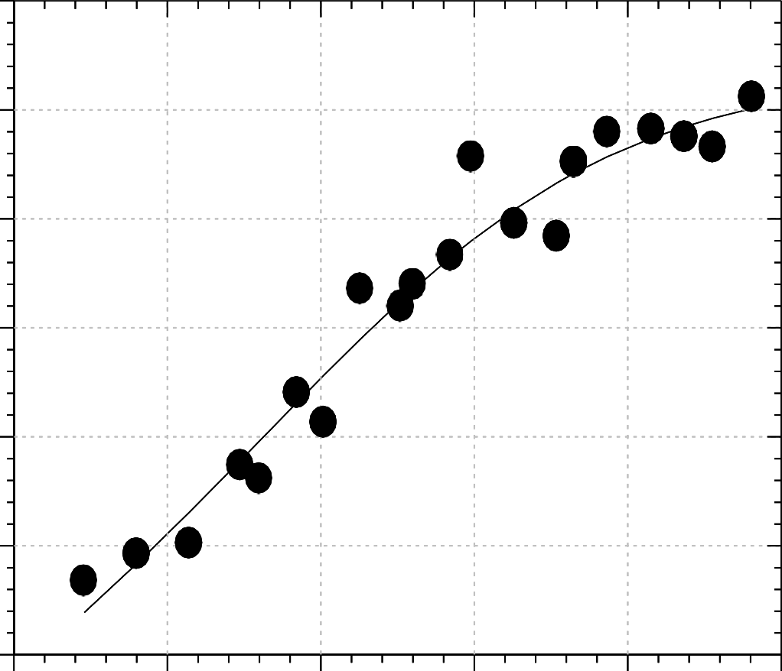
5.5 6.0 6.5 7.0 7.5 8.0

pH

Figure F1.0: Dependence of –log₁₀K_{equ} on pH for the reaction on Ellman’s reagent with CysF9[93]β of major quail oxyhaemoglobin in the presence of inositol-P₆.
Conditions: phosphate buffers, pH 5.6 -7.8 (ionic strength 50 mmol dm⁻³; added salt, NaCl); haemoglobin concentration, 25 µmol haem dm⁻³ (12.5 µmol dm⁻³ in reactive sulphydryl group); [Inositol-P₆] = 25 µmol dm⁻³. Each data point is the mean of a minimum of 10 determinations and is subject to a standard error of about ± 0.1 in the log.
*At 8.00 ≥ pH ≤ 9.00, K_{equ} the values obtained were negative for all volumes of DTNB added, giving an invalid –log₁₀K_{equ}.

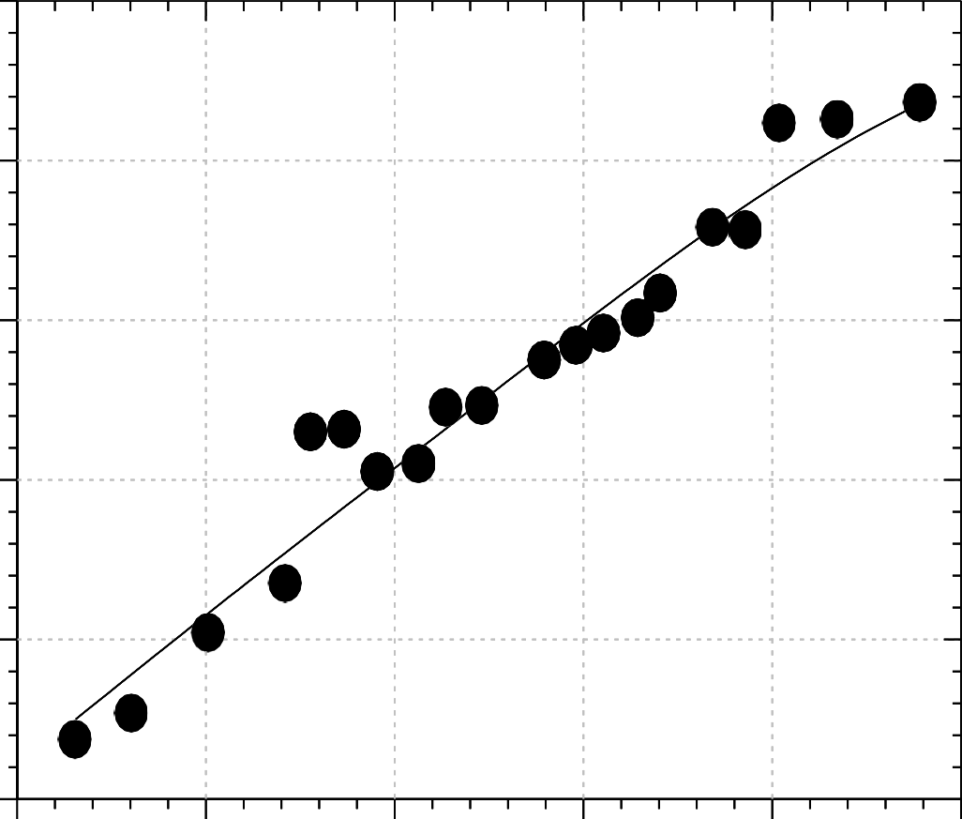
1.5

1.0

0.5

0.0
-log10Kequ

-0.5

-1.0

5.5 6.0 6.5

pH 7.0 7.5 8.0

Figure F1.2: Dependence of –log₁₀K_{equ} on pH for the reaction on Ellman’s reagent with CysF9[93]β of major quail carbonmonoxyhaemoglobin in the presence of inositol-P₆.
Conditions: phosphate buffers, pH 5.6 -7.8 (ionic strength 50 mmol dm⁻³; added salt, NaCl); haemoglobin concentration, 25 µmol haem dm⁻³ (12.5 µmol dm⁻³ in reactive sulphydryl group); [inositol-P₆] = 25 µmol dm⁻³. Each data point is the mean of a minimum of 10 determinations and is subject to a standard error of about ± 0.1 in the log.
Data obtained at 450nm on a Cecil BioQuest UV/Visible spectrophotometer.
*At 8.00 ≥ pH ≤ 9.00, K_{equ} the values obtained were negative for all volumes of DTNB added, giving an invalid –log₁₀K_{equ}.

F1.4 Effect of inositol-P₆ on the pH dependence profiles of the K_{equ} for the reaction of DTNB with quail haemoglobins

Figures F1.1 and F1.2 were fitted with Equ. 4.31 and Scheme II. The line of best-fit was obtained with n = 2. The best-fit parameters are reported in Table F1.3. The reaction of DTNB with the stripped quail haemoglobins had earlier been reported (Bello, 2008). We have refitted Bello‟s date with the new scheme - Scheme II – and Equ. 4.31. The corresponding paremters are reported in Table F1.4. In Figures F1.3 and F1.4, we compare the pH dependence profiles of the stripped quail heamoglobin with that in the presence of inositol-P₆. It is seen in the figures that the addition of inositol-P₆ does not significantly affect the K_{equ} in both the major oxy and the carbonmonoxyhaemoglobins .

2.0

1.5
-log10Kequ

1.0

0.5

0.0

-0.5

-1.0

-1.5
5.5 6.0 6.5 7.0 7.5 8.0 8.5 9.0

pH
Figure F1.3: Effect of inositol-P₆ on the equilibrium constant for the reaction of 5,5′- dithiobis(2- nitrobenzoate) with CysF9[93]ß of the major quail oxyhaemoglobin. Open circles, stripped haemoglobin (Bello, 2008); filled circles, haemoglobin + inositol-P₆.
Each point is the mean of at least 10 determinations and is subject to a standard error of ± 0.1 in the log.

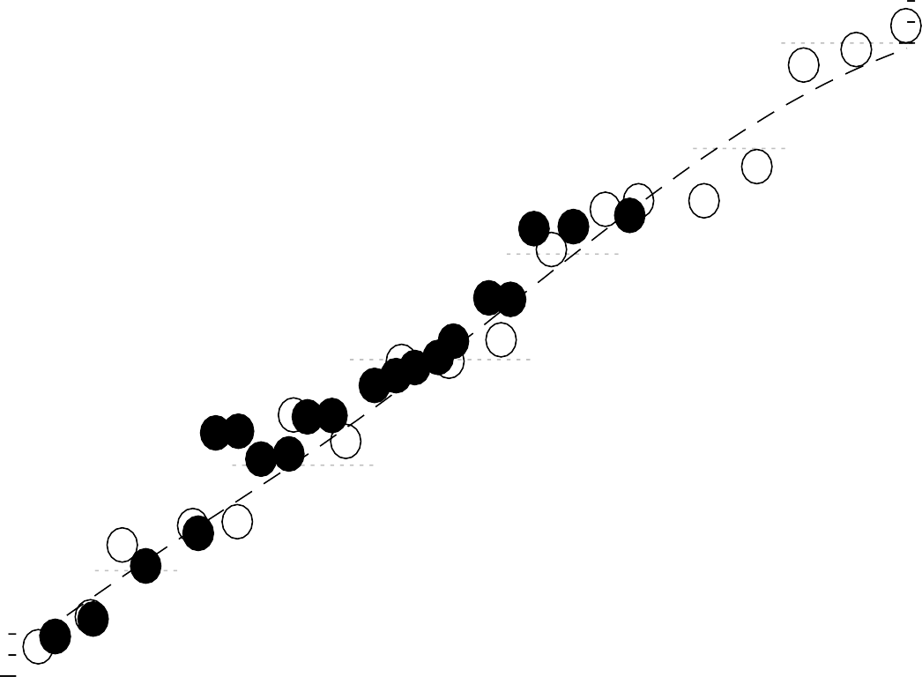
2.5
-log10Kequ

2.0

1.5

1.0

0.5

0.0

-0.5

-1.0

5.5 6.0 6.5 7.0 7.5 8.0 8.5 9.0

pH

Figure F1.4: Effect of inositol-P₆ on the equilibrium constant for the reaction of 5,5′- dithiobis(2-nitrobenzoate) with CysF9[93]ß of the major quail carbonmonoxyhaemoglobin. Stripped haemoglobin: Open circles with dashed line, (Bello, 2008); haemoglobin + inositol-P₆: filled circles with a solid line.
Each point is the mean of at least 10 determinations and is subject to a standard error of ± 0.1 in the log.

Table F1.3: Reaction of 5,5′-dithiobis(2-nitrobenzoate) with the CysF9[93]β sulphydryl groups of the major derivatives of quail haemoglobin in the presence of inositol-P₆. Best-fit parameters used to fit the equilibrium data reported in Figures F1.1 – F1.2 using Scheme II and Eq. 4.31, for n = 2.

Paramters | Major quail haemglobin derivatives + inositol-P₆ |  | Mean
 | Oxy | Carbomonoxy
pQ_{1r} | 5.67 | 5.60 | 5.64 ± 0.04
pQ_{1t} | 6.82 | 6.58 | 6.70 ± 0.2
pQ_{2r} | 6.44 | 7.41 | 6.93 ± 0.5
pQ_{2t} | 7.64 | 8.03 | 7.84 ± 0.2
KE3/ KE2 | 0.84 | 0.74 | -
KE3/ KE1 | 0.0021 | 0.041 | -
-log₁₀K_{E3} | 0.92 | 1.21 | -
Krt3 | 1.00 | 1.74 | 1.37 ± 0.4

Table F1.4: Reaction of 5,5′-dithiobis(2-nitrobenzoate) with the CysF9[93]β sulphydryl groups of the stripped major derivatives of quail haemoglobin. Best-fit parameters used to fit the equilibrium data reported in Figures F1.3 – F1.4 using Scheme II and Eq. 4.31, for n = 2.

Paramters | Stripped major quail haemglobin derivatives |  | Mean
 | Oxy | Carbomonoxy
pQ_{1r} | 6.12 | 5.62 | 5.87 ± 0.3
pQ_{1t} | 7.21 | 6.21 | 6.71 ± 0.5
pQ_{2r} | 8.14 | 7.56 | 7.85 ± 0.3
pQ_{2t} | 8.26 | 8.99 | 8.63 ± 0.4
KE3/ KE2 | 0.088 | 0.22 | -
KE3/ KE1 | 0.015 | 0.021 | -
-log₁₀K_{E3} | 1.74 | 2.05 | -
Krt3 | 0.86 | 1.18 | 1.02 ± 0.2

Table F1.5: Reaction of CysF9[93]β of DTNB with stripped major quail haemoglobin: Tertiary conformation transition constants, K_{rti} (i = 1, 2, 3) for the haemoglobin species H₂PS.ST, HPS.ST and PS.ST, respectively. Compare with Scheme I for n = 2. The numbers in brackets are the percentage t isomer populations.

Haemoglobin Species | Transition constant | Stripped major quail haemoglobin derivatives
 |  | Oxy | Carbonmonoxy
H₂PS.ST | Krt1 | 13.9  (93.3%) | 123.6  (99.2%)
HPS.ST | Krt2 | 1.13  (53.1%) | 31.8  (97%)
PS.ST | Krt3 | 0.86  (46.2%) | 1.18  (54.1%)

Table F1.6: Reaction of CysF9[93]β of DTNB with major quail haemoglobin in the presence of inositol-P₆: Tertiary conformation transition constants, K_{rti} (i = 1, 2, 3) for the haemoglobin species H₂PS.ST, HPS.ST and PS.ST, respectively. Compare with Scheme I for n = 2. The numbers in brackets are the percentage t isomer populations.

Haemoglobin Species | Transition constant | Major quail haemoglobin derivatives +  inositol-P₆
 |  | Oxy | Carbonmonoxy
H₂PS.ST | Krt1 | 223.9  (99.6%) | 69.3  (98.6%)
HPS.ST | Krt2 | 15.8  (94.0%) | 7.25  (87.9%)
PS.ST | Krt3 | 1.00  (50%) | 1.74  (63.5%)

Table F1.7: Reaction of CysF9[93]β of DTNB with stripped major quail haemoglobin: Equilibrium constants, K_{Ei} (i = 1, 2, 3), for the reaction of DTNB with the haemoglobin species H₂PS⁻, HPS⁻ and PS⁻, respectively. Compare with Scheme II for n = 2.

Haemoglobin Species | Equilibrium constant | Stripped major quail haemoglobin  derivatives
 |  | Oxy | Carbonmonoxy
H₂PS.ST | KE1 | 13.8 | 1.93
HPS.ST | KE2 | 0.21 | 0.041
PS.ST | KE3 | 0.018 | 0.0089

Table F1.8: Reaction of CysF9[93]β of DTNB with major quail haemoglobin + inositol-P₆: Equilibrium constants, K_{Ei} (i = 1, 2, 3), for the reaction of DTNB with the haemoglobin species H₂PS⁻, HPS⁻ and PS⁻, respectively. Compare with Scheme II for n
= 2.

Haemoglobin Species | Equilibrium constant | Major quail haemoglobin derivatives +  inositol-P₆
 |  | Oxy | Carbonmonoxy
H₂PS.ST | KE1 | 68.1 | 2.03
HPS.ST | KE2 | 0.14 | 0.083
PS.ST | KE3 | 0.12 | 0.0062

APPENDIX G

G1: Programme written on Micromath Scientist software for calculating equilibrium constant, K_{equ} for the reaction of DTNB with human deoxyhaemoglobin A.

IndVars: pH, DTNBVOL, HBTOT, EXT405, EXT412, EXT450, EXT470 DepVars: KEQ405, KEQ412, KEQ450, KEQ470
Params: pKTNB, pKSH pKTNB = 5.267
pKSH = 8.3
K1TNB = 1 + (10^(-pH)/10^(-PKTNB)) K1SH = 1 + (10^(-pH)/10^(-pKSH)) PATHLENT = 0.2
TNBC405 = EXT405/(14050*PATHLENT) TNBC412 = EXT412/(14220*PATHLENT) TNBC450 = EXT450/(7800*PATHLENT) TNBC470 = EXT470/(3940*PATHLENT) HBVOL = 1000
DTNBTOT = 0.029*DTNBVOL/(HBVOL + DTNBVOL) NUM405 = TNBC405*TNBC405*K1TNB*K1SH SHTOT = (HBTOT*10^(-6))/2
DEN405 = (SHTOT - TNBC405*K1TNB)*(DTNBTOT - TNBC405*K1TNB) KEQ405 = NUM405/DEN405
NUM412 = TNBC412*TNBC412*K1TNB*K1SH
DEN412 = (SHTOT - TNBC412*K1TNB)*(DTNBTOT - TNBC412*K1TNB) KEQ412 = NUM412/DEN412
NUM450 = TNBC450*TNBC450*K1TNB*K1SH
DEN450 = (SHTOT - TNBC450*K1TNB)*(DTNBTOT - TNBC450*K1TNB) KEQ450 = NUM450/DEN450
NUM470 = TNBC470*TNBC470*K1TNB*K1SH
DEN470 = (SHTOT - TNBC470*K1TNB)*(DTNBTOT - TNBC470*K1TNB) KEQ470 = NUM470/DEN470
***

G2: Programme written on Micromath Scientist software for the calculation of K_{equ} for the reaction of DTNB with cat haemoglobins.
IndVars: pH, EXT, DTNBVOL DepVars: TNBCONC, KEQ
Params: pKTNB, pKSH pKTNB = 5.267
pKSH = 8.3
K1TNB = 1 + (10^(-pH))/(10^(-pKTNB))
K1SH = 1 + (10^(-pH))/(10^(-pKSH)) HBTOT = 25E-6
TNBCONC = EXT/14000
DTNBTOT = 0.029*DTNBVOL/(3000 + DTNBVOL) NUM = TNBCONC*TNBCONC*K1TNB*K1SH
DENOM = (HBTOT - TNBCONC*K1TNB)*(DTNBTOT - TNBCONC*K1TNB) KEQ = NUM/DENOM
***

G3: Programme for fitting the pH dependence of K_{equ} for the reaction of DTNB with haemoglobin (n = 2)

IndVars: PH DepVars: PKEQ
Params: PQ1R, PQ2R, PQ1T, PQ2T, QUOT1, QUOT2, PKE3, KRT Q1R = 10^(-PQ1R)
Q2R = 10^(-PQ2R) Q1T = 10^(-PQ1T) Q2T = 10^(-PQ2T) KE3 = 10^(-PKE3)
FIRSTTOP = 1+ 10^(-PH)/10^(-PQ2R)
SECTOP = ((10^(-PH))^2)/(10^(-PQ1R)*(10^(-PQ2R))) THIRDTOP = (1 + 10^(-PH)/10^(-PQ2T))
KRT3TOP = KRT*THIRDTOP
FOTOP = (((10^(-PH))^2)/(10^(-PQ1T)*(10^(-PQ2T)))) KRT4TOP = KRT*FOTOP
TOP = FIRSTTOP + SECTOP + KRT3TOP + KRT4TOP NUM = KE3*TOP
QUOT1 = KE3/KE2 QUOT2 = KE3/KE1
FIRSTBOT = 1+ (QUOT1*10^(-PH)/10^(-PQ2R))
SECBOT = QUOT2*((10*(-PH))^2)/10^(-PQ1R)*10^(-PQ2R) DENOM = FIRSTBOT + SECBOT
KEQ = NUM/DENOM PKEQ = -LOG10(KEQ)
***

G4: Program for fitting pH dependence of k_{F} for the reaction of DTNB with haemoglobin (n = 2)

IndVars: PH DepVars:KF
Params: K1, K2, K3, PQ1R, PQ2R, PQ1T, PQ2T, PQ1H, PQ2H, PQS3, KRT3 Q1R =10^(-PQ1R)
Q2R = 10^(-PQ2R) Q1T = 10^(-PQ1T) Q2T =10^(-PQ2T) Q1H = 10^(-PQ1H) Q2H = 10^(-PQ2H) QS3 = 10^(-PQS3)
A = (K1*((10^(-PH))^2))/((10^(-PQ1R))*(10^(-PQ2R))) B = (K2*(10^(-PH)))/(10^(-PQ2R))
C = ((10^(-PH))^2)/((10^(-PQ1R))*(10^(-PQ2R))) E = (10^(-PH))/(10^(-PQ2R))
F = (10^(-PH))/(10^(-PQS3))
G = ((10^(-PH))^2)/(10^(-PQ1H) *(10^(-PQ2H))) H = (10^(-PH))/(10^(-PQ2H))
I = 1 + H + G
FOTBOT = I*(10^(-PH))/(10^(-PQS3))
J = (10^(-PH))/(10^(-PQ2T))
L = ((10^(-PH))^2)/((10^(-PQ1T))*(10^(-PQ2T))) THIRDBOT = 1 + J + L
TFBOT = THIRDBOT + FOTBOT BOTPROD = KRT3*TFBOT FIRSTBOT = 1 + C + E
NUM = K1*C + K2*E + K3 DENOM = FIRSTBOT + BOTPROD KF = NUM/DENOM
***

APPENDIX H

Determination of ionic strength
The equation for the reaction between sodium hydroxide and sodium dihydrogen phosphate is given as:
NaH₂PO₄ + NaOH → Na₂HPO₄ + H₂O (1)
The ionic strength, I, of any species i, is given by:

I = 1 ∑C Z²

-------------------------- (2)

2 i i


where I = ionic strength,
C = concentration, and Z = charge on the ion
From Equ. 1, the species contributing to the ionic strength of the phosphate buffers are NaH₂PO₄ and Na₂HPO₄. (NaOH was added to NaH₂PO₄, a weak acid, to produce Na₂HPO₄, the salt of a weak acid).
From Table 3.1, the initial concentration of sodium dihydrogen phosphate in the solution at any given pH is 0.01 mol dm⁻³. At the end of the reaction, the final concentration of sodium dihydrogen phosphate, ( CNaH PO ), after all the NaOH has reacted, will be
2 4

CNaH PO
2 4
= (0.01 - x) mol dm⁻³, (3)

where x is the concentration of NaOH in the buffer solution at a particular pH. If v is the volume of 0.4 mol dm⁻³ NaOH used at a particular pH (cf Table 3.1), then,
x = v × 0.4 , (4)
1000
From the stoichiometry of Equ. 1, the concentration of disodium hydrogen phosphate, ( C ), produced will also be x mol dm⁻³.
Na HPO
2 4

To calculate the ionic strength contributed by sodium dihydrogen phosphate, INaH PO , we first write the ionic equation for NaH₂PO₄:
2 4

NaH PO 
Na⁺ + H PO⁻ (5),

From Equ. 5, if
2 4 2 4

C = y mol dm⁻³, then the concentrations of the ionic species,
NaH PO
2 4

C + and
Na
CH2PO⁻
, will be y mol dm⁻³ each. Also from Equ. 5, the charge, Z, on each of

the species is 1. Therefore, by correct substitution into Equ. 2,
4

INaH PO
= 1 {(C

× Z²
+
+ ) + (C

× Z²
−
− )}---------------------- (6)

2 4 2
Na Na H2PO4
H2PO4

= 1 {( y × 1² ) + ( y × 1² )}
2
= 1 (2 y )
2
= y mol dm⁻³
To calculate the ionic strength due to disodium hydrogen phosphate, we first write


Na HPO  2Na⁺ + HPO²⁻
------------------------ (7)

Since CNa HPO
2 4 4

= x mol dm⁻³, then,
2 4

INa HPO
= 1 {(2C

× Z²
+
2
+ ) + (C
2− 2− )} --------------------(8)

2 4 2
Na Na HPO₄
HPO4

= 1 {(2x × 1² ) + (x × 2² )}
× Z
2

= 1 (2x + 4x) 2
= 1 (6x) 2
= 3x mol dm⁻³

The addition of
INaH PO and
I does not yield the ionic strength of 0.05 mol dm⁻³
2 4
NaH PO

needed for the experiments. We therefore add a calculated amount of sodium chloride salt, NaCl, to make up for the deficit. The total ionic strength, I, of the buffer solution
2 4

at a particular pH, is therefore the addition of
INaH PO ,
INaH PO , and
INaCl , the latter

being the ionic strength contributed by NaCl which is calculated as:
2 4
2 4

INaCl = {0.05 −
(INa2HPO4 +
I )} mol dm⁻³

------------------------(9)

From the ionic equation for NaCl:
NaH2PO4

NaCl 
Na⁺ + Cl⁻
------------------------(10)

If the concentration of the NaCl required to be added, C_{NaCl}, is z mol dm⁻³, then the concentrations of Na⁺ and Cl⁻ will be z mol dm⁻³ each. From Equ. 10, the ionic strength due to NaCl is given as:

I = 1 {(C
× Z² ) + (C × Z² )}
+ − −
+

--------------------------(11)

NaCl 2
Na Na Cl Cl

= 1 {(z × 1² ) + (z × 1² )}
2

= 1 (2z ) 2
= z mol dm⁻³
Equations 9 and 11 will enable the calculation of the concentration of NaCl required, C_{NaCl}, which will in turn enable the determination of the mass of NaCl needed to be added to the buffer solution.

