## ADSORPTION OF CHROMIUM(VI) AND COPPER(II) IONS FROM WELL WATER IN CHALLAWA INDUSTRIAL AREA USING PECTIN-CHITOSAN POLYELECTROLYTE COMPLEX

**BY**

## ACHANYA, Bridget Ene MEng/SEET/2016/6612

**DEPARTMENT OF CHEMICAL ENGINEERING FEDERAL UNIVERSITY OF TECHNOLOGY MINNA**

## NOVEMBER, 2019

## ABSTRACT

The aim of the research was to carryout adsorption study of the removal of chromium(vi) and copper(ii) ions from well water using pectin-chitosan polyelectrolyte complex as adsorbent. The optimum pH and ratio of pectin/chitosan was determined and the chitosan/pectin complex was characterized by using FTIR, BET, XRD, and SEM. Finally, removal efficiency of the PEC for chromium and copper was studied under optimum conditions. I.e. 0.4 g adsorbent mass, 1.221 and 0.12 mg/L of initial copper and chromium concentration respectively, 60 oC temperature and 30 mins of time. Result shows that the optimum pectin/chitosan ratio and pH of the medium required to produce PEC with high removal efficiency was pH: 4 and pectin/chitosan ratio: 1:3. The active groups identified from FTIR are NH2 group and OH group from carboxylate group, with particle size 2 nm and surface area was 377 m2/g from BET. When the optimum temperature was 60 ℃, adsorption time of 30mins and the amount of adsorbent was 0.4g, the results showed that the adsorption capacities of the PEC of Cu2+ and Cr6+ were 333.33 and 270.27 mg/g respectively when the initial concentration was 1.221 and 0.12 mg/L respectively. The fitting results of Langmuir isothermal model, the pseudo second order kinetic model and the copper and chromium’s

∆Gowhich had negative values and ∆Ho of 53.39 and 51.67KJ.mol-1 respectively and

∆So of 0.163 and 0.167 J.mol-1K-1 respectively of thermodynamics data of the ions adsorption process show that the adsorption of heavy metal ions of Cu2+ and Cr6+ by the PEC is a spontaneous process of single-layer chemisorption.

## TABLE OF CONTENTS

**Content Page**

TITLE PAGE i

DECLARATION ii

CERTIFICATION iii

DEDICATION vi

ACKNOWLEDGEMENTS v

ABSTRACT vi

TABLE OF CONTENT vii

LIST OF TABLES xii

LIST OF FIGURES xiii

LIST OF ABBREVIATIONS xv

CHAPTER ONE

* 1. INTRODUCTION 1
  2. Background of the Study 1
  3. Statement of the Problem 3
  4. Aim and Objectives 3
  5. Justification of Study 4
  6. Scope of the Study 4

CHAPTER TWO

* 1. LITERATURE REVIEW 5
  2. Preamble 5
  3. Sources of Water Pollution 5
  4. Chemical Structure of Chitosan 5
     1. Preparation of chitosan 6
     2. Solubility of chitosan 7
     3. Cationic properties 8
     4. Application of chitosan 8
        1. Pharmaceutical and biomedical applications of chitosan 8
        2. Dye removal 9
        3. Metal ion adsorption 9
  5. Pectin 9
     1. Raw materials 10
     2. Chemistry of pectin 10
     3. Esterification pattern 11
     4. Chemical and physical properties 13
     5. Stability 13
     6. Functional properties 14
     7. Application of pectin 14
        1. Food industry 14
        2. Pharmaceutical industry 15
        3. Wastewater treatment 15
  6. Polyelectrolyte Complex (PEC) 15
  7. Heavy Metals 16
     1. Sources and emissions of heavy metals 17
  8. Adsorption 18
     1. Engineered adsorption processes in water treatment 20

CHAPTER THREE

* 1. METHODOLOGY 22
  2. Materials and Chemicals 22
     1. Chemicals 22
  3. Adsorbent Preparation 23
  4. Adsorbent Characterization 25
     1. Fourier transform infra-red (FT-IR) spectroscopy 25
     2. Determination of scanning electron microscopy 25
     3. Determination of x-ray diffraction (XRD) 25
     4. Brunnauer, Emmitt and Teller (BET) analysis 26
  5. Absorption Experiment 26
     1. Effect of absorbent dosage 26
     2. Effect of temperature 27
     3. Effect of copper and chromium initial concentration and contact time 27
  6. Well Water analysis 27
     1. Equilibrium Study 28
     2. Determination of removal efficiency 28
     3. Determination of adsorbent capacity 28
     4. Adsorption isotherm 28
        1. Freundlich isotherm 29
        2. Langmuir isotherm 30
        3. Temkin isotherm 31
        4. Dubinin-Radushkevich (D-R) 31
     5. Chi-square (ᵪ2) analysis 32
     6. Adsorption kinetics study 32
     7. Adsorption thermodynamics study 34

3.7 Treated Well Water analysis 35

CHAPTER FOUR

* 1. RESULT AND DISCUSSION OF RESULT 36
  2. Optimisation Study of Process Parameters (ratio of Chitosan, Pectin

And Mediums pH) for the preparation of PEC Adsorbent 36

* + 1. Effect of pectin to chitosan ratio 37
    2. Effect of pH 38
    3. Statistical analysis of PEC preparation 39
       1. Analysis of variance (ANOVA) of PEC preparation for Cu2+ and

Cr6+ ions removal efficiency (%) 39

* + - 1. Effect of Interaction between process parameters involved in PEC Preparation for Cu2+ removal efficiency 42
      2. Effect of Interaction between process parameters involved in PEC preparation for Cr6+ ion removal efficiency 43
  1. PEC Characterisation 45
     1. Fourier transform infrared spectra (FT-IR) analysis of PEC 45
     2. Scanning electron microscopy (SEM) analysis of PEC 45
     3. X-ray diffraction (XRD) Spectrometry 48
     4. Brunauer Emmet Teller (BET) analysis of PEC 49
  2. Batch Adsorption Study 49
     1. Effect of adsorbent dosage 50
     2. Effect of temperature 50
     3. Effect of initial concentration and contact time 51
  3. Well water analysis 54
  4. Equilibrum Study 55
     1. Adsorption isotherm 55
        1. Freundlich isotherm 55
        2. Langmuir model 55
        3. Temkin model 56
        4. Dubinin-Radushkevich 56
     2. Adsorption kinetics study 58
        1. Pseudo first-order kinetic 58
        2. Pseudo-second kinetic 58
        3. Elovich kinetic Adsorption thermodynamics study 59
        4. Intra partial kinetic model 59

4.7.1 Adsorption thermodynamics study 61

CHAPTER FIVE

* 1. CONCLUSION AND RECOMMENDATIONS 63
  2. Conclusions 63
  3. Recommendations 64

REFERENCES 65

APPENDICES 68

## LIST OF TABLES

**Table Page**

|  |  |  |
| --- | --- | --- |
| 2.1 | Toxic Metal in Industrial Effluents | 18 |
| 2.2 | Adsorption processes in water treatment | 20 |
| 3.1 | List of Equipment’s/Apparatus used | 22 |
| 3.2 | Constraints used to optimize the process parameters | 24 |
| 3.3 | Optimization of the Polyelectrolyte Complex | 24 |
| 4.1 | Optimization study of process parameters (ratio of chitosan and pectin and mediums pH) for the preparation of PEC Adsorbent | 36 |
| 4.2 | Analysis of variance of PEC preparation for Cu removal efficiency (%) | 39 |
| 4.3 | Analysis of variance of PEC preparation for Cr removal efficiency (%) | 41 |
| 4.4 | BET analysis result for PEC | 50 |
| 4.5 | Table showing the physicochemical properties of the well water after treatment | 55 |
| 4.6 | Showing isotherms parameters for Freunlich Langmuir Temkim and Dubinin | 58 |
| 4.7 | Pseudo – First order and Pseudo – second order kinetics for the adsorption of Cr6+ and Cu2+ | 61 |
| 4.8 | Thermodynamics parameters in the adsorption of Cr and Cu | 62 |

## LIST OF FIGURES

**Figure Page**

|  |  |  |
| --- | --- | --- |
| 2.1 | Conversion of chitin to chitosan using an alkali | 7 |
| 2.3 | Pectin consists of long sequences of anhydrous galacturonic acid completely or partly esterified with methanol | 11 |
| 2.5 | β-elimination mechanism | 13 |
| 2.6 | Mechanism of Adsorption | 19 |
| 4.1 | Effect of pectin to chitosan ratio on the removal efficiency of copper (Cu) and chromium (Cr) | 37 |
| 4.2 | Effect of pH on the removal efficiency of chromium (Cr (VI) and copper (Cu (II) ions | 38 |
| 4.3 | Parity plot showing Cu (1I) ion removal | 40 |
| 4.4 | Parity plot showing Cr (VI) ion removal | 42 |
| 4.5 | Response surface plot of the interaction effect of Pectin to chitosan ratio and the pH on the PEC preparation for Cu removal efficiency | 43 |
| 4.6 | Response surface plot of the interaction effect of Pectin to chitosan ratio and the pH on the PEC preparation for Cr removal efficiency | 44 |
| 4.7 | Fourier Transform Infrared Spectra (FT-IR) Analysis of PEC | 45 |
| 4.8a | SEM micrograph of unused Adsorbent at different magnifications of  A (500X) B (1000X) and C (1500X) | 46 |
| 4.8b | SEM micrograph of Spent Adsorbent at different magnifications of A  (500X) B (1000X) and C (1500X) | 46 |
| 4.8c | SEM micrograph of unused Absorbent at a magnification of 1500x | 47 |
| 4.8d | SEM micrograph of spend absorbent at a magnification of (500x) | 47 |
| 4.8e | SEM micrograph of spent absorbent at a smagnification of (1000x) | 48 |
| 4.8f | SEM micrograph of spent absorbent at a magnification of (1500x) | 48 |
| 4.9a | X-ray Diffraction (XRD) Spectrometry of A (PEC) | 49 |
| 4.9b | X-ray Diffraction (XRD) Spectrometry of (Spent PEC) | 49 |

|  |  |  |
| --- | --- | --- |
| 4.10 | Plot of adsorbent dosage | 51 |
| 4.9 | Plot of Temperature against Removal efficiency | 52 |
| 4.10a | Plot of effect initial concentration of copper | 53 |
| 4.10b | Plot showing effect of initial chromium concentration and contact time | 54 |

## LIST OF ABBREVIATION

PEC: Polyelectrolyte complex

WAFT: Water aquaculture and fishery technology NDWQS: Nigeria drinking water quality standard

## CHAPTER ONE

## INTRODUCTION

## Background of Study

The demand for water is on the increase and this is attributed to an increase in human population. Similarly, a large fraction of this water is been used for other industrial processes (Basheer, 2018). However, the quality and availability of usable water is on the decline as the introduction of pollutants from industrial process has led to a decrease in the quality of water as well as making this water toxic and unsafe for consumption (Basheer, 2018).

According to Radaideh *et al.* (2017) industries such as electroplating, hospitals, pharmaceuticals, power plant, refineries, leather tanning, mining, dyes and pigments, steel fabrication, canning and inorganic chemical production plants are at the helm of affairs in the release of toxins which contaminate water.

This has brought about the need to purify these contaminated waters of which methods such as filtration, screening, oxidation, precipitation, coagulation, centrifugation, flotation, crystallization, sedimentation, distillation, evaporation, reverse osmosis, electro-chemical, ion exchange and adsorption are at the forefront (Sabino *et al.,* 2016). However, the high operational and maintenance costs, generation of toxic sludge and complicated procedure involved in the implementation of any of the separation methods listed above has put a damper on their use (Sabino *et al.,* 2016). However, the adsorption process does not suffer from this constrains and its ease of operation and simplicity of design gives it an edge over other separation techniques (Czikkely *et al.,* 2018).

The numerous toxins been released by numerous industrial processes particular attention is given to the release of heavy metals as this metal’s possess a great threat to the environment. Heavy metals (metals and metalloids with a density greater than 5 g/cm3 with atomic weights between 63.5 and 200.6 and a specific gravity greater than

5.0 such as Copper (Cu), Chromium (Cr), Cadmium (Cd), Lead (Pb), Nickel (Ni) been amongst the most prevailing heavy metals (Chen *et al.,* 2018; Singh & Gupta, 2016).

According to Sabino *et al.* (2016) and Arie *et al.* (2018) factors such as the technical applicability, cost-effectiveness, selectivity, good chemical and thermal properties, reusability, low solubility in the contacting fluid as well as favorable kinetics, thermodynamics and transport properties are all pointers to what a good adsorbent should be. The desire for that perfect adsorbent has necessitated the need for research into different types of adsorbent and their impact on the adsorption process in general (Ambali *et al.,* 2015). A typical classification of adsorbents categorizes them as activated carbons, activated alumina, silica gel, clays, zeolite and hydrogels (Ambali *et al.,* 2015).

The guiding principle in adsorption is the interaction between functional groups which exist on the surface of the adsorbent and metal ions. This interaction leads to the formation of complexes where the heavy metal ions attach themselves to the functional groups (Hastuti *et al.,* 2016). Adsorbents can be classified as either nature derived adsorbents or synthetic adsorbents with preference been given to nature-derived adsorbents. Different natural polymers have been used as adsorbents including pectin and chitosan (Chirani *et al.,* 2015).

Pectin is a compound widely found in plant cell. It is a polymer of D-galacturonic acid linked by 1,4 glycosidic bond and widely available in the middle lamella of plant cell

walls its functional groups include hydroxyl, carboxyl, amide and methoxy while chitosan on the other hand (which is obtained from deacetylation of chitin compounds) is a cationic copolymer of glucosamine and N-acetylglucosamine is a derivative of chitin which is extracted from the skin of crustaceans, such as shrimp and crab. The presence of amine and hydroxyl functional groups makes it a suitable adsorbent (Hastuti *et al.,* 2016). The formation of a polyelectrolyte complex (PEC) which is simply the incorporation of chitosan with pectin to fabricate the composite material called polyelectrolyte complex (PEC) this incorporation exploits both the functional groups of both the pectin and chitosan leading to the formation of a highly functionalized composite material.

## Statement of the Research Problem

The presence of heavy metals in drinking water has caused serious health hazards to humans. The need to combat this environmental challenge treatment measures such as precipitation, electrochemical removal has been proposed, but this conventional methods have significant disadvantages, some of which are incomplete removal of contaminants, high energy requirements, sludge etc. The search for low cost adsorbent especially from waste materials has intensified. Pectin and chitosan are direct waste materials from crustaceans which has been estimated to be 1.5 million ton per annum (Chen *et al.,* 2016) and orange peel which has been estimated to be 25 million ton per annum (Ana *et al.,* 2011) respectively and has been considered to be good adsorbents.

## Aim and Objectives

The aim of the study is the Adsorption of chromium(vi) and Copper(ii) ions from well Water in Challawa Industrial Area using Pectin-Chitosan Polyelectrolyte Complex

The objectives were to:

1. Optimize the effect of pH and ratio on the synthesis of PEC.
2. Characterize PEC to determine its morphology, functional group, surface area, pore size, pore volume, and crystallinity.
3. Conduct batch adsorption studies of the effect of operating parameters such as temperature, effect of time, adsorbent dosage, adsorption isotherms, kinetics and thermodynamics

## Justification for the Study

The utilization of pectin and chitosan will check environmental and aquatic pollutant such as shells of shrimps, snail, crabs which are in abundance in riverine areas and orange peel which are by products of orange juice industry. Adsorption is a cost effective method for removing contaminants, the use of chitosan and pectin are a promising material to be used as adsorbent due to their efficiencies.

## Scope of Work

This research work is limited to the optimization of the effect of ratio and pH on the synthesis PEC, characterization of PEC as well as the adsorption of heavy metals by using PEC as an adsorbent.

## CHAPTER TWO

## LITERATURE REVIEW

## Preamble

Pure and uncontaminated water is a basic requirement for all living organisms. 71% of the earth surface is covered with water, less than 1% of this water is drinkable as per international standards because of different contaminations. The main sources of water pollution include: wastewater discharge from industries, agricultural activities, municipal wastewater, environmental and global changes. The presence of heavy metals, dyes and microorganisms even in trace amounts, are very dangerous to human health, aquatic systems and the environment Singh (2018).

## Sources of Water Pollution

The sources of water pollution can be categorized into two groups

* + 1. Point sources: Factories, Sewage system, Power plants, Underground coal mines, Oil wells. Etc. Every year about 300–400 MT of heavy metals, toxic sludge, solvents, and other harmful materials go into water due to industrial activity.
    2. Non-point sources: Non-point sources are diffused across a broad area and their contamination cannot be traced to a single discharge point.

## Chemical Structure of Chitosan

Chitosan has a polycationic backbone and its structure is similar to that of cellulose. It is a copolymer consisting of N-acetyl-2-amino-2-deoxy-D-glucopyranose and 2-amino-2- deoxy-D-glucopyranose units. The two types of repeating units are linked by β (1→4)- glycosidic bonds.

## Preparation of chitosan

Chitosan is formed through N-deacetylation of the chitin molecule (Ambrose *et.al.,* 2018). It is prepared by hydrolysis of acetamide groups of the chitin. Thermal treatments of chitin under strong aqueous alkali are needed to give partially deacetylated chitin (DA lower than 30%), is regarded as chitosan. Usually, sodium or potassium hydroxides are used at a concentration of 30-50% w/v at high temperature (100ºC). There are two major different methods applied in the preparation of chitosan from chitin with varying degree of acetylation. These are the heterogeneous deacetylation of solid chitin and the homogeneous deacetylation of pre-swollen chitin under vacuum (by reducing pressure) in an aqueous medium. Heterogeneous deacetylation, is the preferred method applied in treating chitosan industrially, this involves preferential reaction in the amorphous regions of the polymer, leaving almost intact the intractable crystalline native regions in the parent chitin (Chen *et al.,* 2017). In both, heterogeneous or homogeneous conditions, the deacetylation reaction involves the use of concentrated alkali solutions and long processing times which can vary depending on the heterogeneous or homogeneous conditions from 1 to nearly 80 hours. Factors that affect the extent of deacetylation include concentration of the alkali, previous treatment, particle size and density of chitin. The last two factors affect penetration rate of the alkali into the amorphous region and to some extent also into the crystalline regions of the polymer, needed for the hydrolysis to take place. In practice, the maximal DD that can be achieved in a single alkaline treatment is about 75-85%.

Chitin

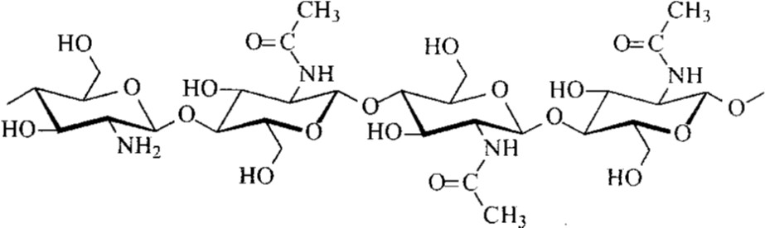

Alkali

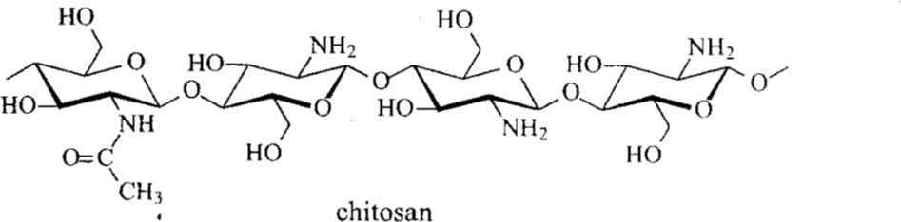

Figure 2.1: Conversion of chitin to Chitosan using an alkali (Chan *et al.,* 2017)

## Solubility of chitosan

Chitosan is insoluble in water, alkali and most organic solvents, and dissolves in most aqueous solutions of organic acids such as formic, acetic, lactic, citric, etc., acids, at pH values of less than 6.3. A polysaccharide precipitates at pH > 6.5 in aqueous solutions, in the form of a gelatinous-like flock. Some diluted inorganic acids such as nitric acid, hydrochloric acid, perchloric acid and phosphoric acid can improve preparation of chitosan solutions, but only by prolonged agitation and frequent warming. However, the molecular weight of chitosan reduces under the condition described above. The

preparation of water-soluble chitosan from alkali chitin dispersion was reported. This chitosan is dissolved in the absence of acids, in contrast to chitosan salts, which are readily soluble in water.

## Cationic properties

Chitosan behaves like s Polycationic, due to the presence of free, protonated amino groups, which enables it to form complexes with derivatives carrying negative charges, such as polymers, proteins, dyes, etc. In addition, chitosan is capable to bind selectively with cholesterol, fat, tumor cells, or DNA and RNA. Chitosan also forms a chelate with metal ions, requiring the involvement of -OH and -O- groups on the D-glucosamine residues as ligands, or else, two or more amino groups from a single chain, binding to the same metal ion.The increase of free amino groups content does not directly increase the ability to form derivatives, due to the effect of other properties, such as crystallinity, affinity to water and/or distribution of residual units. The capacity for metal adsorption could be enhanced by crosslinking, controlled N-acetylation or by cooperative bonding with other polymers like glucan.

## Application of chitosan

## Pharmaceutical and biomedical applications of chitosan

Chitosans characteristics such as biocompatibility, renewable origin, non-toxicity, non- allergenicity and biodegradability in the body have made it widely used in the pharmaceutical industry. Chitosan a polycationic substance and its electrostatic complexes formed with synthetic or natural polymers (as alginate) are used as antithrombogenic materials for: controlled release, drugs encapsulation, enzymes and cells immobilization and also as gene carriers.

## Dye removal

Chitosan is easily protonated in acidic medium and can adsorb anionic dye due to the presence of a large number of amino groups in chitosan. It is usually used as a perfect material for the removal of anionic dyes via strong electrostatic attraction between chitosan and anionic dyes. Due to its unique chemical structure, chitosan can be used as an efficient adsorbent for dyes, especially for anionic dyes. Moreover, chemical modification can expand its applications in dye removal.

## Metal ion adsorption

Metal ions widely exist in industrial effluents which are usually discharged into environment from metal finishing, lead smelters, electroplating, and battery manufacturing industries. Chitosan is also modified to adsorb other metal ions, such as Zn (II) , Hg(II), Cr(VI) ions and other cations. Due to the presence of a large number of hydroxyl and amino groups, metal ions can be adsorbed by chitosan and its derivatives through chelation mechanism.

## Pectin

Pectin represents a family of heterogeneous polysaccharides mainly located in the primary cell wall and middle lamella of higher plants. Pectin naturally exhibits a wide diversity in its molecular structure and is prone to chemical and enzymatic conversions. Specifically, the fine structure of pectin reveals numerous functional groups which, depending on environmental conditions, are capable of inducing specific polymer functionalities.

## Raw materials

The major sources of pectin are citrus peels, which are by-product from the extraction of citrus juice and oil, and apple pomace, the dried residue from the extraction of apple juice. Within the commercially processed types of citrus, the peel from lemons or limes is preferred for most qualities of pectin, although orange peel is available in much larger quantities, and can be used for some applications. Citrus peel may be washed free from acidity and sugar, and carefully dried to preserve the pectin quality, or may be processed directly in the wet state. Wet peel processing requires a large and consistent source of peel very near to the pectin plant. Pectin is very prone to degradation either by enzymes in the wet peel or by heat during drying and subsequent processing, and such loss of quality must always be controlled as far as possible. Pectin producers devote considerable resources to ensuring both the availability and quality of raw materials, and quality has a major effect on the types of pectin which can be economically produced. Scientists always search for new sources of pectin, but not every pectin is suitable for gelation due to its chemical structure.

## Chemistry of pectin

The Homo galacturonic acid Backbone of pectin consists of a chain of galacturonic acid units which are linked by a 1,4 glycosidic bonds. The galacturonic acid chain is partly esterified as methyl esters. Pectin molecules can have a molecular weight of more than 200 000, corresponding to a degree of polymerization up to 1000 units (Figure 2.3).

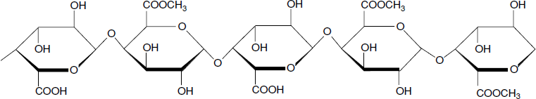

Figure 2.3: Pectin consists of long sequences of anhydrous galacturonic acid completely or partly esterified with methanol.

Though the esters are the most significant components on the galacturonic acid backbone, other chemicals, such as acetyl, can be important in specific pectin types. Commercial pectin can also be partly amidated with ammonia to form galacturonamide units in the molecular chain. Some neutral sugars are also included in the homogalacturonic backbone. This is the case for rhamnose but also specifically in apple pectin for xylose. The percentage of galacturonic acid of the whole molecule is defined as the galacturonic acid content (% GA), which is set at a minimum of 65% in the definition of pectin as a food additive. The percentage of esterified or amidated galacturonic acid units of the total number of galacturonic acid units in the molecule are respectively defined as the degree of esterification (DE) and the degree of amidation (DA). Regulations limit the DA to a maximum of 25%.

## Esterification pattern

In addition to the number of components on the backbone, their position is of significant importance to the functional properties of pectin. The distribution of esters is of special importance as it affects the local electrostatic charge density of the polymer and so its interaction with other charged molecules, whether ions such as calcium, proteins, or other pectin molecules.

Apple pectin can, with great care, be extracted with up to 80% esterification. Pectin is readily degraded by a β elimination mechanism adjacent to the ester groups at ambient temperature or above at neutral or alkaline pH values. The ester groups can be hydrolysed under either alkaline or acidic conditions, or by pectin esterases. Commercially, acidic treatment is most commonly used, producing pectins with around 60% of ester groups which are `slow setting'. Under identical conditions of 65% total sugar solids by refractometry and a pH of say 3.1, the gel will take much longer to set. The setting of these gels is both time and temperature dependent, and the setting temperature depends on the rate of cooling. Slow-setting pectins permit gels to be prepared at higher sugar contents, valuable for sugar confectionery, biscuit jams, and so on. Because of the higher charge density on the slow-set pectin molecules, there is also a change in the pH requirements for gelation towards a lower pH in gels of otherwise similar composition.

Further de-esterification to below 50% esterification produces a range of `low methyl ester' pectins. These show a markedly greater reactivity towards calcium ions, which will cause gelation under suitable conditions of soluble solids and pH. Conditions for effective gelation depend on a balance of several factors, including soluble solids content, pH, calcium and pectin concentrations, and the presence of sequestrants. Amidated pectins (mostly of the low methyl ester type) are produced by reaction of suitable high methyl ester pectins with ammonia.

The reaction is normally carried out in an aqueous alcohol slurry of the pectin at ambient or lower temperature. The process requires careful control of the relative rates of de-esterification and amidation, whilst minimising the rate of polymer chain degradation.

## Chemical and physical properties

Pectin and its compounds are prepared with various chemical and physical properties. Pectin is soluble in water, but insoluble in most organic solvents. The solubilisation rate in water is related to the degree of polymerization and the number and distribution of methyl-ester groups. The pH, temperature, and ionic strength of the solution are of great importance to the rate of pectin dissolution. The calcium content of the water used to dissolve the pectin is of special relevance as it is common that a high-water hardness will translate into an incomplete dissolution of pectin.

## Stability:

High-ester pectins are stable at pH levels of 2.5–4.5. Above a pH level of 4.5, β- elimination will occur, depolymerizing the galacturonic acid chain. This mechanism requires an esterified carboxyl group next to the glycosidic bond to be cleaved (Figure 2.5), so low-ester pectins are more stable at higher pH values. The pectin molecular structure is quite resistant to heat. At pH around 3.5 pectin is only marginally depolymerized at high temperatures. The heat-stability of pectin is greatly improved when the water activity of the system is lowered through the addition of sugar.

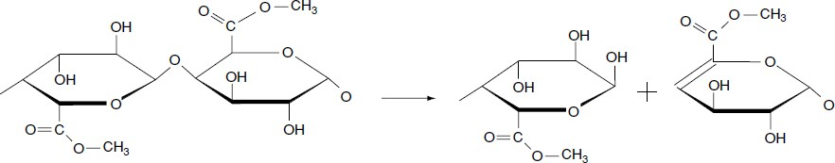

Figure 2.5: β-elimination mechanism (Zhang *et al.,* 2016)

## Functional properties

Naturally occurring polymers such as Pectins are used in a broad variety of food and pharmaceutical products and enjoy a very good public image as a natural product derived from fruits (effortless accessibility, non-hazardous and eco-friendly nature). In pharmaceuticals, it can be used as emulsifying, suspending, stabilizing and binding agent for predictable dose form. In tablet or capsule dose form, it can be used as a disintegrating and potential binding agent. As methods develop for obtaining a better understanding of the pectin molecular structure, it is likely pectin will be attributed new functional properties in the future.

## Application of pectin

* + - 1. **Food industry**

Jam manufacturers make a very wide range "of jams, fillings and toppings for bakery and related industries. Many of these employ pectin as a gelling or thickening agent. High methoxyl pectins are useful in standard jams, above about 60% soluble solids. These are now the major product. Low methoxyl pectins, used at 0.75-1.0%, are cabable of giving excellent results. Selection of the correct pectin is important (the lower the soluble solids, the more calcium-sensitive the pectin that should be used) but fruit content is also important. Sometimes, especially at very low solids.

Pectin has other uses in the dairy field. High methoxyl pectin will prevent the aggregation of casein on heating at pH values below 4.3. It can therefore be used as a stabiliser for UHT-treated drinkable yogurts and for blends of milk and fruit juices.

## Pharmaceutical industry

Pectin acts as a natural prophylactic substance against poisoning with toxic cations. It has been shown to be effective in removing lead and mercury from the gastrointestinal tract and respiratory organs (Kohn, 2019). When injected intravenously, pectin shortens the coagulation time of drawn blood, thus being useful in controlling hemorrhage or local bleeding (Joseph, 1956). Pectin and combinations of pectin with other colloids have been used extensively to treat diarrhea diseases, especially in infants and children.

Pectin hydrogels have been used in tablet formulations as a binding agent (Slany *et al.,* 2017a,b) and have been used in controlled-release matrix tablet formulations (Krusteva *et al.,* 1990; Naggar *et al.,* 2012). Recently, Sungthongjeen *et al.* (2017) have investigated HM-pectins for their potential value in controlled release matrix formulations.

## Wastewater treatment

Modified pectin from durian rind and orange peel has been reported to be able to bind metals. The effectiveness of adsorption of orange peel towards metals is Cu<Pb<Ni<Cd<Zn. Carboxyl group of pectin is known to form complex with metals. The pectin reactivity is known of heavy metal ions is highly dependent on the degree of esterification.

## Polyelectrolyte Complex (PEC)

Polyelectrolyte complex (PEC) result from the interaction between macromolecules carrying opposite charges. They present a wide range of applications, such as encapsulation of substances, drug delivery systems, and waste-water treatment, among others. The PECs made from natural ionic polysaccharides are generally non-toxic and

biocompatible, properties that are very valuable for their use in medicine and pharmacy. In dependence of their final use, PECs can be prepared as powders, membranes, sponges, fibers, gels, spheres or in solutions.

This study used the absorbent material of pectin and chitosan, because it can be used as a biomaterial that can absorb the metal. Pectin has an active groups of carboxylic and chitosan amine groups. It is a very reactive material that can bind a metal by forming a complex compound. Composite pectin with chitosan forms stable polyelectrolyte complexes. Interaction between active group COO- of pectin and active group -NH2 of chitosan complement the character of these macromolecules. Its complexes usually have a rigid structure that is very different from its original properties.

## Heavy Metals

Metals occur naturally in the earth's crust, and their contents in the environment can vary between different regions resulting in spatial variations of background concentrations. The distribution of metals in the environment is governed by the

properties of the metal and influences of environmental factors (Khlifi & Hamza- Chaffai (2010). Of the 92 naturally occurring elements, approximately 30 metals and metalloids are potentially toxic to humans, Be, B, Li, Al, Ti, V, Cr, Mn, Co, Ni, Cu, As, Se, Sr, Mo, Pd, Ag, Cd, Sn, Sb, Te, Cs, Ba, W, Pt, Au, Hg, Pb, and Bi. Heavy metals is the generic term for metallic elements having an atomic weight higher than 40.04 (the atomic mass of Ca) (Ming-Ho, 2015). Heavy metals enter the environment by natural and anthropogenic means. Such sources include: natural weathering of the earth’s crust, mining, soil erosion, industrial discharge, urban runoff, sewage effluents, pest or disease control agents applied to plants, air pollution fallout, and a number of others (Ming-Ho, 2015). Although some individuals are primarily exposed to these contaminants in the

workplace, for most people the main route of exposure to these toxic elements is through the diet (food and water). The contamination chain of heavy metals almost always follows a cyclic order: industry, atmosphere, soil, water, foods and human. Although toxicity and the resulting threat to human health of any contaminant are, of course, a function of concentration, it is well-known that chronic exposure to heavy metals and metalloids at relatively low levels can cause adverse (Castro-González & Méndez-Armenta, 2018). Therefore, there has been increasing concern, mainly in the developed world, about exposures, intakes and absorption of heavy metals by humans. Populations are increasingly demanding a cleaner environment in general, and reductions in the amounts of contaminants reaching people as a result of increasing human activities. A practical implication of this trend, in the developed countries, has been the imposition of new and more restrictive regulations (European Commission, 2016; Figueroa, 2018).

## Sources and emissions of heavy metals

Toxic metals, to a large extent, are dispersed in the environment through industrial effluents, organic wastes, refuse burning, and transport and power generation. They can be carried to places many miles away from the sources by wind, depending upon whether they are in gaseous form or as particulates. Metallic pollutants are ultimately washed out of the air into land or the surface of water ways. Thus air is also a route for the pollution of environment.

Metal containing industrial effluents constitute a major source of metallic pollution of hydrosphere. Another means of dispersal is the movement of drainage water from catchment areas which have been contaminated by waste from mining and smelting units. The chief toxic metals in industrial effluents are shown in table 2.1.

## Table 2.1: Toxic Metal in Industrial Effluents

|  |  |
| --- | --- |
| Metal | Manufacturing Industries |
| Arsenic | Phosphate and Fertilizer, Metal Hardening , Paints And Textile |
| Cadmium | Phosphate Fertilizer, Electronics, Pigments And Paints |
| Chromium | Metal Plating , Tanning, Rubber And Photography |
| Copper | Plating, Rayon And Electrical |
| Lead | Paints, Battery |
| Nickel | Electroplating , Iron Steel |
| Zinc | Galvanizing, Plating Iron And Steel |
| Mercury | Chlor-Alkali, Scientific Instruments , Chemicals |

(Chen *et al.*, 2014)

## Adsorption

Adsorption may be defined as the process of accumulation of any substance giving higher concentration of molecular species on the surface of another substance as compared to that in the bulk. When a solid surface is exposed to a gas or a liquid, molecules from the gas or the solution phase accumulate or concentrate at the surface. The phenomenon of concentration of molecules of a gas or liquid at a solid surface is called adsorption. Adsorption is a well established and powerful technique for treating domestic and industrial effluents. In water treatment, the most widely method is “adsorption” onto the surface of activated carbon.

Adsorbate: The substance that concentrates at the surface is called adsorbate. Adsorbent: The material upon whose surface the adsorption takes place is called an adsorbent. Mostly activated carbon is used as an adsorbent

Adsorbents are used usually in the form of spherical pellets, rods, moldings, or monoliths with hydrodynamic diameters between 0.5 and 10 mm.

They must have high abrasion resistance, high thermal stability and small pore diameters, which results in higher exposed surface area and hence high surface capacity for adsorption. The adsorbents must also have a distinct pore structure which enables fast transport of the gaseous vapours.

Most industrial adsorbents fall into one of three classes:

1. Oxygen-containing compounds are typically hydrophilic and polar, including materials such as silica gel and zeolites.
2. Carbon-based compounds are typically hydrophobic and nonpolar, including materials such as activated carbon and graphite.
3. Polymer-based compounds are polar or non-polar functional groups in a porous polymer matrix.

Activated carbon is used for adsorption of organic substances and non-polar adsorbates and it is also usually used for waste gas (and waste water) treatment. It is the most widely used adsorbent since most of its chemical (e.g. surface groups) and physical properties (eg. pore size distribution and surface area) can be tuned according to what is needed. Its usefulness also derives from its large micro pore (and sometimes mesopore) volume and the resulting high surface area.

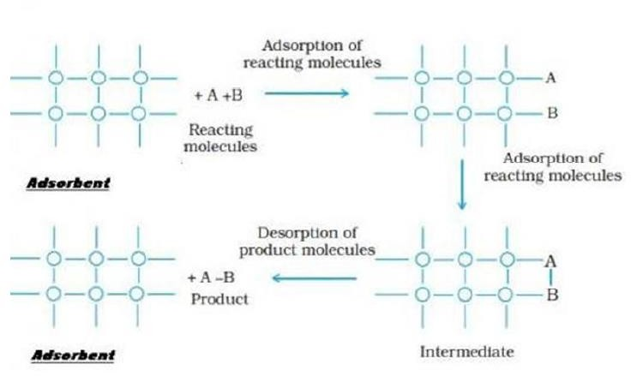

## Figure 1.6: Mechanism of Adsorption (Lakhewal, 2014)

## Engineered adsorption processes in water treatment

Adsorption processes are widely used in water treatment. Table 2.2 gives an overview of typical application fields and treatment objectives. Depending on the adsorbent type applied, organic substances as well as inorganic ions can be removed from the aqueous phase.

## Table 2.2: Adsorption processes in water treatment

|  |  |  |
| --- | --- | --- |
| Application field | Objective | Adsorbent |
| Drinking water treatment | Removal of dissolved organic matter Removal of organic Micropollutants  Removal of arsenic | Activated carbon  Activated carbon,  Aluminum oxide, iron hydroxide |
| Urban wastewater treatment | Removal of phosphate Removal of micropollutants | Aluminum oxide, iron hydroxide  Activated carbon |
| Industrial wastewater  treatment | Removal or recycling of  specific chemicals | Activated carbon,  polymeric adsorbents |
| Swimming-pool water  treatment | Removal of organic  Substances | Activated carbon |
| Groundwater remediation | Removal of organic  Substances | Activated carbon |
| Treatment of landfill leachate | Removal of organic  Substances | Activated carbon |
| Aquarium water treatment | Removal of organic  Substances | Activated carbon |

Source: (Chan *et al.,* 2017)

Activated carbon is the most important engineered adsorbent applied in water treatment. It is widely used to remove organic substances from different type swimming-pool water, and aquarium water. Other adsorbents are less often applied.

Their application is restricted to special adsorbates or types of water of water such as drinking water, wastewater, groundwater, landfill leachate, swimming-pool water, and aquarium water. Other adsorbents are less often applied. Their application is restricted to special adsorbates or types of water.

## CHAPTER THREE

## METHODOLOGY

## Materials and Chemicals

The water was sourced from a well in Challawa, Kano State, Nigeria. Table 3.1 present the list of equations used for the research

Table 3.1: List of Equipment used.

|  |  |  |  |  |
| --- | --- | --- | --- | --- |
| **S/N** | **EQUIPMENT** | **MODEL** | **MANUFACTURER** | **SOURCE** |
| 1. | Weighing Balance | MP300 | Citizen | WAFT LAB |
| 2. | PH meter | PH 25 | REX | WAFT LAB |
| 3.  4. | UV Spectrometer  Magnetic stirrer | UV-GS-  Uv61pc double beam spectrometer | Jenway  Gallenkamp, England | WAFT LAB  Chemical Engineering lab, FUT,  Minna |

## Chemicals

Chitosan with a degree of deacetylation of approximately 85%, chitosan (viscosity of

800.000 cps) and pectin from orange peel with degree of esterification 34% were purchased from Sigma-Aldrich, Germany. .

## Adsorbent Preparation

Chitosan and pectin solutions were prepared according to the method proposed by Hastuti *et al.*, (2018). Pectin powder was dissolved in distilled water using a magnetic stirred to prepare pectin solution (3%, w/v). Chitosan powder was also dissolved in distilled water containing 0.1% (v/v) acetic acid to prepare the chitosan solution (1%, w/v), both solutions were left to stand 12hrs.

Synthesis of polyelectrolyte complexes (PEC) of chitosan-pectin was subsequently conducted by the following steps: The solutions of chitosan and pectin where mixed together and the pH of the mixture was adjusted appropriately according to Table 3.2. The mixture was then continuously stirred for 30 mins at a temperature of 50 0C. (Bernab *et al*, 2017). After heating, the resulting solution’s pH was adjusted to 5.5 to precipitate out the PEC. The mixture was transferred to glass vessel and centrifuged at 200 rpm for 3min. The supernatant was carefully decanted through a Whatman paper filter (no. 5) and washed until it was neutral. The PEC was poured out in a petri dish and was dried in an oven at 60 °C for overnight in order to get a dried adsorbent film. (Chan *et al.*, 2015).

Different ratios of pectin to chitosan solution were chosen during synthesis of pectin- chitosan and at different pH according to Table 3.2, to optimize the PEC for removal efficiency. As shown in Table I. Optimization of the polyelectrolytes complex was also performed for several parameters, including pectin-chitosan ratio and pH using design expert.

Table 3.2 presents the constraint used to optimize the process parameters.

## Table 3.2: Constraints used to optimize the process parameters

|  |  |
| --- | --- |
| **Factors low high** | **References** |
| **Pectin to Chitosan ratio 1:1 1:5** | Ofori- Kwakye *et*  *al.,* 2013 |
| **pH 2.9 5.6** | Ofori- Kwakye *et*  *al.,* 2013 |

Table 3.3 shows the parameter used for the optimization of the polyelectrolyte complex as given by design expert

**Table 3.3: Optimization of the Polyelectrolyte Complex**.

|  |  |  |
| --- | --- | --- |
| Run | Factor 1  A: Pectin to Chitosan ratio | Factor 2  B: pH |
| 1 | 0.17 | 4.00 |
| 2 | 3.00 | 4.00 |
| 3 | 5.83 | 4.00 |
| 4 | 3.00 | 5.41 |
| 5 | 3.00 | 4.00 |
| 6 | 3.00 | 4.00 |
| 7 | 3.00 | 4.00 |
| 8 | 3.00 | 4.00 |
| 9 | 5.00 | 5.00 |
| 10 | 3.00 | 2.59 |
| 11 | 5.00 | 3.00 |
| 12 | 1.00 | 3.00 |
| 13 | 1.00 | 5.00 |

## Adsorbent Characterization

## Fourier transform infra-red (FT-IR) spectroscopy

The infra-red spectrometer analysis of the adsorbent was performed using Bruker Alpha II infra-red spectrometer. In carrying out the analysis, the spectrometer was powered and allowed to warm up for 5 mins after which sample was mixed with alkali halide potassium bromide (KBr) and compressed into a thin transparent pellet using a hydraulic press, before being placed in the standard sample compartment of the spectrometer. The transmission spectra of composite films were recorded at ambient temperature and the sample was scanned from 4000 to 400 cm-1 with resolution of 0.4 cm-1 (Sani *et al.,* 2017).

## Determination of scanning electron microscopy (SEM)

This was carried out according to the method reported by Kolawole *et al.* (2017) where a ASPEX 3020 scanning electron microscope, model SIRIUS50/3.8 with an attached energy dispersive X-ray spectroscopy (SEM/EDX) machine is used to generate images of the sample. The machine is operated at an accelerated voltage of 5 to 15 kV to determine the samples elemental composition

## Determination of x-ray diffraction (XRD)

This is carried out according to the method reported by Kolawole *et al.* (2017) where an Empyrean X-ray diffractometer DY 674 is used with 40 mA, 45VA and 240 mm tube current, voltage rating and goniometer radius, respectively. The sample is compressed in the flat sample holder to create a flat, smooth surface. The sample is then mounted on the sample stage in the XRD cabinet. The X-ray of Cu Kα radiations were collimated and directed onto the sample. The sample is then analyzed using the reflection- transmission spinner stage and Theta-Theta settings scanning range of 4 to 75.000

degrees with a two-theta step of 0.026 at 13.7700 seconds per step. The intensity of the diffracted X-rays is continuously recorded automatically on a chart and the appropriate (Ө) and (d) values are then obtained.

## Brunnauer, Emmet and Teller (BET) analysis

The BET analysis gives the surface area, pore size and pore volume of the sample. The Quantachrome Instruments Nova 3200e surface area analyzer was used to analyze the sample.

## Adsorption Experiments

According to Abbas *et al.,* (2014) factors which affect the removal of heavy metals include but are not limited to i) the effect of temperature ii) the effect of contact time iii) the effect of adsorbent dosage. Similarly, Lakherwal (2014) reported that adsorption parameters such as contact time, adsorbent dosage and temperature have immense effect on the removal efficiency. Each of the parameters was studied with each setup stirred continuously with the aid of a magnetic stirrer.

## Effect of adsorbent dosage

The adsorption process is setup in a 250 ml flask containing 100ml of the well water and the adsorbent. The adsorbent at different dosages (0.1, 0.2, 0.3, 0.4, and 0.5 g) was then added to the flasks and the setup was maintained at optimum conditions (60 mins, 60 0C) and left to stand on a magnetic stirrer and agitated at 100 rpm (Hastuti *et al., 2018).*

## Effect of temperature

The adsorption process was setup in a 250 ml flask containing 1000 ml of the well water and the adsorbent. The setup is exposed to temperatures of 45, 60, 75, 90, 100 oC respectively. Data determined from here helps in estimation of the thermodynamic behavior of the adsorption process whereby a decrease in the adsorption rate as the temperature increase would denote an exothermic system and vice versa. The setup was left to stand on a magnetic stirrer and agitated at 100 rpm at optimum conditions (0.4 g dose of adsorbent, 60 mins). (Lakherwal, 2014).

## Effect of copper and chromium initial concentration and contact time

The copper (II) initial concentration was 1.221, 1.2, 1.1 and 1 mg/L, while that of chromium (V1) were 0.2, 0.15, 0.1 and 0.075 mg/L of 500 mL pyrex flasks. The content was subjected to constant agitation for 60 oC and adsorbent dosage of 0.4 g. the water sample was drawn at different time interval for analysis using AAS.

## Well water analysis

The physical and chemical properties of the well water are characterized in other to determine the constituents and nature of the well water. Properties such as pH, Turbidity, Total Dissolved Solids, Conductivity, Chemical Oxygen Demand, Biological Oxygen Demand, Dissolved Oxygen, Total Alkalinity, Nitrates and Ammonia will all be determined.

The pH and temperature were measured using the standard pH electrode meter (Hanna HI 98129 pH EC/TDS Waterproof Combo Tester/Meter) as reported by Muriuki, (2015). Similarly, the Total dissolved solids (TDS), Total suspended solids (TSS),

Electrical conductivity (EC), ammonia and Nitrates were estimated using the standard methods for the Examination of Water and Well water (NSDWQ, 2007).

## Equilibrium Study

The optimum parameters determined from the batch adsorption studies was used to carry out the adsorption of the heavy metals in the well water. After which the spent catalyst and the treated well water are characterized (Adiotomre, 2015).

## Determination of removal efficiency

The removal efficiency of the adsorbents on the metal ion adsorption was determined using Equation 3.1

Removal efficiency (%) = (𝐶0− 𝐶𝑒)

𝐶0

× 100 (3.1)

where Co and Ce are the initial and final concentrations of metal ions

## Determination of adsorbent capacity

The adsorbent capacity (qe) was determined using Equation 3.2

Adsorbent capacity (𝑞 )

(𝐶0− 𝐶𝑒)

(3.2)

𝑒 = (

) 𝑣

w

where V and w are the volume of the well water used and the weight of adsorbent used

## Adsorption isotherm

The equilibrium characteristic of the adsorption process in this study was described using the Freundlich, Langmuir, Temkin and Dubinin isotherm models.

## Freundlich isotherm

This model gives an empirical relationship that describes the adsorption of solutes from a liquid to a solid surface and assumes that different sites with several adsorption energies are involved. In other words, the Freundlich adsorption isotherm is the relationship between the amounts of contaminant adsorbed per unit mass of adsorbent, qe and the concentration of the contaminant at equilibrium, Ce where (Bolade and Sangodoyin, 2018; Adewoye *et al.,* 2017)

1

𝑞𝑒 = 𝐾ƒ𝐶𝑒𝑛 (3.3)

In logarithmic form Equation 3.3 becomes

log 𝑞 = log 𝐾 + 1 log 𝐶

(3.4)

𝑒 ƒ 𝑛 𝑒

Kf and n indicate the adsorption capacity and adsorption intensity respectively

where the plot of log qe vs. log Ce was used to generate the intercept value of Kf and the slope of the plot gave n.

This model assumes that the maximum adsorption occurs when a saturated monolayer of solute molecules is present on the adsorbent surface, the energy of adsorption is constant and that there is no migration of adsorbate molecules in the surface plane (Bolade & Sangodoyin, 2018; Adewoye *et al.,* 2017). The Langmuir Isotherm model is given by Equation 3.5

1 = 1

qe 𝑞m

+ 1

𝑞m 𝐾𝐿

(3.5)

where qm and KL represent the maximum adsorption capacity for the solid phase loading and the energy constant related to the heat of adsorption respectively.

where the plot of (1/qe) versus (1/Ce) was used to generate the intercept value of (1/qm)

and the slope of the plot equated to 1

𝑞m 𝐾𝐿

to get KL.

where qe and qm represents the amount of metal ion removed (mg/g) and qm (mg/g) is the maximum metal uptake under the given conditions

What is important to note that the separation factor or equilibrium parameter RL (dimensionless constant) is an essential characteristic of Langmuir adsorption isotherm. Where RL is determined by Equation 3.6

R = 1 (1+KLCo)

L

(3.6)

## Langmuir isotherm

This model assumes that the maximum adsorption occurs when a saturated monolayer of solute molecules is present on the adsorbent surface, the energy of adsorption is constant and that there is no migration of adsorbate molecules in the surface plane (Bolade & Sangodoyin, 2018; Adewoye *et al.,* 2017). The Langmuir Isotherm model is given by Equation 3.7

1 = 1

qe 𝑞m

+ 1

𝑞m 𝐾𝐿

(3.7)

where qm and KL represent the maximum adsorption capacity for the solid phase loading and the energy constant related to the heat of adsorption respectively.

where the plot of (1/qe) versus (1/Ce) was used to generate the intercept value of (1/qm)

and the slope of the plot equated to 1

𝑞m 𝐾𝐿

to get KL.

where qe and qm represents the amount of metal ion removed (mg/g) and qm (mg/g) is the maximum metal uptake under the given conditions

What is important to note that the separation factor or equilibrium parameter RL (dimensionless constant) is an essential characteristics of Langmuir adsorption isotherm. Where RL is determined by Equation 3.8

R = 1 (1+KLCo)

L

(3.8)

## Temkin isotherm

Temkin and Pyzhev suggested that, because of the existence of adsorbate–adsorbate interactions, the heat of adsorption should decrease linearly with the surface coverage (Fierro *et al.,* 2018).

The corresponding adsorption isotherm can thus be adjusted by the following equation:

𝑄𝑒 = 𝑘1 * 𝑙𝑛𝑘2 + 𝑘1ln(𝐶𝑒) (3.9)

where k1 is related to the heat of adsorption (L/g), and k2 is the dimensionless Temkin isotherm constant.

## Dubinin-Radushkevich (D-R)

The isotherm model is based on Polanyi potential energy theory. It is pointed out that the adsorption space on the adsorbent surface is constant, and the adsorption potential is independent of temperature as shown in equation 3.10.

ln 𝑄𝑒 = 𝛽s2 + ln 𝑄𝑚,𝐷−𝑅 (3.10)

where, qe (mg g-1) is the adsorption capacity of the adsorbent at equilibrium, Qm, D-R (mg g-1) is the theoretical maximum adsorption capacity, β (mol2 KJ-2) is the adsorption constant related to the adsorption energy, and Ɛ is the adsorption potential.

s = 𝑅𝑇 ln (𝐶𝑒+1) (3.10a)

𝐶𝑒

where, Ce (mg L-1) is the concentration of adsorbate at equilibrium, R (J K-1 mol-1) is the universal constant of gas, and T (K) is the temperature of reaction.

## Chi-square (2) analysis

2 analysis was carried out to identify the suitable isotherm model for describing the removal of Cu (II) and Cr (VI) ions from aqueous solution using PEC. The 2 values provide the significant information about the suitability of the isotherm model (Karthik *et al*. 2014). The mathematical expression for the 2 analysis is represented by

χ2 =∑((𝑞𝑒−𝑞𝑒,𝑚)2) (3.11)

𝑞𝑒

where qe,m is equilibrium capacity obtained by calculating from the model (mg/g) and qe is experimental data on the equilibrium capacity (mg/g). If data from the model are similar to the experimental data, ᵪ2 will be a small number, while if they differ; ᵪ2 will be a bigger number.

## Adsorption kinetics study

In other to study the adsorption kinetics the concentration of Cu2+ and Cr6+ were determined at a time range of 10 to 50mins (Adewoye *et al.,* 2017). The amount of the metal ion adsorbed at time t, Qt (mg/g) is determined by Equation 3.12

(𝐶0− 𝐶𝑒)

𝑄𝑡 = ( w ) 𝑉 (3.12)

where V and w are the volume of the wastewater used and the weight of adsorbent used and Co and Ce are the initial and final concentrations of metal ions.

The Pseudo first order and Pseudo second order kinetic models were used to evaluate the mechanism of adsorption in this study. The linearize form of the pseudo first order

model Pseudo second order kinetic models (Adewoye *et al.,* 2017) are given by Equation 3.13 and Equation 3.14

log(𝑄 − 𝑄 ) = log 𝑄

− 𝐾1 𝑡 (3.13)

𝑒 𝑡

𝑒 2.303

𝑡 Q𝑡

= 1

𝐾2Q𝑒2

+ 1 𝑡 (3.14)

Q𝑒

where the plot of log (Qe – Qt) against (t) is used to determine if the data fits the Pseudo first order kinetic model and the plot of t/Qt against time (t) is used to determine if the data fits the Pseudo second order kinetic model.

where k1 (min-1) and k2 (g/mg min) are the pseudo first order rate constant and the pseudo second order rate constant respectively. Qe (mg/g) and Qt (mg/g) are the metal ion adsorption capacity at equilibrium and at any time t (min) respectively.

Elovich’s equation describes activated adsorption. It was established through the work of Zeldowitsch dealing with the adsorption of carbon monoxide on manganesedioxide (Zeldowitsch *et al.,* 2013). Elovich’s equation has also been used for describing successfully the adsorption of pollutants from aqueous solutions in recent years, and can be expressed as follows:

𝑄𝑡 =

1 ln(

𝛽

𝛼𝛽) +

1 ln(𝑡)

𝛽

(3.15)

where a is the initial adsorption rate (mg/(g min)), and the parameter 1/b (mg/g) is related to the number of sites available for adsorption. If this equation applies, it should lead to a straight line by plotting qt as a function of ln t.

The sorption kinetics may alternatively be described from a mechanistic point of view. The overall adsorption process may indeed be controlled either by one or more steps,

e.g. film or external diffusion, pore diffusion, surface diffusion and adsorption on the pore surface, or a combination of more than one step. In a rapidly stirred batch, the

diffusive mass transfer can be related by an apparent diffusion coefficient, which will fit the experimental sorption rate data. Generally, a process is diffusion-controlled if its rate depends on the rate at which components diffuse towards one another. The possibility of intra-particle diffusion was explored by using the intra-particle diffusion model (Fierro *et al.,* 2018), according to which the amount adsorbed at time t, qt, reads:

𝑄𝑡 = 𝑘i𝑑. 𝑡0.5 + 𝜃 (3.16)

where kid is the intra-particle diffusion rate constant (mg/(gmin1/2)), and 𝜃 (mg/g) is a constant related to the thickness of the boundary layer: the larger is the value of θ, the greater is the boundary layer effect.

## Adsorption thermodynamics study

The parameters that describe the thermodynamic behavior of adsorption of Cd, Pb and Ni unto the carbonized carbon produced from snail shell was calculated using Equation

3.16, 3.17 and 3.18 (Yusuff *et al.,* 2017; Boparai *et al.,* 2011).

∆G = −RTln𝐾𝑐 (3.17)

ln𝐾

= ∆So − ∆Ho

(3.18)

𝑐 𝑅

𝑅𝑇

K = Cad

c

Ce

(3.19)

where ∆G = Change in standard Gibbs free energy (kJ mol-1), R = Universal gas constant, T = Temperature, Kc = Equilibrium constant, ∆H = Change in enthalpy (kJ mol-1), ∆S = Change in entropy (J mol-1 K-1), Cad = Adsorbed heavy metal concentration, Ce = Equilibrium concentration of metal solution (mg L-1)

## Treated Well Water Characterisation.

The physical and chemical properties of the treated waste water are characterized in other to give a complete overview of the constituents and nature of the well water. Properties such as pH, Turbidity, Total Dissolved Solids, Conductivity, Chemical Oxygen Demand, Biological Oxygen Demand, Dissolved Oxygen, Total Alkalinity, Nitrates and Ammonia would all be determined.

The pH and temperature were measured using the standard pH electrode meter (Hanna HI 98129 pH EC/TDS Waterproof Combo Tester/Meter) as reported by Muriuki, (2015). Similarly, the Total dissolved solids (TDS), Electrical conductivity (EC), ammonia and Nitrates were estimated using the standard methods for the Examination of Water and Well water (APHA, 1998).

## CHAPTER FOUR

* 1. **RESULTS**

## DICUSSION

**Optimization Study of Process Parameters (Ratio of Chitosan and Pectin and Mediums pH) for the Preparation of PEC Adsorbent**

Table 4.1 presents parameters for the optimization study of process parameters (ratio of chitosan and pectin and mediums pH) for the preparation of PEC adsorbent.

|  |  |  |  |  |
| --- | --- | --- | --- | --- |
| **Table 4.1: Optimization Study of Process Parameters (Ratio of chitosan and**  **pectin and Mediums pH) for the Preparation of PEC Adsorbent** | | | | |
| Run Number | A: Pectin to Chitosan ratio (w/w) | B: pH | Cu2+ Removal efficiency (%) | Cr6+ removal efficiency (%) |
| 1 | 0.17 | 4.00 | 42.33 | 13.33 |
| 2 | 3.00 | 4.00 | 93.33 | 73.33 |
| 3 | 5.83 | 4.00 | 86.67 | 33.33 |
| 4 | 3.00 | 5.41 | 6.67 | 22.58 |
| 5 | 3.00 | 4.00 | 85.67 | 55.59 |
| 6 | 3.00 | 4.00 | 93.00 | 55.33 |
| 7 | 3.00 | 4.00 | 93.33 | 73.33 |
| 8 | 3.00 | 4.00 | 93.33 | 73.33 |
| 9 | 5.00 | 5.00 | 53.30 | 5.91 |
| 10 | 3.00 | 2.59 | 60.00 | 45.16 |
| 11 | 5.00 | 3.00 | 61.00 | 38.33 |
| 12 | 1.00 | 3.00 | 60.00 | 15.07 |
| 13 | 1.00 | 5.00 | 20.33 | 33.33 |

The Optimization study was carried out using the response surface methodology (RSM) from the DESIGN EXPERT (Version 7.0.0, Stat Ease, Inc., USA) software where the pectin to chitosan ratio and the mediums pH were the process variables studied.

## Effect of pectin to chitosan ratio

The result presented in Table 4.1 shows the effect of the pectin to chitosan ratio studied, were the pectin to chitosan ratio was varied from 1:1 to 1:5 after comparing values of parameters from scientific literature (Baron *et al.,* 2016) which stated that a higher pectin ratio to chitosan the PEC formed is stable. The effect of the pectin to chitosan ratio on the removal efficiency of copper (Cu**2+**) and chromium (Cr**6+**) was noted and presented in Figure 4.1.

100

90

Removal efficiency (%)

80

70

60

50

40

30

20

10

0

Cu Cr

0.17 1 3 5 5.83



pectin to chitosan ratio (w/v

## Figure 4.1: Effect of Pectin to Chitosan Ratio on the Removal Efficiency of Copper (Cu2+) and Chromium (Cr6+) ions

The plot represented by Figure 4.1 it was observed that an increase in the chitosan to pectin ratio from 1:0.17 to 1:3 showed an increase of copper (Cu**2+**) and chromium (Cr**6+**) ions removal of 42. to 93.3 % and 13.3 to 73.3 % respectively this was because the polyelectrolyte complex yield increases with increase in pectin concentration in the mix (Baron *et al.,* 2016). Further increment in the pectin to chitosan ratio resulted in a drop in the removal efficiency of copper (Cu**2+**) and chromium (Cr**6+**) ions from 93 to 61

% and 73.3 to 38.3 % respectively as was observed at pectin to chitosan ratio of 1:5.

This results from the fact that as pectin increased in the mix the available carboxylate group becomes more than that of the amine group present in chitosan, hence there is a reduction in the PEC yield (Baron *et al.,* 2016).

## 4.1.2 Effect of medium’s pH

The effect of the pH from table 4.1 was studied were the pH was varied from 3 to 5 after comparing values of parameters from scientific literature stated that pH range 2.9-

5.6 produced a stable PEC (Ofori-Kwakye *et al.,* 2013) and the effect of the pH on the removal efficiency of PEC was noted and presented in Figure 4.2.

100

90

**Removal efficiency (%)**

80

70

60

50

40

30

20

10

0

Cu Cr

2 3 4 5 6



## pH

**Figure 4.2: Effect of pH on the Removal Efficiency of Chromium (Cr2+) and Copper (Cu2+)**

The plot represented by Figure 4.2 it was observed that an increase in the pH from 2.59 to 3 saw a decline in the removal efficiency of copper (Cu**2+**) and chromium (Cr**6+**), that was because at this pH the amine and carboxylate group in the chitosan and pectin respectively will not dissociate (Meka *et al.,* 2016). On further increment in the pH led to an increase in the removal efficiency of copper (Cu**2+**) and chromium (Cr**6+**) as a result of dissociated amine and carboxylate group with combine to form a stable PEC

(Meka *et al.,* 2016). At pH above 4 it was observed that the removal efficiency of copper (Cu) and chromium (Cr**6+**) dropped significantly and continued to drop as the pH was increased, at this pH the amine group is not protonated.

## Statistical analysis of PEC preparation

* + - 1. **Analysis of variance (ANOVA) of PEC preparation for Cu2+ and Cr6+ removal efficiency (%)**

Table 4.2 presents parameters from analysis of variance of PEC preparation for Cu2+ removal efficiency (%).

## Table 4.2: Analysis of variance of PEC preparation for Cu2+ removal efficiency (%)

|  |  |  |  |  |  |
| --- | --- | --- | --- | --- | --- |
| **Source** | **Sum of**  **Squares** | **Degree of**  **Freedom** | **Mean**  **Square** | **F Value** | **p-value**  **Prob > F** |
| Model | 9954.29 | 5 | 1990.86 | 56.26 | < 0.0001* |
| A-Pectin to  Chitosan | 1168.29 | 1 | 1168.29 | 33.01 | 0.0007* |
| B-Ph | 1884.67 | 1 | 1884.67 | 53.26 | 0.0002* |
| AB | 255.52 | 1 | 255.52 | 7.22 | 0.0312* |
| A^2 | 1302.05 | 1 | 1302.05 | 36.79 | 0.0005* |
| B^2 | 5957.23 | 1 | 5957.23 | 168.34 | < 0.0001* |
| Residual | 247.72 | 7 | 35.39 |  |  |
| Lack of Fit | 201.71 | 3 | 67.24 | 5.84 | 0.0605 # |
| Pure Error | 46.02 | 4 | 11.50 |  |  |
| Cor Total | 10202.01 | 12 |  |  |  |

R2 = 0.9757 C.V. % = 9.11, *- Significant , #- Not significant

The analysis of the variance (ANOVA) presented in Table 4.2 confirms the adequacy of the quadratic model. Where the models p-value less than 0.05 and F-value of 56.26

imply the model is significant for the response. The significant factors from the ANOVA analysis are the effect of the pectin to chitosan ratio (A), the pH (B), the interaction effect of the pectin to chitosan ratio and the pH (AB) with p-values of 0.0007, 0.0002 and 0.0312 respectively. The other factors include the quadratic effect of the pectin to chitosan ratio (A2) and the quadratic effect of the pH (B2) with p-values of 0.0005 and < 0.0001 respectively. In this study the value of the determination coefficient (R2 = 0.9757) indicates that the sample variation of 97.57% is attributed to independent variables and 2.43% of the total variation is not explained by the model. The value of the coefficient of variation (C.V. % = 9.11) gives the precision and reliability of the experiment carried out.

The model produced the following coded equation

Cu**2+** removal efficiency = 91.73 + 12.08A – 15.35B + 7.99AB – 13.68A2 – 29.26B2

The model coded equation process variables inluding the interaction effect (AB) and the quadratic effect of the process variables all have a signifiant effect on the Cu Removal efficiency. However, the Cu**2+** removal efficiency of the PEC relies largely on the linear effect of the pH (B) and the quadratic effect of the pH (B2) in that these have the largest coefficients and as such plays a larger role on the Cu**2+** removal efficiency.

From the parity plot presented in Figure 4.3, It was observed that there was a close correlation between the experimental data and the predicted data. The parity plot shows that the experimental data points lies close to the predicted data plot as shown.

Table 4.3 presents parameters from analysis of variance of PEC preparation for Cr6**+** removal efficiency (%).

## Table 4.3: Analysis of variance of PEC preparation for Cr6+ ions removal efficiency (%)

|  |  |  |  |  |  |
| --- | --- | --- | --- | --- | --- |
| **Source** | **Sum of**  **Squares** | **Degree of Freedom** | **Mean Square** | **F Value** | **p-value** |
|  |  | **Prob >**  **F** |
| Model | 6089.22 | 5 | 1217.84 | 13.90 | 0.0016 |
| A-Pectin to  Chitosan | 72.75 | 1 | 72.75 | 0.83 | 0.3925 |
| B-pH | 265.57 | 1 | 265.57 | 3.03 | 0.1253 |
| AB | 642.12 | 1 | 642.12 | 7.33 | 0.0303 |
| A^2 | 3611.84 | 1 | 3611.84 | 41.21 | 0.0004 |
| B^2 | 2134.33 | 1 | 2134.33 | 24.35 | 0.0017 |
| Residual | 613.49 | 7 | 87.64 |  |  |
| Lack of Fit | 230.25 | 3 | 76.75 | 0.80 | 0.5546 |
| Pure Error | 383.24 | 4 | 95.81 |  |  |
| Cor Total | 6702.71 | 12 |  |  |  |

R2 = 0.9085 C.V. % = 22.61

The analysis of the variance (ANOVA) presented in Table 4.3 confirms the adequacy of the quadratic model. Where the models p-value less than 0.05 and F-value of 13.90 imply the model is significant for the response. The significant factors from the ANOVA analysis are the interaction effect of the pectin to chitosan ratio and the pH (AB) with p-values of 0.0303. The other significant factors include the quadratic effect of the pectin to chitosan ratio (A2) and the quadratic effect of the pH (B2) with p-values

of 0.0004 and 0.0017. In this study the value of the determination coefficient (R2 = 0.9085) indicates that the sample variation of 90.85% is attributed to independent variables and 9.15% of the total variation is not explained by the model. The value of the coefficient of variation (C.V. % = 21.61) gives the precision and reliability of the experiment carried out. The model produced the following coded equation for Cr6+ removal efficiency = 66.18 + 3.02A – 5.76B – 12.67AB – 22.79A2 – 17.52B2

The model coded equation all the process variables inluding the interaction effect (AB) and the quadratic effect of the process variables all have a signifiant effect on the Cr6+ Removal efficiency. Howbeit, the Cr6+ Removal efficiency of the PEC relies largely on the quadratic effect of the pectin to chitosan ratio (A2) and the quadratic effect of the pH (B2) in that it has the largest coefficients and as such plays a larger role on the Cr6+ Removal efficiency.

From the parity plot presented in Figure 4.4, It was observed that there was a close correlation between the experimental data and the predicted data. The parity plot shows that the experimental data points lies close to the predicted data plot as shown.

## Effect of Interaction between process parameters involved in PEC preparation for Cu removal efficiency

The Three-dimensional response surfaces plots are plotted on the basis of the generated model equation to investigate the interaction among the variables and to determine the optimum condition for the process parameters involved in PEC preparation for Cu removal efficiency.

Design-Expert® Softw are

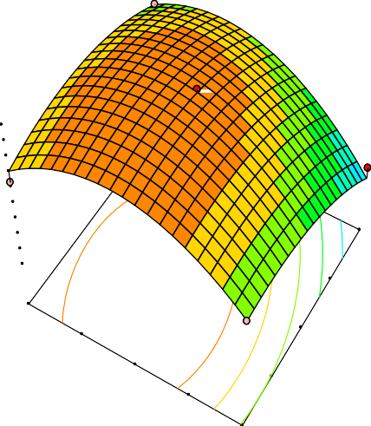

Cu Removal efficiency 93.33



6.67

X1 = A: Pectin to Chitosan ratio X2 = B: pH

96.0

Cu Removal efficiency

86.0

76.0

66.0

56.0

46.0

36.0

26.0

16.0

6.0

3.00

3.50

3.00

2.00

1.00

4.00

B: pH

4.50

5.00

A: Pectin to Chitosan ra

4.00

5.00

## Figure 4.5: Response surface plot of the interaction effect of Pectin to chitosan ratio and the pH on the PEC preparation for Cu2+ ions removal efficiency.

Figure 4.5 it was observed that an increment in the Pectin to chitosan ratio resulted in an initial increment in the Cu**2+** removal efficiency until a Pectin to chitosan ratio of 1:3 where the Cu2+ removal efficiency begins to drop this was because the polyelectrolyte complex yield increases with increase in pectin concentration in the mix (Baron *et al.,* 2016). A similar observation was noticed in terms of the pH where an initial increment in the Cu removal efficiency is noticed however this increment panned out as the pH rose above 4 this was because beyond this pH, the amine group becomes less pronated this reduces the PEC yield (Ofori-Kwakye *et al.,* 2013). A look at the interaction effect of both the Pectin to chitosan ratio and pH on the Cu removal efficiency resulted in an optimum Cu removal efficiency of 95.51 at a Pectin to chitosan ratio of 1:3.7 and pH of 3.7.

## 4.1.3.3 Effect of Interaction between process parameters involved in PEC preparation for Cr6+ ion removal efficiency

The Three-dimensional response surfaces plots are plotted on the basis of the generated model equation to investigate the interaction among the variables and to determine the optimum condition for the process parameters involved in PEC preparation for Cr**6+** removal efficiency.

Design-Expert® Softw are

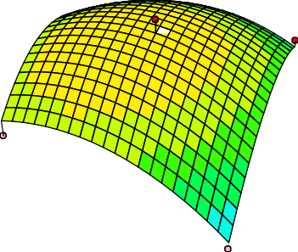

Cr Removal efficiency 73.33



5.91

X1 = A: Pectin to Chitosan ratio X2 = B: pH

74

Cr Removal efficiency

56.75

39.5

1.00

22.25 2.00

5

3.00

3.50

4.00

B: pH

4.50

5.00

3.00

A: Pectin to Chitosan

4.00

5.00

## Figure 4.6: Response surface plot of the interaction effect of Pectin to chitosan ratio and the pH on the PEC preparation for Cr Removal efficiency.

From Figure 4.4 A look at the interaction effect of both the Pectin to chitosan ratio and pH on the Cr Removal efficiency result shows that at a pH between 3 and 5 the chromuim removal is high, this was because at this pH both the amine and coborxylate group was completely dissociated thereby leading to the formation of a stable PEC (Ofori-Kwakye *et al.,* 2013) and at a ratio of pectin to chitosan of 1:3, the removal effeicieny of chromium beings to increase due to the fact that at a higher pectin concentration in the mix, a stable complex is formed ( Baron *et al.,* 2016). (in an optimum Cr removal efficiency of 66.94 at a Pectin to chitosan ratio of 1:3.32 and pH of 3.79.

## PEC Characterisation

* + 1. **Fourier transform infrared spectra (FT-IR) analysis of PEC 4.2 PEC Characterization**

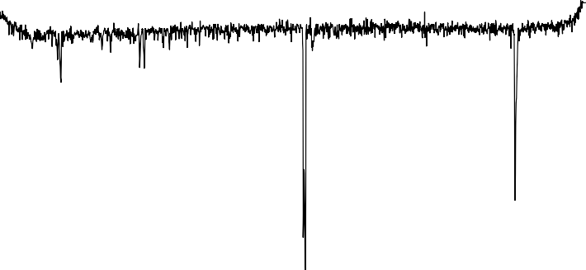

30

25

20

15

10

5

0

0

500

1000

1500

2000

2500

3000

3500

Wave Number

% Transmittane

## Figure 4.7: Fourier Transform Infrared Spectra (FT-IR) Analysis of PEC

The spectrum observed in the region between 1600 – 1800 cm-1 is indicative of the presence of the overlapping bands of amide and carboxylic groups in the interacting molecule as reported by Archana *et al.,* (2013). Furthermore Wang *et al.,* (2017) reported that the spectrum observed in these region (1600 – 1800 cm-1) is indicative of electrostatic interactions that have occurred in the pectin chitosan complex. The presence of bands at 2880 cm-1 can be attributed to the presence of –NH groups from the chitosan (Coimbra *et al.,* 2011).

## Scanning electron microscopy (SEM) analysis of PEC

The PEC produced from pectin/chitosan blend presented certain structural discontinuities shown as cracks and roughness along the entire surface(Baron *et al.,* 2017) . The surface morphology of PEC produced presented intermediary texture, The microstructure of the developed films was compact, without phase separation, and presented rough microsphere as a result of pectin content (Baron *et al.,,* (2017).

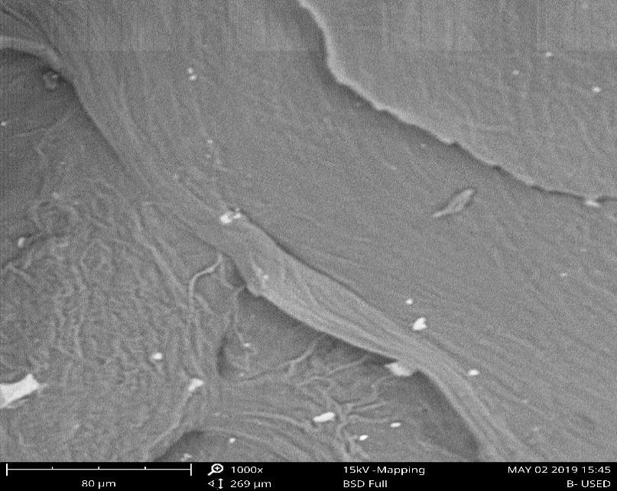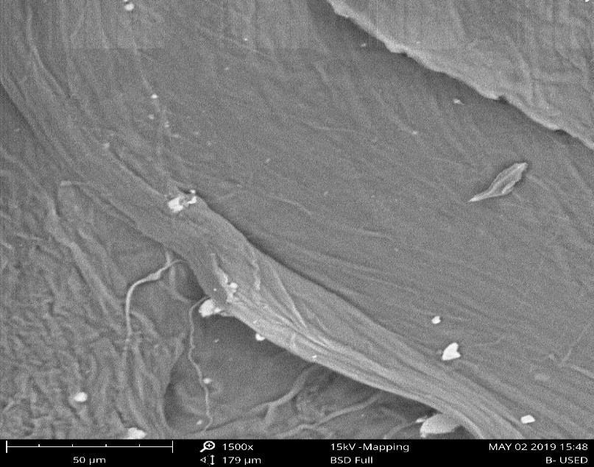

## A (500X) B (1000X)

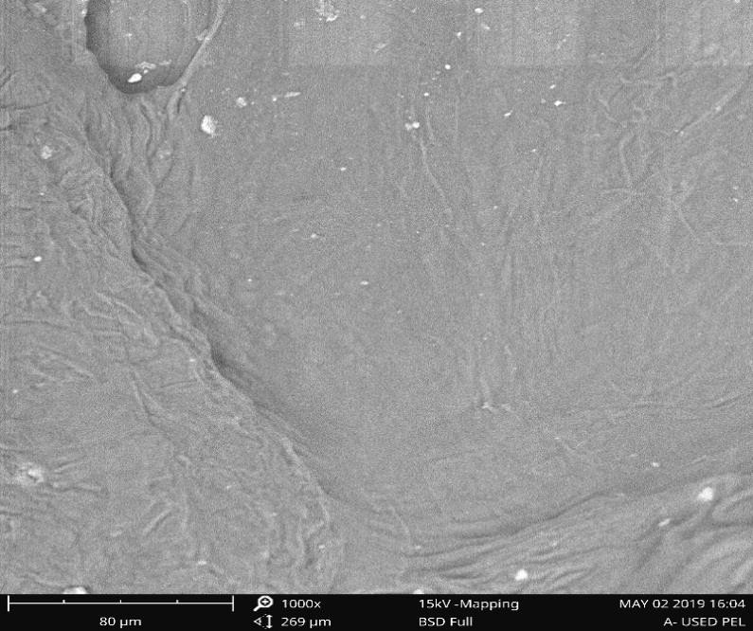

**C (1500X)**

## Figure 4.8: SEM micrograph of unused Adsorbent

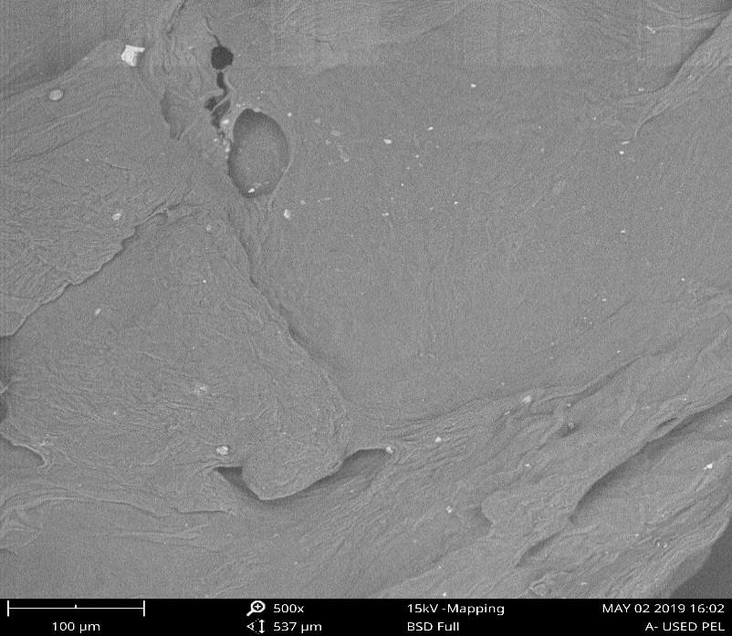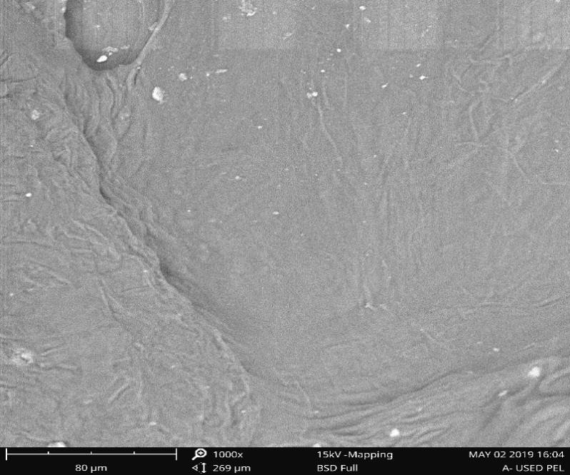The microsphere presented in Figure 4.8d, e, f is the different magnification of the spent adsorbent.

## D (500X) E (1000X)

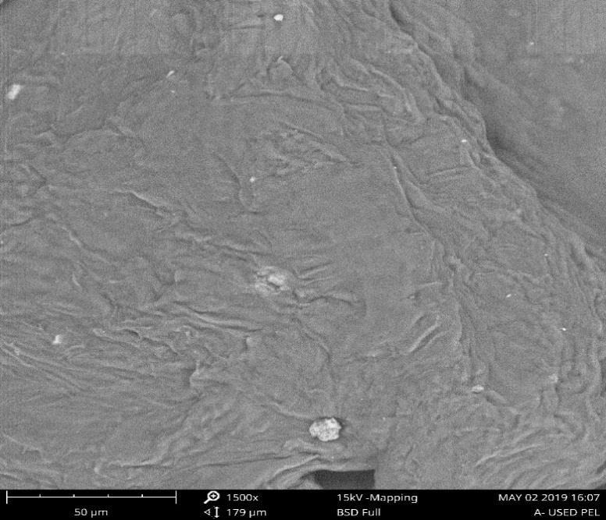

**F (1500X)**

## 4.8: SEM micrograph of Spent Adsorbent

## X-ray diffraction (XRD) spectrometry

800

700

600

500

Intensity (ounts)

400

300

200

100

0

0 10 20 30 40 50 60 70 80

2-Theta (degrees)

## Figure 4.9a: X-ray diffraction (XRD) spectrometry of A (PEC)

1200

1000

800

Intensity (ounts)

600

400

200

0

0 10 20 30 40 50 60 70 80

2-Theta (Degrees)

## Figure 4.9b: X-ray Diffraction (XRD) spectrometry of (Spent PEC)

The XRD pattern shown in Figure 4.8 is consistent to that reported by Marcia *et al.* (2015) where there are no sharp peaks indicating the PEC is amorphous in nature, this might be due to the preparation method of heating the PEC. (The characteristic peaks observed are representative of the chitosan and the pectin compounds with the peak at

21 o and ascribed as characteristic peak for PEC. The increase in the XRD peaks after the adsorption process is due to the formation of composites between the adsorbed heavy metals and the PEC

## Brunauer Emmet Teller (BET) analysis of PEC

The surface area pore size and pore volume were determined by Brunauer Emmet Teller (BET) Surface Area Analysis.

## Table 4.4: BET analysis result for PEC

|  |  |  |  |
| --- | --- | --- | --- |
| Samples | Surface area (m2/g) | Pore volume  (cc/g) | Pore size  (nm) |
| PEC | 377.016 | 0.2269 | 2.118 |

The BET was used to determine the pore volume and surface area of composite. About 3g of Pectin/chitosan composite was used for BET analysis. Before analysis, the specimens were degassed at 100 oC for 5 h. The surface area was calculated using multipoint BET methods. The specific surface area (SBET) was calculated as 377.016 m2 g-1. Moreover, pore volume and mean pore size were found to be 0.2269 cc/g and

2.118 nm respectively. The pore size distribution in the micropore (0–2 nm), mesopore (2–50 nm), and the macropore (50–300 nm) diameter range (Karaer *et al.,* 2017). According to BET results, diameter pores of composite show microspore.

## Batch Adsorption Study

The batch adsorption study was carried out where the parameters investigated include the adsorbent dosage, adsorption temperature and initial metal ion concentration. The investigation of these parameters revealed their effect on the adsorption capacity of the adsorbent.

## Effect of adsorbent dosage

The effect of the adsorbent dosage on the removal efficiency of Cr**6+** and Cu**2+** was studied at adsorbent dosages of 0.1, 0.2, 0.3, 0.4, and 0.5 g. From Figure 4.9 it was observed that the removal efficiency of the adsorbent dosage increased for both the Cr**6+** and Cu**2+** heavy metals as the adsorbent dosage increased as was observed when the adsorbent dosage was increased from 0.1g to 0.4g where further increment in the adsorbent dosage resulted to a decline in the removal efficiency rapidly due to the growing number of adsorbent process of diffusion and binding of the better adsorbate molecules on the available sites beyond this the adsorbent becomes saturated (Hastuti *et al.,* 2016)..

100.00

**Removal efficiency (%)**

80.00

60.00

40.00

20.00

0.00

Cr Cu

0 0.1 0.2 0.3 0.4 0.5 0.6



## Adsorbent Dosage

**Figure 4.10: Plot of Adsorbent Dosage against Removal efficiency**

## 4.3.2 Effect of temperature

From Figure 4.11 it was observed that as the temperature increased there was an increase in the Removal efficiency for both Cr**6+** and Cu**2+**, from 45- 60% and from 73- 89% respectively. However at a reaction temperature of 60 oC there was a decrease in the Removal efficiency of Cr**6+** and Cu**2+** ions and further increase of temperature to

90oC equilibrium was attained. The decrease in adsorption with increase in temperature, suggest weak adsorption interaction between PEC surface and metal ions because the boundary layer decreases due to the increased tendency of the metal ion to escape from the PEC surface to the solution phase (Horsfall *et al.,*2017).

100

90

80

**% Removal efficiency**

70

60

50

40

30

20

10

0

Cr Cu

0 20 40 60 80 100



## Temperature

**Figure 4.11: Plot of Temperature against Removal efficiency**

## 4.3.3 Effect of initial concentration and contact time

The effect of initial concentration of the metal ions and the contact time was investigated.



600

500

400

**Qt (m**3**g**0**/**0**g)**

200

1.221

mg/L

100

0

0

10

20 **Time**3**(**0**mins)** 40

50

60

## Figure 4.12a: Plot of effect copper initial concentration and contact time

The Figure 4.10a shows the effect of the initial copper concentration from 1–1.221 mg/L on the adsorption of copper. It was observed that amount of copper adsorbed was rapid for the first 10min and thereafter it proceeded at a slower rate (10–30 min) and finally reached saturation. The adsorption capacity Qt increased from 9.8 to 560.3 mg/g, with increase in the initial copper concentration from 1 to 1.221 mg/L. The findings are because as the initial concentration increases, the mass transfer driving force becomes larger, hence resulting in higher copper adsorption. It is also shown in Fig. 4.10a that the contact time needed for copper solution with initial concentrations of 1– 1.221 mg/L to reach equilibrium was 30 min.The initial concentration provides an important driving force to overcome all mass transfer resistances of the copper between the aqueous and solid phase. However, the experimental data were measured at 50 mins to be sure that full equilibrium was attained.

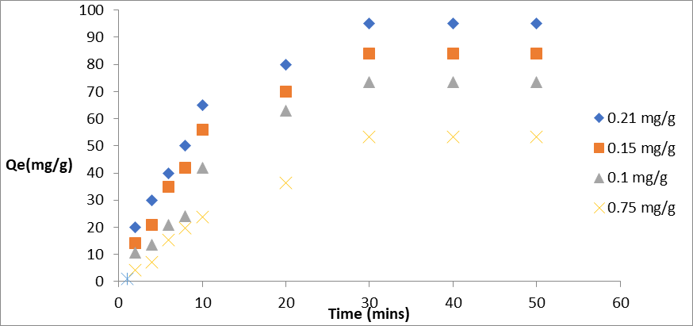

## Figure 4.12b: Plot showing effect of initial chromium concentration and contact time

The plot of Figure 4.10b shows the effect of the initial chromium concentration from (0.75–0.21 mg/L) on the adsorption of chromium. It was observed that amount of chromium adsorbed was rapid for the first 10min and thereafter it proceeded at a slower rate (10–30 min) and finally reached saturation. The adsorption capacity from figure 4.10b increased from 4.2 to 94.4 mg/g, with increase in the initial Cr6+ concentration from 0.75 to 0.21 mg/L. The findings are because as the initial concentration increases, the mass transfer driving force becomes larger, hence resulting in higher chromium adsorption. It is also shown in Figure, 4.10b that the contact time needed for copper solution with initial concentrations of 0.75– 0.21 mg/L to reach equilibrium was 30min.The initial concentration provides an important driving force to overcome all mass transfer resistances of the Cr6+ between the aqueous and solid phase. However, the experimental data were measured at 50 min to be sure that full equilibrium was attained (He *et al*. 2017).

## Well water analysis

The well water was analyzed to determine the physiochemical properties pH, Turbidity, Total Dissolved Solids, Conductivity, Dissolved Oxygen, Total Alkalinity, Nitrates and Ammonia. Table 4.5 presents parameters of the physicochemical properties of the well water after treatment

## Table 4.5: Physicochemical properties of the well water after treatment

|  |  |  |  |
| --- | --- | --- | --- |
| **Physicochemical**  **Parameters** | **Well Water Before**  **Treatment** | **Well Water After**  **Treatment** | **NSDWQ 2007** |
| pH | 7.34 | 8.0 | 6.5-8.5 |
| Color (tcu) | 5 | 5 | 15 |
| Conductivity (µS/cm) | 400.95 | 400 | 1000 |
| TDS(mg/L) | 209 | 200 | 500 |
| Temperature o C | 26.9 | 27 | Ambient |
| Total hardness(mg/L) | 74.25 | 74.25 | 150 |
| Turbidity(ntu) | 3.48 | 0.3 | 5 |
| Calcium (mg/L) | 3.75 | 3.0 | NA |
| Magnesium (mg/L) | 14.98 | 0.69 | 20 |
| Nitrate (mg/L) | 0 | 0 | 50 |
| Chlorides (mg/L) | 19.82 | 0.55 | 250 |
| Sulphate (mg/L) | 3.19 | 1.34 | 100 |
| Sodium (mg/L) | 16.01 | 5.3 | 200 |
| Copper (mg/L) | 1.221 | 0.122 | 1.0 |
| Zinc (mg/L) | 1.91 | 0.15 | 3.0 |
| Chromium (mg/L) | 0.12 | 0.011 | 0.05 |
| Lead (mg/L) | 0 | 0 | 0.01 |
| Iron (mg/L) | 0 | 0 | 0.3 |

Source: Laboratory Analysis, 2019, NA: Not available, S – Statistically Significant, NS- Not Statistically Significant

## Equilibruim Study

## Adsorption isotherm

The adsorption isotherm was used to describe to the equilibrium process, where the freundlich, Langmuir, Temkin and Dubinin-Radushkevich isotherms were used.

## Freundlich model

The Freundlich model gives an empirical relationship that describes the adsorption of solutes from a liquid to a solid surface and assumes that the adsorbent surface is heterogeneous, the adsorbate adsorption is multi-layered, and there is interaction between adsorbents (Jiang *et al.,* 2019). The Freundlich adsorption isotherm is the relationship between the amounts of contaminant adsorbed per unit mass of adsorbent, qe and the concentration of the contaminant at equilibrium, Ce. (Bolade & Sangodoyin, 2018; Adewoye *et al.,,* 2017). The Freundlich isotherms in table 4.6 shows constant Kf and n are the adsorption capacity and intensity of the adsorption process. The value of 17.3980 and 0.9692 which represent the adsorption intensity and capacity for Cu**2+** ion indicates that the adsorbent is selective towards copper as such preferentially favoring its adsorption unlike Cr6+ with adsorption capacity and intensity of 2.5942 and 0.8449 respectively. The correlation values (R2) obtained for the Freundlich isotherm in the adsorption of Cr6+ and Cu2+ ions are 0.9498 and 0.8117 respectively. Figure 4.13 Shows Freundlich plot where Kf, n and R2 was generated.

## Langmuir model

The Langmuir model as reported by (Jiang *et al.* 2019), that this isotherm posits that the maximum adsorption occurs when a saturated monolayer of solute molecules is present on the adsorbent surface, the energy of adsorption is constant and that there is no

migration of adsorbate molecules in the surface plane. Once the surface is covered by a layer of adsorbate molecules, the force field will be saturated and the adsorption will not occur, so the adsorption is monolayer adsorption. From the Langmuir model it was observed that the adsorption was favorable in that the obtained RL for both Cr**6+** and Cu**2+** was less than 1 (Jiang *et al.,* 2019). However, the adsorption process based on the Langmuir model is favorable towards Cu2+ in that its RL value of 0.9440 is much lower than that of Cr**6+**. However, the correlation coefficient (R2) of 0.9477 and 0.9514 obtained for the Langmuir isotherm (which indicates monolayer adsorption) are much higher than those obtained when the freundlich isotherm is considered. This correlation coefficient posits that the adsorption process is favorable towards the Langmuir isotherm model than the Freundlich isotherm. Figure 4.14 shows the Langmuir plot where RL, R2 and Qm was generated.

## Temkin model

Temkin adsorption isotherm model discussed the interaction between adsorbent and adsorbate, assuming that the heat of adsorption decreases with the degree of adsorption process. The Temkin parameters, k1 and k2, together with the correlation coefficients, R2, corresponding to each Cr6+ and Cu2+ions. The values of R2 are, again, very close to1, indicating that all the isotherms are very well fitted. This parameter is presented in Table 4.6. The Figure 4.15 a and b Shows the Temkin plot where the Temkin parameters where generated from.

## Dubinin-Radushkevich

It is pointed out that the adsorption space on the adsorbent surface is constant, and the adsorption potential is independent of temperature. The parameters are presented in

table 4.6. Dubinin-Radushkevich plot was presented in Figure 4.16 a and b to show the fit between experimental and predicted values.

Table 4.6 presents isotherms parameters for Freunlich, Langmuir, Temkin and Dubinin.

## Table 4.6 Showing isotherm parameters for Freunlich, Langmuir, Temkin and Dubinin.

|  |  |  |
| --- | --- | --- |
| **Isotherm parameters** | **Copper** | **Chromium** |
| **Freundlich Isotherm** |  |  |
| **Kf** | 17.3980 | 2.5942 |
| **N** | 0.9692 | 0.8449 |
| **R2** | 0.8855 | 0.9498 |
| **ᵪ2** | 49.35 | 5.72 |
| **Langmuir Isotherm** |  |  |
| **Qm (mg/g)** | 333.3333 | 270.2703 |
| **Kl** | 0.0485 | 0.0293 |
| **RL** | 0.9440 | 0.9964 |
| **R2** | 0.9477 | 0.9514 |
| **ᵪ2** | 3.23 | 4.10 |
| **Temkin isotherm** |  |  |
| **Qe (mg/g)** | 1.3681 | 0.1152 |
| **K1** | 2.5685 | 0.2118 |
| **K2** | 8.134 | 11.757 |
| **R2** | 0.7593 | 0.924 |
| **ᵪ2** | 4.90 | 0.88 |
| **Dubinin-Radushkevich (D-R)** | | |
| **β (mol2 KJ-2)** | 7*E-8 | 3*E-6 |
| **Ξ** | 165.8 | 221.399 |
| **Qm (mg g-1)** | 2.04 | 1.38 |
| **Qe (mg g-1)** | 1.345 | 1.335 |
| **R2** | 0.7287 | 0.941 |
| **ᵪ2** | 8.19 | 4.96 |

The correlation constant R2 for copper and chromium ion for each model is 0.8855 and 0.9498, 0.9477 and 0.9514, 0.7593 and 0.924, 0.7287 and 0.941 respectively. This result showed that the adsorption process was well fitted for Langmuir. The x2 values for PEC were calculated and tabulated in Table 4.6. The lower x2-values of the Langmuir than Freundlich, Temkin, and Dubinin isotherm suggest the better applicability for the Cr

(VI) and Cu(II) ions adsorption of PEC. Which confirms the correlation constant R2 (Kirthik *et al*. 2014).

## Adsorption Kinetics study

The adsorption kinetics is the measure of the adsorption uptake with respect to time at a constant concentration and it is employed to measure the diffusion of adsorbates in the pores.

## Pseudo first-order kinetic

The pseudo first-order kinetic model is based on the membrane diffusion theory, and it is considered that the adsorption reaction rate of the adsorbate is proportional to the square of the difference between the equilibrium adsorption amounts in the system. The parameters are presented in Table 4.7. Figure 4.16 shows plot for pseudo first-order kinetic.

## Pseudo-second order kinetic

The pseudo-second order kinetic model is established on the adsorption rate limiting step, including the adsorption mechanism, electron sharing or electron transfer between the adsorbate and the adsorbent. The degree to which the correlation coefficient (R2) is close to 1 reflects the closeness of the actual situation to the model. The parameters are presented in Table 4.7. Figure 4.17 shows the plot for pseudo-second order kinetic.

## Elovich kinetic model

Elovich’s equation has also been used for describing successfully the adsorption of pollutants from aqueous solutions in recent years. If the equation applies, it should lead to a straight line by plotting qt as a function of ln t. from figure 4.18 a and b It shows that it was not a perfect fit because it was not a straight-line graph (Jiang *et al*. 2018). The parameters are presented in Table 4.7

## Intra particle kinetic model

The Weber–Morris plot of qt versus t1/2 gives a straight line, then the sorption process is controlled by intra-particle diffusion. However, if the data exhibit multi-linear plots, then two or more steps influence the sorption process (Fierro *et al*. 2018). From the plot in figure 4.19 a and b, It showed that the sorption process is not controlled by intra- particle diffusion because it was not a straight line graph (Fierro *et al*. 2018). The parameters are presented in Table 4.7.

## Table 4.7: Pseudo – First order, Pseudo – second order, Elovich and Intra particle kinetics for the adsorption of Cr6+ and Cu2+

|  |  |  |
| --- | --- | --- |
| **Heavy metals** | **Cr6+** | **Cu2+** |
| **Pseudo first order kinetics** |  |  |
| Qe (mg/g) | 0.1107 | 1.2180 |
| k1 (mg/mg min-1) | 0.0905 | 0.0841 |
| R2 | 0.9618 | 0.9864 |
| **Pseudo second order kinetics** |  |  |
| Qe (mg/g) | 0.4034 | 9.8446 |
| k2 (mg/mg min-1) | 0.4034 | 2.1903 |
| R2 | 0.9989 | 0.9926 |
| **Elovich kinetics** |  |  |
| 1 (mg/g)  𝖰 | 22.086 | 142.16 |
| α (mg/(mgmin) | 48.46 | 274.75 |
| R2 | 0.9325 | 0.9371 |
| **Intra particle diffusion kinetics** | | |
| kid (mg/(mgmin1/2) | 1.4054 | 3.9268 |
| Θ (mg/g) | 5.5158 | 29.431 |
| R2 | 0.7663 | 0.9354 |

Table 4.7 gathers the parameters derived from the application of the pseudo first-order equation (ke and k1), of Elovich’s equation (α and β), of the pseudo second-order kinetic model (k and qe), and intra particle diffusion model. For each case, the corresponding correlation coefficients, R2, for Cu (II) were found to be 0.9864, 0.9926, 0.9371, and 0.9354 respectively. That of Cr (VI) was found to be 0.9618, 0.9989, 0.9325, and 0.7663 respectively. Pseudo second order model had the highest R2 for both

metal ions. Therefore, the sorption kinetics can be very satisfactorily approximated by a pseudo second-order model for all the investigated materials. Such a finding is also in good agreement with previous studies, were chitosan was used as a polyelectrolyte (Yan *et al.,* 2011; Jiang *et al.,* 2018). The pseudo-second kinetic model is established on the adsorption rate limiting step, including the adsorption mechanism, electron sharing or electron transfer between the adsorbate and the adsorbent (Jiang *et al.,* 2018).

## 4.7.1 Adsorption thermodynamics study

The thermodynamics parameters enhance the study of the feasibility of the adsorption process. The thermodynamic parameter’s in the adsorption of Cu2+ and Cr6+ was presented in Table 4.8. Figure 4.20 shows the thermodynamic plots where parameters where generated.

## Table 4.8 Thermodynamics parameters in the adsorption of Cr6+ and Cu2+

|  |  |  |  |  |
| --- | --- | --- | --- | --- |
| Temperature (K) | K c  (L.g-1) | ∆Go  kj.mol-1 | ∆Ho  kj.mol-1 | ∆So  j.mol-1.K-1 |
| Chromium (Cr) |  |  |  |  |
| 318 | 1.2222 | -0.5306 |  |  |
| 333 | 1.9412 | -1.8364 | 51.4666 |  |
| 348 | 7.3333 | -5.7648 |  | 0.1625 |
| 363 | 11.5000 | -7.3711 |  |  |
| Copper (Cu) |  |  |  |  |
| 318 | 1.0833 | -0.2116 |  |  |
| 333 | 1.5641 | -1.2384 | 53.3871 | 0.1674 |
| 348 | 8.0909 | -6.0492 |  |  |
| 363 | 10.1111 | -6.9827 |  |  |

The thermodynamics data revealed that the adsorption process is feasible and spontaneous because of the negative (∆Go) values obtained from the adsorption

thermodynamics study of both Cr6+ and Cu unto the PEC adsorbent (Suresh *et al.,* 2010). The (ΔSo) is indicative of the degree of freedom of the adsorbed species where a positive value indicates an increase in the degree of freedom of the adsorbed species. The positive (ΔHo) indicate the adsorption process is endothermic in nature. According to Boparai *et al.,,* (2010) the (ΔHo) values are used to determine if the adsorption process is governed by chemisorption (where a chemical bond is formed between adsorbate molecules and the surface of the adsorbent) or physiosorption (where there is no chemical bond formed between adsorbate molecules and the surface of the adsorbent). (ΔHo) range of (5 to 40) kJ.mol-1 is for physiosorption while the range of (40 to 800) kJ.mol-1 is by chemisorption (Boparai *et al.,,* 2010). The (ΔHo) values obtained indicate the adsorption process is governed by chemisorption.

## CHAPTER FIVE

## CONCLUSION AND RECOMMENDATIONS

## Conclusion

Polyelectrolyte complex-based adsorbent from chitosan/pectin composite was successfully prepared by a high-efficiency, environmentally friendly, easy method. The response surface plot of the interaction effect of Pectin to chitosan ratio and the pH on the PEC preparation for the removal of both Cu2+ and Cr6+ gave optimum values for pectin to chitosan ratio to be 1:3.32 and pH of 3.79. The FTIR should that the OH from the carboxylate group and NH2 were the functional group BET indicated that the PEC had a microspore with surface area of 377m2/g. the PEC was completely amorphous from the image of XRD with a rough surface. The adsorption process of Cu2+ and Cr6+ took place on homogeneous surface. The maximum of adsorption capacities at 60 ºC for Cu2+ and Cr6+ were 333.33 mg/g and 270.27 mg/g respectively when the initial concentration was 1.221 mg/L and 0.12 mg/L respectively. The heavy metals adsorption process on the surface of the pectin/chitosan composite was demonstrated to be an endothermic, chemical monolayer adsorption and spontaneous process. The H+ ions on hydroxyl groups exchanged with heavy metal ions and electrostatic interactions worked together during the adsorption process. This study proved that the pectin/chitosan composite could be developed into a kind of effective adsorbent for Cu2+ and Cr6+.

## Recommendations

1. Desorption studies should be carried to determine the number of circles pectin/chitosan composite can be effective.
2. The effect of swelling capacity on adsorption should be carried out.
3. Research in the presence of impurities such as Na+, Mg2+ and Ca2+ should be carried out To investigate practical applications, of the effects of Na+, Mg2+ and Ca2+ on adsorption in the use of PEC for the removal of heavy metals.

## REFERENCES

Abd El-Mohdy. H.L.Hegazy. E.A. El-Nesr. E.M. & El-Waha.M.A. (2013). Metal sorption behavior of poly(N-vinyl-2-pyrrolidone)/(acrylic acid-co-styrene) hydrogels synthesized by gamma radiation, *Journal of Environmental Chemical Engineering*, 1(6), 328–338,

Adewoye, L.T., Mustapha, S.I., Adeniyi, A.G., Tijani, J.O., Amoloye, M.A. & Ayinde,

L.J. (2017). Optimization of nickel (ii) and chromium (iii) removal from contaminated water using sorghum bicolor. *Nigerian Journal of Technology (NIJOTECH),* 36(3), 960 – 972.

Adiotomre KO. (2015). Production of bioethanol as an alternative source of fuel using cassava and yam peels as raw materials. *International Journal of Innovation, Science, engineering and technology.* 3(2), 28-44.

Ambali, A.B., Evbuomwan, B.O. & Momoh, Y. (2015). Comparative Study on the adsorption capacity of Snail and Periwinkle Shells for the removal of Nickel (Ni) ion from aqueous solution. *International Journal of Geology, Agriculture and Environmental Sciences,* 3(1), 39 – 50.

Ana, G. R. E. E., Oloruntoba, E. O., *Shendell*, D., Elemile, O. O., Benjamin, O. R. and Sridhar, M.K.C., (2011). Solid waste management problems in secondary schools in Ibadan, Nigeria. *Journal of Environmental Health*. 74 (2), 24–29.

APHA (1998). Standard Methods for the examination of water and waste water American Public Health Association. American Water Works Association and Water Environmental Federation, Washington DC. 874pp

Archana, D., Upadhyay, L., Tewari, R.P., Dutta, J., Huang, Y.B. & Dutta, P.K. (2013). chitosan pectin alginate as a novel scaffold for tissue engineering application. *Indian Journal of Biotechnology,* 12(1), 475 – 482

Arie, A.A., Kristianto, H. & Apecsiana, F. (2018). Adsorption of Cu (II) from Aqueous Solution by Salacca Peel Based Activated Carbons. *Journal of Chemistry and Applied Chemical Engineering,* 2(1), 1 – 9.

Baron, R.D., Perez, L.L., Salcedo, J.M., Cordoba, L.P. & Amaral., P.J. (2017). Production and characterization of films based on blends of chitosan from blue crab *(Callinectes sapidus)* waste and pectin from Orange *(Citrus sinensis Osbeck)* peel. *International Journal of Biological Macromolecules,* 1(1), 1 – 26

Basheer, A. (2018). New generation nano-adsorbents for the removal of emerging contaminants in water. *Journal of Molecular Liquids,* 1(1), 1 – 41.

Bolade Oladipo O & Sangodoyin Abimbola Y. (2018). Adsorption and Equilibrium Studies of Textile Effluent Treatmentwith Activated Snail Shell Carbon. *Journal of Environmental Science, Toxicology and Food Technology* 12(4), 26- 33.

Boparai, H.J., Joseph, M. & Denis, M. (2011). Kinetics and thermodynamics of cadmium ion removal by adsorption onto nano zerovalent iron particles. *International Journal of Material science and Engineering,* 4(5), 11 – 15.

Chen, H., Xie, A. & You, S. (2018). A Review: Advances on Absorption of Heavy Metals in the Waste Water by Biochar. *International Journal of Material science and Engineering,* 1(1), 1 – 5.

Chirani, N., Yahia, L., Motta, F.L., Chirani, S. & Faré, S. (2015). History and Applications of Hydrogels. *Journal of Biomedical Sciences,* 4(2), 1 – 24.

Coimbra. P, P. Ferreiraa, H.C. de Sousaa, P. Batista, M.A. Rodrigues, I.J. Correia &

M.H. Gil. (2011). Preparation and chemical and biological characterization of a pectin/chitosan polyelectrolyte complex scaffold for possible bone tissue engineering applications. *International Journal of biological Macromolecules,* 4 (8), 112–118.

Czikkely, M., Neubauer, E., Fekete, I., Ymeri, P. & Fogarassy, C. (2018). Review of Heavy Metal Adsorption Processes by Several Organic Matters from Wastewaters. *Journal of water,* 10(1), 1 – 15.

Han Yan, Jie Dai, Zhen Yang, Hu Yang, & Rongshi Cheng (2011). Enhanced and selective adsorption of copper (II) ions on surface carboxymethylated chitosan hydrogel beads. *Chemical Engineering Journal.* 1(74)586– 594.

Hastuti, B., Mudasir, C., Siswanta, D., & Triyono, A. (2016). The preparation of polyelectrolyte complexes carboxymethyl chitosan (CMC)-pectin by reflux method as a Pb (II) metal ion adsorbent. *6th Nanoscience and Nanotechnology Symposium.* 4(6), 1 – 7.

Hatice Karaer & Ismet Kaya (2017). Synthesis, characterization and a polysaccharide composite hydrogel based on crosslinked glucan/chitosan for heavy metal ions. Composites Part B.

Jiang C, Wang X, Wang G, Hao C, Li X, Li T. (2019). Adsorption performance of a polysaccharide composite hydrogel based on crosslinked glucan/chitosan for heavy metal ions. *Composites Part B.* 4(2), 11 – 16

Junyong He, Yulian Li, Chengming Wang, Kaisheng Zhang, Dongyue Lin, Lingtao Kong, Jinhuai Liu. (2017). Rapid adsorption of Pb, Cu and Cd from aqueous solutions by cyclodextrin polymers. *Journal of Applied Surface Science*. 4(2), 12–18

Lessa, E.F., Gularte, M.S., Garcia, E.S., Fajardo, A.R., 2016. Orange waste: a valuable carbohydrate source for the development of beads with enhanced adsorption properties for cationic dyes. *Carbohydrate Polymer*. 57(9), 660–668.

Marcia Parente Melo da., Ferreira, Ivana Lourenc¸o de Mello., & Cruz, Mauricio Tavares de Macedo. (2015). New polyelectrolyte complex from pectin/chitosan and montmorillonite clay. *Journal of Carbohydrate polymer science*. 7(3), 15– 19

Micheal Horsfall jnr & ayebaemi I.Spiff. (2017). Effects of temperature of Pb2+ and Cd2+ from aqueous solution by caladium bicolor (wild cocyam) bomass. *Journal of biotechnonlogy*, 8(2), 112 – 121

Radaideh, J.A., Abdulgader, H.A. & Barjenbruch, M. (2017). Evaluation of Absorption Process for Heavy Metals Removal found in Pharmaceutical Wastewater. *Journal of Medical Toxicology and Clinical Forensic Medicine,* 3(2), 1 – 12.

Ramos-Jacques, A.L, Lujan-Montelongo, J.A, Silva-Cuevas, C, Cortez-Valadez, M., Estevez, A. & Hernandez-Martínez, M. (2018). Lead(II) removal by poly(N,N- dimethylacrylamide-co-2-hydroxyethylmethacrylate).*European Polymer Journal,*10(1), 262–272.

Sabino, D.G., Lofrano, G., Grassi, M., Notarnicola, M., (2016). Characteristics and adsorption capacities of low-cost sorbents for wastewater treatment: A review. *Sustainable Materials and Technologies,* 9(2), 10 – 40.

Singh, N. & Gupta, S.K. (2016). Adsorption of Heavy Metals: A Review. *International Journal of Innovative Research in Science, Engineering and Technology,* 5(2), 2267 – 2281.

Suresh, S. Srivastava, V.C. & Mishra, I.M. (2010). Isotherm, Thermodynamics, Desorption, and Disposal Study for the Adsorption of Catechol and Resorcinol onto Granular Activated Carbon. *Journal of Chemical & Engineering Data.* 56(1), 811 – 818

Teow Y.H, Ming K.L, Mohammad A.W. (2018). Synthesis of cellulose hydrogel for copper (II) ions adsorption, *Journal of Environmental Chemical Engineering*. 9(2), 10 – 40.

Venkata S. Meka. (2018). A comprehensive review on polyelectrolyte complexes, *Drug Discovery Today* 22(11), 120-125

W. Wang, Y. Kang, A. Wang. (2013). One-step fabrication in aqueous solution of a granular alginate-based hydrogel for fast and efficient removal of heavy metal ions. *Journal of Polymer Research,* 20(3), 1-10.

Yin N, Wang K, Xia YA, Li Z. Novel melamine modified metal-organic frameworks for remarkably high removal of heavy metal Pb (II). *Desalination*, ( 4)3,120- 127.

Zetty Azalea Sutirman, Mohd Marsin Sanag, Khairil Juhanni Abd Karim, Ahmedy Abu Naim, & Wan Aini Wan Ibrahim. (2018). Chitosan-Based Adsorbents for The Removal Of Metal Ions From Aqueous Solutions. *Malaysian Journal of Analytical Sciences,* 22(5) 39 –50.

Zhang, Dongyue Lin, Lingtao Kong, & Jinhuai Liu. (2017). Rapid adsorption of Pb, Cu and Cd from aqueous solutions by-cyclodextrin polymers. *Applied Surface, Science.* 4(2), 1 – 4.

Zhao B, Jiang H, Lin Z, Xu S, Xie J, Zhang A. (2019). Preparation of Acrylamide/Acrylic Acid Cellulose Hydrogels for the Adsorption of Heavy Metal Ions, *Carbohydrate Polymers.* 21(5), 11-17

## APPENDIX

Design-Expert® Softw are Cu Removal efficiency

Color points by value of Cu Removal efficiency :



93.3

94.00

# Predicted vs. Actual

3

6.7

72.00

50.00

28.00

6.00

6.67 28.34 50.00 71.67 93.33

X: Actual Y: Predicted

## Figure 4.3: Parity plot showing Cu(II) removal

Design-Expert® Softw are Cr Removal efficiency

Color points by value of Cr Removal efficiency :



73.33

74.00

# Predicted vs. Actual

3

5.91

56.75

39.50

22.25

5.00

5.91 22.77 39.62 56.47 73.33

X: Actual Y: Predicted

## Figure 4.4: Parity plot showing Cr(VI) removal

**Plots showing Isothermal models**

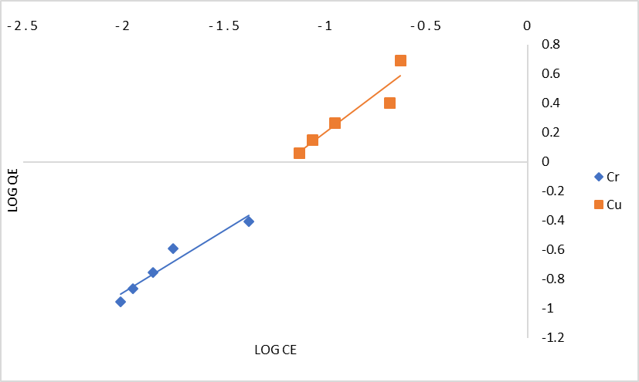

## Figure 4.13 Freundlich Isotherms for the adsorption of Cr6+ and Cu2+

9



8

7

6

5

1/QE

Cr

4

Cu

3

2

1

0

0 20 40 60 80 100 120

1/CE

## Figure 4.14 Langmuir Isotherms for the adsorption of Cr6+ and Cu2+



6

5

y = 2.5685x + 7.6856

R² = 0.7593

4

**Qe (mg/g)**

3

Series1

2

Linear (Series1)

1

0

-3

-2.5

-2

-1.5

-1

-0.5

0

**Ln Ce (mg/L)**

**Figure 4. 15a. Temkin plot of Cu2+ removal**

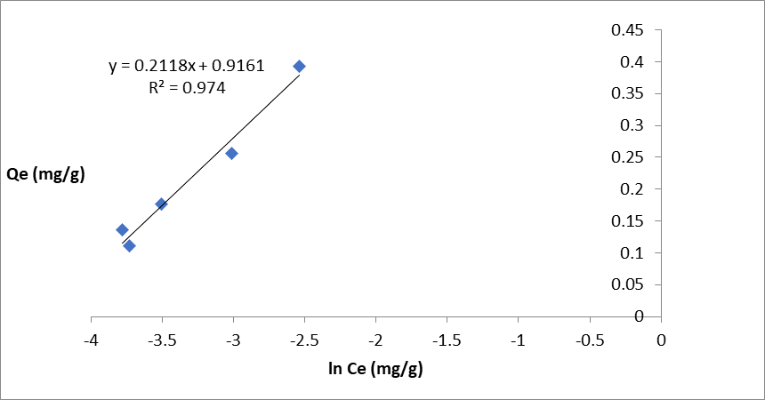

## Figure 4.15b Temkin plot of Cr6+ removal

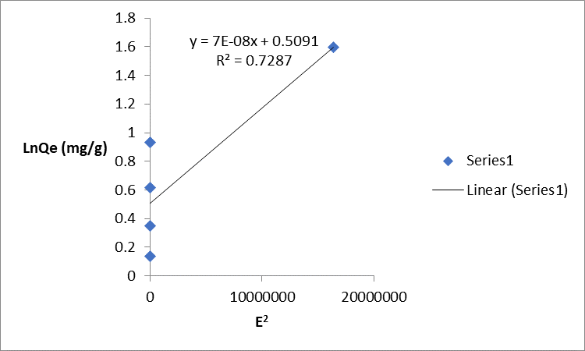

**Figure 4.16a Dubinin-Radushkevich plot for Cu2+ removal**

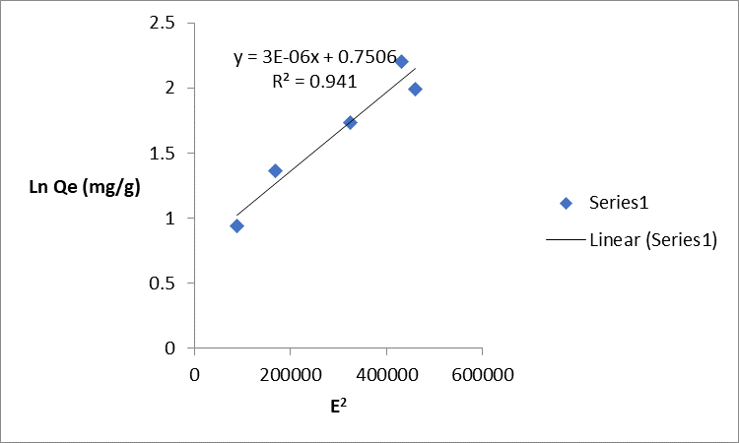

## Figure 4.16b Dubinin-Radushkevich plot for chromium removal

**Plots showing Kinetic models**

0 10 20

1



T (MINS3)0 40 50 60

0.5

0

LOG (QE - QT)

Cu

-0.5

Cr

-1

-1.5

-2

-2.5

## Figure 4.17a Pseudo – first order kinetic model for the adsorption of Cr6+ and Cu2+

600



500

400

300

T/QT

Cu

200 Cr

100

0

0 10 20 30 40 50 60

T (MINS)

## Figure 4.17b: Pseudo – Second order kinetic model for the adsorption of Cr6+ and Cu2+



700

600

500

**Qt (mg/g))**

400

300

200

100

0

y = 142.16x + 93.675

R² = 0.9325

0 1 2 3 4 5

**t0.5 (mins)**

**Figure 4.18a: Elovich kinetic model for the adsorption of Cu**

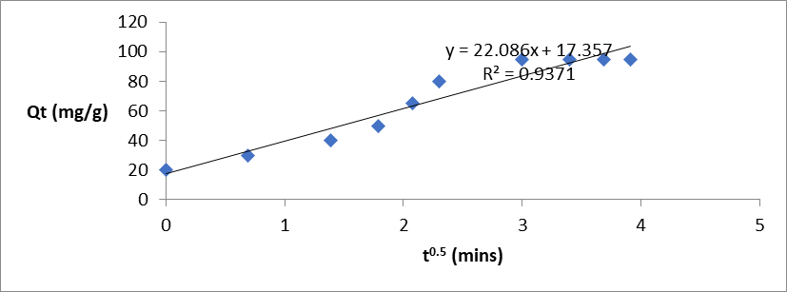

## Figure 4.18b: Elovich kinetic model for the adsorption of Cr6+

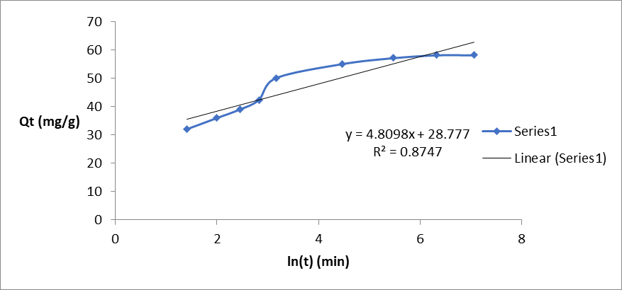

**Figure 4.19a: Intra particle kinetic model for the adsorption of Cr6+**

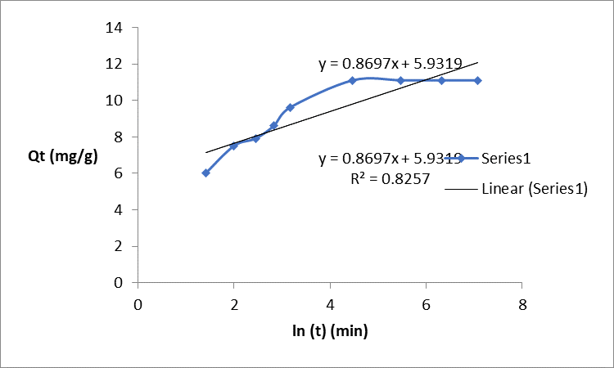

Figure 4.19b: Intra particle kinetic model for the adsorption of **Cr6+**

2.50



2.00

1.50

Cr

Ln Kc

1.00

Cu

0.50

0.00

0.0027 0.0028 0.0029 0.0030 0.0031 0.0032

1/T K-1

Figure 4.20: Plot of adsorption equilibrium constant (Kc) against temperature (T) for the adsorption of Cr and Cu.