### A SURVEY OF TEACHERS’ AWARENESS AND USE OF ASSISTIVE TECHNOLOGY IN TEACHING CHILDREN WITH SPECIAL NEEDS IN NORTH CENTRAL NIGERIA

i

ABANI GWANSHAK SHIKDEN B.ED; M.ED (Jos) PGED/UJ/00191/07

### A thesis in the Department of SPECIAL EDUCATION AND REHABILITATION SCIENCES, Faculty of Education,

**Submitted to the School of Postgraduate Studies, University of Jos, in partial fulfilment of the requirements for the award of the degree of**

### DOCTOR OF PHILOSOPHY in SPECIAL EDUCATION (Visual Impairment) of the UNIVERSITY OF JOS

**JUNE 2015**

### DECLARATION

I hereby declare that this work “A Survey of Teachers’ Awareness and Use of Assistive Technology in Teaching Children with Special Needs in North Central Nigeria” is the product of my own research efforts; undertaken under the supervision of Professor Izuka John Ihenacho and has not been presented elsewhere for the award of a degree or certificate. All sources have been duly distinguished and appropriately acknowledged.

……………………….……………. **ABANI GWANSHAK SHIKDEN** PGED/UJ/00191/07

### CERTIFICATION

This is to certify that the research work for this thesis and the subsequent preparation for this thesis by Abani Gwanshak Shikden (PGED/UJ/00191/07) were carried out under my supervision.

….……………………………………… ………………....

### Prof. Izuka John Ihenacho Date

Supervisor, Department of Special Education And Rehabilitation Sciences, University of Jos

….……………………………………… ………………....

### Prof. Peter Ifeanyi Osuorji Date

H.O.D, Special Education And Rehabilitation Sciences, University of Jos

….……………………………………… ………………....

### Prof. Cletus Tanimu Gotan Date

Dean, Faculty of Education, University of Jos

### ACKNOWLEDGEMENTS

The completion of this thesis was not the result of my individual effort alone. Many persons made significant contributions to this process and I would not have been successful without their love and support. Words are inadequate in expressing my heartfelt gratitude to everyone who helped make this a reality.

First, I must say thank you to Professor Izuka John Ihenacho, my supervisor, who was never tired of reading and correcting my work. Thank you for your patience and words of encouragement; these kept me moving from one stage to the other. I also received love and encouragement from Prof. Peter Ifeanyi Osuorji and Dr. James Nuhu Bature who responded to this work during the first and second seminar presentations; Dr. (Mrs) Anne Okwudire and Dr (Mrs) Georgina Chinyere Imo who chaired my first and second seminar presentations respectively. To Prof. Timothy Oyetunde, the former faculty P.G. coordinator, I say thank you. This work would not have been successfully completed without the comments and contributions of all these people. Dr. Isaiah Elemukan, Prof. Emeka Desmond Ozoji, and Dr (Mrs) Gladys Babudoh, your contributions helped a lot in bringing this work to completion; God bless you all abundantly. A special thanks to the late Prof. (Mrs.) Charity Ashelo Andzayi, Dr. (Mrs) Bolchit Dala and Dr.Yusuf Mustapha who worked tirelessly during the upgrading interview, the Lord bless you abundantly.

I am also indebted to all the people that assisted me when I went out to the field to conduct the study. My thanks go especially to Mr. Monday Bitrus Longs who gave me all the time and assistance when I was in Abuja for the main study; the Lord bless and keep you. Thank you also Dr. Mrs. Elizabeth Ugoh, despite your tight schedule as commissioner, you still assisted me when I was in Benue State for the main study. Thank you Miss Antonia Anzaku for guiding me when I was in Nassarawa State; your assistance can not go unrecognized, may God bless you too. I also want to appreciate all the staff and students of

all the schools that I visited during the main study. I want to appreciate especially those teachers that participated in this research by responding to the questionnaires and doing whatever needed to be done to make this work successful. I tell you without your cooperation, this research would have been a failure. I also want to thank all the schools where the pilot study was conducted to test the instruments. My special thanks go to the principal and staff of Kano State School for the Blind and Kano State School for the deaf both in Tudun Maliki where I conducted my pilot study for all your cooperation. I will not forget the hospitality and encouragement I received from the principal and staff of Katsina State School for the Deaf, Malumfashi when I went there for my pilot study. You helped me so much that the work moved faster than I expected; the Lord bless you abundantly.

I also want to appreciate the love and encouragement that came from all friends of the family especially, Mrs Rose Gyang, Mr and Mrs Samuel Milaham, Mr and Mrs Pius Jelwum, Rev. and Mrs Barry Tongbu and Mr and Mrs Jonah Danyaro, I say a big thank you to you. I am grateful to all members of COCIN LCC Kunga 1 for your love and prayers for me. I appreciate particularly the show of love of the acting reverend, Rev. Sunday Okhifor who personally attended my second seminar presentation. I am grateful to you all.

My appreciation also goes to you Mr. Justin Jonathan Terfa and Mr. Auwal Umar Salis for your patience and kindness. You people took your time to type this work and even taught me how to type and do so many things with the computer. Same goes to you Mr. Musa Toro who did all the analysis for me using the statistical package for social sciences (SPSS). You were always available to me whenever I needed your assistance. Thank you also Mr. Samuel Daprep for your assistance. You availed yourself to repair my systems for me whenever I had problems with them. The Lord bless you abundantly.

I am also indebted to my friends and former colleagues in Federal Government College Kano especially Mrs. Hadiza Gidado and Monsieur Bartein Kounojo; I say a big thank you to all my colleagues in Federal Science and Technical College, Dayi, particularly

the remaining members of the Dayi family, Mr. Pona Killi, Mr. Morakinyo Adebayo and Mr. Mobolorunduro Samuel. Thank you all for your prayers and phone calls asking me “how far?.” These prayers and phone calls continued to keep me moving till the end. To you late Alhaji Bature Shehu Funtua, my former principal in Federal Science and Technical College, Dayi. I say thank you so much for the moral and financial support you rendered to me in the course of this study while you were alive. You used to address me “Doctor insha Allah” even before I completed the studies. This kept me from abandoning the course when the going was tough. I know you would have wished to see the certificate but God had other plans. May your soul continue to rest in peace with the Lord.

I will never forget the love my parents showed me, particularly my father and uncle who wished to see me attain this level and beyond, but they did not live to see their dreams for me come to pass. Though you may not be here today, I know you are there watching, I wish you were here to share in the fulfillment of your dreams for me. To my mother, mama, you will be at the convocation by the grace of God.

To you my brothers, sisters, aunties and uncles, who have been praying for me, thank you for your understanding. To my children, Tapji, Kyenpia, Na’ankus, Lekriinmet and Pankhina’an, thanks for your understanding with me. I hope you will grow to love learning as much as I do.

Most importantly, to my wife, with whom I have held hands all these years through thick and thin; “Nannaa”, this work would not have been completed without your patience, love and support. God bless you.

To the Lord God Almighty, You are my all in all, without You, I can do nothing. Thank You for Your Grace that has kept me thus far and it will continue to keep me. May your name be highly exalted forever.

### DEDICATION

This work is dedicated to my wife Mrs. Na’andi Abani Gwanshak who has worked with me during this period of study. And also to my father Mr. Tenshak Shikden, my uncle Mr. Godson Shikden both of blessed memory and to my mother Mrs. Saratu Tenshak Shikden, you are a great mother.

### TABLE OF CONTENTS

**CONTENT PAGE**

|  |  |
| --- | --- |
| TITLE PAGE - - | - - - - - - - I |
| DECLARATION - | - - - - - - - II |
| CERTIFICATION - | - - - - - - - III |
| ACKNOWLEDGEMENT | - - - - - - - IV |
| DEDICATION - | - - - - - - - VIII |
| TABLE OF CONTENTS | - - - - - - - IX |
| LIST OF TABLES - | - - - - - - - XII |
| LIST OF FIGURES - | - - - - - - - XIV |
| LIST OF APPENDICES | - - - - - - - XV |

ABSTRACT - - - - - - - - - XVII

CHAPTER ONE INTRODUCTION

* 1. BACKGROUND OF THE STUDY - - - - - 1
  2. STATEMENT OF THE PROBLEM - - - - - 7
  3. PURPOSE OF THE STUDY - - - - - - 8
  4. RESEARCH QUESTIONS - - - - - - 9
  5. HYPOTHESES - - - - - - - 10
  6. SIGNIFICANCE OF THE STUDY - - - - - 10
  7. THEORETICAL FRAME WORK - - - - - 12
  8. DELIMITATIONS OF THE STUDY - - - - 14
  9. OPERATIONAL DEFINITION OF TERMS - - - 15

CHAPTER TWO

REVIEW OF RELEVANT LITERATURE

* 1. CONCEPT OF ASSISTIVE TECHNOLOGY - - - 18
  2. CLASSIFICATION AND CATEGORIZATION OF ASSISTIVE TECHNOLOGY DEVICES - - - - - - 22
  3. ASSISTIVE TECHNOLOGY SKILLS AND PROFESSIONAL

NEEDS OF TEACHERS - - - - - - 26

* 1. TEACHERS’ AWARENESS OF ASSISTIVE TECHNOLOGY - 32
  2. TEACHER PREPARATION IN SPECIAL EDUCATION - - 34
  3. RELATIONSHIP BETWEEN SCHOOLS LOCATED IN RURAL

AND URBAN AREAS - - - - - - 41

* 1. TEACHERS’ USE OF ASSISTIVE TECHNOLOGY IN

THE CLASS - - - - - - - - 46

* 1. TEACHERS’ COMPETENCY IN ASSISTIVE TECHNOLOGY - 50
  2. MALE VERSUS FEMALE TEACHERS’ COMPETENCY

IN TEACHING USING ASSISTIVE TECHNOLOGY- - - 54

* 1. REGULAR TEACHERS AND ASSISTIVE TECHNOLOGY IN INCLUSIVE EDUCATION - - - - - - 56
  2. THE IMPACT OF ASSISTIVE TECHNOLOGY IN HELPING

PEOPLE WITH DISABILITIES - - - - - 58

* 1. PROBLEMS OF ASSISTIVE TECHNOLOGY FOR PERSONS

WITH SPECIAL NEEDS IN NIGERIA - - - - 60

* 1. EMPIRICAL STUDIES IN ASSISTIVE TECHNOLOGY - - 65
  2. SUMMARY OF REVIEW OF RELEVANT LITERATURE - - 70

### CHAPTER THREE METHOD AND PROCEDURE

|  |  |  |
| --- | --- | --- |
| 3.1 RESEARCH DESIGN - - - | - - - | 74 |
| 3.2 POPULATION AND SAMPLE - - | - - - | 75 |
| 3.2.1 Population - - - - - | - - - | 75 |
| 3.2.2 Sample - - - - - - | - - - | 78 |
| 3.3 SAMPLING TECHNIQUES - - - | - - - | 83 |
| 3.4 INSTRUMENTS FOR DATA COLLECTION | - - - | 84 |
| 3.4.1 Description of the Instruments - - | - - - | 85 |
| 3.4.2 Procedure for Development of the Instruments | - - - | 88 |
| 3.5 VALIDATION OF THE INSTRUMENTS - | - - - | 89 |

|  |  |  |  |  |  |  |  |
| --- | --- | --- | --- | --- | --- | --- | --- |
| 3.5.1 Validity Results | | - - - - - - - | | | | | 89 |
| 3.5.2 Reliability Results | | - - - - - - - | | | | | 90 |
| 3.6 | PROCEDURE FOR DATA COLLECTION - | | | - | - | - | 91 |
| 3.7 | METHOD OF DATA ANALYSIS - | | - | - | - | - | 93 |

**CHAPTER FOUR RESULTS AND DISCUSSION**

4.1 RESULTS - - - - - - - - 96

* + 1. DATA ANALYSIS AND INTERPRETATION OF

RESULTS BY RESEARCH QUESTIONS - - - - 96

* + 1. DATA ANALYSIS AND INTERPRETATION OF

RESULTS BY HYPOTHESES - - - - - 115

4.2 DISCUSSION - - - - - - - 126

### CHAPTER FIVE

### SUMMARY OF FINDINGS, CONCLUSION, AND RECOMMENDATIONS

5.1 SUMMARY OF FINDINGS - - - - - - 144

5.2 CONCLUSION - - - - - - - 146

* 1. RECOMMENDATIONS - - - - - - 147
  2. LIMITATIONS OF THE STUDY - - - - - 149
  3. SUGGESTIONS FOR FURTHER STUDY - - - - 150
  4. CONTRIBUTION TO KNOWLEDGE- - - - - 151

REFERENCES - - - - - - - 153

APPENDICES - - - - - - - 168

### LIST OF TABLES

**TABLE PAGE**

1. Population Distribution of Special and Regular

Teachers According to States - - - - - - 77

1. Selection of Regular Teachers from The

Different States - - - - - - - 80

1. Population and Sample Size of Special

Education Teachers - - - - - - - 82

1. Teachers’ Level of Awareness of Assistive Technology for Teaching Children with

Special Needs - - - - - - - 97

1. Level of Provision of Assistive Technology Devices

For Persons with visual Impairments - - - - - 99

1. Level of Provision of Assistive Technology for

Persons with Hearing Impairment - - - - - 101

1. Level of Provision of Assistive Technology Devices for

The Education of Persons with Mental Retardation and Learning

Disabilities - - - - - - - - 103

1. Level of Provision of Assistive Technology Devices

For Persons with Physical Handicaps- - - - - 105

1. Extent to Which Teachers Make Use of Assistive Technology Devices While Teaching

Their Students - - - - - - - - 108

1. Teachers’ Expertise in Some Assistive

Technology Competencies - - - - - - 110

1. Teachers’ Proficiency in Some Assistive

Technology Competencies - - - - - - 112

1. *t* –test Analysis of The Difference Between

The Assistive Technology Awareness of Teachers In Special Schools and Teachers In

Regular Schools - - - - - - - 116

1. Differences between the Availability Of Assistive Technology Devices for Persons with

Visual Impairments in Schools in Urban and Rural

Areas - - - - - - - - - 118

1. Analysis of Variance Calculation of the Differences Between the Assistive Technology Competences

Of Teachers According to their Qualifications - - - 121

1. Analysis of Variance Calculation of the Difference between the Assistive Technology Competences of Teachers

Between Groups and Within Groups - - - - 123

1. t- test Analysis between the Assistive Technology Competence of Male and

Female Teachers - - - - - - - 125

### LIST OF FIGURE

**FIGURE PAGE**

1. Showing the Bar chart of Ten Most Cited Factors that Hinder Teachers from Using Assistive Technology in

Teaching Persons with Disabilities - - - - - 114

|  |  |  |  |  |  |
| --- | --- | --- | --- | --- | --- |
| **LIST OF APPENDICES**  **APPENDIX** | |  | | **PAGE** | |
| A1 Letter of Transmittal - - - - - - | |  | | 168 | |
| A2 Teachers’ Assistive Technology Awareness Questionnaire - | | - | | 169 | |
| A3 Teachers’ Assistive Technology Competency Questionnaire | | - | | 171 | |
| A4 Assistive Technology Availability in | |  | |  | |
| Schools Observation Schedule - - - - - | | | 172 | | |
| A5 | Teachers’ Assistive Technology Device Competency Checklist | | | - | 176 |
| A6 | Teachers’ Assistive Technology Awareness Questionnaire Evaluation Report - - - - - - - | | |  | 177 |
| A7 | Teachers’ Assistive Technology Awareness Questionnaire Evaluation Report - - - - - - - | | |  | 180 |
| A8 | Teachers’ Assistive Technology Awareness Questionnaire Evaluation Report - - - - - - - | | |  | 183 |
| A9 | Teachers’ Assistive Technology Competency Questionnaire Evaluation Report - - - - - - - | | |  | 186 |
| A10 | Teachers’ Assistive Technology Competency Questionnaire Evaluation Report - - - - - - - | | |  | 189 |
| A11 | Teachers’ Assistive Technology Competency Questionnaire Evaluation Report - - - - - - - | | |  | 192 |
| A12 | Assistive Technology Device Competence Checklist  Evaluation Report - - - - - - - | | |  | 195 |
| A13 | Assistive Technology Device Competence Checklist  Evaluation Report - - - - - - - | | |  | 198 |
| A14 | Assistive Technology Device Availability in Schools  Evaluation Report - - - - - - - | | |  | 201 |
| A15 | Assistive Technology Device Availability in Schools  Evaluation Report - - - - - - - | | |  | 204 |
| A16 | Descriptive for Teachers’ Assistive  Technology Awareness - - - - - - | | |  | 207 |
| A17 | Descriptive for Teachers’ Assistive Technology  Competency Questionnaire - - - - - - | | |  | 209 |
| A18 | Frequency Table for all The Items - - - - - - | | |  | 211 |

|  |  |  |
| --- | --- | --- |
| A19 | Frequency Table for Teachers’ Assistive Technology  Competency Questionnaire - - - - - - | 217 |
| A20 | t-test For Hypothesis One - - - - - - | 226 |
| A21 | Computation of the Differences between the Availability of Assistive Technology Devices for Persons with Visual Impairments in Schools Located in Urban and  Rural Areas - - - - - - - - - | 227 |
| A22 | Calculation of the Difference between the Availability  of Assistive Technology Devices for Persons with Hearing Impairments in Schools Located in Urban and Rural Areas - - | 228 |
| A23 | Calculation of the Difference between the Availability of Assistive Technology Devices for Persons with Mental Retardation and Learning Disabilities in Schools  Located in Urban and Rural Areas - - - - - | 229 |
| A24 | Calculation of the Difference between the Availability  of Assistive Technology Devices for Persons with Physical Handicaps in Schools in Urban and Rural Areas - - - | 230 |
| A25 | One Way ANOVA test for Hypothesis Three - - - | 231 |
| A26 | t- test of Independence for Hypothesis Four - - - | 233 |
| A27 | Calculation of Teachers’ Use of Assistive Technology  While Teaching - - - - - - - | 234 |
| A28 | Calculation of the Factors that Hinder Teachers From Effectively Using Assistive Technology  In Teaching Children with Special Needs - - - - | 235 |
| A29 | Assistive Technology Devices used for the Education and Rehabilitation of Persons with  Special Needs - - - - - - - - | 236 |
| A30 | Personal Data of Respondents - - - - - | 237 |
| A31 | ISTE National Educational Technology Standards  For Teachers - - - - - - - - | 239 |
| A32 | Map of Nigeria Showing the North Central Zone - - - | 241 |

## Abstract

The purpose of the study was to find out teachers’ awareness and use of assistive technology in teaching children with special needs in North Central Nigeria. The objective of the study was to find out teachers’ competence in assistive technology devices. Six research questions and four hypotheses guided the study. A cross sectional survey research design was adopted for the study and the population for the study was made up of all regular and special education teachers teaching children with special needs in the seven states that make up the North Central Zone. Using the stratified random sampling technique, a sample of 450 teachers was selected from four states out of the 792 teachers teaching persons with special needs in the zone to participate in the study. Four instruments developed by the researcher were used to collect the data to answer the six research questions and test the four hypotheses raised. Two of the instruments centered on teachers’ assistive technology awareness and competency while the remaining two were observation schedules to check the availability of the devices and teachers competence in using them. Data for the research was collected through the administration of the questionnaires and observation of teachers teaching using some of the assistive technology devices in their schools. Research questions were answered using simple percentage and mean scores. Hypotheses one and four were tested using the t-test for related sample while hypothesis three was tested using ANOVA at 0.05 level of significance. The models correlation and t- test were estimated using the estimated likelihood method of Statistical Package for Social Sciences (SPSS) version 22. The results of the study revealed that majority (59%) of the teachers were aware of assistive technology devices while (41%) reported that they were not. Teachers claimed that they use assistive technology devices but majority (69%) of them reported that they are not competent in using them. The devices were found to be grossly inadequate in almost all the schools. Teachers were also faced with many problems like lack of training, lack of competency and lack of devices, among others, that hinder them from effectively using assistive technology devices while teaching children with

special needs. No significant difference was found between the assistive technology awareness of teachers in regular and special schools. Similarly, this research discovered that there was a significant difference in the provision of assistive technology devices between schools located in urban and those in rural areas. Based on these findings, the researcher concluded that though majority of the teachers in North Central Zone were aware of assistive technology devices, they lacked competence in their use. The implication of these findings is the need for teacher training institutions to begin to include assistive technology in their teacher training programme and government and voluntary organizations to provide these devices for teachers and students to use in their classes.

### CHAPTER ONE INTRODUCTION

* 1. **BACKGROUND TO THE STUDY**

The Nigerian school system, particularly the primary and secondary schools, has undergone some changes due to the adoption of the policy of inclusive education. This means more students with special education needs who were educated in separate classrooms or schools are now educated in the same class with other children that do not have any special education need. The special and regular teachers are vested with the responsibility of making the curriculum accessible to the children with special education needs; this they do by adopting different tools and devices. These tools and devices are broadly referred to as assistive technology. The broad term ―assistive technology‖ is used to describe a variety of devices and services that help ensure that students with disabilities are included in a full range of social experiences and are able to function more independently, thus improving their quality of life. Examples of these devices include Braille machine, wheel chair, electronic communication devices, pencil grip and computers. Assistive technology devices can reduce barriers in the environment, enhance ability to communicate and also improve independence. It enhances the educational attainment of persons with disabilities which helps them gain employment and become contributors in the development of the society instead of begging on the streets. This implies that without these devices, learning for children with special needs becomes a big problem.

The utilization of these devices by students depends to a large extent on how teachers use them in their class to teach. The National Policy on Education (NPE, 2008) emphasizes that education should be made accessible to all children irrespective of their abilities or disabilities. However, this access to education for all children would not be possible for children with special needs without assistive technology devices. Assistive technology devices have a tremendous amount of unrealized potential for enhancing the learning of students with disabilities and those without. In order to realize that potential,

however, there must first be awareness, understanding and implementation on the part of the educator and assistive technology user. It is necessary that regular and special education teachers acquire knowledge about the "full range of assistive technology devices and related services and their potential in different environments to respond to the functional needs of users" (National Council on Disabilities, 1993 p. 31). This will help them to provide students with disabilities equal opportunity and access to the curriculum. This "information as awareness" level is, obviously critical to the eventual selection and use of a device. Because of the importance of this awareness, several western countries create awareness in their teachers through workshops, seminars and public enlightenment campaigns. Teachers’ awareness of assistive technology will enable them to compare specific devices based on performance, affordability, reliability and so on. The knowledge will equally be useful in obtaining and utilizing evaluation and training resources, information on maintenance and repairs, as well as funding. Teachers’ awareness of the device will help the teachers to advice and make request for the purchase of the appropriate device for their institutions as well as parents for their affected children. Teachers need to have knowledge of the existence and locations where these devices can be acquired and how to select appropriate devices according to the learning needs of the children.

Closely related to this is the issue of the availability of assistive technology devices in schools. It is the responsibility of the government, whether federal, state or local according to the National Policy on Education (2008) to provide infrastructure and learning materials (assistive technology devices inclusive) for children with disabilities to help them function well in school. Sadly the infrastructure and materials in most schools are dilapidated thus preventing their use. Teachers may also have other problems preventing them from using assistive technology devices in class. This is because teachers who are trained to teach children may not just refuse to use assistive technology devices without cause.

Another issue of interest is the teachers’ use of assistive technology devices for teaching children with special needs in their classes. In many developed countries, assistive technology devices are provided for teachers and students and teachers are encouraged to use it in their classes always. For effective use of the devices, teachers need a lot of skills in the selection and use of the technology for different interventions. Closely related to this issue is the teachers’ competence in using the devices while teaching. In many countries in America and Britain, assistive technology is integrated into the teacher training programme so that teachers will graduate with awareness, knowledge and skills in assistive technology in order for them to use it competently. Teachers or learners are trained to acquire the following competence according to Bowser (2007): operational competence, functional competence, strategic competence and social competence of all the devices.

Operational competence: These are skills that teachers need in order to operate a particular assistive technology device. They may be simple skills like knowing how to press a single switch /button or they may be complicated skills like typing on a computer key board. Operational competence may include not only the skills to operate the device but also the skills that will be needed to use alternative methods such as voice recognition and screen readers. Operational skills are the ones most often thought of when the talk about teaching a child to use assistive technology is mentioned.

Functional competence: This is the skill that gives the teacher the knowledge of how the assistive technology device is used. This skill frees the teacher from the assumption that the new tool will allow a student to do things just because it is provided. This skill also helps the teacher to know well ahead of time the ways that the student will use the technology device that is provided.

Strategic competence: These are skills involving the use of the device in real world situations. This includes skills like how to decide when to use a particular assistive technology device instead of another for a particular purpose.

Social competence: This includes skills needed to develop social relationships using assistive technology devices. This skill can help the teacher to identify skills that relate to using the assistive technology around other people. This involves the skill that the teacher needs to explain to other students in the class why a member of the class is carrying an assistive technology device into the class and how they can help such a student as member of the class. These skills when acquired during teacher training can help special education teachers become competent assistive technology device users. It can also help them to identify a comprehensive array of students’ learning goals and objectives. Researches to determine teachers’ competence and skill in teaching using assistive technology especially in Nigeria are very scarce and the researcher is not aware of any research on teachers awareness and the use of assistive technology in teaching children with special needs in North Central states of Nigeria; hence the need for this study.

Closely related to this is the issue of teachers’ assistive technology competency. Assistive technology competencies are sets of knowledge and skills that teachers of children with special needs are supposed to demonstrate expertise in. These competencies are acquired either during teacher training, workshops or through constant use of the devices. In countries where assistive technology is integrated into the teacher training programme, the course content stipulates the competencies that trainees are expected to acquire before completing their training. But in Nigeria, particularly North Central Nigeria, the contrary is the case hence a need for this research to determine the competency that teachers in North Central Nigeria have in assistive technology.

Children with special needs are educated in special schools (for example, a school for the visually impaired) or in an inclusive school where children with various special education needs and those without any are found depending on the nature of handicaps and availability of the school. They are educated by either a special education teacher or a regular teacher. Some of the advantages of special schools are that special schools are designed with the special needs children in mind, so they are adjudged better than inclusive

schools particularly because they are assumed to have more materials (assistive technology devices) than the inclusive schools.

Closely related to this issue is the fact that the schools that educate children with special needs are sited both in the rural and urban areas.this has advantages and disadvantages as it relates to the education of children with special education needs and teachers’awareness and use of assistive technology devices. For example, close supervision of teachers and the provision of teaching and learning materials and social amenities like electricity is assumed to be more available in schools located in the urban areas than schools in the rural areas. Besides, most of the assistive technology devices need electricity to function; this may not be available in the rural areas. Furthermore, there is the notion that schools in urban areas are more equipped than those in rural areas. However, it is not known whether it is the same with the availability and use of assistive technology by teachers in these schools.

Another issue of interest in teachers’ use of assistive tecchnology is teachers’ qualification. Many teachers in schools possess qualifications that range from grade two certificate to post graduate degrees from different institutions of learning. Depending on the institutions they graduated from, they would have different exposures to assistive technology; as such, their competence in the use of assistive technology devices is expected to be different based on their exposure. Most times employers , partcularly those in the secondary schools prefare to employ graduate teachers to teachers with the National Certificate in Education (NCE). The government has even made it a policy that the minmum qualification for teaching is NCE and that teachers with such qualification should only teach in the primary and junior secondary schools. Does this mean that graduate teachers are more qualified than teachers with other qualifications? The researcher has not come across any research which proves that teachers’ qualification affects their competence in the use of assistive technology hence the need for this study.

Many times in Nigeria when vacancies are declaired for teaching positions, some employers would prefare to employ male teachers while others prefare to employ female teachers and many people have put forward different reasons for this. It is however assumed that since some of these devices are very heavy to carry and some are even stigmatising, many teachers may not like to use them. Therefore it is assumed that female teachers may have difficulty carrying some of them to the classes. On the other hand some people are of the opinion that female teachers are better teachers than their male counterparts and therefore are more effective. They have put forward many reasons to support their position; some believe that female teachers are more caring while some say that female teachers are more committed to their work. But these qualities may or may not translate into competence in teaching or in the effective use of assistive technology. The researcher, up to this point, is not aware of any research conducted to prove that female teachers are better than male teachers in the use of assistive technology devices. Technology is an area of the school curricullum as well as a tool for teaching and learning, therefore teachers must demonstrate their awareness and capabilities for using it. In other words, for effective and meaningful education of persons with disabilities in this technological age, the demonstration of teachers’ awareness and competence in the use of assistive technology can not be underscored.

It is against this background that this research is necessary to find out the level of teachers’ awareness and use of assistive technology and to determine the extent to which teachers in the North Central Zone of Nigeria use these devices in teaching persons with special needs.

### STATEMENT OF THE PROBLEM

The current educational programme demands that all children should have free access to the curriculum for the attainment of proper education for all children with special needs. For many of these children, free access to the curriculum will require the use of assistive technologies. The National Policy on Education (2008) gives mandate for the preparation of both regular and special education teachers; however, the policy does not say anything about the assistive technology preparation of these teachers. As a result, many teacher training institutions prepare their teachers in a way and manner that suits them; in most cases, assistive technology device is omitted from their curriculum. These young teachers on getting jobs find themselves incapable of meeting the assistive technology needs of the students with special needs in their classes. Because of this, many of the students learn under frustration, many drop out of school and many who manage to graduate do so without skills for livelihood and as such they are not employed. Many of them are begging on the streets for survival, many are burdens to their parents, community and the nation rather than contributing to the development of the nation. Many who are lucky to secure employment find it difficult to perform on the job because they need assistive technology devices to aid them in doing their work. Unfortunately, the devices seem not to be well understood by teachers especially in Nigeria.

The introduction of inclusive education in Nigeria today as well as the location of schools in either urban or rural setting perhaps complicates the teachers’ use of assistive technology. These schools differ in many ways, for example in the type of students they train, the teachers in the schools and the availability of assistive technology devices. The researcher is not aware of any research conducted in North Central Nigeria to determine the difference between the assistive technology device awareness of teachers in special and regular schools nor any research to determine the differences between the availability of assistive technology devices among schools located in rural and urban areas.

The teachers that teach these students are either male or female, and they all have different qualifications ranging from Teachers’ Grade Two Certificate to post graduate degrees in different subjects. Sometimes when vacancies are advertised for teaching employment, employers sometimes prefer to employ graduate teachers to teachers with other qualifications. Many also prefer to employ female teachers because it is assumed that they are more caring and therefore more suitable to teach children with special needs. This discrimination makes some schools under staffed in some areas because they are looking for a graduate teacher or a female teacher thereby making the students suffer. The researcher is not aware of any research that has been conducted to establish that female teachers or graduate teachers are more competent than male teachers in terms of teaching using assistive technology devices. Teacher training institutions in developed countries integrate assistive technology into their teacher training curriculum so that their teachers will graduate with awareness, knowledge, competency and a positive attitude towards the use of assistive technology for teaching children with special needs but in Nigeria, the contrary is the case, hence the need for this research to determine the awareness that teachers in North Central Nigeria have in assistive technology.

The summary is that children with special needs in the special and inclusive schools, both in rural and urban areas in North Central Nigeria find it difficult to learn because of the non usage of assistive technology by their teachers. This result from their ignorance of the need, and incompetence in the use of the devices, it therefore becomes essential to determine the extent of awareness of both the special and regular educators in the use of assistive technology while teaching persons with special needs.

### PURPOSE OF THE STUDY

The purpose of this research was to survey teachers’ awareness and use of assistive technology in teaching children with special needs in North Central Nigeria.

Specifically, this research is directed at:

1. Determining teachers’ awareness of the existence of assistive technology devices.
2. Determining the level of provision of assistive technology devices in schools.
3. Finding out the extent to which teachers make use of assistive technology in teaching children with special needs.
4. Finding out the extent to which teachers are competent in the use of assistive technology.
5. Finding out the competencies of teachers in assistive technology in North Central Nigeria.
6. Finding out factors that serve as hindrances to teachers’ awareness and effective use of assistive technology for teaching persons with special needs.
7. Determining the difference between the level of awareness in assistive technology device between teachers in special schools and teachers in regular schools.
8. Finding out the differences in the assistive technology device used among teachers in the urban areas and those in the rural areas.
9. Determining the extent to which teachers’ qualification is related to their awareness and use of assistive technology devices in teaching children with special needs.
10. Determining the competencies in the assistive technology devices competence of male and female teachers.

### RESEARCH QUESTIONS

The following research questions were raised for investigation:

* + 1. To what extent are teachers aware of the existence of different assistive technology devices that are used in the education of children with special needs?
    2. What is the level of provision of assistive technology devices in schools in North Central Nigeria?
    3. To what extent do teachers make use of assistive technology devices in teaching their students?
  1. How competent are teachers in the use of assistive technology devices in teaching children with special needs?
  2. What is the level of assistive technology device competency of teachers in North Central Nigeria?
  3. What are the factors that hinder teachers from effectively using assistive technology devices in teaching persons with disabilities in North Central Nigeria?

### HYPOTHESES

The following hypotheses were tested:

1. There will be no significant difference between the assistive technology awareness mean scores of teachers in special schools and teachers in regular schools.
2. There will be no significant difference in the availability of assistive technology devices between schools located in urban and those in rural areas.
3. There will be no significant difference between the assistive technology competence mean scores of teachers who have degrees and those who have other qualifications.
4. There will be no significant difference between the assistive technology competence mean scores of male and female teachers.

### SIGNIFICANCE OF THE STUDY

The outcome of this research will be of significance to teacher training institutions, curriculum planners, teachers, parents, researchers, students and stakeholders in the education of persons with special needs. The study is significant because it will help special education teacher training institutions to know whether their teacher training program is meeting the assistive technology device training needs of the students they train or not. This will help them when they want to review the program structure, the balance between subject knowledge modules (academic study module) and pedagogical content module

(curriculum and teaching modules). This study is also of significance to curriculum planners as it will bring to light the reasons why teachers use or not use assistive technology devices in teaching. If it is as a result of poor curriculum implementation, then they will know how to address the problem when planning the curriculum. This action is believed to take place every five years which is the life span of curriculum relevance.

This study is also significant because it is hoped that it will shed more light on how teachers make use of assistive technology in teaching persons with disabilities. This will make teachers to sit up knowing that there are people conducting researches on what they do. When the stakeholders in the education of persons with special needs implement the suggestions in the research, it will contribute to producing children with special needs who on graduation, possess skills for independent living. Thus parents will benefit because instead of their children to be dependent on them, they become contributors to the development of the family and the community at large. The students will also benefit from the outcome of this research because it will proffer solutions that will help teachers to use assistive technology devices in teaching their students. This will enhance their learning and bring about improvement in their academic performance.

This study is further significant because it will find out whether or not the special teachers produced in teacher training institutions are competent to teach using assistive technology devices. This will help teacher training institutions organize their teacher training programmes to meet the assistive technology needs of their students.

The outcome of this research is also expected to be of immense benefit to stakeholders in the provision of special education services; these include government, voluntary agencies, private individuals and special educators themselves. This is because they will know whether the teachers they employ are competent in the use of assistive technology devices or not. This will help them whenever they are recruiting teachers or retraining the ones already in their service through workshops, seminars or in-service

training. This research will contribute to the reading materials on the use of assistive technology for teaching persons with disabilities.

The result of this research will hopefully inspire other researchers to conduct more researches in other areas of assistive technology and contribute to the reading materials in assistive technology already in existence. This will help in bringing more knowledge about assistive technology to the public as the study will make useful suggestions and recommendations on how to address some of the factors militating against teachers’ use of assistive technology in teaching persons with special needs.

### THEORETICALFRAME WORK

This study derived its theoretical and conceptual frame from the social learning theory of Albert Bandura, (1986). Social learning theory is a term that has been used to apply to the view of many theorists and researchers. Bandura performed several researches and experiments with children using films and models (assistive technology) and the result was very encouraging. His most comprehensive presentation of this theory is found in his book: Social Foundations of Thoughts and Actions: A Social Cognitive Theory, (1986).

After much research and experiments, Bandura (1992) redefined his theory and came out with assumptions and hypotheses about thinking, reasoning and the concept of reciprocal determinism (mutual relationship). Reciprocal determinism sees behaviour as a continuous reciprocal interaction between an individual’s thoughts, behaviours and environmental factors. This triadic model sees human functioning as a three way interaction among behaviour (B) cognition and other internal events that affect perception and action (P), and a person’s external environment (E). Each of these three elements has the ability to affect the other two elements. One key component of this theory is the concept of self efficacy. Self efficacy means producing the desired result or to be effective. Self efficacy is a complex in which a person assesses the likelihood of successfully performing a task based on previous mastery (for example, through training), vicarious experience (for example,

modeling) and psychological condition (for example, health). In special education classes, self efficacy of teachers will result in greater progress and competence in the subjects they teach. However, teachers can only achieve this when they provide students with, and use the right assistive technology devices competently to teach their students. Bandura (1992) states that persons that have self efficacy will make realistic judgment about their ability to perform tasks, will tend to see appropriately difficult tasks and will persist in them until completed. Reynolds and Fletcher-janzen (2002) believe that Bandura has done the most to conceptualize and advance the ideas of social learning theory which is seen by many as being very comprehensive in its ability to handle diverse ranges of human experiences and problems.

Bandura’s use of models and films has implications for this study. Since some of the films can be played on television and some of the models also can be electronically motioned, they are therefore assistive technology devices. The use of films and models in teaching involves two things: observation of what the films and models are all about and practicing what is being observed so that a permanent change (learning) can take place in the individual. Some of the films can be played on video or projected on a screen for students to watch while the teacher encourages them to copy the good behavior in the film. The film, the projector and the screen are assistive technology devices. Teachers’ effectiveness in teaching using these assistive technology devices is the core of this research. Bandura’s emphasis on human functioning also forms part of the theoretical frame of this study. Special education believes that environment sometimes creates handicap. Assistive technology is all about helping the individual overcome the functional limitations imposed on him by the environment by learning how to select and use appropriate assistive technology devices based on their functional limitations. Human functioning also has implications for this study.

Another aspect of the theory that this research is hinged on is self efficacy. In this research, self efficacy in assistive technology means assessing the likelihood of how

successfully teachers have been trained in assistive technology and how effective they can use the knowledge acquired to teach students in their classes. Self efficacy has to do with previous mastery of that which is acquired through training for instance, during teacher training, workshops and seminars. During these trainings, teachers acquire awareness, knowledge, skills and competence which enhance their self efficacy in assistive technology. Teachers can also attain self efficacy through modeling the behavior of other teachers or people who are using assistive technology devices competently. This is the core of this research. Special education teacher training institutions therefore need to train their teachers in the use of assistive technology so that they can master it properly to enable them teach their students effectively. Teachers with self efficacy will be more likely to believe that they can teach a classroom of difficult children like special needs children having difficulty in learning with appropriate assistive technology devices than teachers without self efficacy.

### DELIMITATIONS OF THE STUDY

This study was designed to investigate teachers’ use of assistive technology in teaching children with special needs in North Central Nigeria; as such all states outside the North Central geo- political Zone are outside the scope of this research. The researcher intended to only find out whether or not teachers were aware of assistive technology and whether or not they had such devices in their schools. The study did not intend to embark on an awareness campaign about assistive technology in schools. However, the research concerned itself with teachers in both special and inclusive schools; to this effect, any school that did not have children with special learning needs was not within the scope of this study.

The researcher’s interest was in knowing whether the teachers were competent in the use of assistive technology or not. The researcher was not interested in measuring the impact of the use or other wise of assistive technology devices on the performance of the

students. This research was limited to schools laying emphasis on teachers. Other professionals working in schools and rehabilitation centers were not within the scope of this research as the research focused only on teachers of primary school children with visual impairment, hearing impairment learning disabilities and physical only. Teachers of adults with these conditions in tertiary schools or rehabilitation centers were outside the scope of this research.

The researcher did not go into other areas of assistive technology like information technology, technology productivity tools, medical and rehabilitation technologies, instructional technology and technology of teaching. These areas were not within the scope of this research. It is a known fact that assistive technology by its definition includes assistive technology devices and assistive technology services. This research focused only on teachers’ awareness and use of assistive technology devices; teachers’ awareness and use of assistive technology services is therefore outside the scope of this research.

### OPERATIONAL DEFINITION OF TERMS

**Assistive Technology Device:** Is any tool that helps students with disabilities do things more quickly, easily or independently. It can be elaborate and expensive or simple and low cost. Example is equipment like wheel chairs, electronic communication devices and braille machines.

**Assistive Technology Services:** These refer to any kind of advice that directly helps an individual with disability to choose, buy and use an assistive technology device.

**Special Education Teacher Preparation:** This refers to the process of initiating; developing and equipping would be special education teachers with relevant experiences, skills and competence that will qualify them to effectively take on the responsibilities of teaching and rehabilitation of persons with special education needs.

**Assistive Technology Knowledge:** This refers to all the facts, information, understanding and skills that special education teachers have acquired about assistive technology. This

skill might have been acquired from teacher training experience or from constant contact with assistive technology devices.

**Availability of Assistive Technology Devices:** These refer to specialized equipment or materials that schools have for students and teachers to use during teaching and learning with special needs children.

**Teachers’ Use of Assistive Technology:** In this research, this refers to how often or regular teachers employ assistive technology devices to teach children with special needs during lessons as measured by the researcher’s instrument.

**Teachers’ Assistive Technology Competence:** In this research, this refers to teachers’ ability to manipulate different kinds of specialized equipment used in teaching persons with disabilities with such skills and experiences that make the teacher present his lesson well as measured by the researcher’s instruments.

**Regular Teachers:** These are teachers that have been trained in different school subjects to teach in regular schools. They were not trained in assistive technology or on how to teach persons with special needs.

**Special Education Teachers:** These are teachers that have been trained in special education teacher training institutions to acquire relevant experiences, skills and competence in special education. These teachers have been certified by the various institutions as qualified to teach children with special needs.

**Special School:** This is a school that has been built specifically to educate children with various special education needs. Some of these schools are built to cater for specific handicapping conditions while some cater for more than one handicapping condition.

**Inclusive School:** This refers to primary and secondary schools that admit and educate children with different special education needs together with those that do not have any special needs with the help of support services.

**Schools Located in Urban Areas:** These are schools that are located in the local government headquarters or state capital of all the states in the area under study.

**Schools Located in Rural Areas:** These are schools that are located outside the local government headquarters of the area under study.

**North-Central Nigeria:** This refers to the seven states in the central region of Nigeria commonly called the Middle-Belt.

**Teachers’ Awareness of Assistive Technology:** This refers to teachers’ knowledge of the existence of some devices that are used in the education of children with special needs as measured by the researcher’s instruments.

**Graduate Teachers:** In this research, this refers to teachers that have bachelor of education degree as their highest qualification.

**Level of Assistive Technology Device:** This refers to the quantity and quality of assistive technology devices available for teaching and learning in schools in the study area as measured by the researcher’s instruments.

**Assistive Technology Competency:** This refers to some sets of knowledge and skills in assistive technology device that teachers of children with special needs are supposed to possess to enable them use assistive technology with expertise.

18

18

### CHAPTER TWO

### REVIEW OF RELEVANT LITERATURE

The review of related literature will be done under the following themes. Concept of Assistive Technology, Classification of Assistive Technology, Assistive Technology Skills and Professional Needs of Teachers, Special Needs Education, Others are: Teachers’ Awareness of Assistive Technology, Relationship Between Rural School and Urban School, Teachers’ Use of Assistive Technology in the Class Room, Teachers’ Competency in Assistive Technology, Male Versus Female Teachers’ Competence in Teaching and Regular Teachers and Assistive Technology in Inclusive Education. Other themes that literatures were reviewed on includes: The Impact of Assistive Technology in Helping Persons with Disabilities, Problems of Using Assistive Technology for Persons with Special Needs in Nigeria, Empirical Studies in Assistive Technology, and Summary of Literature Review.

### CONCEPT OF ASSISTIVE TECHNOLOGY

The broad term ―assistive technology‖ is used to describe a variety of devices and services that help ensure that students with disabilities are included in a full range of social experiences and are able to function more independently in order to improve their quality of life (Batshaw, 2002). Assistive technology as it concerns persons with special needs is divided into two; these are:

1. Assistive technology devices (2) Assistive technology services. These two will be defined separately for proper understanding of assistive technology.

**Assistive Technology Devices:** the Wisconsin Assistive Technology Initiative WATI, (2008) defined assistive technology devices as any item, piece of equipment or product system, whether acquired commercially off the shelf, modified or customized, that is used to increase, maintain or improve functional capabilities of a child with disability. These assistive technology devices include among others: magnifying glass, adapted spoon, canes,

walkers, wheel chairs, pencil grips, picture communication book, electronic communication devices, adapted computer equipment and specialized software. The Individuals with Disabilities Education Improvement Act IDEIA (2004) defines assistive technology as any item, piece of equipment or product system, whether acquired commercially off the shelf, modified, or customized, that is to increase, maintain, or improve the functional capabilities of students (or individuals) with disabilities. However, in the definitions of the Individuals with Disabilities Education Improvement Act of 2004 (that is., Public Law 108-446), the definition of assistive technology is amended to exclude ―[a] surgically implanted medical device or replacement of such device‖ (Mandlawitz, 2006).

The definition by the Wisconsin Assistive Technology Initiative and the Individuals with Disabilities Education Acts apply their definition more to children with disabilities. The Individuals with Disabilities Education ct’s definition see Assistive technology as the same with assistive technology devices. It can be observed that both definitions agree on what assistive technology devices are, that is (they are items, pieces of equipment or product system), and their use is to increase, maintain or improve the functional capabilities of people living with disabilities. To the researcher, assistive technology is a tool to assist an individual with a disability in the accomplishment of tasks that would otherwise be difficult or impossible to complete. Assistive technology devices include equipment like Braille machines, laser canes, type writers, magnifying glasses, and Optacon for persons with visual impairment; wheelchair scooter, prosthesis and orthotics for the physically handicapped and hearing aid, computer and closed circle television for persons with hearing impairment.

Assistive technology devices does not include an ordinary stick cut from a nearby bush to be used by a person with visual impairment or an old man for walking. Devices like these are called no tech devices because they have not passed through the scientific processes of production. Assistive technology also does not include a medical device that is surgically implanted or the replacement of such device. For an equipment to be classified as

assistive technology, that equipment must have been scientifically studied before production. Assistive technologies are used to address functional limitations in the individual as he strives to live in the school, home or place of work. The definition of assistive technology does not imply that assistive technology must include computers, must be expensive or can only be prescribed. The definition is only restricted to our own needs, creativity and imagination. Assistive technology can have numerous definitions depending on the population, the desired out comes, the types of technology to be used and the experience and orientation of the consumers and professionals involved. When considering assistive technology in any situation, the focus should be on what the device does for a person, not on the device or technology itself. Assistive technology is therefore merely the support to ―get the job done‖ more independently. It can reduce a student’s reliance on parents, siblings, friends and teachers, helping the transition into adulthood and fostering self-esteem as well as reducing anxiety.

In a nut shell, Assistive Technology Device (ATD) is any tool that helps students with disabilities do things more quickly, easily or independently. It can be elaborate and expensive or simple and low-cost. There may be a very thin line between educational technology and assistive technology as they are often interrelated. However, one way of looking at the difference is that assistive technology is more personal to the student, whereas educational technology is more classroom-based. However, the distinction is becoming blurred as, for example, visual supports for literacy are used in classrooms and as computers are being used more often in all areas of education. In some texts, assistive technology and assistive technology devices are used interchangeably to mean the same thing; in this research, therefore, the terms will also be used to mean the same thing except otherwise stated.

**Assistive Technology Services**: The Wisconsin Assistive Technology Initiative (2008) defines assistive technology service as any service that directly assists a child with

disability in the selection, acquisition or use of assistive technology devices. Wisconsin assistive technology Initiative lists types of assistive technology services to include:

* 1. The evaluation of the needs of such a child including a functional evaluation of the child in the child’s environment.
  2. Purchasing, leasing or otherwise providing for the acquisition of assistive technology devices by the child
  3. Selecting, designing, fitting, customizing, adapting, maintaining, repairing or replacing of assistive technology devices
  4. Coordinating and using of other therapies, interventions or services with assistive technology devices such as those associated with existing education and rehabilitation plans and programmes.
  5. Training or technical assistance for professionals (including individuals providing education and rehabilitation services), employers or other individuals who provide services to employ or are otherwise substantially involved in the major life functions of such a child.

The Wisconsin Assistive Technology Initiative further sees assistive technology services as any assistance in the selection of an Assistive device. Assistive technology services also include any service that directly assists a student (or individual) with a disability in the selection, acquisition, or use of an assistive technology device. The term includes: (a) evaluation of needs; (b) purchasing, leasing, or otherwise providing for acquisition; (c) selecting, designing, fitting, customizing, adapting, applying, maintaining, repairing, or replacing; (d) coordinating and using other therapies; (e) training or technical assistance for the student (or individual) and family; and (f) training or technical assistance for professionals, employers or other individuals who provide services (IDEIA, 2004).

Assistive technology service is any type of assistance rendered to any child that can help the person in making a choice of the best Assistive technology device. Assistive technology services are supports for using assistive technology devices, such as assistive technology

evaluations, equipment maintenance, technical assistance, demonstration or training. Assistive technology services include such services as advising a person with disability to purchase a particular type of assistive technology device or referring the person to a place where he can get the device or where he can go for training on how to effectively use the device. Assistive technology services are tasks which support the effective and successful use of an assistive technology device for an individual. These services may be provided by a special educator, general educator, speech pathologist, occupational or physical therapist, or other related service providers that may work with the student. Assistive technology services are ongoing and conducted on an individualized basis. For the purpose of this study however unless specifically stated, the term assistive technology will be used to refer to the devices, strategies, services, and applications used to increase the success of students with disabilities in the educational, vocational, recreational, mobility and environmental control.

### CLASSIFICATION/CATEGORIZATION OF ASSISTIVE TECHNOLOGY DEVICES

Assistive technology has the capacity of increasing students’ independence and participation in classroom activities. Several authors have come up with different ways by which assistive technology can be classified; for example, Gitlow (2000) states that assistive technology can be classified into three, according to their levels, these are:

* + 1. Low-tech assistive technology: Assistive technology devices that fall under this level are usually very easy to use, cost less and have no need of electricity in order to work.
    2. Mid-tech assistive devices: These types of devices are easy to operate but require electricity to work. They cost more than the low tech devices
    3. High tech assistive devices: These devices are usually complex and programmable and include items that require computers, electronics or microchips to perform a function.

Gitlow’s classification does not tell us how these devices are used and the examples of such devices. It did not even tell the readers the categories of people with disabilities that will use them and where they will or can be used. It is therefore too technical.

Wall (1999) in his classification of assistive technology posits that assistive technology devices should be classified according to the levels in which the devices could be applied into classroom environment. He states that assistive technology can be classified according to whether or not they are personally, developmentally or instructionally necessary.

**Personally necessary assistive devices** are assistive technology devices that are used by an individual student. For example, a pair of colour blind glasses to enable a learner to move and effectively interact with the environment.

**Developmentally Necessary Assistive** devices are those devices that may be shared among individuals in the classroom. Such devices help meet an educational need which may be based on some developmental delays which in the future may be overcome. Such devices may not be needed again by the individual in the future.

**Instructionally Necessary Assistive Technology Devices** are devices that are used with a modification of the accompany user as he/she progresses to the next academic level. The technologies in this level are needed in order to fulfill the requirements put forth by the class or grade level. From these classifications, it can be seen that the devices used in the developmentally necessary and instructionally necessary levels are likely to be shared among students in the class whereas the personally necessary assistive technology devices are not.

The Rehabilitation Engineering Society of North America (RESNA) (1992) often uses the following listing of assistive technology categories and examples to help people understand the broad scope and potential of assistive devices:

**Aids for Daily Living:** These are self-help aids and are designed for use in activities such as dressing, personal hygiene, bathing, cooking, eating, home maintenance and so on.

**Assistive Listening Devices:** These devices help with auditory processing. They include hearing aids, personal Frequency Modulation (FM) units, sound field FM systems, text phones and closed caption television (CCTV).

**Augmentative Communication:** Augmentative communication systems include symbol systems, non-electric alphabet boards, picture or object communication boards, wallets, electronic communication devices, speech synthesizers, and communication enhancement soft wares.

**Computer Access:** There are wide varieties of computer access technologies. These include: eye blinks, hand movements, mouth movements or head or neck movements. These are some of the methods that may be used to operate devices which provide access to the computer. Once an anatomical site has been determined, then decisions can be made about input devices selection techniques (direct, scanning), and acceleration strategies (abbreviation, expansion, prediction). Impute devices include switches, expanded key boards, mouse, trackball, touch window, speech recognition, head pointers, keyboard emulators and electronic communication devices output. Output devices include any adaptation that may be needed to access the screen display such as tactile (Braille), text enlargement, or synthesized speech.

**Environmental Control:** These are devices used by persons with physical disabilities to achieve various types of environmental controls. These devices include remote control switches and special adaptations of on/off switches to make them accessible (example, Velcro attachments, pointer sticks).

**Mobility:** Mobility devices include braces, self propelled walkers and manual or powered wheel chairs. Mobility, also, includes specialized training and aids for those that have low vision and blindness. The devices for mobility for people with visual impairment include long white canes, electronic image sensors, for example, Russel Pathfinder, laser cane which provides information through vibration and telescopic aids for reading signs or spotting other land marks.

**Visual Aids:** These are devices that assist with vision. They include optical or electronic magnifying devices, low vision aids such as hand held or spectacle mounted magnifiers or telescopes, closed circuit television, optacon, reading/writing systems, cassette tape recording, large print books, and Braille materials. Computer screen reading adaptations such as; enlargements, synthesized voice and refreshable Braille, scanners, optical character readers, reading machines, electronic note taking devices, Braille writers, lighting modifications and vision stimulation devices such as light boxes.

**Physical Education, Recreation, Leisure and Play:** People living with disabilities can participate in physical education and recreational activities with the use of adapted physical education. The assistive devices that can be used to achieve these include beeping balls or goal posts, wheel chairs adapted for participation in sports, changing rules in adapted sports. Recreational devices include drawing soft ware, computer games, and computer simulations, bead wands for pointing, interactive laser disks and adapted puzzles.

**Assistive Toys and Switches:** Play is the work of infants, toddlers and pre-scholars. Both children living with disabilities and those without enjoy play a lot. Assistive devices such as switch operated toys serve a vital role in the development of young children with disabilities. They provide these children the opportunities to develop their play skills with both objects and their peers while giving them more control over their environment. The use of a variety of toys can ensure that children with special needs have a full range of sensory inputs and that playing with these toys offer them a variety of different movement

patterns. Playing with switch operated toys help in building important cause and effect and choice making skills which help prepare a child for communication aids and computer use. **Positioning:** Individuals with physical disabilities need some assistance with positioning so that they can participate effectively in classroom work or in other daily work in the natural environment. Therapists make use of padding structured chairs, straps, supports or restraints to hold the body stable and in a comfortable position. The Childs position in relation to peers or teacher in the classroom should also be considered. Positioning devices should be designed for a variety of settings so that the person with physical impairment can participate in multiple activities in school, home or in other natural environments. Devices that can be used for positioning include side-lying frames, walkers, crawling assists, floor sitters, chair inserts, wheel chairs straps, trays, standing aids, bean bag chairs, and saw bags.

**Transportation Aids:** These are assistive technology devices that give independence in personal transportation such as hand controls, car-top carriers, custom cars and vans and children restraints.

**Vocational Skills:** Preparing people for work often involves skills training with equipment adaptations needed to accomplish tasks. The devices include equipment or materials such as adjustable tables, work station/desks, vocational assessment/training. Jigs are also used to mechanically maintain the correct positional relationship between a piece of work and the tool or between parts of work during assembly. They are constructed to meet the individual need of the student to carry out specific tasks.

RESNA, (1992) classification of assistive technology is very elaborate. But the problem is that, in Nigeria, particularly in north central Nigeria, these devices are not easy to come by. Most of them are only heard of or read about in books. Again, many of these devices rely on electricity to function and this is a problem in Nigeria. Furthermore, even when these devices are available, do we have teachers that are competent in using them? It is important to note that individuals may use one or more than one device for multiple

functions in a variety of settings. A list of some of the different assistive technology devices that can be used in these categories are provided in appendixes A21.

### ASSISTIVE TECHNOLOGY SKILLS AND PROFESSIONAL NEEDS OF TEACHERS

This review critically examines the indicators for successful implementation of assistive technology and professional development needs of teachers. These indicators include technology policies, assistive technology funding, assistive technology competence of teachers and professional development.

In countries like the United States of America, technology policies are developed at state, district and local levels. A comprehensive technology plan provides consistent policies and procedures for: (a) funding (b) development of educator knowledge and skills

(c) provision of training and professional development (d) maintenance of technology and

(e) assessment of the successful use of the technology (Hart, 2000). While Individuals with Disabilities Education Improvement Act (IDEIA) of 2004 mandates the consideration and selection of assistive technology for students with disabilities, there is no formal federal policy or procedure for doing so in Nigeria. In the United States each state is left to develop its own policies guiding the selection and implementation of assistive technology and educational technology plans are developed by individual states to address infrastructure needs, computer purchasing, internet connectivity, and professional development. In the majority of these plans, little consideration was given to the technology needs of students with disabilities. District and local school divisions perpetuated this exclusion of assistive technology services within their own technology policies. In Nigeria, no such laws and policies exist; this makes the issue of assistive technology implementation more difficult.

The Division of Research and Practice at the Office of Special Education Programs (OSEP) suggested that state special education directors develop assistive technology policies that include: (a) a statement of desired assistive technology outcomes (b)

procedures for delivering assistive technology services (c) staff development and technical assistance procedures (d) verification that the technology plan includes research-based practices (e) mechanisms for interdisciplinary involvement (f) procedures for purchasing, using, and managing equipment (g) procedures for obtaining funding and (h) procedures for communicating assistive technology policies.

An additional resource which can be used to guide the development of assistive technology policies and procedures to improve assistive technology services and educational results for students with disabilities are the Quality Indicators for Assistive Technology Services (QIAT). State and local agencies utilize these indicators in the identification of strengths and weaknesses within current policies (Zabala, Blunt, carl, Davies, Deterding and Floss 2000). The following indicators are addressed by QIAT: (a) administration support (b) consideration of assistive technology (c) assessment of assistive technology needs (d) IEP development and documentation, (e) implementation and training and (f) evaluation.

Hart (2000) examined five assistive technology projects from across the United States. A major factor identified as contributing to the success of each of the projects was that well developed policies dealing with the selection, use, and evaluation of assistive technology devices and services were instituted. Each of the projects utilized a ―systematic framework …to build technology policies and practices that support learning for all students, including students with disabilities‖ (p.18).

The development of state and school divisions policies are complicated by the complexity of issues and diversity of the individuals that are involved in the assistive technology process. Furthermore, the lack of formal guidelines spelt out by Individuals With Disabilities Education Amendment Act (IDEA) of 1997 results in services become fragmented (Zabala, et al., 2000). Puckett (2002) suggested that one possible explanation for special educators’ limited knowledge of the use of assistive technology comes from the

fact that state and local technology policies were not developed to meet the assistive technology consideration requirements of IDEA of 1997.

Since technology is constantly evolving, it is essential that deliberate policies should be made to include plans for funding professional development and repair, replacement, and/or purchase of hardware and software. While new technologies may improve the performance of students with disabilities, supplementary support and training for professionals working with the students are also required. However, research shows that lack of funding is one of the major barriers to the selection, implementation, and integration of assistive technology (Abner, and Lahm 2002). Nigeria is yet to enact any law or act on assistive technology therefore the issue of funding assistive technology is even more difficult.

Funding for AT includes the following items as identified in The Synthesis on the Selection and Use of assistive technology Report by IDEA 1997 includes: (a) the actual cost of the assistive technology device (b) special costs for provision of the devices – such as furniture and space (c) costs associated with integrating tools (d) maintenance and repair of device(s) (e) training and staff development needs and (f) assessment costs. The report emphasized the importance of having well developed assistive technology policies which specifically addressed each of these funding lines (Gruner, Fleming, Carl, Diamond, Ruedel and Saunders 2000). Lack of assistive technology policies in Nigeria is seriously affecting funding of assistive technologies; as s result, states and school divisions are left to resolve this problem on their own and without specific guidelines, costs are often overlooked. Neglecting to factor in all costs into the funding equation may result in the assistive technology device being abandoned or having limited impact on the student. The lack of policies to guide funding, often leads special educators to solve the funding puzzle on their own or in most cases, parents or schools are left to purchase these devices for their children.

In order to meet the mandates of IDEIA of 2004 for the provision of assistive

technology devices and services for students with disabilities, special educators require specific knowledge and skills. Multiple studies reported that one of the major barriers to the successful implementation of assistive technology was the lack of special educator knowledge and skills to effectively implement assistive technology devices and services (Abner & Lahm, 2002). The majority of special educators receive one class period (3 hours) devoted to assistive technology within an instructional/educational technology class in teacher training programmes (Bair & Bair, 1998). This shows that teachers are not adequately prepared at pre- service teacher training programme in assistive technology. This lack of pre -service assistive technology training opportunities for special educators means that the job often falls to state and local school systems.

Derer, Polsgrove, and Rieth (1996) surveyed 1100 public school special education teachers in Kentucky, Tennessee and Indiana to ascertain their technology application in school. The researchers focused on the use, benefits, and barriers of using assistive technology. Lack of assistive technology skills and knowledge and professional development opportunities were listed as prominent barriers to the implementation of assistive technology. Over 41% of special educators surveyed reported that the professional development that they had received was not adequate to assist and support students using assistive technology.

In another study, Thompson, Siegal, and Kouzoukas (2000) surveyed over 200 Illinois special educators. Over 60% of these educators indicated that the lack of knowledge about assistive technologies and the amount of time and professional development needed to effectively use assistive technologies were major barriers to the provision of assistive technology services. Professional development opportunities are essential to support the effective use of technology and provide professionals with the needed skills for teaching and learning.

Effective professional development influences teachers’ instructional methods thus improving student achievement. Professional development opportunities are essential to

support the effective use of technology. They can be the vehicle for providing professionals with the needed skills for teaching and learning. The National Staff Development Council (2001) suggests that effective professional development influences teachers’ instructional methods thus improving student achievement. Based on a study of the literature, effective professional development must include the following factors to support the development of technology skills: (a) be based on adult learning principles (Hutinger & Johanson, 2000, & Mouza, 2002); (b) include opportunities for active learning and hands-on activities (Birman, Desimore, Porter, & Garet, 2000) (c) provide time for collaboration and communication between educators; (d) offer sustained instructional and technical support (Birman, Desimore, Porter, & Garet, 2000; Cole, Simkins, & Penuel, 2002; Mouza, 2002; NSDC Standards for Staff Development, 2001), and (e) be related to needs of teacher and students (Birman, Desimore, Porter, & Garet, 2000; Cole, Simkins, & Penuel, 2002; Mouza, 2002; NSDC Standards for Staff Development, 2001).

One project which focused on professional development’s relationship to assistive technology skills was conducted in Tennessee (Puckett, 2002). Project Access was strategically designed as an assistive technology program for Tennessee special education teachers in grades k-8. The program included an assistive technology tool kit and provided professional development opportunities for learning about assistive technology. The tool kit contained a variety of ―no tech‖ to ―high tech‖ assistive technology devices and software. A pretest given at the beginning of the study showed that 80% of the educators reported limited knowledge of assistive technology and assistive technology applications. Following 25 hours of professional development sessions which focused on a variety of the use of a variety of assistive technology devices and general curriculum standards, a post test was given. Over 77 % of teachers indicated that they felt proficient in the use of the assistive technology tools found in the kit. Teachers involved in the training demonstrated improvement in their knowledge base about assistive technology and an increased confidence and willingness to utilize assistive technology within the instructional program.

Results from this study support the importance of sustained, hands-on training opportunities to the development of assistive technology skills.

Technical assistance is often an overlooked component of building assistive technology knowledge and skills for educators (Hart, 2000). The purpose of technical assistance is to assist users in applying what was learned in professional development. In the examination of five successful assistive technology projects around the United States, Hart (2000) found that technical assistance was essential to the success of students utilizing assistive technology. In each of these projects, technical assistance was found to be one essential factor which aided educators in identifying solutions for unique student needs. Technical assistance was viewed as a means for assisting educators with creative problem solving. By providing technical assistance to all stakeholders, attitudinal and skill barriers were reduced and stakeholders reported having increased skill and comfort. The review in this theme has shown that teachers need professional training because professional development influences teachers’ instructional method thus improving students’ achievement. However researches particularly in North Central Nigeria to determine the skill that teachers are deficient in so that teacher training institutions can focus on developing teachers to acquire those skills is lacking.

### TEACHERS’ AWARENESS OF ASSISTIVE TECHNOLOGY

The awareness of teachers about the existence of assistive technology and where they can acquire them is of great importance. Teachers need to be aware of the services that are available to acquire assistive technology and the people that are providing the different services that they need. Special education and regular education teachers must focus not only on course content and pedagogy, but also on technology in accordance with the national policy on education. Teachers must also be trained to use technology with students who have special learning needs. They must be knowledgeable of assistive technology availability and its usefulness for students with needs. Yet both special and general

education teachers lack an awareness of both the availability and effective use of assistive technology (Holmes, Burton and Heaton, 2006). In a recent survey by Margolis and Goodman (2012) for the united cerebral palsy project, they found that 87% of the survey respondents (parents of students with disabilities) said that students had access to some form of assistive technology in schools but primarily computers. But there is more to assistive technology than computers. However, less than 12% said that students had access to assistive technology services; for example, most families were not aware that assistive technology services were required to make assistive technology functional.

Although the use of assistive technology for young children is increasing, the lack of awareness and training continue to act as major barriers to providers using assistive technology. As a result, parents express frustration that professionals lack the necessary knowledge to make assistive technology determinations because teachers and IEP teams are often unprepared to make assistive technology decisions because of their limited awareness of assistive technology, (Goldman, Lowman, Bryen, & Lemanowicz, 2000). Professionals are responsible for helping children and families select and acquire assistive technology devices and equipment as well as instructing them in their use. Because of these mandates, agencies that serve young children are struggling to meet the challenge in a manner that provides appropriate technology, train professionals and families in the use of assistive technology, and demonstrate unique ways for families to access assistive technology in a timely and reasonable manner (Mistrett, Lane, & Ruffino, 2005). However, this kind of service is not available for children with disabilities in north central Nigeria. It is reasonable to assume that if teachers and other professionals in the field of education have inadequate skills and knowledge about technologies, they will be failing to consider and use assistive technology well with young children.

The review of literature in this sub theme indicates fair level of awareness of the benefits and value of assistive technology in the field of special needs. They also indicate keenness to acquire those technologies, both by parents and by professionals in the field.

Challenges are related to lack of access to information about the latest developments, lack of sufficient funding to pursue the leaders in this field for consultancy and acquisition of technology, and the shortage of professional staff who can provide valuable consultancy and support to families at an intensive level. There are indications of rapid growth of awareness and self-development among families and professionals and all that is to the benefit of the children. There is a need for learner-oriented training programs to training the trainers and families on the use of technology to achieve the goal of increasing the child’s independent functioning. Technology should aim to achieve that as it has to meet the unique needs of each child.

### TEACHER PREPARATION IN SPECIAL NEEDS EDUCATION IN NIGERIA

Teacher education programme in Nigeria is generally geared towards ensuring that teachers are adequately equipped with teaching strategies needed for effective teaching and learning. Teacher preparation refers to the process of equipping individuals with the knowledge and skills that will enable them to effectively direct learning situations in educational institutions. It is aimed at equipping individuals with the knowledge of special education and at the same time equipping them with the knowledge of how to teach persons with special learning needs. Teacher training Institutions are supposed to structure their programmes in such a way that their students will be able to teach learners with special needs on graduation.

The National Policy on Education (2008) defines special needs education as the formal training given to people (children and adults) with special needs. These people include: (a) person with disabilities (people with impairment) (b) the disadvantaged and (c) the gifted and talented. In other words, special needs education is the kind of education that gives special instruction with a view of improving the academic, vocational or social performance of exceptional persons.

Obani (2000) and Uyanwa (2001) describe special needs education as a type of education aimed at meeting special learning needs of learners in order to assist them to obtain their optimum development and to live a meaningful interactive life in the mainstream of the community. Special needs persons whose needs this system of education is aimed at meeting are children who deviate from the average or normal children in mental characteristics, sensory abilities, neuromuscular or physical characteristics, social or emotional behaviour, communication abilities, to such an extent that they require a modification of school practices or special education services in order to develop to their maximum capacity (Okunrotifa, 2006).

Okwudire (2008) describes special needs education as the kind of instruction that is specially designed to meet the unique needs of individuals with exceptionalities. Okwudire’s description of special needs education did not however mention some of the unique needs of individuals with exceptionalities. Obani (2006) had earlier given a description of what special need education is. This he described as a concept introduced to minimize, if not abolish, practices which are dehumanizing, such as labeling categorizing and segregating of learners with disabilities and other learning difficulties. The special needs of these people that require special needs education are those that may be categorized as the fundamental, materials physiological and intellectual needs that are not normally anticipated, planned and provided for in the regular or ordinary school system (Osatuyi, 2006). In this research, special needs education refers to educational programs aimed at meeting the special learning needs of the learners so that they can develop to their maximum level and live a meaningful life in their community. Special needs education is a phenomenon in special education service which focuses on the special learning needs of the individual so affected in the whole education system and how to solve those problems rather than focusing on the disability such as deafness, blindness, mental retardation and learning disability.

Teachers that are to teach special needs children have been trained under different teacher training programmes; for example, special education teachers in Nigeria have been trained with a teaching subject believing that without the teaching subjects special education teachers will be denied jobs by their state government. The course offering for this kind of teacher education programme shows 60% general special education while 40% is for the teaching subject. However, the 40% for the teaching subject alone does not qualify the graduate to be a competent teacher in that subject area neither is the 60% from general special education enough to produce a special education teacher. With this teacher training program, one would ask how much of assistive technology would the student learn on graduation to be able to effectively teach learners with special needs? Ozoji (2005) opines that the way out of this problem is to develop different programs for different roles.

Another category of special education teacher training program in Nigeria is the training of special educators on categorical or non categorical basis. Categorical training refers to training of teachers for specific exceptional children like the visually impaired while non categorical training refers to training of teachers in all areas of exceptionalities. The categorical teacher training programme allows the teachers to be trained in specialized skills specific to a category of exceptionality in order to meet the educational needs of children with given disability. Proponents of categorical teacher preparation strongly believe that children with visual impairment and hard of hearing should be taught by teachers who have specialized preparation in visual impairment and hearing handicaps. Thus, such teachers need to go through the categorical teacher preparation programme. Non categorical training on the other hand should be given to those wishing to serve the learning disabled, educable mentally retarded and the behaviour disordered, because they present similar learning problems which could be addressed with similar strategies. In all the programmes, however, there is no course tagged ―assistive technology‖ but the programme affords pre-service teachers the opportunity to learn the use of assistive technology devices. However, it is not known how much of assistive technology knowledge they will acquire

and whether they can effectively use it to teach in their classes to impact special needs education. According to Jordan (2009), a large body of research exists on preparing teachers to teach, use, and integrate technology in the classroom; however, several of these studies report that teacher preparation programs fail to properly prepare teachers for using and integrating technology into classroom teaching (Doering, Hughes, and Huffman, 2003).

One of the models for special education teacher preparation is the competency based teacher education programme (CBTE). This refers to a teacher education programme in which performance goals for trainees are specified in rigorous details and agreed upon in advance of instruction, Samuel and Samuel in (Ozoji 2002). This special education teacher training programme stresses the systematic application of learned skills in work settings, which approximate and in some cases match exactly the post training occupational situations. Lily in Ozoji (2005) observed that the salient features of a competency based teacher education programme are that the trainee is expected to:

1. Demonstrate behaviours known to promote desirable learning
2. Demonstrate that he or she can bring about learning in pupils.

This model also does not say anything about the assistive technology competency of trainees, hence following the competency based teacher education movement of the 1960s and 1970s, Tower and his colleagues in Blackhurst (2001) developed a model for integrating technology into special education teacher preparation programme to help teachers graduate with competency in assistive technology. Tower and his colleagues identified forty-one competencies that were clustered around the roles and technology functions. The functions identified are:

1. Acquire a body of knowledge about the use of technology in special education
2. Evaluate technology hardware, soft ware and related materials for potential use in special education programme
3. Develop a plan for technology use in special education programmes
4. Use technology in special education assessment and planning
5. Use technology to facilitate instruction in special education programmes
6. Use technology to generate teaching aids for special education classroom
7. Use technology as an aid to personnel productivity
8. Assemble, operate, trouble shoot and maintain the components of technology system in a special education environment. It is important to assess and know whether or not these competencies have been acquired by the teachers that pass through teacher training institutions in Nigeria.

Even though assistive technology competencies for special educators were identified by researchers, little research exists relating to the use and effectiveness of these standards. Michaels (2003) surveyed 356 graduate programs in special education seeking to assess how these special education teacher preparation programs integrated assistive technology into their instruction and curriculum. Using a self–designed survey based on national technology standards, the researchers sought to assess the level of knowledge and skills achieved by graduate students on 18 standards focusing on the understanding and use of assistive technology and assistive technology decision making. The results indicated a significant difference in the perceived importance of assistive technology competencies and the attainment of standards. The perceived knowledge of the students was lower than the skills and knowledge levels set forth by the standards.

Cavanaugh (2003) in a review of instructional technology programme in a university which he did not disclose, states that none of the state colleges of education offers a course specifying assistive technology in its title or description. A similar study was conducted in some universities that offered graduate programes in educational or instructional technology in the United States. The study found that fewer than 20% of the colleges provide courses focusing on assistive technology as part of their educational technology degree (Cavanaugh, 2003).

Because it is very difficult for exceptional children to learn effectively without assistive technology devices, teachers that will teach this category of learners must be exposed to training in the use of assistive technology. Technological knowledge should be modeled and emphasized in teacher education programmes in order to ensure its full understanding and its appropriate, successful application by the teacher (Ludlow, 2001; Martin, 2004; Martin & Crawford, 2004; Martin & Crawford, 2005).

Special educators are more likely to use technology competently if it has been embedded into course work and field experiences. Martin (2009) states that many teacher preparation programmes do not include a component of soft ware evaluation and its use with special education students for managing information and determining students needs. To be a technologically competent special educator, Martins asserts that teachers must have the skills to select developmentally appropriate softwares. Teachers should understand how softwares may provide opportunities for students with disabilities to control environment, to stimulate imagination, interact with others and use open exploration to facilitate development of higher order skills (Weber & Forgan, 2002; Weber & Schoon, 2001).

Based on indications reflecting on the need for better training of teachers, the following issues related to assistive technology use and special education teacher preparation programmes have been identified by Ludlow (2001):

* 1. University faculty factors such as lack of modeling of technology into courses
  2. Lack of technology implementation in activities and course work
  3. Lack of expertise to develop complex technology mediated instruction
  4. Lack of technology integration in special education field experiences

Good and sensitive as these issues are to special education teacher preparation, Ludlow (2001) did not suggest ways of tackling the issues so that special education teachers can be better trained in assistive technology.

A study was also conducted in 1994 by the congregational Office of Technology Assessment (OTA) on the factors that affect the use of technology by teachers and how

they relate to the integration of technology in teacher preparation programmes. The major finding of that investigation was that technology is not central to the teacher preparation experience in most colleges of education. Consequently, most new teachers graduate from preparation institutions with limited knowledge of the ways technology can be used in their professional practice. (OTA, 1995, P.165.

Similarly, the International Society for Technology in Education conducted a research for the Milken exchange on education technology, (Moursund and Bielefeldt 1999) using 416 institutions of higher education. They surveyed the technology course offering, faculty capability, facilities, field experience opportunities and the technology skills of graduates of their teacher preparation programs. At the end of their study, they concluded that in general, teacher training programs do not provide future teachers with the kind of experiences necessary to prepare them to use technology effectively in their classes. Although there was evidence that the infrastructure was adequate or better, about one-third of the respondents indicated that their technology offerings were hindered by deficiencies in facilities. Lack of technology plans at institutes of higher education also was identified as a contributing factor to the conclusion above. Although nearly 85% of the institutes of higher education reported that their students took course work in technology, the researchers concluded that there was insufficient integration of technology into existing courses. Although this survey did not focus specifically on the preparation of special education teachers, there is no evidence that the situation is any different for those who are being prepared to be special education teachers. The survey however did include one question related to special education. The most frequently reported response to that question was the believe that only 25% to 50% of the graduates were able to recognize when a student with special needs may benefit by the use of assistive technology and that they could work with a specialist to make such services available. Fifteen percent of respondents reported that they didn’t know whether their students could perform those tasks. These ratings suggest that there is still much work to be done with respect to

preparing graduates of teacher education programme to work with students who have disabilities.

Since this research, many special education teacher training institutions in America and Britain have been integrating assistive technology into their teacher training programs. But special education teacher training institutions in Nigeria have not started introducing assistive technology as a course into their teacher training programmes; one therefore wonders how competent the teachers they produce will be in assistive technology. Many countries that integrate assistive technology into their teacher training programs have institutions or agencies that set standards and monitor the implementation of assistive technology into teacher training programs to ensure that the students graduate with competence in assistive technology. For example, the International Society for Technology in Education (ISTE) has standard for all teachers and administrators regarding assistive technology. ISTE (2001) requires that assistive technology be addressed within teacher education programmes through ISTE technology standards. This suggests that all institutions preparing special education teachers in America should integrate technology into their curriculum in such a way that it will conform to ISTE standards.

The National Council for Accreditation of Teacher Education (NCATE) set out a guideline which demands that a graduate teacher in special education should demonstrate awareness of resources for adaptive assistive devices for students with special needs. Such a graduate should also be able to identify and classify adaptive technology hardware and software for students with special needs and locate sources to assist in procurement and implementation (NCATE, 2002). The case is different in Nigeria particularly in north central Nigeria where assistive technology has not been integrated into special education teacher preparation programme. There is therefore no guideline for the integration of assistive technology into teacher training programmes hence no standard set for graduates.

### RELATIONSHIP BETWEEN SCHOOLS LOCATED IN RURAL AND URBAN AREAS

Rural – urban is found all over the world to be an important indicator or difference in educational performance. Schools located in rural and urban areas are sometimes called rural and urban schools. In Nigeria, particularly in north central Nigeria, most people live in the rural areas; some live in the state capitals, but some of the state capitals are not densely populated or metropolitan enough to be called urban areas. Rural and urban schools are characterized by unique strengths and weaknesses. But schools are much the same when it comes to resources and learning environments, however there are so many variables that affect students’ achievement; these are often directly related to whether a school is located in the rural or an urban area. Rural schools tend to be smaller than urban schools and this carries a number of benefits for rural students as class size tend to be smaller, students enjoy more individual attention from their teachers, and teachers often know most, if not all, of the students by name. There is also some evidence that small rural schools can be more effective in helping their students learn better, behave better, and participate more in civic life. Nielson, Nashton and Mutonyi (2005) stated that rural students express a clear awareness of, and strong attachment to the benefits of attending small schools. Despite these advantages, small rural schools face challenges that can lead to unfavourable educational outcomes for their students.

One of the many problems faced by small rural schools is the difficulty they face in an attempt to attract and retain qualified teaching staff. Staffing issues, in turn, often result in related problems revolving around high turnover rates. Small rural schools therefore have to compete with larger urban schools in recruiting and hiring teachers. Given the wide spread shortage of and demand for specialty teachers, Grimmett and Echols (2000) state that rural schools often have to fill their vacancies with younger and less experienced teachers. These teachers are unlikely to remain in the positions for more than a year or two,

contributing to high staff turnover rates. Looker (2001) states that beyond their lack of experience, these young teachers face a number in obstacles to effective teaching. They are often burdened with heavy workloads, routinely teaching courses in four or five different subject areas—some of which fall outside their teaching specialties. Nielson (2004) is of the view that new teachers in rural settings have little or no access to mentoring and may not receive adequate administrative and classroom support. Moir and Gless (2001) state, further, that new teachers may struggle to build productive relationships with students who are wary of strangers who drop into their communities only to leave again within a year or two.

Furthermore rural schools that are unable to attract and retain specialty teachers are unable to regularly offer the same range of courses found in larger urban schools. However, it is not only rural schools that have this kind of problem as Domenech, (2006) reports that rural and urban schools find it difficult to attract and retain qualified teachers. The main reason for this death of teachers is that most qualified teachers tend to search for better employment opportunities that include higher pay and better working conditions. Rural students consequently have fewer opportunities to take certain kinds of courses, particularly the senior science courses often required for admission to post-secondary institutions. When rural schools do offer these courses, the lack of specialized teachers in rural areas sometimes means that they are taught by non-science specialist teachers. As a result, rural students may be limited in their ability to pursue certain areas of post-secondary education.

Many variables need to be considered when comparing the use of technology in urban and rural middle schools. Just having technology in the classroom does not mean that technology will be used or used correctly. However, community support for technology is a key issue for middle school academic achievement and for future academic success. The research reviewed for this study suggested that the availability of technology in student’s schools and homes is vital to success (Domenech, 2006, p.29).

If students are to reach their potential, they should have daily exposure to technology whether they are in the rural or urban areas. As technology develops, the corresponding opportunity for students to use new technologies must also be developed. Technology should be used to facilitate teaching; it is not the ―be all‖ of teaching, but it is an appropriate tool that should be used often and with variation. The importance of technology is typically down played in rural schools because of funding, unavailability and the lack of desire to implement assistive technology policies from adults/parents and sometimes school administration. Ertl and Plante (2004) states that rural schools in Canada are at a disadvantage compared to urban schools with respect to access to and use of information and communication technology (ICT). According to the available data, over 97% of Canadian schools have computers and are connected to the internet. This high rate of connectivity holds for both urban and rural schools; however, urban schools may be better able to make use of this connectivity as rural schools are still hampered by slower internet connections: more than 20% of rural schools still use dial-up connections, while less than 5% of urban schools do so.

In addition, fewer rural schools have strategies for helping teachers learn how to use ICT and fewer rural schools include ICT learning in teacher development. Thisis particularly of concern given that ICT can provide effective tools for counteracting the difficulties small schools encounter in trying to support their teachers and offer a full range of courses. The situation in Nigerian urban and rural schools may not be the same because ICT and technology are still being introduced in most schools in Nigeria. Particularly in the rural areas, most schools are without infrastructures so ICT and internet connectivity is very rare in such schools.

Rural youths are well aware of the opportunities (or lack thereof) that will be available to them when they finish school; but if staying in school, working hard to excel and pursuing post-secondary education are unlikely to be rewarded with good jobs, then fewer young people will invest their efforts in gaining an education. The tendency for rural

students to have lower educational aspiration is related to the dearth of solid employment opportunities. Alasia and Magnusson (2005) state that rural youth earn lower wages, take longer to find paid employment, and are less likely to find full-time, year-round employment than their urban counterparts.

Clearly, some rural youth have very high educational aspirations and maintain high academic standards. However, these best and brightest are most often pulled away from their rural communities in pursuit of educational and occupational opportunities in the urban areas. The loss of smart, educated young people to big cities can further contribute to the low educational aspirations of rural youth as it leads to leaving behind few highly educated role models.

A recent analysis of the rural-urban gap in reading achievement by Cartwright and Allen (2002) demonstrates the strong link between community economic factors and educational outcomes. According to this analysis, the explanation for rural-urban differences in reading performance is not to be found in differences between rural and urban schools; rather, the rural-urban gap is best explained by differences in the kinds of jobs available in different communities and in the amount of education required by those jobs. In communities where the proportion of workers whose jobs require university training is lower, reading performance among 15-year-olds is correspondingly low—and rural communities tend to have fewer jobs requiring a university education. Achievement in school is influenced by a number of factors including personal aptitude and family circumstances. However, when all of these factors are held constant, the role of community economic factors becomes clear. For example, the smart child of well-educated parents will likely be quite a good reader, but he/she is likely to be an even better reader if he/she lives in an urban environment where a good proportion of jobs require a university education.

In Nigeria, Obasi (2010) reported the result of a research conducted on urban - rural differences in teaching geography in Ahiazu Mbaise and Owerri Municipal Council in Imo State. The research revealed that one consistent indicator of differences in schools

certificate geography achievement is school location confirming the belief that the urban environment tends to be capable of raising and reinforcing children’s cognitive behaviour more than the rural environment. That difference in the supply and availability of geography teachers both in the right quantity and quality, geography equipment, library and text books create differences in the teaching and learning of geography in rural and urban schools*.* Finally, that given the necessary qualified staff and equipment, students in rural schools will perform equally well as those in the urban schools. Rural economic conditions can contribute to negative educational outcomes by pulling students (particularly males) out of the classroom and pushing them prematurely into the workforce. Rural family incomes; as such lower than urban family incomes and rural youth are more likely than their urban counterparts to be called upon to leave school and find work to make up for shortfalls in their family budgets. Looker (2001) is of the view that the short-term economic benefits gained from leaving school in order to work are offset in the long-term by the limited employment opportunities available to high-school dropouts.

The research on the rural-urban gap in education indicates that there is nothing intrinsic to rural settings that preclude successful educational outcomes. In fact, small rural schools carry a number of benefits of great value to students, their teachers, and their parents. Rural schools and communities that take advantage of innovative strategies for recruiting and retaining teachers, for providing a full range of courses, and for smoothing the transition between work and school can help their students bridge the rural-urban gap. Although there is literature on rural schools as well as urban schools, there is an inadequate amount of researches on urban and rural schools as it relates to special education and the provision and use of assistive technology in teaching.

### TEACHERS’ USE OF ASSISTIVE TECNOLOGY IN THE CLASS

Students of different learning grades with physical sensory or cognitive disabilities face a lot of barriers to learning. For example, some of the students with motor disabilities may not be able to hold a pencil or write answers or hold a compass to do a mathematics lesson just as students with learning disabilities may not be able to decode words in printed text. To remedy this, many teachers have consistently worked to provide alternative ways of learning for students who learn in different ways. Teachers use assistive technology in different ways in the class; for instance to display information, create charts, monitor students and engage students. On their own part, students use assistive technology for learning, practicing and expanding their knowledge, for movement and for other activities that they find difficult to do. As such, assistive technology is so important in the education of persons with special needs, Cooper & Nichols (2007); Strobels, Fassa, Arthanat & Brace (2006) states that assistive technology has played an important part in the education of persons with visual impairment such that it also affects their employment and daily lives. When assistive technology is properly integrated into the classroom, students are provided with multiple means to complete their work and focus on achieving academic standards. Different assistive technology devices are used in schools to provide accommodation, modifications or adaptations made in the environment, curriculum, instruction, or assessment practices. As inclusive schools become the norm, creative curriculum design may depend on assistive technology.

Teachers also benefit from the effective use of assistive technology as assistive technology can provide a teacher more options to use in addressing different learning needs. It also provides styles for students using visual, auditory and tactile approaches by making a student more independent. Assistive technology also allows teachers to spend more time on group activities and to give students more one - on - one attention but all these depend to a large extent on how much a teacher knows about assistive technology devices and how competent the teacher is in the use of the devices. Jordan (2009) states that

a large body of researches exist on the issue of preparing teachers to teach, use and integrate technology into the classroom. Several of these researches for example, Doering, Hughes & Huffman (2003), reported that teacher preparation programs fail to prepare teachers for using and integrating technology into classroom teaching. Another research by Laffey and Musser (1998) also discovered that novice teachers reported high anxiety in the use of assistive technology in the classroom although they frequently use assistive technology outside of the classroom in personal context. If they so use technology for their personal context then, why are they not using it in the classroom? These reviews out that those teachers may or may not be reluctant or ill equipped to use technology for mentoring purposes. Teachers need to consider the many assistive technology devices available to them and how they could be integrated into every day teaching of the curriculum (Mckenzie 2001). Educational researchers and practitioners assert that the potential of new technologies for learning is likely to be found not in the technologies themselves but in the way these technologies are used as tools for learning. An analysis was completed of the categories of assistive technology concerning uses or application as identified by the Rehabilitation Engineering and Assistive Technology Society of North America (RESNA, 2000).The resulting compiled list contained fourteen different major application areas for assistive technology. While all the fourteen areas could apply in some way to the educational setting, only six apply to common educational activities, and as such teachers will need knowledge of assistive technology options as they relate to their own teaching of students with special needs. These areas include reading, writing, mathematics, and computer access.

Technology is an area of the curriculum, as well as a tool for learning in which teachers must demonstrate their own awareness and capacity for learning. In other words, for meaningful and effective learning in the present information age, the demonstration of teachers’ awareness and competencies for instruction and use of assistive technology cannot be underscored. However, research has found that assistive technology is being

significantly underutilized by students who are visually impaired, for example, Kapperman, Sticken and Heninze (2000) found that in Illinois, 37% of primary and secondary students with visual impairment in non itinerant placement and 73% of those in itinerant placement did not use assistive technology. Similarly, Kelly (2009) found that nationwide, 59% to 71% of the primary and secondary students with visual impairments who were most inclined to benefit from assistive technology did not have the opportunity to use it from 2000 to 2004. In contrast to the popular public opinion that the use of assistive technology is quite common in United States schools, the Teachers Training (2012) states that only about half the nations’ teachers use technology in their daily teaching. They went further to report that evidence gathered from technology proponents indicates that much of the use is ineffective. While this figure may be alarming, it might be true that on average, half of Americas’ teachers use technology to facilitate learning in the classroom, but the disparity among schools is wide. In some schools technology is used almost 100% while in others, the use of technology is close to zero percent. The reason for the disparity may not be too far from the lack of assistive technology devices in some schools and teachers’ lack of training and experience on how best to utilize technology in the classroom.

Many literature on teachers’ use of assistive technology suggest that most teachers do not use assistive technology because they do not have the knowledge or technology, skills and experiences that are necessary for teaching with technology as a result of not having grown with technology and not being taught with technology (Prensky, 2001). A second reason for teachers’ poor use of technology is that teachers often hold negative attitudes and are skeptical about the use of technology for teaching (Bahr, Shaba, Fransworth, Levis & Benson, 2004). On the whole, teachers’ proclivity towards technology has not been positive. In the early days of technology, teachers were compared to luddites in the industrial revolution who destroyed machines (Conway & Zao, 2003); but in the first decade of technology integration in schools, teachers had a feeling of anxiety, latter they

acted as gate keepers because they decided what technologies may enter the classroom and whether and how they could be used.

The situation is expected to be different nowadays since many students come to school with at least a basic knowledge of technology. Many schools have computers and some are connected to the internet. Lei (2009) studied the technology preparation that is needed for digital natives. The research was conducted with a group of 2007 fresh intakes into the teacher education programme. The research was designed to examine their beliefs, attitudes and technology experience and expertise, to identify the strength and weaknesses in their knowledge of technology and skills and to explore what technology preparation was needed to prepare them to integrate technology into their classrooms. The result revealed, among others that they lacked experiences and expertise in classroom technologies especially assistive technology. In general, teachers are characterized as reluctant and unwilling to use new technologies (Eteokleous, 2008). But even if teachers know what assistive technology is, it does not ensure that teachers will be able to identify or use assistive technology effectively to support students with disabilities in their classrooms.

### TEACHERS’ COMPETENCY IN ASSISTIVE TECHNOLOGY

Teachers’ competency and skill in the use of assistive technology in teaching students with disabilities is so important that we cannot talk about the use of technology without knowing how effectively the teachers are using it. As earlier mentioned, one of the reasons for the non use of assistive technology by students with visual impairment is that teachers lack adequate knowledge and skills to teach students with visual impairment using assistive technology (Lee & Vega 2005). For example Edwards and Lewis (1998) conducted a research in Florida to find out the competency of teachers of the visually impaired in assistive technology in Florida; they discovered that over half of the 113 teachers that participated in the study admitted that they were not familiar with many of the assistive technology devices that were examined in that study and thus lack the expertise to

teach their students how to use the devices. Similarly, Abner and Larm (2002) found that in Kentucky, 49% of the 72 teachers of students with visual impairments who completed their survey reported a lack of confidence in teaching using assistive technology. The majority of these teachers reported that they were at either the apprentice level (51%) or the novice level (24%) in terms of their teaching skills related to assistive technology. Another study by Kapperman, sticken and Heinz (2002) almost discovered a similar trend. Kapperman et al studied 43 teachers of the visually impaired in Illinois about their knowledge of assistive technology. Their response to questions failed to provide valid response to the questions on assistive technology because they lacked enough background knowledge about such technology. If the situation is like this in America, then one wonders what obtains in in a developing like Nigeria.

The United States of America has established standards for the use of assistive technology for both students and teachers through the International Society for Technology in Education (ISTE) and its National Education Technology Standards (NETS). The ISTE National Education Technology Standards for all students (2005) identified six (6) broad competency categories these are (1) technology operations and concepts (2) planning and designing learning environments and experiences (3) teaching, learning, and the curriculum

(4) assessment and evaluation (5) productivity and professional practice (6) social, ethical, legal, and human issues. (See appendix A31 for details). Similarly, Thomas & Knezek (1999) identified the following assistive technology standards for both teachers and students: (1) basic operational concepts (2) social, ethical and human issues (3) technology productivity tools (4) technology research tools (5) technology problem solving and decision making tools. Within these broad areas, ISTE further defines the specific knowledge and skills in areas that all students should acquire. In addition, ISTE has developed standard indicators in education technology for teachers and administrators. Teachers performance standards include competencies for technology operation and concepts; planning and designing learning environments and experiences; assessment and

evaluation; productivity and professional practice; teaching, learning and the curriculum; social, ethical, legal and human issues (Thomas 2000). These national technology standards identified the need for teachers to learn and apply strategies using assistive technology to support learners with diverse needs and backgrounds; however, they did not specifically define the assistive technology competencies for teachers.

The national standards for the preparation of and licensure of special educators from the Council for Exceptional Children (CEC) (2000) identified knowledge and skills that every beginning special education teacher should possess as part of their common core of knowledge. Lahm and Nichols (1999) identified a comprehensive list of essential assistive technology knowledge and skill competencies for all special educators; these include (a) philosophical, historical and legal foundation (b) characteristics of learners (c) assessment, diagnosis and evaluation (d) instructional content and practice (e) planning and managing ethical practices.

While the field of special education recognizes the need for assistive technology competence, the status of such competence in existing special education practice particularly in North Central Nigeria is of significant concern. In a study of the level of competency self-report of 49 special educators on 35 core skills from the 1997 council for exceptional children CEC common core, low level of competence (ranging from barely adequate to inadequate) were identified in the following areas; (a) technology implementation with students with disabilities (b) use of technology in professional plans

(c) use of technology to enhance management of resources and (d) appropriate application of technology to classroom learning (Wigle and Wilcox, 1998). Though this research was not conducted in Nigeria, finding points to the existing gap that exist between policy and practice in special education and assistive technology.

Many teacher training colleges have not been able to come up with the assistive technology competences that their pre-service teachers must acquire during teacher training. However, several researches have been conducted to determine the type of

competencies expected of special education teachers Smith. Pat Kelly, Maushak, Griffin- shirley and Lan (2009) came up with 1,192 potential competencies that were provided by the panelist; these competencies were later condensed to152 competencies by eliminating redundancy and statements that are not related to assistive technology. They concluded their work by further narrowing these competencies to 111 competencies that are expected of teachers of the visually impaired. Smith et al divided their111 competencies into 10 knowledge and skill domains and these are only for teachers of the visually impaired. In this study, the researchers discovered that teachers lack competency in most of the competency areas. In another study, Zhou, Parker, Griffin-Sherley (2011) selected 74 assistive technology competencies of teachers of the visually impaired from the 111 competencies of Smith et al. These 74 competencies were chosen by focusing on less global and more specific knowledge and skill in assistive technology. These competencies were chosen from 6 domains. In all these studies, teachers’ competencies in assistive technology were discovered to be low.

Similarly, Nickels in Glenna (2006) developed a comprehensive list of assistive technology competencies for beginning educators, experienced educators and assistive technology specialists. Using a Delphi method, two panels of special education and assistive technology experts ranked a set of assistive technology competencies based on their importance. Following three Delphi rounds, 37 knowledge statements and 167 skills statements were identified. Of these statements, 133 were considered essential skills and knowledge for assistive technology specialists, with 47 for beginning educators, and 50 for experienced educators. Lahm (2003) further refined these standards by again using the Delphi method. The Knowledge and Skills Committee of Council for Exceptional Children validated 49 statements as being essential skills and knowledge for assistive technology specialists. The CEC Standards and Practices Committee utilized a standard based model of competencies developed by The Interstate New Teacher Assessment and Support Consortium (INTASC) to categorize these knowledge and skill statements into 10

standards. These standards formed the foundation for the assistive technology knowledge and skills needed by all professionals working in special education. Individual skills and knowledge competencies are included under each of the following standard headings: (a) Foundations, (b) Development and Characteristics of Learners, (c) Individual Learning Differences, (d) Instructional Strategies (e) Learning Environments and Social Interactions,

(f) Language, (g) Instructional Planning, (h) Assessment, (i) Professional and Ethical Practice, and (j) Collaboration.

To address the problem in teachers’ assistive technology competency, one must understand their specific area of deficit; for instance, questions that need to be asked are; have these teachers familiarized themselves with the use of a variety of assistive technology devices? Why are they not competent? A clear awareness of the specific assistive technology knowledge and skill areas in which teachers of children with disabilities have significant deficit is critical for finding ways to help them. However, little research in this area has been conducted to determine teachers’ specific deficit in the use of assistive technology.

### MALE VERSUS FEMALE TEACHERS’ COMPETENCE IN TEACHING USING ASSISTIVE TECHNOLOGY

The issue of male versus female teachers’ competency in teaching has been an issue of debate and it will continue to be an issue of debate for a long time to come. Male and female teachers are found in the teaching profession all over the world in all levels of education. They are found both in special and the inclusive schools. The debate is however on which of these teachers have more competence than the other in teaching persons with special needs? In most schools today, we find more female teachers than male teachers particularly in schools in the urban areas. Largely, proprietors prefer employing female teachers to male teachers for different reasons that have not been empirically studied, but the absence of male teachers in the teaching profession is not only a problem to male students but also a problem to the female students as well (Marsh, Martin & Cheng, 2008)

Discussions on this subject matter have been thrown to the public for people to give their opinions, for example, Forumosa (2009) published the views of many people on the subject matter. They reported the views of David (2009) who said that women are preferred in the teaching profession because women seem to be more mature, responsible, less prone to come to work drunk and less prone to do stupid things in general and also exhibit a bit of the ―nurturing‖. David was quick to give an instance that happened in his own school where a female teacher was sacked from his school for being drunk at work, late coming, partying all night and calling in sick. Because of such complains, she lasted only two months in that school. She was replaced by another female teacher who though doesn’t drink, was derelict in her teaching duties. That one was also fired after two months. Does that mean that female teachers are bad? Okami (2009), contributing to the debate stated that female teachers tend to be weaker and less prone to violence. They also do what they are told easier than men, therefore women are more likely to behave better. Millig (2009) states that, though the teaching profession is women dominated and it can be argued that female are more natural nurturers, it cannot be generalized that they are better ―teachers‖. He states that he knows some women who are fantastic teachers and some who are very poor. He said that he also knows some men who are fantastic teachers so it is difficult to give a definite answer to the question. All these are based on public opinions and there are many diverse opinions on the subject matter.

Wong and Lai (n.d) in a research to find out whether gender differences exist between student teachers’ subject content knowledge and pedagogical content knowledge in mathematics discovered that females did slightly better than males in pedagogical content knowledge. This difference in pedagogical content knowledge may exert an effect on student teachers’ teaching performance and eventually lead to gender difference in teaching competence. They concluded that generally speaking, females did better than males in presenting mathematics content in their teaching practice.

Most of the literature on this subject matter centered on the lack of male teachers in schools and why school proprietors prefer female teachers to male teachers. Much work has not been done to determine the differences between their competencies in assistive technology and or teaching persons with special learning needs, therefore a gap exist that this research intends to fill.

### REGULAR TEACHERS AND ASSISTIVE TECHNOLOGY IN INCLUSIVE EDUCATION

One of the more extensive changes in the education of students with disabilities in recent years has been the inclusion of persons with disabilities into the general education program. This is to ensure that students with disabilities receive instruction designed to meet their educational needs while being taught in the regular school environment to the maximum extent appropriate, (Idol 2006). Inclusive education refers to the provision of services to students with disabilities in the neighborhood school in age appropriate general education classes; with the necessary support services and supplementary aids (for the child and the teacher). The essence is to ensure the child’s success academically, behaviourally, and socially and to prepare the child to participate as a full and contributing member of the society. In North Central Nigeria and in other regions of the country, the number of special needs students served in an inclusive setting along with non disabled students is rising. As education professional teachers are charged by the National Policy on Education to make accommodations to the process of education to allow all the students access to the educational situations. Because of the size and growing number of students classified as special needs students, assistive technology in schools is growing in importance. Special needs students are now having a greater impact on the general education teacher as during the past 10 years the number of students with disabilities served in schools and classes with their nondisabled peers has gradually increased. Cavanaugh (2000) states that in the 1997/1998 school year in the United States of America, between 94.7 and 97.8 percent of

students (depending on age) with disabilities were served in schools with their non disabled peers as compared to just four years before when only 43.4 percent were included. As the percentage of students with disabilities served in an inclusive setting along with nondisabled students rises, the number of regular education teachers prepared to provide inclusive environment must also increase (United States Department of Education, 2000)

One of the factors that lead to successful inclusion of children with disabilities is the attitude of regular teachers. In Nigeria however, much research has not been conducted in this area. The ones that have been conducted show that regular teachers’ attitude towards inclusive education is negative. Many teachers have negative attitude towards students with disabilities because they do not know how to teach them. Similarly, large class size, the lack of equipment and lack of support services create problems as well (Aluxter, Pyfer and Huetig, 2001). Researches conducted outside the country agree that the most important condition for successful inclusion of students with special needs into the regular classroom is a change from negative to positive attitude of regular teachers towards students with special needs and their inclusion into the regular classroom, (Samuel, Albernathy, Butera & Lessa, 1991). Another condition for successful implementation of inclusive education is continuous support and assistance to regular teachers by other professionals such as the school counselor, principal, special education teachers, school psychologist and so on. Most schools in Nigeria do not have these professionals working in their schools therefore the regular teacher finds himself in a dilemma sometimes because he has students he has not been taught how to handle in his class. All the states in North Central Nigeria have embraced inclusive education, but despite the philosophy and support for inclusive education, there is evidence that suggests that regular teachers do not believe that they are fully prepared for the inclusion of students with disabilities (singh 2001).

Inclusive programmes typically assume that the ability of the educator to use developmentally appropriate practices and the availability of support services accompanying students with disabilities into the regular education classes are available

(Aluxter, Pyfer & Huettig 2001). Such support services should include aides who are trained to handle the special needs of students. These include school personnel, peer grouping, special equipment, various instructional adaptations, and any other services that would allow for effective teaching of students with disabilities in a regular school. These special equipment are assistive technology devices that are necessary in the education of children with disabilities. Many regular education teachers have identified barriers to inclusion of students with disabilities in general education. Some of these barriers include inadequate preparation of regular teachers at teacher training level, the lack of information about children with special needs and the lack of teaching methods and knowledge about the use of assistive technology in the education of persons with disabilities (Sherrill, 1998).

Yasutake and Learner (1996) in a study discovered that 41.9 percent of general educators believed that inclusion is not workable regardless of the level of support provided. Only 4.6 percent of educators responded positively about the academic result of inclusion. In the same vein, LaMaster, Gall, Kinchin and Siedentop (1998) interviewed six elementary physical education specialists to obtain their views on inclusive education practices and perceived outcomes. The teachers reported that they were inadequately prepared to teach effectively in inclusive classes and they had strong feelings of guilt and inadequacy as they continued to try to be effective for all children.

At present, in North Central Nigeria and other parts of the country, inclusive education has been adopted as the best education practice for the education of persons with disabilities. Due to the fact that regular teachers continue to play an important role in the inclusive education practice, their attitude towards the inclusion of children with disabilities and how effective they are in the use of assistive technology needs to be determined.

### THE IMPACT OF ASSISTIVE TECHNOLOGY IN HELPING CHILDREN WITH DISABILITIES

Proper and effective use of assistive technology devices by people with disabilities can provide support in areas of self-care, education, employment, recreation/leisure and

community living. Martin (2004) states that access to assistive technology can provide meaningful learning experiences to develop problem solving and higher order thinking skills so as to function in the world beyond the classroom. Burgstahler (2003) in discussing the role of assistive technology in helping children with disabilities states that assistive technology helps students to:

1. Maximize independence in academics and employment
2. Participate in classroom discussion
3. Gain access to peers, mentors and role models
4. Self advocate
5. Gain access to the full range of educational opportunities
6. Participate in experiences not otherwise possible
7. Succeed in work based learning experience
8. Secure high level of independent learning ix Prepare for transition to college and careers
9. Work side by side with peers.
10. Master academic tasks that they cannot accomplish otherwise
11. Enter high technology career fields
12. Participate in community and recreational activities

Assistive technology can make a difference for students with disabilities; to corroborate this, Rose and Meyer (2000) state that Assistive technology tools can allow access to information and activities that otherwise would have been inaccessible. Assistive technology tools can make information and resources more available even to those who do not have a disability or have not yet been identified as having a disability. Madani (2009) in discussing the role of assistive technology in helping people with disabilities states that assistive technology can help someone to Participate in everyday activities such as (a) feeding and dressing oneself, (b) Playing and enjoying recreational activities (c) becoming mobile (d) Communicating (e) Hearing better (f) Seeing better (g) Learning better (h)

Using computer (i) Increasing independence. Many students with disabilities will benefit from an array of assistive devices; but this requires collaboration among people from different fields and agencies. Bryan (2008) states that with the collaboration of these agencies and professionals from different fields, assistive technology will be beneficial to students with disabilities in the following ways as outlined by Ademuyiwa (2009).

* 1. It helps them succeed in independent living without relying on somebody else to take up their responsibilities.
  2. It makes it easier for persons with physical disabilities to engage in productive employment.
  3. It helps them to enjoy their health through less vigorous and rigorous physical engagement or activities, which in turn improve their quality of life.
  4. Assistive devices enhance inclusion of the handicapped into the society when considered with accessible environment.
  5. Assistive technology helps to strategize method for indigenous material for mass production.
  6. Assistive technology assists in the choice of proper materials and proper styles to ensure that a device is suitable and appropriate for its user.

As can be seen from the discussion above, assistive technology does not only help the student in learning, it also helps in the performance of day-to-day tasks. Therefore there is a serious need for persons that will teach these people to be really trained in the use of assistive technology. We need to know whether or not our teacher training institutions are preparing teachers with the needed competency to help meet the assistive technology needs of our children with disabilities.

### PROBLEMS OF USING ASSISTIVE TECHNOLOGY FOR PERSONS WITH SPECIAL EDUCATION NEEDS IN NIGERIA

Despite the benefits of Assistive Technology in the education and rehabilitation of persons living with disabilities, there are some problems that hinder teachers from effectively using it to teach students with special needs. Some of these problems are discussed below:

### Epileptic Power Supply

The nature of electricity supply in Nigeria is terribly bad such that most institutions are using generating sets to power their electronics. Anyebe (2008) states that power supply by the nation’s Power Holding Company of Nigeria (PHCN) is scarcely available in most of the urban cities not even for 12 hours at a stretch daily. Anyebe further states that stable power supply is the hub of an ICT classroom since computers, television, radio, projectors, and video recorders are solely dependent on a stable and uninterrupted power supply. Most of the assistive technology devices are electronically driven; they rely totally on electricity to function. There can therefore not be proper integration of these technologies into special education teacher training without steady electricity supply.

### High Cost of Assistive Technology Devices

The assistive technology devices are mostly produced overseas. The cost of production and importation is very high thereby making it difficult or impossible for many institutions to purchase. A Chukwuka (2009) state that, one of the factors militating against teachers’ use of assistive technology is the high cost of the technological tools. Nwamarah (2002) also noted high cost of equipment as one of the problems of assistive technology. This has made most teaching on the use of some of these devices to be theoretical instead of practical Owobi (2008). Most teachers only know the names of the devices without having even seen them.

### Teachers’ Attitude

Most of the teachers that are on in service training have a negative attitude towards some of these devices. Dorman (1998) while reporting a study of teachers’ willingness to accept technology stated that teachers were less willing to accept the technology if they

believed its use will require them to alter their teaching style. Teachers’ attitude is a key factor for using ICT and teachers’ acceptance of ICT is partly responsible for students’ success using ICT (Dubbels, 2001). These teachers lack of acceptance of ICT goes a long way to affecting even those that are pre- service teachers. Teachers’ attitude is therefore one of the major barriers to teachers use of assistive technology devices for teaching persons with special needs.

### Poor Funding of Education

Funding of education is still very poor in Nigeria compared to other countries. Sometimes the funds are not even released or they are diverted to other sectors or private pockets. Austria, for example, estimated that $4.3 billion dollars was spent on ICT between 1999 and 2000 (Hall & Higgins, 2005). The education sub sector which is the engine room for the production of tomorrow’s leaders is grossly neglected by the Nigerian government and also private participation in funding education is still very low. This has made it very difficult for teacher training institutions to purchase assistive devices that will be used for training of teachers. The result is that teachers that have no competence in assistive technology devices are produced yearly.

### Poor Remuneration

In Nigeria, teachers’ salaries, whether in the primary, secondary or tertiary sector is very poor. This is amplified by frequent strikes in the educational sector. Many qualified lecturers have left their places of work and many that went on study leave overseas have refused to return home; this has led to brain drain. Due to this poor remuneration, some teachers that are still working have little or no interest in the job. They lack the needed impetus to bring about innovative instruction (Anyebe 2008).

### Lack of Infrastructure

One of the biggest problems in special education and the use of assistive technology is the dearth of infrastructures in the training institutions. Most of the institutions lack basic classrooms and resource rooms to accommodate the number of students they have. In some

institutions a class that is supposed to accommodate only twenty students is being used by 80-100 students telecommunication gadgets are not available where they are available, they are not functional.

### Student’s Attitude towards Assistive Technology

The attitude of students towards assistive technology is one of the problems of using assistive technology for teaching children with special needs. Many of the children with special needs do not to use the devices; this is particularly with those whose problems are not severe. Many of them will prefer to pretend that they can learn or work without the devices; this always causes a problem between the teachers and such students in the class. Some of the students may be doing that because of their ignorance of the benefit of assistive technology devices; as such they learn with difficulty for refusing to use the devices.

### Teachers’ Lack of Competence in Assistive Technology

Teachers’ lack of competence in the use of assistive technology is also one of the problems militating against teachers’ use of assistive technology for teaching persons with disabilities. This problem might have arisen from the fact that many teachers in the special schools did not study special needs education and so they did not have the opportunity learn how to use some of these devices. Even some of the special education teachers who had the opportunity of learning how to use these devices are not competent in using the devices because they did not acquire the competence to use them in their teacher training institution. Many of the teachers do not show or have interest in some of these devices because they are cumbersome or stigmatizing, therefore they did not put in the necessary effort needed to learn and acquire competence in the use of the devices. This is even compounded by the lack of assistive technology devices in teacher training institutions for proper training of would be teachers.

### Dearth of Adaptable Software

There are several universal softwares available for various applications globally. However, most of these softwares have not been adapted for use by special needs people as specialists in writing and designing softwares are inadequate in our training institutions. Aduwa-Ogigbaen & Iyamu (2005) citing Solomon (1989) observed that there are clear indications from many countries that the supply of relevant and appropriate softwares is a major bottle neck obstructing wider application of computer. Most nations of the world are developing adaptable softwares not only for use by their persons with special needs for greater effectiveness in ICT but for all their citizens. For instance, ILO (2001) states that, the development of educational software is relatively well promoted in North Korea, especially Kim Jung Suk Teachers’ College which is prominent in developing educational softwares. The teachers in the college produced 2400 items of educational soft ware. (International Labour Organization (ILO), National Initiative Concerning ICT- Republic of Korea 2001).

### Unavailability of Skilled Personnel

For every programme to be successful, the lecturers or teachers must be available and competent to teach or train their students in the use of assistive devices. Olulube (2006), appraising the relationship between ICT usage and integration and the standard of teacher education programmes in a developing economy discovered that most of the teachers in our training institutions do not have the needed competence in the use of computers. Similarly, Bausch & Hasselbrig (2004) states that teachers are inadequately trained; they stated further that the following constitute a barrier to teachers’ successful implementation of ICT: (a) experience to use ICT (b) skills to employ ICT (c) resources to learn the use of ICT and (d) the best ways to teach ICT. Teachers comfort in the use of ICT is closely related to training issues. Other barriers to assistive technology are: (a) professional understanding remains uneven (b) assessment and support are reported to be

inadequate (Watts 2004), (c) there is also the problem of lack of systematic approach (Puckett 2004) (d) most ICTs are relatively new to education and (e) schools are lagging behind in keeping pace with new technological developments (Okojie & Olinzock, 2006). However, Taiwo (2008) states that researchers who have studied the use of technology with individuals with special education needs have concluded that access to this technology is an equity tool and has the potential to meet the learning needs of these individuals. The review above has shown that teachers in many parts of the world faced different problems as they try to use assistive technology devices in schools.

### EMPIRICAL STUDIES ON ASSISTIVE TECHNOLOGY

Many empirical studies have been conducted on assistive technology in special education. Most of these studies were conducted outside Nigeria as such; the researches reviewed here are not indigenous to Nigeria except two. One of the foreign studies is the one conducted by Edward A. Blackhurst and Timothy E. Morse in 1996 as reported by Blackhurst and Edyburn (2000). The title of the study is Using Anchored Instruction to Teach about Assistive Technology‖ This research was a formative evaluation of an assistive technology instructional module that was developed in an integrated hyper media format according to the principles of anchored instruction. The purpose of the study was to describe the result of an investigation to explore the effectiveness of a hypermedia instruction module to provide pre-service and in-service teachers instruction about assistive technology. At the end of the investigation, all the participants in the training were given a questionnaire to answer to obtain feedback about their participation in the module. The first 12 items in the questionnaire were in the likert-type scale with response guide of strongly disagree, disagree, unsure, agree and strongly agree. One question sought to know how much the participant learned with response guide as (not much, a little, some, a lot, more than I expected). Three open ended questions sought information about strongest aspect of the session, weakest aspect of the session and changes that should be made if the session was to be repeated. Participants were also asked whether or not they would recommend the

session to their colleagues. This question had response guide as (no, unsure, perhaps, with changes, definitely). One question inquired about how much they knew about assistive technology prior to the session. This question had response guide as (nothing, a little, some, a lot). The module was first tested with twenty three (23) undergraduate students enrolled in a special education course. The second test was with 22 graduate students enrolled in an introductory special education class. After some modifications of contents in the context of the module, it was then used in two in-service training programs with 14 persons studying application of technology in special education. The grand mean for the rating on likert scale indicated that the module was well received by the participants with grand means ranging from 4.2, 4.7 and 4.8 for undergraduate students, graduate and professionals respectively.

When asked how much they had learned, majority of the participants reported that they had either learned a lot or more than they had expected. The highest percentage was reported among professionals who participated in the training with 35% against 21.8% for undergraduate and 9.1% for graduate students. The participants were sufficiently satisfied with the module and stated that they would recommend it to their colleagues; 100% of the professionals would definitely recommend it to their colleagues.

At the end of the research, the following conclusions were drawn.

1. It is possible to develop assistive technology training materials in a hypermedia format that uses the principles of anchored instruction.
2. People respond positively to anchored instruction on the topic of assistive technology.
3. Anchored instruction on assistive technology appears to have utility for pre-services training at the under graduate and graduate levels and for in service training of professionals.

Despite the result of the research, there still remain some gaps that this research must to address. First this research was conducted in the United States of America with

American respondents. This study will be conducted in Northern Nigeria using Nigerian participants.

The sample size in this study was relatively small; only 22 (twenty two) graduates, twenty three (23) under graduates and fourteen (14) professionals. This study will employ a larger number of participants drawn from different institutions.

Each group in the research was presented with slightly different questionnaire, thus, it is not appropriate to aggregate the questionnaire data across groups because each group was exposed to a slightly different version of the module. In the present research, the respondents will be presented with the same questionnaires.

Another gap that the present study intends to fill is the effectiveness of using the assistive devices for teaching by teachers. It is one thing to learn something and another, to like the thing and effectively use it to make an impact on the life of some body. The researchers would have taken the participants to the field to practice what they have learned so that the researcher will know their effectiveness in using it but that did not. This research is therefore aimed at filling this gap. Another gap that exists in the study is that the researcher did not investigate some of the problems militating against the use of assistive technology by teachers. This study will try to find out some of the problems militating against effective use of assistive technology by teachers and suggest ways of overcoming them.

Another empirical study that will be considered is the one conducted by Obidike, Anyikwa & Enemou, (2010) Their work is titled ―Teachers Awareness of the Existence and Use of Technology to Promote children’s Literacy Instruction‖ was conducted in Awka Local Government Area of Anambra State, Nigeria. The study was undertaken to examine the awareness of teachers of nursery and primary schools on the existence of technological resources that could be used to support children’s literacy instruction as well as use of such technological resources for enriching children’s literacy instruction. Two research questions guided the study. Using a simple random sampling technique, the researchers sampled 500

teachers from the population of 2,996 teachers in both nursery and primary schools in the 2008/2009 academic year.

The instrument for data collection in the research was a questionnaire designed with 20 items which were structured using a four point rating from strongly agree (SA) to strongly disagree (SD). Ten items in the questionnaire present the existing technological resources that promote children’s literacy instruction while the other ten were on teachers’ awareness of the use of the resources. The findings of the study revealed that both public primary and public nursery school teachers could identify the technological tools that could be used to promote children’s literacy instruction but were not aware of the use of the identified resources to promote children’s literacy instruction. This shows that teachers were not aware of how the resources could be used in promoting reading and writing skills in children. The study equally revealed that there is no significant difference in the mean scores of the public primary school teachers and public nursery school teachers in their awareness of the use of technological resources to promote children’s literacy instruction. This result can be attributed to lack of ICT facilities in all the levels of the educational system. As at now, ICT plays a very limited role in all aspects of Nigerian education. This study was carried out only with nursery and primary school teachers as participants, therefore the result cannot be generalized to include teachers in secondary schools. Also, the research was carried out in public schools therefore the result cannot be generalized to include teachers in private schools. A gap therefore exists that this research intends to fill. This study only tried to find out teachers’ awareness of the existence and use of technology. The issue of their competence in using the technological resources were not investigated, therefore another gap exists that this research intends to fill.

Zhou, Parker, & Griffin-Shirley, conducted a research in 2011 to examine teachers’ perception of assistive technology knowledge. The researchers selected a sample of 165 teachers of the visually impaired in Texas. The teachers were from Texas school for the blind and visually impaired. The researchers used a web-based for the collection of data.

This was done through telephone calls to the administration of the school. A survey questionnaire was use which contained two parts; the first part addressed the demographic information of the respondents while the second part consisted of 74 assistive technology competencies of teachers of students with visual impairment that were selected from a set of 111 competencies developed by Smith and Kelly (2007). The 74 competencies that were used by these researchers are from the six domains such as ―the access to information‖ domain. For each of the 74 competencies, the participants were asked to rate the level of their expertise that they thought they currently possessed and the level of expertise that they thought the teachers of students with visual impairment in general should have. The four point Likert scale (1 = novice, 2 = basic, 3 =proficient or 4 = advanced) was used in the study.

The data in this research was analyzed with the following descriptive statistics: the mean, standard deviation, percentages and Pearson correlation. These were used to find the relationships between participants overall confidence in assistive technology. All the statistics were conducted using the Statistical Package for Social Sciences version 17.0. The t-test result shows that there were significant differences in the participants’ perception of their current and expected levels of expertise in 65 (74.32%) of the 74 assistive technology competencies. For all 55 competencies, the participants reported that their level of knowledge and skills were significantly lower than they thought teachers of students with visual impairment in general should have. The study also discovered a small positive relationship between the participants’ years of working with students with visual impairments and their confidence level (**r** =+23, **N**=164, **P**=.003 two tailed).

The participants’ evaluation of themselves that their levels of competencies were significantly lower than their expected level of expertise not only indicates a perceived deficit of knowledge and skills but also suggests that more competence is necessary to fulfill the requirements of educating students who are visually impaired. If it can be assumed that all 74 assistive technology competencies that were examined in the study

were indispensable for teachers of students with visual impairments to meet their work demands and that the participants’ evaluation accurately reflect their current knowledge of, and skills in this area. The occurrence of such a deficit in 55(74.32%) of the 74 of the competencies reveals a dismal picture about the level of knowledge of assistive technology by practicing teachers of students with visual impairment. It is not surprising that 57% of the 165 participants lacked adequate confidence in teaching assistive technology. Good as this research may be, it did not include teachers working in non itinerant settings. The research also focused only on teachers of the visually impaired so it cannot be generalized to include all special education teachers. The research did not investigate the assistive technology competencies of teachers teaching students in an inclusive setting. This is a gap that this research intends tofill.

Another empirical study that was reviewed in this study is the survey conducted by Yusuf, Fakomogbon & Issa (2012) aimed at finding out the availability of assistive technology in Nigerian educational institutions. The researchers conducted their research in south west Nigeria using a sample of 1115 teachers drawn from primary, secondary and tertiary institutions from the zone. The researchers used a researcher – designed instrument for their investigation. The result of this study indicated that majority of the institutions do not have required assistive technologies for students with disabilities. Most of the existing pieces of equipment are outdated. The study also discovered that some of the schools that have computers use them for administrative purposes not for instruction. This result indicated that most of the students who need assistive technology did not have them.

The research did not investigate teachers’ awareness of the existence of assistive technology and teachers’ use of assistive technology therefore a gap exists that this research intends to fill. The researchers conducted their study in the south west region so we do not know whether the same result can also be obtained in other parts of Nigeria, hence this research will find out the availability of assistive technology for teaching children with special needs in north central zone of Nigeria.

### SUMMARY OF REVIEW OF RELEVANT LITERATURE

The review of relevant literature has revealed that there are many assistive technology devices that are used for the education and rehabilitation of persons with special needs. These devices are categorized differently according to their functions. However, researches to determine the availability of these devices in schools in North Central Nigeria are very scanty, hence the need for this research. The relevant literature reviewed reveal that many teachers (depending on the country) are aware of some of the assistive technology devices but they do not know how to use them to promote teaching and learning. For example, many researches conducted in developed countries show that teachers are aware of assistive technology devices while researches conducted in developing countries show that teachers are not aware of the devices.

The review on teachers’ assistive technology skills and professional development showed that many teachers have not been prepared to acquire skills that will assist them in the use of assistive technology devices. The review also shows that many teacher training institutions in many developed countries integrate assistive technology into their teacher training programmes to help would–be teachers graduate with awareness, knowledge and skills in assistive technology for effective education of children with special education needs. However, this is not so in Nigeria, particularly, in North Central Nigeria, therefore a need for this research on the awareness teachers has in assistive technology.

As far as school location is concerned, the review shows that there exists some differences in the availability of professional teachers, academic performance and the availability of infrastructure and learning materials between schools located in urban and rural areas. However it is not known whether such differences also exist between the availability of assistive technology devices. Thus a gap exists that this research intends to fill.

The review on teachers’ use of assistive technology devices shows that many teachers were not using the devices regularly. Many teachers are reluctant and unwilling to use assistive technology in teaching; some of them that try to use them were not using the devices competently. Researches to determine teachers’ competence in assistive technology is very scanty, hence the need for this research to increase knowledge of teachers, competence in assistive technology.

Literature reviewed also indicated that assistive technology devices are not adequately provided for children with special needs. There also exists differences in the provision of assistive technology devices between schools located in the rural and urban areas in Europe and America, but researches to determine whether there exists that kind of difference in Nigeria particularly in North Central Nigeria is scanty thus the need for this research.

Furthermore, literature reviewed revealed that there are many assistive technology competencies that teachers of children with special needs are supposed to possess to enable them teach children with special needs effectively. However, there is no standard universal assistive technology competency set for special education teachers therefore every institution or state sets their own standards. With this kind of teacher training in Nigeria, it is not known whether teachers are competent in assistive technology since there is no standard organization to examine and certify them. Therefore a gap exists here that this research intends to fill.

Relevant literature reviewed on the issue of male versus female teachers’ competence in teaching shows that many empirical studies have not been done on the subject particularly as it relates to teaching persons with disabilities, hence the need for this research to fill this gap. Literature reviewed further showed that most regular teachers do not have a good knowledge of special education and assistive technology as most of them are opposed to the idea of inclusion because they don’t know much about how to use assistive technology to teach children with special needs. Empirical studies to determine

whether or not they can teach children with special education needs is therefore very scanty, hence the need for this research

The review has also shown that there are some factors that hinder teachers from effectively using assistive technology devices for teaching children with special education needs, but researches to determine which of these factors affects teachers more in North Central Nigeria has not been taken seriously, therefore a gap exists that this research intends to fill.

The review shows that much work has not been done to ascertain regular teachers’ competencies in the use of assistive technology for teaching persons with special needs. The review also revealed that many teachers are aware of some of the technological equipment or devices, but researches to determine whether they know how to use it to promote teaching and learning in their classes is very scanty, hence the need for this research to fill that gap. Generally, the review showed that research on teachers’ awareness and use of assistive technology in teaching special needs children in Nigeria particularly in the North Central Geopolitical Zone is very scanty, and research to determine the constraints to teacher’s effective use of Assistive technology has not been taken seriously. It is on the basis of this that this research is being conducted to fill these gaps.

74

74

### CHAPTER THREE METHOD AND PROCEDURE

This chapter discussed the research design, population and sample, instrument for data collection, validation of instrument, procedure for data collection and method of data analysis.

### RESEARCH DESIGN

This research investigated the awareness that teachers in North Central Nigeria have in assistive technology devices and how they make use of assistive technology in teaching children with special education needs. The appropriate research design for this study is a survey design. This is because this research involved the gathering of information from a representative sample from a larger population.

This research used the cross sectional survey type because the researcher selected a representative sample from the target population for the study. The design is appropriate because it allows the use of a sample of a smaller or larger population, which is studied in order to determine the character of the whole population that may be of interest to the researcher. The researcher decided to use this design because of the nature of the population which included special education teachers and regular teachers. This made the population so large that it became impossible for the researcher to study all except to select a smaller sample of the population to study after which results were generalized on the whole population which this design permits. Another reason for choosing this design was the nature of the schools where the sample was drawn from, which included special schools, inclusive schools, primary and secondary schools. This made the population of schools so large that it was impossible for the researcher to study all except to select a smaller sample of the schools to study which this design also permits. Another reason for choosing this design was the jurisdiction this research covered, that is the North Central Zone of Nigeria. There are so many special and inclusive schools in the zone, both primary

and secondary and the researcher could not study all except to select some few which this design permits.

### POPULATION AND SAMPLE

* + 1. **Population**

The target population for this study consisted of all special education teachers and all regular teachers teaching in special schools and inclusive class rooms in North Central Nigeria. North Central Nigeria is made up of seven states including the Federal Capital Territory, Abuja. The states are Benue, Kogi, Kwara, Nassarawa, Niger, Plateau and the Federal Capital Territory (FCT) Abuja. The zone is inhabited by people of diverse ethnic and religious groups having different views about the education of persons with special education needs. Like any other geopolitical zone of Nigeria, the North Central Zone has many schools for the education of persons with special education needs. Some of these schools are special schools while some are inclusive schools. The zone was chosen for the study for three reasons: first, the zone is one of the geopolitical zones in the country that has early history of the education of persons with special education needs. As a matter of fact, the first school for blind children in Nigeria was established in the North Central Zone, which is the School for the Blind Children Gindiri, Plateau State. Secondly, the zone has many schools that offer special education services for children with special needs. Most of these schools were established by the missionaries before the various state governments later established more schools for persons with various special education needs. These schools are manned by teachers who are either special or regular education teachers. Thirdly, all the states have at least a college of education for the preparation of would be teachers where they are introduced to special education. The zone also has two tertiary institutions (University of Jos and Federal College of Education Pankshin) where special education teachers are trained. It is therefore not out of place for this research to be

conducted in this zone. (See Appendix A32for the map of Nigeria showing the North Central Zone).

The population for the study is divided into two groups; the first group had a total of 291 teachers who either had National Certificate of Education (N.C.E), Diploma in Special Education, Bachelor of Education degree or Post Graduate degrees as their qualifications. They teach in special schools, regular schools, private schools or government owned primary or secondary schools.

The second group in the population for this research was all regular teachers teaching in regular or special schools who were directly teaching children with special needs. These teachers have different qualifications ranging from National Certificate of Education (NCE) to Postgraduate degrees in their areas of specialization. Such teachers were either teaching in primary or secondary schools where children with special needs are admitted. They made up a total of about 501 in the zone. Thus the total number of teachers teaching in special and inclusive classes in the zone is 792. These teachers were drawn from 37 schools that provide special education services to different categories of children with special needs as shown on table 1 below.

### Table 1: Population Distribution of Special and Regular Teachers According to States

**Type of Teachers**

### Regular Teachers Special Teachers

|  |  |  |  |  |  |  |  |  |
| --- | --- | --- | --- | --- | --- | --- | --- | --- |
| **S/N** | **States** | **Male** | **Female** | **Total** | **Male** | **Female** | **Total** | **Total** |
| 1 | Benue | 41 | 52 | 93 | 32 | 25 | 57 | 150 |
| 2 | F.C.T | 11 | 21 | 32 | 8 | 11 | 19 | 51 |
| 3 | Kogi | 42 | 25 | 67 | 11 | 21 | 32 | 99 |
| 4 | Kwara | 35 | 53 | 88 | 28 | 35 | 63 | 123 |
| 5 | Niger | 53 | 31 | 84 | 21 | 13 | 34 | 118 |
| 6 | Nassarawa | 38 | 19 | 57 | 9 | 14 | 23 | 80 |
| 7 | Plateau | 51 | 29 | 80 | 34 | 29 | 63 | 143 |
|  | **Grand total** | **271** | **230** | **501** | **143** | **148** | **291** | **792** |

Table 1 shows a population of 501 regular teachers out of which 271 were male and 230 were female. It also showed a population of 291 special education teachers out of which 143 were male and 148 were female. The total population of the teachers according to states is as follows; Benue 150, FCT 51, Kogi 99, Kwara 123, Nassarawa 80, Niger 118 and Plateau 143. This gave a total 792 teachers.

### Sample

From the population discussed above, the researcher sampled 450 teachers as participants for this research. This number was made up of 150 special education teachers teaching in either primary or secondary schools (Special or regular school) in North Central Nigeria. The reason for this number was that the special schools and inclusive schools in the zone were very few. Another reason was the nature of the population which is Special education teachers who were not as many as the regular teachers who teach in special schools and regular schools which includes both primary and secondary schools where the sample was drawn from. Similarly, the researcher selected 300 regular teachers from both special and inclusive schools. Teachers in inclusive schools who do not teach children with special needs were not selected. The researcher decided to choose this number because there were more regular teachers in the schools than special needs education teachers. The researcher decided to select the special schools and inclusive schools because in them will be found children with special needs that need assistive technology devices to learn and to adjust to their life activities; and it is also assumed that such schools will have assistive technology devices. In a situation where a state did not have the required number of teachers, the researcher selected more teachers from other states within the area of study to complete the number. The researcher did this for the purpose of maintaining the number of sample the researcher intended to use.

From the seven (7) states that make up the North Central Zone, the researcher randomly selected four (4) states including the Federal Capital Territory (F.C.T.) Abuja as sample for the study. These states are Benue, F.C.T. Abuja, Nassarawa, and Plateau States.

From these states, the researcher selected 27 schools that provide special education services to children with special needs. Some of these schools were located in the rural areas while some are in the urban areas.

The formula that was used to draw participants from the regular teachers was n/N where

|  |  |  |
| --- | --- | --- |
| n | = | the size of the sample to be drawn |
| N | = | the population size from which the sample is to be drawn. |

This formula was used to draw participants from the population of regular teachers as follows:

300/501 = 0.598

Therefore regular teachers were drawn from the states using the formula shown on table 2.

### Table 2: Sample of Regular Teachers From the Different States.

**Population Total s/frac Sample Total**

|  |  |  |  |  |  |  |  |
| --- | --- | --- | --- | --- | --- | --- | --- |
| **S/N** | **State** | **Male** | **Female** | **0.598** | **Male** | **Female** |  |
| 1 | Benue | 86 | 74 160 |  | 59 | 37 | 96 |
| 2 | F.C.T. | 72 | 53 125 |  | 43 | 31 | 74 |
| 3 | Nassarawa | 34 | 42 76 |  | 29 | 17 | 46 |
| 4 | Plateau | 81 | 59 140 |  | 49 | 35 | 84 |
|  | **Grand total** | **273** | **228 501** |  | **180** | **120** | **300** |

### Key: s/frac. = sampling fraction

Table 2 shows that 300 regular teachers made up of 180 male and 120 female were selected from a population of 501 which is made up of 273 male and 228 female. Similarly the formula that was used for the selection of special education teachers is n/N

Where n = the size of the sample to be drawn.

N = the population size from which the sample is to be drawn.

Thus the sample fraction is 150/291 = 0.5.

Therefore special education teachers were drawn from the states as shown on table 3.

### Table 3: Population and Sample Size of Special Education Teachers

**Population Total s/frac Sample Total**

|  |  |  |  |  |  |  |  |
| --- | --- | --- | --- | --- | --- | --- | --- |
| **S/N** | **State** | **Male** | **Female** | **0.5** | **Male** | **Female** |  |
| 1 | Benue | 48 | 41 89 |  | 26 | 20 | 46 |
| 2 | F.C.T. | 25 | 30 55 |  | 12 | 17 | 29 |
| 3 | Nassarawa | 24 | 27 51 |  | 16 | 11 | 27 |
| 4 | Plateau | 50 | 46 96 |  | 27 | 21 | 48 |
|  | **Grand total** | **147** | **144 291** |  | **81** | **69** | **150** |

Key: s/frac. = sampling fraction

Table 3 shows that out of the population of 291 special education teachers made up of 147 male and 144 female, 150 made up of 81 male and 69 female were selected using the sampling fraction of 0.5 to participate in the research.

### SAMPLING TECHNIQUES

This research by its very nature is a qualitative research, so the researcher implored the probability sampling technique. The stratified random sampling technique was used in the selection of schools and teachers as participants. This was because the participants for the research were drawn from different schools (special schools and inclusive schools), some of the participants were female and others were male. Some of the participants were special education teachers while some were regular teachers. This means that the participants have already been divided into different stratum. Stratified random sampling refers to a type of sampling procedure used when representative samples must be drawn from two or more population frames for a single study. Stratified sampling is of two types; these are: Proportional stratified sampling and disproportional stratified sampling. Proportional stratified sampling is used when the numbers of units to be drawn from each stratum are of equal size, and when a uniform sampling fraction is used to draw units from each stratum in a situation where the strata are not equal.

On the other hand, disproportional stratified sampling is used when different sampling fractions are used to manipulate the number of units selected from stratum to stratum. This research employed the proportional stratified random sampling technique in the sampling of participants and institutions because the elements from each stratum were of different sizes.

The researcher used simple random sampling in selecting the four states that were used. This was done by writing all the seven states on a piece of paper. The names of the states were cut and squeezed, put in a cap and shuffled properly. The researcher randomly drew four of the squeezed pieces of paper and opened; whatever state was written on the

paper was selected. Similarly, the researcher employed the stratified random sampling technique in sampling the schools that were used for the study. The researcher wrote down the names of the special and inclusive schools in the different states on pieces of paper, cut out, squeezed and put in a cap. The researcher then shuffled it properly and randomly drew the number he required from the cap. Any school that the researcher randomly picked from the cap was selected for the study. This process was repeated in all the states until 27 schools were selected.

The selection of the teachers took a slightly different procedure; this was because the teachers’ population was more than the states and the schools. The population of the teachers was more complex because of their gender, some of the teachers were special education teachers while others were regular teachers; and some were teaching in rural areas while some were teaching in urban areas. The researcher selected participants from the male, female, special, regular, urban and regular teachers by writing the word ―yes‖ and

―no‖ on pieces of paper; he then squeezed them properly and kept in a bucket. The researcher shuffled the squeezed pieces of paper together properly and invited the teachers from each stratum to pick any of the squeezed papers from the bucket. All the teachers that picked ―yes‖ were selected to participate in the research. This process was repeated in all the schools selected for the study for the selection of the required number of male and female teachers and special and regular education teachers. Through this technique, the researcher was able to select 150 special education and 300 regular teachers for the study. The researcher took time to ensure that the number of those that picked ―yes‖ is not more than the number of respondents the researcher intended to work with.

### INSTRUMENTS FOR DATA COLLECTION

The instruments that were used for data collection in this research were questionnaire and observation schedule. Questionnaire is one of the instruments that is mostly used for collecting data in a survey research. A questionnaire can be used for

obtaining factual information from the respondents about the past, present or future events. The questionnaire contains two major parts, the descriptive part and the analytic part. The descriptive part seeks information about the personal data of the respondents for example, age, sex, or marital status. The analytic part contains relevant information a researcher wants to obtain about the problem under investigation. There are two types of questionnaires; these are structured and unstructured questionnaire. This research employed the structured type of questionnaire for data collection.

The second instrument for data collection in this research was observation. There are two types of observation in educational research; these are participant observation and non-participant observation. In this research, the non-participant observation was used. This involved direct visit to the schools by the researcher and assessing the type, number and status of assistive technology devices in the schools; and also observing to see how competent teachers were in the use of assistive technology devices. These instruments are described in detail below:

### Description of the Instruments A Questionnaire

Two questionnaires were developed and validated by the researcher. These are, Teachers Assistive Technology Awareness Questionnaire (TATAQ) and Teachers’ Assistive Technology Competency Questionnaire (TATCQ). The Teachers Assistive Technology Awareness Questionnaire (TATAQ) was developed by the researcher in the form of a four point likert scale ranking. The questionnaire is a self reporting questionnaire where the respondent was required to report on his awareness of assistive technology. The teachers’ assistive technology awareness questionnaire has three sections: sections A, B and C. Section A sought to know the personal data of the respondents while section B contained twenty four (24) items that pertain to teachers’ awareness of assistive technology. The questionnaire had response guides of Strongly Agreed, (meaning very aware), Agreed, (aware) Disagreed (little awareness) and Strongly Disagreed (not aware) with the points 4,

3, 2, and 1 respectively allocated to the responses. This section had items that asked questions on teachers’ awareness of assistive technology. The questionnaire was used to collect samples, background information and knowledge of assistive technology. This information provided an overview of the respondents’ background knowledge of assistive technology. The questionnaire had a maximum scale of ninety-six points and a minimum of twenty-four points. The lower the score of an individual, the lower that person’s assistive technology awareness, and the higher the score of an individual is, the higher the person’s assistive technology awareness is. Section C of the questionnaire allowed the respondents to write down at least five (5) hindrances to their effective use of assistive technology for teaching persons with special needs. The assistive technology awareness questionnaire is enclosed as Appendix A2.

The second questionnaire is Teachers’ Assistive Technology Competency Questionnaire (TATCQ). This questionnaire was also developed by the researcher after a careful review of relevant literature on the issues under study. It is also a self reporting questionnaire divided into three sections. Section one contains the bio-data of the respondents while section two contains some of the assistive technology competencies expected of special education teachers. The section contains twenty four (24) assistive technology competencies where respondents were expected to indicate their level of competency in each of the competencies. The questionnaire was designed in the form of a likert scale ranking with a ranking scale of 1 - 5. 1 = no experience, 2 = beginner or little skill, 3 = moderate, 4 = substantial and 5 = expert. Section three contained a question that sought to know how often teachers make use of assistive technology while teaching their students. The teachers’ assistive technology competency questionnaire is enclosed as appendix A3.

### B Observation

The second instrument for data collection in this research was observation. Two instruments were developed for that purpose. One of the instruments is called the Assistive

Technology Device Availability in Schools (ATDAS). ATDAS is designed in the form of a checklist. The checklist has columns for name of the school, type of school, which is whether special or inclusive school, proprietor of the school (private or government) and the state in which the school is located. The checklist also has columns for the researcher to indicate the quantity and the functionality of the devices. This checklist contained some of assistive technology devices that are commonly used in the education of children with visual impairment, hard of hearing, mental retardation and learning disability as well as children with physical handicaps. ATDAS is divided into four sections; section A is called assistive technology devices for persons with visual impairments, this section has 18 assistive technology devices, Section B is called assistive technology devices for persons with hearing impairment, and it had 16 assistive technology devices; section C is called assistive technology devices for persons with mental retardation and learning disabilities and had 11 assistive technology devices and section D is called assistive technology devices for persons with physical handicaps and there were 13 devices in this section. The researcher was interested in seeing the assistive technology devices that were available in the schools for teachers and students to use during teaching and learning, their quantity and quality was also recorded on this checklist. This checklist is enclosed as appendix A4.

The second observation that was done was direct observation of teachers teaching using some assistive technology devices that are common in the education of persons with special needs. These devices were written down and prepared in form of a checklist by the researcher. The checklist is called Teachers’ Assistive Technology Devices Competence Checklist (TATDCC). The checklist had nineteen assistive technology devices that are commonly used for teaching and learning with children who have special education needs. The checklist was designed in form of a four point rating scale of 4, 3, 2 and 1. 1 = novice, 2 = basic, 3 = proficient and 4 = advanced. Teachers’ competence in using these devices for instruction was rated according to their knowledge and experience in teaching using these

devices. The Teachers’ Assistive technology Device Competence Checklist is enclosed as appendix A5.

### Procedure for development of the instruments

Teachers’ Assistive Technology Awareness Questionnaire (TATAQ) was developed after a thorough review of relevant literature on the use of assistive technology by teachers. The researcher also asked some colleagues to suggest some items that are relevant to the subject under study. The researcher first came up with a forty one item questionnaire which was given to some professionals in the field of special needs education who studied them in terms of content coverage and relevance to the study with respect to the research questions and hypotheses. Some of the items were dropped and some new ones suggested. At the end, only thirty four of the items remained. The researcher then submitted these to the supervisor who looked at them and made some modifications in some of the items to ensure that all the research questions and hypotheses were covered in the questionnaire. The items were further reduced to twenty four (24). This questionnaire was then given to some experts in the Faculty of Education for validation. All the corrections and observations of the experts were effected.

Teachers’ Assistive Technology Competency Questionnaire (TATCQ) also has twenty four

(24) items. The first eight (8) competencies in section B part one of this questionnaire were adapted from the eight assistive technology competencies expected of special education teachers suggested by Blackhurst (2001). The remaining sixteen items were adapted from Smith, Kelly, Maushak, Griffin-Shirley and Lan, (2009). This gives a total of twenty four competencies in this questionnaire. This was also given to experts for validation.

The Teachers’ Assistive Technology Devices Competence Checklist (TATDCC) was also developed by the researcher. The checklist contained nineteen different assistive technology devices for the education of children with special needs. These assistive technology devices were selected from a wide range of devices used in the education of

children with visual impairment, hearing impairment, mental retardation and learning disabilities as well as children with physical handicaps. The researcher used it to observe the teachers in their schools and the observations were recorded in the columns provided. (See Appendix A4). Similarly, the Assistive Technology Device Availability in Schools (ATDAS) is an observation checklist developed by the researcher. This checklist contained some assistive technology devices that are expected to be available in a special or inclusive school for effective teaching and learning. The researcher gathered the names of some of these devices and shared them into four groups according to the categories of children with special needs. It was used to record observations on the type of assistive technology devices that were available in the schools in the schools sampled for the study.

### VALIDATION OF THE INSTRUMENTS

Validity is the most important characteristics of any test instrument. The researcher must be certain that the instrument is appropriate for the intended population and the purpose of the study. Validity and reliability of instruments are therefore considered very seriously.

### Validity

After writing and editing the questionnaires, they were given to experts in the department of special education and rehabilitation sciences and test and measurement for expert judgment. The expert in test and measurement scrutinized the instrument for content validity while the two experts in special education scrutinized the instrument to measure the items in special education. They also judged the adequacy and comprehensiveness of the items as well as the clarity of expression used in constructing the instruments. All the corrections and suggestions of these experts were taken and subsequently implemented. This was to ensure the content validity of the instruments. A pilot study of the instrument was conducted with teachers of school for the blind, school for the deaf and Torrey home Tudun Maliki, Kano state; and teachers of school for the deaf Malumfashi, Katsina state

before the main study. This was for the purpose of finding out the functioning and effectiveness of the instrument.

In order to reduce threat to the internal validity of the instruments, the researcher during the selection procedure of participants, made sure that the participants were similar especially with respect to the variables that would affect the desired outcome. As such, only special education teachers and regular teachers teaching children with special needs were selected. The researcher also took steps to control threats to external validity. This the researcher did by ensuring that all the participants responded to the same questionnaires. All these were done for the purpose of ensuring that the instruments measured what they were meant to measure. The instruments for data collection in this research were validated by Professionals (see appendix A6 – A15).

### Reliability

The reliability of an instrument refers to the degree of consistency and accuracy with which the instrument measures what it purposes to measure. Reliability refers to the dependability and consistency of a measuring instrument. The method that was used to determine the reliability of the Teachers’ Assistive Technology Awareness Questionnaire (TATAQ) was the test- re-test method. The questionnaires were first administered to a group of teachers and re-administered to them again after a period of six weeks. The results obtained from the first and second tests were correlated using the Pearson Product Moment Correlation Coefficient. The reliability index obtained for the TATAQ was 0.68; this shows that the correlation is high.

Similarly, the reliability coefficient of the Teachers Assistive Technology Competency Questionnaire (TATCQ) was also determined by the test- re-test method. The results were correlated using the Pearson Product Moment Correlation Coefficient. The reliability index obtained through this method was 0.85. This also shows that the correlation is high. Going by the guide line provided by Ughamadu, Onwuegbu and

Osundu (cited in Ugodulunwa, 2008) which stated that any ***r*** value that falls between 0.60 –

0.80 is regarded as high and ***r*** value that falls between 0.40 – 0.60 is considered as moderate, it can be said that these instruments are highly reliable since their ***r*** value falls between 0.60 and 0.85. This was done to ascertain the consistency and suitability of the instruments.

However, the qualitative instruments, the ―Assistive Technology Availability in Schools‖ (ATDAS) and the Teachers’ Assistive Technology Devices Competence Checklist (TATDCC) observation checklists that could not be measured through the Chronbach’s Alpha method or any statistical method were subjected to expert judgment and input.

### PROCEDURE FOR DATA COLLECTION

The data for this research was collected through the administration of questionnaires and observation. Before the researcher started administering the instrument, a letter of transmittal (see appendix A1) from the researchers’ supervisor introducing the researcher and asking for permission to carry out the research in their institutions was obtained and presented to the principals and head teachers of the various schools selected for the study. This was to seek the cooperation of the schools and that of the respondents and to create a good rapport with them. As described earlier, this study was in two phases. The first phase involved the administration of the Teachers’ Assistive Technology Awareness Questionnaire (TATAQ) and the Teachers’ Assistive Technology Competency Questionnaire (TATCQ). This was aimed at getting a general picture of the teachers’ awareness of assistive technology and an overview of the respondents’ background knowledge of assistive technology. This involved all the 450 participants selected for the study. The researcher after obtaining permission from the heads of the institutions selected for the study gathered all the teachers in a classroom and addressed them on his mission. The teachers were latter divided into two groups, that is, special education and regular

teachers. The two groups were also shared into male and female; the groups were finally divided according to their highest academic qualifications. The researcher then selected the required number of participants and distributed the questionnaires to them. This was done during break time so that the teachers will not miss their lessons. The participants were asked to respond to the questionnaires as required by the instruction in the questionnaires. The researcher waited to collect the completed questionnaires in every school visited. This was to avoid lost of questionnaire in if they were posted or sent through someone. None of the respondents had difficulty answering the questionnaires because of their educational background.

The second phase of the data collection involved the observation of teachers using some assistive technology devices in teaching. The observation was conducted in two phases; first, the researcher requested the principals or head teachers to show him the assistive technology devices that they had for teaching and learning in their schools. This was with the aim of getting information about the number and types of assistive technology devices available in the schools. These were recorded on a checklist called Assistive Technology Device Availability in Schools (ATDAS). This was done in order to collect information about the availability or otherwise of assistive technology devices in the schools. Information on the types and functionality of the devices were also obtained. Every school had one checklist for recording the researchers’ observations. The second phase of the observation involved direct observation of teachers in their classes using some of the assistive technology devices. This was done in order to know teachers’ competence in the use of assistive technology devices. Their performances were recorded on Teachers Assistive Technology Device Competence Checklist (TATDCC) according to their performance in the use of each device. Every teacher was observed using one checklist. The researcher tried as much as possible to avoid forcing respondents.

Every respondent was given the free hand to respond to any question the way they wanted to. The researcher also tried as much as possible to avoid deception; the researcher

did not tell lies to the respondents or make any promise that was not fulfilled at the end of the day. The respondents were also assured of the confidentiality of their responses; to ensure this, the names of participants or their school was optional. The instruments for data collection were administered directly by the researcher. This means that the researcher personally traveled to the institutions to administer the questionnaires. This was to avoid delay and loss of questionnaire, which is usually associated with sending of questionnaire through someone or through mail. The respondents by their educational backgrounds were expected to read and respond to the items in the instruments without any problem.

### METHOD OF DATA ANALYSIS

The raw scores generated from the questionnaires were calculated and analyzed with appropriate statistical tools for data analysis. Responses to each question were coded by purpose- specific or device specific question using a crosstab procedure that provided frequency count. The data analysis was based on the research questions and hypotheses raised in chapter one.

Research question one sought to know what teachers have known about assistive technology. Frequency count of teachers’ opinion regarding their awareness of assistive technology was obtained and the percentage worked out and the mean score calculated.

Research question two sought to ascertain whether there were assistive technology devices in the schools or not and whether they were functioning or not if there are. Frequency counts of the respondents’ opinion about the status of assistive technology in the schools were also obtained, simple percentage and mean score was used to answer this research question.

Research question three sought to know whether teachers always use assistive technology devices when teaching their students or do not use it at all. In answering this research question, the responses of teachers to section C of Teachers’ Assistive Technology Competency Questionnaire was calculated using simple percentage and mean score.

Research question four sought to know teachers’ competence in teaching using assistive technology devices as rated by the researcher during the observation of teachers teaching using assistive technology devices. The researchers’ observations were recorded in the Teachers’ Assistive Technology Device Competency Checklist; this was calculated using simple percentage.

Research question five sought to ascertain whether the teachers who use assistive technology in teaching their students had competence in the use of the devices; frequency count of the items in teachers’ assistive technology competency questionnaire was taken and simple percentage as well as mean score were used to analyze the data for this research question. For the mean scores, a scale of 2.5 and above was accepted while a scale less than that was not be accepted.

Similarly, research question six was analyzed using simple percentage. The data collected from teachers’ response to section C of teachers’ assistive technology awareness questionnaire was calculated using simple percentage.

Hypotheses one, two and four were subjected to t- test for unrelated samples while hypothesis three was subjected to one way analysis of variance (ANOVA). The models correlation and t- test were estimated using the estimated likelihood method of Statistical Package for Social Sciences (SPSS) version 22.

* + 1. t- test for unrelated samples. The result of the calculated or observed t- test value was tested to determine the significance by using the tabulated value at the appropriate degree of freedom and level of significance. If the calculated or observed value of ***t*** is less than the tabulated ***t*** at 0.05 level of significance, then the null hypothesis is accepted. On the other hand, if the observed or calculated **t**-value is greater than the tabulated ***t*** at 0.05 level of significance, then the null hypothesis is rejected.
    2. The Analysis of Variance. The data collected were calculated to determine the level of variation between and within groups. When the **p**. value is greater than the level of significance which is 0.05 then the result is not significant therefore the null hypothesis is accepted. But when the **p**. value is less than the level of significance, then the result is significant. Therefore we reject the hypothesis for an alternative hypothesis.

### CHAPTER FOUR RESULTS AND DISCUSSION

This chapter deals with the results and discussion of results obtained. The data collected were analyzed, presented in tabular form and interpreted according to the research questions and hypotheses stated in chapter one.

### RESULTS

* + 1. **DATA ANALYSIS AND INTERPRETATION OF RESULTS BY RESEARCH QUESTIONS**

**Research Question One:** To what extent are teachers aware of the existence of different assistive technology devices that are used in the education of children with special needs?

The data generated from the administration of the Teachers’ Assistive Technology Awareness Questionnaire were calculated and analyzed to determine teachers’ level of awareness of the existence of assistive technology devices for teaching persons with disabilities. The data were analyzed under teachers’ being very aware (strongly agree), aware (agree), little awareness (disagree) and not aware (strongly disagree) of the existence of different assistive technology devices that were used in the education of children with special needs. These results are shown on table 4.

### Table 4: Teachers’ Level of Awareness of Assistive Technology for Teaching Children with Special Needs

|  |  |  |
| --- | --- | --- |
| **Teachers’ awareness of assistive technology**  **devices** | **Frequency** | **Percentage** |
| Strongly agree (Very  Aware) | 54 | 12 |
| Agree (Aware) | 131 | 29.1 |
| Disagree (Little awareness) | 161 | 35.8 |
| Strongly disagree (Not aware) | 104 | 23.1 |
| **Total** | **450** | **100** |

Table 4 shows above that 12% of the teachers indicated that they were very aware of the existence of different assistive technology devices used in the education of persons with special needs; 29.1% were aware, 35.8% had little awareness while 23.1% were not aware of any assistive technology devices. This result indicated that above 50% of teachers were not aware of the assistive technology devices that are used in the education of persons with disabilities since the total of those who responded positively was 185 (41%) while 265 (59%) of the respondents stated that they had little or no knowledge of assistive technology.

### Research Question Two:

What is the level of provision of assistive technology devices in schools in North Central Nigeria?

This research question was analyzed based on the availability and functionality of frequently used assistive technology devices in schools where children with special needs were being educated. These schools included both the inclusive schools and special schools. The number of schools that had the devices or otherwise were counted and written against the names of the devices. The number of the devices available, number of devices available but not functioning and those not available at all were counted and divided by the number of schools, which was twenty seven in all, to get the percentage. The information generated from the Assistive Technology Device Availability in Schools Checklist was used for this purpose. The devices were grouped into four: devices for the education of the visually impaired, devices for the education of children with hearing impairment, devices for the education of children with mental retardation and learning disabilities and devices for the education of children with physical handicaps. The results are presented in tables 5, 6, 7 and 8.

### Table 5: Availability and Functionality of Assistive Technology Devices for Persons

|  |  |  |  |  |  |
| --- | --- | --- | --- | --- | --- |
| **with** | **Visual Impairments** |  | | | |
| **S/N** | **Assistive technology devices** | **Available functional** | **and** | **Available but Not functional** | **Not available** |
| 1 | Braille Machine | 10 (37%) |  | 3 (11.11%) | 14 (51.9%) |
| 2 | Talking calculators | 7 (25.9%) |  | 2 (7.4%) | 18 (66.7%) |
| 3 | White canes | 16 (59.3%) |  | 0 (0%) | 11 (40.7%) |
| 4 | Slate and stylus | 16 (59.3%) |  | 0 (0%) | 11 (40.7%) |
| 5 | Type writers | 19 (70.4%) |  | 5 (18.5%) | 3 (11.1%) |
| 6 | Computers | 15 (55.6%) |  | 2 (7.4%) | 10 (37%) |
| 7 | ICT connectivity | 1 (3.7%) |  | 0 (0%) | 26 (96.3%) |
| 8 | Soft wares | 4 (14.8%) |  | 0 (0%) | 23 (85.2) |
| 9 | Wheel chairs | 0 (0%) |  | 0 (0%) | 27 (100%) |
| 10 | Adjustable tables | 0 (0%) |  | 0 (0%) | 27 (100%) |
| 11 | Talking computers | 0 (0%) |  | 0 (0%) | 27 (100%) |
| 12 | Qwerty keyboard | 0 (0%) |  | 0 (0%) | 27 (100%) |
| 13 | Oral computers | 0 (0%) |  | 0 (0%) | 27 (100%) |
| 14 | Screen readers | 1(3.7%) |  | 0 (0%) | 26 (96.3%) |
| 15 | Alternative key board | 0 (0%) |  | 0 (0%) | 27 (100%) |
| 16 | Refreshable Braille display | 0 (0%) |  | 0 (0%) | 27 (100%) |
| 17 | Screen magnification | 0 (0%) |  | 0 (0%) | 27 (100%) |
| 18 | Talking clocks/wrist watch | 13 (48.15%) |  | 3 (11.11%) | 11 (40.74%) |

Table 5 showed that out of the 27 institutions surveyed, only 10 representing (37%) had braille machines while 14 representing (51.9%) did not have any. Three of the institutions representing 11.11% had braille machines that were not functioning. Sixteen of the institutions representing 59.3% had white canes and slate and stylus while 11of the institutions representing 40.3% had none of these devices. Nineteen out of the 27 institutions had type writers representing 70.4% while 5 of the institutions representing 18.5% had type writers that were not functioning. Three of the institutions representing 11.1% did not have any type writer for the education of children with visual impairment. The table also showed that 15 of the institutions, representing 55.6% had computers while 10 of the institutions, representing 37% did not have any computer at all. Two of the institutions surveyed’ representing 7.4% had computers that were not functioning. Thirteen of the institutions’ representing 48.15% had talking clocks/ wrist watches available and functional while 11(40.74%) did not have these devices at all. Three institutions representing 11.11%, had talking calculators and wrist watches that were not functional. Other devices like ICT and screen readers were available in 1 school representing, 3.7%, out of the 27 schools surveyed. Only 4 schools, representing 14.8% of the schools selected, had some educational softwares for the education of children with visual impairments while 85% of the schools did not have any educational softwares. Assistive technology devices like wheel chairs, adjustable tables, talking computers, alternative keyboard, refreshable braille display and screen magnification were not available at all in any of the 27 schools selected. It can be deduced from these results that the schools do not have most of the assistive technology devices used in the education of persons with visual impairments.

### Table 6: Availability and Functionality of Assistive Technology for Persons with Hearing Impairment

**S/N Assistive Technology devices**

### Available and functional

**Available but Not functional**

### Not available

|  |  |  |  |
| --- | --- | --- | --- |
| 1 Audiometer | 2 (7.4%) | 0 (0%) | 25 (92.6%) |
| 2 Booth | 1 (3.7%) | 0 (0%) | 26 (96.3%) |
| 3 Speech trainer | 3 (11.1%) | 0 (0%) | 24 (88.9%) |
| 4 computers | 11 (40.7) | 4 (14.8%) | 12 (44.4%) |
| 5 Type writers | 24 (88.9%) | 0 (0%) | 3 (11.1%) |
| 6 Hearing aids | 5 (18.5%) | 2 (7.4%) | 20 (74.1%) |
| 7 ICT connectivity | 1 (3.7%) | 0 (0%) | 26 (96.3%) |
| 8 Soft wares | 0 (0%) | 0 (0%) | 27 (100%) |
| 9 Wheel chairs | 0 (0%) | 0 (0%) | 27 (100%) |
| 10 Signaling devices | 0 (0%) | 0 (0%) | 27 (100%) |
| 11 Adapted door bell | 0 (0%) | 0 (0%) | 27 (100%) |
| 12 Telephone / sign devices | 0 (0%) | 0 (0%) | 27 (100%) |
| 13 Typanometer | 0 (0%) | 0 (0%) | 27 (100%) |
| 14 Motion films | 3 (11.1%) | 2 (7.4%) | 22 (81.5%) |
| 15 Amplification devices | 4 (14.8%) | 0 (0%) | 23 (85.2%) |
| 16 Alerting devices | 0 (0%) | 0 (0%) | 27 (100%) |

Table 6 above shows that of the 27 institutions surveyed, only 2 institutions, representing 7.4% had audiometers, 25 of the institutions representing 92.6% did not have audiometers at all. Only one of the institutions (3.7%) had booth and ICT connectivity, 96.3% of the schools did not have any. The result also showed that 4 of the institutions (11.1%) had speech trainers and motion films while 88.0% did not have any. In addition, 11(40.7%) of the schools surveyed had computers that were functional, 4 representing 14.8% had computers that were not functional and 12 out of the schools, representing 44.4%, did not have any computer for the education of persons with hearing impairment. Twenty four of the institutions (88.9%) selected had type writers for the education of children with hearing impairments while 3 institutions representing 11.11% did not have any. Assistive technology devices such as soft wares, wheel chairs, signaling devices, adapted door bell, telephone/ sign devices, typanometer and alerting devices were not available in the schools surveyed for the research. These results showed that most of the schools lacked basic assistive technology devices needed for the education of children with hearing impairments.

### Table 7: Availability and Functionality of Assistive Technology Devices for the Education of Persons with Mental Retardation and Learning Disabilities

|  |  |  |  |  |  |
| --- | --- | --- | --- | --- | --- |
| **S/N** | **Assistive technology devices** | **Available functional** | **and** | **Available but Not functional** | **Not available** |
| 1 | Electronic organizers | 0 (0%) |  | 0 (0%) | 27 (100%) |
| 2 | Disc reading | 0 (0%) |  | 0 (0%) | 27 (100%) |
| 3 | Talking dictionaries | 0 (0%) |  | 0 (0%) | 27 (100%) |
| 4 | Toys | 17 (63%) |  | 0 (0%) | 10 (37%) |
| 5 | Models | 19 (70.4) |  | 3 (11.1%) | 5 (18.5%) |
| 6 | Computers | 16 (59.3%) |  | 0 (0%) | 11 (40.7%) |
| 7 | ICT connectivity | 1 (3.7%) |  | 0 (0%) | 26 (96.3%) |
| 8 | Soft wares | 6 (22.2) |  | 0 (0%) | 21 (77.8%) |
| 9 | Wheel chairs | 5 (18.5%) |  | 2 (7.4%) | 20 (74.1%) |
| 10 | Art activities | 3 (11.1%) |  | 0 (0%) | 24 (88.9%) |
| 11 | Word processing | 4 (14.8%) |  | 0 (0%) | 23 (85.2%) |

Table 7 above shows that 63% of the institutions, representing 17 out of the 27 schools surveyed, had toys; it was not available in 37% of the schools representing 10 of the institutions; 70.4% of the institutions representing 19 institutions had models that were functioning, while 11.1% of the institutions, representing 3 schools had models that were not functional and 18.5% representing 5 schools did not have any model at all. The result showed that 59.3% of the institutions, representing 16 institutions, had computers available and functional while 40.7% of the institutions had no computers. Only 3.7% of the institutions surveyed representing only one school had internet connectivity. Only 22.2% of the institutions surveyed, representing 6 schools, had some educational soft wares for the education of children with mental retardation and learning disabilities while 77.8% did not have any soft ware. Eighteen percent of the schools had wheel chairs; 74.1 had no wheel chair while 7.4 had wheel chairs that were not functional. Eleven percent of the schools had art activities while 88.9% did not have any art activity. The result also showed that14.8% of the schools had word processing devices while 85.2% did not have any word processing device available. The results further revealed that assistive technology devices like electronic organizers, disc reading and talking dictionaries were not available in all the schools surveyed. Only a few of the devices were available but not functional. These results indicated that most of the schools did not have assistive technology devices for the education of persons with mental retardation and children with learning disabilities. Where some of the devices were provided, they were grossly inadequate.

### Table 8: Availability and Functionality of Assistive Technology Devices for Persons

|  |  |  |  |  |
| --- | --- | --- | --- | --- |
| **with** | **Physical Handicaps** | | | |
| **S/N Assistive technology Available and Available but Not** | | | | |
| **devices** | | **functional** | **Not functional** | **available** |
| 1 Ergonomic chairs | | 0 (0%) | 0 (0%) | 27 (100%) |
| 2 Calipers | | 6 (22.2%) | 3 (11.1%) | 18 (66.7%) |
| 3 Crutches | | 8 (29.6%) | 2 (7.4%) | 17 (63%) |
| 4 Ergonomic tables | | 0 (0%) | 0 (0%) | 27 (100%) |
| 5 Type writers | | 24 (88.9%) | 0 (0%) | 3 (11.1%) |
| 6 Computers | | 16 (59.3%) | 1 (3.7%) | 10 (37.0%) |
| 7 ICT connectivity | | 1 (3.7%) | 2 (7.4%) | 24 (88.9%) |
| 8 Soft wares | | 0 (0%) | 0 (0%) | 27 (100%) |
| 9 Wheel chairs | | 11 (40.74%) | 8 (29.63%) | 8 (29.63%) |
| 10 Pencil grip | | 0 (0%) | 0 (0%) | 27 (100%) |
| 11 Side lying frames | | 0 (0%) | 0 (0%) | 27 (100%) |
| 12 Ergonomic keyboard | | 0 (0%) | 0 (0%) | 27 (199%) |
| 13 Scooter | | 0 (0%) | 0 (0%) | 27 (100%) |

From table 8, only 6 of the schools surveyed, representing 22.2%, had calipers, 11.1%, representing 3schools, had nonfunctional calipers while 66.7%, representing 18 schools, did not have any at all. Eight of the institutions, representing 29.6%, had functional crutches, 63%, representing 17 schools, did not have any at all while 7.4%, representing 2 schools, had crutches that were not functional at all. Only one of the schools had internet connectivity representing 3.7% while 2 of the institutions representing 7.4% had ICT connectivity but were not functional. Eighty nine percent (89%) representing 24 schools did not have any ICT connectivity; however, assistive technology devices like type writers were available in 88.9%, representing 24, of the institutions surveyed; 11.1% representing, 3 institutions, did not have any type writer. Fifty nine percent (59%) of the institutions surveyed representing 16 had computers that were functional, 37% representing 10 institutions did not have any computer while 3.7% of the institutions had computers that were not functional. Assistive technology devices like wheel chairs were found available in 40.74% of the schools surveyed representing 11 schools; 29.63% representing 8 schools had wheel chairs that are functional and those that are not functional. Assistive technology devices like ergonomic chairs, pencil grip, ergonomic tables, soft wares, side lying frames, ergonomic key board and scooters were not available (100%) in all the schools surveyed. The table also showed that some of the devices were available but not functional. These results indicate that many of the schools surveyed did not have the assistive technology devices for the education of persons with physical handicaps; some of the schools that have some of the devices did not have them in sufficient quantity and quality.

### Research Question Three:

To what extent do teachers make use of assistive technology devices in teaching their students?

The extent to which teachers make use of assistive technology devices in teaching their students was analyzed based on their usage of assistive technology on a criterion of always, sometimes, rarely or not at all. The frequency and percentage of their responses to section C of Teachers’ Assistive Technology Competency Questionnaire were calculated and analyzed as shown on table 9. See appendix A27 for the calculation.

### Table 9: The Extent to Which Teachers Made Use of Assistive Technology Devices While Teaching their Students

**Assistive technology usage**

### Responses frequency N Percentage Mean Std. Deviation

|  |  |  |  |  |  |
| --- | --- | --- | --- | --- | --- |
| Always | 71 |  | 15.8 | 2.5311 | 0.9392 |
| Sometimes | 140 |  | 31.1 |  |  |
| Rarely | 168 |  | 37.3 |  |  |
| Not at all | 71 |  | 15.8 |  |  |
| **Total** | **450** | **450** | **100** |  |  |

Table 9 shows that 15.8% of the teachers indicated that they always use assistive technology devices when teaching their students, 31.1% sometimes use assistive technology devices while teaching, 37.3% rarely used assistive technology devices and 15.8% did not use assistive technology at all. This showed that 239 (53%) of the respondents stated that they did not use assistive technology, while only 211 (47%) stated that they use assistive technology. The table also showed a mean of 2.53 and a standard deviation of 0.9. This showed that on the average, most teachers did not use assistive technology while teaching since the mean was higher than 2.5 and the standard deviation more than the level of significance which was 0.05.

### Research Question Four:

How competent are teachers in the use of assistive technology in teaching children with special needs?

Teachers’ competence in the use of assistive technology was analyzed based on teachers’ expertise in teaching using some common assistive technology devices. These devices were given to the teachers to teach any topic that they wish while the researcher observed them to see how competent they were in using the devices. The data collected using the teachers’ Assistive Technology Competence Checklist (TATCC) was used for this purpose. The result is shown on table 10.

### Table 10: Teachers’ Expertise in Some Assistive Technology Devices

**S/N Level of experience**

### No. of resp. Percent

|  |  |  |  |
| --- | --- | --- | --- |
| 1 | Novice | 169 | 37.5 |
| 2 | Basic | 143 | 31.8 |
| 3 | Proficient | 93 | 20.5 |
| 4 | Advanced | 45 | 10.2 |
| **Total** |  | **450** | **100** |

Table 10 shows that 37.5% of teachers indicated that they were novices, 31.8% were at the basic level. 20.5% were proficient in the use of assistive technology while only 10.2% of the teachers indicated that they are advanced in assistive technology. These results show that a higher number of teachers’ level of competence in assistive technology was still at the novice and basic level indicating that many teachers were not competent in the use of assistive technology in teaching persons with special needs.

### Research Question Five

What is the level of assistive technology device competency of teachers in North Central Nigeria?

To know teachers’ level of competency in assistive technology devices, the researcher gave the teachers the Teachers’ Assistive Technology Competency Questionnaire to rate their level of proficiency in twenty four assistive technology device competencies developed by the researcher. The data was analyzed and the results are shown on table 11.

### Table 11: Teachers’ Proficiency in the Use of Some Assistive Technology Devices

|  |  |  |  |
| --- | --- | --- | --- |
| **S/N** | **Level of competence** | **No. of resp.** | **Percent** |
| 1 | No experience | 153 | 34 |
| 2 | Beginner | 208 | 46.3 |
| 3 | Moderate | 81 | 18.1 |
| 4 | Substantial | 7 | 1.6 |
| 5 | Expert | 1 | 0.07 |
| **Total** |  | **450** | **100** |

Table 11 shows that 34% of the teachers indicated that they had no experience in the use of assistive technology devices, which is to say that they had never used it at all, 46.3% were at the beginner level which meant that they had little skill in the use of assistive technology. Eighteen percent (18.1%) had moderate experience in the use of assistive technology; this means that they could use some already prepared applications or can perform the task with little help. The table also shows that 1.6% of the teachers had substantial experience in the use of assistive technology; this means that they can use, create/customize many applications on their own or can perform the task only without creating or customizing any application. Only 0.07% of the teachers were experts in the use of assistive technology which means that they could teach others how to use and create/customize many applications. The result further indicates that most of the teachers teaching children with special needs either had no experience in most of the assistive technology competencies or were at beginner level. These results points to the fact that most of the teachers were not proficient in the use of the assistive technology device competencies.

### Research Question Six:

What are the factors that hinder teachers from effectively using assistive technology in teaching persons with disabilities?

Teachers were asked to write down five factors that hinder them from effectively using assistive technology devices in teaching persons with disabilities. Their responses were clustered under 10 factors. The percentages of responses according to these factors were calculated and the result is presented on figure 1.

**Frequency (%)**

|  |  |  |  |  |  |  |  |  |  |  |
| --- | --- | --- | --- | --- | --- | --- | --- | --- | --- | --- |
| 20 |  |  |  |  | 18.4 |  | | | | |
| 18  16 | 14.5 |  |  |  |  |  |  |  | 15.2 |  |
| 14 |  |  |  |  |  |  |  | 13.1 |  |  |
| 12 |  |  |  |  |  |  | 10.5 |  |  |  |
| 10 |  |  |  |  |  | 8.8 |  |  |  | 7.7 |
| 8 |  |  |  |  |  | | | | | |
| 6 |  | 4.5 | 4.7 | 3.2 |
| 4 |  |  |  |  |
| 2 |  |  |  |  |
| 0 |  |  |  |  |

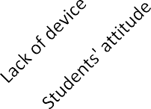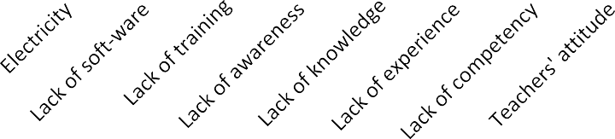

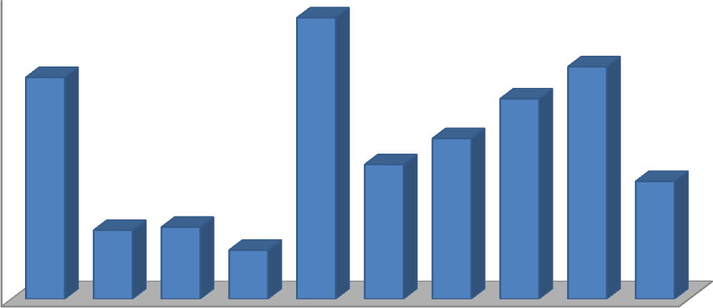**Factors**

### Figure 1: Bar Chart Showing Ten Most Cited Factors that Hinder Teachers from Using Assistive Technology in Teaching Persons with Disabilities.

Figure 1 shows ten problems most frequently cited by respondents as hindrances to their effective use of assistive technology in teaching. The five most cited problems were: lack of training in assistive technology (18.4%), lack of competency in assistive technology devices (15.2%), lack of assistive technology devices (14.5%). Others are lack of experience in the use of assistive technology (13.1%) and lack of knowledge in assistive technology (10.5%). The last five problems were lack of awareness in assistive technology (8.8%), teachers’ attitude towards assistive technology (7.7%), students’ attitude towards assistive technology, (4.5%) epileptic power supply (4.1%), and lack of assistive technology soft wares (3.2%). These were the least among most cited problems by teachers. The figure showed that there were problems that prevent teachers from using assistive technology devices for teaching.

### DATA ANALYSIS AND INTERPRETATION OF RESULTS BY HYPOTHESES

**Hypothesis One:** There will be no significant difference between assistive technology awareness mean scores of teachers in special schools and teachers in regular schools.

In calculating the result of this hypothesis, the researcher separated the responses of teachers to the Teachers’ Assistive Technology Awareness Questionnaire according to the school type. The responses of teachers teaching in regular schools were calculated separately and the responses of teachers in special schools were also calculated separately. The two results were subjected to t- test for unrelated samples to determine the significance of difference. The calculation is shown on appendix A20. The result is presented on table 12.

### Table 12: *t* –test Analysis of the Difference Between the Assistive Technology Awareness of Teachers in Special Schools and Teachers in Regular Schools

|  |  |  |  |  |  |  |
| --- | --- | --- | --- | --- | --- | --- |
| Teachers | N | X | DF | t.cal | P.value | Decision |
| Regular School teachers | 304 | 55.03 | 448 | 1.628 | 0.175 | Not sig. |
| Special school teachers | 146 | 55.56 |  |  |  |  |

Table 12 shows the t-test result of the assistive technology awareness of teachers in special and regular schools. A mean score of 55.03 for teachers in regular schools and 55.56 for teachers in special schools with a ***t***. cal. of -1.628 and a ***P***. value of 0.175 was indicated. This result indicated that the difference between the assistive technology competence of teachers in special and regular schools was not significant since the P. value was greater than the level of significance which was 0.05. Therefore, we fail to reject the null hypothesis. This result meant that the difference between assistive technology awareness of teachers in special and regular schools is not significant. Teachers in both school types had awareness of assistive technology.

**Hypothesis Two:** There will be no significant difference in the availability of assistive technology devices between schools located in urban and those in rural areas.

The researcher calculated the number of assistive technology devices that were available in schools located in urban and rural areas according to the different categories of special needs. After that calculation, the researcher then added the total for schools in urban areas and the total for schools in rural areas. The mean score for each was also calculated. The researcher then subtracted the mean of rural schools from the mean of urban schools to get the mean difference to enable us decide whether the hypothesis was accepted or rejected. See appendix A21 -24 for the calculations. The result is presented on table 13.

### Table 13: Difference between the Availability of Assistive Technology Devices for Persons with Visual Impairments in Schools in Urban and Rural Areas

Differences in assistive technology between schools in rural and urban areas

Location

|  |  |  |  |  |  |  |
| --- | --- | --- | --- | --- | --- | --- |
| S/N | Assistive technology devices | Rural  No. | Mean | Urban  No. | Mean | Mean dif. |
| 1 | For the visually impaired | 49 | 3.1 | 67 | 6.1 |  |
| 2 | For the hearing impaired | 22 | 1.4 | 40 | 3.7 |  |
| 3 | For Learning disabilities/ M R | 31 | 2 | 47 | 4.2 |  |
| 4 | For the Physically impaired | 39 | 2.4 | 43 | 3.9 | 2.3 |
|  | Total | 141 | 8.8 | 197 | 17.9 |  |
|  |  | mean | 2.2 | mean | 4.5 |  |

From table 13, it can be seen that the provision of assistive technology devices for the education of persons with visual impairment in schools located in the rural areas had a mean score of 3.1 while those located in urban areas had a mean score of 6.1. Assistive technology for the education of persons with hearing impairments in schools located in rural areas had a mean score of 1.4 while schools located in the urban areas had a mean score of 3.7. On the other hand, assistive technology devices for the education of persons with mental retardation and learning disabilities in schools located in the rural areas had a mean score of 2 while schools located in the urban areas had a mean score of 4.2. The availability of assistive technology for students with physical impairment in schools located in rural areas had a mean score of 2.4 while those located in the urban areas had a mean score of 3.9. The total mean score for schools located in the rural areas was 2.2 while that of those located in the urban areas was 4.5. The mean difference between schools in rural areas and schools in urban areas was 2.3. Thus, the null hypothesis which states that there will be no significant difference in the availability of assistive technology devices between schools in urban areas and schools in rural areas was rejected for an alternative hypothesis. This showed that the difference between the availability of assistive technology between schools located in the rural areas and schools located in the urban areas was significant since the difference between the mean score for schools located in urban areas and schools in the rural areas was lower than 2.5 for the calculation.

**Hypothesis Three:** There will be no significant difference between the assistive technology competence mean scores of teachers who have degrees and those who have other qualifications.

In analyzing the data collected for this hypothesis, the researcher calculated the assistive technology competence of teachers separately according to their qualifications The results were then subjected to comparative analysis using the one way Analysis Of Variance ANOVA to see whether or not the differences between their assistive technology competences were significant or not. The researcher also analyzed using same one way ANOVA to see if there existed any difference between groups and within groups. The results were presented on tables 14 and 15. See appendix A25.

### Table 14: One Way Analysis of Variance Calculation of the Differences between the Assistive Technology Competences of Teachers According to their Qualifications

**Assistive technology competence scores**

95% Confidence Interval for Mean

|  |  |  |  |  |  |  |  |  |
| --- | --- | --- | --- | --- | --- | --- | --- | --- |
|  | N | Mean | Std.  Deviation | Std.  Error | Lower  Bound | Upper  Bound | Min. | Max. |
| Diploma | 52 | 44.6923 | 2.74068 | 0.38 | 43.9293 | 45.4553 | 38 | 52 |
| HND | 13 | 44.0769 | 3.12147 | 0.866 | 42.1906 | 45.9632 | 39 | 49 |
| NCE | 117 | 44.7521 | 3.1181 | 0.288 | 44.1812 | 45.3231 | 37 | 52 |
| B. Ed | 252 | 44.5437 | 3.1877 | 0.201 | 44.1482 | 44.9391 | 37 | 55 |
| PG | 16 | 45.1875 | 2.2574 | 0.564 | 43.9846 | 46.3904 | 42 | 49 |
| Total | 450 | 44.6244 | 3.08294 | 0.145 | 44.3388 | 44.9101 | 37 | 55 |

Table 14 shows the comparison of the assistive technology competence of teachers according to their highest educational qualifications. Diploma had a mean score of 44.7 with a standard deviation of 2.7, Higher National Diploma (HND) had a mean score of 44.1 with a standard deviation of 3.1, National Certificate of Education (NCE) had a mean score of 44.8 with a standard deviation of 3.1 Others were Bachelor of Education (B. Ed) with a mean score of 44.5 and a standard deviation of 3.2; and those with post graduate degrees had a mean score of 45.2 with a standard deviation of 2.3. In all these comparisons, the mean scores were above 2.5. Therefore, we fail to reject the null hypothesis which state that there was no significant difference between the assistive technology competences means scores of teachers who have degrees and those who have other qualifications for an alternative hypothesis.

### Table 15: Analysis of Variance Calculation of the Difference between the Assistive Technology Competences of Teachers between and Within Groups

**ANOVA**

Assistive technology competence score

|  |  |  |  |  |  |
| --- | --- | --- | --- | --- | --- |
|  | Sum of  Squares | Df | Mean  Square | F | Sig. |
| Between Groups | 12.762 | 4 | 3.19 | 0.334 | 0.855 |
| Within Groups | 4254.77 | 445 | 9.561 |  |  |
| Total | 4267.53 | 449 |  |  |  |

The difference between the assistive technology competences of teachers according to their qualifications was further calculated between groups and within groups. When the mean square was calculated, the difference between groups showed a mean square of 3.19 and a difference in within group’s mean square of 9.561 with a ***p***. value of 0.855. This result showed that the assistive technology competence mean score of teachers who have degrees and those who had other qualifications was not significant since the ***P***. value of 0.855 is higher than the level of significance which is 0.05. We therefore fail to reject the null hypothesis for an alternative one. This means that there was no significant difference between the assistive technology competence of teachers who had degrees and those who had other qualifications such as Diploma, National Certificate in Education Higher National Diploma and Postgraduate degrees.

**Hypothesis Four:** There will be no significant difference between the assistive technology competence mean scores of male and female teachers.

In analyzing the data collected for this hypothesis, the researcher separated all the responses of male teachers from those of female teachers on the Teachers’ Assistive Technology Competence Checklist. The results of male and female teachers were subjected to a comparative analysis in order to know whether the difference between the two results obtained was significant or not. The results were subjected to t- test for unrelated samples. The result is presented on table 16. See appendix A26 for the calculation.

### Table 16: *t*- test Analysis of Assistive Technology Competences of Male and Female Teachers

|  |  |  |  |  |  |  |
| --- | --- | --- | --- | --- | --- | --- |
| Gender | N | X | DF | t.cal | P.value | Decision |
| Male | 254 | 44.5 | 448 | -0.728 | 0.839 | Not sig. |
| Female | 196 | 44.7 |  |  |  |  |

Table 16 shows the t-test result between the assistive technology competence of male and female teachers. The table indicated a mean score of 44.5 for male teachers and 44.7 for female teachers with a ***t***. cal. of -0.728 and a ***P***. value of 0.839. This result showed that the difference between the assistive technology competence of male and female teachers was not significant since the ***P***. value was greater than the level of significance which was 0.05. Therefore, we fail to reject the null hypothesis for an alternative one. This result showed that there was no significant difference between the assistive technology competence of male and female teachers. No gender possessed more competence than the other in the knowledge and use of assistive technology.

### DISCUSSION OF RESULTS

**Teachers’ awareness of assistive technology** The analysis in table 8 showed that quite a number of teachers were aware of assistive technology. The Table showed that 54 teachers representing 12% of the sampled teachers indicated that they were very aware of the existence of different assistive technology devices used in the education of persons with special needs; 131 teachers (29.1%) indicated that they were aware, 161 teachers (35.8%) indicated that they had little awareness, while 104 teachers (23.1%) indicated that they were not aware of assistive technology devices. This result indicated that quite a number of the teachers were aware of assistive technology since only 23% of the respondents stated that they had no knowledge of assistive technology. When the percentages were added, a total of 79.9% of the teachers sampled had different levels of awareness of assistive technology devices while 21.1% had no awareness of assistive technology devices. This result was similar to the findings of Obidike, Anyikwa and Emenou (2010) which discovered that both public primary and public nursery school teachers could identify the technological tools that could be used to promote children’s literacy instruction but were not aware of the use of the identified resources to promote children’s literacy instruction. This showed that teachers were not aware of how the resources could be used in promoting

reading and writing skills in children. This finding is different from that of Holmes, Burton and Heaton, (2006) who discovered that both special and general education teachers lack awareness of both the availability and effective use of assistive technology.

Even though teachers in this research indicated that they were aware of the assistive technology devices that were used in the education of children with special needs, it did not guarantee that they knew how to use the devices. When further investigations were made through the observation with the Assistive Technology Device Availability in Schools Checklist, it was discovered that the teachers did not know most of the devices that were presented to them particularly softwares and some modern devices used in the education of persons with special needs. A closer look at the result also showed that most of the teachers who said they had no knowledge of assistive technology devices were regular teachers. It was surprising that teachers who were exposed to introduction to special education during the teacher training programme still said that they had no knowledge of assistive technology devices.

Similarly, this finding did not agree with that of Edwards and Lewis (1998) who conducted a research in Florida to find out the competency of teachers of the visually impaired in assistive technology. They discovered that over half of the 113 teachers that participated in the study admitted that they were not familiar with many of the assistive technology devices that were examined in that study.

Several reasons might have led to the differences in these results. First, there were more regular education teachers selected as participants in this research than special education teachers. The special education teachers by the nature of their training might have learnt some concepts of assistive technology because most of the respondents who claimed they didn’t know were from the regular teachers. Another reason was that some of the teachers might have wanted to cover their ignorance in assistive technology devices since 161 (35.8%) claimed they had little awareness. This little awareness was not enough to qualify them to claim awareness of assistive technology devices. Another reason was that

some of the teachers might just decide to tick the questionnaires without actually reading the statements just to cover up for their lack of knowledge. Yet another reason for the difference in the results might be the time in between the researches. From 2002, 2006 and 2014, many changes have taken place in the field of assistive technology devices. Thus many teachers have become aware of assistive technology. Teachers’ understanding of what assistive technology is also counted a lot in this result. If a teacher’s understanding of assistive technology is limited to, for instance, the braille machine then this result should be expected. Though the result showed that 59% of the teachers either had little awareness or no awareness of assistive technology, The result was not significant enough to conclude that teachers in North Central Nigeria were not aware of assistive technology devices. It can be said that teachers in North Central Nigeria have a superficial awareness of assistive technology since 41% of the teachers had awareness of assistive technology devices.

### Level of provision of assistive technology in schools

Out of the 27 schools surveyed, it was discovered that assistive technology devices for the education of persons with visual impairment was inadequate, for instance, only 10 out of the 27 schools representing 37% had Braille machines, 13 of the 27 institutions (48.15%) had talking clocks/ wrist watches available and functional while 11(40.74%) did not have these devices at all. There were also 3(11%) that were available but not functional. Other devices like ICT and screen readers were available in 1 (3.7%), out of the 27 schools surveyed. Only 4 (14.8%) of the schools surveyed had educational soft wares for the education of children with visual impairments. Assistive technology devices like wheel chairs, adjustable tables, talking computers, alternative keyboard, and refreshable Braille display and screen magnification were not available at all in any of the schools surveyed.

In the same vein, assistive technology devices for the education of persons with hearing impairment were lacking. For example, out of the 27 institutions surveyed, only 2 institutions, representing (7.4%) had audiometers, 25 of the institutions, representing 92.6% did not have audiometers at all. Only one of the institutions (3.7%) had booth and ICT

connectivity, 96.3% of the schools did not have any at all. The result also showed that 4 of the 27 institutions (11.1%) had speech trainers and motion films, 24 (88.9%) did not have any at all. In addition, 11 (40.7%) of the schools surveyed had computers and, 24 (88.9%) had type writers. This showed that the devices were grossly inadequate. Similarly, assistive technology devices for the education of persons with mental retardation and learning disabilities were not adequate in all of the schools. The study showed on Table 7 that 17 (63%) of the 27 schools surveyed had toys but, it was not available in 10 of the schools representing (37%); 19 of the institutions representing 70.4% had models that were functioning, 3 schools had models that were not functional while 5 (18.5%) did not have any model at all. The table showed that 16 institutions, representing 59.3% had computers available and functional; 11 (40.7) of the institutions had no computers. Only 1(3.7%) of the institutions surveyed had internet connectivity. Similarly, only 22.2% of the institutions surveyed had some educational soft wares for the education of children with mental retardation and learning disabilities. Eighteen and a half percent (18.5%) had wheel chairs, 11.1% had art activities and 14.8% had word processing devices. The result also shows that assistive technology devices such as electronic organizers, disc reading and talking dictionaries were not available at all in all the schools surveyed. Only 11.1% and 7.4% of the schools had models and wheelchairs respectively that were available but not functional.

In the same vein, assistive technology devices for the education of persons with physical handicaps were inadequate; for instance, table 12 showed that 6 of the 27 schools surveyed representing 22.2% had calipers, 3 (11.1%) had nonfunctional calipers while 18 (66.7%) did not have any at all. Eight of the institutions representing 29.6% had functional crutches, 17 (63%) did not have any at all. Only one of the schools had internet connectivity, representing (3.7%), 2 of the institutions, representing 7.4% had ICT connectivity but it was not functional while 24 (88.9%) did not have any ICT connectivity. Assistive technology devices like ergonomic chairs, pencil grip, ergonomic tables, soft wares, side lying frames, ergonomic key board and scooters were not available at all (0%)

in all the schools surveyed. The table also showed that 11.1% of the schools had calipers, 7.4% had crutches, 3.7% had functional ICT while 7.4% had ICT that were not functional; 29.63% had wheel chairs that were available but not functional. These results showed that many of the schools surveyed did not have the assistive technology devices for the education of persons with physical handicaps; schools that had assistive technology devices did not have them in sufficient quantity and quality. Comparing what we obtained in this research with the array of assistive technology devices on appendix A29, one can say that the devices are grossly inadequate in the schools.

In an interview with some of the teachers, the researcher discovered that some of the computers were kept in the principal’s office and used for administrative purposes.

Many of the computers were not put to use because of teachers’ incompetence. Some of the devices were owned by students and not the school. This result was similar to those of Yusuf, Fakomogbon and Issa (2012) who conducted a research to ascertain the availability of assistive technology for teaching children with special needs in South West Nigeria.

They discovered that majority of the institutions did not have the required assistive technologies for students with disabilities and that some of the existing pieces of equipment were outdated. The study also discovered that some of the schools that had computers used them for administrative purposes and not for instruction primarily because they did not have the soft wares with which to use the computers. Also they lacked knowledge and competency in computer aided instruction. This result indicated that most of the students who needed assistive technology did not have them. This agrees with Izu and Atolagbe (2003), who discovered that most of the instructional materials and equipment for students with special needs were grossly inadequate in schools. With this result agreeing with what was discovered in the south west and south east, it therefore meant that there was serious lack of assistive technology devices supplied to schools for the education of persons with special needs in Nigeria.

This is not surprising because there was a general lack of infrastructure and teaching materials in schools in Nigeria as a country; therefore, the case may not be different for persons with disabilities. Another reason was that there was no law in the country on the procurement and use of assistive technology devices by schools that educate persons with special needs. Therefore, no one can be held responsible for not procuring the devices.

Other countries like the United States of America who have that law have made tremendous progress in their use of assistive technology devices. With the law in the United States, parents or children with special needs can sue the school or the government for not supplying the equipment. Therefore, the government is always supplying them with the devices to maintain standard. Another reason why this result was so could be that most people were not aware of these devices or where to procure them; thus, they could not purchase them for use. More so, most of these devices were in the past procured overseas and very costly to purchase. These were the probable reasons why there was a general lack of these devices in the schools. It could be the reason too why there were many devices that were not functioning in schools because the spare parts to repair them on break down must also be imported from overseas. Corruption in the system was also among the causes of lack of the devices in many schools. Many times, money was budgeted for purchasing the devices, but such money could have been diverted for something else or into personal pockets as the case may be.

**Teachers’ use of assistive technology** The result in this research showed that most of the teachers 168 (37.3%) rarely used assistive technology while teaching, while 71 (15.8%) of the respondents indicated that they did not use assistive technology at all. Seventy one (15.8%) also said that they used assistive technology devices always, 140 (31.1%) said they used them sometimes. On the whole, 211 (47%) of the respondents stated that they sometimes use assistive technology devices while 239 (53%) said they did not use assistive technology devices. This result was surprising because this research had discovered that these devices were grossly in adequate in the institutions surveyed. This result agreed with

the Teachers Training (2012) report which stated that only about half the nations’ teachers used technology in their daily teaching. They went further to report that evidence gathered from technology proponents indicated that much of the use of the devices was ineffective. The finding was consistent with Kapperman, Sticken and Heninze (2000) who found that assistive technology was being significantly underutilized by students who were visually impaired, probably due to teacher’s non use of the devices. They discovered that in Illinois, 37% of primary and secondary students with visual impairment in non itinerant placement and 73% of those in itinerant placement did not use assistive technology. Similarly, Kelly (2009) found that nationwide, 59% to 71% of the primary and secondary school students with visual impairments who were most inclined to benefit from assistive technology did not have the opportunity to use it from 2000 to 2004 due to teachers’ non use of the devices while teaching. In the same vein, Eteokleous (2008) discovered that teachers were characterized as reluctant and unwilling to use new technologies.

Though this research has discovered that teachers generally did not use assistive technology devices often, the difference was not significant. This suggested that some teachers made use of the devices while teaching. This result might have been so because of teachers’ lack of awareness of many assistive technology devices especially the modern devices. Other factors that make teachers not to use assistive technology devices are lack of knowledge and skills by both special and regular educators to effectively implement assistive technology devices and services in schools. Teachers also lack positive attitude towards the use of assistive technology devices this is as a result of their lack of awareness of assistive technology devices. Another reason why teachers may not be willing to use assistive technology devices is because of the poor pay package for teachers of persons with disabilities. In an open interview with some of the teachers, the researcher discovered that some of them could not differentiate between assistive technology devices and teaching aids. Therefore, since they were used to using teaching aids to teach, they believed they were using assistive technology devices. They were not totally wrong because some of the

teaching aids can also be used as assistive technology devices. This idea was more predominant among the regular teachers who made up 67.6% of the respondents in this research.

**Teachers’ competence in assistive technology** The result displayed on table 10 showed that 169 (37.7%) of the respondents indicated that they were novices in assistive technology. This group did not know anything about assistive technology; that is to say that they had never learned or used it. One hundred and forty three (31.8%) were at basic level. This group of teachers was just learning about assistive technology possibly at the introductory level, while 93 (20.5%) were proficient in the use of assistive technology devices. Only 45 (10.2%) of the respondents indicated that they were advanced in the use of assistive technology. This group of teachers was able to use the devices very well. This showed that teachers in North Central Nigeria were not competent in the use of assistive technology. This finding was consistent with the finding of Abner and Larm (2002) who discovered that in Kentucky, 49% of the 72 teachers of students with visual impairments who completed their survey reported a lack of confidence in teaching using assistive technology. Majority of these teachers reported that they were at either the apprentice level (51%) or the novice level (24%) in terms of their teaching skills related to assistive technology. They stated that one of the major barriers to the successful implementation of assistive technology was the lack of special educator knowledge and skills to effectively implement assistive technology devices and services.

Supporting this, Lee and Vega (2005) stated that one of the reasons for the non use of assistive technology by students with visual impairment was that teachers lacked adequate knowledge and skills to teach students with visual impairment using assistive technology. What influences teachers’ competence in assistive technology is their awareness, their knowledge and their experience in the use of the devices. Such knowledge and experience can be gained through well designed teacher training programmes where every graduate comes out with competency in assistive technology. Unfortunately, no

teacher training institution in Nigeria, to the best of the researcher’s knowledge, offers assistive technology as a course. No wonder teachers lacked competence in assistive technology. Teachers can gain experience from regular use of the devices in their classes even if they did not graduate with competency from teacher training colleges. Unfortunately such devices were not adequately provided in schools.

**Teachers’ assistive technology competency The** result displayed on table 11 showed that 153 (34%) of the respondents indicated that they had no experience of assistive technology devices, two hundred and eight (46%) indicated that they were at beginner level. Eighteen percent stated that they had moderate competency in assistive technology while 1.6% stated that they had substantial competency in assistive technology devices. Only 0.07% of the respondents claimed that they were experts in assistive technology. This showed clearly that teachers in North Central Nigeria lacked competency in assistive technology devices.

Thus, they lacked the competency to teach their students how to use the devices. A closer look at the result showed that teachers lacked competency in six of the eight assistive technology devices competency of Blackhurst (2001); and fifteen out of the sixteen assistive technology competencies of Smith, Kelly, Maushak, Griffin-Shirley and Lan (2009). This showed that out of the 24 assistive technology devices competencies scale that the respondents were asked to rate their competency on, only four of them obtained a mean score of 2.5 and above. This showed that even though teachers claimed that they were aware and used assistive technology devices, they lacked competency in the use of the devices as shown on appendix A17. Surprisingly, the following competencies mean scores of 2.5 and above: use assistive technology to facilitate instruction in special education programmes (2.5), use of assistive technology as aid to personal productivity (2.54) and use of technology implementation with students with disabilities (2.51). Teachers that responded positively to these competencies were those that had been teaching for 15 years and above and especially those teaching in special schools.

However, when the teachers were observed using some assistive technology devices that were available to them in the schools, many of them were not competent in the use of many of the devices. None of the devices had a mean score of 2.5 as shown on section 2 of appendix A17. This lack of competency in the use of these devices may be as a result of lack of integrating assistive technology in teacher training programmes. Therefore, most teachers graduated from teacher training institutions without competency in the use of assistive technology devices. In some teacher training institutions where they teach courses like methods and materials in special education, many of these devices were not in the schools to enhance a hands- on- training with the devices so that teachers can graduate with competency in the manipulation of the devices. More so, teacher training institutions in Nigeria have not come out with the type of assistive technology competencies expected of teachers of persons with special education needs. Therefore, every teacher training institution produces their teachers the way and manner they want and so the competency of such teachers in assistive technology cannot be guaranteed. Some teachers, on the other hand, may have a negative attitude towards the devices because some of these devices were cumbersome both to move and to operate. Therefore, they were not ready to learn how to use them.

**Problems that hinder teachers from using assistive technology devices** The result in this research showed that teachers in North Central Nigeria were faced with many problems that served as barriers to their effective teaching using assistive technology devices. The problem that had the highest percentage was teachers’ lack of training in assistive technology devices (18.4%). This result suggested that teacher training programmes in Nigeria did not produce teachers that were competent in using assistive technology devices. Lack of competency in assistive technology was cited by 15.2% of the respondents as a hindrance to their use of assistive technology devices. This result agreed with the findings of the United States Congress (1995), Panel on Educational Technology (1997) and Doering, Hughes & Huffman (2003) who all reported that teacher preparation programs

failed to prepare teachers for using and integrating technology into classroom teaching. These researches were conducted many years ago but this problem has consistently appeared both in America and now in Nigeria meaning that the problem was a serious one.

Despite the immense benefits of assistive technologies in rehabilitating and assisting students with special educational needs, these devices were not provided for the students.

The third most cited problem by the respondents was lack of assistive technology devices in the schools. This was cited by 14.4% of the respondents. In most of the schools visited, most of the devices that were seen were obsolete and in some schools, they were not available at all. Some of the devices that some schools claimed to have were personally owned by the students, particularly those that employ new technologies. This result was similar to those of Izu and Atolagbe (2003); and Yusuf, Fakomogbon and Issa (2012) who discovered that most of the instructional materials and equipment for the students with special needs were grossly inadequate in schools.

Another problem that was cited by many respondents was teachers’ lack of experience in assistive technology. This lack of experience could be as a result of lack of proper knowledge of assistive technology which was cited by 10.5% of the respondents. This could be because most teachers do not have the knowledge of technology, skills and experiences that were necessary for teaching with technology because they did not grow with technology and were not taught with technology as claimed by Prensky (2001). Many of the respondents were those who had been teaching for 11-20 years (42.9%) and 21-30 years (23.3%); who claimed they left school before most of the technological equipment were introduced. This result agrees with that of Abner & Lahm, (2002) who reported that one of the major barriers to the successful implementation of assistive technology was the lack of knowledge and skills by special educators to effectively implement assistive technology devices and services.

Although the use of assistive technology for young children was increasing, the lack of its awareness by teachers still remained a serious problem. Surprisingly, lack of

awareness of assistive technology was cited by only 8.8% of the respondents in this research. This result was in line with that of Holmes, Burton and Heaton, (2006) who stated that both special and general education teachers lacked awareness of both the availability and effective use of assistive technology. This lack of awareness covered the awareness of the existence of assistive technology devices, where to purchase or repair the device, and the category of people to use the devices. No wonder, most of the devices were not available in schools because those who were supposed to request for their purchase or agitate for laws concerning assistive technology were not aware of the devices. This was so probably because the companies that manufacture these devices and professionals in assistive technology had not embarked on enough public enlightenment on the availability and use of assistive technology; as a result, most schools and teacher training institutions did not have the devices for use. Another reason for teachers’ poor use of technology was that teachers often held negative attitudes towards assistive technology; this was cited by 7.7% of the respondents. This result was in line with Bahr, Shaba, Fransworth, Levis & Benson, (2004) who stated that teachers held negative attitudes and were skeptical about the use of technology for teaching. This research discovered that most of the respondents were not aware of the assistive technology devices used in teaching children with special education needs. There was no way anybody can have a positive attitude towards something he was not aware of. Therefore, lack of awareness was one of the reasons why teachers had negative attitudes towards assistive technology devices. Another thing that made teachers to have a negative attitude towards assistive technology devices was the fact that many of these devices were stigmatizing and some were also cumbersome to carry.

Therefore, teachers disliked carrying them about. In Nigeria, particularly in the North Central Region, the teaching profession was seen by many as the last option. People did not like it because of the poor remunerations and other factors. The worst was to teach persons with special education needs. It was not surprising therefore; that the teachers had negative attitudes towards assistive technology devices for teaching special needs learners.

Other problems cited by respondents were students’ attitude towards assistive technology devices (4.5%), epileptic power supply (4.1%) and lack of soft wares (3.2%). Surprisingly, lack of soft wares appeared last when soft wares were found lacking in almost all the schools visited. This is an indication that the respondents might not have known what a soft ware is. These problems had continued to surface over the years in different countries. This showed that the government had a lot to do to solve these problems to help the teachers use assistive technology devices effectively.

### Differences between the assistive technology awareness mean scores of teachers in special schools and teachers in regular schools

The study discovered that the difference between the assistive technology devices awareness mean score of teachers in special schools and teachers in regular schools was not significant. Table 12 showed a mean score of 55.03 for teachers in regular schools and

55.56 for teachers in special schools with a ***t***. cal. of -1.628 and a ***P***. value of 0.175. This clearly showed that the difference between the assistive technology awareness of teachers in special and regular schools was not significant since the P. value was greater than the level of significance which was 0.05. Thus, the null hypothesis was accepted. This meant that teachers in both schools had some awareness of the existence of assistive technology devices. This was in line with what Singh (2001) discovered that there was enough evidence which suggest that regular teachers did not believe that they were fully prepared for the inclusion of students with disabilities. The teachers’ lack of preparation was as a result of their lack of awareness of assistive technology and the methods of teaching children with special needs. This is because they have not been taught the techniques and strategies of how to manage the special education needs of such children in their classes.

This result did not agree with the findings of Holmes, Burton and Heaton (2006) which discovered that both special and general education teachers lacked an awareness of both the availability and effective use of assistive technology. The result was also different from Sherrill (1998) who discovered that inadequate preparation of regular teachers at

teacher training level, lack of information about children with special needs, lack of teaching methods and lack of knowledge about the use of assistive technology in the education of persons with disabilities as their barriers to successful inclusion of children with special needs in general education programmes.

However, teachers’ awareness of assistive technology was not the same thing with competence in the use of the equipment. On the other hand, the result was suggestive that both regular and special education teachers had the same lack of awareness of assistive technology devices. This was because the respondents had earlier mentioned it as one of the problems that was preventing them from using assistive technology devices in schools. Appendix 22, the personal data of the respondents showed that 304 (67.6%) of the respondents were regular teachers while 146 (32.4%) were special education teachers. This showed that the regular teachers were more than twice the number of the special education teachers which might even affect the result. It was expected that a different result would have been obtained if the number of respondents were the same.

### Differences in the availability of assistive technology devices between schools located in urban and rural areas

The result in table 16 shows that schools in urban areas had a higher mean score (4.5) than schools in the rural areas (2.2). A sharp difference between urban and rural schools was thus discovered; as such, we fail to accept the hypothesis which states that there will be no significant difference in the availability of assistive technology devices between schools located in urban and those in the rural areas. This simply means that schools in urban areas were more equipped with assistive technology devices than schools in rural areas as none of the schools in the rural areas had computers and internet connectivity. This result was in line with the result obtained by Ertl and Plante (2004) who discovered that rural schools in Canada were at a disadvantage relative to urban schools with respect to access to and use of information and communication technology (ICT). The indication is that schools in the urban areas were more catered for than schools in the rural areas. The difference was higher

for the supply of equipments for children with hearing impairment where schools located in the rural areas had a mean score of 1.4 against a mean score of 3.7 for schools located in urban areas.

So many factors could be attributed to this finding. First, there was the problem of electricity in the rural areas and many of the assistive technology devices are electricity- powered. Therefore, it was seen to be useless to procure equipment that requires electricity for a school in the rural where there was no electricity. Secondly, schools located in the urban areas housed mostly children of literate people living in the urban areas who had knowledge of some of the devices; some might have acquired some of the devices for their children. Furthermore, since most of the parents were literates they may request the schools to purchase these devices for the children. Another reason might be that government paid more attention to schools in urban areas than those in rural areas. Therefore, more equipment was supplied to urban schools than rural ones. Same applies to supervision. This might be because of the proximity of the schools to the headquarters. With these reasons, there will definitely be differences in the availability of the devices in these schools.

### Differences between the assistive technology competence of graduates and non graduate teachers

This study discovered that the difference between the assistive technology devices competence of graduates and non graduate teachers was not significant. In all the comparisons on table 14, the mean scores were above 2.5, therefore, the null hypothesis which stated that there will be no significant difference between the assistive technology competences mean scores of teachers who have degrees and those who have other qualifications was accepted. The mean scores were further calculated between groups and within groups yet, the difference between groups showed a mean square of 3.19 and a

difference within group’s mean square of 9.561 with a ***p***. value of 0.855. This result showed that the assistive technology competence mean score of teachers who had degrees and those

who had other qualifications was not significant since the ***P***. value of 0.855 is higher than the level of significance which was 0.05; thus, the null hypothesis was accepted. Even when there were more graduate teachers in the sample for this research 252 (56%), the result did not show any significant difference in their teaching competence. One then wonders why there was such discrimination in the employment of teachers where graduate teachers are always given priority over other teachers when they did not exhibit superior competence over the others. This lack of difference in the assistive technology competence of teachers emanated from teacher training. Cavanaugh, (2003) discovered the same thing and stated that fewer than 20% of the teacher training colleges provided courses focusing on assistive technology as part of their educational technology degree programme.

This result also showed that teacher training programmes at whatever level did not prepare teachers with competence in assistive technology. This finding was similar to the findings of the International Society for Technology in Education (ISTE) who conducted a research for the Milken exchange on education technology, Moursund and Bielefeldt (1999). At the end of their study, they concluded that in general, teacher training programs did not provide future teachers with the kind of experiences necessary to prepare them to use technology effectively in their classes. This was because the institutions did not have the devices for training. The same is the case in Nigeria, many institutions of higher learning in were crying out for lack of infrastructure and equipment, so this might not be different with the institutions that prepare special education teachers. Another reason might be the lack of professionals in assistive technology devices in Nigerian teacher training institutions. This contributed to the lack of devices because there were no professionals to recommend the devices for government to purchase; therefore, the teachers produced in these schools lacked competence to teach their students.

### Differences between the assistive technology competences mean scores of male and female teachers

The result on table 16 showed that no significant difference existed between the assistive technology competences mean score of male and female teachers. The table showed a mean score of 44.5 for male teachers and 44.7 for female teachers with a ***t***. cal. of -0.728 and a ***P***. value of 0.839. This result showed that the difference between the assistive technology competence of male and female teachers was not significant since the ***P***. value was greater than the level of significance which was 0.05. Thus the null hypothesis was accepted. This result was different from the findings of Wong and Lai (n.d) who discovered that females performed slightly better than males in pedagogical content knowledge. That was to say that female teachers showed more competence in methodology than male teachers,

A closer look at the gender of the participants showed that 56. % of the participants was males while 44.6% were females. One would have thought that this will affected the result since there were more male participants but the contrary was the case. This result was in line with Millig (2009) who stated that since the teaching profession was women dominated, it can be argued that females were more natural nurturers. He posited that it cannot be generalized that women were better ―teachers‖. Many schools gave priority to females when it comes to recruitment of teachers because of the belief that female teachers were more competent than male teachers. This research has shown that female teachers in North Central Nigeria were not more competent than the male teachers in the use of assistive technology as both male and female teachers lacked competence in the use of assistive technology devices. This result was not surprising as there was no separate teacher training institution for male and female teachers. Therefore what affects the male teachers also affects the female teachers. It was assumed that the problem emanated from the teacher training institution as earlier suggested; therefore the lack of competency cuts across gender. One would have expected that the teachers would have learnt how to use some of these devices on the job. Many of them had spent more than ten years working with

children with special education needs which would have increased their competency in the use of assistive technology devices. Unfortunately, these devices were not available to guarantee such.

### CHAPTER FIVE

**SUMMARY OF FINDINGS, CONCLUSION AND RECOMMENDATIONS**

This chapter summarizes the major findings in this research; drew conclusion and made some recommendations based on the findings of the research. Also included in this chapter are some problems that were encountered in the course of the study, suggestions for further studies and the contributions this research has made to knowledge.

### SUMMARY OF FINDINGS

This research was concerned with finding out teachers’ level of awareness and the use of assistive technology in teaching persons with special needs. Six research questions and four hypotheses guided the study. Relevant literature, both documentary and empirical, were reviewed on the variables under study and gaps were identified which helped in shaping the study. The cross sectional survey research design was used to carry out this research and the stratified random sampling technique was used to select participants from 27 schools that provided educational services to children with special needs in North Central Nigeria. From these schools, 450 teachers, were selected to participate in the study. Four instruments: Teachers’ Assistive Technology Competency Checklist (TATCC), Teachers’ Assistive Technology Awareness Questionnaire (TATAQ), Assistive Technology Device Availability in Schools (ATDAS) and the Teachers’ Assistive Technology Device Competence Checklist (TATDCC) were developed by the researcher and validated by professionals in the field and used to collect data for this research. The data collected were analyzed with descriptive statistics such as mean, percentage, one way Analysis of Variance ANOVA and T-test for related samples. The research discovered among that:

1. The data collected with these instruments were analyzed and the result showed that both special education and regular teachers were aware of assistive technology devices that are used in the education of persons with disabilities even though a few teachers claimed ignorance of such devices.
2. The study also discovered that many of the schools that educate children with special needs in North Central Nigeria did not have most of the assistive technology devices that were used for the education of persons with special needs. Some of the schools that had them did not have them in sufficient quality and quantity; furthermore, some of the devices that were available were personal to the students and not the school.
3. The study further discovered that teachers were not always using assistive technology devices while teaching children with special needs as they were not competent in the use of assistive technology devices. Many of the teachers were actually novices in the use of assistive technology devices or at the beginner level (just starting to learn about the devices and how to use them).
4. Another discovery of the study was that most teachers teaching children with special needs in North Central Nigeria were not competent in assistive technology devices. Most of the teachers were still at the novice or basic level.
5. This research also discovered that most teachers teaching children with special needs in North Central Nigeria lacked knowledge in most of the assistive technology competencies. Few of them were at beginner level.
6. Teachers in North central Nigeria were faced with many problems as they try to teach students using assistive technology devices. The most serious problem being lack of training in assistive technology devices, lack of competency in assistive technology devices and lack of the devices in the schools. This was another finding of the study.
7. Furthermore, the research discovered that teachers in both regular and special schools had awareness of assistive technology devices even though some of the regular teachers claimed they were not aware of assistive technology devices but the number of those who said they were not aware was not significant.
8. When the researcher tried to find out the difference between the availability of the devices between schools located in the rural and urban areas, the study discovered that schools in the urban areas had more assistive technology devices than those in the rural areas. This showed that more attention was paid to schools in the urban areas than schools in the rural areas.
9. When the researcher tried to find out whether or not there existed any difference between assistive technology devices competence of teachers with degrees and those who had other qualifications, the study found that the difference between their assistive technology devices competence was not significant. That meant that all of them had the same lack of competency in assistive technology devices. Thus, academic qualification was not a criterion for qualifying someone to be competent in the use of assistive technology devices to teach special needs learners.
10. Whereas it was assumed that female teachers were more competent in teaching using assistive technology devices than male teachers, this study discovered that they were not more competent than the male teachers; both genders were at par in their competence in teaching special needs learners. Therefore, gender was not a factor in determining the assistive technology devices competence of teachers who taught children with special needs.

### CONCLUSION

Based on the findings of this research, the researcher concluded that though the teachers that taught children with special needs in North Central Nigeria had awareness of assistive technology devices, they were not competent in teaching using the devices. This suggested that they only had a superficial awareness of the devices without deep knowledge. The lack of competence was as a result of lack of integrating assistive technology devices into teacher training programmes and that was why both graduate teachers and non graduate teachers alike exhibited the same lack of competence.

The researcher also concluded that most of the schools that educated children with special needs in North Central Nigeria did not have assistive technology devices. Therefore, many of the children with special needs learnt under very difficult conditions. As far as assistive technology competence was concerned, there was no difference between male and female teachers’ competence and there was no difference in teaching performance between graduate and non graduate teachers. All of them had the same problem in teaching using assistive technology devices. Therefore, this researcher felt that the data gathered in this study were sufficient to characterize the current teachers’ awareness and use of assistive technology devices while teaching children with special needs. The results provided

baseline data on the teachers’ awareness and use of assistive technology devices; their competence, availability of the devices in the schools and the problems that stood as hindrance to teachers’ use of assistive technology devices. The need for further training of these teachers and integration of assistive technology in special education teacher preparation programme was highlighted; and the need for further research in this area was also suggested.

### RECOMMENDATIONS

Based on the findings of this research, the following recommendations were made:

* + 1. There is need for an enlightenment campaign on the importance of assistive technology devices in schools. This will create more awareness among teachers and students particularly those who claimed that they are not aware of the existence of assistive technology devices.
    2. Government should come up with a policy on assistive technology devices to make it mandatory for schools to purchase them before they can admit children with special needs into their schools. This should be made into a law backed by the appropriate statute. This will make local, state and federal governments to provide these devices for children with special needs. This is because many concepts and

some aspects of the curriculum will not be learned without assistive technology devices.

* + 1. Teacher training institutions can develop the will power to integrate assistive technology devices into their teacher training programmes so that they are able to produce teachers that can effectively use assistive technology devices for teaching children with special needs. These institutions must ensure that workshops or seminars on the use of assistive technology devices are organized for teachers that are already teaching. This will help them to learn more on assistive technology devices.
    2. Teacher training institutions should emphasize more on hands- on- trainings rather than theory so that they will produce teachers that are competent in the use of assistive technology devices. This is because many of the teachers confessed that they only read about these devices in books without even seeing some of them.
    3. Special education teacher training institutions should come up with the assistive technology competencies that they expect teachers to possess on graduation so that they can train their teachers in such a way that they can acquire those competencies on graduation
    4. Government and voluntary agencies should find ways of eliminating or reducing the problems faced by teachers as they try to teach their students using assistive technology devices in school.
    5. Refresher courses and regular training and re-training in the use of assistive technology should be organized for teachers of children with special needs. Such training and or workshops should be organized by institutions that admit special children and sponsored by the government.
    6. Government can ensure that assistive technology devices are purchased and shared equally to schools without minding whether the school is located in the rural or urban area because the people that are going to use them will use them for the same

purpose and sit for the same examination at the end. There should be no segregation between schools.

* + 1. The principle of no segregation between teachers because of their educational qualifications can be applied to the employment of teachers who will teach children with special needs since graduate teachers do not have any superiority above teachers who have other qualifications in the use of assistive technology devices.

10 Similarly, government and proprietors of private schools should not segregate between male and female teachers when it comes to recruitment of teachers or even when it comes to assigning of classes to teachers, because female teachers are not more competent than male teachers in the use of assistive technology devices.

### LIMITATIONS OF THE STUDY

The researcher encountered some problems which made it so difficult to carry out this study the way it was earlier planned. First, the researcher found it difficult to lay hands on accurate data on the number of schools and teachers that educate children with special needs in all the states in North Central Nigeria. The Ministry of Education in these states could not give the correct number and names of the schools that practice inclusive education. This lack of proper record keeping made it difficult for the researcher to get the accurate number of schools and teachers in these states. This consequently affected the sample that was used for the study.

Another limitation was that some school administrators saw the researcher as one who was on a fact finding mission so some of them did not easily open their doors for the researcher. Many of them gave appointments that they did not keep. This delayed and extended the period of the main study unnecessarily. Closely linked to this is the problem of transportation as the schools are located far away from one another. This made it very difficult for the researcher to cover them within a short time. This also prolonged the period of the main study unnecessarily.

Finance was another problem that the researcher encountered. Travelling around the states selected for the study and lodging in hotels involved a lot of money. This is coupled with the fact that in some places, the researcher had to hire somebody to take him round some of the schools since the researcher did not know some of the towns and villages where the schools are or located. All these involved money and the researcher did not have enough to comfortably carry out the research.

Many teachers were not willing to be observed while teaching using assistive technology devices and so many of them kept dodging their lessons. This also elongated the period of the main study. Some of the schools that claimed to practice inclusive education were not really practicing it. This was because many of the teachers were not qualified teachers and some schools had only one or two children with special needs without any special education teacher in the school to them. This made it difficult for the researcher to select equal number of participants from the schools and the states because some of the schools and the states did not have the required number of teachers to participate in the study.

### SUGGESTIONS FOR FURTHER STUDY

Based on the result of this research, the following suggestions were made for further studies.

1 As this researcher investigated teachers’ awareness and use of assistive technology devices only, there is therefore need for a research on the impact of assistive technology devices on the academic performance of children with special needs.

1. There is further need of study in the area of evaluating the special education teacher training programme in Nigeria.
2. This research was conducted using both private and public schools; thus, there is need for a research on the difference in the availability of assistive technology devices between private and public schools.
3. Another research is needed to determine the difference between the assistive technology devices competence of special education and regular teachers teaching in inclusive schools. This is because this research investigated assistive technology competence of teachers in both special and regular schools.
4. The researcher investigated the availability of assistive technology in both primary and secondary schools. Therefore, further research is needed to determine the differences in the availability of assistive technology devices between primary and secondary schools in North Central Nigeria.
5. There is need for another research to gather data about the number of children with special needs that need assistive technology and the type of devices they need.
6. This research was conducted only in assistive technology devices. Therefore there is need for a research to determine teachers’ effective use of assistive technology services with children with children with special needs.
7. This research was conducted in the North Central geopolitical zone of Nigeria; there is therefore need for this research to be replicated in other regions of the country for the purpose of generalization.

### CONTRIBUTION TO KNOWLEDGE

This research has contributed to knowledge in many ways:

1. The researcher has been able to develop and validate some instruments that measured the awareness and competency that teachers in North Central Nigeria have in assistive technology which was not known with certainty before now thereby contributing to knowledge.
2. In the same vein, the researcher was able to find out that teachers in North Central Nigeria were not using assistive technology devices competently while teaching which was not known with certainty before now. This is a contribution to knowledge
3. Looking at the literature reviewed in chapter two, it can be seen that most of the literature are either from America or Britain. This showed that there was inadequate literature and researches in assistive technology in Nigeria. The study harnessed contributed to literature and researches in assistive technology devices for systematic reading and application to other researches thereby contributing to knowledge.

### REFERENCES

Abner, G. H., & Lahm, E. A. (2002). Implementation of assistive technology with students who are visually impaired: Teachers’ readiness. *Journal of Visual Impairment and Blindness*, 96 (2): 98-105

# Ademuyiwa, O.A. (2009). Enhancement of quality life through assistive technology devices for person with physical impairment. *The Exceptional Child. 2(1):* 117 -122.

Aduwa-Oyregbaen, S.E. & Iyamu, E.O.S. (2005). Using information and communication technology in secondary schools in Nigeria: Problems and prospects. *Educational Technology and Society,* 8 (1): 104-112.

Alasia, A. & Magnusson, E. (2005). Occupational skill level: The divide between rural and urban Canada. *Rural and Small Town Canada Analysis Bulletin*. Statistics Canada Catalogue number 21-006-XIE.

Aluxter, D., Pyfer, J. & Huettig, C. (2001). *Principles and Methods of Adapted Physical Education and Recreation*. Saint Louis, Missouri: Mosby-Year Book.

Anyebe, E.A. (2008). Information and communication technology in secondary schools in Nigeria. *Nigerian Journal of Teacher Education and Teaching 5 (1):* 161-169.

Assistive technology act (2004). Retrieved from: <http://www.ataprog.org/senate%20final%20Act%20sept%2030Pdf>.

Bahr, D. L., Shaha, S. H. Fransworth, B.J., Lewis, V. K. & Benson, S. F. (2004). Preparing tomorrow’s teachers to use technology: Additional impact of technology – field experience on pre-service teacher candidates. *Journal of Instructional Psychology,* 31 (2): 88-97

# Bair, J. H. & Bair, R. K. (1998). Linkages among top-ranked graduate programs in special education: A brief report. *Mental Retardation,* 36 (1), 52-54.

Bandura, A. (1986). *Social foundation of thoughts and actions: A Social Cognitive Theory*. Englewood Cliffs, N.J: Prentice Hall.

Bandura, A. (1992). *A social learning theory*. New Jersey: Prentice Hall. Batshaw, M. L. (2002). *Children with disabilities*. Baltimore: Paul H.

# Brookes.

Bausch, O.E., & Hasselbrig, B (2004). Word Processing as an assistive technology tool for enhancing academic outcomes of students with writing disabilities in the general classroom. *Journal of Learning Disabilities.* 7 (2*):* 143 -135.

Birman, B. F., Desimore, L., Porter, A. C., & Garet, M. S. (2000). Designing professional development that works. *Educational Leadership, 57* (8): 28-33.

Blackhurst, A.E., & Edyburn, D.L. (2000). A brief history of special education technology.

*Special Education Technology and Practice*, 2 (1): 21 –35.

Blackhurst, A.E (2001). Designing technology professional development program in J. Woodward & L. Cuban (Eds) implementing technology in special education:

Implication for curriculum, professional development and managing charge (p 128- 136). Thousand Oaks, C.A: Cowin Press Inc.

Bowser, G. (2007). SETT & Re-SETT: Concepts for AT Implementation. Retrieved from [http://www](http://www/). Connsensebulletin.com/reset.html

Bryan, A. (2008). Assistive technology in action: In advancing research improving education. http://wwws:d/org/rural/seeds/assistivetech.@definehtml retrieved 19th July 2008.

Burgstahler, S. (2003). The rate of technology in preparing youths with disabilities for post secondary education and employment. *Journal of Special Education Technology, 18 (4):* 7-19*.*

Cartwright, F., & Allen, M. (2002). Understanding the rural-urban reading gap. *Education, Skills and Learning Research Papers*. Statistics Canada Catalogue number 81-595-MIE2002001.

Cavanaugh, T.W. (2003). Preparing teachers for the inclusive classroom: Understanding assistive technology and its role in education retrieved from <http://www.unf.edu/~tcavanau/research/aet/index.htm>.

Cavanaugh, T. (2000). Assistive technology and its relationship with instructional/educational technology. Retrieved from: <http://www.unf.edu/~tcavanau/research/aet/index.htm>.

Chukwuka, E.U. (2009). Facilitating the education of children with visual impairment through information technology. *The Exceptional Child: II (I):*188-195.

Cole, K., Simkins, M., & Penuel, W. R. (2002). Learning to teach with technology: Strategies for inservice professional development. *Journal of Technology and Teacher Education 10* (3): 431-455.

Conway, P., & Zao, Y. (2003). *From luddites to designers: portraits of Teachers and technology in political documents.* In Zao (ed) what should teachers know about technology: perspectives and practice. Greenwich ICT: information age publishing. pp 14 - 30

Cooper, H. L., & Nichols, S. K. (2007). Technology and early braille literacy: Using the [Mountbatten](http://encyclopedia2.thefreedictionary.com/Mountbatten) Pro [Brailler](http://www.thefreedictionary.com/Brailler) in primary-grade classrooms. *Journal of Visual Impairment & Blindness*, 101, 22-31.

Council for Exceptional Children. (2000). W*hat Every Special Educator must Know*. (4th Ed.). Reston, VA: Author.

David, T.W. (2009). Are women better teachers? Retrieved on 7/6/2012 from <http://www.forumosa.com/taiwan/viewtopic.php?f=35&t=76400>

Derer, K. R., Polsgrove, L., & Rieth, H. J. (1996). A survey of assistive technology applications in schools and recommendations for practice. *Journal of Special Education Technology,* 13, 62-80.

Doering, A., Hughes, J., & Huffman, D. (2003). Pre service teachers: Are we thinking with technology*? Journal of Research on Technology in Education*, 35, 342-361.

Dorman, S.M. (1998). Assistive technology for students with disabilities: *Journal of Health* 68 (3): 120-124.

Domenech, D.A. (2006). City- Country. *American School Board Journal*, 28-29. Dubbels, L. (2001). Assistive technology in the individual education Plan outline.

Retrieved from htt[p//:www.proxyIl](http://www.proxyIlib.uwo.ca.2084/atiep.htm)ib[.uwo.ca.2084/atiep.htm](http://www.proxyIlib.uwo.ca.2084/atiep.htm).

Edwards, B. J., & Lewis, S. (1998). The use of technology in programs for students with visual impairments in Florida. *Journal of Visual Impairment & Blindness,* 92, 302-312.

Enhancing Education through Technology Act of 2005, 20 U.S.C. § 8801 *et seq*.

Ertl, H., & Plante, J. (2004). Connectivity and Learning in Canada’s Schools.

*Connectedness Series.* Statistics Canada Catalogue number 56F0004MIE, No. 11.

Eteokleous, N. (2008). Evaluating computer technology integration in a centralized school system. *Computers & Education,* 51 (2): 669–686.

Federal Ministry of Education, (2008). *National policy on education* (third edition), Lagos NERDC.

FORUMOSA (2009). Female vs Male teachers. Are females better teachers? Retrieved on 7/6/2012from<http://www.forumosa.com/taiwan/viewtopic.php?f=35&t=76400>

Gitlow, L. (2000). Assistive technology. retrieved from; [http://www.ume.maime.edu/cci/FactsFC/articles/assistec.html](http://www.ume.maime.edu/cci/FactsFC/articles/ass%09istec.html)

Glenna, S. G. (2006). The Assistive Technology Skills, Knowledge, and Professional Development Needs of Special Educators in Southwestern Virginia. A Doctor of Education Dissertation submitted to the faculty of the Virginia Polytechnic institute and state University in partial fulfillment of the requirements for the degree of Doctor of Education.

Grimmett, P., & Echols, F. (2000). Teacher and administrator shortages in changing times. *Canadian Journal of Education*, 25, 328-343.

Goldman, A., Lowman, J., Bryen, D. N., & Lemanowicz, J. (2000). Assistive technology use by students in Pennsylvania (Brief Report #1). Philadelphia: Institute on Disabilities/UAP, Temple University.

Gruner, A., Fleming, E., Carl, B., Diamond, C. M., Ruedel, K. L., Saunders, J., et al. (2000). *Synthesis on the Selection and Use of Assistive Technology.* Washington, DC: US Department of Education, Office of Special Education Programs.

Hall L., & Higgins, S. (2005). Primary school students’ perception of interactive while boards. *Journal of Computer Assisted Learning,* 2, 102-117.

Hart, D. (2000). *Promising Practices in Technology: Supporting Access to and Progress in the General Curriculum.* Boston: United States Office of Special Education Programs.

Holmes, B., Burton, N., & Heaton, L. (2006). Increasing teachers’ awareness of assistive technology through integration into special education preparation programs. Retrieved 30/6/2012 from http://www.editlib|p|23259

Hutinger, P. L., & Johanson, J. (2000). Implementing and maintaining an effective early childhood comprehensive technology system. *Topics in Early Childhood Special Education,* 20 (3): 159-173.

Idol, L. (2006). Toward inclusion of special education students in general education. *Remedial & Special Education*, 27 (2): 77-94. Retrieved Tuesday, March 20, 2007, from the Academic Search Premier database.

Individuals with Disabilities Education Act Amendments of 1997, Pub. L. No. 105-17. (1997). Retrieved November 21, 2003, from

<http://www.ideapractices.org/law/downloads/Idea97.pdf>

Individuals with Disabilities Education Improvement Act of 2004, 20 U.S.C. § 300 *et seq.*

International Labour Organization ILO, (2001). National Initiates concerning ICT Republic of Korea: Ministry of Education and Human Resources Development and Edunet.

International Society for Technology in Education (2001). ISTE online book store. (Available on line) [http://www.Iste.org/Bookstore/index.html](http://www.iste.org/Bookstore/index.html).

International Society for Technology in Education (ISTE) NETS for teachers project, ISTE-NETS. (2005). *National Educational Technology Standards for Teachers.* Retrieved October 2, 2005 from [http://cnets.iste.org/teachers/t_overview.html.](http://cnets.iste.org/teachers/t_overview.html)

Izu, R. O., & Atolagbe, S. A. (2003). Sourcing for local materials for educating the blind.

*Journal of Science and Technology in Special Education,* 2*,* 57 – 63.

Jordan, T.M. (2009). Using web resources to support novice teachers in literacy instruction. Retrieved August 31, 2010, from [*http://contentdm.lib.byu.edu/ETD/image/etd3082.pdf*](http://contentdm.lib.byu.edu/ETD/image/etd3082.pdf)

Kapperman, G., Sticken, J., & Heinze, T. (2002). Survey of the use of assistive technology by Illinois students who are visually impaired. *Journal of Visual Impairment & Blindness,* 96, 106-108.

Kelly, S. M. (2009). Use of assistive technology by students with visual impairment: Findings from a national survey. *Journal of Visual Impairment and Blindness,* 103, 470-480.

Laffey, J., & Musser, D. (1998). Attitudes of pre -service teachers about using technology in teaching. *Journal of Technology in Teacher Education,*

223-241.

Lahm, E., & Nickels, B. (1999). What do you know? Assistive technology competencies for special educators. *Teaching Exceptional Children* 32 (1):

56-63.

Lahm, E. (2003). Assistive technology specialists: Bringing knowledge of assistive technology to school districts. *Remedial and Special Education,* 24 (3): 141- 153.

LaMaster, K., Gall, K., Kinchin, G., & Siedentop, D. (1998). Inclusion practices of effective elementary specialists. *Adapted Physical Activity Quarterly,* 15*,*

64-81.

Lee, Y., & Vega, L. A. (2005). Perceived knowledge, attitudes, and challenges of AT use in special education. *Journal of Special Education Technology*, 20, 60-62.

Lei, J. (2009). Digital natives as pre- service teachers: What technology preparation is needed? *Journal of Computing in Education* 25 (3): 82-97.

Looker, D. (2001). Policy research issues for Canadian youth: An overview of human capital in rural and urban areas – October 2001. Applied Research Branch, Strategic Policy, Human Resources and Skills Development Canada.

Ludlow, B.L. (2001). Technology and teacher education in special education: Disaster or deliverance? *Teacher Education and Special Education*. 24 (2): 143 – 163.

Madani, J. K. (2009). Are women better teachers? Retrieved on 7/6/2012 from <http://www.forumosa.com/taiwan/viewtopic.php?f=35&t=76400>

Mandlawitz, M. (2006). *What every teacher should know about IDEA* 2004. Boston: Pearson, Allyn and Bacon.

Margolis, L., & Goodman, S. (2012). United Cerebral Palsy Project. Retrieved from: [http://www.bing.com/search?=](http://www.bing.com/search) assistive+ technology + use + b4 teachers & qs = n& form = QBLH & pc =HPNTD & pq = assistive technology + teachers & SC = O –O & sp = 1 & sk =

Martin, S.S. (2004). A sampling of activities used in special education teacher preparation course work, meeting the standard. In proceedings of society for information technology and teacher education International Conference. (1) 4930-4935. Norfolk,

V.A AACE.

Martin, S.S., & Crawford, E.M. (2004). Pre-service educators and the integration of technology to meet state and national standards. In *Proceedings of Society for Information technology and Teacher Education International conference* 1, 4938 – 4941. Norfolk, VA: AACE.

Martin, S.S., & Crawford, C.M. (2005). Supportive learning environments for students with diverse news *and* technology use. Discussion of case studies and implication for teacher training. *In proceeding of society for information technology and teacher education international conference* 1, 522 – 527 Norfolk, VA: AACE.

Martin, S.S. (2009). Special Education, technology and teacher Education. *In proceedings of society for information technology and Teacher Education International Conference* (1) 209 – 218. Norfolk,VA: AACE

Marsh, H. W., Martin, A. J. & Cheng, J. H. S. (2008). A Multilevel Perspective on Gender in Classroom Motivation and Climate: Potential Benefits of Male Teachers for Boys? *Journal of Educational Psychology*, 100 (1): 78-95. Retrieved April 13th, 2010 from Eric EBSCO Host. (EJ787142)

McKenzie, J. (2001). Head of the class: How teachers learn technology best. *American School Board Journal*, 188 (1): 20-23.

Michaels, C. A. (2003). Assistive technology integration in special education teacher preparation: Program coordinators' perceptions of current attainment and importance. *Journal of Special Education Technology,* 18 (3): 29-41.

Millig, J. K. (2009). Are women better teachers? Retrieved on 7/6/2012 from <http://www.forumosa.com/taiwan/viewtopic.php?f=35&t=76400>

Mistrett, S. G., Lane, S. J., & Ruffino, A. G. (2005). Growing and learning through technology: Birth to five. In D. Edyburn, K. Higgins, & R. Boone (Eds.), Handbook of special education technology research and practice (pp. 273-307). Whitefish Bay, WI: Knowledge by Design.

Moir, E., & Gless, J. (2001). Quality induction: An investment in teachers. *Teacher Education Quarterly*, 28, 109-114.

Moursund, D., & Bielefeldt, T. (1999). Will teachers be prepared to teach in a digital age. A national survey on information technology in teacher education: Milken exchange on educational Technology. C.A: Santa Monica.

Mouza, C. (2002). Learning to teach with new technology: Implications for professional development. *Journal of Research on Technology in Education, 35* (2): 272-289.

National Council on Disability. (1993). Study on *the financing of assistive technology devices and* services *for individuals with disabilities:* A *report to the president and the Congress of the United States.* Washington, DC: National Council on Disability.

NCATE - National Council for Accreditation of Teacher Education (2002). Professional Standards for the Accreditation of Schools, Colleges, and Departments of Education 2002 edition. Retrieved from: <http://www.ncate.org/2000/unit_stnds_2002.pdf>

Nielsen, W. (2004). Accessing senior science courses in rural BC: A cultural border crossing metaphor. *Paper presented at the annual meeting of the Canadian Society for Studies*. Winnipeg, May 2004.

Nielsen, W., Nashon, S. M., & Mutonyi, H. (2005). Offering senior science in small rural British Columbia schools: Perceptual expectations of students. *Conference Proceedings CD of the National Association for Research in Science Teaching* (NARST), Dallas. (# 206078).

NSDC Standards for Staff Development. (2001). In *National Staff Development Council.* Retrieved September 6, from <http://www.nsdc.org/standards>.

Nwamarah, L. (2002). The need to introduce computer education in Nigeria primary schools. *A paper presented during a workshop on design, production and use of instructional materials for UBE for south and South East Zone*. Unpublished Manuscript.

Obani, T.C. (2000). The UBE Programme in Nigeria and review with special educational needs. *Being the text of the 4th Annual Public Lecture of the School of Special Education,* Federal College of Education (Special) Oyo on 6th September.

Obani, T.C. (2006). *Teaching Pupils with Special Educational Needs in the Regular UBE Classroom.* Ibadan: Book Builders.

Obasi, M. N. (2010). Urban –Rural differentials in teaching Geography in Ahiazu Mbaise and Owerri municipal council in Imo state. *Report on opinion* 2,(9):

33- 44.

Obidike, N. D., Anyikwa, N.E., & Emenou, J.O, (2010). Teachers’ awareness of the existence and use of technology to promote children’s literacy instruction. *African Journal of Teacher Education* 1 (1): 115-125.

Office of Technology assessment (1995). *Teachers and technology: Making the connection*.

Washington, D.C. U.S. Government printing office.

Office of Special Education & Rehabilitation Services, OSERS. (1991). *Letter to Rose, 18, Individuals with Disabilities Act. L. Reg53.* Washington, DC: Office of Special Education and Rehabilitation Services.

Okami (2009). *Are women better teachers?* Retrieved on 7/6/2012 from <http://www.forumosa.com/taiwan/viewtopic.php?f=35&t=76400>

Okojie, M., & Olinzock, A. (2006). Developing a positive mindset toward theuse of technology in classroom instruction *International*. *Journal of instructional media,* 33 (1): 33-41.

Okunrotifa, E.B. (2006). *Physical Education and Persons with Special Needs. Special Education in Nigeria. A search for New Direction Ibadan*: Glory Land Publishing Company.

Okwudire, A.N. (2008). Government policies and special needs education. *The Exceptional Child*, 10 (1): 16-22

Olulube, P.O. (2006). Appraising the relationship between ICT usage and Integration and the standard of teacher education programmes in a developing economy. *International Journal of Education and Development using ICT* .2(3) Retrieved from <http://ijedict.dec.uwi.edu/viewarticle.Php?Id=194>

Osatuyi, N.O.O. (2006). *Interdisciplinary Assessment Practices for Special Needs Children, Special Education in Nigeria. A Search for New Direction* Ibadan: Glory land Publishing Company.

Owobi, A.E. (2008). The role of information and Communication Technology (ICT) in the Education of Children with special needs. *Jos Journal of Education,* 1 *(1):*

87-94.

Ozoji, E.D. (2002). The place of educational technology in the education of special needs children, in Nigeria. *Journal of research in special education,* 5 (1): 15-22.

Ozoji, E.D. (2005). *Special Needs Education and Rehabilitation for Beginner and Professionals.* Jos: Deka Publications.

Prensky, M. (2001), September/October). Digital natives, digital immigrants. *On the Horizon, 9* (5): 1–6.

Prensky, M. (2006). Listen to the natives. *Educational Leadership*, *63*(4), 8-13.

Retrieved August 25, 2008, from <http://www.ascd.org/authors/ed_lead/el200512_prensky.html>

Puckett, K. S. (2002). *Integrating Assistive Technology with Curriculum Standards.* Paper presented at the meeting of the Mid-South Educational Research Association.

RESNA (1992). *Assistive technology: A funding work book*. Washington D.C: RESNA Technical Assistance programme.

RESNA (2000). *Assistive Technology Categories*. Retrieved from: <http://www.resna.org/>.

Reynold, R.C., & Fletcher-Janzen, E. (2002). Social learning theory Reynolds and E. Fletcher-Jansen (Eds.) *Concise Encyclopedia of Special Education 2nd ed.* A reference material for the exceptional children and adult. New Jersey: John Willy and Sons Inc.

Rose, D., & Meyer, A. (2000). The future is in the margin: the role of technology and disability in Educational reform. Retrieved from: <http://www.cast.org/udl/index.cfm?i542>

Samuel, M. L., Albernathy, J.V., Butera,G., & Lesar, S. (1991). Teacher perception of the regular education initiative, *Exceptional Children* 58, 9 -24

Sherrill, C. (1998). *Adapted Physical Activity, Recreation, and Sport. Cross disciplinary and Lifespan*. Dubuque, Iowa: W C B/McGraw Hill.

Singh, D. K. (2001). Regular educators and students with physical disabilities. Retrieved July 7, 2012 from: [http://teach](http://teach/), vol dosta.edu|are| vol16no1|pdf%20 articles Eps J R A.

Smith, D. W., & Kelley, P. A. (2007). A survey of the integration of assistive technology knowledge into teacher preparation programs for individuals with visual impairments. *Journal of Visual Impairment & Blindness*, 101, 429-433.

Smith, D. W., Kelley, P., Maushak, N. J., Griffin-Shirley, N., & Lan, W. Y. (2009). Assistive technology competencies for teachers of students with visual impairments. *Journal of Visual Impairment & Blindness,*103, 457-469.

Strobel, W., Fossa, J., Arthanat, S., & Brace, J. (2006). Technology for access to text and graphics for people with visual impairments and blindness in vocational settings. *Journal of Vocational* [*Rehabilitation*](http://encyclopedia2.thefreedictionary.com/Rehabilitation)*,* 24, 87-95.

Taiwo, S.A. (2008). Using ICT to support students with Special Education Needs: Issues involved. *The Exceptional Child,* 10 (1): 61-69.

Teachers Training (2012). Assistive Technology Training for Teachers: some great examples of assistive technology training for teachers. Retrieved from [www.teachertrainingguide.com.](http://www.teachertrainingguide.com/)

Thomas, L., & Knezek, D. (1999). National educational technology standards.

*Educational Leadership,* 56 (5): 26-27.

Thomas, L. (2000). ISTE national educational technology standards (NETS) and performance indicators: *Educational technology foundations for all teachers*. [on- line]. Retrieved July 11, 2000 from the World Wide Web: <http://cnets.iste.org/teachstand.html>

Thompson, J. R., Siegal, J., & Kouzoukas, S. (2000). Assistive technology at the dawn of the 21st century. *Special Education Technology Practice,* 2 (3), 12-21.

Ugodulunwa, C. A. (2008). *Fundamentals of Educational Measurement and Evaluation.*

Jos : Fab Educational *Books*.

U.S. Congress, Office of Technology Assessment. (1995). *Teachers and technology: Making the connection* (OTA-HER-616). Washington, DC: U.S. Government Printing Office.

Uyanwa, C. N. (2001). Universal Basic Education in Nigeria and people with special needs. Being a paper presented at the 11th NCEC Annual conference of FCE Katsina held between 21st – 24th August, 2001.

Wall, J. (1999). *Necessary Categorizations*. Retrieved from: <http://www.aten.scpsk12.fl.us/>

Watts, E.H (2004). Four models of assistive technology consideration: How do they compare to recommended educational assessment practice? *Journal of Educational Practice,* 19 (1)*:* 43-43.

Weber, R.K., & Forgan, J.W. (2002). Challenging decisions: Software selection and IEP process. *In proceeding of society for information technology and teacher Education International Conference* (1) 2276 – 2280 Norfolk, VA: AACE.

Weber, R.K., & Schoon, P.L. (2001). Special Educators technology literacy: Identifying the Void. *In proceedings of society for information technology and teacher Education International Conference* 2001 (1) 2641 – 2646. Norfolk, VA: AACE.

Wigle, S., & Wilcox, D. (1998). *The special education competencies of special educators.* Paper presented at the annual conference of the Mid-West Educational Research Association, Chicago, IL. (ERIC Document Reproduction Service No. ED 425 584)

Wisconsin Assistive Technology Initiative (2008). Retrieved from htt[p//w](http://www.wati.org/)ww.[wati.org.](http://www.wati.org/) Wong, T., & Lai, Y. (undated). *Exploring Factors Affecting Mathematics Teaching*

*Effectiveness among pre-Service Primary Mathematics Student- Teachers.* The Hong Kong Institute of Education.

Yasutake, D., & Lerner, J. (1996). Teachers’ perceptions of inclusion for students with disabilities: a survey of general and special educators. *Learning Disabilities: A Multidisciplinary Journal,* 7 (1): 1-7.

Yusuf, M. O., & Fakomogbon, M. (2008). Availability, teachers’ awareness and attitude towards the use of assistive technologies in special schools in Kwara State, Nigeria. In J. Luca, & E. R. Weippl (Eds), *Proceedings of World Conference on Educational Multimedia, Hypermedia and Telecommunications 2008* (pp. 6228 6235). Chesapeake,VA: AACE. <http://www.editlib.org/p/29245>.

Yusuf, M.O., Fakomogbon, M.A., & Issa, A.I.( 2012). Availability of Assistive Technologies in Nigerian Educational institutions. *Journal of Social Science Education*. 2 (1): 43 - 55.

Zabala, J., Blunt, M., Carl, D., Davis, S., Deterding, C., & Floss, T. (2000). Quality indicators for assistive technology services in school settings. *Journal of Special Education Technology,* 15 (4): 25-36.

Zhou, L., Parker, A.T., Smith D.W., & Griffin-Shirley, N. (2011). Assistive technology for students with visual impairment: challenges and needs in teachers’ preparation programmes and practice. *Journal of Visual Impairment and Blindness.* The free library. Retrieved from www2. Itt-tech. edu.

### APPENDIX A1 LETTER OF TRANSMITTAL

Department of Special Education and Rehabilitation Sciences,

University of Jos.

P.M.B 2084.

25/5/2012.

Dear Respondent,

The bearer is an M.Phil/Ph.D student in the above named institution undertaking a **“Survey of Teachers’ Awareness and Use of Assistive Technology in Teaching Special Needs Children in North Central Nigeria”** under my supervision**.** You are kindly required to express your feeling about your awareness and use of assistive technology in teaching children with special needs in your school. I urge you to be as honest in your responses as possible as your responses will be useful in the process of data collection. The data collected will be treated confidentially and used strictly for the purpose of this research.

Thanks for your co-operation.

Yours sincerely,

### PROF. IHENACHO IZUKA JOHN

**(supervisor)**

### APPENDIX A2

**TEACHERS’ ASSISTIVE TECHNOLOGY AWARENESS QUESTIONNAIRE (TATAQ)**

### SECTION A:

* **Sex**: Male [ ] Female [ ]
* **Highest qualification**:

- **Institution:** - - - - - - - - - - - - - - -- - - - - - - - - - - - - - -- - - - - - - - -

* **Specialization**: Special Teacher [ ] Regular Teacher [ ]

- **Years in service: 1-10** [ ] **11-20** [ ] **21 -30** [ ]

### 31 and above [ ]

**SECTION B:**

Please read the statements below carefully and indicate on a scale of **1 – 4** your response to each of these statements about your awareness of assistive technology in Special Education. **SA** = Strongly Agree =**4**, **A** =Agree, **3, DA** = Disagree **2** and **SD** = Strongly Disagree = **1*.*** Your responses will be treated with all the confidentiality it deserves and for the purpose of this research only.

|  |  |  |  |  |  |
| --- | --- | --- | --- | --- | --- |
| **S/N** | **STATEMENTS** | **SA** | **A** | **DA** | **SD** |
| 1 | I know that assistive technology devices do not replace human function but aids in the functional capabilities of children with special needs. |  |  |  |  |
| 2 | I know that assistive technology is useful in the  education of children with special needs. |  |  |  |  |
| 3 | I know the effectiveness of assistive technology. |  |  |  |  |
| 4 | I know all the importance of assistive technology in the education of persons with special needs. |  |  |  |  |
| 5 | Assistive technology devices are in the market but most of them are costly. |  |  |  |  |
| 6 | Assistive technology helps children with special needs to  learn or move around easily. |  |  |  |  |
| 7 | I am aware that different assistive technology devices exist for the education of different categories of children with special needs. |  |  |  |  |
| 8 | I know that assistive technology will help children with  special needs learn better. |  |  |  |  |
| 9 | I am familiar with general assistive technology for  individuals with disabilities. |  |  |  |  |
| 10 | I don’t know anything about Assistive technology in the education of person’s with special needs. |  |  |  |  |

|  |  |  |  |  |  |
| --- | --- | --- | --- | --- | --- |
| 11 | I can identify a variety of assistive technology devices  e.g softwares, hardwares and peripheral devices for students with different handicaps. |  |  |  |  |
| 12 | I am aware of the need for portability and the limitations of specific assistive technology for students in various  environments. |  |  |  |  |
| 13 | I graduated from teacher training without proper understanding of assistive technology devices. |  |  |  |  |
| 14 | I know assistive technology devices that allow students to participate at the same level of involvement in learning activities as non disabled peers. |  |  |  |  |
| 15 | I started hearing of assistive technology when my school started inclusive education so my understanding of  assistive technology is very limited. |  |  |  |  |
| 16 | I have never operated any assistive technology device that uses electricity to function. |  |  |  |  |
| 17 | I just have a theoretical knowledge of assistive  technology. |  |  |  |  |
| 18 | I am aware of local and international agencies that  provide technology assistance to individuals with disabilities. |  |  |  |  |
| 19 | The assistive technology devices in our school are too  old. |  |  |  |  |
| 20 | Teachers’ irregular use of assistive technology devices in teaching affects their skills in the use of assistive  technology. |  |  |  |  |
| 21 | I have a good knowledge of assistive technology but I am not skillful in using it. |  |  |  |  |
| 22 | Computer softwares and hardwares are not available in  our school. |  |  |  |  |
| 23 | I know some of the assistive technology manufacturers and vendors. |  |  |  |  |
| 24 | I can teach very well using some of the devices that do  not use electricity to work. |  |  |  |  |

### SECTION C:

Based on your experience, can you please suggest some **5** hindrances to your using assistive technology in teaching?

i. - - - - - - - - - - - - - - -- - - - - - - - - - - - - - -- - - - - - - - - - - - - - -- - -

ii. - - - - - - - - - - - - - - -- - - - - - - - - - - - - - -- - - - - - - - - - - - - - -- -

iii. - - - - - - - - - - - - - - -- - - - - - - - - - - - - - -- - - - - - - - - - - - - - -- -

iv. - - - - - - - - - - - - - - - - - - - - - - - - - - - - - -- - - - - - - - - - - - - - - -

v.- - - - - - - - - - - - -- - - - - - - - - - - - - - -- - - - - - - - - - - - - - -- -

### APPENDIX A3

**TEACHERS’ASSISTIVE TECHNOLOGY COMPETENCY QUESTIONNAIRE (TATCQ)**

### PART 1 SECTION A

* **Sex:** Male [ ] Female [ ]

### Highest qualification:

- **Institution:** - - - - - - - - - - - - - - -- - - - - - - - - - - - - - -- - - - - - - - -

* **specialization:** special teacher [ ] Regular teacher [ ]

- **Years in service**: 1-10 [ ] 11-20 [ ] 21 -30 [ ] 31 and above [ ]

### SECTION B

How would you rate your proficiency in the following assistive technology competencies? Please check your response on a scale of 1 – 5. Your responses will be treated with all the confidentiality it deserves and for the purpose of this research only.

1 = No experience

2 = Beginner (little skill)

3 = moderate (can use some already prepared applications or can perform the task with help).

4 = substantial (can use, create/customize many applications on my own or can perform the task only).

5 = expert (can teach others how to use and create/customize the many applications.

|  |  |  |  |  |  |  |
| --- | --- | --- | --- | --- | --- | --- |
| S/N | **STATEMENT** | **1** | **2** | **3** | **4** | **5** |
| 1 | Use of assistive technology in special education  assessment and planning. |  |  |  |  |  |
| 2 | Use of assistive technology to facilitate instruction in special education programmes. |  |  |  |  |  |
| 3 | Acquire a body of knowledge about the use of technology in special education. |  |  |  |  |  |
| 4 | Evaluate technology hardwares and softwares and related materials for their potential use in special education programme. |  |  |  |  |  |
| 5 | Use assistive technology to generate teaching aids for special education classroom. |  |  |  |  |  |
| 6 | Use assistive technology as aid to personnel  productivity. |  |  |  |  |  |
| 7 | Teach students to use trouble shooting techniques. |  |  |  |  |  |
| 8 | Assemble, operate trouble shoot and maintain the components of technology system in special education  environment. |  |  |  |  |  |
| 9 | Teach various concepts related to the basic installation  of assistive technology devices. |  |  |  |  |  |
| 10 | Develop plan for technology use in special education programmes. |  |  |  |  |  |
| 11 | Develop lesson plans that incorporate assistive  technology. |  |  |  |  |  |

|  |  |  |  |  |  |  |
| --- | --- | --- | --- | --- | --- | --- |
| 12 | Teach the appropriate social skills for using technology in various environments. |  |  |  |  |  |
| 13 | Teach students with disabilities the use of assistive  technology for access to information in the classroom. |  |  |  |  |  |
| 14 | Teach students the appropriate application of assistive technology to classroom learning. |  |  |  |  |  |
| 15 | Use of assistive technology to enhance management  of resources. |  |  |  |  |  |
| 16 | Use technology in professional development plans. |  |  |  |  |  |
| 17 | Use of technology implementation with students with disabilities. |  |  |  |  |  |
| 18 | Use assistive technology as part of the core curriculum  including independent living devices |  |  |  |  |  |
| 19 | Use of effective evaluative practices in collaboration with a multidisciplinary team to determine what technology would best assist a student in accessing the  educational curriculum. |  |  |  |  |  |
| 20 | Provide instruction in assistive technology devices in purposeful ways and in authentic environment. |  |  |  |  |  |
| 21 | Develop lesson plans that incorporate assistive technology. |  |  |  |  |  |
| 22 | Recommend assistive technology devices for specific learning environments such as classroom and mobility. |  |  |  |  |  |
| 23 | Know the strategies to involve a student with  disability in the class while still using assistive technology. |  |  |  |  |  |
| 24 | Know how to use assistive technology across environment. |  |  |  |  |  |

### SECTION C

How often do you use assistive technology devices when teaching your students? Check your answer against the following:

**1 =** Always

**2 =** Sometimes

**3 =** Rarely

**4 =** Not at all

### APPENDIX A4

**ASSISTIVE TECHNOLOGY AVAILABILITY IN SCHOOLS OBSERVATION SCHEDULE (ATDAS)**

Name of school………………………………………………………….

State ………………………………………………………………………

Year of establishment …………………………………………………….

Type of school special school (……) inclusive school (… )

Proprietor private (………) government (… )

### PART 1:

**SECTION A**

### Assistive Technology Devices for Persons with Visual Impairment

|  |  |  |  |  |
| --- | --- | --- | --- | --- |
| **S/N** | **Assistive Technology Devices** | **Quantity** | **Condition** | |
|  |  |  | **Functioning** | **Not Functioning** |
| 1 | Braille machine |  |  |  |
| 2 | Talking calculators |  |  |  |
| 3 | White canes |  |  |  |
| 4 | Slate and stylus |  |  |  |
| 5 | Type writers |  |  |  |
| 6 | Computers |  |  |  |
| 7 | ICT connectivity |  |  |  |
| 8 | Soft wares |  |  |  |
| 9 | Wheel chairs |  |  |  |
| 10 | Adjustable tables |  |  |  |
| 11 | Talking computers |  |  |  |
| 12 | Qwerty keyboard |  |  |  |
| 13 | Oral computers |  |  |  |
| 14 | Screen readers |  |  |  |
| 15 | Alternative key board |  |  |  |
| 16 | Refreshable Braille display |  |  |  |
| 17 | Screen magnification |  |  |  |
| 18 | Talking clocks/wrist watch |  |  |  |

**SECTION B**

### Assistive Technology Devices for Persons with Hearing Impairments

|  |  |  |  |  |
| --- | --- | --- | --- | --- |
| **S/N** | **Assistive technology devices** | **Quantity** | **Condition** | |
|  |  |  | **Functioning** | **Not functioning** |
| 1 | Audiometer |  |  |  |
| 2 | Booth |  |  |  |
| 3 | Speech trainer |  |  |  |
| 4 | computers |  |  |  |
| 5 | Type writers |  |  |  |
| 6 | Hearing aids |  |  |  |
| 7 | ICT connectivity |  |  |  |
| 8 | Soft wares |  |  |  |
| 9 | Wheel chairs |  |  |  |
| 10 | Signaling devices |  |  |  |
| 11 | Adapted door bell |  |  |  |
| 12 | Telephone / sign devices |  |  |  |
| 13 | Typanometer |  |  |  |
| 14 | Motion films |  |  |  |
| 15 | Amplification devices |  |  |  |
| 16 | Alerting devices |  |  |  |

**SECTION C**

### Assistive Technology Devices for Persons with Mental Retardation and Learning Disabilities

|  |  |  |  |  |
| --- | --- | --- | --- | --- |
| **S/N** | **Assistive Technology Devices** | **Quantity** | **Condition** | |
|  |  |  | **Functioning** | **Not Functioning** |
| 1 | Electronic organizers |  |  |  |
| 2 | Disc reading |  |  |  |
| 3 | Talking dictionaries |  |  |  |
| 4 | Toys |  |  |  |
| 5 | Models |  |  |  |
| 6 | Computers |  |  |  |
| 7 | ICT connectivity |  |  |  |
| 8 | Soft wares |  |  |  |
| 9 | Wheel chairs |  |  |  |
| 10 | Art activities |  |  |  |
| 11 | Word processing |  |  |  |

**SECTION D**

### Assistive Technology Devices for Persons with Physical Handicaps

|  |  |  |  |  |
| --- | --- | --- | --- | --- |
| **S/N** | **Assistive technology devices** | **Quantity** | **Condition** | |
|  |  |  | **Functioning** | **Not functioning** |
| 1 | Ergonomic chairs |  |  |  |
| 2 | Calipers |  |  |  |
| 3 | Crutches |  |  |  |
| 4 | Ergonomic tables |  |  |  |
| 5 | Type writers |  |  |  |
| 6 | Computers |  |  |  |
| 7 | ICT connectivity |  |  |  |
| 8 | Soft wares |  |  |  |
| 9 | Wheel chairs |  |  |  |
| 10 | Pencil grip |  |  |  |
| 11 | Side lying frame |  |  |  |
| 12 | Ergonomic keyboard |  |  |  |
| 13 | Scooter |  |  |  |

**APPENDIX A5**

### TEACHERS’ ASSISTIVE TECHNOLOGY DEVICES COMPETENCE CHECKLIST (TATDCC)

How well the teacher did used any of the following assistive technology devices in the class? Check the response against the following:

**1** = novice **2** = basic **3** = proficient **4** = advanced.

|  |  |  |  |  |  |
| --- | --- | --- | --- | --- | --- |
| **S/N** | **ASSISTIVE TECHNOLOGY DEVICES** | **1** | **2** | **3** | **4** |
| 1 | Toys |  |  |  |  |
| 2 | Models |  |  |  |  |
| 3 | Slate and Braille stylus |  |  |  |  |
| 4 | Perkins Braille writer |  |  |  |  |
| 5 | Motion films |  |  |  |  |
| 6 | Software |  |  |  |  |
| 7 | ICT |  |  |  |  |
| 8 | White cane |  |  |  |  |
| 9 | Speech trainer |  |  |  |  |
| 10 | Talking calculator |  |  |  |  |
| 11 | Amplification devices |  |  |  |  |
| 12 | Audiometer |  |  |  |  |
| 13 | Hearing aid |  |  |  |  |
| 14 | Booth |  |  |  |  |
| 15 | Wheel chair |  |  |  |  |
| 16 | Type writer |  |  |  |  |
| 17 | Computer |  |  |  |  |
| 18 | Crutches, |  |  |  |  |
| 19 | Calipers |  |  |  |  |

### APPENDIX A6 FACULTY OF EDUCATION

**INSTRUMENT OF EVALUATION EXPERTS**

### TEACHERS’ ASSISTIVE TECHNOLOGY AWARENESS QUESTIONNAIRE EVALUATION REPORT

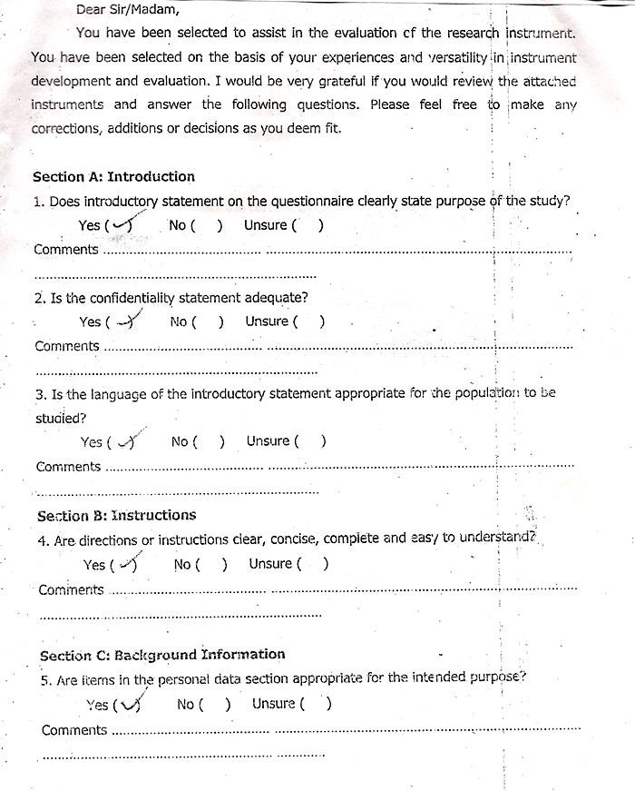

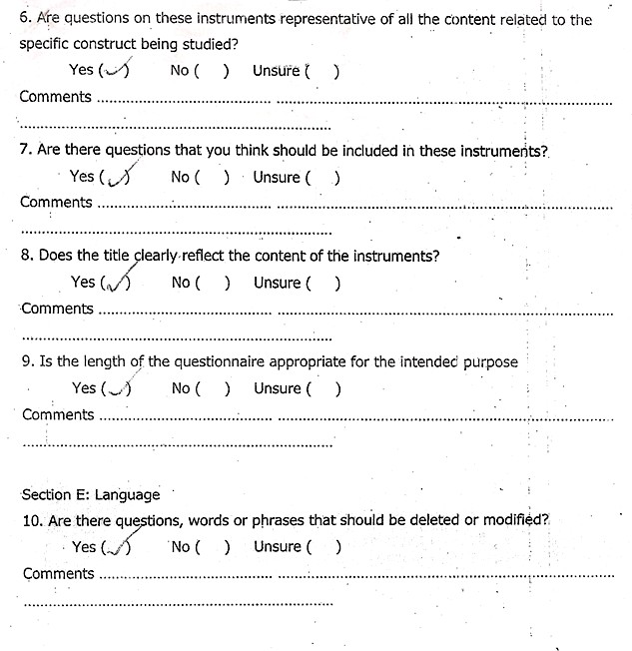**Section D: Content**

### Section F: General Comments

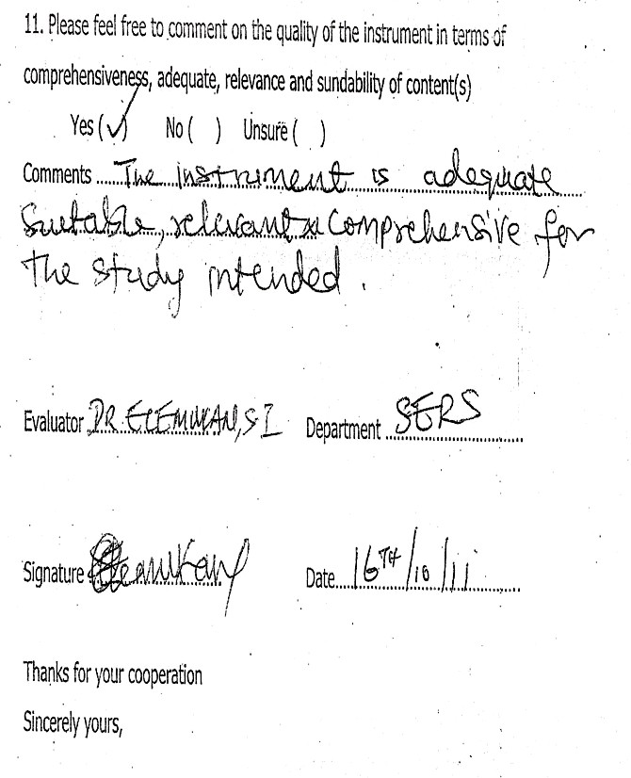

**APPENDIX A7 FACULTY OF EDUCATION**

### INSTRUMENT OF EVALUATION EXPERTS

**TEACHERS’ ASSISTIVE TECHNOLOGY AWARENESS QUESTIONNAIRE EVALUATION REPORT**

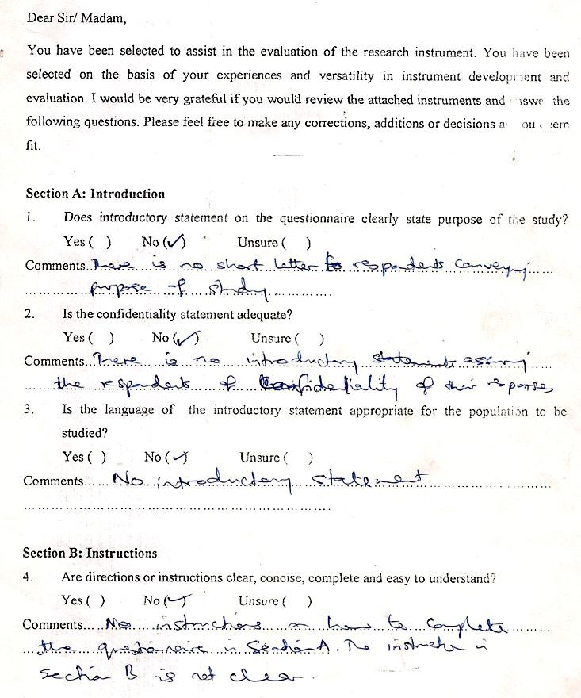

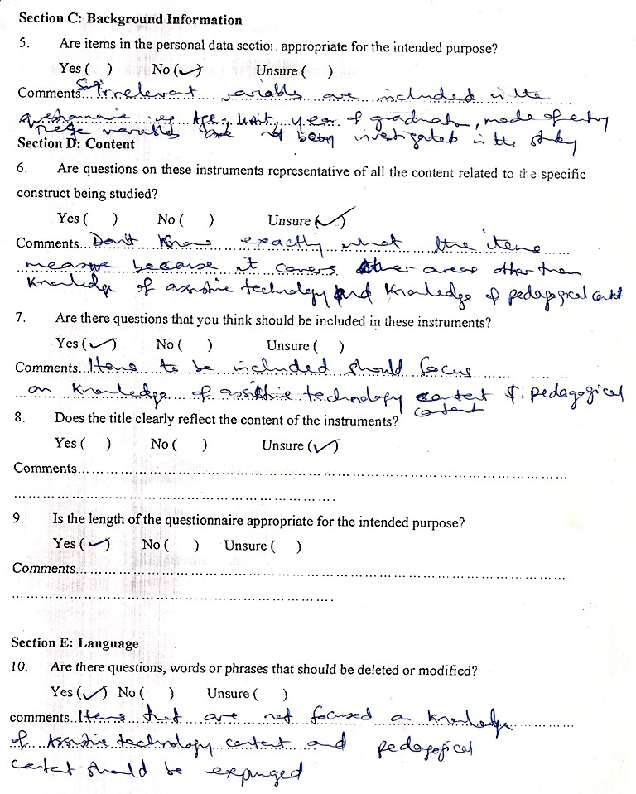

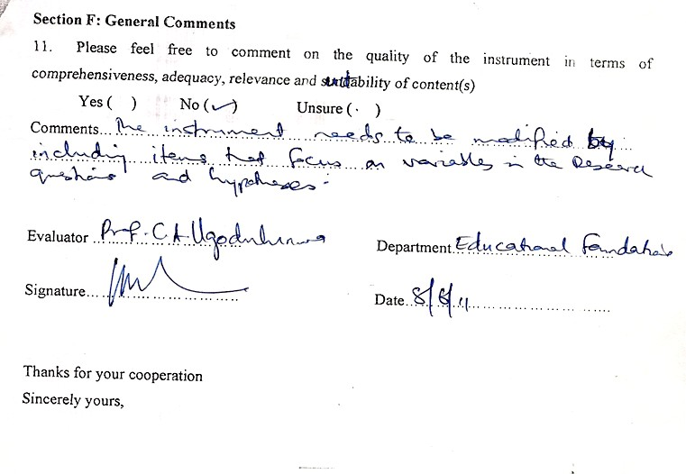

### APPENDIX A8 FACULTY OF EDUCATION

**INSTRUMENT OF EVALUATION EXPERTS**

### TEACHERS’ ASSISTIVE TECHNOLOGY AWARENESS QUESTIONNAIRE EVALUATION REPORT

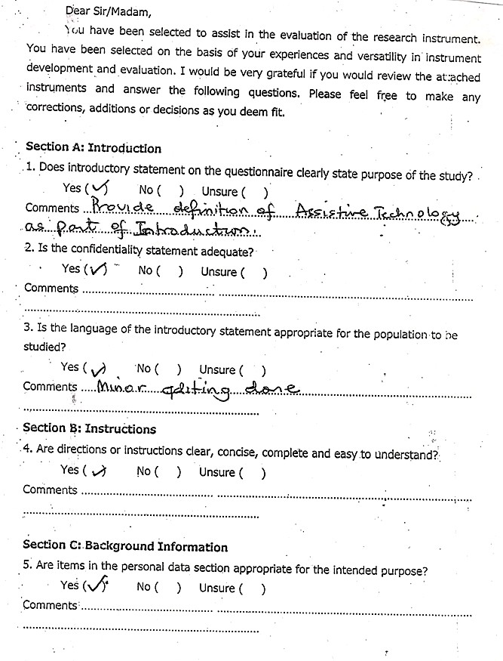

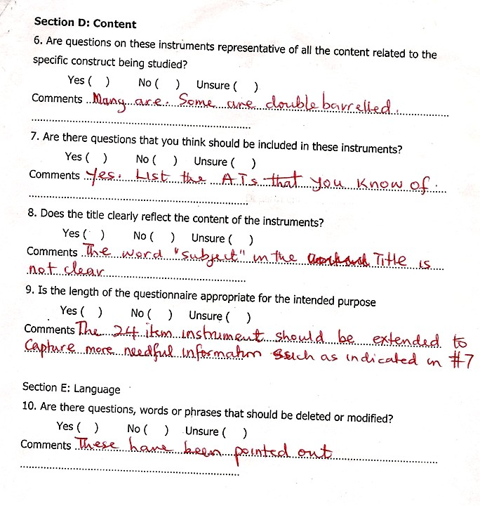

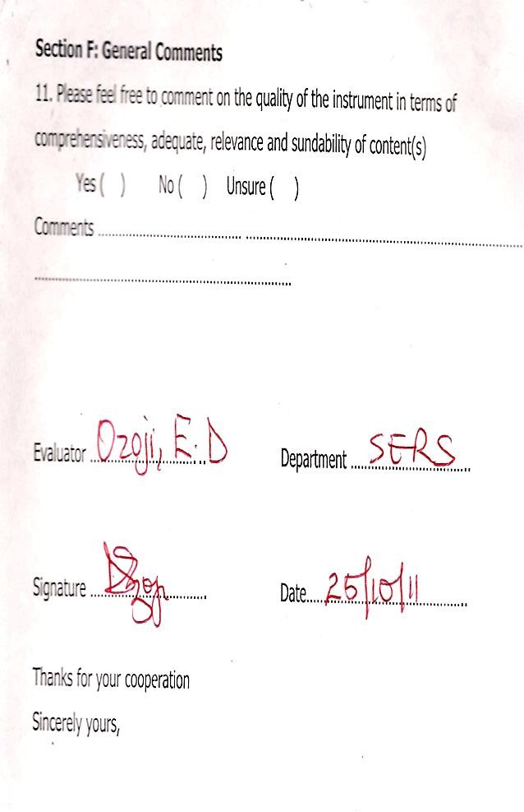

**APPENDIX A9 FACULTY OF EDUCATION**

### INSTRUMENT OF EVALUATION EXPERTS

**TEACHERS’ ASSISTIVE TECHNOLOGY COMPETENCY QUESTIONNAIRE EVALUATION REPORT**

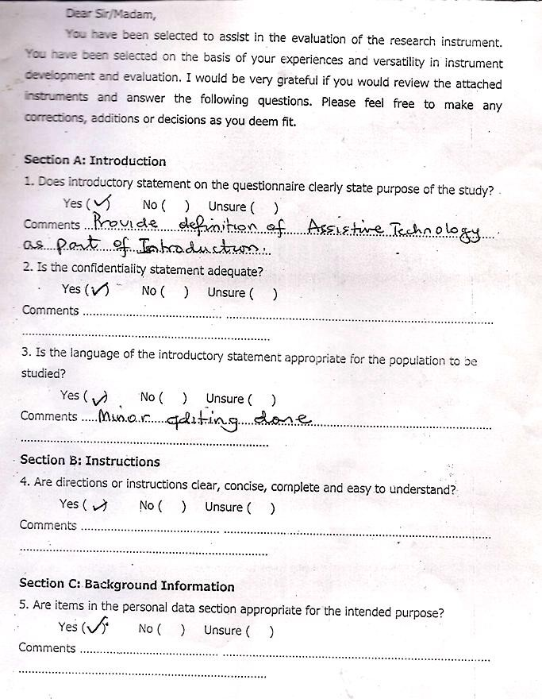

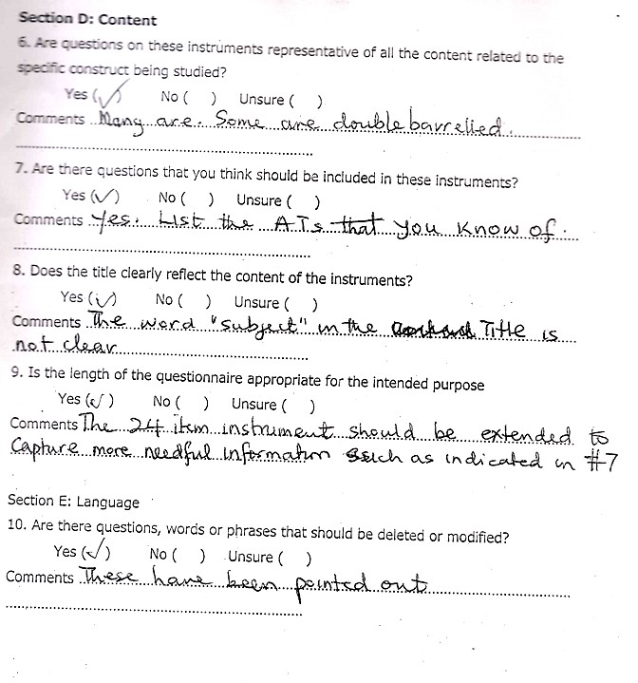



### APPENDIX A 10

**FACULTY OF EDUCATION INSTRUMENT OF EVALUATION EXPERTS**

### TEACHERS’ ASSISTIVE TECHNOLOGY COMPETENCY QUESTIONNAIRE EVALUATION REPORT

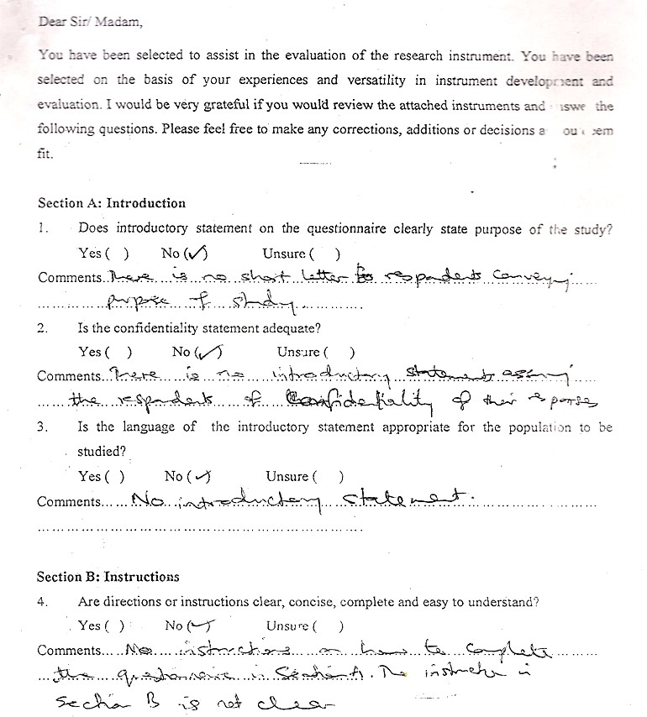

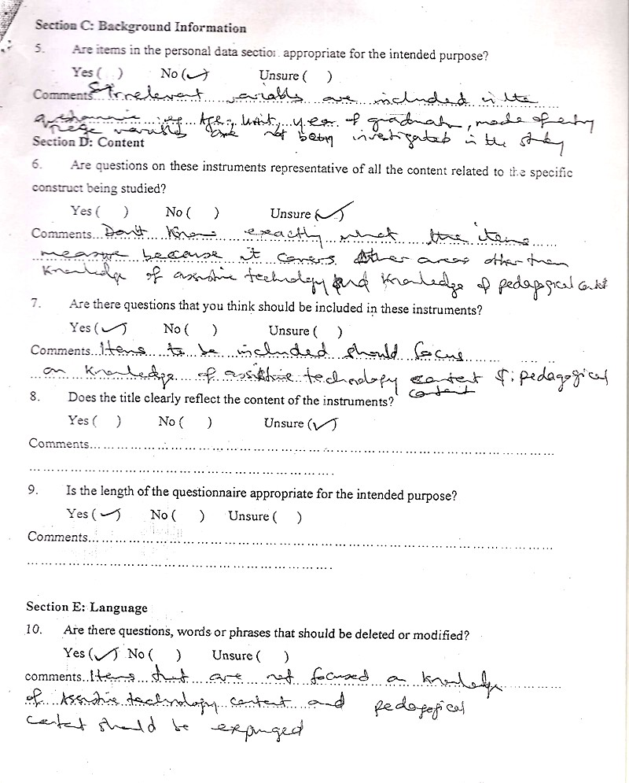

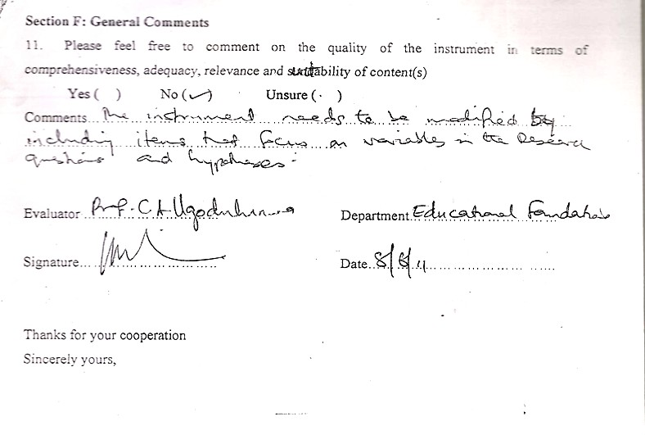

**APPENDIX A11**

### FACULTY OF EDUCATION INSTRUMENT OF EVALUATION EXPERTS

**TEACHERS’ ASSISTIVE TECHNOLOGY COMPETENCY QUESTIONNAIRE EVALUATION REPORT**

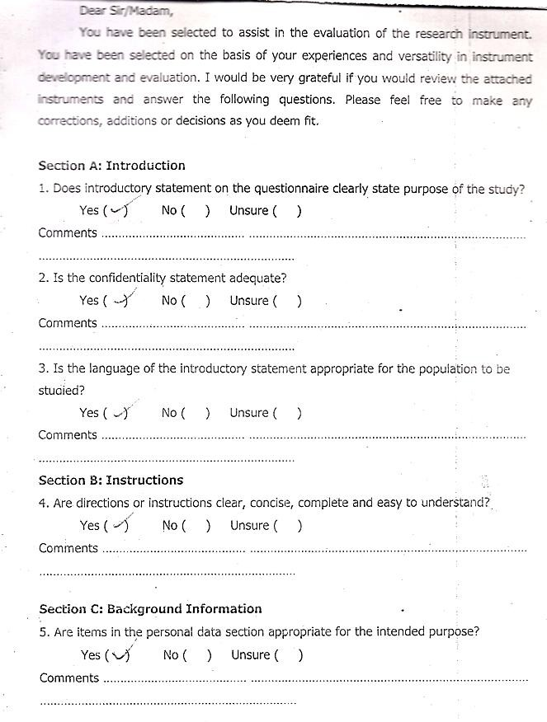

### Section D: Comment

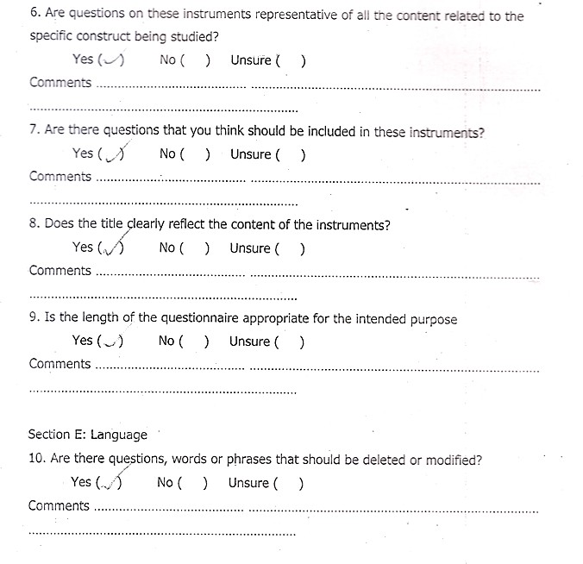

**Section F: General Comments**

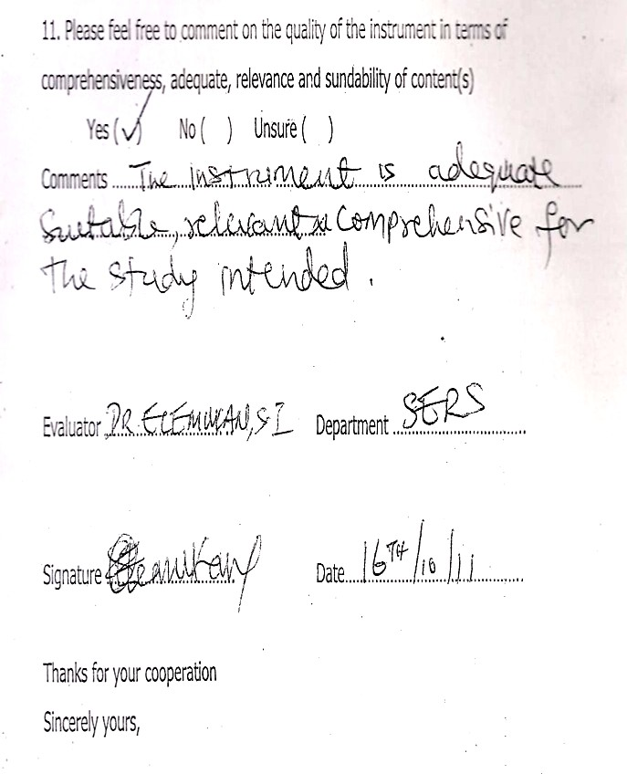

### APPENDIX A12

**FACULTY OF EDUCATION INSTRUMENT EVALUATION GUIDE FOR EXPERTS**

### ASSISTIVE TECHNOLOGY DEVICE COMPETENCE CHECKLIST EVALUATION REPORT

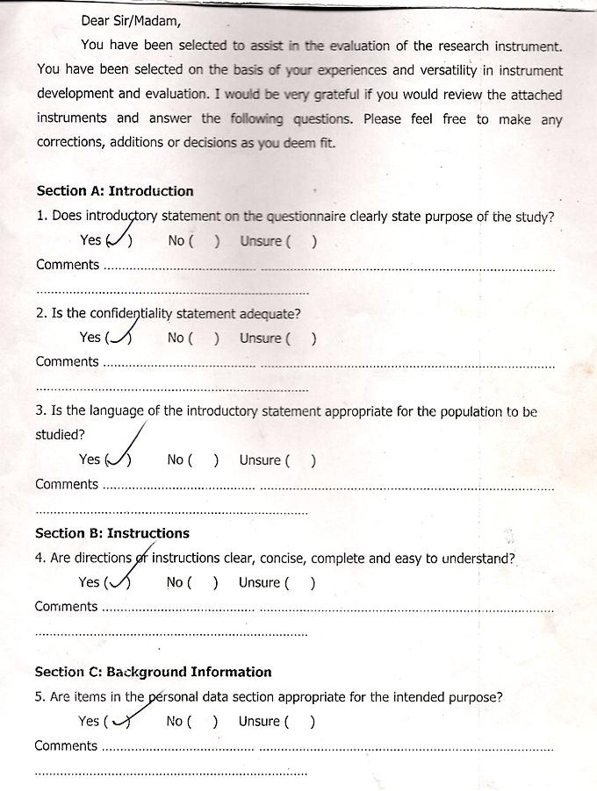

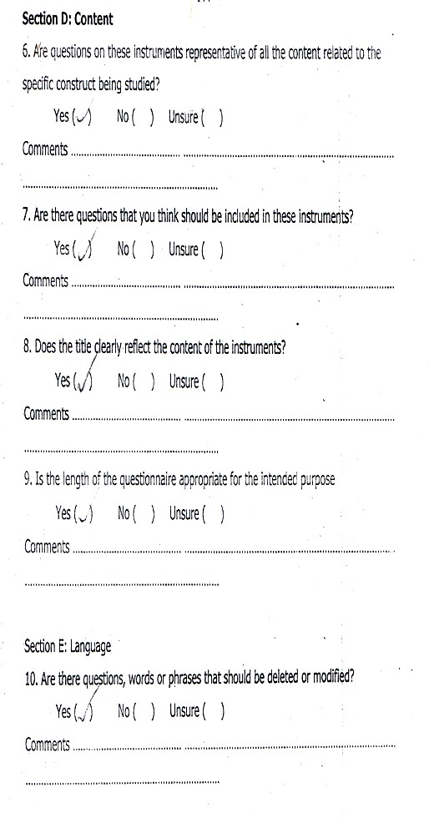

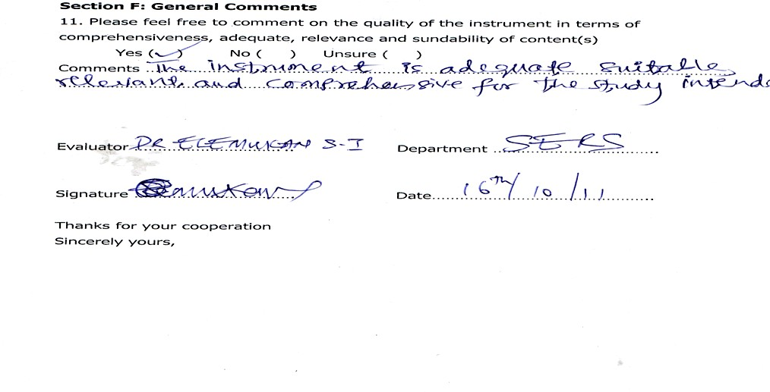

**APPENDIX A13**

### FACULTY OF EDUCATION INSTRUMENT EVALUATION GUIDE FOR EXPERTS

**ASSISTIVE TECHNOLOGY DEVICE COMPETENCE CHECKLIST EVALUATION REPORT**

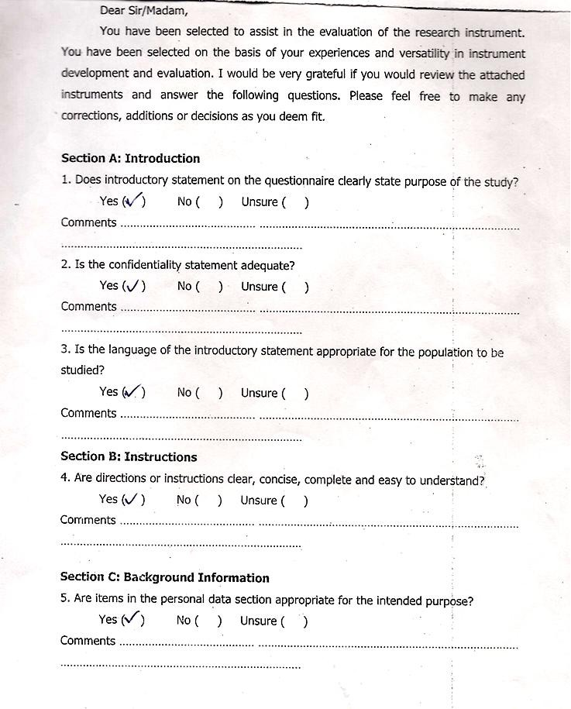

### Section D: Content

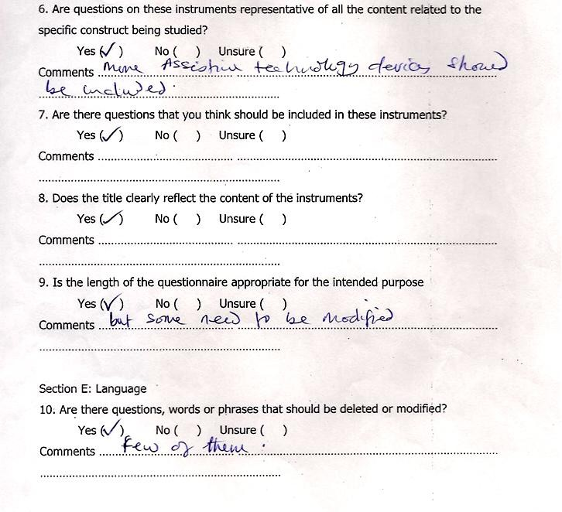

**Section F: General Comments**



### APPENDIX A14

**FACULTY OF EDUCATION INSTRUMENT EVALUATION GUIDE FOR EXPERTS**

### ASSISTIVE TECHNOLOGY DEVICE AVAILABILITY IN SCHOOLS EVALUATION REPORT

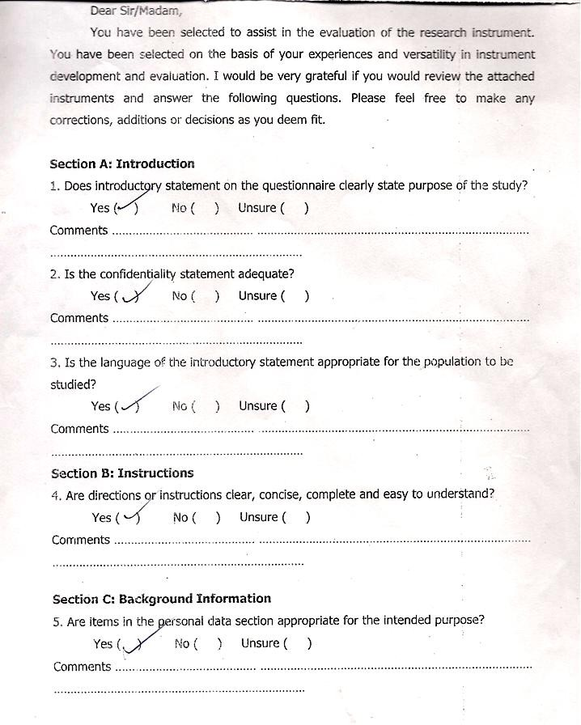

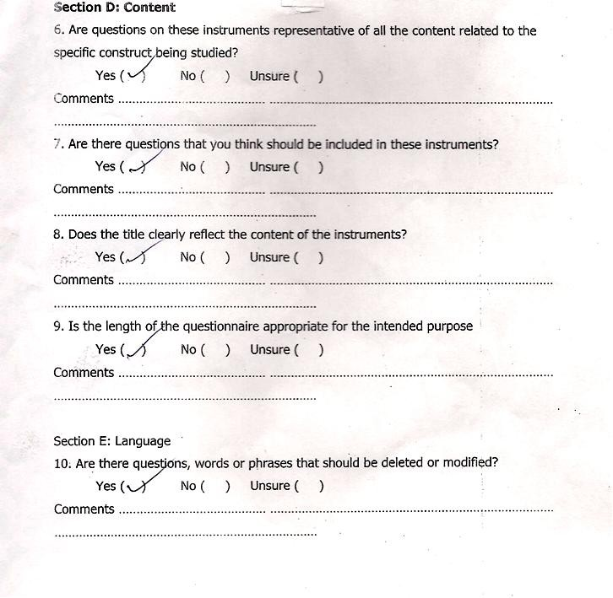

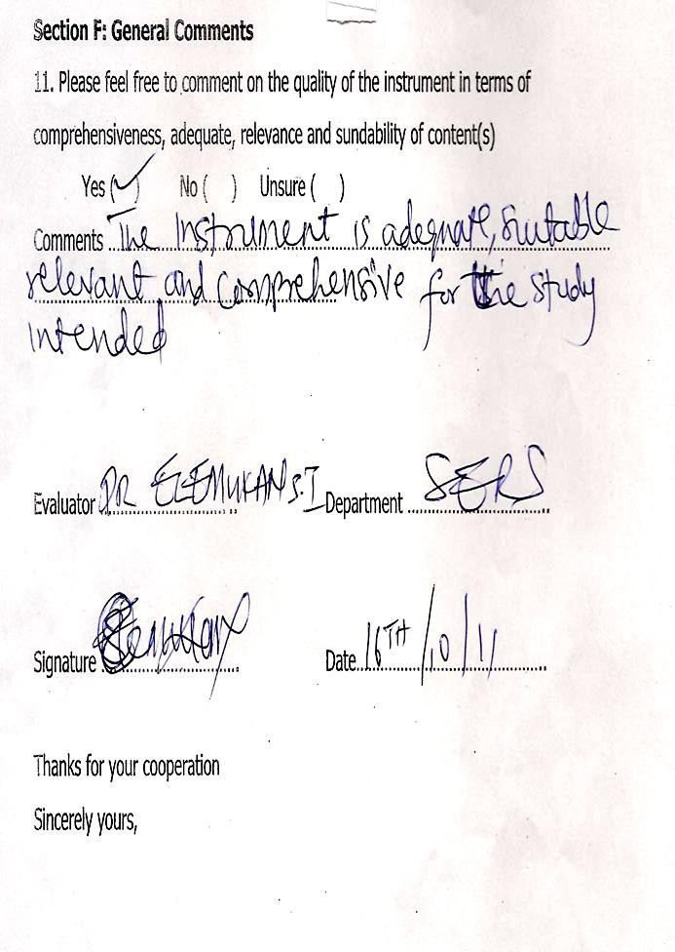

**APPENDIX A15**

### FACULTY OF EDUCATION INSTRUMENT EVALUATION GUIDE FOR EXPERTS

**ASSISTIVE TECHNOLOGY DEVICE AVAILABILITY IN SCHOOLS EVALUATION REPORT**

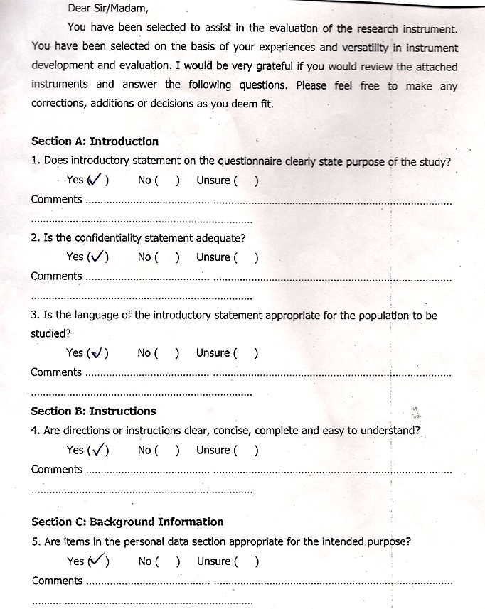

### Section D: Content

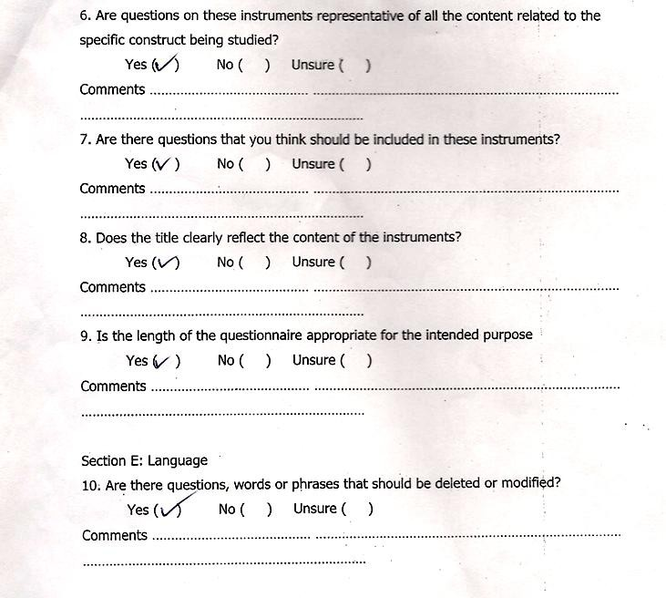

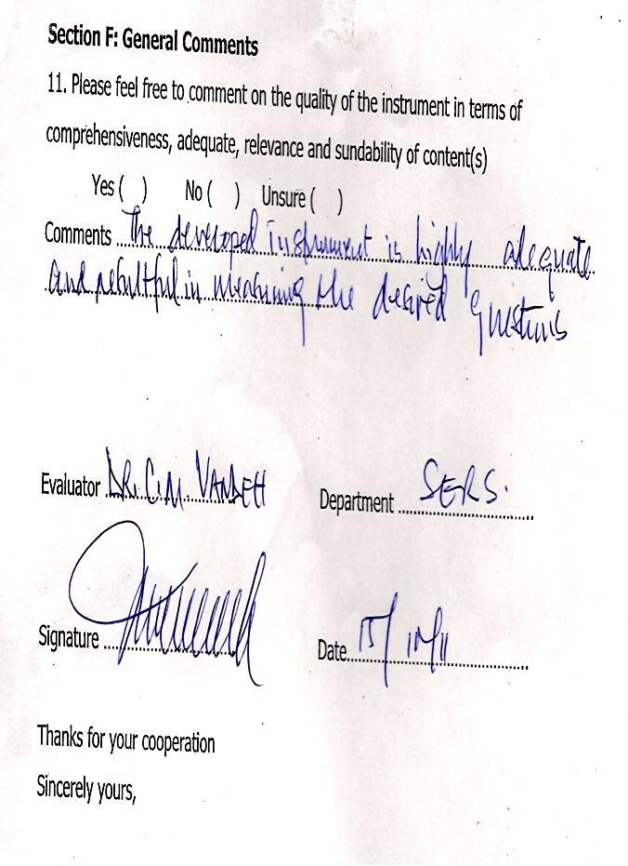

**APPENDIX A16**

### DESCRIPTIVES FOR TEACHERS’ ASSISTIVE TECHNOLOGY AWARENESS QUESTIONNAIRE (TATAQ)

DESCRIPTIVE VARIABLES=B1 B2 B3 B4 B5 B6 B7 B8 B9 B10 B11 B12 B13 B14 B 15 B16 B17 B18 B19 B20 B21 B22 B23 B2 /STATISTICS=MEAN STD DEV.

|  |  |  |  |
| --- | --- | --- | --- |
| **Descriptive Statistics** | | | |
|  | N | Mean | Std. Deviation |
| I do know that assistive technology devices do not replace human function but aids in the functional capabilities of the children with special needs. | 450 | 3.0356 | 0.62863 |
| I know that assistive technology is useful in the education of children with special needs. | 450 | 3.2 | 0.64363 |
| I know the effect of handicap on the use of assistive technology. | 450 | 3.1311 | 0.65267 |
| I do know all the importance of assistive technology in the education of persons with special needs. | 450 | 1.88 | 0.65651 |
| Assistive technology devices are in the market but most of them are costly. | 450 | 3.2578 | 0.6298 |
| Assistive technology helps children with special needs to learn or move around easily. | 450 | 3.0067 | 0.63488 |
| I am aware that different assistive technology devices exist for the education of different categories of children with special needs. | 450 | 3.0511 | 0.62577 |
| I know that assistive technology will help children with special needs learn better. | 450 | 2.9756 | 0.79353 |
| I am familiar with general assistive technology for individuals with disabilities. | 450 | 1.7267 | 0.71475 |
| I don’t know anything about assistive technology in the education of persons with special needs. | 450 | 1.6378 | 0.58936 |
| I can identify a variety of assistive technology devices eg softwares, hardwares and peripheral devices for students with different handicaps. | 450 | 1.6244 | 0.58855 |
| I am aware of the need for portability and the limitations of specific assistive technology for students in various  environments. | 450 | 1.68 | 0.64349 |
| I graduated from teachers training without proper understanding of assistive technology devices. | 450 | 1.6044 | 0.57333 |
| I know assistive technology devices that allow students to participate at the same level of involvement in learning activities as non disabled peers. | 450 | 1.5556 | 0.54856 |
| I started hearing of assistive technology when my school started inclusive educ. so my understanding of assistive technology is very limited. | 450 | 1.7067 | 0.64584 |

|  |  |  |  |
| --- | --- | --- | --- |
| I have never operated any assistive technology devices that use electricity to function. | 450 | 2.0356 | 0.79451 |
| I just have a theoretical knowledge of assistive technology. | 449 | 3.1693 | 0.71204 |
| I am aware of agencies local and international that provides technology assistance to individuals with disabilities. | 450 | 1.7067 | 0.63189 |
| The assistive technology devices in our school are too old. | 450 | 1.9222 | 0.7376 |
| Teachers’ irregular use of assistive technology devices in teaching affects their skills in assistive technology. | 450 | 3.0267 | 0.78357 |
| I have a good knowledge of assistive technology but they are not skillful in using it. | 450 | 1.8844 | 0.7157 |
| Computer hard wares and soft wares are not available in our school | 450 | 2.8867 | 0.90189 |
| I know some of the assistive technology manufacturers and vendors. | 450 | 1.6689 | 0.62904 |
| I can teach very well using some of the devices that do not use electricity to work. | 450 | 1.8333 | 0.84487 |
| Valid N (listwise) | 449 |  |  |

### APPENDIX A17

**DESCRIPTIVES FOR TEACHERS’ ASSISTIVE TECHNOLOGY COMPETENCY QUESTIONNAIRE (TATCQ)**

### Descriptives for section C

|  |  |  |  |
| --- | --- | --- | --- |
| **Descriptive Statistics** | | | |
|  | N | Mean | Std. Deviation |
| Use of assistive technology in special educ. assessment and planning. | 450 | 1.64 | 0.62194 |
| Use of assistive technology to facilitate instruction in special education programmes. | 449 | 1.8352 | 0.60468 |
| Acquire a body of knowledge about the use of technology in special education. | 450 | 1.3756 | 0.4848 |
| Evaluate tech. hardwares and softwares and related materials for their potential use in special education Programme. | 450 | 1.6111 | 0.57981 |
| Use assistive technology to generate teaching aids for special education programme classroom. | 450 | 2.5 | 0.5751 |
| Use assistive technology as aid to personnel productivity. | 450 | 2.5444 | 0.58109 |
| Teach students to use trouble shooting techniques. | 450 | 1.8578 | 0.60602 |
| Assemble, operate trouble shoot and maintain the components of technology system in special education environment. | 450 | 1.8133 | 0.57475 |
| Teach various concepts related to the installation of assistive technology devices. | 450 | 1.4578 | 0.53746 |
| Develop plan for technology use in special education Programmes. | 450 | 1.4422 | 0.55237 |
| Develop lesson plans that incorporate assistive technology. | 450 | 1.5311 | 0.57036 |
| Teach students the appropriate social skills for using technology in various environments. | 450 | 1.38 | 0.49501 |
| Teach students with disabilities the use of assistive technology for access to information in the class room | 450 | 1.4378 | 0.51429 |
| Teach students the appropriate application of  technology to classroom learning. | 450 | 1.6467 | 0.61318 |
| Use of technology to enhance management of resources | 450 | 1.9444 | 0.68326 |
| Use technology in professional development Plans | 450 | 1.9933 | 0.73563 |
| Use of technology implementation with students with  disabilities. | 450 | 2.5111 | 0.78182 |

|  |  |  |  |
| --- | --- | --- | --- |
| Use assistive technology as part of the core curriculum including independent living device. | 450 | 1.7556 | 0.6245 |
| Use of effective evaluative practices in collaboration with a multidisciplinary team to determine what technology would best assist a student in accessing the  educational curriculum. | 450 | 1.6222 | 0.58902 |
| Provide instruction in assistive technology devices in purposeful ways. | 450 | 2.2667 | 0.80643 |
| Develop lesson plans that incorporate assistive  technology. | 450 | 2.6 | 0.78403 |
| Recommend assistive technology devices for specific learning environments. | 450 | 2.2467 | 0.77778 |
| Know the strategies to involve a student with disability in the class while still using assistive technology. | 450 | 2.0178 | 0.66046 |
| Know how to use assistive technology across environment. | 450 | 1.5978 | 0.67107 |
| Valid N (listwise) | 449 |  |  |

**SECTION 2**

### Descriptive for Teachers’ Assistive Technology Device competence checklist (TATDCC)

|  |  |  |  |
| --- | --- | --- | --- |
| **Descriptive Statistics** | | | |
|  | N | Mean | Std.  Deviation |
| Toys | 450 | 1.92 | 1.00458 |
| Models | 450 | 1.9933 | 1.0563 |
| Slate and Braille stylus | 450 | 2 | 1.07202 |
| Perkins Braille writer | 450 | 2.0044 | 1.05947 |
| Motion films | 450 | 2.0467 | 1.07411 |
| Software | 450 | 2.0267 | 1.0379 |
| ICT | 450 | 2.0333 | 1.03233 |
| White cane | 450 | 2.0444 | 1.04371 |
| Speech trainer | 450 | 2.0267 | 1.0052 |
| Talking calculator | 450 | 2.0467 | 1.03181 |
| Amplification devices | 450 | 2.0689 | 1.01532 |
| Audiometer | 450 | 2.0311 | 1.01828 |
| Hearing aid | 450 | 1.9822 | 0.99873 |
| Booth | 450 | 1.94 | 0.98923 |
| Wheel chair | 450 | 1.9489 | 1.00092 |
| Type writer | 450 | 1.9289 | 0.97374 |
| Computer | 450 | 1.8844 | 0.94385 |
| Crutches | 450 | 1.8867 | 0.957 |
| Calipers | 450 | 1.9067 | 0.90295 |
| Valid N (listwise) | 450 |  |  |

**APPENDIX A18**

### FREQUENCY TABLE FOR ALL THE ITEMS.

|  |  |  |  |  |  |
| --- | --- | --- | --- | --- | --- |
| **Sex** | | | | | |
|  | | Frequency | Percent | Valid Percent | Cumulative Percent |
| Valid | Male | 254 | 56.4 | 56.4 | 56.4 |
| Female | 196 | 43.6 | 43.6 | 100 |
| Total | 450 | 100 | 100 |  |

|  |  |  |  |  |  |
| --- | --- | --- | --- | --- | --- |
| **Specialization** | | | | | |
|  | | Frequency | Percent | Valid Percent | Cumulative  Percent |
| Valid | Regular teacher | 300 | 66.7 | 67.6 | 67.6 |
| Special teacher | 150 | 33.3 | 32.4 | 100 |
| Total | 450 | 100 | 100 |  |

|  |  |  |  |  |  |
| --- | --- | --- | --- | --- | --- |
| **Years of experience** | | | | | |
|  | | Frequency | Percent | Valid Percent | Cumulative  Percent |
| Valid | 1-10yrs | 115 | 25.6 | 25.6 | 25.6 |
| 11-20yrs | 193 | 42.9 | 42.9 | 68.4 |
| 21-30yrs | 105 | 23.3 | 23.3 | 91.8 |
| 31 & above | 37 | 8.2 | 8.2 | 100 |
| Total | 450 | 100 | 100 |  |

|  |  |  |  |  |  |
| --- | --- | --- | --- | --- | --- |
| **Highest Qualification** | | | | | |
|  | | Frequency | Percent | Valid Percent | Cumulative Percent |
| Valid | Diploma | 52 | 11.6 | 11.6 | 11.6 |
| HND | 13 | 2.9 | 2.9 | 14.4 |
| NCE | 117 | 26 | 26 | 40.4 |
| B. Ed | 252 | 56 | 56 | 96.4 |
| PG | 16 | 3.6 | 3.6 | 100 |
| Total | 450 | 100 | 100 |  |

|  |  |  |  |  |  |
| --- | --- | --- | --- | --- | --- |
| **I do know that assistive technology devices do not replace human function but aids in the functional capabilities of children with special needs.** | | | | | |
|  | | Frequency | Percent | Valid Percent | Cumulative  Percent |
| Valid | DA | 81 | 18 | 18 | 18 |
| A | 272 | 60.4 | 60.4 | 78.4 |
| SA | 97 | 21.6 | 21.6 | 100 |
| Total | 450 | 100 | 100 |  |

|  |  |  |  |  |  |
| --- | --- | --- | --- | --- | --- |
| **I know that assistive technology is useful in the education of children with special needs** | | | | | |
|  | | Frequency | Percent | Valid Percent | Cumulative Percent |
| Valid | SD | 2 | 0.4 | 0.4 | 0.4 |
| DA | 51 | 11.3 | 11.3 | 11.8 |
| A | 252 | 56 | 56 | 67.8 |
| SA | 145 | 32.2 | 32.2 | 100 |
| Total | 450 | 100 | 100 |  |

|  |  |  |  |  |  |
| --- | --- | --- | --- | --- | --- |
| **I know the effect of handicap on the use of assistive technology.** | | | | | |
|  | | Frequency | Percent | Valid Percent | Cumulative Percent |
| Valid | SD | 1 | 0.2 | 0.2 | 0.2 |
| DA | 67 | 14.9 | 14.9 | 15.1 |
| A | 254 | 56.4 | 56.4 | 71.6 |
| SA | 128 | 28.4 | 28.4 | 100 |
| Total | 450 | 100 | 100 |  |

|  |  |  |  |  |  |
| --- | --- | --- | --- | --- | --- |
| **I do know all the importance of assistive technology in the education of persons with special needs** | | | | | |
|  | | Frequency | Percent | Valid Percent | Cumulative  Percent |
| Valid | SD | 127 | 28.2 | 28.2 | 28.2 |
| DA | 250 | 55.6 | 55.6 | 83.8 |
| A | 73 | 16.2 | 16.2 | 100 |
| Total | 450 | 100 | 100 |  |

|  |  |  |  |  |  |
| --- | --- | --- | --- | --- | --- |
| **Assistive technology devices are in the market but most of them are costly** | | | | | |
|  | | Frequency | Percent | Valid Percent | Cumulative  Percent |
| Valid | SD | 2 | 0.4 | 0.4 | 0.4 |
| DA | 40 | 8.9 | 8.9 | 9.3 |
| A | 248 | 55.1 | 55.1 | 64.4 |
| SA | 160 | 35.6 | 35.6 | 100 |
| Total | 450 | 100 | 100 |  |

|  |  |  |  |  |  |
| --- | --- | --- | --- | --- | --- |
| **Assistive technology helps children with special needs to learn or move around easily** | | | | | |
|  | | Frequency | Percent | Valid Percent | Cumulative Percent |
| Valid | DA | 89 | 19.8 | 19.8 | 19.8 |
| A | 269 | 59.8 | 59.8 | 79.6 |
| SA | 92 | 20.4 | 20.4 | 100 |
| Total | 450 | 100 | 100 |  |

|  |  |  |  |  |  |
| --- | --- | --- | --- | --- | --- |
| **I am aware that different assistive technology devices exist for the education of different categories of children with special needs** | | | | | |
|  | | Frequency | Percent | Valid Percent | Cumulative  Percent |
| Valid | SD | 3 | 0.7 | 0.7 | 0.7 |
| DA | 68 | 15.1 | 15.1 | 15.8 |
| A | 282 | 62.7 | 62.7 | 78.4 |
| SA | 97 | 21.6 | 21.6 | 100 |
| Total | 450 | 100 | 100 |  |

|  |  |  |  |  |  |
| --- | --- | --- | --- | --- | --- |
| **I know that assistive technology will help children with special needs learn better** | | | | | |
|  | | Frequency | Percent | Valid Percent | Cumulative Percent |
| Valid | SD | 18 | 4 | 4 | 4 |
| DA | 93 | 20.7 | 20.7 | 24.7 |
| A | 221 | 49.1 | 49.1 | 73.8 |
| SA | 118 | 26.2 | 26.2 | 100 |
| Total | 450 | 100 | 100 |  |
| **I am familiar with general assistive technology for individuals with disabilities** | | | | | |
|  | | Frequency | Percent | Valid Percent | Cumulative Percent |
| Valid | SD | 185 | 41.1 | 41.1 | 41.1 |
| DA | 211 | 46.9 | 46.9 | 88 |
| A | 46 | 10.2 | 10.2 | 98.2 |
| SA | 8 | 1.8 | 1.8 | 100 |
| Total | 450 | 100 | 100 |  |

|  |  |  |  |  |  |
| --- | --- | --- | --- | --- | --- |
| **I don’t know anything about assistive technology in the education of persons with special needs** | | | | | |
|  | | Frequency | Percent | Valid Percent | Cumulative  Percent |
| Valid | SD | 188 | 41.8 | 41.8 | 41.8 |
| DA | 238 | 52.9 | 52.9 | 94.7 |
| A | 23 | 5.1 | 5.1 | 99.8 |
| SA | 1 | 0.2 | 0.2 | 100 |
| Total | 450 | 100 | 100 |  |

|  |  |  |  |  |  |
| --- | --- | --- | --- | --- | --- |
| **I can identify a variety of assistive tech. devices e.g. softwares, hardwares and peripheral devices for students with different handicaps** | | | | | |
|  | | Frequency | Percent | Valid Percent | Cumulative  Percent |
| Valid | SD | 194 | 43.1 | 43.1 | 43.1 |
| DA | 231 | 51.3 | 51.3 | 94.4 |
| A | 25 | 5.6 | 5.6 | 100 |
| Total | 450 | 100 | 100 |  |

|  |  |  |  |  |  |
| --- | --- | --- | --- | --- | --- |
| **I am aware of the need for portability and the limitations of specific assistive technology for students in various environments** | | | | | |
|  | | Frequency | Percent | Valid Percent | Cumulative  Percent |
| Valid | SD | 187 | 41.6 | 41.6 | 41.6 |
| DA | 221 | 49.1 | 49.1 | 90.7 |
| A | 41 | 9.1 | 9.1 | 99.8 |
| SA | 1 | 0.2 | 0.2 | 100 |
| Total | 450 | 100 | 100 |  |

|  |  |  |  |  |  |
| --- | --- | --- | --- | --- | --- |
| **I graduated from teachers training without proper understanding of assistive technology devices** | | | | | |
|  | | Frequency | Percent | Valid Percent | Cumulative Percent |
| Valid | SD | 198 | 44 | 44 | 44 |
| DA | 232 | 51.6 | 51.6 | 95.6 |
| A | 20 | 4.4 | 4.4 | 100 |
| Total | 450 | 100 | 100 |  |

|  |  |  |  |  |  |
| --- | --- | --- | --- | --- | --- |
| **I know assistive technology devices that allow students to participate at the same level of involvement in learning activities as non disabled peers** | | | | | |
|  | | Frequency | Percent | Valid Percent | Cumulative Percent |
| Valid | SD | 212 | 47.1 | 47.1 | 47.1 |
| DA | 226 | 50.2 | 50.2 | 97.3 |
| A | 12 | 2.7 | 2.7 | 100 |
| Total | 450 | 100 | 100 |  |

|  |  |  |  |  |  |
| --- | --- | --- | --- | --- | --- |
| **I started hearing of assistive technology when my school started inclusive educ. So my understanding of assistive technology is very limited** | | | | | |
|  | | Frequency | Percent | Valid Percent | Cumulative Percent |
| Valid | SD | 179 | 39.8 | 39.8 | 39.8 |
| DA | 224 | 49.8 | 49.8 | 89.6 |
| A | 47 | 10.4 | 10.4 | 100 |
| Total | 450 | 100 | 100 |  |

|  |  |  |  |  |  |
| --- | --- | --- | --- | --- | --- |
| **I have never operated any assistive technology devices that uses electricity to function** | | | | | |
|  | | Frequency | Percent | Valid Percent | Cumulative  Percent |
| Valid | SD | 121 | 26.9 | 26.9 | 26.9 |
| DA | 205 | 45.6 | 45.6 | 72.4 |
| A | 111 | 24.7 | 24.7 | 97.1 |
| SA | 13 | 2.9 | 2.9 | 100 |
| Total | 450 | 100 | 100 |  |

|  |  |  |  |  |  |
| --- | --- | --- | --- | --- | --- |
| **I just have a theoretical knowledge of assistive technology** | | | | | |
|  | | Frequency | Percent | Valid Percent | Cumulative Percent |
| Valid | SD | 4 | 0.9 | 0.9 | 0.9 |
| DA | 70 | 15.6 | 15.6 | 16.5 |
| A | 221 | 49.1 | 49.2 | 65.7 |
| SA | 154 | 34.2 | 34.3 | 100 |
| Total | 449 | 99.8 | 100 |  |
| Missing | System | 1 | 0.2 |  |  |
| Total | | 450 | 100 |  |  |

|  |  |  |  |  |  |
| --- | --- | --- | --- | --- | --- |
| **I am aware of local and international agencies that provide technology assistance to individuals with disabilities** | | | | | |
|  | | Frequency | Percent | Valid Percent | Cumulative Percent |
| Valid | SD | 175 | 38.9 | 38.9 | 38.9 |
| DA | 232 | 51.6 | 51.6 | 90.4 |
| A | 43 | 9.6 | 9.6 | 100 |
| Total | 450 | 100 | 100 |  |

|  |  |  |  |  |  |
| --- | --- | --- | --- | --- | --- |
| **The assistive technology devices in our school are too old** | | | | | |
|  | | Frequency | Percent | Valid Percent | Cumulative Percent |
| Valid | SD | 132 | 29.3 | 29.3 | 29.3 |
| DA | 230 | 51.1 | 51.1 | 80.4 |
| A | 79 | 17.6 | 17.6 | 98 |
| SA | 9 | 2 | 2 | 100 |
| Total | 450 | 100 | 100 |  |

|  |  |  |  |  |  |
| --- | --- | --- | --- | --- | --- |
| **Teachers irregular use of assistive technology devices in teaching affects their skills in the use of assistive technology** | | | | | |
|  | | Frequency | Percent | Valid Percent | Cumulative Percent |
| Valid | SD | 17 | 3.8 | 3.8 | 3.8 |
| DA | 81 | 18 | 18 | 21.8 |
| A | 225 | 50 | 50 | 71.8 |
| SA | 127 | 28.2 | 28.2 | 100 |
| Total | 450 | 100 | 100 |  |

|  |  |  |  |  |  |
| --- | --- | --- | --- | --- | --- |
| **I have a good knowledge of assistive technology but I am not skillful in using it** | | | | | |
|  | | Frequency | Percent | Valid Percent | Cumulative  Percent |
| Valid | SD | 140 | 31.1 | 31.1 | 31.1 |
| DA | 226 | 50.2 | 50.2 | 81.3 |
| A | 80 | 17.8 | 17.8 | 99.1 |
| SA | 4 | 0.9 | 0.9 | 100 |
| Total | 450 | 100 | 100 |  |

|  |  |  |  |  |  |
| --- | --- | --- | --- | --- | --- |
| **computer hard wares and soft wares are not available in our school** | | | | | |
|  | | Frequency | Percent | Valid Percent | Cumulative Percent |
| Valid | SD | 36 | 8 | 8 | 8 |
| DA | 103 | 22.9 | 22.9 | 30.9 |
| A | 187 | 41.6 | 41.6 | 72.4 |
| SA | 124 | 27.6 | 27.6 | 100 |
| Total | 450 | 100 | 100 |  |

|  |  |  |  |  |  |
| --- | --- | --- | --- | --- | --- |
| **I know some of the assistive technology manufacturers and vendors** | | | | | |
|  | | Frequency | Percent | Valid Percent | Cumulative  Percent |
| Valid | SD | 188 | 41.8 | 41.8 | 41.8 |
| DA | 223 | 49.6 | 49.6 | 91.3 |
| A | 39 | 8.7 | 8.7 | 100 |
| Total | 450 | 100 | 100 |  |

|  |  |  |  |  |  |
| --- | --- | --- | --- | --- | --- |
| **I can teach very well using some of the devices that do not use electricity to work** | | | | | |
|  | | Frequency | Percent | Valid Percent | Cumulative  Percent |
| Valid | SD | 186 | 41.3 | 41.3 | 41.3 |
| DA | 171 | 38 | 38 | 79.3 |
| A | 75 | 16.7 | 16.7 | 96 |
| SA | 18 | 4 | 4 | 100 |
| Total | 450 | 100 | 100 |  |

**APPENDIX A19**

### FREQUENCY TABLE FOR TEACHERS’ ASSISTIVE TECHNOLOGY COMPETENCY QUESTIONNAIRE (TATCQ)

|  |  |  |  |  |  |
| --- | --- | --- | --- | --- | --- |
| **Use of assistive technology in special education assessment and planning** | | | | | |
|  | | Frequency | Percent | Valid Percent | Cumulative  Percent |
| Valid | No experience | 197 | 43.8 | 43.8 | 43.8 |
| Beginner | 218 | 48.4 | 48.4 | 92.2 |
| Moderate | 35 | 7.8 | 7.8 | 100 |
| Total | 450 | 100 | 100 |  |

|  |  |  |  |  |  |
| --- | --- | --- | --- | --- | --- |
| **Use of assistive technology to facilitate instruction in special education programmes** | | | | | |
|  | | Frequency | Percent | Valid Percent | Cumulative Percent |
| Valid | No experience | 125 | 27.8 | 27.8 | 27.8 |
| Beginner | 273 | 60.7 | 60.8 | 88.6 |
| Moderate | 51 | 11.3 | 11.4 | 100 |
| Total | 449 | 99.8 | 100 |  |
| Missing | System | 1 | 0.2 |  |  |
| Total | | 450 | 100 |  |  |

|  |  |  |  |  |  |
| --- | --- | --- | --- | --- | --- |
| **Acquire a body of knowledge about the use of technology in special education** | | | | | |
|  | | Frequency | Percent | Valid Percent | Cumulative  Percent |
| Valid | No experience | 281 | 62.4 | 62.4 | 62.4 |
| Beginner | 169 | 37.6 | 37.6 | 100 |
| Total | 450 | 100 | 100 |  |

|  |  |  |  |  |  |
| --- | --- | --- | --- | --- | --- |
| **Evaluate technology hardwares and softwares and related materials for their potential use in special education programme** | | | | | |
|  | | Frequency | Percent | Valid Percent | Cumulative  Percent |
| Valid | No experience | 197 | 43.8 | 43.8 | 43.8 |
| Beginner | 231 | 51.3 | 51.3 | 95.1 |
| Moderate | 22 | 4.9 | 4.9 | 100 |
| Total | 450 | 100 | 100 |  |

|  |  |  |  |  |  |
| --- | --- | --- | --- | --- | --- |
| **Use assistive technology to generate teaching aids for special education class room** | | | | | |
|  | | Frequency | Percent | Valid Percent | Cumulativ e Percent |
| Valid | No experience | 15 | 3.3 | 3.3 | 3.3 |
| Beginner | 198 | 44 | 44 | 47.3 |
| Moderate | 234 | 52 | 52 | 99.3 |
| Substantial | 3 | 0.7 | 0.7 | 100 |
| Total | 450 | 100 | 100 |  |

|  |  |  |  |  |  |
| --- | --- | --- | --- | --- | --- |
| **Use assistive technology as aid to personnel productivity** | | | | | |
|  | | Frequency | Percent | Valid Percent | Cumulativ e Percent |
| Valid | No experience | 17 | 3.8 | 3.8 | 3.8 |
| Beginner | 174 | 38.7 | 38.7 | 42.4 |
| Moderate | 256 | 56.9 | 56.9 | 99.3 |
| Substantial | 3 | 0.7 | 0.7 | 100 |
| Total | 450 | 100 | 100 |  |

|  |  |  |  |  |  |
| --- | --- | --- | --- | --- | --- |
| **Teach students to use trouble shooting techniques** | | | | | |
|  | | Frequency | Percent | Valid Percent | Cumulativ e Percent |
| Valid | No experience | 119 | 26.4 | 26.4 | 26.4 |
| Beginner | 276 | 61.3 | 61.3 | 87.8 |
| Moderate | 55 | 12.2 | 12.2 | 100 |
| Total | 450 | 100 | 100 |  |

|  |  |  |  |  |  |
| --- | --- | --- | --- | --- | --- |
| **Assemble, operate, troubleshoot and maintain the components of technology system in a special education environment** | | | | | |
|  | | Frequency | Percent | Valid Percent | Cumulativ  e Percent |
| Valid | No experience | 124 | 27.6 | 27.6 | 27.6 |
| Beginner | 286 | 63.6 | 63.6 | 91.1 |
| Moderate | 40 | 8.9 | 8.9 | 100 |
| Total | 450 | 100 | 100 |  |

|  |  |  |  |  |  |
| --- | --- | --- | --- | --- | --- |
| **Teach various concepts related to the installation of assistive technology devices** | | | | | |
|  | | Frequency | Percent | Valid Percent | Cumulativ e Percent |
| Valid | No experience | 253 | 56.2 | 56.2 | 56.2 |
| Beginner | 188 | 41.8 | 41.8 | 98 |
| Moderate | 9 | 2 | 2 | 100 |
| Total | 450 | 100 | 100 |  |

|  |  |  |  |  |  |
| --- | --- | --- | --- | --- | --- |
| **Develop plan for technology use in special education programmes** | | | | | |
|  | | Frequency | Percent | Valid Percent | Cumulativ  e Percent |
| Valid | No experience | 264 | 58.7 | 58.7 | 58.7 |
| Beginner | 173 | 38.4 | 38.4 | 97.1 |
| Moderate | 13 | 2.9 | 2.9 | 100 |
| Total | 450 | 100 | 100 |  |

|  |  |  |  |  |  |
| --- | --- | --- | --- | --- | --- |
| **Develop lesson plans that incorporate assistive technology** | | | | | |
|  | | Frequency | Percent | Valid Percent | Cumulativ e Percent |
| Valid | No experience | 228 | 50.7 | 50.7 | 50.7 |
| Beginner | 205 | 45.6 | 45.6 | 96.2 |
| Moderate | 17 | 3.8 | 3.8 | 100 |
| Total | 450 | 100 | 100 |  |

|  |  |  |  |  |  |
| --- | --- | --- | --- | --- | --- |
| **Teach the appropriate social skills for using technology in various environment** | | | | | |
|  | | Frequency | Percent | Valid Percent | Cumulativ e Percent |
| Valid | No experience | 281 | 62.4 | 62.4 | 62.4 |
| Beginner | 167 | 37.1 | 37.1 | 99.6 |
| Moderate | 2 | 0.4 | 0.4 | 100 |
| Total | 450 | 100 | 100 |  |

|  |  |  |  |  |  |
| --- | --- | --- | --- | --- | --- |
| **Teach students with disabilities the use of assistive technology for access to information in the class room** | | | | | |
|  | | Frequency | Percent | Valid Percent | Cumulativ e Percent |
| Valid | No experience | 257 | 57.1 | 57.1 | 57.1 |
| Beginner | 189 | 42 | 42 | 99.1 |
| Moderate | 4 | 0.9 | 0.9 | 100 |
| Total | 450 | 100 | 100 |  |

|  |  |  |  |  |  |
| --- | --- | --- | --- | --- | --- |
| **Teach students the appropriate application of technology to classroom learning** | | | | | |
|  | | Frequency | Percent | Valid Percent | Cumulativ e Percent |
| Valid | No experience | 192 | 42.7 | 42.7 | 42.7 |
| Beginner | 225 | 50 | 50 | 92.7 |
| Moderate | 33 | 7.3 | 7.3 | 100 |
| Total | 450 | 100 | 100 |  |

|  |  |  |  |  |  |
| --- | --- | --- | --- | --- | --- |
| **Use of tech of assistive technology to enhance management of resources** | | | | | |
|  | | Frequency | Percent | Valid Percent | Cumulativ  e Percent |
| Valid | No experience | 118 | 26.2 | 26.2 | 26.2 |
| Beginner | 239 | 53.1 | 53.1 | 79.3 |
| Moderate | 93 | 20.7 | 20.7 | 100 |
| Total | 450 | 100 | 100 |  |

|  |  |  |  |  |  |
| --- | --- | --- | --- | --- | --- |
| **Use technology in professional development plans** | | | | | |
|  | | Frequency | Percent | Valid Percent | Cumulativ e Percent |
| Valid | No experience | 115 | 25.6 | 25.6 | 25.6 |
| Beginner | 231 | 51.3 | 51.3 | 76.9 |
| Moderate | 96 | 21.3 | 21.3 | 98.2 |
| Substantial | 8 | 1.8 | 1.8 | 100 |
| Total | 450 | 100 | 100 |  |

|  |  |  |  |  |  |
| --- | --- | --- | --- | --- | --- |
| **Use of technology implementation with students with disabilities** | | | | | |
|  | | Frequency | Percent | Valid Percent | Cumulativ e Percent |
| Valid | No experience | 43 | 9.6 | 9.6 | 9.6 |
| Beginner | 172 | 38.2 | 38.2 | 47.8 |
| Moderate | 197 | 43.8 | 43.8 | 91.6 |
| Substantial | 38 | 8.4 | 8.4 | 100 |
| Total | 450 | 100 | 100 |  |
| **Use assistive technology as part of the core curriculum including independent living device** | | | | | |
|  | | Frequency | Percent | Valid Percent | Cumulativ  e Percent |
| Valid | No experience | 156 | 34.7 | 34.7 | 34.7 |
| Beginner | 248 | 55.1 | 55.1 | 89.8 |
| Moderate | 46 | 10.2 | 10.2 | 100 |
| Total | 450 | 100 | 100 |  |

|  |  |  |  |  |  |
| --- | --- | --- | --- | --- | --- |
| **Use of effective evaluative practice in collaboration with a multidisciplinary team to determine what technology would best assist a student in accessing the educational curriculum** | | | | | |
|  | | Frequency | Percent | Valid Percent | Cumulativ e Percent |
| Valid | No experience | 195 | 43.3 | 43.3 | 43.3 |
| Beginner | 230 | 51.1 | 51.1 | 94.4 |
| Moderate | 25 | 5.6 | 5.6 | 100 |
| Total | 450 | 100 | 100 |  |

|  |  |  |  |  |  |
| --- | --- | --- | --- | --- | --- |
| **Provide instruction in assistive technology devices in purposeful ways and in authentic environment** | | | | | |
|  | | Frequency | Percent | Valid Percent | Cumulativ  e Percent |
| Valid | No experience | 75 | 16.7 | 16.7 | 16.7 |
| Beginner | 204 | 45.3 | 45.3 | 62 |
| Moderate | 150 | 33.3 | 33.3 | 95.3 |
| Substantial | 18 | 4 | 4 | 99.3 |
| Expert | 3 | 0.7 | 0.7 | 100 |
| Total | 450 | 100 | 100 |  |

|  |  |  |  |  |  |
| --- | --- | --- | --- | --- | --- |
| **Develop lesson plans that incorporate assistive technology** | | | | | |
|  | | Frequency | Percent | Valid Percent | Cumulativ  e Percent |
| Valid | No experience | 31 | 6.9 | 6.9 | 6.9 |
| Beginner | 167 | 37.1 | 37.1 | 44 |
| Moderate | 207 | 46 | 46 | 90 |
| Substantial | 41 | 9.1 | 9.1 | 99.1 |
| Expert | 4 | 0.9 | 0.9 | 100 |
| Total | 450 | 100 | 100 |  |
| **Recommend assistive technology devices for specific learning environments such as classroom and mobility** | | | | | |
|  | | Frequency | Percent | Valid Percent | Cumulativ e Percent |
| Valid | No experience | 72 | 16 | 16 | 16 |
| Beginner | 216 | 48 | 48 | 64 |
| Moderate | 142 | 31.6 | 31.6 | 95.6 |
| Substantial | 19 | 4.2 | 4.2 | 99.8 |
| Expert | 1 | 0.2 | 0.2 | 100 |
| Total | 450 | 100 | 100 |  |

|  |  |  |  |  |  |
| --- | --- | --- | --- | --- | --- |
| **Know the strategies to involve a student with disability in the class while still using assistive technology** | | | | | |
|  | | Frequency | Percent | Valid Percent | Cumulativ  e Percent |
| Valid | No experience | 94 | 20.9 | 20.9 | 20.9 |
| Beginner | 254 | 56.4 | 56.4 | 77.3 |
| Moderate | 102 | 22.7 | 22.7 | 100 |
| Total | 450 | 100 | 100 |  |

|  |  |  |  |  |  |
| --- | --- | --- | --- | --- | --- |
| **Know how to use assistive technology across environment** | | | | | |
|  | | Frequency | Percent | Valid Percent | Cumulativ  e Percent |
| Valid | No experience | 226 | 50.2 | 50.2 | 50.2 |
| Beginner | 181 | 40.2 | 40.2 | 90.4 |
| Moderate | 41 | 9.1 | 9.1 | 99.6 |
| Substantial | 2 | 0.4 | 0.4 | 100 |
| Total | 450 | 100 | 100 |  |

**Frequency Table for Teachers’ Assistive Technology Device Competency Checklist**

|  |  |  |  |  |  |
| --- | --- | --- | --- | --- | --- |
| **Toys** | | | | | |
|  | | Frequency | Percent | Valid Percent | Cumulativ e Percent |
| Valid | Novice | 205 | 45.6 | 45.6 | 45.6 |
| Basic | 117 | 26 | 26 | 71.6 |
| Proficient | 87 | 19.3 | 19.3 | 90.9 |
| Advanced | 41 | 9.1 | 9.1 | 100 |
| Total | 450 | 100 | 100 |  |

|  |  |  |  |  |  |
| --- | --- | --- | --- | --- | --- |
| **Models** | | | | | |
|  | | Frequency | Percent | Valid Percent | Cumulativ e Percent |
| Valid | Novice | 195 | 43.3 | 43.3 | 43.3 |
| Basic | 120 | 26.7 | 26.7 | 70 |
| Proficient | 78 | 17.3 | 17.3 | 87.3 |
| Advanced | 57 | 12.7 | 12.7 | 100 |
| Total | 450 | 100 | 100 |  |

|  |  |  |  |  |  |
| --- | --- | --- | --- | --- | --- |
| **State and Braille stylus** | | | | | |
|  | | Frequency | Percent | Valid Percent | Cumulativ e Percent |
| Valid | Novice | 196 | 43.6 | 43.6 | 43.6 |
| Basic | 120 | 26.7 | 26.7 | 70.2 |
| Proficient | 72 | 16 | 16 | 86.2 |
| Advanced | 62 | 13.8 | 13.8 | 100 |
| Total | 450 | 100 | 100 |  |
| **Perkins Braille writer** | | | | | |
|  | | Frequency | Percent | Valid Percent | Cumulativ e Percent |
| Valid | Novice | 194 | 43.1 | 43.1 | 43.1 |
| Basic | 117 | 26 | 26 | 69.1 |
| Proficient | 82 | 18.2 | 18.2 | 87.3 |
| Advanced | 57 | 12.7 | 12.7 | 100 |
| Total | 450 | 100 | 100 |  |

|  |  |  |  |  |  |
| --- | --- | --- | --- | --- | --- |
| **Motion films** | | | | | |
|  | | Frequency | Percent | Valid Percent | Cumulativ  e Percent |
| Valid | Novice | 183 | 40.7 | 40.7 | 40.7 |
| Basic | 129 | 28.7 | 28.7 | 69.3 |
| Proficient | 72 | 16 | 16 | 85.3 |
| Advanced | 66 | 14.7 | 14.7 | 100 |
| Total | 450 | 100 | 100 |  |

|  |  |  |  |  |  |
| --- | --- | --- | --- | --- | --- |
| **Software** | | | | | |
|  | | Frequency | Percent | Valid Percent | Cumulativ  e Percent |
| Valid | Novice | 181 | 40.2 | 40.2 | 40.2 |
| Basic | 131 | 29.1 | 29.1 | 69.3 |
| Proficient | 83 | 18.4 | 18.4 | 87.8 |
| Advanced | 55 | 12.2 | 12.2 | 100 |
| Total | 450 | 100 | 100 |  |

|  |  |  |  |  |  |
| --- | --- | --- | --- | --- | --- |
| **ICT** | | | | | |
|  | | Frequency | Percent | Valid Percent | Cumulativ e Percent |
| Valid | Novice | 182 | 40.4 | 40.4 | 40.4 |
| Basic | 121 | 26.9 | 26.9 | 67.3 |
| Proficient | 97 | 21.6 | 21.6 | 88.9 |
| Advanced | 50 | 11.1 | 11.1 | 100 |
| Total | 450 | 100 | 100 |  |

|  |  |  |  |  |  |
| --- | --- | --- | --- | --- | --- |
| **White cane** | | | | | |
|  | | Frequency | Percent | Valid Percent | Cumulativ  e Percent |
| Valid | Novice | 179 | 39.8 | 39.8 | 39.8 |
| Basic | 128 | 28.4 | 28.4 | 68.2 |
| Proficient | 87 | 19.3 | 19.3 | 87.6 |
| Advanced | 56 | 12.4 | 12.4 | 100 |
| Total | 450 | 100 | 100 |  |

|  |  |  |  |  |  |
| --- | --- | --- | --- | --- | --- |
| **Speech trainer** | | | | | |
|  | | Frequency | Percent | Valid Percent | Cumulativ e Percent |
| Valid | Novice | 173 | 38.4 | 38.4 | 38.4 |
| Basic | 140 | 31.1 | 31.1 | 69.6 |
| Proficient | 89 | 19.8 | 19.8 | 89.3 |
| Advanced | 48 | 10.7 | 10.7 | 100 |
| Total | 450 | 100 | 100 |  |

|  |  |  |  |  |  |
| --- | --- | --- | --- | --- | --- |
| **Talking calculator** | | | | | |
|  | | Frequency | Percent | Valid Percent | Cumulativ  e Percent |
| Valid | Novice | 173 | 38.4 | 38.4 | 38.4 |
| Basic | 139 | 30.9 | 30.9 | 69.3 |
| Proficient | 82 | 18.2 | 18.2 | 87.6 |
| Advanced | 56 | 12.4 | 12.4 | 100 |
| Total | 450 | 100 | 100 |  |

|  |  |  |  |  |  |
| --- | --- | --- | --- | --- | --- |
| **Amplification devices** | | | | | |
|  | | Frequency | Percent | Valid Percent | Cumulativ  e Percent |
| Valid | Novice | 165 | 36.7 | 36.7 | 36.7 |
| Basic | 141 | 31.3 | 31.3 | 68 |
| Proficient | 92 | 20.4 | 20.4 | 88.4 |
| Advanced | 52 | 11.6 | 11.6 | 100 |
| Total | 450 | 100 | 100 |  |

|  |  |  |  |  |  |
| --- | --- | --- | --- | --- | --- |
| **Audiometer** | | | | | |
|  | | Frequency | Percent | Valid Percent | Cumulativ e Percent |
| Valid | Novice | 178 | 39.6 | 39.6 | 39.6 |
| Basic | 128 | 28.4 | 28.4 | 68 |
| Proficient | 96 | 21.3 | 21.3 | 89.3 |
| Advanced | 48 | 10.7 | 10.7 | 100 |
| Total | 450 | 100 | 100 |  |

|  |  |  |  |  |  |
| --- | --- | --- | --- | --- | --- |
| **Hearing aid** | | | | | |
|  | | Frequency | Percent | Valid Percent | Cumulativ  e Percent |
| Valid | Novice | 181 | 40.2 | 40.2 | 40.2 |
| Basic | 143 | 31.8 | 31.8 | 72 |
| Proficient | 79 | 17.6 | 17.6 | 89.6 |
| Advanced | 47 | 10.4 | 10.4 | 100 |
| Total | 450 | 100 | 100 |  |

|  |  |  |  |  |  |
| --- | --- | --- | --- | --- | --- |
| **Booth** | | | | | |
|  | | Frequency | Percent | Valid Percent | Cumulativ e Percent |
| Valid | Novice | 189 | 42 | 42 | 42 |
| Basic | 144 | 32 | 32 | 74 |
| Proficient | 72 | 16 | 16 | 90 |
| Advanced | 45 | 10 | 10 | 100 |
| Total | 450 | 100 | 100 |  |

|  |  |  |  |  |  |
| --- | --- | --- | --- | --- | --- |
| **Wheel chair** | | | | | |
|  | | Frequency | Percent | Valid Percent | Cumulativ  e Percent |
| Valid | Novice | 190 | 42.2 | 42.2 | 42.2 |
| Basic | 140 | 31.1 | 31.1 | 73.3 |
| Proficient | 73 | 16.2 | 16.2 | 89.6 |
| Advanced | 47 | 10.4 | 10.4 | 100 |
| Total | 450 | 100 | 100 |  |
|  | | | | | |

|  |  |  |  |  |  |
| --- | --- | --- | --- | --- | --- |
| **Type writer** | | | | | |
|  | | Frequency | Percent | Valid Percent | Cumulativ  e Percent |
| Valid | Novice | 188 | 41.8 | 41.8 | 41.8 |
| Basic | 148 | 32.9 | 32.9 | 74.7 |
| Proficient | 72 | 16 | 16 | 90.7 |
| Advanced | 42 | 9.3 | 9.3 | 100 |
| Total | 450 | 100 | 100 |  |

|  |  |  |  |  |  |
| --- | --- | --- | --- | --- | --- |
| **Computer** | | | | | |
|  | | Frequency | Percent | Valid Percent | Cumulativ e Percent |
| Valid | Novice | 196 | 43.6 | 43.6 | 43.6 |
| Basic | 143 | 31.8 | 31.8 | 75.3 |
| Proficient | 78 | 17.3 | 17.3 | 92.7 |
| Advanced | 33 | 7.3 | 7.3 | 100 |
| Total | 450 | 100 | 100 |  |

|  |  |  |  |  |  |
| --- | --- | --- | --- | --- | --- |
| **Crutches** | | | | | |
|  | | Frequency | Percent | Valid Percent | Cumulativ  e Percent |
| Valid | Novice | 197 | 43.8 | 43.8 | 43.8 |
| Basic | 144 | 32 | 32 | 75.8 |
| Proficient | 72 | 16 | 16 | 91.8 |
| Advanced | 37 | 8.2 | 8.2 | 100 |
| Total | 450 | 100 | 100 |  |

|  |  |  |  |  |  |
| --- | --- | --- | --- | --- | --- |
| **Calipers** | | | | | |
|  | | Frequency | Percent | Valid Percent | Cumulativ e Percent |
| Valid | Novice | 175 | 38.9 | 38.9 | 38.9 |
| Basic | 173 | 38.4 | 38.4 | 77.3 |
| Proficient | 71 | 15.8 | 15.8 | 93.1 |
| Advanced | 31 | 6.9 | 6.9 | 100 |
| Total | 450 | 100 | 100 |  |

### APPENDIX A 20

**t-Test for Hypothesis One**

|  |  |  |  |  |  |
| --- | --- | --- | --- | --- | --- |
| **Group Statistics** | | | | | |
|  | Specialization | N | Mea n | Std. Devi ation | Std. Error Mean |
| Awareness | Regular teachers | 304 | 55.0 | 3.194 | 0.183 |
| score |  |  | 33 | 3 | 2 |
|  | Special teachers | 146 | 55.5 | 3.413 | 0.282 |
|  |  |  | 69 | 78 | 5 |

|  |  |  |  |  |  |  |  |  |  |  |
| --- | --- | --- | --- | --- | --- | --- | --- | --- | --- | --- |
| **Independent Samples Test** | | | | | | | | | | |
|  | | Levene's Test for Equality of  Variances | | t-test for Equality of Means | | | | | | |
|  | |  | | | | | 95%  Confidence Interval of the Difference | |
| F | Sig. | T | Df | Sig. (2-  taile d) | Mean Differ ence | Std. Error Differe nce | Low er | Uppe r |
| Awaren | Equal | 1.8 | 0.17 | - | 448 | 0.10 | - |  | - | 0.110 |
| ess | variances | 4 | 5 | 1.628 |  | 4 | 0.5356 | 0.3289 | 1.18 | 9 |
| score | assumed |  |  |  |  |  |  | 5 | 2 |  |
|  | Equal |  |  | - | 269.7 | 0.11 | - | 0.3367 | - | 0.127 |
|  | variances not | 1.591 | 6 | 3 | 0.5356 | 3 | 1.19 | 4 |
|  | assumed |  |  |  |  |  | 9 |  |

### APPENDIX A 21

**Calculation of the Difference in the Availability of Assistive Technology Devices for Persons with Visual Impairments in Schools Located in Urban and Rural Areas for Hypothesis Two**

|  |  |  |  |  |  |
| --- | --- | --- | --- | --- | --- |
| S/N | Assistive technology devices | Location | | | |
|  |  | Rural | | Urban | |
|  |  | No. | Av. | No. | Av. |
| 1 | Braille machine | 7 | 0.4 | 6 | 0.5 |
| 2 | Talking calculators | 2 | 0.1 | 7 | 0.6 |
| 3 | White canes | 5 | 0.3 | 11 | 1 |
| 4 | Slate and stylus | 9 | 0.6 | 7 | 0.6 |
| 5 | Type writers | 15 | 0.9 | 9 | 0.8 |
| 6 | Computers | 6 | 0.4 | 11 | 1 |
| 7 | ICT connectivity | - | - | 1 | 0.1 |
| 8 | Soft wares | - | - | 4 | 0.4 |
| 9 | Wheel chairs | - | - | - | - |
| 10 | Adjustable tables | - | - | - | - |
| 11 | Talking computers | - | - | - | - |
| 12 | Qwerty keyboard | - | - | - | - |
| 13 | Oral computers | - | - | - | - |
| 14 | Screen readers | - | - | 1 | 0.1 |
| 15 | Alternative key board | - | - | - | - |
| 16 | Refreshable Braille display | - | - | - | - |
| 17 | Screen magnification | - | - | - | - |
| 18 | Talking clocks/wrist watch | 5 | 0.3 | 11 | 1 |
|  | Total | 49 | 3 | 67 | 6.1 |

### APPENDIX A 22

**Calculation of the Difference between the Availability of Assistive Technology Devices for Persons with Hearing Impairments in Schools Located in Urban and Rural Areas for Hypothesis Two**

|  |  |  |  |  |  |
| --- | --- | --- | --- | --- | --- |
| S/N | Assistive technology devices | Location | | | |
|  |  | Rural | | Urban | |
|  |  | No. | Av. | No. | Av. |
| 1 | Audiometer | - | - | 2 | 0.2 |
| 2 | Booth | - | - | 1 | 0.1 |
| 3 | Speech trainer | 1 | 0.1 | 2 | 0.1 |
| 4 | computers | 5 | 0.3 | 10 | 0.9 |
| 5 | Type writers | 13 | 0.8 | 11 | 1 |
| 6 | Hearing aids | 2 | 0.1 | 5 | 0.5 |
| 7 | ICT connectivity | - | - | 1 | 0.1 |
| 8 | Soft wares | - | - | - | - |
| 9 | Wheel chairs | - | - | - | - |
| 10 | Signaling devices | - | - | - | - |
| 11 | Adapted door bell | - | - | - | - |
| 12 | Telephone / sign devices | - | - | - | - |
| 13 | Typanometer | - | - | - | - |
| 14 | Motion films | 1 | 0.1 | 4 | 0.4 |
| 15 | Amplification devices | - | - | 4 | 0.4 |
| 16 | Alerting devices | - | - | - | - |
|  | Total | 22 | 1.4 | 40 | 3.7 |

### APPENDIX A 23

**Calculation of the Difference between the Availability of Assistive Technology Devices for Persons with Mental Retardation and Learning Disabilities in Schools Located in Urban and Rural Areas for Hypothesis Two**

|  |  |  |  |  |  |
| --- | --- | --- | --- | --- | --- |
| S/N | Assistive technology devices | Location | | | |
|  |  | Rural | | Urban | |
|  |  | No. | Av. | No. | Av. |
| 1 | Electronic organizers | - | - | - | - |
| 2 | Disc reading | - | - | - | - |
| 3 | Talking dictionaries | - | - | - | - |
| 4 | Toys | 6 | 0.4 | 11 | 1 |
| 5 | Models | 11 | 0.7 | 11 | 1 |
| 6 | Computers | 5 | 0.3 | 11 | 1 |
| 7 | ICT connectivity | - | - | 1 | 0.1 |
| 8 | Soft wares | 1 | 0.1 | 5 | 0.5 |
| 9 | Wheel chairs | 5 | 0.3 | 2 | 0.2 |
| 10 | Art activities | 2 | 0.1 | 1 | 0.1 |
| 11 | Word processing | 1 | 0.1 | 3 | 0.3 |
|  | Total | 31 | 2 | 47 | 4.2 |

### APPENDIX A 24

**Calculation of the Difference between the Availability of Assistive Technology Devices for Persons with Physical Handicaps in Schools in Urban and Rural Areas for Hypothesis Two**

|  |  |  |  |  |  |
| --- | --- | --- | --- | --- | --- |
| S/N | Assistive technology devices | Location | | | |
|  |  | Rural | | Urban | |
|  |  | No. | Av. | No. | Av. |
| 1 | Ergonomic chairs | - |  | - |  |
| 2 | Calipers | 6 | 0.4 | 3 | 0.3 |
| 3 | Crutches | 6 | 0.4 | 4 | 0.4 |
| 4 | Ergonomic tables | - | - | - | - |
| 5 | Type writers | 13 | 0.8 | 11 | 1 |
| 6 | Computers | 6 | 0.4 | 11 | 1 |
| 7 | ICT connectivity | - | - | 3 | 0.3 |
| 8 | Soft wares | - | - | - |  |
| 9 | Wheel chairs | 8 | 0.5 | 11 | 1 |
| 10 | Pencil grip | - | - | - | - |
| 11 | Side lying frame | - | - | - | - |
| 12 | Ergonomic keyboard | - | - | - | - |
| 13 | Scooter | - | - | - | - |
|  | Total | 39 | 2.4 | 43 | 3.9 |

### APPENDIX A 25

**One way Anova test for Hypothesis Three**

|  |  |  |  |  |  |  |  |  |  |
| --- | --- | --- | --- | --- | --- | --- | --- | --- | --- |
| **Descriptives** | | | | | | | | | |
| Assistive technology competence score | | | | | | | | | |
|  | N | Mean | Std.  Deviation | Std. Error | 95% Confidence Interval for Mean | | Min. max. | | Maximu m |
| Lower Bound | Upper Bound |
| Diplo  ma | 52 | 44.692  3 | 2.74068 | 0.38 | 43.9293 | 45.4553 | 38 | 52 | 52 |
| HND | 13 | 44.076  9 | 3.12147 | 0.866 | 42.1906 | 45.9632 | 39 | 49 | 49 |
| NCE | 11  7 | 44.752  1 | 3.1181 | 0.288 | 44.1812 | 45.3231 | 37 | 52 | 52 |
| B. Ed | 25  2 | 44.543  7 | 3.1877 | 0.201 | 44.1482 | 44.9391 | 37 | 55 | 55 |
| PG | 16 | 45.187  5 | 2.2574 | 0.564 | 43.9846 | 46.3904 | 42 | 49 | 49 |
| Total | 45  0 | 44.624  4 | 3.08294 | 0.145 | 44.3388 | 44.9101 | 37 | 55 | 55 |

|  |  |  |  |  |  |
| --- | --- | --- | --- | --- | --- |
| **ANOVA** | | | | | |
| Assistive technology competence score | | | | | |
|  | Sum of Squares | Df | Mean Squar e | F | Sig  . |
| Between Groups | 12.762 | 4 | 3.19 | 0.3 | 0.8 |
|  |  |  |  | 34 | 55 |
| Within Groups | 4254.769 | 445 | 9.561 |  |  |
| Total | 4267.531 | 449 |  |  |  |

### Post Hoc Tests

|  |  |  |  |  |  |  |
| --- | --- | --- | --- | --- | --- | --- |
| **Multiple Comparisons** | | | | | | |
| Assistive technology competence score LSD | | | | | | |
| (I) Highest Qualification | (J)  Highest Qualifica tion | Mean Difference (I- J) | Std. Error | Sig. | 95% Confidence  Interval | |
| Lower Bound | Upper Bound |
| Diploma | HND | 0.61538 | 0.95883 | 0.521 | -1.269 | 2.4998 |
| NCE | -0.05983 | 0.51536 | 0.908 | -1.0727 | 0.953 |
| B. Ed | 0.14866 | 0.47097 | 0.752 | -0.7769 | 1.0743 |
| PG | -0.49519 | 0.884 | 0.576 | -2.2325 | 1.2421 |
| HND | Diploma | -0.61538 | 0.95883 | 0.521 | -2.4998 | 1.269 |
| NCE | -0.67521 | 0.90399 | 0.456 | -2.4518 | 1.1014 |
| B. Ed | -0.46673 | 0.87945 | 0.596 | -2.1951 | 1.2617 |
| PG | -1.11058 | 1.15458 | 0.337 | -3.3797 | 1.1585 |
| NCE | Diploma | 0.05983 | 0.51536 | 0.908 | -0.953 | 1.0727 |
| HND | 0.67521 | 0.90399 | 0.456 | -1.1014 | 2.4518 |
| B. Ed | 0.20849 | 0.34592 | 0.547 | -0.4714 | 0.8883 |
| PG | -0.43536 | 0.8242 | 0.598 | -2.0552 | 1.1844 |
| B. Ed | Diploma | -0.14866 | 0.47097 | 0.752 | -1.0743 | 0.7769 |
| HND | 0.46673 | 0.87945 | 0.596 | -1.2617 | 2.1951 |
| NCE | -0.20849 | 0.34592 | 0.547 | -0.8883 | 0.4714 |
| PG | -0.64385 | 0.7972 | 0.42 | -2.2106 | 0.9229 |
| PG | Diploma | 0.49519 | 0.884 | 0.576 | -1.2421 | 2.2325 |
| HND | 1.11058 | 1.15458 | 0.337 | -1.1585 | 3.3797 |
| NCE | 0.43536 | 0.8242 | 0.598 | -1.1844 | 2.0552 |
| B. Ed | 0.64385 | 0.7972 | 0.42 | -0.9229 | 2.2106 |

**APPENDIX 26**

### t- Test of Independence for Hypothesis Four

|  |  |  |  |  |  |
| --- | --- | --- | --- | --- | --- |
| **Group Statistics** | | | | | |
|  | Sex | N | Mean | Std.  Deviation | Std. Error Mean |
| Assistive technology competence score | Male | 254 | 44.53 | 3.0212 | 0.19 |
| Female | 196 | 44.74 | 3.1649 | 0.226 |

|  |  |  |  |  |  |  |  |  |  |  |
| --- | --- | --- | --- | --- | --- | --- | --- | --- | --- | --- |
| **Independent Samples Test** | | | | | | | | | | |
|  | | Levene's Test for Equality of Variances | | t-test for Equality of Means | | | | | | |
|  | |  | | | | | 95%  Confidence Interval of the Difference | |
| F | Sig. | T | Df | Sig. (2-  tailed  ) | Mean Differe nce | Std. Error Differe nce | Low er | Upp er |
| Assistiv | Equal | 0.04 | 0.83 | - | 448 | 0.467 | -0.213 | 0.2932 | -0.79 | 0.36 |
| e | variance | 2 | 9 | 0.728 |  |  |  | 6 |  | 3 |
| technolo | s |  |  |  |  |  |  |  |  |  |
| gy | assumed |  |  |  |  |  |  |  |  |  |
| compete | Equal |  |  | - | 409. | 0.47 | -0.213 | 0.2950 | - | 0.36 |
| nce | variance | 0.723 | 6 |  |  | 3 | 0.79 | 7 |
| score | s not |  |  |  |  |  | 3 |  |
|  | assumed |  |  |  |  |  |  |  |

**APPENDIX A 27**

### Calculation of Teachers’ Use of Assistive Technology while Teaching

|  |  |  |  |  |  |
| --- | --- | --- | --- | --- | --- |
| **Assistive technology usage** | | | | | |
|  | | Frequency | Percent | Valid Percent | Cumulative Percent |
| Valid | Always | 71 | 15.8 | 15.8 | 15.8 |
| Sometimes | 140 | 31.1 | 31.1 | 46.9 |
| Rarely | 168 | 37.3 | 37.3 | 84.2 |
| Not at all | 71 | 15.8 | 15.8 | 100 |
| Total | 450 | 100 | 100 |  |

**Descriptive**

|  |  |  |  |
| --- | --- | --- | --- |
| **Descriptive Statistics** | | | |
|  | N | Mean | Std. Deviation |
| Assistive technology usage | 450 | 2.5311 | 0.9392 |
| Valid N (listwise) | 450 |  |  |

### APPENDIX A 28

**Calculation of the Factors that Hinder Teachers from Effectively Using Assistive Technology in Teaching Children with Special Needs**

|  |  |  |  |
| --- | --- | --- | --- |
| S /N | Factors | Freq. | % |
| 1 | Lack of competency in assistive technology | 342 | 15.2 |
| 2 | Lack of assistive technology devices | 327 | 14.5 |
| 3 | Lack of training in assistive technology | 414 | 18.4 |
| 4 | Lack of experience in assistive technology | 294 | 13.1 |
| 5 | Lack of knowledge of assistive technology | 237 | 10.5 |
| 6 | Teachers, attitude towards assistive technology. | 174 | 7.7 |
| 7 | Devices in our school are old and obsolete | 71 | 3.2 |
| 8 | Lack of awareness of assistive technology | 198 | 8.8 |
| 9 | Students attitude towards assistive technology | 101 | 4.5 |
| 10 | Epileptic power supply | 92 | 4.1 |
| TOTAL |  | 2250 | 100 |

### APPENDIX A 29

**Assistive Technology Devices Used for the Education and Rehabilitation of Persons with Special Needs**

|  |  |  |
| --- | --- | --- |
| **Device** | **Description** | **Example** |
| **Mobility and Positioning Aids** | These are tools that can be used to find the most comfortable and effective solution for sitting, standing, resting, or  moving for an individual. | wheelchair, walker, stander, cushions |
| **Sensory Aids** | Sensory aids are assistive technology tools for people who are blind, visually impaired, or hearing impaired. | hearing aids, FM systems, auditory trainers, eyeglasses, low vision aids, reading devices, and telecommunication devices for the deaf. |
| **Daily Living** | These tools are used to increase independence and assist an individual in performing functional living skills or self-help activities such as cooking, eating, bathing, toileting, dressing,  and home maintenance. | adapted eating utensils, buttoner |
| **Computer Access** | Tools that assist people with using the computer. | adapted keyboards, mice and switches |
| **Environmental Aids** | These tools allow a person to manipulate his or her environment for daily living, working, schooling, playing. | electronic systems which control access to lights, home appliances, television, computers, and security systems |
| **Motivational Devices** | These are tools that promote participation in cultural events and leisure time activities for individuals with disabilities. | guide rails in bowling alleys, special prosthetic devices, and audio descriptions of movies, sporting, and cultural events, and games in large print or Braille. |
| **Instructional Aids** | These tools are used to assist in the education and instruction of an individual. | audiotape players, multimedia software and tools, internet technology, computer software and hardware |

**Source:** Glenna Gustafson 2006

### APPENDIX A 30

**Showing the Personal Data of Respondents**

### Gender of respondents,

|  |  |  |
| --- | --- | --- |
| **Gender** | **No. of resp.** | **Per. %** |
| Male | 254 | 56.4 |
| Female | 196 | 43.6 |
| Total | 450 | 100 |

**Highest qualification of respondents**

|  |  |  |  |
| --- | --- | --- | --- |
| **S/N** | **Qualification** | **No. of res.** | **Per. %** |
| 1 | Diploma | 52 | 11.6 |
| 2 | NCE | 117 | 26 |
| 3 | H.ND | 13 | 2.9 |
| 4 | graduates | 252 | 56 |
| 5 | post graduates | 16 | 3.6 |
| Total |  | 450 | 100% |

### Specialization of Respondents

|  |  |  |  |
| --- | --- | --- | --- |
| **S/N** | **Specialization** | **No. of resp.** | **Per. %** |
| 1 | Special teachers | 146 | 32.4 |
| 2 | Regular teachers | 304 | 67.6 |
|  | Total | 450 | 100 |

**Teaching Experience of Respondents**

|  |  |  |  |
| --- | --- | --- | --- |
| **S/N** | **Years of experience** | **No. of resp.** | **Per. %** |
| 1 | 1 – 10 | 115 | 25.6 |
| 2 | 11 – 20 | 193 | 42.9 |
| 3 | 21 – 30 | 105 | 23.3 |
| 4 | 31 and above | 37 | 8.2 |
|  | Total | 450 | 100 |

### APPENDIX A31

**Educational Technology Standards and Performance Indicators for All Teachers ISTE National Educational Technology Standards for Teachers** <http://cnets.iste.org/teachers/t_stands.html>

Building on the NETS for Students, the ISTE NETS for Teachers (NETS•T), which focus on pre service teacher education, define the fundamental concepts, knowledge, skills, and attitude for applying technology in educational settings. All candidates seeking certification or endorsements in teacher preparation should meet these educational technology standards. It is the responsibility of faculty across the university and at cooperating schools to provide opportunities for teacher candidates to meet these standards.

The six standards areas with performance indicators listed below are designed to be general enough to be customized to fit state, university, or district guidelines and yet specific enough to define the scope of the topic. Performance indicators for each standard provide specific outcomes to be measured when developing a set of assessment tools. The standards and the performance indicators also provide guidelines for teachers currently in the classroom.

1. TECHNOLOGY OPERATIONS AND CONCEPTS.

*Teachers demonstrate a sound understanding of technology operations and concepts. Teachers:*

* demonstrate introductory knowledge, skills, and understanding of concepts related to technology (as described in the ISTE National Education Technology Standards for Students)
* demonstrate continual growth in technology knowledge and skills to stay abreast of current and emerging technologies.

1. PLANNING AND DESIGNING LEARNING ENVIRONMENTS AND EXPERIENCES.

*Teachers plan and design effective learning environments and experiences supported by technology. Teachers:*

* design developmentally appropriate learning opportunities that apply technology enhanced instructional strategies to support the diverse needs of learners.
* apply current research on teaching and learning with technology when planning learning environments and experiences.
* identify and locate technology resources and evaluate them for accuracy and suitability.
* plan for the management of technology resources within the context of learning activities.
* plan strategies to manage student learning in a technology-enhanced environment.

1. TEACHING, LEARNING, AND THE CURRICULUM.

*Teachers implement curriculum plans that include methods and strategies for applying technology to maximize student learning. Teachers:*

* facilitate technology-enhanced experiences that address content standards and student technology standards.
* use technology to support learner-centered strategies that address the diverse needs of Students
* apply technology to develop students' higher order skills and creativity.
* manage student learning activities in a technology-enhanced environment.

1. ASSESSMENT AND EVALUATION.

*Teachers apply technology to facilitate a variety of effective assessment and evaluation*

*strategies. Teachers:*

* apply technology in assessing student learning of subject matter using a variety of assessment techniques.
* use technology resources to collect and analyze data, interpret results, and communicate findings to improve instructional practice and maximize student learning.
* apply multiple methods of evaluation to determine students' appropriate use of technology resources for learning, communication, and productivity.

1. PRODUCTIVITY AND PROFESSIONAL PRACTICE.

*Teachers use technology to enhance their productivity and professional practice. Teachers:*

* use technology resources to engage in ongoing professional development and lifelong learning.
* continually evaluate and reflect on professional practice to make informed decisions regarding the use of technology in support of student learning.
* apply technology to increase productivity.
* use technology to communicate and collaborate with peers, parents, and the larger community in order to nurture student learning.

1. SOCIAL, ETHICAL, LEGAL, AND HUMAN ISSUES.

*Teachers understand the social, ethical, legal, and human issues surrounding the use of technology in PK-12 schools and apply those principles in practice. Teachers:*

* model and teach legal and ethical practice related to technology use.
* apply technology resources to enable and empower learners with diverse backgrounds, characteristics, and abilities.
* identify and use technology resources that affirm diversity
* promote safe and healthy use of technology resources.
* facilitate equitable access to technology resources for all students.

Source: International Society for Technology in Education (ISTE) NETS for Teachers Project, ISTENETS. (2005)

### APPENDIX A32

**MAP OF NIGERIA SHOWING THE NORTH CENTRAL ZONE**

