# A STUDY ON THE EFFECT OF RAMAN PUMP ON SIGNAL TRANSMISSION OVER FIBER OPTICS CABLE



**BY**

**OMOGOROYE FOLAKEMI JUDITH PG/19/023067/ENG**

**SUBMITTED TO THE DEPARTMENT OF ELECTRICAL AND ELECTRONIC ENGINEERING, FACULTY OF ENGINEERING**

**IN PARTIAL FULFILMENT OF THE REQUIREMENTS FOR THE AWARD OF MASTER OF ENGINEERING (M.ENG) IN ELECTRICAL AND ELECTRONIC ENGINEERING**

**ABDULSALAMI A. ABUBAKAR COLLEGE OF ENGINEERING IGBINEDION UNIVERSITY, OKADA**

**SEPTEMBER, 2021**

# CERTIFICATION

This is to certify that **Omogoroye Folakemi Judith**, with Matriculation Number: **PG/19/023067/ENG** carried out this research work in partial fulfillment for the award of a Master of Engineering in Electrical and Computer Engineering, Igbinedion University Okada.

# OMOGOROYE FOLAKEMI JUDITH DATE

# APPROVAL PAGE

This is to certify that, this researched and written dissertation entitled; **A study on the effect of raman pump on signal transmission over fiber optics cable** was carried out by **OMOGOROYE FOLAKEMI JUDITH** with Matriculation Number: **PG/19/023067/ENG**. In partial fulfillment of the requirement for the award of Master Degree (M.ENG) in Electrical and Computer Engineering Department of Igbinedion University Okada, Nigeria under my supervision and guidance.

# Engr. Dr. Ezomo P.I Date

Project Supervisor

# Dr. (Mrs.) Guiawa Mathurine Date

**Head of Department**

# External Supervisor Date

**College Postgraduates Rep Date**

# Dean Faculty of Engineering Date

# ACKNOWLEDGEMENTS

Firstly, I give all praise, honor and glory to the Almighty God, creator of heaven and earth for his wisdom, direction, protection and provision throughout the period of this course and project work.

My sincere gratitude goes to my supervisor Engr. Dr. Patrick I. Ezomo for his good advice, suggestions and encouragement, Engr. A.I. Onyegbadue for his guidance, insightful suggestions and correction. I am also greatly indebted to Dr. (Mrs.) Guiawa Mathurine for her, contributions and support. Also, worthy to appreciate my lecturers for their academic drill, help and motivation towards the success of our course works and this project.

I also sincerely appreciate the efforts of all the academic and non-academic staff of Electrical and Computer Engineering Department, Abdulsalami A. Abubakar College of Engineering, Igbinedion University, Okada, for their immeasurable effort and time.

My deepest gratitude and appreciation goes to my blessed children and sibling for their numerous prayers, support, patience, tolerance and advice through the period of this academic work. I must not forget to appreciate the contributions, discussions and knowledge exchange of my classmates in this programme. Also to everyone who has contributed immensely in making this work a success, I say thank you and God bless you all.

# ABSTRACT

Signal fading and attenuation are key issues in optical transmission over long distances (usually >100km). For example, a transmission link with a length of more than 100 kilometers on fiber optic cable will experience significant packet loss, detectable dropouts, and fluctuating attenuation. In essence, this will result in an unreliable and unusable transmission link. From the input, the optical signal passes through an Erbium Doped Fiber Amplifier (EDFA). With a Wavelength Division Multiplexer, the 1550nm signal is coupled with a 980nm pump laser. (The signal and pump laser pass through a length of Erbium-doped fiber, and the EDFA uses the erbium-doped fiber as an optical amplification medium. The interaction with the doping Erbium ions amplifies the 1550nm signal. The interactions enhance the signal intensity by amplifying the weak optical signal to a higher power. The signal booster described above can only send signals for a distance of 100 kilometers. This research looked into the issues of massive packet drop and loss, as well as attenuation on the transmission path. The optical transmission signal was improved above 100km using the Dense Wavelength Division Multiplexing approach with the help of the Raman pump. This method helps to reduce transmission losses and boost signal intensity from one location to another. The optical transmission efficiency and performance were measured using BER (Bit error rate) and SNR (signal to noise ratio) tests to confirm the optical strength of the transmission link.

# Card List (Abbreviations)

|  |  |
| --- | --- |
| DWDM | Dense wavelength Division Multiplexer |
| EDFA | Erbuim-doped Fibre Amplifier |
| EMU | Element Management Unit (card) |
| EOW | Engineer Order Wire |
| FE | Fast Ethernet |
| FEC | Forward Error connection |
| GE | Gigabit Ethernet |
| IP | Internet Protocol |
| LAN | Local Area network |
| MAN | Metropolitan Area Network |
| NMS | Network Management System |
| OA | Optical Amplifier |
| OAD | Optical Add Drop |
| OADM | Optical Add Drop Multiplexer |
| OBA | Optical Boost Amplifier |
| ODF | Optical Distribution frame |
| OLA | Optical Line Amplifier |
| OMT | Optical Multiplexer Terminal |
| OPA | Optical Pre-Amplifier |
| OSC | Optical Supervisory Channel |
| OSNR | Optical signal-to-Noise Ratio |
| PDP | Power Distribution Panel |
| RX | Receiver |
| SDH | Synchronous Digital Hierarchy |
| Tx | Transmitter |
| NMS | Network Monitoring System |
| TDM | Time Division Multiplex |
| WDM | Wavelength Division Multiplexer |
| ODU | Optical Demultiplexer Card |
| OMU | Optical Multiplexer Card |
| OSC_A/OSC_D | Optical Supervisory Channel Add/Drop Card |

# TABLE OF CONTENTS

# CONTENTS PAGE

Title Page i

Certification ii

Approval page iii

Acknowledgements iv

Abstract v

List of Abbreviation vi

Table of contents vii

CHAPTER ONE INTRODUCTION

1. .1 Background of the Study 1
   1. Statement of the Problem 2
   2. Aim of the Study 3
   3. Objectives of the Study 3
   4. Significance of the Study 3
   5. Scope of the Study 4
   6. Limitations of the Study 4
   7. Project Layout 4

CHAPTER TWO LITERATURE REVIEW

* 1. Review of Related Works 5
  2. Overview of telecommunication transmission Media 8
     1. Optical Fiber 13
     2. Single Mode Fiber 14
     3. Multimode Fiber 14
     4. Benefits of Fiber Optics 16
     5. Fiber Optic Loss Calculations 17
     6. Total Internal Reflection 18
     7. Attenuation 18
     8. Optical Amplifiers 20
     9. Applications of Fiber Optics 20
     10. Internet 21
  3. Fiber Optics in the communication Industry 21
     1. Basic Fiber Optic Communication System 22
     2. Types of Electronics Communication 23
     3. Advantages of Optical Fiber Communication 24
     4. Applications of Optical Fiber Communication 24
  4. Multiplexing Techniques 25
     1. Time-Division Multiplexing (TDM) 25
     2. Wavelength-Division Multiplexing (WDM) 26

2.3.3. Dense Wavelength Division Multiplexer (DWDM) Topology Design 31

2.4. Raman Pump Amplifier in optical Communication 36

* 1. Transmission Equipment 37
     1. Power Budget 38

CHAPTER THREE RESEARCH METHODOLOGY

* 1. Methodology 41
     1. Optical Time Domain Reflectometer 42
     2. Raman Pump Design 47
     3. Raman Amplification 49
  2. Design Considerations 49

# CHAPTER FOUR RESULT AND ANALYSIS

|  |  |  |
| --- | --- | --- |
| 4.1 | Introduction | 52 |
| 4.2 | Analysis | 59 |

**CHAPTER FIVE CONCLUSIONS**

* 1. Conclusion 65
  2. Recommendation 66

# REFERENCES 67

# INTRODUCTION

# 1 .1 Background of the Study

With the advent of wire communications, communications have expanded beyond intended boundaries. It has also introduced several techniques, schematics and methodologies to signal transmission. Consequently, signal propagation has shifted from the use of electronic wires to the use of optical signals carried by fibre optic cable.

As with wired communications, some of the challenges were alleviated by the advent of an amplification technique, which enabled to amplify the optical signal over a very long distance from the base station to the service rendering locations.

Despite these precautions or provision, several flaws remain. With its relative benefits, it will be easier, faster, and more secure to carry signals over very long distances with less electromagnetic interference, improved bandwidth, and higher power output, thanks to the advent of optical fiber into the communication sector.

Fiber optic communication is the telecommunications technology with the most bandwidth. The dense wavelength division multiplexer is the most convenient approach to share this enormous bandwidth among different users (DWDM). The DWDM technology allows for a simple upgrading of system capacity, either by expanding the used bandwidth (number of channels) or by more efficiently utilizing the available bandwidth (increasing the bit rate per channel).

See Table 1.1

# Table 1.1: DWDM system capacity

|  |  |  |  |  |
| --- | --- | --- | --- | --- |
| Capacity | Unregenerated  reach | Spectral  Efficiency | Company | Year |
| 10.9 Tb/s | 117km | 0.8 b/s/Hz | NEC | 2001 |
| 6 Tb/s | 6000km | 0.8 b/s/Hz | Alcatel | 2012 |
| 5 Tb/s | 1280km | 0.8 b/s/Hz | Lucent | 2002 |
| 10.2 Tb/s | 100km | 1.28 b/s/Hz | Alcatel | 2011 |
| 320 Gb/s | 200km | 1.6 b/s/Hz | Siemens | 2003 |

# Statement of the Problem

Ideally, optical transmission should deliver reliable and efficient bandwidth in transmission. However, they are bound by EDFA Amplifiers, which cover restricted distances and bring absorption, noise, and packet drop to the transmission channel, and therefore the entire system.

As a result, utilizing compact wavelength division multiplexing with a bidirectional RAMAN pump helped to reduce resistance and clear out noise, resulting in a robust optical transmission network.

# Aim of the Study

The purpose of this work is to reduce attenuation and losses in a fiber optic transmission channel by introducing Raman pump into the network.

# Objectives of the Study

1. To characterize, model and simulate a typical fiber optic transmission link
2. To model a Raman Pump in a fiber optic network using dense wavelength division multiplexing (DWDM) technique.
3. To stabilize optical transmission signal and reduce attenuation on a transmission link that is more than 100km.
4. To measure the improvement in bit error rate when using a RAMAN pump and compare it with the results of other works.

# Significance of the Study

In a dense wavelength division multiplexing network, the RAMAN pump plays an important role:

1. The amplifier of the Raman pump increases tremendous demand for bandwidth from network operators and end users.(populace)
2. Substantially reduce capital expenditure (CAPEX) for operators (Telecom industries) by removing regenerators and installing RAMAN pump Amplifier stations in WDM networks.
3. Raman pump centralizes in strengthening optical link while increasing transmission reach in Dense Wavelength Division Multiplexing (DWDM) network
4. It is a good implementation of EDFA, allowing achievable or practical applications with classical EDFA technology.

# Scope of the Study.

Other types of losses are unavoidable when a signal travels via an optical fiber link. The optical fiber link used in this study is assumed to be in good working order and does not enable light signals to stray outside of channel boundaries. As a result, this research mainly considers losses due to attenuation.

# Limitations of the Study

The methodology and equipment utilized in this work can only be used to light signals traveling over an optical fiber link. As a result, it cannot be extended for use in other types of transmission signals, such as radio waves.

# Project Layout

The first chapter discusses the research's history as well as its goals and aims. It identifies current issues and defines the study objectives, significance, and scope.

The second chapter examines related literature on optical transmission, Raman Pump Amplifiers, and DWDM Network technology and methodologies.

The third chapter is about designing a methodology for upgrading an optical transmission network using a validated amplification technology.

The fourth chapter focuses on the study of the results received from the work simulation. The fifth chapter summarizes the findings, conclusion, and recommendation.

# CHAPTER TWO LITERATURE REVIEW

# Review of Related Works

Sanjeev et al. (2016) conducted a statistical analysis on stimulated Raman scattering (SRS) crosstalk to investigate the influence of pulse walk-off in wideband WDM Raman amplification systems. They looked at the influence of group velocity dispersion on crosstalk. They used a computational technique known as the finite difference method to solve nonlinear coupled Raman gain equations for a few channels. **The findings revealed that the pulse walk-off effect (a time-dependent impact) is to blame for temporary effects in the channels studied.**

The generation kinetics of optical noise in a silica single mode fiber (SMF) as a function of pump power variation in a counter pumped fiber Raman amplifier (FRA) were investigated experimentally (Georgii & Mykhailo, 2016). A detailed analysis of experimental data in the pump power range of 100–300 MW yielded a quantitative determination of the ratio between the power of amplified spontaneous emission and the power of incoherent optical noise. This was done across the whole Stokes frequency spectrum, including FRA working wavelengths over the C + L transparency windows. **The experiment revealed that the maximum Raman gain coefficient for optical noise does not surpass 60% of the comparable peak at the gain profile maximum of coherent signal.** It is demonstrated that the real FRA noise figure can be significantly less than 3 dB throughout a large wavelength range (100 nm) at hundreds of mW of pump power.

A multi-objective particle swarm optimizer was used to create the configuration of pumping lasers of Raman amplifiers (Carmelo et al, 2012). The purpose is to get the pump laser wavelengths and power which maximizes the amplifier startup gain while keeping the gain on the employed bandwidth flat. To produce non-dominated solutions, the researchers employed the Multiple Objective Particle Swarm Optimization method with Crowding Distance and Roulette Wheel, with the average on-off gain and the ripple of the amplifier over the transmission bandwidth as the optimization criteria. The amplifiers were created utilizing three, four, and five pump lasers. When 20 signal channels and a total pump power of 1W were evaluated, the experimental findings revealed that the proposed methods could develop Raman amplifiers with **a gain ripple of less than 0.2 dB and an average on-off gain of roughly 16.7 dB**. They also proved that it is possible to allow the decision maker to select among a large number of non-dominated solutions based on the application criteria.

Because of its ability to provide a greater data rate and its inexpensive cost, amplifier optical fiber transmission is frequently employed in communication systems today. Light is employed as a carrier in optical fiber transmission, and it is transmitted through thin glass fiber-like structures (silica). Light is produced by a variety of sources, including light emitting diodes (LEDs) and lasers.

If the light movement through the Standard Signal Mode Fiber (SSMF), it dissipates, and if the data speed is high enough (> 15 Gb/s), it changes owing to diffraction dispersions. Optical Fiber Amplifiers (OFA) are used to prevent dissipation. Following the OFA, the system has issues such as enhanced abrupt emission. As the signal strength grows, the ASE noise will collect the OFA. The bandwidth of the optical fiber is great if the S-band, C-band, and L-

band are properly utilized, so that optical amplifiers are designed to amplify the signal with the fiber, there must be more gain, more distance from end to end amplifier as long as signal did not deform due to high optical power. We employ the Dense Wavelength Division Multiplexing DWDM technology to make advantage of the bandwidth, and each of the Raman amplifiers must have a separate bandwidth.

In an optical transmission network, a Raman pump amplifier is an amplifier that leverages gain caused by stimulated Raman scattering. When compared to other amplifiers and wavelength division multiplexing WDM, a Raman amplifier produces a greater power pump laser. The amplification occurs in the fibre and is dispersed across the path, with a wide bandwidth of 10nm. In optical fiber, it can magnify up to 10dB. In the dense wavelength division multiplexing approach, the Raman pump amplifier is paired with an EDFA to increase gain flattened bandwidth.

As the demand for greater bandwidth develops, more efficient and dependable transmission medium is required. This research proposes a dense wavelength division multiplexing technique to revolutionize / modernize data transmission technology by expanding and enhancing the capacity signal of the embedded fiber. This approach will allow a single bidirectional Raman pump to magnify a wide variety of wavelengths in between very long distance networks (>180km), resulting in fewer interruptions and increased efficiency.

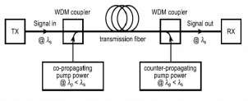

**Figure 2.1:** The diagram of a Raman Pump Amplifier (Rajan Miglani)

# Overview of telecommunication transmission Media

Telecommunication is defined as the electronic transmission of information across long distances; examples include voice, data, and video transmission. The examples given are broad terms that cover a wide range of information transmission methods and communications, including corded phones, mobile devices like cell phones, and microwave communication. Satellites, fiber optics, radio and television broadcasting, the internet, and telegraphs prior to the introduction of fiber optics cable, copper wire was widely used.

Copper Wire - As communications evolved, copper wire was one of the transmission technologies used to send signals from one location to another. Copper wire has an electrical conductivity of 5.88x107 ohms and a thermal conductivity of 39.5kw/m2 k0, therefore it has a high current output for power applications and shorter wire for fine pitch applications, which improves efficiency of heat transfer.

Copper wire has mechanical features such as improved tensile strength, ductility, stiffness, and reduced molding sway, as well as good mechanical stability and long-term reliability etc. Copper provides low latency, bandwidth, and varied route loss in data communication, and it can be coiled into a spiral shape to eliminate noise and crosstalk. Because of the advantages of fiber optic cable over copper cable, it was widely employed. The need to transport more information quickly and across great distances prompted the development of fiber optic cable from century copper lines.

# The differences between copper wire and fiber are shown in the table below. Table 2.1

|  |  |  |  |
| --- | --- | --- | --- |
| **S/N** | **SPECIFICATION** | **COPPER WIRE** | **FIBER OPTICS** |
| 1 | Transmission signal | copper wire uses electrical  signal for transmission | it uses optical form of signal for  transmission |
| 2 | Distance | 100meters @1,000mbps | >40km@10,000mbps |
| 3 | Capacity or bandwidth | moderately high, 10Gbps | Very high 10Gbps and goes up  to 69 Tbps |
| 4 | Repeater spacing | 1 to 10km | 10 to 100km |
| 5 | Attenuation or path  loss | Low | Very Low |
| 6 | Life Cycle | 5years | 30 to 50years |
| 7 | Energy Consumed | >10 watts per user | 2 watts per user |
| 8 | Weight | Heavier | Lighter |
| 9 | Handling | Heavy and thick in  diameter, strict pulling specification | Light and thin in diameter strong pulling strength |
| 10 | Noise Immunity | susceptible to EMI/RFI interference, cross talk and  voltage surge | Immune to EMI/RFI, Interference and cross talk |

|  |  |  |  |
| --- | --- | --- | --- |
| **S/N** | **SPECICICATION** | **COPPER WIRE** | **FIBER OPTICS** |
| 11 | Security | It emits electromagnetic (EM) wave which interfere with other system connected nearby. it is easy to tap through copper wire  and offer less security | It is hard to tap signal being transported. Fiber optics cable offers high security |
| 12 | Cost | Lower | Higher |
| 13 | Spark Hazard | Hazardous | No spark Hazard |
| 14 | Durability | Lower, it can be improved  with light jacket | High |
| 15 | Types | shield twisted pair (STP)  UTP, unshielded twisted, coaxial | Single mode fiber and multimode fiber |
| 16 | Voice Channel | 24 | 32,000 + |

The table above clearly shows that both copper cable technology and fiber optics are good, but fiber optics is utilized for longer distances at very high data rates

# Radio wave

Radio waves are electromagnetic waves that are utilized in communication technology. They have a frequency range of 104 to 1011Hz and are used for long-distance communication, such as television, mobile phones, and radios. The gadgets pick up radio waves and convert them to mechanical vibrations in the speaker, which produces sound waves. Its waves are typically produced by radio transmitters and can be received by radio receivers; it has various frequencies that contain varying amounts of propagation in the earth's environment; the long wave gets diffracted around various impediments and follows the outline through the short waves and reflects the ionosphere to return to the great beyond of sky waves.

The radiation pattern or spectrum is a relatively tiny component of the electromagnetic (EM) spectrum, which is divided into seven areas in decreasing wavelength and increasing energy and frequency order, e.g. radio waves, microwaves, infrared, visible light, ultraviolet (UV) X- rays, and gamma-rays. Radio waves have an extremely short frequency range band wavelength, with frequencies spanning from 3kHz to 100km (VLF). Radio waves are electromagnetic waves that have a recurrence with the longest frequency ranging from high 300GHZ to low 3kkz. Radio waves have a frequency of 1mm at 300Ghz and a frequency of 100km at 3kHz, and they travel at the speed of light, just like all other electromagnetic radio speeds.

# Types of Radio waves

Low to medium frequency radio waves have a long range and are useful for communicating with submarines, as well as inside mines and caverns. Lightning is the most common wellspring of ELF/VLF waves. Marine and aviation radio are included in the LF and MF radio groups, as well as commercial AM radio. AM radio recurring groups extend from 535kHz to 1.7 MHz and have a long range, especially at night.

# Higher frequency range radio waves

High frequency HF, VHF, and UHF are radio waves that are used to broadcast TV sound, public radio service, cell phones, and GPS using FM radio. These category groups encode or overlay a sound or information signal onto the transporter wave using frequency modulation (FM), and the recipient overlooks variations in amplitude.

# Short Wave Frequency Range of Radio Waves

It operates on frequencies in the high frequency (HF) band ranging from around 1.7 MHz to 30Mgz, while the short wave range is divided into a few fragments, some of which are dedicated to standard telecom stations.

# The Highest Frequency range of Radio Waves

SHF and EHF refer to the highest frequencies in the radio band and are sometimes regarded as a feature of the microwave band. The molecules that may be observed all around will absorb the frequencies that limit their range and applicability.

# Table 2.2:

**Difference between Radio waves and fiber optic**

|  |  |  |  |
| --- | --- | --- | --- |
| **S/N** | **SPECIFICATION** | **RADIO WAVES** | **FIBER OPTICS** |
| 1 | Reliability | Rain and wind affected the  quality of connection | suitable for data transport |
| 2 | Data speed | the capacity of radio link is  capped at 1Gigabit | Capacity exceeds that of  radio |
| 3 | Cost | Installation cost is lower | Installation cost is higher |
| 4 | Up time | Service level agreement (SLA) of radio is equally high but it depend on the country  geographical climate | SLA is higher than radio |

The Research discovered the fault between radio waves and optical fiber from the table above, which is listed below.

1. In contrast with microwaves with up to 1Ghz, fibre optics employs carrier frequencies in the 200Thz range, which is best suitable with fiber bandwidth. In order to handle increasing bandwidth, Fiber uses wavelength multiplex (WDM) technology. A variety

of limitations include absorption, reflection and impedance in the electric distribution of radiofrequency signal.

1. As radio is analogous, it is vulnerable to signal degradation such as noise, distortion and nonlinear phenomena like as scattering.

# Optical Fiber

An optical fiber is a thin, light-carrying fiber of glass. Optical fiber is also defined as a thin, flexible glass or plastic strand which enables large amounts of information to be conveyed in the form of light pulses. Optical fibre is often called the medium and the technology related with data transfer as light pulsations through a glass or plastic beam or fiber (or "fiber optic"). A light-carrying cable that incorporates one or more optical fibers is an optical fibre cable. Individually covered optical fibers are often placed in an environmentally friendly tube to attach the cable.

Single mode fiber, Multimode fiber, and Graded Index fiber are the three types of optical fiber.

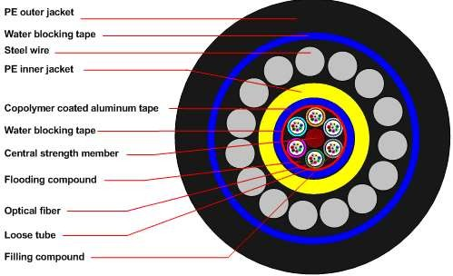

# Figure 2.2: Structure of optical fiber (Ftth-China.com)

13

# Single Mode Fiber

This is a form of fiber for the transmission of long-term signal, which is designed to carry a single ray or light mode as a carrier. The insert covers a diameter of 125 microns and a fibre of 9 microns in a single mode. Single-mode fiber has a core, which is only around ten times the light's wavelength. Light travels in just one direction or mode within this fiber.

# Multimode Fiber

It is an optical fiber which may simultaneously transmit numerous light beams or modes at slightly varied angles of reflection within the core. Multi-mode Optical Fiber is an optical fiber form commonly used to communicate on short distances, such as in a building or on a campus. Typical multimode lines have speeds ranging from 10 Mbit/s to 10 Gbit/s across lengths of up to 600 metres (2000 feet).The index of the refraction profile from low to high to low is calculated from cladding into core and cladding. The core diameter and numerical aperture are relatively high. The core / reclining diameter of a popular multimode fiber for use in communication is 62.5/125 m. (about the size of a human hair). The term 'multimode' means that many fiber modes or paths can be supported. In applications such as local area networks or on campus networks that require large capacities (1 GHz) over small distances, multimode fibre is used (3 km). Multimode fiber has the main advantages:

1. It is comparatively easy to work with;
2. Light is easily coupled to and from it because to its greater core size;
3. It may be utilized with both lasers and LEDs as sources; and
4. Coupling losses are smaller than single-mode fiber coupling losses. The downside is that it suffers from modal dispersion because several modes can traverse it (a function

of core diameter, wavelength, and numerical aperture). Due to modal dispersion, bandwidth is constrained, resulting in lower data rates.

# Graded-index fiber

Is a hybrid of multimode fiber's big core diameter and N.A. and single-mode fiber's higher bandwidth. Because of the creation of a core whose index of refraction drops parabolic from the core center toward the cladding, light traveling through the center of the fiber encounters a higher index than light traveling in the higher modes. This means that higher-order modes travel faster than lower-order modes, allowing them to "catch up" to lower-order modes, reducing modal dispersion and increasing fiber bandwidth.

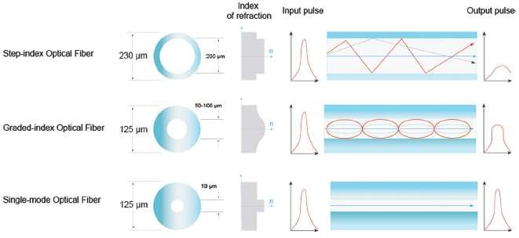

**Figure 2.3:** Multimode step index, Graded index and single mode fiber

# Benefits of Fiber Optics

Optical fiber systems have many advantages over metallic-based communication systems. These advantages include:

# Long-distance signal transmission

Optical systems have substantially lower attenuation and better signal integrity than metallic- based systems, allowing for far longer signal transmission intervals. While single-line, voice- grade copper systems over a few kilometers (1.2 miles) require in-line signal for excellent performance, optical systems can easily exceed 100 kilometers (km), or roughly 62 miles, without active or passive signal processing.

# Large bandwidth, light weight, and small diameter

The quantity of bandwidth required by today's apps is increasing all the time. As a result, various end users' space limits must be taken into account. Installing new cabling within existing duct systems or conduit is a typical practice. Optical cable's tiny diameter and low weight make installation simple and feasible in these locations, saving valuable conduit space.

# Nonconductivity

Another benefit of optical fibers is that they are dielectric. Because optical fiber contains no metallic components, it can be used in regions where electromagnetic interference (EMI), such as radio frequency interference, is present (RFI). Utility lines, power-carrying lines, and railroad tracks are examples of areas with strong EMI. All-dielectric cables are also excellent for places with a high incidence of lightning strikes.

# Security

The dielectric property of optical fiber, with the exception of metallic-based systems, makes it hard to detect the signal being conveyed within the cable remotely. Access to the optical fiber

is the only method to do so. Accessing the fiber necessitates intervention, which can be easily detected by security cameras. Fiber is particularly appealing to governmental entities, banks, and others with substantial security concerns because of these factors.

# Designed for future applications needs

Fiber optics is now more affordable than ever, thanks to falling electronics prices and low optical cable prices. Fiber solutions are frequently less expensive than copper. Fiber will continue to play a critical role in the long-term viability of telecommunication as bandwidth demands rise in tandem with technological advancements.

# Fiber Optic Loss Calculations

Loss in a system can be expressed as the following:

Loss = Pout/Pin. (2.1)

where Pin is the input power to the fiber and Pout is the power available at the output of the fiber. For convenience, fiberopticlossis typically expressed in terms of decibels (dB) and can be calculated using Equation *2.2.*

power difference in db=10log10[pout/pin] Voltage difference in db =20log[vout/vin]

LossdB= 10logPout/Pin (2.2)

Often times, loss in optical fiber is also expressed in terms of decibels per kilometer (dB/km). The total link loss =cable attenuation

Connector loss+ Splice loss Cable Attenuation (db) =Maximum cable Attenuation Coefficient (db/km) x length (km)

# Total Internal Reflection

When light passing through an optically thick medium meets a barrier at an angle larger than the Critical Angle of the medium, it is completely reflected. It's referred to as total inward introspection. In fiber optic connections, total internal reflection is used inside the optical fiber. When light enters an optical fiber, it is completely internally reflected every time it reaches the fiber's edge. In this way, light travels along the optical wire.

Total link loss = cable attenuation+connector loss+splice loss

Cable attenuation (db)=Maximum cable attenuation coefficient(db/km) x length (km) Connector loss (db) = Number of connector pair x connector loss allowance (db) Splice loss (db) = Number of splice x splice loss allowance (db)

# Attenuation

Attenuation refers to any decrease in the strength of a signal. Attenuation occurs in both digital and analog communications. Signal attenuation is the end result of sending signals over vast distances. Attenuation is generally measured in decibels (dBs). The type of cable determines where signal degradation occurs over the cable's length. Repeaters and Raman pump amplifiers can be put along the length of the wire to boost signal strength and hence increase the maximum data transmission range.

External factors that can cause attenuation, including as connection loss, physical forces on the fiber, minute density fluctuations, and improper splicing methods, will be assessed. Prior to final activation of each span, the attenuation of the route must be determined using a power source and a power meter at either end of the connection, and the link budget must be estimated to verify that the received powers meet the system margin. The frequency of the

transmission, as well as the length and physical structure of the cable, all influence attenuation. It is influenced by the following factors:

1. The inner conductor's diameter: as the conductor's diameter grows, attenuation reduces.
2. The composition of the outer conductor: the lower the attenuation, the more effective the screening action.
3. The nature of the dielectric: the lower the dielectric constant, the lower the attenuation.

As a result, at any given dimension, an extended dielectric has lower attenuation values than a solid dielectric. Because the type of cable, temperature, and rate at which data is transported through the cables are all constant, the length of the cable is the only element that effects attenuation in the two cables. "As the cable lengths rise, the rising time of the edges will exceed the time for a bit cell, and at this point the signal will be attenuated, and its peak-to-peak amplitude will become smaller and smaller."If attenuation is 5dbm at 500 feet, attenuation is 15dbm at 5000 feet, which is three times the original level (D.Coker, Leek J.K. and Marcenac)

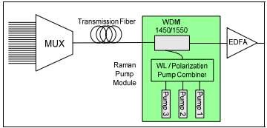

**Figure 2.4:** Block diagram of a fiber optic network with a Raman pump

# Optical Amplifiers

Fiber Home OBAs (Optical Boaster Amplifiers) come in single, dual, or triple pump configurations. 980nm is the wavelength of the first level pump. Some of the optical input is detected via the coupler (TAP), and the majority of the optical input is supplied to the Optical Isolator (IS) via the WDM device (WDM) to be multiplexed with the pump laser.). The input combination is amplified using an EOF at a 1550nm window, then sent via an optical isolator and a coupler (TAP) to obtain management data.

# Applications of Fiber Optics

Cable television (CATV) services are delivered to subscribers via a coaxial cable connection via a fiber optic network to an optical node, which transforms and distributes the electrical signal.

CATV application utilizes both single and multimode signals within different areas of the network. Single mode fiber is used to distribute signal from the central office to optical nodes, where it can be converted to multimode.

Transmission of data simply described, fiber optics is the transmission and reception of data via a network from one point to another.

It includes everything from basic cables that connect servers or storage arrays within a network or telecommunication system to huge multi-fiber distribution cables that provide intra-building connectivity and beyond.

# Internet

The Independent Telecommunication Providers segment is a subset of the industry that offers services in rural areas, typically to support households and small-to-medium-sized companies. Depending on the provider, customer location, and service availability, services in these areas can range from basic telephone to triple play. Over a single broadband connection, expanded services can include television transmission (in some circumstances in high definition), voice over internet protocol (VOIP) phone services, and security. However, these services are becoming more widely offered in rural areas around the country.

# Fiber Optics in the Communication Industry

Communication is the exchange of information, the sending and receiving of messages from one location to another, and the essential elements involved in communication are: information source, transmitter, communication channel, and receiver.

The telecommunications business has been transformed by fiber optic connection. It has also made a strong impression on the data networking sector. Optical communication has enabled telecommunication links to be formed over considerably greater distances by using fiber optics cable and, perhaps most importantly, with significantly reduced levels of loss in the transmission medium, fiber optical communications has enabled much higher data to be accommodated.

Fiber optic communications systems are widely used for applications ranging from significant telecommunications backbone infrastructure to Ethernet systems, broadband distribution, and general data networking as a result of these benefits.

# Basic Fiber Optic Communication System

Fiber optics is a medium for transmitting information in the form of light from one location to another. Fiber optics, unlike copper transmission, is not electrical in nature. A simple fiber optic system consists of a transmitting device that converts an electrical signal into a light signal, an optical fiber cable that transports the light, and a receiver that receives the light signal and turns it back into an electrical signal. A fiber optic system's complexity can range from very simple (i.e., local area network) to exceedingly intricate and expensive (i.e., long distance telephone or cable television trucking). For example, the system seen in Figure 8-1 might be constructed for a very low cost by combining a visible LED, plastic fiber, a silicon photo detector, and some simple electronic circuitry. The total cost may be less than $20. A typical system used for long-distance, high-bandwidth telecommunication that employs wavelength-division multiplexing, erbium-doped fiber amplifiers, external modulation using DFB lasers with temperature compensation, fiber Bragg gratings, and high-speed infrared photo detectors, on the other hand, could cost tens of thousands, if not hundreds of thousands, of dollars. The fundamental question is "how much information is to be conveyed and how far must it travel?" With this in mind, we will look at the many components that make up a fiber optic communication system, as well as the factors that must be considered while designing such systems.

Optical fiber transmission employs wavelengths in the near-infrared region of the spectrum, slightly above visible, and so imperceptible to the naked eye. The wavelengths of typical optical transmission are 850 nm, 1310 nm, and 1550 nm. Light is transmitted across optical fiber using both lasers and LEDs. Lasers are often utilized for single-mode applications at 1310 or 1550 nm. LEDs are utilized in multimode applications at 850 or 1310 nm.

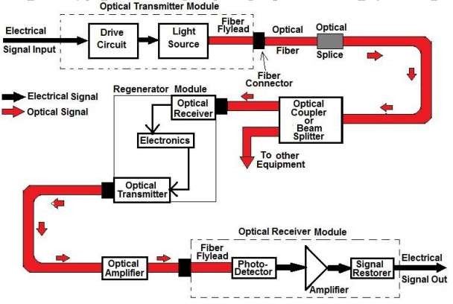

**Figure 2.5:** Basic Model of an Optical Communication link

# Types of Electronics Communication

**Simplex:** This sort of communication is one-way, such as radio, television broadcasting, beepers (personal receivers), and so on.

**Half Duplex:** Half duplex is a type of two-way communication in which only one side transmits at a time, such as police, military, and other radio transmissions, Citizen band (CB), Family radio, and Amateur radio.

**Full Duplex:** Full-duplex communication refers to most electronic communication that is two-way. Full duplex means that people can chat and listen at the same time. This method of communication is represented by the telephone.

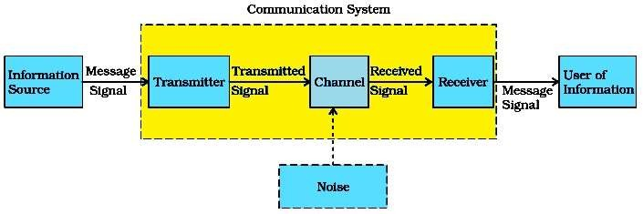

**Figure 2.6:** Block diagram of communication system.

# Advantages of Optical Fiber Communication

1. Fiber can accommodate more bandwidth with just a pair of the strands.
2. Attenuation on fiber is usually low when properly installed.
3. There is no interference of any sort when fiber is in use
4. Lower Bit Error Rates is enhanced with fiber.
5. It is very efficient in Signal Security.
6. The weight and size of a fiber cable small compared to other cables.
7. Fiber has high resistance to Temperature Variations and is environmental friendly.
8. The cost of installation of an optical fiber cable is cheap.
9. Cost of transmission equipment from electrical to optical signals is minimal.
10. Optical fibers do not have the capability to carry electrical power.

# Applications of Optical Fiber Communication

As fibers are very flexible, they are used in flexible digital cameras.

Fibers are employed in mechanical imaging, which is used to evaluate mechanical welds in pipes and engines on rockets, space shuttles, and airplanes.

Endoscopes and laparoscopes are examples of medical imaging devices that utilise fibers.

Undersea communication can be accomplished using fibers.

Fibers are employed in a variety of military applications, including airplanes, ships, and tanks. Optical fiber phase sensors and transducers are employed in nuclear testing applications.

Public utilities, such as railways and television broadcasts, rely on fibers. Fibers are utilized in LAN systems in businesses, factories, and institutions, among other places.

Telecommunications applications include voice phones, video phones, telegraph services, message services, and data networks.

# Multiplexing Techniques

The available multiplexing techniques for fiber optic transmission are listed below.

# Time-Division Multiplexing (TDM)

Time on the information channel, or fiber, is shared among the many data sources in time- division multiplexing. The multiplexer MUX is a form of "rotary switch" that spins at a high rate, connecting each input to the communication channel individually for a set period of time. On the output, a device known as a demultiplexer, or DEMUX, reverses the process. The method is repeated after each channel has been linked in order. A frame is a single full cycle. Start and stop frames are added to synchronize the input with the output, ensuring that each channel on the input is connected to its corresponding channel on the output. Any of the digital modulation methods discussed can be used by TDM systems to convey data (analog multiplexing systems also exist). This is illustrated in Figure 2.7

# Table 2.3

Transmission frame table.

|  |  |  |  |  |  |  |  |  |  |
| --- | --- | --- | --- | --- | --- | --- | --- | --- | --- |
| Start | Input | Input | Input | Input | Input | Input | Input | Input | Stop |
| Frame | 1 | 2 | 3 | 4 | 5 | 6 | 7 | 8 | Frame |

The amount of data that can be transmitted using TDM is given by the MUX output rate and is defined by Equation2.3

MUX output rate = N * Maximum input rate (2.3)

where *N* is the number of input channels and the maximum input rate is the highest data rate in bits/second of the various inputs. The bandwidth of the communication channel must be at least equal to the MUX output rate. Another parameter commonly used in describing the information capacity of a TDM system is the channel-switching rate*.* This is equal to the number of inputs visited per second by the MUX and is defined as

Channel switching rate = Input data rate x Number of channels (2.4)

# Wavelength-Division Multiplexing (WDM)

Each data channel is sent using a slightly different wavelength in wavelength-division multiplexing (different color). Many channels can be delivered through the same fiber without interfering if each channel uses a separate wavelength. Many times, this technology has been utilized to expand the capacity of existing fiber optic systems. A single data source or a combination of a single data source plus a TDM (time-division multiplexing) and/or FDM (frequency-division multiplexing) signal can make up a WDM data channel. The transmission of numerous closely spaced wavelengths through the same fiber is referred to as dense

wavelength-division multiplexing (DWDM).For any given wavelength A and corresponding frequency f, the International Telecommunications Union (ITU) defines standard frequency spacing Af as 100 GHz, which translates into a AA of 0.8-nm wavelength spacing. This follows from the relationship AA = A_6£_. (See Table 2.2.) DWDM systems operate in the 1550-nm window because of the low attenuation characteristics of glass at 1550 nm and the fact that erbium-doped fiber amplifiers (EDFA) operate in the 1530-nm-1570-nm range. Commercially available systems today can multiplex up to 128 individual wavelengths at 2.5 Gb/s or 32 individual wavelengths at 10 Gb/s (see Figure 2.4). Although the ITU grid specifies that each transmitted wavelength in a DWDM system is separated by 100 GHz, systems currently under development have been demonstrated that reduce the channel spacing to 50 GHz and below (< 0.4 nm). As the channel spacing decreases, the number of channels that can be transmitted increases, thus further increasing the transmission capacity of the system.

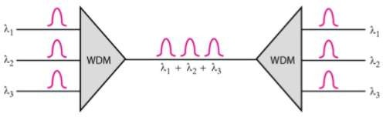

**Figure 2.7:** Wavelength-division multiplexing

# Table 2.4:

**International Telecommunication Union Grid (ITU)**

|  |  |
| --- | --- |
| Center Wavelength -nm (vacuum) | Optical Frequency (THz) |
| 1530.33 | 195.9 |
| 1531.12 | 195.8 |
| 1531.90 | 195.7 |
| 1532.68 | 195.6 |
| 1533.47 | 195.5 |
| 1534.25 | 195.4 |
| 1535.04 | 195.3 |
| 1535.82 | 195.2 |
| 1536.61 | 195.1 |
| 1537.40 | 195.0 |
| 1538.19 | 194.9 |
| 1538.98 | 194.8 |
| 1539.77 | 194.7 |
| 1540.56 | 194.6 |
| 1541.35 | 194.5 |
| 1542.14 | 194.4 |
| 1542.94 | 194.3 |
| 1543.73 | 194.2 |
| 1544.53 | 194.1 |
| 1546.92 | 193.8 |
| 1547.72 | 193.7 |
| 1548.51 | 193.6 |
| 1549.32 | 193.5 |
| 1550.12 | 193.4 |
| 1550.92 | 193.3 |
| 1551.72 | 193.2 |

|  |  |
| --- | --- |
| 1552.52 | 193.1 |
| 1 553.33 | 193.0 |
| 1554.13 | 192.9 |
| 1554.93 | 192.8 |
| 1555.75 | 192.7 |
| 1556.55 | 192.6 |
| 1557.36 | 192.5 |
| 1588.17 | 192.4 |
| 1558.98 | 192.3 |
| 1559.79 | 192.2 |
| 1560.61 | 192.1 |
| 1561.42 | 192.0 |
| 1562.23 | 191.9 |
| 1563.05 | 191.8 |
| 1545.32 | 194.0 |
| 1546.12 | 193.9 |
| 1563.86 | 191.7 |

A multiplexer at the transmitter in a WDM system combines the various signals, while a de- multiplexer at the receiver separates them. It is feasible to create a device that can do both at the same time and serve as an optical add-drop multiplexer using the right type of fiber. The concept was initially reported in 1978, and by 1980, experimental WDM systems had been developed. Initially, only two signals were merged in WDM systems. Modern systems can handle up to 160 signals simultaneously, allowing a basic 100 Gbit/s system to be extended to more than 16 Tbit/s over a single fiber pair. WDM systems are used by telecommunications firms to increase network capacity without adding new fiber. They can resist multiple generations of technical advancement in their optical infrastructure by deploying WDM and

optical amplifiers without having to rework the backbone network. A link's capacity can be increased simply by upgrading the multiplexers and de-multiplexers at each end. This is often achieved at the transport network's very edge by using optical-to-electrical-to-optical (O/E/O) translation, which allows interchange with existing optical-interfaced equipment. The vast majority of WDM systems employ single-mode fiber optic cables with a diameter of 9 jrn. WDM can also be used in multi-mode fiber cables with core diameters of 50 or 62.5 m. (also called as premises cables).WDM systems were first both costly and difficult to maintain. WDM has grown less expensive to deploy as a result of current standards and a better knowledge of WDM system dynamics. Optic receivers, as opposed to laser sources, are often wideband demodulators. As a result, in a WDM system, the demultiplexer must supply the receiver's wavelength selectivity. WDM systems use two types of wavelength patterns: coarse (CWDM) and dense (DDM) (DWDM). Coarse WDM spreads up to 16 channels across multiple silica fiber transmission windows.

WDM, DWDM, and CWDM all use multiple wavelengths of light on a single fiber, but their wavelength spacing, channel count, and capacity to amplify multiplexed signals in optical space differ. Raman amplification adds an L-band amplification method to EDFA's effective C-band wideband amplification. Over a large bandwidth, CWDM optical amperage.

**Figure 2.8:** Network Topology showing link between locations and equipment used.

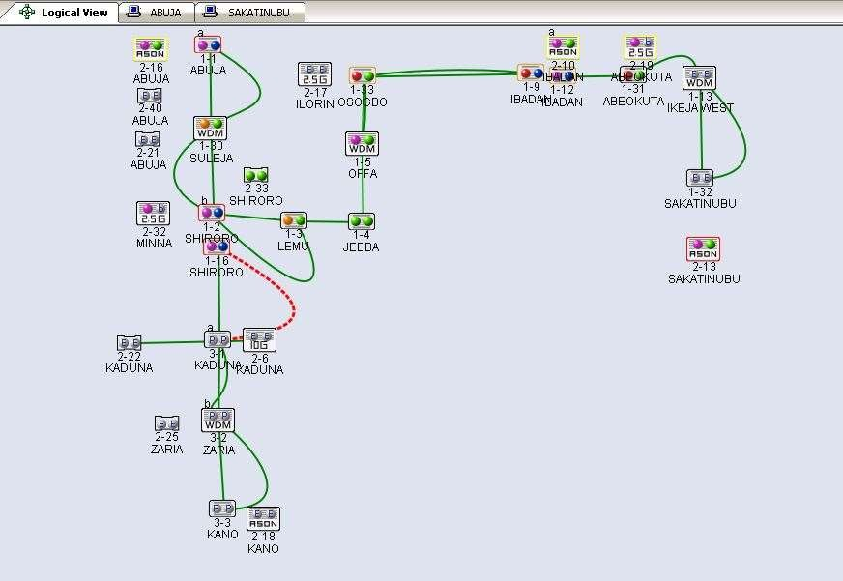

# 2.3.3. Dense Wavelength Division Multiplexer (DWDM) Topology Design

Dense Wavelength Division Multiplexing (DWDM) is a type of optical multiplexing that is used to boost bandwidth on existing fiber networks. DWDM works by mixing and transmitting many signals at different wavelengths on the same cable at the same time. Malis (1999)

The four major topological configurations of dense wavelength division multiplexing (DWDM) networks are DWDM point-to-point networks with or without add-drop multiplexing, fully connected mesh networks, star networks, and DWDM ring networks with OADM (Optical Add and Drop Multiplexer) nodes and a hub. Each topology has its own set

of criteria, and depending on the application, different optical components may be employed in the designs.

There are also hybrid network topologies, which are made up of stars and/or rings connected via point-to-point links. The Metropolitan Optical Network project (MONET), for example, is a WDM network created and supported by a variety of commercial enterprises and government agencies in the United States. It is made up of two subnetworks, one in New Jersey and one in the Washington, D.C./Maryland area, which are linked via a long-distance point-to-point optical link (Koga .M, 1998).

# Point-To-Point Topology

Long-haul transport demands ultrahigh speed (10-40 Gb/s), ultrahigh aggregate bandwidth (in the order of several terabits per second), high signal integrity, high reliability, and fast path restoration capabilities uses the point-to-point architecture. The distance between the transmitter and receiver can be hundreds of kilometers, and the number of amplifiers between them is usually less than ten (as determined by power loss and signal distortion). The system can drop and add channels along its path with point-to-point with add-drop multiplexing. Number of channels, channel spacing, type of fiber, signal modulation method, and component type selection are all important parameters in the calculation of the power budget.

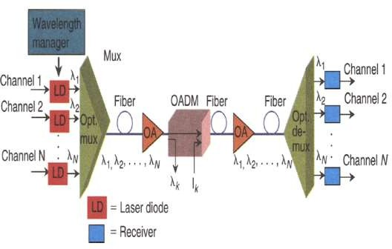

**Figure 2.9:** A DWDM point to point with add-drop multiplexing enables the system to drop and add channels along its path. (Aria Zhu)

Each channel in DWDM is transmitted across a specific wavelength (hi), sometimes referred to as a "optical channel." Different data (e.g., voice, data, video, data packets) may be carried on varying channels at different bit rates. Fiber(s), optical amplifiers, OADM, optical filters, couplers, laser sources, modulators and receivers are among the optical components of the transmitter-receiver optical link. As detailed in Part II, each has its own signal-influencing property. A simplified end-to-end perspective of a DWDM

Lasers, an optical multiplexer and demultiplexer, fibers, and optical amplifiers are all part of a point-to-point system (OA), and an optical add-drop multiplexer is shown in figure.2.6.

# Ring-Configured Mesh and Star Networks

There have been a number of proprietary ring DWDM networks deployed. A DWDM ring network, in general, consists of a fiber ring that fully interconnects nodes; some systems include two fiber rings for network protection. A ring like this may reach a few tens of kilometers and cover a local or metropolitan area. There may be a few (4) to many

wavelength channels in the fiber ring, as well as a few too many nodes. The bit rate per wavelength channel could be as little as 622 Mb/s or as high as 1.25 Gb/s.

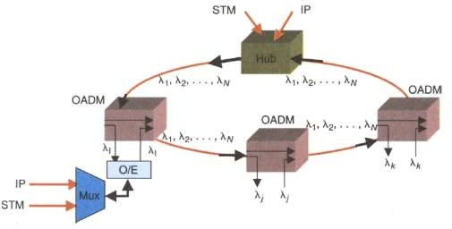A hub station is one of the ring's nodes, where all wavelengths are sourced, terminated, and maintained, as well as communication with other networks. Optical odd-drop multiplexers (OADM) are used in each node and hub to drop off and add one or more predefined wavelength channels. The hub station in DWDM ring networks can originate and terminate a variety of traffic [e.g., synchronous transport module (STM) IP, video]. The hub is in charge of all channels (wavelengths) and traffic types assigned to a path between nodes. One (or more) optical frequencies are discarded and inserted at an OADM, while the remaining frequencies are transparently sent through. However, as the number of OADMs grows, the signal suffers from losses, necessitating optical amplification (not illustrated).

**Figure 2.10:** A DWDM ring network; the hub station sources and terminates payloads of several types (Aria Zhu)

The number of nodes in a fiber is usually smaller than the number of wavelengths. The basic configuration shown in Figure 2.10 does not address network survivability or ring fault avoidance. The hub station coordinates channel (wavelength) assignment in the ring architecture, resulting in a fully connected network of nodes using OADM. The hub might also be able to link to other networks. In addition, an OADM node can be connected to a multiplexer/demultiplexer to multiplex multiple data streams. Figure 2.10 depicts a simple ring topology with a hub and two nodes, A and B, connected via wavelength Ak, where node A additionally multiplexes numerous data sources. Because they are on the same channel, all data sources are ended by the relevant OADM node (node B) (and the same wavelength).

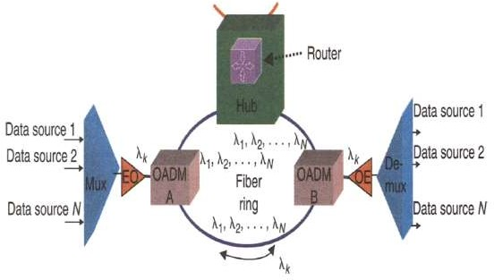

**Figure 2.11:** In a DWDM ring topology, channel (wavelength) assignment may be managed by the hub Station (B. Furht, 1999)

The C-Band (1530 nm-1560 nm) transmission window is used in dense wavelength division multiplexing (DWDM), but the channel spacing is smaller. The channel layout varies, but a typical DWDM system would include 80 channels with a TOO GHz spacing or TOO GHz spacing. 12.5 GHz spacing is possible with some technologies (sometimes called ultra-dense

WDM). As illustrated in figure, new amplification options (Raman amplification) permit the extension of acceptable wavelengths to the L-band, more or less double these numbers. 2.12.

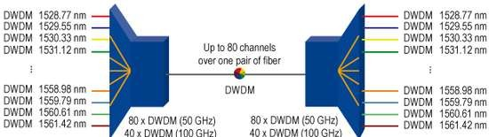

**Figure 2.12:** Available DWDM Channels in C and L band depending on channel spacing (Siva Ram M**.)**

Finally, the number of nodes, maximum traffic capacity, scalability, number of fiber links between nodes, and other parameters all influence the network topology of your DWDM system. The network components involved in the DWDM system should also be given consideration.

# 2.4. Raman Pump Amplifier in optical Communication

Attenuation, distortion, and relative time delay deviation rise even when traditional optical amplifiers (EDFA) are used in long-distance optical communication systems. As a result, distributive amplification Raman pumps must be introduced. The term "distributed amplification" refers to a method of canceling inherent fiber loss.

Unlike discrete amplification, which will be discussed in Chapter 3, the loss in distributed amplifiers is counterbalanced at every point along the transmission fiber in an ideal distributed amplifier. The transmission fiber is transformed into an amplifier in its own right. Even though the intrinsic loss of a transmission fiber in current communication systems is

fairly low, around 0.2 dB per km at 1550 nm, it is one of the major constraints when transferring light through an optical fiber. To compensate for the loss, amplification is required. This can be done totally optically thanks to Raman amplification. One of the primary benefits of adopting distributed amplification is that signal gain may be pushed into a transmission span, preventing the signal from degrading as much as it would if no amplification was provided within the span.

Future long-distance communication systems are expected to use an entirely optical Raman distributive amplifier, ensuring that the signal-to-noise ratio does not suffer as much as it would in a system based on transmission through a passive fiber followed by a discrete amplifier, as demonstrated in this dissertation work.

# Transmission Equipment

This project will make use of Fiber Home's FONST W1600 DWDM (Wavelength division multiplexing) equipment, a new generation of dense WDW system with massive capacity and long-distance transmission potential. The equipment is made up of OMT, OLA, and OADM: OMTI: is made up of a transmitting and a receiving component. To comply with G.652, the signal from the client interface (for example, STM N) can be transformed by the OTU at the transmitting end into a certain wavelength optical signal before being sent to the fiber line through an optical supervisory channel, the signal will be multiplexed and amplified. On the receiving end, the signal is reversed: it is first separated from OSC, then amplified, de- multiplexed, processed by the receiving OTU (Rx OTU), and finally delivered to client interfaces.

**OLA:** It consists of an optical line amplifier and an optical supervisory channel that extends east and west. When a signal is received by line, it is separated into OSC and DWDM main signals. The main signal will be sent downstream after optical dispersion adjustment, optical amplification, and optical power equalization. After O/E conversion for OSC, the information from the local station is obtained and included into the OSC. Following framing, OSC is converted into optical signals with ISIOnm or 1625nm wavelengths by E/O conversion and proceeds downstream with the WDM main signal.

**OADM:** It serves the same function as OLA. The distinction is that OADM equipment requires an optical add/drop card (OAD), which can be either fixed wavelength or programmable wavelength. The number of wavelengths added or removed can be adjusted.

In equipment networking, equipment can be configured as OMT or OADM with flexible or fixed add/drop channels to build a link transmission network or a ring/mesh network. The equipment can help long-distance backbone networks. It is designed with a variety of user service interfaces, agile networking modes, and high transmission flexibility to serve as a good platform for a wide range of transmission applications.

# Power Budget

An optical fiber link budget is the accounting of all gains and losses from the transmitter to the receiver in a system via the medium (free space, cable, waveguide, fiber, etc.). It accounts for signal attenuation due to propagation. Assuming all other parameters are known, the graph below represents a typical link budget scenario, including transmitter, medium, and receiver, splice point, and connection.

# Figure 2.13

**Power Budget Structure**

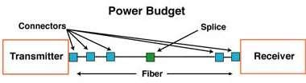

# Figure 2.14:

**Power Budget Structure**

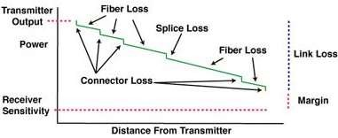

Table 2.5 presents the link budget as it is used in the telecommunication industry.

A simple link budget equation looks like this: Received Power (dbm) = Transmitted power (dbm) - Losses (dbm).

# Table 2.5:

**Power Budget (Source: P3 Telecom)**

|  |  |
| --- | --- |
| TRANSMITTER OUT POWER | Xdbm |
| RECIEVER SENSITIVITY | Ydbm |
| Total Availability power | X-Y dbm |
| CABLE LENGTH | A km |
| FIBER ATTENUATION @wavelength | B dbs/km |
| Total loss due to cable | A x B dBs |
| LOSS DUE CONNECTOR | CdBs |
| NUMBER OF CONNECTORS | C dBs |
| SPLICE LOSS | EdBs |
| NUMBER OF SPLICES | F |
| Total loss due to splice | F x F dBs |
|  | Total carrier medium loss |
| Total loss due to carrier medium | H(A x B)+(C x D)+(E x F) dbs. |

# CHAPTER THREE RESEARCH METHODOLOGY

# Methodology

In recent years, distributed Raman amplification (DRA) has emerged as a vital technology for modern optical networks, notably for long-distance coherent transmission. Recognizing this, it is necessary, as with any new technology, to understand the applications that can benefit from it, as well as the myriad challenges associated with the technology's real-world adoption.

To improve the optical transmission in the Raman pump station, the fiber optic transmission medium was first assessed and simulated in order to obtain an acceptable value that would improve the RAMAN pump's performance and efficiency. To simulate the transmission fiber, an optical time domain reflector-meter (OTDR) was employed, and the results were used to fine-tune the dense wavelength division multiplexing settings, transponders, and the Raman pump. The purpose is to evaluate the attenuation level and optical to signal noise ratio (OSNR), as well as to reduce attenuation caused by the optical transmission connection. After establishing and setting up the Raman pump in the equipment, a BER test was run to determine the level of improved optical signal strength on the path, and there was no signal deterioration or packet failures.

The Raman pump transmission station provides transmission over very long distances with minimum loss in long haul and ultra-long networks. This is especially true for systems that operate at speeds of 40Gb/s and 100Gb/s.

# Optical Time Domain Reflectometer

In general, losses occur in some form or another in all forms of communication systems. Defects and losses in optical fiber communication must be found and traced to improve the system's efficiency. Optical time domain reflectometry (OTDR) is a commonly used technique in optical fiber transmission systems for fault classification and localization. It is calculated how much of a probe pulse is dispersed back from a silica fiber. Due to the low backscatter of single-mode fiber at long wavelengths, very sensitive optical detection is necessary for optimal range performance. Testing and evaluation at many levels are required to ensure the availability and efficiency of fiber networks. Optical fiber testing methods include continuity, splice continuity, splice loss, fiber loss, fiber quality testing, splice reflectance, and connector testing, as well as loss measuring techniques such as splice loss measurement, fault location identification, and insertion loss.

# Table 3.1:

**Fiber Optic Transmission Windows**

|  |  |
| --- | --- |
| Window | Operating Wavelength |
| 800-900 nm | 850 nm |
| 1250-1350 nm | 1310 nm |
| 1500-1600 nm | 1550 nm |

# Wavelength:

1. There are wavelength ranges where the fiber performs best. An operational window is the name given to each range. These wavelengths were chosen because they best fit the transmission properties of available light sources with optical fiber transmission
2. There are wavelength ranges where the fiber performs best. An operational window is

the name given to each range. As shown in the table below, each window is centered on the normal working wavelength.

1. These wavelengths were chosen because they best match the transmission properties of available light sources with the transmission qualities of optical fiber.

# Below are the interpretation and the parameters of OTDR

1. **Range**: in OTDR parameter determine distance that the OTDR can cover.
2. **Pulse:** Set the duration of each laser pulse emitted, pulse width allows OTDR to measure accurately and pulse width maximum is1.0ns.
3. **Acquisition time:** Set the time duration of averaging the measured of reflected light, the time OTDR acquires and average date point from the fiber under test.
4. **Length:** Length of the cable installed per route or to conduct test upon.
5. **Total loss:** Total loss on fiber cable measured at all event and it can be differentiated by maker (between two marker).
6. **Average loss:** Specifications of average loss on the fiber optics cable measured which is less or equal to 0.1db.
7. **Maximum Splice loss:** All the wavelength losses has their individual maximum losses etc. splice loss in 1310wavelenght cannot be more than 0.1-1db.
8. **Splice loss:** in 1550 wavelength cannot be more than 0.1-07db. So maximum splice loss is 0.05db (average)and the maximum connector loss is 0.5db.
9. **Optical Return Loss (ORL):** OTDR is used to measure ORL of fiber span and optical continuous wave reflectometer (OCWR), it is an instrument designed to specifically measure system and component ORL reflectance.
10. **High Resolution Acquisition:** Determines the location of event on a fiber with more

accuracy, OTDR takes measurement of every 8meters along fiber spans.

1. **Indexing of Refraction (IOR):** is a value to calculate distance, if IOR is not known, it is used for setting to know the distance length of a cable.
2. **Rayleigh back scatter (RBS):** During propagation in fiber, some light is scattered in all directions, part of it is coupled into fiber in the backward direction and that is what is called RBS.
3. **Helix Factor:** is an information expected from manufacturer parameter, the parameters are refractive index, backscatter coefficient. This is used to confirm specification of fiber supplied to company to determine spec requested.
4. **Splice loss Threshold:** is guideline on loss to expect when testing optical fiber.
5. **End of Fiber Threshold:** optical pulse is launched by OTDR to a fiber under test are reflected back from end of the fiber via Fresnel reflection and then the aggregate averages of pulses are calculated. OTDR is connected to one end of fiber optic within a few seconds after pressing the start button and it will measure the overall loss, overall length and distance.

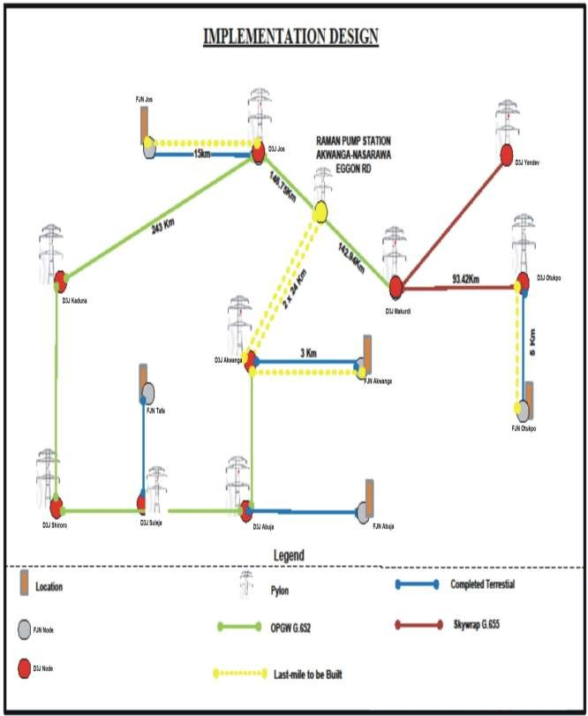

**Figure 3.1:** I Network implementation design

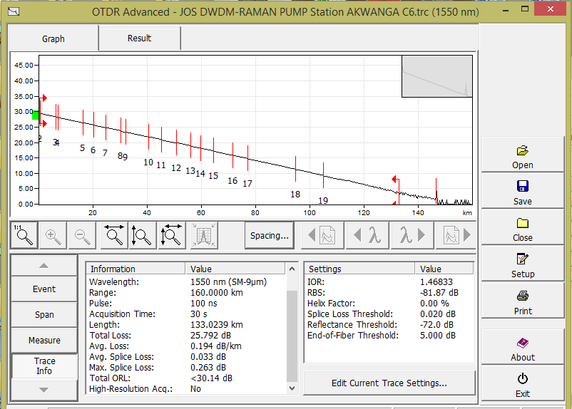

**Figure 3.2:** Fiber test from Jos DWDM to RAMAN PUMP Station in Akwanga using the OTDR Simulator

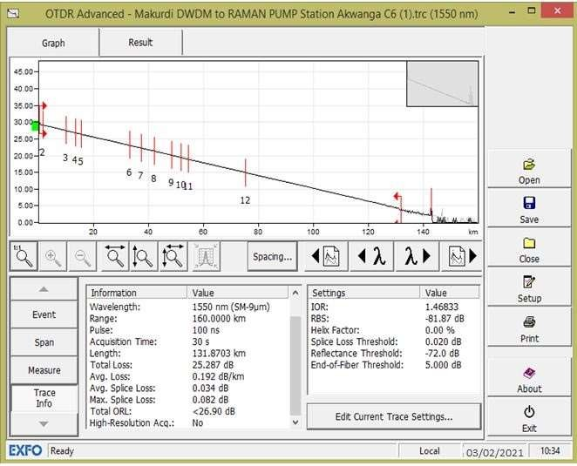

**Fig 3.3:** Fiber test from Makurdi DWDM to RAMAN PUMP Station Akwanga using the OTDR Simulator

# Raman Pump Design

In the optical transmission architecture, the Raman pump is located at the Akwanga station to energize and improve the optical signal coming from the far ends of Makurdi and Jos. The increased OSNR (5-7 dB) offered by the Distributed Raman pump can also be used to boost system capacity by expanding the number of channels. Coherent 100Gb/s channels, for example, are often particularly susceptible to non-linear effects, which get more pronounced as the number of channels increases. The usage of DRA allows for a reduction in channel launch power, which decreases the penalty due to non-linear effects in high capacity systems.

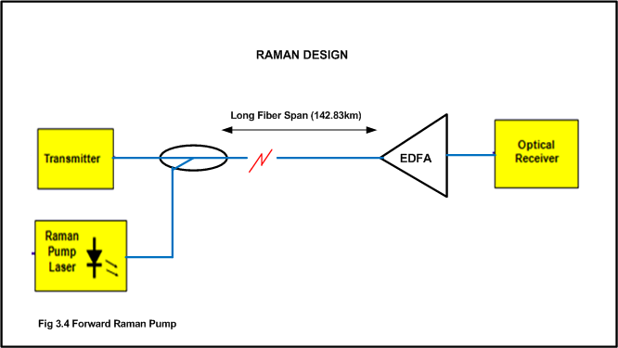

**Figure 3.4:** Block Diagram of Forward Raman Pump

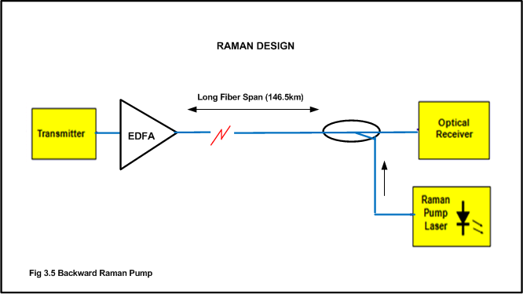

**Figure 3.5:** Diagram of Backward Raman Pump.

# Raman Amplification

Using the stimulated Raman scattering principle, the Raman Amplifier amplifies and enhances the optical fading signal. Stimulated Raman scattering is a basic nonlinear mechanism that converts optical fibers into broadband Raman amplifiers. The distributed Raman pump amplifier used in optical communication systems differs from typical EDFA systems in two fundamental ways:

1. The output power of Raman pump modules is much higher than typical power levels in EDFA based systems, and in all cases is well above the designated safe level of radiation.
2. Amplified Spontaneous Emission (ASE) is generated along the transmission line by a distributed Raman pump amplifier. This means that even if a fiber fails, ASE power in the C-Band can still propagate through the system. This throws a wrench in the traditional shut-down method based on Loss of Input Signal, which is often used to shut down EDFAs in a system.

# Design Considerations

1. **Environmental Requirement of Equipment Room**

A good operational environment is required for the operation of optical transmission and access equipment. As a result, this project design took into account building construction, equipment room layout, and cabinet structure. To meet the environmental requirements of optical transmission equipment, the power supply and installation instructions were established. According to the relevant requirements, the equipment room must have safety measures such as fire protection and sufficient air ventilation.

# Equipment Room Examination

Prior to actually installation, the equipment room must be checked for existing facilities and any necessary modifications for ease of installation and appropriate operation of the installed equipment. The main challenges are the current environment and electricity stability. If there are any issues, it is recommended that the project be modified to avoid difficulties during installation and subsequent equipment instability.

# Condition of Equipment Room

* 1. Check that the ventilation and dustproof arrangement of equipment room is adequate.
  2. Check that the grounding and protection against lightening meets the relevant standards.
  3. Check that the equipment room is adequately illuminated.
  4. Check that the temperature and humidity of equipment room are within acceptable limits.
  5. Check that the equipment room is provided with sufficient fire protection arrangements.

# Power Supply to the Equipment Room

* 1. Check that the power supply of equipment room is stable and is provided with adequate backup through storage battery.
  2. Check that the power of equipment room is grounded properly.
  3. Check that the voltage and current of equipment room power supply meet the equipment.

# Check Supporting Facilities

* 1. Check that the relevant supporting facilities of transmission equipment are all ready, including DDF racks, ODF rack and power cabinet of equipment.
  2. Check that the anti-electrostatic facilities in equipment room are all ready and well grounded.
  3. Check that the cable tray is installed properly and is located at the correct height from floor level in the equipment room.

# CHAPTER FOUR RESULT AND ANALYSIS

* 1. **Introduction**

The data gathered throughout the research is given in this chapter. This is followed by a detailed examination of the findings and their significance for the project's research goals.

Network Monitoring System equipment (NMS) software, OTDR and power meter was used to design and simulate optical transmission.

1. Raman amplifier/pump is basically deployed to compensate for losses on fiber optic network link with longer span more than 100 – 120km (though subject EOM design)
2. The pump assists EDFA in balancing optical link power for better performance of the network.
3. Raman inject a high power (gain +dBm) into Rx leg of an optical fiber from upstream node and boost the attenuated receive power.
4. Raman pump is only compatible with installed standard SM fiber (G652D & G655).
5. For better performance of Raman Amplifier, functional AGC (automatic gain control) is require to manage appropriated gain/noise in the link.

The Raman pump and dense wavelength division multiplexing settings was set right as a result of the findings. The results are presented below.

# Table 4.1:

**Received Power at both directions without RAMAN Pump**

|  |  |  |  |  |  |  |  |  |
| --- | --- | --- | --- | --- | --- | --- | --- | --- |
| **S/N** | **DISTANCE (KM)** | **TX A**  **(dbm)** | **RX A**  **(dbm)** | **TX B**  **(dbm)** | **RX B**  **(dbm)** | **Dir A** | **Dir B** | **NOTES** |
| 1 | 44 | 3.0298 | -27.4715 | 2.95611 | -29.431 | 32.4608 | 30.42761 | Degrade Fiber but short distance, No  RAMAN Required |
| 2 | 68 | 2.49981 | -17.0997 | 2.83979 | -17.2515 | 19.75131 | 19.93949 | Current results are satisfactory, No RAMAN Required |
| 3 | 69 | 2.5887 | -18.0052 | 2.85985 | -17.3025 | 19.8912 | 20.86505 | Current results are satisfactory, No RAMAN Required |
| 4 | 108 | 2.53895 | -542288 | 2.98984 | -51.2185 | 53.75745 | 57.21864 | Distance not too long, but degraded Fiber causing lots of frame loss, RAMAN pump required to compensate for the  loss |
| 5 | 52 | 2.73441 | -12.6801 | 2.59976 | -16.5423 | 19.27671 | 15.27986 | Current results are satisfactory, No RAMAN pump Required |
| 6 | 126 | 2.78982 | -413657 | 2.93186 | -40.8709 | 43.66072 | 44.29756 | RAMAN pump required to improve  the signal quality on long distance |
| 7 | 147 | 2.82984 | -54.2288 | 2.98984 | -54.3827 | 57.21254 | 57.21864 | Long distance, received power already full of noise, RAMAN pump required to  compensate for the loss |
| 8 | 130 | 2.9091 | -38.9568 | 2.84972 | -37.3268 | 40.2287 | 41.80652 | Long distance, received power already full of noise, RAMAN pump required to  compensate for the loss |
| 9 | 108 | 2.66984 | -39.1323 | 2.81987 | -48.2082 | 50.87804 | 41.95217 | Distance not too long, but degraded Fiber causing lots of frame loss, RAMAN required to compensate for the  loss |
| 10 | 57 | 2.80168 | -16.3846 | 3.11987 | -16.0241 | 18.82578 | 19.50447 | Current results are satisfactory, No RAMAN Required |

The above result in table 4.1 was conducted without Raman pump and the result proves that from 100km, Raman pump is required due to signal degrade, loss of frame and Noise on the link that is above 100km.Though we have link on table 4.1 that is lower than 100km and it’s having signal degrade but from my finding it was discovered that the fiber optics cable core is having high attenuation. The solution to this particular link is to check the temperature of the equipment and the equipment room and ensure the equipment room temperature is cool or to clean the fiber optics connectors from dust.

# Table 4.2

**Received Power at both directions with RAMAN Pump**

|  |  |  |  |  |  |  |  |  |
| --- | --- | --- | --- | --- | --- | --- | --- | --- |
| **S/N** | **DISTANCE (KM)** | **TX A**  **(dbm)** | **RX A**  **(dbm)** | **TX B**  **(dbm)** | **RX B**  **(dbm)** | **Dir A** | **Dir B** | **NOTES** |
| 1 | 44 | 3.0298 | -30.892 | 2.95611 | -29.3554 | 32.3852 | 33.84811 | Degrade Fiber but short distance, No RAMAN pump  Required |
| 2 | 68 | 2.49981 | -17.09987 | 2.83979 | -15.4806 | 17.98041 | 19.93966 | Current results are satisfactory, No  RAMAN pump Required |
| 3 | 69 | 2.5887 | -17.0983 | 2.85985 | -17.1988 | 19.7875 | 19.95815 | Current results are satisfactory, No RAMAN pump Required |
| 4 | 108 | 2.53895 | -40.9691 | 2.98984 | -41.549 | 44.08795 | 43.95894 | RAMAN  introduction improved the received signal and compensate for the  loss. |
| 5 | 52 | 2.73441 | -12.5477 | 2.62997 | -14.5063 | 17.24071 | 15.17767 | Current results are satisfactory, No  RAMAN pump Required |
| 6 | 126 | 2.78982 | -29.6257 | 2.81987 | -30.4576 | 33.24742 | 32.44557 | RAMAN pump introduction improved the received signal. |
| 7 | 147 | 2.82984 | -45.2288 | 2.98984 | -36.1979 | 39.02774 | 48.21864 | RAMAN pump introduction improved the received signal and  compensate for the |

|  |  |  |  |  |  |  |  |  |
| --- | --- | --- | --- | --- | --- | --- | --- | --- |
|  |  |  |  |  |  |  |  | loss. |
| 8 | 130 | 2.9019 | -28.9963 | 2.84972 | -26.517 | 29.4189 | 31.84602 | RAMAN pump introduction improved the received signal and compensate for the  loss. |
| 9 | 108 | 2.66984 | -28.9279 | 2.81987 | -39.2082 | 41.87804 | 31.74777 | RAMAN pump introduction improved the received signal and compensate for the  loss. |
| 10 | 57 | 2.80168 | -16.4092 | 3.11987 | -16.052 | 18.85368 | 19.52907 | RAMAN pump introduction improved the received signal and  compensate for the loss. |

Table 4.2 result was received Power at both directions with RAMAN pump, the test was conducted and the result proves that from 100km, Raman pump was introduced due to signal degrade, loss of frame and Noise to the link. The improved received signal compensated for the losses and the distance.

# Table 4.3

**Another text conducted on different kilometers**

# Received Power at both directions without RAMAN Pump

|  |  |  |  |  |  |
| --- | --- | --- | --- | --- | --- |
| **Distance (Km)** | **TX A (dBm)** | **RX A**  **(dBm)** | **TX B**  **(dBm)** | **RX B**  **(dBm)** | **COMMENT** |
| 20 | 30.29 | 7.6025 | -6.000 | -0.300 | Degraded Signal over short distance but result still within acceptable range. |
| 40 | 33.09 | 2.0878 | -12 | -0.300 | Degraded Signal over short distance but result still within acceptable  range |
| 60 | 35.07 | 0.5558 | -18.0001 | -0.300 |  |
| 80 | 37.02 | 0.5867 | -18.0002 | -0.02250 | Degraded Signal over short distance but result  still within acceptable range |
| 100 | 40.03 | 0.04003 | -30 | -0.3 | Degraded Signal over short distance but result still within acceptable range |
| 120 | 43.11 | 0.0108 | -30.0115 | -0.3001 | degraded signal over a long distance, Raman pump required to boost  output signal to acceptable range |
| 131 | 49.25 | 0.0053 | -39.3134 | -0.3001 | Degraded Signal over a long distance, Raman pump required to boost output signal to acceptable range. |
| 142 | 27.37 | 0.0015 | -42.6118 | -0.3001 | Degraded Signal over a long distance, Raman pump required to boost output Signal to  acceptable range. |

**Table 4.4**

# Received Power at both directions with RAMAN Pump

|  |  |  |  |  |  |
| --- | --- | --- | --- | --- | --- |
| **Distance (Km)** | **TX A (dBm)** | **RX A**  **(dBm)** | **TX B**  **(dBm)** | **RX B**  **(dBm)** | **COMMENTS** |
| 20 | 30.29 | 17.6085 | -2.3558 | -0.1178 | Results are satisfactory  given the distance. |
| 40 | 33.09 | 12.0878 | -4.3735 | -0.1093 | Output is better and satisfactory. |
| 60 | 35.07 | 10.5558 | -5.2144 | -0.0369 | Results are OK. |
| 80 | 37.07 | 10.5867 | -5.4426 | -0.0080 | Results are satisfactory given the distance |
| 100 | 40.03 | 10.0400 | -6.0065 | -0.0601 | Degraded Signal over a long range but Raman pump adequately compensated for losses  bringing it to acceptable range. |
| 120 | 43.11 | 10.0108 | -6.3411 | -0.0529 | Raman pump amplifier helped compensate the loss over the long distance and bring output to acceptable range |
| 131 | 45.25 | 10.0053 | -6.5539 | -0.0500 | The introduction of the Raman pump amplifier boosted the output. |
| 142 | 27.37 | 10.0015 | -4.3721 | -0.0308 | The Raman pump amplifier was able to compensate for losses thus giving a good output. |

**Table 4.5**

# Transmission gain without Raman pump

|  |  |  |  |  |
| --- | --- | --- | --- | --- |
| **Distance**  **(KM** | **Input Power**  **(dBm)** | **Output power**  **(dBm)** | **Gain** | **Gain (dBm)** |
| 20 | 29.32 | 25.74 | 0.8778 | -0.5660 |
| 40 | 29.32 | 21.66 | 0.7387 | -1.3153 |
| 60 | 29.32 | 18.07 | 0.6163 | -2.1021 |
| 80 | 29.32 | 14.16 | 0.4829 | -3.1614 |
| 100 | 29.32 | 10.26 | 0.3499 | -4.5606 |
| 120 | 29.32 | 6.38 | 0.2175 | -6.6254 |
| 132 | 29.32 | 3.46 | 0.1180 | -9.2812 |
| 146.5 | 29.32 | 0.89 | 0.0296 | -15.2871 |

**Table 4.6:**

# Transmission gain without RAMAN pump

|  |  |  |  |  |
| --- | --- | --- | --- | --- |
| **Distance (KM)** | **Input Power (dBm)** | **Output power (dBm)** | **Gain** | **Gain (dBm)** |
| 20 | 43.966 | 21.710 | 0.5797 | -2.3680 |
| 40 | 43.966 | 17.79 | 0.4939 | -3.0636 |
| 60 | 43.95 | 13.91 | 0.4047 | -3.9287 |
| 80 | 43.95 | 10.29 | 0.3165 | -4.9963 |
| 100 | 43.95 | 6.9 | 0.2341 | -6.3060 |
| 120 | 43.95 | 0.23 | 0.1569 | -8.0438 |
| 131 | 43.95 | 3.25 | 0.0052 | -22.8400 |
| 142.83 | 43.95 | 3.02 | 0.0739 | -11.3136 |

**Table 4.7:**

# Attenuation measurement

|  |  |  |  |
| --- | --- | --- | --- |
| S/N | Distance (Km) | Attenuation (dB) with Raman Amplifier | Attenuation (dB) Without Raman amplifier |
| 1 | 10.0000 | 0.1900 | 0.2500 |
| 2 | 26.6667 | 0.1956 | 0.2578 |
| 3 | 43.3333 | 0.2011 | 0.2656 |
| 4 | 60.0000 | 0.2067 | 0.2733 |
| 5 | 76.6667 | 0.2122 | 0.2811 |
| 6 | 93.3333 | 0.2178 | 0.2889 |
| 7 | 110.0000 | 0.2233 | 0.2967 |
| 8 | 126.6667 | 0.2289 | 0.3044 |
| 9 | 143.3333 | 0.2344 | 0.3122 |
| 10 | 160.000 | 0.2400 | 0.3200 |

* 1. **Analysis**

The attenuation varied over the 160km monitored during the simulation and was measured as shown in table 4.5. At several points along the transmission network, measurements of the signal's attenuation were taken.

Signal power loss was reduced by adding a distribution Raman amplifier to a fiber span with EDFAs. A counter-propagating Raman amplifier is made up of one or more Raman pump lasers and a wavelength combiner that sends the Raman pump wavelengths into the fiber in the opposite direction of the signal. The signal will be attenuated as it travels up the fiber, but as it gets closer to the fiber end, where the Raman pump is positioned, it will begin to gain from the Raman pump wavelength, as illustrated in figure 4.2. As a result of the higher signal strength, the OSDR increases, allowing for a longer fiber span, higher capacity and spectral efficiency, and a longer link distance.

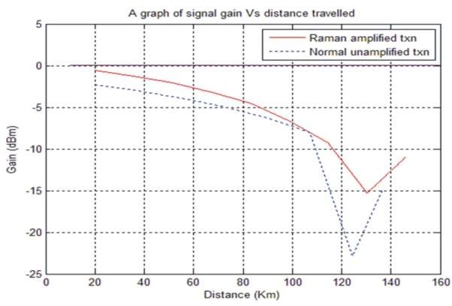

**Figure 4.1:** Graph of signal gain vs distance travelled

Figure 4.1 depicts the signal levels from the receiver end with and without Raman pumping, as well as the Raman gain dispersed along the 160-kilometer fiber connection span. The exact distribution of gain in systems employing a single fiber type is mainly independent of the fiber effective area and is related to the fiber loss at the pump wavelength in systems using a single fiber type.

When a signal is transmitted across an optic fiber link without the Raman amplifier, the gain is significantly reduced. At a distance of roughly 125 kilometers, the signal strength begins to deteriorate to the point where it is too weak to travel farther without amplification. The Raman pump was introduced at this time, which increased the signal strength as shown in figure 4.1.

The main advantage of a Distributed Raman Amplifier (DRA) over a discrete amplifier like an erbium doped fiber amplifier (EDFA) is that the amplification takes place away from the fiber end, where the signal power is larger. As a result, the signal power drops to a lower level in the span, increasing the total optical signal-to-noise ratio and thereby improving the system bit error rate (BER).

By incorporating Raman amplifier into DWDM networks, the link becomes more robust

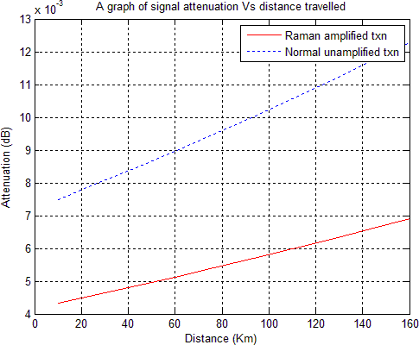

**Figure 4.2:** Graph of signal attenuation vs distance travelled.

The use of a Raman in the transmission connection helps to reduce losses by making the signal transmitted less vulnerable to interference and losses along the transmission channel, as shown in figure 4.2. The signal's attenuation was much reduced when it passed through a fiber

optic network link equipped with a Raman pump in addition to the usual EDFA. This reduction in attenuation had a significant impact on the bit error rate, which was significantly lower than when a Raman pump was not present in the transmission channel.

It was discovered that in the absence of an amplifier, the bit error rate climbed to more than 10% of the signal strength. This is not a satisfactory performance. The Raman pump amplifier, on the other hand, can reduce the BER to an acceptable level.

There are numerous important precautions to take while using a Raman amplifier in a real- world setting that must be addressed in order to fully enjoy the potential benefits.

When using a Raman amplifier in a DWDM system, it must be linked to the network fiber with the least amount of loss possible before contamination like as dust and dirt, as well as misalignment, reduce fiber attenuation, network operators must keep the fiber and connections clean during the connecting process in order to avoid degrading the system's performance.

High transmission line loss, particularly discrete loss spots near the Raman amplifier, can drastically reduce the available pump power for DRA and hence the potential Raman gain. Dirty or broken connectors, as well as acute bends and other stress areas along the fiber, can cause discrete loss points. Figure 2 shows the effect of discrete loss points at varying distances from the Raman amplifier on Raman gain. For example, if the amplifier's normal Raman gain (for a given fiber type) is 15 dB, a discrete loss point of 0.5 dB at the output will reduce the gain by more than 1.5 dB, and a discrete loss point of 1 dB at the same place will reduce the gain by more than 3 dB.

The number of jumper wires between the Raman amplifier and the transmission fiber should

be kept to a minimum to minimize discrete loss sites. Splices should be used instead of connectors wherever possible, and in the event that connections must be used, care should be taken to clean them and ensure that they are correctly closed. In the cable plant between the Raman amplifier and the outside cable plant, care should be given to reduce bend losses and stress. The total loss between the Raman amplifier and the outside cable plant should not exceed 0.5dB as a rule of thumb. In order to analyze the transmission line and detect discrete loss sites, an OTDR can be used.

Back-reflection along the transmission line is another significant factor to consider while deploying the Raman amplifier. Because high back reflection is frequently related with loss, it can occur at discrete loss spots, as detailed in the previous section. If there is high back- reflection, then part of the pump energy propagating along the line will be back-reflected, and will return to the pump laser diode from which it originated. A high level of back reflection can degrade the performance of the laser diode, and thus decrease the available pump power. As a rule of thumb, the total back-reflection from the line should not exceed a level of -25 dB, and should preferably be in the region of -30dB.

As previously noted, filthy or broken connectors might result in signal loss and/or back- reflection, lowering the available Raman pump power. Another issue that could arise when using the Raman pump is that the high Raman pump power traveling through the connectors can damage or degrade the connectors over time. To avoid this, the number of connectors close to the Raman amplifier should be kept to a minimum, with those that remain being particularly constructed to handle high power (such as E2000 connectors). The Raman amplifier's output port should ideally be a high-power adapter, with the other end of the

jumper connecting to it immediately spliced to the outside cable plant.

Even though the transmission line has been prepared as detailed in section 3.2 and all other necessary procedures have been followed, the quality of the transmission fiber itself can still impact the Raman amplifier. Varying types of fibers, such as NZDSF (G.654) and SMF (G.652), have different Raman gains, but even fibers of the same type but from distinct batches might have different Raman gains. This is especially true with older fiber (deployed before 2000) with large water peaks, resulting in high (and fluctuating) attenuation coefficients for the Raman pump with wavelengths in the 1420-1460 range.

1. As a result of this effect, the achievable Raman gain can vary by up to 10%. To remedy this, a Raman amplifier should be run in automatic gain control (AGC) mode, which allows it to deal with non-ideal fiber lines and deterioration over time. Two key components of measuring are merged in AGC mode: At any given time, accurate measurement of the Raman gains is required. Ability to control the Raman pumps to achieve a required gain while maintaining good gain flatness.
2. When the Raman gain is correctly measured, it is compared to the needed gain, and the AGC loop adjusts the Raman pump power until the desired Raman gain is reached. Each of the Raman pumps is corrected in such a way that optimal gain flatness is always maintained.

# CHAPTER FIVE CONCLUSIONS

* 1. **Conclusion**

Finally, the creation and present application of distributed RAMAN amplifiers in dense wavelength division multiplexing techniques has ushered in a new era of optical transmission medium improvement.

The Raman amplifier appears to be a vital technology that is constantly being developed for widespread use in optical communication networks. Raman amplifiers, which are commonly used in long-haul networks, are projected to expand their reach in dense wavelength-division multiplexing (DWDM) networks. As a result, the tremendous bandwidth demand that network operators are always confronting is fueling this rising adoption.

In the optical transport network of long-distance optical communication, the dense wavelength division multiplexing (DWDM) approach has become the favored transmission technology. The invention of an efficient and powerful Raman optical amplifier has aided improvements in optical communication by eliminating the need for expensive regenerators, multiple EDFAs, and converters over long distances.

The above-mentioned project's aims were met, as evidenced by the effect in the results. A research of increasing optical signal in the RAMAN station utilizing the DWDM technology was proven and achieved, including system modeling of critical parameters using **network Monitoring system (NMS) software equipment, power meter source and optical time domain reflectometer (OTDR) simulator**. **59%**

The optical signal can be improved utilizing RAMAN pump amplifier in DWDM technology, according to the optical time domain reflectometer simulator, NMS and power meter source.

# Recommendation

Despite the fact that attenuation causes optical transmission loss over long distances, the need for very long fiber optical transmission links appears to be insatiable. In order to complete this project, a very long fiber optical transmission link with a large capacity and a rapid transmission rate was planned. This was accomplished utilizing a Raman pump amplifier.

Because of the EDFA amplifier's working band and bandwidth limitations, the Raman amplifier, which can provide the expected gain at any wavelength, was proposed to meet future proof network needs as an advanced optical amplifier that enhances and improves optical transmission signals through stimulated Raman scattering.

For network design, we consider the features of our fiber optical link distance, fiber type, attenuation, wavelength, and channel count, and recommend that the Raman pump amplifier be employed to compensate for the EDFA's performance and efficiency shortfall.

# REFERENCES

Agrawal G.P. and Headley (2005). Raman Amplification in fiber optical systems. Elsevier Academic Press.

Bromage J. (2003). "Raman Amplification for fiber communication systems. In Optical fiber communication conference 2003 –OFC 2003 page 156 Vol 1.

Berger, M. et al., (1998). "Pan-European Optical Networking using Wavelength Division Multiplexing", IEEE Communications Magazine, Vol. 35, No. 4, pp. 82-88.

Borella, A., Cancellieri, G., and Chiaraluce, F. (1998) Wavelength Division Multiple Access Optical Networks, Artec House, Boston. Vol. 3. No. 15, pp 30-33.

Buchholz, D.B et al, (1999). Broadband Fiber Access: A Fiber-to-the-Customer Access Architecture", Bell Labs Technical Journal, Vol.4, No. 1, pp. 282-299. ''

Carmelo J. A. Bastos-Filho, Elliackin M. N. Figueiredo, Joaquim F. Martins-Filho, Daniel A.

R. Chaves, Marcelo E. V. Segatto, (2012). Design of distributed optical-fiber Raman amplifiers using multi-objective particle swarm optimization, Journal of Microwaves, Optoelectronics and Electromagnetic Applications.

Chatterjee, S. and Pawlowski, S. (1999). "All-Optical Networks", Communications of the ACM, Vol. 47, No. 6, pp. 74-83. Chibat, M.W. et al, (1998). "Toward Wide-Scale All- Optical Transparent.

Networking: The ACTS Optical Pan-European Network (OPEN) Project", IEEE Journal on Selected Areas in Communications, Vol. 16, No. *7,* pp. 1226-1244.

Chen, Y., Fatehi, M.T., LaRoche, HJ., Larsen, J.Z., and Nelson, Bill (1999). "Metro Optical Networking", Bell Labs Technical Journal, Vol. 4, No. 1, pp. 163-186.

Cotter, D., Leek, J.K., and Marcenac, D.D. (1997). "Ultra-High-Bit-Rate Networking: From the Transcontinental Backbone to the Desktop", IEEE Communications Magazine, Vol. 35, No. 4, pp. 90-96.

DeLange, O.E. (1970). Wide-Band Optical Communication Systems. Part II. Frequency Division-Multiplexing", Proceedings of IEEE, Vol. 58, No. 10, pp. 1683-1690.

Doshi, B.T., Dravida, S., Harshavardhana, P., Hauser, O. and Wang, Y. (1999). "Optical Network Design and Restoration", Bell Labs Technical Journal, Vol. 4, No. 1, pp. 58- 84.

Fabianek, B., Fitchew, K., Myken, S. and Houghton, A. (1997). "Optical Network Research and Development in European Community Programs: From Race to Acts", IEEE Communications Magazine, Vol. 35, No. 4, pp. 50-56.

Furht, B. (1999). Handbook of Internet and Multimedia: Systems and Applications, IEEE Press, Piscataway, NJ.

Garret, L.M. et al. (1998). "The Monet New Jersey Network Demonstration", IEEE Journal on Selected Areas in Communications, Vol. 16, No. 7, pp. 1199-1219.

Carmelo J. A. Bastos-Filho, Elliackin M. N. Figueiredo, Joaquim F. Martins-Filho, Daniel A.

R. Chaves, Marcelo E. V. Segatto, (2012). Design of distributed optical-fiber Raman amplifiers using multi-objective particle swarm optimization, Journal of Microwaves, Optoelectronics and Electromagnetic Applications.

Glance, R., Pollock, K., Burrus, C.A., Kasper, B.L., Eisenstein, G. and Stulz, L.W. (1987). Densely Spaced WDM Coherent Optical Star Network", Electronics Letters, Vol. 23, No.17, pp. 875-876.

Hunter, O.K. et al. (1999). "WASPNET: A Wavelength Switched Packet Network", IEEE Communications Magazine, Vol. 37, No. 3, pp. 120-129.Indian Journal of Science and Technology, Vol 9 (47) DOI 10.17485/IJST/2016/V9I47/106879, December 2017.

Jake Bromage (2004) “Raman Amplification of fiber communication, J.Lightwave technology Vol 22, Pg 79.

Johnson, S.R. and Nichols, V.L (1999). "Advanced Optical Networking-Lucent's Monet Network Elements", Bell Labs Technical Journal, Vol. 4, No. 1, pp. 145-162.

Jourdan, A, et al. (1998). "Key Building Blocks for High-Capacity WDM Photonic Transport Networks", IEEE Journal on Selected Areas in Communications, Vol. 16, No. 7, pp. 1286-1297.

Kartalopoulos, S.V., (1990) "Manhattan A. Fiber Distributed Data Interface Network", Globecom '93, Houston, TX, pp. 2-5.

Kobrinski, H., Bulley, R.M., Goodman, M.S., Vecchi and Bracket, C.A. (1987). "Demonstration of High Capacity in the LAMBDANET Architecture: A Multi Wavelength Optical Network", Electronics Letters, Vol. 23, pp. 303-306.

Koga, M. et. al. (1998). "Large-Capacity Optical Path Cross Connect System for WDM Photonic Transport Network", IEEE Journal on Selected Areas in Communications, Vol. 16, No. 7, pp. 1260-1269.

Lin, L.Y., Karasan, E., and Tkachi R.W., (1998). "Layered Switch Arctitectures for High- Capacity Optical Transport Networks", IEEE Journal on Selected Areas in Communications, Vol. 16, No. 7, pp. 1074-1080.

Lin, Y.K.M., Spears, D. and Yin, M. (1989). Fiber-Based Local Access Network Architectures", IEEE Communications Magazine, pp. 64-73.

Linke, R.A. (1989). "Optical Heterodyne Communications Systems", IEEE Communications Magazine, pp. 36-41.

Malis, A.G. (1999). "Reconstructing Transmission Networks using ATM and DWDM", IEEE Communications Magazine, Vol. 37, No. *6,* pp. 140-145.

Modiano, E. (1999). "WDM-Based Packet Network", IEEE Communications Magazine, Vol.

37, No. 3, pp. 130-135.

Palais, J.E., (1992) Fiber Optic Communications, 3rd Ed., Prentice-Hall, Englewood Cliffs, NJ.

Ramamurthy, B. and Mukerjee, B. (1998). "Wavelength Conversion in WDM Networking", IEEE Journal on Selected Areas in Communications, Vol. 16, No. 7, pp. 1061 -1073.

Raman, L.G., (1999). Fundamentals of Telecommunications Network Management, IEEE Press, Piscataway, NJ.

Sanjeev Kumar Raghuwansh and Talabattula Srinivas (2015), Raman Amplification in WDM Optical Communication Systems: A System Perceptive. Journal of optical communication. <https://doi.org/10.1515/joc-2015-0101>

Takato, N. et al. (1990). "128-Channel Polarization-Insensitive Frequency-Selection-Switch using High-Silica Waveguides on Si", IEEE Photon Technology Letters, Vol. 2, No. 6, pp. 441-443.

Toba, H., and Nosu, K. (1992). "Optical Frequency Division Multiplexing Systems: Review of Key Technologies and Applications", IEICE Transactions on Communications, Vol. 75, No. 4, pp. 243-255.

Sanjeev, K., Niraj, K., Toshiaki, Y., & Seiji, N. (2016)," Statistical Analysis on Stimulated Raman Crosstalk in Dispersion-Managed Fiber Links, Vol. 21, Issue 10, pp. 2229