A REVIEW ON FACTORS INFLUENCING CONSUMER BUYING BEHAVIOUR ON HOUSEHOLD PRODUCTS IN NIGERIA

ABSTRACT

The broad objective of this study is focused on factors influencing consumer buying behaviour on household products in Nigeria in Lagos. The study specifically sought to answer research questions related to the influence of social and cultural, psychological/personal class, demographic and economic factors on consumer buying behaviour on household products. The study employed a Descriptive design. A total of 70 questionnaires were distributed to the respondents. However, only 57 (81.4%) respondents participated in this study. These participants were selected using purposive sampling methods to ensure participants meet the criteria for the study. Data were collected using mainly questionnaires and interviews but also methods of observation and documentary reviews were used to supplement collected data as required. Theories and literature relating to consumers’ buying behaviour were reviewed and summarized and used to develop a conceptual framework, the questionnaire and interviews for studying consumers' buying behaviour on household products on supermarkets. The findings of this study did not show wide variations to studies conducted in other places and literature. The majority of respondents agreed that social cultural factors, psychological/personal class factors, demographic factors and economic factors influence consumers buying behaviour on household products on supermarkets. The study recommends attention should put on social cultural, psychological/personal, demographic and economic factors while developing, pricing, distributing and communicating products.

CHAPTER ONE
INTRODUCTION
1.1 BACKGROUND OF THE STUDY
In the ever changing business environment, understanding customers and the consuming process has a variety of advantages especially for manufacturing companies. According to Haque, Khatibi, and Rahman (2019), these advantages include supporting managers in decision making and providing marketing research with a theoretical foundation from which to analyse customers in order to make better purchasing decisions. To buttress further, Foxall & Goldsmith (2016), consumer research can help businesses learn more about the psychological, social, and economic elements that drive human behaviour. A general understanding of consumer behaviour offers personal significance as well. It can assist people in becoming better consumers by educating them about how they and others conduct their consumption activities. Furthermore, it might help customers in the purchasing process by alerting them about some of the marketing methods utilized by businesses. In Berkman & Gilson, (2018) position, consumer behaviour studies why individuals make specific purchasing decisions, what items and services they buy, where they buy them, how they use them, how frequently they buy them, and how the consumer decision process works.
In the opinion of Jones and Zufryden (2020), consumer behaviour has been characterized in this context as the behaviours of persons who engage in real or potential usage of market items—whether products, services, retail environments, or ideas Therefore, managers must understand customer behaviour in order for their company to achieve commercial success. The relationship between consumer behaviour and marketing strategy is emphasized because the success of companies' marketing strategies is dependent on managers' understanding of consumer behaviour therefore understanding of consumer behaviour is especially important during a recession, according to Kotler and Caslione (2009).
Interestingly, consumer purchasing decisions reveal how successfully a company's marketing approach matches market demand. Marketing thus begins and finishes with the consumer. Customer behaviour research is centred on consumer purchasing behaviour, with the customer having three separate roles: user, payer, and buyer. Consumer behaviour is difficult to forecast, according to research, even for specialists in the industry (Armstrong & Scott, 1991). Consumer behaviour refers to the psychological processes that consumers go through when recognizing their needs, finding ways to meet those needs, making purchase decisions (e.g., whether to purchase a product and, if so, which brand and where), interpreting information, making plans, and putting those plans into action (e.g., by engaging in comparison shopping or actually purchasing a product). By definition, Hasslinger, Hodzic and Obazo (2017) opined that consumer purchasing behaviour refers to the selection, acquisition, and consumption of products and services to satisfy their desires. Consumer behaviour is comprised of several processes. Many elements, specification, and traits impact the person in who he is, as well as the consumer in his decision-making process, shopping habits, purchasing behaviour, the brands he buys, and the merchants he visits. Every one of these criteria contributes to a buying decision. The consumer begins by attempting to identify which commodities he want to consume, and then he picks just those commodities that offer more benefit. After picking the items, the customer estimates how much money he has available to spend. Finally, the customer assesses the current commodity pricing and decides which commodities he should consume. Meanwhile, other elements such as social, cultural, economic, personal, and psychological influences influence consumer purchasing.
Schiffman & Kanuk (2007) asserts that consumer behaviour study seeks to comprehend both the individual and collective decision-making processes of buyers. It investigates individual consumer attributes like as demographics and behavioural variables in order to comprehend people's desires. Consumer behaviour research enables for better knowledge and predictions of not only the subject of purchases, but also purchasing reasons and frequency of purchases One of the current core assumptions in consumer behaviour research is that people buy things for their subjectively perceived values rather than for their primary purposes (Stávková, Stejskal, & Toufarova, 2008). This is not to say that the products' essential functions are unimportant, but that a product's present role is more than its core use-value (Solomon, 2004). Consumers frequently rate products not on the basis of their core attributes (i.e., the primary utility they provide), but rather on the basis of the so-called real product (i.e., the qualities of a specific product) and the extended product, which represents the set of intangible factors that confer a desired perceived advantage on the consumer - including image, consultancy, and after-sale service (Foret & Procházka, 2007). The majority of industrialized nations have met their goals by depending on domestic manufacturing as well as government initiatives encouraging the use of local goods. The degree to which people are committed to buying local items is heavily influenced by ethnocentrism (Sciffman & Kanuk 2007). As a result, the focus of this study is on the factors impacting consumer purchasing behaviour on home items in Nigeria.
1.2 STATEMENT OF THE PROBLEM
The research problem can be stated as finding out the right and suitable marketing strategy to be adopted by organization producing households products to increase the local consumption of their locally made products.
In Africa, Nigeria is one of the developing countries where large amounts of products from other countries are imported each year and alcoholic beverages are not an exception. This has exposed many Nigerian to alternative preference for domestic made products and foreign products. The great variety of goods and services from other countries has made many consumers to patronize imported products. However, many of the local industry are thriving hard to survive in today’s turbulent Nigerian market.
As more companies consider the value of expansion in Africa, the need to understand the African consumer is becoming a priority (Hatch, Becker & van Zyl, 2011). However, there is currently very little research that has been conducted regarding the factors that impact the consumer decision-making process in Africa.
It has been assumed that African companies are not as mature in their analysis and assessment of their consumer base, when compared to companies in developed countries. Maturity in this context can be defined as having progressed to a state of understanding the required consumer and consumer base. Companies are not mature largely due to their inherent composition, and also because of the consumers that they serve. Much of Africa’s markets are also immature, with a large portion of purchasing happening in open markets. It is estimated that approximately 80% of total consumer purchasing happens in open markets in Nigeria, which is one of Africa’s largest economies (CNBC Africa, 2014). These problems make it glaring that there is a need to carry out a study on the factors influencing consumer buying behavior on household products in Nigeria.

1.3 OBJECTIVES OF THE STUDY
The general objective of this study is to examine the factors influencing consumer buying behavior on household products in Nigeria. The specific objectives include the following:
1. To find out the perception of consumers towards buying household products in Nigeria.
2. To ascertain if social factors influence consumer buying behavior on household products in Nigeria.
3. To investigate the socioeconomic factors influencing consumer buying behavior on household products in Nigeria.
4.To know the impact of Psychological factors on consumer buying behavior on household products in Nigeria.
5.To examine if cultural factors influence consumer buying behavior on household products in Nigeria.

1.4 Research Questions
This study was guided by the following questions:
- To what extent do social and cultural factors influence consumer buying behaviour on household products?
- To what extent do psychological/personal class factors influence consumer buying behaviour on household products?
- To what extent do demographic factors influence consumer buying behaviour on household products?
- To what extent do economic factors influence consumer buying behaviour on household products?

1.5 Significance of the Study
The findings of this research are of interest to policy analysts, decision makers marketing managers in their efforts to formulate policies and make decisions that impact positively on consumers' behaviours motivational approaches and retain more loyal employees. It is expected that the findings of the study will enable academicians and researchers to better understand and forecast not only of the subject of purchases but also of purchasing motives and purchasing frequency. It is further expected that the findings of this study will help the household products sellers to recognize consumer behavioural attributes and needs, lifestyles, and consumers' motives behind purchase and then make proper marketing-mix decisions.

1.6 Scope and Limitations of the Study
Geographically, the scope of this study was delimited to Lagos. Lagos was selected because it is a major port city of Nigeria and centre of Government administration, industry, commerce, banking activities, shopping malls and supermarkets. The study was limited at examining the factors that influencing consumer buying behaviour on household products in Lagos.
The major limitation for this study is that it was confined to the city of Lagos. The city was therefore considered as a good representation of the whole population. Furthermore this study only researched the consumer buying behaviour of household consumers goods, since the consumption pattern between products may differ. Consumers show a unique buying behaviour to every single product. For instance, the buying behaviour toward appliances differs from foods and beverages.
Also, this study was limited to Lagos consumers, since it was considered that consumers of different parts of the country behave differently because of the cultural factors. Although the household consumers' goods market is countywide and global, generalization of the findings of this research beyond Lagos is therefore not recommended. Finally, only some social - cultural, economic, demographic and psychological (personal) factors were selected for this study. Although there are more types of factors which influence the consumer buying behaviour, only four types were investigated in this study. This was because of time and administrative restrictions.

1.7 Organization of the Study
This study is organized into five chapters. Chapter one introduces the study. It presents the background of the study, statement of the problem, objectives of the study, research questions, significance of the study, scope and limitation of the study as well as organization of the study. Chapter two provides the literature review related to the topic under study. It defines the key concepts used in the study. The chapter further presents the theoretical perspectives, the empirical studies, the research gap and the conceptual framework of the study. Chapter three presents the design and methodology used in the study. It explains the area of the study, the population of the study, sampling design, data collection methods, data collection instruments, data analysis procedures and validity and reliability test. Chapter four presents the findings of the study. It also analyses and discusses the findings of the study. Chapter five concludes the study. It presents the conclusion and the summary.
It further offers the recommendations and areas for further studies.

CHAPTER TWO

LITERATURE REVIEW

2.1 Definition of Key Concepts
This section defines the key concepts used in the study. These concepts are consumers, consumer products, household, household consumer products and consumers buying behaviour.

2.1.1 Consumers
Consumers (or the customers) are valuable assets for any organization. Consumer is an individual or group of individuals who select, purchase, use, or dispose of products, services, ideas, or experiences to satisfy needs and desires (Schiffman and Kanuk, 2007). In other words, consumers are the eventual destination of any products or services. Organizations are striving to satisfy these consumers to be profitable (ibid). The term consumer refers to two types of consuming units; final consumer and organizational consumer. The final consumer (an individual, a family or a household) differs from the organizational consumer (a business organization, a government agency and a non-profit-making organization) in terms of behaviour and the factors affecting it. The final consumer is any individual that purchases goods or services for either his/her own personal use (e.g clothes and dental treatment) or for his/her family use (food items and carpets or curtains for the house). In other words, the goal of his/her purchases is to satisfy his/her personal or his/her family members needs or wants. For the case of organizational consumer, they mostly purchase goods such as machinery, parts, stationery, furniture, and merchandise. The purpose of purchase is to enable them to perform their functions and to achieve their organizational objectives such as to produce products and deliver services to final consumers (Aaker, 1997 and Solomon, 2002). This study focused on consumers who bought household products.

2.2.2 Consumer Products
Consumers products are the goods and services that a consumer buys him/herself or through others in order to use (consume) them to satisfy personal own needs and wants as well as his/her family's, but not to re-sell them (Lamb et al., 2001). This study adopted the same definition.

2.2.3 Household
A household consists of one or more people who live in the same dwelling and also share a meal or living accommodation. This group of people may be members of the same family or may include others nonrelatives such as servants (Haviland, 2003).
The same context was used in this study.

2.2.4 Household Consumer Products
Household consumer products are products produced to sale to a consumer for use in the household or for the personal use, consumption or enjoyment of a consumer in a household. These household consumer products include durable and non-durable products. Durable goods have a significant lifespan usually more than one year such as kitchen utensils, air conditioners, and sofas. On the other hand, non-durable products are those purchased for either immediate use or to keep it for every short span of life. Examples of non-durable goods are food, beverages, clothing, shoes and gas (Schiffman and Kanuk, 2007).

2.2.5 Consumers' Buying Behaviour
One of the present fundamental presumptions for the consumer behaviour is the fact that people often buy products not because of their main functions but for their subjectively perceived value. It does not mean that products' basic function is not important, but that the today's role of product exceeds its service limits (Salomon, 2002). Consumer behaviour is the study of when, why, how, and where people do or do not buy a product. It blends elements from psychology, sociology, social anthropology and economics. It attempts to understand the buyer's decision making process, both individually and in groups. It studies characteristics of individual consumers such as demographics and behavioural variables in an attempt to understand people's wants. Such understanding is important to companies, especially in the eve of the competition. Factors affecting consumer buying behaviour are varied and not standardized (ibid).
Consumer buying behaviour is mostly limited by budgetary constraints and especially when buying seems to have a small impact on the daily life and one's lifestyle. During the sellers marketing situation, consumers had a smaller level of influence on the availability of household products and for the most part had to contend with what was on offer (Mbura, 2014). With increased disposable income, access to information and competition has empowered consumers to demand more and to have higher expectations, especially during the era of buyers marketing situation (ibid). Consumers are no longer driven by their needs for a product but are instead driven by their wants which is a typical characteristic of the household products market.

2.3 Theoretical Perspectives
This section presents the theoretical perspectives related to the study. Consumer behaviour theorists generally believe that consumer behaviour theories can be applied globally but consumer preferences and tastes are influenced by their cultural background (Schutte and Ciarlante, 1998). Therefore, marketers and business practitioners have to recognize that consumers' attitudes and beliefs, preferences, needs and tastes towards certain products or services are greatly influenced by their culture and the society they belong to. For instance, consumers in other parts of the globe may consider price as the most important determinant in their decision to buy food items, whereas, in others, they may consider quality as the most important factor that may affect their choices. The psychological, situational and personal factors influencing consumers' decision making process and buying behaviour are hereby discussed.

2.3.1 Bases for Consumer Decision-Making
According to Kotler (1998), all consumer buying decisions generally fall along the continuum of three broad categories. These are routine response behaviour or habitual decision making; limited-decision making; and extensive decision-making (Lamb et al., 2001). The common notion is, consumer tends to be highly involved when they purchase expensive items, and less involved when they purchase low involvement products that they purchase frequently and the price is less expensive (Blackwell et al., 2001).
Prior to choice decision or repurchase intention, consumers place a number of attributes in his or her choice sets, in order of importance and relevance. Among these attributes are price and quality. Consumers tend to use price as a proxy to quality (Lichtenstein et al., 2004). However, studies also reveal that, besides price and quality, other cues that are also considered as more important to assess the products worth, are attributes such as brand, store name, past experience, attitude and product information (Dodds et al., 1991). Brand name, for example, often signals as a cue or as a surrogate of product quality use by consumers in their evaluation of goods or services before they decide to purchase. Some scholars argue that the effect of price tends to be stronger when it is presented alone as compared to when it is combined together with brand name (ibid).
On the other hand, Bristow et al., (2002) suggest that if consumers believed that there are differences among brands, then the brand name becomes the centre piece of information in the purchase decision or repurchase intention and the dependence on the usage of brand name in the search information will likely increase. Another branch of consumer behaviour research related to brand is that, consumers use brands to create or communicate their self-image or status (Encalas and Betman, 2003). Consumers, sometimes, associate themselves to a given brand when they make brand choice, and also make their brand choice based on associations with manufacturer's brand name (Aaker, 1997). Besides, brand names contribute value to the consumers image, as well as the economic success of the businesses, and it also can affect preference, purchase intention and consequently, sales (Ataman and Ulengin, 2003).

2.3.2 Psychological Factors
According to Brown (2006), Hasslinger et al, (2007); Kotler and Armstrong, (2007) and Stávková et al., (2008), psychological factors include motivation, perception, skills and knowledge, personality, positions and style of life. These factors are commonly used in marketing field when describing, explaining and predicting consumers' behaviour.

The first factor used in marketing field is perception. Perception means the adaption of reality. The process of selection, processing and interpretation of input data from the environment to make them purposeful.Personality is the second factor used in marketing field. Personality is created by inner characteristics and by behaviour. This makes a person unique. Personal characteristics influence the way how people behave. It is, however, difficult to find a reliable connection between the individual personality and the behaviour type.

Skills and Knowledge are yet other factor used in marketing field. Skills and knowledge are connected to learning and predestinate changes of Consumers' behaviour. Therefore, to cause changes of consumer behaviour concerning the concrete product, it is necessary to give the adequate information. Learning process can come through a simple association between the impulse and the reaction to it, or through the complicated set of rational activities.The other important factor used in marketing field are motives. Motive means the inner driving force that orients human/consumers' activities towards meeting the needs or achievement of the definite aim.
In every decision-making process several motives plays role, not only one. In case of need of measuring or analyzing, there is one questionable thing that motives often work only on the subconscious level.Positions and style of life are also among the factors used in marketing field. Positions and style of life means knowledge and positive or negative feelings which influence humans' perception and consequently decision making and behaviour. People learn their bearings through experience and interaction with other people. The eventual changes of positions are conditioned by consumers' personality and his or her style of life. Consumer generally refuses information that is in conflict with his or her positions; eventually he or she modifies them to reach correspondence.

2.3.3 Situational Factors
Situational factors can notably influence purchase decision which social environment, physical environment of the purchase place, time influences and the previous states fall into this group (Vysekalová, 2004).

2.3.4 Personal Factors
Personal factors are referred to ones unique for each consumer. Above all data like age, sex, and place of domicile, occupational and economic conditions, personality and self - consciousness can be found here (Trommsdorf, 2002).

2.3.5 Economic Theory of Information
An economic theory of information was first proposed by Stigler (1961). Accordingly, this theory assumes that the markets are characterized by price dispersions and both seller and buyer have little information about this dispersion of prices. As such, consumer has to engage in search activity in order to obtain information about the products and price at cost.

According to Avery (1996), rational consumers are assumed to search for product information/price information to a point where the marginal benefits of search are equal to the marginal costs of search. The search for product information varies in accordance to price and quality perception on products or services to be purchased. If consumers perceive that there is a high level of price and higher quality variability in the market then they should be more willing to engage in search activities for price and quality information (Avery, 1996).

Consumers purchase/repurchase intention or purchase decision for a product and/or service is driven by various reasons, which can be triggered by rational or emotional arousal (Schffmann and Kanuk, 2007). For example, consumers use brands to communicate their self-image or status, and the brand images chosen must be congruent to their own and match to groups they aspire to establish an association with (Encalas and Bettmann, 2003).

Similarly, consumers will seek for others who are significant to them for information or wish to associate or bond with, that is, the group social norms with whom consumers aspire to establish a psychological association or bonding, such as friends, neighbours, and the like (Mourali et al, 2005). Besides, other factors, such as price,
income, education, and other attributes also contribute to purchase
decision/repurchase intention (Andaleeb and Conway, 2006).

2.3.6 Stochastic Models
Jones and Zufrydens (1980) model used demographic variables (household income and the number of children in a household) and marketing mix (price dimension) as explanatory variables to predict brand choice or purchase (criterion variable). Jones and Zufrydens model was tested using logit model estimation. The explanatory variables were categorical data and the criterion variable was metric data. Their modified model was adapted due to its flexibility.

It was suggested by the authors who developed the model that, in terms of its use, the model involves relatively straightforward parameter estimation procedure and one that is adaptable to exploratory model building (ibid). In other words, their intention was to develop a general model which can be used to aid in marketing decision process. Hence, it was also suggested that the model is very flexible in which the explanatory variables can be added and dropped as required by the researchers who wish to replicate or adapt the model.

However, in the current research framework, besides household income, number of children and price, additional explanatory variables of product attributes importance such as quality, brand name, product information and interpersonal influence variables were added to the model.

2.3.7 The Buying Decision Process
The consumer buying process for household consumer goods is often regarded as similar to that for other products and services. The assumption is that a consumer moves through a number of stages leading up to a purchase.
The process begins with awareness, a stage that may be initiated by promotional efforts or by word of mouth which makes the buyer becomes aware of existence of a product that can reduce his/her drive. The next stage involves the buyer obtaining more information, and as suggested previously, there are likely to be various levels of commitment depending on the nature of the purchase. This information search will result in the formation of an attitude, perhaps reinforcing an existing attitude or bringing about a change on the part of the buyer.
At the evaluation stage, the buyer will make more detailed comparisons. For example, a consumer may consider a number of destinations and will choose based on criteria such as price, recommendation, convenience or convention. Subject to time and financial constraints, the consumer will then make the purchase of most preferred product.
The purchase is followed by the final stage of the buying process, post-purchase behaviour , where a consumer is either satisfied or dissatisfied. A satisfied consumer will most probably repeat the purchase and say good things about the product to others. While, dissatisfied consumer will reduce dissonance by abandon the product or seek more confirmation information about the product (Zeithaml et al., 2009 and Mbura, 2014).

2.4 Empirical Studies
This section presents the empirical studies related to this topic. These include world and Nigeria related studies.

2.4.1 World Related Studies
Kim (2009) conducted a study on factors which influence Chinese consumer behaviour when buying innovative food products. The study conceptualizes a model of Chinese consumers' purchase decision for the GM foods by empirically testing the interrelationship among the GM food purchase decision determinants with a multiattribute model. The purpose of this study was to explore the lying factors which affect the Chinese consumer choice behaviour for the GM food. The assumption was that a clear understanding of the determinants of consumers' GM food choice may enable policy makers and marketers to build effective policies and marketing strategies and to establish market position of the GM food. The findings revealed that consumers' perceived concern toward the subjects such as limited information availability and environmental issues. This study was conducted in China a place where differ with Nigerian culture. The study was also concerned with consumers choice behaviour to GM food. These findings cannot be directly applicable in Nigeria. This study based on consumers buying behaviour on household products in Nigeria.

Young et al. (2008) conducted a study on sustainable consumption, the case being green consumer behaviour when purchasing products. The study investigated the purchasing process for green consumers in relation to consumer technology products in the UK. Data was collected from 81 self-declared green consumers through in depth interviews on recent purchases of technology products. The study found out that a green consumer purchasing model is developed and success criteria for closing the gap between green consumer's values and their behaviour.

The study concluded that incentives and single issue labels (like the current energy rating label) would help consumers concentrate their limited efforts. More fundamentally the study revealed that "being green" needs time and space in peoples' lives that is not available in increasingly busy lifestyles. The implications for policy and business were proposed. This study concentrated on green consumer behaviour only in the UK which is very different to Nigeria. Thus, there was a need to conduct a study in Nigeria to determine factors influencing consumers buying behaviour in Nigeria.

A Strategic Household Purchase: Consumer House Buying Behaviour was a study conducted by Koklic and Vida (2009) in Slovenia. The aim of the study was to examine consumer house-buying behaviour from the consumers' perspective. In view of the existing literature exploring consumer decision making, the purpose of this research was threefold to propose a conceptual model of consumer decision making within the frame of consumer behaviour; to gain knowledge of factors impacting this process from the empirical standpoint with the focus on prefabricated house purchases; and to offer implications for beneficial purchases of prefabricated houses.

The findings from their in-depth interviews with recent owners and potential buyers of a custom-made prefabricated house suggested that cognitive and rational factors do not offer sufficient explanation of consumer behaviour in the case of a highinvolvement product such as a house. In addition to the idiosyncratic characteristics of the customer, his/her personal situation and environmental factors, the study suggested that the role of feelings, experience, subconscious factors, needs and goals should to be taken into account to better understand this kind of decision making.

The study offers knowledge of consumers' behaviour while buying houses which high involvement products and are very different to household products which are low involvement products. Consumers may indicate different behaviour s on each of these products. Thus, it was thought that, there was a need to study consumers' buying behaviour to household products in Nigeria.

Stávková et al. (2008) conducted a study on the factors which influence consumer behaviour. The main aim of the study was to understand the influence of factors biasing purchase decisions connected with measurement of consumers' involvement. Consumption expenditures were purposefully subdivided according to the classification made by the Statistical Office of the European Communities. The performed survey showed that the most important factors biasing purchases of all commodity groups are products' characteristics and the perceived quality.

Together with these goes the factor of price, nevertheless for example for the commodity group health price did not appear in the scale of the perceived importance at all. In the study, factor necessity of need proved to be significant for decision making about the purchase of all commodities with the exception of alcoholic drinks, tobacco and recreation. The study further revealed that, former experience compared to that is not crucial for clothing and footwear and housing equipment and contents. For alcoholic drinks and tobacco, there has notably approved also the factor brand. These analysis enable disclosure of rules of consumer decision making and thereby definition which factors for individual commodities should be targeted by the help of the marketing doyens or where the gradual changes should be achieved. This study was conducted outside. It was therefore thought necessary to conducted a study in Nigeria.

Prameela and Husain (2007) conducted a survey on short communication consumer choice of branded agro-processed products in Kannur municipality of Kerala state. A survey was conducted among 150 household consumers of Kannur municipality in northern Kerala to identify the factors which influence purchase decision/consumer choice of Branded Agro-processed Products (BAPs) manufactured by private and cooperative sector organizations.

The findings revealed that product features (taste, freshness, and shelf life) and advertisement determine the consumer choice of BAPs such as sambar powder, meat masala, rasam powder, pickle, and jam. There was, however, no significant difference between the brands made by the cooperatives and private sector organizations in this regard. This study does not explain the effects of consumer personal factors on their buying behaviour especially for household products, a gap which this study intended to fill.
Haque et al (2009) conducted a study on factors which influence buying behaviour of piracy products and its impact to Malaysian market. The primary attempt in this study was to explore the influencing factors of the Malaysian consumers toward the pirated products. To explore these factors, this study conducted a survey among the Malaysian consumers. The findings of the study revealed that there is significant relationship between the consumers' perception and the social influence, personality or believe, pricing and the economy toward the piracy. The findings also revealed that society has strong influence on the consumers' personality and believes, that leads to grow consumers' perception.

On the other hand, it revealed that most of the respondents are willing to buy pirated product because of cost effective. Since, price plays a key role to convey individuals toward price sensitive, therefore it is important for the marketers or producers to be attentive of pricing. More importantly marketer can decrease the production cost and secondly, they show intention to reduce their profit margin. To perform all those necessary steps need to set up the price by considering the all income groups. This will help to reduce the consumers' consumption of pirated goods. Though, there is no doubt about the quality of original products but they should look at the price. This study does not explain how consumers' personal factors influence their buying behaviour on pirated goods, a gap which this study intended to fill.

2.4.2 Nigeria Related Studies
Barakaeli (2008) conducted a study on factors which influence consumer buying decisions in mobile phones market in Nigeria. The aim of the study was to find out how do different markets strategies e.g. pricing, promotion, presence of reliable supplier (distribution) and product attributes influence the consumer buying decision in the mobile phones markets. In this study the questionnaire survey was used as the method of data collection where by a total of 90 respondents were surveyed in the three municipals of Lagos city; Kinondoni, Temeke, and Ilala. The data obtained were analyzed using Statistical Packages for Social Science (SPSS) and both descriptive and hypothesis testing through the data obtained was carried out. From the data analysis, the findings revealed that pricing, some product attributes, price and presence of reliable supplier influence the consumer buying decision in mobile phone markets. From the findings of this study promotion/advertisement contributes less to consumer buying decision due to poor techniques used during promotion that discourage customers.

The study recommended to manufacturers and marketers that the product attributes like quality and size as well as price and presence of reliable supplier influenced consumer buying decision. Therefore, they need to improve and put more efforts on them by introducing mobile phones of higher quality offered at low price and increase availability of the phones. They also need to take into consideration other factors which can influence consumer buying decision like the nature of the customers, buying classes, social class and other environmental and economic
factors.

The policy implication of this study is that; the government and other stakeholders like Fair Competition Commission should ensure that the manufactures or importers of mobile phones from abroad offer/import phones of good quality so as to meet customers' satisfaction and enhance their buying decisions. However, the study does not explain the effects of consumers' personal factors on buying behaviour of mobile phones.
Sanga (2007) conducted a study on the factors which influence consumer brand choice and purchasing decision making process, the case being bottled drinking water in Nigeria. The overall objective of this study was to assess the attributes that influence the customers in buying bottled drinking water in Nigeria.

Rather than trying to understand all the various decision-making criteria involved in brand choice and the buying decision process, the study focused solely on seven attributes and examined what percentage of each attribute contributed to the final decision. These included, price, brand, corporate image and packaging elements (package colour, package shape, further usage package and package size). The study findings suggest that price as well brand have got strong influence towards customers brand choice and purchasing decision process making. This implies that bottled water manufacturer and marketer should put more weight on these factors when designing their brands product.

The findings also revealed that price and brand attributes do not stand alone on influencing customer of bottled water in their buying decision process. Packaging elements (i.e. package colour, package shape, further usage package and package size) and corporate image attribute go hand on hand in influencing customer brand choice and purchasing decision-making process. The study found that, bottled companies should understand consumer needs and wants and all market efforts toward bottled water consumer by considering the above attributes. The study also revealed that customer characteristics in terms of sex, education level, occupation, and location develop different consumer attitudes towards brand choice. Thus, all marketing programs should address its customer need by considering of the above customer characteristics. This study was confined to consumers' behaviour on drinking waters only thus, the findings cannot be applied for other products such as household consumer goods.

Mkanda (2009) assessed some products, price, quality, package, label and promotional factors that affect consumer choice of brand the case being carbonated soft drink brands in Nigerian market. This study analyzed the consumer buying behaviours of carbonated soft drinks in the Nigerian market. It investigated critical product attributes that influence consumer preference for a particular brand of carbonated soft drink. It examined consumer buying behaviour and assessed some product, price, quality, packages, label and promotional issues that affect the choice of brand by consumers.

The aim of the study was to contribute to theoretical knowledge and at the same time guide market practitioners in deciding on which of the best market tactics to adopt. The research methodology consisted of a survey of 167 carbonated soft drinks consumers from five regions, through the use of a standard questionnaire. Chi-square statistical method and technique was used to measure the indicators while multiple regression method was used for testing the hypotheses.

Five hypotheses were empirically tested and the findings revealed that there is a significant negative relationship between the price of the pack and the choice of brand of carbonated soft drinks. Regarding quality the findings revealed that the perceived quality of the product negatively influenced the decision to purchase a carbonated soft drinks brand. The negative correlation might result from the fact that consumers often judge the quality of the products on the basis of variety of information cues that they associate with products. Generally, the study found out that the explanatory variables greatly influence the decision to purchase carbonated soft drink brands on the Nigerian market.

The study recommended that carbonated soft drinks companies should redirect their resources to fund projects that will address marketing issues that are relevant to consumer so as to sustain loyalty. Also, the study strongly advised the government to create a sustainable business environment by revising its taxation, import and export polices to safeguard the local soft drinks industry. This study failed to determine the factors which affect consumer behaviour as it focused on products critical attributes.

CHAPTER THREE

RESEARCH DESIGN AND METHODOLOGY

3.1 Research Design
This study adopted a descriptive design. Hartley (2004) contends that, descriptive studies tend to be inductive as they piece together evidence to support theory development. According to him, depth of understanding is important to the author. Morris and Wood (1991) and Fisher (2004) also suggest that descriptive studies are more appropriate for an in depth understanding of a particular situation. Punch (1998) argues that while there may be a variety of specific purposes or research questions, the general objective of the study is to develop as full an understanding of that study as possible.

3.2 Area of the Study
Lagos is the economic capital of Nigeria with over 21 million inhabitants
(Census, 2012). The relatively high population growth rate is due to increased birth rates, immigration rates, and more significantly by transient population. Lagos has a unique status, being the major City of Nigeria and the center of government administration, industry, commerce, banking activities shopping malls and supermarkets. Lagos is also the major port City of Nigeria. Thus, the research area was selected due to business opportunities available and many shopping malls and supermarkets where by people have a wide choice of household products.
3.3 Target Population
The study was conducted in Lagos state. Thus, the target population was males and females' household products consumers and supermarket dealers. The population for this study was 70 respondents.. Also consisted of 25 supermarket dealers from Game, Shoprite,Imalaseko,Shoppers Plaza and Uchumi.

3.4 Sampling Design
It was important to select the most appropriate sampling technique to obtain the required data to answer the proposed research question. The design in this study included sampling unit, sample size and sampling procedures.

3.4.1 Sampling Unit
Sampling unit was reflected in the focus of factors influencing consumers buying behaviour on household products in Lagos. The individual opinion was collected in several supermarkets and shopping malls in Lagos. The unit of analysis included consumers and supermarkets dealers.

3.4.2 Sample Size
The study drew the required number of elements for study from a larger population. Analysis was carried normally on the sample whereas conclusions were referred to the whole population. The sample was required to have similar characteristics of the population since it was picked in a manner that makes it has an appropriate representative of the whole population as also noted by Mbeche (2004).
The objective of this study was to obtain a sample that is representative of household products consumers and to describe the factors which influence their purchasing decision

3.4.3 Sampling Procedures
According to Kothari (2006), sampling procedure is a technique used in selecting the items for the sample. He adds that the procedure stands for the sample itself. In addition, Saunders et al. (2007) assert that the sampling procedures available can be divided into two types. The first is probability or representative sampling which is the one where the chance of each case being selected from the population is known and is usually equal for all cases. The second type is non-probability or judgmental sampling which is the one where the chance of each case being selected from the total population is not known.

During the study, a non-probability or judgmental sampling was used. In particular, the study used purposive sampling in order to obtain a sample which was a true representative of the population and usually tried to ensure that a range from one extreme to the other was included. This is because the main purpose of the study was to examine the factors which influence consumer buying behaviour on household products in Lagos.

3.5 Data Collection Methods
Primary data was collected by means of structured questionnaire and semi-structured interview. Secondary data was collected through a review of relevant information, published documents on factors influencing consumer buying behaviour on household products in Nigeria and globally. Other information was gathered from key institutions involved in the design, in an attempt to demonstrate for those themes and hypotheses that they were supported data collection and conditions under which they hold the truth.

3.6 Data Collection Instrument
This study used four instruments to collect data. These were questionnaire, observation, documentary sources and interviews.

3.6.1 Questionnaire
A questionnaire is a method of collecting data which used a set of question for collecting data (Kothari, 2006). A structured questionnaire was used to collect data. This served as primary data to answer the research questions and objectives. The questionnaires consisted of 5 distinct sections, each of which contained question pertaining to different parts of the study.

3.6.2 Observation
Observation method allowed the researcher to observe how respondents conducted their day-to-day shopping behaviour. Due to the fact that the researcher conducted the study through direct participation, hence there was a possibility to see and accumulate data from the events associated to the selected topic.

3.7 Data Analysis and Procedures
Qualitative and quantitative data were analyzed by using the computer program (excel) so as to safeguard the drawing of conclusions concerning this study. During analysis however, the non-standardized and complex nature of data, which were collected, were classified into categories before they were meaningfully analyzed. Moreover, the data collected were presented in charts, tables, and word-reporting systems. The process of analysis aimed at determining whether the data collected support or reject the objectives and the research questions formulated before going to the field to collect the information.

3.8 Validity and Reliability Test
The issue of validity was addressed by ensuring that question content in the data collection instruments (interviews, observation, and focus groups) directly concentrated on the research objectives. The study addressed external validity through various means. A sample was selected which allowed for a subject to be viewed from all relevant perspectives. Furthermore, this study was able to ensure the validity of the findings through a quantitative survey of the semi-structured interviews, where the categories counted was derived from the theoretically defined concepts. According to Silverman (2006), simple counting techniques, theoretically derived and ideally based on participants' own categories offer a means to survey the whole groups of data, test and to revise their generalizations, and remove doubts about the accuracy of their impressions about data.

Reliability was improved in the data analysis process. The availability of similar information from different sources was ensured. Information that appeared to be consistent and non-controversial was considered as reliable. The instruments were always administered in a consistent fashion. Furthermore, when subjective judgments were required, specific criteria was established that dictated the kinds of judgments the researcher made. In addition, thick descriptions of the qualitative study findings was provided to maximize the transferability of the study findings and inferences to other people and settings which were similar in the context of this study.

CHAPTER FOUR

FINDINGS, ANALYSIS AND DISCUSSION OF THE FINDINGS

4.1 Characteristics of the Respondents
This section presents the characteristics of the respondents in terms of status, age, education level and gender of the respondents.

4.2.1 Status Distribution of the Respondents
Questionnaires were distributed to household products consumers and supermarket dealers asking respondents to indicate whether they belong to household consumers' or supermarket dealers. 57 (81.4%) respondents responded to questionnaires out of which 41 (71.9 %) were household product consumers while 16 (28.1%) were supermarket dealers. Table 4.1 and Figure 4.1 provide the findings.

Table 4. 1: Status Distribution of the Respondents
Status | Frequency | Percentage (%)
Household products consumers | 41 | 71.9
Supermarket dealers | 16 | 28.1
Total | 57 | 100
Source: Field Data (2019)
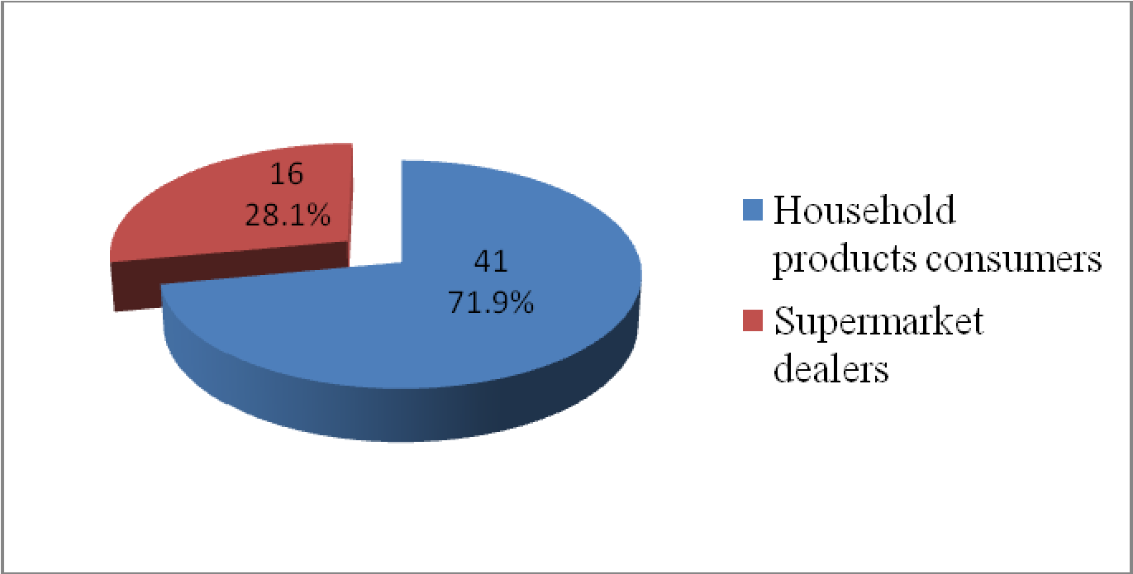
Figure 4.1: Status of the Respondents
Source: Field Data (2019)

As shown in Table (4.1) and Figure (4.1), household products consumers were 41 (71.9%) while supermarket dealers were 16 (28.1%) of the total respondents. This implies that the majority of respondents who participated in this study were household products consumers due to the requirements of the sample size.

4.2.2 Age Distribution of the Respondents
The respondents were asked to indicate their age. Table 4.2 and Figure 4.2 illustrate the age of the respondents.

Table 4.2: Age Distribution of the Respondents
Age Range (in years) | Frequency | Percentage (%)
Below 26 | 3 | 5.3
26 – 35 | 26 | 45.6
36 – 45 | 17 | 29.8
46 – 55 | 7 | 12.3
Above 55 | 4 | 7.0
Total | 57 | 100
Source: Field Data (2019)
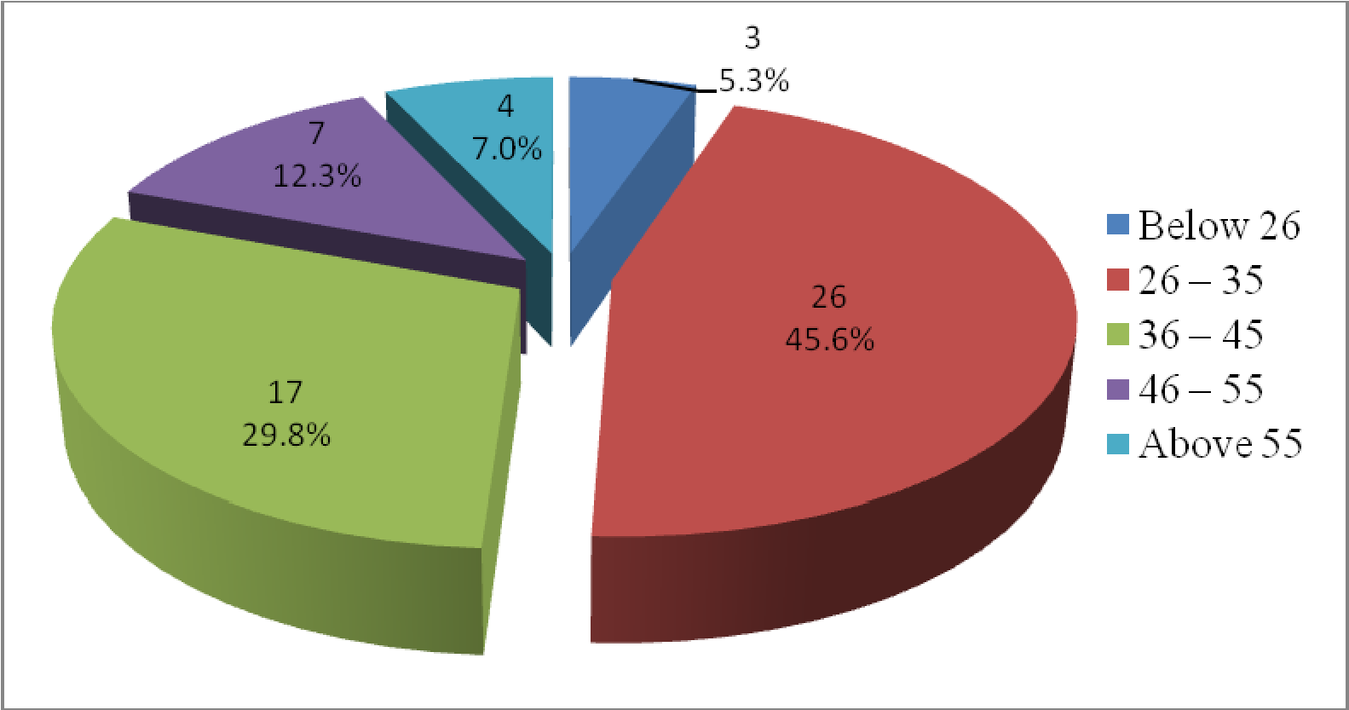
Figure 4.2: Age Distribution of the Respondents
Source: Field Data (2019)

Table 4.2 and Figure 4.2 indicate the distribution of the respondents who participated in this study according to their ages, from the figure and the table, 3 (5.3%) of the respondents aged below 26 years, 26 (45.6%) of them were within the ages of 26 to 35, while 17 (29.8%) of the respondents fell within the ages of 36 to 45 years, 7 (12.3) were in the age group of 46 to 55 and 4 (7.0%) were aged above 55 years.

The presented age distribution of the respondents had implication in the study as it indicate that the large number of respondents were between 26-55 years old which were 87.7% of the entire sample. This implies that, the people of that particular age group are more active in shopping activities than their younger and senior counterparts because they belong to working group with high income earnings.

4.2.3 Gender Distribution of the Respondents
The respondents were asked to indicate their gender and their responses are as shown in Table 4.3 and Figure 4.3.
Table 4.3: Gender Distribution of the Respondents
Gender | Frequency | Percentage (%)
Male | 34 | 59.6
Female | 23 | 40.4
Total | 57 | 100
Source: Field Data (2019)

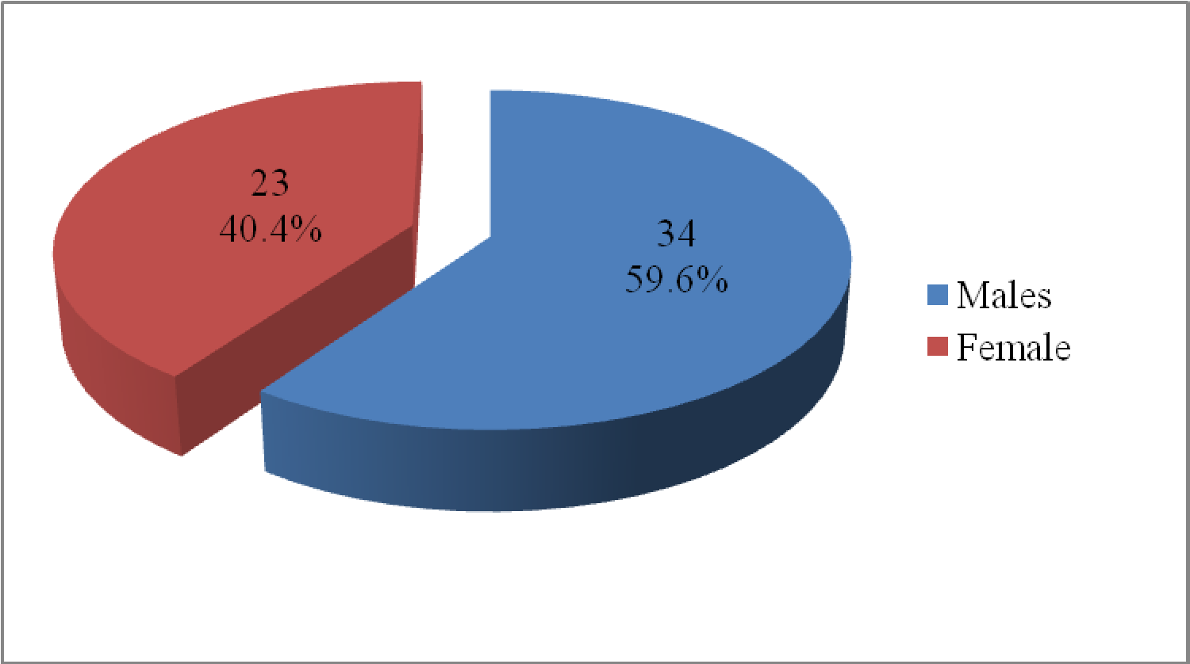
Figure 4.3: Gender Distribution of the Respondents Source: Field Data (2019).

Table 4.3 and Figure 4.3 reveal the gender distribution of the respondents participated in this study. Out of 57 of respondents, 34 (59.6%) of them were males while 23 (40.4%) of the respondents were females. As the samples were randomly selected, it might be concluded that gender can influence consumer behaviour in terms of the roles males and females are expected to play. In Lagos the number of males with higher earnings and those who has a tendency to shop has been growing steadily compared to females. This implies that, gender has an influence in consumer buying behaviour of household products.
4.2.4 Level of Education of the Respondents
The respondents were asked to indicate their education level from primary school, secondary school, college or university. Their responses are as shown on Table 4.4 and Figure 4.4.

Table 4.4: Level of Education of the Respondents
Level of Education | Frequency | Percentage (%)
Primary Education | 4 | 7.0
Secondary Education | 9 | 15.8
College | 16 | 28.1
University | 28 | 49.1
Total | 57 | 100
Source:Field data (2019)

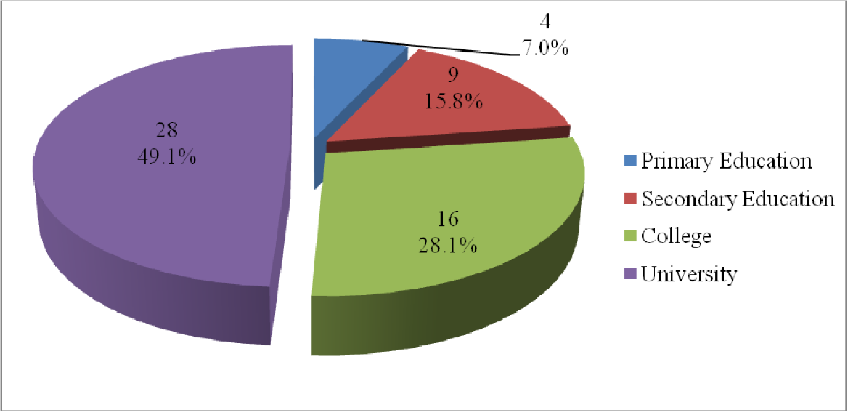
Figure 4.4: Level of Education of the Respondents
Source: Field Data (2019)
The findings reveal that out of 57 respondents, 4 (7.0%) of the respondents had primary level education, 9 (15.8%) respondents had secondary level of education, 16 (28.1%) respondents had college education and 28 (49.1%) respondents had university degrees. This entails that most of the people in Dar esSalaam become more objective in their judgment about products in the market because of their level of education.
The educated elites represented by 44 (77.2%) respondents who had university and college level of education, belong to a class that cannot accept anything without critical analysis of need and satisfaction they intended to get from the product. The education level of respondents was very necessary in this study in order to get views and opinions from different levels of education.

4.3 Findings, Analysis and Discussion of the Findings
This section presents the findings of the study. It also analyses and discusses the findings. The objectives of the study were to examine the extent to which social and cultural factors influence consumer buying behaviour on household products, to determine the extent to which psychological/persona class factors influence consumer buying behaviour on household products, to determine the extent to which demographic factors influence consumer buying behaviour on household products
and to examine the extent to which economic factors influence consumer buying behaviour on household products.

4.3.1 Social and Cultural Factors on Consumer Buying Behaviour on
Household Products
The first objective of this study was to determine the extent to which social and cultural factors influence consumer buying behaviour on household products. Culture, Subculture, social class, roles and status, reference groups, family and
education factors were identified as social and cultural attributes whereby respondents were asked and responded on how these factors influence their behaviour on buying household products.

4.3.2 Culture
Respondents were asked about the influence of culture on consumer buying behaviour on household products. Figure 4.5 illustrates responses of the respondents;

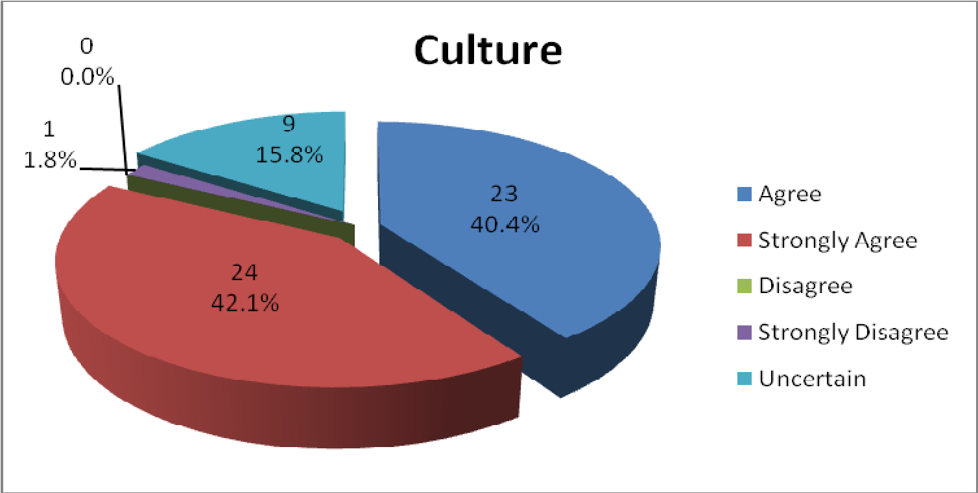
Figure 4.5: Influence of Culture on Consumers Buying Behaviour on Household Products
Source: Field data (2019)

Figure 4.5 indicates that, almost all respondents agreed that culture has influence on buying behaviour of the consumers on household products although at different levels. It shows that 24 (42.1%) respondents agreed strongly while 23 (40.0%) respondents agreed. So overall, 47 (82.1%) respondents either agreed or strongly agreed with the statement that culture has influence on consumer buying behaviour of household products. Moreover, none of the respondents disagreed, while 1 (1.8%) respondent strongly disagreed and 9(15.8%) respondents were uncertain that culture has an influence on their behaviour towards buying various products. Thus, majority of the respondents agreed that culture influences their behaviour on buying household products. The study by Vijayalakshmi and Mahalakshmi (2019) also found culture to have influence on consumers' buying behaviour. Sellers, in this case supermarkets are required to pay attention on the culture of their customers in deciding what to sell.
4.3.2.2 Subculture
Respondents were asked whether subculture has influence on consumer buying behaviour for household products or not. Their responses are as shown in Figure 4.6.
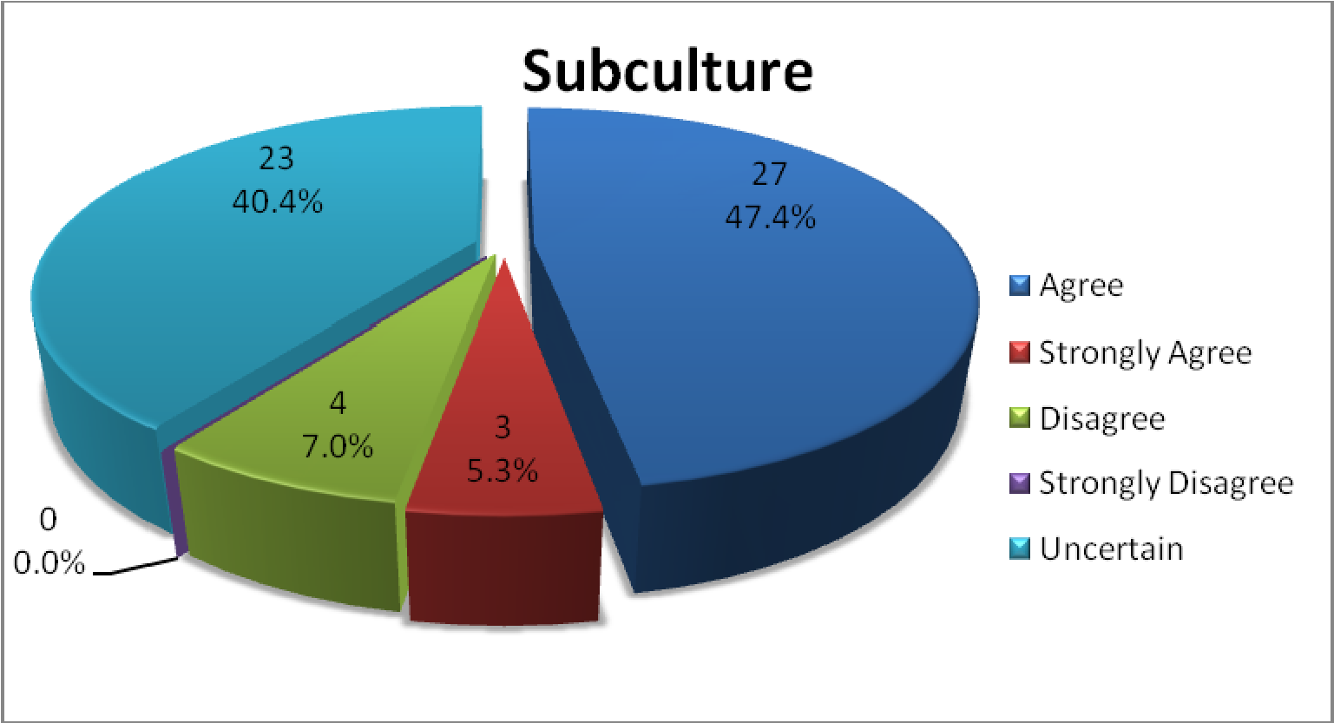
Figure 4.6: Influence of Subculture on Consumers Buying Behaviour on Household Products
Source: Field Data (2019)

Figure 4.6 illustrates that, 27 (47.4%) respondents agreed and 3 (5.3%) respondents strongly agreed. In total, 30 (52.7%) respondents either agreed or strongly agreed that subculture influences consumer behaviour on purchasing household products. On the other hand, 4 (7%) respondents disagreed while 23 (40.4%) respondents were uncertain and none of the respondents strongly disagreed. From the above figure, it can be revealed that majority of the respondents agreed that subculture influences their behaviour on purchasing household products.

These findings are also at par to the findings of Vijayalakshmi and Mahalakshmi (2019) concerning subculture's influence on consumers' buying behaviour. According to them,subculture includes factors such as religions, nationalities, geographic regions, racial groups and the like. Supermarkets can use these groups by segmenting the market into various small portions. For example, supermarkets can design products according to the needs of a particular racial group.

4.3.2.3 Social Class
The respondents were asked whether or not the social class factor has the influence on consumer buying behaviour on household products. Their responses are as shown in Figure 4.7.
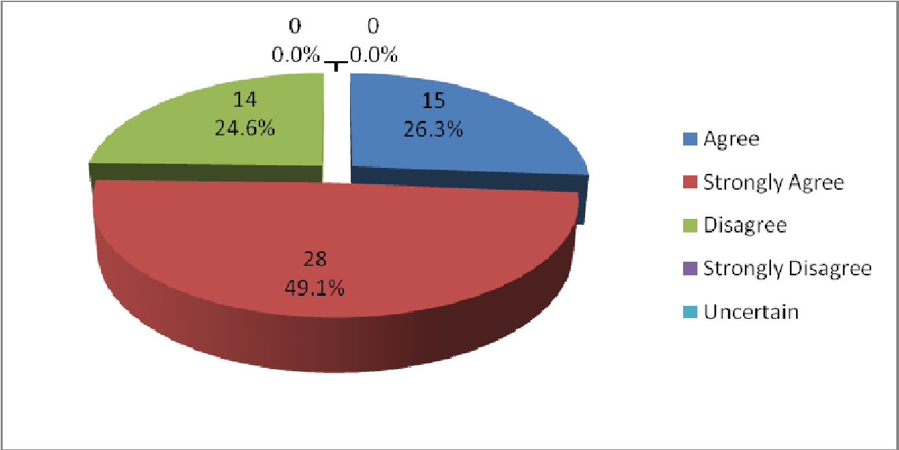
Figure 4.7: Social Class as a Factor Influencing Consumers' Buying Behaviour on Household Products

Source: Field data (2019)
Figure 4.7 indicates that, 28 (49.1%) of the respondents strongly agreed and 15 (26.3%) respondents agreed. Therefore, 43 (75.4%) either strongly agreed or agreed that social class has an influence on consumer buying behaviour on household products. However, 14 (24.6%) respondents disagreed while none of the respondents neither strongly disagreed nor was uncertain. From the findings, it can be revealed that majority of the respondents agreed that social class has influence on consumer buying behaviour on household products.
The findings of this study are in line with those of Halson and Baron (1994). They identified that higher-class individuals have ability to pay for goods and services and this determines the material affluence of one's lifestyle in comparatively lower socioeconomic class that has to mainly purchase product on the basis of utility and resources.
4.3.4 Demographic Factors on Consumer Buying Behaviour on Household
Products
The aim of the third objective was to determine the extent to which sex, age, place of domicile and physical environment of purchase place as demographic factors influence consumer behaviour on buying household products.
4.3.4.1 Sex
The respondents were asked if sex has an influence on their buying behaviour of household products. The responses are as shown in Figure 4.20.
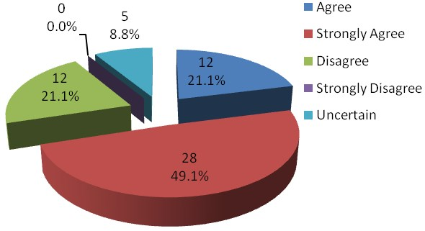

Figure 4.20: The Influence of Sex on Buying Behaviour of Consumers on Household Products
Source: Field Data (2019)

Figure 4.20 illustrates that, 12 (21.1%) of the respondents and 28 (49.1%) of the respondents agreed and strongly agreed respectively that sex has influence consumer behaviour on purchasing household products. On the other hand, 12 (21.1%) of the respondents disagreed while none of the respondents strongly disagreed and 5 (8.8%) respondents were uncertain. From the findings, it can be revealed that majority of the respondents (70.2%) agreed that sex influences consumer behaviour to buy household products.

Bakshi (2012) conducted a study with this variable of influence of sex on consumers' buying behaviour. According to the study, huge differences lie in the attitudinal, behavioural, focus, information gathering, emotions aspects of men and women due to psychological and physiological differences. The study concludedthe same as per the findings of this study.

4.3.4.2 Age
Respondents were asked to express their views concerning age as a factor which influence consumer buying behaviour on household products. Their responses are as shown in Figure 4.21.

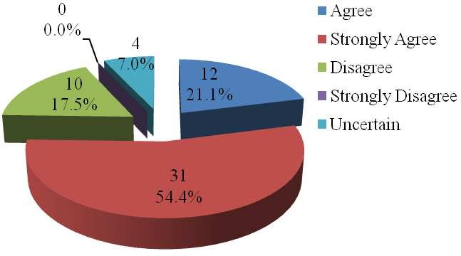

Figure 4.21: The Influence of Age on Buying Behaviour of Consumers on Household Products
Source: Field Data (2019)

Figure 4.21 provides that, 12 (21.1%) respondents agreed and 31 (54.4%) respondents strongly agreed that age is a factor which influences behaviour towards buying household products. 43 (75.5%) respondents either agreed or strongly agreed to the statement. 10 (17.5%) of the respondents disagreed while none of the respondents strongly disagreed and 4 (7.0%) respondents were uncertain. Thus, majority of the respondents agreed that age influences their behaviour towards buying household products.

These findings are also supported by a study conducted by Mazloumiet al (2019). This study concluded that the consumers' age affects their purchasing behaviour although they were not clear if this finding is applicable to all types of products.

4.3.4.3 Place of Domicile
The respondents were asked if place of domicile has influence on their buying behaviour of household products. The responses are as shown in Figure 4.22.

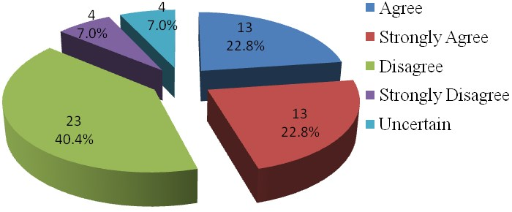

Figure 4.22: Whether or not Place of Domicile's Influence on Buying Behaviour of Consumers on Household Products
Source:Field Data (2019)

Figure 4.22 illustrates that, 13 (22.8%) of the respondents were agreed and 13 (22.8%) respondents strongly agreed. 23 (40.4%) respondents disagreed and 4 (7.0%) respondents strongly disagreed. Therefore 27 (47.4%) respondents either disagreed or strongly disagreed that place of domicile has an influence on purchasing household products. 4 (7.0%) respondents were uncertain. Thus, the findings it cannot be concluded whether respondents agreed or disagreed to statement that place of domicile has influence on consumer behaviour to buy household products.

While my study could not come to conclusion on this factor, other studies such as that of Yakupet al. (2012) found that place of domicile has an influence on consumers' buying behaviour. They found out that supermarkets consumers' products are favourite on suburbs and not on townships.

CHAPTER FIVE

SUMMARY, CONCLUSIONS AND RECOMMENDATIONS

5.1 Summary
The aimed of the study was to examine factors that influence consumer buying behaviour on household products in Lagos. The objectives of the study were accomplished and attained because numerous data were gathered and analyzed which gave the blueprint of the factors that influence consumer buying behaviour on household products in Lagos targeting household product consumers at main supermarkets and supermarkets dealers in Lagos.
The study used a descriptive research design. This study involved 57 respondents whereby 41 were household product consumers and 16 were supermarkets dealers. These participants were selected using purposive sampling methods to ensure participants meet criteria for the study. Data were collected using several data collection methods. The main methods used were questionnaires and interviews also methods of observation and documentary reviews were used to supplement collected data as required. Theories and literature relating to consumers buying behaviour were reviewed and summarized in this study and were used to develop conceptual framework, questionnaire and interviews for studying consumers' buying behaviour on household products on supermarkets. The findings of this study did not show wide variations to studies conducted in other places and literatures. The majority of respondents agreed on the presence of factors that influence consumers buying behaviour on household products on supermarkets. These factors included social and cultural factors which are culture, subculture, social class, roles and status, reference groups, family and education. Motivation, perception, beliefs, attitudes, skills and knowledge, self - consciousness, personality and lifestyle, were Psychological/personal class factors identified in this study.
Other factors were demographic factors which are determined by sex, age, place of domicile and physical environment of the purchase place. Also, economic factors which are determined by price, quality of product, product branding, economic situation and occupation were assessed.
5.2 Conclusion
From the findings of this study it can be concluded that; Consumer buying behaviour on household products is influenced by a unique set of social and cultural factors, psychological/personal class factors, demographic factors and economic factors. These factors are non-controllable by producers or marketers but should be aware of these factors and take them into account while formulating their marketing strategies.

5.3 Recommendations
Based on the above findings and conclusions, the following recommended.
- It is recommended that in designing marketing strategy for household products, decision makers and marketers should take into account socio-cultural factors basing on the fact that the society's culture is one of the most fundamental determinants of a person's want and behaviour. Also, as part of their effort to convince customers to purchase the kinds of products they sell, they need to use socio-cultural representations, especially in promotional appeals that are easily understood and often embraced by the consumers. This would make the consumer feel more comfortable with or can relate better to the product since it corresponds with their cultural values.
- In order to maximize relevance and effectiveness, business and marketing programs of any type, but particularly those that relate directly to the products
buying behaviour of consumers, must take into account the psychological/personal class and economic factors. By knowing the influence of the factors such as personality, lifestyle and economic positions to the people they intend to serve, the marketing managers will effectively enhance their target marketing.
- It is also recommended that marketing managers should adopt market segmentation strategies and segment their products markets on the bases of demographic variables such as age and sex since they were all found to have great degree of influences on household products consumer's buying decisions.
- Marketing managers are recommended to stimulate opinion leadership in some key members of the society by encouraging favourable word-of-mouth about their products since household consumers are found to heavily rely on them for information. They should also ensure that their products are adequately labelled with important features and attributes to satisfy the educated ones who are found to be problem solvers and would deliberately seek for information in that direction.
- Finally, the study has found that, concessions in the form of price reduction, discount sales and the like have become common practices in supermarkets. The buyer or consumers of household products should try to avail of these benefits, whenever they are available. However, the buyers of such goods should not be lured merely by concessions without considering the quality and performance aspects of these household products.

REFERENCES
Aaker, L. (1997). “Dimensions of brand personality,”Journal of Marketing Research, Vol.34 (3), pp 126-136.
Akir, O. and Othman, N. (2010).“Consumers' Shopping Behaviour Pattern on Selected Consumer Goods: Empirical Evidence on Malaysian Consumers.”Journal of Business & Policy Research,Volume 5. Number 1. July 2010, pp 123-157.
Andaleeb, S.and Conway, C. (2006).“Customer Satisfaction in the Restaurant Industry; An Examination of the Transaction-Specific Model”, Journal of Services Marketing, Vol.20 (1), pp 3-11.
Attaman, B. and Ulengin, B. (2003). “Anote on the effect of brand image on sales”,Journal of Product & Brand Management, Vol.12 (4), pp 237-250.
Avery, J. (1996).“Determinants of search for non-durables goods; An empirical Assessment of the Economics of Information Theory”,The Journal of Consumer Affairs, Vol. 30 (2), pp 390-420.
Bakshi S (2012). “Impact of Gender on Consumer Purchase Behaviour”.Journal of Research in Commerce & Management, Volume 1, Issue No.9, pp 1-8.
Barakaeli, N (2008).“Factors Influencing Consumer Buying Decisions in Mobile
Phones Market in Nigeria”, MBA Dissertation, University of Nigeria. (Unpublished)
Blackwell, D., Miniard, W. and Engel, F. (2001).Consumer Behaviour ,Six Edition, South-Western Thomson Learning, Ohio, USA.
Bristow, N., Schneider, C. and Schuler, K. (2002).“The brand dependence scale: measuring consumers use of brand name to differentiate among product alternatives”, Journal of Product & Brand Management, Vol. 11 (6), pp 343356.
Brown, F. (2006).“The determination of factors influence brand choice”,Journal of Marketing, Vol. 14,(4), pp 699-714.
Clarke, P. (2006). “Christmas gift giving involvement”, Journal of Consumer Marketing, Vol. 23 (5), pp 283-291.
Creswell, J. W. (2003). Research Design: Qualitative, Quantitative and Mixed Methods Approaches, 2nd ed., Thousand Oaks, Sage publications.
Dodds, W. B., Monroe, K. B., and Grewal, D. (1991).Effect of price, brand and store information on buyers' product evaluations.Journal of Marketing Research, Volume 28(3), pp 307-319.
Encalas, E. and Bettman, R. (2003). “You Are What They Eat: The Influence of Reference Groups on Consumer Connections To Brands”,Journal of Consumer Psychology,Vol. 13 (3), pp 339-348.
Felipe, K. and Betty, K. (2005). “Hispanic Marketing: A Cultural Perspective”. Amsterdam: Elsevier Butterworths- Heinemann.
Fisher, C. (2004), Researching and Writing a Dissertation for Business Students, Pearson Education Ltd, Harlow.
Foret, M., and Procházka, P. (2007).“Buying Behaviour of Households in the Czech Republic”.Agricultural Economics - Czech, 53(7), pp 318-324. Gray, D. E. (2004), Doing Research in the Real World, Sage, London.
Halson, N. and Baron, J. (1994). “An Examination of the Pathways through Which Social Class Impacts Health Outcomes”.Academy of Marketing Science Review, pp 32-60.
Haque,A., Khatibi, A. andRahman,S. (2009). “Factors Influencing Buying Behaviour of Piracy Products and its Impact to Malaysian Market”, International Review of Business Research Papers,Vol.5 (2), pp 383-401.
Hartley, J. (2004), Essential Guide to Qualitative Method on Organisational Research, Sage. London.
Hasslinger, A., Hodzic, S., and Obazo, C. (2017).Consumer Behaviour in Online Shopping.Kristiansand: Kristiansand University, Department of Business Studies.
Haviland, W. A. (2003).Anthropology. Wadsworth: Belmont, CA.
Jones, M. and Zufryden, S. (2020).“Adding explanatory variables to a consumer purchase behaviour model; An exploratory study”,Journal of Marketing, Vol. 17 (9), pp 323-334.
Kim, R. (2009). “Factors influencing Chinese consumer behaviour when buying innovative food products”,Agricultural Economist - Czech, 55, (9), pp 436– 445.
Kinnear, T., and Taylor, J. (1996).Marketing Research: An Applied Research, 5thed, McGraw Hill, USA.

