CHAPTER ONE

Introduction

Background of the Study

Human beings use verbal and nonverbal means to communicate. Nonlinguistic messages are important because what people do often conveys more meaning than what they say. At first glance, it seems as if meanings come from words alone but nonverbal communication accounts for much of the meaning in any interpersonal interaction. Advancing this point,
Adler et al. posit that

by tuning into their facial expressions, postures, vocal tones, gestures and other behaviours, one probably can make assumptions about the way communicators feel about one another at the moment of communication and gets some ideas about the nature of their relationship. (175)
Oftentimes, what comes out of people‟s mouths and what they communicate through their body language are totally different. However, when confronted with a mixture of both, the nonverbal is chosen because it is a natural, unconscious means of expressing people‟s feelings and intentions. In addition, these nonverbal expressions can also vary across cultures and nations.
Some ways of communication replace speech; some supplement speech. Those that replace speech are the speech-independent gestures. The most obvious of the gestures that supplement speech are gestures of various kinds which people make when speaking. These

gestures are a natural concomitant of speaking that people use them even when it is unnecessary to do so, such as when they speak on telephone. Allen and Corder point out that:
Gestures are a limited set of social signals and are as specific to a particular society as is the language which accompanies them. A common gesture in one society may carry a quite different significance in another, and this fact has, on occasions, been the source of a good deal of embarrassment and misunderstanding. The term gesture generally refers to some significant movement of the arms, hands or head. Other physiological means of supplementing the communicative import of actual speech are the use of facial expressions or positions of the body…. (161 - 162)
People learn most of their gestures from their cultural environment. Adler et al. posit that culture is the language, values, beliefs, traditions, and customs people share and learn. When a person identifies himself as a member of a culture, he must not only share certain characteristics, but must also recognise himself and others like him as possessing these features and see others who do not possess them as members of different categories. Co- culture is the term used to describe the perception of membership in a group that is part of an encompassing culture. Members of co-cultures often develop unique patterns of communication (37 - 38).
Many people assume that because nonverbal communication lacks words, it does not include sound. Sound, however, is a very important aspect of nonverbal communication. The

qualities of sound that surround words, such as how loud or fast people speak, or how they emphasize certain words or phrases with inflection and pitch, are parts of the messages they send. In support of this point, Trenholm and Jensen posit that:
Vocal qualities include loudness, pitch, inflection, tempo, rhythm, intensity, articulation, and resonance. Vocal characterisers are more specific sounds that we may occasionally recognize as speech acts themselves. Laughing, crying, moaning, yelling, and whinning are examples. Vocal segregates are sounds that get in the way of fluent speech, including „uhs‟ and „ums‟, stuttering, and uncomfortable silences. The combinations of these cues produce the unique voice patterns of each person. (72)
There is a whole spectrum of communication that is vocal but not really verbal. The most obvious examples are spontaneous gasps of surprise or cries of pain. One of the most significant signals that is vocal but nonverbal is the ungrammatical pause which is where the speaker is thinking and searching for words and planning how to continue his utterance. They reveal something about the thought process of the speaker. In careful speech, most of our pauses are grammatical. That is to say, our pause occurs at the boundaries of grammatical segments and serves as a kind of audible punctuation. By calling them grammatical pause, it is implied that they are a normal part of the verbal message. In support of this point, Adler et al. express the view that for a linguist, the grammatical pause is most germane, since it reveals something about the structure of the verbal message. For a psychologist, however, the ungrammatical pause is more relevant, because it reveals something about the thought process of the speaker (58).

Some ideas are communicated by silence. Even when one is silent, one is communicating nonverbally. The old expression „silence means consent‟ in many instances holds true. Adler et al. corroborate this by stating that:
There are times when the best response is to say nothing. This is certainly true when you don‟t want to encourage a speaker to keep talking … Silent listening isn‟t just an avoidance strategy. It also can be the right approach when you are open to the other person‟s ideas but your interjections wouldn‟t be appropriate. There are even times when silent listening can help others solve their problems … silent listening is a response style that many of us could profit from using and receiving more often. (220 - 221)
For example, one friend may tell another to wait for him in the car. In that case, a reply is unnecessary unless it is negative. Silence can mean consent, but it can also mean „I understand‟ without necessarily indicating agreement. Under other circumstances, silence may indicate that the intended listener did not hear the speaker. Silence can be an appropriate expression between people who are intimate. At still other times, it can signal rudeness, such as when a question is not responded to. There could be silence when there is unequal power relations and the communicators are aware of this. There is usually room for considerable misunderstanding over silence.
Human touch such as handshakes, hand holding, kissing (cheeks, lips, hand), back slapping, high fives, pat on the shoulder and arm brushing can be described as nonverbal communications. They may send messages that reveal the intentions or feelings of a

communicator and a listener. They may have very different significances in various cultural contexts. Touch can vary from culture to culture. Advancing this point, Trenholm and Jensen posit:
Touching may be the most ambiguous of the nonverbal codes because its meaning depends so much on the nature of the relationship, the age and sex of the other, and the situation, as well as where we are touched, how much pressure was applied, whether we think the touch was intentional or accidental, and how long the touch lasted. Touching may be used to signal aggression, status, friendliness, or sexual interest or simply to regulate interaction. But these meanings are mediated by context. (75)
When people of different ethnicities interact, they sometimes use the space around them in ways that may reflect their attitudes. Some cultures need more space than others and unless one is aware of this, one may try to move closer to others while they compensate by moving away to re-establish their comfort zone. The use of space and the way people create and protect their spaces communicate volumes. A person‟s space can be violated when another stands or sits too close when there are other chairs available.
Various factors can influence space beyond culture. The gender, topic, mood, position – whether sitting or standing – racial backgrounds of the communicators can influence their use of space. When one stands too close to another, it is an invasion of privacy. When prescribed distances are not observed, people feel crowded even though they are not actually

touching. The actual distance at which one is comfortable talking to others varies according to personality, age, sex, status or cultural differences in relation to those one interacts with.
The use of time depends greatly on culture. Cultural values influence the ways people use time. Orbe and Bruess observe that:
Cultural values influence the ways that people use and perceive time. Observing that many African Americans are typically late for social events is best understood through recognition of history and economic circumstances. Because of different cultural experiences, what is defined as being late varies among different racial and ethnic groups. (35)
Orbe and Bruess explain that Monochronic time, M-time, is characteristic of the United States of America and Great Britain. Monochronic people tend to schedule their time more rigidly and do one thing at a time (157).
Polychronic time, P-time, is characteristic of the culture of Africans. P-time people place great value on the activity that is happening currently, regardless of time. Polychronic people are not ruled by precise calendars and schedules. They often schedule multiple appointments simultaneously, so keeping on schedule is almost an impossibility. The culture of polychronic people is more focused on relationships rather than watching the clock. They have no problem being late for an event if they are with family or friends because relationship is what really matters.
The use of time indicates status. In most companies, for instance, the boss can interrupt progress to hold an important meeting in the middle of the work day, yet the average worker

would have to make an appointment to see the boss. It is natural for a boss to drop into a subordinate‟s office unannounced, while the employee would never intrude into the boss‟s office without an appointment. People of higher status may be excused when they are late while others less so may not be excused. To keep someone of a lower status waiting is a sign of dominance (Orbe and Bruess 157).
Oculesics is the study of how the eyes can communicate. Eye movements convey information. Most personal interaction is initiated by a short period during which two people look directly at each other. Eye contact is powerful and signals interest if it is unbroken. Nonverbal communication is natural. This is why some nonverbal communications have the same meaning across cultures. The involuntary nature of nonverbal communication makes it difficult to fake or control it. Even when one shuts out another and does not communicate with him, one still sends a message with one‟s blank stare which is still a facial expression. Nonverbal communication is ambiguous. It can be understood in more than one way. For example, silence.
Against the above background, there is the need to investigate nonverbal communications in Nigeria, the United States of America and Great Britain to establish that each of the countries has its own nonverbal communications despite some similarities.

Statement of the Problem

Nonverbal communications are messages expressed by nonlinguistic means. People do not always say what they mean but their body gestures and movements tell the truth. One wonders if the nonverbal codes express the same meaning globally and if they do, what

similarities and differences do they share? Are there evidences of cultural indices in the application of the code by the study population? There is also the issue of non-existing comparative work on nonverbal communication among the three chosen countries.

Purpose of the Study

The purpose of this study is to examine the similarities and differences that exist in the nonverbal means of communication among the study group. This study will also examine if there are evidences of cultural indices in the application of the code by the chosen countries. It will equally find out if there are existing comparative works on the issue at hand.

Scope of the Study

This research is a study of the nonverbal communications of Nigeria, the United States of America and Great Britain. It compared and described how the three countries use nonverbal communications and how their cultural differences influence their nonverbal communications. There is a cultural dimension to human communication. When people from different backgrounds interact, they face a set of challenges different from those that arise when members of the same culture communicate. Whenever two people communicate, both similarities and differences exist. The similarities make interpersonal communication possible. The differences make interpersonal communication interesting, valuable and sometimes challenging. Being an effective communicator requires understanding the subtle

means by which a culture shapes the ways its members communicate in different settings. This reduces ambiguity. For example, the meaning of some gestures varies from one culture to another. The „OK‟ sign which is made by joining thumb and forefinger to form a circle is a cheery affirmation to most Americans, but has very different meanings in other parts of the world.
Some emblems are culturally understood substitutes for verbal expressions, like, nodding the head up and down which means „Yes‟. Communicators become more tolerant of others once they understand that unusual nonverbal behaviours are the result of cultural differences. The scope of nonverbal communications that have been studied are emblems, illustrators, regulators, adaptors and affect displays.

Significance of the Study

Human beings use verbal and nonverbal means to communicate. This research is meant to shed more light on the nonverbal communications of Nigeria, the United States of America and Great Britain. It delved into the details of the different types, characteristics and functions of nonverbal communications. The researcher examined the various ways through which nonverbal messages are communicated and identified. This study revealed that nonverbal messages occur in clusters. Several channels operate simultaneously and usually in concert. All behaviours have communicative value. They are natural and unconsciously done. They are more believable and trusted than words. Nonverbal communications convey emotions people may not be willing to express or not aware of. It takes a good deal of practice for one to hide one‟s actual feelings from others. Nonverbal communications occur in different contexts, are primarily relational and are important in interpersonal relationships.

They are influenced by culture. There may be room for ambiguity if nonverbals are not well understood. This ambiguity is more conspicuous in silence.
Despite differences, many nonverbal behaviours are universal. Certain expressions have the same meaning all over the world. This study revealed that some nonverbals act as honest channels of information and convey emotions that people feel intensely. Nonverbal and verbal communications occur together naturally. Nonverbal communications enhance verbal communication. Some ways of communication replace speech; some supplement speech. The culture in which one lives is more important than one‟s nationality or ethnicity because communication takes place where one lives.
Different societies use nonverbal forms of communication in varying ways. The ability to use nonverbal communication appropriately and how it relates to other forms of communication is of utmost importance. This study, therefore, took stock of the nonverbal communications of Nigeria, the United States of America and Great Britain. The research revealed that the three countries use nonverbal communications in varying ways though with some similarities.
It is expected that communications researchers will benefit from this study. They will understand the types, characteristics and functions of nonverbal communications and their relationship to verbal communication. This research will help readers to be more competent interpersonal communicators because of their understanding of other peoples‟ cultural backgrounds. Readers will be more tolerant of ambiguous nonverbals such as silence and winking. They will understand that culture influences nonverbal communications and there would be no room for attributions which would lead to faulty interpretations. Nonverbal messages are natural and more trusted than verbal. This study will most likely be of help to

Nigerian students in the United States of America and Great Britain in understanding these two countries‟ nonverbal communications. The researcher‟s choice of the topic is to compare and describe nonverbal communication as used by Nigerians, Americans and Britons.

Research Questions

    - In what ways are there similarities in the selected nonverbal codes of the study population?
    - What are the cultural specificities of the selected nonverbal codes; in what ways could culture influence nonverbal communication?
    - In what ways are nonverbal messages universal?

    - In what forms do nonverbal communications act as honest channels of information?

    - In what ways do nonverbals convey emotions that people feel intensely?

CHAPTER TWO

Review of Related Scholarship

Conceptual Framework

Nonlinguistic messages are important because what people do conveys more meaning than what they say. Nonverbal communication can be so powerful. At first glance, it seems as if meanings come from words. If one observes speakers of an unfamiliar language communicating, although one cannot understand the words being spoken, there are plenty of clues that give one an idea of what is going on in the exchange. By becoming aware of their facial expressions, postures, gestures, vocal tones, and other behaviours one probably can make assumptions about the way the communicators feel about one another at the moment and get some ideas about the nature of their relationship.
The work of Trenholm and Jensen deals with the power of nonverbal codes which are striking in cross-cultural situations. But people often overlook the importance of more subtle nonverbal messages. For example, their studies of small group communications demonstrate that those who talk more often become leaders while those who actively listen and provide nonverbal feedback seldom get any credit for their contribution. People especially competent at reading others‟ nonverbal messages are labelled „intuitive‟, while those who send more nonverbals are called „expressive‟. By focusing on nonverbal codes, one becomes aware of their functions in everyday communication. The tendency to believe nonverbal messages when they contradict verbal ones may well be traced to the fact that nonverbal communication has a much longer evolutionary history. Language is, in the scheme of

things, the „new kid on the block‟. Nonverbal communication, having been around, is like an old, trusted friend (52-53).
Trenholm and Jensen note, however, that if limits are not established, the term communication becomes too vague and loses its meaning. To counter this problem, two conditions are attached to nonverbal behaviours before they are considered acts of communication: There must be both some degree of intentionality and some level of consciousness on the part either of the sender or the receiver (53).
Buck, as cited by Trenholm and Jensen makes a distinction between intentional and unintentional forms of nonverbal communication. He argues that both forms occur simultaneously but are largely independent of each other. In Buck‟s view, two radically different forms of communication exist: spontaneous and symbolic communication systems. Spontaneous communication refers to a sender‟s non-voluntary display of inner emotional states and a receiver‟s direct and immediate sensory awareness of those states. Buck is of the opinion that it is a biologically based signal system that humans share with other animals. When we communicate spontaneously, our nonverbal signs such as gestures or facial expressions are simply external manifestations of our internal emotions; they are not planned or intentional messages to others. Another person may, however, directly perceive these emotional signals if he or she is „tuned in‟ to them. It is possible for both sender and receiver to communicate in a purely spontaneous manner, where neither person consciously intends to send or receive the nonverbal signal (54-55). Buck goes on to explain that whereas spontaneous communication occurs as a conversation of natural gestures, symbolic communication involves the use of arbitrary symbols, socially defined and intended to convey specific messages. While language is the clearest example of symbolic

communication, many nonverbal cues are also used symbolically. When you want someone to know that you are glad to see him, you may „put on a happy face‟ to express that feeling. If one wants to gain sympathy, one can produce a sagging posture and a hangdog facial expression. Buck agrees that even though symbolic communication constitutes much of our human communication, spontaneous communication is still very much with us and perhaps more important than is realized (55).
In a similar vein, Trenholm and Jensen record that the realm of nonverbal communication can be limited to those behaviours that are consciously attended to by sender, receiver, or some third party. Frequently, one may not be aware of the nonverbal messages one sends to others. As long as no one else is aware of such messages, they are not considered as communication. For instance, most people are not aware of how their voice sounds to others. To some, a person whose voice has a nasal quality may sound like whining, while others would not consciously perceive the nasality at all (55).
Additional work by Orbe and Bruess stress that nonverbal communication accounts for much of the meaning in any interpersonal interaction. Some communication scholars suggest we cannot really know how much meaning is in the verbal or nonverbal aspect of our messages because both are so intricately interwoven. Yet, we know that both verbal and nonverbal elements are important in all interpersonal interactions and that communicating meaning usually requires both verbal and nonverbal elements (132).

Types of Nonverbal Communication

There are many types of nonverbal communication:

Face and Eyes

The face and the eyes are probably the most noticeable parts of the body. However the nonverbal messages from the face and eyes are not the easiest to read. Levine and Adelman note that peoples‟ faces are the most expressive parts of their bodies. People generally perceive smiles as more genuine when the other persons smile „with their eyes‟. This type of smile is difficult to fake because the muscles around the eyes that are activated when one spontaneously or genuinely smiles are not under one‟s voluntary control. It is the involuntary and spontaneous contraction of these muscles that moves the skin around one‟s cheeks, eyes, and nose to create a smile that is distinct from a fake or polite smile.
In order to set a positive tone before one starts a public speech, one briefly looks at the audience and smiles to communicate friendliness, openness and confidence. Facial expressions can be used to infer personality traits and make judgements about a speaker‟s credibility and competence. Facial expressions can communicate that a speaker is tired, excited, angry, confused, frustrated, sad, shy, confident or bored. Even if one is not bored, a slack face with little animation may lead one‟s audience to think that one is bored with one‟s speech, which is not likely to motivate them to be interested. One‟s facial expressions should match the content of one‟s speech. When delivering something light-hearted or humorous, a smile, bright eyes, and slightly raised eyebrows will nonverbally enhance one‟s verbal messages. When delivering something serious or sombre, a furrowed brow, a tighter mouth, and even a slight head nod can enhance that message. If a person‟s facial expressions and speech content are not consistent, the audience could become confused by the mixed messages, which could lead them to question his honesty and credibility.

Orbe and Bruess explain that the face has long been known as a primary, and perhaps the richest source of information about how others are feeling. The face is paid a great deal of attention when communicating because it is very visual and is used to recognize and identify others. The face is capable of producing over 250,000 facial expressions and there are only three sets of facial muscles that allow all of those expressions. The three sets of facial muscles used to form facial expressions are the brow and forehead; the eyes, eyelids, and root of the nose; and the lower face including the cheeks, remainder of the nose, mouth, and chin. Facial expressions are both innate and learned. Babies express three of their primary emotions through seven common facial expressions: sadness, anger, disgust, fear, interest, surprise, and happiness (143). Jeanne et al. posit that some people find it unsettling when one gazes into their eyes, not necessarily because they have anything to hide, but because of their cultural upbringing. Therefore gazing at the shoulder level or the forehead is a polite way of avoiding such a confrontation. One can look eye-to-eye at a friend or a very familiar acquaintance or use whichever nonverbal communication that is understood between the two of them.
Orbe and Bruess aver that many cultures maintain strict rules about communicating with the eyes - direct and strong eye contact connotes respect in one culture whereas averting eye contact is a sign of respect in another. Many expressions in the United States‟ culture are used to describe eye behaviour, for example, the person is „shifty-eyed‟, „bug eyed‟, or
„cross eyed‟; the person „gave me the eye‟, he‟s „making eyes‟ at me, among others. Communication with the eyes has great significance in the British and American cultures (144). Jeanne et al. explain that in the American culture, the smile is typically an expression of pleasure. Many Americans smile freely at strangers, although this is less common in big

cities. It is difficult to generalize about the Americans and facial expressiveness because of individual and ethnic differences in the United States of America. People from certain ethnic backgrounds in the United States of America tend to be more facially expressive than others. Orbe and Bruess have this to say:
Eye behaviour serves a number of important functions in interpersonal interactions; it regulates interactions, helps us monitor feedback, assists us in expressing emotions, and generally communicates the type and nature of interpersonal relationship in which we are engaged. Eye behaviours are more important than any other kind of nonverbal behaviour in initiating, establishing and developing intimate relationships. We use our eyes to indicate attention and level of interest, and look more and longer at people we like and are intimate with than at those we don‟t know. (144)
Trenholm and Jensen observe that our eyes are not just instruments for receiving stimuli; they are themselves messengers. Even the simple act of appreciating physical beauty requires that we proceed with caution. „We discipline our eyes‟ until we have mastered the skill of knowing how to look without appearing to be looking (64). Trenholm and Jensen state that one reason for getting a full view of the other person rather than gazing in the direction of the eyes is to pick up entire facial expressions, which may well be the single most important channel of nonverbal communication. People read a lot in our facial expressions. They infer some personality traits and attitudes, judge reactions to their own messages, regard facial expressions as verbal replacements, and primarily use them to determine our emotional state (66). Avoiding eye contact or gazes also serves a number of

important functions in relationships. A person communicates something to others if he avoids looking at them or „catching their eye‟. He might be trying to reduce the intimacy of the relationship, communicate that he is not interested in them or what they are saying, limit the amount or length of communication, and/or protect his own privacy in the interaction. In general, one is likely to use more eye contact when the topic being discussed is lighthearted, easy, or impersonal, when in love or interested in the other person‟s comments or reactions; and when one‟s status is lower than that of the other person. On the other hand, one will likely use less eye contact when in a discussion that involves challenging, conflictual, or intimate topics, when embarrassed or trying to hide something; when there is little interest or investment in the topic or the reactions of the other; and when one believes one‟s status is higher than that of the other (Orbe and Bruess 144).

Body Movements and Gestures

Body movement is another way people communicate nonverbally. This is done through the physical movement of bodies: postures, gestures, physical orientation to others, and so on. Kinesics is the term used to describe the study of how people communicate through bodily movements (Adler et al. 188). Advancing this point, Orbe and Bruess note that kinesic behaviour includes all behaviour of the body such as gestures, eye behaviour, head movements, postures, facial expressions and movements of the arms, legs, hands, fingers, and trunk of the body. Kinesics is the study of the many ways body movements communicate nonverbally. When a person encounters someone from another culture and does not speak his or her language, he or she often relies on gestures to help him/her communicate. People have used gestures to communicate since ancient times, even before

using verbal communication (138). Levine and Adelman aver that like verbal language, nonverbal language is linked to a person‟s cultural background. People are generally comfortable with others who have „body language‟ similar to their own. When one person‟s nonverbal language matches that of another, there is increased comfort. The „silent language‟ is much louder than it first appears.
Adler et al. posit that gestures are a fundamental element of communication ─ so fundamental in fact that people who have been blind from birth use them. Gestures are sometimes intentional, for example, a cheery wave or thumbs-up. In other cases, however, gestures are unconscious. Unconscious gestures are unambiguous emblems such as a shrug that clearly means „I don‟t know‟. However, there are several possible interpretations to gestures. A group of ambiguous gestures consists of fidgeting - movements in which one part of the body grooms, massages, rubs, holds, punches, picks – or otherwise manipulates another part. The amount and type of gesturing a person uses can be a measure of power and status. For example, people who gesture more are rated by observers as being in positions of control and power, whereas those who gesture less are judged by observers as being subordinates. Head bowing is generally perceived as a submissive gesture and head raising as a dominant gesture. Head nodding occurs more often when speaking with a person of higher status than of equal status; for example, a student nods more when talking with a professor than with another student. Pointing is judged by observers as one indicator of power, since it implies at least some ability to order other people around. Gestures can produce a wide range of reactions in receivers. In many situations, the right kinds of gestures can increase persuasiveness. Increasing hand and arm movements, leaning forward,

fidgeting less, and keeping limbs open all make a speaker more effective at influencing others (189).
Orbe and Bruess posit that gestures and body movements can be categorized into five types: emblems, illustrators, regulators, adaptors, and affect displays.

Emblems

Emblems are gestures that can take the place of words or phrases, and often have direct verbal translations. They are known as „speech-independent‟ gestures such as the hand wave used for „hello‟ and „goodbye‟ because they can easily exist independently of speech though they occasionally accompany speech. Common examples of emblems in the U.S. culture include the hitchhiking emblem ─ arm extended with a closed fist and the thumb extended upward, „no‟ ─ shaking head side to side, „you‟re dead‟ ─ using hand or finger to slit throat or „he‟s nuts‟ ─ using circular finger motion next to one‟s head. Generally, emblems are known by most or all of a group, class, culture or co-culture. The emblem has more in common with verbal communication than any other kind of nonverbal behaviour (139). Krauss et al. assert that an emblem is a gesture that has a specific agreed-on meaning. Some emblems have agreed-on meanings with a culture. Emblems can be still or in motion, for example, circling the index finger around the side of a person‟s head says „He is crazy‟ or rolling one‟s hand over and over in front of one says „move on‟. Holding up the index and middle fingers in a „v‟ shape with the palm facing in is an insult gesture in Great Britain that basically means „up yours‟. This gesture dates back centuries to the period in which the primary weapons of war were the bow and arrow. When archers were captured, their enemies would often cut off these two fingers, which was seen as the ultimate insult and

worse than being executed since the archer could no longer shoot his bow and arrow. So holding up the two fingers was a provoking gesture used by archers to show their enemies that they still had their shooting fingers. Emblems are gestures that have specific meanings. In the United States of America, a „thumbs up‟ can mean „I need a ride‟ or „ok‟.
Krauss et al. advanced the point that emblems or quotable gestures are conventional, culture specific gestures that can be used as replacement for words such as the hand wave used in the United States of America for „hello‟ and „goodbye‟. A single emblematic gesture can have a very different significance in different cultural contexts, ranging from complimentary to highly offensive. Emblems are gestures that can easily be translated into verbal statements; there is a widely shared agreement as to what they mean. Almost every culture has developed different nonverbal symbols for saying yes or no. The way someone sticks out his tongue may indicate that he dislikes another (Rude Tongue), that he wants to be left alone (Concentration Tongue), or that he is flirting with the other (Sexy Tongue). In each case, the placement or movement of the tongue is the critical factor (Trenholm and Jensen 62).

Illustrators

Illustrators are arm or hand movements that accompany speech, but usually cannot stand alone. Krauss et al. posit that illustrators are the most common type of gestures and are used to illustrate the verbal messages they accompany. For example, one can use hand gestures to indicate the size and shape of an object. The involuntary and natural gestures flow from people as they speak but vary in terms of intensity and frequency based on context. Illustrators are used automatically even when answering telephones or during conversations.

Orbe and Bruess explain that illustrators are often used to literally „illustrate‟ verbal messages, or to complement or emphasize them. A person illustrates with gestures or body movements when he points on the map to the place he is talking about, or to emphasize a point ─ stomping foot while saying „Get yourself up the stairs this instant‟. Each illustrator provides additional meaning to the verbal communication (139-140). Krauss et al. posit that all hand gestures are hand movements, but not all hand movements are gestures. These hand movements that are not gestures consist of manipulations either of the person or of some object, for example, eye glasses, pencil, clothing, the kind of scratching, fidgeting, rubbing, tapping, and touching that speakers often do with their hands. In a similar vein, Trenholm and Jensen note that nonverbal behaviours that accompany speech, often emphasizing particular words or painting a picture of what is being said, are called illustrators. Hand batons are common examples. When people talk, they may raise a forefinger or wag it at the other person; hold their palms up, down, in front of them, or sideways; thrust their feet through the air, or clasp their hands together. None of these gestures has a meaning in and of itself, as an emblem would. Illustrators depend on, but also add emphasis to verbal messages (62). Bancroft observed that more illustrators are used in difficult communication situations when words fail or when the potential receiver is unable to comprehend the intended message. Individuals who are excited and enthusiastic display more illustrators than those who are not.

Regulators

Regulators are gestures or facial expressions that are used to control or regulate the flow of a conversation. Skilled communicators are aware of how to raise eyebrows, lean slightly forward, raise a finger, open mouths a little, nod heads, or shift eye contact when telling

another communicator they would like to take a turn in a conversation. Regulators are also used to tell others to hurry up, continue, elaborate, or conclude what they are saying. Regulators are important nonverbal cues that help people interact effectively in interpersonal interactions (Orbe and Bruess 140). Trenholm and Jensen posit that nonverbals that help control interaction flows are known as regulators. When one wants to break into a conversation, one may use preliminary gestures such as leaning forward or tilting one‟s head while raising one‟s hand to a position where it may be used as an illustrator (63). Levine and Adelman posit that a head nod is a universal sign of acknowledgement. Head shakes side to side signal „no‟. A head up typically indicates interest and is an innate submission gesture that exposes the neck and subconsciously makes people feel more trusting of others, and a head down signals a negative or aggressive attitude. Familiar regulators associated with turn-taking include head nods, hand movements and eye behaviour. Eye contact serves several communicative functions ranging from regulating interaction, to conveying information, to establishing interpersonal connections. In terms of regulating communication, people use eye contact to signal to others that they are ready to speak or to cue others to speak. Americans typically shift eye contact while speaking - looking away from the listener – and then looking back at his or her face every few seconds. Eye contact is also used to monitor interaction by taking in feedback and other nonverbal cues and to send information. A speaker can use his or her eye contact to determine if an audience is engaged, confused or bored and then adapt his or her messages accordingly. A person‟s eyes also sends information to others. One naturally looks away from others when processing information. Making eye contact with others also communicates that one is paying attention and is interested in what they are saying. Eye contact is a key part of active listening. Eye

contact can also be used to intimidate others. Staring at another in some contexts could communicate intimidation while in other contexts it could communicate flirtation. Eye contact is a key immediacy behaviour, and it signals to another that one is ready for communication. Once communication begins; eye contact helps establish rapport or connection. One can also use eye contact to signal that one does not want to make a connection with others. For example, in a public setting like an airport or a gym where people often make small talk, one can avoid making eye contact with others to indicate that one does not want to engage in small talk with strangers. Another person can use eye contact to try to coax one into speaking. For example, when one person continues to stare at another who does not reciprocate eye contact, the person who avoids eye contact may eventually give in, become curious, or become irritated and say „Can I help you with something‟. So, eye contact sends and receives important communicative messages that help interpret others‟ behaviours, convey information about a person‟s thoughts and feelings, and facilitate or impede rapport or connection. Regulators seem to be on the periphery of our awareness and are generally difficult to inhibit. While they have an involuntary nature when one uses them personally, people are very much aware of these signals when they are used by others.

Adaptors

Krauss et al. state that adaptors are touching behaviours and movements that indicate internal states typically related to arousal or anxiety. Adaptors can be targeted toward the self, objects or others. In regular social situations, adaptors result from uneasiness, anxiety, or a general sense that people are not in control of their surroundings. Many people subconsciously pick their nose, rob their palms together, shake their legs, or engage in

adaptors during classes, meetings or while waiting, as a way to do something with their excess energy. There are body movements designed to manage anxious, emotionally charged situations. They tell onlookers one is nervous or uncomfortable. Adaptors make one more comfortable, release excess energy, pacify nervousness or shift weight to change posture. That is why they are called adaptors. They adapt one‟s body to a more calibrated and comfortable state.
Adaptors are actions one takes almost entirely not aware of. One does not think about or notice them. This attribute makes adaptors a very honest channel of information. People identify tension and nervousness from such gestures and also discover „hot spots‟ – key moments during an interaction that signal suppressed feelings or thoughts. They help reveal deceit, exaggeration, fear, shame, doubt and uncertainty. Such negative feelings inspire nervous actions that require some sort of pacifying behaviour people learn to spot. Shifting weight or scratching the head might be a simple reaction to physical uneasiness that has nothing to do with feelings or attitude.
This ambiguity in adaptors is the reason one needs to be careful when analyzing such gestures. One can assume too much or rely too heavily on a single nervous expression.

Self-adaptors

Trenholm and Jensen identify self-adaptors as manipulations of one‟s body: pressing a hand against mouth, clapping the hand to the forehead, chewing nails, crossing arms or brushing hand through hair. Since touch is often reassuring, one may touch one‟s self to calm down or just to feel better. Self-touch may also indicate a desire to withdraw from interaction, to be left alone. Common self-touching behaviours like holding and rubbing, scratching or

fidgeting with fingers or hands are considered self adaptors. Some self adaptors manifest internally as coughs or throat-clearing sounds (63),

Object-adaptors

Object-adaptors are material objects used in tension management process. Smoking cigarettes, tapping a pencil on desk, caressing a stuffed animal, or chewing on a straw are examples. Their only communicative value is that they tell onlookers one is nervous or uncomfortable. Many kinesic movements, with the exception of emblems may operate as unconscious messages on the sender‟s parts. They tell others what one is thinking or feeling. They may also be cues to deception (Trenholm and Jensen 63). Krauss et al. express the view that some people display the use of object adaptors by touching, playing or fidgeting with any object around. Use of object adaptors can also signal boredom as people play with the straw in their drink or peel the label off a bottle of beer. Smartphones have become common object adaptors, as people can fiddle with their phones to help ease anxiety.
Adaptors are not gestures. They are not perceived as communicatively related to the speech they accompany, although they may serve as the basis for dispositional inferences, for example, that the speaker is nervous, uncomfortable, bored and so on. Adaptors may reveal unconscious thoughts or feeling that the speaker is trying consciously to conceal. Orbe and Bruess see adaptors as those nonverbal behaviours often habitual or automatic that help one adjust to one‟s environment. For example, many people tap their pens, pick their nose, rub their arms or doodle in their notebooks. People are often unaware of adaptors until someone points them out or they become mindful of them (141).

Affect Displays

Affect displays are the nonverbal cues that allow one to express one‟s emotion, or affect, such as anger, fear, love, anxiety, pain or sorrow. Orbe and Bruess assert that people often use facial expressions to display how they feel, although they also do so by their posture, the way they walk, the movement of their arms and hands, and other behaviours. Affect displays are important indicators of not just what one feels, but also how intensely one feels a particular emotion. For instance, when a student gets back a test from his professor with a large „F‟ written on his paper, he might have a confused or depressed look on his face, but the slump of his shoulders and the way he walks slowly and solemnly back to his desk might indicate the intensity of his despair. On the other hand, if he received the paper with an „A‟ on the top, he might automatically smile wide; the way he lifts his head, raises his eyebrows, holds his paper in front of him, and walks confidently and swiftly back to his seat might indicate the intensity of his happiness. Affect displays are often called displays because people generally express such nonverbal behaviours unconsciously and automatically, displaying without awareness of how or what they are communicating (140).
While emotions are communicated primarily via the face, affect displays also convey how one feels. Trenholm and Jensen give the example that a child throws himself or herself to the ground and kicks arms and legs widely in reaction to parental refusal. Such a tantrum is usually intentional and has a twofold purpose. It spontaneously expresses the emotion felt - rage, and is also a symbolic attempt to annoy or embarrass parents until they give in. People may also synchronize their actions, consciously or not, to physically demonstrate an affective or emotional relationship among themselves, for instance, hugging and kissing, deep eye contact. Children imitate the postures and gestures of their parents or heroes;

people simultaneously lean forward to hear some choice gossips; and a group of „cool‟ teenagers mirror one another by leaning casually on one leg and resting their thumbs in their belt loops (62).
Krauss et al. aver that there are four human postures- sitting, standing, squatting, lying down. Within each of these postures, there are many variations, and when combined with particular gestures such as squeezing the hands or other nonverbal cues, they can express many different meanings. Most of people‟s communications occur while they are standing or sitting. One interesting standing posture involves putting hands on hips and is a nonverbal cue that people use subconsciously to make them look bigger and show assertiveness. When the elbows are pointed out, this prevents one from getting past others easily and is a sign of attempted dominance or a gesture that says one is ready for action. In terms of sitting, leaning back shows informality and indifference, straddling a chair is a sign of dominance, but also some insecurity because the person is protecting the vulnerable front part of his or her body. Leaning forward shows interest and attentiveness.

Touch

Adler et al. aver that the term haptics is used to describe the study of touching. Touch has value for infants. Pre-mature babies grow faster and gain more weight when massaged. Massage helps newborn babies thrive, helps depressed mothers of newborns feel better and smoothes the delivery process. Touch between therapists and clients have the potential to encourage a variety of beneficial changes: more self-disclosure, client self-acceptance, and better client-therapist relationships. In addition, patients with dementia who were administered hand massage on each hand, along with intermittent gentle touch on the arm

and shoulder and calm soothing speech, decreased their anxiety and dysfunctional behaviour. In contemporary society, unwanted touching is cause for concern, and even legal action. In the United States of America, touching is generally more appropriate for women than for men. Males touch their male friends less than they touch their female friends, and less than females touch their female friends. The degree of touch comfort goes along with openness to expressing intimate feelings, an active interpersonal style, and satisfactory relationships (191).
Advancing this point, Adler et al. point out that touch has the power to comfort someone in a moment of sorrow when words alone cannot. This positive power of touch is countered by the potential for touch to be threatening because of its connection to sex and violence. A lack of nonverbal competence related to touch can have negative interpersonal consequences. For example, if one does not follow the advice one has been given about the importance of a firm handshake, another person can make negative judgement about one‟s confidence or credibility. A lack of confidence could have a more dire negative consequence, including legal punishment, if one touches inappropriately ─ intentionally or unintentionally. Touch is necessary for human social development and it can be welcoming, threatening or persuasive (191).
Trenholm and Jensen affirm that the nonverbal code of touch ─ haptics- is extremely important. Tactile stimulation triggers social, emotional, and even intellectual growth. Touching conveys a wide range of emotions and meanings. Touching may be the most ambiguous of the nonverbal codes because its meaning depends so much on the nature of the relationship, the age and sex of the other, the situation, as well as where is touched, how much pressure is applied, whether the touch is intentional or accidental , and how long the

touch lasts. In addition, touch may be applied by brushing, patting, squeezing, stroking, embracing, slapping, kicking, and even tickling. Shaking hands with someone whose palm is sweaty is not very pleasant and may be interpreted as a sign of nervousness. The manner in which one places hand on a person‟s arm may be the difference between re-assuring and patronizing that person. The warmth or coldness of other cues, such as the tone of voice, may add meaning to being touched (Trenholm and Jensen 75). Trenholm and Jensen explain that the contexts and functions of touch may be used to signal aggression, status, friendliness, or sexual interest or simply to regulate interaction. But these meanings are mediated by context.
The professional/functional context legitimates any kind of touch necessary to accomplish impersonal ends or services. Doctors and hair stylists are allowed to touch one in ways that other people cannot. Social/polite relationships allow for a minimum of touching during greetings, goodbyes, and conversations. A handshake is acceptable, as is a brush on the arm to get another‟s attention. Touch may simultaneously communicate warmth and dominance, but men and women pay attention to different aspects of the message. When an equal-status stranger initiates touch, men more often see it as an act of dominance; women see it as a friendly gesture. Higher-status individuals seem to have more rights regarding touch. They can initiate touch more frequently, whereas a lower-status person rarely feels comfortable enough to reciprocate that touch. Friendship encourages a number of touching behaviours associated with liking. A shoulder embrace, a greater frequency of brushing the hand or arm, and a slight squeeze are examples of appropriate actions. In love/intimate relationships, we find more hand-in-hand and arm-in-arm contacts, more bodies leaning against one another, and more touching in general. Finally, sexual relationships forbid very few forms of touch.

But even in sexual relationships, the meaning of touch may vary. As a relationship becomes defined as loving or sexual, intimate touch becomes pleasurable. There is a danger, however, that the quantity of touching may lead to the view of the other person as a „sex object‟, reducing, sometimes drastically, the pleasure of touch (75).
Krauss et al. affirm that there are several types of touch. At the functional-professional level, touch is related to a goal or part of a routine professional interaction, which makes it less threatening and more expected. For example, barbers, hairstylists, doctors, nurses, tattoo artists, and security screeners touch people in ways that otherwise would be seen as intimate or inappropriate if not in a professional context. At the social-polite level, socially sanctioned touching behaviours help initiate interactions and show that others are included and respected. A handshake, a pat on the arm, and pat on the shoulder are examples of social-polite touching. A handshake is actually an abbreviated hand-holding gesture, but prolonged hand-holding may be considered too intimate and therefore inappropriate at the functional-professional or social-polite level. At the functional and social-polite levels, touch still has interpersonal implications. The touch between a hair stylist and his or her client, or between a nurse and his or her patients has the potential to be therapeutic and comforting. A social-polite touch exchange plays into initial impression formation, which can have important implications for how an interaction and a relationship unfold. At the friendship-warmth level, touch is more important and more ambiguous. At this level, touch serves a relational purpose and communicates closeness, liking, care, and concern. The type of touching at this level varies from more formal and ritualized to more intimate, which means friends must sometimes negotiate their own comfort level with various types of touch and may encounter some ambiguity if their preferences do not match up with their relational

partners. In a friendship for example, too much touch can signal sexual or romantic interest, and too little touch can signal distance or unfriendliness. At the love-intimacy level, touch is more personal and is typically only exchanged between significant others, such as best friends, close family members, and romantic partners. Touching faces, holding hands and full frontal embraces are examples of touch at this level. Although this level of touch is not sexual, it enhances feeling of closeness and intimacy and can lead to sexual-arousal touch, which is the most intimate form of touch intended to stimulate another person.
Touch is also used in many contexts, - during plays, for example, arm wrestling; during physical conflicts, for example, slapping and during conversations, for example, to get someone‟s attention. People also inadvertently send messages through accidental touch, for example, when one bumps into another.
Orbe and Bruess identify that the way one touches another communicates a message. If one hits a friend in the face with a tightly closed fist, one is clearly communicating something different from if one pats him lightly on the shoulder. If someone gently nudges a stranger on the bus with his elbow, he communicates something quite different from if he shoves that person with both arms. Touch is important for a person‟s health and well-being. Infants who are not held or touched can actually die from lack of touch. The amount we hug our kids, other things being equal, could affect their success later in life. Touch has become more recognized as an important form of nonverbal communication in a variety of contexts, beyond its most basic importance in the development of physically and socially healthy children and adults. No other nonverbal form of communication has the same potential to communicate love, warmth, and intimacy, or inflict harm and injury. One might hit, kiss, kick, rock, embrace, jab, bite, hug, brush, poke, tap, groom, push, rub, pinch, pat, caress,

shake, pull, guide, tweak, slap, tug, punch, hold, tickle, grab, shove, stroke, grasp, lick, tackle, restrain, or nuzzle. All types of touch are not created equal. There are many dimensions of touch:
- The intensity or amount of pressure (soft/hard)

- The duration (brief to prolonged)

- The location of touch on the body (shoulder, face, hands)

- The body part delivering the touch (hand, foot, lips, upper torso)

- The frequency of contact (single or multiple touches) (153).

Proxemics

Adler et al. posit that proxemics is the study of how communication is affected by the use, organization, and perception of space and distance. Each of us carries around a sort of strong feeling or invisible bubble of personal space wherever we go. Our personal bubbles vary in size according to the culture in which we were raised, the person we are with, and the situation. It is precisely the varying size of our personal space ─ the distance we put between ourselves and others ─ that gives a nonverbal clue to our feelings. Preferred spaces are largely a matter of cultural norms. Adler et al. list four types of distance used by communicators, each of which reflects a different way they feel toward others at a given time. By „reading‟ which distance people select, we can get some insight into their feelings (194).

Intimate Distance

Adler et al. explain that intimate distance is usually used by people who are emotionally close, and then mostly in private situations such as making love, caressing, comforting, protecting. By allowing people to move into a person‟s intimate space, he lets them enter his personal space. When they are let in voluntarily, it‟s usually a sign of trust, willingly lowering defenses. On the other hand, when someone invades this most personal area without consent, one usually feels threatened (195).

Personal Distance

This is the distance at which most couples stand in public. Adler et al. give the example that if someone thought to be sexually attractive stands very near someone‟s partner at a party, the other partner is likely to become alert. This „moving in‟ often is taken to mean that something more than casual conversation is taking place (195).

Social Distance

Within this zone, Adler et al. explain, the distance between communicators can have a powerful effect on how people regard and respond to others. For example, students are more satisfied with teachers who reduce, at appropriate levels, the distance between themselves and their classes. They also are more satisfied with the course itself and are more likely to follow the teacher‟s instructions. Likewise, medical patients are more satisfied with physicians who use close physical proximity to convey warmth and concern (195 – 196).

Public Distance

Public distance allows one to protect one‟s self from others in a public context. Public distance does not allow for interpersonal interactions but is still close enough so that visual cues of the situation are available (Orbe and Bruess 146). Adler et al. posit that public distance is appropriate for public ceremonies, speech making, classroom lectures and so on. The users of public distance are not interested in dialogue.
When someone‟s spatial bubble – personal space is invaded, he reacts with barrier behaviours. He is most likely simply to back away. Next, he might attempt to put an object as a barrier, such as a desk, chair, or some books clutched to the chest, all in an effort to get some separation. Further, he can sneeze, cough, scratch, and exhibit any variety of behaviours to discourage the antisocial behaviour. If none of these behaviours achieves the desired goal of getting some space, there might be a „counterattack‟ gently at first ─ „move back, will you?‟ ─ then more forcefully, probably with a shove (196).
Levine and Adelman explain that the amount of space changes depending on the nature of a relationship. For example, people are usually more comfortable standing closer to family members than to strangers. Personality also determines the size of the area with which people are comfortable when talking to others. Introverts often prefer to interact with others at a greater distance than do extroverts. For Americans, the usual distance in a social conversation ranges from about an arm‟s length to four feet. Less space in the American culture may be associated with either greater intimacy or aggressive behaviour. The common practice of saying „Excuse me‟ for the slightest accidental touching of another person reveals how uncomfortable Americans are if people get too close. Thus, a person

whose „space‟ has been intruded upon by another may feel threatened and react defensively. Americans may be perceived as cold and distant.
Orbe and Bruess similarly explain that the study of the way we use space to communicate is proxemics. You can imagine how a lady felt when her „space‟ was violated by someone who stood too close, touched her arm when she felt it was inappropriate, or chose to sit in the chair right next to her when there were many other chairs available at a further distance. A person can create his own territories, or protect his personal space in a number of ways, such as putting his coat over the chair next to him, or stretching his feet over the chair across from him in the library. The way a person arranges and decorates his apartment or bedroom, the size and style of his bedroom or apartment, and whether he leaves the door open, or always closes it communicates something about his personality or interest (45).

Territoriality

Orbe and Bruess posit that beyond personal space, most of us also have types of „space‟ we call our „territory‟. It is the space people often nonverbally claim ownership of, even when they are not present in that space. For instance, the spot at the library table where students put their books, bags and other things. Even when they temporarily leave that space to get to the restroom, they expect the territory to remain ─ no one should sit there ─ before they return. Most people stake out their territories with a „marker‟. A sign on a bedroom door that says „DO NOT ENTER!‟ is an obvious marker. Other ways may be positioning desk and chair in a room so that the „study area‟ is clearly delineated, placing plastic bar between one‟s groceries and the next person‟s at the market, putting down the arm rest between a person‟s seat and his companion‟s on an airplane, spreading one‟s feet out on the couch, and

writing one‟s child‟s name with permanent marker on his book, bag, toys and other personal objects to indicate ownership. In so many ways, people use nonverbal cues to protect and
„mark‟ their territories, an extension of personal space.

Both the ways people use space and occupy and protect their territories reflect intricate power and status differences. For instance, the higher one‟s status, the more personal space one tends to have. The higher a person‟s status, the more he can invade others‟ personal space. Those with more power are granted more rights to protect their territory. Those with higher status and power can invade the territory of others of lower status and less power.
There are many examples of how people who have more status or power use space and territory to communicate such power nonverbally. For instance, parents or elders probably occupy the largest bedrooms; have private baths, personal television and other comforts. The head of a company is usually the person with the largest, best-furnished office, security codes, a long hallway, or closed doors. One‟s parents and boss are also likely to be allowed to enter one‟s private space ─ bedroom or office ─ without invitation or warning, but the reverse is generally unacceptable and inappropriate (146-149).

Time

Adler et al. posit that chronemics is the study of how humans use and structure time. There are several ways time can communicate. For instance, in cultures like those of the United States of America, Europe and Canada which value time highly, waiting can be an indicator of status. „Important‟ people may be seen by appointment only, while it is acceptable to intrude without notice on lesser beings. A boss can drop into a subordinate‟s office unannounced, while the employee would never intrude into the boss‟s office without an

appointment. A related rule is that low-status people must never make more important people wait. It would be a serious mistake to show up late for a job interview, although the interviewer might keep one waiting. Important people are often whisked to the head of a restaurant or airport line, while presumably less exalted ones are forced to wait their turn.
The use of time depends greatly on culture. In some cultures, punctuality is critically important, while in others it is barely considered. In schools, some teachers begin and end classes punctually, while others are more casual. With some people, one feels comfortable talking for hours in person or on phone, while with others time seems precious and not to be
„wasted‟. Differences also may be associated with health. For example, children with attention- deficit/hyperactivity disorder have an impaired time perception when compared to children without it (197-198).
Trenholm and Jensen express the view that time is related to status. For instance, a doctor‟s time is considered more valuable than the patient‟s time. A boss often determines what time employees must arrive at work, when they can take a break, how long lunch is, and when they take vacation. Conflicts in relationships often focus on time. A man may ask his wife
„why does it take you so long to get ready before we go out? You know I hate being late!‟ Jealousy in relationships often prompts close scrutiny of how one partner‟s time is spent. This is to minimize the partner‟s opportunities to be unfaithful. One of the best methods for indicating intimacy and commitment in a relationship is by simply spending time with each other (74).
Orbe and Bruess express the view that we live in a time-obsessed culture in which „time is money‟ and being on time and not „wasting time‟ are important. One‟s use of time

communicates in a number of ways. First, it indicates status. For example, higher status people are allowed to be late when others are not. The amount of time people spend with others tends to communicate their liking for them. People‟s use of time can also communicate their personalities and backgrounds, for example, being aggressive, impatient, hostile or more reserved, patient, and calm. People‟s use of time tells them something about their health. For instance, cities with the fastest paces - more watches worn, faster walking pedestrians, quicker service from tellers and clerks - have the highest rates of heart disease (155).

Oculesics

Oculesics, a subcategory of kinesics, is the study of how the eyes can communicate. Martins records that in Nigeria, constant and direct eye contact can be seen as being intrusive. Surya notes similarly that in Britain and America, it is considered rude to stare. Adler et al. identify that gazes and glances are usually signals of the looker‟s interest. Sometimes, looking is a conversational turn-taking signal that says, „I‟m finished talking. Now it‟s your turn‟. Gazing also is a good indicator of liking. Sometimes, eye contact reflects liking that already exists, and at other times it actually creates or increases liking, hence the expression „making eyes‟. In other situations, eye contact indicates interest, but not attraction or approval, such as when a teacher glares at rowdy students or a police officer „keeps an eye on a suspect‟ (188).
Clark et al. observe that most personal interaction is initiated by a short period during which two people look directly at each other. Direct eye contact is a signal that each has the other‟s attention and that some further form of interaction can follow. Lovers can communicate by

their eyes. Eye contact also has an important role in regulating conversational interactions. Such eye signals will vary, depending on what the people are talking about and what the personal relation is between them. But whatever the pattern of eye signals that two people are using, they use them unconsciously. Even the pupils of eyes communicate. For example, when a person becomes excited or interested in something, the pupils of the person‟s eyes increase in size (54-55).
Trenholm and Jensen, citing Kendon, explain that gaze serves three primary functions in communication: expressive, regulative and monitoring (65).
Expressive Function: The eyes are especially expressive in conveying fear and surprise. Bancroft explains that when one displays fear, the eyes could be wide, or look downward or even be closed. When he displays surprise, the eyes are wide open. Likewise, gaze broadcasts interest in and liking of the other person. People gaze more when they receive or want to receive approval, especially from someone who is higher in status. In addition, gazing can frequently create arousal in those being stared at. For instance, a lady is eating lunch alone, enjoying her private thoughts, and suddenly becomes aware that someone is watching her; she glances in the person‟s direction, expecting him to look away but he does not. If she senses that the other person‟s motives are harmless or finds him interesting in someway, she probably reciprocates by smiling and looking in that direction again. If she attributes the other person‟s behaviour negatively, she may compensate by turning away, giving a nasty look, or leaving the other‟s presence.

Using Gaze to Regulate and Monitor Interaction

Treholm and Jensen express the view that gaze, along with other nonverbals, serves to regulate and monitor the other‟s reactions during a conversation. Gaze first signals that one is available for communication. When one is in a hurry and cannot stop to talk, one may pretend not to see the other, or may opt for the „eyebrow flash,‟ a common sign of recognition that involves a look, a smile, a raising of the eyebrows, and a nod. It may be used to acknowledge the other without committing one‟s self to a conversation. When one listens, gaze shows interest in what the other is saying and allows complementary or contradictory nonverbal cues. When one begins to speak, one concentrates on what one wants to say and does not look at the other so frequently.
People use their eyes to monitor feedback during conversation. Looking refers to gazing in the direction of the other‟s eyes, whereas seeing is visual contact with the whole person. Seeing is necessary for picking up other turn-taking cues such as nods and gestures. This relegates gaze to a lesser role in regulating interaction. Eye contact (mutual looking) plays an even smaller role. Eye contact happens so rarely that it is probably a random occurrence (65-66).
Bancroft notes that eye contact is powerful and shows sincere interest if it is unbroken. A softening of the stare can indicate sexual desire. Breaking that eye contact can be threatening to the person who does not break the eye contact. Staring at a person‟s lips can indicate that one wants to kiss that person. In general, staring means „I want that‟. Avoiding eye contact or looking down, can be a sign of submission or fear. It may also indicate that someone feels guilt.

Vocalics/Paralanguage

Orbe and Bruess observe that nonverbal communication does indeed include the voice. The study of the way people use their voice and vocal qualities to communicate nonverbally is known as vocalics. The vocal but nonverbal dimensions of one‟s speech, such as the pitch, volume and the tone of voice, is paralanguage. Paralanguage includes the manner in which people say things, and a wide range of vocal qualities: rate, volume, pitch, pausing and hesitations, and rhythm (149). Orbe and Bruess give the example that students are aware of the way professors use their voices to get students excited and interested in their topics or lectures by talking faster or louder to emphasize a point, or by making dramatic swings in their pitch or tone to indicate interest in the idea. Other professors could use some training in using paralanguage more dynamically ─ less monotone ─ to increase interest in their lectures. When public figures and professionals, such as Dr. Martin Luther King Jr. speak, they use each aspect of paralanguage ─ changes in volume, rate, pitch, and rhythm ─ to more clearly and effectively communicate their messages. Paralanguage is used extensively by ministers preaching sermons to an audience of thousands (150).
Orbe and Bruess assert that people tend to be perceived as more persuasive and intelligent when they speak quickly, and as more believable and objective when they speak at a slightly faster than normal rate. Based solely on paralinguistic cues, most of us could correctly identify the sex, status, and appropriate age of a speaker most of the time (150). Adler et al. posit that vocal rate, pronunciation, pitch, tone, volume, and emphasis can give the same word or words many meanings. For example, many meanings come from a single sentence just by shifting the emphasis from one word to another:

  - This is a fantastic communication book (Not just any book but this one in particular.)

  - This is a fantastic communication book (This book is superior, exciting.)

  - This is a fantastic communication book (The book is good as far as communication goes; it may not be so great as literature or as drama.)
  - This is a fantastic communication book (It‟s not a play or record; it‟s a book.)

Along with tone, speed, pitch, volume, and emphasis, paralanguage includes length of pauses and disfluences such as stammering and use of „uh‟, „um‟ and „er‟. All these factors can do a great deal to reinforce or contradict the message that words convey. Listeners pay attention to paralanguage than to the content of the words when asked to determine a speaker‟s attitude. Furthermore, when vocal factors contradict a verbal message, as when a speaker shouts „I am not angry‟, listeners tend to judge the speaker‟s intention from the paralanguage, not the words themselves (191-192).
Advancing this point, Adler et al. aver that vocal changes that contradict spoken words are not easy to conceal. If the speaker tries to hide fear or anger, the voice will probably sound higher and louder, and the rate of talk may be faster than normal. Sadness produces the opposite vocal pattern: quieter, lower-pitched speech delivered at a slower rate. When a television character is being ironic or sarcastic, that attitude is signalled by a contrasting change of pitch, along with a blank facial expression. Sarcasm is one approach in which both emphasis and tone of voice are used to change a statement‟s meaning to the opposite of its verbal message. As with other nonverbal messages, people often ignore or misinterpret the vocal nuances of sarcasm. Children, people with weak intellectual skills, poor listeners, and people with certain forms of brain damage are more likely to misunderstand sarcastic

messages than are others. Young children in particular have difficulty making sense of mixed messages. When positive statements such as „Dad gave me a new bike for my birthday‟ were delivered in a sad tone of voice, the children gauged the speaker as happy because they paid attention to the words rather than the vocal cues. When negative statements were read in an upbeat tone, children interpreted the message as negative, relying more on the content than the paralanguage. There is a relationship between age and sensitivity to nonverbal cues, with young children relying most heavily on the words spoken. Pre-school children of 3-5 years have the hardest time decoding mixed messages. The only time they can do so is when there is an exaggerated difference between the verbal and nonverbal meanings (192 - 193).
Adler et al. explain that communication through paralanguage is not always intentional. Peoples‟ voices often give them away when they are trying to create an impression different from their actual feelings. For example, when one is trying to sound calm and serene when one is really seething with inner nervousness. Someone‟s deception may go along perfectly for a while ─ just the right smile, no telltale fidgeting of the hands, posture appears relaxed
— and then without being able to do a thing about it, right in the middle of his relaxed comments, his voice squeaks. In addition to reinforcing or contradicting messages, some vocal factors influence the way a speaker is perceived by others. For example, surgeons whose voices are regarded as dominating and indifferent are more likely to be sued for malpractice than those with a less threatening vocal style. Communicators with more attractive voices are rated more highly than those whose speech sounds less attractive. What makes a voice attractive can vary. Culture can make a difference. Older-sounding communicators whose language is accent-free are rated as most competent, while older-

sounding speech by people who do not speak in a culturally standard way are judged least competent (Adler et al. 193 - 194).
Adler et al. have this to say:

When you identify yourself as a member of a culture, you must not only share certain characteristics, but you must also recognize yourself and others like you as possessing these features and see others who don‟t possess them as members of different categories…. Social scientists use the label in-groups to describe groups with which we identify and out-groups to label those we view as different. Cultural membership contributes to every person‟s social identity – the part of the self-concept that is based on membership in groups. (38)
Trenholm and Jensen posit that words are spoken through the medium of the voice which has characteristics of its own, apart from the content of what is said. What is said is frequently less important than how it is said. What is conveyed in voices can accent, alter, or flatly contradict verbal meaning. For example, sarcasm is often a product of vocal inflection. Vocal qualities include loudness, pitch, inflection, tempo, rhythm, intensity, articulation, and resonance. Vocal characteristics are more specific sounds that we occasionally recognize as speech acts themselves. Laughing, crying, moaning, yelling and whining are examples. Vocal segregates are sounds that get in the way of fluent speech, including „uhs‟ and „ums‟, stuttering and uncomfortable silences. The combinations of these cues produce the unique voice patterns of each person. People from different cultures or regions within the same

culture usually differ from one another in characteristic ways (72). The authors assert that the voice is often used to infer personality trait. A „breathy‟ male voice may lead listeners to infer that the speaker is young and artistic. Vocal cues are also used to infer emotional states, especially when facial cues are unavailable. Two emotions are most likely to be interpreted accurately: joy and hate. The hardest to communicate are love and shame. At certain times the context makes vocal cues more silent. In one study, alcoholic patients were more likely to seek additional treatment when a doctor made the referral in an „anxious‟ voice (73).

Appearance and Artefacts

Orbe and Bruess aver that a person‟s appearance and the artefacts he displays are used by others to make judgements of him. Sometimes, one‟s appearance provides the only information others have about one. Artefacts include all the personal objects people use to announce their identities, interests, and backgrounds – clothing, jewelry, bags, purses, cars, books – among others. One‟s appearance includes everything from body type, hairstyle, skin colour, eye colour to height. People communicate nonverbally in each of these ways with or without knowing it, and perceive others in each of these ways. In an appearance-obsessed culture, the way one looks is judged and perceived extensively, sometimes exclusively on appearance alone. Attractive employees are more likely to be hired and promoted. One‟s appearance communicates nonverbally.
The use of artefacts, those personal objects we choose to surround ourselves with, is an interesting form of nonverbal communication. The clothing a person selects is one of the most common and visual forms of the artefacts he uses to communicate his style and

personal identity. Someone in a long white lab coat with a prescription pad in hand communicates he is a doctor. Police officers in uniforms with badges, squad cars and sometimes with guns communicate clearly their role and status. Most people do not have to dress in a uniform, so their clothing choices say a great deal about who they are and what they like. One‟s dressing can communicate that one is confident, successful, stylish, up-to- date with the latest fashion. A person‟s choice of dress, adornment, artefacts, and appearance communicate his interests, choices, lifestyle, personality and moods. The dress and appearance of many teenagers have come under scrutiny lately because of what such choices potentially communicate (154-155). Trenholm and Jensen assert that clothing has been long recognized as a way to communicate social status, group identification, and personality. In many large companies status distinctions are maintained by subtle factors such as suits made of more expensive fabric, while group membership is maintained by similarity in the basic type of apparel. People often identify with one another by wearing the same or similar clothes. An example is a family where Mom, Dad, and all kids wear T-shirts with the family‟s last name printed across the back. Finally, dress may convey messages about the self, whether intentional or not. Physical appearance may be so eye-catching that the person becomes the focus of visual field (72).
Adler et al. similarly observe that besides protecting people from the elements, clothing is a means of nonverbal communication. They posit that clothing conveys at least 10 types of messages to others:
- Economic level

- Educational level

- Trustworthiness

- Social position

- Level of sophistication

- Economic background

- Social background

- Educational background

- Level of success

- Moral character

Assumptions are made about people based on their style of clothing. The way people are dressed affects judgements of their credibility. For example, a table-tennis opponent wearing clothing specific to the sport is more intimidating than one wearing general sportswear. Dressing up may be more important for men than for women when it comes to perception of status. Observers rely more on women‟s nonverbal behaviours as cues to their social position, whereas men are rated more on their attire. Judgements based on what a person wears, like other perceptions, need to be made carefully. For example, while many Americans believe hijab ─ a „veil‟ or „headscarf‟ functions to oppress women, veiled women see their hijab as helping them define their Muslim identity, resist sexual objectification, and afford more respect (200-201).

Physical Attractiveness

Adler et al. posit that physical attractiveness affects interaction between people. Women who are perceived as attractive have more dates, receive higher grades in college, persuade males with greater ease, and receive lighter court sentences. Both men and women whom others view as attractive are rated as being more sensitive, kind, strong, sociable, and

interesting than their less fortunate brothers and sisters. Also, pre-school children rated by their peers as pretty are most liked, and those identified as least pretty are least liked (198).
In their study, Trenholm and Jensen explain that physical appearance alone can be a powerful message. Each culture defines its own particular images of physical beauty, but there are some underlying aspects of body types and proportional arrangements that appear to be fairly universal across cultures. Facial features; beauty, colour, length, and style of hair; skin colour, the general shape of the body, and posture are among the physical features that people pay close attention to when they first make visual contact. The role of these features in communication depends on awareness of them and the belief that the sender intended some message by his or her appearance (69-70).

Physical Environment

Adler et al. note that physical settings, architecture, and interior design affect communication. Some homes are more comfortable to be in than others (201). In support, Trenholm and Jensen state that while each person reacts to the environment in some unique ways, human beings are also programmed genetically and culturally to react in more similar ways. When people feel comfortable in a physical setting, they are more likely to communicate effectively. But when they feel uncomfortable, they communicate less effectively and may even attribute the negative feelings to the people in that environment (59).
Additional work by Adler et al. asserts that an environment can shape the kind of interaction that takes place in it. Workers in a „beautiful‟ room are more positive and energetic than

those in an „average‟ or „ugly‟ room. Residents living in relatively barren buildings report more mental fatigue, aggression, and violence than their counterparts in buildings with nearby grass and trees. Students see professors who occupy well-decorated offices as being more credible than those occupying less attractive work areas. Physicians shape environments to improve the quality of interaction with their patients by simply removing the doctor‟s desk, making patients feel more at ease during visits. Also, redesigning a convalescent ward of a hospital greatly increases the interaction between patients. By grouping the chairs around small tables so that patients face each other at a comfortable distance, the amount of conversations double (201-202).
Orbe and Bruess explain that the environment or physical context is where communication takes place. The architecture, lighting, wall and décor colours, noise level, and room arrangements not only communicate something about the people who create such environments, but also affect the mood and communication of the people in such environments. Restaurants with bright lighting, loud music, and hard-plastic seating do not encourage lengthy conversations; they communicate that one should eat fast and move on. Environments with these qualities are considered „high-load environments; they arouse emotions and involve participants visually. High-load environments force people to deal with a lot of stimuli at once. Restaurants with comfortable chairs, dimmer lighting, and softer, more relaxing music invite longer conversations and encourage people to stay longer and spend more money. Such environments are considered „low-load‟, inviting people to feel more relaxed and comfortable (150).
Orbe and Bruess are of the opinion that when students study in an area painted in red colour, their performance may be lower than students who study in a study area painted blue or

white. This might be due to the fact that red is one of the most arousing colours; blue is one of the more calming colours. Many aspects of our environment affect our moods, communicate to others, and reflect aspects of our life that are important to us. A number of environmental factors encourage or facilitate communication, and some discourage or inhibit it. Both kinds of factors serve important functions, depending on the context. For instance, airports are designed in such a way as to limit interaction and inhibit communication among visitors. The long, straight lines of immovable chairs allow for travellers to maintain some privacy by not being forced to make eye contact with others as they wait for arrivals and departures. Living rooms that are structured with couches and chairs placed closely around a small table tend to encourage communication and interaction among family members and guests. On the other hand, more than three people sitting on a couch together have a difficult time interacting because of diminished eye contact. Small areas with semicircular or circular seating in large hotels invite guests or visitors to sit and interact (150-151).
Orbe and Bruess aver that even the temperature of a room can encourage or discourage interaction and activity. The colour of an environment can affect communication and behaviour. The colour of the packaging used for products greatly affects consumer behaviour; sugar does not tend to sell well in green packages; beauty aids do not tend to sell well in brown jars. Green cars are not safe in summer months because they blend with foliage. Children have positive reactions to bright colours such as pink, blue, and red, but negative reactions to dark colours such as brown and gray. The colour of a room greatly affects the mood and behaviour of the people in it. Classrooms with bright, warm colours tend to enhance positive emotions and facilitate learning; bedrooms that are white, light blue

or light green tend to enhance relaxation; and orange is a colour that tends to create excitement, and thus is often used in stimulating environments like theatres, parks, and casinos (152).
Trenholm and Jensen posit that while each of us reacts to the environment in some unique ways, we are also programmed genetically and culturally to react in more similar ways. When one feels comfortable in a physical environment, one is more likely to communicate effectively. Physical features of an environment such as lighting, colour, noise, and extremes in temperature affect our preference for that environment. In addition, more subjective perceptions such as familiarity, novelty, and mystery have been shown to affect whether one will approach or avoid an environment. For some people, social conversation is very difficult in a bar or night club because they are unable to screen out all the background noise and flashing strobe lights. Most people feel more dominant in settings that are very familiar to them. We are more likely to tell people what to do when they are on our turf, or territory, than when we are on theirs (59-60).

Characteristics of Nonverbal Communication

Nonverbal codes occur in clusters. Several channels operate simultaneously and usually in concert. When different nonverbal codes send the same message, the impact is intensified (Trenholm and Jensen 56). Nonverbal communication occurs in a context. Orbe and Bruess posit that context includes the physical environment ─ a bar, the nature of a relationship ─ a stranger or a former intimate partner, the culture or ethnic heritage of the communicators ─ what are the rules for nonverbal behaviour assumed and used in that particular cultural context?, or a host of other contextual factors - the political, historical or economic issues of

a situation. For instance, if one winks at a person in one context it might signal interest or liking; in another, it might indicate telling a lie. Raising one‟s hand in the classroom indicates a question or request; raising it on the side of a busy New York Street might indicate one needs a cab. Two fingers raised and slightly apart indicates a sign of peace which is a friendly gesture in the United States of America but is a highly offensive gesture in other cultures (133). Levine and Adelman explain that gestures are specific body movements that carry meaning. Hand motions alone can convey many meanings: „Come here‟, „Go away‟, ‟It‟s okay‟ are just a few examples. The gestures for these phrases often differ across cultures. For example, beckoning people to come with the palm up is common in the United States of America. Drawing conclusions from bits of nonverbal behaviours without considering the context in which they occurred may be wrong.
Orbe and Bruess assert that nonverbal messages are more believable than verbal messages. Common sense tells us and communications researchers confirm that actions speak louder than words. When one‟s verbal and nonverbal messages contradict one another, people tend to believe the nonverbals. Orbe and Bruess give an example of how Janet received a birthday present from her friend Tamica. She said, „I love it‟ without looking up, without raising her voice in excitement and with a blank look in her eyes. Her nonverbal behaviour spoke more loudly than her words of praise. We often look for nonverbal „leakage‟ cues, those behaviours that we think are signs that someone is lying, such as longer pauses before answering a question, reduced eye contact, reduced smiling, slower speech or unfilled pauses (133).
Adler et al., state that all nonverbal behaviours have communicative value. No matter what we do, we send out messages that say something about ourselves and our relationships with

others. For instance, if one observes another sitting forward or reclining back, tensed or relaxed, with eyes wide open or closed, what message would one get? Even people with expressionless faces communicate something. Someone may not intend to show that he is embarrassed, but his or her blushing can still be a giveaway (176). Adler et al. express the view that nonverbal communication is primarily relational. Some nonverbal messages serve utilitarian functions. For example, a police officer directs the flow of traffic, or a team of street surveyors uses hand motions to coordinate their work. Nonverbal communication also serves in a far more common and more interesting series of social functions. Along with identity management, nonverbal communication allows one to define the kind of relationship one wants to have with others. When greeting another person, one could wave, shake hands, nod, smile, clap the other person on the back, give a hug, or avoid all contact. Each one of these behaviours sends a message about the nature of one‟s relationship with the other person. Nonverbal messages perform another valuable social function: they convey emotions that one may be unwilling or unable to express, or those one may not even be aware of. In fact, nonverbal communication is much better suited to expressing attitudes and feelings than ideas. As technology develops, an increasing number of internet messages include visual and vocal dimensions, making communication richer and enhancing understanding. E-mail correspondents have developed a series of symbols called emoticons or smileys that can be created using keyboard characters to simulate nonverbal dimensions of a message. Like most nonverbal messages, emoticons can have multiple meanings. Smileys may be helpful, but they would not be adequate substitutes for the rich mixture of nonverbal messages that flow in face-to-face exchanges or even in telephone conversations (177-178).

Adler et al. note that most nonverbal behaviour has the potential to be even more ambiguous than verbal statements. They give the illustration of the ambiguity of nonverbal behaviour when one supermarket tried to emphasize its customer-friendly approach by instructing employees to smile and make eye contact with customers. Several clerks filed grievances when some customers mistook the service-with-a smile approach as sexual come-ons. There are many interpretations of silence from a person‟s companion during an evening together. There are several possible meanings of these nonverbal behaviours - anger, boredom, nervousness and others. Because nonverbal behaviour is so ambiguous, caution is wise when responding to nonverbal cues. Rather than jumping to conclusions about the meaning of a sigh, smile, slammed door, or yawn, it is far better to use perception-checking approaches like „when you yawned, I got the idea I might be boring you. But maybe you‟re just tired. What‟s going on?‟ (179).
In a similar vein, Orbe and Bruess assert that nonverbal communication is important in interpersonal relationships. Nonverbal behaviour can indicate the power dynamics in relationships, is guided by and reflects the rules of a relationship, and can reveal the intentions of those in a relationship. In so many ways, nonverbal behaviours are central to interpersonal relationships. One can communicate one‟s power in a relationship by purchasing more expensive gifts or by trying not to be late for a date or meeting. One‟s nonverbal behaviour is guided by the rules in the relationship. For example, a private gesture could be used to indicate a loving message. It could be a smile, eye contact, intimate touch or simply leaning toward another. Silence or distance is a nonverbal cue which could indicate one‟s intention to end a relationship. Most of the first impressions others have of us and we have of others are based on nonverbal cues, sometimes exclusively. Our appearance,

smile, hairstyle, clothing, body type, posture and the artefacts we carry or surround ourselves with communicate a great deal about our interests, desires and world views (134). Trenholm and Jensen note that nonverbal codes are influenced by culture. Body movements and gestures have multiple and sometimes contradictory meanings within and across cultures (55).

Functions of Nonverbal Communication

Nonverbal cues play several important roles in the way people relate with others.

Creating and Maintaining Relationships

Adler et al. assert that nonverbal communication is important during the first stage of a relationship. The other person‟s nonverbal cues, including facial expression, eye contact, posture, gesture, and tone of voice are observed, to find out if „I‟d like to know this person better‟ and „Is she or he interested in me?‟ At the same time one is sizing up others, one is providing nonverbal cues about one‟s attitude toward them. People rarely share these thoughts and feelings overtly. Nonverbal cues are just as important in established, ongoing relationships, where they both create and signal the emotional climate. For example, the amount and coordination of ongoing touch is a strong measure of a couple‟s degree of commitment to each other. In families, nonverbal cues offer a clear sign of relational satisfaction, as well as who controls interaction and decision making. In companies, supervisors who offer nonverbal cues of liking can increase subordinates‟ job motivation, job satisfaction, and liking of their boss (181 - 182).

Regulating Interaction

Adler et al. express the view that nonverbal regulators are cues that help control verbal interaction. The best example of such regulation is the wide array of turn-taking signals in everyday conversation. Three nonverbal signals that indicate a speaker has finished talking and is ready to yield to a listener are: changes in vocal intonation - a rising or falling in pitch at the end of a clause, a drawl on the last syllable or the stressed syllable in a clause, and a drop in vocal pitch or loudness when speaking a common expression such as „you know‟. Eye contact is another way of regulating verbal communication. In conversations, the person listening typically looks more at the speaker than the reverse. When the speaker seeks a response, he or she signals by looking at the listener, creating a brief period of mutual gaze called a „gaze window‟ At this point, the listener is likely to respond with a nod, „uh-huh‟ or other reaction, after which the speaker looks away and continues speaking. Children and some socially insensitive adults have not learned all the subtle signals of such turn taking. Through a rough series of trial and error, children finally learn how to „read‟ other people well enough to avoid interrupting behaviours (183 - 184).

Influencing Others

Adler et al. assert that how people look, act, and sound can be more important in meeting their goals than the words they speak. The influence of nonverbal behaviour comes in many forms. It can capture attention, show or increase liking, generate power, and boost credibility. Sometimes deliberately and sometimes without thought, people use nonverbal behaviours in ways that get others to satisfy their wants and needs. For example, people are more willing to do someone‟s bidding when he looks them directly in the eyes, wears high-

status clothing, and uses open body postures. Touching others, even strangers in appropriate ways can increase compliance (184).

Concealing/Deceiving

Adler et al. note that the majority of messages people exchange are not completely truthful even though they may value and honour the truth. Sometimes, people keep silent, sometimes they hedge, and sometimes they downright lie. For example, one may pretend to have a good time at a family celebration or business event, even though one is bored senseless. Likewise, a person might act graciously when socializing with someone he would rather never see again. In situations like these and many others, it is easy to see how nonverbal factors can make the face-saving deception either succeed or fail. Some people are better at hiding deceit than others. High self-monitors are usually better at hiding their deception than communicators who are less self-aware. Not surprisingly, people whose jobs require them to act differently than they feel, such as actors, lawyers, diplomats, and salespeople, are more successful at deception than the general population. Some nonverbal cues offer more important information about lying than others. In addition, these cues manifest themselves more clearly during „high-stake lies‟, when deceivers are under greater levels of mental and emotional stress.
Despite the challenges, there are some clues that may reveal less-than-totally-honest communication. For example, deceivers typically make more speech errors than truth- tellers: stammers, stutters, hesitations, false starts, and so on. Vocal pitch often rises when people tell lies, and liars hesitate more. Liars also make fewer hand and finger movements, have more speech disturbances, and pause longer before offering answers than do truth-

tellers. Even with clues like these, it is a mistake to assume that every tongue-tied, fidgeting, eye-blinking person is a liar. Nonverbal cues offer important information for detecting deception, but most lies are not detected through snap judgements of a facial expression or a shift in posture. Jumping to conclusions based on limited information is not wise and may lead to relational difficulties (184 - 186).

Managing Identity

Adler et al. posit that in many cases, nonverbal cues can be more important than verbal messages in creating impressions. Impressions are managed through nonverbal means. When someone meets a stranger he would like to know better, instead of projecting his image verbally - „Hi! I‟m attractive, friendly, and easygoing‟, he behaves in ways that present this identity. For example, he dresses fashionably, smiles a lot, and perhaps tries to strike a relaxed pose (186-187).
Trenholm and Jensen explain that nonverbal messages are often used to convey how people feel about others and how they see their relationship. Three dimensions of feeling are expressed through nonverbal communication: liking, status, and responsiveness. It is easy to recognize that nonverbals express liking or disliking, as when people smile or turn up their noses at one another. Status is conveyed by nonverbal cues indicating how important or influential people think they are in relation to others. Staring at a subordinate may communicate snobbishness or dominance. Responsiveness indicates how aware one is of the other person and what level of involvement one feels with him or her. Bursting into tears or laughing heartily would indicate high responsiveness, a blank stare or an ever-so-slight chuckle would represent low responsiveness (56). Trenholm and Jensen conclude that

nonverbal codes function to regulate the flow of talk. When two people converse, nonverbals are primarily responsible for the smoothness of taking turns, avoiding long pause, changing topics, even signalling when it is appropriate to end the conversation. In many professional contexts the function of nonverbal communication is simply the administration of a service or task. Thus, the nonverbal act of holding a patient‟s arm while the doctor administers an injection functions to make the task easier (58).

Nonverbal Communication in Company of Verbal Communication

Clerk et al. are of the view that for a balanced view of the communication process one should always keep in mind the great variety of other signals that can reinforce or contradict the verbal message. These subtleties are especially important in psychotherapy, where a patient tries to communicate his emotional troubles to a doctor, but may find it difficult or impossible to express in words the real source of his distress. Under such circumstances, a good therapist learns to listen for more than words, and to rely on nonverbal signals to help him interpret the verbal signals. There are no dictionaries or grammars to help analyze nonverbal communication; nevertheless, the obvious fact is that so much communication occur nonverbally. Verbal messages and nonverbal messages both have their natural and complementary roles to play in the vast tapestry called human society (59).
Orbe and Bruess assert that nonverbal communication often accents, emphasizes, or enhances what is said. If a father wants to emphasize a point to his son about mowing the lawn or coming home late, he may raise his voice, squeeze his son‟s shoulder or look at him with glaring eyes. Each nonverbal is an attempt to accent the seriousness of the verbal message. A teacher may emphasize her message about reading an assigned chapter by

banging her hand on the desk while scolding the unprepared students. A husband may accent his happiness to see his wife when he smiles as he greets her. As more people become active internet users, they learn the nonverbal language of e-mail messages. Many of these serve to accent what people want to say (135). Orbe and Bruess posit that along with accenting, nonverbals can also complement - reinforce, add to, or clarify verbal messages. The more one can complement one‟s verbal messages with reinforcing or additional nonverbal messages, the more accurately someone might be able to interpret the meaning. For instance, if a close friend apologizes for not keeping information private as she was asked to, it is more likely to interpret her apology as sincere if she moves close, looks the person in the eyes, and in a sincere and serious tone says „I‟m really sorry about what I did‟. She might as well have shouted, while laughing and smiling with friends „I‟m really sorry for what I did!‟. When messages are in opposition to one another, the tendency is to believe the nonverbal cues over the verbal because they are natural (136).
The authors assert that sometimes nonverbal messages do not accent or complement the verbal message, but contradict it. When a person smiles and says he is sad, reads the paper when he is supposed to be listening, or says to his clients that they are important but does not respond to their e-mail for over a week or return their phone calls for days, when he sneers when he reassures his mother he will not walk on the carpet with his shoes on, his nonverbals contradict his verbals (136 - 137). One of the most common and overlooked uses of nonverbal behaviour is to regulate or help coordinate the verbal interaction between people. The subtle and implicitly understood use of nonverbal communication works to indicate when people should or can speak. People generally know that when others look their way, or when there is a pause or silence, it is „our turn‟ in a conversation. People often

indicate interest in what someone is saying by leaning forward and encouraging him with their body stance and eye contact (Orbe and Bruess 137).
Orbe and Bruess express the view that a nonverbal message that serves to repeat or reiterate the verbal message is one that could stand alone if the verbal message is not present, although it is used in conjunction with the verbal message. For instance, if a father says
„Good job‟ to his pre-school son who is learning to swim, while also giving him the

„thumbs-up‟ sign from the side of the pool, or when a person holds up his five fingers when asked which floor he wants to go, his gesture is repeating his verbal message and can even substitute it. Nonverbals might not only repeat what is said verbally but can also substitute it or be sent in place of it. A lady might wave her hand in the air to a friend walking on the other side in place of yelling „Hello‟; shrug her shoulders when her spouse asks her where her wallet is, instead of saying, „I don‟t know‟, raise her hand in class instead of yelling out,
„I have something to say‟; or walk by someone silently with a frown to substitute for the message „I‟m in a bad mood today; please leave me alone‟. All day long, people use nonverbal communication to substitute for what they could say verbally (137).
Trenholm and Jensen note that nonverbal codes are used to reinforce, repeat, or contradict verbal messages. For instance, it is appropriate in some cultures to cry at funerals (just like in the Nigerian culture) and weddings, so it is likely for people to experience sadness or happiness in those circumstances (79).

Nonverbal Communications Used in Place of Verbal Communication

Some ways of communicating replace speech. Adler et al.‟s investigation has demonstrated the wide range of ways one can behave when one wants to greet another. One can wave, shake hands, nod, smile, give a hug or clap the other person on the back (177). The study of Clark et al. reveals that ritualized gestures – the bow, the shrug, the smile, the wink, the military salute, the pointed finger, sticking out the tongue and so on – are really substitutes for the verbal meanings that are associated with them (57). The findings of Trenholm and Jensen have given a proof that sometimes, one avoids the verbal response altogether and the nonverbal serves a substituting function. For example, a cold stare may say „NO‟ better than any verbalized refusal could (56). Trenholm and Jensen further reveal that staring at a subordinate may communicate snobbishness or dominance (56). The authors show that widened eyes signify surprise or wonder (394). Adedimeji illustrates that by even raising eyebrows, one can show a speaker that one has a contrary opinion.
The work of Orbe and Bruess has identified that some kinds of nonverbal behaviour substitute speech and are more obvious or intentional than others. For example, waving to say goodbye, kissing someone to indicate liking, the beautiful gifts selected for others, choosing what to wear to appear gorgeous, the kind of car one drives to showcase one‟s class or economic background or how one arranges his home and apartment (132). The authors reveal that the context in which a nonverbal behaviour occurs should be considered. For instance, a wink at a person in one context might signal interest or liking; in another, it might indicate telling a lie. Raising one‟s hand in the classroom indicates one wants to ask a question or make a request (133).

Adedimeji points out that rather than speak at all, a person can smile to mean he is fine. Krauss et al. reveal that a picture of a burning cigarette with a red-cross over it can easily communicate a no-smoking warning. An umbrella marked over a carton indicates that it should be kept in a dry place and not in the open. Visual sign of a wheel chair outside a toilet indicates that it is meant for physically disadvantaged people. Red and green lights on railway tracks and traffic junctions are visual signs conveying messages. The stripes drawn on the road at a zebra crossing form visual sign indicating a pedestrian crossing. Posters, drawings, cartoons are all employed as substitutes for verbal communication.
Visual signs are advantageous because they arrest attention and are brief to a point. They can cut across linguistic barriers provided they carry a universally accepted meaning, though they can be misunderstood in different contexts. They are useful only in conveying short messages and cannot be employed for long ones.

Nonverbal Communication Across Cultures

Members of two or more cultures or co-cultures exchange messages in a manner that is influenced by their different cultural perceptions and symbol systems. Since human beings belong to many groups – ethnic, economic, age, among others – one might ask whether there is any communication that is not intercultural or at least co-cultural. Trenholm and Jensen argue that whenever one interacts with others who have been taught a different set of understandings about the world, one has engaged in cross-cultural communication (386).
Adler et al. affirm that nonverbal communication is influenced by culture. They note that in 2005, many television viewers were surprised to see television news clips of United States

President, George Bush, holding hands with Saudi Arabia‟s Crown Prince Abdullah during the Arab leader‟s visit to the president‟s Texas ranch. Man to man hand-holding did not seem to fit with the usual image of Texan masculinity, but most Saudis probably found it quite normal. In the Arab world, this gesture is a sign of solidarity and kinship between men, with none of the homosexual connotations that Americans might read into it. Cultures have different nonverbal languages as well as verbal ones. The meaning of some gestures varies from one culture to another. Some nonverbal behaviours called emblems are culturally understood as substitutes for verbal expressions. Nodding the head up and down is an accepted way of saying „yes‟ in the United States of America, Great Britain and Nigeria and most other cultures. Likewise, a side-to-side head shake is a nonverbal way of saying „no‟, and a shrug of the shoulders is commonly understood as meaning‟ I don‟t know‟ or „I‟m not sure‟. However, some emblems such as the „thumbs-up‟ gesture varies from one culture to another. In the United States of America, it means „good job‟, in Great Britain it means that things are „okay‟. A wink might mean something entirely different to the person on the receiving end than it does to the person winking (180). Martins records that in Nigeria, a wink is considered a very rude signal. When children are around and there is a guest, a wink at the children tells them to leave the room.
Orbe and Bruess observe that the way one culture greets may be the way another insults. The distance one appropriately stands from another in a social conversation may be perceived as an invasion of space in another culture (134). Martins asserts that when people stand too close to each other in Nigeria and other parts of the world, it is an invasion of privacy. The standard distance for communication is an arm‟s length. Orbe and Bruess note

that in England, it is generally seen as impolite to talk with hands in pockets (134). In Nigeria, Martins notes that it is disrespectful to talk to an elder with hands in pockets.
Adler et al. aver that despite differences like these, much nonverbal behaviours are universal. Certain expressions have the same meanings around the world. Smiles and laughter are universal signals of positive emotions while sour expressions convey displeasure in every culture (180). Cicalese posits that some gestures are universal and therefore have ubiquitous meaning across cultures. For example, pointing made by extending the index finger and balling up the rest of the fingers is one of the gestures that has the same meaning everywhere. Gallimore et al. express the view that facial expressions and smiles register the same meanings to people almost everywhere. Adler et al. assert that many elements of nonverbal communication are shared by all humans, regardless of culture. For instance, people of all cultures convey messages through facial expressions and gestures. Crying is a universal sign of unhappiness or pain, and smiles signal friendly intentions. Smiles and tears may be insincere and manipulative, but their overt meanings are similar and constant in every culture. Despite nonverbal similarities, the range of differences in nonverbal behaviour is tremendous. For example, the meaning of some gestures varies from one culture to another, like the use of gestures such as the „Ok‟ sign made by joining thumb and forefinger to form a circle. This gesture is a cheery affirmation to most Americans, but it has very different meanings in other parts of the world. In France and Belgium it means „you‟re worth zero‟, in Japan it means „money‟ and in Greece and Turkey it is an insulting or vulgar sexual invitation. Given this kind of cross-cultural ambiguity, it is easy to visualize how an innocent tourist from the United States of America could wind up in serious trouble overseas without understanding why (53).

Adler et al. express the view that less obvious cross-cultural differences can damage relationships without the communicators ever recognizing exactly what has gone wrong. Patterns of eye contact vary around the world. A direct gaze is considered appropriate for speakers in Latin America and Southern Europe (54). Martins identifies that in Nigeria, eye contact can be very intrusive if it is constant or direct. Constant and direct eye contact can be seen as being intrusive. Gazing at the shoulder level or the forehead is considered polite.
Orbe and Bruess express the view that just as language is a reflection of culture, so too is nonverbal behaviour. Most nonverbal behaviour is culturally specific (156). Trenholm and Jensen aver that nonverbal codes, while influenced by culture, do express more universal meaning. They assert that members of different linguistic groups must spend a lot of time and effort to learn one another‟s verbal codes, but they can communicate instantly by smiling or wrinkling their faces in disgust. There are a number of emotions expressed in the same way by members of different cultural groups. Happiness, anger, disgust, fear, surprise and sadness are all conveyed by using the same facial muscles in much the same way. There are differences, but they occur primarily in the rules that govern when it is appropriate to show the emotion in public or how much emotion should be displayed. Facial expressions are probably the most universal codes because of their prominence in face-to-face interaction. Other body movements and gestures have multiple and sometimes contradictory meanings within and across cultures. The more natural and spontaneous a nonverbal code is, the more universal its meaning. Nonverbal codes used in symbolic ways will express the localized meanings of a particular group or culture (55).
Trenholm and Jensen further observe that nonverbal codes are continuous and natural. Gestures and body movements flow into one another without obvious beginnings and

endings; they seem to be a more natural part of our existence than words. Nonverbals are immediate, that is, they are physical extensions of our bodies, and their form resembles their message more than words‟ form does. A gesture signalling someone to „come here‟ imitates the movement of a body from a far place to a closer proximity. Nonverbal codes occur in clusters. Several channels operate simultaneously and usually in concert. When different nonverbal codes send the same message, the impact is intensified. There is the intensity of the combined forces of touch and tone, facial expressions, body positioning and movement, and so on (56).
Human beings communicate in a variety of ways. Allen and Corder assert that in Great Britain women are very acquainted with the use of dress, cosmetics and perfumes for the transmission of nonverbal messages. There are societies in which messages of a somewhat intimate and delicate nature are transmitted solely by means of whistling. In the United States of America and Great Britain, notices in flower shops urge people to „say it with flowers‟. A common gesture in one society may carry a quite different significance in another, and this fact has, on occasions, been the source of a good deal of embarrassment and misunderstanding (161).
Allen and Corder aver that the term „gesture‟ generally refers to some significant movement of the arms, hands or head. Other physiological means of supplementing the communicative import of actual speech are the use of facial expressions or positions of the body; yet another is the use of the sound producing mechanism itself in some special way. Thus, it is possible for a certain meaning to be overlaid on the actual words by, for example, constricting the glottis and so producing the kind of voice quality often associated with the pulpit or by superimposing a nasal quality on speech to produce a manner of speaking which, on

occasions, used to be affected by members of the upper class in Great Britain (162). Allen and Corder observe that a given communicative function may be fulfilled verbally but if there is no verbal means available, the function is fulfilled by gesture, giving of gifts or by some kind of facial expression. Every language has alternative ways of saying „the same thing‟ but these alternative ways are not in free variation; we cannot choose freely from them in every situation. Sometimes, communication is effected by silence (162-163).
Furthermore, Clark et al. note that in the United States of America, pictures are one kind of nonverbal communication and moving pictures can communicate some of the information that is difficult to capture in words. Now that there are televisions satellites, pictures can be transmitted instantaneously all over the world, just as words can be transmitted by radio. An example of the sort of thing that children learn nonverbally is the way people use clothing and bodily ornamentation to communicate. In any culture, there is an accepted and normal way to dress and to arrange the hair, to paint the face and to wear jewelry. By adopting those conventions for dressing, a person communicates to the world that he wants to be treated according to the standards of the culture for which they are appropriate. When a black person in the United States of America rejects the normal American dress and puts on African clothing, he is communicating to the world that he wants to be treated as an Afro- American. The nonverbal message that such a costume communicates is „I reject your culture and your values‟ (53 - 54).
Clark et al. posit that most personal interaction is initiated by a short period during which two people look directly at each other. Direct eye contact is a signal that each has the other‟s attention, and that some further form of interaction can follow. In Great Britain and the United States of America, to look directly into a person‟s eye is equivalent to saying „I am

open to you, let the action begin‟. Everyone knows how much lovers can communicate by their eyes, but aggressive eye contact can also be extremely informative. In large cities where people are crowded together, many people develop a deliberate strategy of avoiding eye contact. They want to mind their own business, they don‟t have time to interact with everyone, and they communicate this fact by refusing to look at other people‟s faces. It is one of the things that make newcomers to the city feel that it is a hostile and unfriendly place. Eye contact also has an important role in regulating conversational interactions (55).
Clark et al. observe that in the United States of America, a typical pattern is for the listener to signal that he is paying attention by looking at the talker‟s mouth or eyes. Since direct eye contact is often too intimate, the talker may let his eyes wander elsewhere. Such eye signals vary, depending on what the people are talking about and the personal relation between them. But whatever the pattern of eye signals that two people are using, they use them unconsciously. Even the pupils of one‟s eyes communicate. When a person becomes excited or interested in something, the pupils of the person‟s eyes increase in size. Eye communication seems to be particularly important for Americans. It is part of the American culture that people should be kept at a distance, and that contact with another person‟s body should be avoided in all but the most intimate situations. Because of this social convention of dealing with others at a distance, Americans have to place much reliance on their distance receptors, their eyes and ears for personal communication. In other cultures, however, people normally come close together and bodily contact between conversational partners is as normal as eye contact is in America (55-56).
Levine and Adelman note that eye contact is important because insufficient or excessive eye contact can create communication barriers. In relationships, it serves to show intimacy,

attention and influence. As with facial expressions, there are no specific rules governing eye behaviour in the United States of America, except that it is considered rude to stare, especially at strangers. In parts of the United States of America such as the West Coast and in the South, it is quite common to glance at strangers when passing them. For example, it is usual for two strangers walking toward each other to make eye contact, smile, and perhaps say „Hi‟ before immediately looking away. This type of contact does not mean much; it is simply a way of acknowledging another person‟s presence. In general, Americans make less eye contact in bus stations, for example, than in more comfortable settings such as a university students' centre.
Some Americans feel uncomfortable with the gaze. For Americans, this style of eye contact is too intense. Yet too little eye contact may also be viewed negatively, because it may convey a lack of interest, inattention, or even mistrust. The relationship between the lack of eye contact and mistrust in the American culture is stated directly in the expression „Never trust a person who doesn‟t look you in the eyes‟. Clark et al. identify that in the United States of America, for example, two strangers will converse impersonally at a distance of about four feet. If one moves closer, the other will back away. In a waiting room, strangers will keep apart, but friends will sit together, and members of a family may actually touch one another (56).
Clark et al. note that as part of the speech act, gestures usually emphasize what a person is saying, but they may occur without any speech at all. Some gestures are spontaneous, some are highly ritualized and have very specific meanings and they differ enormously from one culture to another. Misunderstanding of nonverbal communication is one of the most distressing and unnecessary sources of international friction. For example, few Americans

understand how much the Chinese hate to be touched or slapped on the back, or even to shake hands. Sticking out the tongue and quickly drawing it back can be a gesture of self- castigation in one culture, an admission of a social mistake, but someone from another culture might interpret it as a gesture of ridicule or contempt, and in the Eskimo culture it would not be a gesture at all, but the conventional way of directing current of air when blowing out a candle. There are many spontaneous gestures and actions that are instinctual but communicate a great deal. If someone takes a moving picture of someone who is deeply engrossed in a conversation and later shows it to him, he will be quite surprised to see many of the gestures he has used and the subtle effects they produced. Sometimes, what a person says unconsciously by his actions may directly contradict what he says consciously with his words (57). Because there is such great variation in nonverbal communication across cultures, innocent misunderstandings can easily occur when one communicates with another from a culture different from one‟s own.
Orbe and Bruess express the view that innocent nonverbal cultural misunderstandings may arise amidst all the forms of nonverbal cues – touch, appearance, space, gestures, among others. There are multiple opportunities for offending unintentionally people from other cultures as one meets and greets them. For instance, something as simple as a „yes‟ or „no‟ head nod can cause great confusion and is highly cultural. In Turkey, an up-and-down head nod is a negative expression, not „yes‟. In India, a „yes‟ is a sideways movement of the head, which is often interpreted in Western cultures as „no‟. In many other cultures, the head movement up and down has no meaning whatsoever. Touch, even the simple act of shaking hands is highly cultural and has the potential for offending others. The firm handshake perceived as appropriate in the U.S. culture is often offensive and inappropriate in many

other cultures. In Kenya and Tanzania, the Masai generally prefer that the palms barely touch during a handshake. In India, handshaking is not widely practiced; a very limp handshake is usually preferred. A generally more appropriate greeting in India, especially of a respected individual such as a parent or teacher is to touch his or her feet. In Korea the right forearm should be touched with the left hand while shaking hands. People in Turkey often shake hands continuously while negotiating a deal, and do so until it is completed. The Japanese usually prefer little touching and greet each other with a bow. The depth of the bow reflects status - the lower the bow, the higher the status of the one being greeted (156- 157).
MacBride et al., as cited by Martins, posit that the most common greeting in Nigeria is a handshake with a warm, welcoming smile. A man may place his left hand on the other person‟s shoulder while shaking hands with him. As in the rest of Africa, it is rude to rush the greeting process. A Nigerian generally waits for the woman to extend her hand for a handshake. Observant Muslims do not generally shake hands with members of the opposite sex. Nigerians shake hands at the beginning and end of meetings.
Adler et al. identify that people of all cultures convey messages through facial expressions and gestures. Some of these physical displays have the same meaning everywhere. Crying is a universal sign of unhappiness or pain, and smiles signal friendly intentions. The universality of many basic nonverbal behaviours was demonstrated when inhabitants of the New Guinea rain forest, who had not been exposed to any media from the industrialized world, correctly identified the emotions on photos of U.S. citizens‟ faces (53).

Adler et al. note that despite nonverbal similarities, the range of differences in nonverbal behaviour is tremendous. Anglo-Saxons use the largest zone of personal space, followed by Asians. People from the Mediterranean and Latinos use the closest distance. It is easy to visualize the awkward advance and retreat patterns that might occur when two diplomats or business people from these cultures meet. The Middle Easterner would probably keep moving forward to close the gap that feels so wide, while the North American would continually back away. Both would probably feel uncomfortable without knowing why. When people of different races or ethnicities interact, they sometimes use the space around them in ways that may reflect their attitudes. Like distance, patterns of eye contact vary around the world. In Latin America, the Arab world, and Southern Europe, a direct gaze is considered appropriate for speakers. On the other hand, Asians, Indians, Pakistanis, and northern Europeans gaze at a listener peripherally or not at all. In either case, deviations from the norm are likely to make a culturally uneducated listener uncomfortable (53-54).
Adler et al further explain that in some cultures, display rules discourage the overt demonstration of feelings like happiness or anger. In other cultures-the same feelings are perfectly appropriate. Thus, a Japanese might appear much more controlled and placid than an Arab, when in fact their feelings might be identical. It is important to note that the culture in which people live is far more important than their nationality or ethnicity. For example, the facial expressions of Japanese nationals and Japanese Americans differ in ways that reflect their cultural backgrounds. The same principle operates among co-cultures. For example, black women in all-black groups are nonverbally more expressive and interrupt one another more than white women in all-white groups. This does not mean that black women always feel more intensely than their white counterparts. A more likely explanation

is that the two groups follow different cultural rules. Skilled communicators can adapt their behaviour when interacting with members of other cultures or co-cultures in order to make the exchange smooth and effective (180-181).
Orbe and Bruess posit that cultures tend to organize time in one of two ways: monochronic time (M-time) or Polychronic time (P-time). M-time is characteristic of the United States of America, Germany, Austria and Switzerland. M-time cultures tend to view time as something valuable, fixed, usable, linear, segmented, and manageable. People in these cultures abhor „wasting‟ or „losing‟ time. People from a P-time orientation view time quite differently. P-time is characteristic of the cultures of Africans and of many people who are Spanish, Portuguese, Arab, Greek, or Mexican. From a P-time perspective, time is not as tangible and „valuable‟ as M-time people see it. P-time people put great value on the activity, conversation, or meeting that is happening currently, regardless of the time. Schedules are not highly valued, and thus they are often „broken‟ or rearranged without explanation. The lifestyle of P-time cultures is often more spontaneous and focused on relationships (157).
Many cultures in Latin America and Southern Europe, such as France, Greece, Italy, Spain, and Mexico, as well as Israel and Indonesia are considered contact cultures, where people stand closer while talking, prefer more direct eye contact, touch frequently, and speak louder. Other cultures - many countries in Northern Europe, North America, and East Asia, such as China, Hong Kong, Japan, Taiwan, Thailand, Sweden, Finland, and Germany - are classified as noncontact cultures, where people prefer more personal space and view casual touch as less desirable and appropriate. It is a potential offence or misunderstanding if one pats another on the back in Japan, or keeps one‟s distance from friends in Spain. For many

in the United States of America, maintaining eye contact is perceived as respectful. In Japanese culture, however, the preferred focus is not often on the other‟s eyes, but on his or her Adam‟s apple or on the knot of his tie, particularly if the other person is of higher status (Orbe and Bruess 157-158).
Advancing this point, Orbe and Bruess explain that appearance, space, and environmental factors are also highly cultural. Beauty is not only in the eye of the beholder, but has a cultural basis as well. For instance, although tall and thin is considered attractive in the United States‟ culture, short is attractive in the Japanese culture. Cultural rules for what space „means‟ and communicates are very important when building homes and businesses. The Navajo always build their hogans - six or eight-sided one storey structures - to face the east, the direction of the rising sun. Islamic people believe entrances to buildings should face Mecca. Nonverbal cues can generate various meanings depending on cultural or co-cultural orientation (158).
Western cultures tend to view talk as desirable and use it for social purposes as well as to perform tasks. Adler et al. note that silence has a negative value in these cultures. It is likely to be interpreted as lack of interest, unwillingness to communicate, hostility, anxiety, shyness, or sign of interpersonal incompatibility. Westerners are uncomfortable with silence, which they find embarrassing and awkward. On the other hand, Asian cultures tend to perceive talk quite differently. For thousands of years, Asian cultures have discouraged the expression of thoughts and feelings. Silence is valued. Unlike Westerners, who are uncomfortable with silence, the Japanese and Chinese believe that remaining quiet is the proper state when there is nothing to be said (121).

Adler et al. aver that these different views of speech and silence can lead to communication problems when people from different cultures meet. Both the „talkative‟ Westerner and the
„silent‟ Asian are behaving in ways they believe are proper, yet each views the other with disapproval and mistrust. Only when they recognize the different standards of behaviour can they adapt to one another, or at least understand and respect their differences (121). Wardhaugh posits that silence is also used as a kind of sympathizing device after someone dies; one is silent in the presence of „people who are sad‟, and one should not further disturb those who are already disturbed by grief. Silence is often communicative. Among other things it can communicate respect, comfort, support, disagreement or uncertainty (235).

Sign Language and Nonverbal Communication

American Sign Language is not nonverbal communication. It is considered „verbal‟ because it is a linguistic system - „a language‟ - communicated by the use of hands and body movements. It is different from nonverbal communication because of its linguistic qualities (Orbe and Bruess 129). Adler et al. express the view that sign language, as „spoken‟ by most deaf people is symbolic in nature and not the pantomime it might seem. Because this form of communication is symbolic and not literal, there are hundreds of different sign languages used around the world that have evolved independently, whenever significant numbers of deaf people have come in contact. These distinct languages include American Sign Language, Mexican Sign Language, British Sign Language, and Australian Aboriginal Sign languages (141). Furthermore, some non-spoken forms of communication, including sign languages used in the deaf community are actually linguistic and not really nonverbal (Adler et al. 175).

O‟Grady et al. posit that sign languages are bona fide linguistic systems, with structures and rules and the full range of expressive power that characterize spoken languages. Sign languages as a group are of special importance, crucial to our understanding of the essential nature of languages. Sign languages are used by communities of deaf people all over the world. They are natural languages in the sense that they are not consciously invented by anyone but developed spontaneously whenever deaf people have an opportunity to congregate and communicate regularly with one another. Sign languages are not derived from spoken languages; they have their own independent vocabularies and their own grammatical structures. Natural sign languages are passed down without instruction from one deaf generation to the next, and used by deaf people in their communities all over the world. Different styles are adopted for different social contexts; university lectures are delivered in or translated to sign language; storytelling has been heightened to an art in some deaf communities; deaf poets create artistic poetry in signs, marshalling the formational elements of the languages to convey images, emotions, and ideas (527-528).

Linguistic and Emotional Facial Expression

Clark et al. posit that the face carries both linguistic and emotional information for American Sign Language (ASL) signers. Both hearing and deaf people use their faces in the same way to convey emotional information, for example, happiness, sadness, anger are universal. However, ASL signers also use facial expressions to convey linguistic contrasts. For example, TODAY SNOW, TRIP CANCEL. This means „it‟s snowing today, the trip is cancelled‟. These are two coordinate main clauses. However, if the first clause is produced with a conditional facial expression, the eyebrows are raised, the head is tilted slightly to the side, and the shoulders move slightly forward, the syntactic structure is altered. The first

clause becomes a conditional subordinate clause, the meaning changes to „If it snows today, the trip will be cancelled‟. The only difference between the two structures is the facial marking that co-occurs with the first clause (42).
Clark et al. note that facial behaviours also represent adverbs which appear in predicates and carry different specific meanings. For example, two ASL sentences may have exactly the same signs and differ only in the facial adverbials which co-occur with the signs. The facial expression „mm‟ – lips pressed together and protruded – indicates an action done effortlessly, whereas the facial expression „th‟ - tongue protrudes between the teeth - means
„awkwardly‟ or „carelessly‟ done. These two facial expressions accompanying the same verb, for example, DRIVE convey quite different meanings – „drive effortlessly‟ or „drive carelessly‟. Linguistic and emotional facial expressions differ in their scope and timing and in the face muscles that are used (42). Clark et al. observe that sign languages are rich and complex linguistic systems which conform to the universal properties found in all human languages. Sign language shares - albeit in a different format all the characteristics and complex structural patterns of language (34).
Denham and Lobeck posit that sign language differs quite dramatically from body language

- the physical gestures people make such as smiling, waving, winking, crossing our arms or clapping. Although these motions and gestures convey meaning and might be argued to be arbitrary and to express semanticity, different gestures and motions are not combined to create novel „utterances‟. Body language has no grammar so there is no duality of patterning or productivity. There is no displacement: a wave or a handshake is just that, an expression of greeting or leave-taking, in the moment. Moreover, much body language is instinctive – smiling and crying, for example and stimulus bound, as in other species. So, though body

language is highly expressive, it does not have the same structure or feature as signed languages (16-17). Thus sign languages differ from nonverbal communications, even though there are some similarities.
From the above records, the differences between nonverbal communications and sign language are many. Sign language is a linguistic system with grammatical structures and rules, while nonverbal communication has no grammar. Sign language is developed spontaneously whenever deaf people come together and communicate regularly with one another, while nonverbal communication is natural; it is a biological heritage. Sign language has independent vocabulary and grammatical structures and shares all the characteristics and complex structural patterns of language. It does not make use of sounds while nonverbal communication uses sounds. In nonverbal communication, gesturing supplements speech but sign language has specific established gestures. Nigerian Sign Language is used in the schools for the deaf and it is based on the American Sign Language cultural undertone.

Empirical Studies

A lot of studies have been carried out on nonverbal communications. Many researchers on nonverbal communications have set out to prove that all nonverbal behaviour communicates.
Damnet and Borland conducted a study in 2007 to investigate the learning of nonverbal codes such as facial expression, eye contact, and body language. Two groups of Thai College students in the study attempted to enhance their nonverbal communication skills by watching scenes from movies such as Erin Brokovich and While You Were Sleeping. Prior to watching the clips, one group was given traditional instruction that focused on language

issues. The second group was given additional instruction on understanding and interpreting nonverbals. Post-test showed that the students who received nonverbal instruction understood more accurately the communication between the characters in the scenes they viewed.
Communication Professor Albada and her associates explored a different approach in 2002, which they labelled Interaction Appearance Theory (IAT). IAT predicts that rewarding interactions with a partner will make him or her see the other as more physically attractive. Albada and her colleagues collected data to test IAT in three different ways: a series of interviews with people in romantic relationships, a survey of college students in newly formed dating relationships, and analyses of diaries kept by romantic partners. The researchers found support for the notion that partners find one another more physically attractive as they communicate with one another in positive ways, such as offering compliments, expressing affection, and buying gifts. IAT suggests that physical attractiveness is not a static property of an individual; instead, it is a perception that can be enhanced through good communication skills.
Adler et al. conducted their research in Power Distance, Achievement, and Nurturing in Two Cultures in 2010. They discovered that the contrast in standards and expectations is almost as great as the difference in languages. In China, the power distance between teachers and students is much larger. The Chinese are taught to respect their teachers, and to do whatever they say without challenging. In the United States, it is more acceptable to ask „why‟ or even to dispute a teacher‟s judgement. The authors assert that they are not sure which system produces better results, but the way teachers and students communicate is certainly different.

Orbe and Gruscurth in their work of 2004, Communicating in Two Cultures: The Dual Lives of First Generation College Students, have shown that First Generation College (FGC) students are a co-culture in the world of higher education, and their communication patterns change dramatically between school and home. Because no one in their family has attended college, FGC students often feel a step behind in their preparation for higher education. One way they cope is to engage in assimilation behaviours, that is, they go out of their way to fit in with what they view as the „college crowd‟. Sometimes, assimilating requires self- censorship, as FGC students avoid discussions that might reveal their educational or socioeconomic backgrounds. In addition, some FGC students say they overcompensate by studying harder and getting more involved on campus than their non-FGC classmates, just to prove they belong to the college culture.
The study shows that at home, FGC students also engage in self-censorship but for different reasons. They are cautious when talking about college life for fear of threatening and alienating their families. Many FGC students say they set up barriers and pull away from family interactions because the rewards of communicating at home do not always outweigh the costs. The only exception is that some feel a need to model their new educational status to younger family members so „they can see that it can be done‟. The study has made it clear that many FGC students feel the intercultural strain of „trying to live simultaneously in two vastly different worlds‟.
Another study by Franz in 1991 on „Hugging Kids‟ recorded by Orbe and Bruess found that adults who had received regular affection – kissing, hugging, affectionate touching/holding
– as children were significantly more likely to have happy, enduring marriages: raise children of their own; be socially happy with friends; and have other satisfying recreational

activities. Interviews with the original children in this study years later revealed a direct link between original parental warmth and social accomplishment. Touch, even in the form of a hug, communicates powerful and lasting nonverbal messages.
Caso et al. in their study „Detecting Deception from Nonverbal Behaviour‟ in 2006 used one hundred and twenty-eight psychology students. The students in a lab were given objects to memorise because they would be interviewed about the objects. Half of the students were instructed to tell the truth, while the others were instructed to lie. In the first, the students answered the interviewer‟s questions by either lying or telling the truth. In the second, the interviewers pretended to disbelieve the subjects and asked them to repeat their stories. All their hand gestures were coded and classified. The researchers made a variety of predictions. In the first place, they reasoned that liars would use fewer self-adaptors in order to appear more convincing and more metaphoric gestures because of the cognitive complexity involved in lying. In the second phase, they predicted all subjects would use fewer self- adaptors and more metaphoric gestures as they worked to avert suspicion. Results generally supported the authors‟ predictions, indicating that close attention to hand gestures can be used to detect deception. Interpreting their results, the authors underline the fact that no single cue indicates lying. They also emphasize that being under suspicion influences not only liars, but also truth-tellers. Finally, they point out that cues to deception are more than likely culturally specific.
In spite of all the works already done in nonverbal communication, none has paid attention to the Nigerian, American and British nonverbal communications.

Summary

This study has advanced knowledge on nonverbal communications. Nonverbal cues communicate in similar and different ways across cultures. They are indicative of relationships and power dynamics, play a large role in the communication of meaning in our interpersonal interactions, and can be used to more effectively communicate interpersonally. Nonverbal communication consists of messages expressed by nonlinguistic means. Nonverbal communication is pervasive, nonverbal messages are always available as a source of information about others. Most nonverbal behaviour suggests messages about relational attitudes and feelings, in contrast to verbal statements, which are better suited to expressing ideas. Messages that are communicated nonverbally are usually more ambiguous than verbal communication. Some accompany verbal language.
Nonverbal communication serves many functions. It can help in creating and maintaining of relationships. Nonverbal communication also serves to regulate interaction and to influence others. It can be used as a tool to enhance the success of deceptive verbal messages. Nonverbal cues are used to manage one‟s identity and impressions with others.
Nonverbal messages can be communicated in a variety of ways: Through the face and eyes, body movement, touch, voice, distance, territory (space), time, physical appearance, clothing, and environment. Culture plays a significant role in determining the rules and meaning for each of these factors. Some nonverbal cues are universally accepted. The study has given a detailed information on nonverbal communication and goes further to advance knowledge on how culture influences nonverbal cues.

CHAPTER THREE

Theoretical Framework and Methodology

Theoretical Framework

This work is hinged on Ekman and Friesen‟s theory on Kinesics. The authors analysed nonverbal activities in three ways: ORIGIN – Source of the act, CODING – Relationship of the act to its meaning, and USAGE – Degree to which a nonverbal behaviour is intended to convey information. The tenets of the theory state that all nonverbal behaviour is one of five types depending on the origin, coding and usage.

EMBLEM – A speech independent gesture or body movement with exact verbal meaning. It can stand on its own though it occasionally accompanies speech. It is a culturally understood substitute for verbal expression. Some examples are „come‟, „V‟ for victory, triumph or „peace‟ sign, „Stop‟ sign, hand wave, „thumbs up‟, a shrug, among others.

ILLUSTRATOR – A behaviour or gesture that must be used with verbal messages to make sense. It is a nonverbal cue linked to the word. It accompanies speech and reinforces it but cannot stand alone. It provides additional meaning to verbal communication and adds emphasis to it. For example, „V‟ for victory sign, clasping hands together, pointing, spreading both arms.
REGULATOR - A gesture or facial expression used to control or regulate the flow of a conversation. For example, the raise of eye brows, raise of finger, nodding the head, shift of eye contact, among others.

ADAPTOR – A behaviour that facilitates the release of bodily (physical) or emotional tension caused by anxiety or uneasiness. It is body movement designed to manage anxiety or emotion. It also satisfies the need of an individual to adapt to his environment. Examples are head scratching, picking the nose, biting finger nails, foot joggling, and others.

AFFECT DISPLAYS – This is the presentation of feelings and emotions, and the use of facial expressions, for example, a frown, the way one walks to display how one feels. Affect displays indicate not just what people feel but how intensely they feel it. Example, anger or rage.
The theory is relevant to this research because it is the aim of this research to compare the different forms of nonverbal communications as used by Nigerians, Americans and Britons.
The study examined the similarities and differences of nonverbal communications in the study population and the impact of culture on each of the study population‟s nonverbal behaviours.
It also examined the extent to which the similarities and differences enhanced or jeopardized effective communication among the study population.

Research Design

This chapter discusses the methodology that was employed in carrying out this research as well as the theoretical framework in which this study is anchored.

Area of the Study

The areas of study for this research were the various features and indicators of nonverbal communication and the researcher compared and described the nonverbal communication systems of Nigeria, the United States of America and Great Britain.

Population of the Study

The sample populations of the research included the various features of nonverbal communications as can be identified among Nigerians, Americans and Britons.

Sample and Sampling Techniques

This study adopted the non-probability sampling technique. In other words, the purposive or judgemental sampling technique was used to select emblems, illustrators, regulators, adaptors, affect displays as the samples for this study.

Method of Data Collection

The methods used for the data collection were library research and internet sources. These sources served as means of garnering data for this work.

Method of Data Analysis

Ekman and Friesen‟s theory on Kinesics was used in the analysis of the data, in addition to the comparative and descriptive methods.

CHAPTER FOUR

Data Presentation and Analysis

Data Presentation

In this chapter, the data gathered by the researcher were presented along with the data that gave rise to the analyses. The data for this research were obtained using library research and internet sources. The analysis was based on comparing and describing nonverbal communications of Nigeria, Great Britain and the United States of America.

Data Analysis Research Question 1
Similarities in Nonverbal Communications

In what ways are there similarities in the selected nonverbal codes of the study population?

It was discovered from the analysis of the data in Appendix 1A that emblems such as the hand wave used for „hello‟ and „good bye‟ is used in a similar way in the study population. In Nigeria, the United States of America and Great Britain, either of the two hands is raised and waved to say „hello‟ or „goodbye‟. In addition, it was discovered that an upraised hand with the palm out in Appendix 1B indicates „stop‟. It was also discovered in Appendix 1C that the hand gesture that signals someone to „come here‟ imitates the movement of a person from a far place to a closer proximity. The discovery from the data in Appendix 1D showed that putting the index finger in the mouth signals „be quiet‟ or „stop talking‟. It is the „hush‟

sign. The data analysis in Appendix 1E showed that a hand gesture to the left or right indicates a move in that direction. The data in Appendix 1F revealed that using hand or finger to slit the throat indicates „you‟re dead‟. In the American Sign Language, the sign means „satisfied‟ or „filled up to the chin‟ or „fed up‟. In slang usage, the sign is made with great emphasis. The British lady probably takes her own threat as a joke hence the laughter. The Nigerian uses the gesture as a slit throat sign.
The data analysis in Appendix 1G revealed that smiles and laughter are signals of positive emotions. It was also revealed in Appendix 1H that expressions such as a frown, anger, crying, shaking a fist at someone convey displeasure in the study population. The Nigerian woman shakes a fist at her son for misbehaving and warns him not to do so again. The American woman conveys her displeasure with her son. She warns him not to misbehave anymore, even though he looks nonchalant. The Briton is in a rage while conveying his displeasure. He shows his deep anger and shakes his fist at someone as a warning.
In the American Sign Language, the signer shakes the index finger in a natural motion of scolding.
It was found out from the data in Appendix 1I however, that some emblems such as the

„thumbs up‟ gesture vary in the study population. The analysis revealed that it means „good job‟ in the United States of America and „things are okay‟ in Great Britain. On the contrary, in Nigeria, the „thumbs up‟ gesture is considered a very rude signal. But my opinion is that the thumbs up is a universal signal. It means the same thing either in the United States of America or Great Britain. Nigerians use it to say „ride on‟ or just like the Americans „good job‟. In the American Sign Language, it represents the number „10‟. The data analysis also

revealed in Appendix 1J that the „Ok‟ sign is a cheery affirmation to most Americans and the British. In Nigeria, however, the „Ok‟ sign is culture based and takes any interpretation it is given. The data in Appendix 1K revealed that the „V‟ sign represents victory, peace or triumph in the United States of America, Great Britain and Nigeria.
The data analysis in Appendix 1L revealed that the handshake is a common form of greeting in the three chosen countries though with some cultural colourings. In America and Britain, the handshake is usually brief but with a firm grip. Similarly, the most commonly used emblem in Nigeria is the handshake but with a warm welcoming smile. In some parts of Nigeria, if it is a woman that is to be greeted, the woman bends and the man parts her on the back.
The data analysis in Appendix 1M showed that the use of illustrators such as pointing and spreading both arms accompany verbal messages and give them additional meaning but cannot stand alone. Spreading both arms accompany verbal messages and give them additional meaning but cannot stand alone and make sense. In Nigeria, spreading both arms is used to show the size of a thing or to complement or emphasize a point. It provides additional meaning to the verbal message.
Moving one‟s hands apart or spreading both arms like the American, can illustrate the length or width of the object one is talking about or describing.
Americans illustrate with gestures or body movements when they illustrate the shape or size of a thing, or emphasize a point.
The Briton uses the illustrator – spreading both arms, to capture attention and boost his credibility. The gesture accompanies speech and used literally to illustrate verbal messages.

In addition, the data in Appendix 1N revealed that regulators such as the raise of a finger or eye contact is used to regulate or control the flow of a conversation. They help communicators to interact effectively in interpersonal interactions.

Research Question 2

Cultural Specificities and the Influence of Culture on Nonverbal Communications

What are the cultural specificities of the selected nonverbal codes; in what ways could culture influence nonverbal communication?
It was discovered from the analysis of the data in Appendix 2A that man to man handholding has a homosexual connotation in the United States of America. For most US and British citizens, as shown in Appendix 2B holding hands with one‟s partner in public is nothing more than a simple display of affection. In Nigeria, men and women holding hands is gaining acceptance but traditionally was offensive. From the data in Appendix 2C, it was discovered that the firm handshake is appropriate in the US culture. In Nigeria, the most common greeting is a handshake but with a smile. The data analysis in Appendix 2D revealed that a Nigerian male, as a rule, waits for the woman to extend her hand for a handshake. But in Igboland, the woman bends and gets a pat on the back by the man. This is cultural.
From the analysis of the data in Appendix 2E, it was revealed that the „Ok‟ sign is a cheery affirmation to most Americans and Britons. However, in Nigeria, the OK sign has a cultural undertone and takes any interpretation from the cultures. In the American Sign Language, the OK sign represents the alphabet „F‟ or the number „9‟. The data analysis also revealed in Appendix 2F that in the United States of America and Great Britain, the „V‟ sign is viewed

as the victory, triumph or peace sign. In the American Sign Language, the „V‟ sign represents the alphabet „V‟. It was discovered from the data in Appendix 2G that the
„thumbs up‟ gesture is used to indicate that „things are okay‟ in Great Britain and in the United States of America it means „good job‟. It was also discovered that in the United States of America and Great Britain, the „thumbs up‟ is commonly used by hitch-hikers who thumb a lift.
It was found out from the data in Appendix 2H that for the cheek kiss, the British either avoid kissing by standing back or give a European double kiss. To the British, hugging and kissing are usually reserved for family members and very close friends. Similarly, as revealed in Appendix 2I, Nigerians exchange hugs and kisses with people they know well. On the contrary, as shown in Appendix 2J, the Americans give a single kiss. The data in Appendix 2K revealed that in Nigeria, when greeting someone who is older, it is a sign of respect to prostrate or bow. It was discovered from the data in Appendix 2L that in Great Britain and the United States of America, to look directly into a person‟s eyes is appropriate when greeting or talking. However, in Nigeria, as revealed in Appendix 2M, constant and direct eye contact can be seen as being intrusive. Nigerians do not look directly into elders‟ eyes. They tend not to look directly at their superiors eye-to-eye, which is seen as being confrontational, thus gazing at the shoulder level or the forehead is considered polite.

Research Question 3

Universality of Nonverbal Communications
In what ways are nonverbal messages universal?

From the analysis of the data in Appendix 3A, it was discovered that pointing made by extending the index finger and balling up the rest of the fingers has ubiquitous meaning across the cultures. One can point to an object of discussion and add additional meaning to the verbal message.
It was discovered from the analysis in Appendix 3B that a smile connotes happiness or joy and signals friendly intentions while a frown connotes „sadness‟ in the study population. It was shown in Appendix 3C that crying is a universal sign of unhappiness or pain. The data analysis in Appendix 3D revealed that the raise of one‟s finger may indicate that one wants to speak, ask a question or signal to a speaker that he has one minute remaining. It was found out from the data analysis in Appendix 3E that when people talk, they may raise a forefinger or wag it at the other person but none of the gestures has a meaning. The data analysis in Appendix 3F revealed that despite cultural differences, the expressions of happiness, fear, anger, surprise, sadness and disgust are communicated or conveyed with the same facial expressions in much the same ways across cultures and in the three chosen countries. The data analysis revealed that the expressions are part of the biological heritage of human beings communicated spontaneously. They are universally recognised. It was also found out from the data in Appendix 3G that people fold their arms to indicate lack of interest in a person or topic of discussion or could be interpreted that the person is less approachable. The analysis of the data in Appendix 3H revealed that the raise of eye brows or finger is used to control or regulate the flow of a conversation.
From the data analysis in Appendix 3I, it was discovered that the hand clapped against the mouth with a sharp intake of breath expresses a kind of panic at having forgotten something. It may also express shock. In addition, the data in Appendix 3J showed that when one

becomes excited or interested in a person or something, the pupils of one‟s eyes increase in size.

Research Question 4

Nonverbal Communications as Honest Channels of Information

In what forms do nonverbal communications act as honest channels of information?

It was discovered from the analysis of the data in Appendix 4A that signals such as smoking and picking the nose are often habitual and automatic nonverbal behaviours that reveal anxiety and emotional tension and help people to adjust to their environments, especially when they are nervous or uncomfortable.
It was discovered from the data analysis in Appendix 4B that when one experiences fear, one‟s body tenses up and builds energy. One prepares the body for emergency reaction but without a specific purpose, this energy creates impatience and is wasted on meaningless activities like biting finger nails as shown in Appendix 4C which reveals emotional tension. People identify tension and nervousness from such behaviours. They reveal uncertainty. The data analysis in Appendix 4D showed that yawning can indicate boredom, tiredness or discomfort. This makes yawning ambiguous because one can consider more than one possible interpretation for it. Similarly, it was discovered in Appendix 4E that silence is ambiguous because it has multiple interpretations. It can mean consent; it can signal rudeness or unequal power relations which the communicators are aware of; it can be because of uncertainty or not to criticize; it can be because of intimacy. It can also be due

anxiety, shyness, a sign of interpersonal incompatibility, unwillingness to communicate, respect, comfort, disagreement or hostility.
The data analysis revealed that one‟s posture says a lot about how uneasy one is. It was discovered from the data in Appendix 4F that when one is bored or interested in a conversation, it registers in one‟s posture and facial expressions. The analysis of the data revealed that in interpreting postures, the key is to look for small changes that might be shadows of suppressed feelings or thoughts of people. The data in Appendix 4G revealed that scratching the head may be a simple reaction to physical uneasiness that may have nothing to do with feelings or attitude.
Regarding the data in Appendix 4H, it was discovered that clapping of the hand to the forehead may be a self-punishing act for having forgotten something or it may signal deep pain. It was discovered from the data analysis in Appendix 4I that closing the eyes may be a reaction to fear or embarrassment or to shut out the world. From the data analysis in Appendix 4J, it was discovered that people fiddle with their smart phones to ease anxiety.
Based on the data, it was discovered that people take some actions they are almost entirely not aware of, notice or think about. These nonverbals are honest channels of information, though they may be useless yet they are ambiguous and enhance or jeopardize interpersonal interactions.

Research Question 5 Indication of Emotions
In what ways do nonverbals convey emotions that people feel intensely?

The analysis of the data in Appendix 5A revealed that affect displays such as a smile depicts joy, happiness and interest. A smiling face displays a happy mood. An angry face however, portrays anger or rage as shown in Appendix 5B. The data showed that the face is the primary site for the communication of affect. In other words, people use facial expressions to display their emotions or affect. From the data in Appendix 5C, it was discovered that the emotion of fear registers in facial expressions.
It was found out from the data in Appendix 5D that a deep hug and kiss in total embrace convey love or lust. Likewise, Appendix 5E revealed that a deep eye to eye contact between a male and female conveys the emotion of love between the couple. The analysis of the data in Appendix 5F revealed that crying depicts a deep emotion of pain or sorrow, which could be as a result of the loss of a loved one or thing or because of any other misfortune.
Regarding the data in Appendix 5G, it was found that people squeeze their hands tightly together, rub their nose as shown in Appendix 5H or twist strand of their hair as is revealed in Appendix 5I when they are anxious, nervous or uncomfortable.
People‟s faces are the most expressive parts of their bodies. They indicate not just what people feel but how intensely they feel a particular emotion. People generally express such nonverbal behaviours unconsciously and automatically, displaying without awareness of how or what they are communicating.

CHAPTER FIVE

Discussion of Results, Recommendations and Conclusion

This chapter presents a summary of the findings. It finally draws conclusion and makes recommendations for further studies.

Discussion of Results

From the data analysis of the study, the findings show that emblems are speech-independent gestures that have exact verbal translations but occasionally accompany speech, emphasizing and intensifying the message.
As the analysis revealed, the study established that to a great extent, there are similarities in the use of emblems in Nigeria, the United States of America and Great Britain, though with some differences, for some interpretations vary with culture. Because of the similarities that exist in the use of emblems in the three chosen countries, there is mutual intelligibility of nonverbals and therefore communication among members of the study population is not hindered. From the data analysis, it was found that the similarity of emblems in Nigeria, the United States of America and Great Britain facilitates international relationships, peace and understanding. The similarities will help in eliminating international misunderstanding and bring unity among the nations. When verbal language fails, nonverbal communications save situations especially at international airports or any other international gathering.
The findings of the analysis support the work of Adler et al. which disclosed that many elements of nonverbal communication are shared by all humans, regardless of culture. The work of Krauss et al. correlates with the findings and showed that there is a widely shared

agreement as to what emblems mean. It was discovered from the analysis that illustrators provide additional meaning to verbal communication. They accompany, illustrate and emphasize speech but cannot stand alone. The analysis revealed that the gestures have no meaning in and of themselves. Bancroft observed that more illustrators are used in difficult communication situations when words fail or when the potential receiver is unable to comprehend the intended message. Individuals who are excited and enthusiastic display more illustrators than those who are not. It was also discovered from the analysis that regulators are gestures or facial expressions used to regulate the flow of a conversation. They help people to interact effectively in interpersonal interactions. This is in line with the work of Levine and Adelman which revealed that eye contact serves several communicative functions ranging from regulating interaction, to establishing interpersonal connections. In terms of regulating communication, people use eye contact to signal to others that they are ready to speak or to cue others to speak. Eye contact helps to communicate that one is paying attention and is interested in what another person is saying. It helps to establish rapport or connection.
Allen and Corder showed that despite nonverbal similarities, human beings communicate in a variety of ways. Cross-cultural differences can damage relationships without the communicators ever recognizing exactly what has gone wrong.
The findings of the analysis revealed the cultural dimensions to nonverbal communications in the three chosen countries and it was found that culture affects the interpretation made of gestures. The findings discovered that culture influences nonverbal communication and that nonverbal communications have cultural meanings and are interpreted according to the

contexts they occur. Kinesic measurements carry a significant risk of being misinterpreted in an intercultural communication situation.
The findings indicate that significant differences were found in the ways Nigeria, the United States of America and Great Britain use nonverbal communications. The meanings of some nonverbals such as the „Ok‟ sign and „thumbs up‟ gesture vary in the three countries so there may be innocent nonverbal cultural misunderstanding when one communicates with another from a different cultural background. From the analysis, it was found that the three different cultures exchange messages in manners that are influenced by their different cultural perceptions and symbol systems. They are ambiguous for people from the other cultures. Regarding the findings, nonverbal communications are coloured by the nuances of different cultural settings. It could be concluded from the findings that cultures indeed influence the use and interpretations of nonverbal communications. Regarding the influence of culture on communication, the findings support the work of Adler et al. which revealed that unless communicators are aware of cultural differences, they may see people from other cultures as unusual or even offensive without realizing that their apparently odd behaviour comes from following a different set of beliefs and unwritten rules about the „proper‟ way to communicate. In addition, the findings of this study support the observations of Trenholm and Jensen which revealed that most nonverbal behaviour is culturally specific. Because there is such great variation in nonverbal communication across cultures, innocent misunderstandings can easily occur when people communicate with others from a culture different from their own.
It was discovered from the analysis that many elements of nonverbal communication are shared by the chosen population regardless of cultural differences. The findings revealed

that some of the physical displays in the data have the same meaning across the cultures of the chosen population. The universality of many of the nonverbal communications were exposed in the data especially in facial expressions. The findings revealed that the universality of nonverbal communications improves international relationships and reduces attributions.
The findings support the observations of Cicalese that some gestures are universal and therefore have ubiquitous meaning across cultures. . In addition, the findings of Gallimore et al. support the findings of the study when they discovered that facial expressions and smiles register the same meanings to people almost everywhere.
The findings of the analysis revealed that there are body movements often habitual or automatic designed to manage anxiety or emotions and help an individual to adapt to his environment and release bodily tensions. Krauss et al. revealed that they tell onlookers that one is nervous or uncomfortable and is not in control of one‟s environment. The findings discovered that by paying attention to the postures or actions of people around, one finds another channel of nonverbal communication that reveals how people feel about themselves and others. Those body movements help people to discover key moments that signal suppressed feelings or thoughts. In other words, the key is to look for small changes that might be shadows of the way people feel. In addition, the findings revealed that these nonverbal behaviours may reveal unconscious thoughts or feelings that the communicator is trying consciously to conceal.
The findings show that adaptors pacify nervousness; they reveal fear, deceit, shame, restlessness, uncertainty which inspire nervous actions. Adaptors are honest channels of

information. They can be targeted toward the self or objects. Some are ambiguous because they can take several interpretations. They enhance or jeopardize interpersonal interactions. The findings of the study support the observation of Krauss et al. that adaptors result from uneasiness, anxiety or a general sense that people are not in control of their surroundings. People engage in adaptors while waiting or during classes as a way to do something with their excess energy. The findings are also in line with the work of Orbe and Bruess which sees adaptors as those nonverbal behaviours often habitual or automatic that help one to adjust to one‟s environment.
It was discovered from the analysis that affect displays convey how people feel. Regarding the findings, it was discovered that affect displays are important indicators of not just what people are feeling but also how intensely they are feeling a particular emotion. The explanation is that affect displays are often called displays because people generally express such nonverbal behaviours unconsciously and automatically, displaying without awareness of how or what they are communicating. The findings revealed that the emotions show in one‟s facial expressions. It was discovered from the analysis that the face is the primary site for the communication of affects – whether one is afraid, anxious, happy, angry or in a rage. The discovery from the analysis was that affect displays convey emotions that people feel intensely, though the context in which affect displays occur makes all the difference in the results they produce. The observation of Orbe and Bruess support the findings when they revealed that when one identifies an affect display, it would not only indicate what the emotion is but also its intensity.

Recommendations

The researcher makes the following recommendations based on the findings of this study with the hope that they will help to improve scholarship on nonverbal communications.
When people encounter communicators from different cultures, the level of uncertainty is especially high. Without tolerance for ambiguity, the mass of often confusing and sometimes downright incomprehensible nonverbal messages that bombard intercultural communicators would be impossible to manage. Preparedness is an important aspect of successful adaptation. The intercultural communicator should read some books, take a course in nonverbal communication, or try to meet people from the host country and ask them what to expect. This knowledge will give the communicator a sense of confidence and will impress host nationals with the effort he has made to understand their culture.
Being comfortable with ambiguity is important but without an open-minded attitude a communicator will have trouble interacting competently with people from different backgrounds. When one encounters a new culture, he should suspend his judgement and find out how the culture functions. Instead of being a critic, he should be an observer. When one travels to another country, he should expect differences in language and culture which may not meet the standard he is used to. He should practice patience while he learns. It is naturally stressful to be cut off from familiar customs. When one feels the stress of culture shock especially in communication, he may withdraw a bit until he learns what is needed to communicate in the new environment.
The desire to communicate successfully with strangers is an important start. He should make friends with people from other cultures and backgrounds to guarantee success in intercultural encounters. Communicators need to possess enough knowledge of other

cultures to know what approaches are appropriate. If a communicator understands a potential friend‟s background, he is likely to make displays of respect especially important and adjust his communication accordingly. Knowledge of how to communicate with people from different backgrounds is usually culture specific because the rules and customs that work with one group might be quite different from those that succeed with another. The ability to adapt one‟s style to the norms of another culture is an essential ingredient of communication competence. A communicator should have an awareness of his own behaviour and those of others so he will not blunder through intercultural encounter mindlessly, oblivious of how his behaviour may confuse and offend others, and how behaviour he considers weird may be simply different.
Passive observation by communicators involves noticing what behaviours members of a different culture use and applying the insights to communicate in ways that are most effective. Active strategy by a communicator includes reading, watching films, and asking experts and members of the other culture how to behave, as well as taking academic courses related to intercultural communication and diversity. Self-disclosure by a communicator involves volunteering personal information to people from the other culture with whom he wants to communicate. One type of self-disclosure is cultural ignorance. Most people are pleased when strangers attempt to learn the practices of their culture especially in nonverbal communication and they are usually more than willing to offer information and assistance.
A communicator in a new environment should realize that he will make mistakes. From time to time; he will violate norms of the new culture. Laugh off the mistakes and learn from them. If reactions to his behaviour suddenly seem strained, he should ask someone what

went wrong and discuss what he should have done instead. Cross-cultural misunderstandings are best repaired by metacommunication.
A communicator in a different racial background should open himself to new contacts. The first step in increasing subcultural understanding is to make contact. An intercultural communicator should develop empathy and should not assume that everyone in the world thinks and feels as he does. He should observe people and be aware that careless attitude can be potentially hurtful. Before he does something that might be offensive, he should ask himself, „How would I feel if someone does that to me?‟

Conclusion

The results have revealed that Nigerians, Americans and the British use nonverbal communications in varying ways though with some similarities. Therefore, there is mutual intelligibility of nonverbals. As a result, communication among members of the three countries is not hindered and international relationship is facilitated. Most nonverbal behaviours are culturally specific. Because there is such great variation in nonverbal communication across cultures, innocent misunderstandings can easily occur when one communicates with another from a different culture. The meanings of some gestures vary from one culture to another. They are ambiguous for a person from another culture. Many elements of nonverbal communication are shared by the three countries, regardless of culture because they are natural.
Some nonverbals are honest channels of information though they may be ambiguous and may enhance or jeopardize interpersonal interactions. Some are expressed unconsciously and automatically. Nonverbal communications convey emotions that people feel intensely which show mostly in the face.

This study is by no means exhaustive. It has been an attempt to describe the features and devices that constitute nonverbal communications. Much work remains to be done to improve knowledge in nonverbal communications, to understand better the strategies and principles underlying nonverbal communications, to investigate nonverbals in different contexts and interactions in different countries. It is expected that further studies in nonverbal communications be carried out so that researchers in the field of nonlinguistic studies will better appreciate the importance and use of nonverbal communications.

Works Cited

Adedimeji Mahfouz. Nonverbal Semantics. University of Ilorin. Nov. 2015. Web. 9 December 2016.
Adler, Ronald., & G. Rodman. Understanding Human Communication. New York: Oxford UP, 2009. Print.
Adler, Ronald., Lawrence Rosenfeld, and Russel Proctor. Interplay: The Process of Interpersonal Communication. New York: Oxford UP, 2010. Print.
Albada, K.F., M.L. Knapp and K.E. Theune. “Interactional Appearance Theory: Changing Perceptions of Physical Attractiveness”. Communication Theory. 12, 8 – 40, 2002.
Allen, J.P.B and S. Pit Corder. Language and Language Learning: The Edinburg Course in Applied Linguistic. Oxford: Oxford UP, 1980. Print.
Axtell, Roger. “Do‟s and Taboos of Body Language”. Jan. 2016. Web. 9 February, 2016.

Bancroff, Jane. “Research in Nonverbal Communication and Its Relationship to Pedagogy and Suggestopedia” Jan. 2016 Web 10 February, 2016.
Barriaw, Rass “Eye Contact Cultural Anthropology: Manners and Etiquette” 2016 Web. 5 February, 2016.
Barry, Gerald., J. Bronowski., James Fisher and Julian Huxley Eds. Communication and Language Networks of thought and Action. New Jersey: Responsive Environments Corporation, 1996. Print.
Blake, Reed and Edwin Haroldson. A Taxonomy of Concepts in Communication. New York: Hastings House Publishers, 1975. Print.
Boltz, C.J. and D.U. Seyler. Eds. Language Power. New York: Random House, 1982. Print.

Bright, William. International Encyclopaedia of Linguistics. Vol. 1. The Hague: Mouton, 1966. Print.
Brooks, G.L. Varieties of English. London: Macmillian Press, 1979. Print.

Caso, Letiza., Fridanna Maricchiolo., Marino Bonaiuto., Aldert Vrij and Samantha Mann. “The Impact of Deception and Suspicion on Different Hand Movements”. Journal of Nonverbal Behaviour, 30, 1, 1 – 19, 2006.
Cicalese, Mathew. “Nonverbal Communication” Feb. 2016. Web. 7 February, 2016.

Clark, Virginia., Paul Eschhotz., Rosa Alfred., Beth Lee Simon. Eds. Language: Introductory Readings. New York: Bedford/St Martin‟s, 2008. Print.
Coulmas, Florian Ed. The Handbook of Sociolinguistics. Oxford: Blackwell Publishers, 1997. Print.
Crystal, David and D. Davy. Investigating English Style. London: Longman, 1969. Print. Crystal, David. Linguistics. Harmondsworth: Penguin, 1971. Print.
Crystal, David. The English Language. London: Penguin Books 1988. Print.

Damnet, Anamai and Helen Borland. “Acquiring Nonverbal Competence in English Language Contexts: The Case of Thai Learners of English viewing American and Australian Films”. Journal of Asia Pacific Communication, 17, 127-48, 2007.
Darbyshire, A.E. A Description of English. London: Edward Arnold Publishers, 1967. Print. Denham, Kristine and Lobeck Ann. Linguistics for Everyone: An Introduction. Boston:
Wadsworth Cenage, 2010. Print.

Drucker, Peter, How to use Effective Nonverbal Communication when Relocating Overseas,

Dec. 2015. Web. 19 February, 2016.

Ekman, Paul and Wallace Friesen. “Theory on Kinesics”. March 2011. Web. 23 December, 2011.
Ekman, Paul. Telling Lies. New York: Norton, 2001. Print.

Ervin-Tripp, Susan. Language Acquisition and Communicative Choice. Stanford: Stanford UP, 1973. Print.
Field, T. Touch. Cambridge, MA: MIT Press, 2003. Print.

Fromkin, Victoria, Robert Rodman, Nina Hyams. An Introduction to Language. LA: Wadsworth, 2011. Print.
Fromkin, Victoria. An Introduction to Language. New York: Holt, Rinehart and Winston Inc., 1988. Print.
Gallimore, R., J.W. Boggs and C. Jordan. Behaviour and Education: A Study of Hawaiian- Americans Beverly Hills. CA: Sage Publications, 1974 Web. 6 February, 2016.
Goodrich, R. Sociolinguistics. London: Cambridge UP, 1972. Print. Hudson, R.A. Sociolinguistics. Cambridge: Cambridge UP, 1980. Print.
Hymes, Dell. On Communicative Competence. Philadelphia: Philadelphia UP Press, 1971.

Print.

Isokoski, Poika and Jukka Sprnggare. (Eds.) “Haptics: Perception, Devices, Mobility, and Communication”. Jan. 2016. Web. 9 February 2016.
Jandt, F. An Introduction to Intercultural Communication: Identities in a Global Community. Thousand Oaks, C.A: Sage, 2007. Print.

Jeanne, Segal., Melinda Smith., Greg Boose, and Jaelline Jaffe. Helpguide. Dec. 2015. Web.

12 January 2016.

Johnson, William and Holt Parker Eds. Ancient Literacies. New York: Oxford UP, 2009.

Print.

Knapp, Mark l. and Judith A. Hall. Nonverbal Communication in Human Interaction.

Belmout, CA: Wadsworth, 2006. Print.

Krauss, Robert., Yinsiu Chen and Purnima Chawla. Nonverbal Behaviour and Nonverbal Communication: What Do Conversational Hand Gestures Tell Us. San Diego, CA: Academic Press Dec. 2015. Web. 6 January, 2016.
Leathers, Dale. Successful Nonverbal Communication: Principles and Applications. Boston: Allyn and Bacon, 1997. Print.
Levine, Deena and Mara Adelman. Beyond Language Cross-cultural Communication.

Prentice Hall, Nov. 1993. Web. 12 January 2016.

Littlejohn, Stephen. Theories of Human Communication 9th ed. Boston: Cengage, 2008.

Print.

Longe, V.U. Studies in the Variety of Language. Benin City: Headmark Publishers, 1995.

Print.

Martins, Davies. “Nonverbal Communication in Nigeria” Dec. 2015. Web. 8 February, 2016.
Merabian, A. Nonverbal Communication. Chicago; Aldine Atherton, 1972. Print.

O‟Grady, William, John Archibald, Mark Arnoff and Janie Rees-Miller. Contemporary Linguistics: An Introduction. New York: Bedford/St Martin‟s, 2010. Print.

Oki, Caleb. “Eye Contact Cultural Anthropology Manners and Etiquette” Dec.2015 Web. 5 February 2016.
Orbe, M.P. and C. Groscurth. “A Co-cultural Theoretical Analysis of Communicating on Campus and at Home: Exploring the Negotiation Strategies of First Generation College (FGC) Students” Qualitative Research Reports in Communication, 5, 41-47, 2004.
Orbe, Mark and Carol Bruess. Contemporary Issues in Interpersonal Communication.

California: Roxbury Publishing Company, 2005. Print.

Richmond, V.P. and James McCroskey. Nonverbal Behaviour in Interpersonal Relations.

Boston: Allyn and Bacon, 2004. Print.

Riekehof, Lottie. The Joy of Signing. Second Edition. The Illustrated Guide for Mastering Sign Language and the Manual Alphabet. Springfield, Missouri: Gospel Publishing House, 1987. Print.
Sapir, Edward. Language. New York: Harcourt, Brace and World, 1921. Print.

Surya, M. Nonverbal Communication in England. Feb. 2015. Web. 22 October 2015. Tannen, Deborah, S. Kendall and C. Gordon (Eds.). Family Talk. New York: Oxford UP,
2007. Print.

Tannen, Deborah. Conversational Style. New York: Oxford U P, 2005. Print.

The Cambridge Encyclopaedia of language. London: Cambridge UP, 1997.Print.

The New Encyclopaedia Britannica. Chicago: Helen Hemingway Benton, 1975. Print.

Thomas, Linda and Shan Wareing Eds. Language, Society and Power: An Introduction.

New York: Routeledge, 1999. Print.

Trenholm, Sarah and Arthur Jensen. Interpersonal Communication. New York: Oxford UP, 2008. Print.
Wardhaugh, Ronald. An Introduction to Sociolinguistics. Oxford: Basil Blackwell Ltd., 1986. Print.
Widdowson, H.G. Teaching Langua.ge as Communication. Oxford: Oxford UP, 1978. Print. Yule, George. The Study of Language. London: Cambridge UP, 1996. Print.

Appendix 1A Hand Wave


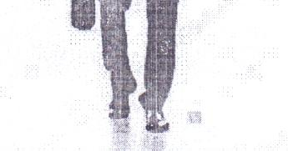Nigerians

An American

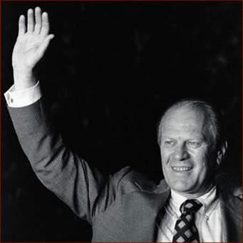
A Briton

The three countries use the hand wave in a similar way for „hello‟ and „goodbye‟

In Nigeria, the United States of America and Great Britain, either of the two hands is raised and waved to say „hello‟ and „goodbye‟.

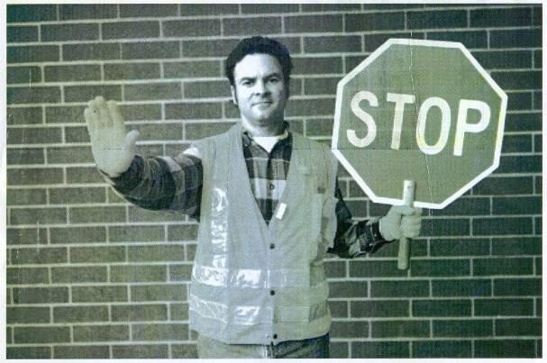
Appendix 1B The Stop Sign

A Briton
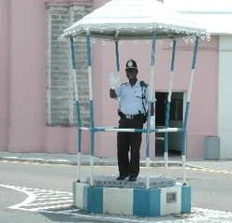
A Nigerian

An American

An upraised hand with the palm out indicates „stop‟ in the three countries.

Appendix 1C Come


An American A Briton



A Nigerian

The hand gesture that signals someone to „come here‟ – movement of a person from a far place to a closer proximity – is used the same way by the study population.

Appendix 1D

Hush – Be Quiet or Stop Talking


An American A Briton



A Nigerian

Putting the index finger in the mouth signals „be quiet‟ or „stop talking‟ in the study population. It is the „hush‟ sign.

Appendix 1E

In This or That Direction



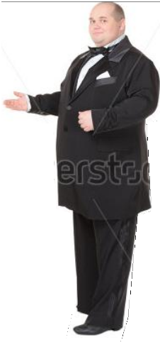
An American
A Nigerian



A Briton

A hand gesture to the left or right indicates a move in that direction.

Appendix 1F

Slit Throat Sign or You’re Dead Gesture
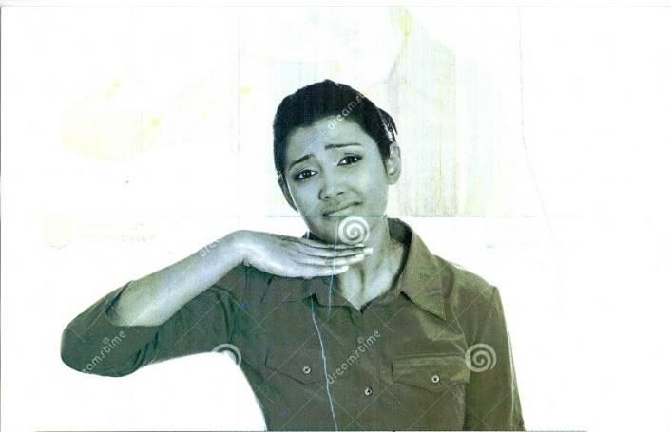
An American


A Briton A Nigerian

Using the hand or finger to slit the throat indicates you‟re dead in the three countries.

In the American Sign Language, the sign means „satisfied‟ or „filled up to the chin‟ or „fed up‟. In slang usage, the sign is made with great emphasis.
The British lady probably takes her own threat as a joke hence the laughter. The Nigerian uses the gesture as a slit throat sign.

Appendix 1G Smiles
A Nigerian An American



A Briton

Smiles and laughter are signals of positive emotions in the three countries under study.

Appendix 1H Frown


Americans



A Nigerian A Briton

A frown conveys displeasure in the study population.

People from the study population frown when they are displeased with a situation or people.

Appendix 1H Anger


A Nigerian A Briton


An American

Anger conveys displeasure in the study population. It is spontaneous and can sometimes turn to rage. From the data, the Nigerian woman is in a rage, just like the Briton and the American. They depict deep anger.

Appendix 1H Crying

A Nigerian An American



A Briton

Crying conveys displeasure in the study population. It depicts deep pain or hurt in the study population.

Appendix 1H

Shaking a Fist at Someone
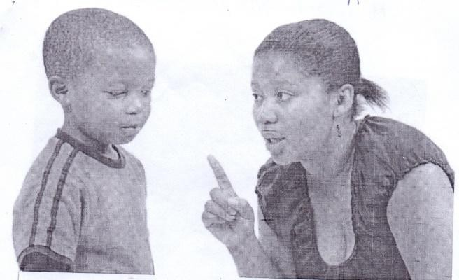


Nigerians

Americans
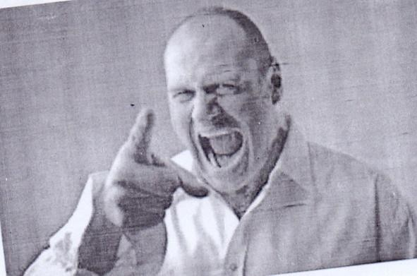
A Briton

Shaking a fist at someone conveys displeasure in the study population. The Nigerian woman shakes a fist at her son for misbehaving and warns him not to so again. The American woman conveys her displeasure with her son. She warns him not to misbehave anymore, even though he looks nonchalant. The Briton is in a rage while conveying his displeasure. He shows his deep anger and shakes his fist at someone as a warning.
In the American Sign Language, the signer shakes the index finger at someone in a natural motion of scolding.

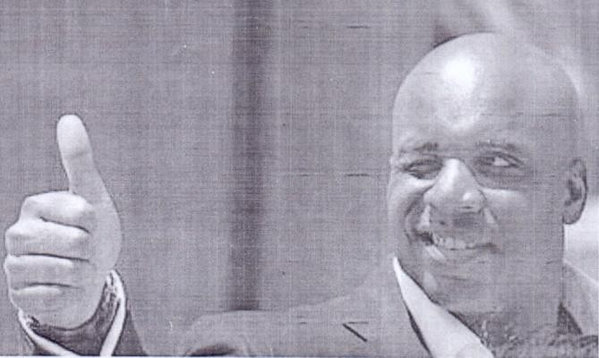

Appendix 1I Thumbs Up
A Nigerian A Briton

An American

This gesture varies in the study population. It means „good job‟ in the United States of America and „things are okay‟ in Great Britain. On the contrary, in Nigeria, it is considered a very rude signal.
But my opinion is that the thumbs up signal is a universal signal. It means the same thing either in the United States of America or Great Britain. Nigerians use it to say „ride on‟ or, just like the Americans, „good job‟. In the American Sign Language, it represents the number „10‟.

Appendix 1J OK Sign
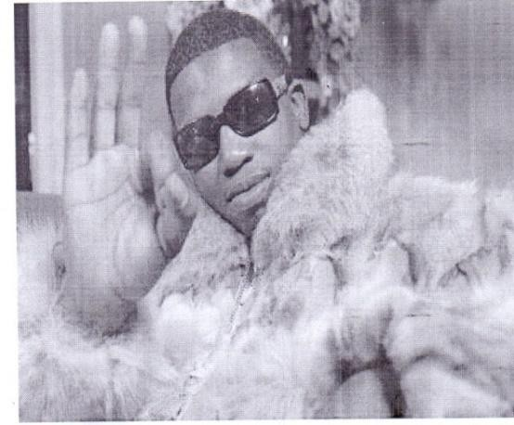
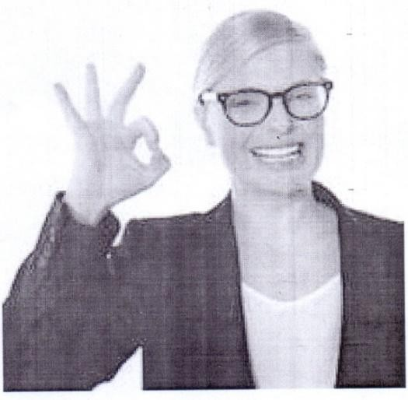
A Nigerian

An American

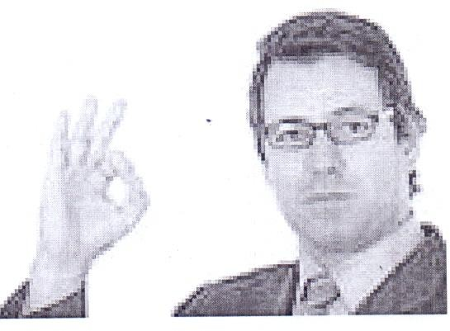
A Briton

This gesture is a cheery affirmation to most Americans and the British. In Nigeria, however, it is culture based and takes any interpretation it is given.
In the American Sign Language, this sign stands for the letter „F‟ or the number „9‟.

Appendix 1K

The Victory Sign

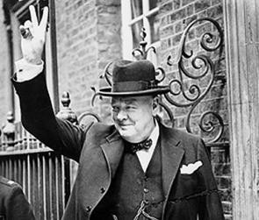
An American A Briton

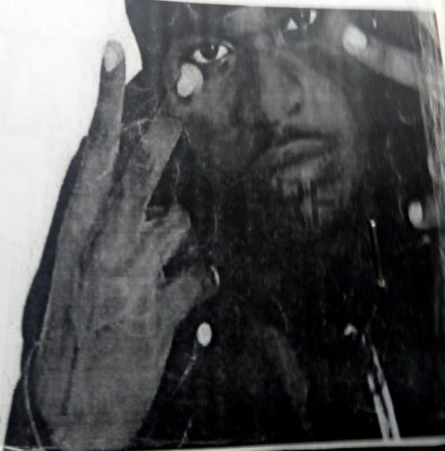
A Nigerian

The „V‟ sign represents victory, peace or triumph in the United States of America, Great Britain and Nigeria.

Appendix 1L

Handshake
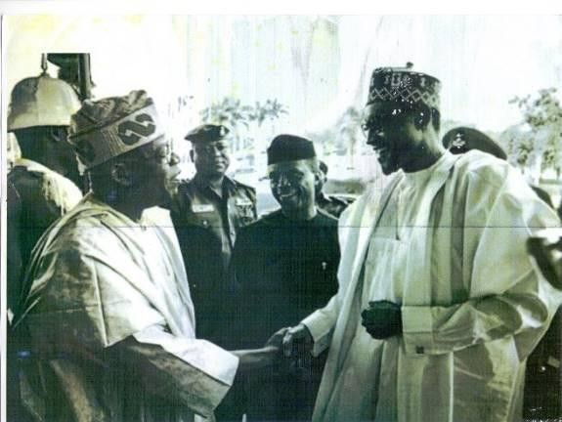
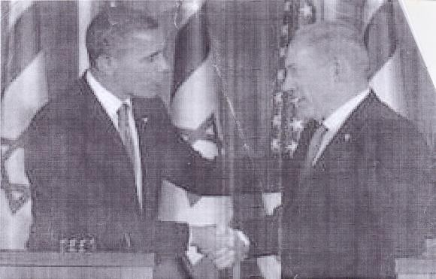
Nigerians Americans


Britons
The handshake is a common form of greeting in the three chosen countries but with some cultural colourings. In America and Britain, the handshake is usually brief but with a firm grip. In Nigeria, the handshake which is the most commonly used emblem comes with a warm welcoming smile. In some parts of Nigeria, if it is a woman that is to be greeted, the woman bends and the man pats her on the back.

Appendix 1M Pointing
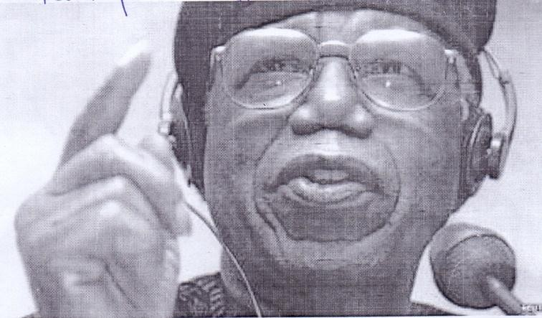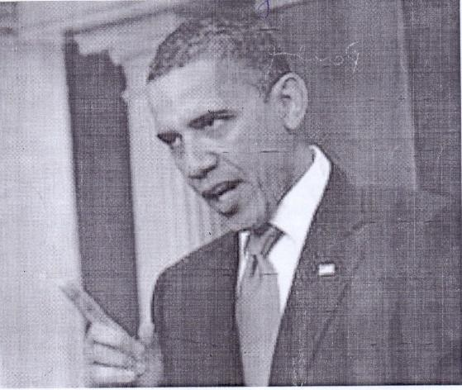
A Nigerian An American


A Briton

They accompany verbal messages and give them additional meaning but cannot stand alone and make sense. They are used similarly in the chosen population.

Appendix 1M Spreading both Arms
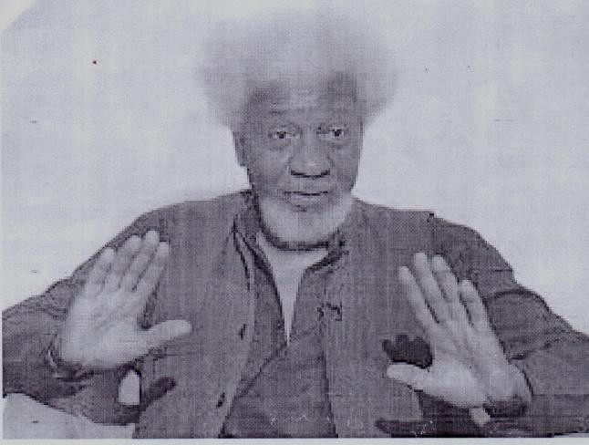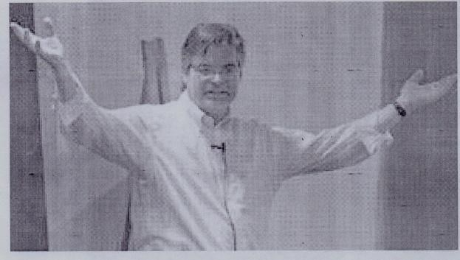
A Nigerian An American
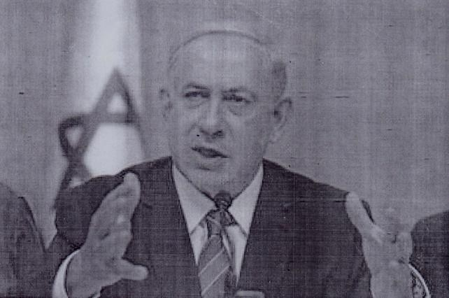

A Briton

Spreading both arms accompany verbal messages and give them additional meaning but cannot stand alone and make sense. In Nigeria, spreading both arms is used to show the size of a thing or to complement or emphasize a point. It provides additional meaning to the verbal message.
Moving one‟s hands apart or spreading both arms like the Americans, can illustrate the length or width of the object one is talking about or describing. Americans illustrate with gestures or body movements when they illustrate the shape or size of a thing, or emphasize a point.
The Briton uses the illustrator – spreading both arms to capture attention and boost his credibility. The gesture accompanies speech and used literally to illustrate verbal messages.

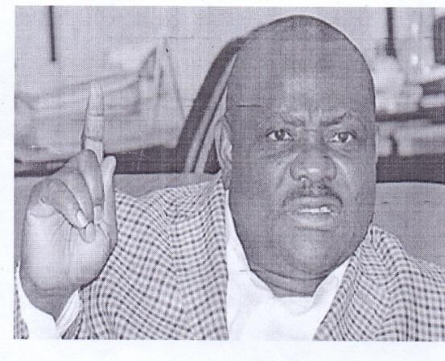
Appendix 1N Raise of Finger

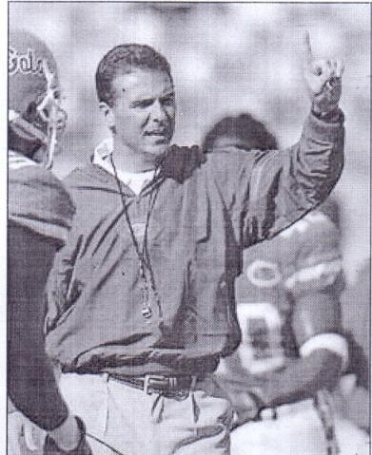
A Nigerian

An American



A Briton

Raise of a finger or eye contact (regulators) is used to regulate or control the flow of a conversation. They help communicators to interact effectively in interpersonal interactions.

Appendix 1N Eye Contact

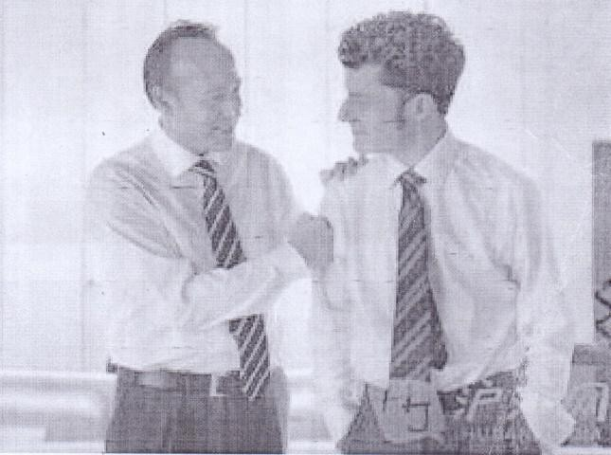
Britons Americans

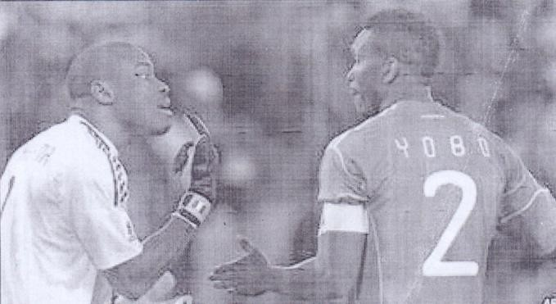
Nigerians

Eye contact or raise of a finger (regulators) is used to regulate or control the flow of a conversation. They help communicators to interact effectively in interpersonal interactions.

Appendix 2A Handholding
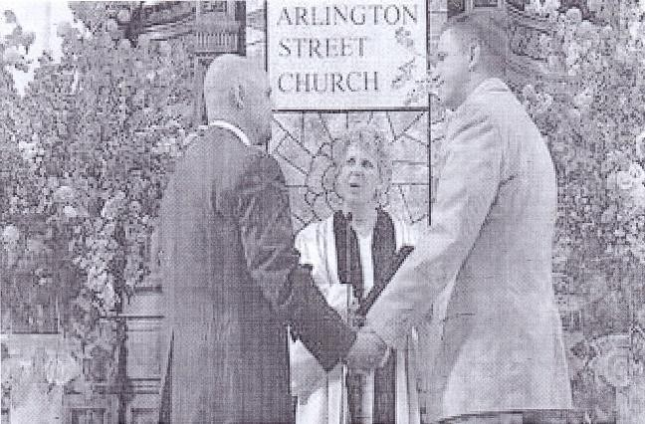
Americans

Man to man handholding has a homosexual connotation in the United States of America

Appendix 2B

Holding Hands with One’s Partner

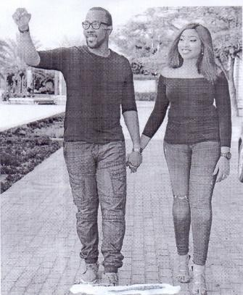
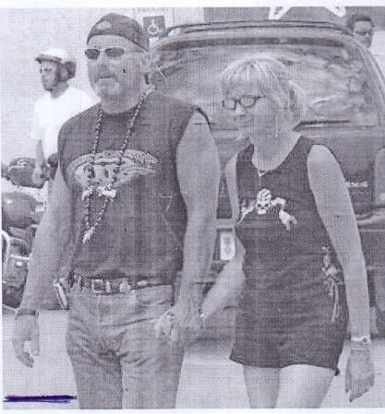
Nigerians Britons

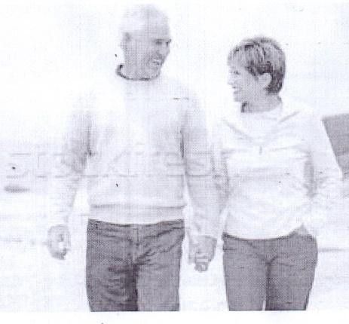
Americans

For most US and British citizens, holding hands with one‟s partner in public is nothing more than a simple display of affection. In Nigeria, men and women holding hands is gaining acceptance but traditionally was offensive.

Appendix 2C Handshake

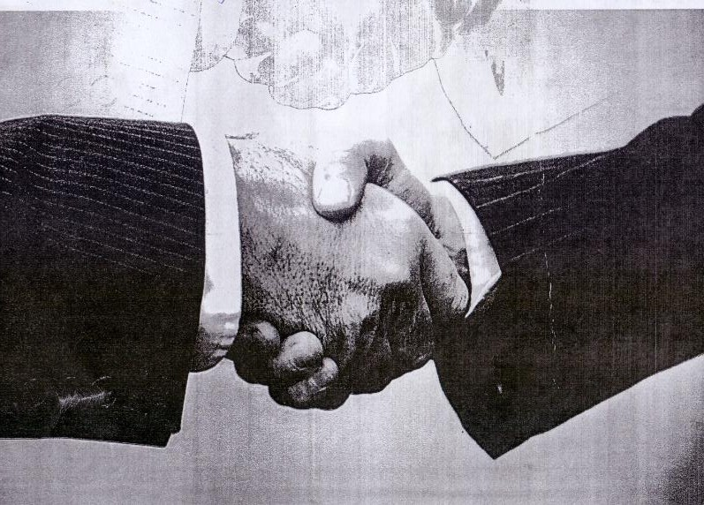

The Firm Handshake

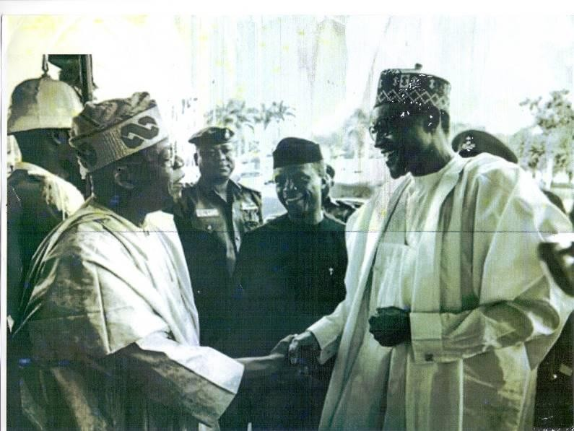

Handshake in Nigeria

The firm handshake is appropriate in the US culture. In Nigeria, the most common greeting is a handshake but with a smile.

Appendix 2D Handshake with a Woman in Nigeria

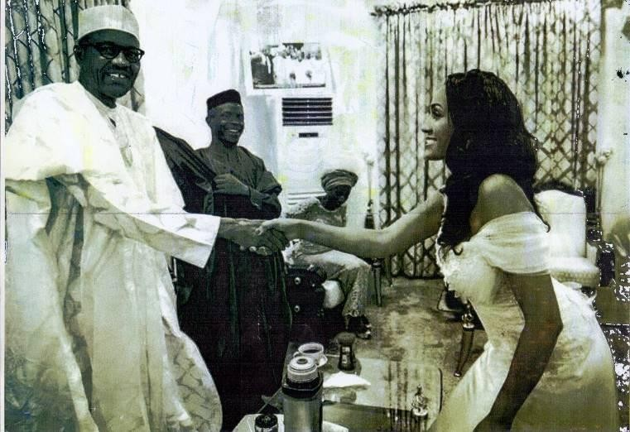

A Nigerian male, as a rule, waits for the woman to extend her hand for a handshake.

But in Igboland, the woman bends and gets a pat on the back by the man. This is cultural.

Appendix 2E The ‘OK’ Sign

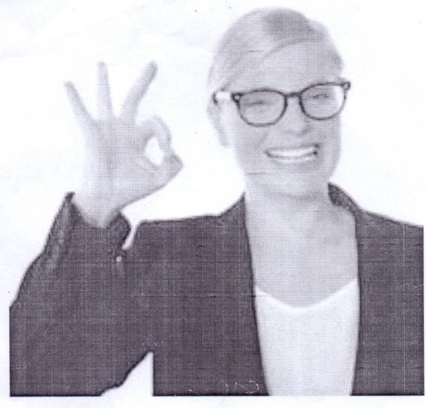

A Nigerian An American

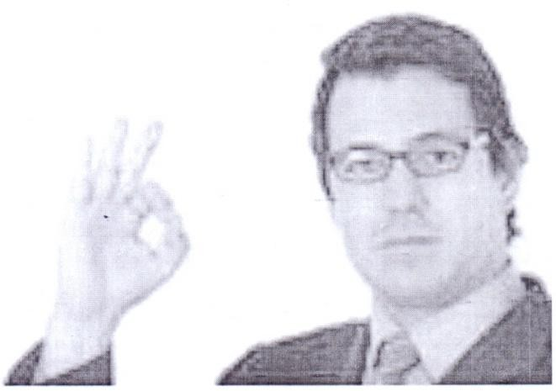

A Briton

The OK sign is a cheery affirmation to most Americans and Britons. However, in Nigeria, the OK sign has a cultural undertone and takes any interpretation from the cultures.
In the American Sign Language, the Ok sign represents the alphabet „F‟ or the number „9‟.

Appendix 2F The ‘V’ Sign



An American


A Briton

The „V‟ sign is viewed as the victory, triumph or peace sign in the United States of America and Great Britain. In the American Sign Language, the „V‟ sign represents the alphabet „V‟.

Appendix 2G Thumbs Up

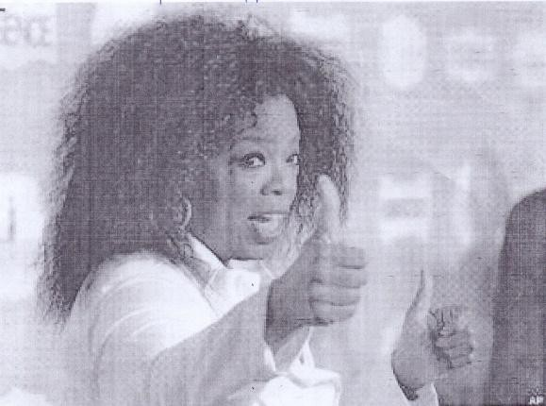

An American A Briton


An American Hitch-Hiker

The „thumbs-up‟ gesture is used to indicate that „things are okay‟ in Great Britain and the United States of America, it means „Good job‟. In the United States of America and Great Britain, the „thumbs up‟ is commonly used by hitch-hikers who thumb a lift.

Appendix 2H The Cheek Kiss
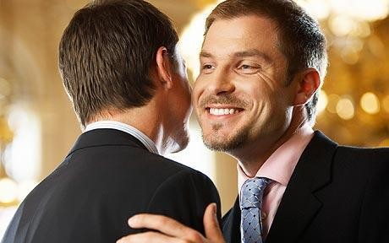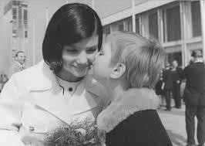

Britons Britons



Britons

For the check kiss, the British either avoid kissing by standing back or give a European double kiss. To the British, hugging and kissing are usually reserved for family members and very close friends.

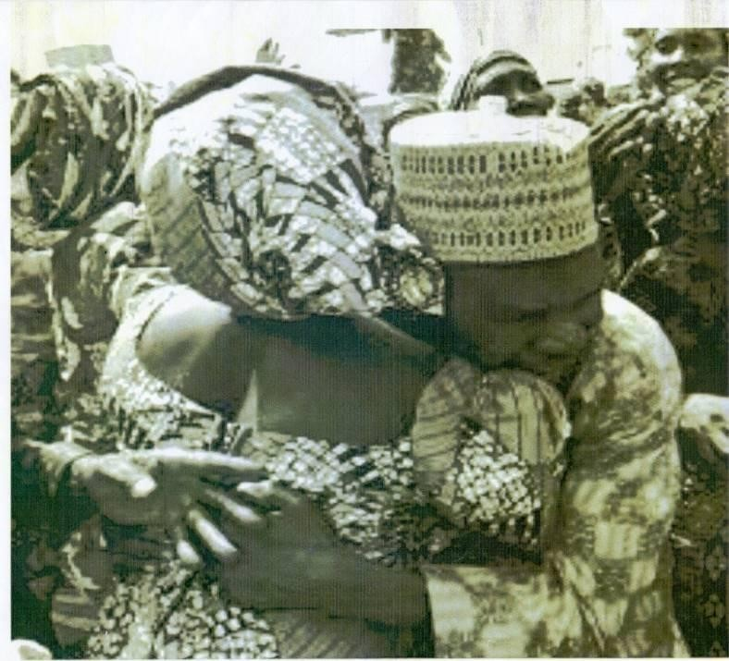
Appendix 2I Hug

Nigerians
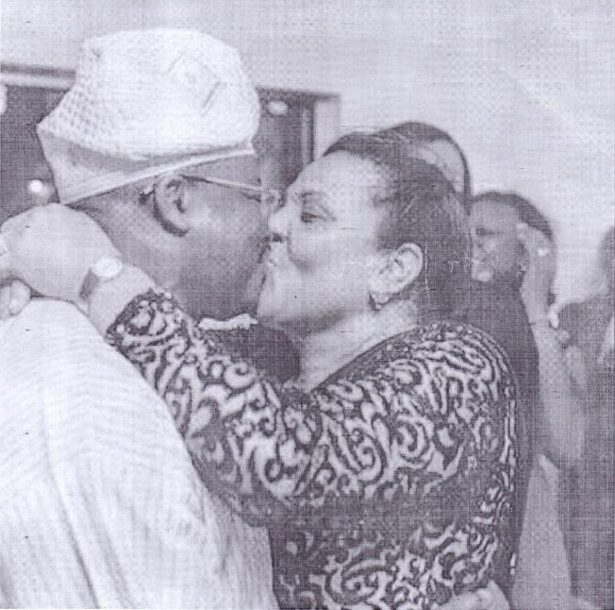

Nigerians

Similarly, Nigerians exchange hugs and kisses with people they know well.

Appendix 2J Cheek Kiss


Americans

The Americans give a single kiss on the check.


Appendix 2K Greeting in Nigeria

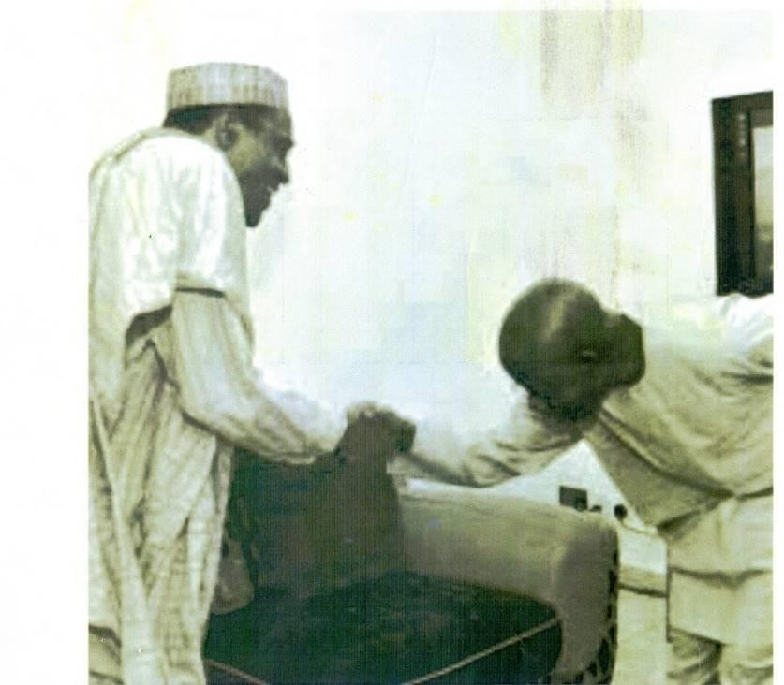

In Nigeria, when greeting someone who is older, it is a sign of respect to prostrate or bow.

Appendix 2L

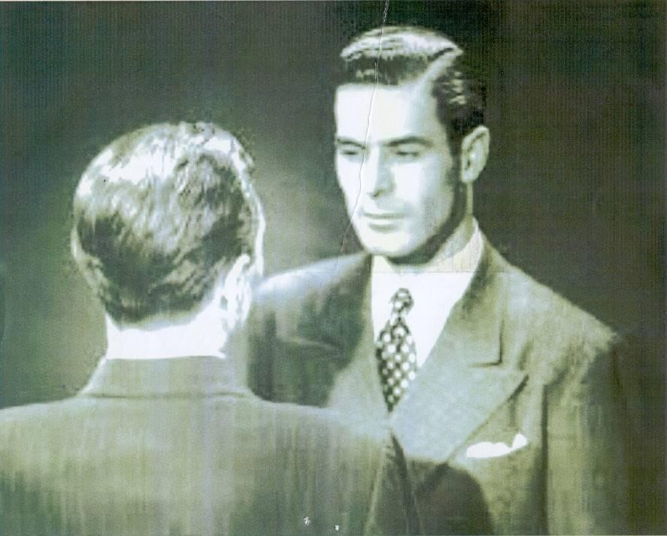
Looking into a Person’s Eyes
Americans


Britons

In Great Britain and the United States of America, to look directly into a person‟s eyes is appropriate when greeting or talking.

Appendix 2M Direct Eye Contact

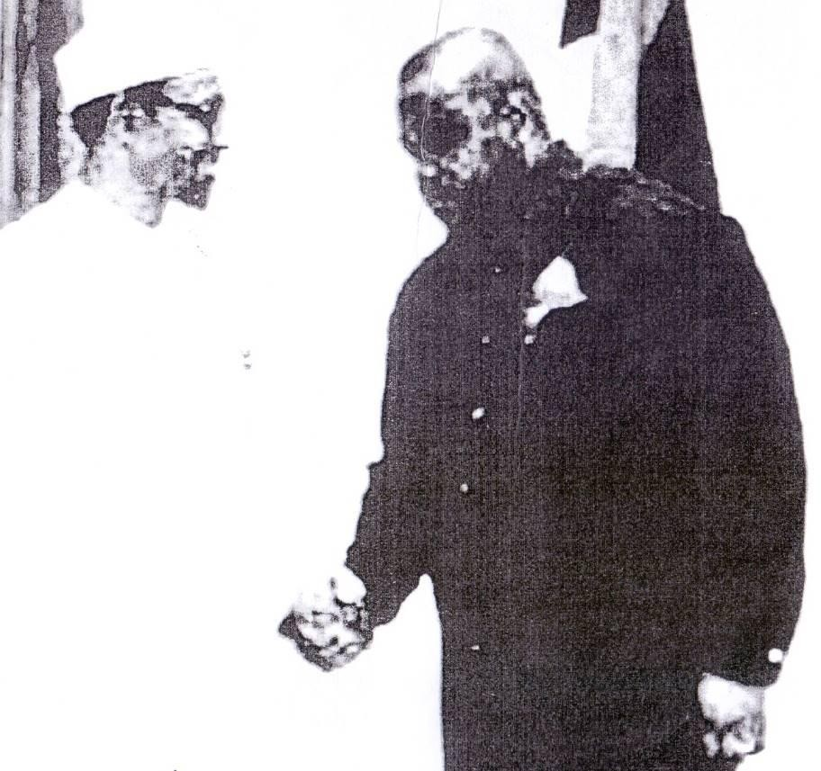

In Nigeria, however, constant and direct eye contact can be seen as being intrusive. Nigerians do not look directly into elders‟ eyes. They tend not to look directly at their superior‟s eye-to-eye, which is seen as confrontational, thus gazing at the shoulder level or the forehead is considered polite.

Appendix 3A Pointing

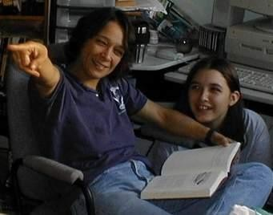
A Briton

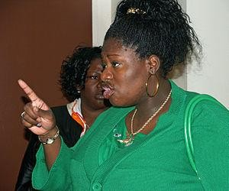
A Nigerian


An American

Pointing has ubiquitous meaning across cultures. One can point to an object of discussion and add additional meaning to the verbal message.

Appendix 3B Smile




An American A Briton


A Nigerian

A smile connotes happiness or joy everywhere and signals friendly intentions while a frown connotes sadness.

Appendix 3B Frown
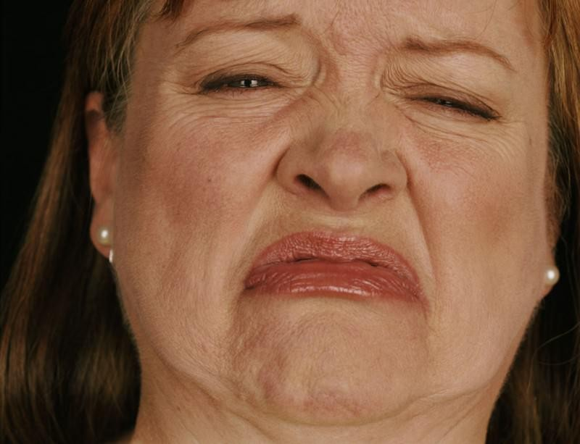
A Nigerian A Briton



An American A frown connotes sadness in the study population.

Appendix 3C Crying

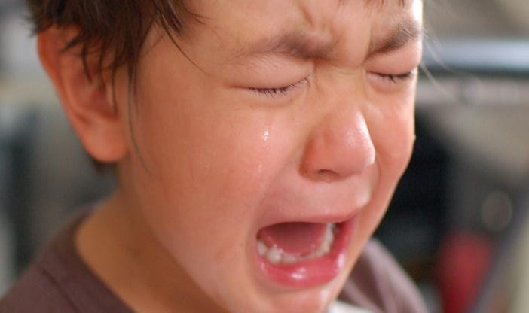
A Nigerian A Briton

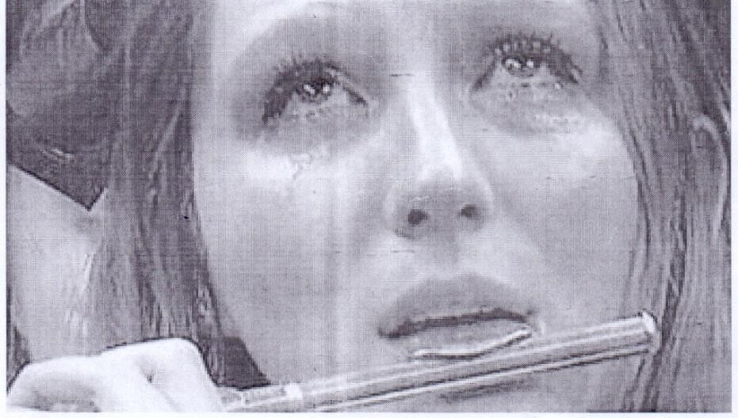

An American

Crying is a universal sign of unhappiness or pain.


Appendix 3D Raise of Finger



A Nigerian

An American

A Briton

The raise of one‟s finger may indicate that one wants to speak, ask a question or signal to a speaker that he has one minute remaining.


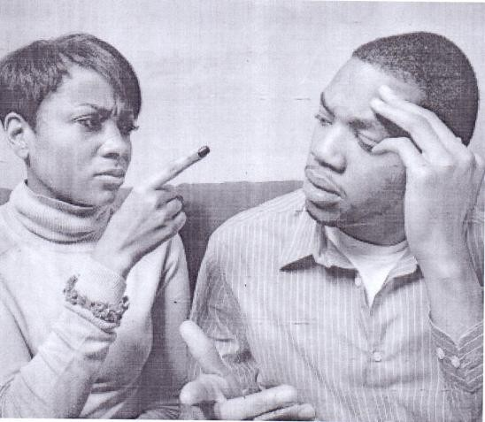
Appendix 3E Wagging a Finger at Someone
A Nigerian Americans



A Briton

When people talk, they may raise the forefinger or wag it at the other person but none of the gestures has a meaning. They simply enhance the verbal message. Wagging a finger at someone expresses anger.

Appendix 3F Happiness

A Nigerian


A Briton
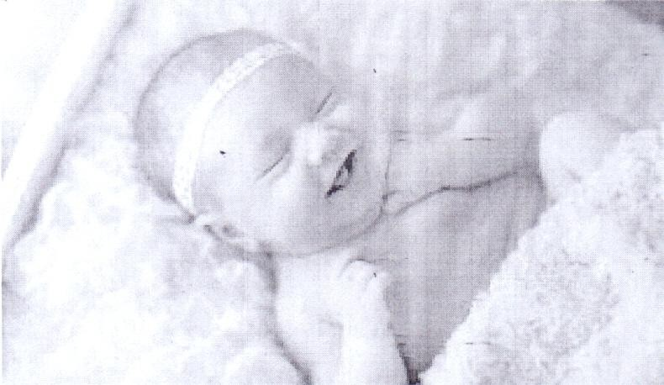

An American

Despite cultural differences, the expression of happiness, fear, anger, surprise, sadness and disgust are communicated or conveyed with the same facial expressions in much the same ways across cultures. The expressions are part of the biological heritage of human beings communicated spontaneously. They are universally recognized.

Appendix 3F Fear


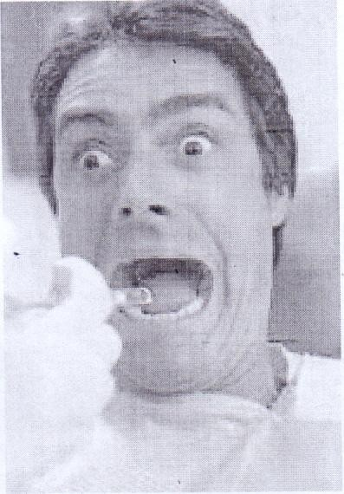
A Briton


An American

A Nigerian

Despite cultural differences, the expression of fear is communicated or conveyed with the same facial expression in much the same way in the study population. The expression is part of the biological heritage of human beings that is communicated spontaneously. It is universally recognized.


Appendix 3F Anger


A Nigerian A Briton



An American

The expression of anger is conveyed with the same facial expression in the study despite cultural differences. The expression is part of the biological heritage of human beings that is communicated spontaneously. It is universally recognized.

Appendix 3F Surprise

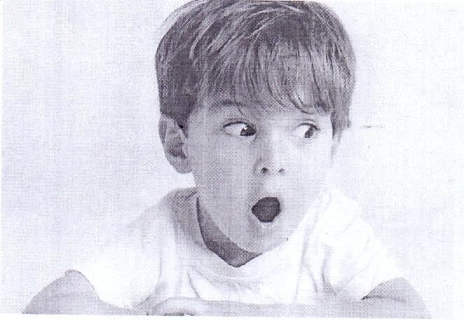
An American

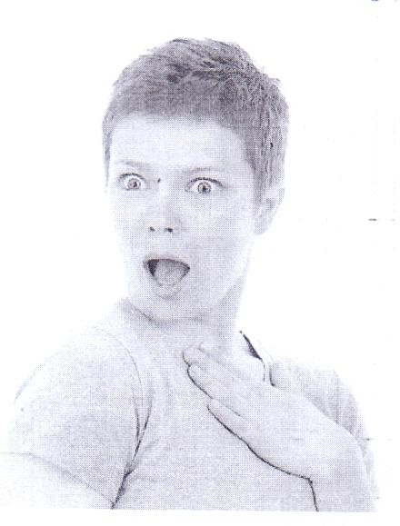
A Briton


A Nigerian

Despite cultural differences, the expression of surprise is communicated with the same facial expression in the study population. The expression is part of the biological heritage of human beings that is communicated spontaneously. It is universally recognized.

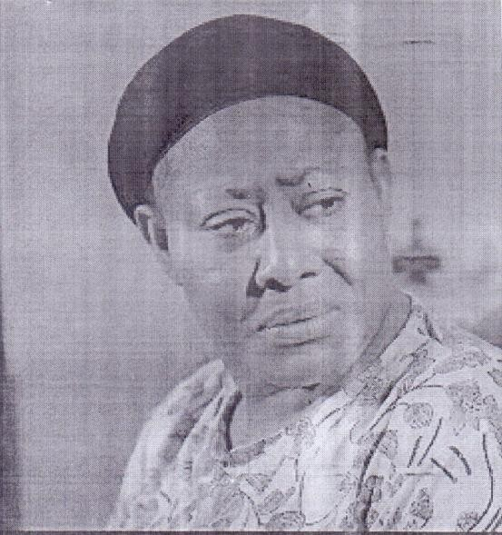
Appendix 3F Sadness


A Nigerian

A Briton


An American

Sadness is conveyed with the same facial expression in the study population despite cultural differences. The expression is part of the biological heritage of human beings that is communicated spontaneously. It is universally recognized.

Appendix 3F Disgust

An American


A Briton
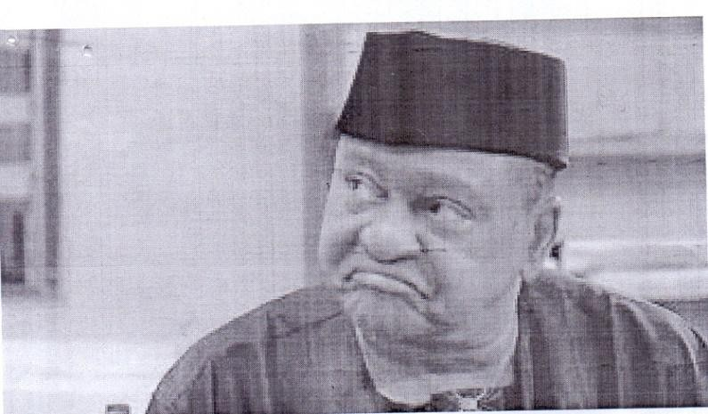
A Nigerian

Despite cultural differences, the expression of disgust is communicated or conveyed with the same facial expression in the study population. The expression is part of the biological heritage of human beings that is communicated spontaneously. It is universally recognized.

Appendix 3G Folding Arms
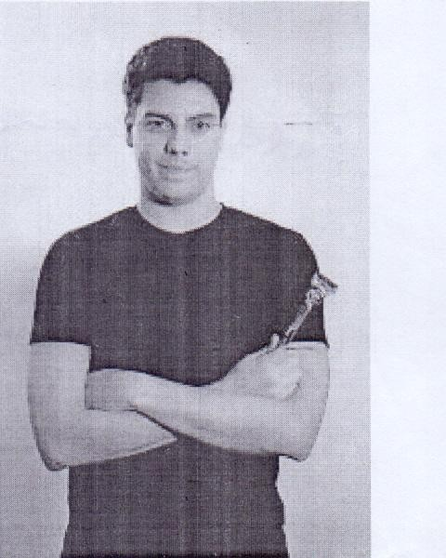

An American A Briton


A Nigerian

People fold their arms to indicate lack of interest in a person or topic of discussion. It could also be interpreted that the person is less approachable.

Appendix 3H Raise of Eye Brows
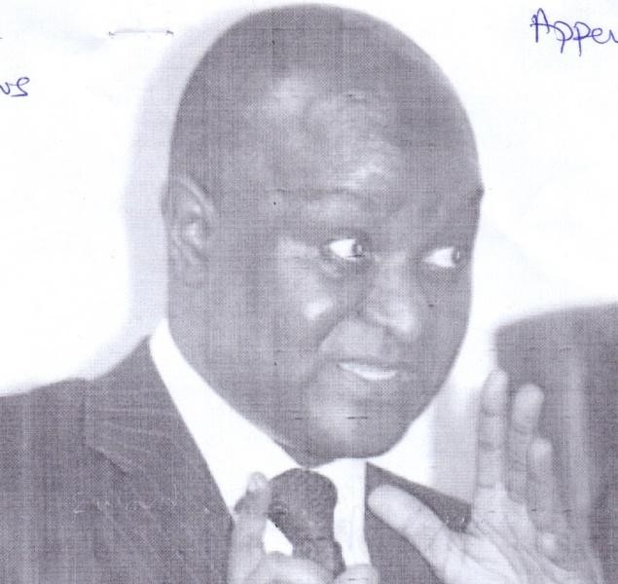
An American A Nigerian



A Briton

The raise of eyebrows or finger is used to control or regulate the flow of a conversation.

Appendix 3I

Hand Clapped against the Mouth

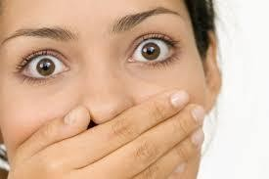


A Briton

A Nigerian
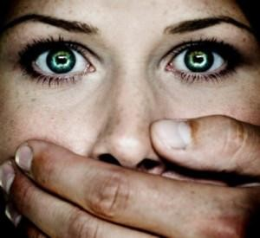
An American

Clapping the hand against the mouth with a sharp intake of breath expresses a kind of panic at having forgotten something. It may also express shock.

Appendix 3J Excitement


An American A Briton


A Nigerian

When one becomes excited or interested in a person or something, the pupils of one‟s eyes increase in size.

Appendix 4A Smoking


A Nigerian A Briton
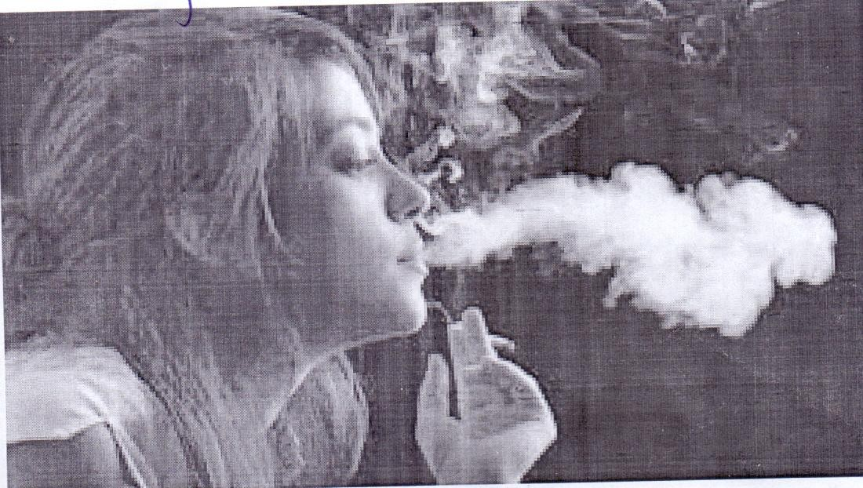

An American

Signals such as smoking and picking the nose are often habitual and automatic nonverbal behaviours that reveal anxiety and emotional tension and help people to adjust to their environments, especially when they are nervous or uncomfortable.


Appendix 4A Picking Nose
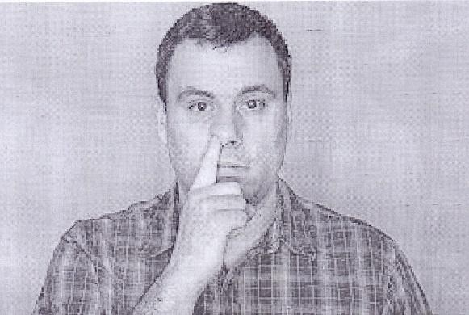

A Briton A Nigerian

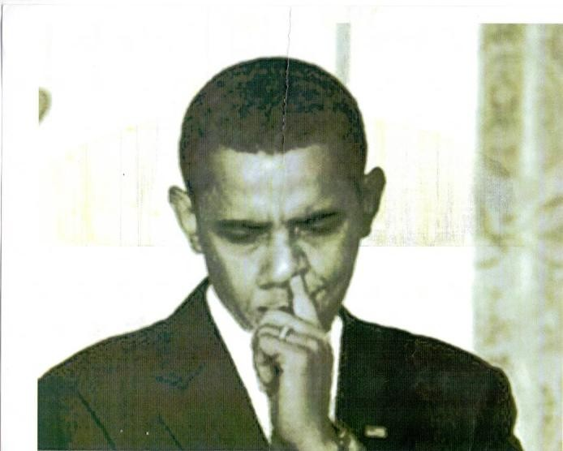

An American

Picking the nose is habitual and automatic. It reveals anxiety and emotional tension. It helps people to adjust to their environment, especially when they are nervous and uncomfortable.

Appendix 4B Fear
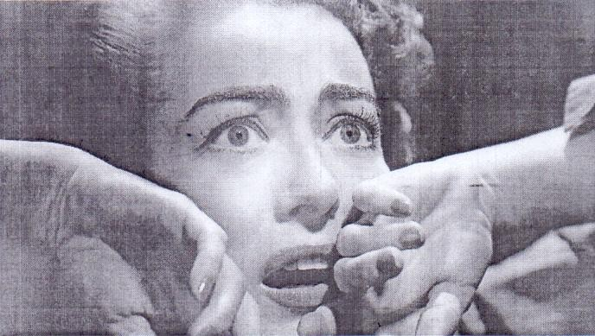

An American

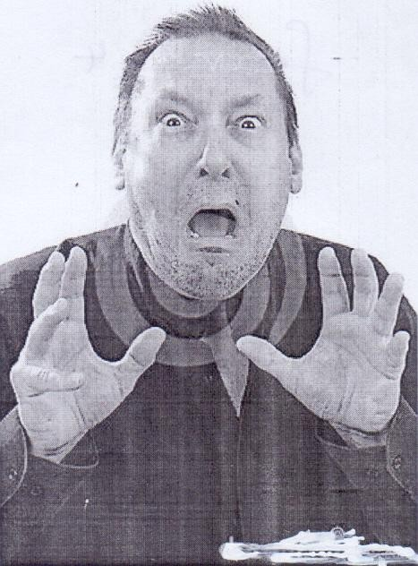
A Briton

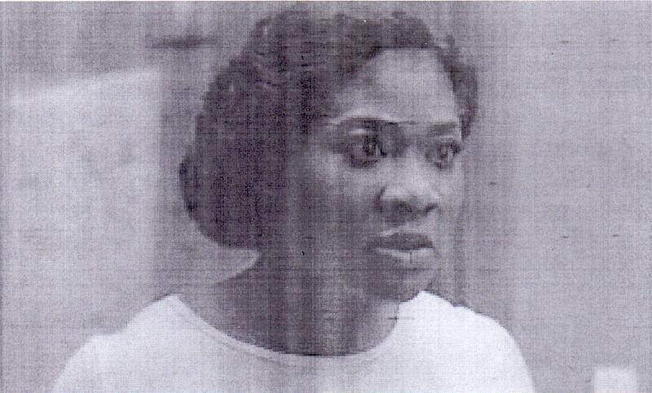
A Nigerian

When one experiences fear, one‟s body tenses up and builds energy. The body is prepared for emergency reaction but without a specific purpose, this energy creates impatience and is wasted on meaningless activities.


Appendix 4C Biting the Finger Nails
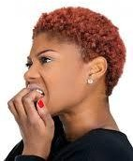
A Nigerian

An American


A Briton

Biting finger nails reveals emotional tension. People identify emotional tension and nervousness from such behaviors. They reveal uncertainty

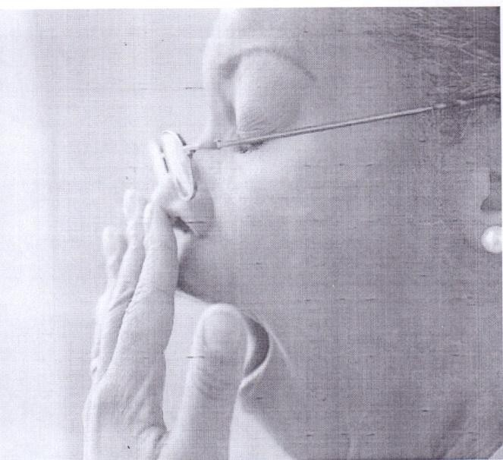
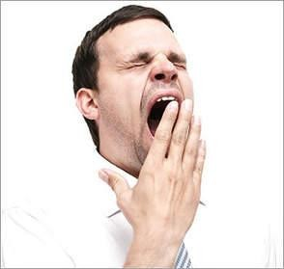
Appendix 4D Yawning
A Nigerian A Briton

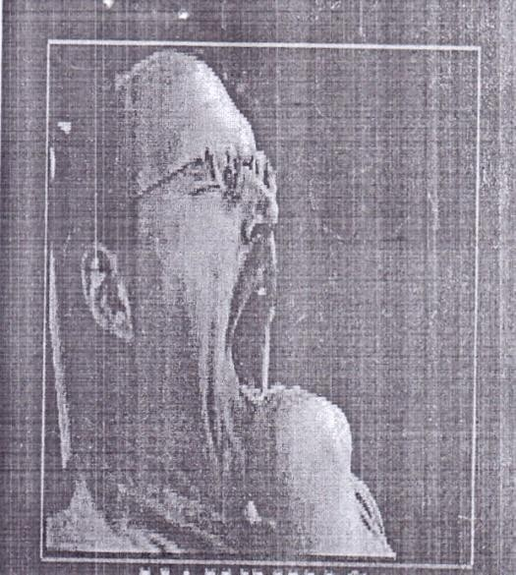

An American

Yawning can indicate boredom, tiredness or discomfort. This makes yawning ambiguous because one can consider more than one possible interpretation for it.


Appendix 4E Silence
Americans

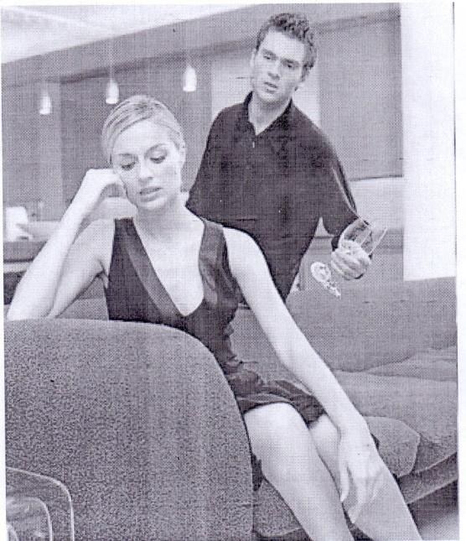
Britons

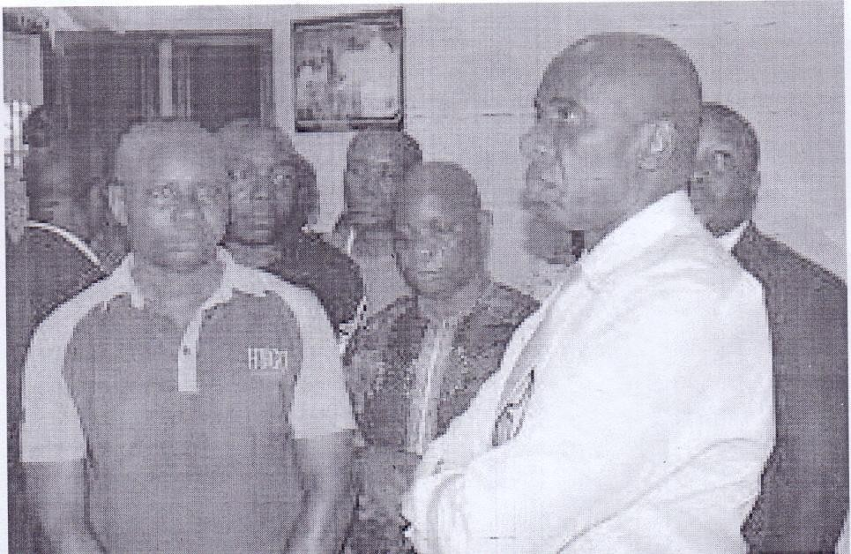
Nigerians

Silence is similarly ambiguous because it has multiple interpretations. It can mean consent; it can signal rudeness or unequal power relations which the communicators are aware of; it can be because of uncertainty or not to criticise; it can be because of intimacy.

Appendix 4F

Posture and Facial Expression
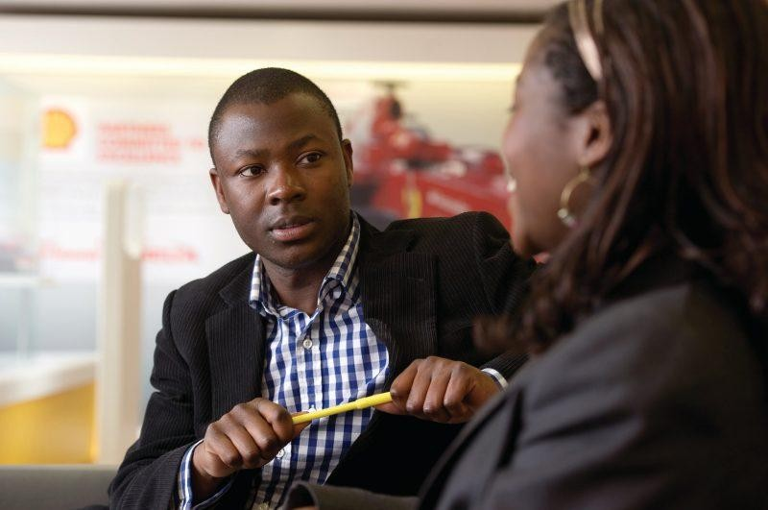

Nigerians Americans

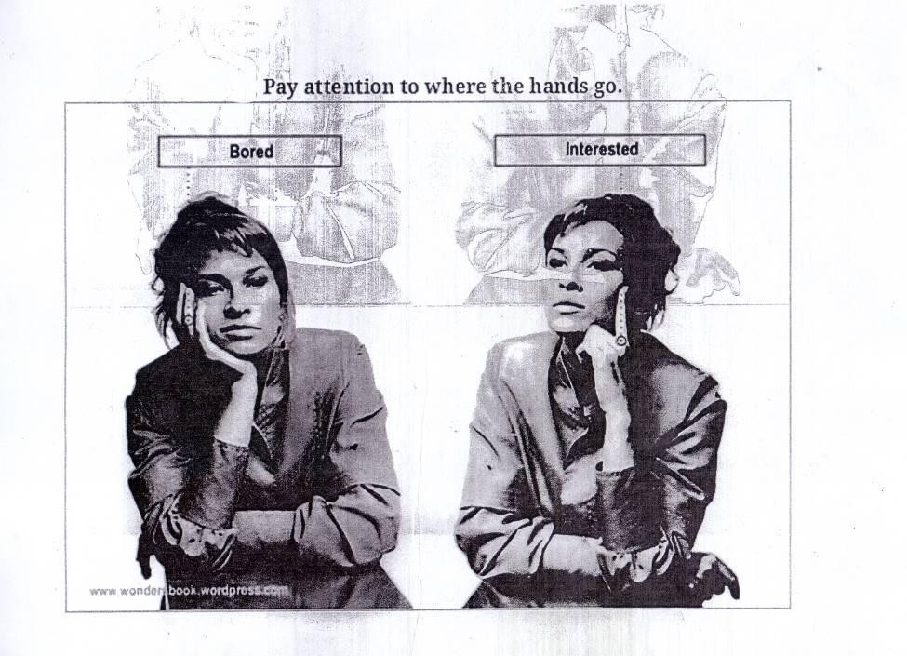
Britons

One‟s posture says a lot about how uneasy one is. When one is bored or interested in a conversation, it registers in one‟s posture and facial expressions. In interpreting posture, the key is to look for small changes that might be shadows of suppressed feelings or thoughts of people. People take actions they are almost entirely not aware of.

Appendix 4G Scratching the Head
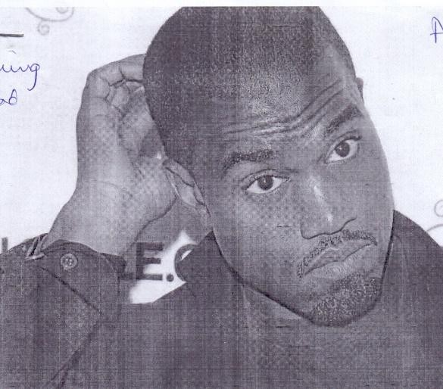
A Nigerian

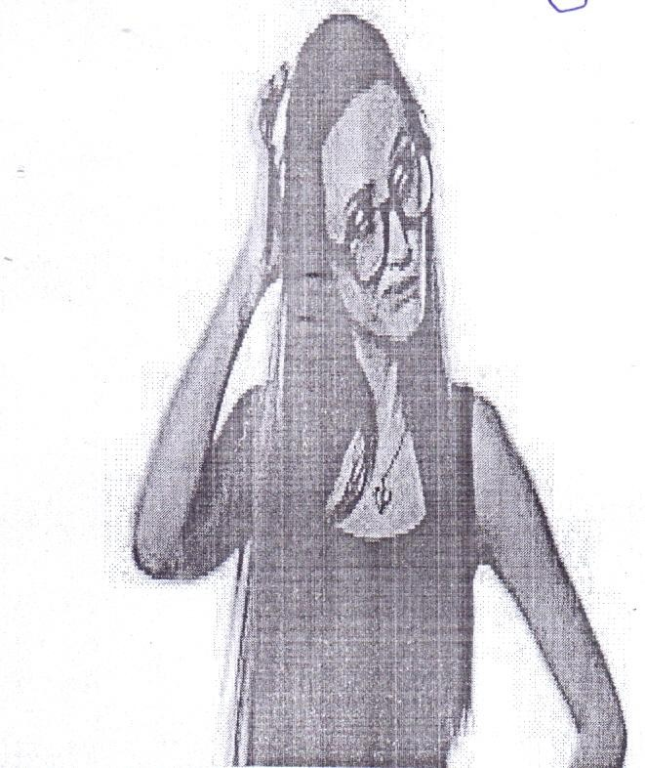
A Briton
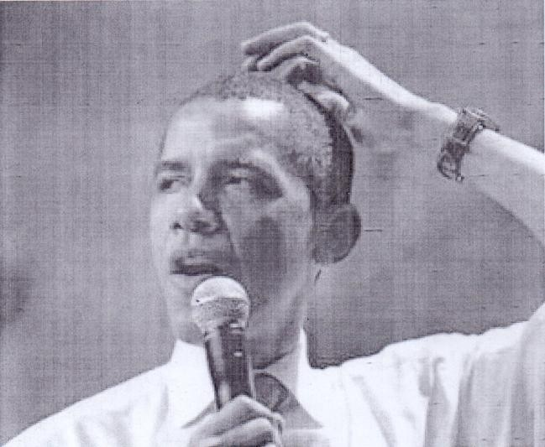
An American

Scratching the head may be a simple reaction to physical uneasiness that may have nothing to do with feelings or attitude.

Appendix 4H

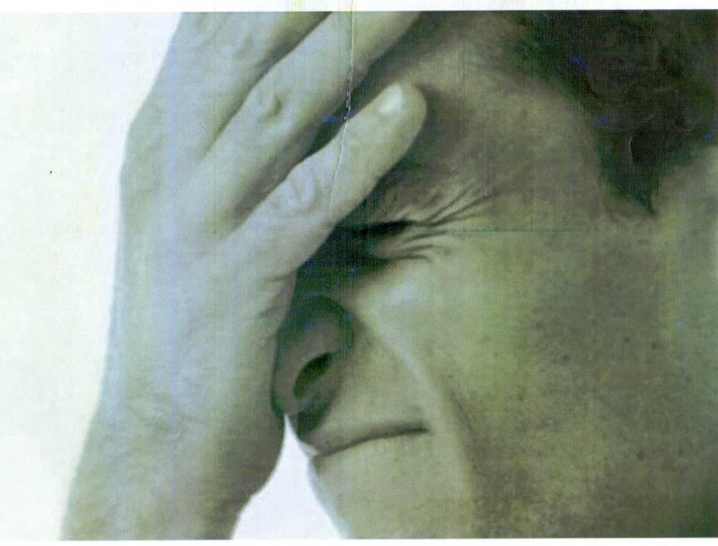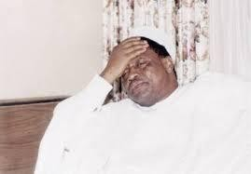Clapping the Hand to the Forehead

A Nigerian A Briton



An American

Clapping of the hand to the forehead may be a self-punishing act for having forgotten something or it may signal deep pain.

Appendix 4I Closed Eyes




An American

A Nigerian

A Briton

Closing the eyes may be a reaction to fear or embarrassment or to shut out the world.

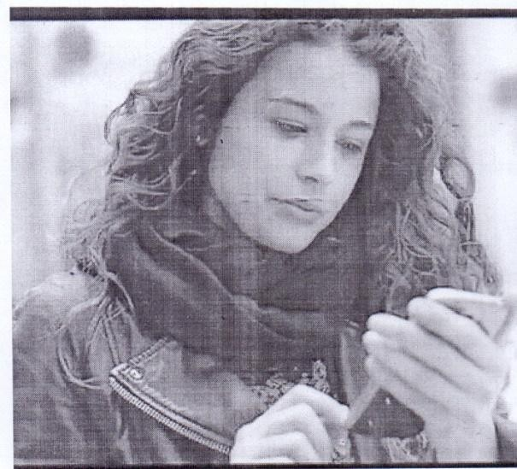
Appendix 4J Fiddling with Smart Phones
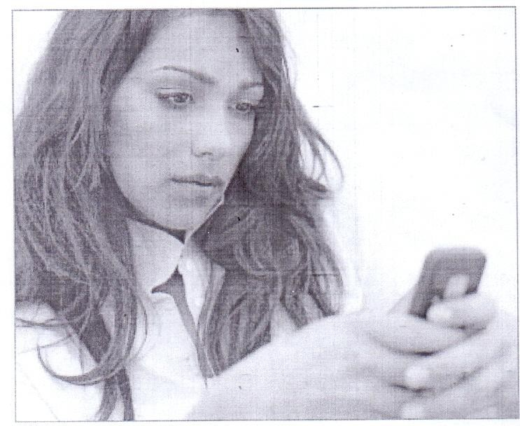
A Briton An American

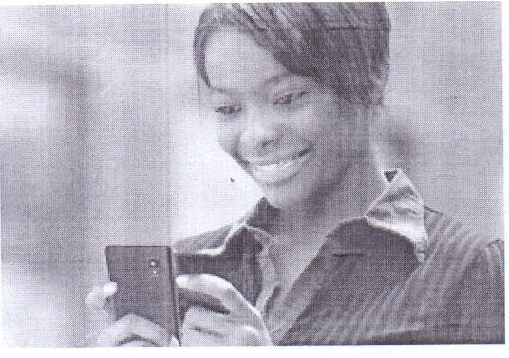
A Nigerian

People fiddle with their phones to help ease anxiety.

Appendix 5A Smile

A Briton


An American


A Nigerian

A smile depicts joy, happiness, interest. A smiling face displays a happy mood.

Appendix 5B Anger

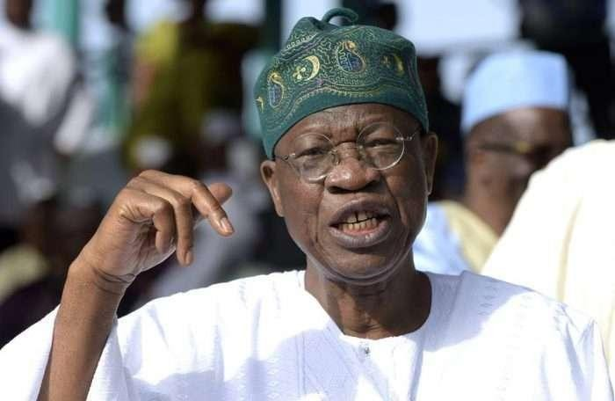


A Nigerian A Briton



An American

An angry face however portrays anger or rage. People use facial expressions to display their emotions.

Appendix 5C Fear

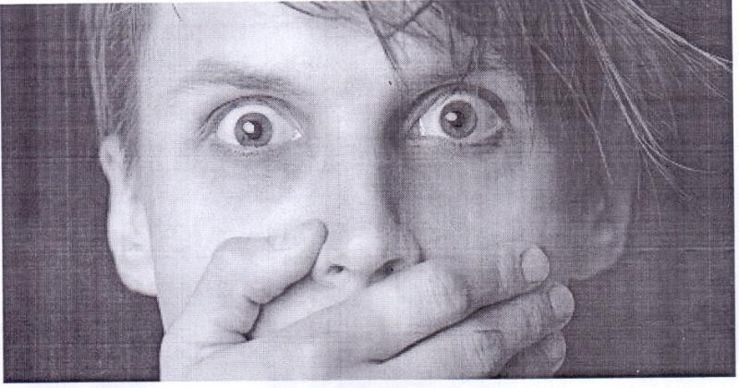
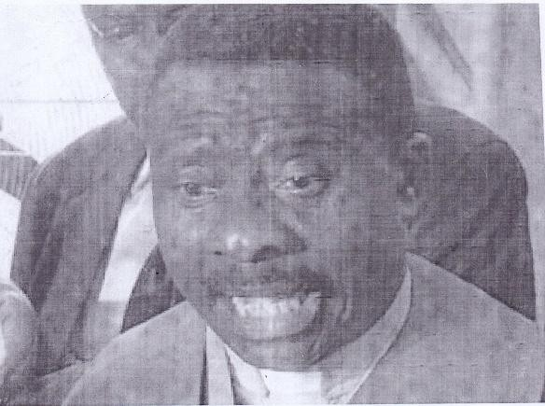
A Briton A Nigerian



An American

The emotion of fear registers in facial expressions.

Appendix 5D Deep Hug and Kiss


Nigerians Americans
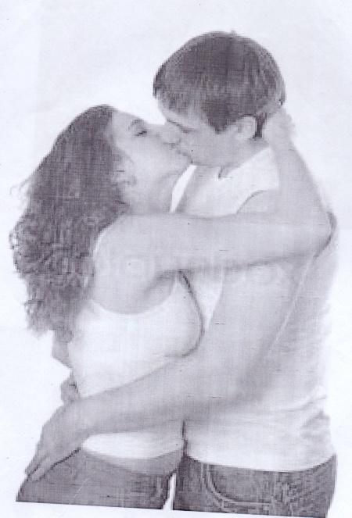
Britons

A deep hug and kiss in total embrace convey love or lust.

Appendix 5E

Deep Eye to Eye Contact
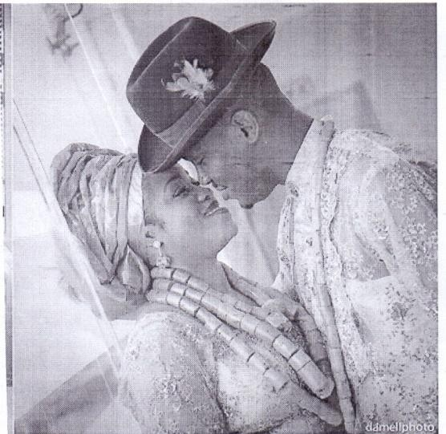
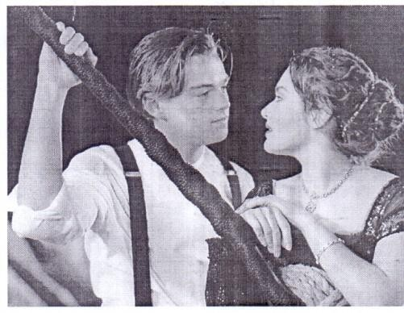
Nigerians Britons


Americans

A deep eye to eye contact between a male and female conveys the emotion of love between the couple.



Appendix 5F Crying
A Nigerian A Briton


An American

Crying depicts a deep emotion of pain or sorrow, which could be as a result of the loss of a loved one or thing or because of any other misfortune.


Appendix 5G Squeezing the Hands
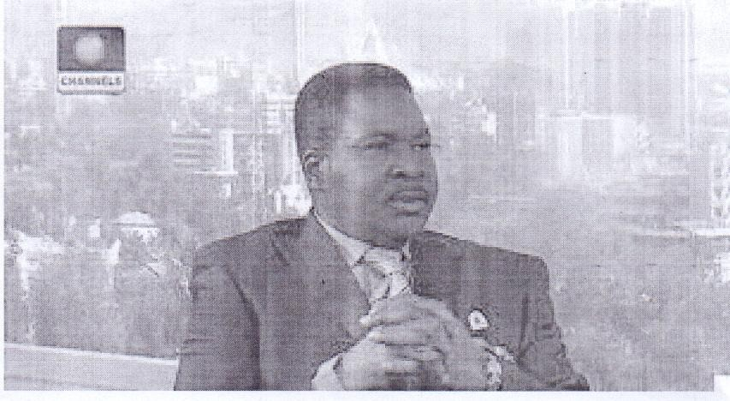
A Nigerian A Briton

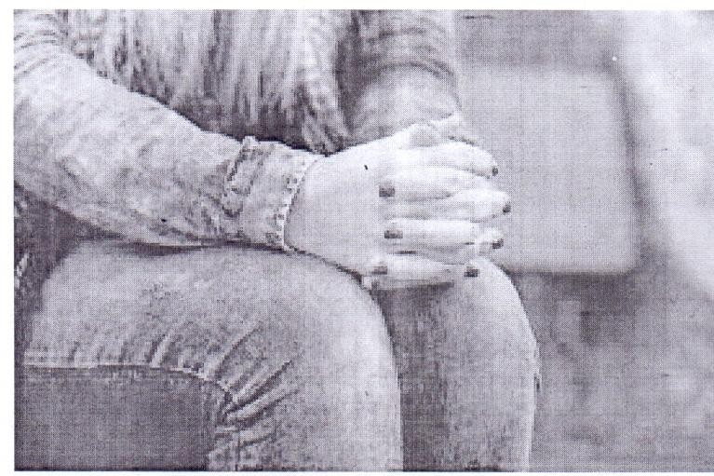
An American

People squeeze their hands when they are anxious, nervous or uncomfortable.

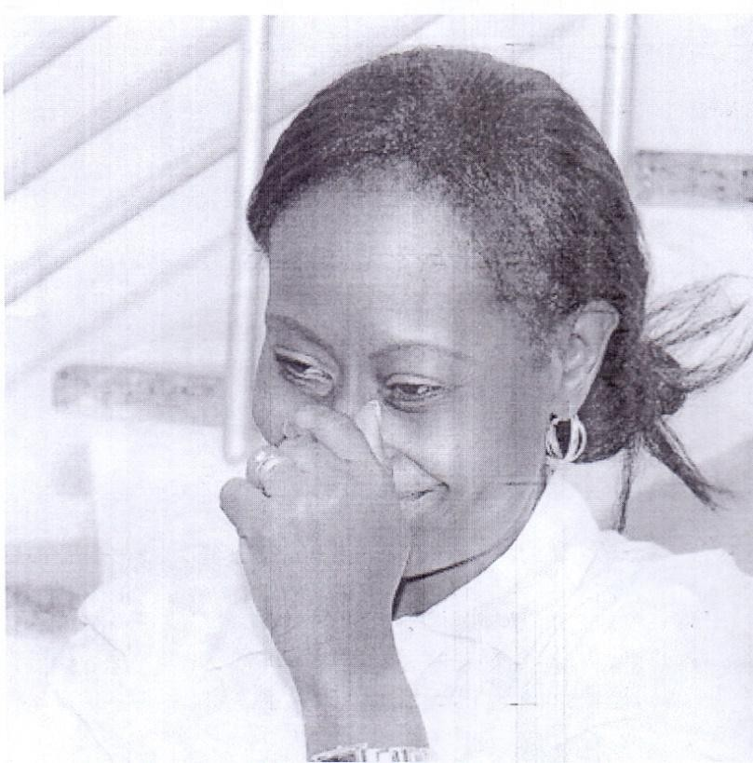
Appendix 5H Rubbing the Nose
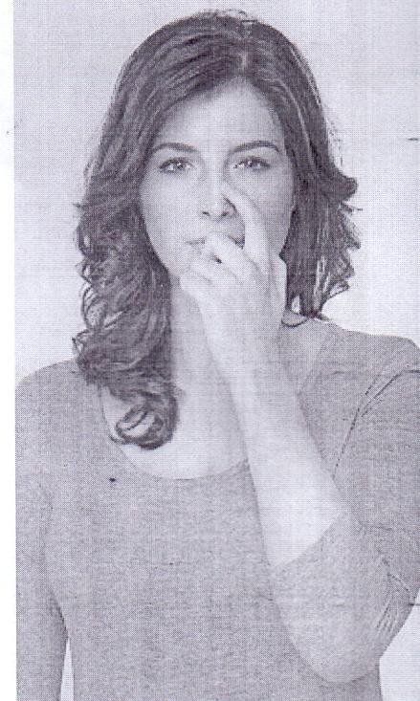
A Nigerian A British

An American

A person rubs his or her nose when anxious, nervous or uncomfortable.

Appendix 5I Twist Strand of Hair
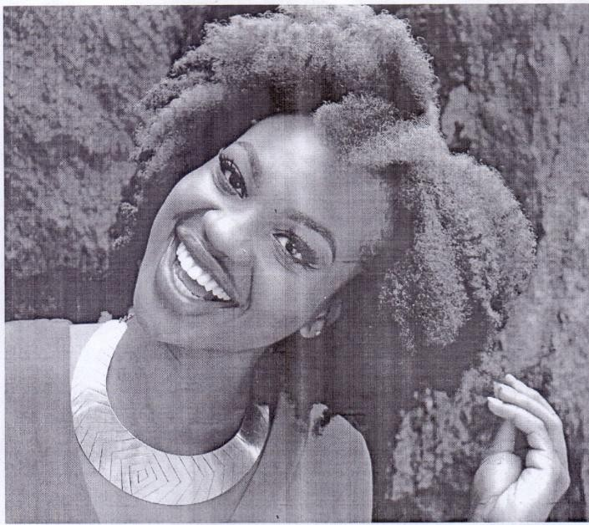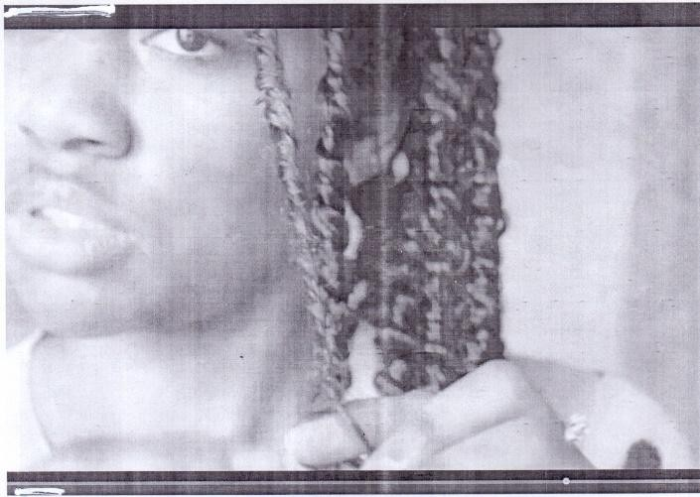
An American A Nigerian


A Briton

Women twist strand of their hair when they are anxious, nervous or uncomfortable.

