# A CUCKOO SEARCH BASED CO-ORDINATION OF DISTRIBUTED GENERATION UNITS AND SHUNT CAPACITOR BANK IN RADIAL DISTRIBUTION NETWORKS

**BY**

# MOSES UCHENDU P14EGEE8034

[**uchendulife500@gmail.com**](mailto:uchendulife500@gmail.com)

# A THESIS SUBMITTED TO THE DEPARTMENT OF ELECTRICAL ENGINEERING, AHMADU BELLO UNIVERSITY ZARIA, IN PARTIAL

**FULFILLMENT OF THE REQUIREMENTS FOR THE AWARD OF MASTER OF SCIENCE (M.SC.) DEGREE IN ELECTRICAL ENGINEERING POWER SYSTEMS ENGINEERING**

# NOVEMBER, 2017

**DECLARATION**

I Moses Uchendu, hereby declare that the work in this Dissertation entitled “Cuckoo search based co-ordination of Distributed Generation Units and Shunt Capacitor Banks in Radial distribution Networks” has been carried out by me in the Department of Electrical and Computer Engineering. To the best of my knowledge, the information derived from the literatures has been duly acknowledged in the text and a list of references provided. No part of this dissertation was previously presented for another degree or diploma at this or any other institution.

Moses UCHENDU (Student) Signature Date

# CERTIFICATION

This Dissertation entitled “**CUCKOO SEARCH BASED CO-ORDINATION OF DISTRIBUTED GENERATION UNITS AND SHUNT CAPACITOR BANKS IN**

**RADIAL DISTRIBUTION NETWORKS**”by Moses Uchendu meets the regulations governing the award of Master of Science (M.Sc) degree in power System Engineering of Ahmadu Bello University, and is approved for its contribution to knowledge and literary presentation.

Prof. B. Jimoh

Chairman, Supervisory Committee (Signature) Date

Dr. Y. Jibril

Member, Supervisory Committee (Signature) Date

Dr. Y. Jibril

Head of Department (Signature) Date

Prof. S.Z Abubakar

Dean. School of Postgraduate Studies (Signature) Date

# DEDICATION

This work is dedicated to the Almighty God and to my family members.

# ACKNOWLEDGEMENT

All praise and thanks be to Almighty God, my Lord and Saviour for his grace, favor and blessings.

First and foremost, I would like to appreciate the moral, financial and spiritual support of my parents, Mr. and Mrs. Uchendu and to my brothers. My gratitude is beyond words.

I wish to express my profound gratitude to my supervisor Prof. BoyiJimoh for his tireless efforts,valuable guidance, and constant supervision towards the success of this work. I really appreciateand value your tolerance, guidance, and inspiration from the beginning to the end of thisdissertation. Thank you very much Sir. My appreciations also go to my co-supervisor Dr.

Y. Jibril for his meticulous approach and continuous advice during all those stages of my presentations. Many thanks to Prof. M.BMu‟azu for having assisted me shape the problem and providing insights towards the solution.Thank you Sir.

I acknowledge with thanks the entire staff of Electrical and Computer Engineering Department, Ahmadu Bello University, namely, Prof. B. G. Bajoga, Dr. S. M. Sani, Dr. A. D. Usman, Dr. T. H. Sikiru, Dr. I. J. Umoh, Dr. K. A. Abu-Bilal, Engr. Adamu, Engr.Taiwo, Engr. Josiah, Engr. M. J. Mu‟azu, Engr. A. I. Abdullahi, Engr. Zannah, Engr. B. O.Sadiq, Engr. Shehu and to those whose names could not be mentioned. My deepest appreciationalso goes to Engr. Olaniyan Abdulrahman, Engr. Salawudeen A. Tijjani, for your assistance in going through my work and providing insights and to Abdullahi Tukur for his administrative support.

I am also thankful to my special friends, Sunday Okpanachi, Caleb, Oyibo Prosper, Rimamfate Gideon, Umar Abubakar., Malachi E., Yusuf H. Your continuous support and contributionstoward the success of this work would never be forgotten. May God reward and strengthenour friendship. I am very much thankful to all my course mates, Mazi Collins O., Mallama Zainab, Daniel, Mrs. Alli, Engr. Abdulkareem Z., Mallam Hassan may God bless and reward you all. Amen.Last but not the least, a big thank you goes to Abubakar Humairahand all those that have directly and indirectly contributed to the success of thiswork. May God bless you all.

# Moses UCHENDU

November, 2017.

# ABSTRACT

This research work presents the Application of Cuckoo Search Algorithm for the simultaneous placement of distributed generation units and shunt capacitor banks in radial distribution networks. The approaches used in most literatures for determining the optimal allocation of DG units and Capacitor banks did not consider the simultaneous placement of multiple combinations of DG units and capacitor banks in order to obtain the best combination of optimal sizes and installed an appropriate location for optimal network performance. The Cuckoo Search Algorithm was applied to determine the optimal location and sizes of Micro-DG units and Shunt Capacitor Banks with an objective of minimizing the total active and reactive power loss and maximizing voltage profile improvement and voltage stability of distribution networks. The DGs units and Capacitor banks where separately and simultaneously applied on standard IEEE 33 and 69 test bus systems and on 50 bus Canteen Feeder in Zaria distribution network. The result obtained from the simultaneous allocation was validated by comparing with that obtained from the separate allocation of Distributed Generators and Capacitor Banks. For the **33** bus test system, the Cuckoo search algorithm found the optimal sizes and locations of the best simultaneous combination of the DG units and capacitor bank allocated to be 515.69 kW at bus 25, 214.01 kW at bus 32 and 572.27 kVAr at bus 30 with 63.29% and 59.38% reduction in active and reactive power loss, 6.32% Improvement in average voltage profile and 7.89% in overall VSI, as compared to 31.65% and 31.25% active and reactive power loss reduction, 5.11% improvement in average voltage profile and 6.13% in overall VSI for separate DG placements, and 53.16% and 53.13% power loss reductions, 3,95% improvement in average voltage profile and 3.85% improvement in overall VSI for separate capacitor bank placement when compared to the base case result. For the standard IEEE **69** test bus system the optimal sizes and locations of the best combinations of DG units and CBs that were simultaneously allocated were found to be 239.83 kW at bus 53, 885.58 kW at bus 50 and 1408.79 kVAr at bus 50 with 74.29% and 79.17% reduction in active and reactive power loss, 2.34% Improvement in average voltage profile and 3.79% in overall VSI as compared to 51.43% and 54.17% active and reactive power loss reduction, 2.02% improvement in average voltage profile and 2.69% in overall VSI for the separate DG placements and 28.57% and 31.25% active and reactive power loss reductions, 1.65% improvement in average voltage profile for separate capacitor banks placement when compared to base case results. Finally for the **50**- bus Canteen Feeder in Zaria distribution network, the optimal sizes and locations of the best combinations of DG units and capacitor banks simultaneously allocated was 247.19 kW at bus 23, 137.82 kVAr at bus 25 and 131.78 kW at bus 25 with 17.77% and 17.76% reduction in active and reactive power loss, 0.47% improvement in average voltage profile and 0.32% improvement in overall VSI as compared to 15.70% and 15.79% active and reactive power loss reductions,0.45% improvement in average voltage profile and 0.30% improvement in overall VSI for the separate DG placements, 9.92% and 9.87% active and reactive power loss reductions, 0.38% improvement in average voltage profile and 0.28% improvement in overall VSI for separate capacitor banks placements when compared to the base case results. From results comparison, it is evident that the simultaneous placement of DGs and Capacitor banks using the cuckoo search algorithm gave a better performance to the separate placement of the DG units and capacitor banks.

|  |  |  |
| --- | --- | --- |
|  | **TABLE OF CONTENTS** |  |
| **TITLE PAGE** |  | **II** |
| **DECLARATION** |  | **III** |
| **CERTIFICATION** |  | **IV** |
| **DEDICATION** |  | **V** |
| **ACKNOWLEDGEMENT** |  | **VI** |
| **ABSTRACT** |  | **VIII** |
| **LIST OF FIGURES** |  | **XVI** |
| **LIST OF TABLES** |  | **XVIII** |
| **LIST OF ACRONYM** |  | **XIX** |

# CHAPTER ONE: INTRODUCTION

* 1. Background of study 1
  2. Motivation 5
  3. Statement of Problem 6
  4. Aim and Objectives 7
  5. Methodology 8
  6. Dissertation Organization 9

**CHAPTER TWO: LITERATURE REVIEW**

|  |  |  |
| --- | --- | --- |
| **2.1 Introduction** |  | **10** |
| **2.2 Review of Fundamental Concepts** |  | **10** |
| 2.2.1 Radial distribution network (RDN) |  | 10 |
| 2.2.2 Power flow analysis |  | 11 |
| 2.2.3 Inclusion of DG unit in the Power Flow solution |  | 15 |
| 2.2.4 Distributed generation |  | 15 |
| 2.2.4.1 Types of Distributed generation |  | 18 |
| 2.2.4.2 Classification of Distributed Generations model types | 182.2.5 Distributed Generation  19 |  |

|  |  |  |
| --- | --- | --- |
| 2.2.5.1 DG Modelled as a PV type | 19 |  |
| 2.2.5.2 DG Modelled as a PQ Node | 20 |
| 2.2.6 Capacitor Banks | 22 |
| 2.2.6.1 Shunt Capacitor Banks | 23 |
| 2.2.7 Voltage Stability | 24 |
| 2.2.7.1 Voltage Stability Index | 25 |
| 2.2.8 Standard IEEE Test Benchmarks | 28 |
| 2.2.8.1 Standard IEEE 33 Bus Distribution Network | 29 |
| 2.2.8.2 Standard IEEE 69 Bus Distribution Network | 29 |
| 2.2.8.3 Zaria Distribution Network | 30 |
| 2.2.9 Methods for Optimal DG and Capacitor bank Placement and Sizing | 31 |
| 2.2.10 Cuckoo Search Algorithm | 32 |
| 2.2.11 Performance Metrics | 36 |
| **2.3 Review of Similar Works**  **CHAPTER THREE: MATERIALS AND METHODS** |  | **38** |
| **3.1 Introduction** |  | **45** |
| **3.2 Materials** | **45** |  |
| 3.2.1 Personal Computer |  | 45 |
| 3.2.2 Matlab 2013a Software |  | 45 |
| 3.2.3 Distribution Network Parameters |  | 46 |
| **3.3 Methods** |  | **46** |
| 3.3.1 Acquisition of Relevant Data |  | 46 |
| 3.3.2 Base Case Power Flow Analysis |  | 46 |
| 3.3.3 Application of the Cuckoo Search Algorithm |  | 47 |

|  |  |  |
| --- | --- | --- |
| 3.3.4 Comparison of Results obtained |  | 48 |
| * 1. **Distributed Generator Model**   2. **Model of DG units and Shunt capacitors in Radial Distribution Networks** | **48** | **48** |
| **3.6 Objective Function** | **50** |  |
| **3.7 Cuckoo Search Algorithm** | **51** |  |
| **3.8 Cuckoo Search Algorithm for Simultaneous DG and Capacitor bank allocation** | **52** |  |
| **3.9 Voltage Stability Index** | **54** |  |
| * 1. **Standard Test Systems**      1. IEEE 33 Bus System 54      2. IEEE 69 Bus System | **54**  55 |  |
| 3.10.3 Zaria Distribution Network | 55 |  |
| 3.11 Performance Evaluation | 55 |  |

# CHAPTER FOUR: RESULT AND DISCUSSIONS

|  |  |  |
| --- | --- | --- |
| **4.1 Introduction** |  | **56** |
| **4.2 IEEE 33 bus system** |  | **56** |
| 4.2.1 Base case system |  | 56 |
| 4.2.2 Effect of Capacitor allocation |  | 58 |
| 4.2.3 Voltage and VSI Profiles after Capacitor allocation | 59 |  |
| 4.2.4 Effect of DG allocation |  | 61 |
| 4.2.5 Voltage and VSI Profiles after DG allocation |  | 62 |
| 4.2.6 Allocation of Multiple DGs and CBs combinations Simultaneously |  | 64 |
| 4.2.7 Voltage and VSI Profiles after simultaneous DG and CB allocation | 66 |  |
| 4.2.8 Power loss reduction profiles for 33- bus System | 68 |  |

4.2.9 Summary of results for 33- bus System 70

|  |  |  |  |
| --- | --- | --- | --- |
| **4.3 IEEE 69 bus system** |  |  | **71** |
| 4.3.1 Base case system |  |  | 71 |
| 4.3.2 Effect of Capacitor allocation |  |  | 74 |
| 4.3.3 Voltage and VSI Profiles after | CB allocation | 76 |  |
| 4.3.4 Effect of DG allocation |  |  | 77 |
| 4.3.5 Voltage and VSI Profiles after | DG allocation |  | 80 |
| 4.3.6 Allocation of Multiple DGs and CBs combinations Simultaneously | |  | 82 |
| 4.3.7 Voltage and VSI Profiles after simultaneous DG and CB allocation | | 85 |  |
| 4.3.8 Power loss reduction profiles for 69-bus System | | 87 |  |
| 4.3.9 Summary of results for 69- bus System | | 89 |  |
| * 1. **Zaria 50-bus Canteen Feeder**      1. Base case system | | **89** | 90 |
| * + 1. Effect of Capacitor allocation 91     2. Voltage and VSI Profiles after CB allocation | | 93 |  |
| 4.4.4 Effect of DG allocation | | 95 |  |
| 4.4.5 Voltage and VSI profiles after DG allocation | | 97 |  |
| 4.4.6Allocation of Multiple DGs and CBs combinations simultaneously | | 99 |  |
| 4.4.7 Voltage and VSI Profiles after simultaneous DG and CB allocation | | 102 |  |
| 4.4.8 Summary of results for 50- bus Zaria Canteen Feeder System | | 104 |  |

# CHAPTER FIVE: CONCLUSION AND RECOMMENDATION

# Conclusion 108

# Significant Contributions 110

# Limitations 111

# Recommendations for Further Work 111

# REFERENCES 110

# APPENDIX A1: SYSTEM DATA FOR 33 BUS SYSTEM 116

# APPENDIX A2: SYSTEM DATA FOR 69 BUS SYSTEM 117

# APPENDIX A3: SYSTEM DATA FOR ZARIA 50 BUSCANTEEN FEEDER 119

# APPENDIX B1: M-FILE: MATLAB CODE FOR POWER FLOW 121

# APPENDIX B2: M-FILE: MATLAB CODE FOR VSI ANALYSIS 125

# APPENDIX B3: M-FILE: MATLAB CODE FOR CUCKOO SEARCH FOR 127

**OPTIMAL CB AND DG ALLOCATION**

# LIST OF FIGURES

|  |  |  |
| --- | --- | --- |
| Figure 1.1: Schematic Diagram of a simple Power Distribution System |  | 2 |
| Figure 2.1: Single Line Diagram of n-Bus Radial Distribution System |  | 12 |
| Figure 2.2: Distributed Generation Types and Technologies |  | 17 |
| Figure 2.3: Shunt Capacitor Bank | 24 |  |
| Figure 2.4: Circuit Model of a Radial Distribution Network |  | 26 |

Figure 2.5: Single Line Diagram of IEEE 33 Bus Test Feeder System 29

Figure 2.6: Single Line Diagram of IEEE 69 Bus Test Feeder System 30

Figure 2.7: Single Line Diagram of 50 Bus Canteen Feeder in Zaria 31

Figure 2.8: Flow Chart of CSA Algorithm 33

Figure 3.1: Distribution System with DG unit and shunt capacitor bank Installation 49

Figure 3.2: Flow Chart for the Simultaneous location and sizing of DG and CB 53

Figure 4.1: Voltage Profile for 33 Bus Network after CB Allocation 59

Figure 4.2:VSI Profile for 33 Bus Network after CB Allocation 60

Figure 4.3: Voltage Profile for 33 Bus Network after DG Allocation62

Figure 4.4: VSI Profile for 33 Bus Network after DG Allocation 63

Figure 4.5: Voltage Profile for the 33 Bus Systemafter Simultaneous 67

DG and CB Allocation

Figure 4.6: VSI Profile for the 33 Bus System after Simultaneous DG and CB Allocation 68

Figure 4.7: Active Power loss reduction profile for 33 Bus System 69

Figure 4.8: Reactive Power loss reduction profile for 33 Bus System 70

Figure 4.9: Voltage Profile for 69 Bus Network after CB Allocation 76

Figure 4.10: VSI profile for 69 Bus Network after CB Allocation 77

Figure 4.11: Voltage Profile for 69 Bus Network after DG Allocation 80

Figure 4.12: VSI Profile for 33 Bus Network after DG Allocation 81

Figure 4.13: Voltage Profile for the 69 Bus System after Simultaneous 85

DG and CB Allocation

Figure 4.14: VSI Profile for the 69 Bus System after Simultaneous DG and CB Allocation 86 Figure 4.15: Active Power loss reduction profile for 69 Bus System 87

Figure 4.16: Reactive Power loss reduction profile for 69 Bus System 88

Figure 4.17: Voltage profile for 50 Bus Network after CB Allocation 94

Figure 4.18: VSI profile for 50 Bus Network after CB Allocation 95

Figure 4.19: Voltage profile for 50 Bus Network after DG Allocation 98

Figure 4.20: VSI profile for 50 Bus Network after DG Allocation 99

Figure 4.21: Voltage Profile for the 50 Bus System after Simultaneous 103

DG and CB Allocation

Figure 4.22: VSI Profile for the 50 Bus System after Simultaneous DG and CB Allocation 104

# LIST OF TABLES

Table 4.1: Base case Voltage and VSI values for 33 Bus Network 57

Table 4.2: Improved Voltage and VSI values for 33 Bus after Capacitor Allocation 58

Table 4.3: Improved Voltage and VSI values for 33 Bus after DG Allocation 61

Table 4.4: Improved Voltage and VSI values for 33 Bus after simultaneous DG and 65

CB Allocation

|  |  |  |
| --- | --- | --- |
| Table 4.5: Summary of Result for 33 Bus Network 71 |  | |
| Table 4.6: Base case Voltage and VSI values for 69 Bus Network 72 |
| Table 4.7: Improved Voltage and VSI values for 69 Bus after Capacitor Allocation |  | 74 |
| Table 4.8: Improved Voltage and VSI values for 69 Bus after DG Allocation |  |  |
| 78 |  |  |
| Table 4.9: Improved Voltage and VSI values for 69 Bus after simultaneous DG and Allocation83 | CB |  |
| Table 4.10: Summary of Result for 69 Bus Network |  | 89 |
| Table 4.11: Base case Voltage and VSI values for 50 Bus Network 90 |  |  |
| Table 4.12: Improved Voltage and VSI values for 50 Bus after Capacitor Allocation |  | 92 |
| Table 4.13: Improved Voltage and VSI values for 50 Bus after DG Allocation |  | 96 |
| Table 4.14: Improved Voltage and VSI values for 50 Bus after simultaneous DG and |  | 101 |

CB Allocation

Table 4.15: Summary of Result for 50 Bus Network 104

# LIST OF ACRONYMS

|  |  |
| --- | --- |
| **ACRONYMS** | **DEFINITION** |
| DG | Distributed Generation |
| CB | Capacitor Bank |
| CSA | Cuckoo Search Algorithm |
| PSO | Particle Swarm Optimization |
| FC | Fuel Cell |
| AFC | Alkaline Fuel Cell |
| PAFC | Phosphoric Acid Fuel Cell |
| MCFC | Molten Carbonate Fuel Cell |
| SOFC | Solid Oxide Fuel Cell |
| P | Active Power |
| Q | Reactive power |
| PV | Active Power and Voltage |
| PQ | Active and Reactive Power |
| V | Voltage |
| VSI | Voltage Stability Index |
| R | Resistance |
| X | Reactance |
| BIBC | Bus Injection Current and Branch Current |
| BPSO | Binary Particle Swarm Optimization |
| BSA | Back Tracking Search Algorithm |
| PU | Per Unit |

|  |  |
| --- | --- |
| KCL  WT RDN | Kirchhoff‟s Current Law Wind Turbine  Radial Distribution Network |
| DDC | DG – DG - Capacitor |
| DCD | DG – Capacitor – DG |
| CDD | Capacitor – DG – DG |
| DCC | DG – Capacitor – Capacitor |
| CDC | Capacitor – DG – Capacitor |
| CCD | Capacitor – Capacitor - DG |

**CHAPTER ONE**

# INTRODUCTION

# Background of Study

Electrical power systems are evolving from the conventional power systems known, where generation plants are connected to a distribution or transmission network to new trends involving decentralized systems consisting of small generating units connected directly to a distribution system near demand consumption. This type of generating unit is termed Distributed Generation (DG) (Pepermans*et al*., 2005). Among various DG types, the renewable energy (Micro- DG) units are becoming more common since majority of other DG resources (power electronic and synchronous generator based DG units) are capable of injecting harmonics to the network and are not environmentally friendly. A capacitor bank is another device that can be directly connected to a distribution network to provide a proper balance between active and reactive power injection and consumption. Among the types of capacitor banks, the shunt compensating capacitor bank is mostly suitable for distribution networks because of its ability to inject as well as absorb reactive power when needed thereby protecting against low power factor associated with network loads that leads to power losses, voltage drops and voltage instability.

Distribution system is a network that provides a final link between the high voltage transmission system and the consumers. In distribution system, among the various network topologies, the radial network topology is common because of its simplicity. The challenges of radial distribution system include; high power losses, voltage drops, transients and harmonic distortion on the distribution networks (Ogunyemi and Adejumobi, 2012). Solving

these power quality problems using conventional solutions such as distribution network expansions and substation upgrades are more capitally incentive and requires years of planning and implementation. The adverse effects of harmonic injection and low power factor in power systems include the accumulation of zero sequence current in the neutral line causing overheating of the neutral cable, overheating of transformers and power system equipments, additional losses and voltage instability. This therefore provides a motivation to select a Distributed Generation and shunt capacitor bank (Heydari et al, 2013).

Distribution networks are mostly radial in nature with very rare exceptions, with the customers having one source of supply. A typical distribution network consists of distribution substation, feeders, switches, fuses, transformers, voltage regulators, meters and circuit breakers as shown in Figure 1.1

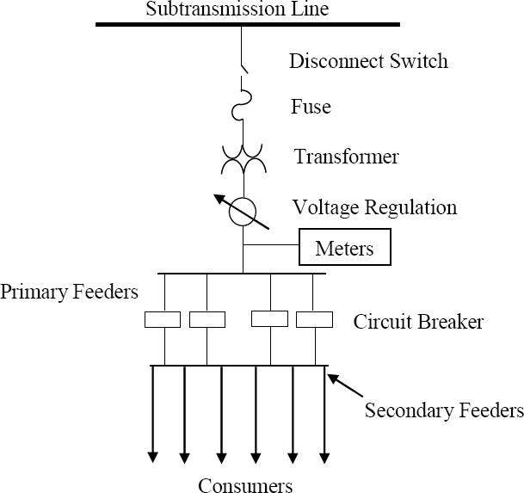

Figure 1.1: Schematic Diagram of a Simple Distribution Network (Kersting, 2012)

The deregulation of power networks to augment the imbalances between generation and consumption results in loss of the networks passive nature. This scenario subsequently results in technical issues that may affect the power quality of the entire network (Machowski*et al.*, 2011). Poor voltage quality in distribution networks which can be due to variations in

consumer‟s demand forces electrical equipment to draw more than their rated current, resulting in excessive heating capable of inflicting severe damages to Power system equipments(Watson and Miller, 2015).

Due to low voltage level and high current in distribution systems, the largest power loss among the three (3) power system sections of generation, transmission and distribution, belongs to the distribution section. Such that the line losses at the distribution level in Nigeria constitute about 15% to 30% of total power generation (NERC).

Nowadays, because of the industrialization of societies and overloading of distribution networks, the voltage stability of distribution networks has become an important subject for consideration. Over the years, many efforts have been made to reduce the losses in distribution networks, which include the use of series voltage regulators, capacitor placements, distributed generation (DG) resources.

Shunt capacitors have been employed in several literatures to locally compensate for the reactive power in the network and in consequence reduce the power loss in the lines and improve their voltage profile as in the works of Gailego*et al*, (2001), Ellithy*et al,*(2008) and Khodr*et al.*, (2008), where shunt capacitors optimal placement was applied as effective economic tool to an improved and stable distribution network.

Distributed generation (DG) units are employed at the distribution level to supply power and reduce losses. The optimal sizing and placement of these resources to minimize the power loss

improve voltage profile; enhance systems reliability indices have been proposed in several researches (Pepermans*et al*.,2005, Archarya,*et al*., 2006, Akorede, 2010, Hung *et al*, 2014).

With increase in economic growth and development, load demands in distribution networks are susceptible to sharp increment. Hence, the distribution networks in most developing nations like Nigeria are operating very close to the voltage instability boundaries. The decline of voltage stability margin is one of the important factors which restrict increment in loads served by distribution companies (Jain, *et al*. 2014).

The rapidly increasing electricity demand and difficulties in providing the required capacity using traditional solutions, such as transmission network expansions and substation upgrades, the need to protect power systems from voltage associated disturbances and provide an argumentation to grid generated power lead to the emergence of Distributed Generation (DG) and other network compensating devices (Pepermans, 2005)

Several DG types have been used in finding solutions to power loss reduction and voltage profile improvements and voltage stability in networks over the years but some have been found to create further disturbances in the network during power injection and thus might not be suitable for voltage support in power networks. In this work renewable energy DG units would be made use of because of its low harmonics injectioninto power systems and as an environmentally friendly alternative to other DG units.

Capacitors alongside DGs have been used in previous work to provide active and reactive power compensations on a network and have been confirmed to be a good approach for

optimum network operation and planning (Heydari*et al*, 2013, Esmaeilian*et al*, 2014, Harisha and Lakshmi, 2015).

Analytical and numerical techniques have been employed in the search for optimal position and size of distributed generation and capacitors in power networks. Their computational complexity and inability to fully incorporate the nonlinearity of the power networks prompted the search for better and more robust techniques (Ming *et al.*, 2014).

The evolution of meta-heuristics algorithms has led to a new, faster and robust approach of solving complex power system optimization problems (Binitha and Sathya, 2012).

Out of the many meta-heuristics algorithm presently developed, the Cuckoo search algorithm was applied to the location and sizing of Type 1DG units and shunt capacitor banks in radial distribution networks with respect to a multi-objective function encompassing power loss minimization, improvement of voltage profile and voltage stabilityina radial distribution network.

# Motivation

A sharp increase in demand for energy has caused suppliers of energy to search for a quicker and less expensive alternate means of improving the sustainability and stability of power distribution networks. Also the need to provide additional reactive power compensation due to network loads that are majorly inductive in nature, in order to provide proper balance between active and reactive power injection and consumption, motivated the choice of renewable Distributed Generationand shunt capacitor banks as an emergency approach to solve this problem and provide augmentation to the grid generated power in a less expensive means as

compared to the conventional transmission expansion or network reconfiguration and environmentally friendly compared to some other DG options. Secondly, large proportions of electric machinery used in industries have inherently low power factor and so also are most loads on power networks. When the overall power factor of generating stations is low, systems become inefficient, corresponding cost of electricity becomes high, increase in power losses and poor voltage regulation of loads. In a bid to address issues on poor power factor of loads the shunt capacitor bank, which have been employed mostly for the purpose of power factor correction purposes, thus improvingthe low power factor problems in power systems and reducing power losses will also be employed.In this work the DG units and shunt capacitor banks will be simultaneously placed on radial distribution networks to obtain the best combinations suitable for reduction in power loss and improving the voltage profile of the networks using the cuckoo search algorithm.

# Statement of Problem

With DG mainly considered as an active source of energy by most power distribution companies in order to get maximum benefit from electricity purchased, drawing maximum active power can result into deficiency in fulfilling the kVAr of the reactive load requirement which when worst may lead to voltage collapse situations. Most researchers have addressed the issue of voltage instability in distribution networks with the use of DGs alone, which studies have shown might not be able to meet the kVAr requirements especially since networks are having loads that are mostly inductive in nature and may require the use of additional compensators to meet the kVAr demands from loads. The use of shunt capacitor banks for reactive power compensation, power factor correction and voltage stability improvement have shown to be efficient in meeting the kVAr demands in situations where

inductive loads dominate the loads in a network. Another problem widely faced when allocating DG units and capacitor banks in distributionssystems is how to efficiently integrate them optimally in order to achieve improved system performance. The search for an optimal location and the size of DG units and capacitor banks to be placed can be quite challenging. In most cases, the methods employed for locating and sizing DG units and capacitor banks in distribution network are either analytical method or heuristic which arecomputationally exhaustive and time consuming optimization techniques and are characterized by slow convergence of power flow especially when used for complex system analysis. The meta- heuristic method tends to provide a lesser time consumption and faster convergence of power flow analysis.

# Aim and Objectives

The aim of this work is to apply a Cuckoo search algorithm for the placement ofDistributed Generation (DG) units and shunt capacitor banks in radial distribution networks with the intent of minimizing power loss (active and reactive), improving the voltage profile and voltage stability. To achieve the set aim, theobjectives are:

* + 1. To Run power flow for base case power loss and voltage at each bus
    2. To integrate the Cuckoo search algorithm to the power flowfor separate and simultaneous (combined)DG units and shunt capacitor bank location and sizing on radial distribution networks in MATLAB 2013a environment.
    3. To compare the results obtained from the separate sizing and location of DG units and capacitor banks with that from the simultaneous DG units and shunt capacitor bank sizing and locationon the basis of power loss minimization, voltage profile and voltage

stability improvement using cuckoo search algorithm on IEEE 33 and 69 radial test buses and on 50-bus Canteen Feeder in Zaria distribution network.

# Methodology

The following steps which comprises the methodology adopted for this research are as follows

* + 1. Base case load flow program for base case power loss and voltage values
    2. Application of the CSA for simultaneous DG units and shunt capacitor bank location and sizing on standard IEEE- 33 and 69 radial distribution networks and 50 bus Canteen Feeder in Zaria distribution network with corresponding loss reduction and voltage profile improvement.
    3. Validation through results comparison
       1. Comparison of results obtained from the simultaneous placement of the DG units and shunt capacitor banks to that obtained from the separate (singular) placements of DG units and CBs

# Dissertation Organisation

A general introduction has been presented in chapter one, while chapter two presented a review of relevant fundamental concepts such as definition of a radial distribution network distributed generation, capacitor bank, voltage stability and voltage stability indices, power flow analysis for radial distribution network, methods for DG allocation etc. and a review published similar works directly related to this research. Chapter three presents the materials and methodology used such as hardware and software employedand the application of DG units and shunt capacitor banks on radial distribution test networks were presented. In chapter

four, results obtained after the simultaneous allocation of the DGs and shunt capacitor banks were presented while conclusion and recommendations for further works were presented in chapter five. Quoted references and appendices were also presented at the latter end of this research report.

# Introduction

**CHAPTER TWO LITERATURE REVIEW**

This chapter is divided into two sections. The first section shows the review of fundamental concepts that will enable the understanding of the basic aspects of distribution systems, load flow analysis, etc. while the second presents the review of similar works published in the areas of separate DG and capacitor bank placement and sizing and a combined DG and capacitor bank placement and sizing.

# Review of Fundamental Concepts

Some of the fundamental concepts regarding this research work are discussed below. These concepts served as background information to the study.

# Radial Distribution Network (RDN)

Radial distribution systems are systems with only one power source for a group of customers. They are intended mainly to attend to customers in a reliable and quality manner thereby reducing investment costs and energy losses (Kumarasaswamy et al., 2014). In this system, separate feeders radiate from a single substation and feed the distributors at one end only. This is the simplest distribution circuit widely used in sparsely populated areas and has the lowest initial cost. Classical power flow techniques such as Gauss-Seidel, coupled and fast-decoupled Newton-Raphson are more suitable for transmission systems. These techniques, in most cases, fail to converge when used for distribution systems power flow. The failure of classical techniques in a distribution system as clearly attributed to its inability to accommodate features of RDNs such as High *R X* ratio, large number of buses and lines, uncertainties and

imperfection of network parameters, dynamic nature of connected loads and dynamic change in imposed load (Singh and Ghose, 2013). In RDNs, the large R/X ratio causes problems in convergence of conventional load flow algorithms. Due to this reason, popularly used Newton

– Raphson and Fast Decoupled load flow algorithms may provide inaccurate results and may not converge. Hence, conventional load flow methods cannot be applied to obtain the load flow solution of radial distribution systems.

# Power Flow Analysis

Power Flow Analysis is an important and basic tool for power system analysis which helps to determine the steady state behavior of the power system. A number of power flow algorithms were developed in order to solve unbalanced distribution system. Some of them were capable of finding solution even after including DG sources. The most popular method is the Backward-Forward sweep method (Maya and Jasmin, 2015). Backward-forward sweep power flow algorithm for Radial Distribution Systems (RDS) described by Alhaddad and El-Hawary (2014) is used in this research work. In this radial distribution power flow algorithm (RDPF) with backward forward sweep, two matrices namely [BIBC] and [BCBV] are formed to get the power flow solution. [BIBC] is the relationship matrix between bus current injections and branch currents. Whereas, [BCBV] represent the relationship between branch currents and bus voltages. In order to explain the backward-forward sweep method, a radial distribution system is considered having „n‟ buses. The single line diagram is presented in Figure 2.4 (Alhaddad and El-Hawary, 2014).

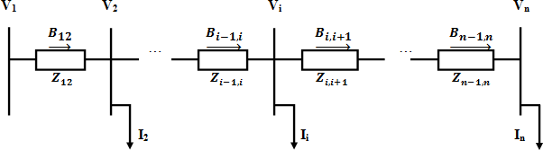

Figure 2.1: Single Line Diagram of n-bus RDS (Alhaddad and El-Hawary, 2014)

The system is assumed to be balanced with (n-1) load buses which are treated as PQ buses and bus 1 is a slack/swing bus. The general bus „*i*‟ current injection kth iteration is given by the following equation (Alhaddad and El-Hawary, 2014):

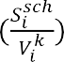(2.1)

where  is the scheduled complex power at bus i,  is the bus „*i*‟ voltage at the kth iteration.

Now, Kirchhoff‟s current law (KCL) is applied by backward current sweep starting from the last bus „n‟ to the source bus 1 to obtain the branch currents. In this step we obtained the first of the two matrices given by (Alhaddad and El-Hawary, 2014):





= (2.2)

 

Equation (2.2) in a compact form is given as:





Where

(2.3)

is the relationship matrix between branch currents and bus current injections



In the forward voltage sweep, Kirchhoff‟s voltage law (KVL) is applied to obtain the bus voltages and second relationship matrix given by:



= (2.4)

 

By rearranging the above Equation (2.17), the change in voltage vector [ ] was obtained as follows:



 (2.5)



where is the relationship matrix between bus voltages and branch currents.

Hence, by substituting equation (2.4) in (2.5), [ ] in terms of bus current injections is expressed as follows:

 (2.6)



 (2.7)



Where [DLF] is the relationship matrix between voltage drops and bus current injections.

The RDPF solution is achieved by employing KCL and KVL respectively to form the matrices [BIBC] and [BCBV] and performing matrix multiplications. Moreover, the following

equations are solved iteratively to get the power flow solution (Alhaddad and El-Hawary, 2014):

 ) (2.8)



 (2.9)



[ (2.10)



where [ ] is initial bus voltage vector

The iterative process stops when the absolute of difference between previous bus current injection and most recent bus current injection is less than or equal to a prescribed tolerance :

(2.11)



Finally, the total active power loss can be calculated by the following equation:

 (2.12)



*I m* (2.13)



where [ ] is magnitude of the ith branch current R is the ith branch resistance

*br* is the number of branches in RDS

The total active power loss can be written in terms of [ ] as follows (Alhaddad and El- Hawary, 2014):

(2.14)



# Inclusion of DG Unit in the Power Flow Solution

DG units can be included in the distribution power flow as PQ nodes or PV nodes depending on the means of interconnection to the power grid and also based on their size. DG units which are modeled as PQ loads do not pose any difficulty to the power flow since they can be treated as negative loads. But when DG units are modeled as PV nodes, some alterations in the power flow are necessary (Maya and Jasmin, 2015).

# Distributed Generation (DG)

The IEEE defines distributed generation as the generation of electricity by facilities that are sufficiently smaller than central generating plants so as to allow interconnection at nearly any point in a power system (Pepermans *et al.,* 2005).

According to(Georgilakis and Hatziargyriou, 2013), distributed generation (also called dispersed and embedded generation) is defined as a small generator or an electric power source connected directly to the distribution network or grid or to the customer side of the meter.

Distributed generation technologies often consist of modular (and sometimes renewable energy) generators and they offer a number of potential benefits such as lower cost of electricity, high power reliability and security with fewer environmental consequences than can traditional power generators(Georgilakis and Hatziargyriou, 2013).

In contrast to the application of a few large scale generating stations far from load centers as in the case of electric power paradigm , DG systems employs numerous but small plants and can provide power on site with little reliance on the distribution transmission grid.

DG technologies yield power in capacities that range from a fraction of kilowatt to about 50 MW (EPRI). Utility scale generation units generate power in capacities that often reach beyond 1000MW.

* + - 1. *Types of Distributed Generation*

From constructional and technological points of view and available energy resources, DGs can be divided into two groups namely; traditional and non-traditional generations (El- Khattam and Salama, 2004).

Distribution Generation Types & Technologies

Non -Traditional

Traditional Generation (combustion Engines)

Micro Turbine

(MT)

Natural Gas turbine

Simple

cycle

Recuper

ated

Comb ined

cycle

Cycle

Electrochemical

Devices

Storage

Devices

Renewable

Devices

Wind turbine (WT)

Photovo ltaic (PV)

cells

Flywheels

Batteries

Figure 2.2: Distributed Generation Types and Technologies (El- Khattam and Salama, 2004)

PAFC

Fuel cells (FC)

MCFC

AFC

SOFC

# Traditional distributed generation

These are mainly standard conventional generating systems which come in smaller units with smaller power ratings and can be directly integrated into the distribution voltage levels. They are basically combustion generations operated with the use of non-renewable energy sources

such as micro-turbines, gas turbines (recuperated and combined), diesel generators and so on (El-Khattam and Salama, 2004).

# Non- traditional distributed generation

These are the types of non-conventional generating systems which come in small power ratings and can be directly integrated into the distribution voltage levels. They can be classified into storage devices, electromechanical and other renewable energy devices. Typical examples include fuel cell, deep cycle batteries and photovoltaic (PV) models, wind turbines (WT) and so on (El-Khattam and Salama, 2004) with many different types of fuel cells.

DGs have shown a lot of advantages in power system operations which is the major reason behind its wide spread acceptance. Some major technical and economic benefits derived include (Pepermans, Driesen *et al.,* 2005):

Reducing losses in power system

Voltage profile improvement

Increased energy efficiency

Systems power quality and security improvement

Lower operating cost because of peak shaving

* + - 1. *Classification of Distributed Generation*

DGs can be classified into four major types based on their terminal characteristics in terms of real and reactive power delivering capability as follows:

* + - * 1. Type 1: DG capable of injecting *P* only.
        2. Type 2: DG capable of injecting *Q* only.
        3. Type 3: DG capable of injecting both *P* and *Q*.
        4. Type 4: DG capable of injecting *P* but consuming reactive power

Photovoltaic, micro turbines, fuel cells, which are integrated to the main grid with the help of converters/inverters, are good examples of Type 1 or P-type DG units. Type 2 (Q-type) could be synchronous compensators such as gas turbines. DG units that are based on synchronous machine (cogeneration, gas turbine, etc.) fall in Type 3. Type 4 is mainly induction and synchronous generators that are used in fixed speed wind turbines.

# Distributed generator Model Types

A DG can be modeled and operated as either a constant active power and voltage (PV) node mode or a constant active power and reactive power (PQ) node mode. In most cases, the model of a DG unit depends on the control method which is used in the converter control circuit (Yammani *et al.,* 2012).

* + - 1. *DG modeled as a PV type*

The DG which is modeled to have control over voltage at the installed bus is a PV node DG. In this case, the DG is a constant voltage model and the specified values of the DG model are the real power output and the bus voltage. In order to maintain constant voltage, the change in voltage „ i‟ should remain zero by injecting the required reactive power. This reactive power can be computed as (Yammani *et al.,* 2012):

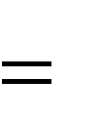*Qgen*,*i*

*Qref Qi*

(2.15)

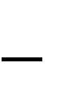Where:

*Qgen*,*i* is the generated reactive power at bus „i‟

*Qref* is the reference reactive power,

*Qi* is the load reactive power to maintain specified terminal voltage.

* + - 1. *DG modeled as a PQ Node*

A DG unit can be modeled as three different ways in PQ node mode as illustrated below:

* + - * 1. *DG as a ‘Negative PQ Load’ Model of PQ Mode*

In this case the DG is simply modeled as a constant active (P) and reactive power (Q) power generating source. The specified values of the DG model are real ( *PDG* ) and reactive ( *QDG* )

power output of the DG. It may be noted that fuel cell type DGs can be modeled as negative PQ load model. The load at bus-i with DG unit is to be modified as (Yammani *et al.,* 2012):

*Pi Pload* ,*i*

*Qi Qload* ,*i*

*PDG*,*i QDG*,*i*

(2.16)

(2.17)

Where;

*Pi* and *Qi* are the modified active and reactive powers at bus „i‟ after DG addition,

*Pload* ,*i* and *Qload* ,*i* are the initial active and reactive powers at bus „i*’*.

*PDG*,*i* and *QDG*,*i*

are the active and reactive powers of the DG represented as negative loads in

bus „i‟.

* + - * 1. *DG as a ‘Constant Power Factor’ Model of PQ Mode*

The DG is commonly modeled as a constant power factor model. Controllable DGs such as synchronous generator based DGs and power electronic based units are preferably modeled as constant power factor model. For example the output power can be adjusted by controlling the exciting current and trigger angles for synchronous generator based DGs and power electronic based DGs respectively. For this model, the specified values are the real power and power factor of the DG. The reactive power of the DG can be calculated by (2.18) and then the equivalent current injection can be obtained by (2.19)(Yammani *et al.,* 2012):

*iDG*

*QiDG*

*PiDG*

tan(cos 1 (*PF* ))

(2.18)

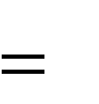*I iDG*

*I r iDG* (*V*

*iDG* )

*jI i iDG* (*V*

*iDG* )

(2.19)

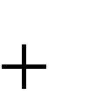Where,

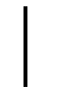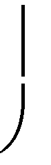

*PiDG*

*jQiDG*

*ViDG*

*

*QiDG* is the reactive power of the DG

*I iDG* is the equivalent current injection at bus „i‟.

*PFiDG* is the power factor of the DG

* + - * 1. *DG as a ‘Variable Reactive Power’ Model of PQ Mode*

DGs employing induction Generators as the power conversion devices will act mostly as variable reactive power generators. By using the induction generator based wind turbine as an example, the real power output can be calculated by wind turbine power curve. Then, its reactive power can be formulated as a function comprising the real power output, bus voltage, generator impedance and so on. However, the reactive power calculation using this approach is cumbersome and difficult to calculate efficiently. From a steady- state view point, reactive power consumed by a wind turbine can be represented as a function of its real power, that is

*Q* '*iDG*

*iDG*

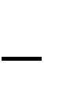

*Q*0 *Q*1 *P*

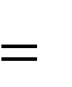

*Q P* 2 *iDG*

(2.20)

# Capacitor Banks

2

Historically, to improve the distribution networks, first initialize with the placement of an appropriate size of capacitor banks. Because all the arrangements in electrical home systems are done to meet up the basic requirement of alternating power system, reactive power always come into play.Static capacitor banks or capacitor banks are groups of several capacitors of the same rating that are connected in series or parallel with each other to store electrical energy (Gustavo *et al*., 2003). The resulting bank is then used to counteract or correct power lag or phase shift in an alternating current (AC) power supply.

The demand for reactive power is mainly originated from inductive loads connected to system. Adequate reactive power compensation is required, otherwise total power (vector sum of active and reactive power) of systems becomes quite less. This ratio is alternatively known as electrical power factor (Harisha and Lakshmi, 2015)

Poor system power factor makes the ampere burden of transmission, distribution network, transformers, alternators and other equipments connected to power systems become high for required active power, and hence reactive power compensation becomes very important (Ashish and Taru, 2014).

This compensation is commonly done through capacitor banks which could be of the shunt compensating or series compensating type.

In this work the shunt compensating capacitor bank or shunt capacitor bank will be employed.

* + - 1. *Shunt capacitor bank*

Shunt capacitor banks are used to improve the quality of electrical supply and the efficient operation of power systems. They are mainly installed to provide capacitive reactive compensation and power factor correction. Shunt compensating capacitors draws almost fixed amount of leading current which is superimposed on the load current and consequently reduces reactive components of the load and hence improves the power of the system (Harisha and Lakshmi, 2015). They are among the first equipment used in electricity network, in order to improve voltage profile.

Since the consumers and distribution network components like motors and transformers are inductive loads, the network power factor will lag and the result is reduced system capability, increased system losses and voltage reduction. Hence adding compensation shunt capacitor in appropriate locations reduces losses, improves the power factor, reduces voltage drops, better surge protection, reduces the line current of the line and relocates voltages of buses inside the allowed range (Harisha and Lakshmi, 2015). They also have considerable effect on reduction of reactive losses and voltage profile improvement and can also aid towards relieving feeder loading.

Their usage has increased significantly, as they are relatively inexpensive, easy and quick to install and can also be deployed anywhere in the network.

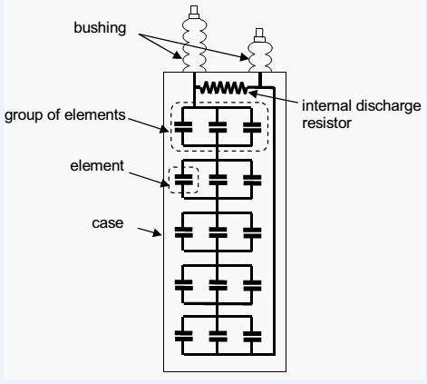

Figure 2.3: A Shunt Capacitor Bank(Gustavo *et al*., 2003)

# Voltage Stability

Voltage stability is a fundamental component of dynamic security assessment and it has been emerged as a major concern for power system security and a main limit for loading and power transfer. It is considered as the potential of a power system in maintaining its buses voltage amplitude against the increment of load demand. It is one of the important factors that dictate the maximum permissible loading of a distribution system (Banerjee *et al.,* 2009). A system enters a state of voltage instability when a disturbance, increase in load demand or change in system conditions causes a progressive and uncontrollable drop in voltage (Kundur, 1994).The loads generally play a key role in voltage stability analysis and therefore the

voltage stability is known as load stability. Voltage instability stems from the attempt of load dynamics to restore power consumption beyond the capability of the combined transmission and generation system. Instability occurs in the form of a progressive fall or rise of voltages of some buses. A possible outcome of voltage instability is loss of load in an area, or tripping of transmission lines and other elements by their protective systems. The problem of voltage stability may be explained as inability of the power system to provide the reactive power or non- uniform consumption of reactive power by the system itself (Banerjee *et al.*, 2009). The reactive power can be supplied by generators through transmission networks or compensated directly at load buses by compensators such as shunt capacitors Therefore, voltage stability is a major concern in planning and assessment of the security of large power systems in contingency situation, especially in developing countries because of the non-uniform growth of load demand and lacuna in the reactive power management side.

* + - 1. *Voltage Stability Index (VSI)*

Many different indices have been introduced to evaluate the power system security level from the point of voltage static stability. The voltage stability index is a parameter that identifies the near collapse nodes. The nodes with small stability indices are called weak nodes and then should be reinforced by injecting reactive power. In addition, the best location for reactive power compensation to improve voltage stability margins is the weakest bus in the network. Therefore, the best locations to install compensation devices for voltage stability enhancement are the buses with the minimum voltage stability index. Unbalanced operation of distribution networks significantly decreases the voltage stability margins and thus analysis on voltage stability index will help power system operation and researchers to identify the weakest bus for voltage stability enhancement under unbalance scenarios. By considering the radial

distribution network properties a simple power flow method was used to obtain the voltage stability index for radial distribution systems (Chakravorty and Das, 2015).

A simple radial distribution system with source at end one and load at the other end with two nodes as shown in Figure 2.4.

*r*

SI

R+jX

S

I12

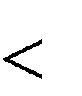

*Vs*

*s Vr*

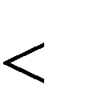

*PLs jQ Ls PLr jQ Lr*

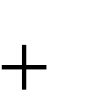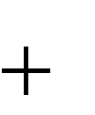Figure 2.4: Circuit Model of Radial Distribution Network (Chakravorty and Das, 2015)

Charkravorty, M., and Das, D. (2015), developed a voltage sensitivity analysis technique for radial distribution networks that calculates an index at each node and can identify the most sensitive node susceptible to voltage collapse. The index is derived from the bi- quadratic equation relating the voltage equation which is generally used for the voltage calculation of distribution load flow algorithms.

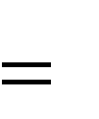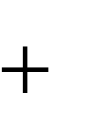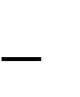Considering a distribution line model as presented in Figure 2.4. The bi-quadratic equation relating the voltage magnitude at the sending and receiving ends and power at the receiving end of the branch can be written as;

*V* 4 *r*

2*V* 2 *r* (*PR*

*QX* )

*V* 2 *sV* 2 *r*

(*P* 2

*Q* 2 ) | *Z* |2 0

(2.21)

Where,

*Vs* is the phase voltage magnitude at bus s

*Vr* is the phase voltage magnitude at bus r Z is the line impedance

*P* is the line transferred active power

*Q* is the line transferred reactive power

It is seen from the quadratic equation that the receiving end voltage *Vr* has four roots and the maximum positive value of these roots, given in equation (2.21), is the feasible solution and gives the receiving end node voltage magnitude.

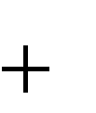1 1

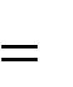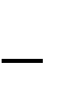*Vr* 0.707[*b*

(*b* 2

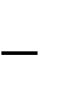4*ac*) 2 ] 2

(2.22)

1. 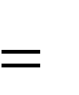*V* 2 *s*

2*PR*

2*QX*

(2.23)

1. 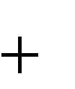(*P* 2

*Q* 2 )(*R* 2

*X* 2 )

(2.24)

Where, |Z|=R+jX (2.25)

From equation (2.22), clearly seen that the real value of the receiving end voltage magnitude will exist on the condition of

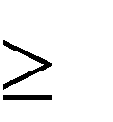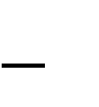*b*2 4*ac* 0 (2.26)

And the critical loading point is reached when equation (2.26) related to any line is zero.

*SI* (*r*) =*V* 4 *s*

4(*PX*

*QR*) 2

4*V* 2 *S* (*PR*

*QX* )

(2.27)

In this case, the bus which has minimum stability index value is defined as the critical bus which is the most sensitive to voltage collapse. After the load flow study, the voltages for all nodes and the branch currents are known, therefore P and *Q* at the receiving end of the line can easily be calculated. And hence using eqn (2.27) the voltage stability index of each bus can be calculated. The node, at which the value of the stability index is minimal, is most sensitive to voltage collapse.

Under normal operating conditions, VSI value should be less than 1 (unity). If the value of VSI is close to zero, then the system will be more stable. If the value of VSI is high, then the system is vulnerable to stability. The buses with higher VSI are more sensitive to voltage instability.

# Standard IEEE Test Benchmarks

These are standard test benchmarks designed by the IEEE for researchers to have a common testing platform and for easier comparison. Standard distribution testing benchmarks include: The IEEE 6-bus test system, the 14-bus test system, the 15-bus test system, the 33-bus test system, the 34-bus test system, the 69-bus test system and many more (Kaseem and Wafaa, 2012). The standard IEEE 33- bus and 69-bus distribution test feeders were chosen as testing benchmarks for this research because either or both test buses have been used by most of the literatures consulted.

* + - 1. *Standard IEEE 33-Bus Distribution Network*

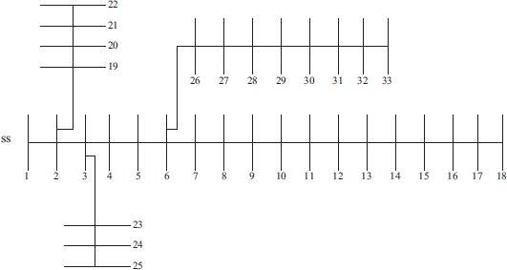This is a medium scale radial distribution network with 33-buses and 32-branches. Line data and bus data are given in appendix A1. The line voltage and real and reactive power loads of the radial distribution network are 12.66kV, 3.72MW and 2.3 MVAr, respectively. Figure 2.5depicts the single line diagram of the network (Yuvaraj et al., 2015).

Figure 2.5: Single line diagram of IEEE 33-bus system (Yuvaraj *et al.,* 2015).

* + - 1. *Standard IEEE 69-Bus Distribution Network*

This is a large scale test network which consists of 69-buses and 68-branches with line voltage of 12.66kV, total real and reactive load of 3.80MW and 2.69MVAr respectively. The network line and bus data are given in appendix A2. Figure 2.6 depicts the single line diagram of the network (Yuvaraj *et al*.,2015).

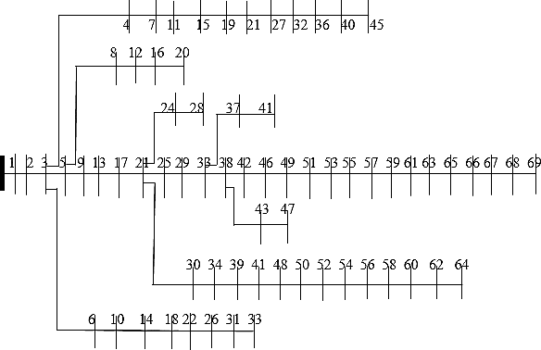

Figure 2.6: Single line diagram of IEEE 69-bus system (Yuvaraj *et al*., 2015)

* + - 1. *Zaria Distribution Network*

This is a real distribution network equipped with 8 feeders namely: RLY/NTC feeder, Sabon- Gari feeder, Gaskiya feeder, Canteen feeder, Zaria-City feeder, Wusasa feeder, Kofar-Kibo feeder and Teaching-Hospital feeder. The Canteen feeder which has 50-buses and 49-branches will be adopted in this research based on the available historical records from the Power Holding Company of Nigeria (PHCN) Zaria Business District. The network line voltages, base MVA, total real and reactive load are given as 11KV, 100MVA, 0.388MW and 0.294MVAr respectively (Abubakar, 2014). The network line and bus data is presented in appendix A3. Figure 2.7 depicts the single line diagram of the network.

31 32 33 38 39

29 30

36 37

40 41

48 49 50

1 2 3 4 5 6 7 8 9 10 11 12 13 14 15 16 17 18 19 20 21 22 23 24 25 26 27 28

34 35

42 43

44 45 46 47

Figure 2.7: Single line diagram of 50-bus Canteen feeder, Zaria distribution

Network(Abubakar, 2014)

# Methods for Optimal DG Units and Capacitor Banks Placement and Sizing

Several methods from several researchers have been introduced for finding the optimal location and size of DGs and that of capacitor banks in a radial distribution system. Previous methods proposed include the analytical approach as presented by (Acharya *et al.,* 2006), Khodr, (2008) and Hung *et al.,* (2014), the classical or numerical method as presented by (Atwa *et al.,* 2010). Another method used is the heuristic approach as proposed in the works of Akorede, M.,(2010), Molaei*et al*., (2011). This choice is mostly based on the general problem statement, objectives and constraints considered. Some methods used for optimal placement and sizing of DGs are as follows:

1. **Numerical method**: This method involves the use of numerical analysis in searching for an optimal solution. Its main advantage lies in the ability to guarantee finding global optimum; however, it is mostly not suitable for large scale systems. The different types of

numerical methods that have been used include Gradient search, linear programming, Non- linear programming, Sequential quadratic programming, Exhaustive search etc. (Georgilakis and Hatziargyriou, 2013):

1. **Analytical method**: This method originated from the 2/3 rule and is mostly executed based on the exact loss formula for active power in a system. Analytical methods are easy to implement and execute, but their results are only indicative, since they make simplified assumptions including the consideration of only one power system loading snapshot (Georgilakis and Hatziargyriou, 2013):
2. **Meta-heuristic method**: High level heuristic methods that use information and selection to guide the search process and aresaid to be problem independent (suited to a wide range of optimization problems. Some types of meta-heuristic solution methods used for optimization problems includesGenetic Algorithm (GA), particle swarm optimization (PSO), Ant colony Optimization (ACO), Artificial Fish Swarm Algorithm (AFSA), Harmony Search, Firefly Algorithm (FA), Cuckoo search algorithm (CSA) etc. (Georgilakis and Hatziargyriou, 2013):

# Cuckoo Search Algorithm

A more recent meta- heuristic search algorithm, cuckoo search algorithm (CSA) has been developed by (Yang and Deb, 2009). CSA has two main operators. One is direct search based on levy flights and another one is random search based on the probability for a host bird to discover an alien egg in its nest.

CSA consists of three steps. They are (Yang and Deb, 2009):

1. Every cuckoo lays one egg at a time, and dumps its egg in a randomly chosen nest.
2. The best nests with high quality of eggs will carry over to the next generation
3. The number of available host nests is fixed, and the egg laid by a cuckoo is discovered

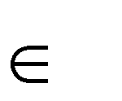by the host bird with a probability *Pa*

[0,1] .

The flow chart for CSA in shown in Figure 2.8

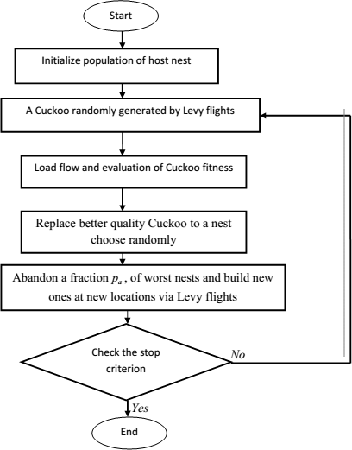

Figure 2.8: Flow chart for the Cuckoo Search Algorithm (Yang and Deb, 2009).

Cuckoos are attractive birds; it not only makes beautiful sound, but also has fantastic reproduction strategy. Some of the species in cuckoo, such as *ani and guira* lay their eggs in common nests, though they may remove others eggs to raise the hatching probability of their own eggs(Payne *et al*., 2005). The cuckoo eggs may hatch earlier than those of their host eggs. When the first cuckoo egg is hatched, the first action is to remove the host eggs by blindly pushing out the egg from the nest. The cuckoo chicks may also mimic the call of host chick to increase the feeding opportunity.

The term Levy flight was introduced by Benoit Mandelbrot, who used this term for one specific definition of the distribution of step size. Naturally most of the animals search (cuckoo bird will search for host nest) their food is in a random manner (the next step is always based on the current location and the probability of moving to the next location). It can be modeled with a Levy distribution (a continuous probability distribution for non-negative random variables) known as Levy flights(Payne*et al*., 2005).

The cuckoo bird will find the best nest to lay their eggs (solution) to maximize their eggs survival rate. Actually every cuckoo lays one egg at a time. The high quality eggs (optimal value) which are more similar to the host birds eggs have more chance to develop (next generation) and become a mature cuckoo. Unhealthy eggs (not optimal value) are identified by host bird with a probability pa [0, 1] and these eggs are thrown away or the nest is discarded, and the new nest is built at new location. A randomly distributed initial population of host nest is generated and then the population of solutions is subject to repeat cycles of the search process of the cuckoo birds.

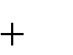When generating new solutions *x*(*t* 1) for a cuckoo *i*, a Lévyflight is performed

*xi*(*t*

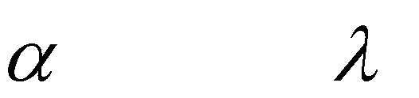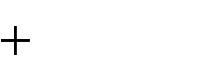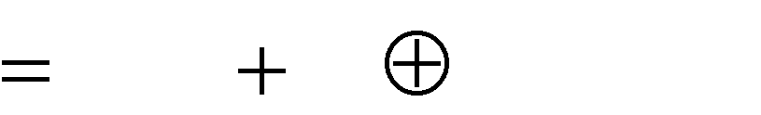

1) *xi*(*t* )

*Levy*( )

(2.28)

Where is the step size which should be associated to theproblem of interests‟ scales; 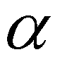

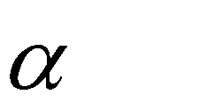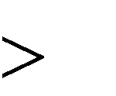

0

can be set to value 1 in most situations Eqn. (2.28) is basically the stochastic equation forrandom walk, which is a Markov chain whose next status orlocation only depends on the current status or location, and thetransition probability, which are the first and second termrespectively. The product 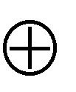 represents the entry wisemultiplication, which is similar to those used in PSO. In termsof exploring the search space, random walk via Lévy flight ismore efficient as its step length is much longer in the long run(Yang and Deb, 2009)

Levy flights essentially provide a random walk while their random steps are drawn from a Levy distribution for large steps (Yang and Deb, 2009).

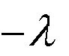Levy *u 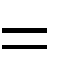t* (2.29)

Where 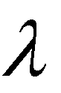is a constant (1 3)

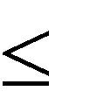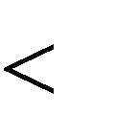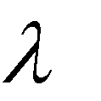

Here, the sequential jumps of a cuckoo fundamentally form arandom walk process with a power law step length distribution with a heavy tail (Yang and Deb, 2009). Numerous new solutions should begenerated by Lévy walk near the best solution obtained, sincethis procedure will speed up the local exploration.

Existing eggs will be replaced with a good quality of new generated ones from their current position through random walks with step size as follows:

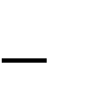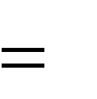*S rand*(*nests*(*randperm*1(*n*),:)

*nests*(*randperm*2(*n*),:))

(2.30)

Where randperm1 and randperm2 are random permutation functions used for different rows permutation applied on nests matrix.

The justification for using cuckoo search algorithm for the DG units and shunt capacitor co- ordination was based on the following features and qualities of the CSA (Yang and Deb, 2009):

1. Exploration by levy flights
2. Mutation by a combination of levy flight and a vectorised solution difference
3. Cross over by selective random permutation and elitism
4. Ability to solve non linearcomplex optimization problems
5. Efficiently solve global optimization problem due to its global convergence properties and presence of levy flight
6. Faster convergence ability (with fewer parameters to be fine tuned).
7. Fewer parameter settings as compared to some other meta- heuristic algorithms

# Performance Metrics

Electricity distribution companies measure their performance by using various types of qualitative and quantitative assessments. They measure achievements of their objectives through monitoring numbers of performance metrics. Performance metrics are parameters that are related to the distribution lines and network such as power loss, voltage profile and voltage stability index, total harmonic distortion etc. these metrics are useful in planning for future development to ensure a high degree of reliability of the distribution system.

Three performance metrics was used in evaluating this research work.

1. Total Active Power Loss: This obtains the losses due to the voltage drop along the branches of the network. It is defined as the product of the square of the branch current and the resistance of the line (Alhaddad and El-Hawary, 2014).

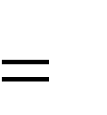

*P br P*



*br* |*B*

|2 *R *

(2.31)

*loss*

*i* 1 *loss*

*i* 1 *i*

1. Voltage Profile: This shows the voltage level of each bus due the features in the network. It is obtained by subtracting the voltage drop across a branch from the bus voltage preceding it (Alhaddad and El-Hawary, 2014).

*V j Vi*

(*Bij*

*Z ij* )

(2.32)

1. Voltage Stability Index: this obtains the weakest voltage buses that are susceptible to contingency situations. It is obtained by using the relationship(Chakravorty and Das, 2015).

*SI* (*r*) =*V* 4 *s*

4(*PX*

*QR*) 2

4*V* 2 *S* (*PR*

*QX* )

(2.33)

# Review of Similar Works

Over the years, researchers have come up with quite a number of approaches foroptimal placement and sizing of DG units and capacitor banks in radial distribution networks. Also, different techniques have been employed in the optimal placement and sizing of DG units and capacitor banks in radial distribution networks. Detailed reviews of some literatures on works accomplished in this area are presented.

**Molaei*et al.*, (2011)** presented the placement and sizing of DG units and capacitor banks in radial distribution networks using Genetic Algorithm (GA). Capacitor bank and DG units were placed in order to achieve the optimal real power losses on IEEE -33 radial test bus and showed promising result in meeting objective of real power loss reduction in the network.However, the algorithm often prematurely converges into local optima and validation of the work was limited to the use of a medium size network.

**Reza et al., (2012)**presented the optimal placement of DGs and capacitors for loss reduction, reliability and voltage improvement in distribution networks using BPSO. The work encompassed a multi objective function which includes reliability index, active power loss index, DGs and capacitors investment cost index and voltage profile index. The effectiveness of the proposed work was examined on IEEE 10 and 33 bus systems and comparative studies were conducted before and after DGs and capacitors installation. However, BPSO may easily get trapped in local optima and thus may converge prematurely to a non optimal result. Also, validation was limited to the use of medium size test networks.

**Sadighmanesh*et al*., (2012)** proposed the placement of DG units and capacitors for multi objective optimization using genetic algorithm. The multi objective function encompassed loss reduction, voltage profile improvement and available transfer capacity increment.

Validation was done on IEEE 41 and simulation results from the work showed better result for (loss reduction and voltage profile improvement) when compared to results from the work of Reza et al., (2012), however, you must need a decent sized population and a lot of generations before you see good results when working with the algorithm and with heavy simulation you can often wait for days for a solution. Also, the work did not address issues of voltage instability that may occur with increasing loads on a network with no index used for voltage stability assessment.

**Tan *et al*., (2012)** proposed a novel cuckoo search algorithm for optimal location and sizing of distributed generation. The work was based on a multi objective function that encompassed real power loss minimization, voltage profile improvement and voltage stabilitymargin**.**Validation was done using two case studies on IEEE 69 radial test bus. However, for a single DG the power factor is not a function of the DG but a function of the load. Since most loads are inductive and consume a lagging reactive power, a single DG may not be able to meet the sudden and gradual demand for reactive power compensation (leading reactive power) to counteract the effect of the inductive loads and raise the load power factor. Furthermore the sizes of DG used violated the power balance criterion, as they were more than the loads on the network.

**Attia *et al.,* (2013)** presented a cuckoo search based algorithm for optimal static shunt capacitors allocation in radial distribution networks. The objective function of their work was adapted to reduce the system peak losses, to support the system voltage profile, and to improve overall system power factor. In their work, the higher potential buses for capacitor placement are initially identified using a power loss index, and at that moment take final decision for the optimal location within the number of buses nominated with a minimum

number of effective locations and with fewer injected VARs. Validation was done on IEEE 33- and 69 bus radial distribution systems. However, their approach only considered one period with the highest peak losses and did not consider the effect of total average peak losses, and such will not give a true reflection of loss reduction in the networks.

**Aman *et al.*, (2013)**presented optimum simultaneous DG and shunt capacitor bank placement and sizing using PSO on the basis of minimization of power system losses. In their work, both approaches were combined together to achieve overall minimum power losses and better voltage regulation. Validation was done on IEEE 12- bus, 30- bus, 33- bus and 69- bus radial distribution system. The approach was characterized by lots of assumptions on the types, cost and sizes of DGs and capacitor banks because the costs of the DG units and capacitor bank vary with time. Furthermore, the optimization technique used is characterized by premature convergence to local optima.

**Reddy and Gunaprasad (2014)** presented a sensitivity based capacitor placement approach using Cuckoo search algorithm for maximum annual savings. The work involved a two stage approach that determines the optimal location and size of capacitors on radial distribution systems needed to improve the voltage profile and reduce active power loss. The loss sensitivity is computed for all the buses in the network, upon which the buses are ranked in descending order of its values with the buses having the highest numerical value considered for capacitor placement. The Cuckoo search algorithm was proposed to find the optimal capacitor sizes. Validation of the work was done on IEEE 15, 34 and 69 bus radial distribution systems and result showed improvement in total power loss after capacitor placement. However, the use of loss sensitivity analysis prevents full analysis of the buses in the

networks and constancy is assumed for the ignored buses. This assumption is often unrealistic and may limit its application in online scenarios.

**Esmaeilian*et al*., (2014)** presented the optimal placement and sizing of renewable (Micro) DG units and shunt capacitors in radial distribution networks based on voltage stability security margin. Genetic algorithm was used in selecting chromosome with best fitness. The work encompassed a multi- objective function which includes DG units and capacitor costs, power losses and voltage stability margins. Validation was done on IEEE-33 bus radial distribution network. Although the simulation in his work showed that optimum operation from network is obtained by the simultaneous placement of multiple DG units of multiple types and capacitors using the optimization technique when compared to the work of Aman *et al.*, (2013). However,fixed sizes of DGs and capacitor banks were used in the work and this consideration limits the accuracy of the result because the fixed sizes might not be the optimal size for the network and may lead to over- voltage situations when compensating at full load conditions.Also voltage profile improvement was no considered in their work

**Meera and Satish(2014)** presented a simultaneous optimal placement of DGs and fixed (series) capacitor banks in radial distribution systems using Back tracking search algorithm (BSA) with the intent of reducing power loss and improving the voltage profile of the systems. Validation was done on IEEE 33 and 69 bus radial distribution systems, and appreciable result was obtained for power loss reduction and voltage profile improvement when compared to the PSO approach for same objective function. However, fixed capacitor banks might notmeet the required kVAr needed under varying loads and the power factor varies as a function of load requirements and thus may not have proper control of voltage at

high loads. Furthermore, voltage stability is not guaranteed in the network as there is varying power factor under high load.

**Harisha and Lakshmi (2015)** presented performance improvement of radial distribution network using capacitors and distributed generation units for the purpose of active power loss minimization and voltage profile improvement. Loss sensitivity factor was calculated from base case load flow to obtain the buses with inflowing power for capacitor placement, and the descending order of the loss sensitivity factors decides the sequence in which the buses are to be considered for compensation. Particle swarm optimization was used for the optimal sizing of the capacitor and DG units and the average, minimum (best), minimum (worst), and standard deviation of the active power loss was computed. However, the process of incorporating the capacitor banks in each of the possible locations predetermined by the LSF to obtain the optimal location is time consuming and computationally complex.

**Chandrasekhar *et al.*, (2016)**presented a hybrid multi-objective shuffled Bat algorithm (MoshBat) for optimal placement and sizing of multi- distributed generations in radial distribution system. Different voltage dependent load models for industrial, residential, commercial were considered for verification purpose. The feasibility of the work was verified with a 33 radial distribution test bus. Furthermore validation was limited to IEEE 33 radial distribution test bus, as larger networks with high loads was not considered for validation of the proposed method and to test the robustness of the MoshBat.

**Ramakrishma and Vasu (2016)** presented the optimal placement and sizing of capacitor and DG in radial distribution network using direct search algorithm (DSA). The objective function of the work includes power loss minimization and energy cost of capacitors and DGs before

and after placements. Validation was done on IEEE 15 and 33 radial test buses. However, the work did not consider improvement of voltage profile which is regarded as one of the most important parameter in optimal DG and Capacitor allocation problems and voltage stability for optimal network performance. Also, validation was limited to the use of two medium size networks with larger networks not considered.

**Yuvaraj, T., (2016)**presented an efficient method for solving the optimal siting and sizing problem of capacitor banks based on cuckoo search algorithm. The objective function of their work was formulated to minimize power loss and to the enhancement of voltage profile and system stability. The voltage stability index (VSI) was implemented to determine the optimal location of the capacitors. The cuckoo search algorithm (CSA) was proposed to determine the optimal size of the capacitor. The feasibility of their proposed method was tested on IEEE 34 and 69 radial distribution systems with different load factors. However, the use of VSI in determining the optimal location of the capacitors is computationally complex procedure and may lack accuracy.

It is evident from literature that the analytical method can provide one of the best solutions to allocation of DGs and capacitor banks but is marred by the large computations (iterations involved) and time consuming procedures when problems become complex, while some heuristic methods on the other hand are characterized by high computational speed, complexity, and the possibility of an algorithm getting trapped in local minima as shortcomings. Furthermore, most of thetechniques used literatures focused on the separate use of DG units and capacitor banks for multi-objective optimization problems without considering their mutual input to the quality of power distributed when simultaneously placed on distribution networks, while some considered their simultaneous placements while

ignoring the aspect of voltage instability and power loss reduction that may occur when they are not properly placed as well seeking for the best combinations that could lead to improved voltage stability and better power loss reduction in networks. In this research work, several simultaneous combinations of DGs and shunt capacitor banks were considered to obtain the best combination that would give an improved voltage stability and better power loss reduction.

# CHAPTER THREE MATERIALS AND METHODS

* 1. **Introduction**

In this chapter, the detailed procedures, methods and materials used in achieving the aim of this research are discussed. This involves the application of the Cuckoo Search Algorithm in order to optimally site and size Micro-DGs and Shunt capacitor banks ina radial distribution network.

# Materials

The materials employed for the actualization of this research are as follows:

# Personal Computer

All simulation analyses were carried out using HP EliteBook 6930p with the following specifications:

* + - 1. Intel(R) Core(TM) 2Duo CPU P8700;
      2. 2.5.3 GHz 64-based processor;
      3. 4.00GB installed memory (RAM) and;
      4. 32-bit windows 8 Operating system (OS)

# MATLAB 2013a Software

Simulations were performed under virtual platform using MATLAB 2013a for analysis (Mathworks Corporation). The details of the programs developed are provided in the appendices.

# Distribution Network Parameters

The standard IEEE 33 and 69- bus and a dedicated 50-bus Canteen Feeder in Zaria distribution network with the following network parameters: slack bus, active and reactive powers and bus voltages in Appendix A1, A2 and A3 have been adopted for this research.

# Methods

The following steps which comprises the methods adopted for this research as follows

# Acquisition of Relevant Data

Relevant network data for the standard IEEE 33 and 69- bus radial distribution network and the 50- bus Canteen Feeder in Zaria distribution network used are:

* + - 1. Line data (resistance and reactance of lines in ohms)
      2. Bus data (active and reactive power demand of lines in kW and kVAr respectively)
      3. Network base voltage
      4. Sending and receiving end bus numbers and voltages

# Base- case Power Flow Analysis

The pseudo-code used in developing the algorithm for running the base case power flow analysis of the distribution networks are presented below.

* + - 1. Load the network line and bus data
      2. Compute the load current at each bus of the network using equation (2.1)
      3. Formulate the bus injected to Branch Current matrix (BIBC)
      4. Compute the current flow

*I B* (*ik* )

at each branch of the network using equation (2.2)

* + - 1. Formulate the Branch current bus voltage matrix and network Z-bus
      2. Obtain the voltage at each bus of the network using equation (2.4)
      3. Compute the line losses ( *Pik* (*loss*) and *Qik* (*loss*) ) using equations (2.12) and (2.13)

# Application of the Cuckoo Search Algorithm

The following give a brief outline to the steps used for the application of the CSA to the networks for optimal placement of the DG units and capacitor banks, for power loss, improvement of voltage profile and voltage stability.

* + - 1. Load the load line and bus data of IEEE 33 and 69 bus radial distribution network and 50 Bus Canteen Feeder in Zaria distribution network
      2. Perform base case power flow analysis for the IEEE 33 and 69 bus radial distribution network and 50 Bus Canteen Feeder in Zaria distribution network
      3. Initialize the Cuckoo parameters
      4. Determine the optimal location and sizes of the DGs and shunt capacitor banks for standard IEEE- 33, 69 radial distribution networks and on 50- bus Canteen Feeder in Zaria distribution network.
      5. Modelling the steps required for determining the separate and simultaneous DG and CB allocation.
      6. Formulation of multi-objective function for power loss minimization, voltage profile and voltage stability improvement.
      7. Applying the cuckoo search algorithm to the formulated multi-objective function
      8. Perform final power flow analysis with the optimal sizes of DG and CBS incorporated at the optimum bus

# Comparison of Results obtained from analysis

The results obtained from the simultaneous allocation of the DGs and CBs were compared with that obtained from the separate (individual) allocation of DGs and CBs on the networks via:

* + - 1. Bar- chart representation (voltage and VSI profile improvement)
      2. Graphical representation (active and reactive power loss reduction)
      3. Tabular representation (percentage active and reactive power loss reduction, bus locations and sizes of DGs and CBs, etc)

# Distributed Generator Model

In the different types of DG models as discussed in subsection 2.2.5, the DG employed for this research, is that which injects active power alone and requires a power electronic interface to be connected to the grid. It is a generator smaller in size (based on power ratings) with a small output power compared to the conventional power generator and was modeled as a PQ node. It is classified as type one DG which is capable of supplying active power only. The PQloadmodel is found to be efficient and easily applicable in distribution system load flow analysis and is treated as negative load. The PQ load model was used to reduce the total active power loss and improve the voltage profile of networks. The PQ model of a DG is given by equation (3.1)

*PiDG Pi*, *D*

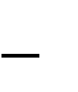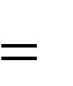

(3.1)

# Model of DG units and Shunt Capacitors in Radial Distribution System

By considering the types of DG units and benefits of a shunt capacitor banks as discussed in subsection 2.2.4.2 and 2.2.6.1 respectively, the DG units in this work are modeled such as to

provide active power injections while the shunt capacitors will be modeled as a negative *Qload* such as to provide reactive power injection. The active and reactive power injections from the DG units and shunt capacitor banks to the *i th* bus are modeled as follows:

*Pi PDGi*

*PLi*

(3.2)

*Qi Qcapi*

*QLi*

(3.3)

Consider Figure (3.1) with DG and capacitors installed simultaneously on a distribution network

Where,

*Vo* and*Vn*

are the respective sending and receiving end voltages

*Rij* and *jX ij* are the respective resistance and reactance at node i and j

Sending End Receiving End

*VO Vi*

*I i*, *j*

*Pi 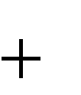jQi V j Vn*

*Pn*

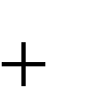

*Rij*

*jX ij*

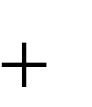

*Pj jQ j*



*jQn*



DG Cap

*PLi jQ Li PLj jQ Lj*

Figure 3.1: Distribution System with DG unit and Shunt Capacitor Installation at Any Bus

# Objective Function

In mathematical terms,

Objective Function: To minimize total active power loss

Min

*F* (*x*)

*n*

*fi* (*x*)

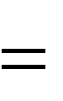

*i* 1

(3.4)

Subject to the following constraints

1. Equality constraints

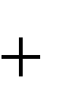Power balance constraints: the summation of the power from the grid and that from the distributed generation and capacitors must be equal to the sum of the load and the losses in the system

*PSUB*

*n*

*PDG*,*i*



*i* 1

*n*

*PL*,*i*



*i* 1

*PT* , *Loss*

(3.5)

*QSUB*

*n*

*QDG*,*i*



*i* 1

*n*

*QCap* ,*i*



*i* 1

*n*

*QLi*



*i* 1

*QT* ,*Loss*

(3.6)

1. Inequality constraints:

Voltage limits: The voltage at various buses should be maintained within the acceptable

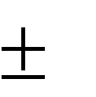limits. A most acceptable voltage variation is within the range of 5% (Heydari*et al.,* 2013).

min

*V*

*V*

*i i*

max

*i*

*V*

(3.7)

Power limits of DG unit: The active power size of DG at *i th* bus is maintained within the

acceptable limits by equation (3.8)

*PDG*,*i*

min

 *PDG*,*i*

 *PDG*,*i*

max

(3.8)

Power limits of Capacitors: The reactive power size of capacitor at the

*i th*

bus are maintained

within the acceptable limits by equation (3.9)

*QCap*,*i*

min

 *QCap* ,*i*

 *QCap*,*i*

max

(3.9)

The constraints presented in equations (3.5), (3.6), (3.7), (3.8) & (3.9) must be satisfied in order to meet the required objectives.

# The Cuckoo Search Algorithm

The Cuckoo search algorithm (CSA) is a nature-inspired meta-heuristic optimization algorithm, inspired by the brood parasitism of some cuckoo species in combination with the levy flight behavior of some birds and fruit flies. The flowchart for implementing the algorithm is shown in Figure2.8, page 33.

Based on the positive inferences associated with the Cuckoo search algorithm as outlined in section 2.2.10, the following parameters were selected for simulation using the algorithm:

1. Number of cuckoos (Nests) = Maximum iteration = 30
2. Discovery rate of alien eggs/ solutions (pa) =0.25
3. Levy coefficient ( ) = 1.5
4. 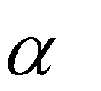Step size ( ) = 1

These parameters were chosenbecause most literatures on CSA in the areas of optimal location and sizing of DGs and CBs make use of these parameters which through iteration have shown to be efficient for Power flow convergence.

* 1. **Cuckoo Search Algorithm for Simultaneous DG and Capacitor Bank Placement** The conventional Cuckoo search algorithm was applied to the optimal sizing and location of DG units and shunt capacitor banks in order to obtain an optimal result for the objective function in equation (3.4).

The steps involved in the algorithm are given as follows:

1. Input network line and bus data
2. Input CSA parameters
3. Run base case power flow
4. Determine candidate DG and Capacitor bank size for each bus
5. Determine the best DG location
6. Determine the best sizes and locations as the optimal result

The flow chart for the simultaneous DGs and CBs placement algorithm is shown in Figure 3.2

**Yes**



Initializing population of host nest (cuckoos). The cuckoo positions represent the DG and CB sizes and locations

Run power flow for base case power loss and voltage at each bus

Calculate the voltage stability index (VSI) for each node using equation (2.27) _



Run final Power Flow after DG and CBS incorporation and Print optimal DG and CB sizes

Select optimal DG and CB sizes and locations

Abandon a fraction *pa* of worst nests and build new ones at new locations via Levy flights

Check stop

criterion?

**No**



Start

Input network data (Line data and bus data) and Cuckoo parameters



Replace better quality Cuckoo to a nest choose randomly

Evaluate fitness function value (minimum loss) for each cuckoo

**Yes**



End

Print *Ploss* , *Voltage* and *VSI* values

Figure 3.2: Flowchart for the Simultaneous Placement and Sizing of DGs and Capacitor Banks using CSA

# The Voltage Stability Index (VSI)

The voltage stability index as discussed in section 2.2.7.1 is an index that was used in this work as an indicator for voltage stability in the networks before and after the allocation of the DG units and Shunt capacitor banks. With this index, we were able to obtain a value for the weakest voltage bus in the networks before the DG units and shunt capacitors placements as well as values showing improvement after DG units and shunt capacitors placements. Plots for voltage stability index for the 33-bus, 69-bus and Zaria (canteen) distribution network were also done. Equation (2.27) presented the mathematical formulation adopted for the computation of the VSI.

# Standard Test Systems

Two standard distribution systems which are the IEEE-33 and 69 buses have been selected for testing and validating the algorithm. This is based on the fact that they have stood out as standard benchmarks in Electrical Engineering for validation of test results.

# IEEE 33 Bus System

This standard test bus as described in subsection 2.2.8.1 is a thirty three bus system which has thirty- three buses and thirty-two sections because the first bus is solely a generator bus. The total loads for this system are 3.72 MW and 2.3 MVAr. The substation voltage is 12.66 kV and the base power is 10 MVA (Yuvaraj *et al*.,2015).The single line diagram of the system is shown in Figure 2.5 and the line and bus data are shown in appendix A1 respectively.

# IEEE 69 Bus System

The standard 69 test busas described in subsection 2.2.8.2 is a sixty-nine bus system which has sixty - nine sections. The total real and reactive power demands are 3.82 MW and 2.69 MVAr respectively while the substation voltage is 12.66 kV and the base power is 10 MVA (Yuvaraj *et al*.,2015). The single line diagram of the system is shown in Figure 2.6 and the line and bus data are shown in appendix A2 respectively.

# Zaria Distribution Network

The Zaria distribution networkas described in subsection 2.2.8.3 is equipped with 8 feeders namely: RLY/NTC feeder, Sabon-Gari feeder, Gaskiya feeder, Canteen feeder, Zaria-City feeder, Wusasa feeder, Kofar-Kibo feeder and Teaching-Hospital feeder. The Canteen feeder which has 50-buses and 49-branches was adopted in this research based on the available historical records from the Power Holding Company of Nigeria (PHCN) Zaria Business District. The network line voltages, base MVA, total real and reactive load are given as 11 KV, 100MVA, 0.388 MW and 0.294 MVAr respectively (Abubakar, 2014). The single line diagram of the system is shown in Figure 2.7 and the line and bus data are shown in appendix A3 respectively.

# Performance Evaluation

Power loss reduction, voltage profile and voltage stability improvement are the performance metrics used in order to compare the results for the separate DG units and shunt capacitor banks allocation to the simultaneous DG units and shunt capacitor banks allocation in networks using the proposed CSA based approach.

# Introduction

**CHAPTER FOUR RESULTS AND DISCUSSION**

In this chapter, results obtained are presented and discussed. The Cuckoo search algorithm was used for the optimal location and sizing of the DGs and Capacitor banks for the test buses. All simulations were carried out on Matlab R2013a environment and the times of simulation for each process were noted.

# IEEE 33 Bus Test System

The bus and line data for the standard IEEE 33- bus system as shown in appendix A1 were used in modeling the system and the base case voltage for each bus were noted. The proposed cuckoo search algorithm described in section 3.8 was used in obtaining the optimal DG and Shunt capacitor bank location and size for the 33-bus network. The bus voltages, total power loss (real and reactive), voltage profile and voltage stability index before and after separate and combined DG and shunt capacitor bank placements were noted for comparison.

# Base Case System

Initially, load flow was run on the 33 bus system to obtain the voltage at each bus, the total power loss and voltage stability index. This is the base case voltage, VSI values and power loss (active and reactive) of the system before the integration of the DG units into the system. The base case real and reactive power loss was found to be 79kW and 64 kVAr respectively. The base case voltages and VSI values for each bus for 33 Bus system is presented in Table 4.1

Table 4.1: Base Case Voltage and VSI values for 33 Bus Network

|  |  |  |
| --- | --- | --- |
| Bus Number | Base case V (PU) | Base case VSI (PU) |
| 1 | 1.0000 | 1.0000 |
| 2 | 0.9970 | 0.9974 |
| 3 | 0.9815 | 0.9742 |
| 4 | 0.9708 | 0.9168 |
| 5 | 0.9616 | 0.8818 |
| 6 | 0.9427 | 0.8421 |
| 7 | 0.9340 | 0.7984 |
| 8 | 0.9234 | 0.7195 |
| 9 | 0.9070 | 0.7111 |
| 10 | 0.8922 | 0.6609 |
| 11 | 0.8906 | 0.6313 |
| 12 | 0.8882 | 0.6233 |
| 13 | 0.8801 | 0.6116 |
| 14 | 0.8778 | 0.5976 |
| 15 | 0.8763 | 0.5843 |
| 16 | 0.8748 | 0.5793 |
| 17 | 0.8727 | 0.5727 |
| 18 | 0.8721 | 0.5672 |
| 19 | 0.9968 | 0.5758 |
| 20 | 0.9803 | 0.9548 |
| 21 | 0.9705 | 0.9166 |
| 22 | 0.9610 | 0.8766 |
| 23 | 0.9812 | 0.8434 |
| 24 | 0.9675 | 0.8348 |
| 25 | 0.9583 | 0.7860 |
| 26 | 0.9426 | 0.8397 |
| 27 | 0.9338 | 0.7846 |
| 28 | 0.9229 | 0.7448 |
| 29 | 0.9060 | 0.7092 |
| 30 | 0.8904 | 0.6878 |
| 31 | 0.8891 | 0.6029 |
| 32 | 0.8875 | 0.6154 |
| 33 | 0.8798 | 0.6205 |

The total base case and VSI values for the 33 bus test system are 30.6105 and 24.6624 per unit.

# Effect of CapacitorAllocation

The CSA based approach was used for the optimal allocation of 3 Capacitor units for the 33 bus system and the sizes and locations of the capacitors were found to be 620.18 kVAr at bus 30, 189.98 kVAr at bus 25 and 188.29 kVAr at bus 24 respectively. The total real and reactive power loss after capacitor allocation was relatively reduced to 37 kWand 30kVAr respectively from base case values, which indicate 53.16% and 53.13% reduction as compared to the base case real and reactive power loss.

Table 4.2: Improved Voltage and VSI for 33 Bus Network after Capacitor Allocation

|  |  |  |
| --- | --- | --- |
| Bus Number | V Improved  (PU) | VSI Improved  (PU) |
| 1 | 1.0000 | 1.0000 |
| 2 | 0.9981 | 0.9974 |
| 3 | 0.9884 | 0.9757 |
| 4 | 0.9817 | 0.9254 |
| 5 | 0.9761 | 0.8952 |
| 6 | 0.9686 | 0.8597 |
| 7 | 0.9692 | 0.8274 |
| 8 | 0.9623 | 0.7558 |
| 9 | 0.9553 | 0.7505 |
| 10 | 0.949 | 0.7092 |
| 11 | 0.9479 | 0.6872 |
| 12 | 0.9463 | 0.6790 |
| 13 | 0.9438 | 0.6689 |
| 14 | 0.9432 | 0.6540 |
| 15 | 0.9424 | 0.6387 |
| 16 | 0.9417 | 0.6336 |
| 17 | 0.9411 | 0.6281 |
| 18 | 0.9408 | 0.6215 |
| 19 | 0.9980 | 0.6292 |
| 20 | 0.9879 | 0.9567 |
| 21 | 0.9816 | 0.9252 |
| 22 | 0.9760 | 0.8906 |
| 23 | 0.9882 | 0.8607 |
| 24 | 0.9794 | 0.7905 |

|  |  |  |
| --- | --- | --- |
| Bus Number | VImproved (PU) | VSI Improved (PU) |
| 25 | 0.9738 | 0.7512 |
| 26 | 0.9685 | 0.8600 |
| 27 | 0.9692 | 0.8122 |
| 28 | 0.9620 | 0.7813 |
| 29 | 0.9550 | 0.7496 |
| 30 | 0.9483 | 0.6857 |
| 31 | 0.9474 | 0.6644 |
| 32 | 0.9461 | 0.6723 |
| 33 | 0.9438 | 0.6766 |

# Voltage andVSI Profile after Capacitor Allocation

The base case and improved voltages shown for each bus in Table 4.1 and Table 4.2 respectively were plotted against the respective bus numbers in order to see the improvement in voltage profile after capacitor allocation and sizing was done with 3 capacitors installation.

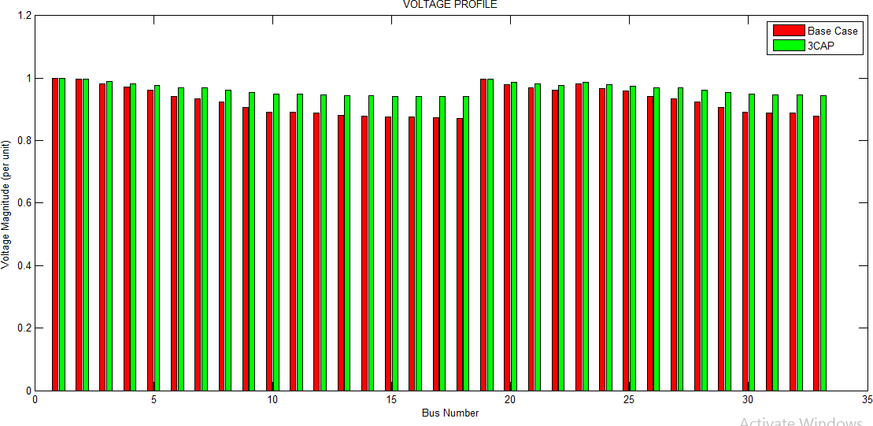

Figure 4.1 Voltage Profile for 33 Bus Network after Capacitor Allocation

Figure 4.1 show that the placement of capacitors has caused an improvement in the voltage profile of the 33 bus network. The bus with the lowest voltage which is bus 18 had its voltage increased from 0.8721 to 0.9411 per unit voltage. The red line indicates the base case voltage trend while the green line shows the improved voltage after capacitor allocations. The optimal allocation of capacitors therefore caused a 3.95% improvement in the average voltage profile for the 33 bus test system as compared to the base case voltage with a value of 31.8211 per unit. For VSI analysis, the base case and improved VSI values shown for each bus in Table

4.1 and 4.2 respectively were plotted against the respective bus numbers in order to see the improvement in VSI values at each bus before and after capacitor allocation and sizing was done with 3 capacitors.

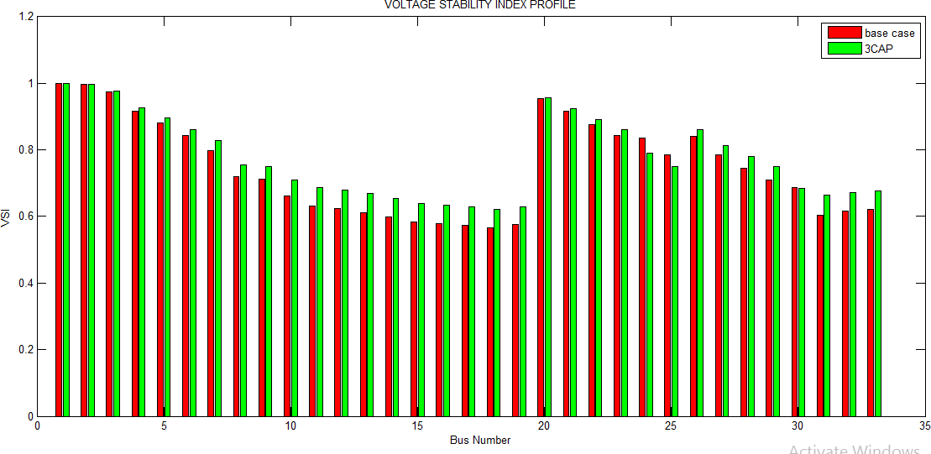

Figure 4.2: VSI Profile for 33 Bus Network after Capacitor Allocation

Figure 4.2 show that the placement of capacitors has caused an improvement in the VSI values of the 33 bus network. The bus with the weakest VSI value which is bus 19 had its VSI value increased from 0.5758 to 0.6292 per unit. The red line indicates the base case VSI trend

while the green line shows the VSI after capacitor placement. The optimal allocation of the capacitors therefore caused a 3.85% average improvement in the VSI of the system compared to the base case VSI with a value of 25.6135 per unit.

# Effect of DG Allocation

The CSA based approach was used for the optimal allocation of 3 DG units for the 33 bus system and the sizes and locations of the DGs were found to be 501.89 kW at bus 25, 100.73 kW at bus 30 and 179.47 kW at bus 29 respectively. The total real and reactive power loss after DG allocation was relatively reduced to 54 kW and 44 kVAr respectively which indicate 31.65% and 31.25% reduction as compared to the base case real and reactive power loss.

Table 4.3: Improved Voltage and VSI after DG Allocation

|  |  |  |
| --- | --- | --- |
| Bus Number | V Improved  (PU) | VSI Improved  (PU) |
| 1 | 1.0000 | 1.0000 |
| 2 | 0.9987 | 0.9974 |
| 3 | 0.9921 | 0.9764 |
| 4 | 0.9877 | 0.9305 |
| 5 | 0.9843 | 0.9036 |
| 6 | 0.9783 | 0.8716 |
| 7 | 0.9794 | 0.8359 |
| 8 | 0.9737 | 0.7574 |
| 9 | 0.9685 | 0.7563 |
| 10 | 0.964 | 0.7144 |
| 11 | 0.9632 | 0.6939 |
| 12 | 0.9621 | 0.6862 |
| 13 | 0.9597 | 0.6743 |
| 14 | 0.9591 | 0.6599 |
| 15 | 0.9583 | 0.6467 |
| 16 | 0.9576 | 0.6413 |
| 17 | 0.957 | 0.6337 |
| 18 | 0.9567 | 0.6283 |
| 19 | 0.9986 | 0.6381 |

|  |  |  |
| --- | --- | --- |
| Bus Number | VImproved (PU) | VSI Improved (PU) |
| 20 | 0.9916 | 0.9568 |
| 21 | 0.9876 | 0.9303 |
| 22 | 0.9842 | 0.8981 |
| 23 | 0.9919 | 0.8732 |
| 24 | 0.9862 | 0.8470 |
| 25 | 0.9858 | 0.9533 |
| 26 | 0.9782 | 0.8785 |
| 27 | 0.9794 | 0.8225 |
| 28 | 0.9734 | 0.7836 |
| 29 | 0.9682 | 0.7537 |
| 30 | 0.9634 | 0.7807 |
| 31 | 0.9627 | 0.6648 |
| 32 | 0.9624 | 0.6988 |
| 33 | 0.9597 | 0.6860 |

# Voltage and VSI Profileafter DG Allocation

The base case and improved voltage after DG allocation shown for each bus of the 33 bus network in Table 4.1 and 4.3 respectively were plotted against their respective bus numbers in order to see the improvement in voltage profile after 3 DG allocation.

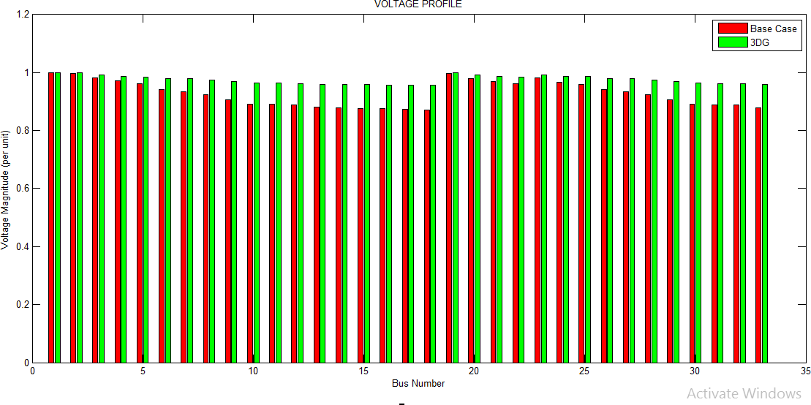

Figure 4.3: Voltage Profile for 33 Bus Network after DG Allocation

Figure 4.3 show that the allocation of the DG units has caused an improvement in the voltage profile of the 33 bus network. The bus with the lowest voltage which is bus 18 had its voltage increased from 0.8721 to 0.9567 per unit voltage. The red line indicates the base case voltage trend while the green line shows the voltage profile after DG placement. The optimal allocation of DG units therefore caused a 5.11% improvement in the overall voltage profile of the system as compared to the base case voltage with a value of 32.1737 per unit. For VSI analysis, the base case and improved VSI values shown for each bus in Table 4.1 and 4.3 respectively were plotted against the respective bus numbers in order to see the improvement in VSI after DG allocation.

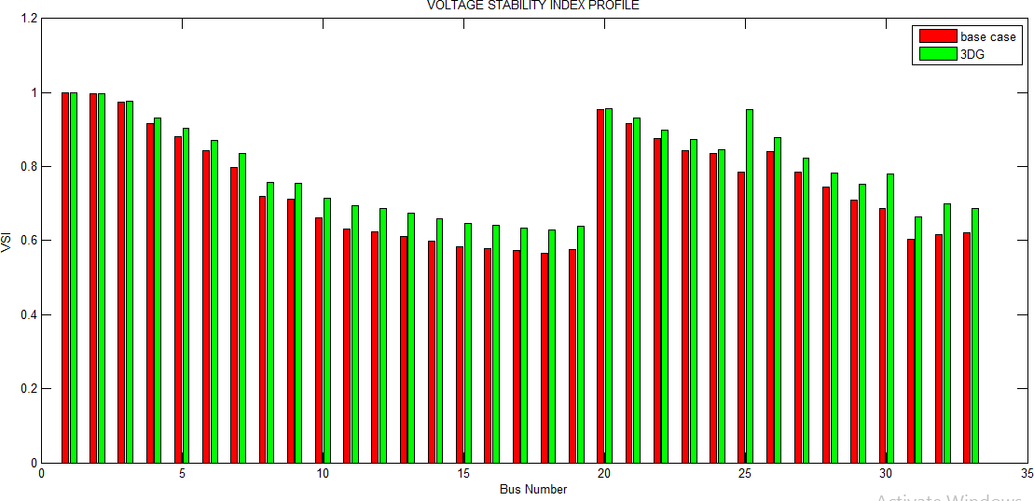

Figure 4.4: VSI Profile for 33 Bus Network after DG Allocation

Figure 4.4 show that the allocation of the DG units has caused an improvement in the VSI values of the 33 bus network. The bus with the weakest VSI value which is bus 19 had its VSI increased from 0.5758 to 0.6381 per unit. The red line indicates the base case VSI trend while the green line shows the VSI after DG placement. The optimal allocation of the DG units

therefore caused a 6.13% improvement in the overall VSI of the system compared to the base case VSI with a value of 26.6073 per unit.

# Allocation of Multiple DG and Capacitor Bank Combinations Simultaneously

The CSA based approach was used for the optimal location and sizing of several combinations of DG and Capacitor banks for the 33 bus system. The several different combinations include CCD, CDC, DCC, DDC, DCD and CDD combinations. The optimal sizes and locations for the combinations as well as their reductions in active and reactive power loss are as follows:

For CCD combination the optimal size and locations for the DGs and capacitor banks are

558.31 kVAr at bus 30, 169.84 kVAr at bus 25 and 198.05 kW at bus 32. With this combination there was a reduction of base case active and reactive power loss from 79 kW to 33 kW and from 64 kVAr to 27kVAr. For CDC combination, the optimal size and locations for the DG and capacitor banks are 596.07 kVAr at bus 30, 296.52 kW at bus 25 and 199.17 kVAr at bus 25 reducing the base case active and reactive power loss from 79 kW to 33 kW and from 64 kVAr to 27 kVAr respectively. For DCC combination, the optimal sizes and locations of the DGs and capacitor banks are 125.44 kW at bus 32, 556.74 kVAr at bus 30 and

197.93 kVAr at bus 25 reducing the base case active and reactive power loss from 79 kW to 34 kW and from 64 kVAr to 28 kVAr respectively. For CDD combination, the optimal sizes and locations of the DGs and capacitor banks are 639.87 kVAr at bus 30, 128.14 kW at bus 32 and 571.92 kW at bus 25 reducing the base case active and reactive power loss from 79 kW to 30 kW and from 64 kVAr to 25 KVAr respectively. For DCD combination, the optimal sizes and locations of the DGs and capacitor banks are 651.57 kW at bus 25, 591.34 kVAr at bus 30

and 185.90 kW at bus 30 reducing the base case active and reactive power loss from 79 kW to 31 kW and from 64 kVAr to 26 kVAr respectively. Finally, for the DDC combination the optimal sizes and locations of the DGs and capacitor bank are 515.69 kW at bus 25, 214.01 kW at bus 32 and 572.27 kVAr at bus 30 reducing the base case active and reactive power loss from 79 kW to 29 kW and from 64kVAr to 24 kVAr.

Based on power loss reduction capability, improvement of voltage and VSI values from base case values the DDC combination was chosen as the best combination among the several other combinations and used for a comparative analysis between its results from simulations and that obtained from the allocation of 3 DGs and 3 Caps on 33 bus test system. Table 4.4 shows the voltage and VSI profile after simultaneous DG and capacitor bank placement

Table 4.4: Improved Voltage and VSI after Simultaneous DG - CB Allocation

|  |  |  |
| --- | --- | --- |
| Bus Number | V Improved  (PU) | VSI  Improved(PU) |
| 1 | 1.0000 | 1.0000 |
| 2 | 0.9989 | 0.9974 |
| 3 | 0.9936 | 0.977 |
| 4 | 0.9902 | 0.9333 |
| 5 | 0.9878 | 0.9078 |
| 6 | 0.9855 | 0.8776 |
| 7 | 0.9891 | 0.8481 |
| 8 | 0.9853 | 0.7761 |
| 9 | 0.9842 | 0.7743 |
| 10 | 0.984 | 0.7365 |
| 11 | 0.9832 | 0.7187 |
| 12 | 0.9821 | 0.7111 |
| 13 | 0.9797 | 0.7013 |
| 14 | 0.9791 | 0.6863 |
| 15 | 0.9784 | 0.6713 |
| 16 | 0.9777 | 0.6659 |
| 17 | 0.9771 | 0.6596 |

|  |  |  |
| --- | --- | --- |
| Bus Number | V Improved  (PU) | VSI Improved  (PU) |
| 18 | 0.9768 | 0.6533 |
| 19 | 0.9989 | 0.6618 |
| 20 | 0.9931 | 0.9576 |
| 21 | 0.9901 | 0.933 |
| 22 | 0.9877 | 0.9027 |
| 23 | 0.9934 | 0.8788 |
| 24 | 0.9887 | 0.851 |
| 25 | 0.9888 | 0.9851 |
| 26 | 0.9854 | 0.8858 |
| 27 | 0.989 | 0.8336 |
| 28 | 0.985 | 0.8022 |
| 29 | 0.9839 | 0.7728 |
| 30 | 0.9851 | 0.7172 |
| 31 | 0.9827 | 0.6932 |
| 32 | 0.9823 | 0.7254 |
| 33 | 0.9797 | 0.7115 |

# Voltage Profile and VSI after simultaneous DG and CB allocation

The base case and improved voltage after simultaneous DG and capacitor allocation shown for each bus of the 33 bus network in Table 4.1 and 4.4 respectively were plotted against their respective bus numbers in order to see the improvement in voltage profile after simultaneous DG and CB allocation.

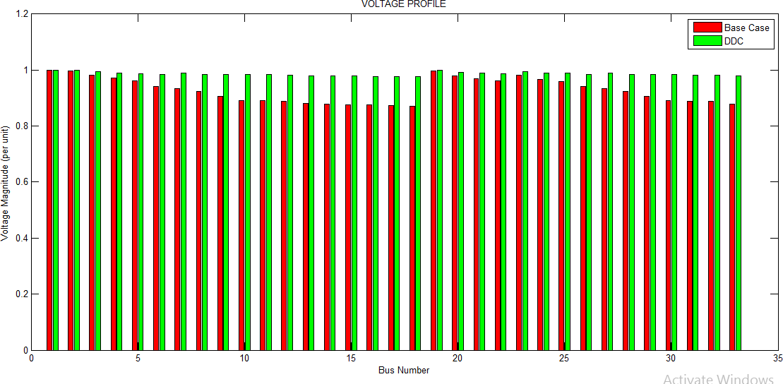

Figure 4.5: Voltage profile for 33 Bus Network after Simultaneous DG and CB Allocation Figure 4.5 show that the simultaneous allocation of DG and CB units has caused an improvement in the voltage profile of the 33 bus network. The bus with the lowest voltage which is bus 18 had its voltage increased from 0.8721 to 0.9768 per unit voltage. The red line

indicates the base case voltage trend while the green line shows the voltage profile after simultaneous DG and CB allocation. The optimal allocation of DG units therefore caused a 6.32% improvement in the overall voltage profile of the system as compared to the base case voltage with value of 32.5465 per unit. For VSI analysis, the base case and improved VSI values shown for each bus in Table 4.1 and 4.4 respectively were plotted against the respective bus numbers in order to see the improvement in VSI after simultaneous DG and CB allocation.

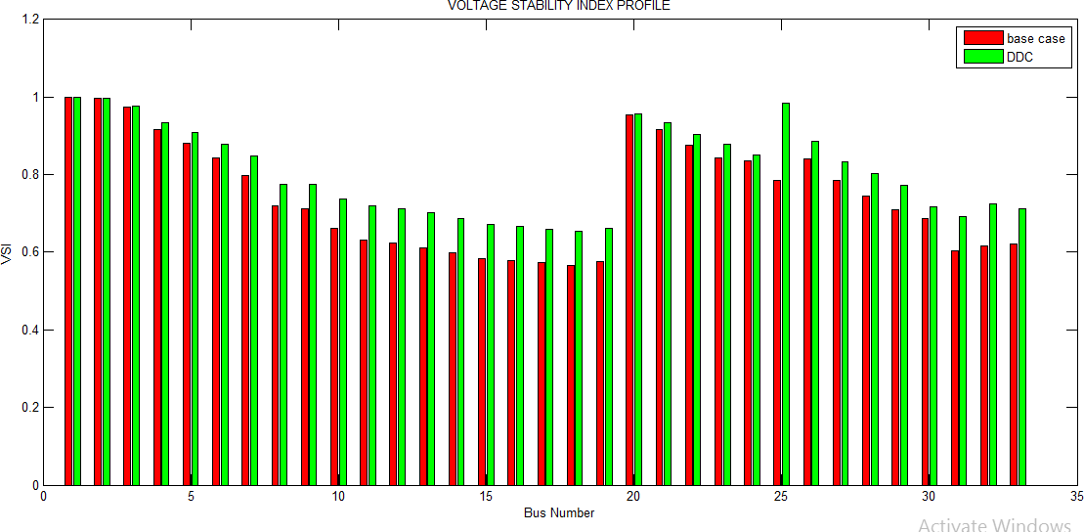

Figure 4.6: VSI for 33 Bus Network after Simultaneous DG and CB Allocation

Figure 4.6 show that the allocation of the DG units has caused an improvement in the VSI values of the 33 bus network. The bus with the weakest VSI value which is bus 19 had its VSI increased from 0.5758 to 0.6618 per unit. The red line indicates the base case VSI trend while the green line shows the VSI after simultaneous DG and CB allocation. The optimal allocation of the DG units therefore caused a 7.89% improvement in the overall VSI of the system compared to the base case VSI with a value of 26.1732 per unit.

# Power Loss Reduction Profiles for 33 -Bus System

A profile plot for 33 bus system was done to pictorially show power loss (active and reactive) reduction via the simultaneous and individual use of DGs and CBs. Figure 4.7 and 4.8 presents the active and reactive power loss reduction profiles.

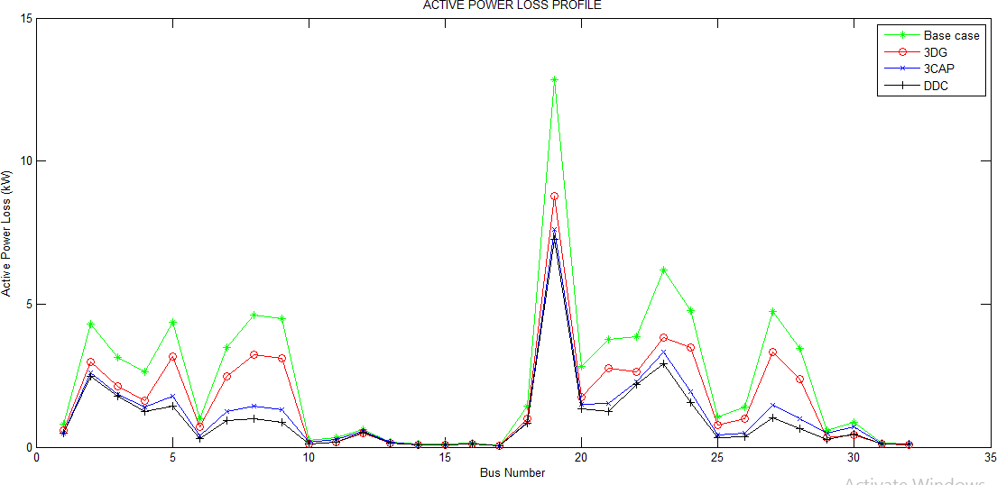

Figure 4.7: Active Power Loss Reduction Profile for 33 -Bus System

As depicted in Figure 4.7 the base case active power loss is represented by the green color, the red color indicates the active power loss reduction after 3 DG allocation, the blue color indicates active power loss after 3 CB allocation while the black color indicates active power loss reduction after simultaneous DG and CB allocation. As seen from the active power loss profile, the simultaneous allocation of DGs and CBs (black color) gave a better active power loss reduction to the separate/ individual placement of DGs and CBs.

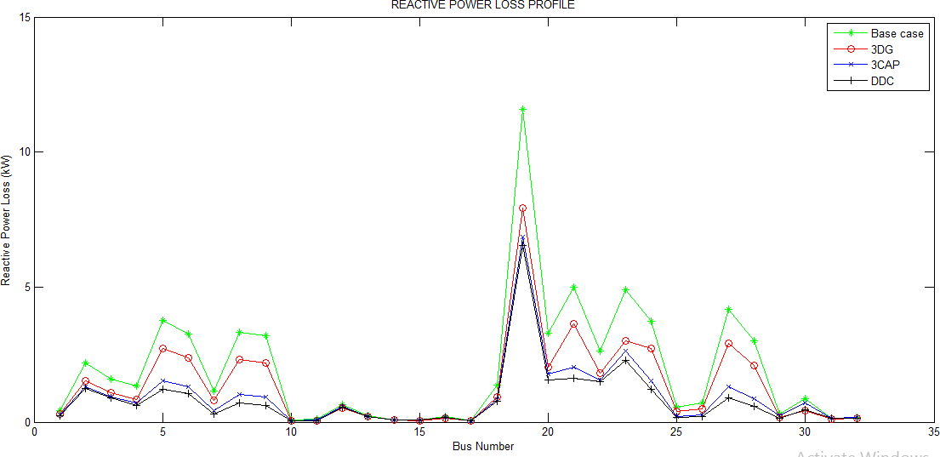

Figure 4.8: Reactive Power Loss Reduction Profile for 33- Bus System

As depicted in Figure 4.8 the base case reactive power loss is represented by the green color, the red color indicates the reactive power loss reduction after 3 DG allocation, the blue color indicates reactive power loss after 3 CB allocation while the black color indicates reactive power loss reduction after simultaneous DG and CB allocation. As seen from the reactive power loss reduction profile, the simultaneous allocation of DGs and CBs (black color) gave a better reactive power loss reduction to the separate allocation of DGs and CBs.

# Summary of Result for 33- Bus System

The DDC combination which was chosen to be the best combination result was compared to results from 3 DGs and 3 CBs allocation on the 33 bus system and the result is summarized in Table 4.5

Table4.5: Summary of Result for 33 -Bus System

|  |
| --- |
| **Particulars Base Case 3 DGs 3 CBs Simultaneous** |
| **PL (active)** 79 kW 54 kW 37 kW 29 kW  **QL (reactive)** 64 kVAr 44 kVAr 30 kVAr 24 kVAr  **Total V** 30.6105 p.u 32.1737 p.u 31.8211 p.u 32.5465 p.u  **% PL** - 31.65% 53.16% 63.29%  **% QL** - 31.25% 53.13% 59.38%  **% V** - 5.11% 3.95% 6.32%  **% VSI** - 6.13% 3.86% 7.89% |

# IEEE 69- Bus Test System

The bus and line data for the standard IEEE 69 bus system as shown in appendix A2 were used in modeling the system and the base case voltage for each bus were noted. The proposed cuckoo search algorithm described in chapter three was used in obtaining the optimal DG and Shunt capacitor bank location and size for the 69-bus network. The bus voltages, total power loss (real and reactive), voltage profile and voltage stability index before and after separate and combined DG and shunt capacitor bank placements were noted for comparison.

# Base Case System

Initially, load flow was run on the 69 bus system to get the voltage at each bus, the total power loss and voltage stability index. This is the base case voltage, VSI values and power loss (active and reactive) of the system before the integration of the DG units into the system. The

base case real and reactive power loss was found to be 70kW and 48kVAr respectively. While the base case voltages and VSI values at each bus is presented in Table 4.6

Table 4.6: Base Case Voltage and VSI values for 69 Bus Network

|  |  |  |
| --- | --- | --- |
| Bus  Number | V BASE CASE  (PU) | VSI BASE (PU) |
| 1 | 1.0000 | 1.0000 |
| 2 | 1.0000 | 1.0000 |
| 3 | 0.9999 | 1.0000 |
| 4 | 0.9998 | 1.0001 |
| 5 | 0.9988 | 1.0002 |
| 6 | 0.9885 | 0.9991 |
| 7 | 0.9792 | 0.9715 |
| 8 | 0.9780 | 0.9589 |
| 9 | 0.9774 | 0.9597 |
| 10 | 0.9704 | 0.9482 |
| 11 | 0.9690 | 0.9293 |
| 12 | 0.9647 | 0.8886 |
| 13 | 0.9601 | 0.925 |
| 14 | 0.9561 | 0.9142 |
| 15 | 0.9523 | 0.9089 |
| 16 | 0.9506 | 0.8901 |
| 17 | 0.9496 | 0.8922 |
| 18 | 0.9495 | 0.9000 |
| 19 | 0.9490 | 0.9001 |
| 20 | 0.9487 | 0.8988 |
| 21 | 0.9482 | 0.8796 |
| 22 | 0.9482 | 0.8971 |
| 23 | 0.9481 | 0.8971 |
| 24 | 0.9480 | 0.8923 |
| 25 | 0.9478 | 0.8966 |
| 26 | 0.9478 | 0.8941 |
| 27 | 0.9477 | 0.8949 |
| 28 | 0.9999 | 0.8959 |
| 29 | 0.9998 | 0.9982 |
| 30 | 0.9988 | 1.0002 |
| 31 | 0.9885 | 0.9997 |
| 32 | 0.9792 | 0.9800 |
| 33 | 0.9779 | 0.9569 |
| 34 | 0.9771 | 0.9439 |

|  |  |  |
| --- | --- | --- |
| Bus Number | V BASE CASE (PU) | VSI BASE (PU) |
| 35 | 0.9703 | 0.9545 |
| 36 | 0.9999 | 0.9424 |
| 37 | 0.9997 | 0.9927 |
| 38 | 0.9968 | 0.8734 |
| 39 | 0.9880 | 0.9670 |
| 40 | 0.9791 | 0.9786 |
| 41 | 0.9780 | 0.9620 |
| 42 | 0.9774 | 0.9600 |
| 43 | 0.9703 | 0.9565 |
| 44 | 0.9689 | 0.9389 |
| 45 | 0.9647 | 0.9391 |
| 46 | 0.9601 | 0.9290 |
| 47 | 0.9998 | 0.9182 |
| 48 | 0.9985 | 0.9850 |
| 49 | 0.9885 | 0.9991 |
| 50 | 0.9736 | 0.6146 |
| 51 | 0.9779 | 0.9511 |
| 52 | 0.9774 | 0.9604 |
| 53 | 0.9760 | 0.8714 |
| 54 | 0.9698 | 0.9237 |
| 55 | 0.9689 | 0.9399 |
| 56 | 0.9647 | 0.9391 |
| 57 | 0.9599 | 0.9190 |
| 58 | 0.9561 | 0.9178 |
| 59 | 0.9523 | 0.9088 |
| 60 | 0.9506 | 0.8985 |
| 61 | 0.9496 | 0.9025 |
| 62 | 0.9495 | 0.8996 |
| 63 | 0.9490 | 0.9000 |
| 64 | 0.9487 | 0.8982 |
| 65 | 0.9482 | 0.8982 |
| 66 | 0.9690 | 0.8969 |
| 67 | 0.9647 | 0.9392 |
| 68 | 0.9646 | 0.9260 |
| 69 | 0.9601 | 0.9290 |

The total base case voltage and VSI values for the 69 bus system are 66.9691and 64.2417 per unit respectively.

# Effect of Capacitor Allocation

The CSA based approach was used for the optimal allocation of 3 Capacitor units for the 69 bus system and the optimal sizes and locations of the Capacitors were found to be 873.64 kVAr at bus 50, 330.85kVAr at bus 39 and 105.67 kVAr at bus 12 respectively. The total real and reactive power loss after capacitor allocation was relatively reduced to 50kWand 33kVAr respectively which indicate 28.57% and 31.25% reduction as compared to the base case real and reactive power loss.

Table 4.7: Improved Voltage and VSI for 69 Bus Network after Capacitor Allocation

|  |  |  |
| --- | --- | --- |
| Bus Number | V Improved  (PU) | VSI  Improved  (PU) |
| 1 | 1.0000 | 1.0000 |
| 2 | 1.0000 | 1.0000 |
| 3 | 1.0000 | 1.0000 |
| 4 | 1.0000 | 1.0000 |
| 5 | 0.9996 | 1.0000 |
| 6 | 0.9932 | 0.9980 |
| 7 | 0.9876 | 0.9646 |
| 8 | 0.9870 | 0.9475 |
| 9 | 0.9867 | 0.9481 |
| 10 | 0.9821 | 0.9367 |
| 11 | 0.9812 | 0.9173 |
| 12 | 0.9784 | 0.8880 |
| 13 | 0.9755 | 0.9122 |
| 14 | 0.9730 | 0.9015 |
| 15 | 0.9706 | 0.8962 |
| 16 | 0.9712 | 0.8774 |
| 17 | 0.9706 | 0.8796 |
| 18 | 0.9706 | 0.8873 |
| 19 | 0.9703 | 0.8874 |
| 20 | 0.9701 | 0.8861 |
| 21 | 0.9698 | 0.8671 |
| 22 | 0.9698 | 0.8845 |
| 23 | 0.9697 | 0.8845 |
| 24 | 0.9696 | 0.8797 |
| 25 | 0.9695 | 0.8840 |
| 26 | 0.9695 | 0.8815 |
| 27 | 0.9695 | 0.8823 |

|  |  |  |
| --- | --- | --- |
| Bus Number | V Improved  (PU) | VSI  Improved  (PU) |
| 28 | 1.0000 | 0.8833 |
| 29 | 1.0000 | 0.9982 |
| 30 | 0.9996 | 1.0000 |
| 31 | 0.9932 | 0.9985 |
| 32 | 0.9876 | 0.9730 |
| 33 | 0.9869 | 0.9455 |
| 34 | 0.9865 | 0.9325 |
| 35 | 0.9821 | 0.9429 |
| 36 | 1.0000 | 0.9303 |
| 37 | 1.0000 | 0.9926 |
| 38 | 1.0001 | 0.8731 |
| 39 | 0.9929 | 0.9928 |
| 40 | 0.9876 | 0.9700 |
| 41 | 0.9870 | 0.9506 |
| 42 | 0.9867 | 0.9485 |
| 43 | 0.9821 | 0.9449 |
| 44 | 0.9812 | 0.9267 |
| 45 | 0.9784 | 0.9268 |
| 46 | 0.9755 | 0.9162 |
| 47 | 1.0000 | 0.9055 |
| 48 | 0.9995 | 0.9848 |
| 49 | 0.9932 | 0.9980 |
| 50 | 0.9836 | 0.7225 |
| 51 | 0.9870 | 0.9343 |
| 52 | 0.9867 | 0.9489 |
| 53 | 0.986 | 0.8603 |
| 54 | 0.9819 | 0.9124 |
| 55 | 0.9812 | 0.9278 |
| 56 | 0.9784 | 0.9268 |
| 57 | 0.9754 | 0.9062 |
| 58 | 0.9730 | 0.9050 |
| 59 | 0.9706 | 0.8961 |
| 60 | 0.9712 | 0.8859 |
| 61 | 0.9706 | 0.8899 |
| 62 | 0.9706 | 0.8870 |
| 63 | 0.9703 | 0.8874 |
| 64 | 0.9701 | 0.8856 |
| 65 | 0.9698 | 0.8856 |
| 66 | 0.9812 | 0.8843 |
| 67 | 0.9784 | 0.9269 |
| 68 | 0.9783 | 0.9132 |
| 69 | 0.9755 | 0.9161 |

# Voltage and VSI Profile after Capacitor Allocation

The base case and improved voltages shown for each bus in Table 4.6 and Table 4.7 respectively were plotted against the respective bus numbers in order to see the improvement in voltage profile after 3 capacitor allocation.

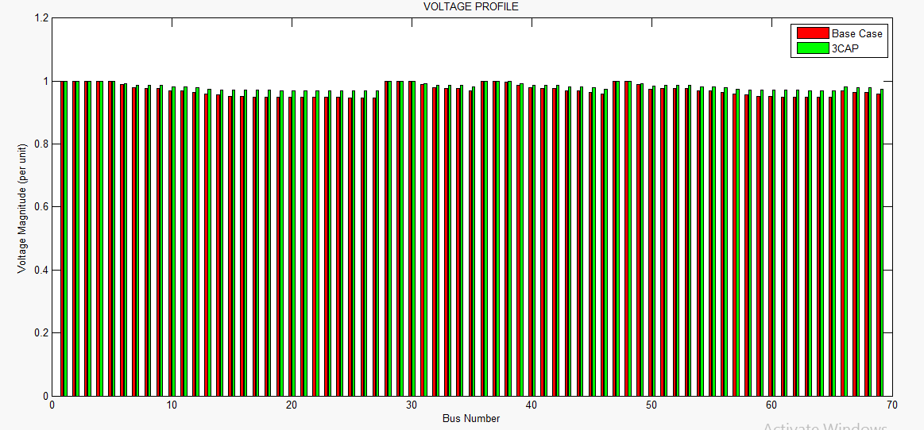

Figure 4.9 Voltage Profile for 69 Bus Network after Capacitor Allocation

Figure 4.9 show that the allocation of capacitors has caused an improvement in the voltage profile of the 33 bus network. The bus with the lowest voltage which is bus 27 had its voltage increased from 0.9477 to 0.9695 per unit voltage. The red line indicates the base case voltage trend while the green line shows the improved voltage after capacitor placements. The optimal allocation of capacitors therefore caused a 1.65% improvement in the voltage profile of the system as compared to the base case voltage with a value of 67.795 per unit. For VSI analysis, the base case and improved VSI values shown for each bus in Table 4.6 and 4.7 respectively were plotted against the respective bus numbers in order to see the improvement in VSI values at each bus before and after 3 capacitor allocation.

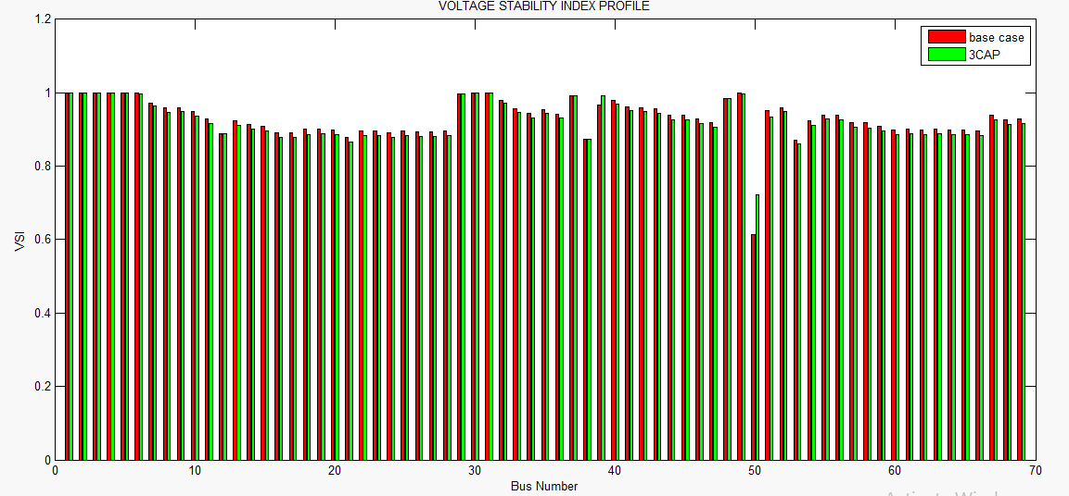

Figure 4.10: VSI for 69 Bus Network after Capacitor Allocation Figure 4.10 show that the allocation of the capacitors has caused an improvement in the VSI values of the 69 bus network. The bus with the weakest VSI value which is bus 50 had its VSI increased from 0.6146 to 0.7225. The red line indicates the base case VSI trend while the

green line shows the VSI with the Capacitor allocation.

# Effect of DG Allocation

The CSA based approach was used for the optimal allocation of 3 DG units for the 69 bus system and the optimal sizes and locations of the DGs were found to be 1314.82 kW at bus 50, 171.46 kW at bus 53 and 677.89 kW at bus 39 respectively. The total real and reactive power loss after DG allocation was relatively reduced to 34 kW and 22 kVAr respectively which indicate 51.43% and 54.17% reduction as compared to the base case real and reactive power loss.

Table 4.8: Improved Voltage and VSI after DG Allocation

|  |  |  |
| --- | --- | --- |
| Bus Number | V Improved  (PU) | VSI  Improved  (PU) |
| 1 | 1.0000 | 1.0000 |
| 2 | 1.0000 | 1.0000 |
| 3 | 1.0000 | 1.0000 |
| 4 | 1.0000 | 1.0001 |
| 5 | 1.0000 | 1.0001 |
| 6 | 0.9980 | 0.9995 |
| 7 | 0.9965 | 0.9834 |
| 8 | 0.9961 | 0.9822 |
| 9 | 0.9959 | 0.9835 |
| 10 | 0.9915 | 0.9723 |
| 11 | 0.9906 | 0.9531 |
| 12 | 0.9880 | 0.912 |
| 13 | 0.9851 | 0.9488 |
| 14 | 0.9826 | 0.9378 |
| 15 | 0.9803 | 0.9324 |
| 16 | 0.9809 | 0.9132 |
| 17 | 0.9803 | 0.9155 |
| 18 | 0.9803 | 0.9233 |
| 19 | 0.9800 | 0.9234 |
| 20 | 0.9798 | 0.9221 |
| 21 | 0.9795 | 0.9027 |
| 22 | 0.9795 | 0.9204 |
| 23 | 0.9794 | 0.9204 |
| 24 | 0.9793 | 0.9156 |
| 25 | 0.9792 | 0.9199 |
| 26 | 0.9792 | 0.9174 |
| 27 | 0.9792 | 0.9182 |
| 28 | 1.0000 | 0.9192 |
| 29 | 1.0000 | 0.9982 |
| 30 | 1.0000 | 1.0002 |
| 31 | 0.9980 | 1.0001 |
| 32 | 0.9965 | 0.9919 |
| 33 | 0.9960 | 0.9802 |

|  |  |  |
| --- | --- | --- |
| Bus Number | V Improved  (PU) | VSI  Improved  (PU) |
| 34 | 0.9957 | 0.9676 |
| 35 | 0.9915 | 0.9786 |
| 36 | 1.0000 | 0.9663 |
| 37 | 1.0001 | 0.9927 |
| 38 | 1.0005 | 0.8733 |
| 39 | 0.9981 | 0.9673 |
| 40 | 0.9965 | 0.9905 |
| 41 | 0.9961 | 0.9853 |
| 42 | 0.9959 | 0.9839 |
| 43 | 0.9915 | 0.9806 |
| 44 | 0.9906 | 0.9627 |
| 45 | 0.9880 | 0.9630 |
| 46 | 0.9851 | 0.9528 |
| 47 | 1.0000 | 0.9418 |
| 48 | 0.9999 | 0.9850 |
| 49 | 0.9980 | 0.9995 |
| 50 | 0.9970 | 1.0246 |
| 51 | 0.9960 | 0.9864 |
| 52 | 0.9959 | 0.9843 |
| 53 | 0.9963 | 0.9623 |
| 54 | 0.9913 | 0.9516 |
| 55 | 0.9906 | 0.9638 |
| 56 | 0.9880 | 0.9630 |
| 57 | 0.9850 | 0.9426 |
| 58 | 0.9826 | 0.9414 |
| 59 | 0.9803 | 0.9323 |
| 60 | 0.9809 | 0.9219 |
| 61 | 0.9803 | 0.9259 |
| 62 | 0.9803 | 0.923 |
| 63 | 0.9800 | 0.9234 |
| 64 | 0.9798 | 0.9216 |
| 65 | 0.9795 | 0.9215 |
| 66 | 0.9906 | 0.9203 |
| 67 | 0.9880 | 0.9631 |
| 68 | 0.9880 | 0.9497 |
| 69 | 0.9851 | 0.9527 |

# Voltage Profile after DG Allocation

The base case and improved voltages shown for each bus in Table 4.6 and Table 4.8 respectively were plotted against the respective bus numbers in order to see the improvement in voltage profile after 3 DG allocation.

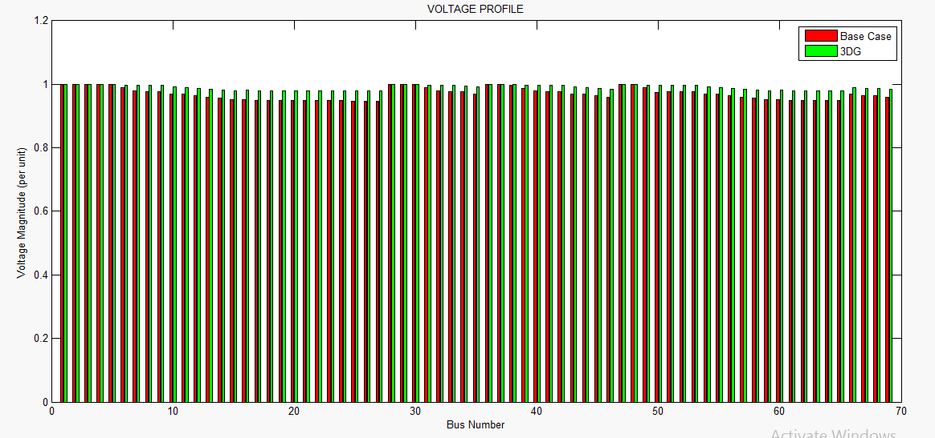

Figure 4.11 Voltage Profile for 69 Bus Network after DG Allocation

Figure 4.11 show that the allocation of the DG units has caused an improvement in the voltage profile of the 69 bus network. The bus with the lowest voltage which is bus 27 had its voltage increased from 0.9477 to 0.9792per unit voltage. The red line indicates the base case voltage trend while the green line shows the improved voltage after DG allocation. The optimal allocation of the DGs therefore caused a 2.02% improvement in the voltage profile of the system as compared to the base case voltage with a value of 68.3147 per unit. For VSI analysis, the base case and improved VSI values shown for each bus in Table 4.6 and

4.8respectively were plotted against the respective bus numbers in order to see the improvement in VSI values at each bus before and after DG allocation.

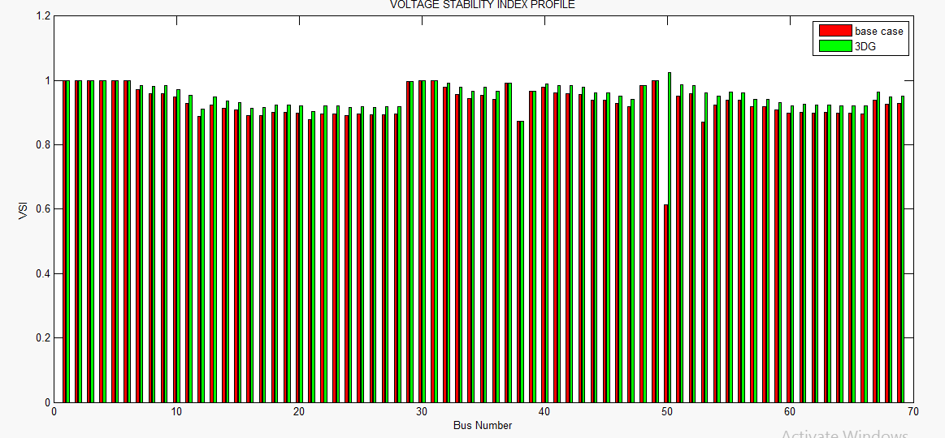

Figure 4.12: VSI for 69 Bus Network after DG Allocation

Figure 4.12 show that the allocation of the DG units has caused an improvement in the VSI values of the 69 bus network. The bus with the weakest VSI value which is bus 50 had its VSI increased from 0.6146 to 1.0246. The red line indicates the base case VSI trend while the green line shows the VSI with the DG and Capacitor placement. The optimal allocation of the DG units therefore caused a 2.69% improvement in the overall VSI of the system compared to the base case VSI with a value of 65.9734 per unit.

# Allocation of multiple DG and Capacitor bank Combinations simultaneously on IEEE 69- Bus System

The CSA based approach was used for the optimal location and sizing of several combinations of DG and Capacitor banks on the 69 bus system. The several different combinations include CCD, CDC, DCC, DDC, DCD and CDD combinations. The optimal sizes and locations for the combinations as well as their reductions in active and reactive power loss are as follows:

For CCD combination the optimal size and locations for the DGs and capacitor banks are

884.39 kVAr at bus 50, 272.79kVAr at bus 39 and 1296.53 kW at bus 50. With this combination there was a reduction of base case active and reactive power loss from 70 kW to 18 kW and from 48kVAr to 10kVAr. For CDC combination, the optimal size and locations for the DG and capacitor banks are 900.88kVAr at bus 50, 975.51 kW at bus 50 and 230.36 kVAr at bus 39 reducing the base case active and reactive power loss from 70 kW to 20 kW and from 48 kVAr to 11kVAr respectively. For DCC combination, the optimal sizes and locations of the DGs and capacitor banks are 1354.83 kW at bus 50, 889.83 kVAr at bus 50 and 943.74 kVAr at bus 50 reducing the base case active and reactive power loss from 70 kW to 38 kW and from 48 kVAr to 25kVAr respectively. For CDD combination, the optimal sizes and locations of the DGs and capacitor banks are 904.09 kVAr at bus 50, 126.36kW at bus 39 and 132.23 kW at bus 12 reducing the base case active and reactive power loss from 70 kW to 49 kW and from 48kVAr to 33kVAr respectively. For DCD combination, the optimal sizes and locations of the DGs and capacitor banks are 239.83 kW at bus 53, 885.58 kVAr at bus 50 and 1408.79 kW at bus 50 reducing the base case active and reactive power loss from 70 kW to 18 kW and from 48 kVAr to 10kVAr respectively. Finally, for the DDC combination the

optimal sizes and locations of the DGs and capacitor bank are 1247.16 kW at bus 50, 493.84 kW at bus 39 and 505.10 kVAr at bus 50 reducing the base case active and reactive power loss from 70 kW to 20 kW and from 48 kVAr to 12kVAr.

Based on power loss reduction capability, voltage and VSI improvement from base case the DCD combination was chosen as the best combination among the several other combinations and used for a comparative analysis between its results from simulations and that obtained from the allocation of 3 DGs and 3 CBs on 69 bus test system. Table shows the voltage and VSI profile after simultaneous DG and capacitor bank placement

Table 4.9: Improved Voltage and VSI after Simultaneous DG and CB Allocation

|  |  |  |
| --- | --- | --- |
| Bus Number | V Improved  (PU) | VSI  Improved  (PU) |
| 1 | 1.0000 | 1.0000 |
| 2 | 1.0000 | 1.0000 |
| 3 | 1.0000 | 1.0001 |
| 4 | 1.0001 | 1.0001 |
| 5 | 1.0003 | 1.0003 |
| 6 | 1.0006 | 1.0007 |
| 7 | 1.0000 | 0.9939 |
| 8 | 0.9995 | 0.9963 |
| 9 | 0.9993 | 0.9973 |
| 10 | 0.9955 | 0.9858 |
| 11 | 0.9947 | 0.9761 |
| 12 | 0.9921 | 0.9275 |
| 13 | 0.9893 | 0.9647 |
| 14 | 0.9868 | 0.9536 |
| 15 | 0.9845 | 0.9482 |
| 16 | 0.9851 | 0.9289 |
| 17 | 0.9844 | 0.9311 |
| 18 | 0.9844 | 0.9390 |
| 19 | 0.9841 | 0.9392 |
| 20 | 0.9839 | 0.9378 |
| 21 | 0.9836 | 0.9182 |
| 22 | 0.9836 | 0.9361 |

|  |  |  |
| --- | --- | --- |
| Bus Number | V Improved  (PU) | VSI  Improved  (PU) |
| 23 | 0.9836 | 0.9361 |
| 24 | 0.9835 | 0.9312 |
| 25 | 0.9834 | 0.9356 |
| 26 | 0.9834 | 0.9331 |
| 27 | 0.9833 | 0.9339 |
| 28 | 1.0000 | 0.9349 |
| 29 | 1.0001 | 0.9983 |
| 30 | 1.0003 | 1.0003 |
| 31 | 1.0006 | 1.0013 |
| 32 | 1.0000 | 1.0024 |
| 33 | 0.9995 | 0.9942 |
| 34 | 0.9991 | 0.9812 |
| 35 | 0.9955 | 0.9921 |
| 36 | 1.0000 | 0.9819 |
| 37 | 1.0001 | 0.9927 |
| 38 | 1.0008 | 0.8734 |
| 39 | 1.0011 | 0.9893 |
| 40 | 1.0000 | 1.0023 |
| 41 | 0.9995 | 0.9995 |
| 42 | 0.9993 | 0.9977 |
| 43 | 0.9955 | 0.9942 |
| 44 | 0.9947 | 0.9783 |
| 45 | 0.9921 | 0.9790 |
| 46 | 0.9893 | 0.9687 |
| 47 | 1.0001 | 0.9577 |
| 48 | 1.0002 | 0.9852 |
| 49 | 1.0006 | 1.0007 |
| 50 | 1.0022 | 0.9465 |
| 51 | 0.9995 | 1.0072 |
| 52 | 0.9993 | 0.9981 |
| 53 | 0.9986 | 0.9075 |
| 54 | 0.9952 | 0.9608 |
| 55 | 0.9947 | 0.9794 |
| 56 | 0.9921 | 0.9790 |
| 57 | 0.9892 | 0.9585 |
| 58 | 0.9868 | 0.9573 |
| 59 | 0.9845 | 0.9480 |
| 60 | 0.9851 | 0.9376 |
| 61 | 0.9844 | 0.9417 |

|  |  |  |
| --- | --- | --- |
| Bus Number | V Improved  (PU) | VSI  Improved  (PU) |
| 62 | 0.9844 | 0.9387 |
| 63 | 0.9841 | 0.9391 |
| 64 | 0.9839 | 0.9373 |
| 65 | 0.9836 | 0.9372 |
| 66 | 0.9947 | 0.9360 |
| 67 | 0.9921 | 0.9791 |
| 68 | 0.9921 | 0.9657 |
| 69 | 0.9893 | 0.9687 |

# Voltage and VSI Profileafter Simultaneous DG and CB Allocation

The base case and improved voltage after simultaneous DG and capacitor allocation shown for each bus of the 69 bus network in Table 4.6 and 4.9 respectively were plotted against their respective bus numbers in order to see the improvement in voltage profile after simultaneous DG and CB allocation.

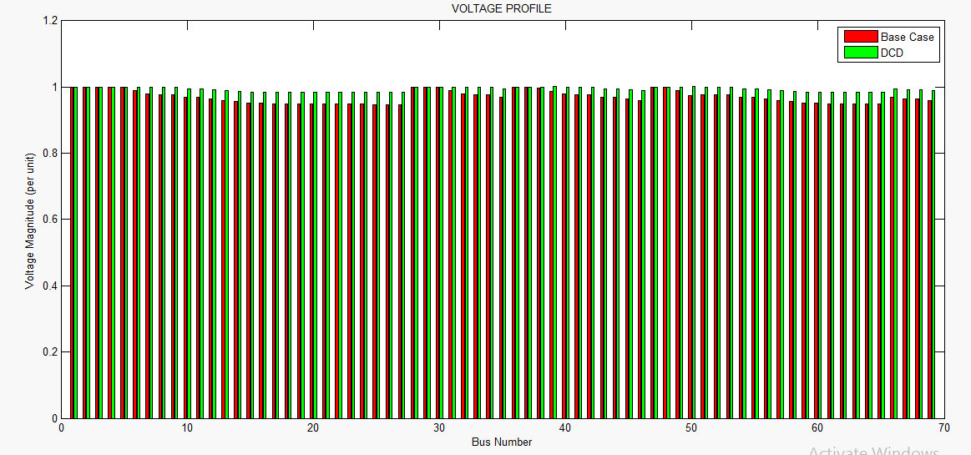

Figure 4.13: Voltage Profile for 69 Bus Network after Simultaneous DG and CB Allocation

Figure 4.13 show that the simultaneous allocation of DG and CB units has caused an improvement in the voltage profile of the 69 bus network. The bus with the lowest voltage which is bus 27 had its voltage increased from 0.9477 to 0.9833 per unit voltage. The red line indicates the base case voltage trend while the green line shows the voltage profile after simultaneous DG and CB placement. The optimal allocation of DG and CB units therefore caused a 2.34% improvement in the overall voltage profile of the system as compared to the base case voltage with a value of 68.5332 per unit. For VSI analysis, the base case and improved VSI values shown for each bus in Table 4.6 and 4.9 respectively were plotted against the respective bus numbers in order to see the improvement in VSI after simultaneous DG and CB allocation.

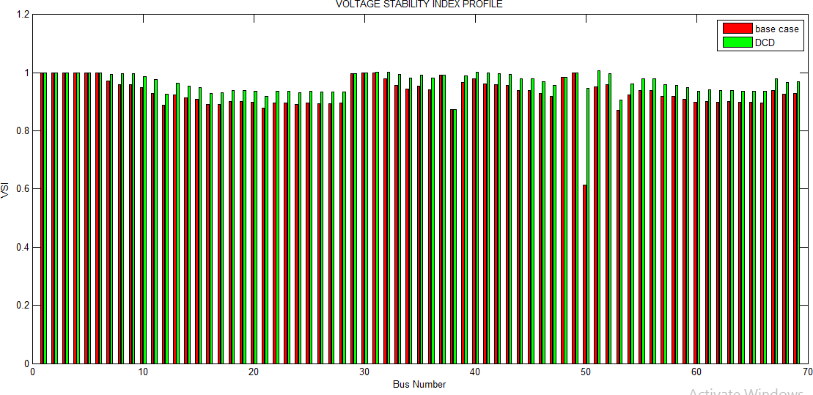

Figure 4.14: VSI for 69 Bus Network after Simultaneous DG and CB Allocation Figure 4.14 show that the allocation of the DG units has caused an improvement in the VSI values of the 69 bus network. The bus with the weakest VSI value which is bus 50 had its VSI

increased from 0.6146 to 0.9465 per unit. The red line indicates the base case VSI trend while the green line shows the VSI after simultaneous DG and CB allocation. The optimal allocation of the DG units therefore caused a 3.79% improvement in the overall VSI of the system compared to the base case VSI with a value of 66.6735 per unit.

# Power loss Reduction Profiles for 69 Bus System

A profile plot for 69 bus system was done to pictorially show power loss (active and reactive) reduction via the simultaneous and separate use of DGs and CBs. Figure 4.21 and 4.22 presents the active and reactive power loss reduction profiles.

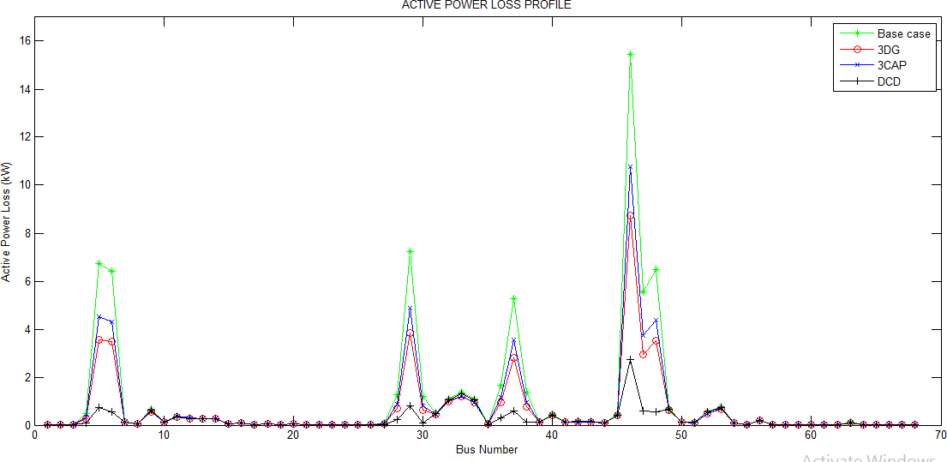

Figure 4.15: Active Power Loss Reduction Profile for 69 -Bus System

As depicted in Figure 4.15 the base case active power loss is represented by the green color, the red color indicates the active power loss reduction after 3 DG allocation, the blue color indicates active power loss after 3 CB allocation while the black color indicates active power

loss reduction after simultaneous DG and CB allocation. As seen from the active power loss reduction profile, the simultaneous placement of DGs and CBs (black color) gave a better active power loss reduction to the separate allocation of DGs and CBs.

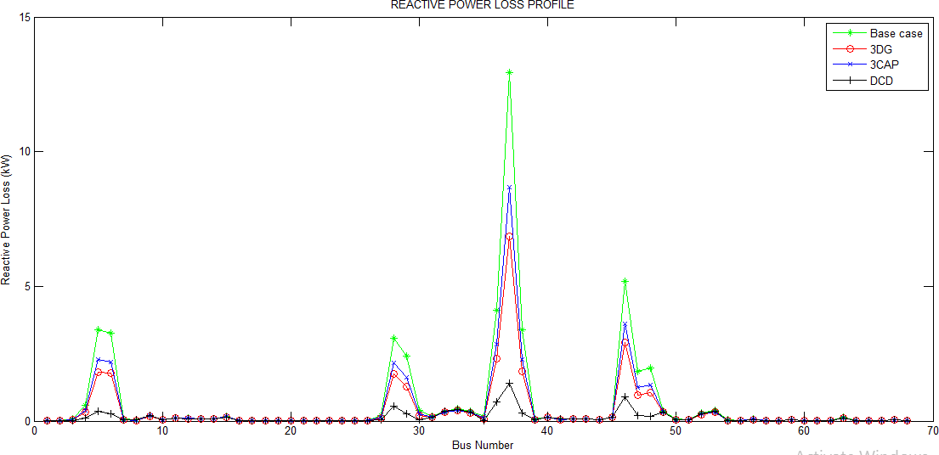

Figure 4.16: Reactive Power Loss Reduction Profile for 69- Bus System

As depicted in Figure 4.16 the base case reactive power loss is represented by the green color, the red color indicates the reactive power loss reduction after 3 DG allocation, the blue color indicates reactive power loss after 3 CB allocation while the black color indicates reactive power loss reduction after simultaneous DG and CB allocation. As seen from the reactive power loss reduction profile, the simultaneous allocation of DGs and CBs (black color) gave a better reactive power loss reduction to the separate allocation of DGs and CBs.

# Summary of Result for 69- Bus System

The DCD combination which was chosen to be the best combination result was compared to results from 3 DGs and 3 caps allocation on the 69 bus system and the summary of result is shown in Table 4.10

Table 4.10: Summary of Result for 69- Bus System

|  |  |  |  |  |
| --- | --- | --- | --- | --- |
| **Particulars** | **Base case** | **3 DGs** | **3 Caps** | **Combined**  **(Simultaneous)** |
| **PL (active) QL (reactive) Total V**  **% PL**  **% QL**  **% V**  **% VSI** | 70 kW  48kVAr 66.9691 p.u  -  -  -  - | 34 kW  32kVAr 68.3147 p.u  51.43%  54.17%  2.02%  2.69% | 50 kW  33kVAr 67.795 p.u  28.57%  31.25%  1.65%  0.79% | 18 kW  10kVAr 68.5332 p.u  74.29%  79.17%  2.34%  3.79% |

# The Zaria 50 Bus Canteen Feeder

The bus and line data for the Zaria 50 Bus Canteen Feeder as shown in appendix A3 were used in modeling the system and the base case voltage for each bus were noted. The cuckoo search algorithm described in chapter three was used in obtaining the optimal DG and Shunt capacitor bank location and size for the 50-bus network. The bus voltages, total power loss (real and reactive), voltage profile and voltage stability index before and after separate and combined DG and shunt capacitor bank placements were noted for comparison.

# Base Case System

Initially, load flow was run on the 50 bus system to get the voltage at each bus, the total power loss and voltage stability index. This is the base case voltage, VSI values and power loss (active and reactive) of the system before the integration of the DG units into the system. The base case real and reactive power loss was found to be 2.42 kW and 1.52kVAr respectively. While the base case voltages and VSI values at each bus is presented in Table 4.11

Table 4.11: Base Case Voltage and VSI Values for 50 Bus Network

|  |  |  |
| --- | --- | --- |
| Bus  Number | V Base(PU) | VSI Base (PU) |
| 1 | 1.0000 | 1.0000 |
| 2 | 0.9986 | 1.0000 |
| 3 | 0.9983 | 0.9948 |
| 4 | 0.9971 | 0.9912 |
| 5 | 0.9962 | 0.9911 |
| 6 | 0.9961 | 0.9925 |
| 7 | 0.9960 | 0.9933 |
| 8 | 0.9958 | 0.9921 |
| 9 | 0.9957 | 0.9929 |
| 10 | 0.9956 | 0.9918 |
| 11 | 0.9955 | 0.9926 |
| 12 | 0.9952 | 0.9915 |
| 13 | 0.9952 | 0.9916 |
| 14 | 0.9934 | 0.9783 |
| 15 | 0.9925 | 0.9684 |
| 16 | 0.9921 | 0.9682 |
| 17 | 0.9919 | 0.9866 |
| 18 | 0.9914 | 0.9673 |
| 19 | 0.9907 | 0.9507 |
| 20 | 0.9905 | 0.971 |
| 21 | 0.9901 | 0.9738 |
| 22 | 0.989 | 0.9785 |

|  |  |  |
| --- | --- | --- |
| Bus Number | V Base (PU) | VSI Base (PU) |
| 23 | 0.9895 | 0.9271 |
| 24 | 0.9893 | 0.9533 |
| 25 | 0.9892 | 0.9690 |
| 26 | 0.9892 | 0.9721 |
| 27 | 0.9891 | 0.9640 |
| 28 | 0.9890 | 0.9576 |
| 29 | 0.9971 | 0.9761 |
| 30 | 0.9962 | 0.9847 |
| 31 | 0.9962 | 0.9909 |
| 32 | 0.9961 | 0.9935 |
| 33 | 0.9960 | 0.9901 |
| 34 | 0.9962 | 0.9858 |
| 35  36 | 0.9958  0.9958 | 0.9925  0.9919 |
| 37 | 0.9957 | 0.9919 |
| 38 | 0.9957 | 0.9928 |
| 39 | 0.9956 | 0.9933 |
| 40 | 0.9955 | 0.9884 |
| 41 | 0.9952 | 0.9930 |
| 42 | 0.9955 | 0.9890 |
| 43 | 0.9952 | 0.9930 |
| 44 | 0.9907 | 0.9693 |
| 45 | 0.9905 | 0.9836 |
| 46 | 0.9901 | 0.9733 |
| 47 | 0.9898 | 0.9381 |
| 48 | 0.9907 | 0.9773 |
| 49 | 0.9904 | 0.9330 |
| 50 | 0.9900 | 0.9581 |

The total base case voltage and VSI values for the 50 bus Canteen Feeder are 49.6831 and 48.9809 per unit.

# Effect of capacitor allocation

The CSA based approach was used for the optimal allocation of 3 Capacitor units for the 50 bus system and the sizes and locations of the capacitors were found to be 123.85 kVAr at bus 24, 189.91 kVAr at bus 25 and 63.80 kVAr at bus 23 respectively. The total real and reactive

power loss after capacitor allocation was relatively reduced to 2.18kW and 1.37 kVAr respectively which indicate 9.92% and 9.87% reduction as compared to the base case real and reactive power loss.

Table 4.12: Improved Voltage and VSI for 50 Bus Network after Capacitor Allocation

|  |  |  |
| --- | --- | --- |
| Bus Number | V  Improved  (PU) | VSI  Improved  (PU) |
| 1 | 1.0000 | 1.0000 |
| 2 | 0.9994 | 1.0000 |
| 3 | 0.9993 | 0.9946 |
| 4  5 | 0.9988  0.9985 | 0.9909  0.9906 |
| 6 | 0.9984 | 0.9919 |
| 7 | 0.9984 | 0.9927 |
| 8 | 0.9983 | 0.9915 |
| 9 | 0.9983 | 0.9922 |
| 10 | 0.9982 | 0.9911 |
| 11 | 0.9982 | 0.9919 |
| 12 | 0.9981 | 0.9907 |
| 13 | 0.9981 | 0.9908 |
| 14 | 0.9973 | 0.9774 |
| 15 | 0.997 | 0.9671 |
| 16 | 0.9968 | 0.9667 |
| 17 | 0.9967 | 0.9850 |
| 18 | 0.9965 | 0.9656 |
| 19 | 0.9962 | 0.9489 |
| 20 | 0.9961 | 0.9689 |
| 21 | 0.9959 | 0.9717 |
| 22 | 0.9958 | 0.9762 |
| 23 | 0.9955 | 0.9351 |
| 24 | 0.9954 | 0.9613 |
| 25 | 0.9954 | 0.9742 |
| 26 | 0.9954 | 0.9691 |
| 27 | 0.9953 | 0.961 |
| 28 | 0.9953 | 0.9546 |
| 29 | 0.9988 | 0.973 |
| 30 | 0.9985 | 0.9843 |
| 31 | 0.9985 | 0.9903 |

|  |  |  |
| --- | --- | --- |
| Bus Number | V  Improved  (PU) | VSI  Improved  (PU) |
| 32 | 0.9984 | 0.9929 |
| 33 | 0.9984 | 0.9895 |
| 34 | 0.9985 | 0.9851 |
| 35 | 0.9983 | 0.9919 |
| 36 | 0.9983 | 0.9912 |
| 37 | 0.9983 | 0.9912 |
| 38 | 0.9983 | 0.9921 |
| 39 | 0.9982 | 0.9926 |
| 40 | 0.9982 | 0.9876 |
| 41 | 0.9981 | 0.9923 |
| 42 | 0.9982 | 0.9881 |
| 43 | 0.9981 | 0.9923 |
| 44 | 0.9962 | 0.9685 |
| 45 | 0.9961 | 0.9815 |
| 46  47 | 0.9959 | 0.9711 |
| 0.9957 | 0.9358 |
| 48 | 0.9962 | 0.9748 |
| 49 | 0.9960 | 0.9310 |
| 50 | 0.9958 | 0.9560 |

# Voltageand VSI Profileafter Capacitor Allocation

The base case and improved voltages shown for each bus in Table 4.11 and Table 4.12respectively were plotted against the respective bus numbers in order to see the improvement in voltage profile after 3 capacitor allocation.

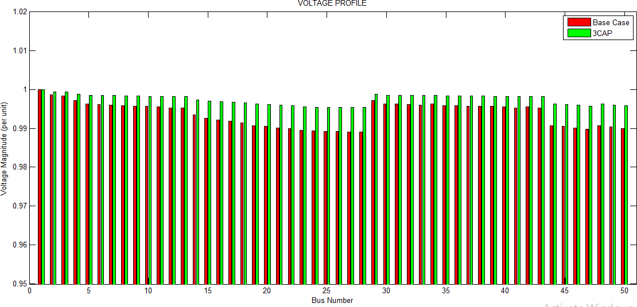

Figure 4.17 Voltage Profile for 50 Bus Network after Capacitor Allocation

Figure 4.17 show that the allocation of capacitors has caused an improvement in the voltage profile of the 50 bus network. The bus with the lowest voltage which is bus 28 had its voltage increased from 0.989 to 0.9953 per unit voltage. The red line indicates the base case voltage trend while the green line shows the improved voltage after capacitor allocation. The optimal allocation of capacitors therefore caused a 0.38% improvement in the voltage profile of the system as compared to the base case voltage with a value of 49.8696 per unit. For VSI analysis, the base case and improved VSI values shown for each bus in Table 4.11 and 4.12 respectively were plotted against the respective bus numbers in order to see the improvement in VSI values at each bus before and after 3 capacitor allocation.

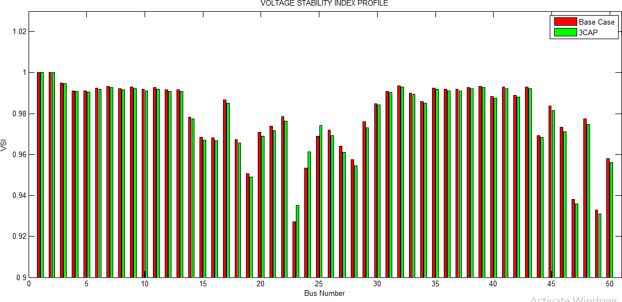

Figure 4.18 VSI for 50 Bus Network after Capacitor Allocation

Figure 4.18 show that the allocation of capacitors has caused an improvement in VSI values of the 50 bus network. The bus with the weakest VSI value which is bus 23 had its VSI value increased from 0.9271 to 0.9351. The red line indicates the base case VSI trend while the green line shows the improved VSI after capacitor placements. The allocation of capacitors did not however cause any significant improvement on the overall VSI values at the buses from their base case values.

# Effect of DG allocation

The CSA based approach was used for the optimal allocation of 3 DG units for the 50 bus system and the optimal sizes and locations of the DGs were found to be 141.89 kW at bus 25,

70.83 kW at bus 47 and 262.95 kW at bus 23 respectively. The total real and reactive power loss after DG allocation was relatively reduced to 2.04 kW and 1.28 kVAr respectively which

indicate 15.70% and 15.79% reduction as compared to the base case real and reactive power loss.

Table 4.13: Improved Voltage and VSI after DG Allocation

|  |  |  |
| --- | --- | --- |
| Bus Number | V  Improved  (PU) | VSI  Improved  (PU) |
| 1 | 1.0000 | 1.0000 |
| 2 | 0.9996 | 1.0000 |
| 3 | 0.9995 | 0.9952 |
| 4 | 0.9991 | 0.9917 |
| 5 | 0.9988 | 0.9919 |
| 6 | 0.9988 | 0.9936 |
| 7 | 0.9988 | 0.9944 |
| 8 | 0.9987 | 0.9933 |
| 9 | 0.9987 | 0.9941 |
| 10 | 0.9987 | 0.9930 |
| 11 | 0.9986 | 0.9939 |
| 12 | 0.9986 | 0.9927 |
| 13 | 0.9985 | 0.9930 |
| 14 | 0.9981 | 0.9797 |
| 15 | 0.9978 | 0.9706 |
| 16 | 0.9977 | 0.9708 |
| 17 | 0.9976 | 0.9894 |
| 18 | 0.9975 | 0.9701 |
| 19 | 0.9973 | 0.9537 |
| 20 | 0.9973 | 0.9745 |
| 21 | 0.9972 | 0.9775 |
| 22 | 0.9972 | 0.9825 |
| 23 | 0.9971 | 0.9519 |
| 24 | 0.9971 | 0.9577 |
| 25 | 0.9971 | 0.9831 |
| 26 | 0.9970 | 0.9767 |
| 27 | 0.9970 | 0.9686 |
| 28 | 0.9970 | 0.9622 |
| 29 | 0.9991 | 0.9807 |
| 30  31 | 0.9988  0.9988 | 0.9855  0.9919 |
| 32 | 0.9988 | 0.9946 |
| 33 | 0.9988 | 0.9912 |

|  |  |  |
| --- | --- | --- |
| Bus Number | V  Improved  (PU) | VSI  Improved  (PU) |
| 34 | 0.9988 | 0.9869 |
| 35 | 0.9987 | 0.9935 |
| 36 | 0.9987 | 0.9931 |
| 37 | 0.9987 | 0.9931 |
| 38 | 0.9987 | 0.9940 |
| 39 | 0.9986 | 0.9946 |
| 40 | 0.9986 | 0.9897 |
| 41 | 0.9986 | 0.9943 |
| 42 | 0.9986 | 0.9904 |
| 43 | 0.9986 | 0.9943 |
| 44 | 0.9973 | 0.9707 |
| 45 | 0.9973 | 0.9871 |
| 46 | 0.9972 | 0.9859 |
| 47 | 0.9972 | 0.9420 |
| 48 | 0.9973 | 0.9814 |
| 49 | 0.9973 | 0.9364 |
| 50 | 0.9972 | 0.9617 |

# Voltage and VSIProfileafter DG Allocation

The base case and improved voltages shown for each bus in Table 4.11 and Table 4.13 respectively were plotted against their respective bus numbers in order to see the improvement in voltage profile after 3DG allocation.

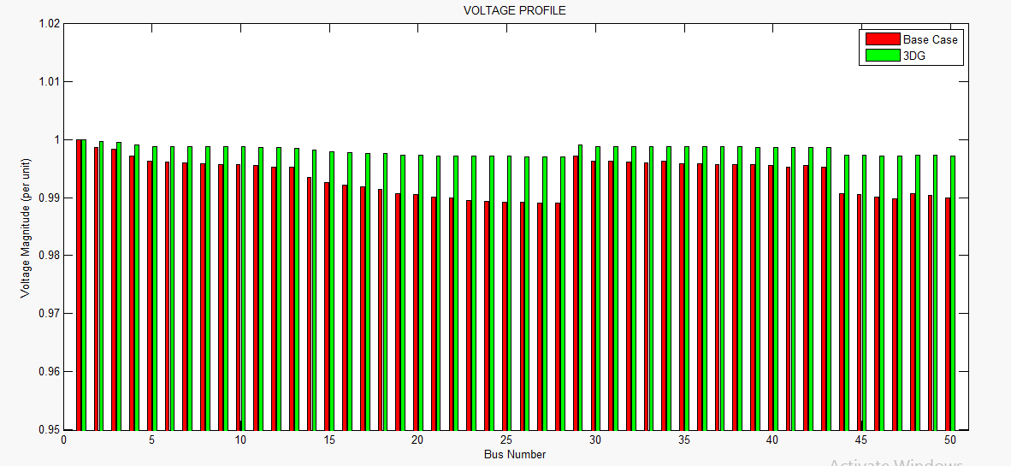

Figure 4.19: Voltage profile for 50 Bus Network after DG Allocation

Figure 4.19 show that the placement of DGs has caused an improvement in the voltage profile of the 50 bus network. The bus with the lowest voltage which is bus 28 had its voltage increased from 0.989 to 0.997 per unit voltage. The red line indicates the base case voltage trend while the green line shows the improved voltage after DG placements. The optimal allocation of DGsand CBs therefore caused a 0.45% improvement in the voltage profile of the system as compared to the base case voltage with a value of 49.9081 per unit. For VSI analysis, the base case and improved VSI values shown for each bus in Table 4.11 and 4.13 respectively were plotted against the respective bus numbers in order to see the improvement in VSI values at each bus before and after DG allocation.

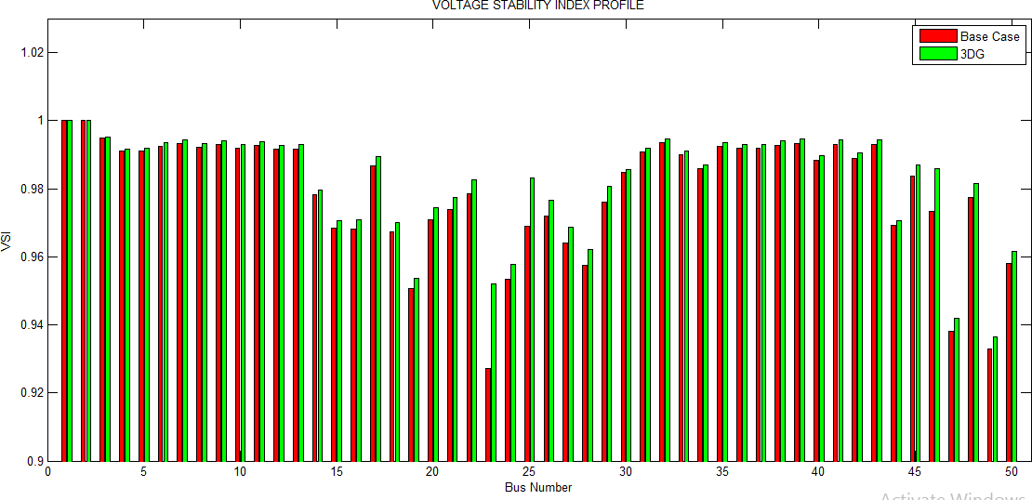

Figure 4.20: VSI for 50 Bus Network after DG Allocation

Figure 4.20 show that the allocation of DGs has caused an improvement in VSI values of the 50 bus network. The bus with the weakest VSI value which is bus 23 had its VSI value increased from 0.9271 to 0.9519. The red line indicates the base case VSI trend while the green line shows the improved VSI after the DG placements. The optimal allocation of DGs therefore caused a 0.30% improvement in the VSI values of the system as compared to the base case VSI with a value of 49.1288 per unit.

# Allocation of multiple DG and Capacitor Bank Combinations Simultaneously

The CSA based approach was used for the optimal location and sizing of several combinations of DG and Capacitor banks for the 50 bus system. The several different combinations include CCD, CDC, DCC, DDC, DCD and CDD combinations. The optimal sizes and locations for the combinations as well as their reductions in active and reactive power loss are as follows:

For CCD combination the optimal size and locations for the DGs and capacitor banks are 106.35kVAr at bus 25, 103.52 kVAr at bus 24 and 193.24 kW at bus 47. With this combination there was a reduction of base case active and reactive power loss from 2.42 kW to 2.09 kW and from 1.52kVAr to 1.31 kVAr. For CDC combination, the optimal size and locations for the DG and capacitor banks are 129.73kVAr at bus 25, 145.14 kW at bus 25 and

134.51 kVAr at bus 24 reducing the base case active and reactive power loss from 2.42 kW to

2.06 kW and from 1.52 kVAr to 1.29kVAr respectively. For DCC combination, the optimal sizes and locations of the DGs and capacitor banks are 239.41 kW at bus 18, 129.14 kVAr at bus 24 and 148.22 kVAr at bus 24 reducing the base case active and reactive power loss from

2.42 kW to 2.16 kW and from 1.52 kVAr to 1.35kVAr respectively. For CDD combination, the optimal sizes and locations of the DGs and capacitor banks are 123.41kVAr at bus 24,

172.79 kW at bus 24 and 155.78 kW at bus 18 reducing the base case active and reactive power loss from 2.42 kW to 2.07 kW and from 1.52kVAr to 1.29kVAr respectively. For DCD combination, the optimal sizes and locations of the DGs and capacitor banks are 247.19 kW at bus 23, 137.82 kVAr at bus 25 and 131.78 kW at bus 25 reducing the base case active and reactive power loss from 2.42 kW to 1.99 kW and from 1.52 kVAr to 1.25kVAr respectively. Finally, for the DDC combination the optimal sizes and locations of the DGs and capacitor bank are 91.53 kW at bus 47, 250.86 kW at bus 25 and 121.12 kVAr at bus 25 reducing the base case active and reactive power loss from 2.42 kW to 2.08 kW and from 1.52 kVAr to 1.30kVAr.

Based on power loss reduction capability, voltage profile and VSI improvement from base case values the DCD combination was chosen as the best combination among the several other combinations and used for a comparative analysis between its results from simulations

and that obtained from the allocation of 3 DGs and 3 Caps on the 50 bus Canteen Feeder system. Table 4.14 shows the voltage and VSI profile after simultaneous DG and capacitor bank placement

Table 4.14: Improved Voltage and VSI after Simultaneous DG and CB Allocation

|  |  |  |
| --- | --- | --- |
| Bus Number | V  Improved  (PU) | VSI  Improved(PU) |
| 1 | 1.0000 | 1.0000 |
| 2 | 0.9996 | 1.0000 |
| 3 | 0.9995 | 0.9951 |
| 4 | 0.9992 | 0.9915 |
| 5 | 0.9989 | 0.9917 |
| 6 | 0.9989 | 0.9933 |
| 7 | 0.9988 | 0.9941 |
| 8 | 0.9988 | 0.9930 |
| 9 | 0.9988 | 0.9938 |
| 10 | 0.9987 | 0.9927 |
| 11 | 0.9987 | 0.9936 |
| 12 | 0.9986 | 0.9924 |
| 13 | 0.9986 | 0.9926 |
| 14 | 0.9982 | 0.9793 |
| 15 | 0.9980 | 0.9700 |
| 16 | 0.9979 | 0.9701 |
| 17 | 0.9978 | 0.9887 |
| 18 | 0.9977 | 0.9694 |
| 19 | 0.9976 | 0.953 |
| 20 | 0.9975 | 0.9736 |
| 21 | 0.9975 | 0.9765 |
| 22 | 0.9974 | 0.9815 |
| 23 | 0.9974 | 0.9899 |
| 24 | 0.9973 | 0.9568 |
| 25 | 0.9973 | 0.9871 |
| 26 | 0.9973 | 0.9757 |
| 27 | 0.9973 | 0.9676 |
| 28 | 0.9973 | 0.9611 |
| 29 | 0.9992 | 0.9796 |
| 30 | 0.9989 | 0.9853 |
| 31 | 0.9989 | 0.9917 |

|  |  |  |
| --- | --- | --- |
| Bus Number | V  Improved  (PU) | VSI  Improved  (PU) |
| 32 | 0.9989 | 0.9943 |
| 33 | 0.9988 | 0.9910 |
| 34 | 0.9989 | 0.9866 |
| 35 | 0.9988 | 0.9933 |
| 36 | 0.9988 | 0.9928 |
| 37 | 0.9988 | 0.9928 |
| 38 | 0.9988 | 0.9937 |
| 39 | 0.9987 | 0.9943 |
| 40 | 0.9987 | 0.9893 |
| 41 | 0.9986 | 0.9940 |
| 42 | 0.9987 | 0.9900 |
| 43 | 0.9986 | 0.9940 |
| 44 | 0.9976 | 0.9703 |
| 45 | 0.9975 | 0.9862 |
| 46 | 0.9975 | 0.9760 |
| 47 | 0.9974 | 0.9410 |
| 48 | 0.9976 | 0.9804 |
| 49 | 0.9975 | 0.9355 |
| 50 | 0.9975 | 0.9608 |

# Voltageand VSI Profileafter Simultaneous DG and CB Allocation

The base case and improved voltage after simultaneous DG and capacitor allocation shown for each bus of the 50 bus network in Table 4.11 and 4.14 respectively were plotted against their respective bus numbers in order to see the improvement in voltage profile after simultaneous DG and CB allocation.

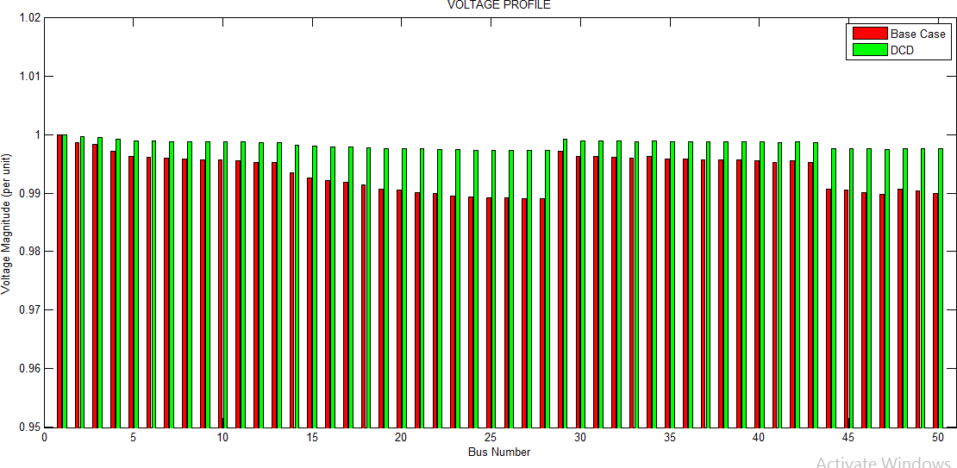

Figure 4.21: Voltage Profile for 50 Bus Network after Simultaneous DG and CB Allocation Figure 4.21 show that the simultaneous allocationof DG and CB units has caused an improvement in the voltage profile of the 50 bus network. The bus with the lowest voltage which is bus 28 had its voltage increased from 0.989 to 0.9973 per unit voltage. The red line

indicates the base case voltage trend while the green line shows the voltage profile after simultaneous DG and CB placement. The optimal allocation of DG and CB units therefore caused a 0.47% improvement in the overall voltage profile of the system as compared to the base case voltage with a value of 49.9153 per unit. For VSI analysis, the base case and improved VSI values shown for each bus in Table 4.11 and 4.14 respectively were plotted against the respective bus numbers in order to see the improvement in VSI after simultaneous DG and CB allocation.

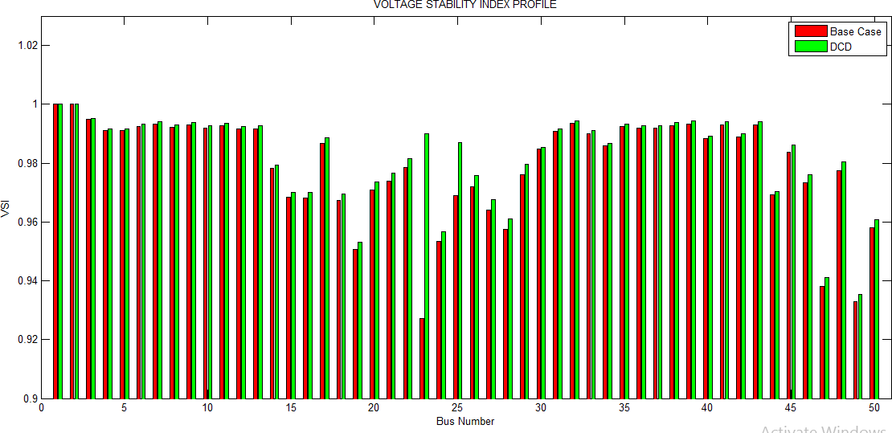

Figure 4.22: VSI Profile for 50 Bus Network after Simultaneous DG and CB Allocation Figure 4.22 show that the allocation of the DG units has caused an improvement in the VSI values of the 50 bus network. The bus with the weakest VSI value which is bus 23 had its VSI increased from 0.9271 to 0.9899 per unit. The red line indicates the base case VSI trend while the green line shows the VSI after simultaneous DG and CB allocation. The optimal allocation

of the DG units therefore caused a 0.32% improvement in the overall VSI of the system compared to the base case VSI with a value of 49.137 per unit.

# Summary of Result for 50 Bus Zaria Canteen Feeder

The DCD combination which was chosen to be the best combination result was compared to results from 3 DGs and 3 caps placement on the 50 bus system and the summary of result is shown in Table 4.15

Table 4.15: Summary of Result for 50- Bus System

|  |  |  |  |  |
| --- | --- | --- | --- | --- |
| **Particulars** | **Base case** | **3 DGs** | **3 CBs** | **Combined**  **(Simultaneous)** |
| **PL (active)**  **QL (reactive) Total V**  **% PL**  **% QL**  **% V**  **% VSI** | 2.42 kW 1.52kVAr 49.6831 p.u  **-**  -  -  - | 2.04 kW  1.28 kVAr 49.9081 p.u  15.70%  15.79%  0.45%  0.30 | 2.18 kW 1.37kVAr 49.8696 p.u  9.92%  9.87%  0.38%  0.07% | 1.99 kW 1.25kVAr 49.9153 p.u  17.77%  17.76%  0.47%  0.32% |

From results comparison, it is clearly seen that the simultaneous placement of the best combination of DG units and shunt capacitor banks, gave a better performance to that obtained from the separate placements of the DG units and shunt capacitor banks, in terms of power loss reduction, voltage profile and voltage stability improvement of networks

# CHAPTER FIVE CONCLUSION AND RECOMMENDATION

**5.1 Conclusion**

This research work has presented the application of DG units and Shunt capacitor banks in a simultaneous placement approach on IEEE 33 and 69 radial test systems with further implementation on 50 Bus Zaria Canteen Feeder. The cuckoo search algorithm was employed in obtaining the optimal sizes and locations of the DGs and CBs for total active and reactive power loss reduction. The voltage stability index was computed for each bus of the networks to ascertain the weakest voltage bus of the network before and after DG and CB allocation. The simultaneous placement approach of the DGs and CBs was applied on the IEEE test networks and Zaria Canteen Feeder network and the results obtained were validated by comparing with the results obtained from separate DGs and CBs allocation on the networks. For IEEE **33** bus system, the simultaneous allocation of DGs and of optimal sizes 515.69 kW,

214.01 kW and at locations of bus 25 and 32 and CBs of optimal size 572.27 kVAr and at locations of bus 30 respectively lead to a 63.29% and 59.38% reduction in active and reactive power loss and 6.32% improvement in voltage profile. The allocation of 3 DGs of sizes

501.89 kW, 100.73 kW, 179.47 kW and at locations of bus 25, 30 and 29 lead to a 31.65% and 31.25% reduction in active and reactive power loss and 5.11% improvement in voltage profile. The allocation of 3 CBs of optimal sizes 620.18 kVAr, 189.98 kVAr, 188.29 kVAr and at locations of bus 30,25 and 24 lead to a 53.16% and 53.13% reduction in active and reactive power loss and 3.95% improvement in voltage profile. For IEEE **69** bus system, the simultaneous placement of DGs and CBs of sizes 239.83 kW, 1408.79 kW, 885.58 kVAr and

at locations of bus 53, 50 and 50 respectively lead to a 74.29% and 79.17% reduction in active and reactive power loss and 2.34% improvement in voltage profile. The allocation of 3 DGs of sizes 134.82 kW, 171.46 kW, 677.89 kW and at locations of bus 50, 53 and 39 lead to a 51.43% and 54.17% reduction in active and reactive power loss and 2.02% improvement in voltage profile. The allocation of 3 CBs of sizes 873.64 kVAr, 330.85 kVAr, 105.67 kVAr and at locations of bus 50, 39 and 12 lead to a 28.57% and 31.25% reduction in active and reactive power loss respectively and 1.65% improvement in voltage profile. For**50-** bus Canteen Feeder in Zaria distribution network, the simultaneous placement of DGs and CBs of sizes 247.19 kW, 137.82 kVAr, 131.78 kW and at locations of bus 23, 25 and 25 respectively lead to a 17.77% and 17.76% reduction in active and reactive power loss and 0.47% improvement in voltage profile. The allocation of 3 DGs of sizes 141.89 kW, 70.83 kW,

262.95 kW and at locations of bus 25, 47 and 23 lead to a 15.70% and 15.79% reduction in active and reactive power loss and 0.45% improvement in voltage profile. The allocation of 3 CBs of sizes 123.85 kVAr, 189.91 kVAr, 63.80 kVAr and at locations of bus 24, 25 and 23 lead to a 9.92% and 9.87% reduction in active and reactive power loss and 0.38% improvement in voltage profile. From results comparison, it is evident that the simultaneous allocation of DGs and Capacitor banksusing the best combination, gives a better performance in terms of power loss reduction, voltage profile and voltage stability improvements of networks when compared to their individual / separate allocation.

# Significant Contribution

The significant contributions of this research work are as follows:

* + 1. Three different types of non- linear complex optimization problems in the direction of optimal placement and sizing problem are proposed considering all the practical constraints. These are
       1. Optimal placement and sizing of capacitors in RDS for minimization of power loss and improvement of voltage and VSI profiles.
       2. Optimal placement and sizing of DGs in RDS for minimization of power loss and improvement of voltage and VSI profiles.
       3. Optimal placement of DGs and CBs simultaneously in RDS for minimization of power loss and improvement of voltage and VSI profiles.
    2. Improvement of active power loss reduction by 63.29% for the 33 bus system, 74.29% for69 bus system and 17.77% for the 50 bus system over the active power loss reduction obtained from the individual placement of DGs and CBs and base case values.
    3. Voltage profile improvement of 6.32%, 2.34% and 0.47% for 33, 69 and 50 bus system respectively over base case values.

# Limitations

The aim of this research work was successfully achieved, but some of the limitations of this research work are highlighted as follows:

* + 1. Recent line and bus data for the 50 bus canteen feeder in Zaria distribution network were not available for proper analysis of voltage instability.
    2. System control and practical implementation of the DGs and capacitor banks was not considered.
    3. This research work does not consider decentralization of the micro- DGs
    4. This research work was carried out based on an offline study of a radial distribution system.

# Recommendations

The following are recommended for future works that can be considered as an extension of this research work:

* + 1. As a future study, researchers can define an index for cost to evaluate the various cost associated with the allocation of the DG units and shunt capacitor banks, operation and maintenance cost of theDG units and shunt capacitor banks.
    2. The simultaneous allocation method for the DG units and shunt capacitor banks can also be used for the optimal location and sizing of decentralised micro- DGs in an online scenario.
    3. Further analysis can also be done by using a hybridization of CSA with analytical optimization algorithms.

# REFERENCES

Abubakar, A. S. (2014). Developement of an Optimal Reconfiguration Algorithm for Radial Distribution Power Network (A Case Study of Zaria Distribution Network)*.(MSc Thesis), Ahmadu Bello University Zaria, Nigeria*

Akorede, M., (2010). "A review of strategies for optimal placement of distributed generation in power distribution systems.*" Research Journal of Applied Sciences****5****(2),137-145*.

Alhaddad and El-Hawary, F.M., & El-Hawary, M. (2014 November). Optimal Filter Placemaent and sizing Using Ant Colony Optimization in Electrical Distribution System. *In Electrical Power and Energy Conference (EPEC), 2014 IEEE (pp. 128- 133). IEEE*

Aman, M.M., Jasmon, G.B., A. H.A Bukar, Mokhlis, H. (2013). Optimal Simultaneous DG and Capacitor bank placement on the Basis of Minimization of Power Losses. IJCEE, Vol. 5(5), 516- 522

Archarya, N., Mahat, P., & Mithulananthan, N. (2006). An analytical approach for DG allocation in primary distribution network. *International Journal of Electrical Power & Energy systems, 28(10), 669-678.*

Ashish, C., & Taru, A. (2014). Capacitor bank designing for power factor improvement.

*International Journal of Emerging Technology and Advanced Engineering Vol,4.*

Attia, A., El- Fergany., Almoataz, Y., Abdelaziz (2013). Cuckoo search based algorithm for optimal shunt capacitors allocations in distribution networks. Journal Electric Power Components and Systems, Vol 41, 1567-1581

Atwa, Y., El-Saadany, E., Salama, M., & Seethapathy, R. (2010). Optimal renewable resources mix for distribution system energy loss minimization. *IEEE Transactions on Power Systems, 25*(1), 360-370.

Binitha, S., & Sathya, S. S. (2012). A survey of bio inspired optimization algorithms.

*International Journal of Soft Computing and Engineering, 2*(2), 137-151.

Bollen, M. H. (2000). Understanding power quality problems, IEEE press New York.

Chandrasekhar, y., Sydulu, M., and Suilaja, K.M (2016). A Multi- objective Shuffled Bat algorithm for optimal placement and sizing of multi- distributed generations with different load models. *Journal Electrical Powerand Energy systems 79, 120-131.*

Charkravorty, M.,& Das, D. (2001). Voltage stability analysis of radial distribution networks.

*International Journal Electrical Power and Energy System, 23(5), 35-129*

Devabalag, K.R & Yuvaraj, T. (2016). An efficient method for solving the optimal siiting and sizing of Capacitor Banks based on Cuckoo Search Algorithm.*Ain Shams Engineering journal doi:* [*http://dx.doi.org/10.1016/j.as*](http://dx.doi.org/10.1016/j.as)

El-Khattam, W., & Salama, M.M.A (2004). Distributed Generation Techniques, Definitions and Benefits. *Electrical Power Systems Research Vol 71, 119-128*.

Ellithy, K., Athinai, A., Moosa, A., (2008). Optimal shunt capacitor allocation in distribution networks using Genetic Algorithm. P*ractical case study International Journal of Innovations in Energy Systems and Power, Vol. 3, 13-45*

Esmaeilian, R.H., Darijany, O., Mohammadian, M., (2014). Optimal placement and sizing of DG units and Capacitors simultaneously in radial distribution networks based on voltage stability security margin. *Turk J Electrical and Computer Science. Pp 1-14*

Georgilakis, P. S., & Hatziargyriou, N. D. (2013). Optimal distributed generation placement in power distribution networks: Models, methods, and future research. *IEEE Transactions on Power Systems, 28*(3), 3420-3428.

Gustavo, B., Bogdan, K., Craig, W., (2003). Shunt Capacitor Bank Fundamentals and Protection. *Conference for Protective Relay Engineers*

Gailego, R.A., Montcelli, A.J., Romero, R., (2001). Optimal capacitor placement in radial distribution networks. *IEEE Transactions on Power Systems, Vol. 16, 630-637*

Harisha, G., and Lakshmi, D., (2015). Performance improvement of distribution network using capacitors and distributed generation units. *International Journal of Innovative Research in Electrical, Electronics, Instrumentation and Control Engineering, Vol 3, 12 (1)*

Heydari, M., Hosseini, S.M., & Gholamian, S.A. (2013). Optimal placement and sizing of Capacitor and Distributed Generation with Harmonic and Resonance Consideration Using Discrete Particle Swarm Optimization. *International Journal of Intelligent Systems and Applications, 5(7), 42.*

Hung, D.Q., Mithulananthan, N., & Bansal, R.C. (2010). Analytical expressions for DG allocation in primary distribution networks. *IEEE Transactions on energy Conversion, 25(3), 814-820.*

Hung, D.Q., Mithulananthan, N., & Lee, K.Y. (2014). Optimal placement of dispatchable and nondispatchable renewable DG units in distribution networks for minimizing energy loss. *International Journal of Electrical Power & Energy systems, 55, 179-186.*

Jain, A., Gupta, A., & Kumar, A. (2014). An efficient method for D-STATCOM placement in radial distribution system.*Paper presented at the Power Electronics (IICPE), 2014 IEEE 6th India International Conference on Power Electronics (IICPE)*

Kaplan, S.M (2009). Smart Grid. Electrical Power Transmission: Background and Policy Issues. *The Capital. Net, Government Series. Pp. 1 -42*

Kassim, A. A., &Wafaa, S. M. (2012). A Reliable Load Flow Method for Radial Distribution System. *Journal of engineering and development*, 16(2), 248-265.

Kersting, W. H. (2012). *Distribution system modeling and analysis*: CRC press.

Khodr, H.M., F.G. Olsina, P.M. De Oliveira- De Jesus, J.M. Yusta (2008). Maximum savings approach for location and sizing of capacitors in distribution systems. *Electric Power Systems Research, Vol. 78, 1192- 1203*

Kumaraswamy, I., Tarakalyani, S., & Prasanth, B. V, (2014). Optimal location of distributed Generation on radial distribution system for loss reduction and voltage profile improvement.

Machowski, J. (2011). *Power system dynamics: stability and control*: John Wiley & Sons. Maya, K.N., & Jasmin, E.A. (2015). A three phase power flow algorithm for distribution

Network incorperating the impact of distributed generation models. *Procedia technology, 21, 326-331.*

Meera, S., Satish, K.I (2014). Simultaneous optimal placement of Distributed generation and fixed capacitor banks in radial distribution systems using BSA. *International journal of computer application. Vol 18 , 0975-8887*

Ming, N.*, et al.* (2014). A review on applications of heuristic optimization algorithms for optimal power flow in modern power systems. *Journal of Modern Power Systems and Clean Energy, 2*(4), 289-297.

Molaei,M.H., Zarei, M.A, Zabihi,M.H., Khodadadi, A (2011). Distributed generation and capacitor banks placement in order to achieve the optimal real power losses using GA. *International Journal of Computer Science and Technology, Vol. 2, 400- 404*

Ogunyemi, F., & Adejumobi, I.A. (2012). Power quality assessment in Nigerian distribution Network.

Pepermans, G., Driesen, J., Haeseldonckx, D., Belmans, R., & D‟ haeseleer, W. (2005).

Distributed generation: definition, benefits and issues. *Energy Policy, 33(6), 787-798. doi:* [*http://dx.doi.org/10.1016/j.enpol.2003.10.004*](http://dx.doi.org/10.1016/j.enpol.2003.10.004)

Palvos, S., & Nikos, D. (2013). Optimal Distributed Generation placement in Power Distribution Networks.*Models, Methods, and Future research*.

Payne, R.B., Sorenson, M.D., and Klitz, K., 2005. *The Cuckoos, Oxford University Press*.

Ramakrishma, D., and Vasu, G.,(2016). Optimal placement and sizing of capacitor and distributed generation in radial distribution system. *IJMTST Vol 2, 2455-3778*

Reddy, P., and Gunaprasad, K., (2014). Sensitivity based capacitor placement using cuckoo search algorithm for maximum annual saving. *Applied Mechanics and Materials, Vol 785, 24-28*

Reza, B., and Mehdi, S., (2012). Placement of distributed generation and capacitor for loss injection, reliability and voltage improvement in network using BPSO. *International Journal on Intelligent Systems and application, Vol 12, 57-64*

Sadeghmanesh, A., Zare, K., and Sabahi, M (2012). Distributed generation unit and capacitor placement for mul- objective optimization. *International Journal of Electrical and Computer Engineering (IJECE) Vol 2, 615-620*

Singh, S., & Ghose, T. (2013). Improved radial load flow method. *International Journal of Electrical Power & Energy Systems, 44*(1), 721-727.

Sumit, B., Chanda, C.K. &Konar, S.C. (2010). Determination of the weakest branch in a radial distribution system using reactive loading,*ACEEE International Journal on Control system and instrumentation, Vol.1, No. 1*

Tan, W.S & Hassan, M.Y. (2012). Allocation and Sizing of Distributed Generation Using Cuckoo Search Algorithm. *IEEE International Conference on Power and Energy (PEcon), 2-5.*

Tchokonte, Y. N. N. (2009). Real-time identification and monitoring of the voltage stability margin in electric power transmission systems using synchronized phasor measurements,*kassel university press GmbH.*

Vovos P.N. & Bialek J.W. (2005). Direct incorporation of fault level constraints in optimal power flow as a tool for network capacity analysis. *IEEE Transactions on Power Systems, Vol 20, 2125-2134*

Watson, N. R., & Miller, A. (2015). Power Quality Indices. *EEA Conference & Exhibition 2015, June 2015, Wellington*.

Yang, X.S and Deb, S. (2009). Cuckoo Search via Levy Flights.*Proceedings of World Congress on Nature & Biologically Inspired Computing, 210-225*.

Yammani, c., Maheswarapu, S., & Matam, S. (2012). Optimal Placement of Multi DGs in Distribution system with Considering the DG Bus Available Limits. *Energy and Power, 2(1), 18-23.*

Yuvaraj, T.*,* (2015). DSTATCOM allocation in distribution networks considering load variations using bat algorithm. *Ain Shams Engineering Journal*.

Yuvaraj, T.*,* (2016). Optimal siting and sizing of capacitor banks in radial distribution networks using Cuckoo search algorithm. *Ain Shams Engineering Journa*

**APPENDIX A1**

# Line and Bus Data for Standard IEEE 33-bus Distribution Network

|  |  |  |  |  |  |  |
| --- | --- | --- | --- | --- | --- | --- |
| Branch Number  *ik* | Sending Bus *i* | Receiving Bus *k* | *Rik* | *Xik* | *PDk kW* | *QDk kVAr* |
| 1 | 1 | 2 | 0.0922 | 0.047 | 100 | 60 |
| 2 | 2 | 3 | 0.493 | 0.2511 | 90 | 40 |
| 3 | 3 | 4 | 0.366 | 0.1864 | 120 | 80 |
| 4 | 4 | 5 | 0.3811 | 0.1941 | 60 | 30 |
| 5 | 5 | 6 | 0.819 | 0.707 | 60 | 20 |
| 6 | 6 | 7 | 0.1872 | 0.6188 | 200 | 100 |
| 7 | 7 | 8 | 0.7114 | 0.2351 | 200 | 100 |
| 8 | 8 | 9 | 1.03 | 0.74 | 60 | 20 |
| 9 | 9 | 10 | 1.044 | 0.74 | 60 | 20 |
| 10 | 10 | 11 | 0.1966 | 0.065 | 45 | 30 |
| 11 | 11 | 12 | 0.3744 | 0.1238 | 60 | 35 |
| 12 | 12 | 13 | 1.468 | 1.155 | 60 | 35 |
| 13 | 13 | 14 | 0.5416 | 0.7129 | 120 | 80 |
| 14 | 14 | 15 | 0.591 | 0.526 | 60 | 10 |
| 15 | 15 | 16 | 0.7463 | 0.545 | 60 | 20 |
| 16 | 16 | 17 | 1.289 | 1.721 | 60 | 20 |
| 17 | 17 | 18 | 0.732 | 0.574 | 90 | 40 |
| 18 | 18 | 19 | 0.164 | 0.1565 | 90 | 40 |
| 19 | 19 | 20 | 1.5042 | 1.3554 | 90 | 40 |
| 20 | 20 | 21 | 0.4095 | 0.4784 | 90 | 40 |
| 21 | 21 | 22 | 0.7089 | 0.9373 | 90 | 40 |
| 22 | 22 | 23 | 0.4512 | 0.3083 | 90 | 50 |
| 23 | 23 | 24 | 0.898 | 0.7091 | 420 | 200 |
| 24 | 24 | 25 | 0.896 | 0.7011 | 420 | 200 |
| 25 | 25 | 26 | 0.203 | 0.1034 | 60 | 25 |
| 26 | 26 | 27 | 0.2842 | 0.1447 | 60 | 25 |
| 27 | 27 | 28 | 1.059 | 0.9337 | 60 | 20 |
| 28 | 28 | 29 | 0.8042 | 0.7006 | 120 | 70 |
| 29 | 29 | 30 | 0.5075 | 0.2585 | 200 | 600 |
| 30 | 30 | 31 | 0.9744 | 0.963 | 150 | 70 |
| 31 | 31 | 32 | 0.3105 | 0.3619 | 210 | 100 |
| 32 | 32 | 33 | 0.341 | 0.5302 | 60 | 40 |

**APPENDIX A2**

# Line and Bus Data for Standard IEEE 69-bus Distribution Network

|  |  |  |  |  |  |  |
| --- | --- | --- | --- | --- | --- | --- |
| Branch Number  *ik* | Sendin g Bus *i* | Receivi ng Bus *k* | *Rik* | *Xik* | *PDk kW* | *QDk kVAr* |
| 1 | 1 | 2 | 0.0005 | 0.0012 | 0 | 0 |
| 2 | 2 | 3 | 0.0005 | 0.0012 | 0 | 0 |
| 3 | 3 | 4 | 0.0015 | 0.0036 | 0 | 0 |
| 4 | 4 | 5 | 0.0251 | 0.0294 | 0 | 0 |
| 5 | 5 | 6 | 0.366 | 0.1864 | 2.6 | 2.2 |
| 6 | 6 | 7 | 0.3811 | 0.1941 | 40.4 | 30 |
| 7 | 7 | 8 | 0.0922 | 0.047 | 75 | 54 |
| 8 | 8 | 9 | 0.0493 | 0.0251 | 30 | 22 |
| 9 | 9 | 10 | 0.819 | 0.2707 | 28 | 19 |
| 10 | 10 | 11 | 0.1872 | 0.0619 | 145 | 104 |
| 11 | 11 | 12 | 0.7114 | 0.2351 | 145 | 104 |
| 12 | 12 | 13 | 1.03 | 0.34 | 8 | 5.5 |
| 13 | 13 | 14 | 1.044 | 0.345 | 8 | 5.5 |
| 14 | 14 | 15 | 1.058 | 0.3496 | 0 | 0 |
| 15 | 15 | 16 | 0.1966 | 0.65 | 45.5 | 30 |
| 16 | 16 | 17 | 0.3744 | 0.1238 | 60 | 35 |
| 17 | 17 | 18 | 0.0047 | 0.0016 | 60 | 35 |
| 18 | 18 | 19 | 0.3276 | 0.1083 | 0 | 0 |
| 19 | 19 | 20 | 0.2106 | 0.0696 | 1 | 0.6 |
| 20 | 20 | 21 | 0.3416 | 0.1129 | 114 | 81 |
| 21 | 21 | 22 | 0.014 | 0.0046 | 5.3 | 3.5 |
| 22 | 22 | 23 | 0.1591 | 0.0526 | 0 | 0 |
| 23 | 23 | 24 | 0.3463 | 0.1145 | 28 | 20 |
| 24 | 24 | 25 | 0.7488 | 0.2475 | 0 | 0 |
| 25 | 25 | 26 | 0.3089 | 0.1021 | 14 | 10 |
| 26 | 26 | 27 | 0.1732 | 0.0572 | 14 | 10 |
| 27 | 3 | 28 | 0.0044 | 0.0108 | 26 | 18.6 |
| 28 | 28 | 29 | 0.064 | 0.1565 | 26 | 18.6 |
| 29 | 29 | 30 | 0.3978 | 0.1315 | 0 | 0 |
| 30 | 30 | 31 | 0.0702 | 0.0232 | 0 | 0 |
| 31 | 31 | 32 | 0.351 | 0.116 | 0 | 0 |
| 32 | 32 | 33 | 0.839 | 0.2816 | 14 | 10 |
| 33 | 33 | 34 | 1.708 | 0.5646 | 19.5 | 14 |
| 34 | 34 | 35 | 1.474 | 0.4873 | 6 | 4 |
| 35 | 4 | 36 | 0.0034 | 0.0084 | 0 | 0 |

|  |  |  |  |  |  |  |
| --- | --- | --- | --- | --- | --- | --- |
| Branch Number  *ik* | Sendin g Bus *i* | Receivi ng Bus *k* | *Rik* | *Xik* | *PDk kW* | *QDk kVAr* |
| 36 | 36 | 37 | 0.0851 | 0.2083 | 79 | 56 |
| 37 | 37 | 38 | 0.2898 | 0.7091 | 384.7 | 274.5 |
| 38 | 38 | 39 | 0.0822 | 0.2011 | 384.7 | 274.5 |
| 39 | 8 | 40 | 0.0928 | 0.0473 | 40.5 | 28.3 |
| 40 | 40 | 41 | 0.3319 | 0.1114 | 3.6 | 2.7 |
| 41 | 41 | 42 | 0.174 | 0.0886 | 4.35 | 3.5 |
| 42 | 42 | 43 | 0.203 | 0.1034 | 26.4 | 19 |
| 43 | 43 | 44 | 0.2842 | 0.1447 | 24 | 17.2 |
| 44 | 44 | 45 | 0.2813 | 0.1433 | 0 | 0 |
| 45 | 45 | 46 | 1.59 | 0.5337 | 0 | 0 |
| 46 | 46 | 47 | 0.7837 | 0.263 | 0 | 0 |
| 47 | 47 | 48 | 0.3042 | 0.1006 | 100 | 72 |
| 48 | 48 | 49 | 0.3861 | 0.1172 | 0 | 0 |
| 49 | 49 | 50 | 0.5075 | 0.2585 | 1244 | 888 |
| 50 | 50 | 51 | 0.0974 | 0.0496 | 32 | 23 |
| 51 | 51 | 52 | 0.145 | 0.0738 | 0 | 0 |
| 52 | 52 | 53 | 0.7105 | 0.3619 | 227 | 162 |
| 53 | 53 | 54 | 1.041 | 0.5302 | 59 | 42 |
| 54 | 11 | 55 | 0.2012 | 0.0611 | 18 | 13 |
| 55 | 55 | 56 | 0.0047 | 0.0014 | 18 | 13 |
| 56 | 12 | 57 | 0.7394 | 0.2444 | 28 | 20 |
| 57 | 57 | 58 | 0.0047 | 0.0016 | 26 | 20 |
| 58 | 3 | 59 | 0.0044 | 0.0108 | 26 | 18.55 |
| 59 | 59 | 60 | 0.064 | 0.1565 | 26 | 18.55 |
| 60 | 60 | 61 | 0.1053 | 0.123 | 0 | 0 |
| 61 | 61 | 62 | 0.0304 | 0.0355 | 24 | 17 |
| 62 | 62 | 63 | 0.0018 | 0.0021 | 24 | 17 |
| 63 | 63 | 64 | 0.7283 | 0.8509 | 1.2 | 1 |
| 64 | 64 | 65 | 0.31 | 0.3623 | 0 | 0 |
| 65 | 65 | 66 | 0.041 | 0.0478 | 6 | 4.3 |
| 66 | 66 | 67 | 0.0092 | 0.0116 | 0 | 0 |
| 67 | 67 | 68 | 0.1089 | 0.1373 | 39.22 | 26.3 |
| 68 | 68 | 69 | 0.0009 | 0.0012 | 39.22 | 26.3 |



**APPENDIX A3**

# Line and Bus Data for Zaria Distribution Network (Canteen Feeder)

|  |  |  |  |  |  |  |
| --- | --- | --- | --- | --- | --- | --- |
| Branch Number  *ik* | Sendin g Bus *i* | Receivi ng Bus *k* | *Rik* | *Xik* | *PDk kW* | *QDk kVAr* |
| 1 | 1 | 2 | 0.3871 | 0.2456 | 0 | 0 |
| 2 | 2 | 3 | 0.0829 | 0.0526 | 6.48 | 4.86 |
| 3 | 3 | 4 | 0.3318 | 0.2105 | 3.24 | 2.43 |
| 4 | 4 | 5 | 0.2489 | 0.1579 | 3.24 | 2.43 |
| 5 | 5 | 6 | 0.0553 | 0.0351 | 6.48 | 4.86 |
| 6 | 6 | 7 | 0.0277 | 0.0175 | 6.48 | 4.86 |
| 7 | 7 | 8 | 0.0553 | 0.0351 | 6.48 | 4.86 |
| 8 | 8 | 9 | 0.0277 | 0.0175 | 6.48 | 4.86 |
| 9 | 9 | 10 | 0.0553 | 0.0351 | 6.48 | 4.86 |
| 10 | 10 | 11 | 0.0277 | 0.0175 | 6.48 | 4.86 |
| 11 | 11 | 12 | 0.1106 | 0.0702 | 3.24 | 2.43 |
| 12 | 12 | 13 | 0.0277 | 0.0175 | 9.72 | 7.29 |
| 13 | 13 | 14 | 0.7742 | 0.4912 | 3.24 | 2.43 |
| 14 | 14 | 15 | 0.3871 | 0.2456 | 9.72 | 7.29 |
| 15 | 15 | 16 | 0.2212 | 0.1403 | 16.20 | 12.15 |
| 16 | 16 | 17 | 0.1106 | 0.0701 | 3.24 | 2.43 |
| 17 | 17 | 18 | 0.2212 | 0.1403 | 16.20 | 12.15 |
| 18 | 18 | 19 | 0.3871 | 0.2456 | 16.20 | 12.15 |
| 19 | 19 | 20 | 0.1659 | 0.1052 | 16.20 | 12.15 |
| 20 | 20 | 21 | 0.3318 | 0.2105 | 6.48 | 4.86 |
| 21 | 21 | 22 | 0.1936 | 0.1228 | 6.48 | 4.86 |
| 22 | 22 | 23 | 0.6083 | 0.3859 | 16.20 | 12.15 |
| 23 | 23 | 24 | 0.3318 | 0.2105 | 16.20 | 12.15 |
| 24 | 24 | 25 | 0.1659 | 0.1052 | 16.20 | 12.15 |
| 25 | 25 | 26 | 0.3318 | 0.2105 | 6.48 | 4.86 |
| 26 | 26 | 27 | 0.3595 | 0.2281 | 9.72 | 7.29 |
| 27 | 3 | 28 | 0.4701 | 0.2982 | 9.72 | 7.29 |
| 28 | 28 | 29 | 0.2212 | 0.1403 | 6.48 | 4.86 |
| 29 | 29 | 30 | 0.1935 | 0.1228 | 9.72 | 7.29 |
| 30 | 30 | 31 | 0.1935 | 0.1228 | 3.24 | 2.43 |
| 31 | 31 | 32 | 0.0277 | 0.0175 | 6.48 | 4.86 |
| 32 | 32 | 33 | 0.1106 | 0.0701 | 6.48 | 4.86 |
| 33 | 33 | 34 | 0.2212 | 0.1403 | 6.48 | 4.86 |
| 34 | 34 | 35 | 0.0553 | 0.0351 | 6.48 | 4.86 |
| 35 | 4 | 36 | 0.0553 | 0.0351 | 6.48 | 4.86 |

|  |  |  |  |  |  |  |
| --- | --- | --- | --- | --- | --- | --- |
| Branch Number  *ik* | Sendin g Bus *i* | Receivi ng Bus *k* | *Rik* | *Xik* | *PDk kW* | *QDk kVAr* |
| 36 | 36 | 37 | 0.0553 | 0.0351 | 6.48 | 4.86 |
| 37 | 37 | 38 | 0.0553 | 0.0351 | 3.24 | 2.43 |
| 38 | 38 | 39 | 0.0277 | 0.0175 | 3.24 | 2.43 |
| 39 | 8 | 40 | 0.1382 | 0.0877 | 6.48 | 4.86 |
| 40 | 40 | 41 | 0.0277 | 0.0175 | 3.24 | 2.43 |
| 41 | 41 | 42 | 0.1106 | 0.0702 | 6.48 | 4.86 |
| 42 | 42 | 43 | 0.0277 | 0.0175 | 3.24 | 2.43 |
| 43 | 43 | 44 | 0.4148 | 0.2631 | 9.72 | 7.29 |
| 44 | 44 | 45 | 0.1659 | 0.1053 | 3.24 | 2.43 |
| 45 | 45 | 46 | 0.1382 | 0.0877 | 16.20 | 12.15 |
| 46 | 46 | 47 | 0.4977 | 0.3158 | 16.20 | 12.15 |
| 47 | 47 | 48 | 0.1383 | 0.1000 | 9.72 | 7.29 |
| 48 | 48 | 49 | 1.0000 | 0.5000 | 9.72 | 7.29 |
| 49 | 49 | 50 | 0.5000 | 0.3000 | 9.72 | 7.29 |



**APPENDIX B1**

**M-file: Matlab code for power flow**

function [SLOSS, QLOSS, S_Demand, S_injected, Vi] = JAHFLOW( V_base, S_base, line, load_power )

% UNTITLED Summary of this function goes here

% Detailed explanation goes here

% clc

% clear all warning('off'); sample_number=1; w=2*pi*50;

for jj=1:sample_number

% % % % % % %

% load_power=[0 7 0 2 0 8 1]; %P+jQ

%%%%%%%%%%%%%%%%%%%%%%%%%%%%%%%%%%%

% line= % % % % % %

%load_power=[];

% source= [];

% %%%%%%%%%%%%%%%%%%%%%%%%%%%%%%%%%%%

% load_power=1e5*T_Load;

%size(line);

%size(load_power);

% V_base=12.66e3;

% S_base=10e6; Z_base=V_base^2/S_base;

%load_power=load_power/S_base; line=line/Z_base; Size_line=size(line); Size_load_power=size(load_power);% 1x33 [line_number,xxx]=size(find(line~= 0));

[xxx,load_power_number]=size(find(load_power~= 0));

%%%% randomize loads with constant power factor with Laplacian random number generator %%%%%%%

% one=ones(Size_load_power(1,2),1);

% rand1=(60*one-15000*(0- (0.002/sqrt(2.))*sign(rand(Size_load_power(1,2),1)-0.5*one).*log(1*one- 2*abs((rand(Size_load_power(1,2),1))-0.5*one))))/100;

%

% for kk=1:Size_load_power(1,2)

% if rand1(kk,1)<0

% rand1(kk,1)=(60-15000*(0-(0.002/sqrt(2.))*sign(rand(1,1)-

0.5).*log(1-2*abs((rand(1,1))-0.5))))/100;

% end

% end

%

% load_power=load_power.*rand1';

%%%%%%%% for BIBC %%%%%%%%%%%%%%%%%%%%%%%%%%%%%%%%%

BIBC=zeros(line_number,Size_load_power(1,2)-1);

for i=1:line_number

for j=1:Size_load_power(1,2)-1 if line(i,j)~= 0

B=j;

if i==1 && j==1 BIBC(i,j)=1;

end

end

end

else

end

%BIBC(:,i-1); BIBC(:,j)=BIBC(:,i-1); BIBC(B,j)=1;

for i=2:Size_load_power(1,2)

if load_power(1,i)== 0 BIBC(:,i-1)=0;

end

end

BIBC;

%size(BIBC);

%%%%%%%% for BCBV %%%%%%%%%%%%%%%%%%%%%%%%

BCBV=zeros(line_number,Size_load_power(1,2)-1); for i=1:line_number

for j=1:Size_load_power(1,2)-1 if line(i,j)~= 0

B=j;

if i==1 && j==1 BCBV(i,j)=line(i,j);

else BCBV(j,:)=BCBV(i-1,:);

BCBV(j,j)=line(i,j);

end

end

end

end

% %%%%%%%%%%%%% main load flow %%%%%%%%%%%%%%%% BCBV;

size(BIBC); size(BCBV); DLF=BCBV*BIBC;

V1=ones(Size_load_power(1,2)-1,1); V_bus=ones(Size_load_power(1,2)-1,1);

I=zeros(Size_load_power(1,2)-1,1); Iaa=zeros(Size_load_power(1,2)-1,1); i=1;

telorance=1;

while i<=200 % maximum iterations for j=1:Size_load_power(1,2)-1

I(j,1)=conj(load_power(1,j+1)/V_bus(j,1));

end I_test(:,i)=I; V_bus= V1-(DLF*I);

V_test(:,i)=V_bus;

if i<=1

telorance= 1; % convergence condition

else

telorance= abs(abs(I_test(line_number,i))-abs(I_test(line_number,i-1)));

end

if abs(telorance) <= 1e-5

%fprintf('Power flow sloution found for %gth sample in "%g" iterations\n',jj,i)

break

end i=i+1;

end

if i==201

%fprintf('No soulotion, the algorithm is not converge\n') break

end

V_bus_size=size(V_bus); v_bus_shift=zeros(V_bus_size(1,1)+1,1); v_bus_shift(1,1)=1;

for i=2: V_bus_size(1,1)+1 v_bus_shift(i,1)=V_bus(i-1,1); end

V_bus=v_bus_shift;

I_bus_shift=zeros(V_bus_size(1,1)+1,1); I_bus_shift(1,1)=(V_bus(1,1)-V_bus(2,1))/line(1,1);

for i=2: V_bus_size(1,1)+1 I_bus_shift(i,1)=I(i-1,1);

end

I_bus=I_bus_shift; V_bus;

size(V_bus); I_bus;

sizeIbus=length(I_bus); sizeline=size(line);

I_node_wo1=I_bus(2:sizeIbus,1);

%PowerlossPU=sum((abs(I_node_wo1).^2)*real(line)); powerlossPU_p=sum((real(line))'*(BIBC)*(abs(I_node_wo1).^2)); powerlossPU_q=sum((imag(line))'*(BIBC)*(abs(I_node_wo1).^2));

%%%%%% calculate the loads Impedance) V_bus_size=size(V_bus); Z_loads=zeros(Size_load_power(1,2),1);

for i=1:V_bus_size(1,1)

if load_power(1,i) ~= 0 Z_loads(i,1)=(V_bus(i,1))/conj(load_power(1,i)/V_bus(i,1));

else Z_loads(i,1)=0;

end

end end

%fprintf(' **** All done ****.\n'); PLOSS=powerlossPU_p;

QLOSS=powerlossPU_q; SLOSS=PLOSS+QLOSS*1i;

Vi=V_bus(2:end); S_source=zeros(Size_load_power,1); S_Demand=load_power; S_injected=S_source-S_Demand;

S_source=transpose(S_source(2:end)); S_Demand=transpose(S_Demand(2:end)); S_injected=transpose(S_injected(2:end)); end

**APPENDIX B2**

**M-file: Matlab code for power flow for VSI Analysis**

function [opt_loc]=vsiJAHFLOW69vsi(S_Demand)

%clc; warning('off'); linedata=

Big_Bus=zeros(68); line=Big_Bus;

S_Demand=S_Demand;

%%%%%%%%%%%%%%%%%%%%%%%%%%%%%%%%%%%%%%%%%%%%%%%%%%%%%%%%%

[BIBC, Ii, Vi, load_power, ~, ~, ~]=JAHFLOW69vsi(S_Demand);

%%%%%%% P&Q transfer through each branch %%%%%%%%%%%%% Ii;

size(Ii); size(load_power);

load_power=transpose(load_power); Branch_current=BIBC*Ii; s_BR_CU=size(Branch_current);

%Apparent_power_transfer=Vi.*Branch_current; Apparent_power_transfer=Vi.*Ii;

%%%%%%%%%%%%%%% Full V with slack bus %%%%%%%%%%%%% Vi;

Vii=ones(length(Vi)+1,1); Vii(2:end)=Vi;

Vi=Vii;

% Apparent_power_transfer=BIBC*load_power real_APT=real(Apparent_power_transfer); imag_APT=imag(Apparent_power_transfer); rA=real_APT;

iA=imag_APT; NLB=1e-6;

|  |  |  |
| --- | --- | --- |
| %%%%%%%%%%%%%%% | linedata | %%%%%%%%%%%%%%%%%%%%%%%%% |
| R=linedata(:, 4); |  |  |
| X=linedata(:, 5);  %%%%%%%%%%%%%%% | VSi | %%%%%%%%%%%%%%%%%%%%%%%%% |

VSM=ones(length(Vi), 1); for i=2:length(R)+1

a=(Vi(i-1)^4);

b=4*(rA(i-1)*X(i-1)+iA(i-1)*R(i-1))^2;

c=4*(((Vi(i-1))^2)*(rA(i-1)*R(i-1)+iA(i-1)*X(i-1)));

VSi(i)=a-b-c; end

VSM;

%%%%%%%%%%%% VSI with BUS NO %%%%%%%%%%%%%%%

S_bus_mem=zeros(size(VSI)); for r=1:length(VSI)

bus=r; S_bus=zeros(size(VSI)); S_bus(r)=bus;

S_bus=S_bus_mem+S_bus; S_bus_mem=S_bus;

end VSI_NO=S_bus_mem;

VSI_with_VSI_NO=[VSI VSI_NO];

%%%%%%%%%%%% VSI RANK %%%%%%%%%%%%%%%%%%

[VSI_R, index]=sort(VSI,1,'descend'); VSI_RANK=[VSI_R index VSI_NO];

%%%%%%%%%%%% OPTIMAL LOCATION %%%%%%%%%%%%%%%%%

for j=1:length(VSI)

if (VSI(j))==min(VSI(:,1)) Min_VSI=VSI(j);

opt_loc_VSI=j; end

end Min_VSI; opt_loc_VSI;

%%%%%%%%%%%%%%%%%%%%%%%%%%%%%%%%%%%%%%%%%

% figure;

% %%%%%%% Plotting bar chart for VSI &&&&&&&&&&&

% Q=1:length(VSI);

% bar_VSI=bar(Q, VSI);

% title('VSI PROFILE');

% axis([0 70 0 0.35]);

% xlabel('BUS NUMBER');

% ylabel('VSI');

figure;

%%%%%%% Plotting bar chart for VSI&&&&&&&&&&& Q=1:length(VSI);

bar_VSI=bar(Q, VSI); title('VSI PROFILE'); axis([0 70 0 1.2]); xlabel('BUS NUMBER'); ylabel('VSI');

end

**APPENDIX B3**

**M-file: Matlab code for DG and CB Placement**

%

% Cuckoo Search (CS) algorithm by Xin-She Yang and Suash Deb %

% Programmed by Xin-She Yang at Cambridge University %

% Programming dates: Nov 2008 to June 2009 %

% Last revised: Dec 2009 (simplified version for demo only) %

%

% Papers -- Citation Details:

% 1) X.-S. Yang, S. Deb, Cuckoo search via Levy flights,

% in: Proc. of World Congress on Nature & Biologically Inspired

% Computing (NaBIC 2009), December 2009, India,

% IEEE Publications, USA, pp. 210-214 (2009).

% <http://arxiv.org/PS_cache/arxiv/pdf/1003/1003.1594v1.pdf>

% 2) X.-S. Yang, S. Deb, Engineering optimization by cuckoo search,

% Int. J. Mathematical Modelling and Numerical Optimisation,

% Vol. 1, No. 4, 330-343 (2010).

% <http://arxiv.org/PS_cache/arxiv/pdf/1005/1005.2908v2.pdf>

% %

% This demo program only implements a standard version of %

% Cuckoo Search (CS), as the Levy flights and generation of %

% new solutions may use slightly different methods. %

% The pseudo code was given sequentially (select a cuckoo etc), %

% but the implementation here uses Matlab's vector capability, %

% which results in neater/better codes and shorter running time. %

% This implementation is different and more efficient than the %

% the demo code provided in the book by

% "Yang X. S., Nature-Inspired Metaheuristic Algoirthms, %

% 2nd Edition, Luniver Press, (2010). " %

% %

% =============================================================== %

% Notes: %

% Different implementations may lead to slightly different %

% behavour and/or results, but there is nothing wrong with it, %

% as this is the nature of random walks and all metaheuristics. %

%

% PROGRAM CODE using cuckoo search algorithm for DG and CAPACITOR %

% placement and sizing, 3DG, 3CAP,VSI by Moses Uchendu,%

% Uchendulife500@gmail.com,08063732880.

%

% CODE 1OF X

% %

%%%%%%%%%%%%%%%%%%% DG THREE %%%%%%%%%%%%%%%%%%%%%%%%%%%%%

function [POST_THREE_Nest]=cuckoo_CAP_3a(n) clear all;

clc;

format long; warning('off'); THREE_Nest=cuckoo_CAP_3; n=69;

V_base=12.66e3; S_base=10e6; Big_Bus=zeros(68); line=Big_Bus;

load =[ T_Load=transpose(load); load_power=1e5*T_Load;

S_Demand=load_power/S_base; S_Demand=transpose(S_Demand);

s_DG3_DG2_DG1_1=zeros(n,1); s_DG3_DG2_DG1_1(THREE_Nest(1,1),1)=THREE_Nest(1,2);

aa=s_DG3_DG2_DG1_1;

s_DG3_DG2_DG1_2=zeros(n,1); s_DG3_DG2_DG1_2(THREE_Nest(2,1),1)=THREE_Nest(2,2);

bb=s_DG3_DG2_DG1_2;

s_DG3_DG2_DG1_3=zeros(n,1); s_DG3_DG2_DG1_3(THREE_Nest(3,1),1)=THREE_Nest(3,2);

cc=s_DG3_DG2_DG1_3;

s_DG3_DG2_DG1=aa+bb+cc; S_Demand=S_Demand-s_DG3_DG2_DG1; size(S_Demand);%33x1

load_power=S_Demand'; vsi_DG3=vsiJAHFLOW69(S_Demand);

[SLOSS_3, ~, ~, ~, Vi_3]=JAHFLOW69(V_base, S_base, line, load_power) THREE_Nest