

# A COMPARATIVE STUDY ON THE CORROSION OF STAINLESS STEEL IN 1M

**HYDROCHLORIC ACID USING *Tamarindus indica* (TAMARIND) AND *Terminalia catappa* (TROPICAL ALMOND) LEAVES EXTRACTS AS INHIBITORS**

SENIOR RESEARCH PROJECT BY

# CHIDINMA MARTINA IFEKAUCHE [A00017531]

A thesis submitted in partial fulfillment of the requirements for the degree of

**Bachelor of Science (Petroleum Chemistry)**

American University of Nigeria, Yola

**Spring 2018**

Approved by

Dr. Feyisayo Victoria Adams

Supervisor Name, PhD. School of Arts &Sciences, AUN

Committee Member Date:

CERTIFICATION OF STATEMENT

This project represents my own work in accordance with university regulations.

I authorize the American university of Nigeria to lend this thesis to other institutions or individuals for the purpose of scholarly research.

Chidinma M. Ifekauche

I further authorize American University of Nigeria to reproduce this thesis by photocopying or by other means, in total or in part, at the request of other institutions or individuals for the purpose of scholarly research.

Chidinma Ifekauche

Dr. Feyisayo Victoria Adams

Prof. Bolade Agboola (Department Chair)

External Examiner

# ABSTRACT

The effectiveness of *Terminalia catappa* (tropical almond) and *Tamarindus indica* (tamarind) as corrosion inhibitors for stainless steel in 1M hydrochloric acid at 30°C, 40°C and 50°C was investigated in this research. The gravimetric method of analysis was employed for 20 days at a 4-day interval using 0.9, 1.1 and 1.3g/15mL of *Terminalia catappa* leaves extracts and 1.4 and

2.3g/15mL of *Tamarindus indica* leaves extracts. The results showed that the two extracts acted as good inhibitors for stainless steel. The corrosion rate, surface coverage, inhibition efficiency, inhibition mechanism and the effects of temperature were analyzed. The results showed that the highest inhibition efficiency for tamarind was 97.71% at 30°C using 2.4g/15mL, while the lowest was 87.95% with 2.3g/mL at 30°C.The highest efficiency for tropical almond was 97.89% with 1.3g/mL at 50°C and the lowest was 88.7% with 0.9g/mL at 50°C. The isotherms showed that tropical almond acted as a mixed type inhibitor, although predominantly by physisorption. The effects of temperatures also confirmed that tamarind adsorbed by physisorption only.

# DEDICATION

This work is dedicated to God almighty, without whose help; I would not be here and for His divine inspiration. I also dedicate it to my family members who have supported me in so many ways, especially my mother, whose prayer has brought me this far. Additionally, I dedicate this work to my friends who have supported me with their words of encouragement and have been there for me during my difficult times.

# ACKNOWLEDGEMENT

I acknowledge the university for making available, a well-equipped laboratory where students can turn their ideas into reality through efficient researches. I would also want to thank the department Chair, Prof. Bolade Agboola for providing the materials needed for the experiment and taking out time from his busy schedule to tutor us and give us guidelines for a world-class research.

My deepest gratitude goes to my supervisor, Dr. Victoria Adams for helping me with the topic, and with whose constant advice and coaching I was able to go through with the research. I also want to thank her for being patient and kind with me, although I did not make it easy for her sometimes.

I appreciate Mr. Madu for always being there when I needed anything and for advising me about ways of making the work easier. I also thank him for being patient with me, even when the lab was messy sometimes because of my work and when it seemed I was going to finish all the chemicals available in the lab.

I thank my family members, my father and my siblings who constantly prayed for me to excel and who always were there to provide for me financially. I especially appreciate my mother who always prayed for me and with me, it is sad that she would not be here to see me reach this milestone in my life. God bless her soul, amen.

Lastly, my warmest gratitude goes out to my friends, Utseoritselaju Okorodudu, Jemimah Donjur, Chukwuma Onwujiuba and Pwafureino Moses for their constant tips and words of encouragement, especially at the initial stage when it seemed I was not going to go through with the work.

# TABLE OF CONTENTS

COVER PAGE i

CERTIFICATE OF STAMENT ii

ABSTRACT iii

DEDICATION iv

ACKNOWLEDGEMENT v

TABLE OF CONTENTS vi

LIST OF TABLES viii

LIST OF FIGURES ix

* 1. CHAPTER ONE:INTRODUCTION 1
  2. PROBLEM STATEMENT PROBLEM STATEMENT 1
  3. MOTIVATION 2
  4. AIMS AND OBJECTIVES 3
  5. SCOPE OF PROJECT 3
  6. RESEARCH OVERVIEW 4
     1. CORROSION 4
     2. TYPES OF CORROSION 5
        1. DRY OR DIRECT CHEMICAL CORROSION 5
        2. ELECTROCHEMICAL OR WET CORROSION 6
     3. CORROSION CONTROL 7
        1. INORGANIC INHIBITORS… 8
        2. ORGANIC INHIBITORS 8
     4. STAINLESS STEEL… 10
     5. HYDROCHLORIC ACID 10
  7. CHAPTER TWO:LITERATURE REVIEW… 11
  8. CORROSION INHIBITION OF METALS IN VARIOUS MEDIA 11
  9. CORROSION INHIBITION OF STAINLESS STEEL IN VARIOUS MEDIA 14
  10. CHAPTER THREE: MATERIALS AND METHODS… 16
  11. MATERIALS 16
  12. METHODS… 16
      1. EXTRACTION OF TAMARIND AND TROPICAL ALMOND 16
      2. PREPARATION OF STAINLESS STEEL 16
      3. PREPARATION OF CORROSION INHIBITION MEDIA 17
      4. GRAVIMETRIC ANALYSIS… 17
  13. CHPATER FOUR: RESULTS AND DISCUSSION 19
  14. GRAVIMETRIC ANALYSIS FOR TAMARIND 19
  15. GRAVIMETRIC ANALYSIS FOR TROPICAL ALMOND 22
  16. ADSORPTION MECHANISM FOR TROPICAL ALMOND 25
  17. EFFECTS OF TEMPERATURE… 27
  18. CHAPTER FIVE: CONCLUSIONS AND RECOMMENDATIONS… 28
  19. CONCLUSIONS. 28
  20. RECOMMENDATIONS 28

REFERENCES 29

# LIST OF TABLES

Table 4.1: Result for the gravimetric analysis of *Tamarindus indica* 19

Table 4.2: Modelled/Predicted values for *Tamarindus indica* 20

Table 4.3: Result for gravimetric analysis of *Terminalia catappa* 22

Table 4.4: Modelled/Predicted values for *Terminalia catappa* 23

Table 4.5: Adsorption mechanism for *Terminalia catappa* 26

Table 4.6: Effect of temperature on the *Terminalia catappa* extracts… 27

Table 4.7: Effect of temperature on the *Tamarindus indica* extracts 27

# LIST OF FIGURES

Figure 4.1: Corrosion rate vs concentration graph for tamarind 20

Figure 4.2:Inhibition efficiency vs Temperature graph for tamari. 20

Figure 4.3: Weight loss vs concentration graph for tamarind… 21

Figure 4.4: Weight loss vs Time graph for tamarind at 30°C 21

Figure 4.5: Weight loss vs Time graph for tamarind at 50°C 21

Figure 4.6: Weight loss vs Time graph for tamarind at 40°C 21

Figure 4.7: Corrosion rate vs Concentration graph for tropical almond… 24

Figure 4.8: Inhibition efficiency vs Temperature graph for tropical almond 24

Figure 4.9: Weight loss vs Concentration graph for tropical almond 24

Figure 4.10: Weight loss vs Time graph for tropical almond at 30°C 24

Figure 4.11: Weight loss vs Time graph for tropical almond at 40°C 24

Figure 4.12: Weight loss vs Time graph for tropical almond at 50°C 24

Figure 4.13: Langmuir Isotherm graph for tropical almond… 26

Figure 4.14: Temkin Isotherm graph for tropical almond… 26

**CHAPTER ONE: INTRODUCTION**

* 1. **PROBLEM STATEMENT**

Metals are used in many industries and they come in contact with a lot of chemicals. The oil industry especially makes use of metals in different applications, which include, pipeline construction, oil tankers, oil well engineering, oil rigs construction, etc. Metal surfaces stand a risk of being attacked by acids used in cleaning them; this leads to corrosion. Corrosion has a lot of effects in different areas in our lives; these areas include economic, safety and environmental. Economically, a lot of cost are put into consideration and accounted for due to corrosion. Corrosion could wear out a machine and could render it useless when not discovered on time. The machine will then have to be replaced adding to the costs incurred. Costs are also incurred as regards to controlling corrosion, by either maintaining the machine or repairing it, or specially designing the machine to resist or withstand attacks by corrosive media1.In safety, corrosion poses a great threat to human life, aquatic life and the life of other animals. For example, the corrosion of iron hulls in ships and the subsequent effects poses a serious threat to the lives of the people aboard.

The corrosion of oil pipelines poses a big threat to the people living in that area, as the subsequent breakdown and explosion of the pipeline could destroy lives. Also, corrosion of drill pipes could cause a breakage and explosion, leading to loss of lives and injury. Breakdown of bridges due to corrosion has caused the loss of lives and property1. Furthermore, airline accidents due to corrosion have caused the loss of many lives and people have lost their jobs due to loss of confidence by customers. A popular example is that of the Aloha airlines Boeing 737 air accident in 1988 where the plane lost a major portion of the upper fuselage in full flight at 24000 ft. above the ground. Although only one loss was recorded, several injuries were also recorded2.

Corrosion has many effects on the environment with the fact that corrosion related failure of pipelines and oil tanks can cause serious problem for the environment as regards the pollution of lands, water and the air. Oil spills due to corrosion have caused loss of vegetation and aquatic lives. Many have lost their farmlands and means of livelihood due to corrosion related oil spill and other activities1.

In this research, a comparative study was carried out with tamarind and tropical almond leaves extracts on the corrosion inhibition of stainless steel in 1M hydrochloric acid with focus on maximizing the inhibition efficiency of the inhibitors.

# MOTIVATION

Corrosion affects the integrity of materials, especially metals used in different industries. The oil industry is one of the most important industries in Nigeria, with oil being its main source of revenue. It is known that the industry makes use of metallic materials either as pipelines, gas tanks, oil rigs, or in well engineering. Ships and boats used in transporting materials offshore are also made using metals.

At the Shell Nigeria Exploration and Production Company (SNEPCo) dedicated base, it discovered that due to non-availability of space inside their warehouse some of their materials are being kept outside and get beaten by rain and sunshine. These materials get attacked by the extreme conditions and often corroded. The company thus invests a lot of time and money into keeping the materials in shape, by cleaning them and repainting them. Also, the company had to off-hire vessels because corrosion and other minor damages had made them unfit for sail. If the maximum efficiency is obtained in this research, the company could have an option of using cheap, easily available, and long-lasting inhibitors to preserve their metal equipment.

# AIM AND OBJECTIVES

The aim of this project was to use the predicted concentrations of *Tamarindus indica* and *Terminalia catappa* leaves extracts to obtain maximum inhibition efficiencies of *Tamarindus indica* and *Terminalia catappa* leaves extracts on corrosion of stainless steel in 1 M HCl. The objectives of this project were:

1. To extract the *Tamarindus indica* and *Terminalia catappa* inhibitors from their leaves.
2. To study corrosion inhibition of stainless steel in 1M HCl using 0.9g/15mL, 1.1g/15mL, 1.3g/15mL, concentrations of the *Terminalia catappa* extracts at 30˚C, 40˚C, and 50˚C temperatures.
3. To study corrosion inhibition of stainless steel in 1M HCl using 2.4g/15mL, 2.3g/15mL,

5.4g/15mL concentrations of *Tamarindus indica* extracts at the same temperatures as *Terminalia catappa*.

1. To determine the inhibition efficiency of both leaves extracts on stainless steel in 1M HCl.
2. To determine the effects of temperature on the inhibition efficiency of the extracts and to calculate the adsorption kinetics of the extracts.

# SCOPE OF PROJECT

This research was focused on the following scopes of study:

# CHAPTER 1

This chapter looks into the introduction of the topic, the aim and objectives of the research, the problem to be solved in the research, the overview of the research, and motivation.

# CHAPTER 2

This chapter examines different articles and researches on corrosion, its sources, and various ways that have been applied in the past and potential inhibition strategies by others. Factors

which affect the selection of a particular type of technique and inhibitor, for instance in what media, which inhibitor works best in, acidic, alkaline, saline or neutral. The inhibition mechanism is also covered here.

# CHAPTER 3

This chapter deals with the materials/reagents used in carrying out the research and the procedure used in successfully carrying out the experiment. It also includes the different formulas and methods used in analyzing the results.

# CHAPTER 4

This chapter contains the results and discussion on the weight loss measurements for the metals. These results include values from the calculations of the inhibition efficiency, corrosion rates, surface coverage, adsorption kinetics, and temperature effects. The graphs that compare these terms for the two extracts used are also shown.

# CHAPTER 5

In this chapter, a summary of the whole research is discussed, the importance of the research is also emphasized and recommendations for improving this area of research are given as well.

# RESEARCH OVERVIEW

## Corrosion

Corrosion is the spontaneous oxidation or deterioration of the surface of a metal through the effects of its interaction with its environment. Corrosion was obtained from the Latin word “corrodere”, which means to “chew to pieces” or “eat away”. Mostly corrosion occurs as an electrochemical mechanism where the metal is oxidized and the oxidizing agent reduced simultaneously. Corrosive environments could be water, air, carbon dioxide, salt solutions,

sulfur; and rarely neutron beams, ultraviolet light, nuclear fission fragments and gamma radiation3.

## Types of corrosion

Corrosion exists in two types: dry or direct chemical corrosion, and wet or electrochemical corrosion.

### Dry or direct chemical corrosion

This type of corrosion occurs when there is a direct chemical action of atmospheric gases such as oxygen, halogens, hydrogen sulphide, carbon dioxide, oxides of sulphur, nitrogen, and hydrogen, or molten metals on metal’s surface in the absence of moisture4.

Corrosion by oxidation: This type of corrosion happens due to attack on metals by oxygen either at low or high temperatures in the absence of moisture. Alkali and alkaline earth metals easily get oxidized at low temperatures, while other metals except gold, silver and platinum get oxidized at high temperatures. The metals form either stable oxides, which prevent further corrosion, or unstable oxides, or volatile oxides, which volatilize and leave fresh surface for attack4.

Corrosion by hydrogen and other gases: Steel when exposed to hydrogen gas at high temperature helps the formation of hydrogen atom, the hydrogen atom then reacts with carbon in the steel to form methane and the methane exerts pressure on the steel causing cracking. On the other hand, when chlorine reacts with some metals, it forms either protective films or volatile films. With silver, chlorine reaction forms a protective film, while it forms a volatile (non-protective) film with tin. Also, hydrogen sulphide gas forms porous films with steel4.

Liquid metal corrosion: This occurs as a result of attack on a solid metal or alloying by a molten metal at high temperature. The corrosion reaction is either by dissolution of a solid metal by a

molten metal or the molten metal penetrates into the solid metal, causing the metals to weaken. This type of corrosion occurs in nuclear powers plants4.

### Electrochemical or wet corrosion

For electrochemical corrosion to occur there must be contact between a metal and a conducting liquid, or when alloys/metals with different potentials, which have been joined together are dipped in a solution. Anodic and cathodic areas are created due to this; there is a transfer of electron-current between the anodic and cathodic sides. The anodic area is oxidized (corroded), while the cathodic area is protected. A corrosion product is then formed at an area between the anodic and cathodic sides. Electrochemical corrosion could either be in form of galvanic/bimetallic corrosion or differential cell corrosion4.

Galvanic corrosion: This occurs when two dissimilar soldered metals come in contact with an electrolyte. The metal with a lower potential/higher in the electrochemical series acts as the anode and corrodes, while the one lower in the electrochemical series acts as the cathode and is protected. Example, when copper and zinc are joined and exposed to a conducting liquid; zinc being higher in the electrochemical series acts as the anode and corrodes, while copper acts as the cathode4.

Differential cell/aeration corrosion:

This type of corrosion occurs when the surface of a metal is attacked when exposed to varying concentrations of an electrolyte. Also, when the metal surfaces are exposed to different air concentrations difference in potential between these areas occur. For example, when a metal is not completely immersed in an electrolyte, the part above the electrolyte is more exposed to oxygen (aerated) and becomes cathodic. On the other hand, the part in the solution becomes the

anode, since it is less aerated, therefore suffering corrosion. Examples of cases under this form of corrosion include pitting corrosion, water line corrosion and crevice corrosion5.

Pitting corrosion is the formation of pin-holes on the metal surface as a result of drops of water, sand, dirt and dust. These impurities create a concentration cell of large cathodic area and small anodic area on the surface of the metal. The area covered by the dirt and water drops, are the anodic areas, while the clean sides are the cathodic areas5.

In water-line corrosion, the differential cell is set at the areas above the water line and below the water line. The area above the water line has more access to oxygen and thus acts as the cathode, while the area just below the water line has insufficient oxygen and acts as the anode. This part suffers corrosion5.

Crevice corrosion is another type of differential corrosion in which metallic areas under space, like screws trap dirt or electrolyte in them and are corroded. The trapped area acts as the anodic side due to insufficient oxygen, while the exposed part act as the cathode5.

## Corrosion control

Different methods have been used to control corrosion depending on the varied conditions and types of corrosion. These methods include properly designing the metal so that two dissimilar metals are not used in a corrosive environment, using metals close to each other in the electrochemical series, use of highly pure metals, the use of organic and inorganic coatings and paints and electroplating. Cathodic protection, a process in which the metal is forced to act as a cathode in an electrolytic cell eliminating the anode could be used, anodic protection, a process where the metal is forced to act as the anode could also be used. The most recent form of corrosion control, although it has been in existence for decades is the use of inhibitors6.

Corrosion inhibitors are organic or inorganic chemical substances which are effective in small concentrations when added to an aggressive environment to reduce the rate of corrosion7.

### Inorganic inhibitors

Inorganic inhibitors are anodic or cathodic in nature. Anodic inhibitors inhibit corrosion by forming a non-soluble compound with produced metal cations, which then adsorbs on the surface of the metal to form a layer of passive film on the corroding surface of the metal. They are often used to repair cracks of oxide films or porous oxide films on metal surfaces, and pitting corrosion. Examples of inorganic inhibitors are Chromates, phosphates, tungstate, nitrates, and molybdates etc7.

Cathodic inhibitors on the other hand are classified based on the nature of the cathodic reaction, because the cathodic reactions differ for different media. In an acidic medium, the main reaction is the liberation of hydrogen gas. This reaction is controlled by slowing down the rate at which the liberated gas diffuses through the cathode. Examples of inhibitors for this type of reaction include amines, mercaptans, thiourea, etc. meanwhile, in a neutral medium; the cathodic reaction is the formation of hydroxyl ions. Corrosion here is controlled by either eliminating oxygen from the medium, or slowing down its diffusion rate to the cathode. Oxygen can be eliminated by addition of reducing agents like sodium trioxosulphate (IV), Na2SO3 or hydrazine, N2H4. Also, the rate of diffusion of oxygen is controlled by using magnesium, zinc or nickel salts4.

### Organic inhibitors

Organic inhibitors possess heteroatoms, such as O (oxygen), N (nitrogen), P (phosphorus) and S (sulphur). They have high basicity and electron density, therefore making them viable as corrosion inhibitor. They are the active centers for the process of adsorption on the metal surface. The order of their inhibition efficiency follows the sequence O < N < S < P. Availability of non-

bonded (lone pair) and pi-electrons in inhibitor molecules enables electron transfer from the inhibitor to the metal; therefore, forming coordinates covalent bond involving transfer of electrons from inhibitor to the metal’s surface. The strength of the chemisorption bond depends on the electron density on the donor atom of the functional group and the polarizability of the group. When an H atom is attached to a C atom in the ring, it is replaced by a substituent group (–NH2, –NO2, –CHO, or –COOH) which then improves inhibition. Chain length, size of the molecule, bonding, aromatic/conjugate, strength of bonding to the substrate, cross-linking ability, and solubility in the environment, are some factors that contribute to the efficiency of inhibitors. Examples are the green organic inhibitors; they are natural inhibitors from plants, they are biodegradable and contain no toxic compounds7.

Tamarind (*Tamarindus indica):* Tamarind belongs to the family of legumes known as *Fabaceae.* It is mostly found in tropical regions such as Africa, some part of Asia like India, Pakistan and Bangladesh. It is mostly used in traditional medicine for treating different diseases like asthma, ulcer, tuberculosis, wounds, diabetes and stomach upsets. Reports have shown that the seeds of tamarind possess anti-ulcer, anti-asthmatic, anti-diabetic, and anti-oxidant activities. This is due to their richness in phenolic compounds, polymeric tannins, fatty acids, flavonoids, saponins, alkaloids and glycosides8.

Tropical almond (*Terminalia catappa):* Tropical almond is a tropical plant, as the name implies, and is mostly found in Southeast Asia, Sub-Saharan region of Africa and other subtropical areas. The tree is grown for ornamental purposes and its fruits and nut kernel are edible. A research states that juice extracted from its fresh leaves is used to prepare medical lotion for scabies and leprosy. The seeds, bark and leaves have been known to contain carbohydrates, proteins and vitamins in large amounts. Its leaves, seeds and barks have also been investigated for antioxidant activities9,10.

## Stainless steel

Stainless steel is a family of corrosion resistant steels. Although steel is an alloy of iron and carbon, stainless steel has very low carbon content (less than 0.03%). Compared to other types of steel, like carbon steel or mild steel, stainless steel possesses several properties that make it superior. It has a higher corrosion resistance, due to the presence of chromium which gives it a self-healing passive oxide layer. It has lower maintenance and is very attractive. Some grades of stainless steel are very strong at either really high or low temperatures. The self-healing property of stainless steel remains intact even when it is damaged or cut. The different grades of stainless steel are the austenitic, ferritic, duplex and martensitic. Austenitic stainless steel, used in this research is made up of 16-20% Cr, 6-12% Ni, 0.03%C, 2%Mn, 0.75%Si, 0.045%P, 0.03%S, 2- 3%Mo, 0.1%N. Stainless steel is used in the oil industry for constructing chemical tanks, heat exchangers, oil pipelines, etc. Austenitic stainless steel easily gets corroded in the presence of strong oxidizing species like chlorides, (HCl and NaCl)11.

## Hydrochloric acid

This is a chemical solution comprising of hydrogen chloride and water. It is also found in the gastric (stomach) acid. It has a pH of 3.01 and dissociates completely in water to give chloride ion, Cl˗ and hydroxonium ion, H3O+, reason why it is being called a very strong acid. It is used in various industries for food processing, industrial waste water treatment, and in cleaning rust on metals before further processing. In the oil industry, it is mainly used in oil-well acidizing and fracking. Chloride ion being a strong oxidizing agent attacks the surface of metals readily, destroying them12.

# CHAPTER TWO: LITERATURE REVIEW

Studies and researches have been going on for more than a century to understand corrosion and various phenomena of corrosion. Some of these phenomena include the role of oxygen during corrosion, kinetics and thermodynamics of corrosion. All of these led to the development of many articles on the study of corrosion and its inhibition.

# CORROSION INHIBITION OF METALS IN VARIOUS MEDIA

Rosaline et al., studied the corrosion inhibition of mild steel in 1N HCl using extracts from *Annona muricata L.* leaves. They used 65-95ppm concentrations of the extract and immersed time of 1 hour was used. The inhibition efficiency increased with an increase in the inhibitor concentration. The 95ppm concentration medium had the highest efficiency of 80.61%. Their polarization studies showed that the inhibitor was a mixed-type inhibitor, i.e. that it inhibits both cathodic and anodic reactions13.

Israel et al, studied the corrosion inhibition of mild steel in 1M HCl using *Aspilia africana* leaf extract at room temperature and 60°C. They used extract concentrations ranging from 0.1-0.6g/L of the acid for this study. The inhibition efficiency increased with the inhibitor concentration and the results were 88.1% and 91% at room temperature and 60°C, respectively. This showed the efficiency increased with an increase in temperature. The thermodynamic and kinetic studies indicated a mixed adsorption mechanism for the inhibition14.

A comparative study on the inhibition efficiency of *Euphorbia hirta* on aluminium alloy (type AA3003) in acidic and alkaline media was carried out by Nnanna et al. in HCl of 0.5M and NaOH of 0.25Mand concentrations of 0.1-0.3g/L of the extracts were also used. The metal was immersed in the electrolyte for 5 hours and the inhibitor was found to be efficient in both media. However, the efficiency in the acidic media was higher than that in the alkaline media. The

inhibitor fitted in the Langmuir isotherm in both media, meaning that the adsorption was by physiosorption. It was also found to fit the Temkin isotherm in the alkaline media15.

Ethanol extract of *Terminalia catappa* was studied as a green inhibitor for mild steel in different concentrations of sulphuric acid by Nnabuk et al6. This was done using the weight loss, hydrogen evolution and infra-red methods of corrosion study. They used 0.01M, 0.02M, 0.1M and 0.5M of the acid; 0.1-0.5g/L concentrations of the extract were also used. The results showed that the inhibition efficiency increased with an increase in the concentration of extracts and reduced with an increase in the acid concentration. The thermodynamic study agreed with the Langmuir isotherm and the kinetic study confirmed that the adsorption of the inhibitor on the metal surface was by physical adsorption16.

Nnanna et al, did a comparative study on the corrosion inhibition of an aluminium alloy (AA3003) in 0.25M NaOH using *Euphorbia hirta* and *Dialum guineense.* The gravimetric method was used in this research using 0.1 to 0.3 g/L of the leaves extracts, immersing the metal for 4 hours at 30°C and 60°C. Both extracts showed maximum efficiency of 87.5% with the 0.3g/L concentration at 30°C. The thermodynamic study showed that both inhibitors fitted in the Langmuir and Temkin isotherms, indicating mixed adsorption17.

Premjith et al investigated the corrosion inhibition of mild steel in 1M NaOH solution by the use of henna/zeolite mixture, using the weight loss method. The concentrations of the inhibitor used were 200, 400 and 600 ppm, each at 30, 50, and 70°C. The corrosion rate was increasing with increase in temperature, while the inhibitor efficiency was increasing with concentration, but decreasing with temperature. The highest efficiency was obtained with the 600 ppm concentration at 30°C. The adsorption data of the inhibitor fitted the Langmuir adsorption isotherm18.

The effect of *Cassia fistula* leaves extract on the corrosion of aluminium in 0.5M H2SO4 was studied by Olugbenga et al19. They did this using both gravimetric and electrochemical methods of analysis. For the gravimetric study, five different concentrations of the extracts 2, 4, 6, 8, 10g/L were used and the experiment was conducted for 32 days at 30°C, taking readings every 4days. The results showed that the corrosion rate decreased with time and the inhibition efficiency increased with increase in the inhibitor concentration. The 10g/L concentration gave the highest efficiency of 76.2% for the gravimetric analysis, while the electrochemical analysis gave 96% efficiency with the same concentration. The adsorption of the inhibitor on the metal surface followed the Langmuir isotherm19.

Joseph et al carried out an investigation on the inhibitive effect of *Vernonia amygdalina* on the corrosion of mild steel in 0.2M sulphuric acid medium. The authors used 0.1-0.5g/L concentrations of the extracts in the sulphuric acid at 30 and 50°C and the weight loss study was carried out for 5 days, weighing the metals every 24 hours. The results showed that the corrosion rate increased with an increase in temperature, but decreased with an increase in inhibitor concentration. The inhibition efficiency also decreased with an increase in temperature and increased with increase in concentration, although only 38.59% and 35.78% were obtained with 0.5g/L at 30 and 50°C, respectively. The thermodynamic study showed that the adsorption of *Vernonia amygdalina* extract on the metal was by physical adsorption20.

Aqueous extracts of mango and orange peel were investigated for use as green inhibitors for carbon steel in 1M hydrochloric acid solution using electrochemical and gravimetric methods by Janaina et al21. Extract concentrations of 200-600 ppm were used in the electrolyte and the weight loss was measured at 1, 4, and 24 hours at room temperature. The potentiodynamic results for the electrochemical test indicated that the two extracts reduced reactions at both the anodic and cathodic sites, although predominantly anodic. The inhibition efficiency increased

with time as 97% and 95% were obtained for the orange peel and mango peel extracts, respectively. The adsorption mechanism followed the Langmuir adsorption isotherm21.

Corrosion inhibition behavior of *Sauropus androgynus* leaves on mild steel in sea water was investigated by Deivanayagam et al22. They carried out the study using 0-500 ppm concentrations of the extracts at a room temperature and a range of 40-60°C for 20 days, weighing the metals after every 5 days. The corrosion rate decreased with time, temperature and concentration of the inhibitor, while efficiency increased with time, temperature and concentration. The 500 ppm concentration gave the highest efficiency and the thermodynamic results revealed that the adsorption is by physiosorption22.

# CORROSION INHIBITION OF STAINLESS STEEL IN VARIOUS MEDIA

Stainless steel is known to be chemical and corrosion resistant. However, in the presence of halide compounds, especially HCl and NaCl, it stands a chance of corrosion attack. Stainless steel is known to undergo mainly localized corrosion, e.g. pitting corrosion, crevice corrosion and stress corrosion cracking23.Soltani et al, carried out an experiment to determine the inhibitive effects of *Salvia officinalis* leaves extract on 304 stainless steel in 1M HCl solution. They used weight loss, potentiodynamic polarization and electrochemical impedance spectroscopy methods for this study. The work was done using 0.5-2.5 g/L concentrations of the extract at 25-65°C and the weight loss was determined after 1 hour of immersion time. The potentiodynamic polarization study showed that the extracts inhibit corrosion by controlling mainly anodic reactions, although it might affect both anodic and cathodic reactions. The weight loss measurements indicated that the inhibition efficiency increased with an increase in the inhibition concentration, giving 96.6% in 2.5g/L extract concentration. The values of the thermodynamic study revealed physiosorption as the inhibition mechanism24.

Iyasara and Ovri studied the corrosion of 314L grade stainless steel in sulphuric acid, brine, sea water and freshwater media using molasses at room temperature. To be able to do this, the authors used 0.2-0.5g/L concentration of this inhibitor and the weight loss measurement was done at 14 days interval for 70 days. The results obtained showed that the sulphuric acid medium gave the highest weight loss and corrosion rate, while the freshwater medium gave the lowest weight loss and corrosion rate. It was observed that the increase in the concentration of the inhibitor resulted to a decrease in the corrosion rate, and an increase in the inhibition efficiency of the inhibitor. Also, a decrease in the corrosion rate was observed with increase in time25.

Omotosho et al, researched on the inhibitive effect of *Cassia fistula* leaves extract on stainless steel in 0.5 sulphuric acid medium. A range of 2-10g/L concentration of the inhibitor was used in the medium at 30°C. The results showed that the efficiency of the inhibitor increased as the concentration changed, although no trend was noticed. The highest efficiency was obtained with 4g/L concentration medium which was 98.59%. The lowest was with 8g/L giving 95.25%. The Langmuir isotherm mechanism of adsorption was obeyed by this inhibitor and the heat of adsorption value indicated that it was a spontaneous physiosorption26.

*Terminalia catappa* and *Tamarindus indica* have been found effective in the inhibition of corrosion of other metals and alloys, including stainless steel. A few researches were done using these extracts on stainless steel gave low efficiencies. *Terminalia catappa* gave an efficiency of 28.3% at 40 °C using a concentration of 0.4g/15mL; while *Tamarindus indica* produced an efficiency of 40.1% at 50°C using the same concentration28. This research therefore would be used to test their efficiency using higher concentrations on stainless steel in 1M HCl as predicted by Okorodudu to obtain their maximum efficiency28.

# CHAPTER THREE: MATERIALS AND METHODS

For the success of this research, different equipment and chemicals were used. The plants used in the experiment were tamarind and tropical almond, which were obtained from around the American University of Nigeria campus.

# MATERIALS

Equipment used include water baths, test tubes and racks, 500ml volumetric flask, rotary evaporator, beakers (1l, 400ml, 50ml), petri dish, analytical balance, measuring cylinders, muslin cloth, filter paper and funnel. The chemicals include distilled water, 90% ethanol, acetone and 1M hydrochloric acid, HCl.

# METHODS

## Extraction of tamarind and tropical almond dye

The leaves of *Tamarindus indica* (tamarind), and *Terminalia catappa* (tropical almond) were obtained, washed and dried under room temperature for a week. The dried leaves were then pulverized at the Yola market. Ethanol extraction was then done with the leaf powders at a concentration of 150g/500ml for 48 hours. It was then sieved using the muslin cloth and the liquid filtered. A rotatory evaporator was used to remove the excess ethanol from the filtrate at 50°C. The semi-solid obtained was then left to dry at room temperature.

## Preparation of steel

In this research, a grade 304 austenitic stainless steel was used. It was cut into rectangular pieces with an approximate dimension of 1.8cm × 0.9cm × 0.3cm in length, width and thickness,

respectively. It was washed with water and acetone, air dried, and weighed to determine their initial weights in grams (g).

## Preparation of the corrosion inhibition medium

In the study with tropical almond, the extract was dissolved in the 1M HCl using concentrations of 0.9g/15ml, 1.1g/15ml and 1.3g/15ml. Triplicates of each concentration was used to minimize error and obtain consistent results. The tamarind study on the other hand, had concentrations of

1.4g/ml and 2.3g/ml. Triplicates of the 1.4g/15ml concentration were used, while an only duplicate of the 2.3g/15ml concentration was used. The study was carried out at 30°C (room temperature), 40°C (water bath) and 50°C (water bath) temperature conditions. The stainless steel metals were later placed in the test tubes and labeled accordingly. The gravimetric study was carried out at a four-day interval for 20 days.

## Gravimetric analysis

The following equations were used in the determination of the weight loss, corrosion rate of the metal, surface coverage of the metal by the inhibitors, and inhibition efficiency of the inhibitors.

For the weight loss calculation, the following equation was used:

* + - * Weight Loss
        +  (3.1)
        + ∆W = weight change of stainless steel in grams
        +  = Initial weight of the stainless steel in grams
        +  = Final weight of the stainless steel in grams

For the corrosion rate, the equation below was used to calculate it:

* + - * Corrosion Rate
        +  (3.2)
        + CR = Corrosion rate
        + K = Corrosion constant (mm/year)
        +  = metal density in g/
        + A = Area of the metal in 
        + t = Time in hours
      * Surface coverage
        +  (3.3)
        + θ = surface coverage of inhibitor
        +  = weight loss in the presence of inhibitor
        +  = weight loss in the absence of inhibitor
      * Inhibition Efficiency
        + IE% = × 100 (3. 4)
        + IE% = percent inhibitor efficiency
        +  = weight loss in the presence of inhibitor

• = weight loss in the absence of inhibitor

# CHAPTER 4: RESULTS AND DISCUSSION

* 1. **GRAVIMETRIC ANALYSIS (TAMARIND**)

After the weight loss study, the following results were obtained and used to calculate the corrosion kinetics. Table 4.1 shows the result for the gravimetric analysis of tamarind. The

∆weight-loss shown are the average values of all the ∆weight-loss measurements of each concentration.

Table 4.1: Results for the gravimetric analysis of *Tamarindus indica*

|  |  |  |  |  |  |
| --- | --- | --- | --- | --- | --- |
| Temperature (°C) | Concentration (g/15ml) | Weight  loss, ∆W (g) | Corrosion rate (mm/yr) | Surface coverage, θ | Inhibition  Efficiency, IE (%) |
| 30 | Blank | 0.0436 | 0.2136 | - | - |
| 1.4 | 0.0027 | 0.01267 | 0.9381 | 93.81 |
| 2.3 | 0.001 | 0.004694 | 0.9771 | 97.71 |
| 40 | Blank | 0.0495 | 0.2425 | - | - |
| 1.4 | 0.0035 | 0.01643 | 0.9293 | 92.93 |
| 2.3 | 0.00235 | 0.01103 | 0.9525 | 95.25 |
| 50 | Blank | 0.0614 | 0.3007 | - | - |
| 1.4 | 0.0074 | 0.03474 | 0.8795 | 87.95 |
| 2.3 | 0.0044 | 0.02065 | 0.9283 | 92.83 |

Tables 4.2 and 4.4 show the predicted values calculated by Okorodudu28. Okorodudu predicted the concentrations of the tamarind extract and tropical almond, respectively that would result to

the given efficiencies. The modeled values show the highest IE to be achieved at temperature 50°C and tamarind concentration of 5.3 g/15ml.

**Figure 4.1:** Corrosion rate vs Concentration plot for *Tamarindus indica*

Table 4.2: Modeled/predicted values for tamarind

|  |  |  |  |
| --- | --- | --- | --- |
| Temperature (°C) | Concentration (g/15ml) | Surface Coverage (θ) | Inhibition Efficiency (%IE) |
| 30 | 2.3 | 0.970 | 97.0 |
| 40 | 1.4 | 0.986 | 98.6 |
| 50 | 5.3 | 0.990 | 99.0 |

Figures 4.1-4.12 show the results of the gravimetric analysis for the *Tamarindus indica* and *Terminalia catappa* extracts. The results of the plots for the two inhibitors indicate that increase in the concentration of the extracts resulted to increase in the inhibitor efficiency. Also, increase in concentration resulted to a decrease in the corrosion rate and rate of weight loss. An increase in time resulted to a decrease in the corrosion rate. The highest efficiency for *Tamarindus indica*, 97.71%was obtained at 30°C, while the lowest efficiency was found to be 87.95% at 50°C with

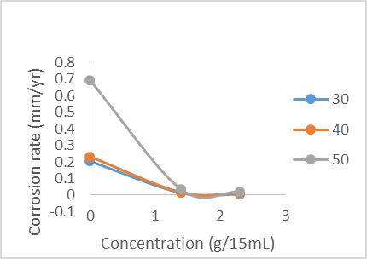2.3 and 1.3g/mL concentrations of the extracts, respectively.

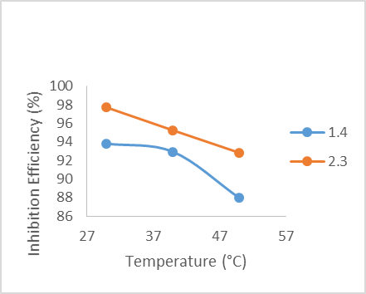

**Figure 4.2:** Inhibition efficiency vs Temperature plot for *Tamarindus indica*

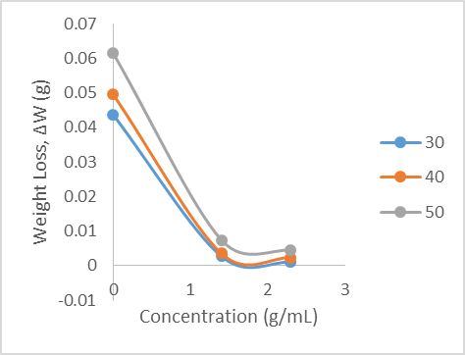 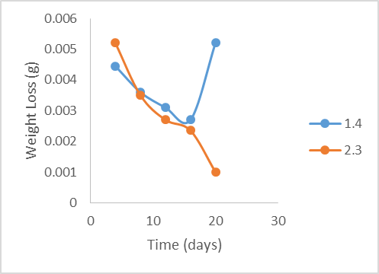

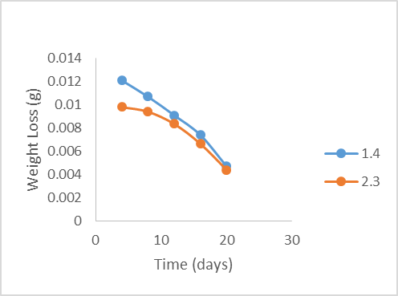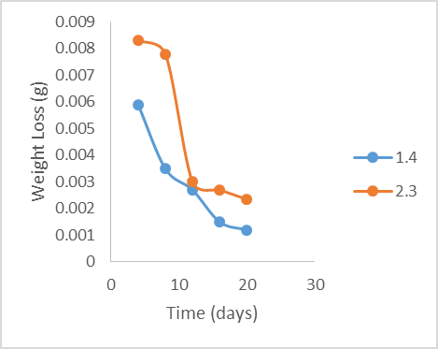

**Figure 4.3:** Weight loss vs Concentration plot for *Tamarindus indica*

**Figure 4.4:** Weight loss vs Time plot at 30°C for

*Tamarindus indica*

**Figure 4.5:** Weight loss vs Time plot at 50°C for

*Tamarindus indica*

**Figure 4.6:** Weight loss vs Time plot at 40°C for *Tamarindus indica*

# GRAVIMETRIC ANALYSIS (TROPICAL ALMOND)

Table 4.3 shows the results for the weight loss analysis of the inhibition of stainless steel in 1 M HCl using tropical almond.

Table 4.3: Result for gravimetric analysis of *Terminalia Catappa*

|  |  |  |  |  |  |
| --- | --- | --- | --- | --- | --- |
| **Temperature (°C)** | **Concentration (g/15mL)** | **Weight loss, ∆W (g)** | **Corrosion Rate (mm/yr)** | **Surface Coverage (θ)** | **%**  **Inhibition Efficiency (%IE)** |
| 30 | 0.9 | 0.0022 | 0.0207 | 0.9495 | 94.95 |
| 1.1 | 0.0015 | 0.0141 | 0.9656 | 96.56 |
| 1.3 | 0.0014 | 0.0131 | 0.9679 | 96.79 |
| 40 | 0.9 | 0.0046 | 0.0432 | 0.9071 | 90.71 |
| 1.1 | 0.0037 | 0.0343 | 0.9263 | 92.63 |
| 1.3 | 0.0021 | 0.0197 | 0.9576 | 95.76 |
| 50 | 0.9 | 0.0070 | 0.0653 | 0.8870 | 88.70 |
| 1.1 | 0.0051 | 0.0479 | 0.9171 | 91.71 |
| 1.3 | 0.0013 | 0.0122 | 0.9789 | 97.89 |

For *Terminalia catappa,* 1.3g/mL gave the highest efficiency of 97.89% at 50°C and 0.9g/mL gave the lowest, 88.7% at 50°C. When compared to the predicted values, it was observed that slightly lower efficiencies were obtained experimentally. This could be attributed to the degradation of the extracts with time, which was not taken into consideration in the calculation. Comparing with the results from literature, where 96.6% efficiency was obtained using 2.5g/L in 1M HCl at a temperature between 25-65°C, it would be concluded that the two leaves extracts used in this study acted as better inhibitors for the corrosion of stainless steel in the same medium24

Table 4.4: Modeled/predicted values for tropical almond

|  |  |  |  |
| --- | --- | --- | --- |
| **Temperature (°C)** | **Concentration**  **(g/15ml)** | **Surface Coverage**  **(θ)** | **Inhibition Efficiency**  **(%IE)** |
| 30 | 1.1 | 0.9240 | 92.4 |
| 40 | 1.3 | 0.9800 | 98.0 |
| 50 | 0.9 | 0.9140 | 91.4 |

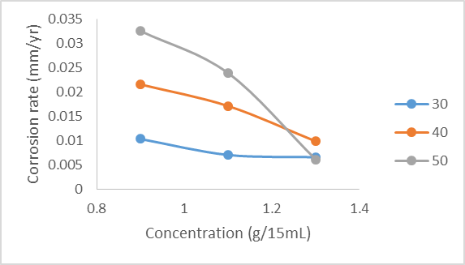 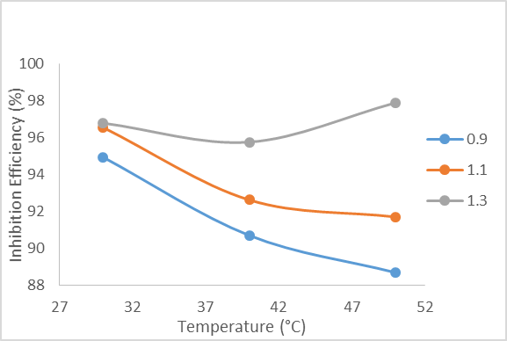

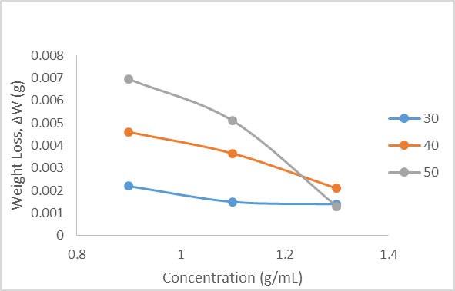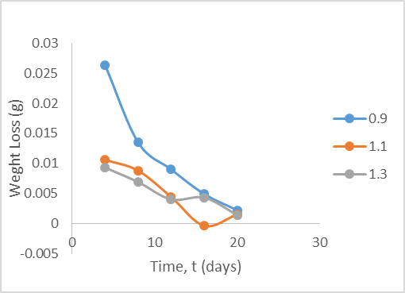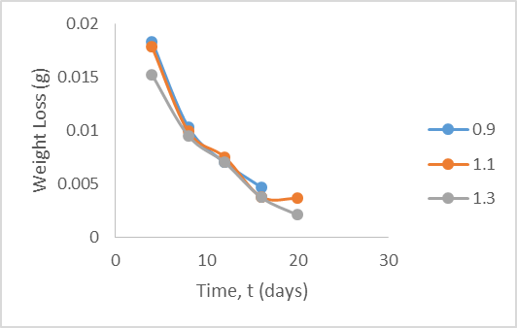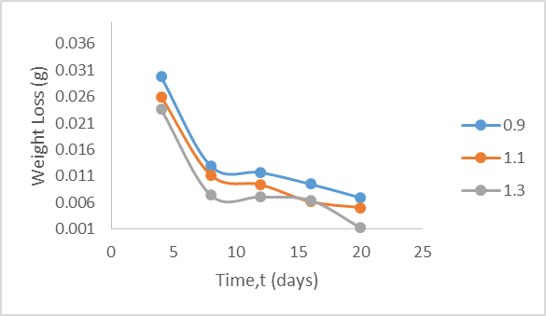

**Figure 4.7:** Corrosion rate vs Concentration plot for *Terminalia catappa*

**Figure 4.8:** Inhibition efficiency vs Temperature plot for *Terminalia catappa*

**Figure 4.9:** Weight loss vs Concentration plot for *Terminalia catappa*

**Figure 4.10:** Weight loss vs Time plot for

*Terminalia catappa*

**Figure 4.11:** Weight loss vs Time plot at 40°C for *Terminalia catappa*

**Figure 4.12:** Weight loss vs Time plot at 50°C for

*Terminalia catappa*

# ADSORPTION MECHANISM FOR TROPICAL ALMOND

Langmuir isotherm was used to figure out if there was a formation of layer of insoluble complex of the metal on the surface acting as a barrier between the metal surface and the corrosive medium; physisorption13.

Temkin isotherm on the other hand was used to determine if the adsorption of the inhibitor on the metal surface is through chemisorption-displacement of water molecules from the metal surface and the sharing of electrons between oxygen atom and iron. Temkin adsorption isotherm assumes a uniform distribution of adsorption energy, which decreases with the increase in the value of surface coverage, θ13.

Langmuir plot describes the relationship between the surface coverage and inhibition concentration;

(4.5)

where C represents the concentration of the extract, θ represents the surface coverage and K is the equilibrium constant.

Temkin graph is expressed as:

(4.6)

where f, represents the adsorbent-adsorbate interaction, the other parameters are the same with that of Langmuir isotherm. The equilibrium constant is used to calculate the Gibb’s free energy,

. (4.7)

Table 4.5: Adsorption mechanism for tropical almond

|  |  |  |  |  |  |  |
| --- | --- | --- | --- | --- | --- | --- |
| **ISOTHERM** | | **SLOPE** | **INTERCEPT** | **K** |  | **(kJ/mol)** |
| LANGMUIR | 303K | 0.9880 | 0.0566 | 17.67 | 0.9997 | -17.352 |
| 313K | 0.9135 | 0.1743 | 5.737 | 0.9984 | -14.998 |
| 323K | 0.7832 | 0.3194 | 3.131 | 0.9894 | -13.851 |
| TEMKIN | 303K | 0.0510 | 0.9567 | 1.402 | 0.8786 | -57.373 |
| 313K | 0.1359 | 0.9189 | 864.01 | 0.9643 | -28.047 |
| 323K | 0.2469 | 0.9067 | 39.34 | 0.9389 | -20.647 |

The slopes and linear regression of the Langmuir and Temkin plots indicate that tropical almond adsorbs on the stainless steel surface by the mixed adsorption method-physisorption and chemisorption. This is due to the tendency to unity of the linear regressions. Also, the negative values of the Gibb’s free energy of adsorption proves that the adsorption process is spontaneous14,20,26,27.

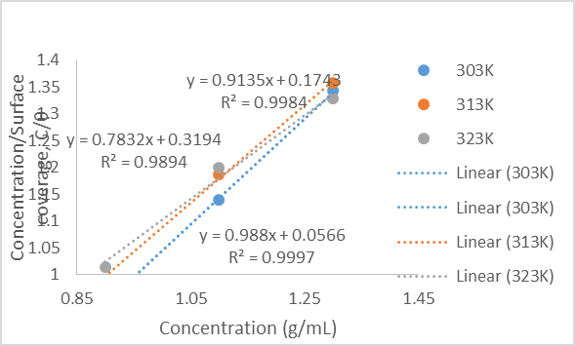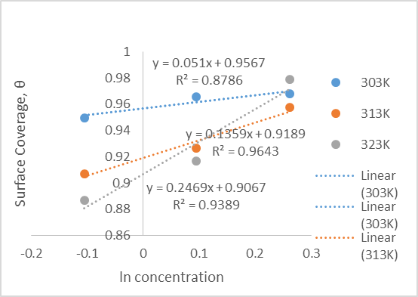

**Figure 4.13:** Langmuir Isotherm plot for

*Terminalia catappa*

**Figure 4.14:** Temkin isotherm plot for *Terminalia catappa*

# EFFECT OF TEMPERATURE

The effect of temperature is determined using the Arrhenius equation and the heat of adsorption.

The Arrhenius equation is expressed as

(4.8) where  and  are corrosion rates at temperatures T1 and T2, respectively. The heat of adsorption is expressed as

(4.9)

where θ1 and θ2 are degrees of surface coverage at temperatures T1 and T2. Table 4.6: Effect of temperature on the *Terminalia catappa* extracts

|  |  |  |
| --- | --- | --- |
| Extract Concentration(g/L) | Ea(kJ/mol) | Qads(kJ/mol) |
| 0.9 | 46.790 | 35.625 |
| 1.1 | 49.781 | -37.995 |
| 1.3 | 90.676 | 17.337 |

Table 4.7: Effect of temperature on the *Tamarindus indica* extracts

|  |  |  |
| --- | --- | --- |
| Extract Concentration(g/L) | Ea(kJ/mol) | Qads(kJ/mol) |
| 1.4 | 41.044 | -29.730 |
| 2.3 | 60.282 | -48.528 |

The increase in the activation energy with increase in the concentration of inhibitor assumes a physical adsorption mechanism. This is because of the assertion that the rate of surface coverage diminishes with increase in the temperature of the corrosion environment. The negative values of the heat of adsorption for the tamarind extract suggests that the adsorption reaction wasexothermic14,20,26,27.

# CHAPTER 5: CONCLUSIONS AND RECOMMENDATIONS

# CONCLUSIONS

The corrosion inhibition efficiency of *Terminalia catappa (*tropical almond) and *Tamarindus indica* (tamarind) on 304 type austenitic stainless steel have been investigated in 1M HCl and both have been found out to be good inhibitors. The results of the gravimetric analysis showed that tropical almond is a better inhibitor than tamarind in 1M HCl because its highest efficiency, 97.89% was obtained at a concentration of 1.3g/mL, while that of tamarind was 97.71% with the addition of 2.3g/mL which is a higher concentration.

The thermodynamic analysis and the isotherms proved that tropical almond acted as a mixed type inhibitor, although predominantly, by physisorption whereas, tamarind adsorbed by physisorption only.

# RECOMMENDATIONS

For future research or study on this topic, higher temperatures from 50°C and above should be considered to ascertain the effect of higher temperature on the inhibition efficiency of both inhibitors. Also, surface analysis of the metal after corrosion should be studied to know the types of oxides that are formed on the metal surface. Other methods such as electrochemical method and UV analysis can also be carried out in the future.

# REFERENCES

1. Sastri, V.S. *Green Corrosion Inhibitors: Theory and Practice,* 2012; 7-8.
2. Walter Shapiro. *Time Magazine,* 2001
3. Bagotsky, V.S. *Fundamentals of Electrochemistry,* 2006; Second Edition, 379-386.
4. Amitha Rani, B.E.; Bharathi Basu, B.J. *International Journal of Corrosion*, 2012; 380217, 1- 15.
5. John Beavers, A; Neil Thomprom,G. *ASM International,* 2006; 13C, 1015-1025.
6. Gummow, R.A. et al. *Journal of Atmospheric and Solar-Terrestrial Physics,* 2002; 64, 1755- 1764.
7. Sumaiah Hussein, I.; Nahi Yaseen, Y.; Shatha Jawad, Q.; Suha Abd, T. *International Journal of Advanced Biological Research,* 2017; 7(2), 360-362.
8. Manoj Acharya; Jinendra Chouhan, S.; Anita Dixit; Gupta, D.K. *Chemistry and Materials Research,* 2013; 3(6), 16-24.
9. Arumugam Anand, V.; Natarajan Divya; Pannerselvam Kotti, P. *Pharmacognosy Review*, 2015; 9(18), 93-98.
10. Francisco Mininel, J.; Carlos Leonardo, S.; Lívia Espanha, G. *Evidence-Based Complementary and Alternative Medicine,* 2014; 676902.
11. Stainless Steels - Introduction to Grades, Properties and Applications, Supplier Data. *Azo Materials,* 2005.
12. Oil & Gas Exploration and Production Chemicals – Hydrochloric Acid. *Continental Chemical, USA.*
13. Rosaline Vimala, J; Leema Rose, A; Raja, S**.** *Der Chemica Sinica*, 2012; 3(3), 582-588.
14. Isreal Owate, O; Onyinyechi Nwadiuko, C; Ijeoma Dike, I; John Isu, O; Lebe Nnanna, A.

*American Journal of Materials Science* 2014; 4(3), 144-149.

1. Nnanna, L.A.; Anozie, I.U.; Avoaja, A.G.I.; Akoma, C.S.; Eti, E.P.*African Journal of Pure and Applied Chemistry*, 2011; 5(8), 265-271.
2. Nnabuk Eddy, O; Patricia Ekwumemgbo, A; Paul Mamza, A.P.*Green Chemistry Letters and Reviews,* 2009; 2(3), 223-231.
3. Lebe Nnanna, A; Ikechi Anozie, U.; Chigozie Akoma, S.; Ihebrodike Mejeha, M; Kelechukwu Okeoma, B.; Kingsley Mejeh, I. *American Journal of Materials Science,* 2011; 1(2), 76-80.
4. Premjith Ramakrishnan, J.; Vishnu Janardhanan, D.K.; Ramkumar Sreekumar; Keerthy Mohan, P. *International Journal of Corrosion,* 2014; ID 487103, 1-5.
5. Olugbenga Omotosho, A.; Joshua Okeniyi, O.; Cleophas Loto, A.; Abimbola Popoola, P.; Adeoluwa Oni; Ayomide Alabi; Abisola Olarewaju. *The Minerals, Metals & Materials Society*, 2018.
6. Joseph Nwabanne, T.; Vincent Okafor, N. *Journal of Minerals and Materials Characterization and Engineering*, 2012; 11, 885-890.
7. Janaina da Rochaa, C.; José da Cunha, A.; Eliane D’Eliab. *Materials Research*, 2014; 17(6), 1581-1587.
8. Deivanayagam, P; Malarvizhi1, I.; Selvaraj, S.; Deeparani, P.*International Journal of advances in Pharmacy, Biology and Chemistry,* 2015; 4(3), 1-11
9. Tsuguo Suzuki; Yoshiharu Kitamura. *National Association of Corrosion Engineers, 1972.*
10. Nasrin Soltani; Nahid Tavakkoli; Maryam Khayatkashani; Mohammad Jalali, R.; Ahmad Mosavizade. *Corrosion Science*, 2012; 62, 122-135.
11. Iyasara, A.C.; Ovri, J.E.O. *The International Journal of Engineering and Science*, 2013; 2(1), 346-352.
12. Olugbenga Omotosho,A.; Joshua Okeniyi, O.; Cleophas Loto, A. *et al.The Minerals, Metals & Materials Society,*2018; 891-900.
13. Zarrouk, A.; Hammouti, B.; Zarrok, H.; Al-Deyab, S.S.; Messali, M. *International Journal of Electrochrmical Science*, 2011; 6, 6261-6274.
14. Utseoritselaju Okorodudu. *School of Arts and Sciences, American University of Nigeria, 2017; 1-32.*