A COMPARATIVE STUDY OF THERAPEUTIC EFFICACY OF DOUBLE – MODALITY THERAPY, PHONOPHORESIS AND CRYOTHERAPY IN THE MANAGEMENT OF MUSCULOSKELETAL INJURIES IN JOS

HENRY ADEIZA KEHINDE ONUWE B Sc (IBADAN); M Sc (IFE) PGMS/UJ/0007/06

A thesis in the Department of HUMAN PHYSIOLOGY Faculty of Medical Sciences

Submitted to the School of Postgraduate Studies,

University of Jos, in partial fulfilment of the requirements for the award of the degree of DOCTOR OF PHILOSOPHY in NEUROMUSCULAR PHYSIOLOGY of the UNIVERSITY OF JOS

March, 2014

### DECLARATION

I hereby declare that this work is the product of my own research efforts; undertaken under the supervision of Prof. Kemakolam Amadi and has not been presented elsewhere for the award of a degree or certificate. All sources have been duly distinguished and appropriately acknowledged.

_ Henry A. K. Onuwe PGMS/UJ/0007/06

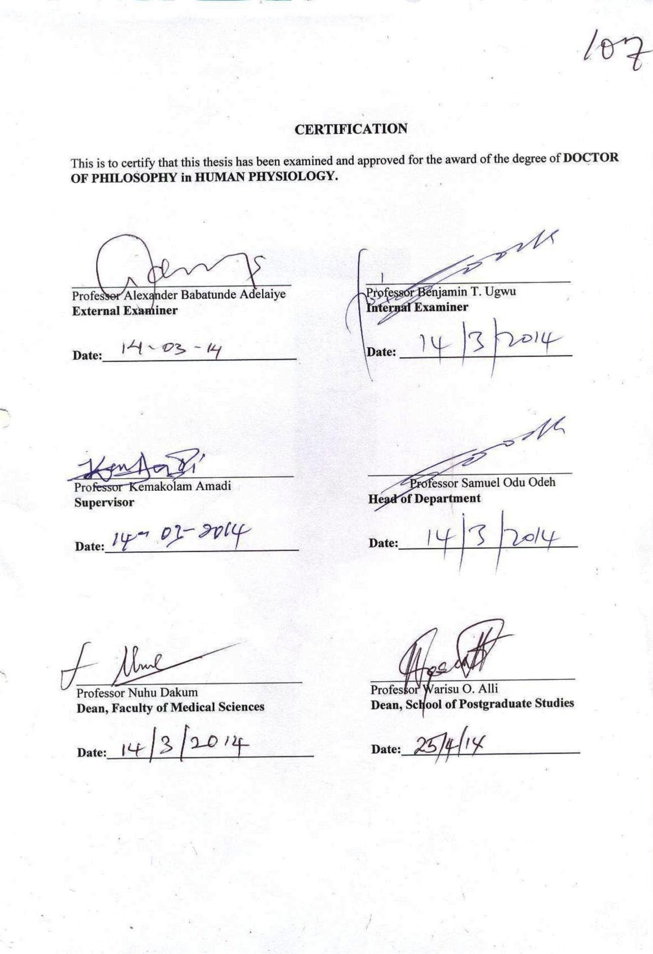

### ACKNOWLEDGEMENTS

To God be the glory for preserving my life. It is by the special grace and mercies of God that I was able to visit my data collection centres despite the incessant crisis which ravaged Jos metropolis and its environs in the last decade.

I like to seize this golden opportunity to express my love and deep appreciation to my able and erudite supervisor Prof. K. Amadi whose full supervision and worthy suggestions have made this work successful.

I convey warm regards to the Head of Department of Human Physiology, Prof. S.O. Odeh. He was cooperative and always gave me useful counsel.

I will not forget to give special recognition to Prof. O. Enyikwola who has never ceased to encourage me to press on hard. I thank you for

your scholarly advice. To you, Dr. Egesie (Departmental P.G. Coordinator and Deputy Dean Pre-Clinical), Dr. Oguche, Dr. Sabo, Dr. Adekwu and other academic and non-academic staff of Human Physiology Department too numerous to mention, I appreciate you all from the depth of my heart for all your contributions and support throughout the study period.

I am obliged to the following prominent stakeholder of our dear Faculty – the Dean, Prof. N.K. Dakum, the Deputy Dean – clinical (past and present), the Faculty Officer and their supportive staff. May the Lord equip you all to keep the Faculty functional and enviable.

The Doctors in Jos University Teaching Hospital, the Director and staff of Sports Centre Jos; and the medical staff of Primary Health Centres, Jos were all helpful during the data collection. I express my warm regards to them all.

Col. S.S. Umaru (rtd) is an individual who was personally concerned about this programme. I remember he kept telling me - “though it is hard and tough, you can make it, don‟t give up”. For your endless words of encouragement I say thank you. Another individual I cannot forget to mention is Mr. Henry Awoshika (physiotherapist). He was a good and reliable assistant throughout the period of data collection. The Lord will bless you.

To some members of staff in Jos University Teaching Hospital, particularly Mr. B.G.Ogundunmade (Chief Physiotherapist) who was always readily available to assist during the course of literature search, Mr. Amos Finangwai (Chief Pharmacist) who did the compounding of Methyl Salicylate 15% cream and the Aquasonic gel, Mrs. C.Okorie (Principal Computer Assistant) and Mr. S.T. Chime (Principal Confidential Secretary I) for their secretarial services, I convey my sincere appreciation.

Mrs. Victoria A. Onuwe, my dear wife and co-sponsor of this work, I cannot forget you. Besides the spiritual and financial resources you put into this work, I remember when the going was getting tough, you kept telling me - “remember it‟s unusual of you to abandon a project unfinished”. For

all your immeasurable contributions, I will continue to fuel the love I have for you.

Finally, I will not forget to acknowledge the Dean, Deputy Dean and the entire staff, especially Mrs. Suzan P. Iliya of Postgraduate School of the University for their relentless effort in ensuring that my work meet the set standard. May the Lord grant you all sufficient grace to bear the academic challenges.

### DEDICATION

This work is dedicated to ELShaddai Almighty God and His Son Jesus Christ our Lord and Saviour; and the entire members of Charismatic Renewal Ministries (C.R.M), in the following Centres : Jos (Amazing Grace), Bukuru, Zaramaganda (Mountain of the Lord), Bassa, Trade Centre, Utan (Potter‟s House) Sot, Fobur (True Gospel Centre) and Dawaki, all in Plateau State.

### TABLE OF CONTENTS

**TITLE PAGE**

DECLARATION ii

CERTIFICATION iii

ACKNOWLEDGEMENTS iv

DEDICATION vii

TABLE OF CONTENTS viii

LIST OF TABLES xii

LIST OF FIGURES xiii

ABSTRACT xiv

CHAPTER ONE INTRODUCTION

* 1. BACKGROUND TO THE STUDY 1
  2. RESEARCH PROBLEM 5
  3. RESEARCH AIM 6
  4. RESEARCH OBJECTIVE 7
  5. RESEARCH HYPOTHESIS 7
     1. Null Hypothesis 7
     2. Alternative Hypothesis 7
  6. JUSTIFICATION OF THE STUDY 8
  7. INCLUSION AND EXCLUSION CRITERIA 9
  8. LIMITATIONS 9

CHAPTER TWO LITERATURE REVIEW

* 1. PHONOPHORESIS 10
     1. Definition 10
     2. Historical Background of Ultrasonophoresis 11
     3. Topical Drugs, Couplants and Transmissivity in Phonophoresis 11
     4. Methods of Application – Therapeutic Ultrasound 17
     5. Treatment Settings for Phonophoresis 20
     6. Passage of Drugs across the Skin – Mechanism of action 21
     7. Uses of Ultrasound 24
     8. Indications for Phonophoresis 24
     9. Dangers/Contraindications of Therapeutic Ultrasound 25
     10. Effectiveness of Phonophoresis 27
  2. CRYOTHERAPY 33
     1. Definition 33
     2. Mode and Method of Cryotherapy Application 34
     3. Length/Duration of Application 39
     4. Indications/Contraindications for Cryotherapy 39
     5. Precautions/Side-Effects of Cryotherapy 40
     6. Pathophysiologic Effect of Cryotherapy 42
     7. Effectiveness of Cryotherapy 46
  3. MUSCULOSKELETAL INJURIES 48
     1. Definition/Epidemiology 48
     2. Causes of Musculoskeletal Injuries 50
     3. Signs and Symptoms of Musculoskeletal Pain 52
     4. Treatment and Management of Musculoskeletal Pain 52
  4. MEASUREMENT OF PAIN/PHYSIOLOGY OF NOCICEPTION 56
     1. Definition of Pain 56
     2. Types of Pain 58
     3. Measurement of Pain 63
     4. Physiology of Nociceptive Transmission Pathways 71
     5. Pain Modulation – Suppression of the Nociceptive System 75

CHAPTER THREE METHODOLOGY

* 1. HUMAN PARTICIPANTS AND RECRUITMENT 79
  2. INSTRUMENTS AND MATERIALS 80
  3. OUTCOME MEASURES 81
  4. EXPERIMENTAL PROCEDURE 81
     1. Double-Modality Therapy Group 83
     2. Phonophoresis Group 84
     3. Cryotherapy Group 85
  5. DATA ANALYSIS 87

CHAPTER FOUR RESULTS

* 1. PARTICIPANTS SEX AND AGE 88
  2. PARTICIPANTS OCUPATION 90
  3. TREATMENT SESSIONS 92
  4. PARTICIPANT DISCHARGE PATTERN 94
  5. PARTICIPANT PAIN PERCEPTION SCORES 96
     1. Comparison of Pain Perception Scores in DMT Group 96
     2. Comparison of Pain Perception Scores in PHONO Group 97
     3. Comparison of Pain Perception Scores in CRYO Group 98
     4. Comparison of Pain Perception Scores in all Groups 99
  6. PARTICIPANT POST-TREATMENT REPORT 100

CHAPTER FIVE

DISCUSSION, CONCLUSION AND CONTRIBUTION TO KNOWLEDGE

* 1. DISCUSSION 101
  2. CONCLUSION 107
  3. CONTRIBUTION TO KNOWLEDGE 107

REFERENCES 109

APPENDIX

A : Ethical Approval Letter 122

B : Informed Consent Form 123

C. : Assessment/Examination Format 124

D : Raw Data Sheet 125

E : Published Articles/Manuscript Acceptance Letters 130

F : Photographs of Instruments/Treatment procedures 137

### LIST OF TABLES

TABLE PAGE

1. Ultrasound Transmission by Phonophoresis Agent 16
2. Temperature decrease with various Cold Therapies (ºC) 37
3. Stages of Analgesia induced by Cold Therapy 43
4. Sex and Mean Age of Subjects 89
5. Participants Occupation 91
6. Mean Treatment Sessions 93
7. Participant Discharge Pattern 95
8. Comparison of Pain Perception Scores in DMT Group 96
9. Comparison of Pain Perception Scores in PHONO Group 97
10. Comparison of Pain Perception Scores in CRYO Group 98
11. Cross-Comparison of Pain Perception Scores in all Groups 99

### LIST OF FIGURES

FIGURE PAGE

1. A summary of the time-course of Physiological Events

following an Injury 60

1. Simple Descriptive Scale (SDS) 64
2. Numerical Rating Scale (NRS) 65
3. Visual Analogue Scale (VAS) 66
4. Graphic Rating Scale(GRS) 67
5. Pain Chart 68
6. The McGill Pain Questionnaire (MPQ) 69
7. Components of Nociceptive System 72
8. Gate Control Theory of Pain 77

### Abstract

Musculoskeletal injuries ( MSIs ) account for approximately 25% of

patients‟ complaints in the primary health care settings and are a leading cause of work absenteeism world-wide. Physical treatments like phonophoresis ( PH ) and cryotherapy ( CRYO ) are being used to reduce pain, control swelling and improve function. The recognition of the importance of pain control in the recovery from MSIs has prompted clinicians to continue to explore more aggressive pain management strategies. It is suggested that PH and CRYO could be combined ( double- modality therapy – DMT ) in managing MSIs for better outcome. There is dearth of information in the literature to support the practise or demonstrate its ( DMT ) efficacy or superiority over the single treatment protocol. This work was a prospective study therefore, designed to investigate the therapeutic efficacy of DMT in the management of pain among participants who suffered from MSIs. Participants were assigned randomly to one of three groups: DMT group ( n=20 ) received cryotherapy and 15% methyl salicylate phonophoresis, PHONO group ( n=20 ) received 15% methyl salicylate phonophoresis and CRYO group ( n=20 ) received cryotherapy and „sham‟ phonophoresis. Pre-and post-treatment pain perception scores

( PPS ) among the participants using visual analogue scale ( VAS ) and the duration of treatment in all groups were recorded.

Treatment was administered on alternate days in all groups. The result shows a total of 275 treatment sessions was recorded in the three groups - 72 ( 26.2% ) in DMT, 105 ( 38.2% ) in PHONO and 98 ( 35.6% ) in CRYO

group which indicates no significant difference ( p > 0.05 ) in treatment sessions in favour of DMT. The difference in the severity of pain before and after treatment was remarkable and statistically significant ( p < 0.05 ) in each group which suggests that DMT, phonophoresis and cryotherapy were equally effective. DMT protocol was significantly ( P < 0.05 ) effective in its group, but could not significantly produce more pain relief among the participants when compared with the two other groups.

In conclusion, the current study has indicated the significant therapeutic efficacy of DMT, but it could not produce more pain relief than the two other protocols ( PHONO and CRYO ). However, the result has indicated that it might take less or fewer sessions to treat and make the participants included in this study pain free and fit to return to active performance when DMT is considered.

## CHAPTER ONE

### INTRODUCTION

### BACKGROUND TO THE STUDY

Musculoskeletal injury refers to damage of muscular or skeletal systems which is usually due to a strenuous activity ( Hootman et al, 2002 ).

Musculoskeletal disorders ( MSDs ) or injuries or impairments ( MSIs ) account for roughly 25% of patient complaints in the primary health care settings ( Childs et al, 2005 ) and are a leading cause of work absenteeism worldwide ( Beebe, Barkin and Barkin, 2005 ). Musculoskeletal problems constitute the largest proportion of injuries among athletes ( Reilly and Hardiker, 1983; Onuwe, 2001 ). Report has indicated that more than 60% of men and women who work on the computer have complained of pain resulting from various MSDs ( Idowu, Adedoyin and Adagunodo, 2005 ). Low back pain ( LBP ) is not only one of the most common MSDs in industrialised societies, but it is the most costly, and it is the primary cause of disability in persons under age 45 years ( DeRosa and Porterfield, 1992; Sanya and Ogwumike, 2005 ). In the United States more than 25,000 ankle sprains occur each day and the concomitant symptoms (pains and swelling) leave the individuals with some functional disability ( Man, Morrisey and Cywinske, 2007 ).

Physical therapists ( physiotherapists ) increasingly provide direct access services ( using physical modalities ) to patients with musculoskeletal conditions, and growing evidence supports the cost-effectiveness of this

mode of healthcare delivery ( Childs et al, 2005 ). These physical modalities ( ultrasound, phonophoresis, cryotherapy, electrical stimulation, laser and iontophoresis ) or treatments have been used for thousands of years and are currently being used to reduce pain, control swelling or inflammation and improve or restore function in the management of MSIs ( Bolin, 2003; Kozanoglu, Basaran, Guzel and Guler-Uysal, 2003 ). Therapeutic ultrasound ( US ) as a deep heating modality may produce temperature elevations of 4 - 5° C at depths of 8cm ( Kozanoglu, Basaran, Guzel and Guler-Uysal, 2003 ) and thus produce a number of physiological effect which makes it a suitable modality in the treatment of MSDs ( Balogun, 1990 ). Report has shown that ultrasound ( US ) has been widely used for more than 40 years in the treatment of musculoskeletal disorders ( MSDs ) such as tendinitis, tenosynovitis, epicondylitis, bursitis, osteoarthritis , etc

( Kozanoglu, Basaran, Guzel and Guler-Uysal, 2003 ).

When ultrasound ( US ) is therefore, used to increase the transcutaneous transmission of topical drugs or used to enhance percutaneous absorption of topical drugs in the management of musculoskeletal disorders ( MSDs ) or injuries ( MSIs ), this treatment procedure is referred to or described as **phonophoresis** ( Byl, 1995; Machet and Boucuad, 2002; Kozanoglu Basaran, Guzel and Guler-Uysal, 2003; Kuntz, Griffins, Rankin, Amstrong and McLaughlin, 2006 ). Phonophoresis has been a widely applied clinical procedure for treatment of MSDs or MSIs ( Byl, 1995; Kozanoglu, Basaran,

Guzel and Guler-Uysal, 2003 ) and dermatological conditions ( Kozanoglu, Basaran, Guzel and Guler-Uysal, 2003 ) since the first time it was used in 1954 by Fellinger and Schmid to treat polyarthritis of the hand ( Byl, 1995 ). It is believed to accelerate functional recovery by decreasing pain and promoting healing ( Cagnie, Vinck, Rimbaut and Vanderstraeten, 2003 ). In a research conducted to determine the effect of phonophoresis (0.5% fluocinonide) and ultrasound in the treatment of 49 subjects with common MSDs, like epicondylitis, tendinitis and tenosynovitis, it was observed at the end of 3 weeks of treatment that both modalities showed significant decrease in pain level ( P < 0.05 ) and an increase in pressure tolerance; although phonophoresis was not superior to ultrasound alone ( Klaiman et al, 1998 ). In a comparative study involving iodex phonophoresis ( n = 15 ), iodex iontophoresis ( n = 15 ) and a placebo ( n = 15 ) in the management of shoulder periarthritis, Bumin and Can ( 2004 ) did observe that iodex phonophoresis and iodex iontophoresis were significantly effective in decreasing pain as compared to the placebo. Similar observation was made in a case report ( Olaogun and Aluko; 2000 ) which presented two cases with different MSDs. This report indicated that application of phonophoresis ( 8% methyl salicylate ) brought about significant pain relief ( Present Pain Index was essentially 0 ) and remarkable improved function.

**Cryotherapy** is defined as the therapeutic application of any substance to the body that removes heat from the body, resulting in

decreased tissue temperature ( Nadler, Weingand and Kruse, 2004 ). Specifically, Cryotherapy is the application of cold for the treatment of injury or disease, particularly for increasing pain threshold, decreasing inflammatory reaction and spasm following MSIs ( Swenson, Sward and Karisson, 1996; Yagiz, 2006 ). Cold therapy has been advocated by some researchers as the sole treatment to be used during all phases of soft tissue injury ( Cote, Prentice, Hooker and Shields, 1988; Swenson, Sward and Karisson, 1996 ). In a systematic review of some randomised controlled trials ( RCTs ) to indentify the efficacy of ice in the management of pain and swelling resulting from soft tissue injury, it is reported that cryotherapy seems to be effective in decreasing pain and speeds return to full activity

( MacAuley, 2001; Hubbard and Denegar, 2004 ). A comparative study

( Cote, Prentice, Hooker and Shields, 1988 ) was conducted to determine the relative effect of cold, heat and contrast bath treatments on the amount of oedema in 30 subjects with post-acute ankle sprains. The results of this study suggest that cryotherapy is the most favourable of the three treatments as regards minimizing oedema. In a randomised controlled study ( Bleakley, McDonough, MacAulley and Bjordal, 2006 ) of two icing protocols in the management of acute ankle sprains, it was observed that cryotherapy raised the ankle pain threshold significantly within one week after injury.

### RESEARCH PROBLEM

Phonophoresis or Cryotherapy in isolation or in combination with other therapies has become widely used treatment regimen for reducing pain, inflammation and improving or restoring function in managing MSIs

( Kellett, 1986; Palmer and Toombs, 2004; Wilson and Best, 2005 ). Davis

( 1991 ) has recommended the application of cryotherapy as a single treatment protocol for hours ( i.e 72 hours ) when there is trauma ( i.e rotator cuff syndrome ) before resorting to phonophoresis for the remaining period of treatment. Literature has indicated that cold application prior to phonophoresis produces an intense hyperemia which may improve the absorption and distribution of the medication ( Santiesteban, 1983 ). There has always been the trend in orthopaedic medicine that with a corticosteroid injection, application of ice ( cryotherapy ) and decreased movement are recommended to decrease the likelihood of “flushing” the product ( drug ) out of the tissue or joint space and into general circulation ( Ball, 2002 ). The recognition of the importance of pain control in the recovery from MSIs to enable the injured persons return to participation ( athletes ) or return to work ( typical population ) has prompted clinicians to continue to explore more aggressive pain management strategies ( Brolinson and Sampson, 2003; Hubbard, Aronson and Denegar, 2004 ). Some reports

( Santiesteban, 1983; Balogun, 1990 ) recommended that phonophoresis and cryotherapy can be combined ( double-modality-DMT ) in the management of MSIs for better outcome. Sequel to this, pain clinics and sport centres

have adopted as a tradition the treatment protocol of combining phonophoresis and cryotherapy ( DMT ) in the management of MSDs worldwide. Despite the general acceptance and the frequency this treatment approach ( DMT ) is being practised, the efficacy or superiority of this treatment combination over the single protocol of phonophoresis or cryotherapy is still questionable and there is dearth of information in the literature to support this practice ( Balogun, 1990; Ball, 2002 ). The practise is probably or largely based on anecdotal evidence rather than on empirical data. Clinical opinion just isn‟t good enough anymore. Hence, it is incumbent upon the clinician or the therapist to collect information or data to support clinical decision making with something more than physiologic philosophy based on opinion. Randomised clinical trials are required therefore, to support clinical decision making ( evidence-based data ) on the use of phonophoresis and cryotherapy as combined treatment ( DMT ) protocol for optimal outcome or response following MSI management.

### RESEARCH AIM

To compare double-modality therapy, phonophoresis and cryotherapy in the management of musculoskeletal injuries in order to provide valid and reliable evidence-based data.

### RESEARCH OBJECTIVE

To determine the therapeutic efficacy of double-modality, phonophoresis and cryotherapy in the management of pain among human participants who suffered from various MSIs ( such as muscle strain, muscle contusion, lateral epicondylitis or tennis elbow, medial epicondylitis or golfers elbow, tendinitis, sprained joints, bursitis, tenosynovitis, carpal tunnel syndrome, whiplash injury, wry neck, rotator cuff syndrome ) and to explore suitable treatment settings ( ultrasound settings ) for this study.

### RESEARCH HYPOTHESIS

* + 1. **Null Hypothesis** : There will be no significant difference in pain relief among the subjects treated with DMT; and there will be no significant difference between the DMT protocol and the one treatment protocol of phonophoresis or cryotherapy respectively in regard to pain relief and treatment duration ( sessions ).
    2. **Alternative Hypothesis** : There will be significant difference in pain relief among subjects treated with DMT; and there will be significant difference in pain relief and treatment duration in favour of DMT among all subjects treated. In other words, the outcome measures ( response ) with respect to pain perception and duration of treatment after DMT protocol will differ significantly from the one treatment protocol of phonophoresis or cryotherapy respectively.

### JUSTIFICATION OF THE STUDY

1. The findings of this research will assist physiotherapists and other clinicians to make their choice or prescription of treatment on evidence-based or empirical data in the use of phonophoresis and cryotherapy as combined treatment ( DMT ) protocol when treating MSIs. Hence, it will encourage therapists or other practitioners to stop using treatment procedures based on anectodal report or experience.
2. The results of the current study may help to alleviate the inconsistency or controversy associated with the efficacy of phonophoresis or cryotherapy treatment in isolation or in combination with other therapies in the management of human participants suffering from MSIs.
3. The study may further demonstrate that phonophoresis enhances the absorption of NSAIDs, particularly methyl salicylate ( 15% ) for therapeutic purposes ( i.e musculoskeletal pain modulation ).
4. The study may also enhance the knowledge-base of the clinicians when selecting or prescribing ultrasound settings and mode of cryotherapy application for DMT protocol for optimal result.

### INCLUSION AND EXCLUSION CRITERIA

1. This study was purposely designed to examine the relative therapeutic efficacy of DMT in the management of musculoskeletal pain.
2. No physical modalities other than phonophoresis ( methyl salicylate 15% ) and cryotherapy were utilized in this study.
3. Participants with not more than one MSI were recruited into the study.
4. Participants who were on any form of analgesics ( steroidal and non- steroidal anti-inflammatory drugs ), muscle relaxants and any form of physiotherapy treatments were excluded from the study.
5. The use of NSAIDs or analgesics and any other form of treatment was not permitted or allowed throughout the period of study.
6. Participants with known disease conditions which contraindicate the treatment protocols used in this study were excluded from the study.
7. Recruitment of participants into this study was carried out in Jos University Teaching Hospital, Health Centres, and Sport Centre located within Jos metropolis.

### LIMITATIONS

1. Inability or difficulty in obtaining homogeneous human participants.
2. Variation of threshold of pain among individual participant.
3. Participants non-adherence strictly to treatment modalities used in the study.
4. Participants inability to keep regular treatment appointments.

## CHAPTER TWO

### LITERATURE REVIEW

### PHONOPHORESIS

### Definition

Phonophoresis ( sonophoresis, ultrasonophoresis, ultraphonophoresis) is the use of ultrasound waves ( US ) for transdermal drug delivery ( TDD ) ( Byl, 1995; Machet and Boucaud, 2002; Kuntz et al, 2006 ). In other words phonophoresis is the use of ultrasound waves to promote local absorption of topically applied drugs at the site of soft tissue injury ( Kellett, 1986 ). Phonophoresis is non-invasive, pain-free, well tolerated and involves minimal risk of hepatic and renal injury ( Klaiman et al, 1998 ). Ultrasound consists of inaudible acoustic, high frequency waves ( >20 KHz ) ( Byl, 1995 ) that may produce either thermal or non-thermal physiologic effects

( Allen, 2005 ) in the body tissues. Traditionally, ultrasound is used for the purpose of elevating tissue temperatures and is referred to as a deep heating modality which operates in the frequency range between 0.75 and 3.0 MHz. For therapeutic use the ultrasound energy is expressed as the number of watts per square centimeter ( W/cm² ) ranging from about 0.1 to 3 W/cm²

( Allen, 2005 ). Delivery of ultrasound can be either thermal – continuous

( producing more thermal heating; intensity of 1.0 to 1.5 W/cm² ) or nonthermal - pulsed ( producing less heating; intensity of 0.8 to 1.5 W/cm² ) ( Allen, 2005 )**.**

### Historical Background of Ultrasonophoresis

Ultrasound was first introduced as a therapeutic modality in the 1950s, when both animal and human studies demonstrated its ability to safely heat tissue several centimeters below the skin, particularly tissues that are high in collagen ( Wong, Schumann, Townsend and Phelps, 2007 ). The first published report on the use of phonophoresis appeared in 1954 when Fellinger and Schmid ( Byl, 1995 ) showed that US could carry hydrocortisone across an avascular membrane for the effective treatment of polyarthritis of the hand. However, ultrasound for transdermal drug delivery ( TDD or ultrasonophoresis ) has been a widely used clinical technique in sports medicine by physiotherapists since the sixties ( Byl, 1995; Machet and Boucaud, 2002 ). Wong, Schumann, Townsend and Phelps ( 2007 ) carried out a study in America to determine the use of phonophoresis by physical therapists. The study reported that 76.3% ( n = 207 ) use phonophoresis as treatment modality for soft tissue inflammation and pain management.

### Topical Drugs, Couplants and Transmissivity in Phonophoresis Drugs

Topical drugs are usually applied to intended site of action, the target for drug interaction may be systemic or local. Drugs with local target diffuse into the area immediately below the administration site – subcutaneous tissue, muscle, synovium, ligaments, tendons and joints; while systemic

drugs diffuse through the epidermis to dermis to reach the capillary network ( Byl, 1995 ). In physical therapy, the preferred target for most topically applied drugs has been local, with the three most common topical drugs among others catigorised below:

### Anaesthetics:

Substances that block pain receptors by creating numbness ( Byl, 1995; Byl, Zellerbach and Pfalzer, 1995; Allen, 2005 ) and they include:

* 1. Lidocaine or lignocaine
  2. Xylocaine

### Counter – irritants:

Substances ( e.g menthol ) that cause inflammation of the skin for purposes of relieving pain from stimulation rather than depression of cutaneous sensory receptors ( Byl, 1995; Byl, Zellerbach and Pfalzer, 1995; Allen, 2005; Kuntz et al, 2006 )

### Anti – inflammatories:

Corticosteroids and non - steroidal drugs are examples of medications in this category ( Byl, 1995; Byl, Zellerbach and Pfalzer, 1995 ) **Steroidal drugs:**

* 1. Hydrocortisone 1% -10%
  2. Dexamethasone 0.04%
  3. Bethamethasone dipropionate 0.05%
  4. Fluocinonide 0.05%

### Non - steroidal drugs:

1. Sodium salicylate 10%
2. Methyl salicylate 15% (aspirin)
3. Ketoprofen 2%
4. Piroxicam 0.5%
5. Naproxen 5%
6. Trolamine salicylate 10%

### Other drugs:

Other drugs administered using ultrasound as an enhancer include

( Byl, 1995; McEnlay, Benson, Harland and Hargraft, 2004; Allen, 2005 ) :

* 1. Chymotrypsin
  2. Hyaluronidase
  3. Iodine 4%
  4. Mecholyl
  5. Trypsin
  6. Zinc oxide 20%
  7. Dimethyl sulfoxide ( DMSO )
  8. Amphotericin B ointment
  9. Methyl nicotinate

### Couplants

Ultrasound waves are not transmitted by air, thus some couplant

( coupling medium ) which does transmit them must be interposed between the treatment head ( transducer ) and the patient‟s body ( skin ). The product should be smooth, non-gritty and should be of relatively low viscosity

for ease of application and ease of movement of the transducer ( treatment head ) during treatment ( Allen, 2005 ). Gel preparations work very well

( Cagnie, Vinck, Rimbaut and Vanderstraeten, 2003; Allen, 2005 ) while emulsions are good but the oil-water interfaces in emulsions can disperse the ultrasonic waves, resulting in a reduction of the intensity of the energy reaching the skin ( Allen, 2005 ). Air should not be incorporated into the product as air bubbles may disperse the ultrasound waves resulting in heating at the liquid : air interface. Some coupling agents ( Reid and Cummings, 1977 ) have been investigated and found relatively efficient in ultrasound transmission and thus useful for phonophoresis. Such coupling agents and their transmission relative to that of water (%) include:

|  |  |
| --- | --- |
| (i) Aquasonic gel | 72.60% |
| (ii) Glycerol | 67.75% |
| (iii) Distilled water | 59.38% |
| (iv) ECG Couplant | 26.60% |
| (v) Liquid paraffin | 19.06% |

The aquasonic gel is the most effective of the agents investigated, transmitting a mean of 72.60% and although more expensive, it should be the agent of choice ( Reid and Cummings, 1977 ).

### Transmission

A critical variable to consider when selecting drugs for phonophoresis is transmissivity of the topical drug. Both the active drug and the carrying agent ( coupling medium ) should transmit ultrasound waves ( Cameron and Monroe, 1992; Byl, 1995 ). The energy from the ultrasound must reach the tissue. In their study to investigate the relative transmission of ultrasound by media used for phonophoresis, Cameron and Monroe ( 1992 ) classified those media that were able to transmit more than 80% of that of water as good ( transmission ) and poor for those that transmitted less than 40% of that of water. Eighty percent ( 80% ) was chosen as the lower cutoff for good transmission because most newer therapeutic ultrasound units automatically shut off when they detect less than 60% to 80% transmission ( Cameron and Monroe, 1992 ). Transmission of US relative to that of water ( % ) through some topical corticosteroids and non-steroidal anti- inflammatory products is presented in Table 1 ( Cameron and Monroe, 1992; Benson and McEnlay, 1994 ).

Table 1 : Ultrasound Transmission by Phonophoresis Agent

|  |
| --- |
| S/no. Phonophoresis Agent % Transmission  relative to water |
| 1. Piroxicam 0.5% 74.67%   1. Ibuprofen 5% (Ibu gel) 56.00% 2. Ketoprofen 2.5% (Oruvail gel) 110.67% 3. Ibuprofen 5% (Proflex cream) 60.00% 4. Felbinac 3% (Traxam gel) 61.33% 5. Diclofenac Sodium 1% (Voltarol Emugel) 106.67% 6. Fluocinonide 0.05% (Lidex gel) 97% 7. Methyl Salicylate 15% (Theragesic or 97% Neurogesic cream) 8. Bethamethasone 0.05% 88% |

Drugs 1 to 6 cited from Benson and McElnay ( 1994 ). Drugs 7 to 9 cited from Cameron and Monroe ( 1992 )

### Methods of Application – Therapeutic Ultrasound

Methods of application described by Oakley ( 1978 ) are as follows :

1. Direct Contact
2. Immersion in a water bath ( under water or water immersion )
3. Water Cushion ( Water bag ).

**Direct contact** - is the most usual and convenient method of application and is effective provided the contours of the body are suitable. Before starting the treatment, enough couplant should be applied to fill the pores and hair follicles, eliminating air pockets which might become trapped there between the transducer and the skin surface. It is essential that the whole of the transducer face is constantly in contact and not allowed to tilt, so as to avoid formation of an air wedge between the skin and the transducer face. Gentle pressure is now exerted on the transducer, which should be moved slowly in small overlapping circles to cover an area about 1½ times the size of the transducer face. Alternatively, a forward and backward stroking movement can be used to cover the area, if this is more suitable to the anatomy of the part. At the end of the treatment, the transducer must remain in contact with the patient‟s body until all the controls are returned to zero. If the transducer is exposed to the air while still emitting, the crystal will be damaged.

**Immersion in Water** - the direct method is not always practical. For example, if the area to be treated is irregular, as with the small joints of the hands and feet, or there is a bony prominence as in the elbow or the ankle, or the part is too tender to be touched, or there is an open wound, then better results are gained if the part is treated in water. The limb or joint to be treated should be completely immersed in a receptacle of tepid water. Ideally, degassed water should be used as this will minimise formation of air bubbles. The receptacle should be large enough to accommodate the limb and to allow free movement and accurate positioning of the ultrasound head. A plastic container is useful.

The sound head is placed gently into the receptacle, so as to cause as little disturbance of the water as possible. The machine is set into operation and the transducer is moved slowly, in a predetermined fashion, at a small distance from but exactly parallel to the area to be treated. It is important that the contours of the limb or joint be followed exactly, with the beam directed on the target throughout. If air bubbles form on the skin during insonation, transmission must be stopped while these are gently removed – the operator runs a hand gently over the skin surface to remove the bubbles. If air bubbles form on the transducer face, these should also be removed. The machine can then be reactivated, and the treatment continued. When the treatment is completed, transmission of the ultrasound waves must be stopped before the soundhead is removed from the water. The soundhead is

dried and returned to the holder. It is important to mention that if the skin is broken a suitable antiseptic should be added to the de-gassed water

( Oakley, 1978 )

**Water cushion** – when the part to be treated has bony irregularities which will prevent good contact, but unsuitable for immersion in water; for example, the shoulder, the scapula, or even the ischeal tuberosities of a very emaciated patient, ultrasound may be applied through a water cushion. This may be of any material which will allow transmission of the beam; plastic and rubber are the most commonly used. The bag should be larger than the area to be treated ( Oakley, 1978 ). The bag should be filled and closed under degassed water, so that no air can enter it. It should be just slack enough to allow adaptation to the bony prominences, but resilient enough for the prominences to be surrounded by the water. Good contact between the various surfaces must be ensured in order to allow transmission of the ultrasonic beam.

The coupling medium must be applied both to the area to be treated and the underside of the cushion, and also to the top of the cushion and the transducer face. The cushion must be held firmly in place, to exclude air from the adjacent body and cushion surfaces. The treatment then proceeds as described in the direct contact method and care is taken to protect the crystal from damage.

### Treatment Settings for Phonophoresis

Ultraphonophoresis has been shown to enhance transdermal transport of various drugs. Although a variety of ultrasound settings have been used for this procedure, the most commonly used treatment settings correspond to the therapeutic ultrasound ( Tyle and Agrawala, 1989; Byl, 1995; Cagnie, Vinck, Rimbaut and Vanderstraeten, 2003 ) and whether the condition to be treated is acute or chronic.

**Frequency**: 1 MHz - 3MHz **Intensity**: 1 – 2 W/cm² **Mode**:

Continuous and Pulsed - to maximise the effectiveness of phonophoresis an intensity in the thermal range (continuous, 1.5W/cm² or higher) should be considered; though, both thermal and nonthermal characteristics of high frequency sound waves can enhance the diffusion of topically applied drugs ( Byl, 1995; Byl, Zellerbach and Pfalzer, 1995 ) **Duration of treatment:**

Reports ( Santiesteban, 1983; Davis, 1991; Byl, 1995; Allen, 2005 ) have shown that a minimum of 5 mins. and maximum of 10 mins. duration is sufficient for therapeutic purpose particularly for local site of application

( e.g subcutaneous tissue, muscle, ligament, tendons, synovium, etc).

### Penetration depth :

The attenuation of US in tissues limits its depth of penetration. This principle would apply for phonophoresis. Ultrasound waves at 3 MHz have been reported to penetrate 1 to 2cm, whereas US at 1MHz has been reported to penetrate 2 to 4cm ( Byl, 1995 ).

### Passage of Drugs across the Skin – Mechanism of action

Phonophoresis is restricted to only a few drugs of low–molecular weight ( molecular weight less than 500 ) and not high–molecular weight protein ( Tyle and Agrawala, 1989 ) because of the extremely low skin permeability to drugs. This low permeability is attributed to the stratum corneum ( SC ), the outermost skin layer which consists of fat, dead cells filled with keratin fibres ( Keratinocytes ) surrounded by lipid bilayers

( Tyle and Agrawala, 1989 ). Numerous studies have demonstrated that ultrasound as an enhancer ( phonophoresis ) is generally safe, with no negative long – or short-term side effects, but the mechanisms by which it

( US ) works are less clearly understood or are not known ( Byl, 1995; Cagnie, Vinck, Rimbaut and Vanderstraeten, 2003 ). Drug absorption and diffusion may involve a disruption of the stratum corneum ( SC ) lipids allowing the drugs to pass through the skin by the following:

1. Thermal effects of ultrasound
2. Mechanical effects ( cavitation/acoustic micro-streaming )

### Thermal effect :

The simplest explanation for the effectiveness of US as an enhancer of drug delivery ( phonophoresis ) is based on its heating or thermal effects

( Byl, 1995 ). Heating from ultrasound increases kinetic energy of the molecules in the drug and in the cell membrane. The heat dilate points of entry such as the hair follicles and the sweat glands, and increases the circulation to the treated area ( Byl, 1995; Cagnie, Vinck, Rimbaut and Vanderstraeten, 2003). These physiological changes can enhance the opportunity for drug molecules to diffuse through the stratum corneum

( SC ) and be collected by the capillary network in the dermis ( Byl, 1995 ).

### Mechanical effects ( non-thermal ) :

Ultrasound waves are associated with mechanical effects such as oscillation, radiation pressure and cavitation of cells as the waves pass through the tissues. These mechanical effects may facilitate drug diffusion by oscillating the particles in the tissue and drug media, decreasing membrane potential, altering the lipid structure, increasing cell permeability or disrupting the cell membrane ( Byl, 1995; Cagnie, Vinck, Rimbaut and Vanderstraeten, 2003 ). Cavitation which involves the formation of small gaseous bubbles ( pockets of air ) in the keratinocytes of the stratum corneum ( SC ) may cause mechanical stress, temperature elevation or enhanced chemical reactivity, thus affecting drug transport ( Tyle and Agrawala, 1989; Cagnie, Vinck, Rimbaut and Vanderstraeten, 2003 ).

According to Benson et al which was reported by Cagnie, Vinck, Rimbaut and Vanderstraeten ( 2003 ), among all the possible mechanisms of phonophoresis, cavitation may play the dominant role. Nevertheless, conflicting results have been reported concerning its occurrence during pulsed or continuous ultrasound ( Cagnie, Vinck, Rimbaut and Vanderstraeten, 2003 ). Reporting the work of Dyson and Suckling, Olaogun and Aluko ( 2000 ) indicated that the acoustic streaming of the US waves is the undirectional movement of tissue components exposed to the field and this effect is thought to be responsible for affecting cellular diffusion rates, membrane permeability and accelerated collagen synthesis. On the other hand the radiation pressure of US enlarges cellular space ( Byl, 1995 ).

In a study ( McElnay, Benson, Harland and Hadgraft, 2004 ) to investigate the skin penetration enhancement effect of ultrasound

( phonophoresis ) on methyl nicotinate, 10 healthy volunteers were recruited

– ultrasound ( 3.0 MHz, 1.0 W/cm², continuous ) was applied prior to methyl nicotinate ( topically ) in one group and “sham” ultrasound ( 0 MHz) was applied prior to methyl nicotinate in other group ( control ) for 5 mins. to the forearms of the volunteers. The study reported that ultrasound treatment applied prior to methyl nicotinate led to enhanced percutaneous absorption of the drug ( ultrasound data versus control data showed significant increases – P < 0.05 ). The authors concluded that ultrasound

could affect the skin by disordering the structured lipids in the stratum corneum to provide skin penetration enhancement. During phonophoresis, therefore, active drug transport occurs as a result of increased membrane permeability during sonation.

### Uses of Ultrasound

The following are uses of ultrasound as reported by Wong, Schumann, Townsend and Phelps ( 2007 ) :

* + - 1. To decrease soft tissue inflammation.
      2. To increase tissue extensibility.
      3. To enhance scar tissue remodeling
      4. To increase soft tissue healing.
      5. To decrease pain
      6. To decrease soft tissue swelling.
      7. To deliver medication ( Phonophoresis ) for soft tissue inflammation, pain management and soft tissue swelling.

### Indications for Phonophoresis

Byl, Cameron, Kloth and Zellerbach ( 1995 ) have reported indications for phonophoresis as follows

* + - 1. To reduce inflammation
      2. To decrease pain
      3. To decrease exercise – induced muscle soreness
      4. To decrease oedema.

### Dangers/Contraindications of Therapeutic Ultrasound

Oakley ( 1978 ) has reported dangers and certain conditions for which ultrasonic treatment ( phonophoresis ) is contraindicated. Such dangers and contraindications are listed below:

### Dangers :

**Periosteal pain** – pain felt by the patient during ultrasound ( phonophoresis) is a danger signal. It usually indicates that considerable heat generation has occurred in the periosteum. This leads to periosteal pain. Pain caused by warmth is an alarm signal and is an indication that an „overdose‟ has probably already been administered.

„**Pins and needles** – pins and needles or tingling sensation felt by the patient in the tissues under the transducer (treatment head) is an indication that the bones in the vicinity of the ultrasonic beam are becoming or could already be overheated.

**Blood clots** – use of stationary transducer ( treatment head ) should be avoided. The danger is that since the peak intensity will remain over the same tissue for the full treatment, there is a strong likelihood that standing waves will form which could result in blood cell arrest and the danger of damage to the endothelial cells in the blood vessels walls. This could encourage formation of blood clots. It is advisable that the ultrasound head should be moved in circular movements over the treatment part.

### Contraindications:

**Thrombophlebitis** – it should not be treated as the vibrations could cause a partial disintegration of the clot which could result in an obstruction in the brain, heart or lungs.

**Acute sepsis of bone** – this should not be treated as a spread of the infection could result.

**Acute sepsis of tissue** – this should not be treated where there is no superficial escape route for the pus.

**Infectious conditions** – should not be treated since there is a possibility that ultrasound may stimulate a division of cells and the cells of the pathogen might be stimulated into division.

Tissues that have been exposed to deep x-ray, radium or radioactive isotopes therapy should not be treated with ultrasound until atleast six months after the termination of the above treatments.

**Neoplasm** – tumours, whether malignant or benign should not be treated by ultrasound as the vibrations ( mechanical effect ) might stimulate the tissues into growth and encourage metastasis.

**Pregnancy** – ultrasound should not be transmitted through the walls of the abdomen and the pelvis, or over the lumbar and sacral regions of the pregnant patient as fetal damage might result.

**Patients with cardiac pace makers** – patients who are fitted with cardiac pace makers should not be treated. The action of pacemakers may be

affected if they are in close proximity to the ultrasound machine which is in operation.

**Specialised organs** – ultrasound waves should not be applied to specialised tissues/organs such as the brain, eyes, ear or the reproductive organs

( ovaries or testes ).

However, Byl, Cameron, Kloth and Zellerbach ( 1995 ) have suggested the following precautions during phonophoresis:

* + - 1. Check the patient for allergies to topical agents.
      2. Be careful when treating patient with desensitised skin.
      3. Be careful to use lower-intensity ultrasound in patients with compromised vascular systems.

### Effectiveness of Phonophoresis

In 1954, Fellinger and Schmid indicated that phonophoresis was effective in the management of pain and inflammatory condition. It was reported their work showed that hydrocortisone phonophoresis was effective in the treatment of polyarthritis of the hand ( Byl, 1995 ). Kleinkort and Wood have indicated that hydrocortisone phonophoresis was effective in the management of pain and inflammation associated with a variety of conditions like tendinitis of the elbow and subdeltoid bursitis. This work which was reported by Byl ( 1995 ), showed that 10% hydrocortisone phonophoresis was more effective in reducing pain from tendinitis or bursitis than 1% hydrocortisone phonophoresis.

In 1991, Ciccone, Leggin and Callamaro carried out a study to determine the effects of ultrasound and phonophoresis using an anti- inflammatory analgesic cream ( trolamine salicylate ) on delayed-onset muscle soreness ( DOMS ). Subjects were assigned randomly to one of four groups: group 1 received sham ultrasound using placebo cream, group 2 received sham ultrasound using trolamine salicylate cream, group 3 received ultrasound using placebo cream, and group 4 received ultrasound using trolamine salicylate cream. The subjects in group 3 experienced an increase in DOMS, whereas no increase in soreness was observed in the subjects in group 4. The authors concluded that ultrasound enhanced the development of DOMS but this enhancement was offset by the anti-inflammatory analgesic action of salicylate phonophoresis.

Byl ( 1995 ) reported the work of Griffin et al which indicated hydrocortisone phonophoresis once a week for three weeks for patients with osteoarthritis, periarticular arthritis, or joint or muscle pathology demonstrated that 68% of the subjects who received phonophoresis

( 1.5W/cm², 1MHz, continuous, 5 mins. ) had a decrease in pain and an increase in range of motion compared with a similar gain for 25% of those who received „sham‟ phonophoresis ( no active drug).

In 1998, Klaiman et al carried out a study to investigate the efficacy of 0.05% fluocinonide phonophoresis ( PH ) versus ultrasound therapy

( US ) in the treatment of common musculoskeletal conditions such as epicondylitis, tendinitis tenosynovitis, etc. The forty-nine (49) subjects were randomly assigned in the PH and US treatment groups. The subjects in the PH group received ultrasound using 0.05% fluocinonide as a coupling agent whereas the subjects in the US group received ultrasound therapy using placebo gel ( no drug ) as a coupling agent. At the end of three ( 3 ) weeks of treatment, both groups combined showed a significant decrease in pain level ( VAS: US 5.5 – 1.9, PH 5.0 - 2.0 ) and an increase in pressure tolerance ( P < 0.05 ), but there were no differences between groups.

Olaogun and Aluko ( 2000 ) reported ( a report of two cases ) the use of 8% methyl salicylate phonophoresis to modulate pain among two patients who suffered from different MS1s. The first patient ( 10 - year - old school girl ) complained of pain around the anterior aspect of the elbow after immobilization as a result of soft tissue injury. The Present Pain Index

( PPI) on examination before treatment was 2 ( discomforting ). The second patient ( 37 - year - old male doctor ) developed pain as a result of musculotendinous strain of the clavicular fibres of the pectoralis major. On examination prior to treatment, he had a PPI of 3. Both patients were treated respectively using continuous US ( 1 W/cm² ) at 3 MHz for 10 mins. The authors reported that on the forth day after the first treatment, the school girl reported that pain had progressively subsided and vanished by the 3rd day.

Similarly, on the 4th day the second patient found it difficult to locate the site of pain and the PPI was essentially 0 according to the authors.

In a study by Kozanoglu, Basaran, Guzel and Guler-Uysal ( 2003 ), the efficacy of 5% ibuprofen phonophoresis ( PH ) versus ultrasound ( US ) therapy was investigated in the treatment of 60 subjects with osteoarthritis of the knee. The subjects were assigned randomly to one of two groups: PH group ( n = 30 ) received ultrasound using 5% ibuprofen cream, while the US group ( n = 30 ) received ultrasound using Aquasonic gel ( without any active pharmacological agent ) for a total treatment period of 10 sessions

( daily treatment without the weekends ). At the end of two weeks, 30% improvement in total Western Ontario and McMaster Universities Osteoarthritis Index ( WOMAC ) score was observed in 12 ( 40% ) and 14

( 46.6% ) of patients in the PH and US groups respectively, indicating no significant difference in improvement rates. However, the authors concluded that both therapeutic modalities were found effective and generally well tolerated after 10 therapy sessions, but ibuprofen phonophoresis was not superior to conventional ultrasound in patients with knee osteoarthritis.

In a study to compare the effects of iodex iontophoresis and iodex phonophoresis in the management of pain associated with shoulder periarthritis, Bumin and Can ( 2004 ) recruited forty-five ( 45 ) subjects randomly divided into three equal groups ( n = 15 ). Iodex iontophoresis

was applied to the subjects in the first group and iodex phonophoresis was applied to the second group. The third group was selected as control group to which placebo treatment was applied. In the result of pain assessment

( using visual analogue scale-VAS ), the difference between the pre- treatment and post-treatment of pain measurements within groups was more significant in iontophoresis and phonophoresis groups than in the placebo group ( P < 0.05 ). The results of this study therefore, indicate that iodex iontophoresis and phonophoresis methods were effective in decreasing pain. According to Hoppenrath and Ciccone ( 2006 ) reporting a study by Baskurt et al, to compare 10% naproxen phonophoresis and 10% iontophoresis in the treatment of lateral epicondylitis, indicated that both modalities decreased pain, increased grip strength and improve function status of the subjects.

Hoppenrath and Ciccone ( 2006 ) reported the work of Holdsworth and Anderson which was a pilot study to investigate the effectiveness of ultrasound used with a hydrocortisone coupling medium or epicondylitis clasp to treat lateral epicondylitis in 1993. This study was divided into four

( 4 ) groups: group A ( n = 9 ) received conventional US, group B ( n = 7 ) received US administered through a coupling medium that contained hydrocortisone ( hydrocortisone phonophoresis ), group C ( n = 8 ) received conventional US and also wore an elbow brace referred to as “epicondylitis clasp”, and group D ( n = 12 ) received hydrocortisone phonophoresis and

wore the epicondylitis clasp. The authors reported that resting pain decreased significantly in group D at the end of the treatment regimen. However, despite the substantial changes in pain ( pain during active wrist movements decreased by 31%, 48% and 40% in group A, B and D respectively ) during active movements, the authors reported that none of these changes were statistically significant.

Phonophoresis is commonly used in the practice of physical therapy, representing up to 30% of the physical therapy visits in some sites (centres ) and approximately 75% of the research studies reviewed by Byl ( 1995 ) indicated some level of effectiveness. However, many of these studies he noted, lacked important elements that would have enhanced their credibility. Byl ( 1995 ) has also reported that to maximize the effectiveness of phonophoresis treatment, clinicians should among others:

1. Select only topical agents that transmit.
2. Position the patient to maximize circulation to the area being treated.
3. Use an intensity in the thermal range ( 1.5 W/cm² or higher ) unless there are contraindications for heating based on the patient‟s condition ( e.g acute injury, open wound )
4. Use pulsating US with an intensity of 0.5 to 1.0 W/cm² when treating open wound.

### CRYOTHERAPY

### Definition

Cryotherapy is defined as the therapeutic application of any substance to the body that removes heat from the body, resulting in decreased tissue temperature ( Nadler, Weingand and Kruse, 2004 ). Specifically cryotherapy is the application of cold for the treatment of injury or disease, particularly for increasing pain threshold, decreasing inflammatory reaction and spasm following MSIs ( Swenson, Sward and Karisson, 1996; Yagiz, 2006 ).

Cold is commonly used in the treatment of acute soft tissue injuries ( Yagiz, 2006 ) while other researchers have advocated cold ( cryotherapy ) as the sole treatment to be used during all phases of soft tissue injury ( Cote, Prentice, Hooker and Shields, 1988; Swenson, Sward and Karisson, 1996 ). Cold application is a simple and inexpensive therapy which has been accepted for decades as an effective nonpharmacologic intervention for pain management ( Yagiz, 2006 ). Cryotherapy has also been shown to reduce pain effectively in the post-operative period after reconstructive surgery of the joints ( Swenson, Sward and Karisson, 1996 ).

### Mode and Method of Cryotherapy Application Mode of application

1. Intermittent Cryotherapy

Intermittent cryotherapy consists of melting iced water or ice chips

( 0° C ) in a standardised wet towel pack ( Bleakley, McDonough, MacAulley and Bjordal, 2006 ) which is applied for repeated periods of 10 minutes. Ice pack is applied for 10 minutes, the pack is then removed and the part under treatment is rested at room temperature for 10 minutes. The ice is then reapplied for a further 10 minutes. This protocol can be repeated every two hours or so as the case may be. Preliminary evidence suggests that intermittent cryotherapy applications are most effective at reducing tissue temperature to optimal therapeutic levels ( Bleakley, McDonough, MacAulley and Bjordal, 2006 ). A systematic review ( MacAuley, 2001 ) suggests that melting iced water applied through a wet towel ( ice pack ) for repeated periods of 10 minutes is most effective. Intermittent cryotherapy application helps sustain reduced muscle temperature without compromising the skin and allows the superficial skin temperature to return to normal while deeper muscle temperature remains low ( MacAuley, 2001 ). Furthermore, MacAuley ( 2001 ) concluded that cryotherapy is effective, but should be applied in repeated application ( intermittent ) of 10 minutes to be most effective, avoid side effects and prevent possible further injury.

Intermittent cryotherapy has been shown to reduce skin temperature to 5°C immediately after treatment ( Bleakley, et al, 2007 ).

1. Standard ( continuous ) Cryotherapy

The standard ( continuous ) cryotherapy consists of 20 minutes of continuous ice treatment using ice packs performed every two hours which is commonly used in the clinical setting ( Bleakley, McDonough, MacAulley and Bjordal, 2006 ).

### Methods/techniques of cryotherapy application

Various methods/techniques can be used in physiotherapy to apply cryotherapy to the injured area. Such methods include ( Haines, 1970; Meeusen and Lievens, 1986; Swenson, Sward and Karisson, 1996 ) :

1. Ice pack
2. Cold-gel packs
3. Chemical cold packs
4. Ice immersion
5. Ice massage
6. Ice towel
7. Ethyl chloride spray

### Ice pack:

Crushed, shaved or chipped ice usually in a plastic bag or towel is applied directly to the injured area ( Swenson, Sward and Karisson, 1996; Martinez, 2008 ) to maximise the effectivenes of the cold application. Most agree that ice packs are the most efficient for ice therapy ( Martinez, 2008 ).

McMaster compared in a study the common forms of cryotherapy

( ice chips, frozen gel packs, chemical ice and freo-injected bladders ) in terms of their abilities to decrease intra-muscular temperatures. This work which was reported by Kellett ( 1986 ), indicated the superiority of ice in producing a decrease in intra-muscular temperature at each of the time periods ( Table 2 ). Since the temperature of an ice pack is 0°C ( 32°F ), the chance of causing frostbite is lessened ( Swenson, Sward and Karisson, 1996 ).

Table 2 : Temperature decrease with various Cold Therapies ( ºC )

|  |
| --- |
| Cold Temperature Decrease ( ºC )  Therapy 15 min 30 min 45 min 60 min Forms |
| Ice 3.4 6.9 9.2 11.3  Gel 1.8 4.4 6.5 8.4  Chemical ice 1.6 2.9 3.0 3.5  Freon 0.2 0.9 1.2 1.7 |

Adapted from Kellett ( 1986 )

### Cold-gel packs:

This pack consists of a gelatinous substance enclosed in a vinyl cover containing water and antifreeze ( such as salt ) ( Martinez, 2008 ). It is applied directly to skin of the injured area.

### Chemical cold packs:

This pack consists of two chemical substances, one in a small vinyl bag within a larger bag. This smaller bag is squeezed until it ruptures and spills its contents into the larger bag causing chemical reaction which produces the cold ( Martinez, 2008 ). Chemical cold packs are ideally utilised for emergency use. It is applied directly to the injured area.

### Ice immersion:

A container is filled with ice and water and the body part ( e.g extremities ) is immersed in it ( Martinez, 2008 ).

### Ice massage:

A cube of ice is applied with constant circular motion over and around the site of injury until numb ( Swenson, Sward and Karisson, 1996; Martinez, 2008 ). Studies have shown ice massage to decrease muscle temperature much sooner than ice bag treatment ( Nadler, Weingand and Kruse, 2004; Martinez, 2008 ).

### Length/Duration of Application

In 1996 Swenson, Sward and Karisson reviewed the literature and found a consensus of treatment at 20 – 30 minutes ( repeated every 2 hours, for up to 48 – 72 hours during the acute inflammatory phase ) to ensure the lowering of deep tissue temperature to effect a beneficial range at the site of injury. However, a study has indicated that the time can be extended to atleast 45 minutes without any increased risk of frost-bite or other severe complications ( Martinez, 2008 ) The duration of application of cold packs is determined by the severity of the injury and the body part to be iced, however, the sooner after injury cryotherapy is initiated, the more beneficial the reduction in metabolism will be ( Swenson, Sward and Karisson, 1996; Bleakley, McDonough and MacAulley, 2004 ). The consensus among authors is for 12 to 72 hours post injury.

### Indications/Contraindications for Cryotherapy Indications :

Some indications for cryotherapy have been documented in the literature ( Haines, 1970 ). They include :

* + - 1. Reduction of swelling (inflammation)
      2. Relief of pain
      3. Relax muscle spasm
      4. Crush injuries of hand and foot
      5. Ice-cube massage useful in preventing the breakdown of skin at pressure areas.

### Contraindications:

Hainess ( 1970 ) and Martinez ( 2008 ) have highlighted conditions listed below as contraindications to cryotherapy:

1. Raynaud‟s phenomenon or disease
2. Varicose veins
3. Peripheral arterial insufficiency
4. Cold hypersensitivity
5. Vasospastic disorders.

### Precautions/Side-Effects of Cryotherapy

Cryotherapy appears to be effective and harmless and few complications or side-effects after use are reported. Prolonged application at very low temperatures should however, be avoided as this may cause serious side- effects such as frost-bite and nerve injuries ( Drez, Faust and Evans, 1981; Swenson, Sward and Karisson, 1996 ).

Factors other than temperature are involved with frost-bite – the length of application, the body part involved and the method of cooling. Since temperature of an ice pack is 0ºC ( 32ºF ), the chance of causing frost-bite is lessened; however, the length of time is still a consideration ( Swenson, Sward and Karisson, 1996 ).

The risk of freezing the skin seems to be minor above •10°C (•14ºF), whereas the risk is pronounced below •25ºC (•13ºF) ( Martinez, 2008 ). Superficial frostbite affects the skin and subcutaneous tissues; deep frostbite affects bones, joints and tendons. Gel packs are chilled to far below 0°C

( 34ºF ) and should be used with caution.

Nerve palsy is more likely to occur in areas where large nerves are situated directly beneath the skin. Injury can occur if cooled to below 10°C

( 50ºF ). Care must be taken with the application of compression with cold therapy. Although nerve palsy is a concern, it is considered rare

( MacAuley, 2001 ). Drez, Faust and Evans ( 1981 ) reported five cases of nerve palsy following cryotherapy. The authors reported that the palsies were temporary and recovery was spontaneous without any significant sequelae. However, the authors recommended ice should not be used for more than 30 minutes to avoid nerve palsy and superficial nerves should be carefully guarded in the area under treatment. In a similar case report, Bassett III, Kirkpatrick, Engelhardt and Molone ( 1992 ) recommended that to avoid the complication of nerve palsy, the thickness of the overlying subcutaneous fat should be considered. Peroneal neuropathy as well as ulnar, axillary and lateral femoral cutaneous nerve injury after cryotherapy has been documented in the literature ( Bassett III, Kirkpatrick, Engelhardt and Molone, 1992 ).

MacAuley ( 2001 ) has warned that necessary precautions should be taken since reflex activity and motor function are impaired following cryotherapy, patients may be more susceptible to injury for up to 30 minutes following treatment. Other reported side-effects of cryotherapy include cardiovascular effects (bradycardia), Raynaud‟s phenomenon, cold induced urticaria and slowed wound healing secondary to decreased metabolic activity ( Nadler, Weingand and Kruse, 2004 ). However, circulatory insufficiency, cold allergy and advanced diabetes require adequate precautionary measures

( Nadler, Weingand and Kruse 2004 ).

### Pathophysiologic Effect of Cryotherapy and Mechanism of Pain Relief

Cryotherapy induces effects both locally ( at the site of application ) and at the level of spinal cord via neurologic and vascular mechanisms. Cold treatment decreases the temperature of the skin and underlying tissues to a depth of 2 to 4cm, decreasing the activation threshold of tissue nociceptors and conduction velocity of pain nerve signals. This results in a local anaesthetic effect called cold-induced neuropraxia ( Nadler, Weingand and Kruse, 2004 ). Kellett ( 1986 ) reporting the work of Hocutt et al, indicated stages of analgesia which may be achieved by cold therapy as : cold, burning, aching and numbness ( Table 3 ).

Table 3 : Stages of Analgesia induced by Cold Therapy

|  |
| --- |
| Stage Response Time after initiation  of Cold Therapy(min) |
| 1. Cold sensation 0 – 3 2. Burning/aching 2 7 3. Local numbness/anesthesia; pain and reflex 5 - 12 impulses stopped; pain spasm cycle interrupted 4. Deep tissue vasodilatation without increase 12 - 15 in metabolism |

Adapted from Kellett ( 1986 )

However, allowance may need to be made for different depths of penetration and varying thickness of adipose tissue, the report added. Cryotherapy decreases tissue blood flow by ( Nadler, Weingand and Kruse, 2004 ) :

1. Causing vasoconstriction
2. Reducing tissue metabolism
3. Reducing Oxygen utilisation
4. Reducing inflammation
5. Reducing muscle spasm

The mechanism by which cryotherapy decreases pain after injury is however a contentious issue ( Bleakley, McDonough, MacAulley and Bjordal, 2006 ). Pain relief with cold application could be due to many mechanisms, which include the following ( Bleakley, McDonough, MacAulley and Bjordal, 2006; Algafly and George, 2007 ) :

1. Altered nerve conduction velocity (NCV)
2. Inhibition of nociceptors (gate control therapy)
3. Reduction in muscle spasm
4. Reduction in metabolic enzyme.

Alternatively, cryotherapy could also be effective as counterirritant to pain via diffused noxious inhibitory controls, pain gate theory, suppressed nociceptive receptor sensitivity or via the analgesic descending pathway of the central nervous system such as endorphins ( Algafly and George, 2007 ).

Analgesic effect is one of the primary reasons clinicians use cryotherapy to manage acute musculoskeletal injuries. Slowing of nerve conduction velocity is the likely mechanism for the analgesic response to cold

( Hubbard, Aronson and Denegar, 2004 ). Ice reduces nerve conduction velocity and slows the stretch reflex. The greatest effect of reduced nerve conduction velocity is shown in superficial nerves and the effect of cold on nerve conduction velocity may last up to 30 minutes after application

( Hubbard, Aronson and Denegar, 2004 ).

For instance in a study to compare the effects of ice pack, ice massage and cold water immersion on the conduction parameters of the sural

( sensorial ) and tibial motor nerves, Herrera, Salvini, Sandoval and Camargo ( 2010 ) reported that ice massage, ice pack and cold water immersion reduced sensory nerve conduction velocity ( NCV ) by 20.4, 16.7 and 22.6 m/s and motor NCV by 2.5, 2.1 and 8.3 m/s respectively. Similarly, the work of Algafly and George ( 2007 ) to assess the effect of cryotherapy on nerve conduction velocity ( NCV ), pain threshold ( PTH ) and pain tolerance ( PTO ) among 23 sports men indicated that cryotherapy can increase PTH and PTO at the ankle and this was associated with a significant decrease in NCV ( tibial nerve ).

### Effectiveness of Cryotherapy

In 2006, Bleakly, McDonough, MacAulley and Bjordal carried out a study to determine the effect of cryotherapy in the management of acute ankle sprain by using two icing treatment protocols – intermittent and standard. Subjects were randomly allocated, under strictly controlled double blind conditions to one of two groups: standard ice application ( n = 46 ) or intermittent ice application ( n = 43 ). The standard ice application consisted of 20 minutes of continuous ice treatment performed every two hours and the intermittent ice group applied ice for 10 minutes, the pack was then removed and the ankle was rested at room temperature for 10 minutes. The ice was then reapplied for a further 10 minutes. The intermittent treatments were repeated every two hours and both groups continued their respective treatments over the first 72 hours of injury. The study indicated that both groups showed significant improvements over time in pain, function and swelling; however, subjects treated with the intermittent protocol had significantly ( P < 0.05 ) less ankle pain on activity than those using a standard 20 minutes protocol. The authors concluded that intermittent applications may enhance the therapeutic effect of ice in pain relief after acute soft tissue injury.

Adegoke and Gbeminiyi ( 2004 ) carried out a study to compare the effects of ice and shortwave diathermy ( SWD ) on pain, ROM and function of patients with osteoarthritis ( OA ) of the knee. The fourteen (14) subjects were randomly assigned into either SWD or ice treatment group. At the end of four weeks of treatment, the result indicated that ice group improved significantly on all three dependent variables ( pain, ROM and function ) while the SWD group improved significantly in pain and ROM only. However, the improvements in pain, ROM and function effected by SWD and ice were not significantly different. The study concluded that SWD and ice are equally effective on OA of the knee and that ice can be substituted for SWD in the treatment of OA of the knee.

Oedema is a major cause of pain and disability when there is soft tissue trauma in sprains. Three treatments are commonly used in rehabilitating sprains ( i.e ankle sprains ) – cold, heat and contrast baths, but which one of these three modalities is more effective than the others in reducing or minimising oedema, and subsequently reducing pain is a void in the literature. Sequel to this, Cote, Prentice, Hooker and Shields ( 1988 ) carried out a study to compare the effects of cold, heat and contrast bath treatments on the amount of oedema in sprained ankles. Thirty (30) subjects with sprained ankles were assigned to the Cold Treatment ( n = 10 ), Heat Treatment ( n = 10 ) or Contrast Bath Treatment ( n = 10) group respectively. The result indicated the three treatment procedures (cold, heat

and contrast baths ) produced an increase in the amount of oedema in the sprained ankles of the subjects. Cold therapy clearly produced the least amount of oedema. Heat and contrast bath therapy produced almost identical increases in the amount of oedema during the study period. However, the authors concluded that cold therapy is clearly the most favourable of the three treatments if the therapeutic objective is to minimise oedema.

In a study by Piechura, Skrzek, Rozek and Wrobel ( 2010 ), the efficacy of cryotherapy was evaluated in the treatment of 20 patients ( 11 women and

1. men ) with unilateral painful shoulder resulting from rotator cuff pathology. The patients were treated with cryotherapy and some exercises as adjunct on daily basis for two weeks. The patients reported after the programme an increase of muscle strength and significant pain reduction.

### MUSCULOSKELETAL INJURIES

### Definition/Epidemiology

Musculoskeletal injury refers to damage of muscular or skeletal systems which is usually due to strenuous activity ( Hootman et al, 2002 ). On the other hand the Occupational Health and Safety Regulation ( Work Safe BC, 2008 ) defines musculoskeletal injury ( MSI ) as an injury or disorder

( MSD ) of the muscles, tendons, ligaments, joints, nerves, blood vessels or related soft tissue including a sprain, strain and inflammation that may be caused or aggravated by work. Musculoskeletal injuries or impairments

( MSIs ) account for roughly 25% of patient complaints in the primary health care settings ( Childs et al, 2005 ) and are a leading cause of work absenteeism worldwide ( Beebe, Barkin and Barkin, 2005 ). In one study, roughly 25% of approximately 6300 adults received a musculoskeletal injury of some sort within 12 months – of which 83% were activity-related ( Hootman et al, 2002 ).

The American Academy of orthopaedic surgeons reports that MSIs and MSDs affect one out of every seven Americans and cost more than 215 billion dollars annually. Furthermore, it is reported that each year in the United States, MSIs cause children to loose more than 21 million days of school and employed workers to loose more than 147 million days at work ( Nadler, Weingand and Kruse, 2004 ). Report has shown that musculoskeletal problems constitute the largest proportion of injuries

among athletes ( Reilly and Hardiker, 1983 ) and more than 60% of men and women who work on the computer have complained of pain resulting from various MSIs ( Idowu, Adedoyin and Adagunodo, 2005 ). Low back pain for instance is not only one of the most common musculoskeletal problem or disorder in industrialized societies ( Sanya and Ogwumike, 2005; Saidu et al, 2011 ), but it is the most costly and primary cause of disability in persons under age 45 years ( DeRosa and Porterfield, 1992 ).

In the United States more than 25,000 ankle sprains occur each day and the concomitant symptoms ( pain and swelling ) leave the individuals with some functional disability ( Man, Morrisey and Cywinske, 2007 ).

### Causes of Musculoskeletal Injuries

Musculoskeletal injury/pain is often caused to bones, joints, muscles, tendons, ligaments, cartilages, spinal discs and nerves by the following ( Brenman, 2007; Klein, 2009 ) :

1. Trauma ( acute injury) – where the effect of injury is felt immediately such as falling down and breaking the leg or tearing the ligament/tendon. Trauma to an area may happen through the following means:
   1. Jerking movement
   2. Falls
   3. Sprains
   4. Strains
   5. Direct blows ( to the muscles, tendons, etc. )
2. Overuse – when musculoskeletal injuries develop as parts of the musculoskeletal system get worn out from overuse.
3. Repetitive motion or repetitive strain injuries – when musculoskeletal injuries develop as the same body parts are used over and over in repeated motions.
4. Poor posture ( postural strain ) – changes in posture or poor body mechanics may bring about injuries to musculoskeletal system.
5. Prolonged immobilization.

Some of the common types of pain depending on the part(s) of the musculoskeletal system affected include: **bone pain, muscle pain, tendon and ligament pain, fibromalgia pain, tunnel syndrome pain.**

Injuries that may affect various parts of the body include :

**Bursitis** – inflammation of a bursa which is common at the shoulder, elbow and knee ( e.g patellar bursitis ).

**Ligament sprain** – the tearing or stretching of a ligament( e.g ankle sprain )

**Myositis** – inflammation of the muscle ( e.g muscle contusion ).

**Sprain** – tearing or rupture of ligament caused by twisting a joint beyond its normal range of motion ( e.g knee sprain ).

**Strain** – tearing of muscle fibers caused by stretching or high force muscle exertions ( e.g low back pain ).

**Tendinitis** – inflammation of a tendon which may cause pain, swelling and loss of mobility ( e.g tennis elbow or lat. epicondylitis, rotator cuff syndrome, etc.).

**Tenosynovitis** – inflammation of the tendon sheaths ( e.g DeQuervain tenosynovitis ).

### Signs and Symptoms of Musculoskeletal Injuries

Signs and symptoms of MSI may appear suddenly – for example, from a single incident or they may appear gradually over a longer period. The most common signs and symptoms of musculoskeletal injuries are ( Work Safe BC, 2008; Klein, 2009 ) :

1. Pain 2. Numbness 3. Tingling 4. Burning

5. Stiffness 6. Limitation 7. Redness/Soft tissue swelling.

### Treatment/Management of Musculoskeletal Pain

The International Association for the Study of Pain - IASP ( 2009 ) template is by Interdisciplinary Approaches or Interdisciplinary Care which makes provision for a pain management physician, a psychologist, a nurse specialist, a physiotherapist and occupational therapist, a vocational counselor and a pharmacist to integrate as a team for effective management of musculoskeletal pain through frequent communication and common goals. Interdisciplinary approaches demonstrate greater long-term improvement in comparison to no treatment and single-modality methods. Interdisciplinary approaches result in varying degrees of pain reduction, ranging from 14% to 60%, with an average of 20% to 30%. These figures are comparable to the conventional medical management of chronic pain with opioids, which yields an average pain reduction of 30%.

Interdisciplinary approaches result in approximately a 65% increase in physical activity. In contrast, only a 35% increase is reported in patients receiving conventional medical care. Return-to-work rates range from 29% to 80%, with a mean of 66%, whereas conventional medical treatments consistently yield lower rates from 0% to 42%, with a mean rate of 27%.

The therapeutic goals for patients with musculoskeletal pain are generally multifaceted. Some of the most common goals are to :

1. Reduce pain/swelling
2. Improve or return to optimal function
3. Permit return to work or performance
4. Resolve medication issues
5. Reduce health care utilization

However, the treatment/management of pain depends on its cause and the overall health of the individual affected. Treatment/management of pain can be divided or classified into :

1. Pharmacological or medical intervention.
2. Non-pharmacological or non-medical intervention.

**Medical treatment of pain** – the pharmacological intervention include the use of analgesics – opioid drugs, non-opioid drugs, narcotics and non- steroidal anti-inflammatory ( NSAIDs ) drugs ( Stovitz and Johnson, 2003; Brenman, 2007; Helms and Barone, 2008 ).

**Non-medical management of pain -** for various forms of pain it include the use of physical modalities ( cold, heat, electrotherapy, etc. ), surgical procedures, hypnosis and the personal beliefs of each patient and the

patient‟s family beliefs which might include prayer, meditation and relaxation techniques ( Brenman, 2007; Helms and Barone, 2008 ).

**Physiotherapy treatment :** physiotherapists increasingly provide direct access services ( using physical modalities ) to patients with musculoskeletal conditions and growing evidence supports the cost effectiveness of this mode of healthcare delivery ( Childs et al, 2005 ).

These physical modalities ( ultrasound, phonophoresis, cryotherapy, electrical stimulation, etc. ) or treatments have been used for years and are currently being used to reduce pain, control swelling or inflammation and improve or restore function in the management of MSIs ( Bolin, 2003; Kozanoglu, Basaran, Guzel and Guler-Uysal, 2003 ).

**Cryotherapy –** the initial control of haemorrhage and management of early inflammation, muscle spasm and pain is of major importance in effective treatment and management of MSIs. Cryotherapy ( cold therapy ) in conjunction with protection, rest, compression and elevation ( “PRICE” ) has been found quite useful for immediate and routine management of acute MSIs ( Bleakley et al, 2007; Block, 2010 ).

The use of anti-prostaglandin medications or non-steroidal anti- inflammatory drugs ( NSAIDs ) in the management of acute MSIs has become increasingly common. However, the use of NSAIDs therapy is certainly no substitute for the non-pharmaceutical measures of protection, rest, ice, compression, elevation and stabilization ( “PRICES” ) during the first 72 hours following injury ( Kellett, 1986; Bleakley, McDonough and MacAuley, 2004 ). Cold therapy has been advocated by some researchers as the sole treatment to be used during all phases of soft tissue injury ( Cote, Prentice, Hooker and Shields, 1988; Swenson, Sward and Karisson, 1996 ). **Phonophoresis -** Phonophoresis has been a widely applied clinical procedure for treatment of MSDs or MSIs ( Byl, 1995; Kozanoglu, Basaran, Guzel and Guler-Uysal, 2003 ) and dermatological conditions ( Kozanoglu, Basaran, Guzel and Guler-Uysal, 2003 ) since the first time it was used in 1954 by Fellinger and Schmid to treat polyarthritis of the hand ( Byl, 1995 ). It is believed to accelerate functional recovery by decreasing pain and promoting healing ( Cagnie, Vinck, Rimbaut and Vanderstraeten, 2003 ).

The most commonly used treatment settings for phonophoresis correspond to the therapeutic ultrasound ( Byl, 1995; Cagnie, Vink and Vanderstraeten, 2003 ) and whether the condition to be treated is acute or chronic. These settings include wave frequency of 1 MHz – 3 MHz, intensity of 1 – 2 W/cm² and the mode of transmission may be continuous or pulsed.

To maximize the effectiveness of phonophoresis an intensity in the thermal range ( continuous, 1.5 W/cm² or higher ) is usually considered; though both thermal and non- thermal characteristics of high frequency sound waves can enhance the diffusion of topically applied drugs ( Byl, 1995; Byl, Zellerbach and Pfalzer, 1995 ).

**Transcutaneous electrical nerve stimulation ( TENS ) –** it is non-invasive physiotherapeutic modality in the management of painful conditions including MSIs. It is another popular modality in the management of acute or painful conditions which contraindicate heat therapy within the first 72 hours post injury ( Onuwe, 2001 ). Therapeutic efficacy of TENS in the management of acute and chronic painful conditions including MSIs has been widely reported ( Denning, 1988; Bending, 1993; Onuwe, 1998 ).

### MEASUREMENT AND PHYSIOLOGY OF PAIN

### Definition of Pain

A working definition of pain can be described as an unpleasant and emotionally distressful experience of bodily hurt ( Charman, 1989 ). On the other hand, Ong ( 1986 ) describes pain as the body‟s message that something biologically harmful is happening to it. It is a distress call. Pain is not a normal sensation such as touch or warmth, rather it is an abnormal experience evoked by abnormal harmful or noxious stimuli or, sometimes abnormal neural functioning.

Because pain is entirely subjective, it is always a symptom and never a sign of an injury or a disease. It is therefore, a necessary warning and protective abnormal experience to prevent further noxious harm; and hence essential for the maintenance of a normal life ( Ong,1986; Charman, 1989 ).

Pain is experienced when impulse from the nociceptor system which monitors and responds to bodily hurt, pour into the limbic system with sufficient intensity to evoke the abnormal pattern of neural activity which is experienced as pain ( Charman, 1989 ). The initial reception and registration of acute pain are carried out by the sensory cortex of the parietal lobe. Pain tolerance is high in emergency, sport, battle and rescue circumstances. It is low when one is uncertain, friendless, alone, depressed or unable to defend oneself ( Merskey, 1974 ). However, the current working definition of pain as proposed by the International Association for the Study of Pain ( IASP ) reads - Pain is an unpleasant sensory and emotional experience associated with actual or potential tissue damage, or described in terms of such damage ( Johnson, 1997 ). This definition identifies the multidimensional experience of pain which consists of ( Troup, 1970; Johnson, 1997 ) :

1. Sensory dimensions, i.e intensity, location and quality of pain.
2. Affective dimensions, i.e emotions associated with pain.
3. Cognitive dimensions, i.e thoughts associated with pain.

Generally, a definition of pain described by Melzack and Wall, but reported by Ong ( 1986 ) indicates:

1. Pain is always a subjective experience.
2. It is generally an unpleasant and emotional experience.
3. It is learnt early in life.
4. Many people report pain in the absence of tissue damage (usually this is for psychological reasons).

### Types of Pain

There are probably as many types of pain as there are people in the world. Pain is usually classified according to time or duration, cause or location, pattern and severity ( Lynn and Harrold, 2006 ). Pain of all the types has been described according to its temporal relationship to injury by Melzack and Wall ( Johnson, 1997 ) as; **Transient pain, Acute pain and Chronic pain**.

### Duration or time Transient pain:

Described as „Pain of brief duration and little consequences‟ transient pain is the initial sensation following a noxious stimulus and may be associated with minimal tissue damage such as the prick of a hypodermic needle or stubbing a toe. It usually does not provide cause for concern.

Transient pain consists of two sensations which are generated by direct activation of the nociceptive ( pain ) system – a sharp, often, „first‟ or „fast‟ pain is followed by a „slow‟or‟second‟ dull aching sensation ( Johnson, 1997 ). If tissue damage is minimal, these pain sensations subside quickly and there is no need for medical attention. The function of this transient pain is to prevent injury by initiating escape and protective responses ( Fig. 1 ).

**Tissue Injury**

# ↓

Seconds Fast/slow pain sensations

Development of inflammation

# ↓

Minutes/hours Inflammation Hyperalgesia/allodynia

# ↓

Hours/days/months Hyperalgesia/allodynia disappear Tissue repair

# ↓

Months/years

## Chronic problem

Figure 1: A summary of the time-course of physiological events following an Injury.

( Adapted from Johnson, 1997 )

### Acute pain:

Lynn and Harrold ( 2006 ) describe acute pain as usually sudden or caused by a specific event such as surgery or injury. They reported that acute pain lasts for hours or days and may cause increased heart rate, increased BP and anxiety. On the other hand, acute pain is described by another author ( Lamb, 2011 ) as pain that comes and goes relatively quickly in about two weeks or less. Common examples include a simple burn, an infection, a scratch etc. The healing and pain time is usually about two weeks. In a nut shell, the person gets better quickly.

### Subacute pain:

It is really acute pain, but lasts a little longer – up to about three months. Common examples are a simple fractured bone, simple and temporary arthritis or joint swelling or even a prolonged infection ( Lamb, 2011 ). However, in the end the person gets better.

### Chronic pain:

Chronic pain is usually described as pain lasting more than three months ( Lamb, 2011 ) or exists for months or years ( Lynn and Harrold, 2006 ). It can come and go and increase or decrease in intensity. The most important aspect of chronic pain is that it probably will not be “cured” unless the source of the pain is found ( Lamb, 2011 ). Chronic pain rarely causes changes in heart rate or blood pressure but can cause loss of appetite, sleep

disturbances and depression. Chronic pain is common with disease condition such as arthritis and cancer.

### Causes or location

Based on where in the body the pain is felt, pain can be described as somatic, visceral and neuropathic. Pain can be located or may exist in bones, muscles and other soft tissues – **somatic pain** ( Lynn and Harrold, 2006 ). Such pain is usually described as sharp, aching, throbbing or pressure. Some pain comes from internal organs. It is usually spread out and not easy to locate in one place - **visceral pain** ( Lynn and Harrold, 2006 ). Such internal pain may be gnawing or cramping, or it may be sharp, aching or throbbing depending on what internal organ is the cause of the pain. Pain sometimes comes from diseases or injuries affecting the nerves - **neuropathic pain**

( Lynn and Harrold, 2006 ). Neuropathic pain is really a variation of these sensations – burning, tingling, shooting and stabbing.

### Pattern of pain

When occasionally pain comes up unpredictably and intermittently, it is often referred to as “break through” pain.

When pain occurs predictably while doing certain activities like taking bath, changing wound dressing, getting out of bed or travelling, such pain is called “incident” pain. On the other hand when pain increase just before the next dose of medication is due, doctors call this pattern “end of dose” pain

( Lynn and Harrold, 2006 ).

### Severity of pain

Pain is often described as none, moderate, severe or excruciate. Pain can also be measured on various scales – including picking a number between zero, for none, and 10 for excruciating ( Lynn and Harrold, 2006 ).

### Measurement of Pain

Pain can not be measured in the same way one would measure pyrexia with clinical thermometer for example. Measurement of pain must always be subjective since pain is a subjective phenomenon. Only the patient can therefore measure its severity ( Scott and Huskisson, 1976; Lynn and Harrold, 2006 ). Different attempts have been made to quantify or assess pain experience in various circumstances. Among such attempts are: **Simple descriptive scale ( SDS ) :**

This is the most fundamental form, which uses 4 or 5 points based on verbal description as: nil, mild, moderate, severe, very severe ( Downie et al, 1978 ). The use of this scale ( Fig. 2 ) for comparative purposes is limited by its lack of sensitivity for detecting relatively small changes

( Scott and Huskisson, 1976; Downie et al, 1978; Williamson and Hoggart, 2005 ). The sensitivity of a measuring scale is defined as the number of units of change for a given force and the force applied to a pain scale is the improvement produced by a particular treatment, which cannot be measured

in exact terms ( Scott and Huskisson, 1976 ). This method is also known as verbal rating scale ( VRS ). For simplicity, patients prefer the VRS

[ Williamson and Hoggart, 2005 ].

SEVERE MODERATE

MILD

NONE

Figure 2 : Simple Descriptive Scale.

(Adapted from Scott and Huskisson, 1976)

### Numerical rating scale ( NRS ) :

Improvement in pain discrimination over descriptive scale can be achieved by using a numerical rating scale ( NRS ) as shown in Figure 3

( Downie et al, 1978 ). The scale is numbered from 0 to 10. The zero (0) score represents no pain while the score of 10 the worst or unbearable pain. For general purposes the NRS has good sensitivity and generates data that can be statistically analysed for audit purposes ( Williamson and Hoggart, 2005 ).

WORST PAIN

|  |
| --- |
| 10 |
| 9 |
| 8 |
| 7 |
| 6 |
| 5 |
| 4 |
| 3 |
| 2 |
| 1 |
| 0 |

NO PAIN

Figure 3 : Numerical Rating Scale.

( Adapted from Downie et al, 1978 )

### Visual analogue scale ( VAS ) :

This technique utilises a straight line, conventionaly 10cm long, whose extreme limits are marked by perpendicular lines ( Scott and Huskisson, 1976; Downie et al, 1978 ) as shown in Figure 4. The ends of the scale carry a verbal description of each extreme of the symptom to be evaluated, and the patient is asked to mark the line at a position between the two extremes, which represents the level of pain. At one end of the straight line, vertical or horizontal is marked zero (0) which presents no pain at all and the other end is marked 10 which indicates the worst pain ever experienced. Numbers should not be superimposed on VAS because certain numbers are preferred and interfere with the distribution results ( Scott and Huskisson, 1976 ). Only plain line can offer an infinite number of points with an unlimited choice of grade. This form of pain assessment has high

level of repeatability when used serially on the same subject ( Bleakley, McDonough, MacAulley and Bjordal, 2006 ). Most patients could readily use VAS and graphic rating scales ( GRS ) despite having no previous experience ( Scott and Huskisson, 1976 ).

10 WORST PAIN

0 NO PAIN

Figure 4 : Visual Analogue Scale.

( Adapted from Scott and Huskisson, 1976 )

### Graphic rating scale ( GRS ) :

A graphic rating scale is a visual analogue scale with descriptive terms ( severe, moderate, mild ) placed at intervals along the line and such a scale might have advantages for the patient who is required to use it ( Scott and Huskisson, 1976 ). Graphic rating scale can be used vertically and horizontally. It can also be calibrated with numbers from 1 to 10 instead of descriptions as shown in Figure 5 ( a, b, c ).

WORST PAIN

SEVERE MODERATE MILD

NO PAIN

* 1. Horizontal GRS

WORST PAIN SEVERE

SEVERE

1 _

2 _

3 _

4 _

5 _

6 _

7 _

8 _

9 _ 10_ 11_ 12_ 13_ 14_ 15_ 16_ 17_ 18_ 19_ 20

MODERATE

NO PAIN

* 1. Vertical GRS

NONE

* 1. GRS calibrated with numbers

Figure 5 A, B, C : Graphic Rating Scale.

( Adapted from Scott and Huskisson, 1976 )

### Pain chart :

Before treatment, the patient is asked to indicate the level of pain on a chart marked from 0 to 10 where 0 represents no pain and 10 the most severe pain ( Fig. 6 ). After treatment, the patient is asked to mark the chart again, so that the short - and long term effects of treatment can be seen at a glance ( Frampton, 1982 ).

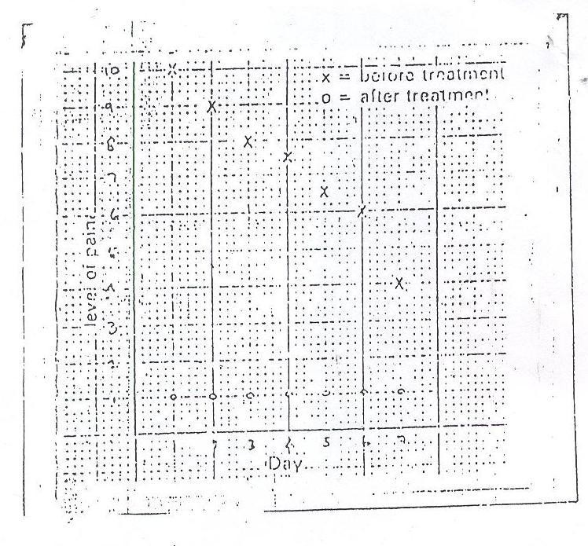

Figure 6 : Pain Chart. ( Adapted from Frampton, 1982 )

### McGill-pain questionnaire ( MPQ ) :

This is a pain rating index ( PRI ) consisting of 78 verbal pain descriptors arranged in 20 subclasses with 2 to 6 words in each subclass. The value of each descriptor is determined by its rank in the subclass. The patient is expected to choose words that best describe his pain experience. The values assigned to these descriptors are summed up ( Fig.7 ). This represents the patient‟s PRI ( Melzack, Vetere and Finch, 1983 ).

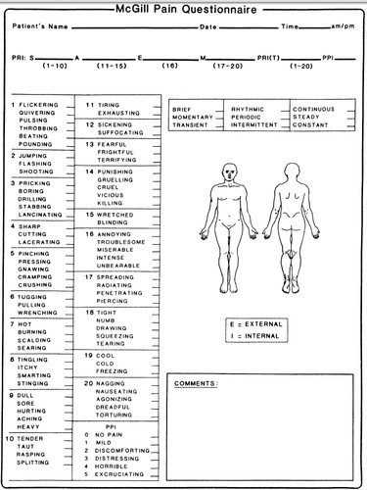

Figure 7 : MPQ (Adapted from Melzack, Vetere and Finch, 1983)

### Auditory rating scale:

Another method for assessing pain was recommended by Peck as reported by Merskey ( 1974 ). He suggested the use of a simple audiometer. Patients are asked to turn up the audiometer at a fixed frequency to the point at which the sound seems to match the intensity of their pain. They are asked in other words to turn up the machine so that the noise is as loud as their pain is strong.

The three pain rating scales ( VAS, NRS, VRS ) are valid, reliable and appropriate for use in clinical practice, although the VAS has more difficulties than the VRS or NRS ( Williamson and Hoggart, 2005 ). Because of their sensitivity, VAS and GRS represent the best method for measuring pain or pain relief ( Scott and Huskisson, 1976 ). In a study

( Downie et al, 1978 ) designed to investigate the degree of correlation between pain scores registered on 4 different rating scales ( SDS, NRS, VAS - vertical, VAS – horizontal ), the results indicate that there is good correlation between pain scores derived from the four scales in the survey. However, the study reported that NRS appears to have some advantages over the other scales as far as accuracy is concerned. In other words, NRS is to be preferred on the grounds of measurement errors. This is because it

( NRS ) provides a good compromise between the SDS which offers only a few choices and the VAS where the great freedom of choice may be confusing. In another study ( Ekblom and Hansson, 1988 ) to measure pain among 80 patients with acute orofacial pain, 6 different pain rating scales

including a “pain relief scale”, were compared. Pain intensity measurements were made before and after 30 minutes period of afferent stimulation

( TENS/vibration and placebo ). A good correlation was found between scores derived from the pain relief scale, VAS, numerical and graphic rating scales. The verbal rating scale did not perform well. The pain relief scale and NRS are interesting alternatives to the established VAS.

### Physiology of Nociceptive Transmission Pathways

Following an injury two transient pain sensations are experienced within the first minute ( Johnson, 1997 ). These are the first ( or fast ) pain and the second (or slow) pain and are a result of direct activation of the nociceptive system by a noxious insult. Within few minutes inflammation may develop and this is usually accompanied by a spontaneous on - going pain, hyperalgesia ( exaggerated pain ) and allodynia ( tenderness ). In otherwords, the first and second pain sensations following a noxious insult are produced by the activation of the nociceptive system. The components of the nociceptive system are summarised schematically in Figure 8 and can be divided into peripheral and central nociceptive transmission pathways.

### PAIN

**Affective and cognitive dimensions**

Evaluation Frontal lobe

Intra- laminar nucleus

Ventro- basal nucleus

Thalamus

Emotional Limbic system

Autonomic Hypothalamus

### PAIN

**Sensory dimensions**



Somatosensory

cortex

C-fibres

**Nociceptors**

A-delta fibres

STT

Contralateral anterolateral quadrant

SRT

Spinal cord processing

Reticular formation

Figure 8 : Components of Nociceptive System.

( SRT = spinoreticular tract, STT = spinothalamic tract )

( Adapted from Johnson, 1997 )

### Peripheral nociceptive transmission pathways:

Noxious stimuli are detected by sensory receptor cells called **nociceptors** which transmit afferent information into the central nervous system ( CNS ). A nociceptor is defined as „A ( sensory ) receptor preferentially sensitive to a noxious stimulus or to a stimulus which would become noxious if prolonged‟ ( Johnson, 1997 ). The nociceptors respond to three types of stimuli – noxious mechanical, noxious thermal ( extremes of hot and cold ) and endogenous analgesic (pain producing) chemicals which are released by damaged cells. A-delta ( A-fibres ) nociceptors respond to noxious thermal and noxious mechanical stimuli and form small diameter myelinated afferents which propagate action potentials into the CNS at a fast speed of 30 meters per second ( m/s ). Activity in these afferents is associated with „first‟ or „fast‟pain sensations which are often described as

„severe‟ and „sharp‟. The C-fibre afferents are also called polymodal nociceptors as they respond to all types of noxious stimuli ( eg. noxious mechanical, thermal and chemical). They form unmyelinated, slow- conducting ( 0.5m/s ) afferent fibres and activity in the C-polymodal nociceptors is associated with the „second‟ or „slow‟ pain sensations which are often described as „dull‟and „aching‟. The C-polymodal nociceptors are particularly sensitive to endogenous analgesic (pain producing) chemicals resulting from cell damage, including potassium, serotonin, bradykinin and substance P.

### Central nociceptive transmission pathways:

The peripheral nociceptive afferents transmit noxious information to the CNS where they synapse with two types of central nociceptive transmission cells ( Johnson, 1997, ) :

1. **Nociceptive specific ( NS ) cells** – they are predominantly found in lamina 1 of the dorsal horn of the spinal cord and respond only to noxious input. When activated, NS cells rapidly transmit information onward to the brain, probably via the spinothalamic tract.
2. **Wide dynamic range ( WDR ) cells** - they are predominantly found in lamina V of the dorsal horn of the spinal cord and receive noxious input from A- delta and C nociceptors and non-noxious input from large diameter A - beta ( touch ) fibres. These A – beta fibres normally transmit information about non-noxious stimuli to produce touch sensations.

The axons of these central nociceptive transmission cells cross the spinal cord and ascend in two main central pathways en route to the brain (Fig. 8) :

1. **The Spinothalamic tract ( STT** ) – this is direct nociceptive pathway that ascends in the white matter of the spinal cord to the thalamus of the brain. Nociceptive information is projected from the thalamus onward to the somatosensory cortex of the cerebrum where the sensory dimensions of pain are processed. This will provide information relating to the intensity, quality and location of the noxious stimuli.
2. **The Spino-reticulo-thalamic/spinorecticulor tract ( SRT ) -** this is an indirect multi - synaptic pathway which sends projections to many regions of the brain including the hypothalamus which co-ordinates the autonomic responses to pain ( e.g elevated blood pressure, irregular breathing ), the limbic system which co-ordinates the affective (emotional) responses to pain ( e.g unpleasant feelings, depressed mood ) and the frontal lobe of the cerebrum which produces the cognitive responses to pain ( e.g the meaning of the pain ).

### Pain Modulation – Suppression of the Nociceptive System

In 1965, Melzack and Wall postulated the “gate control” theory of pain which today is considered a milestone in pain research. It was this theory which highlighted the variable link between pain and injury and also brought about the use of electrotherapeutic techniques such as transcutaneous electrical nerve stimulation ( TENS ) to manage patients in pain ( Melzack and Wall, 1965; Johnson, 1997 ). The theory proposed that there was a metaphorical pain gate in the spinal cord which could regulate the onward transmission of noxious information en route to the brain

( Johnson, 1997 ). Melzack and Wall ( 1965 ) believed that there is a pain modulating **centre** contained in the **substantia gelatinosa ( SG )** of the dorsal horn of the spinal cord, that could be influenced by either peripheral afferent activity or by descending brain stem activity. Under normal physiological conditions information transmitted via the small diameter

nociceptor afferents ( A - delta and C – fibres ) would open the gate in the spinal cord allowing the onward transmission of noxious information to the brain where a sensation of pain would be perceived. Melzack and Wall proposed that a „pain gate‟ could be closed, preventing noxious information reaching the brain by activating either large diameter A - beta afferent fibres in the periphery which normally transmit non-noxious information about touch and pressure, or descending pain inhibitory nerve pathways which start in the brain and project into the spinal cord ( Melzack and Wall, 1965; Johnson, 1997 ). Increased activity in either of these two pain suppressing system would initiate the release of inhibitory neurotransmitters by inter- neurones in the dorsal horn of the spinal cord and these inhibitory neurotransmitters would „switch off‟ activity in the central nociceptive transmission cells ( e.g WDR and NS ). This would reduce the amount of noxious information reaching the brain and thus reduce sensory experience of pain ( Fig. 9 a, b ).

**Periphery**

**Spinal cord**

**Brain**

Small diameter fibre

„Touch‟

Non-noxious input

Descending pain Inhibitory pathway

Small diameter fibre

„Pain‟

Noxious input

Figure 9 (A) : Gate Control Theory of Pain. ( Adapted from Johnson, 1997 )

**GATE CONTROL SYSTEM**

**Large fibres**

+

**–**

**+**

**INPUT**

**T**

**– +**

OUT PUT

**–**

**Small fibres**

+

**S.G**

**CONTROL**

**CENTRAL**

Figure 9 (B) : Gate Control Theory of Pain.

( Adapted from Troup, 1970 )

## CHAPTER THREE

### METHODOLOGY

### HUMAN PARTICIPANTS AND RECRUITMENT

Sixty human participants ( 43 males, 17 females; mean age 34years; range 18 to 77 years ) who sustained various musculoskeletal injuries were recruited after careful history, clinical and radiographic examination as they presented for treatment at the Jos University Teaching Hospital, Primary Health Centres and Sports Council Clinic; all located within Jos metropolis.

Only participants who sustained not more than one musculoskeletal injury

( MSI ) or disorder ( MSD ) ( i.e participants with multiple injuries were not eligible ) with acute onset of symptoms or occurring as an acute exacerbation of chronic lesion were included in the study. Participants who were on any form of analgesics ( steroids and non-steroidal anti- inflammatory drugs – NSAIDs ), muscle relaxants, anticoagulants and any form of physiotherapy treatments were all excluded from the study. Participants with open wounds over the injury sites, pregnancy, disease conditions ( e.g thrombophlebitis, cardiac patient with pacemaker, tumour, etc ) and those allergic to methyl salicylate or cold which contra-indicate the treatment protocols used in this study were all excluded. The use of NSAIDs or analgesics and any other form of treatment was not permitted or allowed throughout the study period. Before entry into the study all participants voluntarily signed the informed consent forms after the protocol for the trial

was explained to them. All procedures involving the participants met criteria established by the University of Jos Teaching Hospital Health Research Ethics Committee.

### INSTRUMENTS AND MATERIALS

The following instruments and materials were employed for this study :

1. Ultrasonic machine ( EMS Therasonic MK IV )
2. Ultrasound treatment head ( 5cm², I MHz and 3 MHz )
3. Aquasonic gel ( Parker Laboratories Inc. NJ ) – 4 ltrs.
4. Methyl Salicylate 15% ( Neurogesic Ointment 35g x 10 )
5. Cotton ( 500g ) – 2 No.
6. Freezer ( Physiotherapy Dept; JUTH )
7. Mortar/pestle ( medium size )
8. Eleganza cooler container ( medium size ) – 3 No.
9. Ice towels ( 40cm x 36cm ) – 4 No.
10. Visual Analogue Scale ( VAS )
11. Digital Timer – 4 No. (xii) Plastic spoon. (xiii) Test tubes – 2 No.

Aquasonic gel ( Parker Laboratories Inc. NJ ) and methyl salicylate 15% cream were chosen for the study as coupling medium and phonophoresis agent respectively in line with the recommendation in the literature that one must use a medium or an agent that transmits ultrasound

effectively ( Cameron and Monroe, 1992; Byl, 1995 ). Aquasonic gel is the most efficient among the common agents, transmitting a mean of 72.60%

( Reid and Cummmings, 1977) and 90% ( Cameron and Monroe, 1992 ) relative to water, while methyl salicylate 15% cream or Aspirin as a NSAID ( Byl, 1995; Veile and Davis, 1998 ) has less side effect ( Veile and Davis, 1998 ) compared with steroids ( e.g hydrocortisone ) transmits 97% ultrasound relative to that of water ( Cameron and Monroe, 1992 ). Above all, methyl salicylate 15% cream is more readily available, cheaper over the counter and has been found useful in clinical situations by previous reports

( Santiesteban, 1983; Ciccone, Leggin and Callamaro, 1991; Olaogun and Aluko, 2000; Bumin and Can, 2004; Palmer and Toombs, 2004 ).

### OUTCOME MEASURES

Two dependent variables were addressed in this study and they include:

1. Participants pain perception ( SPP )
2. Treatment duration ( TD )

### EXPERIMENTAL PROCEDURE

Participants were carefully and thoroughly assessed which included case history and physical examination to determine their suitability for the study and eliminate those who were not qualified for the study respectively with regard to their various MSIs. Radiographs were used to rule out fractures/dislocations. On completion of assessment the sixty ( 60 ) eligible

human participants whose injuries were classified as follows :– rotator cuff syndrome

( n = 15), ankle sprain ( n = 8 ), knee sprain ( n = 4 ), patellar bursitis

( n = 5 ), low back pain ( n = 12 ), muscle strain ( n = 10 ), tennis elbow

( n = 3 ), hamstring tendinitis ( n = 2 ), tenosynovitis ( n = 1 ) were randomly assigned to one of three treatment groups:

1. Double-modality Therapy (“Live” phonophoresis and cryotherapy combined)–DMT (n = 20)
2. “Live”phonophoresis–PHONO ( n = 20 )
3. Cryotherapy and “sham” phonophoresis–CRYO ( n = 20 )

These treatment groups were written and placed in sequentially numbered opaque sealed envelopes which were used to assign the participants to their respective groups. Neither the primary researcher nor any other person that was involved in treatment allocation was aware of the randomisation schedules ( Brolinson and Sampson, 2003 ).

Prior to commencement of treatment in all groups three basic things were carried out :- preparation of equipment or apparatus, subjective assessment or measurement of participants pain perception and preparation of participants. The ultrasound machine ( EMS Therasonic MK IV ) and the transducer ( 5cm² treatment head ) were all tested and certified functional. Participants pain perception ( PP ) was subjectively assessed or measured and recorded using a 10cm visual analogue scale ( Fig. 4 ) marked “ no

pain” at one end and “worst pain ever” at the other ( Klaiman et al, 1998; Bleakley, McDonough, MacAulley and Bjordal, 2006; Hoppenrath and Ciccone, 2006 ) after the participants were carefully educated on the use of VAS and it was observed that they could identify their pain levels or scores on the scale without any difficulties. Sensory test was conducted among the participants to ascertain that there was no sensory loss ( Oakley, 1978 ). Participants were instructed and made to understand that at no time during insonation ( phonophoresis ) should they suffer discomfort. There might be a sensation of very mild warmth, but other than that only the pressure and the movement of the transducer should be felt. Any other sensation should be reported at once. All participants assigned to cryotherapy were made to understand that sensation like cold, burning, aching and numb would be felt during the treatment procedure which causes no harm. Finally, participants were comfortably supported and positioned to maximise circulation to the area being treated ( Byl,1995 ) when they were ready for treatment as presented below :

### Double Modality Therapy Group ( DMT, n = 20 )

The participants in this group received cryotherapy and “live” phonophoresis as combined therapy ( DMT ). Intermittent cryotherapy

( MacAuley, 2001; Bleakley, McDonough, MacAuley and Bjordal, 2006 ) using ice pack ( 16cm x 12cm ) was applied directly over the participants conditions for 10 minutes. The ice pack was then removed after the initial

1. minutes application and allowed the treatment part to rest at room temperature for 10 minutes. The ice pack was reapplied immediately following the expiration of the rest period for another 10 minutes ( total cryotherapy period = 20 minutes ). At the expiration of the second ice pack application the treatment part was cleansed with a towel and continuous ultrasound at an intensity of 1.5W/cm² and frequency of IMHz ( Byl,1995; Klaiman et al, 1998 ) was used to apply 1.5g of 15% methyl salicylate cream thoroughly mixed with 1.5g of aquasonic gel ( Allen, 2005 ) as coupling medium ( drug vehicle ) for 8 minutes. The ultrasound head

( 5cm² ) was moved over the part under treatment about one-half (1½) the width of the transducer at approximately 2 to 4 cm/sec; using small, continuous and overlapping circular movements ( Oakley, 1978; Cagnie, Vinck, Rimbaut and Vanderstraeten, 2003; Allen, 2005; Kuntz et al, 2006 ) to avoid or prevent periosteal pain ( Santiesteban, 1983 ). These treatment values or settings were selected to capture both the thermal and nonthermal effects of ultrasound in other to optimize transdermal methyl salicylate 15% delivery ( Byl,1995; Klaiman et al, 1998; Cagnie, Vinck, Rimbaut and Vanderstraeten, 2003 ).

### Phonophoresis Group ( PHONO, n = 20 )

The participants in this group received a “live” phonophoresis as a single treatment protocol throughout the study period. Continuous ultrasound at an intensity of 1.5W/cm² and frequency of IMHz ( Byl,1995;

Klaiman et al, 1998 ) was used to apply 1.5g of 15% methyl salicylate cream thoroughly mixed with 1.5g of aquasonic gel ( Allen, 2005 ) as coupling medium ( drug vehicle ) directly over the site of lesion for 8 minutes. The ultrasound head ( 5cm² ) was moved over the part under treatment about one-half (1½) the width of the transducer at approximately 2 to 4 cm/sec; using small, continuous and overlapping circular movements ( Oakley, 1978; Cagnie, Vinck, Rimbaut and Vanderstraeten, 2003; Allen, 2005; Kuntz et al, 2006 ) to avoid or prevent periosteal pain ( Santiesteban, 1983 ). These treatment values or settings were selected to capture both the thermal and nonthermal effects of ultrasound in other to optimize transdermal methyl salicylate 15% delivery ( Byl,1995; Klaiman et al, 1998; Cagnie, Vinck, Rimbaut and Vanderstraeten, 2003 ).

### Cryotherapy Group ( CRYO, n = 20 )

The participants in this group received cryotherapy and “sham” phonophoresis with placebo coupling medium. Intermittent cryotherapy

( MacAuley, 2001; Bleakley, McDonough, MacAulley and Bjordal, 2006 ) using ice pack ( 16cmx12cm ) was applied directly over the participants‟ conditions for 10 minutes. The ice pack was then removed after the initial

10 minutes application and allowed the treatment part to rest at room temperature for 10 minutes. The ice pack was reapplied immediately following the expiration of the rest period for another 10 minutes ( total cryotherapy period = 20 minutes ). At the expiration of the second ice pack

application, the treatment part was cleansed with a towel and continuous ultrasound at zero ( 0 ) intensity and frequency settings ( no US transmission ) was applied with 1.5g of placebo aquasonic gel ( devoid of methyl salicylate 15% cream ) as coupling medium ( Ciccone, Leggin and Callamaro, 1991; McElnay, Benson, Harland and Hadgraft, 2004 ) for 8 minutes The ultrasound head ( 5cm² ) was moved over the part under treatment about one-half (1½) the width of the transducer at approximately 2 to 4 cm/sec; using small, continuous and overlapping circular movements ( Oakley, 1978; Cagnie, Vinck, Rimbaut and Vanderstraeten, 2003; Allen, 2005; Kuntz et al, 2006 ).

All treatments were administered on alternate days until participants were fit for discharge and termination of treatment in all groups was based on the following criteria ( Melzack, Vetere and Finch, 1983 ) :

1. When the period of treatment is complete.
2. When participant feels pain is sufficiently relieved and no longer needs treatment.
3. When participant feels pain is not being relieved and needs another form of therapy.

At the end of weeks 1, 2, 3 and 4 after treatment in each group, participants post-treatment pain perception scores were also assessed and recorded with the same instrument – visual analogue scale ( Klaiman et al, 1998 ). Assessment and recording of pre-and post-treatment pain perception scores

( PPS ) was blinded from the therapist ( researcher ) to reduce or eliminate bias ( assessment by neutral assessors ). Treatments were terminated and participants discharged in all groups when they felt pain was sufficiently relieved and no longer needed treatment.

### DATA ANALYSIS

Descriptive and inferential statistics using the Statistical Packages for the Social Sciences ( SPSS ) was used for data analysis. Independent and paired mean difference tests ( t – test ) were used to compute subjects repeated measures within all groups while a one – way ANOVA ( Klaiman et al, 1998 ) was used to compute measures across the groups. The level of significance for all tests was set at 0.05.

## CHAPTER FOUR

### RESULTS

### 4.1 PARTICIPANTS SEX AND AGE

The sex and age of participants in the three groups are presented in Table 4. It shows no significant difference ( P > 0.05 ) in the ages of all participants in the three groups. The mean age of all participants in the DMT group was 32.55 ± 11.43 while it was 39.30 ± 13.42 and

30.30 ± 11.56 in PHONO and CRYO groups respectively. Among all the participants ( n = 60 ) in the three groups, 28.3% were females and the rest 71.7% were males.

### Table 4 : Sex and Mean Age of Human Participants

|  |
| --- |
| **GROUP SEX AGE P – value**  **Male** ( 71.7% ) **Female** ( 28.3% ) **Mean ± SD** |
| **DMT** (n = 20 ) 14 6 32.55 ± 11.43 f = 2.96  **PHONO** ( n = 20 ) 13 7 39.30 ± 13.42 P > 0.05  **CRYO** ( n = 20 ) 16 4 30.30 ± 11.56 |

DMT = Double – Modality Therapy ( Phonophoresis + Cryotherapy ) PHONO = Phonophoresis. CRYO = Cryotherapy

P > 0.05 = No significant difference

### PARTICIPANTS OCCUPATION

Distribution of participants by occupation at the point of entry into the study is presented in Table 5. Participants who engaged in one sport or another were 41 ( 68.3% ), while civil and public servants ( Business, Clergy, Bank and Field workers ) were 19 ( 31.7% ).

### Table 5 : Participant Distribution by Occupation

|  |
| --- |
| **OCCUPATION SUBJECTS ( n = 60 )** |
| Sports/Athletics 41 ( 68.3% )  Civil Servants 14 ( 23.3% )  Business 2 ( 3.3% )  Clergy 1 ( 1.7% )  Banking 1 ( 1.7% )  Field 1 ( 1.7% ) |

Athletes = 41 ( 68.3% )

Civil/Public Servants = 19 ( 31.7% )

### TREATMENT SESSIONS

The total number of treatment sessions recorded in the three groups was

275. Seventy-two ( 26.2% ) was recorded in the DMT group, 105

( 38.2% ) recorded in the PHONO group while the CRYO group recorded 98 ( 35.6% ) respectively. The result in this table indicates no significant difference ( P > 0.05 ) in the mean treatment sessions between DMT group and the other two groups ( PHONO and CRYO ).

This is presented in Table 6.

### Table 6 : Mean Treatment Sessions

|  |
| --- |
| **GROUP TREATMENT SESSIONS**  **Min. Max. Total Mean ± SD P - value** |
| **DMT** ( n = 20 ) 1 9 72 3.60 ± 1.73 f = 2.45  **PHONO** ( n = 20 ) 3 12 105 5.25 ± 2.12 P > 0.05  **CRYO** ( n = 20 ) 1 12 98 4.90 ± 3.31 |

DMT = Double – Modality Therapy ( Phonophoresis + Cryotherapy ) PHONO = Phonophoresis. CRYO = Cryotherapy

Max. = Maximum. Min. = Minimum P > 0.05 = No significant difference

### PARTICIPANT DISCHARGE PATTERN

While 19 ( 95% ) participants in the DMT group were discharged on or before completion of 5 sessions of treatment, only 12 ( 60% ) and 13

( 65% ) participants in PHONO and CRYO groups respectively were discharged fit and pain free to return to their activities of daily living

( ADL ). However, at the completion of 10 sessions of treatment, DMT group had discharged all ( 100% ) the participants fit and pain free while PHONO and CRYO groups discharged 95% of their participants respectively. The groups did not show any significant difference in the overall discharge pattern. The discharge pattern in all the groups is presented in Table 7.

### Table 7 : Participant Discharge Pattern

|  |
| --- |
| **SESSIONS OF TREATMENT DISCHARGED PARTICIPANTS/GROUPS ON DISCHARGE DMT PHONO CRYO**  ( n = 20 ) ( n = 20 ) ( n = 20 ) |
| 1 – 2 6 ( 30% ) 0 6 ( 30% )  3 – 5 13 ( 65% ) 12 ( 60% ) 7 ( 35% )  6 – 10 1 ( 5% ) 7 ( 35% ) 6 ( 30% )  12 0 1 ( 5% ) 1 ( 5% ) |

DMT = Double – Modality Therapy ( Phonophoresis + Cryotherapy ) PHONO = Phonophoresis. CRYO = Cryotherapy

### PARTICIPANT PAIN PERCEPTION SCORES

### Comparison of Pain Perception Scores in DMT Group

Comparison of pre - and post - treatment pain perception scores ( PPS ) among the participants in DMT group was made to determine if there was any significant difference in pain severity. The difference was statistically significant ( P < 0.05 ). The DMT produced optimal pain relief. This is presented in Table 8.

### Table 8 : Comparison of Pain Perception Scores in DMT Group

|  |
| --- |
| **PAIN PAIN PERCEPTION SCORES ( PPS )**  **ASSESSMENT Mean ± SD P - value** |
| Pre – Treatment 5.50 ± 0.89 t = 15.89  Post – Treatment 1.95 ± 0.76 P < 0.05 |

P < 0.05 = Significant difference.

### Comparison of Pain Perception Scores in PHONO Group

Comparison of pre - and post - treatment pain perception scores ( PPS ) among the participants in PHONO group was made to determine if there was any significant difference in pain severity. The difference was statistically significant ( P < 0.05 ). The PHONO produced optimal pain relief. This is presented in Table 9.

### Table 9 : Comparison of Pain Perception Scores in PHONO Group

|  |
| --- |
| **PAIN PAIN PERCEPTION SCORES ( PPS )**  **ASSESSMENT Mean ± SD P - value** |
| Pre – Treatment 5.05 ± 0.69 t = 18.63  Post – Treatment 1.85 ± 0.81 P < 0.05 |

P < 0.05 = Significant difference.

### Comparison of Pain Perception Scores in CRYO Group

Comparison of pre - and post - treatment pain perception scores ( PPS ) among the participants in CRYO group was made to determine if there was any significant difference in pain severity. The difference was statistically significant ( P < 0.05 ). The CRYO produced optimal pain relief. This is presented in Table 10.

### Table 10 : Comparison of Pain Perception Scores in CRYO Group

|  |
| --- |
| **PAIN PAIN PERCEPTION SCORES ( PPS )**  **ASSESSMENT Mean ± SD P - value** |
| Pre – Treatment 5.20 ± 1.24 t = 9.00  Post – Treatment 2.50 ± 1.15 P < 0.05 |

P < 0.05 = Significant difference

### Comparison of Pain Perception Scores among the Groups

Comparison of post-treatment pain perception scores ( PPS ) was made to determine if there was any significant difference in pain severity among the three groups. The difference was statistically not significant ( P > 0. 05 ). The modalities were equally and significantly effective. This is presented in Table 11.

### Table 11: Cross-Comparison of Pain Perception Scores in all Groups

|  |
| --- |
| **PAIN PAIN PERCEPTION SCORES ( PPS )**  **ASSESSMENT Mean ± SD P - value** |
| Pre – Treatment ( DMT : n = 20 ) 5.50 ± 0.89  f = 1.12  Pre – Treatment ( PHONO : n = 20 ) 5.05 ± 0.69 P > 0.05  Pre – Treatment ( CRYO : n = 20 ) 5.20 ± 1.24 Post – Treatment ( DMT : n = 20 ) 1.95 ± 0.76  f = 2.45 Post – Treatment (PHONO : n = 20) 1.85 ± 0.81 P > 0.05  Post – Treatment ( CRYO : n = 20) 2.50 ± 1.15 |

P > 0.05 = No Significant difference

### PARTICIPANT POST-TREATMENT REPORT

All the participants felt satisfied with their level of pain relief and requested for discharge accordingly. In other words no participant was discharged out of the study on the account that pain was not being relieved and needed another type of therapy. Throughout the treatment period in all the groups, no participant complained of any discomfort or adverse effect such as periosteal pain, frostbite or nerve palsy. Participants reported the treatments were effective, tolerable and pleasant.

## CHAPTER FIVE

### DISCUSSION, CONCLUSION AND CONTRIBUTION TO KNOWLEDGE

### 5.1 DISCUSSION

The total number of treatment sessions recorded in the three groups was 275. A total of 72 ( 26.2% ) treatment sessions was recorded in the DMT group, 105 ( 38.2% ) recorded in the PHONO group while the CRYO group recorded 98 ( 35.6% ) respectively. While 19 ( 95% ) participants were pain free and got discharged on completion of one to five sessions of treatment in the DMT group, only 12 ( 60% ) and 13 ( 65% ) were pain free and requested for discharge respectively in the PHONO and CRYO groups. While no participants were fit for discharge in the PHONO group after one to two sessions of treatment, the DMT group recorded 6 ( 30% ) discharges.

A comparative study among the groups has shown that the difference in the mean treatment sessions was statistically not significant. However, the discharge pattern suggests it might take less or fewer sessions to treat and make all the participants with the type of musculoskeletal injuries

( MSIs ) included in this study pain free and fit to return to active performance when Double-modality Therapy ( DMT ) is administered rather than the one or single treatment protocol of phonophoresis or cryotherapy respectively. The fewer treatment sessions may be an advantage for the participants ( patients ), the employer and the clinician. On the part of the participants, absenteeism from work to keep hospital treatment

appointments and subsequent loss of work hours is minimised; while the workload usually experienced by the clinician may be reduced. On the other hand, with the pressure to treat athletes who sustained MSIs safely and efficiently in order to get them back to effective performance as quickly as possible, DMT protocol may have an edge or advantage over other modalities.

The pre-treatment pain perception scores ( PPS ) compared across the three groups did not show any statistical significant difference which suggests that all the participants in the three groups had almost the same level of pain perception before the commencement of treatment. Comparison of pre - and post - treatment pain perception scores was made in each group to determine the level of pain relief and the relative efficacy of each modality. The difference in the severity of pain before and after treatment was statistically significant in each group. This shows that each modality ( DMT, PHONO, CRYO ) was significantly effective in relieving pain and improving function.

There is dearth of information in the literature ( Balogun, 1990; Ball, 2002 ) to suggest or indicate efficacy of combined treatment protocol of phonophoresis and cryotherapy ( DMT ). Hence, the finding of this current study appears to have provided evidence-based data or guidelines to demonstrate the therapeutic efficacy of DMT protocol in managing musculoskeletal pain. The efficacy of phonophoresis and cryotherapy ( as a

single modality ) demonstrated in this study support the works of Klaiman et al ( 1998 ); Cagnie, Vinck, Rimbaut and Vanderstraeten ( 2003 ); Kozanoglu, Basaran, Guzel and Guler-Uysal ( 2003 ); Hubbard and Denegar ( 2004 ); Bleakley, McDonough, MacAulley and Bjordal ( 2006 ); Onuwe and Amadi ( 2013 ).

In a systematic review carried out by Bleakley, McDonough and MacAulley ( 2004 ), only few studies assessed the effectiveness of ice (cryotherapy) on closed soft tissue injury ( MSI ) in isolation or in combination with other therapies. The current study has shown the effectiveness of cryotherapy in isolation and in combination with phonophoresis and hence; the result has improved on the existing data-base in the literature ( Swenson, Sward and Karisson, 1996; MacAuley, 2001; Bleakley, McDonough, MacAulley and Bjordal, 2006; Yagiz, 2006 ) as regards the efficacy of cryotherapy.

Bleakley, McDonough and MacAulley ( 2004 ) did observe in the literature review that there was no evidence of an optimal mode or duration of cryotherapy treatment. Hubbard and Denegar ( 2004 ) made similar observation among others and recommended that studies should be focused on developing modes, duration and frequencies of ice application that will optimise outcomes after MSI.

The current study adopted intermittent cryotherapy mode of application on alternate days. With the significant level of pain relief

achieved when cryotherapy was applied ( in isolation and in combination with phonophoresis ), is indication that intermittent cryotherapy mode of application suggested by Bleakley, McDonough, MacAulley and Bjordal

( 2006 ) and MacAuley ( 2001 ) may be an optimal mode of application when managing MSIs. Intermittent cryotherapy application helps sustain reduced muscle temperature without compromising the skin, allows the superficial skin temperature to return to normal while deeper muscle temperature remains low; and above all, avoid side-effects and prevent possible further injury ( MacAuley, 2001 ).

The use of steroids for phonophoresis ( e.g hydrocortisone and fluocinonide ) in the management of MSDs is reported more in the literature, whereas very limited studies have been done with non-steroidal anti-inflammatory drugs ( NSAIDs ) particularly, methyl salicylate.

The studies done by Fellinger and Schmid, Griffin et al, Kleinkort and Wood to mention a few which were all reported in a systematic review by Byl ( 1995 ) and the one done by Holdsworth and Anderson; and reported by Hoppenrath and Ciccone ( 2006 ) all used hydrocortisone phonophoresis. This study used methyl salicylate 15% phonophoresis which demonstrated significant efficacy in support of the studies of Olaogun and Aluko ( 2000 ),

Bumin and Can ( 2004 ). Methyl salicylate ( NSAIDs ) has less side effects

( Davis and Veile, 1998 ) compared with steroids ( e.g hydrocortisone ) and transmits 97% ultrasound relative to that of water ( Cameron and Monroe,

1992 ) which makes it more preferable to steroids. Above all, methyl salicylate cream is more readily available and cheaper over the counter

( Santiesteban, 1983; Palmer and Toombs, 2004 ). Phonophoresis simply produces thermal effect from the ultrasound which increases kinetic energy of molecules in the drug and in the cell membrane, dialates points of entry such as hair follicles and the sweat glands, and increases the circulation to the treated area ( Byl, 1995; Cagnie, Vinck, Rimbaut and Vanderstraeten, 2003 ). These physiological changes enhance the opportunity for drug molecules ( i.e methyl salicylate ) to diffuse through the stratum corneum

( SC ) and be collected by the capillary network in the dermis ( Byl, 1995 ), thereby initiating pain relief.

However, to determine whether DMT protocol would significantly produce pain relief and improve function among the subjects more than the one treatment protocol of phonophoresis or cryotherapy as suggested in the literature ( Santiesteban, 1983; Balogun, 1990 ) respectively, the post - treatment pain perception scores ( PPS ) across the three groups were compared using ANOVA. There was no statistically significant difference

in pain relief. The result implies that the three modalities ( DMT, PHONO, CRYO ) were equally and significantly effective, but the DMT protocol could not significantly produce more pain relief among the subjects when compared with the two other groups ( protocols ).

Although a variety of ultrasound settings ( treatment setting ) have been used for phonophoresis in the literature, there is still controversy as regards the most suitable US settings ( Byl, 1995 ). The most commonly used include: frequency in the range of 1MHz – 3MHz, intensity in the range of 1 – 2 W/cm² ( Cagnie, Vinck, Rimbaut and Vanderstraeten, 2003 ), continuous and pulsed mode ( Byl,1995; Cagnie, Vinck, Rimbaut and Vanderstraeten, 2003 ). In fact, Byl ( 1995 ) recommended that to maximise the effectiveness of phonophoresis an intensity in the thermal range of 1.5 W/cm² or higher should be considered. In this current study, an intensity of

1.5 W/cm² with the frequency of 1MHz operating at continuous mode were the ultrasound settings. With the significant drop in the level of pain perception recorded in the DMT and PHONO groups, it is not out of place to say that the treatment settings utilised in this current study are effective and support the recommendation of Byl ( 1995 ) and the works of Tyle and Agrawala ( 1989 ) and Cagnie, Vinck, Rimbaut and Vanderstraeten ( 2003 ).

Looking at the distribution of subjects who participated in this study by occupation, 41 ( 68.3% ) were active sports men and women while civil/public servants were 19 ( 31.7% ). This result indicates that sports men and women are more prone and vulnerable to musculoskeletal injuries or disorders ( MSIs or MSDs ) than members of the public who are not frequently exposed to activities that could cause such injuries. Because of their vulnerability, it is not impossible that this might be part of the reason

why clinicians in sports medicine/rehabilitation continue to explore and harness more aggressive pain management strategies to hasten the recovery and quicken return to effective performance of the injured athletes

( Brolinson and Sampson, 2003; Hubbard, Aronson and Denegar, 2004 ).

### CONCLUSION

The study has indicated the significant therapeutic efficacy of DMT, but it was not superior to the single treatment protocol of phonophoresis or cryotherapy. However, it might take less or fewer sessions to treat and make the participants in this study pain free and fit to return to active performance when DMT is considered.

### CONTRIBUTION TO KNOWLEDGE

The study has shown that DMT protocol produced optimal pain relief which literature has scarcely reported. Prescription of DMT shall therefore, be evidence based and not on anecdotal experience.

The result of this study does not support the anecdotal report which suggested that DMT may be superior to the single treatment protocol of phonophoresis or cryotherapy.

On the account of fewer treatment sessions recorded to make the participants pain free in the DMT group, prescribing DMT as against the one treatment protocol may minimise absenteeism from work by patients to keep hospital treatment appointment and subsequent loss of work hours;

while the heavy workload usually experienced by the clinician may be reduced.

With the significant level of pain relief ( optimal pain relief ) recorded among the subjects, the study has further demonstrated that the choice of ultrasound settings ( continuous mode, 1.5 W/cm² and 1 MHz ) and the mode of cryotherapy application ( intermittent ) utilised were appropriate and effective for diagnosis and therapeutic purposes. This may therefore, go a long way to enhance the evidence base practise of the clinician or the physiotherapist.

## REFERENCES

Adegoke, B.O.A. and Gbeminiyi, M.O. ( 2004 ). Efficacy of ice and shortwave diathermy in the management of osteoarthritis of the knee – A preliminary report. *African Journal of Biomedical Research*. 7 :59 - 63.

Algafly, A.A. and George, K.P. ( 2007 ) . The effect of cryotherapy on nerve conduction velocity, pain threshold and pain tolerance.

*British Journal of Sports Medicine.* 41 : 365 - 369.

Allen, L.V. ( 2005 ) . Compounding for Phonophoresis.

*Secundum Artem*. 11 (2) : 1 – 6.

Ball, A.M. ( 2002 ) . Phonophoresis and Ice ( PTupdate )

*URL*[*=http*](http://www.PTupdate.com/)*:*[*//www.PTupdate.com*](http://www.PTupdate.com/)Accessed on 2/9/11 & 4/4/12 Balogun, J.A. ( 1990 ) . Recent Advances in Electrotherapy. *Journal*

*of Nigeria Association of Sports Science and Medicine.* 1 : 1 – 12.

Bassett III, F.H., Kirkpatrick, J.S., Engelhardt, D.L. and Molone,T.R.(1992).

Cryotherapy – induced nerve injury. *American Journal of Sports Medicine*. 20 (5) : 516 - 518.

Beebe, F.A., Barkin, R.L. and Barkin, S.( 2005 ). A Clinical and Pharmacological Review of Skeletal Muscle Relaxants for Musculoskeletal Conditions. *American Journal of Therapeutics.* 12 (2) : 151 - 171.

Bending, J. ( 1993 ). TENS relief of discomfort : “ Like worms wriggling under the Skin ”. *Physiotherapy.* 79 ( 11 ) : 773 – 774.

Benson, H.A.E. and McElnay, J.C. ( 1994 ) . Topical Non-steroidal Anti- inflammatory Products as Ultrasound Couplants - Their Potential

in Phonophoresis. *Physiotherapy*. 80 (2) : 74 – 76

Bleakley, C.M., McDonough, S.M. and MacAuley, D.C. ( 2004 ) . The use of ice in the treatment of acute soft tissue injuries : A systemic

Review of randomised controlled trials. *American Journal of Sports Medicine* 32 : 251 - 261.

Bleakley, C.M., McDonough, S.M., MacAuley, D.C. and Bjordal, J. ( 2006) Crytherapy for Acute Ankle Sprains – A Randomised Controlled Study of Two Different Icing Protocols. *British Journal of Sports Medicine*.

40 (8) : 700 - 705.

Bleakley, C.M., Connor, S.O.,Tully, M.A., Rocke, L.G., MacAuley, D.C. and McDonough, S.M. ( 2007 ). The PRICE Study (Protection

Rest Ice Compression Elevation): design of a randomised controlled trial comparing standard versus cryokinetic ice application in the management of acute ankle sprain. BMC *Musculoskeletal Disorders*. 8:125.

Block, J.E. ( 2010 ). Cold compression in the management of musculoskeletal injuries and orthopedic operative procedures : a narrative review. *Open Access Journal of Sports Medicine*. 1 : 105 - 113

Bolin, D.J. ( 2003 ) . Transdermal approaches to pain in soft tissue injury.

*Curr Sports Med Rep*. 2 (6) : 303 - 309.

Brenman, E.K. ( 2007 ). Pain Management : Musculoskeletal Pain *Medicine Net.com,* [*www.webmd.com/pain-management/guide/*](http://www.webmd.com/pain-management/guide/) *musculoskeletal-pain* Accessed on 27/1/13.

Brolinson, P.G. and Sampson, M. ( 2003 ) . Pathophysiology of pain in sports. *Curr Sports Med Rep*. 2 (6) : 310 – 314 (Abstract)

Bumin, G. and Can, F. ( 2004 ) . Effects of iontophoresis and phonophoresis methods on pain cases with shoulder periarthritis.

*Pain Clinic*. 13 (2): 159 – 162 (Abstract online).

Byl, N.N. ( 1995 ). The use of Ultrasound as an enhancer for Transcutaneous Drug Delivery: Phonophoresis.

*Physical Therapy*. 75 (6) : 539 – 553.

Byl, N., Cameron, M., Kloth, L.C. and Zellerbach, L.R. ( 1995 ). Treatment and Prevention : Goals and Objectives. *In* : R.S. Myers(ed).

Saunders Manual of Physical Therapy Practice, Philadelphia, U.S.A.: W.B. Saunders Company pp. 638 – 639.

Byl, N., Zellerbach, L.R. and Pfalzer, L.A. ( 1995 ). Systemic Issues and Skin Conditions : Wound Healing, Oxygen, Percutaneous Drug Delivery, Burns and Desensitised Skin. *In* : R.S. Myers(ed).

Saunders Manual of Physical Therapy Practice, Philadelphia, U.S.A: W.B. Saunders Company, pp. 604 – 607.

Cagnie, B.,Vinck, E., Rimbaut, S. and Vanderstraeten, G. ( 2003 ).

Phonophoresis Versus Topical Application of Ketoprofen: Comparison Between Tissue and Plasma Levels.

*Physical Therapy*. 83 (8) : 707 – 712.

Cameron, M.H. and Monroe, L.G. ( 1992 ). Relative Transmission of Ultrasound by Media Customarily Used for Phonophoresis.

*Physical Therapy*.72 (2) : 142 - 147.

Charman, R.A. ( 1989 ) . Pain Theory and Physiotherapy

*Physiotherapy*. 75(5): 249 - 254.

Childs, J.D., Whitman, J.M., Sizer, P.S., Pugia, M.L., Flynn, T.W. and Delitto,A. ( 2005 ): A description of physical therapists‟ knowledge in managing musculoskeletal conditions. *BMC Musculoskeletal Disorders.* 6:32 doi: 10.1186/1471-2474-6-32.

Ciccone, C.D., Leggin, B.G. and Callamaro, J.J. ( 1991 ) . Effects of ultrasound and trolamine alicylate phonophoresis on delayed – onset muscle soreness.*Physical Therapy*.71 (9) : 666 – 675

Cote, D.J., Prentice, W.E., Hooker, D.N. and Shields, E.W. ( 1988 ). Comparison of Three Treatment Procedures for Minimizing Ankle Sprain Swelling. *Physical Therapy*. 68 (7) : 1072 - 1076.

Davis, R.V. ( 1991 ) . Management of Rotator Cuff Syndrome.

*Dynamic Chiropractic*. 9 (9) : 26 - 28.

Denning, M.L. ( 1988 ). Retrospective review of long-term transcutaneous nerve stimulation in the management of chronic back pain.

*Physiotherapy.* 74 ( 3 ) : 149 – 151.

DeRosa, C.P. and Porterfield, J.A. ( 1992 ) . A Physical Therapy Model for the Treatment of Low Back Pain. *Physical Therapy*. 72 (4) : 261268.

Downie, W.W., Leatham, P.A., Rhind, V.M., Wright, V., Branco, J.A. and Anderson, J.A. ( 1978 ). Studies with pain rating scales.

*Annals of the Rheumatic Diseases*. 37 : 378 - 381.

Drez, D., Faust, D.C. and Evans, J.P. ( 1981 ). Cryotherapy and nerve palsy.

*American Journal of Sports Medicine*. 9 (4) : 256 - 257.

Ekblom, A. and Hansson, P. (1988 ) . Pain Intensity Measurement in Patients with acute pain receiving afferent stimulation. *Journal of Neurology, Neurosurgery and Psychiatry*. 51 (4) : 481 (Abstract )

Frampton, H. and Moffett, J.K. ( 1982 ) . Physiotherapy management of chronic low back pain.*Physiotherapy*. 63 (3) : 77 – 81

Haines, J. ( 1970 ) . A Study into a Report on Cold Therapy.

*Physiotherapy*. 501 – 502.

Helms, J.E. and Barone, C.P. ( 2008 ). Physiology and Treatment of Pain.

*Critical Care Nurse*. 28 (6) : 38 – 49.

Herrera, .E, Salvini, T.F., Sandoval, M.C. and Camargo, D.M. ( 2010 ) . Motor and Sensory nerve conduction are affected differently by ice pack, ice massage and cold water immersion.

*Physical Therapy*. 90 (4) : 581 - 591.

Hootman, J.M., Macera, C.A., Ainsworth, B.E., Anddy, C.L, Martin, M. and Blair, S.N. ( 2002 ) : Epidemiology of Musculoskeletal injuries

among sedentary and physically active adults. *Medicine and Science in Sports and Exercise*. 34 (5) : 838 - 844.

Hoppenrath, T. and Ciccone, C.D. ( 2006 ) . Is there evidence that phonophoresis is more effective than ultrasound in treating pain associated with lateral epicondylitis?

*Physical Therapy*. 86 (1) : 136 – 140.

Hubbard, T.J., Aronson, S.L. and Denegar, C.R. ( 2004 ) . Does Cryotherapy Hasten Return to Participation? A Systematic Review. *Journal of Athletic Training*. 39 (1) : 88 - 94.

Hubbard, T.J. and Denegar, C.R. ( 2004 ) . Does Crytherapy Improve Outcomes With Soft Tissue Injury?

*Journal of Athletic Training*. 39 (3) : 278 - 279.

Idowu, P.A., Adedoyin, R.A. and Adagunodo, R.E. ( 2005 ) . Computer Related Repetitive Strain Injuries. *Journal of Nigeria Society of Physiotherapy*. 15 (1) : 13 - 18.

International Association for the Study of Pain – IASP ( 2009 ). Global Year Against Musculoskeletal Pain : Interdisciplinary Approaches in

management of musculoskeletal pain. [*http://www.iasp-pain.org/AM/AM*](http://www.iasp-pain.org/AM/AM%20Template.cfm?Section=home)

[*Template.cfm?Section=home&*](http://www.iasp-pain.org/AM/AM%20Template.cfm?Section=home)*TEMPLATE=/CM/ContentDisplay.cfm &SECTION=Home&CONTENTID=9284*

Johnson, M.I. ( 1997 ). The Physiology of the Sensory Dimensions Of Clinical Pain. *Physiotherapy.* 83 (10) : 526 - 535

Kellett, J. ( 1986 ) . Acute soft tissue injuries – a review of the literature.

*Medicine and Science in Sports and Exercise*. 18 (5) : 489 – 499.

Klaiman, M.D., Shrader, J.A., Danoff, J.V., Hicks, J.E., Pesce, W.J. and Ferland, J. ( 1998 ) . Phonophoresis versus ultrasound in the treatment of common musculoskeletal conditions. *Medicine and Science in Sports and Exercise*. 30 (9) : 1349 - 1355(Abstract)

Klein, E. ( 2009 ). Diseases and Condition – Musculoskeletal Pain.

*Health Hub.* [*http://my.clevelandclinic.org/giving/default.aspx*](http://my.clevelandclinic.org/giving/default.aspx)

Accessed on 27/1/13

Kozanoglu, E., Basaran, S., Guzel, R. and Guler-Uysal, F. ( 2003 ) . Short term efficacy of ibuprofen phonophoresis versus continuous ultrasound therapy in knee osteoarthritis.

*Swiss Medical Weekly.* 133 : 333 – 338.

Kuntz, A.R., Griffiths, C.M., Rankin, J.M., Amstrong, C.W. and McLaughlin, T.J. ( 2006 ). Cortisol Concentrations in Human Skeletal Muscle Tissue After Phonophoresis with 10% Hydrocortisone Gel. *Journal of Athletic Training*. 41 (3) : 321 - 324.

Lamb, B.( 2011 ) : Types of pain

The Pain Reliever Corporation. ( update )

[*www.drlamb.com/PainTypes.htm*](http://www.drlamb.com/PainTypes.htm)Accessed on 2/9/11 & 4/4/12 Lynn, J. and Harrold, J. ( 2006 ) . Handbook for Mortals – Guidance for

People Facing Serious Illness.

*www.abcd–caring.org* pp. 242. Accessed on 2/9/11 & 30/3/12 MacAuley, D.C. ( 2001 ) . Ice Therapy – how good is the evidence?

*International Journal of Sports Medicine*. 22 (5) : 379 - 384

Machet, L. and Boucaud, A. ( 2002 ) . Phonophoresis, mechanisms and skin tolerance. *International Journal of Pharmaceuticals*. 243 (1-2) : 1-15

Man, I.O., Morrisey, M.C. and Cywinske, J.K. ( 2007 ) . Effect of Nueromuscular Electrical Stimulation on Ankle Swelling in the

Early Period After Ankle Sprain. *Physical Therapy*. 87 (1) : 401 - 406.

Martinez, D.A. ( 2008 ) . Cryotherapy : A Review of the Literature.

*ChiroACCESS Article* Accessed on 2/9/11

McElnay, J.C., Benson, H.A.E., Harland, R. and Hadgraft, J. ( 2004 ) .

Phonophoresis of Methyl Nicotinate : A Preliminary Study to Elucidate the Machanism of Action.

*Pharmaceutical Research.* 10 (12) : 1726 - 1731 (Abstract online).

Meeusen, R. and Lievens, P. ( 1986 ) . The use of Cryotherapy in sports Injuries. *Sports Medicine*. 3 (6) : 398 - 414.

Melzack, R., Vetere, P. and Finch, L. ( 1983 ) . Transcutaneous Electrical Nerve Stimulation for Low Back Pain – A Comparison of TENS

and Massage for Pain and Range of Motion.

*Physical Therapy*. 63 (4) : 489 - 493.

Melzack, R. and Wall, P.D. ( 1965 ). Pain mechanisms – A New Theory.

*Science.* 150 : 971 – 979.

Merskey, H. ( 1974 ) . Assessment of pain.

*Physiotherapy*. 60 (4) : 96 – 98.

McPoil, T.G. ( 1997 ) . The Foot and Ankle. *In*: T.R Malone, T.G McPoil,

A.J Nitz(ed). Orthopaedic and Sports Physical Therapy 3 edn, St Louis Missouri, USA :Mosby-Year Book, Inc; pp. 276 – 278.

Morrison, M.C.T. ( 1974 ). Treatment of Disc Lesions.

*Physiotherapy*. 60 (1) : 17 – 21.

Nadler, S.F., Weingand, K. and Kruse, R.J. ( 2004 ) . The Physiologic Basis and Clinical Applications of Cryotherapy and Thermotherapy for

the pain practitioner. *Pain Physician*. 7(3) : 395 – 399.

Oakley, E.M. ( 1978 ). Application of Continuous Beam Ultrasound at Therapeutic Levels. *Physiotherapy***.** 64 (6) : 169 – 172.

Oakley, E.M. ( 1978 ). Dangers and Contraindications of Therapeutic Ultrasound. *Physiotherapy*. 64 ( 6 ) : 173 - 174

Olaogun, M.O.B. and Aluko, O. ( 2000 ). Phonophoresis in Pain Modulation. *Journal of Nigeria Medical Rehabilitation Therapist*. 5 (1) : 19 – 21

Ong, K.L.T. ( 1986 ) . Handling the Patient in Pain.

*Physiotherapy*. 72 (6) : 284 – 288.

Onuwe, H.A. ( 2001 ). The Role of Physiotherapy in the Area of Assessment, Handling and Management of Musculoskeletal

Injuries in Sports. *Journal of Nigeria Medical Rehabilitation Therapist*. 6 ( 1 ) : 4 – 7

Onuwe, A.K. and Amadi, K. ( 2013 ). Therapeutic Efficacy of Methyl Salicylate Phonophoresis in the Management of Musculoskeletal Injuries among Athletes. *Journal of Medicine in the Tropics.*

15 (1) : 61 – 64.

Palmer, T. and Toombs, J.D. ( 2004 ) . Managing Joint Pain in Primary Care

*Journal of American Family Practice*. 17 : 532 - 542.

Petty, N.J. and Moore, A.P. ( 2000 ) . Neuromusculoskeletal Examination and Assessment – A HandBook for Therapists. New York :

Churchill Livingstone, 187 – 296 p.

Piechura, J., Skrzek, A., Rozek, K. and Wrobel, E. ( 2010 ) . Local cryotherapy in patients with the painful shoulder syndrome.

*Physiotherapy.* 18 ( 1 ) : 19 – 25.

Reid, D.C. and Cummings, G.E. ( 1977 ) . Efficiency of Ultrasound Coupling Agent. *Physiotherapy*. 63 (8) : 255 - 257

Reilly, T. and Hardiker, R. ( 1983 ). Somatotype and Injuries in Adult Student Rugby Football. *Journal of Sports Medicine*. 12 : 186 - 191.

Saidu, I.A., Utti, V.A., Jaiyesimi, A.O., Rufa‟I, A.A., Maduagwu, S.M., Onuwe, H.A. and Jajere, A.M.( 2011 ). Prevalence of Musculoskeletal Injuries Among Factory Workers in Kano Metropolis, Nigeria.

*International Journal of Occupational Safety and Ergonomics.*

17 (1) : 99 – 102.

Santiesteban, A.J. ( 1983 ) . The Role of Physical Agents in the Treatment of Spine pain. *Clinical Orthopaedic and Related Research*. 179 : 24 – 29

Sanya, A.O. and Ogwumikwe, O.O. ( 2005 ). Low back pain prevalence amongst industrial workers in the private sector in Oyo State, Nigeria. *African Journal of Medical Sciences*. 34 : 245 - 249.

Scott, J. and Huskisson, E.C. ( 1976 ) . Graphic Representation of pain.

*Pain*. 2 : 175 – 184

Stovitz, S.D. and Johnson, R.J. ( 2003 ). NSAIDs and Musculoskeletal Treatment – What Is the Clinical Evidence ?

*THE PHYSICIAN AND SPORTSMEDICINE*. 31 (1)

Swenson, C., Sward, L. and Karisson, J. ( 1996 ) . Cryotherapy in Sports Medicine. *Scandinavian Journal of Medicine and Science in Sports*. 6 (4): 193 – 200

Troup, J.D.G. ( 1970 ). Some Problems of Measurement in Clinical Trials of Physiotherapy with Particular Reference to the Assessment of Pain. *Physiotherapy*. 491 - 496

Tyle, P. and Agrawala. P. ( 1989 ) . Drug Delivery By Phonophoresis.

*Pharmaceutical Research*. 6 : 355 – 361.

Vaile, J.H. and Davis, P. ( 1998 ) . Topical NSAIDs for Musculoskeletal Conditions – A Review Of the Literature.

*Drugs*. 56 (5) : 783 – 799.

Wilson, J.J. and Best, T.M. ( 2005 ) . Common Overuse Tendon Problems- A review and recommendation for treatment.

*American Family Physician*. 72 (5); 811 - 818.

Williamson, A. and Hoggart, B. ( 2005 ) . Pain – A review of three commonly used pain rating scales.

*Journal of Clinical Nursing*. 14 (7) : 798 -804 (Abstract online).

Wong, R.A., Schumann, B., Townsend, R. and Phelps, C.A. ( 2007 ) . A Survey of Therapist who are Orthopaedic Certified Specialists. *Physical Therapy*. 87 (8) : 986 – 994.

Work Safe BC Publications. ( 2008 ). Understanding the risks of Musculoskeletal injury ( MSIs ) : An educational guide for workers on Sprains, strains and other MSIs. ISSN1499 – 2388 [*http://www.worksafebc.com*](http://www.worksafebc.com/)Accessed on 27/1/13.

Yagiz, O.A. ( 2006 ) . Cold Application for the Treatment of Pain.

*Agriculture*. 18 (2) : 5 – 14 (Abstract)

### APPENDIX A : Ethical Approval Letter

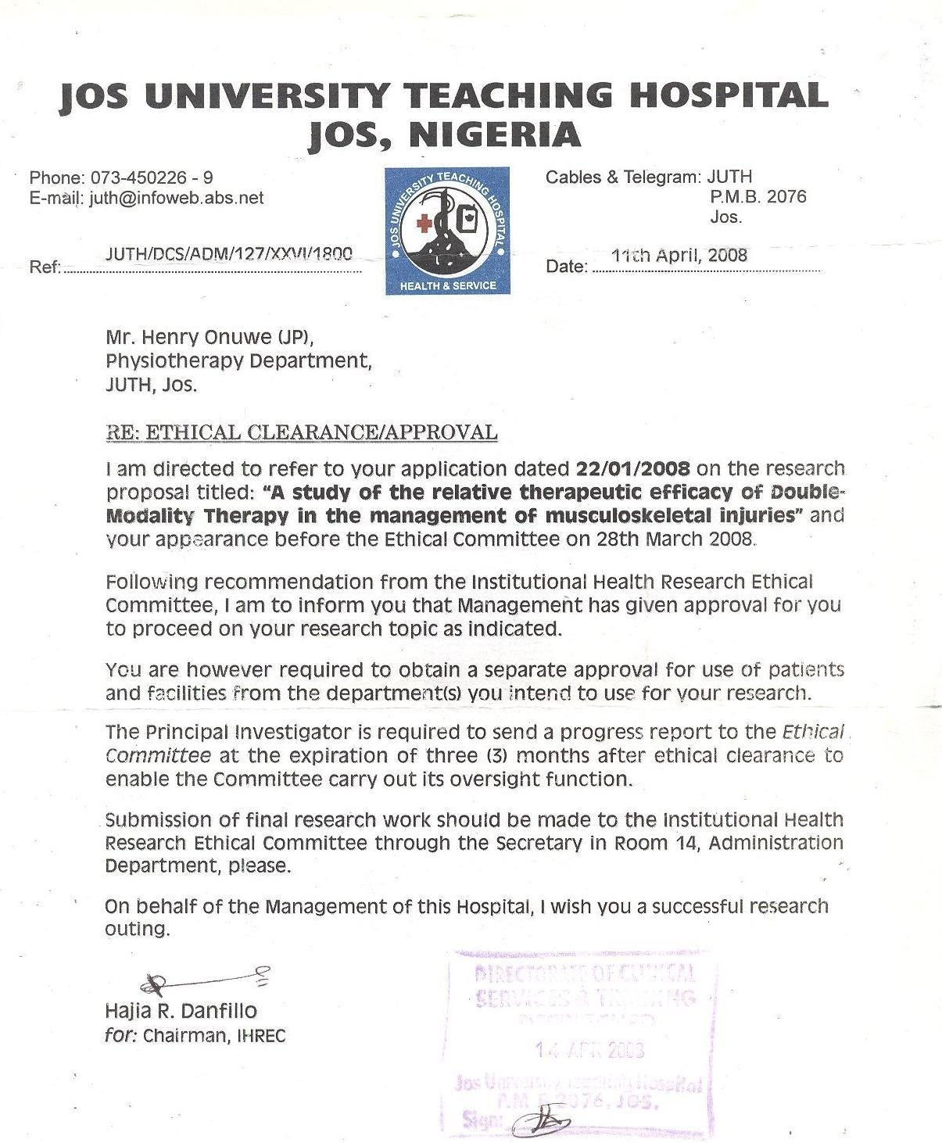

**APPENDIX B : Informed Consent Form**

I, Mr. Henry Onuwe, a Physiotherapist with Jos University Teaching Hospital, Jos is pursuing a doctorate degree (Ph.D) in the University of Jos. My research work (Thesis) is aimed at investigating the therapeutic efficacy of Double-Modality Therapy (DMT) in the management of pain among patients suffering from various musculoskeletal injuries (MSIs).

The findings of this research will assist Physiotherapists and other Clinicians to make their choice or prescription of treatment on evidence-based guidelines in the use of DMT (phonophoresis and cryotherapy) protocol for optimal outcomes (i.e significant pain relief and function) when treating patients with such conditions.

I therefore, seek your earnest consent (voluntary) to participate or to be included as one of the patients for this study. The modalities that will be used in the treatment of your condition are non-invasive (does not require things/objects being inserted into your body). Treatment shall be administered on alternate days for a period of four weeks.

However, you can terminate treatment or discharge yourself when you feel pain is sufficiently relieved or pain is not relieved at all. Your acceptance to participate in this study is highly appreciated. God bless you.

CONSENT: Now that the study has been well explained to me and I fully understand the content of the study protocol, I declare my consent to participate as a subject in this research programme.

Sign./Thumbprint of Subject/Date. Sign. of Researcher/Date

### APPENDIX C : Assessment/Examination Format

**History:** Subject history of present condition(HPC) was taken by adapting the mnemonic

– „SOCRATES‟ presented by Morrison [ 1974 ] :

S – site of pain/injury, O – onset of pain/injury,

C – course of pain(intermittent, constant or persistent),

R – radiation(pins/needles or paraesthesia, numbness or hypoaesthesia), A – alleviation(drugs, rest, change of posture),

T – treatment(current/previous)

E – exacerbation(what exacerbate pain), S – systemic(visceral problems).

**Examination:**Various clinical tests such as stated below were conducted to identify subjects conditions [ McPoil, 1997; Petty and Moore, 2000; Onuwe, 2001 ] :

1. Visual observation – for deformity, swelling, skin discolouration.
2. Palpation – for tenderness, swelling, deformity, pain, warmth(temp.).
3. Visual analogue scale(VAS) – for measuring/rating subject pain perception.
4. Sensory test – subject ability to perceive/feel sensation.
5. Inversion/Eversion stress tests – for lateral/medial collateral ligaments injury of the ankle.
6. Muscle tests (i.e isometric muscle testing) – for golfer/tennis elbow.
7. Finkelstein test for De Quervain tenosynovitis.
8. Impingement test – for supraspinatus muscle/tendon injury .
9. Tinel‟s and Phalen‟s wrist flexion test – for carpal and tarsal tunnel syndrome.
10. Varus/Valgus(adduction/abduction) tests – for injury to lateral/medial collateral ligaments of the knee.
11. Anterior/Posterior Drawer‟s tests – for injury to anterior and posterior cruciate ligaments of the knee.
12. X-ray / MRI Report/ (where necessary).

### APPENDIX D : Raw Data Sheet

|  |  |  |  |  |  |  |  |
| --- | --- | --- | --- | --- | --- | --- | --- |
| S/N | **Participants** | **Diagnosis (MSIs/MSDs)** | **Group** | **Sex** | **Age** | **PRE- TPPS**  **(VAS)** | **POST- TPPS**  **(VAS)** |
| 1. | **WI (Wrestler)** | **® Ankle sprain** | **DMT** | **M** | **28yrs** | **5** | **2** |
| 2. | **MZ**  **(P/Lifter)** | **® Rotator cuff syndrome** | **DMT** | **F** | **25yrs.** | **5** | **2** |
| 3. | **SP (P/Lifter)** | **(L) Rotator cuff syndrome** | **PHONO** | **F** | **27yrs.** | **5** | **1** |
| 4. | **MT (Civil servant)** | **Tendinitis ® Hams.** | **PHONO** | **M** | **55yrs.** | **5** | **2** |
| 5. | **K U(Civil servant)** | **Low back pain** | **CRYO** | **M** | **43yrs.** | **6** | **4** |
| 6. | **C M**  **(P/Lifter)** | **(L) Rotator cuff syndrome** | **DMT** | **F** | **29yrs.** | **5** | **2** |
| 7. | **K A (Boxer)** | **(L) Ankle sprain** | **CRYO** | **M** | **24yrs.** | **5** | **3** |
| 8. | **SM ( Civil servant)** | **Low back pain** | **CRYO** | **M** | **46yrs.** | **5** | **2** |
| 9. | **N N**  **(Wrestler)** | **Low back pain** | **DMT** | **M** | **26yrs.** | **5** | **2** |
| 10. | **M ZA**  **(P/Lifter)** | **® Rotator cuff syndrome** | **CRYO** | **M** | **37yrs.** | **4** | **3** |
| 11. | **M E (Boxer)** | **Muscle contusion**  **– left chest** | **DMT** | **M** | **25yrs.** | **6** | **1** |
| 12. | **A M (Civil servant)** | **(L) Ankle sprain** | **DMT** | **M** | **43yrs.** | **4** | **3** |
| 13. | **NJ (Tennis player)** | **® Tennis Elbow** | **CRYO** | **M** | **26yrs.** | **6** | **2** |
| 14. | **AA (P/Lifter)** | **(L) Latissimus dorsi(strain** | **CRYO** | **M** | **35yrs.** | **9** | **2** |

**PRE-TPPS = Pre-treatment pain perception score POST-TPPS = Post-treatment pain perception score**

### APPENDIX D : Raw Data Sheet

|  |  |  |  |  |  |  |  |
| --- | --- | --- | --- | --- | --- | --- | --- |
| **S/N** | **Participants** | **Diagnosis (MSIs/MSDs)** | **Group** | **Sex** | **Age** | **PRE- TPPS**  **(VAS)** | **POST- TPPS**  **(VAS)** |
| **15.** | **SO (High jumper)** | **® Patellar Bursitis** | **CRYO** | **M** | **23yrs** | **4** | **1** |
| **16.** | **BG (Squash player)** | **(L) Knee Sprain** | **DMT** | **M** | **50yrs** | **5** | **2** |
| **17.** | **ES (P/Lifter)** | **(L) Rotator cuff syndrome** | **CRYO** | **F** | **26yrs** | **3** | **0** |
| **18.** | **WM (P/Lifter)** | **(L) Rotator cuff syndrome** | **DMT** | **M** | **33yrs** | **5** | **2** |
| **19.** | **MD**  **(Footballer)** | **® Ankle sprain** | **DMT** | **F** | **25yrs** | **5** | **1** |
| **20.** | **EST (Polevolt jumper)** | **® Patellar Bursitis** | **PHONO** | **F** | **25yrs** | **6** | **4** |
| **21.** | **BS**  **(Footballer)** | **(L) Patellar Bursitis** | **CRYO** | **M** | **26yrs** | **6** | **3** |
| **22.** | **WO**  **(C/servant)** | **(L) Ankle sprain** | **PHONO** | **M** | **54yrs** | **5** | **2** |
| **23.** | **YD (Volleyball player)** | **Muscle Strain (LBP)** | **CRYO** | **M** | **57yrs** | **6** | **3** |
| **24.** | **SC (Wrestler)** | **(L) Rotator cuff syndrome** | **DMT** | **M** | **26yrs** | **8** | **3** |
| **25.** | **EP (Wrestler)** | **(L) Rotator cuff syndrome** | **DMT** | **F** | **26yrs** | **7** | **2** |
| **26.** | **CA (Volleyball player)** | **® Tibia Contusion** | **CRYO** | **F** | **25yrs** | **6** | **3** |
| **27.** | **M O**  **(C/servant)** | **(L) Quads. contusion** | **DMT** | **F** | **58yrs** | **5** | **1** |
| **28.** | **CO (Pastor)** | **Muscle strain (LBP)** | **DMT** | **M** | **48yrs** | **6** | **1** |

**PRE-TPPS = Pre-treatment pain perception score POST-TPPS = Post-treatment pain perception score**

### APPENDIX D : Raw Data Sheet

|  |  |  |  |  |  |  |  |
| --- | --- | --- | --- | --- | --- | --- | --- |
| S/N | **Participants** | Diagnosis (MSIs/MSDs) | Group | Sex | Age | PRE- TPPS (VAS) | POST- TPPS (VAS) |
| 29. | AO (Banker) | ® Supraspinatus Tendinitis | PHONO | F | 43yrs | 6 | 1 |
| 30. | CI (C/Servant) | LBP (Strain) | PHONO | M | 45yrs | 5 | 1 |
| 31. | BN (C/Servant) | LBP (Strain) | DMT | M | 55yrs | 5 | 2 |
| 32. | AT (C/Servant) | (L) Knee Sprain | PHONO | M | 77yrs | 4 | 1 |
| 33. | AAK  (Volleyball player) | ® Rotator cuff syndrome | CRYO | F | 22yrs | 5 | 2 |
| 34. | GI (Gymnastics) | Strain ® Trapezius | CRYO | M | 28yrs | 5 | 2 |
| 35. | BA (C/Servant) | Erector spinae strain | PHONO | M | 36yrs | 6 | 2 |
| 36. | BS (Field Worker) | LBP (Strain) | PHONO | M | 38yrs | 5 | 2 |
| 37. | HD  (Gymnastics) | ® Rotator cuff syndrome | CRYO | M | 18yrs | 5 | 2 |
| 38. | DU  (Gymnastics) | (L)Rotator cuff syndrome | CRYO | M | 20yrs | 5 | 2 |
| 39. | HS (C/Servant) | Tenosynovitis (L) thumb | PHONO | F | 53yrs | 5 | 3 |
| 40. | OO (Business) | LBP (Strain) | PHONO | M | 39yrs. | 4 | 2 |
| 41. | BO (Trader) | ® Tennis Elbow | PHONO | M | 46yrs. | 6 | 3 |
| 42. | BD (C/servant) | LBP (Strain) | CRYO | M | 53yrs. | 6 | 4 |

**PRE-TPPS = Pre-treatment pain perception score POST-TPPS = Post-treatment pain perception score**

### APPENDIX D : Raw Data Sheet

|  |  |  |  |  |  |  |  |
| --- | --- | --- | --- | --- | --- | --- | --- |
| S/N | **Participants** | Diagnosis (MSIs/MSDs) | Group | Sex | Age | PRE- TPPS (VAS) | POST- TPPS (VAS) |
| 43. | IB (Footballer) | ® Knee Sprain | CRYO | M | 18yrs | 4 | 3 |
| 44. | AS  (Footballer) | Strain (L) Rectus Femoris | PHONO | M | 25yrs | 6 | 2 |
| 45. | PO  (Footballer) | (L) Ankle Sprain | CRYO | M | 19yrs | 4 | 3 |
| 46. | OOG  (Footballer) | ® Ankle Sprain | DMT | M | 19yrs | 5 | 2 |
| 47. | RA  (Gymnastics) | ® Rotator cuff syndrome | DMT | M | 28yrs | 6 | 1 |
| 48. | V N (Boxer) | (L) Rotator cuff syndrome | CRYO | M | 35yrs | 5 | 5 |
| 49. | PD  (Footballer) | (L) Knee Sprain | DMT | M | 28yrs | 6 | 4 |
| 50. | MY  (Gymnastics) | (L) Chronic Patellar Bursitis | PHONO | F | 27yrs | 4 | 1 |
| 51. | AB (Tennis player) | (R) Tennis Elbow | DMT | M | 26yrs | 6 | 1 |
| 52. | BZ  (Footballer) | Tendinitis(L) Ham | PHONO | M | 27yrs | 5 | 1 |
| 53. | PA (Boxer) | Muscle Contusion  (L) Chest | DMT | F | 25yrs | 5 | 2 |
| 54. | JA (Footballer) | (R) Ankle Sprain | PHONO | F | 36yrs | 4 | 1 |
| 55. | SM (Long Jumper) | (L) Patellar Bursitis | PHONO | F | 25yrs | 5 | 2 |

**PRE-TPPS = Pre-treatment pain perception score POST-TPPS = Post-treatment pain perception score**

### APPENDIX D : Raw Data Sheet

|  |  |  |  |  |  |  |  |
| --- | --- | --- | --- | --- | --- | --- | --- |
| S/N | **Participants** | Diagnosis (MSIs/MSDs) | Group | Sex | Age | PRE- TPPS (VAS) | POST- TPPS (VAS) |
| 56. | AA (C/Servant) | Muscle Strain (LBP) | PHONO | M | 27yrs | 5 | 2 |
| 57. | JO (Footballer) | (R) Tibia Contusion | DMT | M | 28yrs | 6 | 2 |
| 58 | AO (P/Lifter) | (R) Rotator cuff syndrome | CRYO | F | 25yrs | 5 | 2 |
| 59. | CO (Boxer) | (R) Serratus Ant. Muscle Strain | PHONO | M | 38yrs | 5 | 2 |
| 60. | MA (C/Servant) | LBP (Strain) | PHONO | M | 43yrs | 5 | 2 |
|  |  |  |  |  |  |  |  |
|  |  |  |  |  |  |  |  |
|  |  |  |  |  |  |  |  |
|  |  |  |  |  |  |  |  |
|  |  |  |  |  |  |  |  |

**PRE-TPPS = Pre-treatment pain perception score POST-TPPS = Post-treatment pain perception score**

**APPENDIX E**

## AFRICAN JOURNAL OF PHYSIOTHERAPY AND REHABILITATION SCIENCES (AJPARS)

**c/o Department of Physiotherapy**

**College of Medicine University of Ibadan, Nigeria. Tel: +234-2-2410088 Ext. 3366**

**+234-8-57325888**

[**ajparsibadan@yahoo.co.uk**](mailto:ajparsibadan@yahoo.co.uk)[**http://www.comui.edu.ng/faculties/clinicalscience/physiotherapy**](http://www.comui.edu.ng/faculties/clinicalscience/physiotherapy)

7 August, 2012

Mr. Henry A.K. Onuwe Physiotherapy Department

Jos University Teaching Hospital, Jos

**Dear Mr Onuwe,**

**ACCEPTANCE OF MANUSCRIPT**

On behalf of AJPARS Editorial Board, I am happy to inform you that your manuscript REF: AJPARS120032A titled “**Relative Therapeutic Efficacy of Phonophoresis and Cryotherapy as combined Therapy in the Management of Musculoskeletal Injuries**” has been accepted for publication in AJPAR**S subject to FULL corrections of the concerns raised by our reviewers.** See main document.

Kindly effect all the corrections and send an electronic copy (as E-Mail attachment or Compact Disc) to the AJPARS Secretariat **not later than three (3) weeks** from the date of this letter. Indicate your point-by-point response to the concerns raised by our reviewers in a cover letter that will accompany your submission. Inability to submit within this period means you are no longer interested in publishing in AJPARS.

You are also expected to pay the sum of **N 5,000.00** only as acceptance fee before your manuscript will be published. Pay this into AJPARS account no: **1011846287**, from any UBA PLC Branch. Ensure that a copy of the deposit teller in the form of E-Mail attachment or hard copy accompanies your submission of the corrected copy.

Thank you for your contribution to AJPARS.

**Adeniyi, A.F. (Ph.D.)**

**Secretary, AJPARS Editorial Board**

### APPENDIX E

Published article – “ Therapeutic Efficacy of Methyl Salicylate Phonophoresis in the Management of Musculoskeletal Injuries among Athletes” by Journal of Medicine in the Tropics ( next page ).

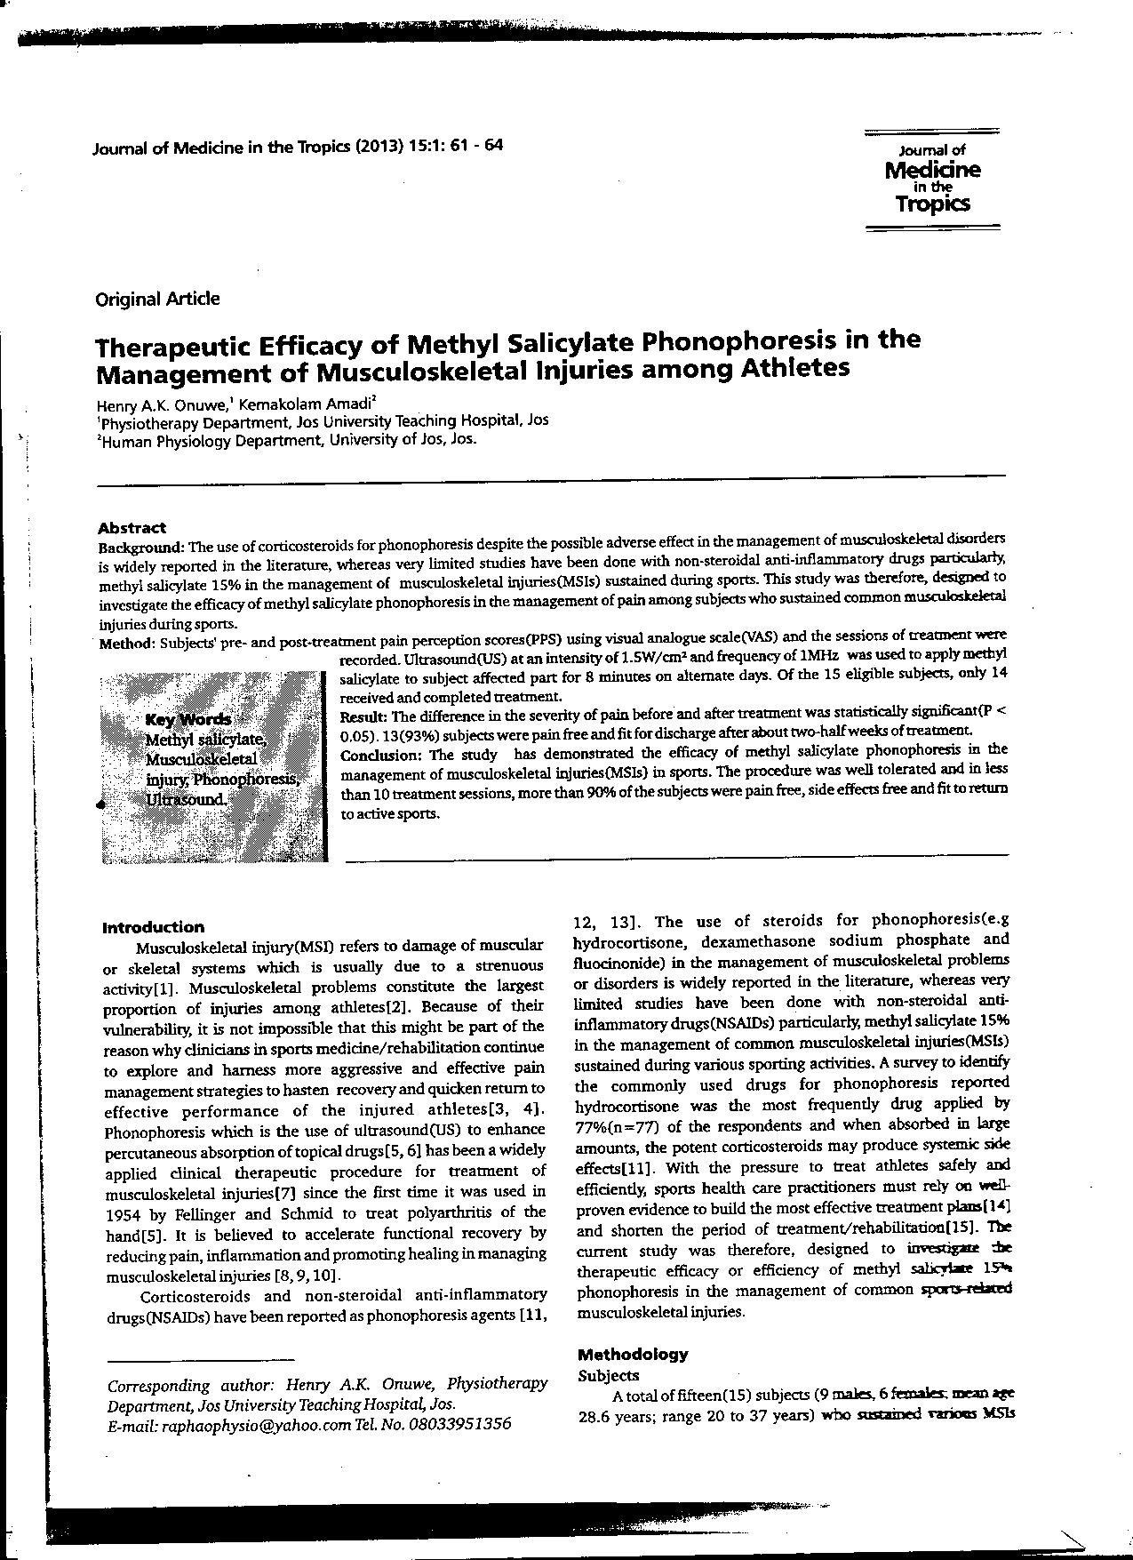

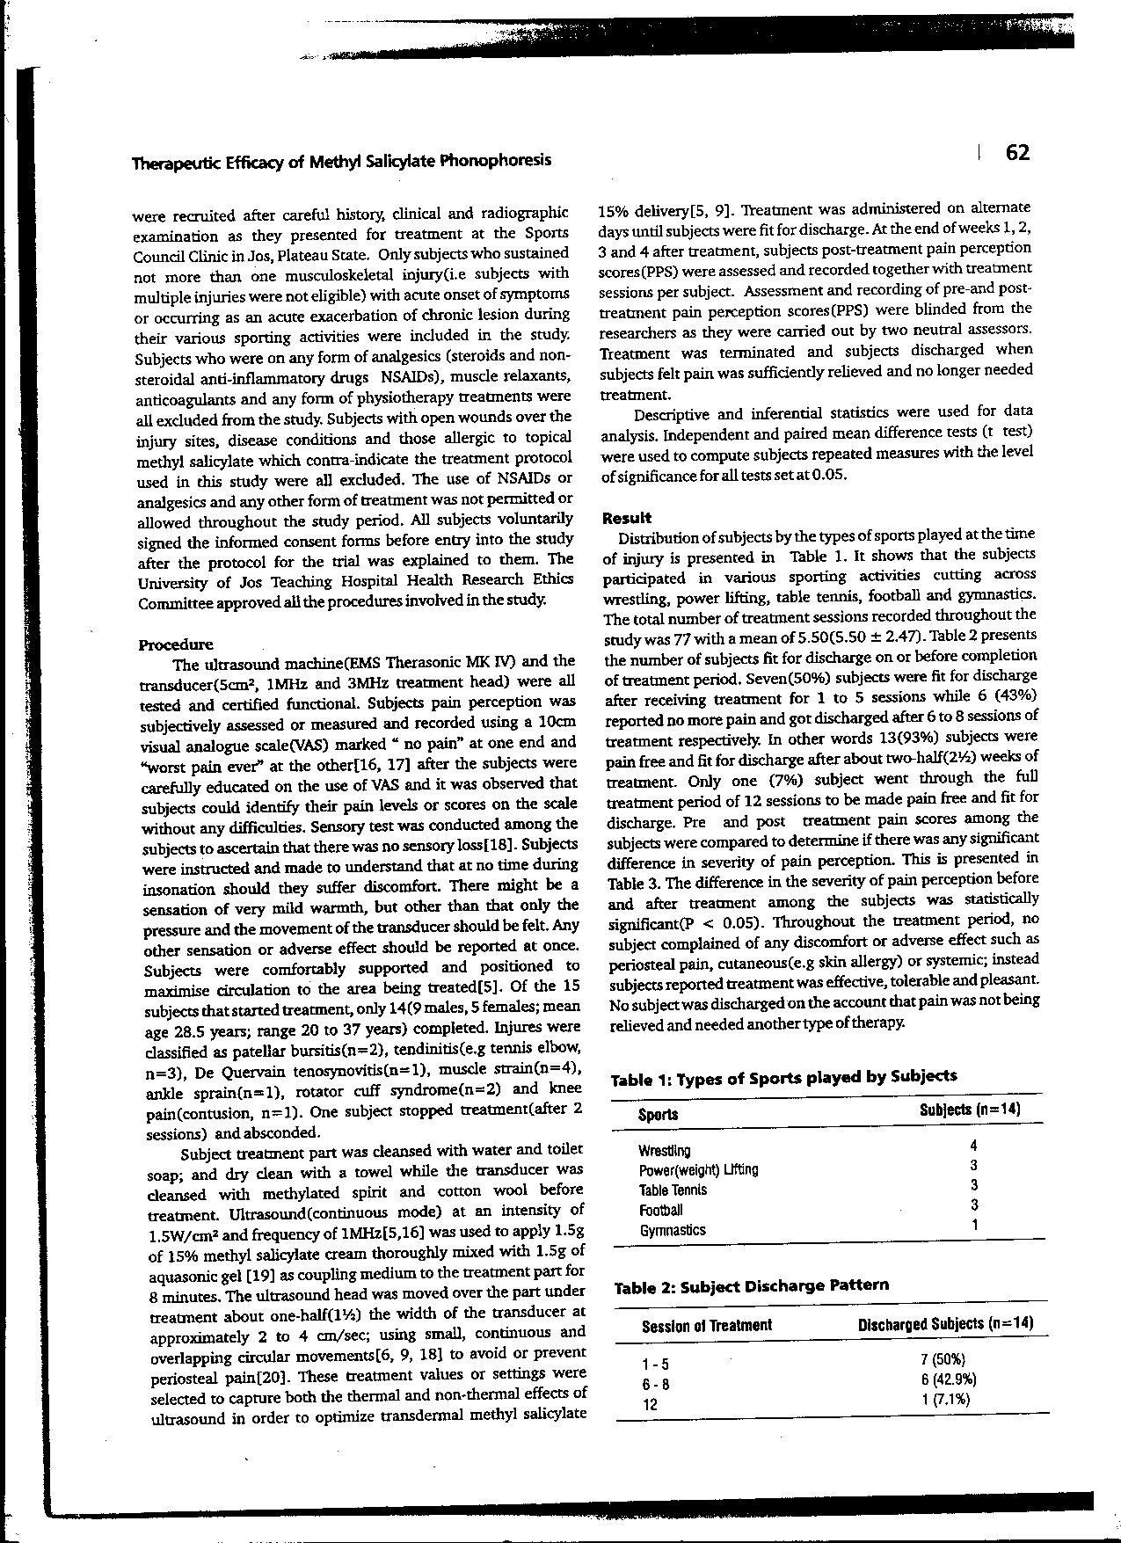

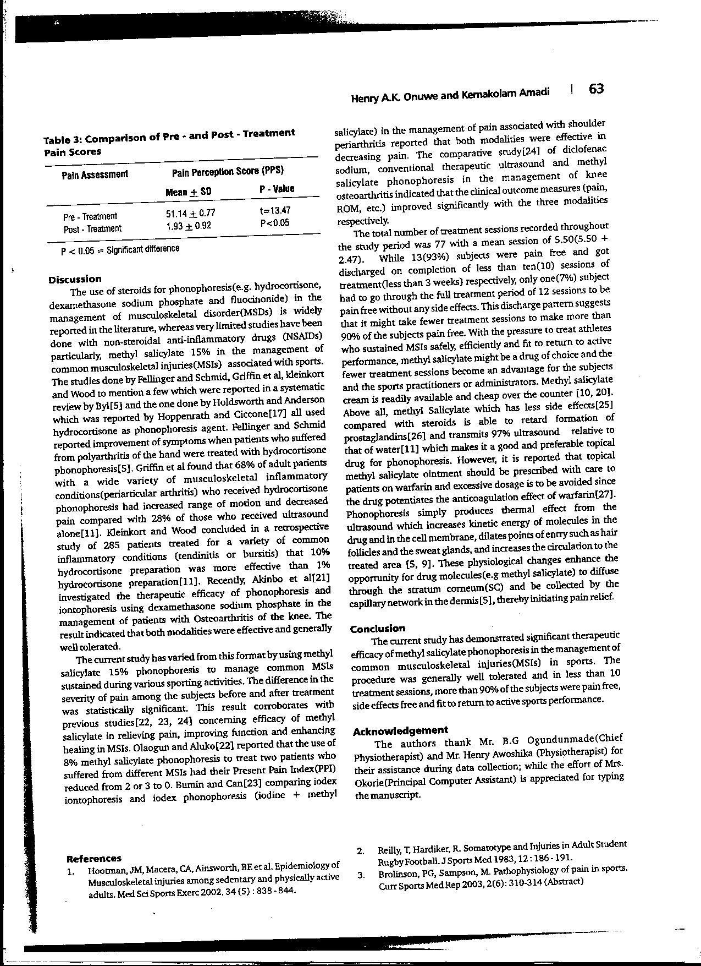

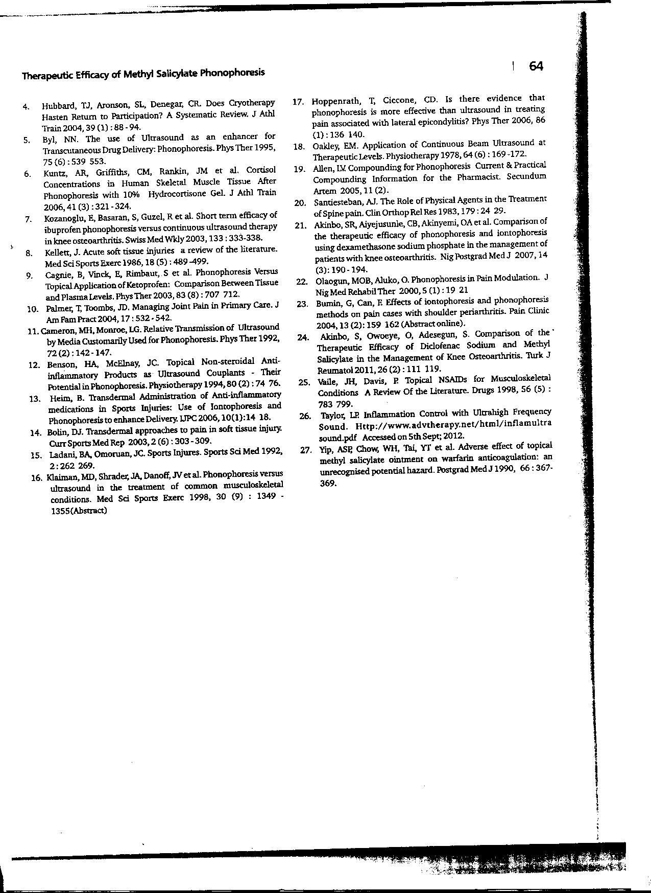

### APPENDIX E

**Provisional acceptance of manuscript at NJPS**

Sheu Tijani Shittu To Me

Feb 21

Dear Sir,

Find attached your reviewed manuscript, the manuscript will be published as soon as the highlighted corrections are duly effected and page charges of #15,000.00 had been paid. The money is payable into:

Bank: GTB, Name: Shittu, Shehu, Acct no: 0035106174, however, send the corrected version of your manuscript first and wait till you have been cleared to pay before payment.

You are urged to effect the correction as swiftly as possible so as to have it featured in the December 2013 issue of the journal.

Thank you,

Shittu, S.T

Editorial Asstant

**SUBMISSION OF CORRECTED MANUSCRIPT (2)**

Me Kindly receive the corrected version of our manuscript titled-COMPARISON OF THE THERAPEUTIC EFFICACY OF DOUBLE-MODALITY THERAPY, PHONOPHORESIS AND CROTHERAPY IN THE MANAGEMENT OF MUSCULOSKELETAL INJUR

Mar 6 at 12:59 PM Sheu Tijani Shittu

To [cletus.adebayor@firstbanknigeria.comMe](mailto:cletus.adebayor@firstbanknigeria.comMe) Mar 6 at 9:52 PM

Dear sir,

I write to acknowledge the receipt of your corrected manuscript, please list all the corrections effected on the old manuscript and send as a separate attachment.

S.T Shittu

### APPENDIX F

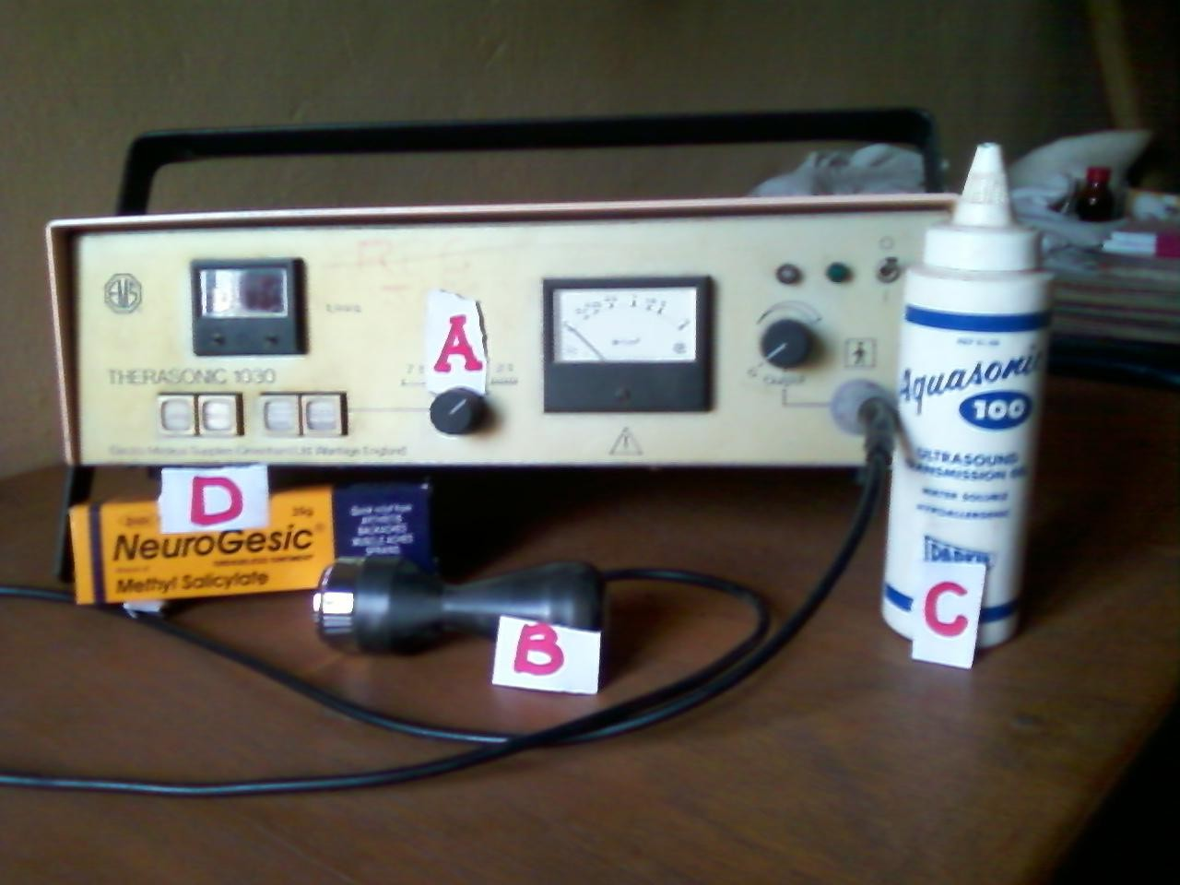

Photo. I : Instruments/Materials for delivering Phonphoresis.

(A) Ultrasound Machine. (B) Treatment Head(Transducer).

(C) Aquasonic Gel(Parkers). (D) Methyl Salicylate 15% Cream.

### APPENDIX F

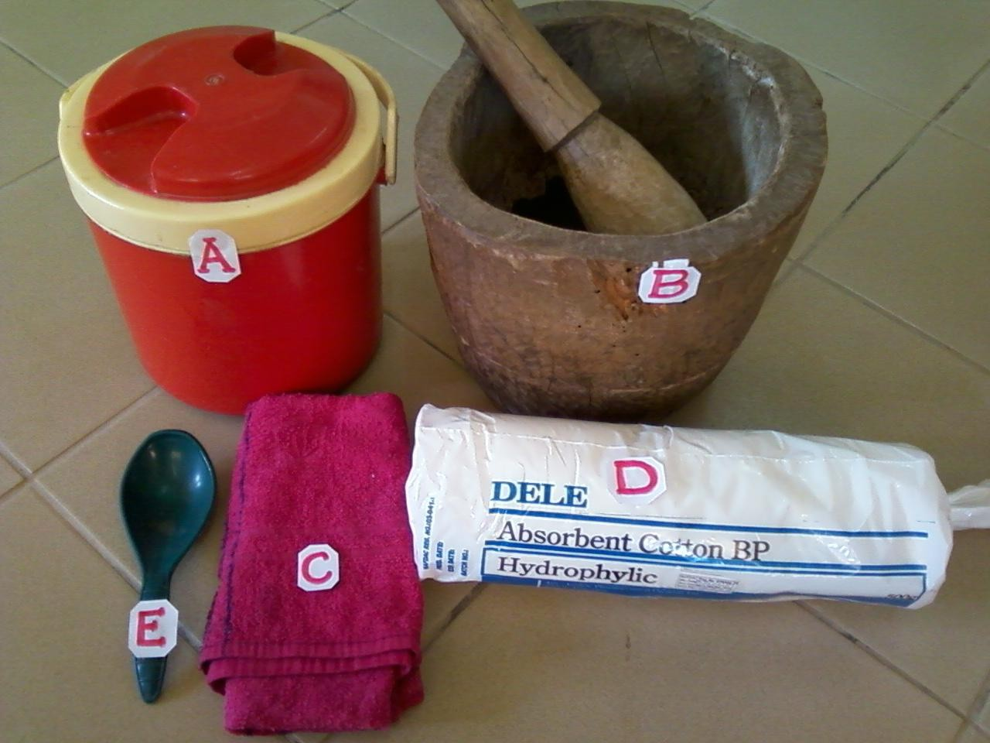

Photo. II : Instruments/Materials for making Ice Chips/Packs

(A) Eleganza Cooler Container. (B) Mortar/Pestle.

1. Towel. (D) Cotton. (E) Plastic Spoon.

### APPENDIX F

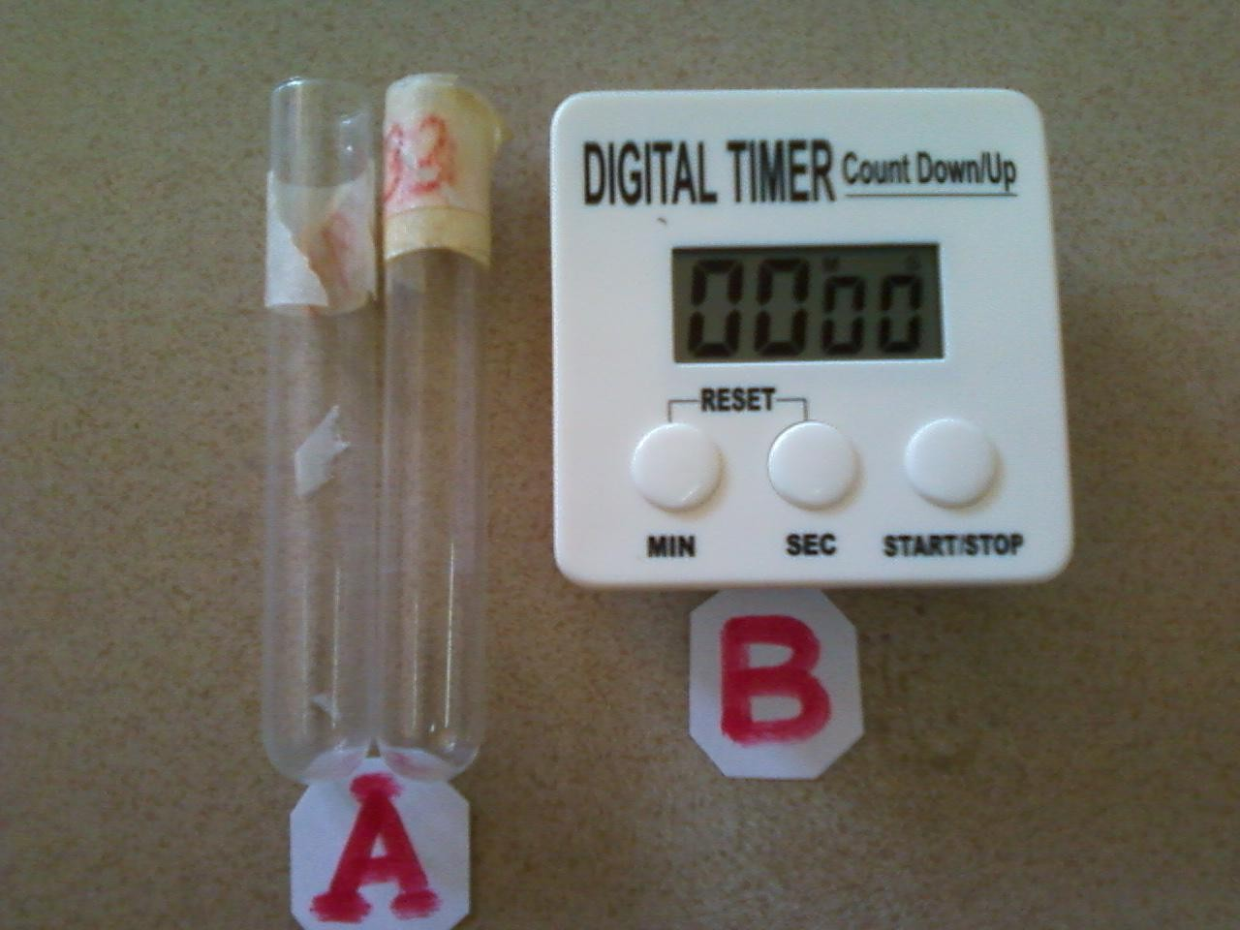

Photo. III : Assessment/Recording Tools.

* 1. Glass Test Tubes. (B) Digital Timer.

### APPENDIX F

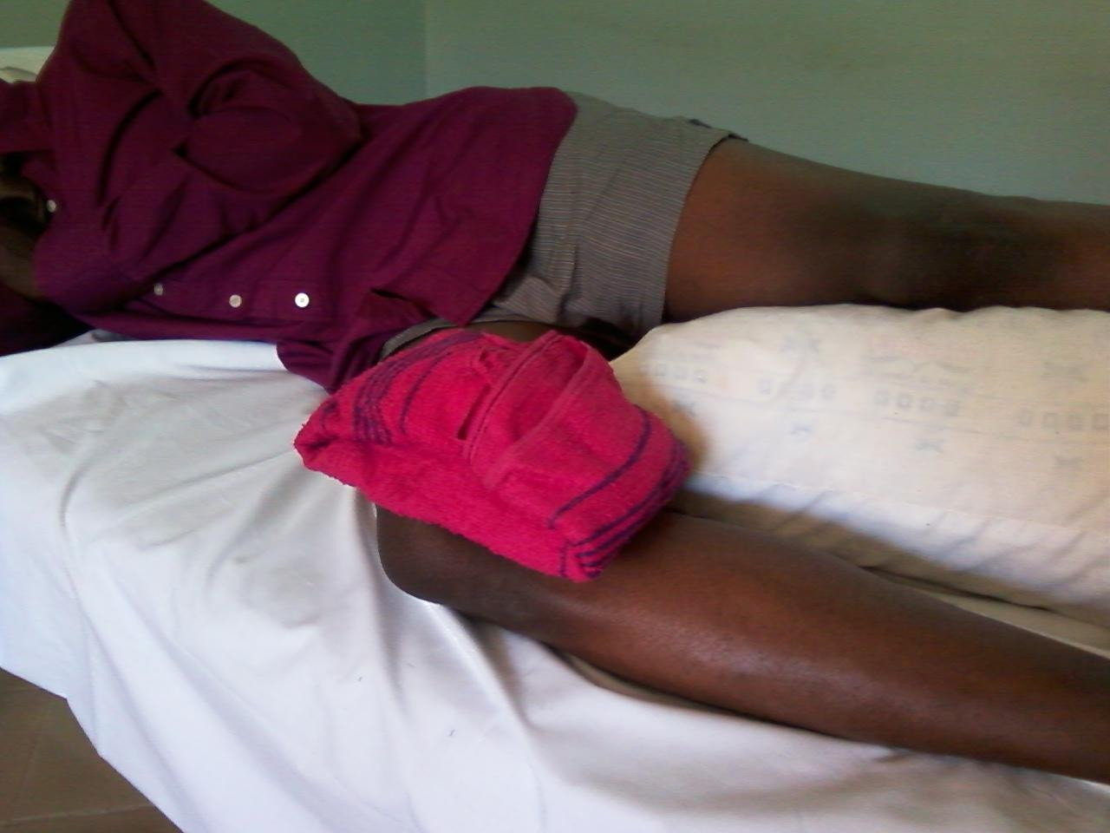

Photo. IV : Participant receiving Cryotherapy Treatment.

### APPENDIX F

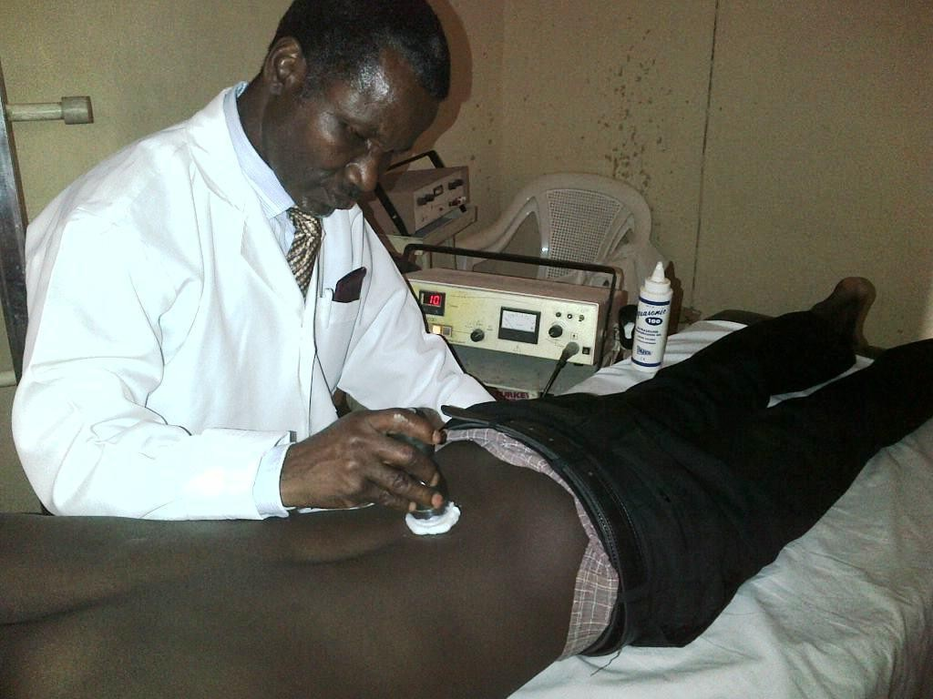

Photo. V: Participant receiving Phonophoresis Treatment.