

# A COMBINED BIOGAS PLANT AND INCINERATOR SYSTEM FOR MUNICIPAL SOLID WASTE MANAGEMENT

**By**

# ABDUL-HAKEEM AYODELE BUSARI

**DEPARTMENT OF WATER RESOURCES AND ENVIRONMENTAL ENGINEERING**

# AHMADU BELLO UNIVERSITY, ZARIA NIGERIA

**A COMBINED BIOGAS PLANT AND INCINERATOR SYSTEM FOR MUNICIPAL SOLID WASTE MANAGEMENT**

# By

**Abdul-Hakeem Ayodele BUSARI, B. Sc. (Hons) Mech. Eng. (UNILAG) 1985 P16EGWR8083**

# A DISSERTATION SUBMITTED TO THE SCHOOL OF POST GRADUATE STUDIES,

**AHMADU BELLO UNIVERSITY, ZARIA**

# IN PARTIAL FULFILMENT OF THE REQUIREMENTS FOR THE AWARD OF A

**MASTER DEGREE IN WATER RESOURCES AND ENVIRONMENTAL ENGINEERING**

# DEPARTMENT OF WATER RESOURCES AND ENVIRONMENTAL ENGINEERING, FACULTY OF ENGINEERING

**AHMADU BELLO UNIVERSITY, ZARIA NIGERIA**

# OCTOBER, 2017

# DECLARATION

I declare that the work in this dissertation entitlHG C³om$bined Biogas Plant and Incinerator System for Municipal Solid Waste Management´h as been carried out by me in the Department of Water Resources and Environmental Engineering, Ahmadu Bello University, Zaria. The information derived from literature has been duly acknowledged in the text and a list of references provided. No part of this dissertation as far as I know was previously presented for another degree or diploma at this or any other Institution.

|  |  |  |
| --- | --- | --- |
| Abdul-Hakeem Ayodele BUSARI | «««« | «««« |
| Name of Student | Signature | Date |

# CERTIFICATION

This dissertation entitled ³A COMBINED BIOGAS PLANT AND INCINERATOR SYSTEM FOR MUNICIPAL SOLID WASTE MANAGEMENT´by Abdul-Hakeem

Ayodele BUSARI meets the regulations governing the award of the degree of Master of Science in Water Resources and Environmental Engineering of Ahmadu Bello University, and is approved for its contribution to knowledge and literary presentation.

Prof. Charles Amen Okuofu Date

Chairman, Supervisory Committee

Dr. E. M. Shaibu-Imodagbe Date

Member, Supervisory Committee

Prof. Abubakar Ismail Date

Head of Department

Prof. S. Z. Abubakar Date

Dean, School of Postgraduate Studies

# ACKNOWLEDGEMENT

All praises and thanks to Allah, for His mercy and abundant blessings in making this work possible for me. My profound appreciation goes to my wives; Aminat Olabisi and Ganiyat Kehinde and all my children (From Zainab to Ridwan, Seyi, Abdul-Rahman, Abdul-Lateef, Lawal, Abdul-Qadri, Muhammadu-Taha, and Sheikh Ibrahim to Sheikh Ahmad Tijani) for their patience and support during the period of this study.

My profound gratitude goes to Prof. Charles Amen Okuofu for his indelible mark of professionalism on me as a supervisor per excellence, if not for his tenacity and insistence a lot of conclusions reached in this study would have been overlooked. He made me to stretch my capabilities in researching issues more than I normally would

have. Dr. Egbenya Musah Shaibu-,PRGDJEH¶V SHRSOH¶V WRXFK L

He continually advocated how this work can benefit the populace at the most affordable cost and made me to have a rethink on a lot of design thoughts and challenges. I hereby appreciate Dr. S. B. Igboro for his invaluable advises based on his previous experience in a similar study.

The data recorded on the performance of the Biogas plant would have been nearly impossible if not for Laboratory Technical Assistant, Mr. Geofrey Ameh and putting together the plant itself would have been a herculean task but for the departmental Senior Foreman, Kajang Thomas Sabo. I am really grateful to both of them. The other teaching and non-academic staff of the Department were just wonderful. Only the Almighty can thank them for their support and encouragement. I cannot close this page without acknowledging Emmanuel Akhimie, Samuel Wamdeo Salihu, Shittu Harun and Meshach Ileanwa Alfa fellow post graduate students of the Department for their support and contributions. May their road in the search for knowledge be rough, enlightening and fulfilling. Amen.

# DEDICATION

Bismillahi al-Rahmani al-Raheemi. In the name of Allah, the generally merciful, the specially merciful. He was the One that placed so much importance on knowledge that His first revelation to the prophet of Islam was ³Iqraa! Bismi robika´(Read, recite or rehearse in the name of your Lord). [Al-4XU¶DQA laz ii a lam a@bil Qalami {He Who taught (the use of) the Pen} [Al-4XU¶DQ, w hi le Hi s s ec@ond revelation was ³ Nun. Wa al-4DODPL ZD PD{DNu n.\BDy tVheWPeXn aUndXbXy tQheD(R´ecord) which (men) write,} [Al-4XU¶DQ @

The prophet of Islam VDLG ³6HH,NH YNHQQR ZLOQH G&JKHLQD´ >+DGLWK

I therefore dedicate this endeavour to Allah, the Almighty, the Sublime, the Wise and all the practitioners in the temple for the search for knowledge. May He consider it a service to His creations and reward me abundantly on the day of recompense. Amin.

# ABSTRACT

This study, assessed the potentials of generating biogas from the organic fraction of municipal solid wastes to fuel an incinerator which is then used to burn the residual combustible solid waste. Municipal solid waste from Ahmadu Bello University (ABU) commercial market was collected, grinded and mixed with intestinal waste from slaughtered cattle at Zango abattoir, Zaria in a 2:1 ratio by volume. The mixture was diluted with water in a 1:1 ratio by volume to form a slurry and digested anaerobically in a digester

The efficacy of the digester in producing biogas were in three (3) phases. Lowest between day 3 ±11; 0.143m3 (0.018m3/kg), highest between day 15 ±55; 1.353m3 (0.034m3/kg) and medium between day 55 ±94; 1.208m3 (0.031m3/kg)

Fertilizer values based on the ratios of N: P: K: Mg were 28: 1: 22: 4; 1: 971: 821: 1995 and 10: 1: 59: 104 for digestate, bottom ash and combined digestate and bottom ash respectively.

Total Organic Carbon contents of the digested solid waste were0.1389 %, 0.8099 %, and 0.3008 % of the initial mass for digestate, Bottom ash and combined digestate and bottom ash respectively.

A small scale incinerator was built with the capacity to burn 1.8m3 of solid waste per day burn cycle. A biogas air mixer was developed to ensure good combustion by the biogas burner. The biogas burnt with a blue flame measured at 8700C and a calorific value of 16,000J/g while the incinerator was able to achieve an average operating temperature of 9300C with a percentage waste reduction of 80 % per hour with 4.5 %

DV ERWWRP DVK %LRJDV FRQVXPSWLRQ E\ W

0.0071m3/min with adequate flame stability during the process. Ratio of gas used to the solid waste combustion was 1: 78: 1 v/v per hour.

# TABLE OF CONTENTS

Title Page ii

Declaration iii

Certification iv

Acknowledgement v

Dedication vi

Abstract vii

Table of Contents viii

List of Tables xiii

List of Figures xiv

List of Plates xvi

List of Appendices xvii

Abbreviations, Definitions, Glossary and Symbols xviii

* 1. INTRODUCTION 1
  2. General Background of the Study 1
  3. Statement of Research Problem 4
  4. Justification of the Study 5
  5. Aims and Objectives 6
  6. Scope and Limitations of the Study 6
  7. LITERATURE REVIEW 8
  8. Municipal Solid Wastes 8
     1. Characteristics and Properties 8
     2. Treatment / Management 8
  9. Anaerobic Digestion 9
     1. Biochemical Reactions 9
     2. Stoichiometry 13
     3. Microbiology and syntrophic relationships in fermentation 14
  10. End Products of Anaerobic Digestion 16
      1. Biogas 16
      2. Digestate 16
  11. Design of anaerobic digesters 17
      1. Design Criteria 17
      2. Design considerations 18
      3. Sizing of a biogas plant 33
      4. Safety considerations in the operation of a biogas plant 42
  12. Incinerator System; Definitions, Background and practices 44
  13. Air requirements for incineration 46
  14. The Components of an incineration plant 47
      1. Waste reception and handling 48
      2. Combustion technology 49
      3. Energy recovery 50
      4. Emission control for releases to the atmosphere 50
      5. Bottom ash handling 51
  15. Design of an incinerator 51
      1. Design criteria for an incinerator 53
      2. Design considerations for an incinerator 54
      3. Design considerations for a biogas fuelled

incinerator auxiliary burner 56

* + 1. Design criteria for a biogas fuelled burner 58
  1. Operation of Incinerators 67
     1. Emission standards and compliance 68
     2. Exposure, safety and health risks from incineration 71
     3. Safety risks in the operation of a small scale incinerator 73
     4. Health risks in the siting and operation of incinerators 74
     5. Hazard assessment in the siting and operation of incinerators 75
  2. By-Products of Municipal Solid Waste Treatment Systems 76
     1. Fertilizer value of digester effluent; liquid digestate and sludge 77
     2. Fertilizer value of wood ash 77
     3. Soil pH and nutrient availability 77
  3. Review of previous similar research in the WREE dept,

ABU, Zaria 78

* + 1. Production of biogas and **compost** from cow dung

in Zaria, Nigeria 78

* + 1. Comparative evaluation of biogas production from

various substrates 79

CHAPTER THREE: MATERIALS AND METHODS

* 1. Materials 81
     1. Materials for the Biogas Plant 81
     2. Materials for Laboratory work 85
     3. Materials for the Incinerator 86
  2. Methods 89
     1. Design of biogas plant and incinerator system 89
     2. Design of the digester 89
     3. Design of the gasholder 90
     4. Construction of the biogas plant 92
     5. Design of the incinerator system 97
     6. Construction of the incinerator 104
     7. Operation and testing of the biogas plant 111
     8. Operation and performance of the incinerator 113
     9. Determining the energy content or calorific value

of the biogas as a fuel 114

* + 1. Performance evaluation of the incinerator 115

CHAPTER FOUR: RESULTS AND DISCUSSIONS

* 1. Biogas plant version 1 116
  2. Biogas plant version 2 118
  3. Biogas plant version 3 121
  4. Incinerator system version 1 123
  5. Incinerator system version 2 124
  6. Biogas production 131
  7. Digester and Samaru Temperatures during Digestion Period 132
  8. Digester pH during biogas production 133
  9. Result of analysis of digested substrate 134
     1. The pH of the digestate at different time intervals 134
     2. Total potassium content of the digestate at different time intervals 135
     3. Total phosphate content of the digestate at different time intervals 135
     4. Nitrate content of the digestate at different time intervals 136
     5. Total sulphate content of the digestate at different time intervals 137
     6. Total organic carbon level of the digestate with time 137
  10. Performance evaluation of the incinerator system 138
  11. Evaluation of the by-SURGXFWV PL[WXUH¶V 1D39QDO\VL
  12. Calorific value of the biogas as fuel 141

**CHAPTER FIVE: CONCLUSIONS AND RECOMMENDATIONS**

|  |  |  |
| --- | --- | --- |
| 5.1 | Conclusions | 142 |
| 5.2 | Recommendations | 143 |
| References |  | 145 |
| Appendices |  | 153 |

# LIST OF TABLES

|  |  |  |
| --- | --- | --- |
| Table 2.1 | Performance data of different anaerobic processes applied for FVW treatment. | 22 |
| Table 2.2 | Moisture requirement of different digester types | 29 |
| Table 2.3 | Properties of Biogas assumed 58 % CH4 and 42 % CO2, saturated with water vapour at 300C, and  standard pressure (1bar) | 57 |
| Table 2.4 | Air Emission Limit Values | 70 |
| Table 3.1 | Biogas Plant Components, Materials Specifications and Methods Description | 93 |
| Table 3.2 | Incinerator Systems Components, Materials Specifications and Methods Description | 105 |
| Table 3.3 | Data obtained in experiment to determine the energy content of the biogas | 114 |
| Table 3.4 | Performance measurements of the incinerator system | 115 |
| Table 4.1 | Performance evaluation of the incinerator system | 138 |

|  |  |  |
| --- | --- | --- |
|  | **LIST OF FIGURES** |  |
| Figure 1.1 | Biogas Cycle | 3 |
| Figure 2.1 | Anaerobic Process Schematic of hydrolysis, fermentation and methanogenesis | 10 |
| Figure 2.2 | Continuously Stirred Tank Reactor (CSTR) | 23 |
| Figure 2.3 | Semi-continuously mixed tubular reactor | 24 |
| Figure 2.4 | Two-Phased integrated anaerobic Solid Bed Hydrolyser (SBH) and Upflow Anaerobic Sludge Blanket (UASB) | 25 |
| Figure 2.5 | Two-Phase integrated Anaerobic Sequencing Batch Reactor (ASBR) and Fixed Film Reactor (FFR) | 26 |
| Figure 2.6 | Gas production from fresh cattle manure depending on retention time and digester temperature | 37 |
| Figure 2.7 | Gas production from fresh pig manure depending on retention time and digester temperature | 37 |
| Figure 2.8 | Graph of flow rate Q through an orifice where *Cd* is taken as 0.9 | 60 |
| Figure 2.9 | Orifice configurations | 60 |
| Figure 2.10 | Flames configuration | 61 |
| Figure 2.11 | Flame lift phenomenon in a gas burner | 64 |
| Figure 2.12 | pH scale and Nutrient Availability Chart | 78 |
| Figure 4.1 | Biogas plant version 1 | 117 |
| Figure 4.2 | Biogas plant version 2 | 120 |
| Figure 4.3 | Biogas plant version 3 | 122 |
| Figure 4.4 | Incinerator system version 1 | 123 |
| Figure 4.5 | Incinerator system version 2 | 125 |
| Figure 4.6 | Plan view of the Biogas burner | 126 |
| Figure 4.7 | Biogas±Air Mixer for the auxiliary burner | 127 |
| Figure 4.8 | Daily gas production during digestion period | 131 |

|  |  |  |
| --- | --- | --- |
| Figure 4.9 | Cumulative gas production during digestion period | 131 |
| Figure 4.10 | Average ambient and digestion temperature during Digestion period | 132 |
| Figure 4.11 | Average digester pH during digestion period | 133 |
| Figure 4.12 | Gas production in relation to pH during digestion period | 134 |
| Figure 4.13 | The pH of the digestate at different times interval | 134 |
| Figure 4.14 | Total potassium content of the digestate at different time interval | 135 |
| Figure 4.15 | Total phosphate content of the digestate at different time interval | 136 |
| Figure 4.16 | Nitrate content of the digestate at different times interval | 136 |
| Figure 4.17 | Total sulphate content of the digestate at different time interval | 137 |
| Figure 4.18 | Total organic carbon content of the digestate at various times interval | 138 |
| Figure 4.19 | Comparing the analysis of the by-products with their mixture | 139 |
| Figure 4.20 | Comparing the nutrient contents of the by-products separately and combined | 140 |

# LIST OF PLATES

|  |  |  |
| --- | --- | --- |
| Plate I | Municipal Solid Wastes Transfer Station on  Abuja ±Keffi expressway, Mararaba, Nassarawa State | 4 |
| Plate II | Municipal solids waste at the community market behind ABU, Zaria Faculty of Education | 5 |
| Plate III | Municipal solid waste in the WREE dept., ABU, Zaria waste dump | 6 |
| Plate IV | Solid waste crusher/grinder installed for processing the substrate | 83 |
| Plate V | Biogas plant set up | 84 |
| Plate VI | Laboratory set up to determine the energy content of the biogas as fuel | 86 |
| Plate VII | Incinerator set up | 88 |
| Plate VIII | The Combined Biogas Plant and Incinerator System set up at ABU, Zaria | 88 |
| Plate IX | Grinding the solid waste to increase the surface area for degradation | 112 |

Plate X Sample collection of the incinHUDWRU¶V ERWWRP 11D3 VK Plate XI Biogas plant version 1 118

Plate XII Gasholder tank showing uncut portion of the top 119

Plate XIII Storing of the biogas in tyre tubes 119

Plate XIV Reinstallation of gasholder after installing the static mixer 121

Plate XV Incinerator system version 1 124

Plate XVI 7KH LQFLQHUDWRU¶V DX[LOLDU\ 12E8 XUQHU

Plate XVII The biogas ±air mixer for the LQFLQHUDWRU¶V DX12[8 LOLDU\

|  |  |  |
| --- | --- | --- |
| Plate XVIII | Flaming biogas with a Bunsen burner | 129 |
| Plate XIX | Biogas flaring using ABU biogas stove | 129 |

Plate XX 7KH LQFLQHUDWRU¶V DX[LOLDU\ 13E0 LRJDV

|  |  |  |
| --- | --- | --- |
|  | **LIST OF APPENDICES** |  |
| Appendix 1. | Biogas production potential of various substrate | 153 |
| Appendix 2. | Biomethane potential from organic residuals | 153 |
| Appendix 3. | Result of analysis of digested effluent from |  |
|  | the biogas plant at ABU Zaria | 154 |
| Appendix 4 | Result of analysis of the combined systems by-products | 155 |
| Appendix 5 | Cost of the installed biogas plant and incinerator |  |
|  | system at ABU Zaria | 156 |

# ABBREVIATIONS, DEFINITIONS, GLOSSARY AND SYMBOLS

|  |  |
| --- | --- |
| ABU | Ahmadu Bello University |
| AD | Anaerobic Digestion |
| ARIA | Analysis, Research and Information on Accidents |
| ASBR | Anaerobic Sequencing Batch Reactors |
| BARPI | Bureau for Analysis of Industrial Risks and Pollution |
| BOD | Biological oxygen demand; measures the dissolved oxygen consumed |
|  | by organisms to oxidize organic compounds |
| CCME | Canadian Council of Ministers for the Environment |
| CH4 | Methane |
| CHP | Combined Heat and Power |
| CO2 | Carbon Dioxide |
| COD | Chemical oxygen demand; this is a measure of all organic compounds |
|  | that can be chemically oxidized |
| CSTR | Continuously Stirred Tank Reactors |
| Defra | Department for Environment, Food and Rural Affairs |
| EfW | Energy-from-Waste |
| EIA | Environmental Impact Assessment |
| EU | European Union |
| FB | Fluidised Bed |
| FEPA | Federal Environmental Protection Agency |
| FFR | Fixed Film Reactor |
| FMOE | Federal Ministry of Environment |
| FRNOG | Federal Republic of Nigeria Official Gazette |
| FVW | Fruits and Vegetable Wastes |

|  |  |
| --- | --- |
| GP® | Plastic water tank produced by GeePee Industries Limited |
| H2S | Hydrogen Sulphide |
| HRT | Hydraulic retention time |
| IAR | Institute for Agricultural Research |
| IED | Industrial Emission Directive |
| iFi | Individual Intake Fraction |
| Maishara | Name for domestic waste disposal practitioners in Hausa language |
| MSW | Municipal Solid Wastes |
| NAPRI | National Agricultural Products Research Institute |
| NESREA | National Environmental Standards Regulatory and Enforcement |
|  | Agency |
| OFMSW | Organic Fraction of Municipal Solid Wastes |
| OLR | Organic Loading Rate |
| PPR | Polypropylene |
| PSP | Private Sector Participants |
| RDF | Refuse Derived Fuel |
| RT | Residence Time |
| SBH | Solid Bed Hydrolyser |
| SRT | Solids Retention Time |
| Tigre® | Plastic pipes and fittings manufactured by Tigre Industries Limited |
| TOC | Total Organic Carbon |
| TS | Total Solids |
| TVS | Total Volatile Solids |
| UASB | Upflow Anaerobic Sludge Blanket |
| UASB | Upflow Anaerobic Sludge Blanket |

|  |  |
| --- | --- |
| UK | United Kingdom |
| USA | United States of America |
| VFA | Volatile Fatty Acids |
| WHO | World Health Organisation |
| WID | Waste Incineration Directive |
| WREE | Water Resources and Environmental Engineering |
| WtE | Waste-to-Energy |

**CHAPTER ONE INTRODUCTION**

# General Background of the Study

Communities around the world generate refuse of diverse nature and complexities, the disposal of which poses serious challenges to waste management systems. Environmentally, sustainable waste management requires the reduction of their pollution potential as well as minimisation of their volume for easier handling and disposal. Above all, the conversion of such waste through transformation and re-use has led credence to

WKH FXUUHQW ³HQHUJ\ IURP ZDVWHV´ DQG ³ZDV

Solid wastes accumulate in the environment in increasing magnitude and sophistication,

be it in urban, semi-XUEDQ DQG UXUDO FRPPXQLWLHV 7KHL activities, ranging from households to commercial ones such as markets, hotels and

restaurants or processing units like abattoirs. These subsequently constitute complex municipal solid wastes in cities and municipalities (Mohammad *et al.,* 2012)

Urban and semi-urban communities waste management practises that evolved include the periodic collection by Private Sector Participants (PSP) and organisations licensed by the local government or waste management authorities at regulated service rates for further disposal at what can be termed formal dump sites. Sometimes, periodic collection are by sole entrepreneurs (usually called "*Maishara*") at negotiated service rates for further disposal at the formal, and most times informal, dump sites. A lot of the time the practise is just by indiscriminate dumping; a practice where people just dump their solid wastes anywhere they could. The formal dump sites are those operated by agencies of government with the responsibility for waste management. The informal ones are usually communal designated dump sites while according to Mohammad *et al.,* (2012)

indiscriminate dumping is carried out at most times in undeveloped and semi-developed plots of land within communities. At times they are natural depressions and gorges; usually the result of gully erosion, and sometimes waterways, drainage channels and expressway road sides.

For specialized environment like abattoirs, vegetable/fruits markets, restaurants and hotels, the solid wastes are usually collected by the PSP operators, the local government or waste management authority at particular service rates while the semi-solid waste, liquid waste and waste water usually at-times involve the construction of expensive sewerage and waste water treatment systems, which most times fail within a very short time due to operation and maintenance challenges and most of the time, the semi-solid, liquid and waste water are just washed down or allowed to flow into drains and natural waterways causing serious environmental nuisance.

The organic portion of waste collected decomposes in the presence or absence of air. In the presence of air the end result is unpleasant odours, fly nuisance, unsightly environment and leachates. In the absence of air, the end result is **biogas;** Hydrogen Sulphide (H2S), Carbon Dioxide (CO2), Methane (CH4), and some trace gases. This biological decomposition of organic matter in the absence of oxygen is referred to as anaerobic digestion (AD). Biogas can be produced from the organic wastes by means of an AD system. The biogas so generated can then be used to operate an incinerator designed and built for the residual combustible wastes generated in the community. Biogas thus described is a renewable fuel produced from controlled waste degradation through anaerobic digestion which is basically a simple process carried out in a number of steps that can use almost any organic material as substrate. It is the process that occurs in digestive systems, in marshes, in rubbish dumps, septic tanks and the Arctic Tundra

(Igboro, 2011). The process does not require large expenditures of energy, as it is biologically driven by a mixed culture of bacteria in the absence of oxygen.

Graunke and Wilkie, (2008), with an illustrated biogas cycle (Figure 1.1) shows why biogas is considered to be carbon neutral because all of the carbon released during its combustion has been recently taken from the atmosphere through photosynthesis when compared with fossil fuels that have stored carbon for millions of years. Biogas is therefore, a sustainable alternative to natural gas. Since anaerobic digestion only releases carbon to the gas phase, the other nutrients (Nitrogen, Phosphorus and Micronutrients) remain in the effluent, which makes it a highly organic fertilizer and soil conditioner.

The slurry which is the by-product of the digester and the ash which is the by-product of the incinerator can be mixed and tested for possible use as a soil conditioner.

Furthermore, energy recovery in the form of heat; generated in the course of burning waste in the incinerator, is possible to which a variety of uses can be found. Examples of such uses are hot water for washing plates and utensils in restaurants, for bathing and laundry in homes and hotels, for meat processing at abattoirs, or for heating in a drier.

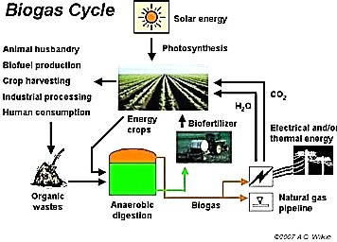

**Figure 1.1: Biogas Cycle (Graunke and Wilkie 2008)**

# Statement of Research Problem

The rural-urban shift has led to a rapid growth in the populations of many urban and semi-urban communities with the concomitant increase in the quantity of municipal solid wastes (MSW) generated. As a result solid wastes have become a serious nuisance and environmental challenge in many Nigerian cities (Plate I). On the other hand, places like restaurants, hotels, abattoirs and vegetables/fruit markets generate organic wastes at various stages of decomposition which causes a degraded and extensively fouled environment when they could be used as perfect feedstock for a biogas plant.

The current mode of managing these municipal solids wastes has fallen far short of the necessary requirements for a healthy, safe and aesthetic environment proliferating obnoxious odours and a preponderance of disease vectors. Leachates from these dump sites contaminate ground water resources and during rainfall generate run-offs which contaminate surface water resources. This therefore underscores the need for methods of disposal which are economic and environment friendly. Such methods require a waste to wealth transformation through an environmentally sustainable reuse programme to transform the waste to bioenergy resource for household and commercial uses including management of the solid wastes as proposed in this study

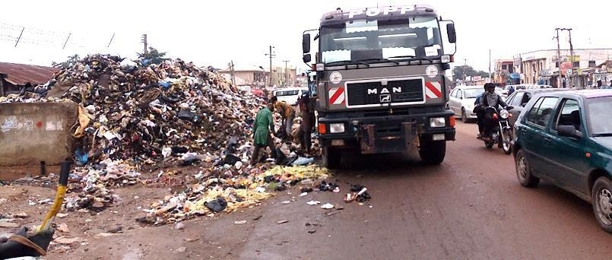

# Plate I: Municipal Solid Wastes Transfer Station on Abuja ±Keffi expressway, Mararaba, Nassarawa State

**1.3 Justification of the Study**

# Justification of the Study

In an effort to create an environment that is safe, healthy and aesthetically pleasing, a combined biogas plant and incinerator system is an attractive option for the management of municipal solids wastes. The organic fraction of the municipal solid waste that produces the obnoxious odours during decay can be utilized in the digester as feedstock thereby reducing or even eliminating their menace and nuisance in many cities in Nigeria (Akinbami *et al.*, 2001). The Biogas generated can be used in the incinerator helping to reduce the amount of greenhouse gas like methane that would have otherwise been released into the atmosphere (Xuereb, 1997)

The combustibles making up the residual municipal solid waste is burnt in the incinerator reducing them to bottom ash while the energy recovery that is possible in the form of heat from the incinerator could be put to a variety of uses depending on the environment in which the system is in operation. Examples of such uses are hot water for plates and utensils washing in a restaurant, bathing and laundry in a hotel and meat processing at an abattoir, or for drying when used in conjunction with an air blower in a drier resulting in huge savings in heating costs.

When used in specialized environments like an abattoir/market or big hotels /restaurants; the utilization of the organic wastes would reduce the loading of any waste water/sewage treatment plant in place with a huge cost saving in its sizing and operation.

Although, on burning biogas, carbon dioxide is released it is not considered that this is a significant contribution to the net global carbon dioxide level because it originated from plants, which have absorbed it from the atmosphere in the first place. Hence, this carbon dioxide does not make a net contribution to the greenhouse effect (Xuereb, 1997; Graunke and Wilkie, 2008)

Finally, the use to which the by-products; digestate from the digester, bottom ash and energy recovery from heat generated in the incinerator, can be put to, makes this combined system to perfectly align with current waste management strategies and practices.

# Aim and Objectives

This study aims at the management of municipal solids wastes using a combined biogas plant and incinerator system. The specific objectives are:

1. to design and construct a biogas plant as well as an incinerator
2. to use the gas generated by the biogas plant as primary fuel to operate the incinerator to burn the residual combustible solid waste and analyse the performance of the two treatment systems
3. to carry out laboratory analysis of the by-products of the two treatment systems, separately, and mixed, with a view to making necessary recommendations for use.

# Scope and Limitations of the Study

This study is limited to the use of municipal solid wastes in the waste dump at the ABU community market behind the Faculty of Education (Plate II)

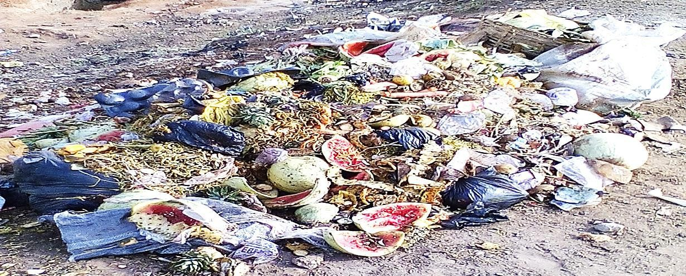

# Plate II: Municipal solids waste at the community market behind ABU, Zaria Faculty of Education

and at the waste dump in the Water Resources and Environmental Engineering (WREE) department (dept.), Ahmadu Bello University (ABU), Zaria (Plate III) mixed with cattle dung and ruminant intestinal waste from Zango abattoir, Zaria shall be utilized to enrich the biogas plant substrate to hasten the anaerobic digestion process and thus bridge the gas production lag phase.

But these wastes could hardly be introduced into the digester as produced, so the combined system has to be complimented with a crushing unit to pulverise the waste to increase its surface area for bacterial action and digestion.

The residual combustible waste introduced into the incinerator is limited to the post- sorted municipal solid wastes (plastics especially, removed) in the WREE dept. waste dump. The scope of the study did not include analysis or scrubbing of the flue gases from the incinerator nor that of the biogas from the digester as long as it is functional for use in the incinerator as is.

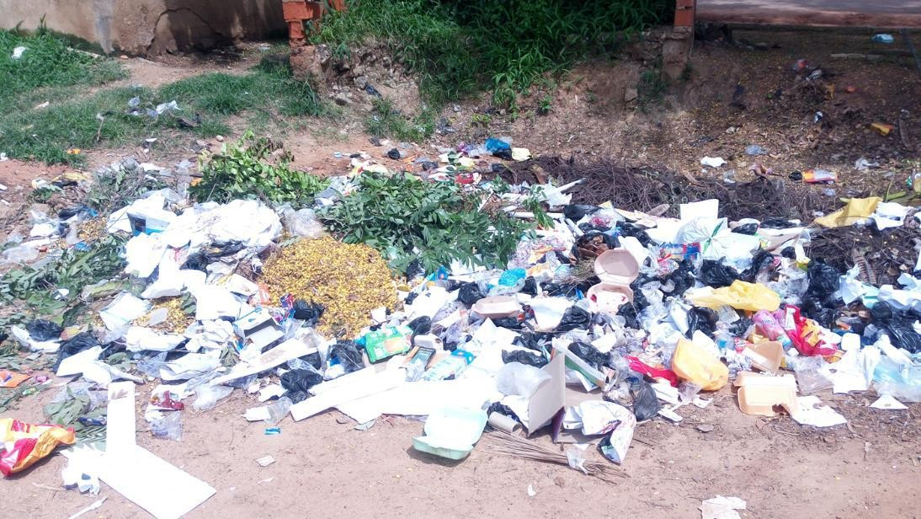

# Plate III: Municipal solid waste in the WREE dept., ABU, Zaria waste dump

**CHAPTER TWO LITERATURE REVIEW**

# Municipal Solid Wastes

Generally, MSW or refuse is regarded as useless material that is unwanted and therefore discarded. Bryne (1997) was more comprehensive in his description of waste ³as material which has no direct value to the producer and so must be disposed of´. This could be why Bailie *et al.*, (1999) insist that ³for practical purposes, the term waste includes any material that enters the waste management system´.

# Characteristics and Properties

Ogunbiyi (2001), classified wastes as gaseous, liquid or solid depending on their phase. He went on to note that it is possible to have solid wastes intermixed with liquid wastes but its non-flowing nature requires its continual retention at the site of generation or deposition until it is removed for disposal. Kiely, (1998) and Bailie *et al.*, (1999) were in agreement that MSW in particular, comprises small and moderately sized solid-waste items from houses, businesses and institutions, while Bryne, (1997) classified municipal waste, as that, generated from urban areas, particularly houses and shops.

# Treatment / Management

One of the guiding principles of current waste treatment/management practices is the concept of a hierarchy of waste management options, where the most desirable option is not to produce the waste in the first place (Waste Prevention) and the least desirable option is to dispose of the waste with no recovery of either materials and/or energy. Between these two extremes there are a wide variety of waste treatment options that may be used as part of a waste management strategy to recover materials or generate energy from the wastes.

Anaerobic digestion (to produce usable biogas) and incineration (to generate energy), the twin arms of this study falls into this latter category of current waste management strategies

# Anaerobic Digestion

Punmia *et al.,* (2005) submitted that AD consists of two distinct stages in four processes which occur simultaneously, in the digestion of organic matter. The first stage known as acid fermentation consists of hydrolysis, acidogenesis and acetogenesis. Hydrolysis is the process where complex organic materials are broken down into their constituent parts; soluble monomers. This is followed by acidogenesis in which liquefaction of high molecular weight organic compounds and conversion to organic acids by acid forming bacteria occurs and finally by acetogenesis, where acetate is formed. Acetic acid, propionic acid and butyric acid are the most common end products of this first stage. The second stage known as methane fermentation or methanogenesis is gasification of the organic acids to methane and carbon dioxide by acid splitting methane forming bacteria. Metcalf and Eddy (2003) on the other hand described as three, the basic steps in the overall anaerobic oxidation of a waste viz hydrolysis, fermentation and methanogenesis in agreement with McCarty and Smith, (1991) as illustrated in Figure 2.1

# Biochemical Reactions

Themelis and Verma, (2004) posited that an approximate chemical formula for the mixture of organic waste is C6H10O4. A hydrolysis reaction where the organic waste is broken down into simple sugar (glucose) is as shown in Equation 2.1

C6H10O4+2H2O ĺ C6H12O6+2H2 Equation 2.1

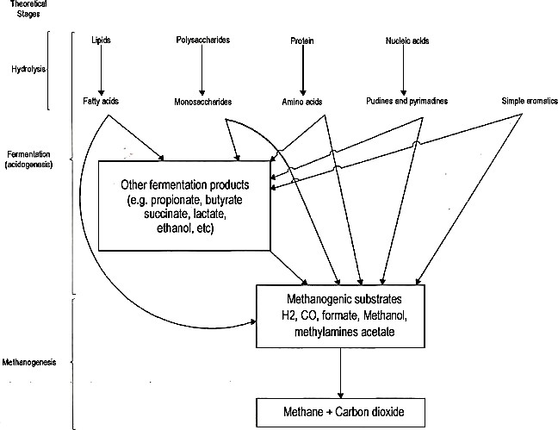

**Figure 2.1: Anaerobic Process Schematic of hydrolysis, fermentation and methanogenesis** (McCarty and Smith, 1991)

Ostream, (2004) went on to show how the product of hydrolysis are converted into simple organic compounds mostly short chain (volatile) acids (propionic, formic and lactic acids), ketones (e.g. ethanol, methanol, glycerol and alcohols) with typical reactions in this stage as shown in Equations 2.2 and 2.3.

|  |  |  |  |
| --- | --- | --- | --- |
| C6H12O6 | ĺ | 2CH3CH2OH + 2CO2 | Equation 2.2 |
| C6H12O6 + 2H2 | ĺ | 2CH3CH2COOH + 2H2O | Equation 2.3 |

Thermelis and Verma, 2004 stated further that acetogenesis is often considered with acidogenesis to be a part of a simple acid forming stage. It is however important to distinguish the two stages because Biological Oxygen Demand (BOD) and Chemical Oxygen Demand (COD) are reduced through these pathways. Acetogenesis occurs through carbohydrate fermentation in which acetate is the main product including other metabolic processes. The result is a combination of acetate, CO2 and H2.

The role of hydrogen is of critical importance in this reaction. The formation of hydrogen gas as shown in Equation 2.1 inhibits the oxidation process under standard conditions with the reaction only proceeding when the partial pressure of H2 is low enough to thermodynamically favour the conversion. The presence of hydrogen scavenging bacteria that consume hydrogen thus lowering the partial pressure is necessary to ensure thermodynamic feasibility of the reactions and thus the conversion to biogas of all the acids. Mata-Alvarez *et al.*, (2003) noted that the concentration of hydrogen measured by this partial pressure is therefore an indication of the health of an anaerobic digester with typical reactions at this stage as shown in Equation 2.4 (Conversion of glucose to acetate) and 2.5 (Conversion of ethanol to acetate)

|  |  |  |  |
| --- | --- | --- | --- |
| C6H12O6 + 2H20 | ĺ | 2CH3 COOH + CO2 + 4H2 | Equation 2.4 |
| 2CH3OH + 2H2O | ĺ | 2CH3 COOH + 4H2 | Equation 2.5 |

According to Gas Technology Inc. (2003) (cited in Hayes, 2004), the transition of the substrate from organic material to organic acids causes the pH of the system to drop. This is beneficial for the acidogenic and acetogenic bacteria but problematic for the methanogenic bacteria of the final stage of these biochemical reactions.

Methanogenesis is the rate-controlling activity of this anaerobic digestion process since methanogens have a much slower growth rate than acidogens (Ostream, 2004). The bacteria involved in this stage are the type found in the guts of herbivores. They convert the soluble matter into methane. They are very sensitive to pH changes preferring a neutral or slightly alkaline environment. If the systems pH is allowed to fall below 6 these group of bacteria cannot survive. Some of the reactions mostly are as follows:

Ethanol converted to acetate and methane

2CH3 CH2OH + CO2 ĺ 2CH3COOH + CH4 Equation 2.6

Acetate further degraded to methane and CO2

CH3COOH ĺ CH4 + CO2 Equation 2.7

Alcohol converted to methane

CH3OH + H2 ĺ CH4 +H2O Equation 2.8

Carbon dioxide reduction by hydrogen to methane

CO2 + 4H2 ĺ CH4 + 2H2O Equation 2.9

(Ostream, 2004; Igboro, 2011)

Finally, Madigan *et al.*, (1997) listed the methanogenic reactions involving the oxidation of hydrogen formic acid, carbon monoxide, methanol, methyl amine and acetate respectively as follows:

4H4 + CO2 ĺ CH4 + 2H2O Equation 2.10

4HCOO- + 4H+ ĺ CH4 + 3CO2 + 2H2O Equation 2.11

4CO + 2H2O ĺ CH4 + 3CO2 Equation 2.12

4CH3OH ĺ 3CH4 + CO2 + 2H2O Equation 2.13

4(CH3)3 N+ H2O ĺ 9CH4 + 3CO2 6H2O + 4NH3 Equation 2.14

CH3COOH ĺ CH4 + CO2 Equation 2.15

In the reaction for the aceticlastic methanogens as given by Equation 2.15 the acetate is cleaved to form methane and carbon dioxide.

# Stoichiometry

A Chemical Oxygen Demand (COD) balance can be used to account for the changes in COD during fermentation. Instead of oxygen accounting for the change in COD, the COD loss in the anaerobic reaction is accounted for by the methane production. By stoichiometry the COD equivalent of methane can be determined. The COD of methane is the amount of oxygen needed to oxidize methane to carbon dioxide and water.

CH4 + 2O2 ĺ CO2 + 2H2O Equation 2.16

From the above, the COD per mole of methane is 2 (32g O2/mole) = 64g O2/mole CH4. The volume of methane per mole at standard conditions (00C and 1 atm) is 22.414 litres. So the CH4 equivalent of COD converted under anaerobic condition is 22.414/64 = 0.35 litres CH4/g COD at standard condition. (Metcalf and Eddy 2003).

The quantity of methane at other than standard conditions is determined by using the universal gas law (Equation 2.17) to determine the volume of gas occupied by one mole of CH4 at the temperature in question. (Metcalf and Eddy, 2003)

Equation 2.17

ܸൌ௡ோ்

௉

Where *V*= Volume occupied by the gas, *l*

*n*= Moles of gas, mol

*R*= Universal gas low constant 0.082057 atm.*l*/mol.k

*T*= Temperature, K (273.15 + 0C)

*P*= Absolute pressure, atm

Thus at 350C the volume occupied by one mol of CH4 is given by

ሺଵ௠௢ሻ௟ቀ଴Ǥ଴଼ଶ଴ ௔ହ௧଻௠Ǥ ೗ Ǥ௞ቁሾሺଶ଻Ǥଵଷହାଷହሻ௄ሿ

*V* = ೘೚೗೐ = 25.29 *l*

ଵǤ଴௔௧௠

Because the COD of one mol of CH4 = 64g, the amount of CH4 produced per unit of COD converted at 350C under anaerobic condition is therefore

(25.29*l*)/(64g COD/mol CH4) = 0.40 *l* CH4/g COD

# Microbiology and syntrophic relationships in fermentation

According to Metcalf and Eddy, (2003), the group of non-methanogenic microorganisms responsible for hydrolysis and fermentation consist of facultative and obligate anaerobic bacteria. Organisms that have been isolated from anaerobic digesters include *Clostridium spp, Peptococcus*, anaerobes, *Bifidobacterum spp, Desulphorvibrio spp, Corynebacterium spp, Lactobacillus, Actinomyces, Staphylococcus,* and *Escherichia coli*. Other physiological groups present include those producing Proteolytic, Lipolytic, Ureolytic or Cellulytic enzymes. The Micro-organisms responsible for methane production, classified as *archaea*, are strict obligate anaerobes. Many of the methanogenic organisms identified in anaerobic digesters are similar to those found in the stomach of ruminant animals and organic sediments taken from Lakes and Rivers. The principal genera of microorganisms that have been identified at mesophilic condition include the rods (*methanobacterium, methanobacillus*) and spheres (*methanococcus*, *methanothox* and *methanosarcina*). *Methanosarcina* and *methanothrix* (also termed *methanosaeta)* are the only organisms able to use acetate to produce methane and carbon dioxide. The other organisms oxidize hydrogen with carbon dioxide as the electron acceptor to produce methane.

Metcalf and Eddy, (2003) reported further that a syntrophic (mutually beneficial) relationship exist between the methanogens and the acidogens in which the methanogens convert fermentation end products such as hydrogen formate and acetate to methane and carbon dioxide. Normally, the hydrogen produced by the acidogens will inhibit the reaction process from moving forward but because the methanogens are able to maintain an extremely low partial pressure of the hydrogen through consumption and conversion, the equilibrium of the fermentation reaction is shifted towards the formation of more oxidized end products (e.g. formate and acetate). In effect the methanogenic organisms serve as a hydrogen sink that allows the fermentation reaction to proceed. If process upset occurs and the hydrogen produced is not utilized fast enough, the fermentation will be slowed with the accumulation of volatile fatty acids resulting in pH reduction which is unhealthy for the digester.

Finally, there are two rate-limiting concepts that are very important in anaerobic processes; the hydrolysis conversion rate and the soluble substrate utilization rate for fermentation and methanogenesis. The anaerobic process is more stable when the volatile fatty acids (VFA) concentration approach minimal level which can be taken as an indication that a sufficient methanogenic population exists and sufficient time is available for them to minimize hydrogen and VFA concentrations. This assertion was supported by Lawrence and McCarty, (1990) in their submission that the rate-limiting

VWHS LV WKH FRQYHUVLRQ RI WKH 9)$¶V E\

fermentation of soluble substrates by the acidogenic bacteria. They therefore concluded that the methanogenic growth kinetics is of most interest in anaerobic process designs and appropriate solids retention times (SRT) as well as adequate factor of safety are selected based on kinetics and treatment goals.

# End Products of Anaerobic Digestion

The end products of AD are biogas, liquid digestate and digester sludge (solid digestate). The components of the biogas are predominantly methane and carbon dioxide (Igboro, 2011)

The liquid digestate is harvested every time a continuously fed digester is loaded with new substrate while the digester sludge is recovered whenever the digester is desludged to create a higher effective volume for digestion. (Gas Technology, Inc., 2003)

# Biogas

Biogas usually contains about 50 to 70 % CH4, 30 to 40 % CO2, and other gases including ammonia, hydrogen sulphide, mercaptans and other noxious gases. It is also saturated with water vapour (Ola, 2008). Biogas burns very well when the CH4 content is higher than 50 %. It can therefore be used as substitute for kerosene, charcoal and firewood for cooking and lighting. This saves time and money and above all it conserves the natural resources such as cutting trees to get firewood (Fumen and Igboro, 2010)

# Digestate

The liquid digestate leaving the digester can be sold as liquid fertilizer because as reported by Mahony, *et al*., (2010) AD does not reduce the NPK content making the digestate more valuable as a fertilizer.

Fischer *et al*., (1984) reported that the concentration of nitrogen, phosphorus, and potassium is generally the same between the manure that has gone through an anaerobic digester and manure that has not. The two major differences are that:

* + - 1. More volatile nitrogen is contained in the anaerobically digested manure and
      2. Nutrients are more uniformly distributed in the anaerobically digested manure The digester sludge (solid digestate) can be post treated aerobically in a process called curing, to produce high quality compost. (Igboro, 2011)

# Design of Anaerobic Digesters

According to Igoni *et al.*, (2008), a preliminary design procedure includes an investigation of the properties of the refuse or MSW with a review to establishing appropriate principles and considerations for the design of the digesters. This, coupled with other relevant information from literature leads to the formulation of the design criteria. The intention is to integrate the technical with economic considerations to form the basis for the design of an anaerobic digester for the production of biogas. Finally comes, scaling of the biogas plant and decisions on materials and methods of construction.

# Design Criteria

* + - 1. Space availability: this item determines the decision whether the digester is going to be above ground or below ground level, whether the shape is going to be cylindrical or rectangular, whether the orientation will be vertical or horizontal
      2. Existing structures and infrastructures: the use to which existing structures could be put as part of the biogas plant layout is investigated and design is aligned as such. Infrastructures like water and power supply are critical to substrate mixing and waste grinding respectively while drainage and irrigation channels are useful for maintenance and digestate use as plant tonic and soil conditioner
      3. Minimizing costs: this criteria becomes very important when taking a critical look at the return on investment on a biogas plant. The choice of material for its various components as well as design options is affected by their cost outlays.
      4. Available substrates: this determines not only the size and shape of the mixing pit but the digester volume (retention time), the heating and mixing devices and whether additional cost outlay on a grinder will have to be made.

# Design considerations

According to Igoni *et al*., (2008), to design a biogas reactor suitable for the biodegradation of MSW with the attendant production of biogas, several factors need to be considered, the main of which are: the type of waste generated, the rate of waste generation and the ambient temperature. These three factors lead to appropriate decisions on the type of digester to be utilized.

* + - 1. *Type of digesters*

Igoni *et al*., (2008) gave a description of a variety of digester types that exist for the anaerobic treatment of organic wastes. The selected type will depend on operational factors, including the nature of the waste to be treated especially, its solids content. They noted further that the Oregon State Department of Energy used the solids content of waste to classify digester type into three as follows:

1. Covered lagoon digesters: Suitable for liquid-manure of less than 2 % solids content. This is basically a manure storage lagoon with a cover. The cover traps the gas produced during decomposition
2. Complete-mix digesters: Suitable for manure of 2-10 % solids content. This converts organic waste to biogas in a tank above or below ground with a mechanical or gas mixer to keep the solids in suspension
3. Plug-flow digesters: Suitable for ruminant animal excreta with solid concentration of 11-13 %. A typical design includes a manure collection system, a mixing pit and the digester itself. Addition of water to the waste in the mixing pit adjust the slurry to the optimal consistency before being fed into the digester which is usually

a long rectangular container usually built below grade, with an airtight, expandable cover. New material added at one end pushes older material to the opposite end.

It should be noted here that the type and solid content of the waste being considered in respect of the above mentioned type of digesters were such that the waste are capable of flowing on their own, or forming slurries with water and eventually flowing. The implication is that they could be used in a continuous system. But, MSW is predominantly solid therefore non-flowing. Hence Kahaynian *et al.*, (1991) (cited in Kiely, 1998) suggested the use of ³high-solid digesters´.

According to Tchobanoglous *et al.*, (1993), continuous-flow digesters, which are by nature low-solid digesters are being used to generate methane from human, animal and agricultural wastes and from the organic fraction of MSW. This process, always requires more water to be added to the waste in order to get it to flow.

In furtherance of this exercise of digester type classification, Vandeberg and Kennedy (1983) and Moletta (1986) highlighted how different anaerobic processes, such as batch, continuous one-stage, and continuous two-stage systems with a variety of methanizers have been applied to the treatment of MSW. Such methanizers include continuously stirred tank reactors (CSTR), tubular reactors, Anaerobic Sequencing Batch Reactors (ASBR), Upflow Anaerobic Sludge Blanket (UASB), and Anaerobic Filters. Based on these developments, Weiland and Rozzi (1991), and Clarck (2001) reported the development of a number of novel reactor designs which have been adapted and developed allowing a significantly higher rate of reaction per unit volume of reactor. Some of these are:

1. Batch Systems: In batch systems, as reported by De Baere, (2000) digesters are filled once with fresh substrates with or without addition of seed materials and allowed to go through all degradation steps sequentially. The hallmark of batch system is the clear separation between a first phase, where acidification proceeds much faster than methanogenesis, and a second phase, where acids are transformed into biogas.

Rajeshwari *et al.*, (1998) reported that anaerobic batch digestion of mixed vegetable waste was carried out successfully at 5% total solids (TS) concentration. Digestion of the waste after 47 days resulted in 0.16 m3 biogas / kg TS added with a maximum gas production rate on day 26.

In another study, Converti *et al.*, (1999), (cited in Bouallagui *et al.*, (2005)) tested the anaerobic batch digestion of fruits and vegetable wastes (FVW), under both mesophilic and thermophilic conditions with a high rate of digestion. This imrovement in cycle time makes adopting the batch digester system more attractive for the treatment of FVW.

An increase in the TS to 8 % by Bouallagui *et al.*, (2001) and Marouani *et al.*, (2002) showed that the anaerobic treatment in a batch digester was inhibited by the accumulation of volatile fatty acids (VFA) and irreversible decreasing pH problems.

An apt concluding remark on this system is that of De Baere, (2000) that though batch systems have really not succeeded in taking a substantial share of the market in developed economies due to their operational rigiodity, the specific features of batch processes, such as simple design and process control, robustness towards coarse and heavy contaminants, and lower investment costs make them particularly attractive and therefore recommended for developing countries.

1. Anaerobic Sequencing Batch Reactor (ASBR): In an effort to improve on the

EDWFK UHDFWRU¶V SuRthSakHer *e*U*t a*D*l.*,W(1L99R1)QemDphOas iseId OtheHim[pLortEanLceOLW\

of the application of sequencing batch reactor technology to the anaerobic treatment of MSW particularly FVW. This is characterised by a high degree of process flexibility in terms of cycle time and sequence, no requirement for separate clarifiers, and retention of a higher concentration of slow-growing anaerobic bacteria within the reactor. Research into the ASBR process has been carried out by several other investigators like Dague *et al.*, (1992) and Ruiz *et al.*, (2000). Also, satisfactory high solid content waste degradation and suspended solid removal (90 ±93 %) using the ASBR were recorded by Archana *et al.*, (1999) and Hur *et al.*, (1999).

1. Continuous one-stage systems: Lissens *et al*., (2001) reported that about 90 % of the full scale plants, currently in use in Europe for the anaerobic digestion of organic fraction of municipal solid wastes (OFMSW) and other bio-wastes, rely on continuous one-stage systems. However, according to Lee *et al.*, (1998), Pavan *et al.*, (2000) and Sachs *et al.*, (2003) a considerable amount of literature has appeared concerning wastes treatment in two phases; first an acid forming phase followed by a methanogenic phase. According to Bouallagui *et al.*, (2005) a likely reason for this discrepancy is that two- and multistage systems (especially using laboratory models) afford the researcher more possibilities to control and investigate the intermediate steps of the digestion process. Industrialists, on the other hand, prefer one-stage systems because of their simpler designs and lower investment costs. Some of the designs in this category include: Fixed dome digesters, floating drum digesters, moving dome digesters, balloon gas holder digesters, etc., with orientation both vertical and horizontal.

Table 2.1 shows the result of different experiments carried out on FVW using anaerobic digestion in different one-stage and two-stage systems.

**Table 2.1 Performance data of different anaerobic processes applied for FVW treatment. (**Bouallagui *et al*., 2005)

|  |  |  |  |  |  |  |
| --- | --- | --- | --- | --- | --- | --- |
| **Process** | **Volume (*l*)** | **Loading Rate (gVS** | **HRT**  **(day)** | **VS**  **removal (%)** | **Methane Yield (litre/gVS)** | **References** |
| **/(*l*day))** | | | | | | |
| Batch System | 10 | 1.06 | 47 | 65 | 0.16 | Rajeshwari *et al.*, (1998) |
| Batch System | 5 | 0.9 | 32 | 58 | 0.26 | Bouallagui *et al*., (2001) |
| Continuous one-stage CSTR | 3 | 1.6 | 20 | 88 | 0.47 | Mata- Alvarez *et al*., (1992) |
| Continuous one-stage CSTR | 16 | 3.6 | 23 | 83 | 0.37 | Verier *et al*., (1987) |
| Continuous tubular reactor | 18 | 2.8 | 20 | 76 | 0.45 | Bouallagui *et al*., (2003) |
| **TWO STAGE SYSTEMS** |  |  |  |  |  |  |
| Solid bed hydrolyser and UASB  methaniser | 100  & 25 | 6.8 | 2.5 | 94 | 0.35 | Rajeshwari *et al*., (2001) |
| ASBR  hydrolyser and anaerobic filter methaniser | 2.5  & 10 | 4.4 | 7 + 10 | 87.5 | 0.34 | Ruynal *et al*., (1998) |
| CSTR  hydrolyser and anaerobic filter | 7  & 4 | 5.65 | 2+ 2.3 | 96 | 0.42 | Bouallagui *et al*., (2003) |
| methaniser | | | | | | |

In a variant of the continuous-one-stage system, Mata-Alvarez *et al.,*, (1992) examined the performance of the mesophilic one-stage completely stirred reactor (Figure. 2.2) for the treatment of the organic fraction of the wastes coming from a large food market. The organic loading rate (OLR) tested was 1.6kgVS/(m3 day) using a hydraulic retention time (HRT) of 20 days with a resulting methane yield of about 0.47m3*/*kgVS (Table 2.1). In another variant; a semi-continuously mixed tubular digester tested by Bouallagui *et al*., (2003) (Figure. 2.3), the best results (methane yield of 0.45m3/kgVS) were obtained by applying an OLR of 2.8kgVS/(m3day), a HRT of 20 days (Table 2.1). In their view, the most significant factor of the tubular reactor, is its ability to separate acidogenesis and methanogenesis longitudinally down the reactor, allowing it to behave as a system of two phases.

Biogas



Effluent

Substrate

Sludge

**Figure 2.2 Continuously Stirred Tank Reactor (CSTR)** (Mata-Alvarez *et al*., 1992)



Biogas

Substrate

Effluent

Sludge

**Figure 2.3: Semi-Continuously mixed Tubular Reactor (**Bouallagui *et al*., 2003)

1. Continuous two-stage systems: The groups of acidogenic and methanogenic organisms are different with respect to their nutritional requirements, physiology, pH optima, growth, and nutrient uptake kinetics. This characteristic includes their ability to withstand environmental stress factors. Using conventional digestion processes, in which they are combined in one reactor therefore automatically imposes uniform conditions on both groups with the resultant reduction in their efficiency. (Weiland, 1993)

However, Llabres-Luengo and Mata-Alvarez, (1988), posited that a process configuration employing separate reactors for acidification and methanogenesis connected in series, which in effect is a two-phase anaerobic digestion system, allows optimisation of both processes.

This two-step technology was applied in a two-phase anaerobic digestion system experiment conducted by Ruynal *et al*., (1998). The hydrolysis-acidification phase was carried out in an ASBR and methane fermentation was performed in a fixed film reactor (FFR) operated in the upflow mode (Figure 2.4). They were able to report that the global

degradation yield remained above 87 % and the biogas production yield was about 0.29*l*/g of input total COD.

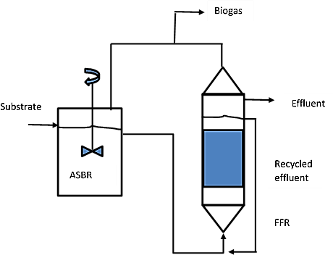

# Figure 2.4: Two-phase integrated anaerobic sequencing batch reactor (ASBR) and fixed film reactor (FFR) (Ruynal *et al*., 1998)

In another application, Rajeshwari *et al*., (2001), as illustrated in Figure 2.5 obtained the conversion of over 94 % of vegetable market waste into biogas which supported Bouallagui *et al*., (2005) general conclusion that phase separated digesters may offer the best choice for high efficiency Other performance data of these experiments can be seen in Table 2.1.

Biogas

Effluent

Substrate

SBH

UASB

# Figure 2.5: Two-Phase Integrated Anaerobic Solid bed hydrolyser (SBH) and Upflow Anaerobic Sludge Blanket (UASB) (Rajeshwari *et al*., 2001)

Other design considerations include

* + - 1. *Temperature control*

The rate of decomposition and gas production in an anaerobic digester is sensitive to temperature changes. In general, according to Steadman, (1975), the process becomes more rapid at high temperatures. Tchobanoglous and Burton, (1991) classified the optimal temperature ranges as the mesosphilic (30 - 380C) and the thermophilic (44 - 570C) zones. They went on to report that despite the thermophilic benefit in an increased

rate of feedstock consumption and gas production, the digestion becomes increasingly unstable as temperature rises. The system would then require higher rates of heat input but would produce poorer quality supernatants containing higher quantities of dissolved solids. However, Kiely, (1998) insisted that most digesters currently in operation do so at mesophilic temperatures at which good stability and gas production occur while Igoni *et al.*, (2008) reported that reactor temperatures between 250c and 350c are generally the preferred temperatures to support biological reaction rates and produce a more stable treatment. Igoni *et al.*, (2008) further noted that though choosing the appropriate operating temperature is vital, stabilizing it is even more important. Fortunately for this study, previous research reported by Igboro, (2011) put the average ambient temperature in Samaru, Zaria to be in the range of 220C to 300C falling within the mesophilic zone.

* + - 1. *Hydrogen-ion concentration (pH control****)***

The bacteria involved in anaerobic digestion according to Igoni *et al.*, (2008), have a pH range of 6-8 with values close to 7 for optimal activity. They reported that in the initial phase of the process, the production of volatile fatty acids depress the pH, but the reaction of the produced CO2 in water with hydroxide ions forming HCO3 ( bicarbonate ions), tend to buffer the process pH and restore it to neutrality thus making the process self- regulating. Eckenfelder, (2000) noted that when the rate of acid formation exceeds the rate of its breakdown to methane, process equilibrium is affected and the pH decreases causing gas production to tail off, and the CO2 content of the gas to increase. The overall effect according to Mattocks, (1984) is the impedance of the whole biogas production process which necessitate sufficient alkalinity to be available at all times up to a level of approximately 3000 mg/l (for sufficient buffering to be maintained), to ensure a high rate of methane production. Eckenfelder, (2000) observed that lime is commonly used to raise the pH. Care must however be taken according to Igoni *et al.,* (2008) to avoid the

precipitation of calcium carbonate through the application of excessive lime. They suggested that, as an alternative, Soda Ash (sodium bicarbonate) can be used for the pH adjustments to overcome this challenge.

* + - 1. *Carbon-Nitrogen (C: N) ratio*

Igoni *et al.*, (2008) reported that the concentrations of carbon and nitrogen in the organic fraction of municipal solid waste determine the performance of the anaerobic digestion process because one or the other usually constitutes the limiting factor. Whereas carbon is the energy source for the microbes, nitrogen is needed for growth and multiplication. They went on further to note that the bacteria in the digestion process use up the carbon present 30 to 35 times faster than the rate at which they convert nitrogen. So, for optimal operation, the ratio of carbon to nitrogen should be about 30:1 in the waste raw material. This is in line with Richard, (1998)¶oVbservation that if there is insufficient nitrogen in the waste material, the microbial population will be small resulting in a longer time to decompose the available carbon. Excess nitrogen, beyond the microbial requirement, is often lost from the process as ammonia gas. Richard, (1998) further observed that usually, nitrogen is the limiting element in the processing of MSW. So with the high carbon content of MSW (paper, cardboard, wood, etc.), additives such as manure, clean sewage-sludge (Bio solids), septage and urea are usually required as a supplemental source of nitrogen for ease of digestion.

* + - 1. *Moisture content of the waste in the digester*

According to Igoni *et al.*, (2008), moisture is essential for the activities of the waste decomposing anaerobes and hence for effective anaerobic digestion. In line with this, Igoni *et al.*, (2008) reported an experimental digestion of domestic garbage diluted with sewage to a local solids concentration of between 5 and 7 %. They maintained that

stirred-tank digesters can deal with slurries of about 3-10 % total solids (TS), much of

ZKLFK DUH VXVSHQGHG VROLGV ,Q WKHLU DQDO

including green-vegetable mater of about 20 % solids concentration, they explained that if these materials are to be used as feed for a stirred-tank digester, then they will have to be made into slurries. In their final conclusion, a slurry of about 10 % TS is the maximum that can be pumped and piped even if the particle size is small, and 7-8 % may be the maximum which can be handled by smaller pumps and pipelines. This was in consonance with the conclusions of Hobson *et al.,* (1981).

Therefore, moisture content viewed from the total solids content of the waste, according to Oregon State Department of Energy (2002), actually determine the type of digester to be adopted as illustrated in Table 2.2.

**Table 2.2: Moisture requirement of different digester types** [Oregon state department of energy (2002)]

Digester Type Total Solids Water

Requirement

Hydraulic

Retention

Temperature

Time (days)

|  |  |  |  |  |
| --- | --- | --- | --- | --- |
| Covered Lagoon | < 2% | High | 35 ±60 | Ambient |
| Fixed film | < 2% | High | 2 ±4 | Ambient/ Mesophilic |
| Upflow Anaerobic Sludge Blanket (UASB) | < 5% | High | 1 ±2 | Mesophilic |
| Continuously Stirred Tank Reactor (CSTR) | < 10% | Medium | 20 - 25 | Mesophilic |
| Plug flow | < 14% | Low | 20 - 30 | Mesophilic |
| Batch | 10-15% | Low | 40-60 | Mesophilic |

Continuous one- stage; fixed dome

< 10% Low 25-100 Mesophilic

Continuous one- stage; moving dome

< 10% Low 25-100 Mesophilic

Continuous one- stage; balloon

< 10% Low 25-100 Mesophilic

dome

* + - 1. *Waste particle size*

The particle size of MSW affects the biological transformation of the waste and hence, equipment sizing. For a container filled with particles, reducing the individual particle- size increases the total surface area of the particles in the container. This is desirable for the process operation, as decomposition occurs on the surface of the organic materials. (Richard, 1998). The relatively-large particle sizes of MSW according to Kiely (1998), considerably retard decomposition; hence the necessity for the reduction of the average particle size of the MSW. The particle size reduction can be achieved by shredding, grinding or pulping of the waste feedstock with the ultimate objective of presenting a larger surface area for microbial activity to occur; and hence improve the efficiency of the system. (Agunwamba, 2001)

* + - 1. *Mixing*

Mixing is another important operation in achieving optimal anaerobic digestion (Tchobanoglous and Burton, 1991). It is desirable to maintain uniformity of substrate concentration, temperature and other environmental factors as well as prevent scum formation and solids deposition (Agunwamba, 2001). Mixing does not have to take place continuously. It is often better intermittently and may be carried out for just several times a day depending on the type of reactor, the type of agitator used and the total solids content of the feedstock, (Burton and Turner, 2003). To prevent the need for moving

parts within the reactor, the recirculation of biogas through the bottom of the reactor or hydraulic mixing by recirculation of the digestate with a pump can be used to achieve adequate mixing.

* + - 1. *Loading rate of organic materials into the digester (OLR)*

The organic loading rate (OLR) represents the amount of volatile solids being fed into the digester each day (Mattocks, 1984). Volatile solids represent that portion of the organic solids that can be digested while the remainder of the solids is fixed. The fixed solids and a portion of the volatile solids are non-biodegradable. The actual loading rate depends on the types of wastes fed into the digester because the types of waste determine the level of biochemical activity that will occur in the digester. The loading rate therefore is very critical to the digester design as it determines the digester volume and indeed the overall process-performance.

It was remarked by Igoni *et al*., (2008) that wide variations in the composition of the incoming flow and the organic loads can upset the balance between acids fermentation and methanogenesis in the anaerobic process. For soluble, easily degradable substrates, such as sugars and soluble starches, the acidogenic reactions can be much faster at high

loadings and may increase the reacWRU¶V 9RODWLOH co)nteDntWaWnd\ $FLG

hydrogen concentration thereby, depressing the pH of the system. The loading rates also affect the food to microbes (F: M) ratio according to Kiely, (1988) with the system achieving equilibrium when the food substrates and the microorganism consuming them are in equilibrium.

* + - 1. *Pre-treatment of the waste*

Pre-treatment refers to the preparation of the waste for the AD process. According to Ogunmola (1989), MSW (particularly in Nigeria), is a complex mixture of both organic

and inorganic materials. So, because the AD process is for the decomposition of the organic components, it would be preferable to sort the organic from the inorganic. Also, in general, the particle size of the organic fraction of the municipal solids wastes (OFMSW) is such that they will require reduction. These and the other processes that the waste may undergo before being fed into the digester are termed as waste pre-treatment.

* + - 1. *Hydraulic retention time (HRT)*

This is the time allowed for the feedstock to stay in the digester. It is also referred to as the residence time (RT). The retention time is determined by the average time is takes for the organic material to digest as measured by the COD and BOD of existing effluents. The longer a substrate is kept under proper reaction conditions the more complete its degradation will be. The rate of the reaction however will decrease with increasing residence time; indicating that there is an optimal time that will achieve the benefits of digestion in a cost effective way. The appropriate retention time depends on the feedstock, the environmental conditions and the intended use of the digestate. Reducing the retention time would reduce the size of the digester, resulting in cost savings. There is therefore an incentive to design systems that can achieve complete digestion in shorter times. A shorter retention time, however, leads to a higher production rate per reactor volume unit but a lower overall waste degradation and poor digestate quality. (Ostream, 2004)

* + - 1. *Costs implications in the choice of a digester*

The design considerations for the choice of a biogas plant will not be complete without a critical look at the costs implication of whatever choices are made. In addition to the cost of procuring the components for an anaerobic digester is the cost of Construction and maintenance of the plant, obtaining the feedstock and preparing the MSW for

digestion. According to Ogunbiyi (2001), Process Costs, (i.e. Capital, Operations and Maintenance) are extremely important in selecting the type and size of the reactor.

Igoni *et al*., (2008) noted that the bio-kinetics and design models for the reactor will directly affect the digester¶s cost, particularly in terms of the digester and feedstock volumes required to yield the desired quantity of gas while for Steadman (1975), the simplest type of methane digester is just a closed container such as a drum, tank or pit in the ground into which the digestible material is loaded. (in short, a batch digester), while, according to the Oregon State Department of Energy (2002), after classifying as three the main types of digesters as; a covered-lagoon, a complete-mix, and a plug-flow digester, the batch digester was the least expensive of the three.

# Sizing the biogas plant components

The major components of the biogas plant are as follows:

* + - 1. The digester
      2. The gasholder
      3. The mixing equipment
      4. The biogas plant piping
         1. to feed the digester
         2. to discharge effluent from the digester
         3. to safely convey gas out of the gasholder to the point of use
      5. The gasholder guide
      6. *Sizing the digester*

According to Sasse (1988), definition of certain parameters are required to calculate the size of a digester. The major parameters are

1. Daily fermentation slurry (Sd): The daily fermentation slurry (Sd) is the amount of daily feed material and the mixing water. All feed materials is made up of
   1. organic solid/material
   2. inorganic solid/material and
   3. water

The biogas is produced from the digestion of the organic materials. The inorganic materials (minerals and metals) are unused ballast, which is unaffected by the digestion process. The water content of the biomass and the additional water added to form a slurry allows the methane forming bacteria to be in contact with the organic solid thereby accelerating the digestion process.

So any quantity of biomass (say, municipal solid waste) has x % solid + y % water

For example, fresh cattle manure is made up of 16 % solids and 84 % water. When the cattle dung is mixed with water in the proportion of 1:1. The prepared slurry then has a solids content of 8 % and water content of 92 %. This means that a 20kg slurry of cattle dung and water mixed in equal proportion has

ͺ

ݐ݊݁ݐݏ݊݀݋݅ܿ ݈ܿ݅݋݊ݏ ܽ݃ݎ݋ ݃ܭൈʹͲൌͳǤ͸

ͳͲͲ

Sd (*l*) = Biomass (*l*) + Water (*l*) Equation 2.18

1. Retention Time (RT): Indicates the period spent by the feed material in the digester. It is appreciably shorter than the total time required for complete digestion of the feed material

RT = Vd/Sd Equation 2.19

Where Vd ±Digester volume and Sd ±daily fermentation slurry

1. Specific Gas Production: This represents the gas production of a specific feed material in a specific retention time at specific digester temperature
2. Dry matter (Dm): The water contents of natural waste material feedstock varies, for this reason, the solids or dry matter content of the feed material is used for exact scientific work.
3. Organic Dry matter or Volatile Solids (Vs)**:** Only the organic or volatile constituent of the feed material are important for the digestion process. Therefore only the organic fraction of the dry matter content is considered.
4. Digester Loading: The digester loading indicates how much organic material per day has to be supplied to the digester. It is calculated in kilograms of organic dry matter per cubic meter of digester volume per day (kg ODM/m3/day).
5. Degree of Digestion: This is measured as a percentage; it indicates the amount of gas obtained as a proportion of total specific gas production. The difference from 100 % indicates the proportion of feed material which is not yet fully digested. In simple biogas plants the degree of digestion is about 50 %; this means that half the feed material is not used
6. Biological Oxygen Demand (BOD): This is an important parameter in effluent treatment. It indicates the degree of pollution of the effluent, waste or sewage. The BOD is a measure of the amount of oxygen consumed by bacteria in biological purification
7. Digester volume (Vd): The digester volume Vd is determined by the length of the retention time (RT) and by the amount of fermentation slurry supplied daily Sd. The amount of fermentation slurry consists of the feed material and the mixing water.

Vd (L) = Sd (L /day) x RT (days) Equation 2.20 Where

Vd = Digester volume, (*L*)

Sd = Daily supply of fermentation slurry (*L* /day) RT = Retention Time, (days)

According to Garcelon and Clark, (2003), the operating volume of the digester should not be more than 90% of the total volume of the digester to allow for the rise of the slurry during fermentation while Sasse (1988) noted that if a biogas plant is loaded not daily but at relatively long intervals, say, weekly, the retention time is correspondingly prolonged.

* + - 1. *Sizing the gasholder*

Gasholder volume (VG): The size of the gasholder, gasholder volume (VG) depends on gas production and the volume of gas drawn-off. Gas production depends on the amount and nature of the fermentation slurry, digester temperature, and retention time.

Figures 2.6 and 2.7 are curves representing averages of laboratory and empirical values for fresh cattle dung and fresh pig dung. The values vary a wide range owing to differences in solids content of the dung, animal feeds and types of biogas plant used to carry out the experiment. Regular stirring increases gas production. The 26 ±28 0C line on the curves is a secure basis for scaling the gasholder in the majority of cases.

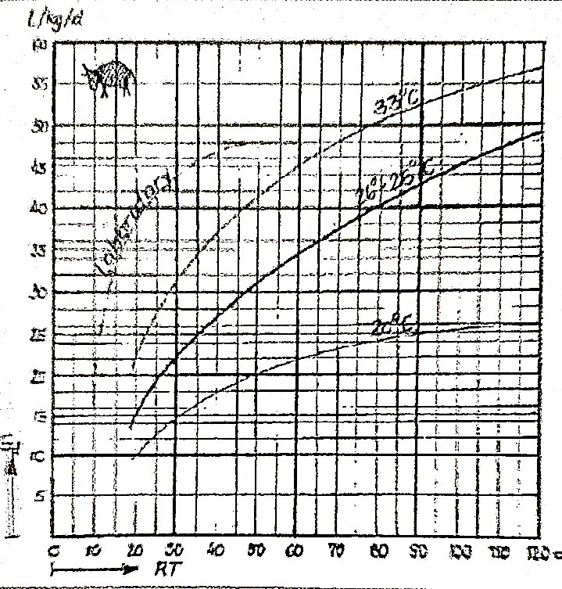

# Figure 2.6: Gas production from fresh cattle manure depending on retention time and digester temperature

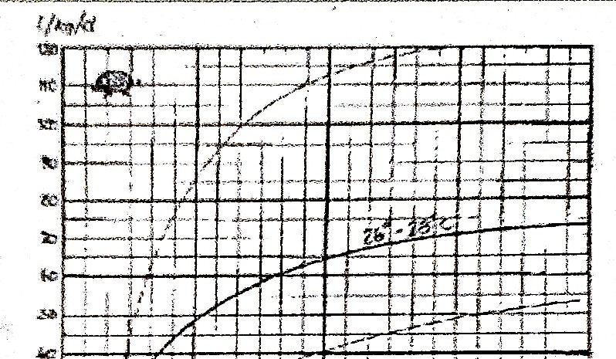

**Figure 2.7: Gas production from fresh pig manure depending on retention time and digester temperature**