# CHAPTER ONE INTRODUCTION

* 1. **BACKGROUND OF STUDY**

According to Chang, K. T. (2008), Geographic Information Retrieval System (GIRS) is a system designed to capture, store, manipulate, analyze, manage and present all types of geographical data. The acronym GIRS is sometimes used for geographical information science or geospatial information a study which refers to the academic discipline or career of working with geographic information system. In simplest terms GIRS is the merging of cartography, statistical analysis and database technology.

A geographical information retrieval system can be thought of as a system which digitally creates and manipulates spatial areas that may be jurisdictional, purpose or application- oriented. Generally, a GIRS can be custom designed for an organization. Hence, a GIS developed for an application jurisdiction, enterprise or purpose may not be necessarily interoperable or compatible with a GIRS that has been developed for some other application, jurisdiction, enterprise or purpose. What goes beyond a GIRS is a spatial infrastructure, a concept that has no such restrictive boundaries.

In general sense, the term GIRS describes any information system that integrates, stores, edits, analyzes, shares and displays geographic information for informed decision making. GIRS applications are tools that allow users to create interactive queries (user – created searches), analyze spatial information, edit data in maps and present the result of all these operations. Geographic information science is the science underlying geographic concepts, applications and systems.

The link between geography and information technology can not to a very large extent be over- emphasized.

Using Enugu State tourism board as a case study has helped to give a comprehensive understanding of the importance and the need of a geographic information system, as it is believed, information technology has a significant role in geographic information system and high level of expectations would and is already being demanded from its use both in Nigeria and the world at large.

# STATEMENT OF THE PROBLEM

In our daily lives as humans, most of our endeavors involve moving from one location to another for one thing or the other. A problem emerges when there is no proper direction or a system as to give accurate direction in locating our destination, what the said destination contains and what is has to offer. This is the problem the state has as concerning tourism, whereby a good number of tourists

(most especially tourists visiting for the very first time) and other individuals wanting to visit tourist sites in the state but cannot do so because of the lack of a well detailed system to provide them (tourists) with an accurate geographic information system as to how to locate these sites within the state.

Due to the lack of an accurate geographic information retrieval system as far as tourism is concerned, most tourists are discouraged from exploring these tourist locations within the state, this in turn hampers the positive impact that tourism is meant to have on the development in the state and the Nigerian society at large.

# OBJECTIVES OF THE STUDY

1. To examine the existing / current system in regards to how geographic information for tourism is provided for tourists in and outside the state.
2. To improve on the already existing system by designing a geographic information retrieval system that is well detailed and easily accessible.
3. This study also seeks to help in broadening the scope of tourism in the state through providing a comprehensive geographic information retrieval system.

# SIGNIFICANCE OF THE STUDY

The significance of this study is to show that a link between geography and other professions can be created on the platform of information technology. i.e. to show

that with information technology the problem of location can and is solved to a very large extent.

# SCOPE OF STUDY

The scope of this study is limited to tourist locations and hotels within the state using the Enugu state tourism board as a case study in view of providing / improving on the existing geographic information system of the board for tourism in the state.

# LIMITATIONS OF THE STUDY

Time was a major constraint faced during the research for this project work and limited the effort in developing a much more comprehensive package needed in the design and implementation of the geographic information retrieval system.

# DEFINITION OF TERMS

GEOGRAPHY: Geography is a science that deals with the distribution and arrangement of all elements of the earth‟s surface. The word *geography* was adopted in the 200s BC by the Greek Scholar Eratosthenes and means „earth description.‟

INFORMATION SYSTEM: An information system can be defined *technically* as a set of interrelated components that collect (or retrieve), process, store and distribute information to support decision making and control in an organization.

GEOGRAPHIC INFORMATION RETRIEVAL SYSTEM: A “geographic

information system” (GIRS) is a computer-based tool that allows you to create, manipulate, analyze, store and display information based on its location LOCATION: The position, site or sitting of somebody or something.

MAP: A diagrammatic drawing of something such as a route or area made to show the location or how to get there.

TOURISM: Travel to benefit from a particular service or activity that is unavailable at home.

COMPUTER : An electronic device that can accept data/ information inform of input , process the data /information in order to produce an output and also has the capability to store the information for future use.

DATA: Data refers to raw or unprocessed information.

SOFTWARE: This is the logically written instruction that controls the operations of the hardware.

HARDWARE: This is the physical components of computer system and other geographic tools or devices.

DATABASE: This is the collection of related data/ information stored mostly in a central location.

COMPUTER AIDED DESIGN (CAD): Software programs for the design, drafting and presentation of graphics. Originally designed for manufacturing and drawing, now also widely used for mapping.

OPERATING SYTEM: A series of computer programs which control the operations of the computer itself. Application programs such as GIS software run under an operating system. Examples of operating system include UNIX, VMS, DOS etc.

# CHAPTER TWO LITERATUE REVIEW

* 1. **INFORMATION SYSTEM**

Information system has been defined in terms of two perspectives: one relating to its function; the other relating to its structure. From a functional perspective; an information system is a technologically implemented medium for the purpose of recording, storing and disseminating linguistic expressions as well as for the supporting of inference making. From a structural perspective, an information system consists of a collection of people, processes, data, models, technology and partly formalized language, forming a cohesive structure which serves some organizational purpose or function.

The functional definition has its merit in focusing on what actual users – from a conceptual point of view –do with the information system while using it. They communicate with experts to solve a particular problem. The structural definition makes clear that IS are socio- technical systems i.e. systems consisting of humans, behavior rules and conceptual and technical artifacts.

An information system can be defined *technically* as a set of interrelated components that collect (or retrieve), process, store and distribute information to support decision making and control in an organization. In addition to supporting

decision – making, coordination and control, information systems may also help managers and workers analyze problems, visualize complex subjects and create new products. Three activities in an information system produce the information that organizations need to make decisions, control operations, analyze problems and create new products or services. These activities are input, processing and output. Input captures or collects raw data within the organization or from its external environment. Processing converts this raw input into a more meaningful form. Output transfers the processed information to the people who will use it pr to the activities for which it will be used. Information systems also require feedback, which is output that is returned to appropriate members of the organization to help them evaluate or correct the input stage.

The diagram below gives a graphical illustration if what an information system is.

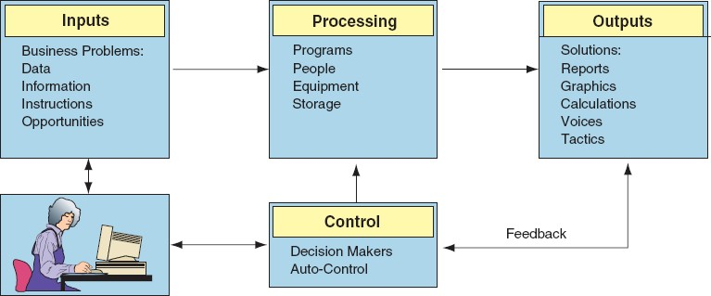

The Components of an information system are as follows;

* Resources of people : ( end –users and IS specialists, system analyst, programmers, data administrators etc)
* Hardware: (physical computer equipments and associate device, machines and media).
* Software: (programs and procedures).
* Data : ( data and knowledge bases) and
* Networks : (communications media and network support)

# INFORMATION TECHNOLOGY

Information technology can defined as the plat form on which information system thrives or functions, without the technological aspect of information, an information system cannot function efficiently. Information technology refers to the technical devices such as machines or various devices like the monitor , cpu, keyboard , mouse and also internal hardware devices such as the RAM ,hard drive or hard disk, mother board etc which all work hand in hand .

The Information Technology Association of America defined information

technology as “the study, design, development, application, implementation, support or management of computer based information systems

Without information technology it is almost impossible to have an efficient or working geographic information retrieval system, in fact it is a basic requirement.

Information technology is a major requirement for a geographic information retrieval system to function and to be available to anyone and at any point in time.

Information Technology can also be broadly defined as the collection of computer systems used by an organization. Information technology in its narrow definition refers to the technological side of an information system. Sometimes, though, the term information technology is also used interchangeably with information system.

One of the major roles of information technology is its being a major facilitator of organizational activities and processes. That role is becoming much more important as time passes.

Human beings have being storing, retrieving ,manipulating and communicating information since the Sumerians in Mesopotamia developed writing in about 3000 BC, but the term" INFORMATION TECHNOLOGY" in its modern sense first appeared in a 1958 article published in Harvard business review. Authors Harold J. Leavitt and Thomas L. Whisler commented as at then that the new technology did not have a single established name.

Based on the storage and processing technologies employed, it is possible to distinguish four distinct phases of information technology and of course its development. These phases include the pre – mechanical (3000 BC- 1450AD),

mechanical (1450-1840) and electromechanical (1840-1940) and electronic (1940- present).

In essence information technology has actually been in existence over the years but not in the form in which it is in this present day. Today information technology has become a core part of every organization / industry which of course includes the tourism industry.

# GEOGRAPHIC INFORMATION RETRIEVAL SYSTEM

In describing a geographic information retrieval system first an understanding of what geography is, is of paramount importance because without it one cannot get a proper view of what an information system is and what it has to offer.

Geography can be defined the science that deals with the distribution and arrangement of all elements of the earth‟s surface. The word *geography* was adopted in the 200s BC by the Greek Scholar Eratosthenes and means „earth description.‟

A Geographic information retrieval system (GIRS) is a system designed to capture, store, manipulate, analyze, manage, and present all types of geographical data. The acronym GIS is sometimes used for geographical information science or geospatial information studies to refer to the academic discipline or career of working with

geographic information system. In the simplest terms, GIRS is the merging of cartography, statistical analysis and database technology.

A GIRS can be thought of as a system that digitally creates and "manipulates" spatial areas that may be jurisdictional, purpose, or application-oriented. Generally, a GIRS is custom-designed for an organization. Hence, a GIRS developed for an application, jurisdiction, enterprise, or purpose may not be necessarily interoperable or compatible with a GIRS that has been developed for some other application, jurisdiction, enterprise, or purpose. What goes beyond a GIRS is a spatial data infrastructure, a concept that has no such restrictive boundaries.

In a general sense, the term describes any information system that integrates stores, edits, analyzes, shares, and displays geographic information for informing decision making. In the case of decision making and this geographic information (web based) system, tourists can make decisions as to which sites they will or would like to visit within the state.

A geographic information retrieval system can also be described a technologically based system that provides precise details about a place; where it is located, how to get there and what such a location or place has to offer. In the case of web based geographic information system, in addition to providing information about a place

or location it also sometimes gives a pictorial view which enhances proper geographic description.

# SOME OF THE BENEFITS OF A GEOGRAPHIC INFORMATION RETRIEVAL SYSTEM

1. Geographic information retrieval system helps in providing proper description in locating an area
2. With a geographic information retrieval system one can single handedly travel or move from one location to another without any form of assistance rather than that from the geographic system.

3 It enhances decision making most especially through pictorial descriptions.

4. Geographic information retrieval system boost business opportunities, in the case of the case study of this work, will boost tourism within the state because more and more individuals will be more informed on tourist sites within the state.

# TOURISM

Tourism according to the world tourism organization can be defined as “all activities of people travelling to and staying in places where they do not normally stay. They should stay at these places for at least 24 hours but not longer than one year”.

Tourism according to South Africa is “travel for whatever purpose that results in one or more nights being spent away from home”.

Though there are many definitions for tourism, it could be simply defined as a “travel and stay of a non-resident”. In order to travel to a particular area there must be a reason. For example a person may travel for leisure, business, visiting friends and relatives, health, education etc. He/she chooses a destination for one or the other reason. Transport is necessary to travel and accommodation to stay at the destination. So, tourism as an industry has three major components: Attraction, Accommodation and Transport. In the developed world, today, all these components have reached their zenith in satisfying their customers‟ needs aided by modern technology. These components have also come a long way to offer a range of products which suit the needs of multitude tourists around the world, and are still working hard to cater to an ever changing test of them.

# BENEFITS OF TOURISM

 Important source of employment

 Stimulates investment in infrastructure

 Provides government with substantial tax revenue

 Generates foreign exchange earnings

 Promotes intercultural understanding and awareness  Can improve the standard of living through income  Can lead to economic and social development

 Assists job creation in rural areas (therefore discourages urban migration)

# THE ROLE OF INFORMATION TECHNOLOGY IN TOURISM

One of the basic role information technology plays in tourism is the use of internet facility. The Internet is especially relevant to tourism since it enables knowledge about the consumer or tourist to be gathered, as well as vice versa. This gives „rise both to global visibility of destinations and a global merging of market segments‟ (Werthner & Klein, 1999, p. 258).

The use of web-based tourist information systems has grown significantly. In 1996,

3.1 million Consumers used these systems and this jumped to 33.8 million consumers in 1998. It was predicted that by 2008, 30% of the whole tourism business will be Internet based (Garzotto et al. 2004). But today this figure has sky rocketed beyond expectations as the tourism industry has continued to grow more and more.

The industry is one of the more successful areas of e-commerce because it is largely consumer oriented and since services and the provision of information is at its centre. Werthner & Klein (1999) suggest tourism is a hybrid industry since even

though it is dominated by the provision of information; essentially it is about a physical product. This requires the „seamless integration of information and physical service, with flexible configurations of the physical and the informational parts” (Werthner &Klein, 1999, p. 257).

ICT facilitates this integration and enables customization of tourism products to suit the needs of individuals. Due to changes in consumer behavior of the tourist the market is becoming more segmented with each potential consumer belonging to a number of market segments simultaneously. Tourist operators need to be aware of these changes and be equipped to respond, or better still, take a proactive approach.

One of the most and basic importance of information technology is that more and more people get to be informed about tourism in their jurisdiction , this means disseminating information about tourism in that jurisdiction or area . One of the simplest ways this is achieved is one having a computer system and having access to the internet. Hence the importance of a web- based geographic information system. Everyone might not have a personal computer with access to the internet but today there are a lot of business which operate internet facilities so the gap of spreading information and getting informed is to a large extent breached

2.6 **MAPPING**: According to Berry, J.K. (1993) mapping is a geographic term used to describe the location of places with the use of maps which usually show exact points where things, places etc are located sometimes with distances in kilometers.

# CHAPTER THREE

**SYSTEM ANALYSIS AND METHODOLOGY**

# SYSTEM ANALYSIS.

Systems analysis is the dissection of a system into its component pieces to study how those component pieces interact and work. We do a systems analysis to subsequently perform a systems synthesis.

Systems synthesis is the re-assembly of a system's component pieces back into a whole system-it is hoped an improved system.”Through systems analysis and synthesis, we may add, delete, and modify system components toward our goal of improving the overall system.

"Moving from the theoretical definition to something a bit more contemporary, *Systems analysis* is a term that collectively describes the early phases of systems development. There has never been a universally accepted definition. And there has never been agreement on when analysis ends and design begins. To further confuse the issue, some methodologies refer to systems analysis as logical design. Based on the definition of system analysis above, the existing system was dissected into its component pieces to have a better understanding of how the existing system actually works.

# METHOD OF DATA COLLECTION

Method of data collection refers to the methods used in gathering the necessary data used for this project.

Two main methods of data collection were employed in this study;

* + 1. Primary source and
    2. Secondary source

# PRIMARY SOURCE

Primary source refers to the sources of collecting original data in which the researcher made use of empirical approach such as personal interview and questionnaires and visiting the site locations.

# SECONDARY SOURCE

Secondary source of data collection for this study proved very important Secondary sources of data were obtained from journals, papers, the internet and most importantly the library. Most of the information from library research has been covered in the literature review of the previous chapter.

# ANALYSIS OF THE EXISTING SYSTEM

In analyzing the existing system, I discovered that the existing system which is a website like GIS system is not sufficient enough to be called a GIRS system

because it does not provide exact location details of how to locate each of the tourists‟ sites in the state. Having a website that shows the tourist locations without a system that shows the tourist how to get to those locations can not to a very large extent be said to be a geographical information system.

# ADVANTAGES OF THE EXISTING

 The existing system provides tourists with information about the tourist sites and what they contain

 It also provides them with details of where they are located

# DISADVANTAGES OF THE EXISTING SYSTEM

 A major disadvantage of the existing system is that it does not have a GIS system dedicated to providing directional details of how to locate each of the tourist sites

 Also since tourism involves hotels for accommodation purposes by the tourist the existing system those not also provide directions of how to locate hotels of their choice around and outside of the tourist location

# ANALYSIS OF THE PROPOSED SYSTEM

The proposed system is going to be a web based geographic information system.

The system is going to be designed in such a way that for a tourist to find the way to a tourist location he or she enters the name of the tourist site in the space provided in the software interface and immediately a map showing actual direction of how to navigate to the site is shown. The same will apply for hotels around and outside the tourist location

# JUSTIFICATION OF THE PROPOSED SYSTEM

 The new system is going to provide detailed description of how to locate each of the tourist sites within the state which the existing system does not provide.

 The new system is also going to provide directional details for hotel accommodation around and outside the tourist locations.

 The new system will reduce money and time spent by tourists in locating these sites.

 It‟s going to boost the tourist industry in the state once more and more tourists discover the ease of having a GIRS system for tourist locations in the state.

# METHODOLOGY

Methodology is generally a guideline system for solving a problem with specific components such as phases, tasks, methods techniques and tools. It can also be defined as the analysis of the principles of methods, rules and postulates employed by a discipline.

The methodology used in this project work was the structured system analysis and design methodology (SSADM) and the Object Oriented Analysis and design methodology.

Structured system analysis and design methodology was basically adopted for data collection**.** The steps taken in SSADM to achieve this model are as follows:

# Structured system analysis and design methodology

Structured system analysis and design methodology is a waterfall view approach whereby there are sequences of events that run in series and each step leads on from the last. There are five steps in total, and each step can be broken down further.

1. **Feasibility study** – To determine whether it is cost effective to go ahead with the system and whether it is actually possible.
2. **Requirements Analysis** – Identifying of the requirements and needs of the

system and modeling these needs in terms of the processes carried out.

1. **Requirements Specification** – The functional and non functional requirements are identified in detail.
2. **Logical System Specification** – Technical systems options are created and the logical design of the system created. This includes the design of update and enquiry processing.
3. **Physical Design** – The logical system specification and technical system Specification is used to design a physical database and set of program specifications.

# Object Oriented Analysis and Design Methodology

Object-oriented analysis and design (OOAD) is the principal industry-proven methodology for developing high-quality object-oriented systems. This prevailing software development methodology involves three aspects: object-oriented analysis (OOA), which deals with the design requirements and overall architecture of a system, and is focused on describing what the system should do in terms of key objects in the problem domain; object-oriented design (OOD), which translates a system architecture into programming constructs (such as interfaces, classes, and method descriptions); and object-oriented programming (OOP), which implements these programming constructs.

The fundamental idea behind an object-oriented (OO) language is object decomposition, breaking the complex software system down into its various objects, combining the data and the functions that operate on the data into a single unit, the object. Objects are discussed and built by modeling real-world instances. A typical OO system consists of a number of cooperating objects, each of which may or may not collaborate with other objects in order to achieve some task for the user. Real-world objects display the characteristic of high cohesion, they maintain a single theme or focus, in turn, software objects model real-world objects. This form of object decomposition provides a natural way of breaking the problem down into isolated, manageable parts. In many cases, the development effort shifts from writing a new code, to assembling existing objects in new and innovative ways to solve a problem. Thus, object-oriented analysis and design methodology cuts down development time and costs, leading to faster time to market and significant competitive advantage, and enables producing more flexible, modifiable, easily maintainable object-oriented systems.

# CHAPTER FOUR

* 1. **OVERVIEW OF DESIGN**

The new system is designed in such a way that any tourist or individual (most especially tourist visiting the state for the first time) willing to visit any of the tourist location can locate any tourist site by searching the name of the tourist site or by its coordinates if known to be able to view a map that will provide location details of how to get there. The system is also designed to provide hotel location details too for tourists who need to lodge in nearby hotels.

# MAIN MENU

**GIRS**

**ADMIN AUTHENTICATION**

**CLIENT**

**ADD A PLACE**

**REMOVE A**

**PLACE**

**VIEW A PLACE BY**

**NAME**

**HELP**

**VIEW A PLACE BY**

**CO ORDINATES**

* 1. **PROGRAM MODULES SPECIFICATION**

The program module specification is a detailed explanation of what each module of the program software will actually do.

# THE ADMIN AUTHENTICATION MODULE

The administrator authentication module allows the administrator to gain access into the system through the provision of an administrator password.

# THE ADD A PLACE MODULE

The add a place module allows the administrator to add a new place or a new direction as to how to get there or to remove a particular place or location if the need arises.

# THE CLIENT MODULE

This module provides an interface where the user logs in to the GIRS system.

# THE VIEW A PLACE BY NAME MODULE

This module allows the user to input the name of the tourist center in order to view its location on the map.

# THE VIEW A PLACE BY COORDINATE MODULE

This module allows for a place to be located by entering the coordinates of the actual location in a case where the name of the place (tourist center) is not known.

# THE HELP MODULE

This module provides help to users who initially do not understand the modus operandi of the system.

# INPUT SPECIFICATION

The input specification specifies where the user inputs the name of the tourist site or the coordinates of the site location to get it location details.

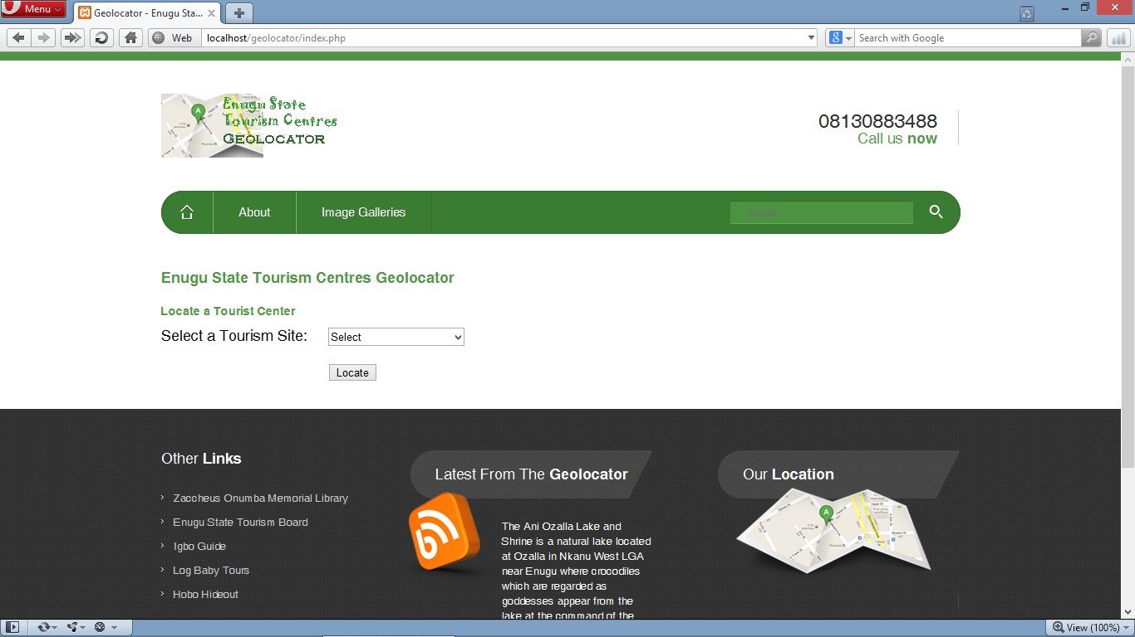

# OUTPUT SPECIFICATION

The outputs are presented in a text format and pictorial information; some of the information are derived from the database. After the user must have provided the name of the tourist location, the system outputs the location of the site which is in the form of a map and a pictorial view of the location to enhance location details.

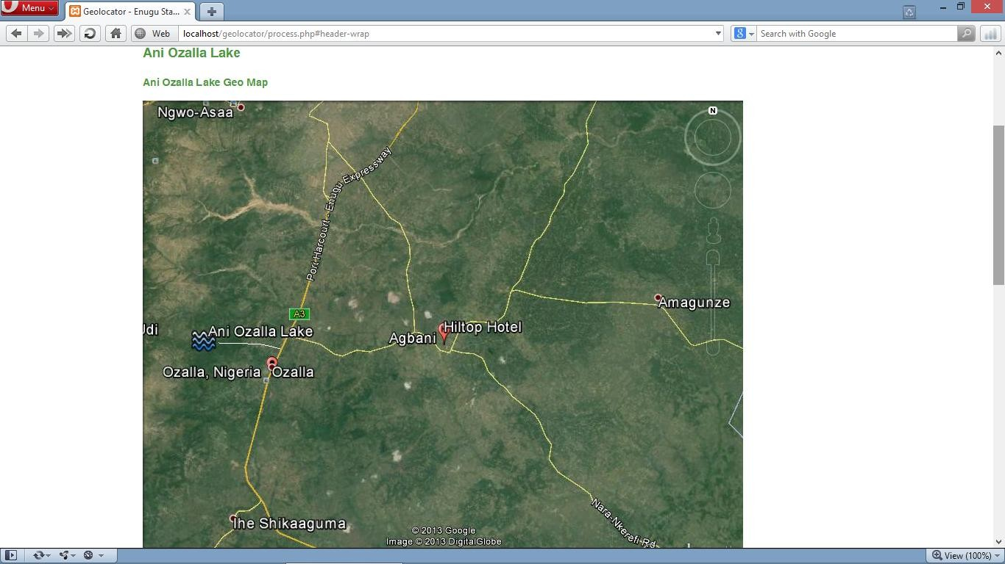

# FLOW CHART OF THE PROPOSED SYSTEM

***Input data***

Input From

the

Keyboard

Reports

Disk

Output

Storage

**CPU**

* + 1. **DATABASE SPECIFICATION FILE DESIGN**

The database type used here is MySQL database type. My SQL database was used in storing the information used in this project. The database was integrated into the system that the program access and update the files.

|  |  |  |
| --- | --- | --- |
| FIELD NAME | FIELD TYPE | FIELD SIZE |
| Tourism center | TEXT | 20 |
| Location | TEXT | 100 |
| Streets | VACHAR | 50 |
| Hotel | TEXT | 60 |
|  |  |  |
|  |  |  |
|  |  |  |

# CHOICE AND JUSTIFICATION OF PROGRAMMING LANGUAGE.

The programming languages used in this project work are PHP and MySql .

Justifications for using the programming language PHP for this work are as follows

 It is a server site scripting language

 Its open source (i.e. free to use) and cost of hosting a PHP application is less compared with the ASP(Active Server Page) and JSP(Java Server Pages)

 It adds dynamism to a website or web application.

Also MYSQL is used for the following reasons;

 It is preferred because it can execute queries against a database

 SQL can insert records in a database and can set permissions on tables, procedures and database.

 It is also preferred because if the back end of the web application. This is because everything that is being done is stored to the database.

# SYSTEM REQUIREMENT

The system requirement includes two parts; the software requirement and the hardware requirement.

The software requirements are;

 Operating system (Windows Xp, windows Vista, windows 7, windows 8, server® 2003 32 or 64 bits)

 PHP program development kit Netbean IDE 6.9.1 or higher  Database MySQL Server.

# The hardware requirement;

 Intel Pentium IV processor/1.5GHZ processor (minimum) recommended.  1GB or higher RAM recommended.

 80GB or higher of HDD recommended. Minimum of 10GB free space required for the windows Java SDK installation.

 Standard mouse for desktop PC‟s.

 Super visual graphics adapters (SVGA) with 1024*800 resolutions.  UPS.

 Local area network connection.  Standard Keyboard

# IMPLEMENTATION PLANS

Implantation plans involves making the newly designed system available to its set users. The implementation plan for this system will take the following order;

 Training of the members of staff (ICT DEPARTMENT) on how the software works.

 In implementing this system , a server with uninterrupted power supply must be up and running

 Finally the System is deployed.

# DOCUMENTATION PLAN

The documentation plan shows how the system operates providing a user guide and a technical guide.

# The user guide

The user guide contains information on how the GIRS works and how it can be used and fully utilized , in the system design the user guide can be found in the

help option , it‟s also basically for those who cannot use the system or will experience little difficulties in using the system.

# The technical guide

The technical guide contains information on the technical design of the system. This is usually for the software experts who might at one point or the other carry out technical work on the system. This guide will help to make their job easier.

# MAINTENANCE DETAILS

Since the system is geographical information, the system and the system database will need to be updated with any changes of street names, junctions, turns etc within the state which in turn affects the map. Because any of such changes means changing details in the software system database.

Another sure way of maintenance is a regular use of system, if the system is regularly in use there are less chances of system break down.

# CHAPTER FIVE

* 1. **SUMMARY**

With the understanding of information system, information technology and the role it plays in tourism, it is believed that if this Geographic information retrieval system is implemented, tourism in the state will experience a giant step and on the long run boost the economical activities within the state as more people become aware of the tourist locations in the state through the designed geographic information system.

# REVIEW OF ACHIEVEMENT

Achievement so far recorded in the course of this work

 In the course of the analysis of the existing system ,it was discovered that the Enugu state tourism board has an existing website on tourist sites in the state but cannot be said to be a full GIRS system

 The existing system has being improved upon by adding a

* A full GIRS system which comes with a map to show exact locations
* In addition too, coordinates which will show exact points where each of the tourists‟ sites is located and hotels within.
* A help option to show users who might need assistance in using the system.

 And above all, a well detailed web –based geographic information retrieval system has being developed, which will ultimately boost tourism in the state.

# AREAS OF APPLICATION

A geographic information retrieval system can be applied in every organizational setting and or sector of the economy; in actual sense every organization can have its own geographic information build or design to fit its own need and specifications.

To mention a but a few it can be applied in the  Banking industry

 Educational

 Commerce industry ETC

# SUGESSTION FOR FURTHER STUDIES

Since a GIRS system has being designed for tourist sites within the state I suggest that anyone or student with interest in GIRS can broaden the scope of tourism by designing a GIRS system for the eastern, western, northern region or even the whole country as the case maybe.

# RECOMMENDATION

I strongly recommend that this system be implemented to give tourism and the state an unprecedented economical growth.

# CONCLUSION

There is no doubt the extent to which a geographic information retrieval system can boost any sector in an economy. I therefore conclude that geographic information is one of the ultimate ways to boost economic growth and development.