“**ACTIVITIES OF SOME ANTIFUNGAL AGENTS AGAINST PHYTOPATHOGENIC YAM ROT FUNGI SPORES IN ZARIA, NIGERIA”**

**BY**

**OTEGWU TEMILOLA CELESTINA**

**(B.Pharm)**

**M.SC/ PHARM-SCI/ 02414/2006-07**

**A THESIS SUBMITTED TO THE POSTGRADUATE SCHOOL, AHMADU BELLO UNIVERSITY ZARIA, IN PARTIAL FULFILMENT FOR THE AWARD MASTER OF SCIENCE IN PHARMACEUTICAL MICROBIOLOGY.**

**DEPARTMENT OF PHARMACEUTICS AND PHARMACEUTICAL MICROBIOLOGY, FACULTY OF PHARMACEUTICAL SCIENCES, AHMADU BELLO UNIVERSITY ZARIA, KADUNA, NIGERIA.**

**AUGUST 2011**

# DECLARATION

I declare that the work in the thesis “Activities of some chemical compounds against phytopathogenic yam rot fungi spores in Zaria, Nigeria” has been performed by me in the department of Pharmaceutics and Pharmaceutical Microbiology, Faculty of Pharmaceutical Sciences, Ahmadu Bello University, Zaria, under the joint supervision of Prof. J. O. Ehinmidu and Dr. (Mrs.) G. O. Adeshina.

All the information derived from literature has been duly acknowledged and referred to accordingly. I solemnly declare that no part of this thesis has previously being presented for any degree or diploma in any higher institution.

Name of Student Signature Date

# CERTIFICATION

This thesis titled “**ACTIVITIES OF SOME ANTIFUNGAL AGENTS AGAINST PHYTOPATHOGENIC YAM ROT FUNGI SPORES IN ZARIA, NIGERIA”** by

Otegwu Temilola Celestina meets the regulations governing the awards of the degree of Masters of Science of Ahmadu Bello University, Zaria, and is approved for contribution to knowledge and literary presentation.

# Prof J. O. AKERELE ---------------------- --------------

(External Examiner) Signature

Date

B. Pharm., M.sc. Pharm. Microbio.., Ph.D Pharm. Microbio (UNIBEN) University of Benin, Benin City.

**Prof J. O. EHINMIDU** ------------------ -------------

(Chiarman Supervisory Committee) Signature Date

B.Sc.Micro. (UNILAG), M. Sc. Pharm Micro (UNIBEN) Ph.D. Pharm Micro (ABU)

Ahmadu Bello University, Zaria.

**Dr (Mrs) G. O. ADESHINA** ------------------ --------------

(Member Supervisory Committee) Signature Date

B.Sc.Micro (UNILORIN), M. Sc. Pharm Micro (ABU) Ph.D. Pharm Micro (ABU)

Ahmadu Bello University, Zaria.

**Dr T. S. ALLAGH** ---------------------- --------------

Head of Dept, Pharmaceutics and Pharmaceutical Signature Date

Microbiology.

B. Pharm (ABU), M. Sc. Pharmaceutics (London) Ph.D. Pharm (ABU)

Ahmadu Bello University, Zaria.

**Prof A. A. JOSHUA** --------------------- --------------

Dean, School of Postgraduate Studies Signature Date

Ahmadu Bello University, Zaria.

# DEDICATION

In loving memory of my brother-in-law, Anthony Owoicho, who passed onto glory on the 27th of November 2010. Continue to rest in the bosom of the Lord till we meet to part no more.

# ACKNOWLEDGMENT

I wish to thank God Almighty who gave me the opportunity to undertake this course from the beginning to the end and for seeing me through to the end of this research work.

I wish to appreciate the invaluable contribution, criticisms and guidance of my supervisors, Prof. J. O. Ehinmidu and Dr. (Mrs.) G. O. Adeshina, whose meticulousness I highly appreciate.

I appreciate my husband, Tom, who stood by me all the way both financially and morally. To my lovely kids who always ask me what class I am and when will I finish, I say thank you.

I also wish to appreciate my parents, brother and sisters for there ever loving moral and financial support at any time I approached them during the period of this my course.

I wish to acknowledge Prof. J. J. Bonire, of the chemistry Dept. Faculty of Sciences ABU, thank you sir for finding time to share your knowledge with me. I appreciate.

Prof Balogun of the biology Dept. Faculty of Sciences ABU, God bless you.

I won’t forget to mention my lecturers who taught me all the new things I know at this level, worth mentioning are; Dr T. S. Allagh, Prof J.A. Onaolapo, Prof. (Mrs) H. Kwanashie, Dr. B. Adeyinka, Prof Olurinola and Prof Y.K.E. Ibrahim.

I am also grateful to the technical staff of the Dept., Pharmaceutics and Pharmaceutical Microbiology especially Mr Daniel, Mr Tanko and Mal Abbas, for their assistance throughout my working in the laboratory.

Lastly I thank my course mates, especially Binta Doroyi, Moji and Falaki, without whom the course wouldn’t have been interesting and worthwhile

For all mentioned above and those who were not mentioned but have contributed meaningfully to my success, God bless you all.

# ABSTRACT

Postharvest deterioration has been a major problem associated with yam storage for both farmers and traders and it is caused mostly by micro-organisms especially fungi. The antifungal activity of some commonly used anti-dermatophytic agents (Fluconazole, Terbinafine Hcl, Ketoconazole, Sodium propionate and Griseofulvin) against phytopathogenic fungi such as *Aspergillus flavus, Aspergillus niger, Penicillium citrinum and Rhizopus stolonifer* spores were investigated.

The sensitivity of phytopathogenic isolated fungi spores to test antifungal agents were carried out using zone of inhibition, Minimum Inhibition Concentrations (MICs), Minimum Fungicidal Concentrations (MFCs), Fractional Inhibitory Concentrations (FICs) and Fractional Fungicidal Concentrations (FFCs) to measure the antifungal activities of the test antifungal agents, their fungi toxic effects against A*. flavus, A. niger, P. citrinum and R. stolonifer* was found to be in the order of:

Terbinafine Hcl > Fluconazole > Ketoconazole > Sodium propionate > Griseofulvin

The *in-vitro* MICs of the antifungal agents for example Terbinafine Hcl against *A. flavus, A. niger, P. citrinum and R. stolonifer* were 1.0, 10.0, 1.0, and 50.0µg/ml respectively. This is an indication that *R. stolonifer* is the most resistant phytopathogenic fungal spores in this investigation against the observed potent antifungal agents in this study.

The effects of fungicidal concentration of the different antifungal agents against viable test fungi spores number at different time interval showed rapid lethal effects.

The six potential fungicides combination observed in this study, viz: Terbinafine Hcl, Fluconazole and Ketoconazole in combination each with either Sodium propionate or Griseofulvin displayed synergistic activity with value of FIC 0.19 to 0.83 against the test phytopathogenic fungal spores.

The antifungal effects of evaluated fungicide combinations were observed to be stable at temperature ranges of 35-70ºC, but effect reduced as the temperature increased to 100 ºC.

At acidic pH, there was general reduction in the antifungal effects of these combinations, but at neutral and alkaline pH the antifungal effects increased.

Within six months storage of these combinations, antifungal effects were stable and sustainable.

The *in-vivo* antifungal activity shows that these formulated fungicide combinations can be used to preserve yam as they inhibited Aspergillus *niger and Rhizopus stolonifer* (1.5 x 106cfu/ml) spores on sliced old and new yam.

|  |  |  |
| --- | --- | --- |
|  | **TABLE OF CONTENTS** |  |
| Title page |  | i |
| Declaration |  | ii |
| Certification |  | iii |
| Dedication |  | iv |
| Acknowledgment |  | v |
| Abstract |  | vi |
| Table of content |  | vii |
| List of figures |  | xii |
| List of tables |  | xiv |
| List of Appendices |  |  |

xviii

# CHAPTER ONE

* 1. Introduction 1
  2. Statement of Research Problem 4
  3. Aim of Study 5
  4. Specific Objectives 6

CHAPTER TWO

2.0 Literature Review 7

* + 1. Yams 7
    2. Agronomic Characteristics of Yam 9
    3. Anti Nutritional Factors of Yam 10
    4. Utilization and Processing of Yam 11
    5. Industrial Processing of Yam 13
    6. Preservation of Yam 14
    7. Spoilage of Yam 14

2.2. Fungi 14

2. 2. 1 Uses of Fungi 17

2. 3 Anti-Fungal Agents 19

2. 3. 1 Polyene antifungals 19

* + - 1. Amphotericin B 20
      2. Nystatin 21

2. 3. 2 Imidazole, Triazole and Thiazole antifungals 22

* + - 1. Miconazole 23
      2. Ketoconazole 24
      3. Fluconazole 26
      4. Itraconazole 29

2. 3. 3 Allylamines 29

2.3.3.1 Terbinafine Hydrocloride 29

2. 3. 4 Echinocandins and others 30

* + - 1. Griseofulvin 31
      2. Benzoic Acid 32
      3. Sodium Propionate 34

**CHAPTER THREE**

* 1. Materials and methods 35
  2. Materials 35
     1. Antibiotics 35
     2. Chemicals 35
     3. Culture Media 35
     4. Test Organisms 36

3.1.5. Equipments. 36

* 1. Methods 36
     1. Determination of Zone of Inhibition Using the Cup Plate Method 36
     2. Determination of Minimum Inhibitory Concentration (MIC) Using

Agar Dilution Method. 37

* + 1. Determination of Minimum Fungicidal Concentration (MFC) 38
    2. Determination of Fractional Inhibitory Concentration (FIC) of

Admixture Using Agar Dilution Method. 38

* + 1. Determination of Fractional Fungicidal Concentration (FFC) of Admixtures 39
    2. Determination of Rate of Kills of the Resistant Test Fungal Spores

(*Rhizopus stolonifer*). 39

* + 1. Biocidal Activities of Different Concentrations of the Test Antifungal

agents against *Rhizopus stolonifer* at 30minutes Contact Time*.* 40

* + 1. Determination of Suitable Concentration of Sodium Metabisulphite as

Stabilizing Agent of the Test Anti-Fungal Agents. 41

* 1. Formulation of Potential Fungicide Combinations 41
     1. Determination of Effect of Varying pH values on the

Antifungal activities of the formulated Fungicide Combinations 44

* + 1. Determination of Effect of Varying Temperature on the Activities of the

Formulated Fungicide Combinations 45

* + 1. Determination of Effect of Duration of Storage on the Antifungal Activities

of the Formulated Fungicide Combinations 45

* + 1. Determination of *In-Vivo* Antifungal Activity of the Formulated Fungicide combinations. 46
  1. Water Analysis 46
  2. Determination of the presence of organic matter in the different types of water. 47

# CHAPTER FOUR

* 1. Results 48
  2. Zones of Inhibition 49
  3. Minimum Inhibition Concentration (MIC), Minimum Fungicidal Concentration (MFC),Fractional Inhibitory Concentration (FIC) and

Fractional Fungicidal Concentration (FFC) 54

* 1. Rate of Kill Studies 60
  2. Fungicidal Activity of Test Antifungal Agents after 30minutes Contact time

at Different Concentrations. 67

* 1. The pH of Combined Antifungal Agents Using Varying Concentration of

Sodium Metabisulphite. 72

* 1. Effect of Varying Temperature on the Antifungal Activity of Test Compounds. 74
  2. pH of Different Types of Water before and after Autoclaving 82
  3. Water Analysis 83
  4. The presence of Organic Matter in the Different Water Used for this Investigation 84
  5. Effect of Varying pH values on the Antifungal activities of the

Formulated Fungicide Combinations. 85

* 1. Effect of Duration of Storage on the Antifungal Activities of the

Formulated Fungicide Combinations. 87

* 1. *In-vivo* Antifungal activity of the Formulated fungicide combinations. 90

# CHAPTER FIVE

* 1. Discussion, Conclusion and Recommendations. 93
  2. Discussion 93
  3. Conclusions 99
  4. Recommendations. 100

**REFRENCES** 101

**APPENDICES** 106

# LIST OF FIGURES

Fig 2.1 Pathway for synthesis of the essential fungal sterol ergosterol and the sites of inhibition by the antifungal agents Terbinafine,

Imidazoles and Triazoles 28

Fig 4.3.1 The Survival of *Rhizopus stolonifer* spores in Fluconazole (10,000µg/ml) and Sodium propionate (10,000µg/ml), singly and in

combination (5000/5000µg/m) at different time intervals. 61

Fig 4.3.2 The Survival of *Rhizopus stolonifer* spores in Terbinafine (1000µg/ml) and Sodium propionate (10,000µg/ml), singly and in combination

(500/5000µg/m) at different time intervals. 62

Fig 4.3.3 The Survival of *Rhizopus stolonifer* spores in Ketoconazole (4000µg/ml and Sodium propionate (10,000µg/ml), singly and in combination (2000/5000µg/m)

at different time intervals. 63

Fig 4.3.4 The Survival of *Rhizopus stolonifer* spores in Fluconazole (10,000µg/ml) and Griseofulvin (10,000µg/ml), singly and in combination (5000/5000µg/m)

at different time intervals. 64

Fig 4.3.5 The Survival of *Rhizopus stolonifer* spores in Terbinafine (1000 µg/ml) and Griseofulvin (10,000µg/ml), singly and in combination (500/5000µg/m) at

different time intervals. 65

Fig 4.3.6 The Survival of *Rhizopus stolonifer* spores in Ketoconazole (4000µg/ml) and Griseofulvin (10,000µg/ml), singly and in combination (2000/5000µg/m)

at different time intervals. 66

Fig 4.4.1 Graph showing the Influence of varying fungicidal concentrationsv of Fluconazole on the viability of *Rhizopus stolonifer* spores (107spores/ml)

at 25ºC after 30minutes contact time. 68

Fig 4.4.2 Graph showing the Influence of varying fungicidal concentrations of Terbinafine on the viability of *Rhizopus stolonifer* spores (107spores/ml)

at 25ºC after 30minutes contact time. 69

Fig 4.4.3 Graph showing the Influence of varying fungicidal concentrations of Sodium propionate on the viability of *Rhizopus stolonifer* spores

(106spores/ml) at 25ºC after 30minutes contact time. 70

Fig 4.4.4 Graph showing the Influence of varying fungicidal concentrations of Griseofulvin of the viability of *Rhizopus stolonifer* spores (108spores/ml)

at 25ºC after 30minutes contact time. 71

# LIST OF TABLES

Table 4.1.1 Zone of inhibition of Fluconazole against *Aspergillus flavus,*

*Aspergillus niger, Penicillium citrinum and Rhizopus stolonifer* at 30ºC

for 48 hours. 49

Table 4.1.2 Zone of inhibition of Terbinafine against *Aspergillus flavus,*

*Aspergillus niger, Penicillium citrinum and Rhizopus stolonifer* at 30ºC

for 48 hours. 50

Table 4.1.3 Zone of inhibition of Ketoconazole against *Aspergillus flavus,*

*Aspergillus niger, Penicillium citrinum and Rhizopus stolonifer* at 30ºC

for 48 hours. 51

Table 4.1.4 Zone of inhibition of Sodium propionate against *Aspergillus flavus,*

*Aspergillus niger, Penicillium citrinum and Rhizopus stolonifer* at 30ºC

for 48 hours. 52

Table 4.1.5 Zone of inhibition of Griseofulvin against *Aspergillus flavus,*

*Aspergillus niger, Penicillium citrinum and Rhizopus stolonifer* at 30ºC

for 48 hours. 53

Table 4.2.1 Minimum Inhibitory Concentration (MIC) of test antifungal agents against *Aspergillus flavus, Aspergillus niger, Penicillium citrinum*

and *Rhizopus stolonifer* at 30 ºC for 48 hours (μg/ml). 54

Table 4.2.2 Minimum Fungicidal Concentration (MFC) of test antifungal agents against *Aspergillus flavus, Aspergillus niger, Penicillium citrinum* and

*Rhizopus stolonifer* at 30 ºC for 72 hours. (μg/ml). 55

Table 4.2.3 Fractional Inhibitory Concentration (FIC) of Fluconazole in admixtures with Sodium propionate that give complete inhibition of

*Aspergillus niger* spores suspension. 56

Table 4.2.4 Fractional Inhibitory Concentration (FIC) of combined Test fungicides against Phytopathogenic fungi spores (106cfu/ml). 57

Table 4.2.5 Fractional Fungicidal Concentration (FFC) of combined Test fungicides

against Phytopathogenic fungi spores (106cfu/ml). 58

Table 4.5 The pH of combined Antifungal Agents using varying concentration

of Sodium Metabisulphite. 71

Table 4.6.1 Effect of heat on activity of Terbinafine Hcl/ Griseofulvin diluted

with unboiled water sources against growth of *Aspergillus niger.* 76

Table 4.6.2 Effect of heat on activity of Terbinafine Hcl/ Griseofulvin diluted

with boiled water sources against growth of *Aspergillus niger.* 76

Table 4.6.3 Effect of heat on activity of Terbinafine Hcl/ Sodium propionate

diluted with unboiled water sources against growth of *Aspergillus niger.* 77

Table 4.6.4 Effect of heat on activity of Terbinafine Hcl/ Sodium propionate

diluted with boiled water sources against growth of *Aspergillus niger.* 77

Table 4.6.5 Effect of heat on activity of Fluconazole/Griseofulvin diluted with

unboiled water sources against growth of *Aspergillus niger* 78

Table 4.6.6 Effect of heat on activity of Fluconazole/Griseofulvin diluted with

boiled water sources against growth of *Aspergillus niger.* 78

Table 4.6.7 Effect of heat on activity of Fluconazole/ Sodium propionate diluted

with unboiled water sources against growth of *Aspergillus niger.* 79

Table 4.6.8 Effect of heat on activity of Fluconazole/ Sodium propionate diluted

with boiled water sources against growth of *Aspergillus niger 79.*

Table 4.6.9 Effect of heat on activity of Ketoconazole/Griseofulvin diluted with

unboiled water sources against growth of *Aspergillus niger.* 80

Table 4.6.10 Effect of heat on activity of Ketoconazole/Griseofulvin diluted

with boiled water sources against growth of *Aspergillus niger.* 80

Table 4.6.11 Effect of heat on activity of Ketoconazole/Sodium propionatediluted

with unboiled water sources against growth of *Aspergillus niger.* 81

Table 4.6.12 Effect of heat on activity of Ketoconazole/Sodium propionatediluted

with boiled water sources against growth of *Aspergillus niger.* 81

Table 4.7 pH of different type of water before and after autoclaving. 82

Table 4.8: Elemental analysis of Water samples of different water sources used for

the dilution of the formulated chemical compounds. 83

Table 4.9 Percentage of organic matter in the different water sources. 84

Table 4.10 Effect of varying pH values on the antifungal activities of the formulated fungicidal combinations, incubated at 30ºC for 48hrs using *Aspergillus niger*

on Sabouraud’s Dextrose Agar (SDA) measured in mm. 85

Table 4.11.1 Effect of storage duration on the antifungal activities of the formulated fungicidal combinations incubated at 30ºC for 48hrs using *Aspergillus niger*

on Sabouraud’s Dextrose Agar (SDA) measured in mm. 88

Table 4.11.2 Effect of storage duration on the antifungal activities of the formulated fungicidal combinations incubated for 48hrs using *Aspergillus niger*

on Sabouraud’s Dextrose Agar (SDA) measured in mm. 89

Table 4.12.1 *In-vivo* Antifungal activity of Formulated Antifungal Agents on

*Rhizopus stolonifer* 91

Table 4.12.2 In*-vivo* Antifungal activity of Formulated Antifungal Agents

on *Aspergillus niger* 92

# LIST OF APPENDICES

|  |  |  |
| --- | --- | --- |
| AP 1 | Preparation of Sabouraud’s Dextrose Agar (SDA) | 105 |
| AP 2 | Preparation of Inactivation Media | 105 |
| AP 3 | Preparation of Spores Harvesting Media | 105 |
| AP 4 | Preparation of Spore Suspension | 105 |
| AP 5 | Preparation of Stock Suspensions of the Antifungal Agents | 106 |

Table AP 1 Combined MIC of Test Antifungal agents against *Aspergillus flavus,*

*Aspergillus niger, Penicillin citrinum* and *Rhizopus stolonifer* at 300C

for 48hours 107

Table AP 2 Combined MFC of Test Antifungal agents against *Aspergillus flavus,*

*Aspergillus niger, Penicillium citrinum* and *Rhizopus stolonifer* at 300 C

for 72hours. 108

Table AP 3 Rate of kill of some antifungal agents (Singly) on resistant

*Rhizopus stolonifer* (Isolated from yam) in spores/ml. 109

Table AP 5 Rate of kill of antifungal agents (combined) on resistant

*Rhizopus stolonifer* (Isolated from yam) in spores/ml (in combination

with Sodium propionate). 111

Table AP 6 Rate of kill of antifungal agents (combined) on resistant

*Rhizopus stolonifer* (Isolated from yam) Incubated for 48hrs in

spores/ml (in combination with Griseofulvin). 112

Table AP 7 Threshold values at 30mins contact time of different concentration

with *Rhizopus stolonifer* incubated for 48hrs in spores/ml. 113

Table AP 9 Effect of heat on Fluconazole /Sodium propionate (5000μg/5000μg/ml) at varying temperature in the different types of water, incubated at 30 ºC for 48hrs using *Aspergillus niger* on Sabouraud’s Dextrose Agar (SDA)

measured in mm. 115

Table AP 10 Effect of heat on Ketoconazole/Sodium propionate (2000μg/ 5000μg/ml) at varying temperature in the different types of water, incubated at 30 ºC for 48hrs using *Aspergillus niger* on Sabouraud’s Dextrose Agar (SDA)

measured in mm. 116

Table AP 11 Effect of heat on Terbinafine/Sodium propionate (500μg/5000μg/ ml) at varying temperature in the different types of water, incubated at 30 ºC for 48hrs using *Aspergillus niger* on Sabouraud’s Dextrose Agar (SDA)

measured in mm. 117

Table AP 12 Effect of heat on Fluconazole /Griseofulvin (5000μg/5000μg/ml) at varying temperature in the different types of water, incubated at 30ºC for 48hrs using *Aspergillus niger* on Sabouraud’s Dextrose Agar (SDA)

measured in mm. 118

Table AP 13 Effect of heat on Ketoconazole /Griseofulvin (2000μg/5000μg/ml) at varying temperature in the different types of water, incubated at 30ºC for 48hrs using *Aspergillus niger* on Sabouraud’s Dextrose Agar (SDA)

measured in mm. 119

Table AP 14 Effect of heat on Terbinafine Hcl/ Griseofulvin (500μg/5000μg/ml) at varying temperature in the different types of water, incubated at 30ºC for 48hrs using *Aspergillus niger* on Sabouraud’s Dextrose Agar (SDA)

measured in mm. 120

# CHAPTER ONE

# 1.0 INTRODUCTION

Yam is an important staple food throughout West Africa and in many regions across Asia, outhern and Central America, the Caribbean and the Payee (Degras, 1993). Yam is a major source of income for farmers and traders (Arene, *et al*, 1985). It is an important sociocultural crop that is prominent in the cultural and religious festivals of the people of West Africa (FAO, 1994; Thompson and Bancroft 1996). Some species of yams are used as pharmaceutical excipients and the toxic bye products used for hunting and as insecticides (Degras, 1993). In addition, there are numerous medicinal uses of yam such as in dermatology and gastroenterology in Asia, Africa and the Americas. Yam is also a source of diosgenin, a precursor of progesterone, cortisone and other medically important steroids (Coursey, 1967).

Yam belongs to the genus *Dioscroea* in the family of *Dioscoreacea* and it is a *monocotyledonous* plant. The Food and Agricultural Organization (1998) estimated that the world production of yam is around 30.2 million tons per year. Over 90% of world yam production is derived from West Africa, namely: Nigeria, Benin, Togo, Ghana and Ivory Coast (Booth, 1974). Nigeria alone produces three quarters of the world total output of yams. For instance, in 1998, Nigeria produced about 70% of yam tubers (FAO 1998).

There are six species of yam in Nigeria namely:

1. *Dioscorea rotundata* (white yam)
2. *Dioscorea cayenensis* (yellow yam)
3. *Dioscorea alata* (water yam)
4. *Dioscorea dementorum* (knuth) pax (cluster or bitter yam)
5. *Dioscorea esculenta* (lour) Burk (Chinese yam)
6. *Dioscorea bulbifera* L (aeria yam) ( Ayensu & Coursey, 1972)

In spite of yam importance, post harvest deterioration has been a major problem facing farmers and traders. Losses of yams in storage mostly to rot are considered to be heavy in Nigeria. These losses are attributed to rot, which is a pathological problem brought about by bacteria, fungi and nematodes (Ayensu & Coursey, 1972 and Coursey, 1967). The losses are estimated to be 10-15% in the first three months while Coursey, (1967) and Adesuyi, (1997) estimated the loss to be 50% and 56% respectively after six months in the yam barn.

The rot in yam is caused mostly by fungi (Hugo *et al*, 1992 and Cheesbrough, 1984). Fungi may either be parasitic or saprophytic. They utilize innate organic matter as an energy source and are also important natural organic decomposers, as well as destroyers of food stuff. Majority of fungi are facultative parasites able to utilize live or dead organic matter. However, although some species can only survive on living cells, thus are called obligate parasites causing disease of plants, animals and man (Hugo *et al*, 1992 and Cheesbrough, 1984).

The importance of fungi rotting in causing storage losses has been emphasized by several workers (Ikotun, 1986; Jones, 1985; Ogali, *et al*, 1991; Ogundana, 1971; Nnodu, 1986). These workers concluded that the entry of pathogens occurs through wounds or cuts and natural opening on the surface of the tubers.

There are different types of microorganism that has been reported in association with storage deterioration in yam tubers (Noon, 1978; Okigbo and Ikediugwu, 2000). The major microorganisms causing diseases in yams are:

*- Aspergillus flavus* Lark Ex Fr

- *Aspergillus niger* Van Tiegh

-*Botryodiplodia theobromae* pat

* *Fusarium oxysporum* schlecht ex Fr
* *Fusarium solani* (Mart). Sacc

*-Penicillium chrysogenum* Thom Rhizoctinia sp

*-Penicillium oxalicum* Curries and Thom

*-Rhizopus stolonifer* (Enrend. ex Fr) Lind

*-Rhizopus nodosus* N’amyslowski

*-Trichoderma viride*. Per. ex S. F. Gray

(Adenyi 1970; Ogundana *et al* 1970; Okigbo and Ikediugwu 2000, 2001, 2002 and Okigbo

2004).

The use of synthetic chemicals such as Sodium orthphenylphenate, borax (Sodium borate), captan (ethanethiol or ethyl mercaptan), thiobendazole, benomly (Acephate) and sodium hypochlorite have been found to significantly reduce storage rot in yam (Booth, 1974; Noon, 1978).

There are several local plants species whose extracts or biocides have been reported in the eastern parts of Nigeria as efficacious in protecting yam produce. These plants are: - *Azadiracta indica* (neem), *Zingiber officinal* (ginger), *Ocimum gratisimum* (scent leave), *Xylopic eathiopica* (African pepper), *Carica papaya* (pawpaw), *Citrus* Spp (orange), *Nicotiana tabaccum* (tobacco), *Ricinus comunis* (caster bean), and Piper guineenais (Pepper). The most popular one among them is the neem (*Azadiracta indica* A Juss). Formulations of extracts of *Azadiracta indica* include water dispersible powder (WDP), dust preparation (DP), emulsifiable concentrate (EC), neem seed water extract (NSWE) and neem cake water extract (NCWE) (Okigbo and Ikediugwu, 2000).

# STATEMENT OF RESEARCH PROBLEM

Post harvest handling and storage of yams are essential aspect of yam economic development in Nigeria. Yam rot in Nigeria was estimated at two hundred million Naira (N200m) or two hundred thousand dollars ($200, 00) (Coursey, 1967).

Yam loss in storage due to rot are considered heavy in Nigeria. The evaluation of rot in different part of Nigeria showed that extent of rotting ranged from 0.5% to 18% at harvesting while storage rot ranges from 3%to 25% (Jones, 1985). It is frequently believed that yams are stored well, but the little documentary evidence that is available on the magnitude of storage losses suggests that contrary to this popularly held opinion, substantial losses occur. In the view of yam storage losses, Coursey, (1967) illustrated how these losses vary considerably in magnitude and nature from country to country, region to region, species to species and even variety to variety, concluding that in general, the losses that occur during storage, even under the best storage conditions are much more serious than is generally realized (Ekundayo and

Naqvi, 1972). Although, there is a great variation among varieties, losses in weight of 10- 20% after only three months storage and 30-60% after six months storage are not unusual even on sound yam tubers, and even greater loses occur if infection by roting organisms takes place (Okigbo, 2001).

Again from other workers, Ayensu and Coursey, (1972), they said “microbial rotting of yam tubers account for a substantial proportion of the annual losses in yam production in Nigeria. Yam stored may suffer from fungal disease, causing rot which quickly spreads.”

The need to develop anti-Yam-rot preservatives can not be over emphasized due to several benefits we derive from yam as stable food and means of economic empowerment to the rural community in Nigeria.

The antifungal agents to be investigated are: Fluconazole, Griesofulvin, Terbinafine hydrochloride, Sodium propionate and Ketoconazole. These agents will be used singly and in combination.

# AIM OF STUDY

Yam significantly contributes to the alleviation of poverty and enhances food security in West Africa (Thompson e*t al* 1996), apart from an avenue for foreign exchange through being exported to foreign countries. Yam is a major source of carbohydrate, minerals of calcium, phosphorus, iron vitamins such as riboflavin, thiamin and vitamins B & C (Coursey, 1967). Some species of yam have been used medically to treat diseases like diabetes mellitus, to increase coronary flow and prevent hyper-cholesosterolemia (Undie and Akubue, 1986).

This study was designed to obtain a preservative system for preserving yam which will add value to yam farmers and traders alike.

# SPECIFIC OBJECTIVES

1. To isolate and identify the fungi causing yam rot in Zaria, Nigeria.
2. To determine the antifungal effect against some phytopathogenic fungi spores, using Minimum Inhibitory Concentration (MIC) and Minimum Fungicidal Concentration (MFC).
3. Determination of combined MIC and Fractional Inhibitory Concentration (FIC).
4. To determine Rate of kill of resistant test fungal spores using single and combined antifungal agents.
5. To determine Effects of heat, pH, and duration of storage on antifungal activities of test chemical agents.
6. To determine In-vivo antifungal activities of the combined antifungal agents in a convenient Pharmaceutical dosage form.

# CHAPTER TWO

# 2.0 LITERATURE REVIEW

# YAMS

The world production of yam was estimated at 47million metric tons in 2004 (FAO, 2004). Out of the world production of yam, 96% comes from West Africa, the main producers being Nigeria with 71% of world production; Côte d'Ivoire 8.1%; Benin 4.3% and Ghana 3.5% (Booth.1974).In the humid tropical countries of West Africa, yams are one of the most highly regarded food products and are closely integrated into the social, cultural, economic and religious aspects of life. Traditional ceremonies still accompany yam production, indicating the high status given to the plant.

The genus *Dioscorea* contains a wide range of species used as food, of which about six species are widely used. There are many varieties of yam species widespread throughout the humid tropics. The most economically important species are:

1. **White yam (***Dioscorea rotundata* Poir): Originated in Africa and is the most widely grown and preferred yam species. The tuber is roughly cylindrical in shape, the skin is smooth and brown and the flesh usually white and firm. A large number of white yam cultivars exist with differences in their production and post-harvest characteristics.
2. **Yellow yam (***Dioscorea cayenensis* Lam**.)**: Derives its common name from its yellow pigment, which is caused by the presence of carotenoids. It is also native to West Africa and very similar to the white yam in appearance. Apart from some morphological differences (the

tuber skin is firm and less extensively grooved), the yellow yam has a longer period of vegetation and a shorter dormancy than white yam.

1. **Water yam (***Dioscorea alata* L**.)**: It originates from South East Asia. The species is widely spread throughout the world. It is second to white yam in popularity in Africa. The tuber shape is generally cylindrical, but can be extremely variable. Tuber flesh is white and "watery" in texture.
2. **Bitter yam (***Dioscorea dementorum***)**: This yam is called trifoliate, because of its leaves.

It originates in Africa where wild cultivars also exist. One marked characteristic of this yam is the bitter flavor of its tubers. Another undesirable characteristic of this yam is that, the flesh hardens if not cooked soon after harvest. Some wild cultivars are highly poisonous.

1. **Chinese yam** (*Dioscorea esculenta* (Lour): This is also an edible yam which can also be used in photochemistry of starch and sugar. It is a spiny climber to 12 m high twining left- handed, with numerous shallow-rooted tubers, native of South-East Indonesia, and widespread in the East, recently introduced to West Africa and found under cultivation around the coast, particularly from Ivory Coast to Nigeria. It is a 6–10 months crop with short dormancy period. The tubers are small and are found in clusters of some 5 to 20 slightly below the soil surface. Tubers grown in Ivory Coast have been recorded producing 83% starch and 12% protein. The tubers do not store well. They are quick to sprout if left in the ground and are easily damaged in harvesting. Six months storage is said to be possible in a dry well-ventilated store. This yam cannot be transported to long distant markets
2. **Aeria yam (*Dioscorea bulbifera):*** This is a yam species also called the air potato. It is native to Africa and Asia. It is a perennial vine with broad leaves. The plant forms bulbils in the leaf axils of the twining stems, and tubers beneath the ground. These tubers are like small, oblong potatoes, and they are edible and cultivated as a food crop, especially in West Africa. The tubers often have a bitter taste, which can be removed by boiling. They can then be prepared in the same way as other yams, potatoes, and sweet potatoes. The air potato is one of the most widely-consumed yam species. Uncultivated forms, such as those found growing wild in Florida can be poisonous. These varieties contain the steroid, diosgenin, which is a principal material used in the manufacture of a number of synthetic steroidal hormones, such as those used in hormonal contraception. Air potato has been used as a folk remedy to treat conjunctivitis, diarrhea and dysentery, among other ailments.

# AGRONOMIC CHARACTERISTICS OF YAM

Yam is cultivated for its energy-rich tuber. Yam planting is adaptable to fairly fertile soils and can be cultivated intercropping with legumes such as cowpeas, soybeans and a variety of leafy vegetables. A well-drained, rich, loamy soil, however is the most favorable. Yam requires a warm, humid climate; however, the crop possesses considerable drought resistance. It gives more calories per unit of land area than most crops and matures within seven months. On soils of average fertility, between 20 and 30 tones per hectare of tubers can be obtained, and up to 55 tones per hectare on fertile soils. It has quite demanding labour and maintenance requirements, such as tilling the soil around each plant to form mounds, to ensure a pulverized soil favorable for tuber development. Storage of tubers occurs after harvest in barns or heaps covered with grass. It is a climbing vine with large underground

roots up to 10 feet (3.3 meters) long. These roots have many shapes and may be white, off- white, or purple inside. Over 60 varieties of yams are grown and eaten in the Pacific. Yams do not grow in areas, where there is not enough soil. Yams must be kept free of weeds for the first 3 months. When the vines start to grow, they are usually trained to grow onto long poles. In smaller gardens, where space is sure, they may be trained onto fruit trees. Some varieties of yams twist around a pole to the right, others twist to the left. After 9-12 months, the yams are ready for harvesting. They are harvested when the leaves are dry (FAO 1994).

# ANTI NUTRITIONAL FACTORS OF YAM

The edible, mature, cultivated yam does not contain any toxic principles. However, bitter principles tend to accumulate in immature tuber tissues of *D. rotundata* and *D. cayenensis*. They may be polyphenols or tannin-like compounds. Wild forms of *D. dumetorum* do contain bitter principles, and hence are referred to as bitter yam. The bitter principle has been identified as the alkaloid dihydrodioscorine, while that of the Malayan species, *D. hispida*, is dioscorine. These are water-soluble alkaloids, which, on ingestion, produce severe and distressing symptoms. Severe cases of alkaloid ingestion may prove fatal. There is no report of alkaloids in cultivated varieties of *D. dumetorum*.

The bitter principles of *D. bulbifera* (called the aerial or potato yam) include a 3-furanoside norditerpene called diosbulbin. These substances are toxic, causing paralysis. Extracts are sometimes used in fishing to immobilise the fish and thus facilitate capture. Toxicity may also be due to saponins in the extract. Zulus use this yam as bait for monkeys, and hunters in Malaysia use it to poison tigers. In Indonesia an extract of *D. bulbifera* is used in the preparation of arrow poison (FAO, 1994).

# UTILIZATION AND PROCESSING OF YAM

Yam tuber utilization is mostly as boiled or pounded yam, that is it is mostly used fresh. Changes in wholesomeness during storage include wound repair, diseases and pests of stored tubers; hence yam tubers are lost after 4-5 months of storage. Drying of (injured) tubers soon after harvest and converting into slices or milling into flour for *fufu* ensures availability of yam in various forms. Traditionally, processed yam products are made in most yam-growing areas, usually as a way of preserving the tubers that can not withstand long storage before microbial spoilage sets in.

Fresh yam is peeled, boiled and pounded until a sticky elastic dough is produced. This is called pounded yam or yam fufu.

The only processed yam product traditionally made at village level is yam flour. Except by the Yoruba people in Nigeria, yam flour is regarded as an inferior substitute for freshly pounded yam because it is often made from damaged tubers. Yam flour is favored in the Yoruba area where the reconstituted food is known as ‘*amala’.* To a limited extent, yam flour is also manufactured in Ghana where it is known as ‘*kokonte’*. The nutritional value of yam flour is the same as that of pounded yam.

*Yam flour:* The tubers are sliced to a thickness of about 10 mm, more or less, depending on the dryness of the weather. The slices are then parboiled and allowed to cool in the cooking water. The parboiled slices are peeled and dried in the sun to reduce the moisture content. The dried slices are then ground to flour in a wooden mortar and repeatedly sieved to produce a uniform texture. Today, small, hand-operated or engine-driven corn mills or flourmills are increasingly used. Treatment with sodium bisulphate is often used to prevent

phenolic oxidation during drying which darkens the color of the product (especially with white guinea yam, *D. rotundata*). Blanching in place of sodium bisulphate achieves similar results. The yam flour is rehydrated during heating and reconstituted into *fufu* and eaten with a soup containing fish, meat and/or vegetables.

Bitter yams are not normally eaten except at times of food scarcity. They are usually detoxified by soaking in a vessel of salt water, in cold or hot fresh water or in a stream. In Asia, detoxification methods, involving water extraction, fermentation and roasting of the grated tuber are used for bitter cultivars of *D. buibifera .*

Yams are a good source of energy, which the body needs to stay active. Yams also contain modest amounts of Vitamin B1 (thiamin) and Vitamin C. Vitamin B1 (thiamin) helps the body use energy foods and Vitamin C helps to keep the body tissues strong, helps the body to use iron, and aids chemical actions in the body. Yams also provide bulk and some fiber, which are needed to make the intestines or bowels work properly.

When eaten in large quantities as they usually are in the Pacific, yams also provide a fair amount of iron and niacin. Iron helps to keep blood healthy and niacin also helps the body to use energy foods.

Because yams do not contain all of the nutrients needed for good health, they should be eaten with other foods for a balanced diet. Health-giving protective foods, such as dark green leafy vegetables, and body-building foods, such as fish, meat, peanuts and milk, should be eaten along with yams. That way, the body will have enough of the different foods it needs to stay healthy and be strong.

Mashed and added to other foods such as fruits, dark green vegetables, or fish, yams make a good food for young babies.

Eating local foods saves money for families who are able to grow their own food. It is discovered that yams are nutritionally better than store foods, such as white bread, because they provide plenty of energy and some protein, as well as a variety of minerals and vitamins. White bread provides the same amount of energy, but very few minerals and vitamins. Yams can be eaten with other foods such as meat, fish, shellfish, vegetables and green leaves. White bread, because it is normally eaten with high energy foods such as butter, margarine, jam etc., provides a lot more energy than yams. This may lead to overweight and obesity (FAO, 1998).

# INDUSTRIAL PROCESSING OF YAM

Yams have not been processed to any significant extent commercially. Dehydrated yam flours and yam flakes have been produced by sun drying. The manufacture of fried products from *D. alata* has also been attempted recently. Both chips and French fries have been manufactured. Preservation of yam in brine has been attempted, but with little success.

Since pounded yam has so much prestige and is the most popular way of eating yam, attempt has been made to commercialize the process. That is, the production of dehydrated pounded yam by drum drying. This product could then be reconstituted without further processing. This production was first attempted in Côte d'Ivoire in the mid-1960s, under the trade name "Foutoupret", by air-drying precooked, grated or mashed yam.

# PRESERVATION OF YAM

Yams keep well if left in the ground until they are needed. After harvesting, store in a place that is dry, dark, cool, and well-ventilated (Gonzalez 1972). They may be kept for several months if stored properly. Check them occasionally to remove any yams that are beginning to go rotten. Pinch off any growing shoots. (FAO, 1998).

# SPOILAGE OF YAM

It is significant to note that rotting in storage probably started in the soil and progressed in storage. This may happen when infected tubers do not show perceptible external symptoms (Jones, 1985; Ogundana, 1970). Each type of rot is characteristic of its causal organism. The incidence of rotting varies with the species and with the varieties of the species of yam (Nnodu and Nwankiti, 1986). Spoilage of yam probably vary from place to place. It has been observed that in the case of white yam, rotting appeared first at the end of yams and then proceeds towards the head regions (Ogundana, *et al* 1970). Rot vary due to variations in the distribution of the infective microorganisms. It does not relate to the soil mineral status, because the differences in the mineral status are not known to be correlated with type of organism isolated nor total percentage of rot (Campbel, *et al*, 1962).

# 2.2.0 FUNGI

Fungi were listed in the Plant Kingdom for many years (Robert, 1995). The organisms of the fungal lineage include mushrooms, rusts, smuts, puffballs, truffles, morels, molds, and yeasts, (Alexopoulos, *et al*., 1996). Fungal cell size range from single-celled organism such as yeast to the multicellular mushroom in the class *Basidomycetes* (Hawksworth, 1991; Hawksworth *et al*., 1995).

Fungi share with animals the ability to export hydrolytic enzymes that break down biopolymers, which can be absorbed for nutrition. Rather than requiring a stomach to accomplish digestion, fungi live in their own food supply and simply grow into new food as the local environment becomes nutrient depleted (Administrator, 2009).

Within their varied natural habitats fungi usually are the primary decomposer organisms. Many species are free-living saprophytes (users of carbon fixed by other organisms) in dead woody substrates, soils, leaf litter, dead animals, and animal exudates. (Administrator, 2009).

However, many other fungi are biotrophs, and in this role a number of successful groups form symbiotic associations with plants (including algae), animals (especially arthropods), and prokaryotes. Examples are lichens, mycorrhizae, and leaf and stem endophytes. Leaf and stem endophytes are a more recent discovery, and some of these fungi can protect the plants they inhabit from herbivory and even influence flowering and other aspects of plant reproductive biology. Fungi are our most important plant pathogens, and include rusts, smuts, and many ascomycetes such as the agents of Dutch elm disease and chestnut blight. Among the other well known associations are fungal parasites of animals. Humans, for example, may succumb to diseases caused by *Pneumocystis* (a type of pneumonia that affects individuals with supressed immune systems), *Coccidioides* (valley fever), *Ajellomyces* (blastomycosis and histoplasmosis), and *Cryptococcus* (cryptococcosis) (Kwon-Chung and Bennett, 1992).

Fungal spores may be actively or passively released for dispersal by several effective methods. The air we breathe is filled with spores of species that are air dispersed. These usually are species that produce large numbers of spores, and examples include many species

pathogenic on agricultural crops and trees. Other species are adapted for dispersal within or on the surfaces of animals (particularly arthropods). Some fungi are rain splash or flowing water dispersed. In a few cases the forcible release of spores is sufficient to serve as the dispersal method as well. The function of some spores is not primarily for dispersal, but to allow the organisms to survive as resistant cells during periods when the conditions of the environment are not conducive to growth.

Fungi are vital for their ecosystem functions, some of which we have reviewed in the previous paragraphs. In addition a number of fungi are used in the processing and flavoring of foods (baker's and brewer's yeasts, Penicillia in cheese-making) and in production of antibiotics and organic acids. Other fungi produce secondary metabolites such as aflatoxins that may be potent toxins and carcinogens in food of birds, fish, humans, and other mammals (Administrator, 2009).

A few species are studied as model organisms that can be used to gain knowledge of basic processes such as genetics, physiology, biochemistry, and molecular biology with results that are applicable to many organisms. Some of the fungi that have been intensively studied in this way include *Saccharomyces cereviseae*, *Neurospora crassa*, and *Ustilago maydis* (Administrator, 2009).

# 2. 2. 1 USES OF FUNGI

The use of fungi can be classified into two i.e. those that are useful to man and those that are harmful to man;

# USEFUL FUNGI

Some fungi are quite useful to man. Several antibiotics have been reported extracted from fungi cultures to fight bacterial infection. *Ashbya gossypii* has been reported to be a source of vitamins, such as riboflavin while *Aspergillus niger* makes enzymes used in laundry detergents and many other products, and for tanning leather. *Beauveria bassiana* has been reported useful as a pesticide to control nuisance insects. *Mucor circinelloide*s is a filamentous fungus that produces long, thread-like filaments called hyphae has been reported to be useful in food production i.e. to convert fatty acids into natural flavoring compounds. *Penicillium notatum* is the mold that was first reported for development of penicillin antibiotics. *Phanerochaete chrysosporium* known for the degradation of various hazardous waste compounds. *Puccinia chondrillina* has been useful as a mycoherbicide to control weeds. *Saccharomyces cerevisiae* (a.k.a. baker’s yeast) is known to effect bread rise and ferments grapes and grains. *Tolypocladium inflatum* has been reported to synthesize cyclosporine, the first drug to prevent organ rejection in transplant patients.

# INFECTIVE FUNGAL

There are some nasty fungi that cause diseases in plants and animals. One of the most famous is *Phytophthora infestans*, which caused the Great Potato Famine in Ireland in the mid-1800s that resulted in a million deaths. Fungi ruin about a quarter to half of harvested fruits and vegetables annually. *Aspergillus flavus* produces a poisonous compound called aflatoxin on

peanuts, and dry groundnuts. *Candida albicans* causes yeast infections. *Fusarium* is a group of fungi that cause diseases in a wide range of plants. *Helminthosporium oryzae* causes disease in rice and led to the Bengal famine of 1942. *Histoplasma capsulatum* causes the lung disease histoplasmosis. In man and animals *Serpula lacryman*s causes dry rot of wood. *Stachybotrys chartarum* is a type of toxin-producing fungi commonly implicated in “sick building” syndrome. *Trichophyton mentagrophytes* causes athlete’s foot (Administrator, 2009).

Many fungi are known to produce poisonous substances called mycotoxins which have been reported to cause acute or chronic intoxication. These mycotoxins are secondary metabolites, and their effects are not dependent on fungal infection or viability. A variety of mycotoxins are produced by mushrooms (e.g. amanita species), and their ingestion results in a dose- related disease called mycetismus. Cooking has a little effect on the potency of some of these mycotoxins, which may cause severe or fatal damage to the liver and kidney. Other fungi that produce mutagenic and carcinogenic compounds can be very extremely toxic to experimental animals. One of the most potent mycotoxins is aflatoxin, which is elaborated by *Aspergillus flavus* and related molds. This organism is a frequent fungal contaminants of peanuts, corn, grains, groundnuts and other foods (Administrator, 2009).

# 2. 3 ANTI-FUNGAL AGENTS

An antifungal compound is an antimicrobial agents used to treat fungal infections such as athlete's foot, ringworm, candidiasis (thrush), serious systemic infections e. g. cryptococcal meningitis. They do so by selectively eliminating fungal pathogens from a host with minimal or no toxic effect on the host.

There are different groups of antifungal and these include:

# 2. 3. 1 POLYENE ANTIFUNGALS

A polyene is a molecule with multiple conjugated double bonds. A polyene antifungal is a macrocyclic polyene with a heavily hydroxylated region on the ring opposite the conjugated system. This makes polyene antifungals amphiphilic. Examples are Natamycin – 33 Carbons, binds well to ergosterol , Rimocidin , Filipin – 35 Carbons, binds to cholesterol (toxic) and others such as Nystatin , Amphotericin B and Candicin

The polyene antimycotics bind with sterols in the fungal cell membrane, principally ergosterol. This changes the transition temperature (Tg) of the cell membrane, thereby placing the membrane in a less fluid, more crystalline state. As a result, the cell's contents leak and the cell dies.

# AMPHOTERICIN B

Amphotericin B is a polyene antifungal drug, often used intravenously for systemic fungal infections. It was originally extracted from *Streptomyces nodosus*, a filamentous bacterium, in 1955 at the Squibb Institute for Medical Research, Orinoco River region of Venezuela. And it has the following structural formula:

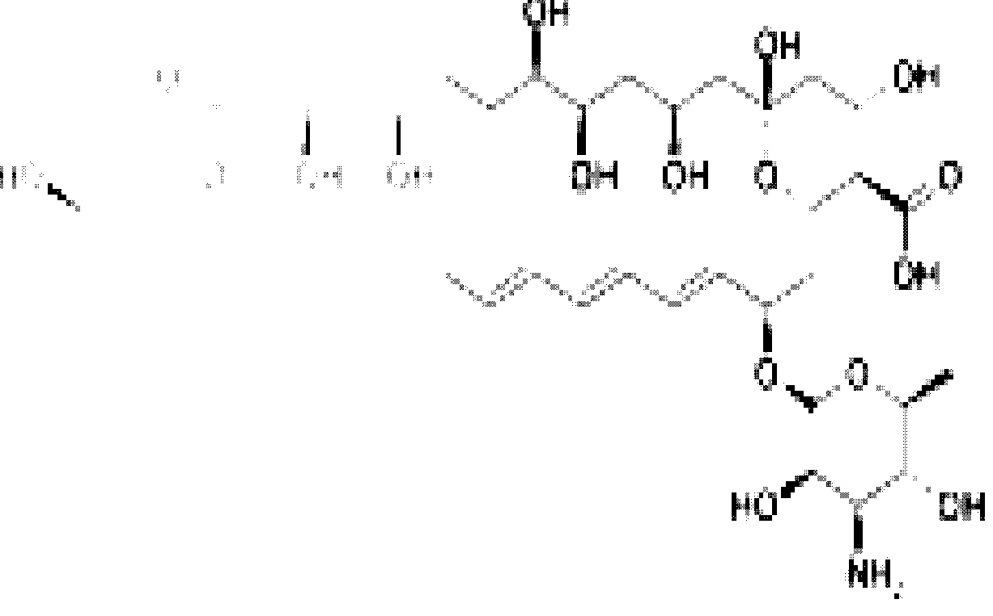

# AMPHOTERICIN B

Two amphotericins, Amphotericin A and Amphotericin B are known, but only B is used

clinically because it is significantly more active in vivo. Currently the drug is available as

plain Amphotericin B, as liposomal formulation.

# Mechanism of Action

cholesteryl sulfate complex, such as lipid

complex, and as

As with other polyene antifungals, amphotericin B associates with ergosterol, the main

component of fungal cell

membranes, forming a transmembrane channel

that leads to K+

leakage and fungal cell death. Recently, however, researchers found evidence that pore

formation is not necessarily linked to cell death. The actual mechanism of action of this agent

may be more complex and multi-faceted.

# NYSTATIN

Like many other antifungals and antibiotics, Nystatin is of bacterial origin. It was isolated

from *Streptomyces noursei* in 1950 by Elizabeth Lee Hazen and Rachel Fuller Brown, who

were doing research for the Division of Laboratories and Research of the New York State

Department of Health. . It has the following structural formula:

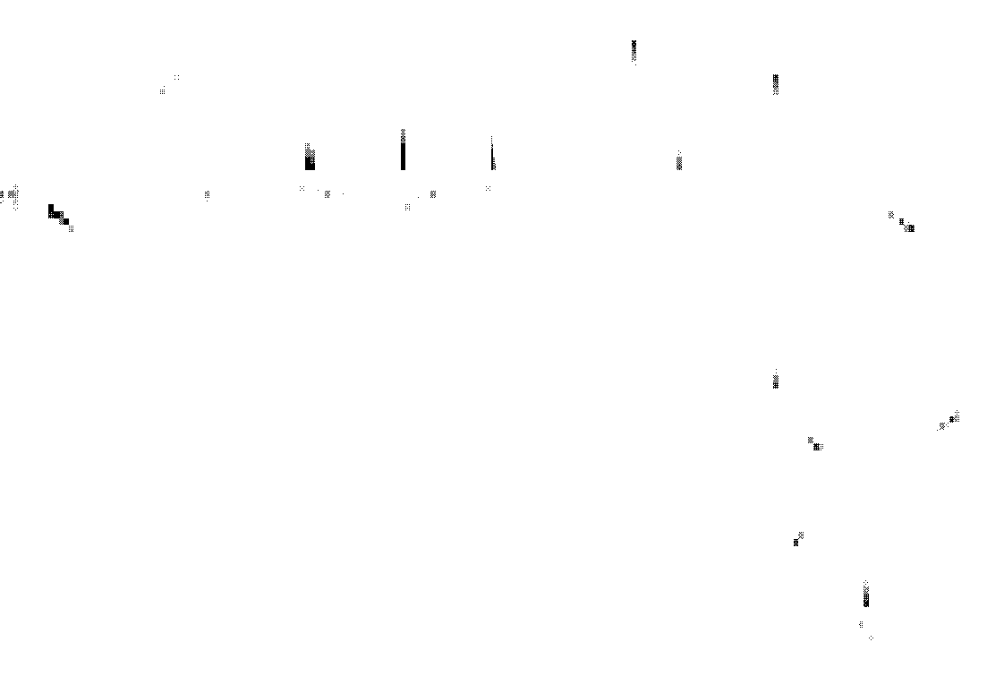

# NYSTATIN

Nystatin applied mildew-infested tangerine effectively control the growth of the pathogenic

fungal spores. In certain cases, Nystatin has been used to prevent the spread of mold on

objects such as works of art. For example, it was applied to wood panel paintings damaged as

a result of the Arno River Flood of 1966 in Florence, Italy.

# Mechanism of Action

Like amphotericin B and natamycin, nystatin binds to ergosterol, a major component of the

fungal cell membrane. When present in sufficient concentrations, it forms pores in the membrane that lead to K+ leakage and death of the fungus. Ergosterol is fairly unique to

fungi, so the drug does not have such catastrophic effects on animals.

# 2. 3. 2 IMIDAZOLE, TRIAZOLE AND THIAZOLE ANTIFUNGALS

The imidazole and triazole drugs are synthetic antifungal drugs that inhibit the enzyme cytochrome P450 14α-demethylase. This enzyme converts lanosterol to ergosterol, and is required in fungal cell membrane synthesis. These drugs also block steroid synthesis in humans.

Example of Imidazoles are Miconazole (miconazole nitrate) , Ketoconazole , Clotrimazole (marketed as Canesten), Econazole , Bifonazole , Butoconazole, Fenticonazole , Isoconazole, Oxiconazole , Sertaconazole, Sulconazole , and Tioconazole .

Example of Triazoles are Fluconazole , Itraconazole , Isavuconazole , Ravuconazole , Posaconazole , Voriconazole and Terconazole. These are newer, less toxic and more effective than the imidazoles.

Example of Thiazole is Abafungin .

# MICONAZOLE

Miconazole is an imidazole antifungal agent, developed by Janssen Pharmaceutica, and commonly applied topically (to the skin) or mucus membranes to cure fungal infections. And it has the following structural formula:

# MICONAZOLE

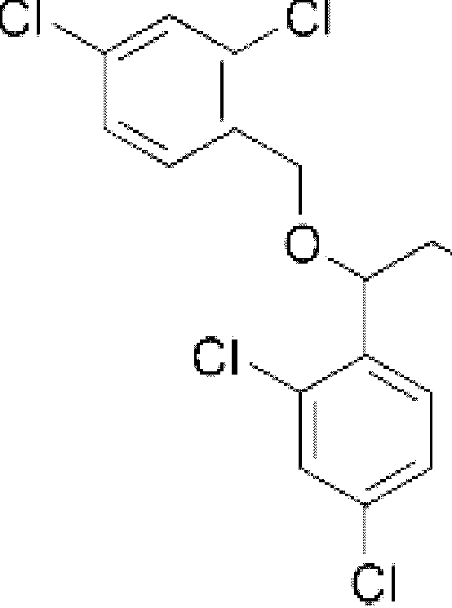

**Mechanism of Action**

It works by inhibiting the synthesis of ergosterol, a critical component of fungal cell

membranes. It can also be used against certain species of Leishmania protozoa (which are a

type of unicellular parasite), as these also contain ergosterol in their cell membranes. In

addition to its antifungal and antiparasitic actions, it also has some limited antibacterial

properties. Maketed as Daktarin.

Physical properties: The solubilities of miconazole nitrate powder are 0.03% in water, 0.76%

in ethanol and up to 4% in acetic acid.

# KETOCONAZOLE

Ketoconazole is cis-1-acetyl-4-[4-[[2-(2, 4-dichlorophenyl)-2-(1H-imidazol-1-ylmethyl)-1, 3-

dioxolan-4-yl]methoxyl]phenyl] piperazine and has the following structural formula:

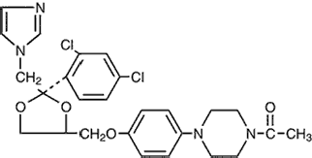

# KETOCONAZOLE

Ketoconazole is a white to slightly beige, odorless powder, soluble in acids, with a molecular

weight of 531.44.

Ketoconazole is a synthetic antifungal drug used to prevent and treat skin and fungal

infections, especially in immunocompromised patients such as those with AIDS.

Ketoconazole is very lipophilic, which leads to accumulation in fatty tissues. The less toxic

and more effective triazole compounds fluconazole and Itraconazole have largely replaced

Ketoconazole for internal use. It is best absorbed at highly acidic levels, so antacids or other

causes of decreased stomach acid levels will lower the drug's efficacy when taken orally.

Ketoconazole was discovered in 1976 and released in the early 1980s, and was one of the

first available oral treatment for fungal infections (Griesofulvin was available before

Ketoconazole).

Mechanism of action

Ketoconazole interferes with the fungal synthesis of ergosterol, a constituent of cell membranes. It is specific for fungi, as the equivalent mammalian pathway, leading to the biosynthesis of cholesterol, is not sensitive to Ketoconazole. However, other mammalian cytochrome P450 enzymes can be sensitive to Ketoconazole, and inhibition of steroid hormone synthesis is a possible side effect of Ketoconazole treatment (Martindale 1996).

As with all azoles antifungal agents, Ketoconazole works principally by inhibition of an enzyme, cytochrome P450 14-alpha-demethylase (P45014DM). This enzyme is in the sterol biosynthesis pathway that leads from lanosterol to ergosterol. Fluconazole and Itraconazole have been found to have a greater affinity for fungal cell membrane than Ketoconazole, and thus lower doses of these azoles are required to kill fungi.

# Sensitive Fungi

Ketoconazole inhibits growth of dermatophytes and yeast species such as *Candida albicans*. Resistance to Ketoconazole has been observed in a number of clinical fungal isolates, including *C. albicans*. Defects in the sterol 5-6 desaturase enzyme reduce the toxic effects of azole inhibition of the 14-alpha demethylation step. MDR or multidrug resistance genes can also play a role in reducing cellular levels of the drug. As azole antifungals all act at the same point in the sterol pathway, resistant isolates are normally cross-resistant to all members of the azole family.

# Hair Loss Benefits

A study in mice indicated that Ketoconazole may have a stimulatory effect on hair growth.

Nizoral shampoo has shown to be beneficial in men suffering from androgenic alopecia.

Results so far indicate that both the 1% and 2% dosages have positive hair loss benefits;

however the more potent

2% formulation could have better results.

Optimal usage is

speculated at every third day, leaving the shampoo on the scalp for 3-5 minutes before

rinsing.

# FLUCONAZOLE

Fluconazole is a triazole antifungal drug used in the treatment and prevention of superficial

and systemic fungal infections. In a bulk powder form, it appears as a white crystalline

powder, and it is very slightly soluble in water and soluble in alcohol. It is commonly

marketed under the trade name Diflucan or Trican (Pfizer) and Alfumet. And it has the

following structural formula:

# FLUCONAZOLE

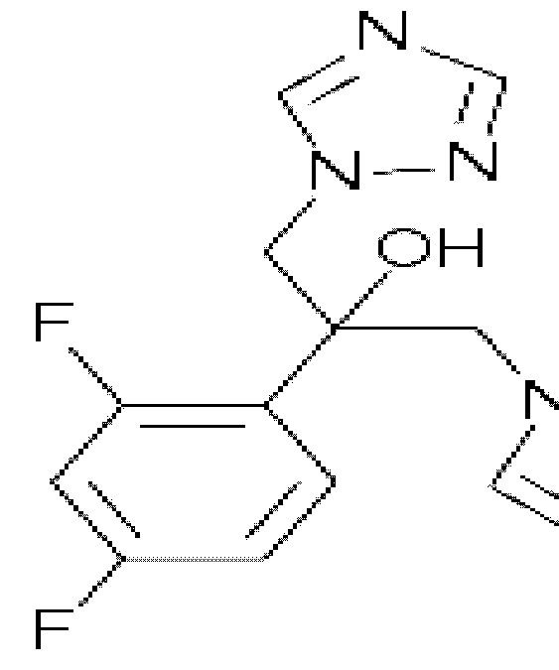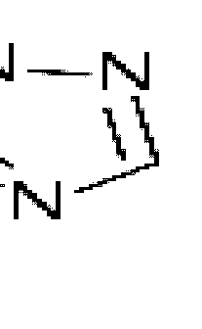

**Mechanism of Action**

Like other imidazole- and triazole-class antifungals, fluconazole inhibits the fungal cytochrome P450 enzyme 14α-demethylase. Mammalian demethylase activity is much less sensitive to fluconazole than fungal demethylase. This inhibition prevents the conversion of lanosterol to ergosterol, an essential component of the fungal cytoplasmic membrane, and subsequent accumulation of 14α-methyl sterols. Fluconazole is primarily fungistatic, however may be fungicidal against certain organisms in a dose-dependent manner (Orozco *et al* 1998).

# Sensitive Fungi

Fluconazole is active against the following microorganisms:

*Blastomyces dermatitidis, Candida* spp. (except *C. krusei* and *C. glabrata* Candida albicans), *Coccidioides immitis, Cryptococcus neoformans, Epidermophyton* spp., *Histoplasma capsulatum*, *Microsporum* spp.and *Trichophyton* spp.

As shown in the pathway below, the elimination by the antifungals is done at different sites during the synthesis of essential fungal sterol ergosterol:-

Fig 2.1 Pathway for synthesis of the essential fungal sterol ergosterol and the sites of inhibition by the antifungal agents Terbinafine, Imidazoles and Triazoles (Stephen *et al* 2005).

# ITRACONAZOLE

Itraconazole (marketed as Sporanox), invented in 1984, is a triazole antifungal agent that is prescribed to patients with fungal infections. The drug may be given orally or intravenously.

# Mechanism of Action

The mechanism of action of itraconazole is the same as the other azole antifungals: it inhibits the fungal cytochrome P450 oxidase-mediated synthesis of ergosterol.

# Indication

Itraconazole has a broader spectrum of activity than fluconazole. In particular, it is active against Aspergillus spp which is resistant to fluconazole. It is also use in blastomycosis, histoplasmosis and onychomycosis.

# 2. 3. 3 ALLYLAMINES

Allylamines inhibit squalene epoxidase, another enzyme required for ergosterol synthesis. Examples are: Terbinafine (marketed as "Lamisil"), Amorolfine , Naftifine , and Butenafine.

# 2.3.3.1 TERBINAFINE HYDROCLORIDE

Terbinafine hydrochloride (commonly marketed as Lamisil, Terbisil and Zabel) is a synthetic allylamine antifungal. It is highly lipophilic in nature and tends to accumulate in skin, nails, and fatty tissues. It has the following structural formula:

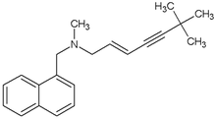

# TERBINAFINE

Terbinafine hydrochloride is a white fine crystalline powder that is freely soluble in methanol and dichloromethane, soluble in ethanol, and slightly soluble in water.

# Mechanism of Action

Like other allylamines, terbinafine inhibits ergosterol synthesis by inhibiting squalene epoxidase, an enzyme that is part of the fungal cell membrane synthesis pathway. Because terbinafine prevents conversion of squalene to lanosterol, ergosterol cannot be synthesized. This has been reported to change cell membrane permeability (Ehinmidu 2004).

# 2. 3. 4 ECHINOCANDINS AND OTHERS

Echinocandins inhibit the synthesis of glucan in the cell wall, probably via the enzyme 1,3-β glucan synthase: examples, Anidulafungin, Caspofungin, and Micafungin

Other antifunal agents are: Benzoic acid – has antifugal properties but must be combined with a keratolytic agent such as in Whitfield's Ointment, Ciclopirox – (ciclopirox olamine), most useful against *Tinea versicolour*, Tolnaftate , Undecylenic acid – (an unsaturated fatty acid derived from natural castor oil; fungistatic as well as anti-bacterial and anti-viral),

Flucytosine or 5-fluorocytosine – an antimetabolite, Griseofulvin, Haloprogin , and Sodium

bicarbonate (NaHCO3).

# GRISEOFULVIN

Griseofulvin (marketed as Grisovin and fulcin) is an antifungal drug. It is used both in

animals and in humans, to treat ringworm infections of the skin and nails. It is derived from

the mold *Penicillium griseofulvum*. This antifungal agent has the following structural

formula:

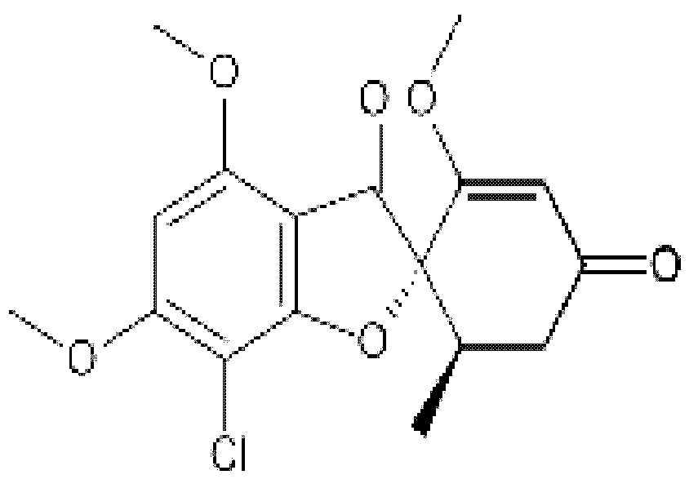GRISEOFULVIN

# Mechanism of Action

It binds to keratin in keratin precursor cells and makes them resistant to fungal infections. It

is only when hair or skin reaches its site of action.

is replaced by the keratin-griseofulvin complex that the drug Griseofulvin will then enter the dermatophyte through energy

dependent transport processes and bind to fungal microtubules. This alters the processing for

mitosis and also underlying information for deposition of fungal cell walls.

# Potential for Cancer Treatment

When cancer cells divide (undergo mitosis), they use an unusual mechanism to ensure the

correct genetic material is

present within each of the resulting tumor

cells. Laboratory

experiments at the German Cancer Research Center (Deutsches Krebsforschungszentrum,

DKFZ) show that griseofulvin causes cancer cells to fail to divide the chromosomes

correctly, which eventually leads to tumor cell death. Griseofulvin does not interfere with

cell division in healthy cells. The observed effect is not strong, but is significant.

Griseofulvin may be combined with other treatments to improve its effectiveness and may

lead to the development of more effective future drug treatments with very low toxic side

effects.

# BENZOIC ACID

Benzoic acid, C7H6O2 (or

C6H5COOH), is a colorless crystalline solid

and the simplest

aromatic carboxylic acid. The name derived from gum benzoin, which was for a long time

the only source for benzoic acid. This weak acid and its salts are used as a food preservative.

Benzoic acid is an important precursor for the synthesis of many other organic substances. .

And it has the following structural formula:

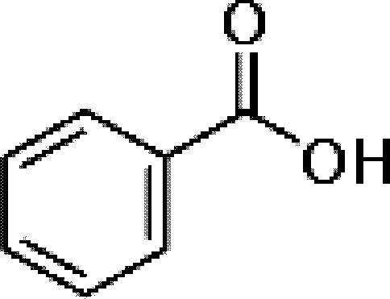

BENZOIC ACID

Benzoic acid was discovered in the 16th century. The dry distillation of gum benzoin first described by Nostradamus (1556), and subsequently by Alexius Pedemontanus (1560) and Blaise de Vigenère (1596).

# Uses

In 1875 Salkowski discovered the antifungal abilities of benzoic acid, which was used for a long time in the preservation of benzoate-containing cloudberry fruits. As Food preservative Benzoic acid and its salts are used as a food preservative, represented by the E-numbers E210, E211, E212, and E213. Benzoic acid inhibits the growth of mold, yeast and some bacteria. It is either added directly or created from reactions with its sodium, potassium, or calcium salt. The mechanism starts with the absorption of benzoic acid in to the cell. If the intracellular pH changes to 5 or lower, the anaerobic fermentation of glucose through phosphofructokinase is decreased by 95%. The efficacy of benzoic acid and benzoate is thus dependent on the pH of the food. Acidic food and beverage like fruit juice (citric acid), sparkling drinks (carbon dioxide), soft drinks (phosphoric acid), pickles (vinegar) or other acidified food are preserved with benzoic acid and benzoates. Typical levels of use for benzoic acid as a preservative in food are between 0.05 – 0.1%.

# SODIUM PROPIONATE

Sodium propionate or sodium propanoate is the sodium salt of propionic acid which has the

chemical formula Na(C2H5COO). Physical Properties: Molecular formula C3H5NaO2, Molar

mass 96.07, appearance. Transparent crystals and Melting point289 °C. And it has the

following structural formula:

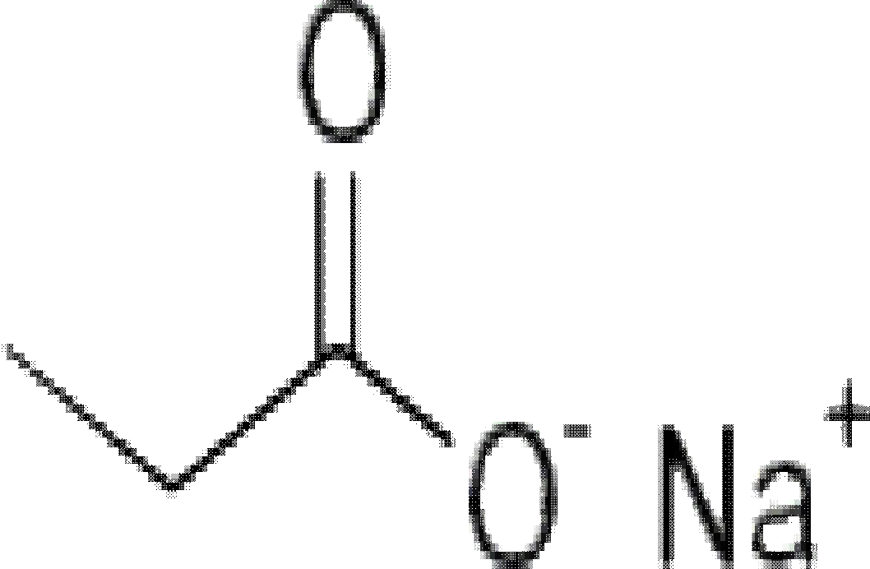

SODIUM PROPIONATE

# Uses

It is used as a food preservative and is represented by the food labeling E number E281 in

Europe. It is used primarily as a mold inhibitor in bakery products.

Other alternatives antifungal agents are: Allicin (created from crushing garlic), Tea tree oil,

Citronella oil, Iodine (Lugols Solution), lemon grass, olive leaf, orange oil, palmarosa oil,

patchouli, lemon myrtle, Neem Seed Oil, Coconut Oil (medium chain triglycerides in the oil

have antifungal activities), Zinc (in dietary supplements or natural food sources, including

pumpkin seeds and chick

peas), and Selenium (in dietary supplements

or natural food

sources, particularly Brazil nuts) (Merck 1999).

# CHAPTER THREE

* 1. **MATERIALS AND METHODS**

# MATERIALS

* + 1. **Antibiotics**

1. Fluconazole (Pfizer Churchgate Towers Afribank Street, PMB 80081. V/Island, Lagos, Nigeria)
2. Terbinafine Hydrochloride (EVANS MEDICAL PLC KM 32 Lagos Badagry Expessway,Agbara Indusrial Estate, Ogun State, Nigeria
3. Ketoconazole nitrates (EVANS MEDICAL PLC KM 32 Lagos Badagry Expessway,Agbara Indusrial Estate, Ogun State,, Nigeria)
4. Sodium propionate (BROADBAND HOLDRS Chemical Ltd Poole England)
5. Griseofulvin (HOVID Bhd.,121, Jalan Abdul Rahman, 30010 Ipoh,Perak, Malaysia)

# Chemicals

* + - 1. Ethanol (Sigma-Aldrich-Laborochemikalein GmBH, Germany)
      2. Tween 80 (BROADBAND HOLDRS Chemical Ltd Poole England)
      3. Sodium chloride (BROADBAND HOLDRS Chemical Ltd Poole England)

# Culture Media

* + - 1. Sabouraud’s Dextrose Agar (SDA) (Oxoid Ltd, Basingstoke Hampshire England)
      2. Sabouraud’s Dextrose liquid medium (SDLM) (Oxoid Ltd, Basingstoke Hampshire England)

# Test Organisms

* + - 1. *Rhizopus stolonifer*
      2. *Aspergillus niger*
      3. *Aspergillus flavus*
      4. *Penicillum citrinum*

All organisms were previously isolated from yam rot and obtained from Prof J. O. Ehinmidu of the Dept of Pharmaceutics. & Pharmaceutical. Microbiology, Ahmadu Bello University, Zaria, Nigeria.

# 3.1.5. Equipments

Automatic pipette, Autoclave, Incubator, weighing balance, Fridge, Oven and Bunsen burner

# METHODS

* + 1. **Determination of Zone of Inhibition using the Cup plate method**

The single strength SDA (20ml) prepared were melted and poured into sterile plates aseptially. They were then allowed to solidify. Standardized spore suspension of the fungal at 106 cfu/ ml was used to flood the agar surface. The number 4 (6mm) sterile cork borer was flamed red hot, allowed to cool and used to bore holes in the agar. Secondly, various

concentrations (2000, 1500, 1000, 500, 250 and 100μg/ml) of the different anti-fungal agents were prepared. Then, 100μl of the varying concentrations were dispensed into each of the holes on the SDA. The plates were allowed to stand for an hour and later incubated at 30ºC for 48hours. The zones of inhibition were measured using a well calibrated transparent meter ruler.

The same procedure was repeated using similar concentrations for Fluconazole, Terbinafine, Ketoconazole, Sodium propionate and Griseofulvin.

# Determination of Minimum Inhibitory Concentration (MIC) using Agar Dilution method.

Ten milliliters (10mls) volume of double strength SDA was melted and mixed aseptically with 10mls volume of varying concentration of the test anti-fungal agents such as Fluconazole viz 2, 5, 10, 20, 40, 60, 100, 200, 500, 1000, 2000 and 4000 (μg/ml). Each admixture was aseptically poured into sterile plates and allowed to set. The standardized spores of test fungi (106 cfu spores/ml) were aseptically inoculated (10.0 μl) in duplicates on sterile filter paper disc plated at equidistance on the SDA test antifungal plates.

The inoculated organisms were allowed to diffuse for a period of 30minutes. The plates were then incubated at 30ºC for 48hours. The first lowest concentration that showed no growth of inoculated test fungi spores was considered as the MIC of the test anti-fungal agent.

# Determination of Minimum Fungicidal Concentration (MFC)

In determining the MFC of the different anti- fungal agents, the filter paper disc that showed no growth were aseptically transferred into the already prepared Saboraud Dextrose Liquid medium. These were then incubated at 30ºC for 72hours in an incubator. Visual observations for any visible growth were made. The lowest concentration of each of the anti-fungal agents that showed no visible growth was taken as the MFC of the test anti-fungal agent.

# Determination of Fractional Inhibitory Concentration (FIC) of Admixture using Agar Dilution method.

Each varying concentrations of the test anti-fungal sub-inhibitory level (e.g. Sodium propionate 50, 100, 200, 300, 500μg/ml) in 5mls volume each were mixed with fixed sub- inhibitory concentration of another test anti-fungal agents (e. g. Fluconazole 500μg/ml) in same 5mls. Each of these admixtures in 10ml volume was mixed with melted 10ml volume of sterilized double strength of SDA aseptically in a Petri-dish. This was allowed to set. 10μml of standardized fungi spores (106 cfu/ ml) were inoculated on a sterile duplicate filter paper discs aseptically placed at equidistance on the test anti-fungal agents contained in the SDA.

The inocula were allowed to diffuse into the SDA for 30minutes. These were then incubated at 30ºC for 48hours and the lowest mixed concentration of test-antifungal agents that showed no growth was taken as combined anti-fungal agents MIC.

This same procedure was carried out for other anti-fungal agents combination such as Terbinafine/Sodium propionate.

# Determination of Fractional Fungicidal Concentration (FFC) of Admixtures

In determining the combined FFC of admixture of test anti-fungal agents, the filter paper disc that showed no visible growths during combined MIC of test antifungal agents were aseptically transfered into 5ml volume of the sterilized Saboraud Dextrose Liquid medium supplemented with 5% tween 80and 3%w/v yeast extract determinations. These were then incubated at 30ºC for 72hours, the lowest concentration of combined anti-fungal agents that showed no growth was taken as the combined test antifungal agents FFC.

* + 1. **Determination of rate of kills of the resistant test fungal spores (*Rhizopus stolonifer*).**

This was done using *Rhizopus stolonifer* in contact with graded concentration of test antifungal agents alone (e.g. Fluconazole 10,000μg/ml) and in combination (e.g. Fluconazole 5000μg/ml and Sodium propionate 5000μg/ml). Fluconazole was prepared in 9mls sterile distilled water with 25% ethanol such that when 1ml of 10 cfu/ml of the test organism was added it gave a concentration of 10, 000μg/ml in the 10mls. Samples were then taken at 5, 20, 30, 45, 60minutes interval and diluted by ten fold dilution protocol with sterile normal saline with 5% tween-80 (to inactivate the antifungal agent). These were then plated out on SDA with 3%v/v Tween 80 in duplicates and incubated at 30ºC for 24hours. Colonies were

counted using a colony counter. The same procedure was also followed in the case of the combination.

A graph of spores survival colonies plotted against time to display the rate of kill of the resistant test organism by the test-antifungal agents.

# Biocidal Activities of different concentrations of the test anti-fungal agents against

***Rhizopus stolonifer* at 30minutes contact time***.*

This was done as in the rate of kill of test fungal spores procedure above. In this case the contact time was 30mins at varying concentrations of test anti-fungal agents (e.g. In Fluconazole 1000μg/ml, 2000μg/ml, 3000μg/ml, 4000μg/ml, and 5000μg/ml concentrations) were used. 1ml of fungal spore and test antifungal agents admixture was taken after 30minutes contact time and ten-fold dilution were carried out with inactivating 9mls sterile normal saline with 5% tween 80. These dilutions were plated out with 20mls of melted SDA (45ºC) containing 3% tween 80. Plates were allowed to set and incubated at 30ºC for 18hours.

# Determination of suitable concentration of Sodium Metabisulphite as stabilizing agent of the test anti-fungal agents.

Different concentrations (0.01% to 1%) of the Sodium Metabisulphite were used in combination with Fluconazole 5000μg and Sodium propionate 5000μg per ml. The pH of each admixture was taken daily for seven days and the Values obtained recorded.

# Formulations of potential fungicide combinations.

Based on the Minimum Fungicidal Concentration (MFC), the rate of kill and the threshold values at 30mins contact time, values of the combinations, six new products were formulated:

# Product I

Fluconazole /Sodium propionate fungicide 5000μg/5000μg per ml.

Fluconazole 500mg Sodium propionate 500mg

Sodium Metabisulphite 10mg

Ethanol 25ml

Sterile Distilled Water to 100ml

# Product II

Ketoconazole /Sodium propionate fungicide 2000μg/5000μg per ml.

Ketoconazole 200mg Sodium propionate 500mg

Sodium Metabisulphite 10mg

Ethanol 25ml

Sterile Distilled Water to 100ml

# Product III

Terbinafine Hcl / Sodium propionate fungicide 500μg/5000μg per ml.

Terbinafine Hcl 50mg Sodium propionate 500mg

Sodium Metabisulphite 10mg

Ethanol 25ml

Sterile Distilled Water to 100ml

# Product IV

Fluconazole/Griseofulvin fungicide 5000μg/5000μg per ml.

Fluconazole 500mg Griseofulvin 500mg

Sodium Metabisulphite 10mg

Ethanol 25ml

Sterile Distilled Water to 100ml

# Product V

Ketoconazole /Griseovulvin fungicide 2000μg/5000μg per ml.

Ketoconazole 200mg Griseofulvin 500mg

Sodium Metabisulphite 10mg

Ethanol 25ml

Sterile Distilled Water to 100ml

# Product VI

Terbinafine Hcl/ Griseofulvin fungicide 500μg/5000μg per ml.

Terbinafine Hcl 50mg Griseofulvin 500mg

Sodium Metabisulphite 10mg

Ethanol 25ml

Sterile Distilled Water to 100ml

Procedure

All solids were dissolved in the 25% ethanol and made up to 100ml with Sterile Distilled Water. All these must be done under aseptic conditions.

# Determination of Effect of varying pH values on the antifungal activities of the formulated fungicide combinations:

Three different pH values (pH 4, 7, and 9) were used, which was obtained and maintained using pH buffers. The buffer powder was added to the Formulated product which is in 10mls volume with sterile distilled water. The content was allowed to stand for 30minutes.

The standardized cultures of the test fungi spores was used to flood the SDA plates which was allowed to dry at 37 ºC in a sterile incubator. Using the cup plate method, a sterile cork borer (6mm diameter) was used to make a hole in each of the agar plates. The bottom sealed with two drops of the melted SDA at 45 ºC.

0.1ml of the fixed concentration of the formulated product and sterile distilled water +25% Ethanol (which served as control) was then dispensed into the holes using micropipette. This was allowed diffuse into the agar at room temperature for one hour after which it was incubated at 30 ºC for 48 hours. The zones of inhibition were then measured to the nearest millimeters.

This procedure was carried out in duplicates and the same method used for the other pH values.

# Determination of Effect of varying temperature on the activities of the formulated fungicide combinations:

Same procedure was carried out as in the case of pH study. The formulated product was dissolved in sterile distilled water, giving a known concentration of the test agent (1/20 of the concentrates). The set up was maintained at different temperatures (37 ºC, 45 ºC, 70 ºC, and 100 ºC) in the water bath for 30minutes. 0.1 ml of the product solution was aseptically transferred into the already made holes in the standardized test fungal spores suspension flooded sterile SDA plates and incubated at 30ºC for 48hours. Positive (flooded sterile SDA plates without the test agents) and negative (unflooded sterile SDA plates with the chemical agent) controls were also set up. The zones of inhibition of the test organism were then measured using a well calibrated meter rule.

# Determination of Effect of duration of storage on the antifungal activities of the formulated fungicide combinations:

A solution of the formulated products was prepared in 10ml volume with sterile distilled water at regular intervals during the six months. At interval of 1month, solution of the formulation prepared was aseptically assessed for antifungal activity using the agar well diffusion method. 0.1ml of the product solution was aseptically dispensed into the bored hole in the SDA containing the test organism. The plates were then allowed to stand for 1hour for diffusion. Positive and negative controls were set up and the plates were incubated at 30ºC for 48 hours and the results of the zone of inhibition taken appropriately.

# Determination of *In-vivo* antifungal activity of the formulated fungicide combinations.

This was determined by inoculating 0.1ml of 106cfu/ml of the test fungal spores suspension in a shallow pit made on the surface of sliced yams predipped in a fixed concentrations test antifungal agent. The yam slices was placed in a desiccant free 70% alcohol-disinfected cubic plastic desiccators cabinet (Aldrich). Two Petri dishes, each containing 10ml of Normal saline water 70% relative humidity, placed at the end of the cabinet to keep it inside environment moist. Control sliced yam predipped in sterile distilled water was also inoculated with 0.1ml of standardized 106cfu/ml fungal spores in the cabinet. These sliced yams were incubated at 27± 2 ºC for 7days at 70% relative humidity (Philip and Malcolm 1992). The level of fungal infection of the sliced yam was then observed and recorded.

# Water analysis

The analysis of metallic ions in the different types of water that was used for the dilution of the formulated fungicide combinations by farmers was carried out in National Research Institute for Chemical Technology (NARICT) and National Animal Production Research Institute (NAPRI) using Atomic Absorption Spectrophotometer by Shimadzu, model AA6800 and Double Beam Atomic Absorption Spectrophotometer by Shimadzu, model AA650 respectively.

# Determination of the presence of organic matter in the different types of water.

This was done using beakers which were cleaned, labeled and weighed. 100mls of the different water was measured and poured into the already labeled beakers, put into a water bath set at 100ºC. The beakers were left in the water bath until all the waters evaporated, transferred into a hot (60 ºC) air oven for 30minutes and weighed again.

The difference in the weight of these beakers before and after the evaporating process of the different types of water represents the quantity of the organic matter in them.

# CHAPTER FOUR

* 1. **RESULTS**

# Zone of inhibition

Observation from this study showed that activity of Fluconazole, Terbinafine, Ketoconazole, Sodium propionate and Griseofulvin in term of zone of inhibition was found to be concentration dependent. The results in table 4.1.1 and 4.1.2 show that Terbinafine was the most effective among the antifungal agents used followed by Fluconazole in contrast to sodium propionate and Griseofulvin which showed the least activity as reported in tables

4.1.4 and 4.1.5 respectively. *Aspergillus flavus* was found to be the most susceptible organism.

**Table 4.1.1** Zone of inhibition of Fluconazole against *Aspergillus flavus, Aspergillus niger,*

*Penicillium citrinum and Rhizopus stolonifer* at 30 ºC for 48 hours.

|  |  |  |  |  |
| --- | --- | --- | --- | --- |
| Test antifungal Concentration | *Aspergillus flavus* | *Aspergillus niger* | *Penicillium citrinum* | *Rhizopus stolonifer* |
| (μg/hole) | (mm) | (mm) | (mm) | (mm) |
| 200 | 41.5±0.70 | 33.5±0.70 | 34.5±0.70 | 20.5±0.70 |
| 150 | 41.0±1.40 | 32.5±0.70 | 31.5±0.70 | 20.0±0.00 |
| 100 | 38.5±0.70 | 31.5±0.70 | 30.0±0.00 | 15.5±0.70 |
| 50 | 38.0±0.00 | 30.5±0.70 | 29.5±0.70 | 15.0±0.00 |
| 25 | 35.5±0.70 | 29.5±0.70 | 29.0±1.40 | 14.5±0.70 |
| 10 | 34.0±0.70 | 26.0±0.00 | 24.5±0.70 | 13.0±0.00 |

**Table 4.1.2** Zone of inhibition of Terbinafine against *Aspergillus flavus, Aspergillus niger, Penicillium citrinum and Rhizopus stolonifer* at 30 ºC for 48 hours.

|  |  |  |  |  |
| --- | --- | --- | --- | --- |
| Test antifungal Concentration | *Aspergillus flavus* | *Aspergillus niger* | *Penicillium citrinum* | *Rhizopus stolonifer* |
| (μg/hole) | (mm) | (mm) | (mm) | (mm) |
| 200 | 60.0±0.00 | 58.5±0.70 | 69.5±0.70 | 19.5±0.70 |
| 150 | 59.5±0.70 | 58.0±1.40 | 64.0±0.00 | 15.5±0.00 |
| 100 | 56.0±1.40 | 56.5±0.70 | 62.5±0.70 | 14.0±0.00 |
| 50 | 45.5±0.70 | 54.5±0.70 | 61.5±0.70 | 13.5±0.70 |
| 25 | 45.0±0.00 | 53.5±0.70 | 61.0±0.00 | 12.5±0.70 |
| 10 | 36.5±0.70 | 52.5±0.70 | 57.0±1.40 | Nil |

Nil – no growth

**Table 4.1.3** Zone of inhibition of Ketoconazole against *Aspergillus flavus, Aspergillus niger, Penicillium citrinum and Rhizopus stolonifer* at 30 ºC for 48 hours.

|  |  |  |  |  |  |  |
| --- | --- | --- | --- | --- | --- | --- |
|  | Test antifungal Concentration | *Aspergillus flavus* | *Aspergillus niger* | *Penicillium citrinum* | *Rhizopus stolonifer* |  |
| (μg/hole) | (mm) | (mm) | (mm) | (mm) |  |
|  | 200 | 46.5±0.70 | 23.5±0.70 | 25.0±0.00 | 12.5±0.70 |  |
|  | 150 | 42.5±0.70 | 18.5±0.70 | 24.5±0.70 | Nil |  |
|  | 100 | 35.5±0.70 | 12.0±0.00 | 23.5±0.70 | Nil |  |
|  | 50 | 34.5±0.70 | Nil | 23.0±0.00 | Nil |  |
|  | 25 | 21.0±1.40 | Nil | 15.0±0.00 | Nil |  |
|  | 10 | 20.0±0.00 | Nil | Nil | Nil |  |

Nil – no growth

**Table 4.1.4** Zone of inhibition of Sodium propionate against *Aspergillus flavus, Aspergillus niger, Penicillium citrinum and Rhizopus stolonifer* at 30 ºC for 48 hours.

|  |  |  |  |  |
| --- | --- | --- | --- | --- |
| Test antifungal Concentration | *Aspergillus flavus* | *Aspergillus niger* | *Penicillium citrinum* | *Rhizopus stolonifer* |
| (μg/hole) | (mm) | (mm) | (mm) | (mm) |
| 200 | 20.5±0.70 | Nil | Nil | Nil |
| 150 | 20.0±1.40 | Nil | Nil | Nil |
| 100 | 17.5±0.70 | Nil | Nil | Nil |
| 50 | 16.5±0.70 | Nil | Nil | Nil |
| 25 | 14.0±0.00 | Nil | Nil | Nil |
| 10 | Nil | Nil | Nil | Nil |

Nil – no growth

**Table 4.1.5** Zone of inhibition of Griseofulvin against *Aspergillus flavus, Aspergillus niger, Penicillium citrinum and Rhizopus stolonifer* at 30 ºC for 48 hours.

|  |  |  |  |  |
| --- | --- | --- | --- | --- |
| Test antifungal Concentration | *Aspergillus flavus* | *Aspergillus niger* | *Penicillium citrinum* | *Rhizopus stolonifer* |
| (μg/hole) | (mm) | (mm) | (mm) | (mm) |
| 200 | Nil | Nil | Nil | 16.5±0.70 |
| 150 | Nil | Nil | Nil | 14.5±0.70 |
| 100 | Nil | Nil | Nil | 12.0±0.00 |
| 50 | Nil | Nil | Nil | Nil |
| 25 | Nil | Nil | Nil | Nil |
| 10 | Nil | Nil | Nil | Nil |

Nil – no growth

# Minimum Inhibition Concentration (MIC), Minimum Fungicidal Concentration (MFC), Fractional Inhibitory Concentration (FIC) and Fractional Fungicidal Concentration (FFC).

The MIC investigation as shown in table 4.2.1 shows that all the test antifungal agents displayed inhibitory effect on the different isolates of the test phytopathogenic fungi spores. Fluconazole, Ketoconazole, Terbinafine Hcl, Sodium propionate and Griseofulvin all showed marked antifungal activities with the Terbinafine HCl being the most active antifungal agents when compared with Fluconazole. Sodium propionate and Griseofulvin on the other hand showed lower antifungal activity as shown in table 4.2.1 and 4.2.2.

However, when these test antifungal agents were combined; better antifungal activities were observed with lower concentration because of the synergistic effect of the Fluconazole/Sodium propionate, Ketoconazole/Sodium propionate and Terbinafine Hcl/Sodium propionate (Tables 4.2.4 ̶ 4.2.5).

**Table 4.2.1** Minimum Inhibitory Concentration (MIC) of test antifungal agents against

*Aspergillus flavus, Aspergillus niger, Penicillium citrinum and Rhizopus stolonifer* at 30 ºC

|  |  |  |  |  |  |
| --- | --- | --- | --- | --- | --- |
| for 48 hours (μg/ml). |  | | | | |
| Test antifungal | *Aspergillus* | *Aspergillus* | *Penicillium* | *Rhizopus* |  |
| Agent | *flavus* | *niger* | *citrinum* | *stolonifer* |  |
| Fluconazole  (μg/ml) | 100.0 | 500.0 | 1.0 | 1000.0 |  |
| Terbinafine  (μg/ml) | 1.0 | 10.0 | 1.0 | 50.0 |  |
| Ketoconazole  (μg/ml) | 10.0 | 20.0 | 10.0 | 50.0 |  |
| Sodium propionate  (μg/ml) | 100.0 | 1000.0 | 100.0 | 2000.0 |  |
| Griseofulvin  (μg/ml) | 200.0 | >2000.0 | 100.0 | >2000.0 |  |

**Table 4.2.2** Minimum Fungicidal Concentration (MFC) of test antifungal agents against *Aspergillus flavus, Aspergillus niger, Penicillium citrinum and Rhizopus stolonifer* at 30 ºC for 72 hours. (μg/ml)

|  |  |  |  |  |
| --- | --- | --- | --- | --- |
| Test antifungal  Agent | *Aspergillus*  *flavus* | *Aspergillus*  *niger* | *Penicillium*  *citrinum* | *Rhizopus*  *stolonifer* |
| Fluconazole  (μg/ml) | 500.0 | 1000.0 | 5.0 | 2000.0 |

Terbinafine 250.0 50.0 50.0 250.0

(μg/ml)

Ketoconazole 50.0 250.0 100.0 1000.0

(μg/ml)

Sodium propionate 500.0 >2000.0 >2000.0 >2000.0

(μg/ml)

Griseofulvin >200.0 − >2000.0 − (μg/ml)

**Table 4.2.3** Fractional Inhibitory Concentration (FIC) of Fluconazole in admixtures with Sodium propionate that give complete inhibition of *Aspergillus niger* spores suspension.

MIC of Fluconazole MIC of Sodium propionate

(500.00µg/ml) (2000.00 µg/ml)

|  |  |  |  |  |
| --- | --- | --- | --- | --- |
| Conc. in admix. | FIC | Conc. in admix. | FIC | ∑FICs |
| (µ/gml) |  | (µ/gml) |  |  |
| - | | | | |
| 0.125 | 0.00025 | 400 | 0.200 | 0.20025 |
| 0.250 | 0.00050 | 250 | 0.125 | 0.1255 |
| 0.400 | 0.00080 | 150 | 0.075 | 0.0758 |
| 0.500 | 0.00100 | 150 | 0.075 | 0.076 |
| 0.750 | 0.00150 | 100 | 0.050 | 0.0515 |
|  |  |  |  | ∑= 0.529 |
| Average FICs = ∑FICs = 0.529 = 0.11 | | | | |

n 5

**Table 4.2.4** Fractional Inhibitory Concentration (FIC) of combined Test fungicides against Phytopathogenic fungi spores (106cfu/ml).

|  |  |  |  |  |  |  |
| --- | --- | --- | --- | --- | --- | --- |
|  | Fungicide Combination | *Aspergillus flavus* | *Aspergillus niger* | *Penicillium citrinum* | *Rhizopus stolonifer* |  |
| Fluconazole/ Sodium Propionate | 0.50 | 0.19 | 0.83 | 0.09 |  |
| Terbinafine/ Sodium Propionate | 0.83 | 0.44 | 0.63 | 0.38 |  |
| Ketoconazole/ Sodium Propionate | 0.59 | 0.35 | 0.59 | 0.43 |  |
| Fluconazole/ Griseofulvin | 0.39 | 0.15 | 0.83 | 0.09 |  |
| Terbinafine/ Griseofulvin | 0.71 | 0.39 | 0.83 | 0.38 |  |
|  | Ketoconazole/ Griseofulvin | 0.49 | 0.28 | 0.59 | 0.43 |  |

Key: FIC>4=Antagonistic FIC=1-4=Indifference FIC<1=Synergistic

**Table 4.2.5** Fractional Fungicidal Concentration (FFC) of combined Test fungicides against Phytopathogenic fungi spores (106cfu/ml).

|  |  |  |  |  |
| --- | --- | --- | --- | --- |
| Fungicide Combination | *Aspergillus flavus* | *Aspergillus niger* | *Penicillium citrinum* | *Rhizopus stolonifer* |
| Fluconazole/ Sodium Propionate | 0.19 | 0.11 | 0.29 | 0.07 |
| Terbinafine/ Sodium Propionate | 0.29 | 0.38 | 0.29 | 0.33 |
| Ketoconazole/ Sodium Propionate | 0.43 | 0.35 | 0.26 | 0.14 |
| Fluconazole/ Griseofulvin | 0.13 | _ | 0.29 | _ |
| Terbinafine/ Griseofulvin | 0.22 | _ | 0.29 | _ |
| Ketoconazole/ Griseofulvin | 0.31 | _ | 0.26 | _ |

Key: FFC>4=Antagonistic FFC=1-4=Indifference FFC<1=Synergistic

# Rate of Kill Studies

Results from the rate of kill using the different compound singly and in combination as can be seen in (fig 4.1-4.6) indicate that these compounds have high biocidal activity against the test resistant *Rhizopus stolonifer* spores at varying contact time investigated. This shows that these compounds, though concentration dependent, possess significant biocidal activity against *Rhizopus stolonifer* isolated from yam in Zaria, Nigeria.

Garret & Brown (1964) reported that there is no single concentration of an antimicrobial agent at which all cells in a suspension will be killed instantaneously. Killing of cells occur mainly as a function of time within a range of concentration.

Terbinafine Hcl combination with Griseofulvin produced faster kill (fig 4.3.5) but does not effect a 100% kill until after 45mins, while the combination of Terbinafine Hcl/ Sodium Propionate (fig 4.3.2) produces biocidal effect and 100% kill at 30mins.



Log Cell Survival

8

7

6

5

4

fluconazole

Sod Prop

3

Fluc/Sod Prop

2

1

0

0

5

20

30

45

60

Time (minutes)

Fig 4.3.1 The Survival of *Rhizopus stolonifer* spores in Fluconazole (10,000µg/ml) and Sodium propionate (10,000µg/ml), singly and in combination (5000/5000µg/m) at different time intervals.

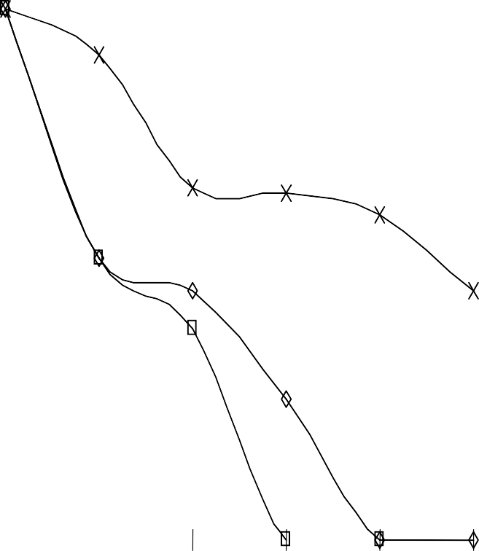

Log Cell Survival

Fig 4.3.2 The Survival of *Rhizopus stolonifer* spores in Terbinafine (1000µg/ml) and Sodium propionate (10,000µg/ml), singly and in combination (500/5000µg/m) at different time intervals.

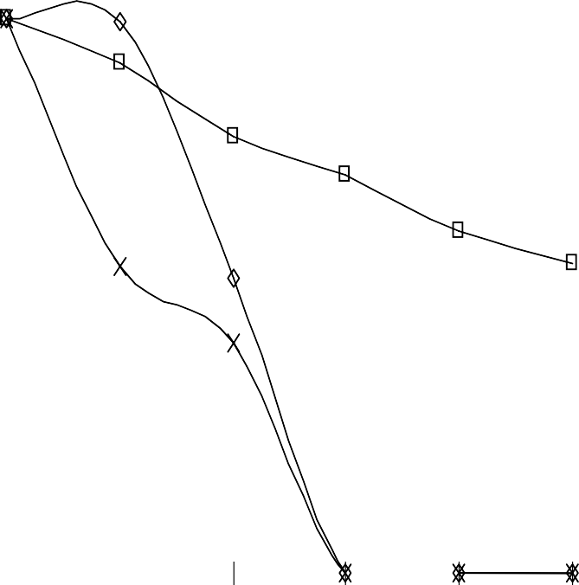

8

7

6

5

4

Terbinafine

Terb/Sod prop

3

Sod prop

2

1

0

0

5

20

30

45

60

Time (minutes)

Log Cell survival

Fig 4.3.3 The Survival of *Rhizopus stolonifer* spores in Ketoconazole (4000µg/ml) and Sodium propionate (10,000µg/ml), singly and in combination (2000/5000µg/m) at different time intervals.

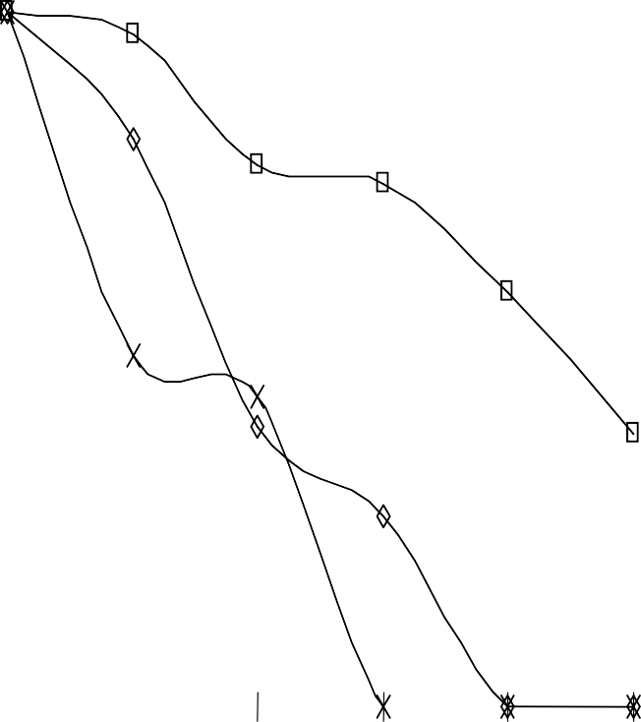

9

8

7

6

5

ketoconazole

4

Keto/Sod Prop

3

Sod Prop

2

1

0

0

5

20

30

45

60

Time (minutes)

Log Cell Survival

Fig 4.3.4 The Survival of *Rhizopus stolonifer* spores in Fluconazole (10,000 µg/ml) and Griseofulvin (10,000µg/ml), singly and in combination (5000/5000µg/m) at different time intervals.

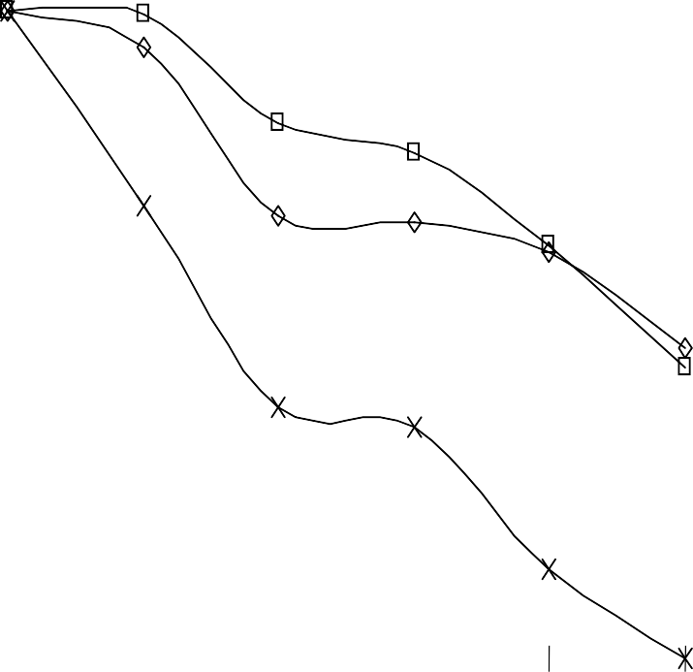

8

7

6

5

Fluconazole

4

Fluco/Griseo

3

Griseofulvin

2

1

0

0

5

20

30

45

60

Time (minutes)

Log Cell Survival

Fig 4.3.5 The Survival of *Rhizopus stolonifer* spores in Terbinafine (1000 µg/ml) and Griseofulvin (10,000µg/ml), singly and in combination (500/5000µg/m) at different time intervals.

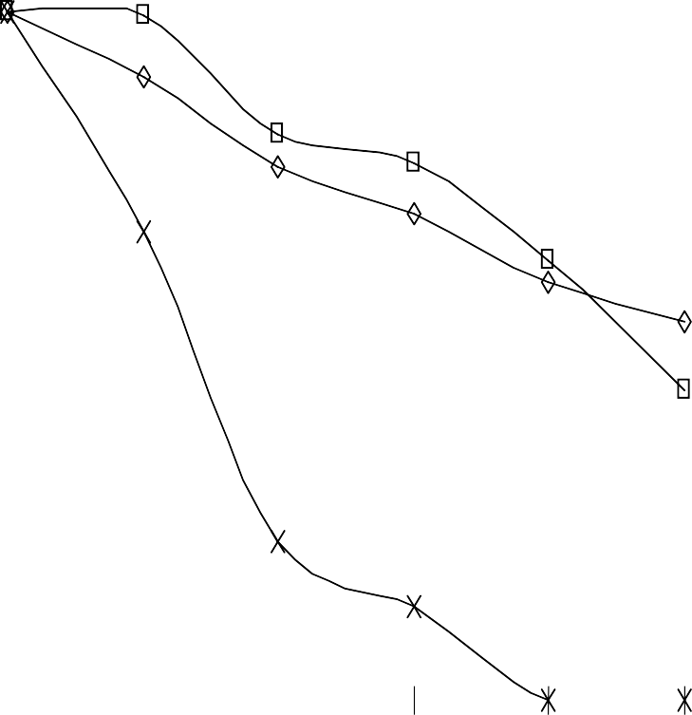

8

7

6

5

Terbinafine

4

Terbi/Griseo

3

Griseofulvin

2

1

0

0

5

20

30

45

60

Time (minutes)

Log Cell Survival

Fig 4.3.6 The Survival of *Rhizopus stolonifer* spores in Ketoconazole (4000 µg/ml) and Griseofulvin (10,000µg/ml), singly and in combination (2000/5000µg/m) at different time intervals.

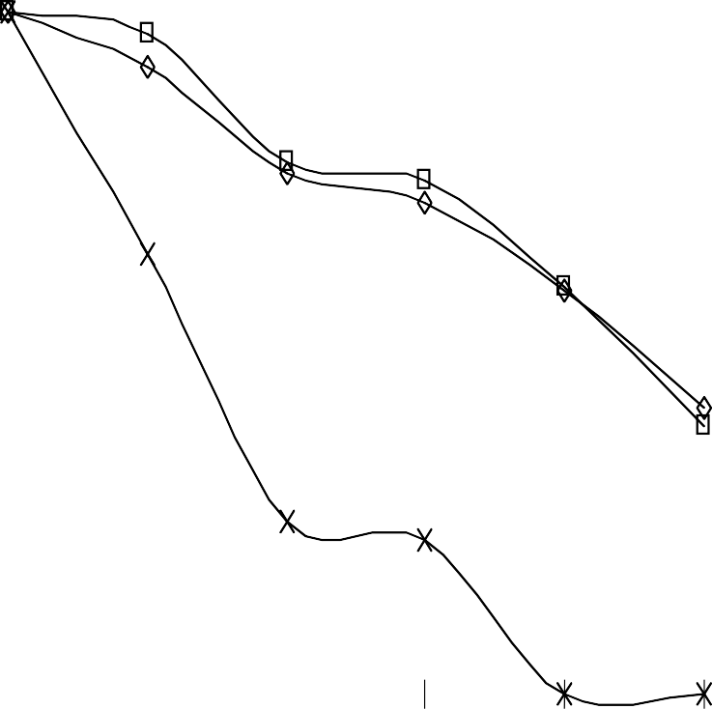

9

8

7

6

5

Ketoconazole

4

Keto/Griseo

3

Griseofulvin

2

1

0

0

5

20

30

45

60

Time (minutes)

# Fungicidal activity of test antifungal agents after 30minutes contact time at different concentrations.

The result obtained in this study showed that at varying concentrations of test antifungal agents, there was rapid biocidal activity until a threshold concentration of 2000 µg/ml for all the test agents. The pattern of biocidal activity of the test antifungal agents were similar as depicted in figure 4.4.1-4.4.4. At a fixed concentration of 2000 µg/ml the D10 values of test antifungal agents were Fluconazole (8.48minutes), Terbinafine hydrochloride (11.36minutes), Griseofulvin (14.25minutes) and Sodium Propionate (14.36minutes).

Furthermore, increase in test antifungal agents biocidal concentration did not decrease significantly the test agents D10 values. For example, the D10 value for Fluconazole at 10,000µg/ml, 2000 µg/ml, 3000 µg/ml, 4000 µg/ml, 5000 µg/ml were 10.37, 8.48, 7.67, 7.45 and 6.32minutes respectively.

An indication of increase in concentration above threshold value has less impact on the biocidal activity of the test agents.

Log Cell Survival

Fig 4.4.1 Graph showing the Influence of varying fungicidal concentrations of Fluconazole on the viability of *Rhizopus stolonifer* spores (107spores/ml) at 25ºC after 30minutes contact time.

9

8

7

6

5

4

Fluconazole

3

2

1

0

0

1000

2000

3000

4000

5000

Concentration (ug/ml)

Log Cell Survival

Fig 4.4.2 Graph showing the Influence of varying fungicidal concentrations of Terbinafine on the viability of *Rhizopus stolonifer* spores (107spores/ml) at 25ºC after 30minutes contact time.

8

7

6

5

4

Terbinafine

3

2

1

0

0

1000

2000

3000

4000

5000

Concentration (ug/ml)

Log Cell Survival

Fig 4.4.3 Graph showing the Influence of varying fungicidal concentrations of Sodium propionate on the viability of *Rhizopus stolonifer* spores (106spores/ml) at 25ºC after 30minutes contact time.

8

7

6

5

4

Sodium prop

3

2

1

0

0

1500

2000

2500

3000

3500

Concentration (ug/ml)

Log Cell Survival

Fig 4.4.4 Graph showing the Influence of varying fungicidal concentrations of Griseofulvin on the viability of *Rhizopus stolonifer* spores (108spores/ml) at 25ºC after 30minutes contact time.

Concentration (ug/,ml)

3500

3000

2500

2000

1500

0

Griseofulvine

10

9

8

7

6

5

4

3

2

1

0

# The pH of combined Antifungal Agents using varying concentration of Sodium Metabisulphite.

The pH value of Terbinafine Hcl//Sodium propionate (500/5000μg/ml) was observed to be concentration of Sodium Metabisulphite dependent. Increase in the concentration of Sodium Metabisulphite was observed to result in decease pH values as demostrated in Table 4.5.

**Table 4.5** The pH values of Terbinafine Hcl//Sodium propionate (500/5000μg/ml) using varying concentration of Sodium Metabisulphite.

|  |  |  |  |  |  |  |  |
| --- | --- | --- | --- | --- | --- | --- | --- |
| Conc | Day | Day | Day | Day | Day | Day | Day |
| % | 1 | 2 | 3 | 4 | 5 | 6 | 7 |
| 0.01 | 6.47 | 6.80 | 6.55 | 6.55 | 6.59 | 6.05 | 6.17 |
| 0.05 | 6.28 | 6.27 | 6.33 | 6.37 | 6.28 | 5.94 | 6.05 |
| 0.10 | 6.14 | 5.91 | 5.93 | 5.93 | 5.68 | 5.37 | 5.43 |
| 0.15 | 5.77 | 5.85 | 5.61 | 5.56 | 5.57 | 5.08 | 5.07 |
| 0.20 | 5.72 | 5.42 | 5.25 | 5.08 | 4.90 | 4.66 | 4.64 |
| 0.25 | 5.64 | 5.30 | 5.27 | 5.22 | 5.20 | 4.76 | 4.87 |
| 0.30 | 5.55 | 5 00 | 5.00 | 5.19 | 4.96 | 4.83 | 4.94 |
| 0.35 | 5.55 | 5.35 | 5.25 | 5.14 | 5.09 | 4.84 | 4.98 |
| 0.40 | 5.46 | 5.37 | 5.28 | 5.18 | 5.20 | 4.74 | 4.86 |

|  |  |  |  |  |  |  |  |
| --- | --- | --- | --- | --- | --- | --- | --- |
| Conc | Day | Day | Day | Day | Day | Day | Day |
| % | 1 | 2 | 3 | 4 | 5 | 6 | 7 |
| 0.45 | 5.36 | 5.26 | 5.10 | 5.10 | 5.10 | 4.77 | 4.94 |
| 0.50 | 5.32 | 5.01 | 5.06 | 5.07 | 4.91 | 4.76 | 4.90 |
| 0.55 | 5.33 | 5.02 | 4.94 | 5.05 | 4.81 | 4.78 | 4.90 |
| 0.60 | 5.30 | 5.24 | 4.92 | 4.94 | 4.96 | 4.68 | 4.81 |
| 0.65 | 5.25 | 4.77 | 4.94 | 4.82 | 5.10 | 4.59 | 4.79 |
| 0.70 | 5.25 | 4.90 | 4.92 | 4.81 | 4.91 | 4.68 | 4.76 |
| 0.75 | 5.17 | 5.04 | 4.81 | 4.81 | 4.92 | 4.66 | 4.82 |
| 0.80 | 5.20 | 5.06 | 4.95 | 4.85 | 4.62 | 4.68 | 4.82 |
| 0.85 | 5.14 | 4.68 | 4.87 | 4.88 | 4.81 | 4.59 | 4.78 |
| 0.90 | 5.15 | 4.88 | 4.79 | 4.94 | 4.82 | 4.65 | 4.62 |
| 0.95 | 5.12 | 4.94 | 4.93 | 4.78 | 4.81 | 4.61 | 4.76 |
| 1.00 | 5.04 | 4.82 | 4.72 | 4.79 | 4.74 | 4.67 | 4.67 |

Terbinafine/Sodium propionate with Sodium Metabisulphite at the 0.01% displayed pH values ranges from 6.05-6.80 which favour optimum antifungal activities at neutral pH values (Table 4.7).

# Effect of varying temperature on the antifungal activity of test compounds.

Results of the effect of temperature on the antifungal activity of the different antifungal compounds on the different type of water shows that at the temperature range of 37ºC, 45ºC, 70ºC and 100ºC, the antifungal activity was significantly reduced at 95% confident limit . This reduction in antifungal activity was antifungal agent combination dependent as demonstrated in table 4.6.1- 4.6.5.

The antifungal activity of Terbinafine/Griseofulvin increased significantly from 37ºC to 70ºC temperatures before reduction commences at 100ºC. The observed antifungal activity of this combination at100ºC was still greater than the one obtained at 37ºC (Table 4.6.6).

From table 4.6.1 to 4.6.3 Sodium propionate combinations with Fluconazole, Terbinafine HCl and Ketoconazole, at temperature of 100ºC displayed decreased antifungal activity compared to lower temperature of 25ºC to70ºC.

Generally when Sodium propionate was in combination of the admixture, the antifungal activity in the different water source was observed to be in the following orders of the adjunct fungicide;

Terbinafine HCl > Ketoconazole > Fluconazole.

Similarly the observed antifungal activity in the different water sources was in the following orders when Griseofulvin was in the admixture;

Terbinafine HCl > Ketoconazole > Fluconazole.

The antifungal activity of Griseofulvin in combination with any of the following antifungal agents viz: Terbinafine HCl, Ketoconazole or Fluconazole was more than that of the combination of Sodium propionate. The antifungal activity potentiated by Griseofulvin was observed to be reduced as from 70ºC temperature unlike Sodium propionate whose antifungal activity reduction started at 45ºC. The combination of Terbinafine HCl/ Griseofulvin at fixed concentration produced the greatest zone of inhibition on *Aspergillus niger* at 45ºC. However increase in temperature from 45 ºC to 100 ºC resulted to decrease in antifungal activity. It was also observed that unboiled Pond, Well, River and Tap waters reduced the antifungal activity of the combine antifungal agents. However when the waters were boiled the antifungal activity of the formulated fungicides combination increased compare to when the water was not boiled (see table 4.6.1 to 4.6.12).

**Table 4.6.1** Effect of heat on activity of Terbinafine HCl/ Griseofulvin diluted with unboiled water sources against growth of *Aspergillus niger.*

Temp ºC zone of inhibition in different unboiled water source

|  |  |  |  |  |  |
| --- | --- | --- | --- | --- | --- |
|  | River | Well | Pond | Tap | Distilled |
| 45 | 63.0±0.00 | 69.0±0.40 | 67.5±0.40 | 68.0±0.70 | 68.5±0.70 |
| 100 | 58.0±2.80 | 54.0±0.70 | 59.2±0.50 | 62.5±0.80 | 52.0±0.00 |

**Table 4.6.2** Effect of heat on activity of Terbinafine HCl/ Griseofulvin diluted with boiled water sources against growth of *Aspergillus niger.*

Temp ºC zone of inhibition in different boiled water source

|  |  |  |  |  |  |
| --- | --- | --- | --- | --- | --- |
|  | River | Well | Pond | Tap | Distilled |
| 45 | 71.0±0.70 | 74.0±0.70 | 72.5±0.50 | 74.0±0.70 | 74.5±050 |
| 100 | 60.0±1.40 | 52.0±1.40 | 55.0±0.70 | 62.0±0.00 | 51.5±2.80 |

**Table 4.6.3** Effect of heat on activity of Terbinafine HCl/ Sodium propionate diluted with unboiled water sources against growth of *Aspergillus niger.*

Temp ºC zone of inhibition in different unboiled water source

|  |  |  |  |  |  |
| --- | --- | --- | --- | --- | --- |
|  | River | Well | Pond | Tap | Distilled |
| 45 | 41.5±1.40 | 49.4±0.70 | 49.5±1.40 | 49.0±0.70 | 53.5±0.70 |
| 100 | 40.0±0.70 | 45.0±0.70 | 40.0±0.70 | 43.0±1.00 | 43.0±1.40 |

**Table 4.6.4** Effect of heat on activity of Terbinafine HCl/ Sodium propionate diluted with boiled water sources against growth of *Aspergillus niger.*

Temp ºC zone of inhibition in different boiled water source

|  |  |  |  |  |  |
| --- | --- | --- | --- | --- | --- |
|  | River | Well | Pond | Tap | Distilled |
| 45 | 49.0±1.40 | 56.5±1.10 | 56.0±1.40 | 55.5±0.70 | 57.5±1.40 |
| 100 | 45.5±0.70 | 56.0±0.70 | 52.0±1.20 | 47.0±0.25 | 55.5±1.40 |

**Table 4.6.5** Effect of heat on activity of Fluconazole/Griseofulvin diluted with unboiled water sources against growth of *Aspergillus niger.*

Temp ºC zone of inhibition in different unboiled water source

|  |  |  |  |  |  |
| --- | --- | --- | --- | --- | --- |
|  | River | Well | Pond | Tap | Distilled |
| 45 | 36.5±2.80 | 34.5±2.80 | 32.0±1.40 | 35.0±0.00 | 32.0±0.70 |
| 100 | 31.0±0.70 | 31.5±2.80 | 32.0±0.00 | 36.0±0.70 | 30.0±2.80 |

**Table 4.6.6** Effect of heat on activity of Fluconazole/Griseofulvin diluted with boiled water sources against growth of *Aspergillus niger.*

Temp ºC zone of inhibition in different boiled water source

|  |  |  |  |  |  |
| --- | --- | --- | --- | --- | --- |
|  | River | Well | Pond | Tap | Distilled |
| 45 | 41.0±1.40 | 47.5±2.80 | 33.5±0.70 | 44.0±0.70 | 42.5±0.70 |
| 100 | 32.5±0.70 | 32.0±0.70 | 31.5±0.70 | 34.5±1.40 | 31.0±0.00 |

**Table 4.6.7** Effect of heat on activity of Fluconazole/ Sodium propionate diluted with unboiled water sources against growth of *Aspergillus niger.*

Temp ºC zone of inhibition in different unboiled water source

|  |  |  |  |  |  |
| --- | --- | --- | --- | --- | --- |
|  | River | Well | Pond | Tap | Distilled |
| 45 | 35.0±1.40 | 32.5±0.70 | 32.5±0.70 | 34.0±0.70 | 35.0±1.40 |
| 100 | 35.0±1.40 | 34.5±0.70 | 36.0±1.40 | 32.0±0.70 | 33.0±0.70 |

**Table 4.6.8** Effect of heat on activity of Fluconazole/ Sodium propionate diluted with boiled water sources against growth of *Aspergillus niger.*

Temp ºC zone of inhibition in different boiled water source

|  |  |  |  |  |  |
| --- | --- | --- | --- | --- | --- |
|  | River | Well | Pond | Tap | Distilled |
| 45 | 42.5±1.40 | 38.5±1.40 | 45.0±1.40 | 44.0±1.40 | 37.0±1.40 |
| 100 | 55.0±1.40 | 35.5±1.40 | 38.0±0.70 | 32.5±0.70 | 35.0±0.70 |

**Table 4.6.9** Effect of heat on activity of Ketoconazole/Griseofulvin diluted with unboiled water sources against growth of *Aspergillus niger.*

Temp ºC zone of inhibition in different unboiled water source

|  |  |  |  |  |  |
| --- | --- | --- | --- | --- | --- |
|  | River | Well | Pond | Tap | Distilled |
| 45 | 40.01±.40 | 39.0±1.40 | 34.0±0.70 | 45.5±1.40 | 45.5±1.40 |
| 100 | 26.0±0.70 | 28.02±.80 | 33.5±0.70 | 28.0±0.00 | 32.0±0.70 |

**Table 4.6.10** Effect of heat on activity of Ketoconazole/Griseofulvin diluted with boiled water sources against growth of *Aspergillus niger.*

Temp ºC zone of inhibition in different boiled water source

|  |  |  |  |  |  |
| --- | --- | --- | --- | --- | --- |
|  | River | Well | Pond | Tap | Distilled |
| 45 | 47.0±0.70 | 41.0±0.00 | 39.0±0.70 | 34.0±0.70 | 55.0±0.70 |
| 100 | 26.0±1.40 | 25.0±2.80 | 32.0±0.00 | 27.00±.00 | 32.0±0.70 |

**Table 4.6.11** Effect of heat on activity of Ketoconazole/Sodium propionate diluted with unboiled water sources against growth of *Aspergillus niger.*

Temp ºC zone of inhibition in different unboiled water source

|  |  |  |  |  |  |
| --- | --- | --- | --- | --- | --- |
|  | River | Well | Pond | Tap | Distilled |
| 45 | 35.0±1.40 | 40.0±0.00 | 42.5±0.70 | 28.0±1.40 | 32.5±1.40 |
| 100 | 34.0±0.70 | 29.0±0.70 | 33.0±1.40 | 28.0±0.70 | 35.0±0.70 |

**Table 4.6.12** Effect of heat on activity of Ketoconazole/Sodium propionate diluted with boiled water sources against growth of *Aspergillus niger.*

Temp ºC zone of inhibition in different boiled water source

|  |  |  |  |  |  |
| --- | --- | --- | --- | --- | --- |
|  | River | Well | Pond | Tap | Distilled |
| 45 | 37.0±1.40 | 38.5±0.70 | 46.0±2.80 | 38.0±2.80 | 35.5±1.40 |
| 100 | 35.0±1.40 | 30.9±0.70 | 34.0±2.80 | 29.0±0.70 | 37.0±0.00 |

# pH of different types of waters before and after autoclaving

**Table 4.7** pH of different types of waters before and after autoclaving

Types of water pH before autoclaving pH after autoclaving

|  |  |  |
| --- | --- | --- |
| Distilled water | 7.05 | 6.56 |
| Tap water | 7.16 | 7.05 |
| Well water | 7.33 | 6.62 |
| River water | 6.80 | 7.93 |
| Pond water | 7.36 | 8.49 |

Averagely, it was observed (table 4.7) that there was an increase in alkalinity of the River and Pond waters after autoclaving while the pH of Distilled and well waters were fairly Neutral.

# Water analysis

The elemental analysis of the different water samples showed that there were no significant metallic ions (Table 4.8) that could affect the formulated antifungal compounds when diluted with such water except organic matter (Table 4.9).

**Table 4.8:** Elemental analysis of Water samples of different water sources used for the

dilution of the formulated chemical compounds;

|  |  |  |  |  |  |  |  |
| --- | --- | --- | --- | --- | --- | --- | --- |
| Type of water | Zn | Cu | Mn | Ni | Fe | Ca | Mg |
| Distilled water (Before autoclaving) | 0 | 0 | 0 | 0 | 0 | 0 | 0 |
| Distilled water (After autoclaving) | 0 | 0 | 0 | 0 | 0 | 0 | 0 |
| Tap water  (Before autoclaving) | 0 | 0 | 0 | 0 | 0.6 | 0.6 | 0 |
| Tap water  (After autoclaving) | 0 | 0 | 0 | 0 | 0.6 | 0.8 | 0 |
| Well water  (Before autoclaving) | 0 | 0 | 0 | 0 | 0.5 | 0.6 | 0 |
| Well water  (After autoclaving) | 0 | 0 | 0 | 0 | 0.4 | 0.5 | 0 |
| River water  (Before autoclaving) | 0 | 0 | 0.03 | 0.17 | 0.7 | 0.6 | 0.01 |
| River water  (After autoclaving) | 0 | 0 | 0 | 0 | 0.5 | 0.8 | 0 |
| Pond water  (Before autoclaving) | 0 | 0 | 0 | 0.17 | 0.5 | 0.5 | 0.01 |
| Pond water  (After autoclaving) | 0 | 0 | 0 | 0 | 0.6 | 0.7 | 0.19 |
| Standards (µg/l)  (FAO and WHO 2006) | 10 | 2 | 400 | 100 | 300 | 90 | 50 |

# The presence of organic matter in the different water used for this investigation.

There were presences of organic matter but in low, negligible quantity in the different type of water: Well water, Pond water, River water, Tap water and Distilled water (Table 4.9). Observation from this study shows that the different water, except Distilled water, contain organic impurities. This is shown below in decreasing order:

Well water > River water > Pond water > Tap water

**Table 4.9** Percentage of organic matter in the different water sources.

Water Percentage of organic matter (%)

|  |  |
| --- | --- |
| Well water | 0.050 |
| River water | 0.045 |
| Pond Water | 0.030 |
| Tap water | 0.022 |
| Distilled water | 0.000 |

# Effect of varying pH values on the antifungal activities of the formulated fungicide combinations.

The observation in this study showed that the antifungal activities were affected with changes in the pH values. Generally at acidic pH, the antifungal activity of formulated fungicide combinations were generally reduced while at the alkaline pH, the combinations of TerbinafineHCl /Sodium propionate, Fluconazole /Griseofulvin, Terbinafine HCl/ Griseofulvin products antifungal activities increased. Ketoconazole/Sodium propionate combinations showed no change in activity at alkaline pH while Fluconazole/Sodium propionate and Ketoconazole /Griseofluvin displayed a reduced antifungal activity at alkaline pH (Table 4.10).

**Table 4.10** Effect of varying pH values on the antifungal activities of the formulated fungicidal combinations, incubated at 30ºC for 48hrs using *Aspergillus niger* on Sabouraud’s Dextrose Agar (SDA) measured in mm.

Antifungal agent pH 4 pH 7 pH 9 DS (pH 7.05)

|  |  |  |  |  |
| --- | --- | --- | --- | --- |
| Fluconazole / Sodium. Propionate | 19.0± 0.00 | 39.0±0.50 | 31.0±0.00 | 41.0±0.00 |
| Ketoconazole/ Sodium. Propionate | 31.0± 0.00 | 35.0 ±0.0 | Nil | 37.0±0.50 |
| Terbinafine / Sodium. Propionate | 60.0±0.00 | 70.0±0.00 | 75.0±0.00 | 65.0±0.50 |
| Fluconazole / Griseofulvin | 25.0±0.00 | 28.0± 0.00 | 35.0±0.00 | 25.0±0.00 |
| Ketoconazole / Griseovulvin | 31.5±0.00 | 42.0±0.50 | 38.0±0.50 | 32.0±0.00 |
| Terbinafine/ Griseofulvin | 48.0±0.00 | 53.0±0.00 | 61.0±0.50 | 55.0±0.00 |

The result is expressed as mean ± standard deviation.

Nil = No zone of inhibition DS = Distilled water

# Effect of duration of storage on the antifungal activities of the formulated fungicidal combinations.

There was no significant change at 95% confident limit in the antifungal activities of the six formulated fungicide combinations observed within the six months period of evaluation (Table 4.10.1 and 4.10.2).

Observation from the combinations of Fluconazole/Sodium propionate, Ketoconazole/Sodium propionate, Terbinafine HCl/Sodium propionate and Terbinafine HCl/ Griseofulvin showed a higher antifungal activity than Fluconazole /Griseofulvin and Ketoconazole /Griseofluvin during the same period of storage evaluation.

**Table 4.11.1** Effect of storage duration on the antifungal activities of the formulated fungicide combinations incubated at 30ºC for 48hrs using *Aspergillus niger* on Sabouraud’s Dextrose Agar (SDA) (mm).

Duration Fluco/Sod prop Keto/Sod prop Terb. Hcl/Sod prop

|  |  |  |  |
| --- | --- | --- | --- |
| Day 1 | 64.0±0.00 | 57.0±0.00 | 69.5±0.50 |
| 4weeks | 63.0±0.00 | 56.5±0.00 | 69.0±0.00 |
| 2months | 62.0±0.50 | 57.0±0.00 | 68.0±0.50 |
| 3months | 61.0±0.50 | 54.5±0.50 | 68.0±0.00 |
| 4months | 61.0±0.00 | 57.0±0.50 | 68.0±0.00 |
| 5months | 60.0±0.00 | 58.0±0.50 | 68.0±0.00 |
| 6months | 60.5±0.00 | 56.0±0.00 | 67.0±0.50 |

The result is expressed as mean ± standard deviation.

# Key

Fluco/Sod prop = Fluconazole / Sod propionate 5000/5000μg/ml Keto/Sod prop = Ketoconazole / Sod propionate 2000/5000μg/ml Terb. HCl/Sod prop = Terbinafine / Sod propionate 500/5000μg/ml

**Table 4.11.2** Effect of storage duration on the antifungal activities of the formulated fungicide combinations incubated for 48hrs using *Aspergillus niger* on Sabouraud’s Dextrose

Agar (SDA) (mm).

|  |  |  |  |
| --- | --- | --- | --- |
| Duration | Fluco/Griseo | Keto/Griseo | Terb Hcl/Griseo |
| Day 1 | 35.5±0.00 | 38.0±1.00 | 63.5±0.00 |
| 4weeks | 35.5±0.50 | 37.5±0.00 | 62.5±0.00 |
| 2months | 32.0±0.50 | 37.0±0.50 | 62.0±0.50 |
| 3months | 31.0±1.00 | 38.0±0.00 | 62.0±0.00 |
| 4months | 31.5±0.00 | 37.0±1.00 | 61.0±1.00 |
| 5months | 31.0±0.00 | 38.0±0.00 | 60.5±1.00 |
| 6months | 30.0±0.00 | 36.0±0.00 | 60.0±0.00 |

The result is expressed as mean ± standard deviation.

# Key

Fluco/Griseo = Fluconazole / Griseofulvin 5000/5000μg/ml Keto/Griseo = Ketoconazole / Griseofulvin 2000/5000μg/ml Terb HCl/Griseo= Terbinafine / Griseofulvin 500/5000μg/ml

# *In-vivo* Antifungal Activity of the Formulated Fungicidal Combinations.

The result of *in-vivo* antifungal activity of the formulated fungicidal combinations can be seen in tables 4.12.1 and 4.12.2 below. The combination of Terbinafine HCl/Sodium propionate and Terbinafine HCl/ Griseofulvin were found to inhibit the spores of *Aspergillus niger* and *Rhizopus stolonifer* (1.5x106 spores/ml) on sliced old and new yams. While Ketoconazole /Griseofluvin and Fluconazole/Sodium propionate were effective against the spores of *Rhizopus stolonifer* and *Aspergillus niger* respectively (Table 4.12.1 and 4.12.2).

# Table 4.12.1 *In-vivo* Antifungal activity of Formulated Antifungal Agents on *Rhizopus*

***Stolonifer***

|  |  |  |  |  |  |
| --- | --- | --- | --- | --- | --- |
|  | Types of yam | A | B | C | D |
|  | Agents |  |  |  |  |
|  | FS | + + + | − − − | − − − | − − − |
|  | KS | + + + | − − − | − − − | − − − |
|  | TS | − − − | − − − | − − − | − − − |
|  | FG | + + + | − − − | − − − | − − − |
|  | KG | − − − | − − − | − − − | − − − |
|  | TG | − − − | − − − | − − − | − − − |
|  | Control | + + + | + + + | + + + | + + + |

# Key

Types of Yam

A − White yam (old) B − Yellow yam (old) C − White yam (new) D − Yellow yam (new)

FS − Fluconazole / Sod propionate 5000/5000μg/ml KS − Ketoconazole / Sod propionate 2000/5000μg/ml TS – Terbinafine HCl / Sod propionate 500/5000μg/ml FG − Fluconazole / Griseofulvin 5000/5000μg/ml

KG − Ketoconazole / Griseofulvin 2000/5000μg/ml TG – Terbinafine HCl / Griseofulvin 500/5000μg/ml

# Table 4.12.2 In*-vivo* Antifungal activity of Formulated Antifungal Agents on

***Aspergillus Niger***

Type of yam A B C D

Agents

|  |  |  |  |  |
| --- | --- | --- | --- | --- |
| FS | − − − | − − − | − − − | − − − |
| KS | + + + | + + + | − − − | − − − |
| TS | − − − | − − − | − − − | − − − |
| FG | − − − | − − − | − − − | − − − |
| KG | + + + | + + + | − − − | − − − |
| TG | − − − | − − − | − − − | − − − |
| Control | + + + | + + + | + + + | + + + |
| **Key:** |  |  |  |  |

A − White yam (old) B − Yellow yam (old) C − White yam (new) D − Yellow yam (new)

FS − Fluconazole / Sod propionate 5000/5000μg/ml KS − Ketoconazole / Sod propionate 2000/5000μg/ml TS − Terbinafine HCl/ Sod propionate 500/5000μg/ml FG − Fluconazole / Griseofulvin 5000/5000μg/ml

KG − Ketoconazole / Griseofulvin 2000/5000μg/ml

TG − Terbinafine HCl/ Griseofulvin 500/5000μg/ml

# CHAPTER FIVE

* 1. **DISCUSSION, CONCLUSION AND RECOMMENDATIONS.**

# Discussion

Yam is a major source of income for farmers and traders (Deutshe, 1995) in Nigeria and has been reported to be useful as pharmaceutical excpients and toxic by-products used for animal hunting and as insecticides (Degras, 1993). Coursey, 1967 reported that yam is a major source of carbohydrate, minerals of calcium, phosphorus, iron and vitamins such as riboflavin, thiamin and vitamins B & C in food.

Medically, Undie and Akubue, (1986) discovered that yam could be used to treat diseases like diabetes mellitus, to increase coronary flow and prevent hyper-cholesterolemia. It is a major source of medicine used in dermatology and gastroenterology infection and also sources of progesterone and cortisone (Coursey, 1967).

Large quantity of yam loss every year has been reported to be due to microbial rot, such as bacteria, fungi and nematodes (Ayensu & Coursey, 1972 and Coursey, 1967). These reported losses are estimated to be 10-15% in the first three months and estimated the loss to be 50% and 56% respectively after six months in the yam barn (Coursey, 1967 and Adesuyi, 1997). Several works have been carried out over the years to overcome this problem; such as the use of synthetic chemicals to reduce yam storage rot in barns (Booth, 1974; Noon, 1978) and Organotin compounds (Olurinola, *et a,l* 1992 and Bonire 1985).

Several local plants species extracts have also been reported to be effective in protecting yam tuber from microbial attack. (Okigbo and Ikediugwu, 2000 Amadioha and Obi, 1999; Onifade, 2000; Okigbo and Emoghene, 2004; Okibgo and Nmeka, 2005).

The results obtained in this work shows that the test antifungal agents viz; Fluconazole, Terbinafine HCl, Ketoconazole, Sodium propionate and Griseofulvin were effective against test phytopathogenic fungi spores (*Aspergillus flavus*, *Penicillium citrinum, Aspergillus niger* and *Rhizopus stolonifer*) isolated from yam rot in Zaria,Nigeria.

The Minimum Inhibitory Concentration (MIC) of test antifungal agents such as Fluconazole, Terbinafine HCl, Ketoconazole, Sodium propionate and Griseofulvin ranged between 1.0- 1000.0 μg/ml, 1.0-50.0 μg/ml, 10.0-50.0 μg/ml, 100.0-2000.0 μg/ml, 100.0->2000.0 μg/ml respectively against the test phytopathogenic fungi spores (106cfu/ml). The results in table

4.2.1 and 4.2.2 showed that Fluconazole and Terbinafine HCl were the most effective in term of the MIC and MFC respectively. Terbinafine HCl displayed effective antifungal activities at low concentrations (MIC and MFC) compared to Fluconazole. Sodium propionate and Griseofulvin on the other hand, had the highest MIC and MFC values which indicate lower antifungal activity among the test antifungal agents. *Aspergillus flavus* and *Penicillium citrinum* were the most susceptible while *Rhizopus stolonifer* was the most resistant test phytopathogenic fungi spores under this investigation.

However, when the test antifungal agents were combined, lower value of MICs were obtained. This may be due to the different mechanism of action of the test antifungal agents. The combination of Fluconazole/Sodium propionate (table 4.2.3) gave MIC range for Fluconazole 1.0-2.25μg/ml as against 1.0-1000.0μg/ml for the single agent and sodium propionate 25.0-250.0μg/ml as against 100.0-2000.0μg/ml for the single agent. The lower MFC value (table 4.2.1) of the combined antifungal agents also showed the same pattern as the combined low MICs of the test antifungal agents.

This strategy of combining antifungal agents could be used to achieve synergism as it reduces the individual MIC and MFC by as much as four times or more as shown above (table 4.2.4). It also reduces the likely toxicity as well as enables the production of potential fungicide system to be cost effective. Synergy is demonstrated when sub-MFC of antifungal agents are combined. The Fractional Inhibitory Concentrations (FICs) and Fractional Fungicidal Concentrations (FFCs) of Fluconazole/Sodium Propionate, Terbinafine HCl/Sodium Propionate, Ketoconazole / SodiumPropionate, Fluconazole / Griseofulvin, Terbinafine HCl/Griseofulvin and Ketoconazole/ Griseofulvin as shown in Table 4.2.4 and Table 4.2.5 respectively show that these combinations displayed marked synergistic inhibitory and fungicidal activities against the test phytopathogenic fungi spores.

The results of the rate of kill resistant *Rhizopus stolonifer* at 0, 5, 20, 30, 45 and 60minutes by test the chemical agent alone and in combinations (Fluconazole, Terbinafine HCl and Ketoconazole with Sodium propionate and Griseofulvin) again showed rapid fungicidal activities as displayed in fig 4.3.1-4.3.6. Singly, these agents have biocidal activities against the test fungal spores, but the combination produced a more highly rapid kill rate. It was observed that after 45minutes contact time, Sodium propionate at 10000μg/ml concentration effect a 100% kill, while Griseofulvin at 10000μg/ml concentration reduced the test fungi spores by 4.69 log cycles. However the combination of Fluconazole and Sodium Propionate (5000/5000µg) and Terbinafine HCl and Sodium Propionate (500/5000µg) at 30minutes contact time effect 100% kill. Terbinafine HCl/Griseofulvin(500/5000µg) and Ketoconazole/ Griseofulvin(2000/5000µg) on the other hand effect a 100% at 45minutes contact time. This goes further to support Garret and Brown (1964) who said “Killing of cells occurs chiefly as a function of time within a range of concentration.”

Rate of kill from this work showed that the combination examined produced fungicidal synergistic effects against Resistant *Rhizopus stolonifer* (Fig 4.3.1-4.3.6). This can be due to the different mechanism of actions of each of the antifungal agent in the combination, inhibiting cell formation process at different stages of development leading to cell death, for example; Ketoconazole and Fluconazole have been reported to both inhibit the fungal cytochrome P450 enzyme 14α-demethylase. This inhibition prevents the conversion of lanosterol to ergosterol, an essential component of the fungal cytoplasmic membrane, and subsequent accumulation of 14α-methyl sterols (Dismukes, 2000).

Furthermore, Terbinafine HCl has been reported to inhibit ergosterol synthesis by inhibiting squalene epoxidase, an enzyme that is part of the fungal cell membrane synthesis pathway. Because terbinafine prevents conversion of squalene to lanosterol, ergosterol cannot be synthesized. Griseofulvin is widely reported to binds to tubulin which interferes with microtubule function, thus inhibiting DNA mitosis (Dismukes, 2000).

The Fungicidal activity of the test antifungal agents (Fluconazole, Terbinafine HCl, Sodium propionate and Griseofulvin) after 30minute contact time with resistant Rhizopus *stolonifer* spore (106cfu/ml) at 25ºC shows that Terbinafine HCl and Fluconazole at concentration of 1000μg/ml reduced remarkably in the number of test fungi spores population from 7.13 to

3.49 log cycles and for Fluconazole from 7.82 to 2.25 log cycle at 30minutes contact time.

When the concentrations of these agents were increased above 2000μg/ml, there was no remarkable decrease in the number of fungi spores, (fig 4.4.1 and 4.4.2). Therefore the threshold value for Terbinafine HCl and Fluconazole is 1000μg/ml while for Sodium propionate and Griseofulvin is 2000μg/ml (fig 4.4.3 and 4.4.4). Any increase in

concentrations above the threshold value appears not to make a significant fungicidal effect on the fungi spores.

The antifungal activity of the different antifungal agents in the different temperature 37, 45, 70 and 100ºC, on *Aspergillus niger* fluctuates. This observed antifungal activity depends on the combination of the agents. In Sodium propionate combinations, e.g. Fluconazole/Sodium Propionate and Terbinafine HCl /Sodium Propionate displayed the highest antifungal activity at 37ºC while Ketoconazole/Sodium Propionate highest antifungal activity occured at room temperature. When pond water was the antifungal agent diluents, the antifungal activity increases with increase in temperature while in Griseofulvin combination, the highest antifungal activity was obseved at 45ºC.

Generally, all the test antifungal agents combinations tend to decrease in antifungal activity with increase in temperature from 45 ºC to 100 ºC. This could probably be due to denatured structure of the compounds at high temperature which in turn affects the antifungal activity of the agents (http:a drugs in summer.htm).

Though the quantity of organic matter present in the different waters were insignificant (table 4.9), it was observe that boiling of the different types of water (Pond, Well, River and Tap) increased the antifungal activity of the formulated compound compared to when the waters are not boiled (table 4.5.1 - 4.5.12).

The antifungal activities of the agents were observed to be affected by changes in pH values. At acidic pH there is a general decrease in antifungal activity while at neutral to alkaline pH there is an increase in activity. The combinations of Ketoconazole/Sodium propionate and

Ketoconazole/Griseofulvin produced the highest antifungal activity at pH of 7, while the rest combinations displayed the highest activity at pH of 9 (table 4.7).

The use of Sodium Metabisulphite as a stabilizing agent at 0.01% favours the highest antifungal activity of the formulated combined antifungal (table 4.5) at pH 6.55.

This study further showed that storage of these combined fungicide products within the period of six month of evaluation, there was no significant changes in the observed antifungal activity (Table 4.11.1 and 4.11.2).

The in-vivo antifungal activity of the combined fungicide products investigated in this study showed that the combination Terbinafine HCl /Sodium Propionate and Terbinafine HCl

/Griseofulvin were found effective inhibiting the growth of the inoculated test fungal spores of *Aspergillus nige*r and *Rhizopus stolonifer* spore (1.5 x106cfu/ml) on sliced old and new yam (table 4.12.1 and 4.12.2).

# Conclusions

1. Fluconazole, Terbinafine HCl and Ketoconazole with Sodium propionate and Griseofulvin singly were found to posses antifungal activity against phytopathogenic *Aspergillus flavus, Aspergillus niger, Penicillium citrinum and Rhizopus stolonifer* spores , isolated from yam in Zaria, Nigeria. Fluconazole and Terbinafine HCl were found to be the most effective against these isolated resistant *Rhizopus stolonifer* spores*.*
2. The combinations of the test antifungal agents were found to display low MIC values with better antifungal activity. The six effective combinations of the test compound are: Fluconazole/Sodium Propionate, Terbinafine HCl/Sodium Propionate, Ketoconazole/Sodium Propionate, Fluconazole/Griseofulvin, Terbinafine HCl/Griseofulvin and Ketoconazole/ Griseofulvin. These combinations were found to display marked synergistic activity both at inhibitory and fungicidal level against the test fungi spores. By combing these agents the individual MIC and MFC were reduced by as much as four or more times thereby reducing toxicity and the likely cost of production.
3. The threshold value of Fluconazole and Terbinafine HCl is 1000μg/ml while for Sodium propionate and Griseofulvin is 2000μg/ml. An increase in concentration of the threshold values will not reduce the level of the fungi spores under study significantly.
4. These antifungal agents were found to have a varying degree of antifungal activity with increase in temperature. They were most effective at temperature range of 37ºC - 45ºC. The observed antifungal effects decreased as the temperature increased above 70ºC.
5. The formulated antifungal agents were found to show the highest antimicrobial activities at pH range of 7 - 9.
6. During the six month storage of these agents at an ambient temperature (27ºC), the antifungal activities were found to be stable.
7. The formulated compounds had *in-vivo* antifungal activity, because they inhibited the spores of Aspergillus *niger and Rhizopus stolonifer* (1.5 x 106cfu/ml) on sliced old and new yam.

# Recommendations.

From the results of the in-vivo investigations in this study, the products obtained in this study all display high level of potential as a novel anti-yam rot agents. Therefore the formulation has the potential of been used to preserve yam. However the effects on the resistance gene pools among the organism and the cost effectiveness of the formulations have to be determined and investigated.

# REFRENCES

Adeniyi, M.O. (1970). Fungi associated with storage decay of yam in Nigeria, Phytopathology; 60 (4), 590-592.

Adesuyi, O. B. (1997). Curing technique for reducing the incidence of rot

in yam. Technical report No. 9 Nigeria Storage Products Research Institute, 57-63.

Administrator R. D. (2004). ‘What is microbe’ Available at <http://www.microbeworld.org/microbes>sited in 14 Jan 2009

Alexopoulos G. S., Mims C. W. and Blackwell M. (1996).Introductory Micology, 4th Edition. New York, USA: John Wiley & Sons,Inc, 868pp.

Amodioha, A. C. and Obi, V.I. (1999) Control of Anthracnose disease of cowpea by *Cymbopogon citratus* and *Ocimum gratissimum*. Acta Phytopathol. Entomol. Hungerica 34 (1-2): 85-89.

Arene, O. B., Nwankiti, A. O. and Okafor, N. (1985). The chemical basis of the

pathology of yam tuber in advances in yam research, G. Osuji, ed. Biochemical society of Nigeria.

Bonire, J. J. (1985). Preventing Yam rot with Organotin compounds. Niger J. Sci 19:145 148 Booth, R. H. (1974). Post harvest deterioration of tropical root crops losses and

their control. Tropical Science, 16(2), 49-63.

Campbel, J. S., Chukwueke, V. O., Teriba, F. A. and Ho-A-Shu, H.V.S. (1962).

Some Physiological experiments with the white Lisbon Yam (Dioscorea alata) in Trinidad III: The effect of chemicals on storage. Empire J Exper. Agric., 30(120).

Cheesbrough, M. (1984). District Laboratory Practice in Tropical Countries. Part 2.

Cambridge University Press. Pp 134,242

Coursey, D. G. (1967). Yam storage-1: A review of yam storage practices and of information on storage losses. J. Stored Prod. Res. 2, 224-229.

Degras, (1993). The yam: A tropical root Crop. *Annuals of applied Biology*.Volume 147, Issue 2: 183-190

Dismukes W. E. (2000). ‘Antifungal Drugs’ available at <http://en.wikipedia.org/wiki/Antifungal>drugs

Ehinmidu, J.O. (2004). In-vitro antifungal activity of single and combined doses of some antifungal agents against clinical Candida albicans isolates in Zaria, Nigeria. *Nigerian Journal of Experimental and Applied Biology Vol 5(2), 127-131.*

Ekundayo, J. A. and Naqvi, J. (1972). Preharvest microbial rotting of yams (Dioscorea spp.) in Nigeria. *Trans. Br. Mycol. Soc. 58 (1), 1972 15-18*

Food and Agricultural Organization (1994).The state of food and agriculture. Retrieved from [http//www.fao.org/decrep/T4450E/t4450E00.htm](http://www.fao.org/decrep/T4450E/t4450E00.htm) on 28th July 2008.

Food and Agricultural Organization (FAOSTAT.) (1998). Agriculture Data base Agriculture production crops primary [fao@www.fao.rog.](mailto:fao@www.fao.rog)

Food and Agricultural Organization (FAOSTAT.) (2004). Cgiar Priorities and Strategies for Resource. Retrieved from [www.cgiar.org/research/yam.htm](http://www.cgiar.org/research/yam.htm) on 25th July 2011.

Food and Agricultural Organization /World Health Organization (2006). WHO guideline for Drinking water quality. 4th Edition pg 47-49

Garrett, E. R. and Brown, M. R. W. (1964). Kinetic and mechanism of action of antibiotics in microorganisms. *Jounal of Pharmaceutical Sciences 53: 179-182*

Gonzalez, N. A. and Collazo, A. de Rivera. (1972). Storage of fresh yam

(Dioscorea alata L) under controlled conditions, J*. Agric. Purto Rico, 56, 46-56.*

Hawksworth, D. L. (1991). The fungal dimension of biodiversity: magnitude, significance and conservation. Mycological Research 95:641-655.

Hawksworth D. L., Kirk P. M., Sutton, B. C. and Pegler D. N. (1995). Ainsworth and Bisby’s Dictionary of the fungi (8h Edition). CAB International, Wallingford, United Kingdom. 616p

Stephen P. Denyer, Norman A. Hodges and Sean P. Gorman (2005) Hugo and Russell’s Pharmaceutical Microbiology. 7th Edition p219

Ikotun, T. (1986). Microbial rot of tubers of Chinese yam (Dioscorea esculenta) in storage Fitopatol. Bras.11, 241-244.

Jones O. (1985). Freeze dried specimen of yam, *Dioscorea composite* US *Agric. Purto Rico* .

766p

Kwon-chung K. J. and Benneth, J. E. (1992). Thermotolerance gene of *Aspergillus fumigates*. Lea & Febiger, Philadelphia and London pg 866

Martindale, (1996). Antifungal agents, the Extra Pharmacopia 31st Edition pp 393-416

Merck Index,(1999). 11th Edition, 8623. Sodium propionate at Sci-toys.com, Retrieved from <http://en.wikipedia.org/wiki/Sodium_propionate>

Nnodu, E. I. and Nwanlati, A. O. (1986). Chemical control of post harvest deterioration of yam tubers*. Fitopatalagia. Brasileria 1 (46) 865-871*

Noon, P.A. (1978). Storage and market diseases of yam. *Trop.Sci. 20:177-188*.

Olurinola, P. O., Ehinmidu, J. O., and Bonire, J. J. (1992). Antifungal activity of n tributyltin acetate on Yam rot with fungi isolates. *Applied and Environmental Microbiology 58(2) 758-760.*

Ogali E. L. Opkadokun J. S. and Okoli A. O. (1991). Effect of lime and local gin on post harvest rot of yams. *Trop.Sci*, 31:165-170

Ogundana, S. K. (1971). “The post harvest decay of yam tubers and its preliminary control in Nigeria in Biodeterioration of materials” A. H. Walters and E. H> Hueck van Plas, eds. 2, 481-492.

Ogundana, S. K., Naqvi, SHZ. and Ekundayo, J. A. (1970) Fungi associated with soft rot of yam (Dioscorea spp.) in storage in Nigeria. Trans Br Mycol Soc 54: 445-451.

Okigbo, R. N. (2001). Mycoflora of tuber surface of yam (Dioscorea rodundata Poir) and post harvest control of pathogens with *Bacillus subtilis*., plant protection science, 39,2003.

Okigbo, R. N. (2004) A review of biological control methods for post harvest yams (Dioscorea spp.) in storage in South Eastern Nigeria KMTL. *Sci J* 4:207-215.

Okigbo, R. N. (2005) A Review Of Biological Control Of Post Harvest Fungal Rot Of Yams (Dioscorea spp.) with *Bacillus subtilis*. *Mycopathologia* 159(20): 307-314

Okigbo, R. N, Emoghene A. O. (2004). Antifungal activity of leaf extracts of some plant species on *Mycosphaerella fijiensis* Morelet, the casual organism black sigatoka disease of Banana (Musa acuminata)KMITL. *Sci. J*. 4:20 31.

Okigbo, R. N and Ikediugwu, F. E. O. (2001). Studies of biological control of tuber surface mycoflora of yam *Dioscorea rodundata*. *Tropical science*, 41(2), 85-89.

Okigbo, R. N and Ikediugwu, F. E. O. (2000). Studies of biological control of postharvest rot of yams (Dioscorea spp.) with *Trichoderma viride. J. Phytopathology*, 148(6), 351 355.

Okigbo, R. N and Ikediugwu, F. E. O. (2002). Evaluation of water losses in different region of yam (*Dioscorea spp*.) tuber in storage. *Nigeria J Exp Appl Biol* 3: 317-321

Okigbo, R. N and Nmeka I. A. (2005). Control of Yam Tuber with leaf Extracts of

*Xylopia aethiopica* and *Zingiber officinale*. *Afr. J. Biotechnol*. 4(8):804 807.

Onifade A. K. (2000).Antifungal effect of *Azadirachta indica* A Juss extracts on sporulation of fungal pathogens on sweet potato and yam by garlic eztrect. Retrieved from [www.scielo.ve/scielo.php/pid=S0378-18442009001000013](http://www.scielo.ve/scielo.php/pid%3DS0378-18442009001000013) on 25th May 2009

Philip H. and Malcolm H. (1992). Yam nutrition. Retrieved from http//www.reserch / decrep/T4450E/t4450E00.htm on 14 July 2008

Robert Fogel, Ivins 15th Nov (1995) ‘Fungi the hidden Kingdom’ available at <http://herbarium.usu.edu/fungi/funfacts/kingfact.htm>

Thompson E.J. and Bancroft R. D. (1996). Relieving post-harvest constrains and identifying opportunities for improving the marketing of fresh yam in Ghana. Retrieved from http//www.reserch chin louse.com/nrk/RIU info/outputs/R6505-FRT.pdf on 28 July 2008.

Undie, A.S. and Akubue, P.I. (1986). Pharmacological Evaluation of Dioscorea *dumetorum* Tuber used in Traditional Antidiabetic Therapy. *J Ethnopharmacol* 15: 133-144.

# APPENDICES

**AP 1 Preparation of Sabouraud’s Dextrose Agar (SDA)**

The SDA was prepared by dissolving 62g powder in a liter of distilled water (for SDA double strength, 124g of the Sabouraud’s Dextrose Agar powder is dissolved in a liter of water). This was then distributed into 10mls bottles and sterilized by autoclaving at 121ºC for 15 minutes. Some were made into slant for subculturing of organisms.

# AP 2 Preparation of Inactivation Media

This was prepared by dissolving 0.9g of Sodium chloride (NaCl) in 95mls of distilled water and 5mls of Tween 80 added to make a 0.9%w/v NaCl and 5%v/v tween 80. The mixture was heated and brought to boil to enhance solubility. This was then distributed into 9mls bottles and sterilized by autoclaving at 121ºC for 15 minutes.

# AP 3 Preparation of spores harvesting Media

NaCl (0.9g) was weighed and dissolved in 99.95mls of distilled water. 0.05mls of Tween 80 was added and heated for solubility. It was distributed in 9mls bottles and sterilized by autoclaving at 121ºC for 15 minutes.

# AP 4 Preparation of Spore Suspension

Sterile glass beads were added to the slants culture of organism. Then 10mls of the normal saline containing 0.05% Tween 80 was added to the same agar slant and shaken severally to ensure proper harvesting of the fungi spores. These spore suspensions were washed several times and then stored in the harvesting medium in the refrigerator at 4 ºC for subsequent use.

# AP 5 Preparation of Stock suspensions of the antifungal agents

These were prepared by dissolving appropriate quantities of the antifungal agents in equal volume of sterile distilled water and 25% ethanol and diluted to required concentration aseptically

**Table AP 1** Combined MIC of Test Antifungal agents against *Aspergillus flavus, Aspergillus niger, Penicillin citrinum* and *Rhizopus stolonifer* at 300C for 48hours

|  |  |  |  |  |
| --- | --- | --- | --- | --- |
| **Fungicide** | ***Aspergillus*** | ***Aspergillus*** | ***Penicillium*** | ***Rhzopus*** |
| **Combination** | ***flavus*** | ***niger*** | ***centrum*** | ***stolonifer*** |

# (μg/ml)

Fluconazole/Sodium 0.25/25 0.25/250 0.25/25 1.0/250 Propionate

Terbinafine/ Sodium 0.25/25 0.25/250 0.25/25 0.5/250 Propionate

|  |  |  |  |  |
| --- | --- | --- | --- | --- |
| Ketoconazole/Sodium  Propionate | 0.25/25 | 0.5/250 | 0.25/25 | 1.0/250 |
| Fluconazole/ Griseofulvin | 0.25/5 0 | 0.25/250 | 0.25/25 | 1.0/150 |
| Terbinafine/ Griseofulvin | 0.25/25 | 0.25/250 | 0.25/25 | 0.5/250 |
| Ketoconazole/ Griseofulvin | 0.25/5 0 | 0.5/250 | 0.25/25 | 1.0/250 |

**Table AP 2** Combined MFC of Test Antifungal agents against *Aspergillus flavus, Aspergillus niger, Penicillium citrinum* and *Rhizopus stolonifer* at 300 C for 72hours

.

|  |  |  |  |  |
| --- | --- | --- | --- | --- |
| **Fungicide** | ***Aspergillus*** | ***Aspergillus*** | ***Penicillium*** | ***Rhzopus*** |
| **Combination** | ***flavus*** | ***niger*** | ***centrum*** | ***stolonifer*** |

# (μg/ml)

Fluconazole/Sodium 0.25/100 5/150 0.25/25 5.0/150 Propionate

Terbinafine/ Sodium 0.25/100 0.5/250 0.25/25 5.0/150 Propionate

|  |  |  |  |  |
| --- | --- | --- | --- | --- |
| Ketoconazole/Sodium  Propionate | 0.25/150 | 5/250 | 0.25/25 | 10/250 |
| Fluconazole/ Griseofulvin | 0.25/150 | 5/250 | 0.25/25 | 5.0/250 |
| Terbinafine/ Griseofulvin | 0.25/100 | 0.5/250 | 0.25/25 | 5/250 |
| Ketoconazole/ Griseofulvin | 0.25/150 | 5/250 | 0.25/25 | 10/150 |

**Table AP 3** Rate of kill of some antifungal agents (Singly) on resistant *Rhizopus stolonifer*

(Isolated from yam) in spores/ml

|  |  |  |  |  |  |  |
| --- | --- | --- | --- | --- | --- | --- |
|  | Contact | Fluconazole | Terbinafine | Sodium propionate. | |  |
| Time | 10,000μg/ml | 1000μg/ml | 10,000μg/ml | |  |
| 0 mins 1.8±0.09x107 | | | 1.9±0.14x107 | 3.4±0.30x107 |  | |
| 5 mins 8.0±2.00x106  20 mins 1.0±0.00x105  30 mins 8.5±3.20x104  45 mins 4.0±2.80x104  60 mins 3.3±2.30x103 | | | 4.5±3.05x106  5.0±0.40x105  1.5±0.70x105  3.0±1.40x104  1.05±0.07x104 | 1.0±0.00x104  3.5±0.10x103  1.0±0.00x102  −−−  −−− |  | |

**Table AP 4** Rate of kill of some antifungal agents (Singly) on resistant *Rhizopus stolonifer*

(Isolated from yam) in spores/ml (continue).

|  |  |  |
| --- | --- | --- |
| Contact | Ketoconazole | Griseofulvin |
| Time | 4000μg/ml | 10,000μg/m |
| 0 mins | 8.5±0.10x107 | 2.2±0.60x107 |
| 5 mins | 4.75±0.60x107 | 2.0±1.14x107 |
| 20 mins | 1.45±1.40x106 | 1.1±1.00x106 |
| 30 mins | 9.0±0.70x105 | 5.35±2.00x105 |
| 45 mins | 5.55±0.70x10 4 | 4.9±2.50x104 |
| 60 mins | 1.25±0.30x103 | 2.0±2.50x103 |

**Table AP 5** Rate of kill of antifungal agents (combined) on resistant *Rhizopus stolonifer*

(Isolated from yam) in spores/ml (in combination with Sodium propionate**).**

|  |  |  |  |
| --- | --- | --- | --- |
| Contact | Fluconazole | Terbinafine | Ketoconazole |
| Time | 5000μg/ml | 500μg/ml | 2000μg/ml |
|  | Sod. Propionate | Sod. Propionate | Sod. Propionate |
|  | 5000μg/ml | 5000μg/ml | 5000μg/ml |
| 0min | 1.35±0.70x106 | 4.90±0.40x107 | 2.15±2.80x107 |
| 5mins  20mins | 1.00±0.50x104  1.00±0.50x103 | 1.60±0.80x107  7.00±3.50x10 3 | 3.20±0.50x106  1.50±0.75x103 |
| 30mins | −−− | −−− | 1.50±0.75x102 |
| 45mins | −−− | −−− | −−− |
| 60mins | −−− | −−− | −−− |

**Table AP 6** Rate of kill of antifungal agents (combined) on resistant *Rhizopus stolonifer* (Isolated from yam) Incubated for 48hrs in spores/ml (in combination with Griseofulvin).

Contact Fluconazole Terbinafine Ketoconazole Time 5000μg/ml 500μg/ml 2000μg/ml

Griseofulvin Griseofulvin Griseofulvin

5000μg/ml 5000μg/ml 5000μg/ml

0min 2.90±2.80x106 1.45±2.10x106 1.95±2.10x106

5mins 1.30±0.65x10 5 1.00±1.40x105 1.30±1.40x105

20mins 7.05±1.30x102 5.00±1.40x102 1.00±2.80x102

30mins 4.00±2.00x102 1.00±0.50x101 6.00±1.40x101

45mins 1.00±0.50x101 −−− −−−

60mins −−− −−− −−−

**Table AP 7** Threshold values at 30mins contact time of different concentration with

*Rhizopus stolonifer* incubated for 48hrs in spores/ml.

Concentration Fluconazole Terbinafine

|  |  |  |
| --- | --- | --- |
| 0μg/ml | 4.45±2.10x106 | 1.35±0.35x107 |
| 1000μg/ml | 2.70±0.42x102 | 3.10±2.80x103 |
| 2000μg/ml | 7.50±0.70x101 | 5.00±1.40x102 |
| 3000μg/ml | 5.00±2.50x101 | 2.44±2.70x102 |
| 4000μg/ml | 4.50±0.70x101 | 1.35±0.70x102 |
| 5000μg/ml | 2.50±0.70x101 | 7.50±0.70sx101 |

**Table AP 8** Threshold values at 30mins contact time of different concentration with

*Rhizopus stolonifer* incubated for 48hrs in spores/ml (continues).

Concentration Griseofulvin Sodium propionate

|  |  |  |
| --- | --- | --- |
| 0μg/ml | 8.60±0.50x108 | 1.70±1.40x107 |
| 1500μg/ml | 3.40±0.50x105 | 1.30±1.40x104 |
| 2000μg/ml | 1.75±2.10x104 | 2.85±2.50x103 |
| 2500μg/ml | 1.45±1.40x104 | 2.00±2.80x103 |
| 3000μg/ml | 1.35±2.10x103 | 1.65±0.70x102 |
| 3500μg/ml | 8.5±2.100x101 | 1.15±0.70x102 |

# Effect of heat on the formulated antifungal agents.

**Table AP 9** Effect of heat on Fluconazole /Sodium propionate (5000μg/5000μg /ml) at varying temperature in the different types of water, incubated at 30 ºC for 48hrs using *Aspergillus niger* on Sabouraud’s Dextrose Agar (SDA) measured in mm

|  |  |  |  |  |  |
| --- | --- | --- | --- | --- | --- |
| Tempt (ºC) | Distilled | Tap | Well | River | Pond |
|  | Water | water | water | water | water |

|  |  |  |  |  |  |
| --- | --- | --- | --- | --- | --- |
| Room | 40.5±0.70 | 43.0±0.00 | 39.0±0.70 | 40.0±0.00 | 38.5±0.70 |
| 37 ºC | 43.0±0.00 | 46.0±2.80 | 40.0±1.40 | 40.0±1.40 | 43.0±1.4 |
| 45 ºC | 37.0± 0.70 | 44.0±1.40 | 38.5±0.70 | 42.5±1.40 | 45.0±1.40 |
| 70 ºC | 33.5±1.40 | 34.0±1.40 | 32.5±2.80 | 34.0±0.70 | 33.5±1.40 |
| 100 ºC | 35.0±0.00 | 32.5±0.70 | 35.5±1.40 | 37.0±1.40 | 38.0±0.7 |

The result is expressed as mean ± standard deviation.

**Table AP 10** Effect of heat on Ketoconazole/Sodium propionate (2000μg/ 5000μg/ml) at varying temperature in the different types of water, incubated at 30 ºC for 48hrs using *Aspergillus niger* on Sabouraud’s Dextrose Agar (SDA) measured in mm

|  |  |  |  |  |  |
| --- | --- | --- | --- | --- | --- |
| Tempt | Distilled | Tap | Well | River | Pond |
| (ºC) | Water | water | water | water | water |

|  |  |  |  |  |  |
| --- | --- | --- | --- | --- | --- |
| Room | 50.5±0.00 | 43.0±2.80 | 47.0±0.00 | 40.0±0.70 | 48.5±0.70 |
| 37 ºC | 47.0±0.70 | 44.5±1.40 | 45.0±2.80 | 41.5±1.40 | 45.0±1.40 |
| 45 ºC | 35.5 ±0.70 | 35.0±2.80 | 38.5±0.70 | 37.5 ±1.40 | 46.0±2.80 |
| 70 ºC | 28.5±1.40 | 24.5±0.70 | 27.0±1.40 | 27.5±0.70 | 25.0±2.80 |
| 100 ºC | 37.0±0.00 | 29.0 ±0.00 | 30.0±0.70 | 35.0 ±0.00 | 34.0±2.80 |

The result is expressed as mean ± standard deviation.

**Table AP 11** Effect of heat on Terbinafine/Sodium propionate (500μg/5000μg/ ml) at varying temperature in the different types of water, incubated at 30 ºC for 48hrs using *Aspergillus niger* on Sabouraud’s Dextrose Agar (SDA) measured in mm

|  |  |  |  |  |  |
| --- | --- | --- | --- | --- | --- |
| Tempt (ºC) | Distilled | Tap | Well | River | Pond |
|  | Water | water | water | water | water |

|  |  |  |  |  |  |
| --- | --- | --- | --- | --- | --- |
| Room | 64.0±0.00 | 52.0±0.70 | 59.0±0.70 | 60.0±0.00 | 58.5±0.70 |
| 37 ºC | 63.5±1.40 | 50.0± 1.40 | 62.5±0.70 | 62.0±1.40 | 57.0±1.40 |
| 45 ºC | 57.5±0.70 | 55.5±0.70 | 56.5±1.40 | 49.0±1.40 | 56.5±1.40 |
| 70 ºC | 46.5±1.40 | 52.0±0.70 | 45.5±1.40 | 55.0±1.40 | 52 5±0.00 |
| 100 ºC | 55.5±0.70 | 47.0 ±0.70 | 56.0±0.70 | 55.0±0.70 | 62.0±1.40 |

The result is expressed as mean ± standard deviation.

**Table AP 12** Effect of heat on Fluconazole /Griseofulvin (5000μg/5000μg/ml) at varying temperature in the different types of water, incubated at 30ºC for 48hrs using *Aspergillus niger* on Sabouraud’s Dextrose Agar (SDA) measured in mm.

|  |  |  |  |  |  |
| --- | --- | --- | --- | --- | --- |
| Tempt (ºC) | Distilled | Tap | Well | River | Pond |
|  | Water | water | water | water | water |

|  |  |  |  |  |  |
| --- | --- | --- | --- | --- | --- |
| Room | 40.5±0.70 | 43.0±0.00 | 39.0±0.70 | 40.0±0.00 | 38.5±0.70 |
| 37 ºC | 31.5±0.70 | 31.5±0.70 | 32.5±2.80 | 29.5±2.80 | 28.0±0.70 |
| 45 ºC | 42.5±1.40 | 44.0±0.70 | 47.5±1.40 | 41.0 ±1.40 | 33.5±0.70 |
| 70 ºC | 30.5±0.70 | 36.0±0.00 | 34.0±0.00 | 31.5±0.70 | 38.0±1.40 |
| 100 ºC | 31.0±1.40 | 34.5±1.40 | 32.0±0.70 | 32.5±0.70 | 31.5±0.70 |

The result is expressed as mean ± standard deviation.

**Table AP 13** Effect of heat on Ketoconazole /Griseofulvin (2000μg/5000μg/ml) at varying temperature in the different types of water, incubated at 30ºC for 48hrs using *Aspergillus niger* on Sabouraud’s Dextrose Agar (SDA) measured in mm.

|  |  |  |  |  |  |
| --- | --- | --- | --- | --- | --- |
| Tempt (ºC) | Distilled | Tap | Well | River | Pond |
|  | Water | water | water | water | water |

|  |  |  |  |  |  |
| --- | --- | --- | --- | --- | --- |
| Room | 40.5±0.70 | 43.0±0.00 | 39.0±0.70 | 40.0±0.00 | 38.5±0.70 |
| 37 ºC | 48.0 ±0.70 | 33.5±1.40 | 40.5±2.80 | 39.5±0.70 | 34.0±0.00 |
| 45 ºC | 55.5±0.00 | 34.0 ±0.70 | 41.0±0.00 | 47.0±0.70 | 39.0±0.70 |
| 70 ºC | 37.5±0.70 | 50.0±0.70 | 42.5±1.40 | 30.0±0.00 | 38.0±0.70 |
| 100 ºC | 32.0±0.00 | 27.0±0.00 | 25.0±1.40 | 26.0±1.40 | 32.0±0.00 |

The result is expressed as mean ± standard deviation.

**Table AP 14** Effect of heat on Terbinafine Hcl/ Griseofulvin (500μg/5000μg/ml) at varying temperature in the different types of water, incubated at 30ºC for 48hrs using *Aspergillus niger* on Sabouraud’s Dextrose Agar (SDA) measured in mm.

|  |  |  |  |  |  |
| --- | --- | --- | --- | --- | --- |
| Tempt (ºC) | Distilled | Tap | Well | River | Pond |
|  | Water | water | water | water | water |

|  |  |  |  |  |  |
| --- | --- | --- | --- | --- | --- |
| Room | 40.5±0.70 | 43.0±0.00 | 39.0±0.70 | 40.0±0.00 | 38.5±0.70 |
| 37 ºC | 64.0±0.00 | 63.5±0.70 | 71.0±0.70 | 60.5±0.70 | 59.0±0.70 |
| 45 ºC | 74.5±0.70 | 74.0±0.70 | 74.5±0.70 | 71.0±0.70 | 68.5±1.40 |
| 70 ºC | 70.5±1.40 | 60.5±1.40 | 65.0±1.40 | 65.0±2.80 | 65.0±0.45 |
| 100 ºC | 51.5±0.70 | 62.0±0.00 | 52.0±1.4 0 | 60.0±1.40 | 55.0± 1.70 |

The result is expressed as mean ± standard deviation.